Corruption of the Commercial Process Revisted
Jim Mason
School of the Built and Natural Environment,
University of the West of England, Bristol, BS16 1QY,
United Kingdom

Email: jim.mason@uwe.ac.uk

Keywords: Specialist contractors, subcontracts, onerous contractual terms, risk apportionment.

1. Introduction
This article is based on a report entitled “The Corruption of the Commercial Process” (“the Report”) written over twenty years ago by John Huxtable, the then Chairman of the Confederation of Construction Specialists. The Report is a passionate call to arms exposing the injustices felt by specialist contractors. This article conducts an enquiry into the validity of the findings of the Report before updating Huxtable’s material from the viewpoint of a 21st century specialist contractor.

The Report was the original rallying cry for the Confederation of Construction Specialists (“the Confederation”) timed as it was with that body’s inception in 1983. The Confederation was set up to provide an effective national focus for the interests of specialist construction companies. The Report includes a Declaration of the Rights of Construction Specialists and a ten point challenge to the wider construction industry to improve the position of the specialists. The main section of the Report promotes Huxtable’s contention that the imposition of one sided terms and conditions by main contractors on specialist contractors amounts to a corruption of the commercial process.

The Report also contains a review of the non-standard terms and conditions from the early 1980’s and a comparison chart for standard and non-standard subcontract provisions. No distinction is drawn between the terms “specialist contractor” and “subcontractor” either in this article or the original Report. Both terms describe the organisation/firms hired by main contractors to perform construction and engineering operations on their behalf for the benefit of a construction client referred to here as the “Client”. A key feature of this arrangement is the lack of any contractual link between the specialist contractors and the Client. This remoteness is identified by Huxtable as being the root cause for many of the problems experienced.

The narrative style adopted in this article is to quote the Report in quotation marks and italics in order to distinguish the original from this work.

2. The Argument

In the Report Huxtable wastes no time in setting out his main contention:

“This report represents the starting point of the campaign aimed at exposing and rooting out contractual abuse which so damages the efficiency and harmony of the UK construction industry.”

“This report exposes a major scandal of truly shocking proportions. The scandal stems from the persistent and continuing imposition as a matter of deliberate policy by building and civil engineering main contractors and major trade contractors of onerous and unfair subcontract conditions onto the specialist companies who nowadays provide the majority of the value input into most construction projects.”

“In construction a grossly disproportionate share of the risk is transferred down the chain of responsibility to the specialist contractor. The Confederation considers that many of what have become common practices in the construction industry amount to a distortion or corruption of the commercial process and to a misuse of commercial power by main contractor companies.”

Huxtable explains in his introduction that the Report is based on the broad experiences of many specialist companies, covering the complete spectrum of construction work.

“[The report] is based on long experience of analysing and investigating individual non-standard conditions and procedures and the consequent problems, uncertainties, disputes and disruption (and all too frequent insolvencies amongst Specialist companies) which inevitably follow.”

Huxtable goes on to identify the victims, which he draws more widely than one might necessarily have expected.

“The initial victims of onerous subcontracts and other forms of contractual abuse are, of course, specialist subcontractor companies who are most directly in the firing line – but the damage spreads much further. The distrust, every-man-for-himself attitude, defensiveness, claims-consciousness and general lack of co-operation which inevitably results when the main contractor abuses his commercial power also- inevitably- has a damaging effect on the efficiency, cost, quality and safety of the construction project. Thus the ultimate victim will be the client.”

The tone and content of Huxtable’s introductory comments will be familiar to some of the other stakeholders in the construction industry, particularly main contractors for whom vociferous sub-contractors airing their grievances are a common occurrence. At this stage of the Report a considerable proportion of the readership might be tempted to dismiss it. Such a reaction would be unjustified; the Report deserves and rewards further scrutiny.

3. The Case for Subcontracting
Following his introduction Huxtable moves on to safer ground as he sets out the benefits of subcontracting. The advantages of subcontracting and the relevance of his comments can only have increased in the intervening years since the report was written.

As long back as the Simon Report in 1944 it was observed that it has become impossible for any single Architect or Builder to have specialised knowledge and experience to deal effectively with all the new processes… as a result specialist firms are operating on a substantial scale.

At that time two thirds of work was carried out by specialist firms, according to the Simon Report’s estimates. In the post war period the growth and extent of Specialist work has been accelerated further by the development of new materials and technology and increasing complexity of construction works. The figure of subcontracted works is now at 90% according to a CIOB/University of Reading Report.

The role of the Main Contractor is now predominantly that of organiser, coordinator or manager of the project, relying on a team of specialist companies to provide virtually all of the value input for the building or structure.”

The Report moves on to present the advantages of using specialist contractors as set out below. Again, few would argue that the comments are accurate and that their accuracy has only increased through the intervening years.

“1. Specialists can keep abreast and promote technological advancements in their field and bring the benefit to the project
2. The use of specialist leads to a highly efficient and economical use of resources provided they are co-ordinated properly by main contractors
3. Specialists are able to offer stability of employment to their workers by operating on a steady stream of projects rather than the one-off nature of employment on behalf of some main contractors.”

The underlying theme to the first sections of the Report is that specialist contractors are and will continue to be of vital importance to the construction industry. They therefore deserve to be treated fairly.

4. The Ideal Subcontract
Huxtable identified that the key feature of most construction projects is the remoteness in contractual and legal terms of the specialist contractor from the Client and that the only link was indirect through a third party middleman –the main contractor. Huxtable emphasised that the terms and conditions of the subcontract agreement thus assumed a very great significance and importance in the smooth running of the project. Ideally, the subcontract should:

“1. closely reflect the terms and conditions of the main contract
2. establish the rights and obligations of the subcontractor as clearly as possible
3. provide a fair balance between the interests of the main contractor and the subcontractor
4. enable the client to get the best out of the specialist firm
5. ensure the specialist is fairly rewarded for its work.”

As for the standard forms of subcontract available, Huxtable lamented the situation at the time that there was no representative of the specialist contractors on such pan-industry bodies as the Joint Contracts Tribunal (JCT). The inclusion of the National Specialist Contractor Council would presumably have addressed this grievance. The other notable criticism in this section of the Report was that there was no JCT compatible form of subcontract with the closest being DOM/1 and DOM/2. This has also now changed with a subcontract in the JCT 05 suite of contracts. Similarly the New Engineering Contract has made great efforts to ensure the terms of the main contract are reflected in the associated forms of subcontract available.

It is probably fair to say therefore that the standard forms of contract available today go much further than was previously the case towards fulfilling Huxtable’s wish-list shown above. A specialist contractor using a modern and unamended form of standard contract including such features as collaborative procedures, risk registers and gain/pain share arrangements would be in an enviable position to their 1980’s counterpart. Research into exactly how many of today’s specialist contractors are in this position would be a worthwhile follow up to this work.

5. Non-Standard Terms
In Huxtable’s experience the use of unamended standard forms of contract was minimal within the industry. The Report pointed out that whilst the RICS surveys of contracts in use at the time showed 80% of construction work (84% on 2004 figures) is let on standard forms the same is not true of sub-contracts where there is a far higher incidence of using non-standard forms upon the main contractors’ insistence that they are used. The Report therefore surmised that the use of an unamended form of subcontract was the exception rather than the rule.
Non-standard terms dominated the industry at the time the Report was written. Huxtable makes some strident remarks in the Report about these non-standard terms.

“Non–standard terms are produced unilaterally with the aim of serving solely the interests of the originator. Amid the infinite variety three broad types:

1. Fully produced subcontract document – more often than not plagiarised from one of the standard forms but with significant amendments additions and omissions which inevitably favour strongly the interests of the main contractor.

2. “Small print” sets of conditions which will typically appear on the back of the order or of the tender documents. It seems like an irresponsible practice to “shrink” the terms and conditions in this way and hide them away obscurely as micro print on the back of the document.

- Incorporation of a standard form of subcontract but subject to a schedule of amendments and additions. This can be the most hazardous for an unwary specialist what seems minor may very significantly alter the balance and meaning and expose specialist to extra risk.

All have the feature of one-sided drafting contrasting sharply with the relative balance of interests which genuine standard forms aim to achieve. Faced with the unenviable task of disentanglement a specialist will often be under great pressure to sign in the dark and hope for the best. If he is prudent he will seek every opportunity to protect himself. The main contractor cannot complain about the defensiveness or claims consciousness of the specialist because the contractor has set the tone of the project from the outset.”

Huxtable supported his views with extracts from the Banwell report from 1964 which condemned the practice of alteration or amendment to standard forms. Similar messages can be taken from the Latham Report in 1994 where this tendency was again specifically criticised. Huxtable met with Michael Latham in the build up to the latter’s report and made the case to him from the subcontractors’ point of view. The latest holder of the baton of change in the industry, Sir John Egan in his report in 1998 also wanted to see an end to the use of one sided forms on construction contracts. The frustration that Sir John Egan might have felt and the inability of government reports to make any significant impact on the industry can be detected from the following quote from a Building Magazine article:

“I am disappointed that the levels of improvement we asked for have not been achieved but pleased we are at least making progress. Right from the start I said most government reports end up in the waste bin so the fact Rethinking Construction had any impact at all is an achievement.”

Specialist contractors need to look to themselves to protect their interests when faced with this admission of relative impotence from the policymakers. The only effective way to achieve this is for specialists to improve their awareness of the dangers inherent in non-standard terms and to position themselves to be able to negotiate properly their commercial impact.

6. Common Features of Non-Standard Terms
The next section of the Report went on to examine the non standard terms themselves. Exactly what terms were causing the commotion? The Confederation has over the years compiled an extensive range of Analysis Notes, a “rogues’ gallery” of non-standard terms that the Report claims are used by almost all of the “top 100” national main contractors

Huxtable singled out six non-standard subcontract terms for particular comment. His choice reflected the most common inequitable terms of the day. This snapshot of the situation facing specialist contractors from 1983 is followed by a distillation of the most common “unfair” terms as taken from the Confederation’s Analysis Notes for the period 2007-2009. Twenty-two analysis notes were examined for the purposes of this exercise. Huxtable commented on his terms as follows:

1. “Pay-when-paid”

“Many main contractors seek to weaken their own obligation (to pay for work performed/materials supplied) and thus their own side of the contractual bargain by introducing a pay-when-paid provision into the subcontract…. The main contractor is only obliged to make payment when (or if) he in turn receives relevant payment from the Client.

2. Set-Off

“If a main contractor considers that he has – or might potentially have – a claim against a sub-contractor he will in many cases wish to use the commercial leverage and set-off his claim against the next interim payment due to the subcontractor

There are instances where in the event of even a minor breach causing little or no financial loss the main contractor would be entitled to withhold all money due to the subcontractor thus exacting a penalty out of all proportion to the breach.”

3. Time for Completion

“Standard forms of subcontract entitle the subcontractor to be awarded a fair and reasonable extension if the progress has been delayed or disrupted by factors outside his control. Non-standard forms typically restrict the entitlement to extensions to the subjective and self-interested opinion of the Main Contractor.”

4. Protection of Works

“Subcontractor responsibility for unfixed material on site is common in standard forms of subcontract. Non-standard forms often seek to impose more onerous terms to “protect” the work for an extended period often following incorporation into the main works and long after the specialist contractor has left site. This often leaves the specialist with an uninsurable risk and amounts to an abdication of responsibility by the main contractor.”

5. Determination

“In standard forms of subcontract the main contractor’s right is strictly limited to cases of fundamental default by the subcontractor, requiring a warning type notice to be given. However, non standard subcontracts widen considerably the grounds for determination to include “any default or breach of this subcontract” this includes minor or trivial breaches and without a notice requirement. In practice these powers are used mainly as a means of intimidating subcontractors and of enforcing other onerous provisions or practices e.g. delayed payment.”

6. Omissions

“Non-standard forms of subcontract almost invariably omit many of the key features providing rights or safeguards for the subcontractor. Frequent omissions include:

- any contractual right to suspend work if payment is not received
- any contractual right for the subcontractor to determine the subcontract
- The word “unreasonable” this qualifying word is almost always omitted
e.g. reasonable satisfaction rather than main contractor’s satisfaction.”

The above are the terms to which Huxtable drew specific attention. His choices are characterised by terms transferring risk onto subcontractors and removing safeguards from them. This study applied this approach to modern day terms and conditions as reported in the sample subcontracts examined as part of the Confederation’s Analysis Notes from 2007-2009. The point of this exercise is to ascertain how much things have changed and how many of the same type of arrangements are still being encountered in today’s industry. This study identified ten commonly occurring clauses from the data examined.

1. Variation of Subcontract Terms

This type of clause provides the contractor with the ability to unilaterally vary the terms of the contract in some way. Some clauses are quite general. Other clauses allow the contractor to take away work from the subcontractor or to vary the timings of the subcontract work and to instruct acceleration without compensation. Varying the terms of the contract is a very different proposition from varying the works under a contract where a mechanism is present for valuation of the variation and the granting of an extension of time.

2. Determination

Huxtable’s commentary on these types of terms is entirely relevant to today’s clauses.

3. Design Responsibility

Not something originally dealt with by Huxtable, the inclusion of this type of clause reflects the further growth in importance of the design input of specialist contractors into the construction process. Typically, this type of clause seeks to place the responsibility for co-ordination of the subcontractor’s design into the rest of the works onto the subcontractor. The duty of a subcontractor is more sensibly to co-operate with other designers and the contractor to assist in co-ordinating the design.

4. Limitations on claims for additional time and money

This type of clause is commonly worded that the subcontractor can claim an extension of time for any event for which the contractor has himself received an extension of time. This will obviously exclude causes of delay stemming from the contractor or other subcontractors. Other clauses seek to limit what constitutes a relevant event for the purpose of claiming extensions of time and loss and expense.

5. Protection

Huxtable’s commentary on these types of terms is entirely relevant to today’s clauses.

6. Future Set-off

Huxtable’s commentary on these types of terms is entirely relevant to today’s clauses.

The remaining common inequitable clauses examined have come about as a consequence of the Housing Grants, Construction and Regeneration Act 1996 (“The Act”). As from 1 May 1998, the position of subcontractors was materially improved in the Act’s introduction of mandatory provisions which all qualifying construction contracts must comply with or have their terms replaced by statutory provisions, in particular:

- Introducing payment and withholding notices so that the subcontractors could see why they were not getting paid and the amounts set against each figure that was being withheld.

- Bolstering the adjudication provisions for construction contracts so that the subcontractors could do something about it if they were not happy with the reasons given for non-payment

- Banning conditional payment of “pay when paid” clauses except in the event of client insolvency

7. The Costs of Adjudication

Huxtable was writing before statutory adjudication was introduced and therefore at the time of writing the Report no attempts were being made to limit its potentially harmful effects to main contractors. The clause makes the referring party responsible for the costs of the adjudicator, and/or inter-party costs irrespective of whom the adjudicator has determined has won. As the referring party will usually be the subcontractor this means the subcontractor will usually pay the costs of adjudication and frustrates the purpose of adjudication.

8. “Pay when Paid” Clauses

Conditional payment agreements are invalid under Section 113 of the Act except on the grounds of the insolvency of the Client. However, some subcontracts still contain measures that link payment under the subcontract in a variety of ways with payment under the main contract. This is a conditional payment provision by another name.

9. Elongation of Time for Payment Period

Huxtable would no doubt have welcomed the provisions of the Act dealing with the mandatory inclusion of mechanisms for determining when payment will fall due, providing information on how much is to be paid, providing for withholding notices and a final date for payment. However the Act allows for flexibility in the time periods allowed and main contractors in the clauses studied have extended these periods far beyond the four week period that would otherwise appear reasonable. Typical extended periods run from 40-65 days and beyond.

10. Suspension

Another subcontractor friendly initiative under the Act (section 113) provided for the ability on seven days written notice for the suspension of performance for non-payment. It is not uncommon for subcontracts to contain provisions extending the notice that must be given prior to suspension being legitimately allowed to fourteen days or twenty one days.

The incidence of these terms in the twenty-two Analysis Notes studied is shown in Table A below. The full description of the entries corresponds to the items listed 1-10 above.

Table A – The incidence of non-standard terms in subcontracts

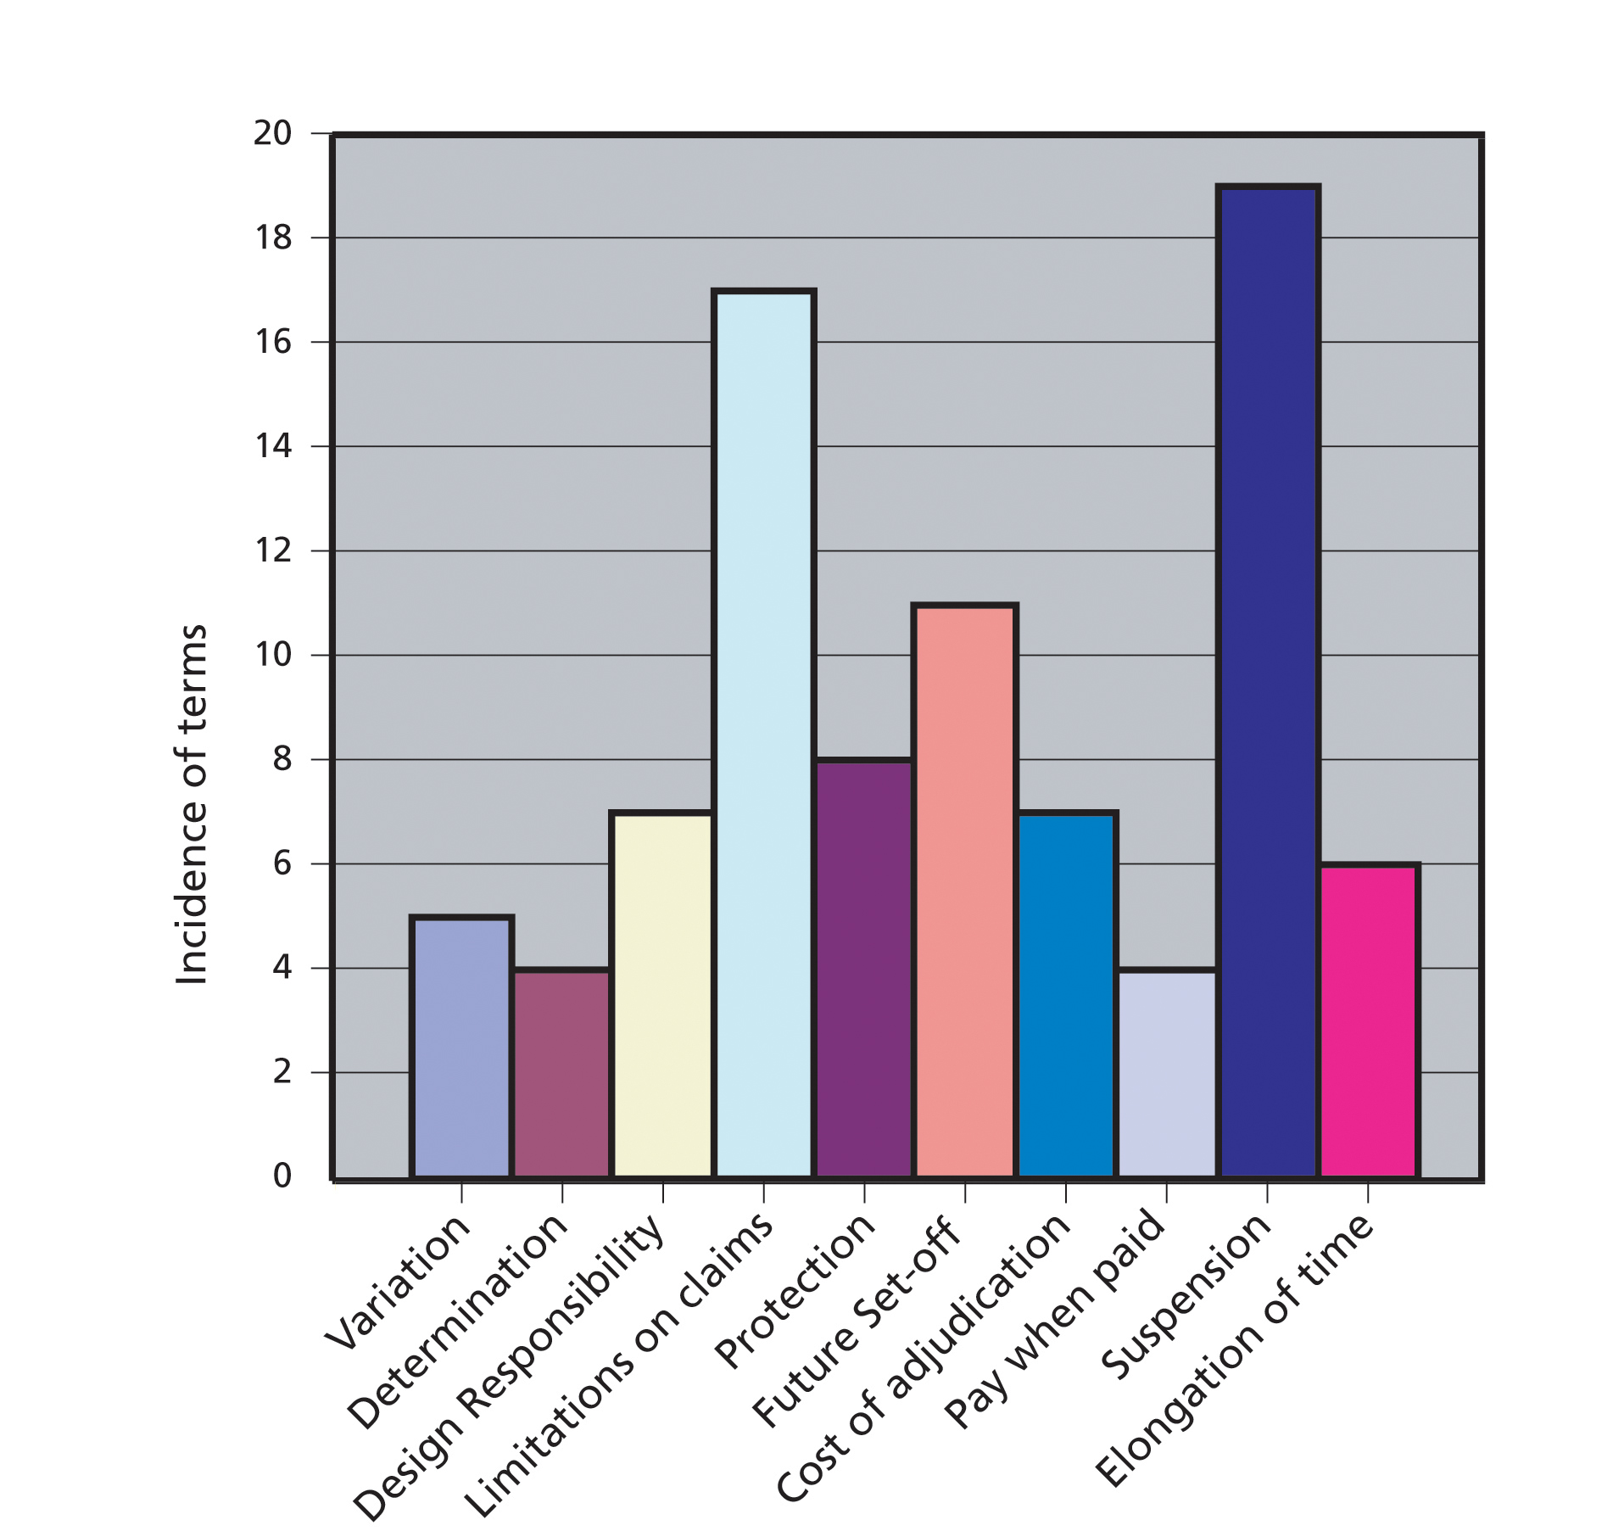

7. The Dangers of Non-Standard Subcontracts
Huxtable had strong views on the damaging effects of non-standard contracts.

“The contractual link is rendered un-necessarily vague and uncertain…. A busy specialist firm may face literally hundreds of different sets of non-standard subcontract terms and conditions and cannot reasonably be expected to assimilate all of the varying procedures and requirements, or figure out all the legal intricacies of each set. These terms are equally difficult to tender from effectively. It is almost impossible to price or quantify accurately the obligations and liabilities of such widely drawn main contractor powers.

Inevitably specialists are forced either to add a prudent margin to their pricing in the hope it will cover all unquantifiable risks, uncertainties and liabilities or they succumb to commercial pressures and price the job as competitively as possible while grimly hoping that non of the risks will unduly affect them during or after the project. Either way the client suffers.

What happens to the specialist subcontractors who are subject to these onerous terms and conditions? The resulting strangle on their cashflow causes some of them to starve (at least commercially) and some of them are pushed under and drown in a sea of insolvency, breaking up specialist teams and depriving the industry of solid chunks of specialist expertise and experience…. There are very many cases where a competent well-managed specialist company is simply cheated into oblivion by the onerous conditions and procedures and behaviour of the Main Contractors under which it has been obliged to work”.

Huxtable’s words in this section are stirring and such phrases as “cheated into oblivion” linger in the mind. Is it though a balanced view?

As a matter of law there is nothing to prevent the parties from entering into any terms and conditions they agree upon as long as they are not themselves illegal. According to a leading academic the written document is interpreted as the sole declaration of the parties’ intention and it is from the words used that the intention must be discovered. Why should attention be drawn to the terms and conditions of a subcontract when the subcontractor should voice their concern before the contract is entered into – if they do not like certain terms then why enter into the contracts in the first place?

Huxtable is aware of this conundrum and addresses it in his Report.

“There is commercial risk in all business….It is argued by apologists for the Main Contractors that this just “reflects commercial reality”. Perhaps it does, but it is an ugly and unacceptable reality involving a corruption of the commercial process which no civilised society should- or in the long run can afford to – tolerate.”

Another problem in the argument being advanced by Huxtable is that quite often subcontractors do not help themselves in terms of acting consistently and/or collectively in how they respond to the imposition of non-standard terms. This point picks up on the main purpose of the Report – to provide a focal point for collective action in forming a concerted response to the situation. The need for this co-ordinated response would appear undiminished in the current prevailing economic conditions.

The underlying rationale to the Report appears sound although Huxtable’s language in this section is emotive. Subcontractors being coerced into signing one-sided terms and conditions have a direct correlation with business failure, additional costs and mistrust in the industry. These consequences are unattractive enough in themselves to be a motivation for avoiding them.

In the writer’s view there is an element in Huxtable’s argument which rings true regardless of one’s starting point. There is a category of term in some forms of non-standard subcontract which goes beyond reflecting the “commercial reality” of the situation – i.e. the main contractor has bigger and better bargaining power – and strays into the category of being unconscionable. This category of term makes a nonsense of the commercial bargain struck and the roles being undertaken. Into this category falls such terms where risks are given to the subcontractor for matters over which they have no control.

Table B returns to the ten most common inequitable terms identified above. For this exercise, the terms have been coloured amber or red to denote the potential damage the term could cause to the specialist contractor. The amber terms are those which a specialist contractor could, in certain circumstances, be expected to manage in their pricing structures as a quantifiable risk. The red terms appear so manifestly one sided and unquantifiable from the specialist contractor’s viewpoint as to be hazardous.

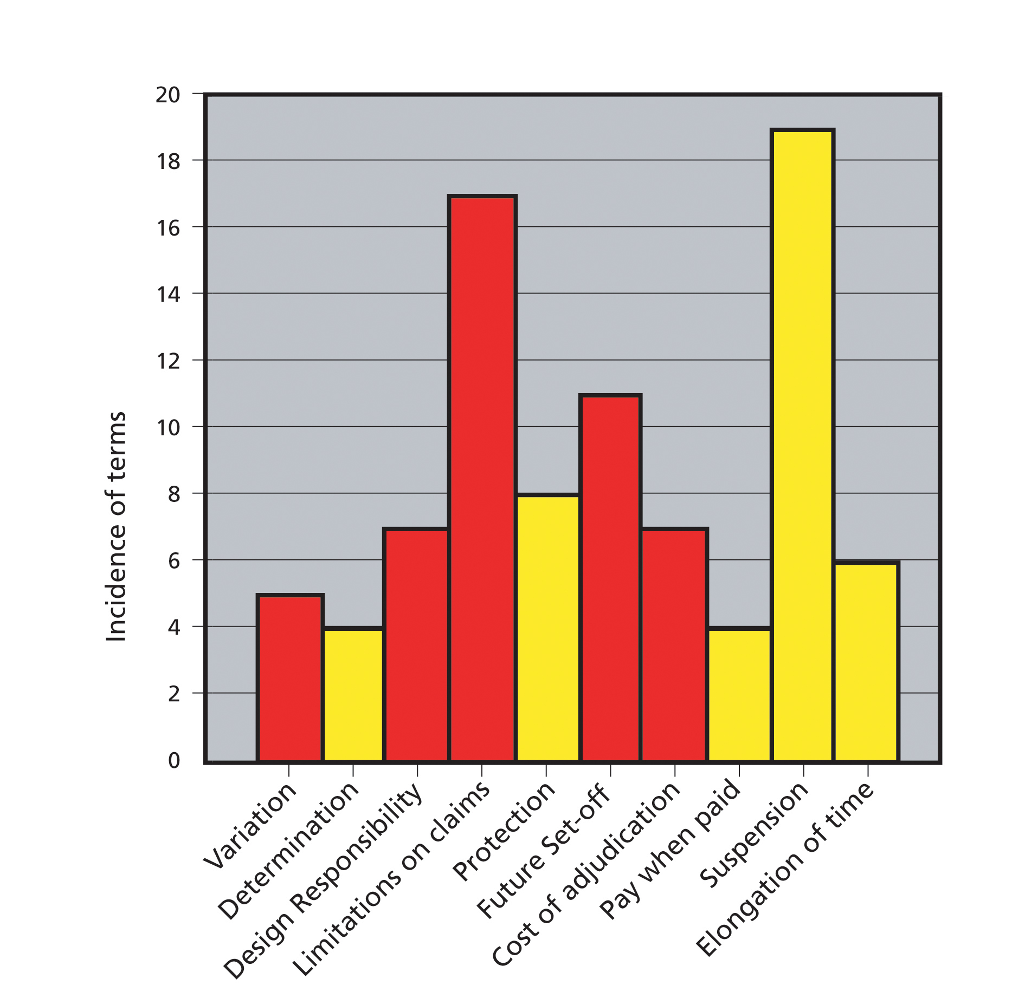
Table B Grading of non-standard subcontract terms

Taken as a percentage, approximately 50% of the terms examined are in the hazardous red category. These are the clauses saddling the subcontractor with the costs of adjudication, allowing main contractor future set-offs, limiting the recoverability of loss and expense, placing design co-ordination on subcontractors and allowing for unilateral variation of subcontract terms. The remaining 50% are in the second category of amber terms. These terms are barely any more manageable for the subcontractor requiring further guess work and predictions as to the behaviour of the main contractors involved.

One clear message to come out of this study of the Confederation’s Analysis Notes is that legislation alone is not sufficient to improve the position of specialist contractors. The benefits introduced by the Act have been blunted by non-standard terms and conditions. The underlying question is how subcontractors find themselves in a position where they feel they have no choice but to sign up to these types of provisions.

8. Huxtable’s Solution
Huxtable’s answer to the last question was clear and a theme he returned to in several places in his Report.

“All clients of the construction industry, whether private concerns or individuals or public sector bodies would be well advised to take a much greater interest in what goes on at the specialist subcontractor level on their projects and also insist on their professional advisers doing the same. …Despite the remoteness of the subcontracts from him, the client and his professional advisers should realise he has a clear vested interest in ensuring that the above are met.

Undue commercial pressures and the “every man for himself” attitudes which are an inescapable by-product of onerous subcontracts have an adverse effect both on standards of workmanship and efficiency to the lasting detriment of the client.”

Whether or not this solution is achievable - expecting the Client to look beyond their arrangements with the main contractors – is debatable. Certainly considerable strides were made towards this during the rise in collaborative and partnering arrangements in the last ten years. The anecdotal evidence available today is that these collaborative/inclusive arrangements are being overlooked in favour of a return to competitive/adversarial type procedures. If this is right then it represents a retrogressive step.

Perhaps a more realistic course of action for the Confederation to pursue would be to continue along its course in exposing the types of contractual abuse identified in the Tables set out above and promote self -help and education amongst its membership. This goal of securing fairer future treatment for subcontractors from the other stakeholders in the industry is entirely consistent with Huxtable’s mission. The importance of this mission and of continuing the campaign for fairer contracts and earlier involvement of specialists in the design process remains critical in today’s industry.

Conclusions
In section two of this paper I gave a warning that a large part of the industry would dismiss Huxtable’s findings as a standard subcontractor rant against the other stakeholders in the industry. The same individuals would no doubt point out that the practices of the subcontractors themselves are to a large extent responsible for bringing about the status quo and resulting lack of mutual trust and respect that exists in certain parts of the industry. There may or may not be some truth in this.

This is the “chicken and egg” conundrum which goes something like this– we mistreat you because you will mistreat us. Furthermore you expect us to mistreat you so we cannot start being nice to you. Whether or not you agree that this conundrum exists, and regardless of how these practices are labelled: subbie-bashing, commercial leverage or mere sound commercial sense, there is a category of risk transferring contractual term shown red on Table B above which ought not to be allocated to the subcontractor.

The subcontractor has no power to control or even manage the outcome of the red risk assigned. To transfer this category of risk to subcontractor appears to be without any logical justification and downright hazardous for the subcontractor to accept. The work of the Confederation of Construction Specialists and other organisations in disseminating this message is clearly of great importance.

A good deal has changed in the construction industry since the report was written in 1983, much of it for the better. The radical provisions of the Housing Grants, Construction and Regeneration Act 1996 have improved the specialist contractors’ position and would no doubt have been welcomed by John Huxtable. Advances by progressive thinking main contractors in risk management/allocation and collaborative working have also been made. However, several areas of deep concern remain for specialist contractors, foremost amongst them the continued imposition of non-standard onerous terms of subcontract. The continued use of these terms undermine the advances made elsewhere and John Huxtable’s central theme – that this amounts to a corruption of the commercial process –remains relevant to today’s industry.

Words 4,993

Huxtable, J (1983) Corruption of the Commercial Process Published by the Confederation of Construction Specialists
Simon, Lord (1944) The Placing and Management of Building Contracts: Report of the Simon Committee: HMSO 1944
Gray, C; Flanagan, R (1989) The Changing Role of Specialist and Trade Contractors, Chartered Institute of Building
RICS Contracts in Use Survey 2004 available at: http://www.rics.org/Builtenvironment/Buildingcontractforms/Contracts+in+use+report.htm
Banwell, H (1964) The Placing and Management of Contracts for Building and Civil Engineering Work, Ministry of Public Building Available from The Library of the Chartered Institute of Building
Latham, Sir M. (1994) Constructing the Team: Joint Review of Procurement and Contractual Arrangements in the United Kingdom Construction Industry, HMSO, London
Egan, J. (1998) Rethinking Construction. London, Department of the Environments Transport and Regions. (http://www.rethinkingconstruction.org/).
Building Magazine article from 8 May 2008 – The Egan Report 10 years on accessed on 7 May 2009 at http://www.building.co.uk/story.asp?storycode=3113047
Uff, J (2005) Construction Law 9th Edition Thomson Sweet & Maxwell

