Skin scar pre-conceptions must be challenged

BC Brown, TP Moss, DA McGrouther, A Bayat

Benjamin C Brown, MB ChB
Department of Plastic & Reconstructive Surgery Research, The University of Manchester, Oxford Road, Manchester, M13 9PL, UK.

Timothy P Moss, MPH PhD FRSH
Centre for Appearance Research, Faculty of Applied Science, University of the West of England, Coldharbour Lane, Bristol BS16 1QY, UK

Duncan A McGrouther, MD, MSc, FRCS
Department of Plastic & Reconstructive Surgery Research, The University of Manchester, Oxford Road, Manchester, M13 9PL, UK.

Ardeshir Bayat, MB ChB, PhD, MRCS
Manchester Interdisciplinary Biocentre, The University of Manchester, Manchester, M1 7DN, UK.

Corresponding author:
Dr Ardeshir Bayat,
Clinician Scientist, Plastic & Reconstructive Surgery Research,
Manchester Interdisciplinary Biocentre, The University of Manchester, Manchester, M1 7DN, UK. Ardeshir.Bayat@manchester.ac.uk

No funding was received for this study and the authors have no conflicts of interest to declare.

Abstract
Introduction
Greater objective scar severity and visibility should intuitively cause greater psychosocial distress for patients. Previous research is contradictory and has often employed non-validated scar severity measures whilst neglecting patient-rated severity. The aim of this study was to assess the effects of objective and patient-rated scar severity, scar type and location on psychosocial distress.

Methods
Patients were recruited from a specialist scar service at a plastic surgery clinic. Skin scars were quantitatively assessed using the “Manchester Scar Scale” (MSS) – a validated measure with high inter-rater reliability and correlation with histological and clinical findings. Scars were scored twice independently: first at consultation and later from photographs – their mean provided a final score. Patients also rated their scars as ‘very good’; ‘good’; ‘neutral’; ‘fair’; or ‘poor’ and completed the Derriford Appearance Scale (DAS24) and Dermatology Life Quality Index (DLQI).

Results
Eighty-three patients (57 women, 69%), with an average age of 34 +/- 15 (16 – 65) years were recruited. Mean psychosocial questionnaire scores were: DAS24 45.8 +/- 17.9 (15 – 91); DLQI 7.5 +/- 6.6 (0 – 26). Participants had on average 2.4 +/- 4.3 (1 – 30) scars with an MSS score of 33.4 +/- 53.3 (5.4 – 480) and subjective score of 2.6 +/- 1.2 (0 – 4). Correlation between psychosocial distress and objective severity was not significant (Kendall’s tau: DAS24 0.16 p=0.07; DLQI 0.16 p=0.06), though was for psychosocial distress and subjective severity (Kendall’s tau: DAS24 0.47 p<0.0001; DLQI 0.58 p<0.0001). Patients with non-visible scars experienced greater psychosocial distress than patients with visible scars (mean difference: DAS24 10.4 p=0.030; DLQI 4.1 p=0.013). Scar type was unrelated to psychosocial distress.

Conclusions
Patient-rated scar severity and scar visibility are correlated with patient psychosocial distress rather than clinician’s objective severity rating or scar type. Although counter-intuitive, results are consistent with research into other disfiguring conditions and should therefore form an integral part of clinical assessment. In addition to improving objective scar severity we recommend that treatment should address patient factors to improve self-perception and quality of life (QoL). Currently there are no measures that directly measure scar-related QoL, which should be developed in order to improve future management of scar patients.

Introduction

With rare exceptions all wounds leave scars – an estimated 100 million patients acquire them post-surgery in the developed world each year.¹ Scars are the imperfect but normal end-point of tissue repair in mammals and result in a spectrum of dermal regeneration. There are five main types of skin scar: ‘normal’ fine line, stretched, atrophic, contracted and raised.2⁻³ Raised scars are caused by excessive scar tissue generation and can be further classified as hypertrophic or keloid. Hypertrophic scars are confined to the wound boundaries, whereas keloids grow beyond them.

Historically, certain cultures consider scarification desirable.⁴ However this is not generally true in modern western society, leading many people to seek treatment for skin scars often with unrealistic expectations fuelled by the media.3 Scar treatment is a long-term process, initially limited to observation prior to starting active therapy.² Depending on scar type, treatment may or may not be invasive (intralesional steroid injections or surgery versus compression and topical silicone gel). While treatments may reduce objective scar severity, they never cause them to completely disappear.² Living with scars can be challenging in a social environment that values physical attractiveness;⁶⁻⁷ up to half of patients living with disfiguring conditions suffer concerning levels of anxiety, social avoidance and quality of life.⁵ Scar patients in particular have been shown to experience wide ranging effects on their lives that have a major influence on their psychological well-being and behaviour.⁸

Intuitively, we may expect greater objective scar severity to cause more psychosocial distress. This also applies to more socially visible and conspicuous scars – they often include areas important for social interaction (such as the hands or face) and lead to greater frequency of stigmatising behaviours from others. However, there is no concensus in the literature.⁹⁻¹² Previous research has often assessed scar visibility subjectively and measured psychometric constructs only indirectly associated with psychosocial distress. Furthermore, any measures of objective scar severity used have not been validated and collection of patient-rated subjective severity data often neglected, despite its postulated importance in body image cognition.¹³ Thus, the purpose of this study was to examine the effects of objective scar severity, patient-rated scar severity, scar type and location on patient psychosocial distress.
Methods
Participants
Ethical approval was granted by all relevant bodies (South Manchester Local Research Ethics Committee and South Manchester University Foundation Trust Research & Development). Patients attending a specialist scar service at a plastic surgery clinic were recruited over a three month period. The attending clinician invited them to take part during consultation; participants received an information sheet and informed written consent was obtained prior to enrolment. Full medical history was taken including screening of active psychological morbidities or diseases that may affect their psychosocial well-being.¹⁴ Patients were also asked if they employed any coping behaviours to compensate for the presence of their scars.

Scar characteristics
Each scar was physically examined in detail and standard digital photographs were taken by the department of medical illustration at South Manchester University Foundation Trust. Photos demonstrated each scar’s bodily location and close-up image. A specially designed pro forma was used to collect data on scar history, location and cause in addition to:

Objective severity
Scar severity was scored independently on two occasions using the Manchester Scar Scale (MSS; figures 1 and 2) – by one author at initial consultation and independently by another later from the photographs. The MSS is a validated measure of objective skin scar severity designed for research and everyday clinical use. Scores range from five to 28; higher scores indicate greater severity and have been shown to correlate well with histological and clinical findings.¹⁵

Subjective severity
Patients were asked ‘How would you rate your scar(s)?’ Possible answers formed a Likert scale (‘very good’; ‘good’; ‘neutral’; ‘fair’; or ‘poor’) and were scored from zero to four – more negative answers scoring higher. This is a generally accepted effective method to assess subjective severity in a range of diseases. Patients were not asked to rate themselves using the MSS as the scoring criteria are designed to be purely objective.

Psychosocial assessment
Participants completed two validated appearance and dermatology-specific measures of psychosocial distress:

Derriford Appearance Scale (DAS24)
A psychometrically sound questionnaire that assesses distress and difficulties encountered by people with disfiguring conditions. Its composite measure includes aspects of self-reported thoughts, feelings and behaviour, which reflect the degree of distress and dysfunction experienced around appearance. It consists of 24 items and scores range from 11 to 96 – higher scores indicate less adjustment to problems of appearance.¹⁶

Dermatology Life Quality Index (DLQI)
An extensively used questionnaire relevant to a range of dermatological conditions. It consists of ten questions and scores range from zero to 30 – higher scores indicating greater impact on quality of life (QoL). ¹⁷

Analysis
Scar assessment
Inter-observer reliability of objective severity was assessed using agreement analysis for both sets of MSS scores. This consisted of Kendall’s rank correlation, one-way random effects intra-class correlation coefficient, estimated within-subjects standard deviation and repeatability coefficient. The average of the two MSS scores for each scar provided a final objective severity score. Participants were allocated an overall scar severity score from the sum of their individual final scar scores. The relationship between participant’s objective and subjective scar severity scores were then analysed using Kendall’s rank correlation.

Participant classification
Patients were classified according to their scar location and type. Locations were divided into: ‘visible’ (head, neck, lower arms, hands or lower legs); ‘non-visible’ (torso, genitalia, upper arms and upper legs); and ‘mixed’ (scars in both visible and non-visible areas). Scar type was divided into ‘raised’ (hypertrophic or keloid), ‘non-raised’ (‘normal’ fine line, widespread, atrophic, contracture) or mixed (both raised and non-raised).

Scar severity versus psychosocial score
The relationship between patients’ scar severity (objective and subjective) and psychosocial scores was assessed using Kendall’s rank correlation. Previous research has suggested this relationship is dependent on visibility,¹⁹ therefore analyses were repeated for ‘visible’ and ‘non-visible’ patients (those classified as ‘mixed’ were omitted).

Scar characteristics and psychosocial score
Difference in psychosocial scores between patients with raised and non-raised, and visible and non-visible scars was analysed using the Mann Whitney U test. Those classified as ‘mixed’ were omitted.

Statistics
All values are provided as mean +/- standard deviation (range). Statistical test results are quoted to one decimal place with the name of the test used and their p value.

Results

Participants
We recruited 83 patients (57 women, 69%), with an average age of 34 +/- 15 (16 – 65) years. All spoke English as their first language and were free of other active psychosocially disturbing conditions. Table 1 demonstrates participant ethnicities. The majority of participants had previously received scar treatment (n=51, 61%) and adopted coping behaviours (n=54, 65%) such as using make-up, adopting certain body positions, refraining from gesticulation when talking or not wearing revealing clothes. Mean psychosocial questionnaire scores were: DAS24 =45.8 +/- 17.9 (15 – 91); DLQI = 7.5 +/- 6.6 (0 – 26).

Participants shared a total of 184 scars: 2.4 +/- 4.3 (1 – 30) per patient, which had been present for an average of 10.4 +/- 8.3 (0.1 – 32) years. Table 2 demonstrates scar characteristics. Fifty-seven (69%) participants had visible scars, 25 (30%) had non-visible and one (1%) had mixed (both visible and non-visible scars). Fifty (60%) participants had raised scars, 31 (37%) had non-raised scars and 2 (2%) had mixed (both raised and non-raised scars). Table 3 demonstrates the distribution of scar characteristics within each group.

Scar severity
Inter-rater agreement between the MSS scores at consultation and from photographs was good (figure 3): Kendall’s tau = 0.42 (p<0.0001); one way random effects intra-class correlation coefficient = 0.52; estimated within-subjects standard deviation = 3.93; within-subjects SD versus mean Kendall's tau = 0.05 (p = 0.44); repeatability coefficient = 10.90. There was no significant correlation between objective and subjective scar assessment Kendall’s tau = 0.08 (p<0.35, figure 4).

Mean final objective MSS score was 16.4 +/- 5.1 (5.4 – 27) per scar and 33.4 +/- 53.3 (5.4 – 480) per patient. Mean subjective scar score was 2.6 +/- 1.2 (0 – 4) per patient.

Scar severity versus psychosocial score
In the overall, visible and non-visible groups, objective scar severity was positively correlated with psychosocial disturbance, though the relationship was not significant (kendall’s tau = X; see table 4 and figure 5). Subjective scar severity in these groups was also positively correlated with psychosocial distress – this relationship was significant (kendall’s tau = X; see table 4 and figure 6).

Scar characteristics and psychosocial score
Patients with raised scars had higher psychosocial distress scores than patients with non-raised scars, though findings were not significant (table 5). Patients with non-visible scars had higher psychosocial disturbance scores than patients with visible scars. These findings were significant in the overall and raised but not non-raised groups (table 5).

Discussion

Assessing the psychosocial impact of scars is fundamental to understanding scar patients’ needs that has previously been subject to conflicting reports. The amount of psychosocial distress suffered by scar patients is demonstrated by the high mean questionnaire scores (DAS24 = 45.8, DLQI = 7.5) and majority of patients previously seeking scar treatment and using coping behaviours in our cohort. Whether the psychosocial impact of scars is related to their objective or subjective severity, location or type has not been previously tested. Our results demonstrate that objective scar severity and scar type do not influence patients’ psychosocial morbidity, whereas patients’ own subjective assessment and scar visibility does. This has important implications for clinical practice.

Our cohort was large enough to achieve statistically significant findings. All participants were free of active psychosocially disturbing conditions and spoke English as their first language, allowing unbiased psychosocial assessments. Like most appearance-related research, the majority (69%) of our cohort were female. The numbers of female participants may also have been high because of the causes of the scars being unique to females such as deliberate self-harm³² (6%) and body piercing (9%). A female majority may have artificially elevated our mean questionnaire scores as females report appearance concerns at greater levels of distress than males.¹⁸ Scores may also have been elevated because participants were recruited from a specialist scar clinic where attendees by definition are have scar-related concerns.

Scar severity versus psychosocial score
Our cohort demonstrated a wide range of scar severity. MSS scores at the two time points showed a high level of agreement, supporting the method for deriving final scar severity scores from their mean and further validating the MSS as an objective scar severity scale.

Results indicate that psychosocial distress is directly related to patient-perceived scar severity and unrelated to clinician-rated scar severity. Association between patient-rated severity and psychosocial distress has been suggested previously in patients with disfigurement.¹⁹⁻²² Furthermore, a lack of association between psychosocial distress and objective severity has been proved in a variety of disfiguring conditions including facial lipoatrophy,²¹ head and neck cancer,²³ psoriasis,²⁴ burns,^{20, 25} vitiligo,²⁶ craniofacial²⁷ and dentofacial²⁸ disfigurement. These findings may initially appear counter-intuitive, though can be logically explained. If an individual perceives their scar to be severe, they will anticipate adverse reactions from others and greater social difficulties, causing psychosocial distress. Furthermore, if a person is psychosocially distressed they are more likely to associate negative thoughts with their appearance and subsequently rate their scar more negatively. Therefore, patients’ own appraisal of their appearance and related cognition defines their psychosocial well-being, not external factors such as other’s objective ratings.

To our knowledge, this is first study to compare objective and subjective severity ratings of the same scars. Our analyses suggest objective and subjective scar severity ratings are unrelated – an objectively severe scar may be rated non-severe by a patient and an objectively non-severe scar may be rated severe by another – which is supported by research in other disfiguring conditions.¹⁹ A truly objective scar severity measure has not been previously available; the scale used here is practical for clinical settings and has been validated with good inter-rater reliability.

Scar characteristics and psychosocial score
All scar locations were well represented in our cohort and results indicate that patients with non-visible scars suffer more psychosocial distress than those with visible scars. This was not statistically significant for non-raised scars most likely because the number of participants with non-visible non-raised scars was very low (n=4). Furthermore, it has been shown that the presence of visible burns do not affect body image, QoL or sexual adjustment^{12, 29} and hidden disfigured body parts cause as much psychosocial distress as more obvious disfigurements.¹⁶ This may appear counter-intuitive as visible bodily locations, such as the face and hands, are permanently on view and are principle tools for human interaction. One explanation may be that visible scars provide greater opportunities to habituate to stigmatising behaviours; a predictable social world in which the person is forced to adopt effective coping strategies. Conversely, non-visible areas are often important in sexual intimacy and these people may never become conditioned to stigmatising behaviours due to limited chances. Furthermore, it is psychologically demanding and potentially distressing to carry a “secret” about one’s appearance; the decision about when and how to reveal the concealed identity associated with non-visible scarring is burdensome ³³

All scar types were well represented in our cohort and results suggest that there is no significant difference in psychosocial distress between patients with raised and non-raised scar types. This may be because raised and non-raised scar types are analogous to objective severity – keloid and hypertrophic scars score higher on the MSS – and therefore have a similar relationship with psychosocial distress.

Implications for clinical practice
When appraising disease severity in scar patients, our results indicate that scar location and the patients’ own rating of scar severity should be integral to the process, as greater subjective severity and non-visibility are more likely to cause greater psychosocial distress. In addition to improving objective scar severity, emphasis should be placed on addressing patient factors to improve self-perception. One way is to help individuals elicit more positive feedback from others and disprove negative cognitions in social situations through support groups, social skills training,or cognitive behavioural therapy (CBT). ^{30, 31}

As a chronic condition, the ultimate goal in assessing scar disease progression is scar-specific QoL. This quantifies the impact of scars from the patients’ perspective and is appropriate in clinical settings and trials. There are currently no instruments that do this, and although the psychometric scales used here evaluate the psychosocial distress suffered by scar patients, these constructs are not specific to scar-related QoL.

This study provides evidence that patient-rated scar severity and scar location are more closely related to psychosocial distress than clinician-rated severity and scar type, which is consistent with research in other disfiguring conditions. These findings have important implications for scar patient management and highlight the need for a scar-specific measure of QoL.
Tables
Table 1: Participant ethinicity (%)
White | 52 (63)
Black African | 1 (1)
Black Caribbean | 10 (12)
Asian Indian | 5 (6)
Asian Pakistani | 7 (8)
Chinese | 4 (5)
Mixed (Black-White) | 4 (5)

Table 2: Scar characterisitics (%)
Aetiology
Acne | 13 (7)
Body piercing | 16 (9)
Chickenpox | 8 (4)
Deliberate self-harm | 11 (6)
Furuncle | 10 (5)
Idiopathic | 10 (5)
Post-surgical | 42 (23)
Trauma (accidental) | 35 (19)
Trauma (violence) | 5 (3)
Tuberculosis vaccine | 4 (2)
Ulceronecrotic Mucha–Habermann disease | 30 (16)
Type
Linear | 22 (12)
Stretched | 48 (26)
Atrophic | 13 (7)
Contracted | 5 (3)
Hypertrophic | 16 (9)
Keloid | 80 (43)

Table 3: Participant classification
 |  | Location
 |  | Visible | Non-visible | Mixed | Total
Type | Raised | 28 | 21 | 1 | 50
Type | Non-Raised | 27 | 4 | 0 | 31
Type | Mixed | 2 | 0 | 0 | 2
Type | Total | 57 | 25 | 1 | -

Table 4: Correlation (Kendall’s tau) between scar severity and psychosocial disturbance
 | Overall | p | Visible | p | Non-visible | p
Objective
DAS 24 | 0.16 | 0.07 | 0.02 | 0.86 | 0.21 | 0.16
DLQI | 0.16 | 0.06 | 0.03 | 0.79 | 0.16 | 0.29
Subjective
DAS 24 | 0.47 | < 0.0001 | 0.53 | < 0.0001 | 0.29 | 0.05
DLQI | 0.58 | < 0.0001 | 0.48 | < 0.0001 | 0.40 | 0.02

Table 5: Difference in mean psychosocial score between patients with different scar characteristics
 |  |  | Scar location
 |  |  | Overall | Visible | Non-visible | p
DAS24 | Scar type | Overall | - | 41.8 | 52.2 | 0.030
DAS24 | Scar type | R | 47.5 | 42.1 | 52.4 | 0.049
DAS24 | Scar type | N | 42.7 | 41.4 | 51.0 | 0.515
DAS24 | Scar type | p | 0.314 | 0.894 | 0.460 | -
DLQI | Scar type | Overall | - | 6.0 | 10.1 | 0.013
DLQI | Scar type | R | 8.0 | 5.7 | 10.2 | 0.027
DLQI | Scar type | N | 6.3 | 5.7 | 9.5 | 0.230
DLQI | Scar type | p | 0.277 | 0.975 | 0.395 | -
Figures
Figure 1: Manchester scar scale
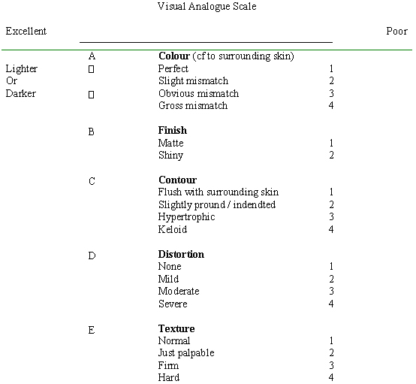
Figure 2: Working example of Manchester scar scale
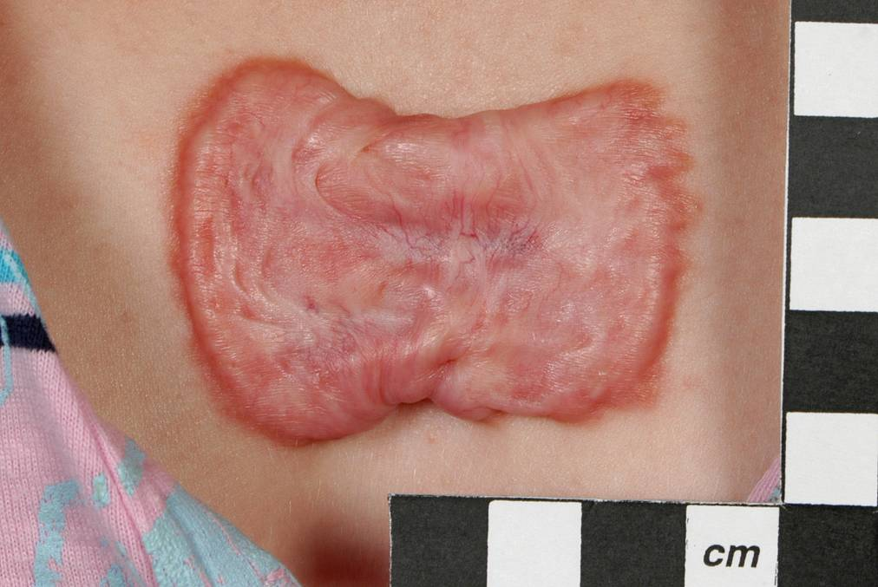
Location chest, Type Keloid
Score time 1 Colour 4, Finish 2, Contour 4, Distortion 3, Texture 3, VAS 8.8
Score time 2 Colour 4, Finish 2, Contour 4, Distortion 4, Texture 4, VAS 9.0
Final MSS score 25.9

Figure 3: Agreement between both sets of MSS score
Figure 4: Relationship between objective and subjective scar assessment
Figure 5: Correlation between objective scar severity and psychosocial disturbance

Figure 6: Correlation between subjective scar severity and psychosocial disturbance
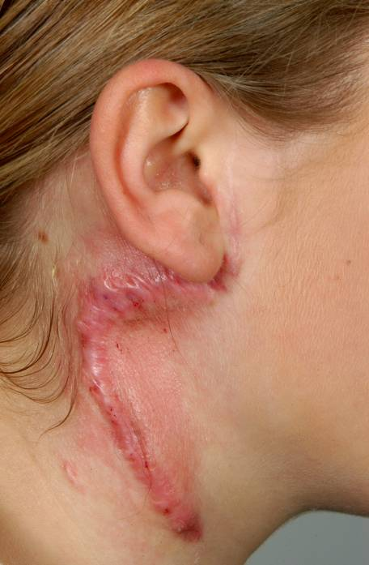
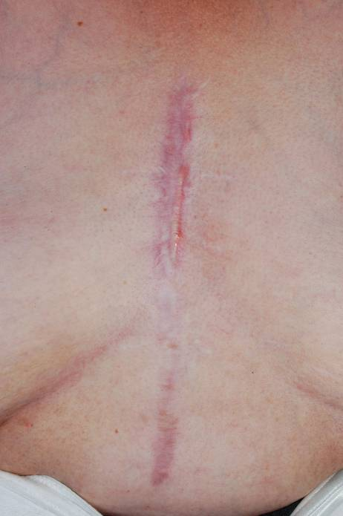
Figure 7: Visible vs non-visible scars

19 year-old female56 year-old female
Location: NeckLocation: Chest
MSS: 26.95MSS: 19
Subjective: 0Subjective: 3
DLQI: 4DLQI: 14
DAS24: 15DAS: 24

19 year-old female
Keloid scar of the neck
Objective severity score 27 Subjective severity score 0
DLQI score 4
DAS 24 score 15
56 year-old female
Stretched scar of the chest
Objective severity score 19
Subjective severity score 3
DLQI score 14
DAS 24 score 72

References

1. Sund B. New developments in wound care. London: PJB Publications, 2000:1-255. (Clinica Reprt CBS 836)

2. Bayat A, McGrouther DA. Spectrum of abnormal skin scars and their clinical management. British J Hosp Med 2006;67:634-9.

3. Bayat A, McGrouther DA, Ferguson M W J. Skin Scarring. BMJ 2003;326:88–92.

4. Rush JA. Spiritual tattoo: a cultural history of tattooing, piercing, scarification, branding, and implants. Berkeley, California: Frog, 2005.

5. Rumsey N, Clarke A, Musa M. Altered body image: the psychosocial needs of patients. Br J Community Nurs 2002;7(11):563-6.

6. Beuf AH. Beauty is the beast: appearance-impaired children in America. Philadelphia: University of Pennsylvania Press; 1990.

7. Thompson TK, Heinberg LJ, Altabe M, Tantleff-Dunn S. Exacting beauty: theory, assessment, and treatment of body image disturbance. Washington, DC: American Psychological Association; 1999.

8. Brown BC, SP McKenna, K Siddhi, DA McGrouther, A Bayat. The hidden cost of skin scars J Plast Reconstr Aesthet Surg (2008)

9. Tebble NJ, Thomas DW, Price P. Anxiety and self-consciousness in patients with minor facial lacerations. Journal of Advanced Nursing. 2004:47(4);417-426

10. Browne G, Byrne C, Brown B et al. Psychosocial adjustment of burn survivors. Burns, 1985;12:28-35

11. Andreasen NJC, Norris AS. Long-term adjustment and adaptation mechanisms in severely burned adults. J Nerv Ment Dis 1972;154:352-62.

12. Kimmo T, Jyrki V, Sirpa AS. Health status after recovery from burn injury Burns. 1998;24(4):293-8.

13. Cash TF. The psychology of physical appearance: Aesthetics, attributes, and images. In: TF Cash and T Pruzinsky (Editors), Body images: Development, deviance, and change (pp 51-79). New York: Guilford Press, 2005.

14. Smith JA. Qualitative Psychology: A Practical Guide to Research Methods. London: Sage, 2003.

15. Beausang E et al. A new quantitative scale for clinical scar assessment. Plast Reconstr Surg 1998;102:1954-61.

16. Carr et al. The DAS24: A short form of the Derriford Appearance Scale DAS59 to measure individual responses to living with problems of appearance British Journal of Health Psychology. Volume 10, Number 2, May 2005, pp. 285-298(14)

17. Finlay AY, Khan GK: Dermatology Life Quality Index (DLQI)—A simple practical measure for routine clinical use. Clin Exp Dermatol. 19:210–216, 1994

18. Harris DL, Carr AT. Prevalence of concern about physical appearance in the general population. Br J Plast Surg 2001;54(3):223-6.

19. Moss TP. The relationships between objective and subjective ratings of disfigurement severity, and psychological adjustment. Body image. 2005:2;151-159.

20. Lawrence JW, Fauerbach JA, Heinberg L, Doctor M. Visible vs hidden scars and their relation to body esteem. J Burn Care Rehabil. 2004:25;25-32.

21. Ong J, Clarke A, White P, Johnson M, Withey S, Butler PE. Does severity predict distress? The relationship between subjective and objective measures of appearance and psychological adjustment, during treatment for facial lipoatrophy. Body Image 2007;4(3):239-48.

22. Rumsey N, Harcourt D. Body image and disfigurement: issues and interventions.
Body Image 2004 Jan;1(1):83-97.

23. Baker CA. Factors associated with rehabilitation in head and neck cancer.
Cancer Nurs 1992;15(6):395-400.

24. Fleischer AB Jr, Feldman SR, Rapp SR, Reboussin DM, Exum ML, Clark AR, Rajashekhar V. Disease severity measures in a population of psoriasis patients: the symptoms of psoriasis correlate with self-administered psoriasis area severity index scores. J Invest Dermatol 1996;107(1):26-9.

25. Williams EE, Griffiths TA. Psychological consequences of burn injury. Burns 1991;17(6):478-80.

26. Thompson AR, Kent G, Smith JA. Living with vitiligo: dealing with difference. Br J Health Psychol 2002;7(Pt 2):213-25.

27. Sarwer DB, Bartlett SP, Whitaker LA, Paige KT, Pertschuk MJ, Wadden TA. Adult psychological functioning of individuals born with craniofacial anomalies. Plast Reconstr Surg 1999;103(2):412-8.

28. Macgregor FC. Social and psychological implications of dentofacial disfigurement.
Angle Orthod 1970;(3):231-3.

29. Fauerbach JA, Heinberg LJ, Lawrence JW, Munster AM, Palombo DA, Richter D, Spence RJ, Stevens SS, Ware L, Muehlberger T. Effect of early body image dissatisfaction on subsequent psychological and physical adjustment after disfiguring injury. Psychosom Med 2000 62(4):576-82

30. Kleve L, Rumsey N, Wyn-Williams M, White P. The effectiveness of cognitive-behavioural interventions provided at Outlook: a disfigurement support unit. J Eval Clin Pract 2002;8(4):387-95.

31. Robinson E, Rumsey N, Partridge J.An evaluation of the impact of social interaction skills training for facially disfigured people. Br J Plast Surg 1996;49(5):281-9.

32. Hawton K, Harriss L. Deliberate self-harm in young people: characteristics and subsequent mortality in a 20-year cohort of patients presenting to hospital. J Clin Psychiatry. 2007 Oct;68(10):1574-83.

33. Pachankis JE. The psychological implications of concealing a stigma: a cognitive-affective-behavioral model. Psychol Bull. 2007 Mar;133(2):328-45.

