

REINVESTMENT PROJECT FINAL REPORT

Attracting Science Graduates into Healthcare Related Careers in the NHS

Rita Phillips
July 2010

Contents

1. Forward 5

2. Executive Summary 6

3. Background 10

4. Project aims and scope 12

5. Project activity 12

6. Key recommendations 30

7. Appendix 34

1 Foreword

This South West Strategic Heath Authority funded re-investment project was undertaken from May 2009 to July 2010 to explore and analyse the current career trajectories of science graduates in the South West and identify areas of improvement in marketing to attract them into health care related careers and roles in the NHS. There are proven deficits within the healthcare workforce which impact on the delivery of healthcare in certain fields for example imaging services and Radiotherapy. The main purpose of this project is to raise the profile of these healthcare careers, and promote them to graduates from a science background. Although these two careers were targeted for this project, It is envisaged that the recommendations from this project will inform strategies for the South West Strategic Health Authority and Higher Education Institutions to widen access for Science graduates in all health care related careers.

2 Executive Summary

2.1 The healthcare science comprises approximately 5% of the healthcare workforce in the UK, and 80% of all diagnoses can be attributed to their work. (Department of Health 2008---Our NHS, Our Future: the contribution of Healthcare Scientists).

2.2 The following diagnostic staff groups appear on the Home Office Shortage Occupation List (HOSOL): diagnostic radiographer, sonographer, nuclear medicine scientist, nuclear medicine technologist, staff working in diagnostic radiology (including magnetic resonance imaging), cardiac physiologist, clinical neurophysiologist, clinical vascular scientist, respiratory physiologist and sleep physiologist and HPC registered ophthalmic and vision scientist.

2.3 One of the key aspects to modernising scientific careers in healthcare is to raise the profile of the healthcare science workforce and careers, making it an attractive career of choice for people interested in science, piloting key elements of the programme where possible, promoting opportunity, equality and equity in careers and the recognition of equivalence of previous experience, training and qualifications.

2.4 The purpose of this report is to provide an overview of the destinations and employability of science graduates established via a scoping exercise. This provided an insight to which science graduates are more likely to be attracted to a health care career.

2.5 Graduate unemployment has increased by 44% in the last year, taking it to its highest level in more than a decade. Approximately 7.9% of students who left university in 2008 were out of work in January, up from 5.5% the previous year, and it is envisaged this picture could be even worse for those graduating in 2009.

2.6 However, there has been a year-on-year increase in the percentages of graduates going into health, social and welfare, and education-related occupations, suggesting that despite the economic downturn, public sector recruitment continues to be buoyant.

2.7 Of the science graduates who are not employed, the majority are continuing to study either as a sole activity or combining with working after obtaining their first degree, reflecting a desire for these graduates to gain more specialist skills and enhance their employability.

2.8 Different marketing strategies were carried out to promote interest in health care careers, namely Radiography, Diagnostic imaging (sonography) and Radiotherapy. These were information and people oriented strategies using website marketing and representation at two separate careers fairs with active participation using relevant technology.

2.9 A focussed marketing strategy involving participation in form of two road shows were conducted and were successful in targeting a small number of graduates with specific skills and backgrounds.

2.10 A broader marketing strategy using websites was very successful in targeting a larger number of graduates, allowing instant access to information for potential recruits. However a further reference point is needed to disseminate career specific information.

2.11 Two case studies were conducted with students from science related graduate backgrounds who have successfully accessed and are completing studies and are embarking on a career in health care. These will be incorporated into the science graduate page on the “day in the life” website

2.12 Encouraging students from more non traditional entry routes will develop the workforce in health care careers and jobs that are currently experiencing deficits. This is crucial to meet future healthcare needs of the South West population.

Key recommendations

- The findings show that science graduates are keen to develop themselves through further studies and vocational studies. The majority of them want to study further to improve their employability.

- Factors such as finding the right place to obtain further information, lack of knowledge regarding complex and technology led health care professions and financial implications impact on students’ decisions to study further.

- The marketing strategies should promote job security, the financial gains, job satisfaction and the vocational nature of the roles in health care.

- HEIs should encourage participation from the students, the service, NHS employers and relevant health care professionals by contributing to science career and recruitment fairs. This provides the potential candidates with first hand information and experiences especially for some health care careers that are technology driven or complex to understand to provide a more direct approach to recruit graduates

- The success of using a variety of marketing strategies in this project including website, road shows and case studies proves that students are keen to explore different ways of obtaining information. HEIs, and SHA should consider using these strategy to recruit students and graduates for specific health courses and careers. This will allow information to be given directly to students with backgrounds that are relevant to the particular course.

- The SHA and HEIs in collaboration with Trusts should promote practical and applied learning opportunities for example provide a framework and placement for science graduates for taster sessions where potential recruits can experience the health care role in reality, for example via an optional short work based learning modules in the final year of study.

- The timing of the website marketing is crucial for an effective response, it should be considered in the student’s second or third trimester before qualifying or within 6 months after graduation as that is the most likely period that students and graduates will be actively seeking jobs or opportunities for further studies.

- The graduate opportunities page on the “Day in the Life” website was very popular in terms of number of hits from potential recruits and should be developed further and sustained.

- The SHA and HEIs in collaboration with Trusts should consider funding for training science graduates in certain field of health care roles where there is a known deficit

3. Background

3.1 The healthcare science workforce is at the heart of safe and effective care for patients, working across some 51 disciplines. It provides expert diagnostic advice and therapeutic care for the treatment of patients and prevention of disease. The workforce develops and applies new technologies that help improve the care of people, across all pathways of care from health and wellbeing to end of life including those in priority groups such as older people, women, and children, patients with mental health problems and the acutely ill.

3.2 The healthcare science workforce comprises approximately 5% of the healthcare workforce in the UK, and 80% of all diagnoses can be attributed to their work. (Department of Health 2008--Our NHS, Our Future: the contribution of Healthcare Scientists)

3.3 The following diagnostic staff groups appear on the government’s shortage occupation list, National Shortage Occupation List : diagnostic radiographer, sonographer, nuclear medicine scientist, nuclear medicine technologist, staff working in diagnostic radiology (including magnetic resonance imaging), cardiac physiologist, clinical neurophysiologist, clinical vascular scientist, respiratory physiologist and sleep physiologist and HPC registered ophthalmic and vision scientist.

3.4 The implementation of Modernising Healthcare Careers – a programme of work across the healthcare workforce with the objective of modernising career and training structures across the NHS – aims to impact positively on workforce availability and productivity.

3.5 One of the key aspect to modernising scientific careers in heathcare is to raise the profile of the healthcare science workforce and careers, making it an attractive career of choice for people interested in science, piloting key elements of the programme where possible, promoting opportunity, equality and equity in careers and the recognition of equivalence of previous experience, training and qualifications through establishment of a UK Healthcare Science Education and Training Board.

3.6 Following a comprehensive consultant exercise, the National Health Service workforce review team recommended that SHAs, HEIs and employers review strategies for training, recruitment and retention of new scientists to increase the size of the permanent workforce.

3.7 A service redesign was needed to account for both the contribution of healthcare scientists, diagnostic and therapeutic radiographers. In addition to the above healthcare science groups, consideration should also be given to sonography/ultrasonography, radiopharmacy, dosimetrists and electron microscopy.

3.8 Graduate unemployment has increased by 44% in the last year, taking it to its highest level in more than a decade, according to a survey from the Higher Education careers service unit (HECSU) in 2009. Around 7.9% of students who left university in the summer of 2008 were still out of work in January of the following year. This figure is increased from 5.5% the previous year, and it is envisaged that the picture could be even worse for those graduating in 2009.

3.9 Despite this, however, researchers found that recruitment in the public sector is increasing with more graduates entering healthcare, teaching and social work increasing. This suggests that despite the economic downturn, public sector recruitment continues to be buoyant

4. Project aims and scope

4.1 To explore and analyse the current career trajectories of science graduates nationally and in the South West and identify areas of science that provide a good basis for a career in the heath service.

4.2 Work with HEIs to consider the marketing processes required for attracting these graduates into professional programmes

4.3 Evaluate chosen marketing strategies

4.4 Assess interest from science graduates.

Project team: Rita Phillips, Principal Lecturer, University of the West of England
Project date: May 2009 – July 2010

5. Project Activity

5.1 The major activities within the project include:

- Scoping Exercises
- Networking
- Marketing Exercises
- Road shows
- Website marketing
- Case studies
- Evaluation Process

Scoping exercises
5.2 A scoping exercise was carried out to determine the destinations and employability of graduates nationally and in the South West. This exercise included communications with various Higher Education Institutions (HEIs) within the South West region, Higher Education and career services, and recruitment websites (Appendix 1)

5.3 Results Appendix 2 shows the destinations of science graduates in 2008 (HECSU 2008)
Further studies undertaken by science graduates
5.4 In the group of science graduates who are not employed, the majority continued to study (as a sole activity) or combine work and study for further qualifications or vocational studies after obtaining their first degree, This reflects a desire for these graduates to gain more specialist skills, and that often to pursue a research and development career within science, a further qualification is useful, and in many cases, even a prerequisite.
5.5 For example in 2008, 31.2% of Biology graduates, 44.8% of Chemistry graduates, 40% of Physics graduates, 24.9% of Psychology graduates and 26.8% of Environmental science graduates carried on to further study, either as a sole activity or combining it with work. This compares with 14.1% of all non science graduates (HESCU 2008).

Employability
5.6 Unemployment at six months after graduation went up in 2008 reflecting the state of the economy in early 2009. For example, unemployment for physics graduates went up from 7% in 2007 to 9.1% in 2008, whilst that for biology has risen from 6.7% to 9.2%, and for chemistry from 6.2% to 8.5%. Unemployment level for anatomy, physiology and pathology graduates six months after graduation rose by 0.9 percentage points from the previous year,

Marketing exercises

Road shows
5.7 The main focus for this strategy was people oriented, to create connections by network opportunities and making contacts. This approach is a more interactive and social strategy with a potentially face to face discussion.

5.8 The targeted science graduates were from Biological sciences, Biomedical sciences, Physical /analytical sciences, Forensic sciences and Psychology.

5.9 In collaboration with other SHA Reinvestment projects, two marketing events were organised. The strategy was to promote a greater understanding of the health care careers by facilitating a more interactive and “hands on” opportunity for the graduates

Bristol Futures fair on 21st January 2010
5.10 Portable ultrasound machine and the Virtual Environment Radiotherapy Training (VERT) technology were showcased to promote potential career opportunities available to graduates. One hour long live demonstrations and interactive exercises were scheduled for a maximum of 15 graduates to register for each session. This event was used to highlight the profession of Diagnostic imaging including sonography and to establish the market for MSc (pre-registration) route for Radiotherapy.

5.11 In addition the website www.dayinthelife.org.uk was also demonstrated to the participants to promote a greater understanding of health related careers and to highlight general opportunities for graduates in health related careers.

5.12 Two student ambassadors were recruited from current healthcare educational
programmes to interact with the participants to promote health related careers. This gives the potential recruits the chance to meet today’s healthcare workforce to motivate and inspire future workforce.

5.13 Marketing flyers and further information for various opportunities to study health related educational courses in HEIs were also distributed to the participants

Plymouth Health Sector fair on 4th March 2010
5.14 A similar approach was undertaken as above to market opportunities to health care graduates. The target audience for this event were graduates from psychology and social sciences

5.15 This event was planned as an open session where graduates can walk in anytime to take part in the demonstrations. This strategy was adopted to target more numbers than the above event.

Evaluation process
5.16 A questionnaire (Appendix 3) was administered to participating graduates.

5.17 In addition verbal informal feedback was sought throughout the sessions.

5.18 Results of evaluation of the road shows are shown in Appendix 4.

Outcomes

The key findings
5.19 Graph 1 in Appendix 4 shows there was a good representation of science graduates. The largest field was biomedical sciences.

5.20 Graph 2 in Appendix 4 shows the response of graduates on their intentions for post graduate studies. The majority of respondents were intending to undertake further studies. This may imply that students are keen to increase their ‘long-term’ chances rather than get an immediate job. Those who are opting for further studies are being more ‘strategic’ and looking at gaining relevant work experience or further qualifications.

5.21 Graph 3 in Appendix 4 shows the considerations of participants for a career in healthcare before and after their experience at the careers fair. 1 in 5 graduates said that they have changed their initial considerations in favour for a career in heath care.

5.22 Graph 4 in Appendix 4 shows the popularity of the practical and interactive sessions where graduates have opportunities to gain an in depth understanding of careers and roles that are complex or technologically led.

5.23 Comments on practical hand on demonstrations:
“I had no idea that Diagnostic imaging and Radiotherapy had so much to
offer”

“it is great to be able to talk to health care students about their
experience directly”
“very approachable team and “very Informative”

5.24 Comments on the “day in the life” website:
“good information on future courses

“Information regarding website use was most useful “

5.25 The graduates from second road show who were already in health care studies were less interested in other health care careers and were less likely to want to change roles at this early stage of their careers. They were more interested in the day in the life website for further information on CPD and extended roles. This was in contrast to the first road show, where the science graduates were graduating with a non health care degree and were more interested in exploring various careers in health care.

Website marketing
5.26 This strategy was information oriented where the main focus is on locating information about jobs, careers and vocations using search engines and websites.

5.27 After communication with HEIs, and a scoping exercise to determine the most appropriate website to market opportunities, the well known graduate recruitment website was chosen to promote careers and opportunities for science graduates in the South West (www.Gradsouthwest )

5.28 A button advert was inserted into the Gradsouthwest website. In order to ensure it is seen by maximum number of graduates, the location of the button advert varied under different sections within the website on a regular basis for example under the “graduate” ,“employers” , “student” and careers” sections. This advert, when clicked would link to the “day in the life” website. This website was active for 3 months commencing on the 1st April 2010.
This could be accessed at
http://www.gradsouthwest.com/cms/ShowPage/Home_page/p!epmblbj

5.29 A contact section was designed on the graduates’ page of the “day in the life” website for interested graduates to register their interest. Graduates who registered their interest were linked to the email of the project lead. Appendix 6 shows examples of these responses. There were a total of 18 responses to the Button advert.

5.30 In addition an HMTL text message was sent to science graduates in May 2010. (appendix 5) Graduates from the selected science backgrounds, namely Biological sciences, Physical sciences and Social and Economics Graduates were targeted. In addition, graduates who have accessed the website in the last six months were also targeted on the basis that they would be the most likely group to still be looking for employment or further opportunities. These were approximately 3113 graduates and students in total.

Evaluation process
5.31 The full evaluation of impact on the “day in the life” website before and after the website marketing strategy can be accessed at
http://www.dayinthelife.org.uk/Data/Sites/7/Stats/Jan10-June10/Report/index.htm

Results
5.32 The key findings were:
The email was opened by 916 unique recipients, which was 28% of those who received the email. Below is the list of links contained in the text email and the number of unique people who clicked these links

1. What can I do with my degree? (http://www.whatcanidowithmydegree.nhs.uk/) - 184 unique users clicked.
2. Science Graduates Opportunities (http://www.dayinthelife.org.uk/preparing_science_grads.aspx) - 217 unique users clicked.
3. NHS Clinical Scientists (https://www.nhsclinicalscientists.info/clrl/recruitment/index.xsp) - 121 unique users clicked.
4. Management Opportunities (http://www.dayinthelife.org.uk/Default.aspx?pageid=372) - 96 unique users clicked.
5. Graduate Management Training Scheme (http://www.nhsgraduates.co.uk/) - 74 unique users clicked.
6. Healthcare Graduate Opportunities (http://www.dayinthelife.org.uk/Default.aspx?pageid=373) - 75 unique users clicked.

5.33 Figure1 below shows the increase in the number of visitors for the “day in the Life” website before and after the gradsouthwest.com advertising campaign.
Time period for the website advertising campaign was between 1/4/2010-26/6/2010.

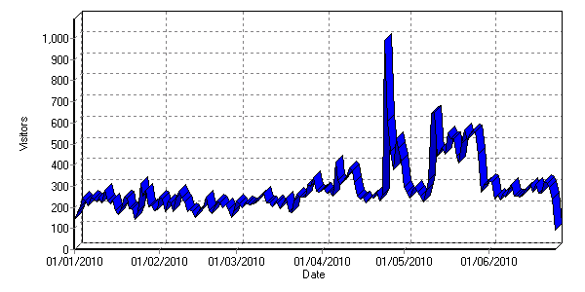

5.34 Figure 2 below shows the number of visitors per month during the period of the marketing strategy including the road shows and website marketing (from mid Jan 2010- end June 2010).
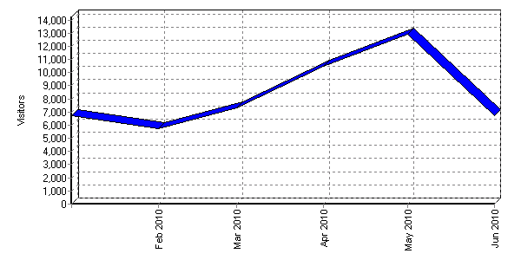

5.35 Figure 3 below shows the most popular website pages before the marketing campaign. There were just over 3000 visitors who accessed the home default page of the website.

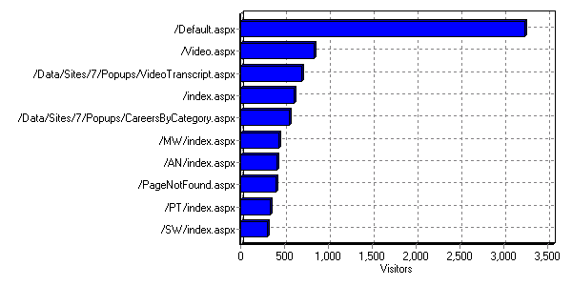

5.36 Figure 4 below shows the most popular pages after the marketing campaign. The visiting rate has significantly increased to just over 10,000 for the graduate opportunities page (/gradopps.aspx) and just under 10,000 visitors for the home default page (/default.aspx)

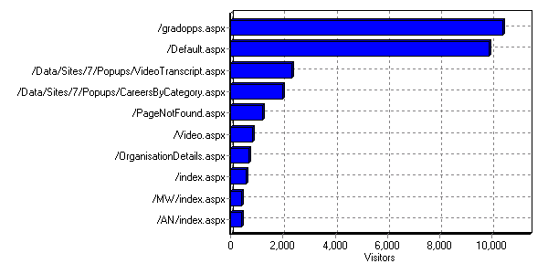

Case Studies
5.37 Two case studies were conducted from students from science related graduate backgrounds who have successfully accessed health care education and are embarking on a career in health care. These will be incorporated into the science graduate page on the “day in the life” website. Details of both case studies are given below. Direct quotes from the transcripts of the interviews are used with the permission from both participants.

Case study one
5.38 A graduate of Equine science who was employed as an Assistant Practitioner ( AfC band 4) , and selected by the trust to train in focussed ultrasound scanning namely Abdominal Aortic aneurysm scans and obstetrics dating scans. She is now sponsored by the NHS Trust to complete a Post Graduate Diploma in Medical ultrasound to widen her scope of practice, for added responsibilities and autonomous practice with the opportunity to progress to a AfC Band 7

Q – When you graduated from your initial degree, did you have any idea of where you were going or what you wanted to do?

A – No, that was the thing, it was a degree that you could finish and pass and it wasn’t like you’d get a job, it was a degree and that was it. But because it was science based I guess that’s why “they” (the NHS Trust) took me on. I think having done a degree, you know how to write your assignments and you know the level you’re at. I’ve seemed to have done quite well with that, there hasn’t been a problem with that side of things.

Also I did a degree in Equine Science and then went and worked in horse racing and then decided that it wasn’t for me, wanted more money, so I got a job at the Local NHS trust as a helper in the imaging department and then they advertised a post to recruit 2 people to do the aneurysm screening and dating scans so I applied and achieved that. I passed and was scanning for 2 years and they asked if I would like to do further modules and I said yes.

Q – Had you any idea what a career in diagnostic imaging or ultrasound entailed? Had you heard about it or know what it was about?

A – yeah, I had heard about it because we covered it in our degree for horses because we use it on legs and hearts so I went to the interview having a bit of knowledge about ultrasound. But I didn’t really know anything else. I just saw it as a way of progressing. I made it clear in my interview because I was thinking of doing the Radiography degree but worked as an Assistant Practitioner first for 2 years but this came up and I didn’t really have a clue whether I liked it or not but just thought it was progression so I did it and they obviously thought I was ok so they let me carry on.

Q –How you feel we can improve marketing or awareness for future students who are looking for a career in ultrasound?

A – Well firstly when people ask what do you do for a career and you say sonographer, they don’t know what a sonographer is. So you say ultrasound and move your hand, and they get it then, they go ‘oh babies’ so that’s one thing. Secondly, I think people who do know about it just think that you need to be a radiographer before you go into it. Also at College where I study, there are lots of people doing these degrees and they go ‘what do I do now?’ because there is no direct career path and perhaps going into places like that would be helpful .And also I do think you’ve got to be a bit more experienced, I mean life experience, I think you’ve got to have seen so I don’t think it’s a particularly a career for a younger person who’s just qualified, you have to have seen a bit of life and experienced emotions. I’m only 27 but still that little bit older, I think it depends on the person doesn’t it, everyone’s different. But I also think of the responsibility, it dawns on you when you pass, you can’t tell people enough, I never realised how bad or how it really gets you going, thinking all the time about work and making sure you’ve done the right thing so you’ve got to have that kind of person.

Q –Is there any way that you feel that we could improve access for science graduates, in terms of previous experience and transferable skills? Did you feel that you came in with enough skills?

A – I never really thought I was any different to anybody who’s been on this course, its only in the general medical module that I feel a little bit behind but then perhaps because I’m with people that are fairly newly qualified so have done some ultrasound training but then perhaps I’m being harsh on myself because everyone seems to feel the same as me but I personally feel I’m a little bit behind, not with the scanning but with the knowledge. You talk to other people and I think they feel the same but like I say, I’m not judging it right.

Q – So if you had to give a final message to science graduates out there, who are considering a career in healthcare, what would your message be?

A – Explore and consider it! I don’t think you know what’s involved, when people say they’re going for a scan they think of the polo mint and the long tunnel, they don’t realise the capabilities of ultrasound, they think its something that no-one can see and they make it up. So it’s definitely a consideration. I think most people pick it up, it’s a good thing, enjoyable and you use your brain.

Case study two
5.39 A mature student with a background in Physical sciences who is currently in her third year of Radiotherapy BSc (Hons) degree with an offer of a job in the South East of England on a AfC band 6 *
Q – Can you talk about your career choice and your radiotherapy training?

A – I suppose it was quite an interesting and rather quite a long process really. I started an initial undergraduate degree, probably about 25 years ago, studying physics and had some personal difficulties there that meant that I didn’t finish that degree and life’s taken me on many different paths since then, including working mainly in social housing and social care. But I think I never forgot my science background and in my late thirties, I had a friend who started a radiotherapy course and actually talking to her fired my imagination a great deal and gave me a thought of I was hearing someone talk about a profession that integrated technical and scientific knowledge with the skills of working with people, I just thought this resonates with me a great deal and draws on all of the things I’ve done. So its almost by chance that she did that and shared her experiences and it was also by chance that I ended up living in an area where a university offered a course in radiotherapy and at a time which was right for me, I suddenly found myself thinking ‘actually can I make the dream a reality?’ and I did and very glad that I did as well. It was a convoluted thing but also quite a privilege to find yourself in mid-life with a renewed opportunity to do something.

Q – Did you think a science background helped you? if so, how?

A – Yes it did. Because it was a physics science background I would be for some people on the course I think, the physics side of the course could be quite daunting. Some people came with more of a biological sciences background and I could see that could be more problematic for people so I felt quite at ease with it and I had quite strong mathematical skills as well, those things are very comfortable. The biological sciences were less familiar to me, so I was perhaps you know I was playing catch up in those respects but certainly I think knowing that I had that science background really gave me confidence that I wasn’t starting from scratch. And it was actually a real pleasure to utilise that knowledge and skills and see those things transferred into a clinical environment.

Q – Would you say regardless of the science background, there will be parts of the course that will appeal to people?

A – definitely, I can’t imagine they wouldn’t be really and whichever branch people came from, there will be those that will feel very familiar and I can think of an example of a young man I’ve worked with recently whose done an anatomy degree and obviously he’s background would be a great advantage. So yeah, wherever you’ve come from, you would feel perhaps that you’ve had a head start in some respects from those from other backgrounds.

Q – if you had to make suggestions or recommendations, how can this course be promoted or marketed better? Do you think people know about radiotherapy out there?

A – I’m not quite sure and I’ve thought about that question a lot. Yes, as I’ve said it was almost by accident, you could say by accident, that I found out about it. I think it would be really helpful in terms, I know that the NHS and some of the large trusts have their own careers and job shops and things like that. And I don’t know how well amongst all those other careers it’s promoting. But also in careers services in schools and things like that, it’s a long time since I’ve been in that environment but I would imagine just letting people know. It was a genuinely a job I didn’t know about until my late thirties. But actually for that experience of leaving, for having to finish a degree early and prematurely, maybe I would have thought differently in my late twenties if I’d have know that radiotherapy had existed. So actually maybe sowing the seed at schools and further education colleges and places like that, those seeds sometimes stay don’t they?

Somebody ten years later can say ‘I remember someone talking about radiotherapy’ so I would say get in there early but obviously there are people like myself who are mid life aren’t going to have that opportunity. One voice is how people know about it?, I’m trying to think how people know about it----Maybe, it could be just promoting that in hospitals. Lots of people would make a visit to a hospital wouldn’t they and is there somewhere explicit about careers in the NHS or in healthcare. There’s a transient population going in and out of hospitals all the time. And also through job centres and things, I’m not sure how much healthcare professions are advertised through a job centre and that’s where a lot of people would, who are older, would go for employment and to seek advice. I think tapping into the obvious really. It wasn’t a profession I was aware of as a young person and perhaps things are different and a young person would know now.

Q –Now that you have embarked on a career in radiotherapy, what is the impact on you in terms of satisfaction, career progression and finance?

A – I think there are very practical benefits and I’ve just been offered my first employment and there’s a great sense of peace about that. And obviously it is a career where there has been a lot of career opportunity, I think the market is probably getting a bit more competitive but non-the less there are opportunities there. I think presently 75% of our year group at the end of the academic year have already got a job, I think that is an amazing outcome for people. So just knowing there’s that security of employment and I’m in my mid forties and I have a great sense of well being actually that I will have a career that will carry me through to the end of my working life and I feel very at peace about that, very privileged to be in that position. And I think also the personal sense of well being and satisfaction to have had some losses in education and to come round and reintegrated those experiences makes me feel really happy. I can’t think of another way of putting it. Just you know, very satisfied and security and a sense of self worth and a sense of real achievement.

Q – What about your experience working in a health care environment. Did you think ‘oh I’ve got to now work in a hospital’? Did you adjust to that well from a non-hospital care background?

A - I think it’s a different environment. I’ve worked in social care so I’m not alien to working with people but I’ve worked with people in residential settings or worked with people in their own homes and supported them there and to be in a clinical environment is different. I think there was a time of adjustment and I think the rules are different and the ethos is different. But also it is an inherently interesting and stimulating environment and that’s what’s different. And I felt that wherever I have been, that if you have a thirst for learning and want to learn you are in a place where that will always be facilitated and there is always something more you could learn. So I’ve just found them fascinating and I have found people that if you expressed an interest, there was someone there who would enable you to have a learning experience. So the interest was great and actually made that transition into a new working environment, which is perhaps quite different to anything else, actually quite straight forward and very stimulating.

Q – ---and in terms of the education at the university, what was that like?

A – I think it was excellent; I was really pleased with it. I think an advantage from what I’ve heard of most radiotherapy course, compared with some courses; the cohorts tend to be quite a small intake. In our year group we started with about 25 and just less than that will graduate in our year group but that makes it very small, very intimate, cohesive group of people, it certainly was in my experience. And actually also with a staff group who feel accessible and they’re people to you and were very supportive. So in terms of the human element, we felt very well supported. I think there are demands in the course, I think it’s helpful for people to be aware of those. And in each academic year, there is a long clinical placement. I don’t know anybody of the people I know well who haven’t got through that but I would say remember the word stamina! It would be a helpful thing, it does take stamina to do that and they’re the most but also what helps is that that though they’re the most intense part of the course, they’re also the time you learn the most. They’re also the time you’re stimulated the most. It may feel like a real challenge but you rise, people rise to the challenge because its very rare that people don’t really enjoy that experience being in the clinical setting and learning and making what you’ve done in the classroom a reality.

Q – You have talked about different opportunities to learn, what do you feel about the career progression in the profession you’ve chosen?

A – I think it has a structure that recently it didn’t have. It has a defined tier, the four tier structure of practice and I’ve worked with people who started on the first tier as an assistant practitioner, either its right for them to stay as that or we’ve had people in our year join as assistant practitioners and have decided to go on to be practitioners. And I think there is a clear pathway now, people who work at an advanced level perhaps as review radiographers or as image radiographers so I think you can see that if there is a speciality that you want to aspire to, that there is a route to do that and there is a consensus and a will to encourage people in their skills to do that as well. And of course there’s the consultant level as well but that seems a very long way away! But I think there is this opportunity, you know, in the departments I’ve been in, I know there’s a desire to encourage people to build on those skills and to aspire to those greater things. And there are those roles that are just about managing groups of people, management of treatment machines and managing the everyday function of the machine and that’s a very skilled job when you take that apart, it’s a very technical, very skilled job to make a very busy department and a very busy treatment machine run efficiently and affectively and in a way that’s very supportive and accessible people who are being treated as well. There are a lot of skills that I can see, you know, some of those skills will suit different temperaments and people with a different skill set.

Q – so if you had to give a final word of advice to science graduates out there who may be considering a career in radiotherapy, what would it be?

A – It would be to think through carefully what you want to do. If a career in radiography or radiotherapy has ever crossed your mind, explore it. Go and visit a department. Departments are very welcoming, they will open the doors to somebody interested in the profession and want to encourage people to do that. Go and see what you think of it, talk to people there and find out what their experiences of the profession is. And if you can, it might not be easy if you’ve done one degree and think have I got the stomach to do another but actually 3 years will go very quickly, it has flown by and the outcome of that is that it opens doors and you have a sense of your inner profession, you have a career laid before you that the last three years have actually mapped out for you. And those years even thought they may be challenging in many ways, personally, financially, whatever, I think it’s an investment worth making.

Collaboration with other SHA attrition projects
5.40 The two road-shows included the showcasing of the VERT technology to enhance healthcare profession recruitment and profession awareness to science graduates. (Developing Approaches to use the Virtual Environment for Radiotherapy Training (VERT) for Continuous Professional Development (CPD) and Recruitment opportunities-Benjamin Roe)

5.41 The day in the life website was demonstrated to all participants in both the marketing strategies. Evaluation showed that this was very successful and further populating of the science graduate page with relevant information, including the inclusion of case studies to promote various entry and exit pathways in healthcare careers. (Developing Early Recruitment to NHS Careers – Lynn Denning; Developing and Widening Access into HEIs – Gail Born).

5.42 The CPD pages on the above website were promoted during the road shows. In addition the marketing strategies were disseminated in the South West Allied Health Professions newsletter (Modernising AHP Careers – Jim Petter /Anne Johnson/Vivien Gibbs).

Publications and disseminations
- Higher Education Institution (HEI) publications -UWE news bulletin (May 2010 issue)
- Professional publications - Radiography,(April 2010 issue) Synergy (May 2010 issue) (Journal targeting Radiographers and Radiotherapists) and the South West Allied Health Profession newsletter (April/May issue2010)
- Commercial publications -Toshiba Medical Systems website

6. Key recommendations

6.1 The findings show that science graduates are keen to develop themselves through further studies and vocational studies. The majority of them want to study further to improve their employability, however there are factors for example finding the right place to obtain further information, lack of knowledge regarding complex and technology led health care professions, and financial implications that may impact on their decision to study further. The marketing strategies should promote job security, the financial gains, job satisfaction and the vocational nature of the roles in health care.

6.2 The audience and the target population should be considered for specific road shows. Health care roles that are technology driven or complex to understand are more effectively promoted by active participation.

6.3 HEIs should encourage participation from the students, the service, NHS employers and relevant health care professionals by contributing to science career and recruitment fairs. This provides the potential candidates with first hand information and experiences to provide a more direct approach to recruit graduates

6.4 The success of the website recruitment strategy proves that students are keen to explore different ways of obtaining information. HEIs, and SHA should consider using this strategy to recruit students and graduates for specific health courses and careers. This will allow information to be given directly to students with backgrounds that are relevant to the particular course.

6.5 The website marketing is easy to administer via networking with graduate recruitment and career services websites to suit the HEI programme timetables. This strategy also has an added benefit of freedom to select the target population in a timely fashion.

6.6 The SHA and HEIs in collaboration with Trusts should consider funding for training science graduates in certain field of health care roles where there is a known deficit.

6.7 The SHA and HEIs in collaboration with Trusts should promote practical and applied learning opportunities for example provide a framework and placement for science graduates for taster sessions where potential recruits can experience the health care role in reality, for example via an optional short work based learning modules in the final year of study.

6.8 The timing of the website marketing is crucial for an effective response, it should be considered in the student’s second or third trimester before qualifying or within 6 months after graduation as that is the most likely period that students and graduates will be actively seeking jobs or opportunities for further studies.

6.9 The graduate opportunities page on the “Day in the Life” website was very popular in terms of number of hits. However it was also found that further strategy would be required to “close the loop”, so that students are directed to the appropriate section of the website and provided further links to obtain the information. This was done by developing a “frequently asked questions” section within the website.

6.10 Potential students should be able to access case studies from a diverse range of healthcare professionals who have successfully trained and are now employed by a health provider for marketing purposes to show the various entry and exit routes for careers and jobs.

6.11 The Day in the Life website is successful and should be developed further and sustained.

References:
Department of Health (2008) -Our NHS, Our Future: the contribution of Healthcare Scientists,
Accessed at http://www.dh.gov.uk/en/Publicationsandstatistics/Publications/PublicationsPolicyAndGuidance/DH_08 on 3rd May 2010

Assessment of Workforce Priorities 2009/10 NHS workforce review team www.wrt.nhs.uk accessed on 3rd May 2010

Department for Innovation, Universities and Skills (2008) “Higher Education at
Work, High Skills: High Value”, HMSO
http://www.dius.gov.uk/consultations/documents/Higher_Education_at_Work.pdf/ accessed on 3rd May 2010

Jensen K and Higgins H (2009) A HECSU Survey: How are Higher Education Career Services Experiencing the Recession? Higher Education Careers Service Unit (HECSU)
http://www.hecsu.ac.uk/hecsu.rd/research_reports_355.htm accessed on 3rd May 2010
7. Appendix

Appendix 1
- Networking with HEIs in the South West region
  - University of the West Of England
  - Plymouth University
  - Portsmouth university
  - Exeter University.
  - Bournemouth university
  - Bath university
  - Bristol university

- Discussion with relevant personnel
  - Department of employability (UWE, Exeter, Plymouth ,Portsmouth)
  - Workforce Intelligence Manager, South West SHA
  - Relevant SHA personnel

- Websites and other sources of information accessed
  - www.prospects.co.uk
  - The sector skills council for science, engineering and manufacturing technologies. www.semta.org.uk
  - The NHS information centre www.ic.nhs.uk
  - NHS workforce review
  - www.skillsforhealth.org.uk
  - Careers Group University of London
  - Higher Education Statistics Agency (HESA)

Appendix 2
 | Numbers graduating (survey respondents) | Entering employment | Entering further study/training | Working and studying | Unemployed at time of survey | Other
Psychology | 9635 | 59.0% | 14.5% | 10.4% | 7.4% | 8.8%
Sociology | 4465 | 62.7% | 12.9% | 7.0% | 8.4% | 9.0%
Biology | 3495 | 51.1% | 24.3% | 6.9% | 9.2% | 8.5%
Chemistry | 2055 | 44.0% | 34.5% | 6.0% | 8.5% | 7.0%
Environmental, physical geographical and terrestrial sciences | 2545 | 54.5% | 20.4% | 6.4% | 8.6% | 10.1%
Physics | 1650 | 37.9% | 36.3% | 8.5% | 9.1% | 8.2%
Sports science | 5665 | 61.2% | 16.6% | 8.0% | 5.6% | 8.6%
Anatomy, physiology and pathology | 2990 | 68.8% | 16.1% | 4.4% | 5.6%
Pharmacology, toxicology and pharmacy | 1910 | 64.8% | 12.8% | 15.7% | 3.5% | 3.1%

Appendix 3

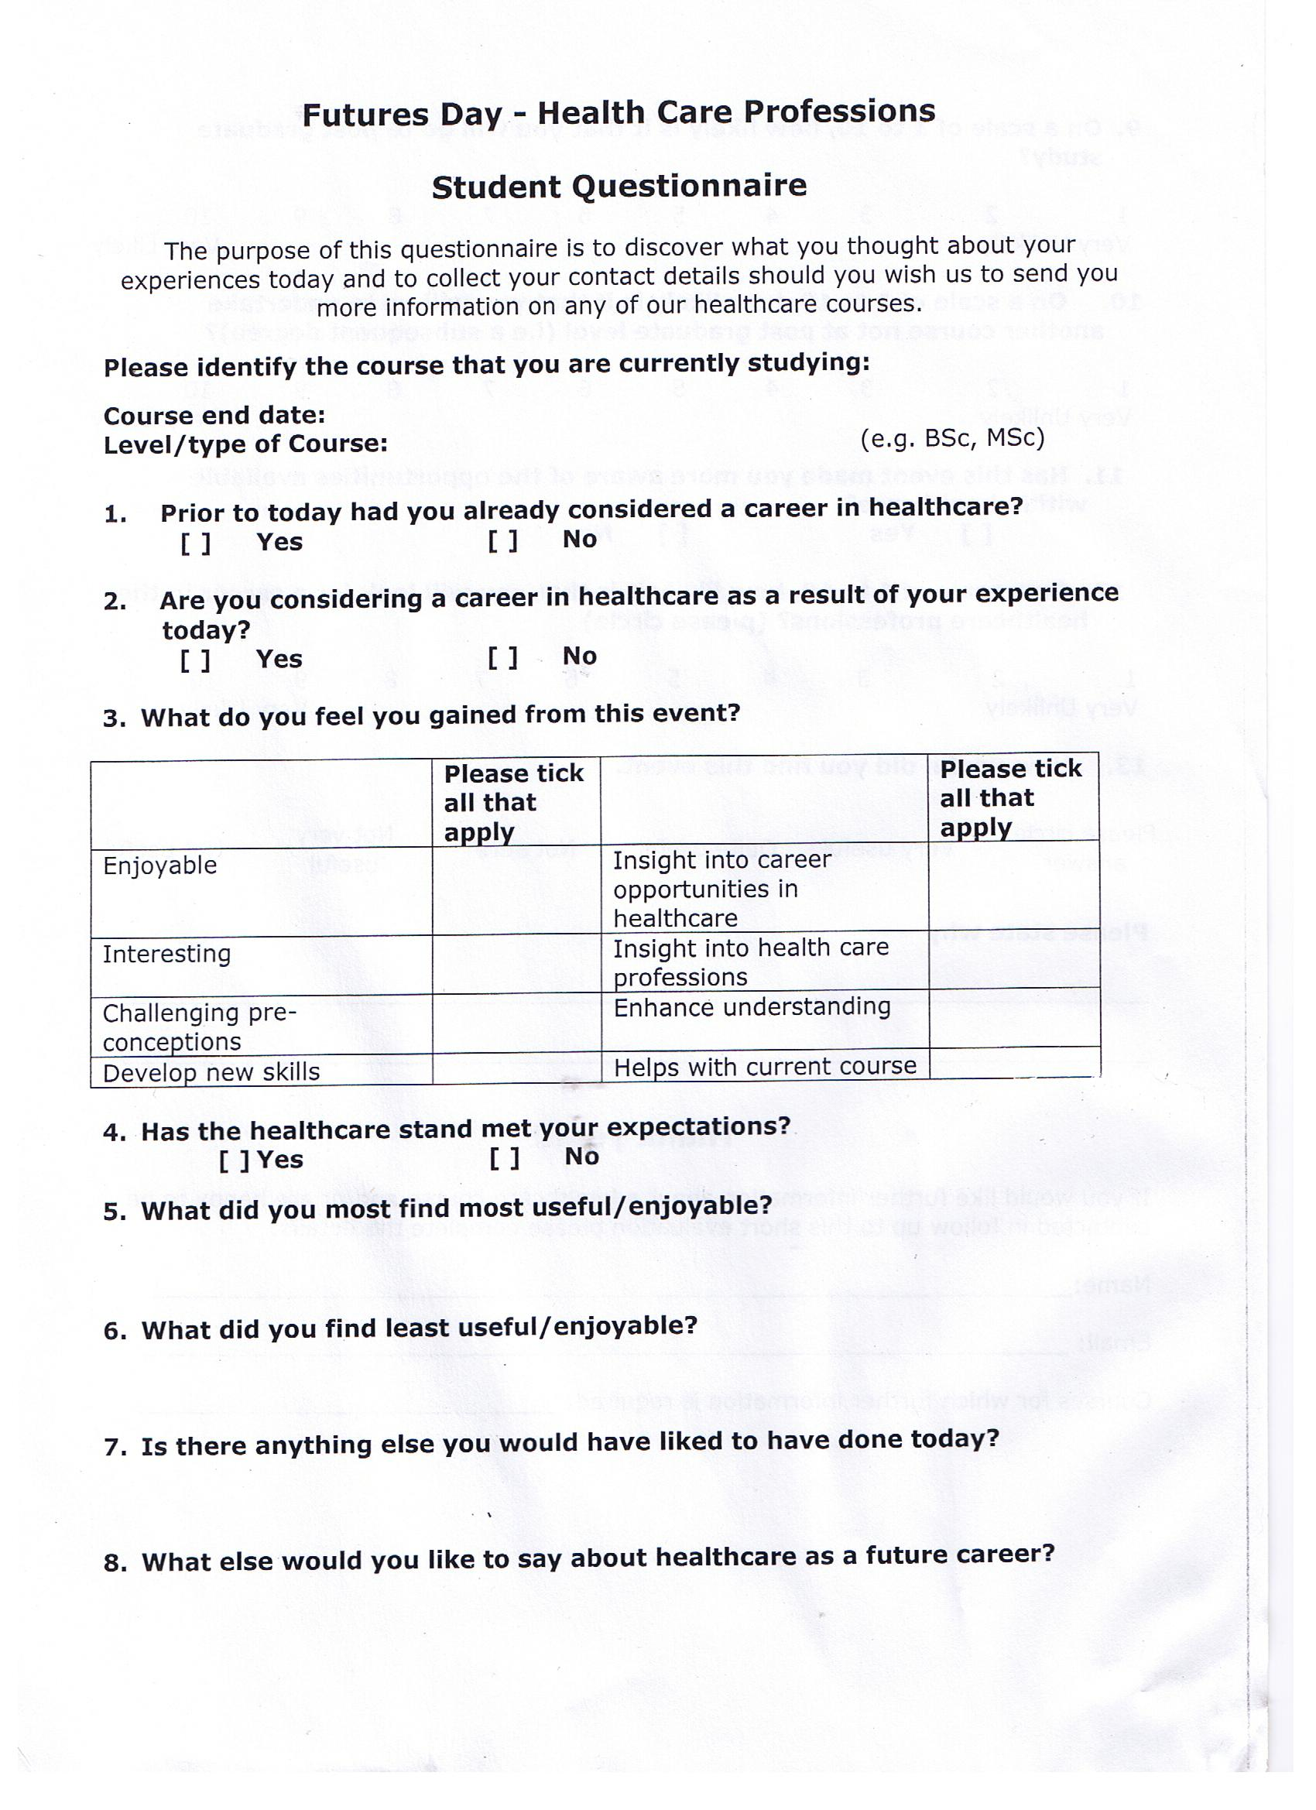
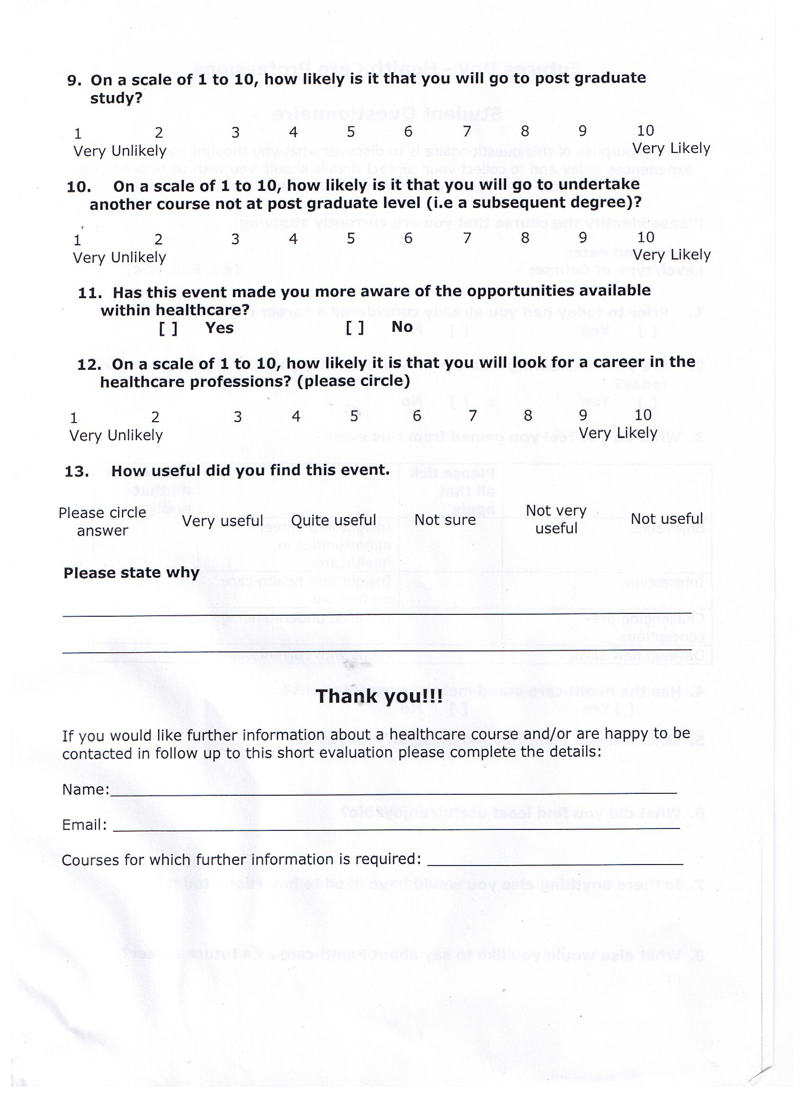
Appendix 4

Futures Fair for Science Graduates
School of Life Sciences
University Of the West Of England

Current Course
0
1
2
3
4
5
6
Current Course
Psychology
Biomedical Sciences
Applied Microbiology
Pharmaceutical
Science
Not specified
Science Group
Numbe
r

0%
5%
10%
15%
20%
25%
30%
35%
40%
45%
1
2
3
4
5
6
7
8
9
10
Response - scale 1 (not) to 10 (very)
Percent age
How Likely Are You to Consider a Post Graduate Study?

Had You Considered a Career in Healthcare
0.00%
10.00%
20.00%
30.00%
40.00%
50.00%
60.00%
70.00%
80.00%
90.00%
100.00%
Yes
No
Response
Percentage
Before Fair
After Fair

Appendix 5

A day in the Life
Helping you understand the range of NHS professions and career progression routes in the South West
NHS Graduate Opportunities
As the largest employer in the UK, the NHS recognises the skills and qualities that graduates can bring to the workforce. The NHS provides opportunities for jobs or specific training programmes dedicated to the graduate to give them the skills and confidence to work and progress in the NHS. There are many other benefits to working for the NHS such as flexible working hours, good pay and pension as well as the opportunities to move around the organisation
In order to find out more about how you could use the degree that you have graduated with, visit the www.whatcanidowithmydegree.nhs.uk website which is a dedicated careers site for undergraduates and graduates who want to build a career in the NHS. Or for more general information on the different careers opportunities within the NHS, please go to: www.dayinthelife.org.uk
There are also training and employment roles in the NHS that are designed especially for students who have graduated from certain courses. These include:
1. Science Graduates Opportunities in the NHS (click here for more information)
There are over 50,000 Healthcare Scientists working in the NHS in the UK and the opportunities for science graduates to train to become Healthcare Scientists are extensive and highly sought after. Please visit www.nhsclinicalscientists.info for more information.
2. Management Opportunities for Graduates in the NHS (click here for more information)
There are also lots of opportunities open to graduates in management roles on the Graduate Management Training Scheme which is designed to develop new managers and give them the skills and confidence they need to become valuable members of the NHS team. Please visit www.nhsgraduates.co.uk for more information.
3. Healthcare Graduate Opportunities (click here for more information)
Students who graduate from health or social care courses are classed as professionals in their chosen discipline and there are many different career and role extension opportunities for them in the NHS. Please visit www.dayinthelife.org.uk for more information.


Appendix 6

Showing examples of various response to the button advert from interested science gradutes

Interested in | Study Background
Health care | BSc Hons Psychology with Sociology degree with 12 months industrial placement experience within a Recovery &amp; Independent Living team. 15 months experience within mental health (specifically older adults) as a Care Support Worker with NHS Professionals
HR and Training | I have already done my three years BBA from pakistan (my major subjects in first degree are Micro Economics, Macro Economics,Developing Economics,Managerial Economics,Financial Accountig,Cost Accounting,Business Mathematic,Statistics,HRM,Logic and critical thinking,Marketing Management, Marketing Research,Financial Management etc. Currently i am doing BA(H) Business Administration Final year student in University of West of England Frenchay Campus. My major subjects are International human resource management, Enterprise creativity and leadership, Organizational analysis, Strategic management, and Developing Business Knowledge.Thanks any quries or information need to know please send me an email. thanks with regards
Nursing and Midwifery | Psychology degree
Science and Engineering | BSc Anatomical Science
Science and Engineering | A degree in Forensic Science
Managers | I studied sports management at plymouth university which was half business management and half sports policy and development
Accounting and Finance
Managers | Environmental Science
Healthcare Social work | Psychology
Science and Engineering | BSc (hons)Applied Marine Sports Science  I am particularly interested in the physiological scientist roles
Social Work | Bsc Psychology & Criminology
Secretarial and PA | Criminology

