**The impact of new sustainable technologies in the rural areas in the UK: performance, policy and governance.**

**Introduction**

The rural economies in many areas of the UK have undergone deep structural changes in recent years which have resulted in the disappearance of many traditional agriculture supply chain business and the arrival or emergence of an eclectic range of new businesses and activities. It is difficult to track these changes, in part because of problems in defining “rural” and in part because of poor data coverage of small businesses. Policy has often amounted to little more than “rural proofing” policies largely conceived with urban areas in mind. It is very likely that further significant changes will occur over the next few years associated with new technologies and the impact of demographic and resource scarcity factors on commodity markets at the global level. New challenges will face authorities and policy makers and a new set of metrics will be needed to guide them.

**Recent structural change in the agricultural sector**

Many observers agree we are experiencing a period of major structural change in the rural economy of most areas of the UK (see, for example, Lobley and Potter (2004). Amalgamations of holdings have been ongoing for many years and some sectors, such as pigs and dairy, have shrunk in size. The family farm is no longer as dominant as the basis of the agricultural sector and the supply chain and supporting services sector have re-structured to match. There are fewer agricultural engineers, livestock markets, slaughter houses, agricultural chemical and pharmaceutical suppliers, agricultural contractors and land agents. This process of consolidation started in the predominantly lowland arable farming areas and has spread more recently to the upland areas. The social and psychological impacts on rural populations have been revealed by surveys of agricultural households (Lobley et al 2005).

The response of some farm enterprises has been diversification or vertical integration. In areas where the landscapes have great appeal for tourism and recreation, the diversification has often been to provide services for these activities (see for example, Turner et al 2002). Where there is accessibility for potential consumers, vertical downstream integration into direct selling has increased the viability of smaller units (Ilbery and Maye 2005). Targeting produce to higher-priced niche markets as part of the organic or local food movement has provided a viable strategy for some producers (Lobley et al 2005). However, few of these diversifications pose significant direct challenges in terms of policy or governance. Nevertheless, there has been concern for those who find difficulty in adapting to a change in the composition and location of employment opportunities in rural areas. In future, policy intervention may prove necessary as more radical changes in land uses in rural areas occur , as is discussed later.

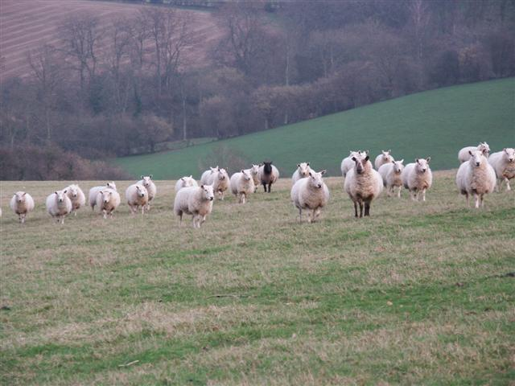

*Less sheep...... More ponies*

**Migration and economic diversity**

In spite of the diversification strategies pursued by some agricultural units in an attempt to survive, many smaller enterprises have disappeared, the holdings amalgamated into larger units. Farmsteads have been sold to incomers, some of whom bring new business activities into rural areas and provide a market for higher priced locally provided goods and services. The migration of households and the relocation of firms to small towns and rural areas has been continuing for some time (Keeble and Tyler 1995). The picture that emerges is that, apart from the presence or otherwise of the agriculture, fishing and forestry sectors, there is surprisingly little difference in the sectorial distribution of businesses between urban and rural areas. Rural areas show higher rates of self-employment and business formation (The Countryside Agency, 2002). There is also a larger proportion of very small firms (and a smaller proportion of very large firms) in rural areas.



*Rural diversification or diversion?*

The high level of diversity of businesses in rural areas is sometimes surprising. Within a few miles of the author’s home in the Welsh Marches is a niche fund management business with in excess of £16billion of assets under management, an engineering firm supplying components for the Red Bull Formula 1 racing team and a specialist importer of ceramic and stone interior finishes with branches throughout the UK.

The governance and policy concerns that have arisen as a result of inward migration have included the shortage of affordable housing and change of use issues arising from the redevelopment of redundant agricultural buildings. The stimulus of migration and incomer enterprise has not been evenly distributed across all rural areas and there are emerging sharp differentials in the economic performance and welfare between accessible and peripheral locations.

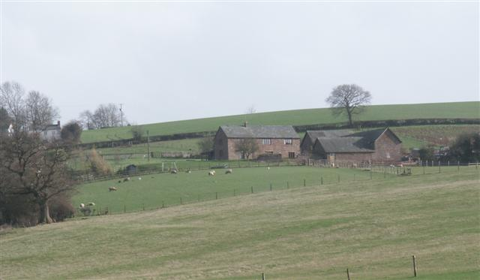

*The headquarters of a £16billion fund management business*

**Difficulties in reflecting diversity in monitoring the economic performance of rural areas**

One of the problems facing researchers interested in the rural economy is one of definition, especially as data is limited for areas smaller than the Local Authority level. Recent work, including that with which the author has been associated, uses the DEFRA (2004) definition of rural which combines settlement scale and population density. Webber et al (2009) use business level data from the Annual Respondents Database (ARD) to examine the variation in business performance across rural areas defined by population density and compare this with businesses in urban areas. Business productivity in the least densely populated areas is significantly lower than in urban areas. This significance diminishes after taking into account the sector in which the business operates, the capital stock of firms, the scale of the business defined by employment, the local supply of skills and the nationality of business ownership. Unpicking the way in which these factors influence rural business performance is somewhat tentative, but some policy relevant suggestions emerge.

Unfortunately, reporting restrictions associated with the ARD limit the detail in which results from this type of work can be reported. It is not permitted to report any results which involve fewer than 10 businesses. Thus to break down results by precisely defined sectors such as “automotive engineering”, “fund management” or “importation of floor and wall tiles” in sparsely populated rural areas would be restricted as there would almost certainly be fewer than 10 firms in these categories. This limitation becomes even more restrictive if the need is to focus on a particular region or sub-region for reasons of policy guidance. Further limitations centre on the limited sampling of smaller firms (some 10% of firms with less than 200 employees) and fact that the composition of this sample varies from year to year. This makes it impossible to track changes in the structure of the rural economy over time. Due to these limitations, some of the studies referred to above have used a case study approach involving primary data collection to reveal the texture of the rural economy and the factors that encourage enterprise and the distribution of wealth. The issue of the need for better data to fully understand economic change in rural areas will be revisited below.

**The impact of new technologies**

As suggested above, some policy and governance issues have been thrown up by these processes of change. These can only multiply if new sustainable farming and energy producing technologies are introduced in rural areas. Some examples are discussed below.

Innovation is required to make agriculture more sustainable. The escape of nitrogen from fertiliser application is a very serious contributor to the greenhouse effect. There is a need to evolve a better understanding of sustainable ways of maintaining soil fertility. It is also necessary to manage irrigation and run-off from cultivated land to conserve water resources, protect the ecology of rivers and reduce flood risk. Composting systems that produce material to enhance the fertility and improve the water retention properties of soils may offer a solution to these problems and reduce waste to landfill. As there is already spatial specialisation in arable and livestock activities and as much organic waste accumulates in urban areas, the transport of feedstock and the compost output may well raise spatial planning and transport issues. Further, waste heat is a by product of composting and this may well require close proximity between composting and residential development to utilise this energy source.

The methane released from livestock is a potent greenhouse gas and believed to be a major contributor to climate change. Biotechnology applications may offer some solutions to these problems through acting on the digestive processes of ruminants. Alternatively, it may be necessary to capture the methane by housing livestock in controlled enclosed environments and using the gas as an energy source. This may well require a concentration of livestock into large intensive units with a significant landscape impact and transport implications. There may be secondary landscape changes and management issues associated with modified grazing regimes.

Further issues arise as a result of decentralised ambient energy collection systems such as small scale hydro and wind schemes. Novel associations between activities may bring food production into the cities and new industries into the countryside. Energy is wasted by the cooling of ICT server installations which produce large amounts of heat in operation. This waste heat could be used in conjunction with greenhouse crops. Some significant spatial planning and development issues are thrown up by biomass energy and waste processing systems. One such scheme which has the potential for very substantial sustainability benefits is discussed in some detail below to illustrate the challenge posed to policy makers by in satisfying competing interests affected by the adoption of the new technology.

**Pyrolosis biomass systems: an example of a sustainable technology**

The potential gains from this technology are very significant as it extracts energy from biomass, produces a valuable soil conditioner as a by-product and can be carbon-negative in overall impact.[1] Pyrolosis is essentially a similar process to that used traditionally in the production of charcoal, the heating of biomass to produce combustible gases and liquids and a carbon residue, similar to charcoal. Combustion of the gases and liquids provides the heat for the process and the surplus can be used as an energy source for heating or even as a road fuel[2]. The carbon residue is known as biochar. This has been shown to be a valuable soil conditioner, improving the nutrient take up of plants and enhancing water retention. Just like charcoal, it remains in the soil indefinitely. Charcoal is regularly found by archaeologists in the excavation of sites thousands of years old. The process effectively provides energy while capturing the carbon in the biomass feedstock. If plant material or timber provides the biomass, absorbing carbon from the atmosphere while growing, the process is carbon negative overall.

Considerable research is underway to explore the feasibility of applying this technology, led in the UK by the UK Biochar Research Centre based at Edinburgh University[3]. A number of technical questions remain to be answered associated with the both the pyrolysis process and the behaviour of soils treated with biochar. However, what is of most interest here are the issues of policy and governance thrown up by the implementation of such technologies at various scales. These issues are similar to those that arise in connection with the conventional combustion of biomass, anaerobic digestion of waste and aerobic composting systems. A comparative study examining the feasibility of some of these technologies for the processing of organic waste in Glascow and the Clyde valley is provided in Ibarrola, A. (2009) With pyrolysis biochar systems, feedstock must be conveniently sourced, tending to favour locations in rural areas where biomass can be produced but also near to urban areas where organic waste is available. A further consideration is the distribution of biochar output to arable farming areas. The spatial planning and governance issues presented by the adoption of this technology are likely to be challenging.

**Policy and governance challenges**

An indication of the issues arising was given by a pyrolysis project in the Mid-Wales area proposed in 2000. This was intended to use timber waste from sawmills in the area. It was refused permission owing to concern for emissions to air, lechate from timber stocks and traffic generation over an area 50 miles in radius from which timber waste was to be sourced. These external costs dominated the evidence presented by objectors, while carbon reduction external benefits were barely considered. This case indicates the importance of evolving an appropriate assessment framework which includes the benefits of reducing carbon emissions. The project did not produce biochar as an output and thus the associated transport costs and soil structure benefits of the process were not considered. The assessment framework must be capable of including these direct and indirect benefits and costs. There opportunities for the application of pyrolysis and biochar production in the timber processing and forestry sectors. The processing of forestry waste, consisting mainly of side branches removed and left to decay on site after tree cropping, would significantly reduce carbon emissions associated with the sector. Because such waste is dispersed all over forestry areas, only a local scale of operation would be feasible.

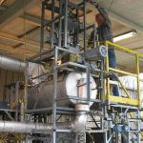

*A small scale pyrolysis plant*

The first challenge for policy makers will be to decide on the most appropriate sustainable technology given the settlement and land use pattern in their areas. To do this an assessment framework is required which will allow an evaluation of the external costs and benefits of installations in different locations and at different scales. The framework will need to include the costs of impacts such as emissions and visual intrusion adjacent to the site and transport externalities over a wider area. External benefits would need to include reduced carbon emissions, the value of carbon capture and the impact on soil fertility. The framework would be similar to that used for road infrastructure schemes but would need to use the latest techniques of environmental impact evaluation.

To monitor the aggregate economic impact of new sustainable technologies over time, there is a need for improved data on the diversity of activities in rural areas. It will be important to monitor particular closely defined sectors in order to distinguish between the impacts of these various new technologies. Many of these innovations will have a very local impact, offering diversification opportunities for existing rural businesses, new business start ups and self employment. it will be necessary to be able to access data for areas below Local Authority scale if such impacts are to be monitored. Further, authorities and agencies need performance indicators that relate economic impact and environmental impact. Jobs created and increases in Gross Value Added both need to be related to associated carbon emission increase and/or the increase in global footprint area. Such indicators become more meaningful to policy makers if they are available at a local level. REAP (Resource and Energy Analysis Programme) goes some of the way to provide a monitoring tool at Local Authority Level (see Wiedmann et al, 2004). However, this is essentially consumption based so more adept at projecting the impact of lifestyle changes. One of the production based software packages can be adapted to meet environmental impact monitoring of areas adopting sustainable technologies.

**Conclusion**

The diverse structure of rural economies is not well reflected in available official statistics. It is difficult to monitor change other than by specific survey projects. The introduction of new sustainable technologies is likely to alter the spatial distribution of economic activity and the economic structure of rural areas. Policy and governance issues are raised by new sustainable technologies and appropriate assessment frameworks are needed which will be comprehensive enough for informed decision making on their implementation. More detailed economic data which relates performance to environmental impact is necessary for effective monitoring of change in rural economies.



*Anthony Plumridge is Principal Lecturer in Economics at the University of the West of England, Bristol, teaching the economics of sustainable development, researching in spatial economics and providing consultancy services to regional, sub-regional and local public and voluntary sector agencies. Anthony has also worked as an architect, a marketing executive and been involved in smallholding for many years.*

The Countryside Agency (2002), *The State of the Countryside Report,* The Countryside Agency, Cheltenham.

Ibarrola, A. (2009), *Pyrolysis for waste management: A life cycle assesment of biodegradable waste, bioenergy generation and biochar production in Glasgow and Clyde valley,* Edinburgh University

Ilbery, B. and Maye, D. (2005), “Food supply an suatainability: evidence from specialist food producers in the Scottish/English borders”, *Land Use Policy* Vol. 22 No. 4 pp 331-344

Keeble, D. And Tyler, P. (1995), “ Enterprising behaviour and the urban-rural shift, *Urban Studies* Vol. 32 No. 7 pp 975-997

Lehmann, J. (2007), “A handful of carbon”, *Nature,* Vol. 447 No 7141 pp143-144

Lobley, M. and Potter, C.A. (2004), “Agricultural change and restructuring: recent evidence from a survey of agricultural households in England”, *Journal of Rural Studies,*  Vol .20 No. 4 pp 499-510

Lobley, M., Potter, C.A., Butler, A. With Whitehead, I. and Millard, M. (2005), *The Wider Social Impacts of Changes in the Structure of Agricultural Businesses,* DEFRA, London

Turner, M., Winter, D. M., Barr, D., Fogerty, M., Errington, A., Lobley, M., Reed, M. and Whitehead, I. (2002) *Farm DiverificationActivities: Benchmarking Study,* DEFRA, London.

Webber, D., Curry, N. and Plumridge, A. (2009)”Business Productivity and Area Productivity in Rural

England”, Regional Studies, Vol. 43 No.5 pp 661 — 675

Wiedmann, T., Barrett, J., Billing, M. and Birch, R (2004), *The REAP Tool – Creating Physical Accounts for the UK and Evaluating Policy Scenarios,* Stockholm Environmental Institute, York

1. For a comprehensive source of literature on this process see http://www.biochar-international.org/biblio
2. Many amusing demonstrations of the potential are available on You Tube: see for example <http://www.youtube.com/watch?v=ilIENTm5muo>
3. See <http://www.geos.ed.ac.uk/sccs/biochar/>