cid:image001.jpg@01CBBBC5.D36823C0 

**Response to the Government’s**

**Healthy Lives, Healthy People:**

**Our Strategy for Public Health in England**

**White Paper**

**Editors:** Lynne Eagle, Yvette Morey, Peter Case, Julia Verne and Nicola Bowtell

Date 28 March 2011

**TABLE OF CONTENTS**

Executive Summary 4

1.0 Introduction 5

2.0 Key objectives 5

3.0 Rationale for Transdisciplinary Approach 7

3.1 Contribution of a Transdisciplinary Approach to Health Challenges 7

4.0 A Transdisciplinary Approach to Behaviour Change – Looking Beyond the Wider Determinants of Health 9

4.1 Overview 9

4.2 Complexity 9

4.3 Relevant disciplines 11

4.4 Range of relevant theories 12

4.5 Overview – selected theories 14

5.0 From Theory to Application 21

5.1 Application of theory 21

5.2 What counts as evidence: qualitative and quantitative research 21

5.3 Importance of communication 23

6.0 Key Contributions of Disciplines 25

6.1 Behavioural economics 25

6.2 Environmental planning and management 26

6.3 Organization development (OD) 27

6.4 Social marketing 29

6.5 Social psychology 30

6.6 Sociology, public health policy and applied political science perspectives 33

6.7 Wider factors influencing health, well-being and health inequalities 35

6.7.1 Health literacy 35

6.8 Fostering a balanced approach 35

6.9 Social networks: social norms, media influence and celebrity influence 36

7.0 Important Outstanding Factors Not Addressed in the White Paper 37

7.1 Legitimacy and trust 37

7.1.1. The source of information 37

7.2 Ethical issues in behaviour change programmes - Benefits, risk and unintended consequences 38

7.3 Risk and behaviour change programmes 42

8.0 Intervening Effectively 47

8.1 Theoretical limitations 47

8.2 Behavioural economics / ‘Nudge’ 48

8.3 Unintended consequences 49

8.4 Message framing 49

8.4.1 Message framing – positive messages 50

8.4.2 Message framing – fear appeals 51

8.5 Emphasis on the need for good leadership 55

8.6. Different approaches for different stages in the life course 56

8.7 HLWP Reaching across and reaching out – addressing the root causes of ill health 57

8.8 HLWP Responsive – owned by communities, shaped to meet their needs 58

9. Effective Partnership Working: The Importance of Outcomes 59

9.1 Evaluation of interventions hierarchy 59

9.2 Evaluating multi-partner interventions 61

HLWP4. A new public health system with strong local and national leadership 62

HLWPA new role and freedoms for local government 63

10. Conclusion 65

Contributors 66

Appendix A: Critical Review of the Potential Efficacy of Product Placement Regulations on Health-related Issues 67

References 72

# Executive Summary

This document provides a transdisciplinary response to the *Healthy Lives, Healthy People: Our Strategy for Public Health in England* White Paper. Due to the complex range of influences on health-related behaviours, a transdisciplinary approach is recommended to address the challenges facing public health. Accordingly, this report presents an illustrative range of disciplines, concepts and theories that may be relevant to understanding the relative impact of different influences on health-related behaviours. It also documents the development of potential interventions that aim to achieve positive sustained behaviour change.

The complexity of influences signals the need to identify concepts and theories that are appropriate for specific situations and population segments, and the need to consider the contribution of a wide range of potential forms of evidence, both qualitative and quantitative. While communications effectiveness is obviously a key factor in intervention success, there is a need to revisit, revise and extend communications models to encompass the role of new media forms; this would include social media along with more traditional media forms.

Examples of specific strengths and competencies offered by individual disciplines illustrate potential synergies that could be achieved through a transdisciplinary approach are discussed. Factors impacting all disciplines and influencing health outcomes such as health literacy, social networks and media influences are also identified.

There are a number of factors not addressed in the White Paper that have potentially significance for health behaviour change activity. These include legitimacy and trust, ethical issues and competing influences. There is also a clear need for consistency and coordination across different health portfolios and to recognise and minimise the effects of counter marketing.

Issues impacting on effective interventions include the inability of extant theories to explain or predict the relative influence of all of the factors potentially impacting on health-related behaviours. Some approaches may work better on unintentional/ automatic behaviours and not be as effective for other types of behaviour. Coupled with this is the prospect of unintended consequences, such as, reactance or ‘boomerang’ effects, where behaviour change is resisted and negative behaviours possibly strengthened. Consideration of the potential impact of different forms of message framing is a significant omission in the White Paper as is the context of advice or information.

A pervasive theme of the White Paper is the need for effective leadership at all levels of the health system in England. This report considers the implications of such an imperative for research, leadership development and change interventions.

# 1.0 Introduction

This document is a response to the Healthy Lives, Healthy People: Our Strategy for Public Health In England White Paper focussing on the question: ‘c. How can Public Health England address current gaps such as using the insights of behavioural science, tackling wider determinants of health, achieving cost effectiveness and tackling inequalities?’ (HLWP, p.71)[1]

In this submission, the University of the West of England, in partnership with the South West Public Health Observatory and the Cornwall and Isles of Scilly PCT highlights the need for a transdisciplinary approach to behaviour change and gives a detailed overview of the range of disciplines and theories involved, as well as the ethical considerations and counteracting forces that may inhibit behaviour change.

This submission is the output from a transdisciplinary workshop held at the University of the West of England involving a number of departments with an interest in improving public health (listed at the end of this document) and partners from the Department of Health South West Public Health Group, the South West Public Health Observatory, The Cornwall and Isles of Scilly PCT and representation from the South West Public Health Transition Communications Sub Group. It is a true transdisciplinary response for two principal reasons. Firstly, the White Paper acknowledges the need to draw on behavioural sciences, but does not make their expected contributions explicit. We outline the range of disciplines which should be involved. Secondly, there is an implicit expectation of integrated activity in the White Paper. We therefore also suggest ways by which this could be achieved.

# 2.0 Key objectives

The principal consultation question that we to respond to in this document is:

‘c. How can Public Health England address current gaps such as using the insights of behavioural science, tackling wider determinants of health, achieving cost effectiveness and tackling inequalities?’ (HLWP, p.71).

##### Primary Objective:

We aim to identify a set of behavioural science disciplines that have the potential to assist Public Health England (PHE) address and implement its mission and goals. The unique approach adopted here, however, is not only to highlight key disciplines but also to indicate how they might be effectively combined within a transdisciplinary framework to enhance effectiveness in bringing about behaviour change. We argue that no single behavioural science discipline, whatever the power of its insights, can effect the kinds of systemic change envisioned in the White Paper. Instead, scientific knowledge from multiple disciplines needs to be enrolled, combined and applied at differing levels of the social and organisational systems implicated by PHE’s programme of change.

##### Secondary Objective:

To demonstrate the benefits of a transdisciplinary approach, and the ways in which the joint efforts of the academic and service sectors are able to drive improvements in public health, affirming the plan to establish an NIHR School for Public Health Research.

The submission is structured as follows:

* We commence with a discussion of the benefits of a truly transdisciplinary approach to health issues and illustrative examples of the contributions specific disciplines can offer. We then discuss a number of specific topics that have not been specifically outlined in the HLWP, and suggest ways in which their inclusion would strengthen the potential efficiency and effectiveness of intervention design and implementation.
* This is then followed by a discussion of a number of specific aspects of the HLWP relating to behaviour change and, where relevant, specific research agendas that would help remedy gaps in extant knowledge.

# **3.0 Rationale for Transdisciplinary Approach**

### 3.1 Contribution of a Transdisciplinary Approach to Health Challenges

Health behaviours are influenced by complex interaction between social, cultural and economic factors[2]. A transdisciplinary approach can contribute to identifying and developing strategies to overcome obstacles to health behaviour[3]. In addition, a transdisciplinary approach can help policy makers to understand more comprehensively the contributions of their policies to improving or harming constituents’ health[4].

There are three possible approaches to the combination of expertise from multiple disciplines: multidisciplinary, interdisciplinary and transdisciplinary. Multidisciplinary approaches seek input from different disciplines but these are independent of each other and may create a mosaic of interventions. In Interdisciplinary approaches, disciplines work together to provide input but individuals stay within their own disciplinary boundaries[5].

The transdisciplinary approach is synergistic in that it uses concepts, theories, research approaches, analytical methods and strategies for the interpretation of findings to develop shared conceptual frameworks that integrate and transcend individual disciplines[6], [7], [8]. Key features of this approach include recognition that no one group has a monopoly on knowledge and that collaborations must be created ‘not only between different academic disciplines but between researchers and non-academic groups with a stake in the problem under investigation’.[9], p.161

Public health is an ideal environment for transdisciplinary approaches due to the influence of intrapersonal, interpersonal, organisational, community and societal influences and the multi-level interventions that will be required to address preventable causes of health problems[10], [11].

**Evidence of Success: Transdisciplinary Approaches to Behaviour Change:**

Much of the evaluation of transdisciplinary approaches has centred on processes rather than outcomes[12], however initial studies in the area show success in areas such as risk perception and planned behaviour change in relation to cancer screening[13], [14] and sustainability[15].

Benefits include a true integration of knowledge to address linkages between the factors influencing health behaviours and to enable the following questions to be addressed effectively[16]:

* *How does power operate in different social contexts to create and maintain disparities?*
* *What factors exist in certain populations that protect them from major health issues?*
* *How do economics and the built environment such as the availability of housing and sidewalks affect health, and how can we encourage the urban design and planning of communities to eliminate health disparities?*
* *How can health educators and society promote such protective factors?*
* *How can we culturally tailor interventions to influence access to health services?*
* *How do we engage and partner with policy makers in diffusing relevant research?*
* *What information are consumers getting on health and how does this information differ by race, ethnicity, socioeconomic and cultural group?*
* *What is the impact of health literacy on health status, and how can we improve message tailoring to reach different groups?*
* *Does engagement in community-based participatory research alter engagement in community structures, processes and other attributes?*
* *How can we develop more evaluative instruments that assess dynamic, changing and social conditions?*
* *How can we improve the measurement of intended and unintended effects and outcomes in evaluation studies?*

# 4.0 A Transdisciplinary Approach to Behaviour Change – Looking Beyond the Wider Determinants of Health

### 4.1 Overview

While the White Paper *Healthy Lives Healthy People: Our Strategy for Public Health in England* tends to focus on behaviour change with respect to the broader determinants of health and primary or secondary prevention of disease, the behavioural change sciences would have a great deal to contribute to secondary and tertiary prevention approaches to improving quality and/or length of life. Key examples of areas as yet relatively unexplored would include:

* Expert patient programmes
* Medication compliance
* Rehabilitation programmes
* End of Life Care.

Short sections will be devoted to the potential benefits of transdisciplinary activity for these and other health challenges later in this document.

### 4.2 Complexity

Foresight’s Obesity System Map[17]: 56 is an example of the complexities of the social determinants of any one health problem and can be found at: <http://www.civilservice.gov.uk/Assets/Behaviour_change_reference_report_tcm6-9697.pdf> . Additionally the complexities of disciplinary and practitioner responses to health related behaviours and issues are illustrated by Figure 1 and Figure 2 overleaf which depict the different ways in which policy managers and clinicians might respond to any one topic.

**Figure 1: Causal loop as seen by Policy Managers**[18]: 175

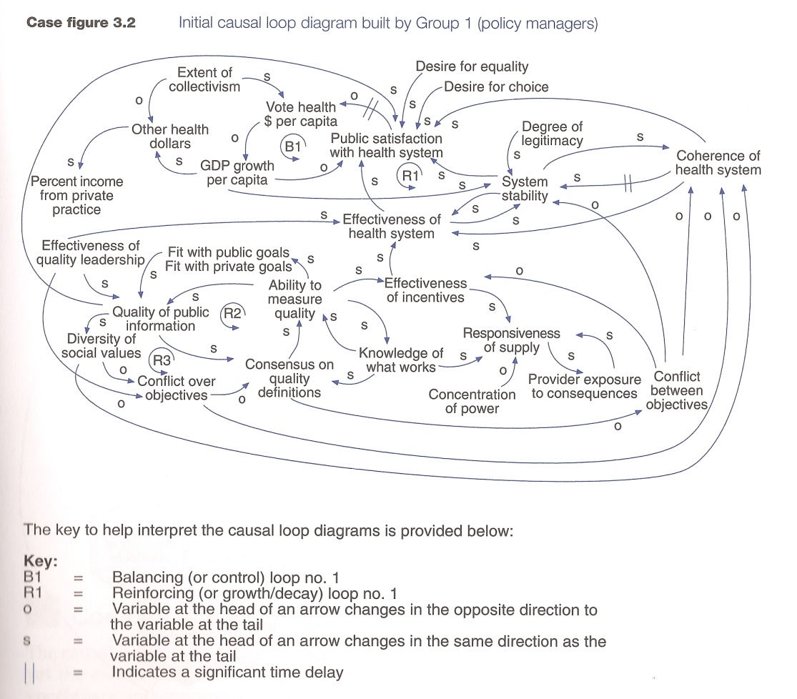

**Figure 2: Causal loop as seen by Clinicians**: 177

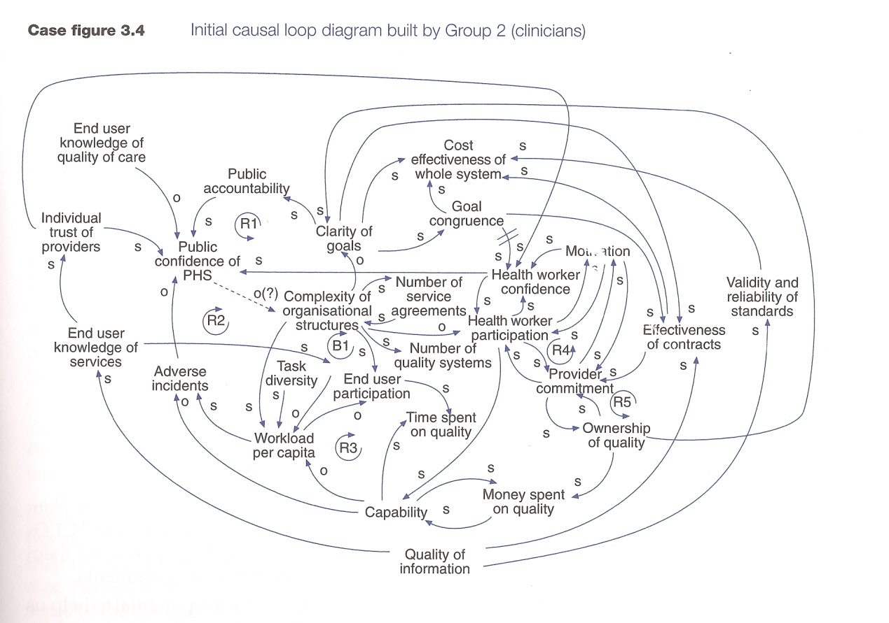

### 4.3 Relevant disciplines

The following two figures have been drawn from a 2005 National Social Marketing Centre publication[19]. We suggest that, while these provide a useful provisional list of possible disciplines, concepts and theories that may be relevant to health interventions, neither is comprehensive. We suggest that *any* discipline with a human dimension, not just those classified as behavioural sciences, is likely to have valuable insights and contributions to make.

**Figure 3: National Social Marketing Centre’s ‘Range of Disciplines Offering Potential Insights’**

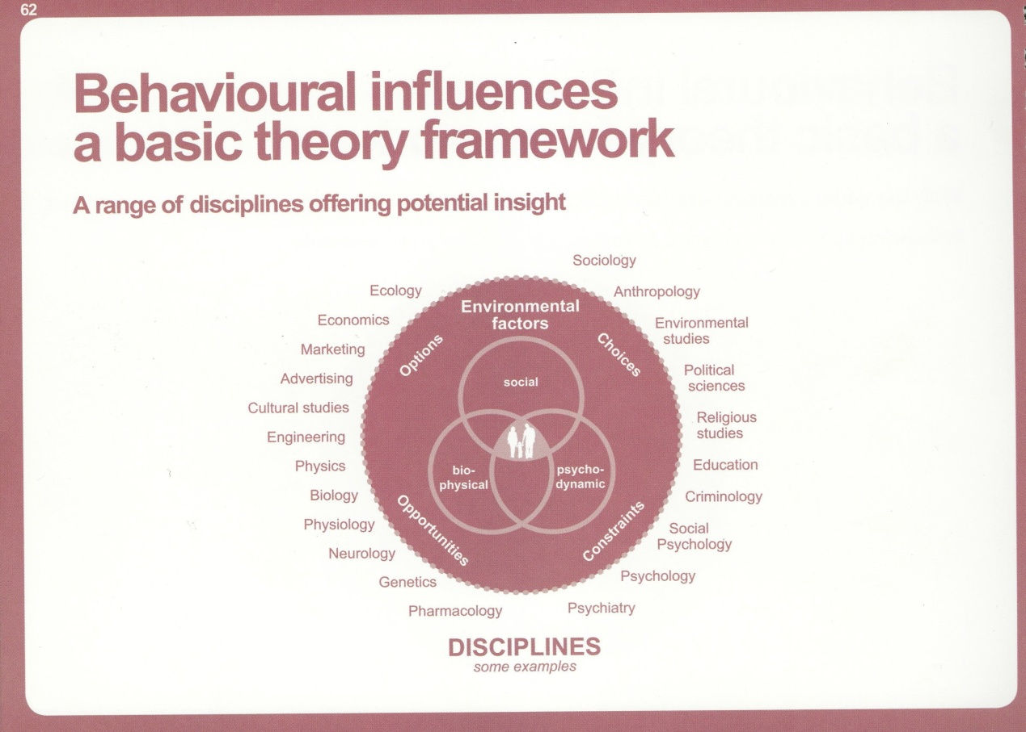

A more comprehensive, but not exhaustive, list might be as follows:

* Advertising (now regarded as part of a wider Marketing Communications field)
* Anthropology
* Behavioural Economics
* Biology
* Built Environment / Architecture / Urban Design
* Communications Studies (including persuasive communication)
* Criminology (in conjunction with other branches of Law)
* Cultural Studies
* Design (including product and urban design, ergonomics etc)
* Ecology
* Economics
* Education
* Engineering (multiple specialisations)
* Environmental Studies
* Ergonomics (see design)
* Ethics (including organisational and communication ethics)
* Genetics
* Geography (including human, medical, physical and social specialisms)
* Journalism
* Law (including environmental, family, public, health and criminology specialism’s)
* Leadership Studies
* Marketing (including marketing communications/advertising, hybrid and social media studies, public relations)
* Media Studies (linked to both marketing and journalism)
* Medicine (with a wide range of specialism)
* Neurology
* Operations Research
* Organisation Development
* Organisation Studies
* Pharmacology
* Philosophy (including applied ethics)
* Physics
* Physiology
* Planning
* Political Studies
* Psychiatry
* Psychology (including clinical, environmental, health and social specialisms)
* Public Health
* Sociology
* Social Policy
* Social Psychology (see psychology)
* Transport Studies
* Youth Studies

### 4.4 Range of relevant theories

Many of these disciplines share common concepts, theories and fields of investigation. For example, Figure 3 provides a wide list of theories and/or groups of theories that may be relevant to health improvement. A large body of research indicates that no single theory is appropriate in all situations, and improved efficacy may be possible by combining two or more theories. Further, all major theories are subject to ongoing testing and refinement, therefore advancements in theory design and application are ongoing.

**Figure 4: National Social Marketing Centre’s ‘Behavioural influences – a basic theory framework’**

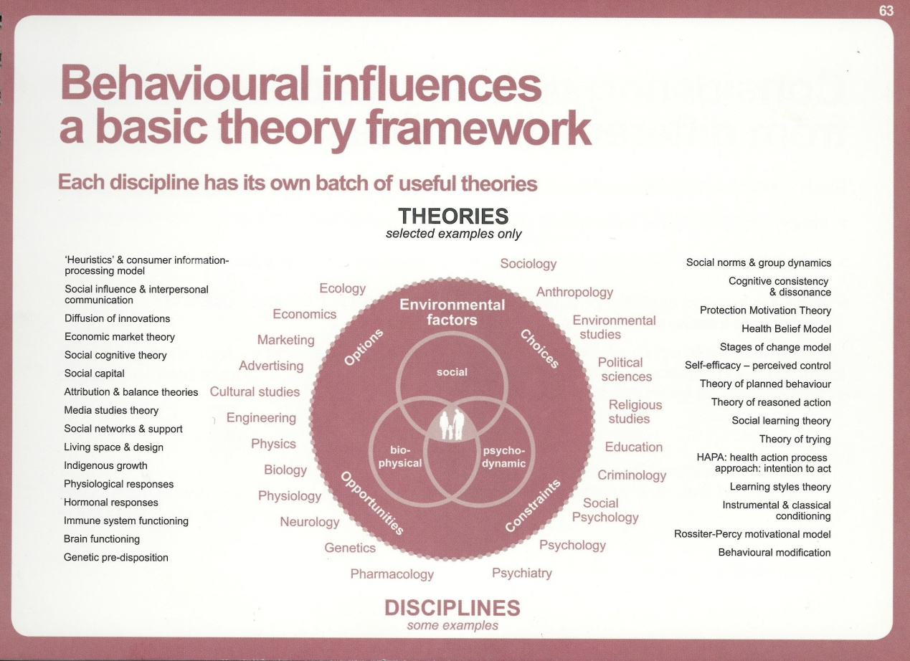

This list could also be considerably expanded, with the addition of the following (again, not an exhaustive listing). In the next section, we expand on a selection of these theories to illustrate the complexity of issues impacting on health behaviours.

Communication Theories

Complexity Theory

Decision Theory

Leadership Theory

Organisation Theory

Process Theory

Risk Theory

Socio-technical Systems Theory

Social Practice Theory

Stakeholder Theory

Systems Theory

Theory of Complex Responsive Processes

Theory of Inter-personal Relationships

Triandis’ Theory of Interpersonal Behaviour

A systematic analysis of the potential contributions of both individual disciplines and their associated theories to an integrated, truly transdisciplinary approach to sustained behaviour change would strengthen the potential efficacy of the reforms under consideration. The White Paper explicitly acknowledged that:

Recent years have proved that one-size-fits-all solutions are no good when public health challenges vary from one neighbourhood to the next.

In considering the complexity of factors impacting on health, we believe that the key question in addressing the behavioural change question that is the focus of this paper is:

What works, for whom, in what circumstances, and for how long.[20], p.264

This also applies to the selection of the most applicable theories to guide intervention development and implementation. There is:

Increasing evidence [to suggest] that public health and health-promotion interventions that are based on social and behavioural science theories are more effective than those lacking a theoretical base.[21], p. 399

We do not intend providing a comprehensive discussion of all possible theories; this type of analysis has been the subject of several texts and recent reports (see, for example, [22], [23]). We have selected a limited number of social learning theories to illustrate both the complexity of factors influencing behaviours and the way in which different disciplines can contribute to understanding the factors and using this knowledge to develop effective interventions.

### 4.5 Overview – selected theories

**Social Cognitive Theory (SCT)**

SCT[24],[25] proposes that behavioural, personal and environmental factors are reciprocal, interacting determinants of each other (reciprocal determinism), so changing one element has implications for the others (Figure 5 )

**Figure 5: Social Cognitive Theory Components**

BEHAVIOUR

EXTERNAL ENVIRONMENT

COGNITIVE AND OTHER PERSONAL FACTORS

**Integrated Model of Behaviour Prediction and Change:** Related to SCT theory and reflecting ongoing development from, and extension of, the widely used Theory of Reasoned Action (TRA)[26],[27] and its successor the Theory of Planned Behaviour (TPB)[28], is the more complex Integrative Model of Behaviour Prediction and Change (IM) shown in Figure 6. This Model shares many attributes of its predecessor in explaining behaviour change as the outcome of behavioural intention, and behavioural intention as the outcome of social norms and an individual’s attitude to the behaviour in question. The element of perceived behavioural control (PBC) accounts for variance in behaviours with incomplete volitional control i.e. where individual’s lack complete control of the behaviour and are therefore unable to change behaviours.

The Integrative Model places more stress on the influence of background factors, including, importantly, the role of intervention activity and media exposure (see later discussions of social networks, media and celebrity influences on health). A key contribution of research underpinning the effective use of this theory is that different population segments may be driven more strongly by attitudinal factors, normative influences or perceived self efficacy, i.e. ability to change behaviour and sustain the change[29]. This indicates that very different intervention strategies may be needed for different population segments[30], [31].

Further considerations illustrated by this model are the relative importance of attitude, perceived norms and self-efficacy:

The relative importance of these psychosocial variables as determinants of intention will depend upon both the behaviour and the population being considered.

and:

one behaviour may be primarily determined by attitudinal considerations, whereas another may be primarily influenced by self-efficacy. Similarly, a behaviour that is attitudinally driven in one population or culture may be normatively driven in another. [32], S3

**Figure 6: Fishbein et al. Integrative Model of Behavioural Prediction and Change** (originally developed by Fishbein – and subsequently refined, for example, Fishbein & Cappella

*Background influence*

Demographics & culture

Attitudes towards targets (stereotypes & stigma)

Personality Moods and emotions

Behavioural Beliefs

and Outcome Evaluations

Attitude

Normative Beliefs and Motivation to Comply

Norm

Self Efficacy

Intention

Environmental factors

Control Beliefs and Perceived Power

Skills and abilities

Past behaviour

Intervention exposure Media exposure

Other individual difference variables (perceived risk)

**Behaviour**

**Triandis’ Model of Interpersonal Behaviour**

Triandis proposed a framework in which affective factors were shown as impacting on behaviours[33]. His model shares many similarities with the Theory of Planned Behaviour and related theories, but adds two additional dimensions – habits and role beliefs, as shown in Figure 7.

The model was originally developed in the 1970s but did not receive considerable attention till much more recently. The Theory of Interpersonal Behaviour has been receiving particular attention in the field of pro-environmental behaviours. It identifies a process of *intention* formation which is made up of: (a) personal rational evaluations based on beliefs about the likely outcomes of certain actions, (b) a reaction to social factors such as social norms and concepts such as societal roles, and (c) an emotional component which can include both values and morals, but also more immediate reactions such as disgust. In addition to intentions, there are *habits* which influence behaviour in an entirely separate way to consciously formed intentions. Triandis originally defined habits as being determined solely by the frequency of past behaviour, however more recently other work has come to see habits as being better defined by *automaticity.* Bargh[34] defines automaticity as: lacking awareness of our action; lacking conscious intent; being difficult to control; and having efficiency, and dependent on a stable context (habits cannot be continued if circumstances are significantly altered).

**Figure 7 Triandis’ Theory of Interpersonal Behaviour (TIB) (1977)**

**Beliefs about outcomes**

**Attitude**

**Facilitating conditions**

**Evaluation of outcomes**

**Norms**

**Intention**

**Social factors**

**Roles**

**Self-concept**

**Behaviour**

**Habits**

**Affect**

**Frequency of past behaviour**

**Emotions**

In this model, the probability of performing a behaviour is affected by intentions, facilitating conditions and habits, i.e. behaviour that has become automatic. As behaviours are repeated, habit becomes a better predictor of behaviour than intentions[35].

**Social Practice Theory - 3 Elements Model**

The 3 Elements model, developed by sociologist Elizabeth Shove, takes a radically different approach to studying behaviour that may provide a suitable way for looking at health issues that have a significant level of social determination - and the obesogenic environment is a very strong example. The model was primarily derived though looking at personal energy usage within the context of climate change and the key determining feature is that the individual is no longer the unit of enquiry[36], [37].

Instead ‘behaviour’ is seen as consisting of sets of ‘social practices’ that exist and occur outside any individual (re) enactment of them. These practices relate to how things are done (and in some cases whether things are done at all). This model sees these practices as emerging from the relationship between three elements: Material, Meanings and Procedures.

**Materials:** Physical objects which permit or facilitate certain activities to be performed in specific ways.

**Meanings:** Images, interpretations or concepts associated with activities that determine how and when they might be performed.

**Procedures:** Skills, know-how or competencies that permit, or lead to activities being undertaken in certain ways.

These three elements are not all independent from each other, there will be interactions. Practices (represented by the dotted line) can be seen as *emergent properties*, arising from the interaction of these factors – they do not come about as a direct and linear result of the various elements. They become normal through a gradual alignment of the three elements, resulting in new sets of societal expectations or conventions. Consequently taking this approach means accepting that policies will need to be designed to encompass a wide range of actors, and they may need to accept a more complex approach as to how specific outcomes might be achieved.

This approach is receiving increasing recognition from a number of government departments – including the Department of Energy and Climate Change, the Department for Food and Rural Affairs and the Department for Communities and Local Government.

Figure 8: Elements Model of Social Practices

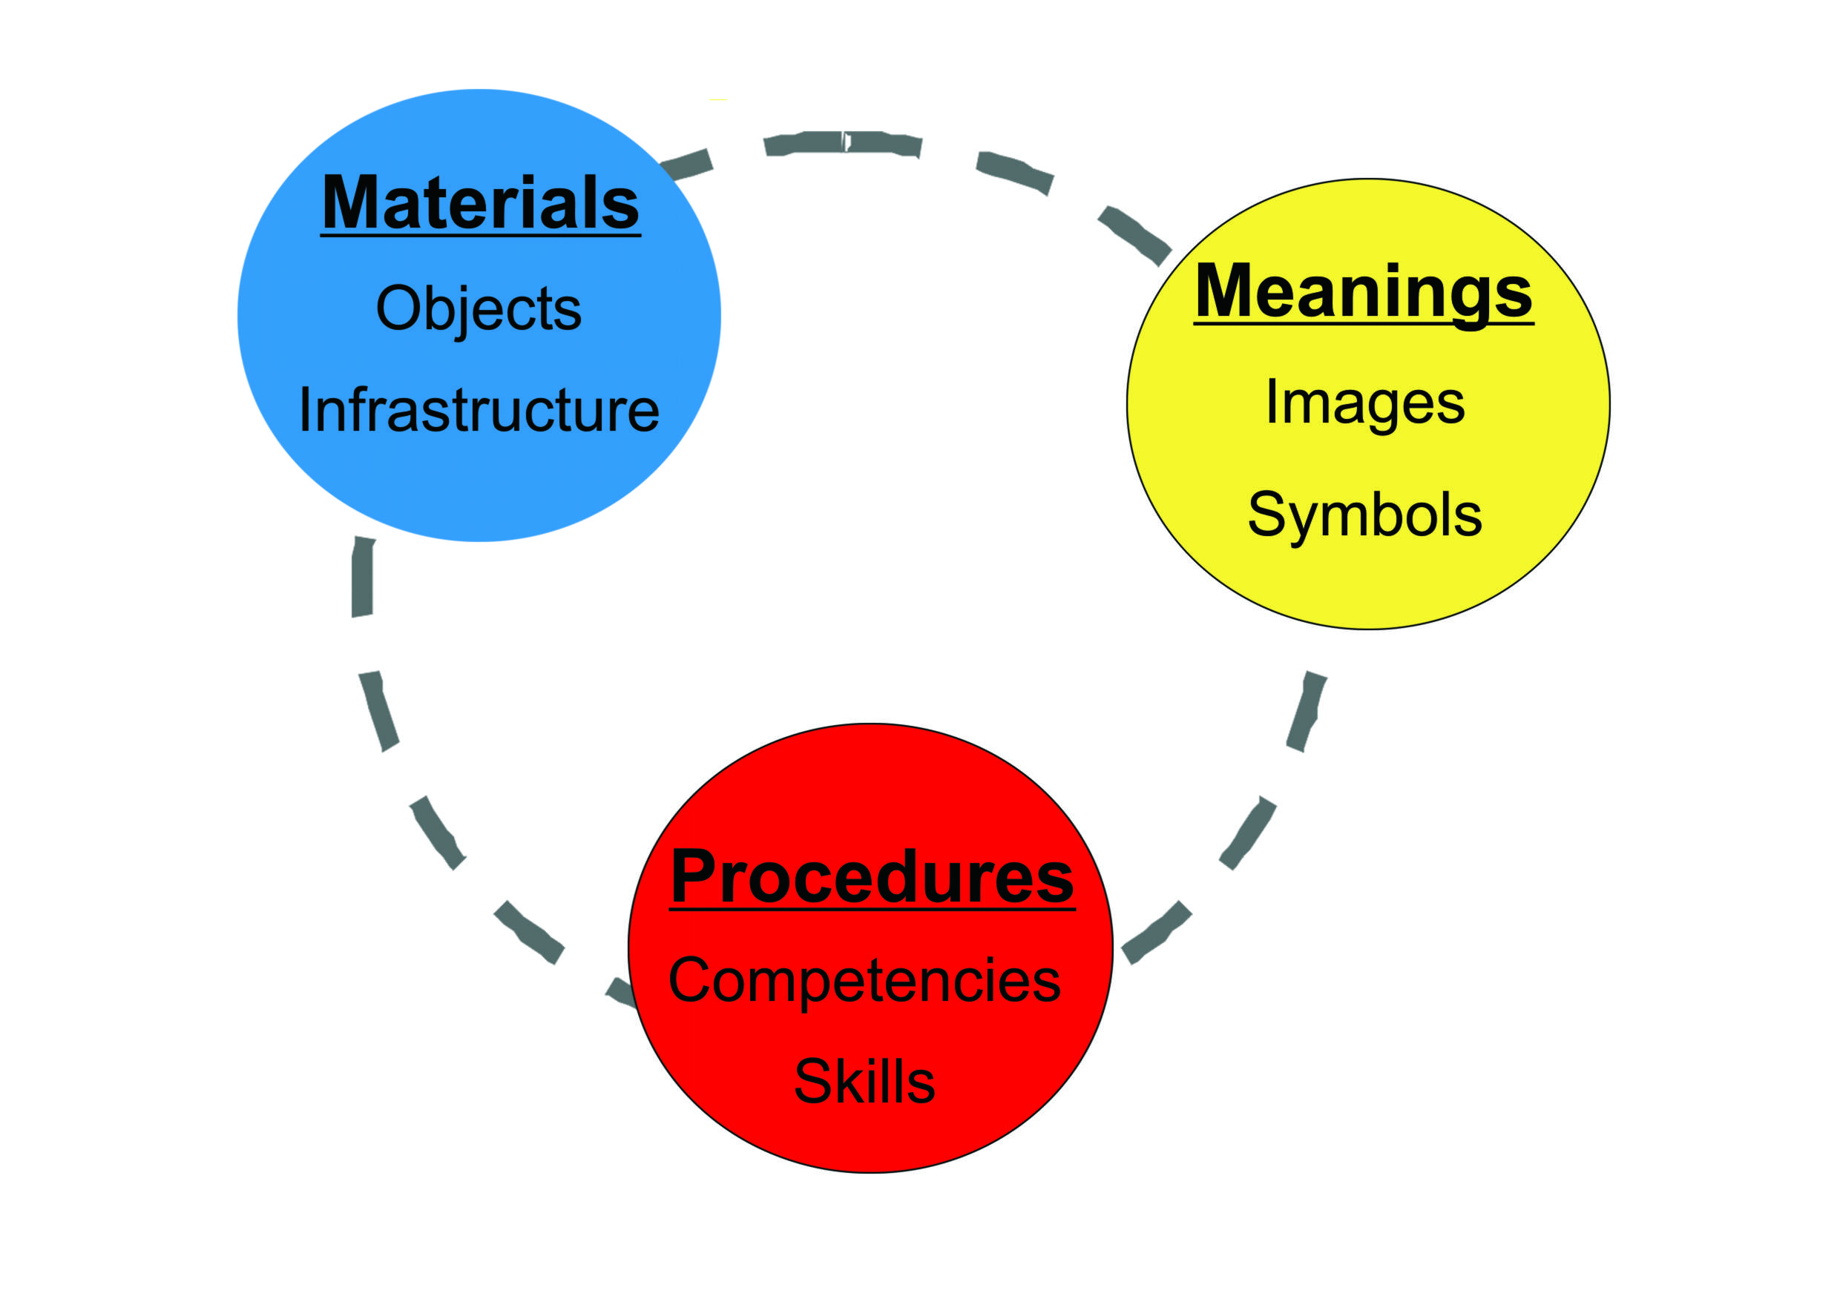

Theories of Social Practice are also closely related to a large body of work on socio-technical systems which look at the interactions between people and technology in society, and how technologies tend to drive and control behaviours. This also feeds in to work on ‘Transitions Theory’ which looks at how widespread changes in society come about, or can be influenced. These theories are currently very prominent in the field of climate change and the need to move to a low-carbon economy (see [38]). However, they can also offer much to the field of public health, particularly when it is accepted that the problem is influenced by the wider societal landscape, and is not just a consequence of the isolated choices of individuals. The use of models like the one shown in Figure 9 can be useful in identifying either negative trends and actors in society that will, unless anticipated and managed, drive behaviours in an anti-health direction, or positive trends which can be accelerated and ‘mainstreamed’.

**Figure 9: Example of Social Practice Model**

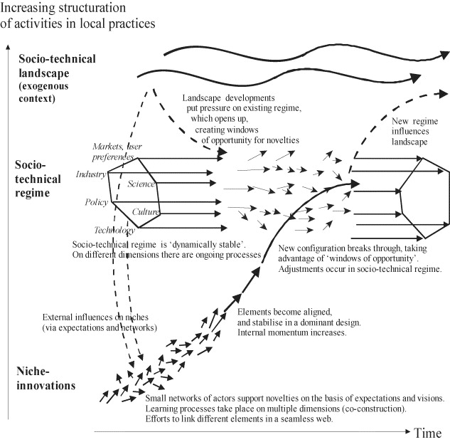

Examples of the linkage of models and theories to determinants of health is shown in Figure 10. These are purely illustrative and are not intended to be a exhaustive list; they reinforce the earlier comments regarding the complexity of factors potentially impacting on health-related behaviours.

**Figure 10: Dahlgren & Whitehead Model of the Main Determinants of Health With Appropriate Theory Linkages** [39]

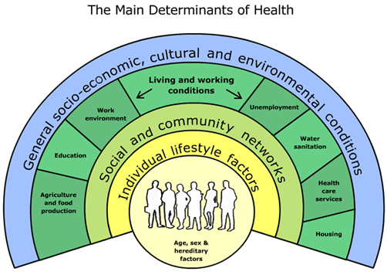

Environmental

Studies

Sociology and Social Psychology

Theory

Organisation Development Theory

Complexity

Theory

Triandis’ Theory of Interpersonal Behaviour

Decision

Theory

Integrative Model of Behaviour Change and Prediction

Stakeholder

Theory

Psychology

# 5.0 From Theory to Application

### 5.1 Application of theory

Understanding the determinants of behaviour is crucial:

Interventions are likely to be more effective if they target causal determinants of behaviour and behaviour change; this requires understanding these causal determinants, i.e. theoretical mechanisms of change.[40]

Behaviour change theories rarely specify which techniques should be used to change behaviour[41] and interventions are more commonly informed by theory or utilize theory in development phases; testing and revising/expanding theories are less common. Glanz & Bishop , Noar & Zimmerman[42] and Weinstein & Rothman[43] have called for the application and testing of health behaviour theories in order to advance science and develop successful health interventions. There is also evidence that theories have failed to predict some behaviours, due either to inapplicability of the theoretical constructs to specific populations or to the impact of personal, social or environmental mediators on behaviour[44].

### 5.2 What counts as evidence: qualitative and quantitative research

A debate, or position, about what constitutes legitimate knowledge[45] and the ways in which knowledge is evidenced, directly and indirectly informs much behavioural and public health research. A great deal of public health research utilises quantitative measures, and in particular, randomised control trials to establish cause-and-effect relationships between behaviours and outcomes. While we do not dispute the value of this research we argue that there is a strong case for the use of qualitative research methods in public health research. Furthermore, we argue that while quantitative and qualitative methods can be used complementarily, qualitative methods enable deeper, multifaceted understandings of the social contexts, experiences and actions that inform people’s health behaviours and decisions.

While it is important not to polarise quantitative and qualitative methods, it is also important to recognise that they derive from different epistemological positions. Quantitative research derives from an ‘experimental’, ‘hypothetico-deductive’ or ‘positivist’ position , p.98 which ‘emphasizes universal laws of cause and effect based on an explanatory framework which assumes a realist ontology; this is, that reality consists of a world of objectively defined facts’. The primary strategy adopted by researchers in this paradigm involves the experimental control of subsets of variables in the service of testing (either verification or falsification) of *prior* theory. , p.98 These quantitative studies usually require very large numbers and resources to achieve statistical significance and if not ‘perfectly’ conducted to eliminate biases and without sufficient ‘statistical power’ are subject to criticism.

However, there is a long history of critique levelled against this approach because of its reductionist view of human experience and meaning.Qualitative research, on the other hand, derives from a ‘naturalistic’ or ‘interpretative’ paradigm. Qualitative research is ‘concerned with meaning … with how people make sense of the world and … experience events’.[46] Qualitative researchers ‘aim to understand what it is like to experience particular conditions (such as living with a chronic illness, or being unemployed) … and study people in their own territory, within naturally occurring settings (home, schools, hospitals, and the street)’., p.9 Arguably these priorities, and the level of understanding they engender, are crucial for the design of public health campaigns and interventions. Glanz & Bishop[47], p.400 state that ‘the most successful public health programmes and initiatives are based on an understanding of health behaviours and the contexts in which they occur’.

Criticisms levelled against qualitative research concern how to measure the validity of research that is conducted outside of laboratory settings, as well as issues to do with generalisability. However, there are several ways of establishing validity in qualitative research as outlined by Willig, p.16. Firstly, qualitative research strives to ensure that the meanings and understandings generated during the research are shared by, or make sense to, participants (participant validation), and that participants are free to challenge, and if necessary correct, the researcher’s assumptions. Secondly, unlike most quantitative research, qualitative data collection takes place in real-life settings and contexts and therefore has a higher ecological validity than experimental research which has to extrapolate from the laboratory to the real world. Thirdly, the process of reflexivity – whereby the ways in which a researcher’s particular background, assumptions, class, race, gender etc., and the epistemological framework of the research are scrutinised in order to unpack how these will shape the data – makes it less easy for the researcher to impose their own meanings on the data outright.

In general qualitative research is difficult to generalise because of the small specific samples it works with, however, Willig and Haug[48] claim that once we have identified a certain experience or understanding in research it is arguable that this is available as a general experience or understanding in our society and culture. Furthermore, generalisability can be achieved by the use of accumulative techniques in which findings from comparable studies can be drawn upon in order to make wider conclusions.

The most important thing for improving future health for the population of England, in line with the Marmot review, is to understand the most effective ways of bringing about behaviour change. We need to embrace a wide range of research methodologies and would therefore recommend, in consideration of the new programme for NiHR's new school for public health, that transdisciplinary behaviour change research has a top priority.

### 5.3 Importance of communication

A key factor in intervention implementation effectiveness is communication, both through conventional mass media, newer electronic media forms including social media and inter-personal communications.

Communications can attempt to increase the strength of beliefs that will promote healthy behaviours, reduce the strength of beliefs that promote risky behaviours (i.e. increase their accessibility) so that these beliefs will carry more weight as determinants of attitudes, norms self efficacy and intentions. , p. 14

This presents another challenge as:

Behavioural theories do not tell us how best to design messages so that they will be attended to, accepted, and yielded to. We would argue that this is the role of theories of communication. , p. 14

The emergence of new media forms (including social media and hybrid media forms such as advergames) presents challenges to the existing foundations of marketing communications theory. Traditional communications theories and models such as Hierarchy of Effects models (e.g. AIDA, originally developed a century ago in the personal selling domain)[49],[50], DAGMAR (Defining Advertising Goals for Measured Advertising Response)[51] and the Elaboration Likelihood Model[52] became prominent during an era in which mass media were dominant and the prevailing belief, particularly in the USA, was that advertising was a strongly persuasive force and people conceived of as passive recipients of communication messages.

These models became prevailing wisdom, if not dominant paradigms, in spite of considerable evidence that they were not universally applicable[53],[54],[55]. There is a clear need to re-examine the relevance of traditional communication theories for the 21st century environment[56], together with newer, but in this context largely untested models, such as, the Technology Acceptance Model and the Innovation Diffusion Model[57],[58] and various hybrid models that combine the Technology Acceptance Model with more widely known models such as the Theory of Planned Behaviour and the Theory of Reasoned Action[59].

In order to understand the impact of new electronic media and, especially, social media, we recommend research to address the following questions:

***Research Agenda: New Media Use, Effects and Effectiveness***

* *To what extent are new media important, and how do individuals and groups use features, such as those that enable user-generated content, to gather information and inform opinions that shape behaviour?*
* *How well do traditional communications models and theories describe, explain or enable prediction of persuasive social marketing communication processes in the 21st century, particularly for new media forms such as social networks, where content is created and managed by users?*
* *How are these media used, and what impact do they have on the lives of users and the effectiveness of the media for communicating persuasive health-related messages.*
* *How do individuals behave in user-generated content environments: how does the role of flow and interaction impact on health-related decisions?*
* *Can we develop an integrated model of communication effectiveness, taking this new context and new communication theories into account?*
* *How can interactive media and consumer generated content (e.g. blogs and forums on specific health issues) be used to develop desirable health behaviour for each life stage?*
* *What is the effectiveness of the placement of health behaviour issues in editorial content (similar to brand placement in television programmes and movies).*
* *How can this knowledge best be used in developing and implementing interventions aimed at achieving long term sustained behaviour change.*

# 6.0 Key Contributions of Disciplines

6.1 Behavioural economics

Neoclassical economics has been applied to understand, predict, and influence the behaviour of individuals in a wide range of contexts. According to its main assumptions, individuals are largely assumed to make choices which are rational, consistent, perfectly informed and which maximise their economic utility by trading off between costs and benefits[60]. Research in behaviour sciences, especially cognitive psychology, indicates that individuals' choices in a wide range of contexts deviate from the predictions of neoclassical economics. Many of these deviations are systematic, consistent, robust and therefore largely predictable.[61] [62] [63] [64] *Behavioural economics* is an emerging body of research seeking to understand behaviour by incorporating insights from behavioural sciences into economics. The approach differs from the traditional, neoclassical economics mainly by giving more weight to what are sometimes called 'irrational' motives and behaviours.

Financial incentives have been applied to encourage a wide range of healthy behaviours, such as smoking cessation, healthy eating, sexual behaviour, and drug misuse (for a review see Marteau et al. [65]). One of the interesting findings of behavioural economics is related to the limitations of financial (dis)incentives to motivate behaviour change. In many contexts, when prices are not mentioned, individuals tend to apply social norms to determine their choices and effort[66]. Financial incentives might crowd out feelings of civic responsibility and may actually discourage the kinds of behaviours needed to solve collective social problems[67]. It is therefore relevant to incorporate insights from behavioural economics to the design of behaviour change interventions that incorporate financial incentives.

The *'predicted irrationality*' (a term coined by Ariely[68]) of individuals could, and some argue should, play a role in the design of behaviour change interventions. Thaler and Sunstein[69] advocate the use of 'nudges', small features designed in the environment of decision making, to highlight the better choices for individuals, to help them overcome cognitive biases, and to support behaviour change.

Applying nudges in a context of government policy is a rather new concept. Examples include, among others, techniques and concepts such as default setting, framing information in terms of gains and losses, provision of immediate and direct feedback, and 'social nudges'. Influencing individual behaviour through 'choice architecture' and the design of nudges is a subject of many on-going research studies (for example, in an on-going research UWE is developing information provision tools for communicating low carbon messages in a travel behaviour context[70]).

Avineri & Goodwin[71] argue that one of the limitations of the nudge approach is that being designed to influence individuals' behaviour through intuitive and impulsive processes, they do not directly address the fundamental problem of behaviour change, as they do not lead directly to a real change to the individual's knowledge, attitudes, believes, and values. It is therefore difficult to maintain and achieve long-term and sustainable behavioural change without introducing in parallel a set of more substantial interventions to support it. The real promise of the nudge approach seems rather to help the design the bigger initiatives better, that is to add 'nudges' to improve or speed up behavioural change effects rather than as a replacement to other initiatives.

### 6.2 Environmental planning and management

Environmental planning and management have a considerable amount to contribute to the field of public health. Although somewhat separated from public health for some time due to governance and policy structures, environmental health is increasingly running parallel to public health in many areas – particularly areas such as food, licensing, transport and air pollution – issues right at the core of some of our major public health issues. As the social (and therefore environmental) determinants of health are seen as playing an increasingly key role, planning is becoming more important in ensuring that different social groups have appropriate access to suitable facilities (see Figure 11).

**Figure 11**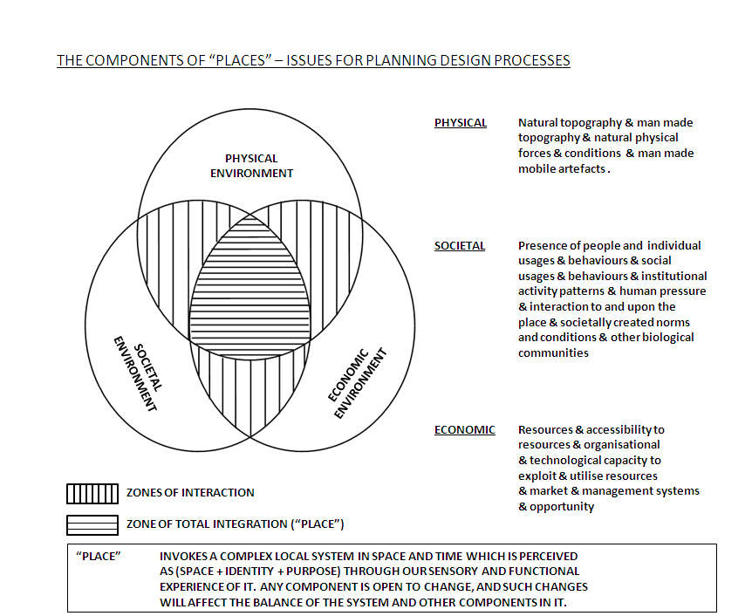

The areas of planning and management can be folded together under the general term Environmental Governance. This field has a long history of combining different approaches to problems in order to achieve goals.

Figure 12 shows a theoretical diagram of the Environmental Governance Cycle from work undertaken by UWE with the Department for Environment, Tourism and Rural Affairs in South Africa. The cycle clearly shows roles for both encouraging behaviour change through awareness raising, but also the role of regulation and enforcement. The view of the process as a cycle is a clear reminder that no single policy is likely to achieve all desired goals, and so a continual approach of policy setting, implementation, evaluation and development of new strategies and policies is required.

Figure 12: Environmental Governance Cycle (Department for Environment, Tourism and Rural Affairs, South Africa)

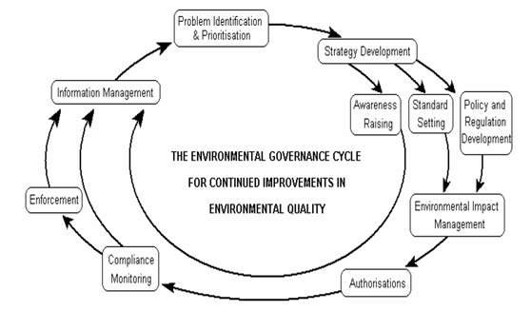

6.3 Organization development (OD)

(OD) can be defined as:

[A] process by which behavioural science knowledge and practices are used to help organizations achieve greater effectiveness, including quality of life, increased productivity, and improved product and service quality... the focus is on improving the organization’s ability to assess and to solve its own problems. Moreover, OD is oriented to improving the total system – the organization and its parts in the context of the larger environment that impacts upon them.[72], p.1

OD consultancy interventions entail a process of working collaboratively with client groups within a context of strategic change to diagnose problems at particular levels of the organizational system with a view to finding practical ways of driving the behaviour change agenda forward. Problems and conflicts should be confronted, and not disguised or avoided and the people affected by change should be involved in its implementation.[73] Consultants in behaviour change using an OD framework typically facilitate ‘action learning sets’ with organizational participants representing different stakeholder interests to diagnose problems and collaborate on practical, ‘joined up’, solutions. Recent development in the field of organization studies combine insights from complexity theory with established processes of OD intervention. There is a growing appreciation of the way in which complex organizations must be understood as complex adaptive systems. Ralph Stacey, a pioneer in this field, lays stress on harnessing the inherent potential of creativity and innovation within systems to self-organize in response to environmental change:

Creative systems spontaneously sustain themselves in a critical state at the

edge of disintegration where they are not adapted to their environments: they

co-evolve with the other systems they interact with and together they create

their own new future... Such systems spontaneously produce emergent new

order out of disorder through a process of self-organization.[74], p.245

Again, OD consultants applying lessons from this theory to bring about behaviour change emphasise being willing to act on local knowledge. Change leaders/champions need to recognise that they can influence the environment/system (e.g., ‘cascading’ the change agenda through processes of consultation, action learning sets, workshops, etc.) but not determine how others will respond. OD processes of intervention and leadership that employ complexity theory cultivate self-knowledge and reflective practice. There is a small but growing body of literature concerning the application of complexity science to the promotion of health.[75], [76]

The manner is which a behavioural change agenda is led or championed will be a crucial determinant of its relative success. Leading change in complex systems requires collective effort and leadership therefore needs to be distributed throughout the system.[77] Initiatives and key messages of behaviour change may originate at the top of the hierarchy but complexity theory dictates that they will be interpreted, adjusted and accommodated by different parts of the system in different ways. This has to be expected and the resulting energies contained within boundaries set by agents of change.[78]

OD can be usefully combined with stakeholder theory and analysis within the social system in order to identify and enrol parties who are strategically implicated within the change agenda. Stakeholder theory requires that behaviour change be understood within the context of systemic relationships. Behaviour change interventions take place at a nodal point within a network of interrelated stakeholder interests: e.g., the public/local communities, national government policy, GP consortia/health professionals, local government health providers, social enterprises, etc. OD can be used to manage stakeholder interests through appropriately targeted intervention within social systems/organizations at both strategic and tactical levels[79] (see Figure 13).

**Figure 13 – Generic model of stakeholder management**

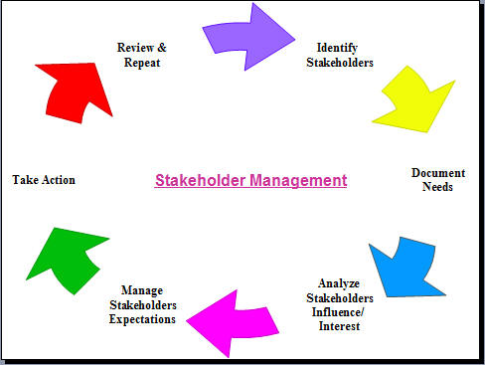

### 6.4 Social marketing

Social marketing is‘the systematic application of marketing concepts and techniques to achieve specific behavioural goals, for a social or public good’ and *health-related social marketing* is ‘the systematic application of marketing concepts and techniques to achieve specific behavioural goals, to improve health and reduce health inequalities.[80], p.1

A more detailed operational definition for social marketing is:

A social change management technology involving the design, implementation and control of programs aimed at increasing the acceptability of a social idea or practice in one or more groups of target adopters. It utilizes concepts of market segmentation, consumer research, product concept development and testing, directed communication, facilitation, incentives and exchange theory to maximise the target adopter’s response.[81], p.7

In the UK, a previous White Paper *Choosing Health*[82] specifically advocated the adoption of the principles underpinning social marketing in order to more effectively promote public health issues, acknowledging that existing communication strategies were not effective. The centrality of social marketing in the dissemination of innovation in health promotion is also acknowledged in the academic literature[83].

Social marketing focuses on the generation of insights into attitudes, beliefs and values that underpin actual behaviours, thus helping to bridge intention-behaviour gaps. It draws on many disciplines to bring about voluntary behaviour change as well as addressing ‘upstream’ factors such as supporting policy and environmental change[84]. Key elements include creating satisfying exchanges, use of integrated strategies to develop interventions, and the use of competitive analysis and segmentation. Consistent with Triandis’ model discussed earlier, by making exchanges satisfying, i.e. providing positive outcomes for the individual, new or amended behaviours will become routine[85].

**Table 1: Social Marketing Benchmarks** adapted from[86] (note: this Table has been extended by others)

|  |  |
| --- | --- |
| **Benchmark** | **Objective** |
| **Behaviour change** | **Intervention seeks to change behaviour and has specific measurable behavioural objectives** |
| **Segmentation and targeting** | **Different segmentation variables are considered when selecting the intervention target group. Intervention strategy is tailored for the selected segment(s)** |
| **Marketing mix** | **Intervention considers as the best strategic application of the ‘marketing mix’ which consists of the four ‘Ps’ of ‘product’, ‘price’, ‘place’ and ‘promotion’. Other ‘Ps’ might include ‘policy change’ or ‘people’ (e.g. training is provided to intervention delivery agents)** |
| **Exchange** | **Intervention considers what will motivate individuals to engage voluntarily with the intervention and offers them something beneficial in return (the offered benefit may be tangible or intangible).** |
| **Competition** | **Competing forces to the behaviour change are analysed. Intervention considers the appeal of competing behaviours (including the current behaviour) and uses strategies that seek to remove or minimise this competition.** |

**Evidence of Social Marketing Success:**

The selection of social marketing entries, including many award winners, from recent communications industry effectiveness (i.e. demonstrable impact / return on investment) awards (Source: World Advertising Research Centre: [www.warc.com](http://www.warc.com) ) below illustrates the success of social marketing interventions across a wide range of topic areas.

Cycling safety: “Cyclists should be seen and not hurt” – an intervention aimed at reducing bicycle traffic casualties in London is estimated to have saved £2.3 million in the year following the intervention due to reduced cycling accidents. Won Gold: IPA Effectiveness Awards, 2009.

British Heart Foundation: “Under the Skin” Smoking Cessation – led to an estimated 5,600 lives saved through smokers successfully quitting smoking permanently and returning £600 of value for every £1 invested. Won Silver: IPA Effectiveness Awards, 2006.

Greater Manchester PCT: “Don’t be a Cancer Chancer” led to significant increases in GP consultation and a 20% increase in referrals to hospitals for breast, colorectal and lung cancer investigation or treatment. Referrals from the most deprived wards increased by 48%. Won Bronze for Best Media, IPA Effectiveness Awards, 2009.

Tower Hamlets Recycling: led to an increase in annual recycling rates from 12.89% to 19.51%. Won Bronze, Design Effectiveness Awards, 2009.

Central Lancashire PCT: “Breast Feed, Be A Star” – a peer support programme for young n=mothers from deprived areas, led to breast feeding rates increasing from 52% to 65.^% in the first month; rates were maintained for several months. The increased led to savings for the NHS on treatments for conditions such as gastroenteritis. Won Gold, Design Effectiveness Awards, 2009.

Northern Ireland Fire Safety /Smoke Alarms: a sustained multi-faceted intervention aimed at reducing domestic fires and increasing properly fitted and maintained smoke alarms reduced fire incidents by 24%, fire-related injuries by 23% and saved an estimated £132.9 million in value of lives saved, almost £4 million through not having to mobilise NIFRS and over £44 million in savings against damage to domestic property, with an overall return on investment of over 80:1 over the 2003 – 2008 period.

### 6.5 Social psychology

Social Psychology is an extremely broad discipline that is difficult to pin down with one definition. However, two broad approaches or schools of thought can be identified as ‘experimental’ and ‘critical’ (or ‘discursive’/’social constructionist’) approaches[87] – both of which will bring distinctly different but valuable contributions to bear on questions concerning the determinants of behaviour and behaviour change.

Experimental or traditional social psychology is concerned with how aspects of the individual such as attitudes, personality, behaviour and beliefs are influenced by the social contexts they find themselves in. Stated differently, it explores the interaction between the psychological processes that go on in individual’s minds and the social forces that exist on the outside . Key topics of interest in this approach include perception of self and others, perception of groups (stereotypes, prejudice, and racism), attitudes and persuasion (conformity, compliance and obedience, including social norms), interpersonal perception and attraction, antisocial and prosocial behaviour (aggression, violence and altruism) and leadership.[88]

Social psychological thinking around these topics is informed by a large number of theories and models, and many of these have direct implications for understandings of how individuals think about their choices and behaviours in relation to health, for example: attribution theory (concerned with the ways in which people explain the behaviour of others); cognitive dissonance (how changes in attitude or behaviour occur as a result of the discomfort of holding conflicting ideas simultaneously); elaboration likelihood model (information processing, particularly in the case of a persuasion attempt, can be divided into two separate processes based on whether the person engages critically with the message content, or whether they respond to the superficial aspects of the message); and observational or social learning theory (behaviour is acquired through the observation and imitation of others). Both experimental and critical approaches are applied approaches. As the name suggests experimental social psychological research tends to be quantitative, involving laboratory experiments, field/quasi-experiments and surveys. This kind of research has been applied to a wide range of disciplines and areas including: the environment, marketing, leisure, business and management, health and preventive medicine, social geography and gerontology among others.[89]

Critical (discursive/social constructionist) social psychology differs from experimental psychology as it views the social world as something that is created and recreated by individuals. It is concerned with people’s experiences, the understandings and meanings they have about themselves and others, and the world around them, and believes that the scientific method adopted by the experimental approach does not provide access to this. It takes a critical stance towards all knowledge, claiming that knowledge is a construct – a product of discourse, or the sets of beliefs and ‘truths’ that exist about a specific topic within a certain cultural and historical context – and seeks to explore how things like knowledge, facts, attitudes, beliefs etc. come to be taken for granted. Language, and the ideological effects of language, or the ways in which language is tied up with power, are key to this approach.

Social constructionist theorists[90] emphasise how people’s accounts of themselves are constructed like stories or narratives – hence it is important to be able to access and engage with these stories and narratives to understand how they reinforce and feed into larger cultural understandings and discursive practices. As such critical social psychological research is nearly always qualitative and employs a wide variety of methods. Data collection often involves conducting ethnographic fieldwork, in-depth interviews and focus groups in order to gain access to the understandings and meanings attached to particular topics and practices or behaviours. Different kinds of text (e.g. health leaflets or other health promotional material) can be analysed using thematic analysis or discourse analysis to explore what kinds of work the texts are doing – what view of the world are they reproducing – and whether or not this is successful. Despite objections from experimental social psychologists that these methods or not objective or neutral, and therefore not scientific, critical social psychology provides extremely rich, complex and multilayered understandings of social phenomena.

**Table 2: Differences between experimental and critical social psychology**, p.58

|  |  |
| --- | --- |
| **Experimental social psychology** | **Critical social psychology** |
| Operates within Modernism | Operates within Postmodernism |
| Views the social world as ‘out there’ external to and separate from people | Views the social world as made by people, and not separate from them |
| Views knowledge as based on facts that are ‘out-there-in-the-world’ waiting to be discovered | Views knowledges as constructed through people’s meaning-making |
| Asserts that there is only one true, objective knowledge that transcends time and cultural location | Accepts that there are multiple knowledges, and that knowledge is highly contingent on time and cultural location |
| Asks of knowledge ‘is it true’? | Asks of knowledge ‘what does it do?’, ‘how can it be used – by whom, and to what ends?’, ‘whose interest does it serve?’, ‘what does it make possible?’ |
| Seeks to gain knowledge primarily through hypothetico-deductive testing of theory | Seeks to gain knowledge primarily through abduction – looking for anomalies and trying to puzzle them out |
| Seeks to provide nomothetic cause-and-effect explanations | Seeks to provide idiographic explications that offer insight into specific social events and phenomena |
| Seeks to be dispassionate and apolitical | Is often motivated by ideology and makes not claim to be objective or dispassionate |

### 6.6 Sociology, public health policy and applied political science perspectives

Sociology and allied disciplines concerned with the study of social life have grown up alongside and have heavily influenced public health interventions. Through research on the social determinants and the social construction of health, these social sciences have found considerable application in the prevention of disease and the improvement of health. Whilst sociological enquiry is not necessarily directed towards behaviour change, there can be little doubt that all health promotion practice draws upon conceptual frameworks of how society works and how people function as social beings.

In recent years there has been a proliferation of public health models that integrate insights from sociology. Whilst it would be hard to do justice to the range of theoretical applications in this summary, the work of Kelly’s team at NICE provides a good example of a sociologically informed approach[91]:

**Figure 13: Socio-environmental Vectors Influencing Health and Well-being**

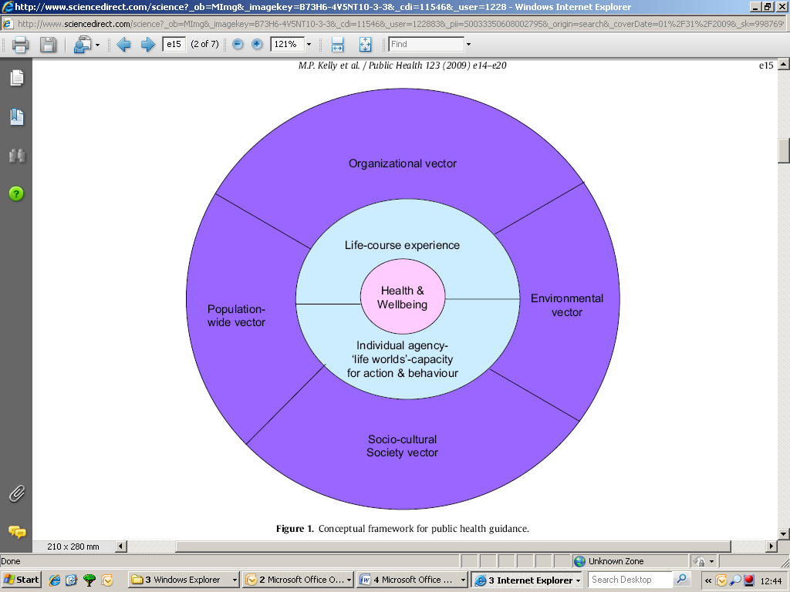

Here the influences on health and well-being are presented as socio-environmental vectors that include state, market and civil society (the population wide vector); social institutions such as schools, workplaces and health care organisations (the organisational vector) and social divisions, socially patterned behaviour (‘lifestyles’ or the social-cultural vector).

This is a causal model in which, empirically, the vectors overlap and interact as forces to produce individual health outcomes. At the level of the individual Kelly et al conceptualise their effects through the ‘life-course’ – or the lifetime accumulation of health ‘insults’ and benefits, critical points in the life trajectory and the ‘life world’ –or the subjective locus of experience.

Analytically these are considered separately to better inform behaviour change interventions. Michie et al’s[92] review of behaviour change intervention with low-income groups represents a good example of applied research that takes into account action at population, community and individual levels.

**Sociology’s contribution to the inter-disciplinary public health agenda: some examples in the recent literature**

Barton, H. and Grant, M. (2006). A health map for the local human habitat. *The Journal for the Royal Society for the Promotion of Health*, 126 (6). pp. 252-253.

Kelly, M.P., Stewart, E., Morgan, A., Killoran, A., Fischer, A., Threlfall, A. and Bonnefoy, J. (2009). A conceptual framework for public health: NICE's emerging approach. *Public Health*, 123(1): 14-20.

Krieger, N. (2008). Proximal, distal and the politics of causation: what’s level got to do with it? *American Journal of Public Health*, 98: 221–30.

Solar, O. and Irwin, A. (2007). Towards a conceptual framework for analysis and action on the social determinants of health. Geneva: WHO Commission on Social Determinants of Health.

National Institute of Health and Clinical Excellence (2007). Behaviour change at population, community and individual levels (Public Health Guidance 6).

Michie, S., Jochelson, K., Markham, W. and Bridle, C. (2009). Low-income groups and behaviour change interventions: a review of intervention content, effectiveness and theoretical frameworks. *Journal of Epidemiology Community Health*, 63: 610–622.

### 6.7 Wider factors influencing health, well-being and health inequalities

### 6.7.1 Health literacy

Research has shown that people with inadequate health literacy are less knowledgeable about the importance of preventive health measures[93],[94] and have a higher risk of hospital admission. The costs of limited health literacy range from 3-5% of the total health care cost per year[95]. Limited health literacy often means that a person is unable to manage their own health effectively, access health services effectively, and make informed health decisions. Improving the health literacy of those with limited literacy skills is a crucial part of reducing health inequalities[96],[97],[98]. Some 20% of the population of most developed countries have severe health literacy challenges and a further 20% have moderate literacy limitations, yet most health information is written in language so complex as to place it beyond the comprehension ability of these groups[99]. Much of the extant research is American in origin. It contains minimal data on how groups access information and from what sources, on their levels of satisfaction with existing information provision or on their preferences for future information.

It is therefore crucial to develop a comprehensive overview of health literacy needs in the UK, and to ascertain the best modes of communication for meeting these needs.

### 6.8 Fostering a balanced approach

We are concerned that the new approach called for in the White Paper does not entail a strong enough case for a properly balanced approach. Whilst there is some discussion of roles for both government, and individuals and communities we have concern that the need carefully to manage the balance and integration between these two domains is not being recognised. If the aim is partly one of ‘adapting the environment to make healthy choices easier’ it is not simply a case of government needing only to make light-touch interventions and open up the space for individual choice. The work on obesogenic environments shows that a significant number of factors that contribute to poor public health are strongly built into our surroundings. Significant efforts to improve these may well require strong planning legislation and guidance in order to change the frameworks in which we operate – not just a focus on trying to intervene at points of decision making.

Whilst the move towards a ‘behavioural science’ based approach is a significant advance on methods based solely on regulation, or pricing signals, it is crucial that these are not seen as being able to provide a complete solution. They must be viewed as part of a toolbox which includes prohibitory and economic tools. They must also consider properly the need for government to set the macro-frameworks in which individuals and communities operate in order to ensure: (a) that those taking action do not have to swim against the tide, and (b) to ensure that all in society can benefit – not just those lucky enough to live in an engaged and capable community. If macro-frameworks are not taken into account there is a risk that the proposed policy could lead to a greater widening of the social inequalities of health.

Evidence emerging from behavioural sciences is that individuals are influenced by ‘significant others’: people in their social networks, people who have geographical and social proximity (neighbours, work colleagues, class colleagues) and sometimes even by strangers with whom they share social identity. For example, energy bills that provide information on how energy efficient their neighbours are encouraged them to use less energy[100]. Many of the behavioural insights emphasized in behavioural economics confirm the importance of self-regulatory mechanisms rather than traditional top-down command-and-control regulation. The small-scale group-based approach applied in the EcoTeams case study [101] provided supportive social context that is accounted as one of its major success factors. Workplace and school travel plans also operate within a community which is limited in size and may encourage pro-social behaviour using ‘bottom-up’ approaches[102] .

### 6.9 Social networks: social norms, media influence and celebrity influence

There is a substantive body of work dealing with how the media impacts on a range of high-risk behaviours and health-related issues including tobacco use[103], alcohol and recreational drug use[104], and increased violence and aggression.[105] Additionally, a large section of this work focuses on the effects of the media on women in terms of body image dissatisfaction, the perpetuation of normative body ideals which associate thinness with attractiveness[106], [107], [108], [109] and the reinforcement of associated behaviours such as cosmetic surgery[110], and binge-eating and dieting.[111]

Younger age groups, particularly young women, appear to be more influenced by media images. By the age of 8, girls are aware of societal images of female beauty and the use of media images to compare self image with the media portrayal of ideals increase markedly between the ages of 8 – 12 and leads to dissatisfaction.,

The international literature indicates that preadolescent girls use media images as a basis for deciding on ideal physical attractiveness, even though the images portrayed are unrealistic or represent poor role models and unwise behaviours.[112] For example, with respect to sun tanning and the use of sunbeds, research indicates that celebrity role models such as Paris Hilton and Jessica Simpson, who openly endorse the use of sunbeds, influence the tanning behaviours of teenage girls.[113]

What is the process involved in deciding to engage in the kinds of high-risk behaviours that we see celebrities engage in, and why do we choose to engage in some of these behaviours and not others? Young people are most likely to engage in a host of high-risk behaviours (binge-drinking, use of recreational drugs, disordered eating, and risky sun tanning practices including the use of sun beds), but are also notoriously resistant to fear appeals and message framing that focuses on the negative consequences of these behaviours[114]. The questions outlined above are therefore crucial to social marketers who need to identify what kinds of sources inform young people’s behaviours and who young people regard as credible sources of information.

# 7.0 Important Outstanding Factors Not Addressed in the White Paper

There are several issues that, while not specifically addressed within the White Paper, are of sufficient importance to warrant consideration. These relate to issues of legitimacy and trust, ethical issues, risk and unintended consequences, factors within health settings and the needs of an aging population. Each of these is now discussed.

### 7.1 Legitimacy and trust

### 7.1.1. The source of information

While seen as more credible than most commercial sources, governments overall, as sources of information, have become significantly less trusted in the last thirty years.[115] The health sector has not been immune from this, with evidence of decreased confidence in public health risk communication[116] and an overall lack of trust in public health experts.[117],[118] In the specific area of immunisation there is also evidence of rising concern regarding vaccine safety, with potential consequences for resulting immunisation levels.[119]

Passive acceptance of government information or advice is no longer assured, particularly when it merely reiterates existing policy stances[120]. Source expertise is known to directly influence perceived credibility of a message[121] and evaluation of the credibility of information has moved from passive acceptance of authority-based information, to judgement based on the synthesis of input from multiple sources, including consumer/news media.[122] There is an assumption that the media will provide accurate and uncritical information (such as the transmission of medical ‘facts’[123]), yet there is evidence from the United States of sensationalism, amplification of risks and emotional aspects such as individual cases and speculation on worst-case scenarios[124], thus the media’s impact may not always be in line with majority expert opinion or possibly even in the public’s overall interest.

In order to understand the impact of trust, we recommend the following questions be addressed:

***Research Agenda: Trust***

* *What are the relative levels of trust for health information across formal and informal channels of communication? Which sources are trusted and seen as most credible?*
* *What is the role of different social groups in forming opinions and shaping behaviour?*
* *What sources of information, and which channels and instruments are used / preferred by different socio-demographic segments across different life stages.*
* *What is the impact of social networks on persuasion and, where these are important, how do these networks operate?*

Legitimacy and trust are also important within multi-party and community-based health initiatives which involve partnerships between often disparate organisations. As members of partnerships will be making decisions affecting others, there is an obvious need to seek support and endorsement from all sectors of communities. This will necessitate the identification and analysis of stakeholders to determine who has a voice and the right to speak on behalf of others. Partners must identify and agree on who has the right to set priorities for a community, and the process by which issue and priority selection will be decided if the community is divided.[125]

Also, partners must agree as to who has the right to assess risks to communities and individuals[126], who decides on norms, standards or goals, what incentives or rewards might be necessary to attract or enable under-represented groups to participate in a partnership[127] and what action should be taken if a group disagrees or decides to opt out after development of a partner-based intervention has commenced.[128] If an intervention is not supported or perceived as legitimate, those who have been excluded from its development and planning may undermine it.[129]

### 7.2 Ethical issues in behaviour change programmes - Benefits, risk and unintended consequences

In the White Paper under the section ‘Intervening effectively’ there is superficial discussion of ethics without a clear reference to ethical principles and approaches.

Ethical issues associated with behaviour change programmes, and indeed much of public health, are under-researched. However, it is well known that most interventions even at an individual level are associated not only with benefits but risks, costs and unintended consequences. The situation is even more complex for interventions at a population level where the beneficiaries and those who suffer costs or adverse consequences are different individuals or groups of people. Sometimes the unintended consequence of behavioural interventions is to widen the inequality gap which most interventions are striving to narrow either directly or indirectly.

Deliberate decisions to change the behaviour of individuals in a democratic society raise questions of governance. There are questions about who legitimately decides what is ideal behaviour, whether those who do not conform to ideal behaviour need to change, whether this is for their own or societal good, and what methods could legitimately be used. In this regard, the Nuffield Council on Bioethics ‘intervention ladder’, which is referred to in the White Paper, focuses on a hierarchy of intrusion in individual decision making to achieve health improvement.

There are several ethical issues that have been identified and which should be included in intervention planning. These include how competing needs might be judged and what information is reasonable to seek from people in order to develop social marketing campaigns[130]. In addition, a surprisingly wide range of potential unintended effects of health communication campaigns have been reported in the academic literature; these have been summarised in Table 3.

**Table 3 Unintended Effects of Health Communication Campaigns[131] (Cho and Salmon 2007: 300)**

|  |  |
| --- | --- |
| **Effect** | **Definition** |
| Obfuscation | Confusion and misunderstanding of health risk and risk prevention methods |
| Dissonance | Psychological discomfort and distress provoked by the incongruence between the recommended health states and the audience’s actual states |
| Boomerang | Reaction by an audience that is the opposite to the intended response of the persuasion message |
| Epidemic of apprehension | Unnecessarily high consciousness and concern over health produced by the pervasiveness of risk messages over the long term |
| Desensitisation | Repeated exposure to messages about a health risk may over the long term render the public apathetic |
| Culpability | The phenomenon of locating the causes of public health problems in the individual rather than in social conditions |
| Opportunity cost | The choice of communication campaigns as the solution for a public health problem and the selection of certain health issues over others may diminish the probability of improving public health through other choices |
| Social reproduction | The phenomenon in which campaigns reinforce existing social distributions of knowledge, attitudes and behaviours |
| Social norming | Social cohesion and control accompanying marginalization of unhealthy minorities brought about by campaigns |
| Enabling | Campaigns inadvertently improve the power of individuals and institution and promote the images and finances of industry |
| System activation | Campaigns influence various unintended sectors of society, and their actions mediate or moderate the effect of campaigns on the intended audience |

While there are a number of potential frameworks available which derive from the field of philosophy, there is no consistency in the literature as to which framework might apply in specific circumstances. The frameworks most commonly cited focus either on intentions (deontology, from the Greek word for ‘duty’) or consequences (teleology, from the Greek word for ‘ends’; also referred to as consequentialism), with the latter being broken down further into utilitarianism and egoism.[132],[133]

Thus a health-related intervention that was driven by good intentions without potential negative consequences being considered would be acceptable under deontological reasoning but not under teleological reasoning. It has been suggested that there is no universal set of ethics that can apply across all sectors of society due to the increasing diversity of society and different perspectives that may be held within cultures or groups and therefore each group’s ethical perspective should be held to be equally valid. An additional perspective is suggested by social contract theory which suggests that there is an implicit contract between the state /government and individuals within society[134]. This is reflected in documents such as the UN Charter which makes reference to basic assumptions about the right of all citizens to health.[135]

A further problem is the lack of clear and unambiguous interpretation of the frameworks. For example, the 2007 Department of Health fear-based smoking cessation ‘fishhook’ intervention which was deemed to be in breach of the Codes of Advertising as a result of multiple complaints. Complaints were primarily based on the fear and anxiety the campaign evoked in children[136], as it featured smokers with fishhooks through their faces being dragged to purchase cigarettes. This approach would be acceptable under deontological reasoning, given that the intention was to help smokers take steps to quit smoking. Others would argue that it is unacceptable to knowingly cause anxiety under deontological reasoning, even if it achieves a beneficial effect.

Some specific areas of communication activity that raise ethical issues relate to targeting. It has been suggested that social marketing ‘may unwittingly substitute a marketing rationale for relevant moral rationales called for by the social problems it addresses. Stated differently, the logic of consumer behaviour may replace a moral justification. Moreover, that there is a danger that when social marketing interventions are targeted they may override normal rights related to self-determination regarding participation.[137]

A fundamental strategy for marketers is to ‘select target markets they can best affect and satisfy’.[138], p.7 This strategy, when applied to social marketing activity, may result in some segments of the target population being excluded because they are difficult, or comparatively costly to reach; This may result in inequalities widening as those harder to reach are usually more marginalised and have worst health. Alternatively, if the health of some groups is perceived to be good enough, scarce resources may be diverted only to those groups with the worst health or health risk factors.[139] This would prevent the ‘healthy’ from gaining the benefits of the programme to become even healthier.

Acceptable behaviour is determined to a large part by socialisation, yet the role of culture in establishing ethical standards is largely ignored within the health communication literature.[140] For example, the needs of immigrant populations who may retain substantial influences from their country of origin, including cultural values and language preferences, are often overlooked. They may be confused by messages such as those that recommend limiting the intake of some foods when these are not restricted in their home countries.[141] Furthermore, failure to take their (culturally based) perceptions of health-related issues[142] into consideration may result in interventions not succeeding.

Further examples include suggestions that the use of fear appeals is contrary to Islamic beliefs[143]; while issues such as safe sex may offend some cultural or religious groups who, while not directly targeted may still receive material relating to the topic. When culture-based perceptions are at odds with prevailing perceptions of best practice , how should respect for minority cultural norms be balanced with the desire to challenge them in the interests of improving health and well-being?

Culture may also influence the acceptability of different ethical frameworks, for example, some cultures that emphasise collective responsibility, i.e. the greatest good for the greatest number over individual self-interest, may find utilitarian perspectives preferable; whereas a culture that emphasises individualism may display preferences for egoism-based frameworks.[144]

A recent review on public attitudes to road safety revealed support of regulation and enforcement .There is support that more visible policing would alter a driver’s own behaviour. For example, there is high support for seat-belt and drink-driving laws, and high compliance with such laws. There is evidence that enforced regulations in France can often improve attitudes towards road-user safety.[145] Stronger penalties are viewed by motorists as appropriate for errors that are perhaps seen as a deliberate violation and less severe penalties for errors perceived as non-deliberate slips or lapses.

As with all public health interventions, a careful appraisal of the potential benefits and risks for both individuals and populations must be made and these weighed against each other.

In considering behaviour change, attention should be given not just to determinants of health, but also to issues that arise within a health setting, as the following vignette illustrates.

**Medication adherence**

Compliance/adherence rates with prescribed medications are on average no better than 50% internationally, with rates for behaviourally demanding treatment regimes being much lower, as are rates for many lifestyle treatments.[146] Even when non-compliance has potentially serious consequences such as vision impairment, or potential organ rejection, correct compliance rates remain low[147]. Non-adherence may also be a factor in the emergence of drug-resistant organisms[148]. In terms of costs to the economy, some 11% of healthcare expenditure in the USA is attributed to medical non-adherence. This excludes the impact of lowered workplace productivity and absenteeism.[149]

An example of the type of challenge that needs to be considered is that those who are least compliant with their medication regimen are also likely to miss hospital appointments or other forms of medical monitoring.[150]Thus, those who would benefit most from help may be difficult to reach or to persuade to participate in interventions aimed at improving their health and quality of life. The arguments for and against allocating resources to trying to reach them versus those who are easier to reach are complex. The nature of proposed interventions also presents challenges. For example, adolescents with epilepsy do not want to meet others with complications or problems as they perceive these patients’ problems as frightening and depressing, thus interventions that could include peer support from others with the same medical condition are unlikely to be successful.[151]

An additional factor relates to diminishing returns – e.g. as more people give up smoking, those who continue to smoke will be those most resistant to change – therefore it is likely that future interventions will deliver diminishing returns. There is a need to find the point where further investment in encouraging behaviour change is likely to be ineffective and consider other measures such as legislation. We have been unable to locate any studies where this type of analysis has been attempted in a relevant health setting.

### 7.3 Risk and behaviour change programmes

The notion of *risk* is integral to the dilemmas and challenges associated with the themes The White Paper is addressing.

Ordinary usage of the word ‘risk’ involves pragmatic links to human action and moral responsibility. It is, therefore, important to understand multi-disciplinary approaches to the conceptualisation of risk, and to debate possible and varying perceptions of risk held by different agents within the context of ‘Healthy Lives, Healthy People’ and in the process of strategising about public health in England. A critical examination of the ways in which contemporary society organises in response to risk inevitably raises the issue of ethics in decision making including risk appraisal processes and management strategies at the organisational and sector levels of analysis. In pragmatic terms, it would be helpful to clarify, through commissioned behaviour science research, how risk is perceived by individuals and public in relation to health issues and to explore, in particular, the implications of such perceptions for daily actions encapsulated by the ‘healthy lives, healthy people’ initiative.

The work of Antony Giddens[152], Bent Flyvbjerg[153], Ulrich Beck[154], Peter Bernstein[155], and Russell Ackoff[156] would be the classic examples of relevant literature. Particularly relevant work to draw on would include Martin Loosemore[157] with his commentary on perspectives and doctrines in risk management (e.g. collaborationist vs homeostatic[158]. The claim is that if risk appraisal is understood as a consideration of a probability of loss, then we need to think about whose perceptions are taken into considerations and from which perspective out of the following categories:

- *economic* (profit, rational comparison of costs/benefits)

- *psychological* (seemingly irrational perceptions due to fear, believes, memory of past or recent events)

- *societal* (participation depends on the level of education and economic well-being)

- *cultural* (bribery, corruption, habits, attitudes, relationship to technology)

As implementation of any new initiative or strategy in a complex interconnected and interdependent society always has a potential to create new risks, it is important to acknowledge the imperative as well as the challenge of capturing, evaluating and exposing these proposals to critical scrutiny against ethical benchmarks (see 7.2 above).

**7.4 Consideration of competing influences**

The very term social marketing implies a similarity with commercial marketing. One of the key issues in marketing is competition. One of the key weaknesses of current behavioural approaches is failure to understand the nature of competing forces. There are a number of sources of the competing forces, some of which may be combative, as shown in Figure 14.

**Figure 14: Competing ideas in social marketing[159]**



The implications of these factors are now discussed in more detail.

**7.4.1 Need for consistency**

There is also the need for consistency across different portfolios. For example, recent relaxation of the rules governing product placements within UK-originated mass media programme content prohibits product placement within children’s programmes and provides a list of products and services that are banned outright. We argue that these new rules fail to take a number of significant issues into account, namely: a large percentage of children’s viewing takes place during adult programming; restrictions do not extend to product placement in video and advergames, or social networking and media sharing sites; and finally, the list of restricted products does not include harmful products and practices, some of which have been legislated against, such as the use of sunbed by under 18 year olds[160], [161]. This issue is explored in more detail in Appendix A.

Similarly, there is no reference to effective sun protection strategies within the Change4Life material, in spite of recognition of the rapid increases in skin cancer rates (doubling every twenty years) within the UK.[162]

Consistency of communication and integration will be critical factors in ensuring success; lessons can be learned from the evolving body of knowledge relating to integrated marketing communications (IMC) – ‘an audience-driven business process of strategically managing stakeholders, content, channels, and results of brand communication programmes’[163]. IMC, in addition to ensuring consistency of communication across all channels of contact with target groups, also incorporates building of positive relationships with all stakeholders to ensure buy-in and ongoing support.[164]

**7.4.2 Counter-marketing**

‘Counter-marketing’ forces promote behaviours which directly oppose those aspired to by the behavioural change programme. The most obvious areas of public health practice where this occurs are smoking, alcohol, unhealthy foods and road safety. The image below is an example of just one counter-marketing activity.

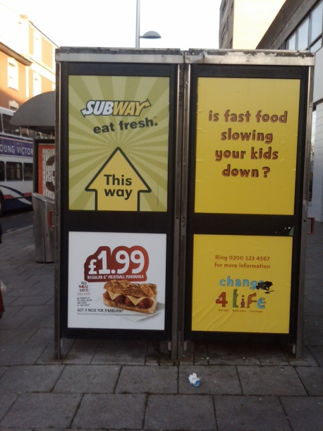

Key issues in counter-marketing are:

* The competition in marketing from commercial companies.
* The massive discrepancy in budgets between those used by the commercial companies for their marketing campaigns and the speed of change of tactic for example in the use of social media.[165]
* Government ambivalence about restricting or legislating for the marketing of some products.
* Different and misleading approaches e.g. the development of a focus on branding to develop positive emotional and psychological associations in the consumer mind[166], which is difficult to achieve in social marketing.
* The ambivalence of or direct avoidance of commercial companies on consideration of ethical and moral problems associated with marketing products. They prefer to see marketing as morally neutral.[167] In contrast, social marketing must always consider the ethical dimensions of changing individual behaviour.

**7.4.3. Social discouragement**

This describes prevailing social values, peer pressure, and contrary views from significant others which contradict the message communicated by the behaviour change programme. A controversial example of this is the abortion debate in which different sectors of society hold opposing views and values and work towards opposing social goals.[168] In other cases social discouragement is associated with enduring rights or confused science such as that related to sun exposure, vitamin D and the risk of cancer.[169]

Confusing and contradictory messages are often apparent: ‘news values can conflict with science, media and public health agendas’[170], p.50 and the information presented by mass media outlets is criticised for its lack of accuracy and tendency to ‘hype’ reports.[171] An example of this is the recent criticism of the 5aDay programme in consumer media as outlined briefly below.

**Example of Media Coverage Opening Criticising Official Advice**

Two recent media articles state that the recommendation of consuming five portions of fruit / vegetables a day is not only ineffective for health and nutrition, but that experts have known this and concealed evidence.

For examples of media coverage of this issue, see:

Daily Mail This cynical five-a-day myth: Nutrition expert claims we've all been duped By [Zoe Harcombe](http://www.dailymail.co.uk/home/search.html?s=y&authornamef=Zoe+Harcombe) <http://www.dailymail.co.uk/femail/food/article-1349960/5-day-fruit-vegetables-myth-claims-nutrition-expert.html?ito=feeds-newsxml>

5-a-Day ‘Not Enough’ Fruits and Vegetables

New Research Finds 8-a-Day May Be Needed to Cut the Risk of Dying From Heart DiseaseBy [Tim Locke](http://www.webmd.com/tim-locke) WebMD Health News <http://www.webmd.com/heart-disease/news/20110118/5-a-day-not-enough-fruits-vegetables>

**7.4.4. Additional considerations**

In addition to the competing influences outlined above, the following influences on behaviour need to be taken into account:

The prevailing preferred behaviour pattern

In behaviour change interventions, there is often the temptation to see the prevailing preferred behaviour pattern as the ‘competition’.[172] It would be a risky strategy to adopt a combative competitive approach to intervention although the language used by those designing such interventions is not dissimilar from military strategists.

Cynicism, distrust and apathy.

There is evidence of growing cynicism and distrust of government bodies.[173], [174] This could be a particular concern for the behaviour change interventions which are identifiably [for the public] linked with government policy. It is therefore essential to understand the social contexts that shape behaviour. Apathy towards attempts to try and effect behaviour change may be linked with locus of control theories[175] or prevailing social views. In the former it can lead to widening of inequality as a result of interventions which will only have positive effects for those who change.

Involuntary behaviour

Despite many smokers wishing to give up smoking, with an understanding of all the arguments for cessation, they feel compelled to smoke because of their physical addiction. A similar situation is seen with drug addicts. One challenge is that in most models behaviour change is promoted in terms of the perceived benefits of change, and costs of not doing so, based on the assumption that those needing to change can choose rationally and neglecting the involuntary component which leads to the behaviour persisting. This is a feature not only of addiction but physical and mental ill health and habitual behaviour.

# 8.0 Intervening Effectively

### 8.1 Theoretical limitations

While there are many tools available to aid in planning effective behaviour change strategies, many have limitations. For example, while we noted earlier that theoretically-grounded interventions are more effective than those lacking a theoretical base, theories do not provide complete explanations of behaviours.[176] For example, one criticism of the Theory of Planned Behaviour had been that it was only really applicable to volitional control, i.e. the individual’s wilful control over their behaviour. For example, driver violations, errors and lapses have been shown to be empirically distinct classes of behaviour[177]; here ‘Violations’ are defined as ‘deliberate deviations from those practices believed necessary to maintain the safe operation of a potentially hazardous system’; ‘Errors’ are defined as ‘the failure of planned actions to achieve their intended consequences’; and ‘Slips and lapses’ can be defined as attention and memory failures, which can cause embarrassment, but are unlikely to have an impact on driving safety.[178] The study of violations, errors and lapses in the context of road safety behaviour was recently reviewed.[179] It can be argued that as violations, errors and lapses result from different psychological processes, they should be treated differently. The following quotation is apposite in this respect:

Research in behavioural sciences, especially psychology, indicates that individuals' choices in a wide range of contexts in fact deviate from the predictions of the simpler forms of economic theory. Some of these deviations are systematic, consistent, robust and largely predictable, but only by including wider considerations than are normally allowed for. Evidence on systematic deviations from rational models have emerged from studies on financial behaviour, consumer behaviour, health behaviour and more recently – travel behaviour.

### 8.2 Behavioural economics / ‘Nudge’

One of the limitations of the ‘nudge’ strategy is that as this is designed to influence individuals’ behaviour through intuitive and impulsive processes of the automatic system, it does not address, in and of itself, the fundamental problem of behavioural change. Nudge approaches work best on unintentional/automatic behaviours. These do not impact on knowledge, attitudes and values, therefore they are difficult to maintain in the long term.[180] Even in situations involving largely automatic behaviours, there is a need for caution in terms of the acceptability of allowing ourselves to be nudged towards what experts judge to be desirable.[181] What may be interpreted as a nudge by the originators may be perceived as a shove by recipients[182] – and the media.

There is also a potential conflict between the assumption of choice architecture that maximises healthy eating proposed in Thaler & Sunstein’s *Nudge* text and commercial imperatives. Many marketers and large retailers use sophisticated computer-based analysis to enable decisions to be made on optimum shelf position and space allocation that will maximise profit.[183], [184] The same principle applies to fast food flyers and menus.[185]

The nudge approach has not yet been tested or systematically analysed across a range of intervention types, nor has its relative efficacy been compared to other approaches or intervention types across population segments and behaviours. There is a possibility that the Nudge approach could widen health inequalities if strategies targeting high risk groups are used at the expense of wider-focussed approaches. As noted earlier, the key questions that remain unanswered are: ‘what works, for whom, in what circumstances and for how long’., p.264 Behavioural economics approaches tend to focus interventions at the point of decision making, thus requiring continual interventions rather than attempting to fundamentally change underlying attitudes, values and other base conditions.

### 8.3 Unintended consequences

Research in other areas suggests that this approach may also lead to reactance effects. The theory of psychological reactance originated in the 1960s.[186], [187] It states that direct or potential perceived threats to personal freedom, such as consumption of specific products or engaging in particular behaviours, may be resisted. Furthermore, people may then become motivated by the perceived threat itself, rather than the actual consequences of the threat, to assert their freedom and regain control of their own decision making and thereby of their threatened freedom.

A further danger is that awareness of attempts to manipulate behaviours may result in the behaviour itself becoming more attractive – the ‘forbidden fruit’ problem that has been seen in interventions such as tobacco cessation programmes targeting adolescents.[188]

Engaging in the threatened behaviour is one means of re-establishing this freedom.[189] Reactance effects appear to be strongest when the threatened freedom is perceived as important and the affected individual perceives that their 'counterforce' efforts will achieve personal control. Conversely, if an individual does not perceive that their actions will be effective in countering the threat, reactance will be minimal.[190]

In terms of persuasive communication such as mass media public health intervention programmes, reactance may generate actions that resist or are the opposite of those desired by the individuals or organizations seeking to influence both attitudes and behaviours. Reactance effects explain not only why some public health interventions may not be effective, but also why they may produce effects contrary to those intended.[191]

### 8.4 Message framing

Nudge approaches may also over-simplify the complexity of message framing, which has its origins in prospect theory[192],[193]and developed from extensive research into responses to people’s perceptions of the prospect of positive (gain) or negative (loss) outcomes stemming from specific behaviours. It generally refers to the way the health (or socially relevant) message should be framed: i.e. the message can either emphasise the advantages of doing a certain action (e.g. for example losing weight as a result of regular exercise) or it can emphasise the negative consequences of not taking a certain action (e.g. having a higher likelihood of cardiovascular disease as a result of not taking regular exercise).

For example, the international 5+ A Day campaign promotes the positive benefits of consumption of fruit and vegetables, i.e. helping reduce the risk of diseases like cancer, heart disease and obesity.[194] Conversely, during the 1980s the ‘Don’t die of ignorance’ campaign highlighted negative consequences (illness/death) as a result of not taking action (safer sex behaviour).[195]

Both approaches are potentially successful, and research that has explored the effects of either positive and negative message framing has lead to conflicting results.[196],[197]Therefore, it is now usually regarded as given that no one single framing approach is applicable across all intervention types.[198],[199]

### 8.4.1 Message framing – positive messages

Positive framing emphasises the positive outcomes of a given action, for example losing weight as a result of exercise, being healthier after making better dietary choices, etc. Positively framed and health affirming messages appear to be stronger for preventative behaviour, such as stopping smoking before the onset of ill-health related to smoking or the benefits of immunisation programmes.

However, reviews of previously published studies suggest that this may not apply in all situations[200], and in fact, the highly acclaimed and generally successful safer-sex campaigns of the 1980s noted above were largely negatively framed despite promoting a prevention message This may potentially be explained by findings that positively framed messages will not be effective if the recipient is unsure about behavioural norms.[201] For example, if the usage of condoms is not considered a behavioural norm, then a positively framed preventative health message may be confusing, as the recipient may question why, if the solution to the problem is simple (e.g. using a condom), it is does not take place all of the time.

Additional factors potentially impacting on potential intervention effectiveness include whether new behaviour is being promoted or whether the cessation of current behaviour is targeted.[202] Additionally, it has been argued that positive framing fosters greater self-efficacy, which in turn is a major factor in compliance behaviour[203] and therefore long-term behaviour change. Self-efficacy has been identified as a factor that should be stressed more strongly by health professionals during their discussions with patients[204] and expectations regarding self-efficacy have long been proven to be a major factor in the outcomes of behaviour change interventions.[205]

The level of personal involvement in a message topic also impacts on the efficacy of message framing. Evidence suggests[206] that in low-involvement conditions positive messages are more effective, whereas the reverse is true for high-involvement conditions. This may help to explain why negatively framed safer sex messages were highly successful in communities that had many AIDS victims, such as the gay population particularly in larger cities.[207] The personal experience of many gay men seeing friends and partners die of AIDS in the 1980s would have increased involvement and thus negatively framed messages were effective.

However, others[208] caution that positive message framing may have a boomerang effect if the message conflicts with pre-existing knowledge, attitudes and beliefs. For example, some anti-smoking interventions have not only been ineffective, but also apparently hardened young smokers’ determination to continue to smoke.[209] Similar effects have been found in relation to anti-drug interventions, such as a 1980s American campaign posters featuring a ‘wasted’ heroin addict which had no effect other than to make the posters a collectable item.[210] At times, message effects have differed across genders, such as anti-speeding interventions which have revealed boomerang effects among young males but not females.[211]

### 8.4.2 Message framing – fear appeals

Negative message framing has been found to be more effective for illness-detecting behaviour[212], for example for screening programmes that prevent a more serious outcome, such as regular mammography for women over 40 or cholesterol checks.

Often, negative framing relies heavily on the usage of fear appeal, such as the fear of dying from a specific cause. As argued by some researchers , if such a condition is high-involvement, for example in a case where a close relative has died from a stroke attributed to high-blood pressure, the fear and high-involvement of also dying from the same cause may have a highly motivating and behaviour changing effect.

The effects of providing mortality-related health-risk information have been explored from a ‘terror management theory’ perspective[213]. The authors argue that ‘health promotion campaigns that focus solely on mortality-related risks might actually trigger increased performance of the very behaviours they aim to deter, and hence have negative health repercussions for some recipients’., p. 952 This is in-line with earlier research[214] which demonstrated that mortality salience manipulations, in which individuals were asked to respond to open-ended questions about their own death, generated increased intentions to take driving risks.

A different aspect however to the usage of fear appeals is the possible erosion of their effectiveness over time. The ongoing usage of fear appeals can in fact lead to complacency as continued exposure results in fear being replaced by indifference to social marketing campaigns.[215] Conversely, the usage of fear appeals may well lead to heightened anxiety in some individuals which, in turn, may cause additional burden on the health system which has to deal with those individuals. A well known example of this is ‘worried well’ patients, who believe that they have contracted HIV and who continue to seek re-testing (sometimes as often as over 50 times in a year) despite not being infected.[216]

Those who have responded to past fear-based campaigns appear to be better educated and more affluent than average, and thus better able to respond to the persuasive message. As well as signalling the need for caution in the use of fear appeals, for which less well educated sectors are significantly targeted, there would appear to be the need for research into the attitudes, information needs and message framing preferences of these social groups.

There may be a more pragmatic reason for caution in the use of fear appeals. In spite of several laboratory studies in which short term effectiveness was found, real-world effects do not show the same results. Many of the unintended effects of health communication campaigns listed in Table 2 are directly, but not exclusively, attributable to fear appeals, i.e. dissonance, discomfort and distress, boomerang effects, epidemics of apprehension and desensitisation[217], [218]. Additionally, strong fear appeals are more likely to be regarded as unethical if the target populations do not believe they can readily undertake the recommended behaviour or that the behaviour will be effective in minimising the perceived threat.[219]

Table 4 summarises the existing state of knowledge regarding the situations in which positive or negative framed messages have been found to be most effective.

**Table 4: Summary of Positive / Negative Framing**

|  |  |
| --- | --- |
| **Positively framed messages more effective** | **Negatively framed messages more effective** |
| Low motivation | High motivation |
| High perceived efficacy  No risk in behaviours  Certain outcomes  Acceptable in relation to perceived behavioural norms | Low or uncertain perceived efficacy  Uncertain outcomes |
| Prevention focus (maintaining good health, appearance) | Detection / early diagnosis |

A comprehensive research programme is needed to inform debate in this area. The following list is not exhaustive, but indicates the complexity of the processes involved in communication and aspects of communication that should be systematically studied in the context noted earlier of understanding ‘what works, for whom, in what circumstances and for how long?’. The following questions should be specifically addressed:

* What are the relative impact of cognitive (arguments) versus affective (emotions) components in persuasive health communication and comparison of findings with extant theories?
* What are the relative effects and effectiveness of different types of message framing (gain or loss framed messages) in health communication?
* What are the relative effects and effectiveness of one-side versus two-sided messages across population segments and their impact on persuasion?
* What are the relative effects and effectiveness of threat and fear appeals in health communication and how do they lead to message acceptance or rejection?
* What is the role of the type of issue (e.g., short term versus long term risks, high control-efficacy and self-efficacy versus low efficacy) on the impact of various types of health campaigns?
* How does the effectiveness of health communication vary across socio-demographic segments?
* What is the role of personality traits (level of involvement with the issue, promotion versus prevention orientation, self esteem) on the impact of health messages?
* What role does scepticism play in the processing of social marketing communications and how does this vary across population segments?
* What sources of information, and which channels and instruments are used by different socio-demographic segments across life stages?
* To what extent are new media important, and how do individuals and groups use user-generated content features to gather information and form an opinion that shapes behaviour?
* Which sources are trusted and seen as most credible? What is the role of different social groups in forming opinions and shaping behaviour?
* How well do traditional communications models and theories describe, explain or enable prediction of persuasive social marketing communication processes in the 21st Century, particularly for new media forms such as social networks, where the content is created and managed by users?
* How are these media used, and what impact do they have on the lives of users and the effectiveness of the media for communicating persuasive health-related messages?
* How individuals behave in user-generated content environments: the role of flow and interaction.
* What is the impact of a social network on persuasion, and what is the role of social network characteristics?
* The development of an integrated model of communication effectiveness, taking this new context and new communication theories into account.
* How can interactive media and consumer generated content (e.g. blogs and forums on specific health issues) be used to develop desirable health behaviour for each life stage?
* What is the effectiveness of the placement of health behaviour issues in editorial content (similar to brand placement in television programmes and movies)?
* How social marketers can best use this knowledge in developing and implementing interventions aimed at achieving ling term sustained behaviour change.

**The context of advice is critical and we need to recognise those people who have contact and potential influence over different population groups, particularly those more likely to suffer from health inequalities. The level of trust placed in professionals, particularly health professionals, may help to prompt people towards behaviour change if advice and support is provided in a sympathetic and realistic manner.**

**CASE STUDY: Brief Interventions in Cornwall and the Isles of Scilly**

**Overview**

The brief intervention training programme is designed to help health professionals and other community staff and volunteers to raise issues around health related behaviour and wellbeing as part of their day-to-day work.

Many people find it hard to have a discussion around sensitive issues like healthy weight or alcohol and the programme builds confidence and skills around this type of conversation.

**Why is it important?**

Encouraging healthy behaviour in relation to diet, physical activity, smoking, drinking and weight management has the potential to improve peoples health and quality of life. Frontline healthcare staff, other public sector workers and volunteers have daily contact with many people who may find it difficult to change daily habits and adopt healthier lifestyles. However, every contact counts.

These staff and volunteers are usually respected and trusted individuals with an opportunity to support people who want to make positive changes. A brief intervention, based on an open conversation and allowing a person to explore their lifestyle habits, identify the change they would like to make and how best to achieve it, can have a significant effect on people's motivation and confidence.

The key is allowing the individual to identify the importance and personal benefits linked to change and the achievable and sustainable action that will follow, for example, swapping a daily lunchtime fizzy drink for water and snacking on fruit rather than biscuits.

It works on the four-step approach of:

Ask

Assess

Advise

Assist

Targeting key modifiable behaviours such as stopping smoking, improving, increasing physical activity, eating well and reducing harmful levels of drinking has the potential to reduce the burden on individuals and local communities.

**What is being done?**

The Health Promotion Service for Cornwall and the Isles of Scilly has developed a well-structured training package based on key national guidance and evidence. Many other local areas have used our approach as a model for their own schemes.

Training is being delivered face-to-face and from 2011 as an online package for busy staff.  
By April 2011, the aim is to have at least 80% of all local health provider staff training in the lifestyle behaviour change, brief intervention approach. This will enable key positive prevention messages to be shared by trusted health professionals with many thousands of patients each year.

**What else is planned?**

The brief intervention training programme will continue and be reviewed in the light of any new guidance and evaluation from participants.

Efforts will be made to better track the impact of training on staff behaviour and sustained behaviour change among patients and the public.

*Source: Director of Public Health’s Annual Report 2010 (Cornwall and the Isles of Scilly)*

[*http://www.cornwallandislesofscilly.nhs.uk/CornwallAndIslesOfScillyPCT/InformationForPatients/StayingHealthy/DirectorOfPublicHealthAnnualReport2010/Employment/BriefInterventions.aspx*](http://www.cornwallandislesofscilly.nhs.uk/CornwallAndIslesOfScillyPCT/InformationForPatients/StayingHealthy/DirectorOfPublicHealthAnnualReport2010/Employment/BriefInterventions.aspx)

### 8.5 Emphasis on the need for good leadership

The White Paper gives repeated emphasis throughout to the crucial role of leadership in bringing about PHE’s desired changes to public health provision. It states, for example, that:

The goal is a public health service that achieves excellent results, unleashing innovation and liberating professional leadership (HLWP, p.4).

And that the intention is to:

Empower local leadership and encourage wide responsibility across society to improve everyone’s health and wellbeing, and tackle the wider factors that influence it (HLWP, p.6).

These are laudable ambitions, but their pursuit must take cognisance of the extensive extant research and literature in the fields of leadership and OD (see p.27ff.above) relating to health service provision. A comprehensive and systematic review of innovation dissemination in health service organizations conducted by Greenhalgh et al., for instance, carry important implications for the implementation of PHE’s with respect to the distributed leadership of change. They conclude:

Champions... emerged in our review as a key determinant of organizational innovation, but no amount of empirical research will provide a simple recipe for how champions should behave that is independent of the nature of the innovation, the organizational setting, the sociopolitical context, and so on., p615

Where the White Paper envisions, ‘A new public health system with strong local and national leadership’ (HLWP, p.8), agents of change should be aware of the complexity of the system and the need to adopt behavioural science tools and techniques that can address such complexity. As Greenhalgh et al. observe:

People are not passive recipients of innovations. Rather (and to a greater or lesser extent in different persons), they seek innovations, experiment with them, evaluate them, find (or fail to find) meaning in them, develop feelings (positive or negative) about them, challenge them, worry about them, complain about them, ‘work around’ them, gain experience with them, modify them to fit particular tasks, and try to improve or redesign them—often through dialogue with other users., p. 598

The challenge faced, therefore, is to mobilize transdisciplinary approaches that have the potential to engage stakeholders and *work with* the complexity of human systems. Ring-fencing resourcing, promoting empowerment etc. will be ineffective unless those empowered to manage resources are provided with adequate training, development and support in dealing with complexity. Disciplinary approaches outlined above, such as, OD, complexity science and stakeholder analysis, offer insights and techniques that could be harnessed to assist PHE in its change efforts.

### 8.6. Different approaches for different stages in the life course

The Marmot Review of Health Inequalities emphasises the need to prioritise investment in infancy and early childhood. To do this we need to understand how learning takes place and put in place age-appropriate interventions not ones that are based on adult learning as the following case study illustrates. This case builds on earlier research identifying lower cognitive, perceptual, attentional and executive functioning of children in relation to road safety judgements and behaviours.[220]

**Case study: Children and Road Safety**

A new study by vision scientists at Royal Holloway, University of London, has measured children’s ability to detect approaching cars in a road crossing scenario. At vehicle speeds faster than 20 mph, primary school age children (6-11 years) may not be able to tell that a car is approaching. This strongly supports arguments for implementing and enforcing 20 mph speed restrictions in areas with child pedestrians such as residential streets.

The study, which is in press for the international journal *Psychological Science*, outlines how a speed illusion can mean that all pedestrians, and/or drivers at junctions, can under-estimate the speed of faster vehicles and may, in some cases, fail to see them at all. Researchers measured the perceptual acuity of over 100 children in primary schools and calculated the approach speed that they could reliably detect. Adult pedestrians can make accurate judgments for vehicles travelling up to 50 mph, but primary school age children become unreliable once the approach speed goes above 20 mph.

Source: <http://www.cyclorama.net/blog/cycling-news/20s-plenty/>

By contrast, older adults have markedly different needs from children and younger adults as the following case study illustrates.

**Older Road Users:**

The increasing proportion of older people in the community in industrialized countries (in many of them this proportion has reached 10 percent and above), and the increase in their level of mobility and physical activity, make the health safety of older road users an increasingly critical issue.[221] Older people are seen as a vulnerable group of road users. A wide range of factors has been examined in this context. Older people are those individuals who are most likely to be physical vulnerable.[222] They experience poorer health status and functional decline, increase in restriction of activity, psychological factors (such as depression and anxiety), deterioration in sensory and cognitive skills[223], and a progressive loss of feeling independent.[224] Some or all of these factors might have affect on the health and safety of older road users.

### 8.7 HLWP Reaching across and reaching out – addressing the root causes of ill health

Whilst the intention to engage individuals, communities, businesses, local authorities and other key players is welcomed, the White Paper conveys a picture of Public Health that is fragmented and atomised across the UK, giving power and control to those communities and individuals that are able to empower themselves, but leaving myriad gaps in the edifice of public health where the less strong sections of society will still be vulnerable to ‘anti-health forces’.

The current regime of public sector cuts poses a serious threat to the aspiration for significant local authority co-ordination of efforts in this area. Whilst the White Paper recognises that ‘Local government is best placed to influence many of the wider factors that affect health and wellbeing’, evidence and experience indicates that resources (both financial and skills) in local authorities are extremely constrained, and that strong direction and support from central government will be essential to their ability to play a significant role in this area. An example of this problem was indicated by by the two inquiries into air quality management in the UK that reported in 2010 (The Government’s In-House Policy Consultancy[225], and the Environmental Audit Committee[226]).

The White Paper indicates that:

The new system [will]: ... put local government in a leadership role as, given the huge variations across the country, local councils are best placed to address the particular issues that their areas face(HLWP, p.22).

It is envisaged that rigorous, professionally-led and evidence-focused local leadership is needed in order ‘to improve everyone’s health and wellbeing, and tackle the wider factors that influence it, most effectively’ (HLWP, p.23).

The implication of this strategy is that provisions need to be put in place to ensure that agents of local government have adequate training and support to effect distributed leadership of the form desired. Appropriate leadership development programmes could assist with the aim of using, ‘... a “ladder” of interventions to determine the least intrusive approach possible, aiming to make voluntary approaches work before resorting to regulation’(HLWP, p.23). The approach advocated is consistent with conclusions drawn by Greenhalgh et al. with respect to large scale health sector change. That is:

[A] more radical ‘developmental’ agenda... in which a one-way transmission of advice from the change agency to the target group has been replaced with various models of partnership and community development., p. 590

Interventions of this sort, however, need careful planning and implementation. Particular emphasis needs to be given to the *process* of intervention (cf. OD, complexity science and distributed leadership approaches, p.27ff, above), a point explicitly noted by Greenhalgh et al. in their focus on, ‘innovativeness concentrated on the ‘softer,’ non-structural aspects of its makeup, especially the prevailing culture and climate, notably in relation to leadership style, power balances, social relations, and attitudes toward risk taking.’ , p. 591

### 8.8 HLWP Responsive – owned by communities, shaped to meet their needs

**Businesses must take more responsibility for the impact of their practices on people’s health and wellbeing.** The Government will work collaboratively with business and the voluntary sector through a new Responsibility Deal (HLWP, original emphases, p.25).

One implication of this imperative would be to set up a series of workshops and interventions nationally to promote corporate responsibility with respect to health promotion and avoidance of harmful activities. This would need to be linked to a coherent PHE strategy of encouraging private sector stakeholders to engage with a business ethics agenda.

Related to this point is the aspiration to provide employers with the opportunity, ‘to improve health outcomes in areas from obesity to smoking, substance misuse and physical activity in their employees, employees’ families and wider local communities... through establishing a strong cultural lead, strengthening management training in recognising and responding to the health needs of the workforce, and working more closely with others, particularly occupational health and primary care’ (HLWP, p.46). Employers will need assistance with putting in place a development framework to pursue and promote this agenda.

# 9. Effective Partnership Working: The Importance of Outcomes

*Not everything that can be counted counts, and not everything that counts can be counted –* Albert Einstein

### 9.1 Evaluation of interventions hierarchy

The following material has been drawn from one of the few papers that specifically focuses on the evaluation of the effectiveness of social marketing interventions.[227] Figure 15 shows a hierarchy of effects, progressing from awareness through to, ultimately, an improvement in overall societal or environmental wellbeing.

Given the lengthy time period between adoption of behaviours and potential impact on health issues, such as in the case of obesity-related illnesses, skin cancer etc, wellbeing may be something to aspire to, but more pragmatic interim measures may be needed. Focus, particularly at the local community level, is likely to be on the three lower levels in the initial stages of an intervention. Changes in social norms may occur over time, as they appear to be doing in relation to tobacco products, but it will be many years before any impact in other areas such as skin cancer rates can be determined.

**Figure 15: Levels of Social Marketing Effectiveness**

**Wellbeing**

(Improvement in social and environmental outcomes)

**Social norm**

(Wide spread and sustained change in individual behaviour)

**Behaviour**

(Change in desired behaviour)

**Engagement**

(Connection with the concepts)

**Awareness**

(Awareness of the concept)

Figures 16 and 17 provide guides to the types of changes that should be sought at each of the preceding levels – and provides a selection of techniques by which these changes can be measured.

**Figure 16: Changes Sought at Each Level of Effectiveness**

|  |  |  |
| --- | --- | --- |
| **Level** | **Key changes sought** | **Result level** |
| Awareness | Increase in awareness of issue | Individual changes in awareness |
| Engagement | A change of attitude and contemplation of behaviour change  Behavioural responses to individual programmes | Individual changes in attitude and responses to programmes |
| Behaviour | Individual behaviour change | Individual changes in behaviour |
| Social norm | The desired behaviour change has permeated widely and sustainably and is therefore maintained | Normative changes in attitude and behaviour |
| Well being | The desired behaviour change has resulted in an improvement in quality of life for individuals and society | Changes in social and environmental outcomes |

**Figure 17: Possible indicators of success at each level of effectiveness**

|  |  |  |
| --- | --- | --- |
|  | Indicators | Means of measurement |
| Awareness | X% aware of issue | Surveys (formal / informal- think about how to administer questionnaires / who, where, when.) Interviews, focus groups, incorporation into language & discourse |
| Engagement | X% contemplating changing behaviour  X% discussing / responding / participating | Surveys  Behavioural data (e.g. website hits, requests for brochures, calls to help-lines etc.) Interviews, focus groups. Engagement with social media |
| Behaviour | X% self report behaviour  X% behaviour changes recorded | Self report (diaries, video diaries), observation.  Behavioural data (e.g. participating in sports clubs, road speed data) |
| Social norms | X% positive attitudes / positive media coverage  Anecdotal feedback / observation  Political environment | Surveys  Media and political tracking  Anecdotal feedback  Observation |
| Well being | X% increase in social outcome  X% increase in environmental outcome | Social reports (annual complications of indicators of wellbeing)  Epidemiological data  Environmental data |

### 9.2 Evaluating multi-partner interventions

In working with partners it is important to gain agreement on what will count as success (or otherwise) for components over which an organisation or funding body may not have direct control. Where interventions are largely based in a community, the resources and techniques by which data can be collected needs to be determined and agreed by all parties – and contingency measures put in place to ensure that data can be collected as agreed if participating organisations or individuals within them become unable to continue to collect the data over time.

Evaluation of procedures may include partners themselves evaluating whether they believe progress is being made and whether they believe their involvement is a positive experience.

Evaluation of service delivery by the partnership may involve counts of the number of users of the services and other quantitative measures. There is the opportunity to gain valuable insights as to how well services meet the client’s expectations and needs through questions such as the following:

Do participants feel like they are making progress?

Are no, or few, negative side effects reported by participants?

Do participants report that they like involvement with the programme?

Do participants recommend it to others?

Do those people around the participants (e.g. family and friends) report that participants are making progress and are satisfied with their involvement?

Do participants feel that they are included in the development process? Do they feel that they have a voice in programme improvement?[228], p. 131

Collection and analysis of data can be problematic, as the following example shows:

UK Community Alcohol Prevention Programme (UKCAPP)

A number of community partnerships have been formed in the UK to reduce alcohol-related harm through community-based interventions focussing not on specific target groups but rather on changing community structures or environments[229]. Partnerships in individual areas involved partners such as ‘health authorities, community safety partnerships, alcohol and / or drugs teams, police, licensing forums, the news media, the licensed trade and groups representing sections of the general public.[230]

Initial analysis of the impact of these programmes focussed on the challenges of developing and maintaining positive relationships between partners, managing time and resources as well as reconciling differing agendas. More recent analyses highlighted difficulties in sourcing and interpreting data intended to measure the impact of programmes. Problems were evident in data collection due to different methods used by partners such as the police, ambulance and hospital / A&E departments, together with the impact of subjective judgement by analysts as to classification of data[231].

From the perspective of those providing funding for services that may be provided by partnerships, there will be an expectation of the impact of the partnership’s activity on the wider community, including cost-effectiveness or return on investment data.

Lessons can be learned from international best practice/demonstrable impact , for example the following two cases provide significant contrasts. The VERB case was grounded in behavioural change theory, involved multiple contributing organisations and achieved all objectives set:

**VERB:** This US physical activity intervention was aimed at 9 – 13 year olds and specifically included the perceptions of ethnic minorities and those with physical disabilities. The involvement of a wide range of stakeholders, including communities, at all stages of development and implementation, coupled with comprehensive qualitative and quantitative research to provide insights into barriers to, and enablers of, increasing physical activity led to sustained improvement in physical activity across the target segment.[232]

In other cases, evidence of impact may indicate variable effects across different types of behaviours, as is shown in the health promoting schools case below.

**Health Promoting Schools:** This is an international holistic, multi-factorial approach, targeting personal, cognitive and social skills in order to improve physical activity, healthy eating and emotional health. Sustained improvements on these factors have been demonstrated in many countries in which the approach has been used[233], [234]. Note: associated programmes aimed at decreasing illicit substance use and reducing suicide potential have been less successful.[235]

### HLWP4. A new public health system with strong local and national leadership

A matter for ongoing debate is the location of Public Health England in terms of whether the needs of the public would be best served by an independent voice focussed on their specific needs versus a location within the Department of Health which may achieve efficiencies of scale but result in public health being subsumed under a broader agenda and possibly losing its focus. In the new NHS structure:

There will be stronger incentives for GPs so that they play an active role in public health (HLWP, p.52).

Incentives are only one part of the motivational equation. GPs (and GP consortia) will need help and training to change *their* behaviour with respect to public health promotion. In addition to drawing on behavioural science to achieve stated behaviour change objectives with respect to healthy living on the part of the general population, a meta-framework of organizational and individual change will be needed to modify attitudes and behaviours on the part of health professionals, other service providers and their respective organizations.

### HLWPA new role and freedoms for local government

The White Paper envisions localism to ‘be at the heart of this new system’, and seeking to devolve, ‘responsibilities, freedoms and funding’ (HLWP, p.51). This will entail a creation of a crucial role, Directors of Public Health, who:

... will be the strategic leaders for public health and health inequalities in local communities, working in partnership with the local NHS and across the public, private and voluntary sectors (HLWP, p.51).

Furthermore, the DPH will be, ‘a public health professional, with the training, expertise and skills needed to enable them to meet both the leadership and technical requirements of the role’ (HLWP, p.55).

Whilst it will be important that DsPHs are health professionals qualified to take up this function and responsibility, there will also need to be programmes and processes in place to ensure appropriate training and development for DsPHs (and other local government employees) who have to take on leadership responsibility. Technical competence and qualification will not necessarily guarantee that incumbents will have the requisite change management, leadership co-ordination and facilitative skills to expedite this demanding role. They will need support to acquire and development these skills.

Public Health England (role outlined HLWP, p.65) would be an obvious locus for provision of leadership training and development for GPs, GP consortia, DsPH, and changes agents at local authority level, etc.

The planned changes to public health structures must also attempt to build knowledge and confidence among key decision makers on how to design and implement behaviour change programmes using a transdisciplinary approach. An active model of support is required rather than an assumption that the emerging Health and Wellbeing Boards will consider and invest time in understanding this approach. Appropriate specialist advice and support should be signposted using academic and other networks so that strategic decision-makers can have confidence about the proposed interventions they may then commission.

With the development of new decision-making structures, there is a significant opportunity to build an understanding and expectation of effective behaviour change but it should not be assumed that Health and Wellbeing Boards will be able to access appropriate guidance and support. Without a true understanding of sustainable behaviour change there is an increased risk that commissioning decisions will continue to be based on historic investments and not a clear assessment of population need and designing programmes to target support where it is needed most.

# 10. Conclusion

This report has provided a critical approach to the main issues raised, or not specifically addressed by, the Health White Paper.  The complexity of factors potentially influencing and impacting on health indicates that a transdisciplinary approach to health-related behaviour change warrants serious consideration.  This would draw on the concepts, theories and competencies offered by a range of disciplines to provide synergistic solutions integrating and transcending individual disciplines.

Effective behaviour change interventions should be theory-based while recognising the limitations of extant theory. They should make use of the contributions of different approaches, remaining cognisant of key issues such as message framing and context effects, and also be clear about the overarching importance of strong and effective leadership.

Research strategies used to inform and evaluate behaviour change at all levels - national through regional and local community - could usefully draw on a wider range of methods and types of evidence than have been used for past interventions. Widening the scope in this way will maximise the utility and accessibility of research data.

It is the report authors’ hope that this response proves helpful in informing future health policy activities, research agendas and interventions that flow from the *Healthy Lives, Healthy People* White Paper.

## Contributors

Dr Erel Avineri, Reader in Travel Behaviour, Centre for Transport & Society, Faculty of Environment and Technology, University of the West of England

Professor Martin Boddy. Assistant Vice Chancellor, Research and Knowledge Exchange, University of the West of England

Nicola Bowtell, End of Life Analyst, South West Public Heath Observatory

Dr Noel Burchell, Associate Dean (Resources and Planning), Faculty of Business and Law, University of the West of England

Professor Peter Case, Professor of Organization Studies, Director, Bristol Centre for Leadership and Organizational Ethics (BCLOE), University of the West of England

Dr Tim Chatterton, Senior Research Fellow, Air Quality Management Resource Centre, Faculty of Environment and Technology, University of the West of England

Dr Svetlana Cicmil, Reader in Global Operations, University of the West of England

Professor Lynne Eagle, Professor of Marketing and Co-Director, Bristol Social Marketing Centre (BSMC), University of the West of England

Dr. Sarah Hills, Knowledge Exchange Development Manager, Institute for Sustainability, Health and Environment (ISHE), ), University of the West of England

Mat Jones, Senior Lecturer Health and Social Policy, University of the West of England

Dr Gill Kemp, Associate Head of Department, Business & Management, University of the West of England

Professor Lamine Mahdjoubi, Professor of Built Environment, University of the West of England

Matt Lenny, Head of Social Marketing, Cornwall and Isles of Scilly PCT

Dr Yvette Morey, Research Fellow, Bristol Social Marketing Centre, University of the West of England

Dr Peter Simpson, Reader in Organization Studies, Director of MBA and Executive Education & Deputy Director Bristol Centre for Leadership and Organizational Ethics (BCLOE), University of the West of England

Dr Julia Verne, Director, South West Public Health Observatory and Deputy Regional Director of Public Health for South West

## Appendix A: Critical Review of the Potential Efficacy of Product Placement Regulations on Health-related Issues

*Based on Paper submitted for 2011 ICORIA Conference

Lynne Eagle 1, Yvette Morey 1, Stephan Dahl 2, Julia Verne 3

1 University of the West of England, 2 University of Hull Business School, 3 South West Health Observatory

#### ABSTRACT

This paper discusses the implications of recent EU and, specifically, UK, relaxation of regulations governing product placements within EU-originated media content. Using the UK regulations that came into force from February 2011, we suggest that the regulations are potentially ineffective, inconsistent with other legislation and regulation and do not reflect the subtleties of product placements across a range of media forms. Recommendations for future research conclude the paper.

#### INTRODUCTION

Product placement involves the insertion of a recognizable branded product into the content or background of a range of media broadcasting formats. Placements may occur in traditional media formats such as radio, television and movies, as well as newer formats such as console-based video games, online games (advergames) and social media sites. A placement may be paid for directly, be provided as part of an exchange of goods or services, or be a part of a joint promotional package[236]. In traditional media formats, such as movies and television, product placement can occur passively (the product is part of the setting but is not actually used), or actively (the product is used by an actor, with or without verbal acknowledgement, as part of the script).

Recent developments in television programmes such as reality and talent shows have provided new opportunities for product placement while product placement in popular music – particularly in rap and hip-hop genres – is endemic[237]. In newer media formats such as console-based video games and advergames products may be peripheral or integral to the game itself. Finally, product placement has found its way onto social media sites such as Facebook, Twitter and You Tube where the combination of user-generated content and word-of-mouth recommendations are regarded as in invaluable opportunities for product placement by marketers[238]. The impact of this activity is poorly understood and attempts to minimise any potential harmful impacts do not reflect the realities of product placements within new media forms.

#### DISCUSSION

##### History

Funding from product placements has long been attractive to entertainment (movies, television and radio) producers as it provides an opportunity to offset production costs[239]. The first recorded product placement in the movies was the featuring of Gordon’s Gin in the 1951 Humphrey Bogart and Katherine Hepburn movie *The African Queen[240]*. Product placements were contained within programme content originating from outside the EU, especially from US programming but were not permitted within EU-originated programme content until a 2007 EU directive[241] . With effect from February 2011, product placements have been permitted within UK-originated broadcasting, including sports programming, soaps, films and television and radio entertainment shows[242]. The following prohibitions apply: placements are banned during news and children’s programmes, together with religious, current affairs and consumer advice programming. The placement of items such as tobacco, alcohol, gambling, infant formula, all medicinal products, electronic or smokeless cigarettes, cigarette lighters etc and foods or drinks high in fat, salt and sugar[243].

##### Product Placement in Music

Product placement in popular music – particularly in rap and hip-hop – is endemic. Songs by rappers like Flo Rida, Kanye West and Jay Z often receive airplay on national stations. In 2008 Flo Rida’s song *Low* peaked at number 2 on the UK Singles Chart and name checked brands such as Apple Bottom, Reebok, Cadillac, Maybach, Patron, Hennessy, and Glock amongst others (American Brandstand, 2008). Music videos are, similarly, often vehicles for product placement. Lady Gaga’s 9.5 minute video for her single *Telephone* includes 10 product placements and was viewed by more than 4 million people in the first 24 hours after its release[244].

##### Product Placement in Computer-based Media / Social Media

In newer media such as advergames – free online games that offer high quality game-play in order to promote a particular product – the product is often an integral part of the game itself. For example, the Chrysler Group created the *Island Rally Racing Series* in order to promote a new range of vehicles for their Chrysler, Jeep and Dodge brands[245]. Advergames appear to have evolved in response to low click-through rates for conventional web advertisements such as banner ads[246] and aim to offer entertainment that engages gamers in such a way that an emotional connection is forged between the game and the brand featured within it[247].

In console-based games product placement may be central or peripheral to the game, however, the immersive nature of game-play means that target audiences react and engage with placements differently. The repetitive exposure provided in videogames that may be played many times is also seen as an advantage for placements in newer media forms[248]. A particular cause for concern is the popularity of these types of games with children as how they interact with and negotiate product placement in this format is not understood[249]. More recently, product placement has extended to social media sites with marketing companies offering cash and discount incentives to those who mention the relevant brands to their friends on social networking sites; similarly companies like Sponsored Tweets pay people for mentioning brands in their tweets. The impact of this activity is also totally un-researched

#### SPECIFIC PRODUCT PLACEMENT CONCERNS

##### Children

Children’s limited ability to understand the nature of persuasion knowledge and thus limited defences against persuasive communication[250], [251] is held by lobby groups to be justification for limiting the type and amount of exposure to persuasive communication. There is, however, little specific research in this area and it remains a very difficult – and hotly contested topic[252]. International moves to deliver media literacy training to children represent attempts to increase knowledge of commercial persuasion forms and techniques and to help children to develop coping skills[253], [254]. These programmes, however, focus on overt marketing communication and not on the more subtle forms of persuasive communication discussed in this paper. There is also considerable doubt regarding the effectiveness of these programmes, particularly among younger children ,[255].

A number of general concerns have been raised in relation to the potential impact of product placement on vulnerable groups such as children if the characters using a specific brand or product type portray the product’s use as ‘cool’ or desirable [256],[257] ). While up to half of children do recognize the commercial intent of programme placements, 72% reported that ‘seeing a favourite character using a certain brand makes them want to use that brand at least some of the time’.[258], p.14

This may indicate a link between involvement in, and loyalty to, the programme and loyalty to the products the programme characters explicitly or implicitly endorse.[259], , [260] While these concerns extend well beyond tobacco advertising, it must be a major concern to regulators that tobacco brands featured in 20% of movies rated as suitable for children over the period 1988 to 1997.

##### Tobacco

Of greater concern is the finding that portrayal of movie stars smoking increases the likelihood of teenagers commencing smoking[261]. The incidence of smoking as portrayed in movies does not reflect its actual (lower) consumption in society. An analysis of the impact of the positive portrayal of smoking in the entertainment media indicates that non-smokers attitudes towards smoking and smokers were affected by the exposure. The exposure appears to lead to an increased tolerance of the behaviours involved. This outcome is accounted for by Social Learning Theory, in which repeated exposure to an observed behaviour can result in actual behavioural change .

One study observes that ‘regulators had not fully appreciated the evolution of new promotion vehicles’ nor ‘the industry's resourcefulness in identifying and developing these’.[262], p. 1251 This study also notes a range of promotional devices such as music and entertainment-oriented websites that are provided by tobacco companies, as well as brand stretching tactics whereby tobacco brand names are placed on products as diverse as sunglasses, clothing and retail outlets for travel and clothing. Where these activities are included as part of movies, television programmes originating from outside the European Union’s sphere of influence, they will not be subject to the EU, let alone OFCOM, regulatory provisions, in spite of concerns that American programmes contain high amounts of tobacco use [263]. This also applies to the growing amount of non-broadcast and web-based promotional activity.

##### Alcohol

Similar to the tobacco industry, the alcohol industry has been found to share promotional practice in order to circumvent advertising bans[264]. This included promotions in social networks, such as facebook [265], and concerns about alcohol branded merchandise[266] and the usage of alcohol, tobacco and drugs related messages in popular music[267] .

##### Potential Regulatory Effectiveness

The UK regulations are unlikely to have any influence on children’s exposure to product placement. The National Consumer Council estimates that nearly 70% of children’s viewing (up to 80% for 10-15 yr olds) takes place during adult programming[268]. Further, restrictions do not extend to product placement across electronic media such as video and online games. The shift to online advertising and product placement in social networking and media sharing sites such as bebo, Facebook and You Tube are not taken into account by the restrictions. This is a significant oversight given that 16-24yr olds are estimated to spend more time online than they do watching television[269] .

##### Inconsistency with Other Legislation

A further concern is the gap between OFCOM’s restrictions on the kinds of products that can be placed and the ongoing placement of harmful products not identified by these restrictions. One example of this is the inclusion of sunbeds in several reality-format television programmes airing in the UK despite legislation that bans the use of sunbeds by under 18s (Sunbed [Regulation] Act, 2010) in recognition of sunbeds’ carcinogenic properties[270]. It would appear reasonable to expect that the intent of this legislation be reflected in regulations covering mass communication tactics such as product placements.

However, over recent years a number of popular television programmes have either directly featured the use of sunbeds and/or place an emphasis on getting a tan and being tanned. These include *Sunset Tan*, a reality series set in a tanning salon in Los Angeles which first aired on the US cable channel E! in 2007. Based on an existing tanning salon which received a great deal of media attention after it became popular with a number of high-profile celebrities (including Britney Spears, Paris Hilton and Kim Kardashian), the series ran for several seasons in the US. The show is no longer running, and did not air in the UK, however video clips from the series are available to watch online (<http://www.sunsettan.com>).

##### Reality Shows Reflecting Unwise Behaviours

Celebrity role models, such as the cast members of the shows above, who maintain year-round tans and who openly endorse the use of sunbeds are known to influence the tanning behaviours of teenage girls[271], [272], yet this is not reflected in any regulations. For example, the regulations do not address programmes whose central focus reflects unwise behaviour, such as MTV’s *Jersey Shore,* a reality show that has successfully crossed over from the US to the UK and which features eight young people living and working in a number of resorts along the Jersey shoreline.

MTV’s promotional material stated that it had gathered the ‘hottest, tannest, craziest guidos’ for the show.[273] Cast members have become minor celebrities with actresses like Nicole ‘Snooki’ Polizzi often appearing in *heat* magazine. A reflection of the show’s popularity and influence can be seen in a recent article in the Mirror which cited ‘the distinctly mahogany cast of MTV’s *Jersey Shore*’ as an inspiration for this summer’s ‘fashion tan’, ‘a deeper, ultra-luxe tan, which quickly spread to celebs like Victoria Beckham and Cheryl Cole’.[274]

A second example is of a UK based reality show that has been phenomenally successful; Katie Price’s ITV2 show *What Katie Did Next*. While tanning is not an explicit focus of the show, Price is a known endorser of sunbeds[275] and has her own private sunbed in her home. One episode features the ‘haunted sunbed’ in which the sunbed alarm is triggered unexpectedly in the middle of the night[276].

#### CONCLUSIONS

The practice of product placements raises many legislative and ethical issues, particularly in terms of growing concerns regarding the impact of persuasive communication on vulnerable groups such as children ; calls for tighter regulation of products such as alcohol[277] and outright bans on the promotion of tobacco products[278].

We argue that the 2011 regulations are unlikely to be effective as they fail to address a number of significant issues. These include firstly, a failure to take children’s actual viewing practices, which are largely focused on adult programming, into account; a neglect of product placement across electronic and social media. Secondly, a failure to act on the presence of a number of harmful products, such as sunbeds, that fall beyond the current list of restricted products.

Finally we argue the need for academic work that not only responds to product placement as and when it happens, and that contributes to an understanding for the impact of product placement in individual media and the cumulative effects of exposure to placements across the increasingly fragmented nature of contemporary ways of engaging with media forms. Regulatory decisions would therefore be informed by a detailed understanding of product placement real-world effects and which was able to respond appropriately to the ever-shifting terrain of formats for, product placement.

# References

1. The *Healthy Lives White Paper* is referred to with the abbreviation HLWP throughout this document.
2. Glanz, K., & Bishop, D. B. (2010). The role of behavioral science theory in development and implementation of public health interventions. *Annual Review of Public Health*, 31, 399-418.
3. Smith, P. M. (2007). A transdisciplinary approach to research on work and health: What is it, what could it contribute, and what are the challenges? *Critical Public Health*, 17(2), 159-169.
4. Fielding, J. E., Brownson, R. C., & Green, L. W. (2011). Public health: Moving from ‘what’ to ‘how’. *Annual Review of Public Health*, 31(1), 1.
5. Holmes, J. H., Lehman, A., Hade, E., Ferketich, A. K., Gehlert, S., Rauscher, G. H., et al. (2008). Challenges for Multilevel Health Disparities Research in a Transdisciplinary Environment. *American Journal of Preventive Medicine*, 35(2, Supplement 1), S182-S192.
6. Mâsse, L. C., Moser, R. P., Stokols, D., Taylor, B. K., Marcus, S. E., Morgan, G. D., et al. (2008). Measuring Collaboration and Transdisciplinary Integration in Team Science. *American Journal of Preventive Medicine*, 35(2, Supplement 1), S151-S160.
7. Kreps, G. L., & Maibach, E. W. (2008). Transdisciplinary science: The nexus between communication and public health. *Journal of Communication*, 58(4), 732-748.
8. Ramadier, T. (2004). Transdisciplinarity and its challenges: the case of urban studies. *Futures*, 36(4), 423-439.
9. Balsiger, P. W. (2004). Supradisciplinary research practices: history, objectives and rationale. *Futures*, 36(4), 407-421.
10. Emmons, K. M., Viswanath, K., & Colditz, G. A. (2008). The Role of Transdisciplinary Collaboration in Translating and Disseminating Health Research: Lessons Learned and Exemplars of Success. *American Journal of Preventive Medicine*, 35(2, Supplement 1), S204-S210.
11. Colditz, G. A., Emmons, K. M., Vishwanath, K., & Kerner, J. F. (2008). Translating science to practice: community and academic perspectives. *Journal Of Public Health Management And Practice*, 14(2), 144-149.
12. Stokols, D., Harvey, R., Gress, J., Fuqua, J., & Phillips, K. (2005). In vivo studies of transdisciplinary scientific collaboration: Lessons learned and implications for active living research. *American Journal of Preventive Medicine*, 28(2, Supplement 2), 202-213.
13. Waters, E. A., Weinstein, N. D., Colditz, G. A., & Emmons, K. M. (2007). Reducing Aversion to Side Effects in Preventive Medical Treatment Decisions. *Journal of Experimental Psychology: Applied*, 13(1), 11-21.
14. Chen, M. S-C. (2005). The AANCART’s Infrastructure: Empirical Evidence of Transdisciplinary Effectiveness. *Journal of Healthcare for the Poor and Underserved*, 16 (2), 237- 243.
15. Cronin, K. (2008). *Transdisciplinary Research (TDR) and Sustainability*. Report for Ministry of Research, Science and Technology. Wellington, Environmental Sicence and Research Ltd.
16. Gambescia, S. F., Woodhouse, L. D., Auld, M. E., Green, B. L., Quinn, S. C., & Airhihenbuwa, C. O. (2006). Framing a Transdisciplinary Research Agenda in Health Education to Address Health Disparities and Social Inequities: A Road Map for SOPHE Action. *Health Education & Behavior*, 33(4), 531-537.
17. Foresight (2007). Tackling Obesities: Future Choices - Project Report (2nd Edition).London: Government Office for Science.
18. Maani, K. E. & Cavana, R. Y. (2000). *Systems Thinking and Modelling – Understanding Change and Complexity*. Auckland: Pearson Education.
19. National Social Marketing Centre (2005). *Social Marketing: Pocket Guide*. London: National Social Marketing Centre.
20. Marteau, T. M., Ogilvie, D., Roland, M., Suhrcke, M., & Kelly, M. P. (2011). Judging nudging: can nudging improve population health? *BMJ*, 342*, 263 - 265*.
21. Glanz, K., & Bishop, D. B. (2010). The role of behavioral science theory in development and implementation of public health interventions. *Annual Review of Public Health*, 31, 399-418.
22. Glanz, K., Rimer, B. K., & Lewis, F. M. (Eds). (2002). *Health Behavior and Health Education* (3rd ed.). San Francisco: Jossey-Bass.
23. Darnton, A. (2008). Reference Report: An Overview of behaviour change models and their uses: Report for Government Social Research, July.
24. Bandura, A. (1986). *Social Foundations of Thought and Action: A Social Cognitive Theory*. Englewood Cliffs, NJ: Prentice Hall
25. Wood, R. & Bandura, A. (1989). Social Cognitive Theory of Organizational Management. *Academy of Management Review*, 14(3): 361-384
26. Fishbein, M., & Ajzen, I. (1975). *Belief, Attitude, and Behavior: An Introduction to Theory and Research*. Reading, MA: Addison-Wesley
27. Ajzen, I. & Fishbein, M. (1980). *Understanding Attitudes and Predicting Social Behaviour*. Englewood Cliffs, NJ: Prentice-Hall
28. Ajzen, I. (1991). The Theory of Planned Behaviour. *Organizational Behavior and Human Decision Processes*,50, 1979-211
29. Fishbein, M. (2008). A Reasoned Action Approach to Health Promotion. *Medical Decision Making*, 28(6), 834-844.
30. Smith-McLallen, A., & Fishbein, M. (2008). Predictors of intentions to perform six cancer-related behaviours: roles for injunctive and descriptive norms. *Psychology, Health & Medicine*, 13(4), 389-401.
31. Fishbein, M., & Yzer, M. C. (2003). Using Theory to Design Effective Health Behavior Interventions. *Communication Theory*, 13(2), 164 - 183.
32. Fishbein, M., & Cappella, J. (2006). The Role of Theory in Developing Effective Health Communications. *Journal of Communication*, 56(August Supplement), S1 - S17.
33. Triandis, H. (1977). *Interpersonal Behavior*. Monterey, CA: Brooks / Cole
34. <http://www.yale.edu/acmelab/articles/Bargh_1994.pdf>
35. Verplanken, B., & Wood, W. (2006). Interventions to Break and Create Consumer Habits. *Journal of Public Policy & Marketing*, 25(1), 90-103.
36. Darnton, A. (2010). EVO502: Unlocking habits/reconfiguring routines, final report to Department

    of the Environment, Food and Rural Affairs.
37. Shove, E. (2010), Beyond the ABC: climate change policy and theories of social change, *Environment*

    *and Planning*, *A* 42, 1273-1285
38. Geels, F.W. and Schot, J. (2007). Typology of socio-technical transition pathways. *Research Policy*, 36(3), April, 399-417.
39. Dahlgren, G., & Whitehead, M. (2007). Policies and Strategies to Promote Social Equity in Health. Report for Institute of Future Studies..
40. Michie, S., Johnston, M., Francis, J., Hardeman, W., & Eccles, M. (2008). From Theory to Intervention: Mapping Theoretically Derived Behavioural Determinants to Behaviour Change Techniques. *Applied Psychology: An International Review*, 57(4), 660-680.
41. Gardner, B., Whittington, C., McAteer, J., Eccles, M. P., & Michie, S. (2010). Using theory to synthesise evidence from behaviour change interventions: The example of audit and feedback. *Social Science & Medicine*, 70(10), 1618-1625.
42. Noar, S. M., Zimmerman, R. S. (2005). Health behavior theory and cumulative knowledge regarding health behaviors: Are we moving in the right direction? *Health Education Research*, 20, 275–90.
43. Weinstein, N. D., Rothman, A. J. (2005). Commentary: Revitalizing research on health behavior theories. *Health Education Research*,20, 294–97.
44. Hardeman, W., Kinmonth, A. L., Michie, S., & Sutton, S. (2011). Theory of planned behaviour cognitions do not predict self-reported or objective physical activity levels or change in the ProActive trial. *British Journal of Health Psychology*, 16(1), 135-150.
45. Henwood, K. L. & Pidgeon, N. F. (1992). Qualitative Research and Psychological Theorizing. *British Journal of Psychology*, 83*,* 97 – 111.
46. Willig, C. (2008). *Introducing Qualitative Research in Psychology: Adventures in Theory and Method*. Maidenhead: Open University Press.
47. Glanz, K. & Bishop, D.P. (2010). The Role of Behavioural Science Theory in Development and Implementation of Public Health Interventions. *Annual Review of Public Health*, 31, 399 – 418.
48. Haug, F. (ed.)(1987). *Female Sexualisation*. London: Verso.
49. Barry, T. E. (1987). The Development of the Hierarchy of Effects: A Historical Perspective. *Current Issues and Research In Advertising*, 10(2), 251 - 295.
50. Barry, T. F., & Howard, D. J. (1990). A Review and Critique of the Hierarchy of Effects in Advertising. *International Journal of Advertising*, 9(2), 121-135.
51. Colley, R. H. (1962). Squeezing the Waste out of Advertising. *Harvard Business Review*, July - August, 76-88.
52. Cacioppo, J. T., & Petty, R. E. (1984). The Elaboration Likelihood Model of Persuasion. *Advances in Consumer Research*, 11(1), 673-675.
53. Ehrenberg, A. S. C. (1974). Repetitive Advertising and the Consumer. *Journal of Advertising Research*, 14(2), 25.
54. Ehrenberg, A. S. C., Barnard, N., & Scriven, J. A. (1997). Justifying Our Advertising Budgets. *Marketing and Research Today*, 25(1), 38 - 44.
55. Jones, J. P. (1990). Advertising: Strong Force or Weak Force? Two Views an Ocean Apart. *International Journal of Advertising*, 9(3), 233-246.
56. Ehrenberg, A., Barnard, N., Kennedy, R., & Bloom, H. (2002). Brand Advertising as Creative Publicity. *Journal of Advertising Research*, 42(4), 7-18.
57. Premkumar, G., & Bhattacherjee, A. (2008). Explaining information technology usage: A test of competing models. *Omega*, 36(1), 64-75.
58. Koufaris, M. (2002). Applying the Technology Acceptance Model and Flow Theory to Online Consumer Behavior. *Information Systems Research*, 13(2), 205-223.
59. Venkatesh, V., Morris, M. G., Davis, G. B., & Davis, F. D. (2003). User Acceptance of Information Technology: Towards a Unified View. *MIS Quarterly*, 27(3), 425-478.
60. Avineri, E. and Goodwin, P. (Eds.), (2010). *Individual Behaviour Change: Evidence in Transport and Public Health*. The Department for Transport, London.
61. *Kahneman, D. and Tversky*, A. (1979). Prospect Theory: An analysis of decision under risk. *Econometrica*, 47(2), 263-291.
62. Avineri, E. and Prashker, J.N. (2003). Sensitivity to Uncertainty: The need for a paradigm shift. *Transportation Reseach Record*, 1854, 90-98.
63. Ariely, D. (2008). *Predictably Irrational: The Hidden Forces that Shape our Decisions*. New York: Harper-Collins.
64. Thaler, R. And Sunstein, C.R. (2008). *Nudge: Improving Decisions about Health, Wealth and Happiness*. New Haven, CT: Yale University Press.
65. Marteau, T.M., Aschcroft, R.E., and Oliver, A. (2009). Using financial incentives to achieve healthy behaviour. *British Medical Journal*, 338, 1415.
66. Heymen, J. and Ariely, D. (2004). Effort for payment: A tale of two markets. *Psychological Science*, 15(11), 787-793.
67. Frey, B. (1997). A constitution of knaves crowds out civic virtues. *Economic Journal*, 107, 1043-1053.
68. Ariely, D. (2008). *Predictably Irrational: The Hidden Forces that Shape our Decisions*. New York: Harper-Collins.
69. Thaler, R. And Sunstein, C.R. (2008). *Nudge: Improving Decisions about Health, Wealth and Happiness*. New Haven, CT: Yale University Press.
70. Waygood, E.O.D. and Avineri, E. (2011). Does ‘500g of CO2 for a five mile trip’ mean anything? Towards more effective presentation of CO2 information. Presented at the *Transportation Research Board Annual Meeting*. Washington DC.
71. Avineri, E. and Goodwin, P. (Eds). (2010). *Individual Behaviour Change: Evidence in Transport and Public Health*. London: The Department for Transport.
72. Cummings, T. & Worley, C. (1993). *Organization Development and Change*. 5th Ed. St. Paul, MN: West Publishing.
73. Robbins, S. (1986). *Organizational Behaviour*. London: Prentice Hall.
74. Stacey, R. (1996). *Strategic Management and Organizational* Dynamics. 2nd Ed. London: Pitman.
75. Mohammadi, N. K. (2010). *Complexity Science, Schools and Heath: Application for Management of Change in Schools to Promote Health and Education*. London: Lambert Academic Publishing.
76. Letiche, H. (2010) *Making Healthcare Care*. Charlotte, NC: Information Age Publishing.
77. Hargreaves, A. and Fink, D. (2006). *Sustainable Leadership*. San Francisco: Jossey Bass; Bolden, R. (2007) ‘Distributed Leadership’. In A. Marturano & J. Gosling (eds) *Leadership, The Key Concepts*. Abingdon: Routledge.
78. Buchanan, D. & Boddy D. (1992). *The Expertise of the Change Agent*, London: Prentice-Hall.
79. Freeman, R. E. (1984). *Strategic Management: A Stakeholder Approach*. London: Pitman.
80. National Social Marketing Centre. (2006). *It's Our Health!  Realising the Potential of Effective Social Marketing*. London: National Social Marketing Centre.
81. Andreasen, A. R. (2002). Commercial Marketing and Social Change. *Social Marketing Quarterly*, 8(2), 41-45.
82. Department of Health. (2004). *Choosing Health: Making Healthy Choices Easier* (White Paper). London: Department of Health.
83. Greenhalgh, T., Robert, G., Macfarlane, F., Bate, P., & Kyriakidou, O. (2004). Diffusion of Innovations in Service Organizations: Systematic Review and Recommendations. *Milbank Quarterly*, 82(4), 581-629.
84. Cairns, G. & Stead, M. (2009). Nutrition Communication: Obesity and social marketing: works in progress. *Proceedings of the Nutrition Society*, 68, 11-16.
85. Luck, J., Hagigi, F., Parker, L., Yano, E., Rubenstein, L., & Kirchner, J. (2009). A social marketing approach to implementing evidence-based practice in VHA QUERI: the TIDES depression collaborative care model. *Implementation Science*, 4(1), 64-64.
86. Andreasen, A.R. (1995). *Marketing Social Change: Changing Behavior to Promote Health, Social Development and the Environment*. San Francisco: Jossey-Bass.
87. Stainton Rogers, W. (2003). *Social Psychology. Experimental and Critical Approaches*. Maidenhead: Open University Press.
88. Baron, R.A., Branscombe, N.R., & Byrne, D. (2003). *Social Psychology*. London: Pearson.
89. Buunk, A. & Van Vugt, M. (2008). *Applying Social Psychology. From Problems to Solutions*. London: Sage.
90. Gergen & Gergen and Sarbin in Burr, V. (1995). *An Introduction to Social Constructionism*. London: Routledge.
91. Kelly, M.P., Stewart, E., Morgan, A., Killoran, A., Fischer, A., Threlfall, A. and Bonnefoy, J. (2009) A conceptual framework for public health: NICE's emerging approach. *Public Health*, 123(1): 14-20.
92. Michie, S., Jochelson, K., Markham, W. and Bridle, C. (2009). Low-income groups and behaviour change interventions: a review of intervention content, effectiveness and theoretical frameworks. *Journal of Epidemiology Community Health*, 63: 610–622.
93. Ishikawa H., Kiuchi T. (2010). Health literacy and health communication. *Biopsychosoc Med*, 5(4), 18.
94. Osborn C.Y., Paasche-Orlow M.K., Bailey S.C., et al. (2010). The mechanisms linking health literacy to behavior and health status. *Am J Health Behav*, 35 (1), 118-128.
95. Eichler, K., Wieser, S., & Brügger, U. (2009). The costs of limited health literacy: a systematic review. *International Journal of Public Health*, 54(5), 313-324.
96. Baur, C. (2010). New directions in research on public health and health literacy. *J Health Commun*, 15(Supp 2), 42-50.
97. Parker R., Ratzan S.C. (2010). Health literacy: a second decade of distinction for Americans. *J Health Commun*, 15 (Supp 2), 20-33.
98. Ratzan S.C. (2010). The national health literacy action plan: the time has come for action. *J Health Commun*, 15(6), 575-577.
99. Kemp, G., & Eagle, L. (2008). Shared meanings or missed opportunities? The implications of functional health literacy for social marketing interventions. *International Review on Public and Nonprofit Marketing*, 5(2), 117-128.
100. Schultz, P.W., Nolan, J.M., Cialdini, R.B., Goldstein, N.J. and Griskecius, V. (2007). The constructive, destructive and reconstructive power of social norms. *Psychological Science*,18 (5), 429-434.
101. DeYoung, R. (1996). Some psychological aspects of reduced consumption behavior. The role of intrinsic motivation and competence motivation. *Environment and Behavior*,28, 358-409.
102. Avineri, E. and Goodwin, P. (Eds), (2010). *Individual Behaviour Change: Evidence in Transport and Public Health.* The Department for Transport, London.
103. Jones, S., & Rossiter, J. (2008). Young adults' perceptions of smoking actors. *Health Education*, 450-62.
104. Stern, S. R. (2005). Messages from Teens on the Big Screen: Smoking, Drinking, and Drug Use in Teen-Centered Films. *Journal of Health Communication: International Perspectives*, 10(4), 331–346.
105. Villani, S. (2005). Impact of Media on Children and Adolescents: A 10-Year Review of the Research. *Journal of American Academy of Child and Adolescent Psychiatry*, 40(4), 392-401.
106. Champion, H., & Furnham, A. (1999). The effect of the media on body satisfaction in adolescent girls. *European Eating Disorders Review*, 7(3), 213-228.
107. Bessenoff, G. R. (2006). Can the media affect us? Social comparison, self-discrepancy, and the thin ideal. *Psychology of Women Quarterly*, 30(3), 239-251.
108. Dohnt, H., & Tiggemann, M. (2006). Body Image Concerns in Young Girls: The Role of Peers and Media Prior to Adolescence. *Journal of Youth and Adolescence*, 35(2), 135-145.
109. Ogden, J., & Sherwood, F. (2008). Reducing the impact of media images: an evaluation of the effectiveness of an airbrushing educational intervention on body dissatisfaction. *Health Education*, 12 (11), 489-500.
110. Sarwer, D. B., Cash, T., Magee, L., Williams, E., Thompson, J. K., Roehrig, M., Tantleff-Dunn, S., Agliata, A., Wilfley, D., Amidon, A. D., Anderson, D. A., & Romanofski, M. (2005). Female College Students and Cosmetic Surgery: An Investigation of Experiences, Attitudes, and Body Image. *Plastic and Reconstructive Surgery*, 115(3), 931-938
111. Andrist, L. C. (2003). Media Images, Body Dissatisfaction, and Disordered Eating in Adolescent Women. *American Journal of Maternal Child Nursing*, 28(2), 119-124
112. Fabrianesi, B., Jones, S. & Reid, A. (2008). Are Pre-adolescent Girl’s Magazines Providing Age-Appropriate Role Models? *Health Education*, 108 (6), 437 – 449.
113. Rawe, J. & Scully, S. (2006). Why Teens are Obsessed with Tanning. *Time*, 168 (6), 54 – 56.
114. Hastings, G.B., & Macfadyen, L. (2002). The Limitations of fear messages. *Tobacco Control, 11*, 73-75
115. Berry, T. R., Spence, J. C., Plotnikoff, R. C., Bauman, A., McCargar, L., Witcher, C., et al. (2009). A mixed methods evaluation of televised health promotion advertisements targeted at older adults. *Evaluation and Program Planning*, 32(3), 278-288.
116. McComas, K. A., & Trumbo, C. W. (2001). Source Credibility in Environmental Health Risk Controversies: Application of Meyer's Credibility Index. *Risk Analysis: An International Journal*, 21(3), 467-480.
117. Gilson, L. (2003). Trust and the development of health care as a social institution. *Social Science & Medicine*, 56(7), 1453-1468.
118. Siegrist, M., Cvetkovich, G. T., & Gutscher, H. (2001). Shared Values, Social Trust, and the Perception of Geographic Cancer Clusters. *Risk Analysis: An International Journal*, 21(6), 1047-1054.
119. Cooper, L.Z., Larson, H.J., & Katz, S.L. (2008) Protecting Public Trust in Immunization. *Paediatrics.* 122, 149 – 153.
120. Stroud, L. (2005). MMR-public policy in crisis: whose tragedy? *Journal of Health Organization and Management*, 19(3), 252-260.
121. Eastin, M. S. (2001). Credibility Assessments of Online Health Information: The Effects of Source Expertise and Knowledge of Content. *Journal of Computer-Mediated Communication*, 6(4), 1-10.
122. Lankes, R.D. (2008**).** Trusting the Internet: New Approaches to Credibility Tools. In Metzger, M. & Flanagan, A.J. (eds) *Digital Media, Youth & Credibility.* Cambridge MA: MIT Press.
123. Holmes, B. (2008). Communicating about emerging infectious disease: the importance of research. *Health, risk and society*, 10(4), 349-360.
124. Dudo, A. D., Michael, F. D., & Dominique, B. (2007). Reporting a Potential Pandemic: A Risk-Related Assessment of Avian Influenza Coverage in U.S. Newspapers. *Science Communication*, 28(4), 429-454.
125. Minkler, M., Fadem, P., Perry, M., Blum, K., Moore, L., & Rogers, J. (2002). Ethical Dilemmas in Participatory Action Research: A Case Study from the Disability Community. *Health Educ Behav*, 29(1), 14-29.
126. Minkler, M. (2004). Ethical Challenges for the ‘Outside’ Researcher in Community-Based Participatory Research. *Health Educ Behav*, 31(6), 684-697.
127. Himmelman, A.T. (1996). On the Theory and Practice of Transformational Collaboration, 19-43, in C. Huxham (ed.) *Creating Collaborative Advantage*. London: Sage.
128. Roberts, M.J. & Reich, M.R. (2002). Ethical Analysis in Public Health. *The Lancet*, 359 (23 March), 1055 – 1059.
129. Gray, B. (1996). Cross-sectorial Partners: Collaborative Alliances, in C. Huxham (ed.) *Creating Collaborative Advantage*. London: Sage Publications.
130. Murphy, P. E., & Bloom, P.N. (1992). Ethical Issues in Social Marketing, 68-78, in S. Fine (ed.) *Marketing the Public Sector Promoting the Causes of Public and Nonprofit Agencies*. Edison NJ: Transaction Publishers.
131. Cho, H. & Salmon, C.T. (2007).Unintended Effects of Health Communication Campaigns. *Journal of Communication,* 57(2): 293 – 317.
132. Hoffman, W. M., Frederick, R. E. & Schwartz, M. S. (2001). *Business Ethics: Readings and Cases in Corporate Morality* (4th ed.). New York: McGraw-Hill.
133. Andreasen, A. R. (Ed.). (2001). *Ethics in Social Marketing.* Washington DC:

     Georgetown University Press.
134. Dunfee, T. W., Smith, N.C., & Ross W. T. Jr. (1999). Social Contracts and Marketing Ethics. *Journal of Marketing*,63(3), 14-32.
135. Easley, C. E., Marks, S. P., & Morgan, R. B. Jr. (2001). The Challenge and Place of International Human Rights in Public Health. *American Journal of Public Health*,91(12), 1922-1925.
136. Advertising Standards Authority (2007). Adjudication Department of Health. Retrieved from http:/www.asa.prg.uk/asa/adjudications/Public/TF_ADJ_42557.htm
137. Brenkert, G. G. (2002). Ethical Challenges of Social Marketing. *Journal of Public Policy & Marketing*, 21(1), 14-36.
138. Kotler, P., Roberto, N. & Lee, N. (2002). *Social Marketing: Improving the Quality of Life.* Thousand Oaks, CA: Sage.
139. Brenkert, G. G. (2002). Ethical Challenges of Social Marketing. *Journal of Public Policy and Marketing*, 21(1): 14-36.
140. Pires, G. D. & Stanton, J. (2002). Ethnic Marketing Ethics. *Journal of Business Ethics*,36(1/2), 111-118.
141. Moreno, C., Alvarado, M., Balcazar, H., Lane, C., Newman, E., Ortiz, G. & Forrest, M. (1997). Heart Disease Education and Prevention Program Targeting Immigrant Latinos: Using Focus Group Responses to Develop Effective Interventions. *Journal of Community Health,* 22(6), 435 - 450.
142. Kyngas, H. A., Duffy, M. & Kroll, T. (2000). Conceptual Analysis of Compliance. *Journal of Clinical Nursing,* 9(1), 5 - 12.
143. Saeed, M., Z. U. Ahmed & Mukhtar, S-M. (2001). International Marketing Ethics from an Islamic Perspective: A Value-Maximization Approach. *Journal of Business Ethics*,32(2), 127-142.
144. Vitell, S. J. & Paolillo, J. G.P. (2004). A Cross-cultural Study of the Antecedents of the Perceived Role of Ethics and Social Responsibility. *Business Ethics: A European Review*,13(2/3), 185-199.
145. Constant, A., Salmi, L. R., Lafont, S., Chiron, M. and Lagarde, E. (2008) The recent dramatic decline in road mortality in France: how drivers’ attitudes towards road traffic safety changed between 2001 and 2004 in the GAZEL cohort. *Health Research Education*, 23, 848–858.
146. Haynes, R. B., H. McDonald, et al. (2002). Helping Patients Follow Prescribed Treatment. *Journal of the American Medical Association*, 288(22), 2880-2883.
147. Carter, S., D. Taylor, et al. (2003). *A Question of Choice: Compliance in Medicine Taking*. London, Medicines Partnership.
148. Myers, L. B. and K. Midence (1998). *Adherence to Treatment in Medical Conditions*. Amsterdam, Hawood Publishers.
149. Koehler, A. M. and H. I. Maibach (2001). Electronic Monitoring in Medication Adherence Measurement. *American Journal of Clinical Dermatology,* 2(1), 7 - 12.
150. Osterberg, L., & Blaschke, T. (2005). Adherence to Medication. *New England Journal of Medicine, 353*(5), 487 - 497.
151. Kyngas, H. (2003). Patient Education: Perspective of Adolescents with a Chronic Disease. *Journal of Clinical Nursing*, 12(5), 744 - 751.
152. Giddens, A. (1991). *Modernity and self-identity: Self and society in the late modern age*. Polity Press: Cambridge: Polity.
153. Flyvbjerg, B. (1998). *Rationality and Power: Democracy in Practice*. Chicago, IL: University of Chicago Press.
154. Beck, U. (1992). *Risk Society: Towards a New Modernity*. New Delhi: Sage.
155. Bernstein, P. (1998). *Against the Gods: The Remarkable Story of Risk*. New York: Wiley.
156. Ackoff, R. (1974). *Redesigning the Future: A Systems Approach to Societal Problems*, New York: Wiley.
157. Loosemore, M. (2006). Managing project risks. In S. Pryke and H. Smyth (eds.) *The Management of Complex Projects: A Relational Approach*. Oxford: Blackwell.
158. *Collaborationist* : Multiple perceptions of the risk: Bounded rationality, intuition, multiplicity of values (social and individual); Complexity must be recognised in RM – problems with forecasting; Emphasis on consultation, collective responsibility and social responsibility in RM; Organisational resilience as important as prevention – there is no such thing as crisis-free environment; Multiple rationalities at play.

     *Homeostatic:* A scientific approach to RM / logic of probability; Rationality in decision; prevention  rather than cure; Anticipation rather than reaction (fail-safe vs safe-fail); Blame rather than forgiveness; Elitism rather than collectivism; Confinement rather than consultation; Structures and control systems rather than people and processes of interaction.
159. Peattie, K., & Peattie, S. (2003). Ready to Fly Solo? Reducing Social Marketing's Dependence on Commercial Marketing Theory. *Marketing Theory*, 3(3), 365 - 385.
160. OFCOM. (2010). Ofcom Publishes Product Placement Proposals. Retrieved 24 September 2010, from http://consumers.ofcom.org.uk/2010/06/ofcom-publishes-product-placement-proposals/
161. Sunbed [Regulation] Act, 2010.
162. Office for National Statistics (2006). *Mortality Statistics: Cause, England and Wales 2005*. London: Office for National Statistics.
163. Kliatchko, J. G. (2008). Revisiting the IMC construct. *International Journal of Advertising*, 27(1), 133-160.
164. Kitchen, P.J.& dePelsmacker, P. (2004). *Integrated Marketing Communication: A Primer*. London, Routledge.
165. Dobscha, S. (2007). The New Influencers: A Marketer's Guide to the New Social Media. *International Journal of Advertising*, 26(4), 567-569.
166. Travis, D. (2000) *Emotional Branding: How Successful Brands Gain the Irrational Edge*.

     Roseville, CA: Prima Venture. Cited in Peattie, K., & Peattie, S. (2003). Ready to Fly Solo? Reducing Social Marketing's Dependence on Commercial Marketing Theory. *Marketing Theory* 3*,* (3), 365 - 385.
167. Crane, A. (2000). Marketing and the Natural Environment: What Role for Morality? *Journal of Macromarketing*, 20(2), 144. Cited in Peattie, K., & Peattie, S. (2003). Ready to Fly Solo? Reducing Social Marketing's Dependence on Commercial Marketing Theory. *Marketing Theory*, 3(3), 365 - 385.
168. Sarkar, N. (2006). Emergency contraception: a contraceptive intervention approaching target despite controversy and opposition. *Journal of Public Health*, 14(3), 164-173.
169. Kemp, G., Eagle, L.C. & Verne, J. (forthcoming) The Bronze Debate: Looking Gold versus Getting Old. *Journal of Research for Consumers*.
170. Kline, K. (2006) A Decade of Research on Health Content in the Media: The Focus on Health Challenges and Sociocultural Context and Attendant Informational and Ideological Problems. *Journal of Health Communication,* 11, 43 - 59.
171. Larsson, A., Oxman, A. D., Carling, C., & Herrin, J. (2003) Medical Messages in the Media - Barriers and Solutions to Improving Medical Journalism. *Health Expectations,* 6, 323 - 331.
172. Kotler, P., Roberto, N., & Lee, N. (2002). *Social Marketing. Improving the Quality of Life*. Thousand Oaks, CA: Sage Publications.
173. Eagle, L., Jones, S., and Kemp, G. Who can you trust? Deciphering Decline in Trust of Government-sponsored Sources of Health Information. Paper accepted for 2011 World Social Marketing Conference, Dublin.
174. Eagle, L.C., Kemp, G. & Verne, J. (2010). Mass Media Barriers to Social Marketing Interventions: The Example of Sun Protection. *Health Promotion International*, advance access August, 1 – 10.
175. Ajzen, I. (2002). Perceived Behavioral Control, Self-Efficacy, Locus of Control, and the Theory of Planned Behavior1. *Journal of Applied Social Psychology*, 32(4), 665-683.
176. Armitage, C. J., & Conner, M. (2001). Efficacy of the Theory of Planned Behaviour: A meta-analytic review. *British Journal of Social Psychology*, 40(4), 471-499.
177. Reason, J., Manstead, A., Stardling, S., Baxter, J. and Campbell K. (1990) Errors and violations on the road: a real distinction. Ergonomics, 33(10/11), 1315–1332.
178. Parker, D., Reason, J . T., Manstead, A. S. R. and Stradling, S. G. (1995). Driving errors, driving violations and accident involvement. Ergonomics, 38(5), 1036–1048.
179. Musselwhite, C.B.A., Avineri, E., Fulcher, E., and Susilo, Y.O. (2010). Understanding Public Attitudes to Road-User Safety – Literature Review. Road Safety Research Report No. 112. The Department for Transport, London.
180. Avineri, E., & Goodwin, P. (2010). *Individual Behaviour Change: Evidence in Transport and Public Health*. London: The Department for Transport (by UWE Centre for Transport & Society).
181. Sugden, R. (2009). On Nudging: A Review of Nudge: Improving Decisions About Health, Wealth and Happiness by Richard H. Thaler and Cass R. Sunstein. *International Journal of the Economics of Business*, 16(3), 365-373.
182. Marteau, T. M., Oliver, A., & Ashcroft, R. E. (2009). Changing behaviour through state intervention. *BMJ*, 337(12), 2543.
183. Lira, A., Rodrigues, B., & Zhang, X. (2004). Metaheuristics with Local Search Techniques for Retail Shelf-Space Optimization. *Management Science*, 50(1), 117-131.
184. Urban, T.L. (2002). The interdependence of inventory management and retail shelf management. *International Journal of Physical Distribution & Logistics*, 32(1), 41–58.
185. Eagle, L., & Brennan, R. (2007). Beyond Advertising: In-home Promotion of ‘fast food’. *Young Consumers*, 8(4), 278-288.
186. Ringold, D. J. (2002). Boomerang Effect: In Response to Public Health Interventions: Some Unintended Consequences in the Alcoholic Beverage Market. *Journal of Consumer Policy*, 25(1), 27-63.
187. Brehm, S., & Brehm, J. W. (1981). *Psychological Reactance*. New York: Academic Press.
188. Sussman, S., Grana, R., Pokhrel, P., Rohrbach, L. A., & Sun, P. (2010). Forbidden Fruit and the Prediction of Cigarette Smoking. *Substance Use & Misuse, 45*(10), 1683-1693.
189. Rummel, A., Howard, J., Swinton, J. M., & Seymour, D. B. (2000). You Can't Have That! A Study of Reactance Effects & Children's Consumer Behavior. *Journal of Marketing Theory and Practice*, 8(1), 38-44.
190. Hellman, C. M., & McMillin, W. L. (1997). The Relationship Between Psychological Reactance and Self-Esteem. *Journal of Social Psychology*, 137(1), 135-138.
191. Buller, D. B., Borland, R., & Burgon, M. (1998). Impact of Behavioral Intention on Effectiveness of Message Features: Evidence from the Family Sun Safety Project. *Human Communication Research*, 24(3), 433-453.
192. Rothman, A. J., & Salovey, P. (1997). Shaping Perceptions to Motivate Healthy Behavior: The Role of Message Framing. *Psychological Bulletin*, 121(1), 3 - 19.
193. Gerend, M. A., & Cullen, M. (2008). Effects of message framing and temporal context on college student drinking behavior. *Journal of Experimental Social Psychology*, 44(4), 1167-1173.
194. Ashfield-Watt, P. (2006). Fruits and vegetables, 5+ a day: are we getting the message across? Asia Pacific Journal of Clinical Nutrition, 15(2), 245 – 252.
195. Holland,J., Ramazanoglu,C., Scott,S., Sharpe,S., Thomson, R. (1990) Sex, gender and power: young women's sexuality in the shadow of AIDS. *Sociology of Health & Illness*,12(3), 336–350.
196. Maheswaran, D., & Meyers-Levy, J. (1990). The Influence of Message Framing and Issue Involvement. *Journal of Marketing Research*, XXVII, 361-367.
197. Homer, P. M., & Yoon, S.-G. (1992). Message Framing and the Interrelationships Among Ad-Based Feelings, Affect, and Cognition. *Journal of Advertising*, XXI(1), 19-31.
198. Rothman, A. J., & Salovey, P. (1997). Shaping Perceptions to Motivate Healthy Behavior: The Role of Message Framing. *Psychological Bulletin*, 121(1), 3.- 19.
199. Block, L. G., & Keller, P. A. (1995). When to Accentuate the Negative: The Effects of Perceived Efficacy and Message Framing on Intentions to Perform a Health-Related Behavior. *Journal of Marketing Research*, 32(2), 192 - 203.
200. van Assema, P., Martens, M., Ruiter, R. A. C., & Brug, J. (2001). Framing of Nutrition Education Messages in Persuading Consumers of the Advantages of a Healthy Diet. *Journal of Human Nutrition and Dietetics*, 14(6), 435 - 442.
201. Stuart, A. E., & Blanton, H. (2003). The Effects of Message Framing on Behavioral Prevalence Assumptions. *European Journal of Social Psychology*, 33, 93 - 102.
202. Snyder, L. B., Hamilton, M. A., Mitchell, E. W., Kiwanuka-Tondo, J., Fleming-Milici, F., & Proctor, D. (2004). A Meta-Analysis of the Effect of Mediated Health Communication Campaigns on Behavior Change in the United States. *Journal of Health Communication*, 9(1), 71 - 96.
203. Jayanti, R. K., & Burns, A. C. (1998). The Antecedents of Preventive Health Care Behavior: An Empirical Study. *Journal of the Academy of Marketing Science*, 26(1), 6-15.
204. Holloway, A., & Watson, H. E. (2002). Role of self-efficacy and behaviour change. *International Journal of Nursing Practice*, 8(2), 106 - 115.
205. Strecher, V. J., De Vellis, B. M., Becker, M. H., & Rosenstock, I. M. (1986). The Role of Self-Efficacy in Achieving Health Behavior Change. *Health Education Quarterly*, 13(1), 73 - 91.
206. Donovan, R. J., & Jalleh, G. (1999). Positively versus Negatively Framed Product Attributes: The Influence of Involvement. *Psychology & Marketing*, 16(7), 613-630.
207. May, M. (2004). Commentary: Still dying of ignorance? Human immunodeficiency virus (HIV) prevention strategies revisited. *International Journal of Epidemiology*, 33(3), 549-550.
208. Cox, D., & Cox, A. D. (2001). Communicating the Consequences of Early Detection: The Role of Evidence and Framing. *Journal of Marketing*, 65(3), 91-103.
209. Wolburg, J. M. (2006). College Students’ Responses to Antismoking Messages: Denial, Defiance, and Other Boomerang Effects. *Journal of Consumer Affairs*, 40(2), 294-323.
210. Bird, S., & Tapp, A. (2008). Social Marketing and the Meaning of Cool. *Social Marketing Quarterly*, 14(1), 18 - 29.
211. Goldenbeld, C., Twisk, D., & Houwing, S. (2008). Effects of persuasive communication and group discussions on acceptability of anti-speeding policies for male and female drivers. *Transportation Research: Part F*, 11(3), 207-220.
212. Rothman, A. J., Martino, S. C., Bedell, B. T., Detweiler, J. B., & Salovey, P. (1999). The Systematic Influence of Gain-and Loss-Framed Messages on Interest in and Use of Different Types of Health Behavior. *Personality and Social Psychology Bulletin 25*(11), 1355 - 1369.
213. Jessop, D. C., Alberty, I. P., Rutter, J., & Garrod, H. (2008). Understanding the impact of mortality-related health-risk information: A terror management theory perspective. *Personality and Social Psychology Bulletin*, 34, 951–964.
214. Taubman Ben-Ari, O., Florian, V., & Mikulincer, M. (1999). The impact of mortality salience on reckless driving: A terror management mechanism. *Journal of Personality and Social Psychology,* 76, 35–45.
215. Hastings, G., Stead, M., & Webb, J. (2004). Fear Appeals in Social Marketing Strategic and Ethical Reasons for Concern. *Psychology & Marketing*, 21(11), 961-986.
216. Carlisle, S., & Hanlon, P. (2008). 'Well-being' as a focus for public health? A critique and defence. *Critical Public Health, 18*(3), 263-270.
217. Guttman, N., & Salmon, C. T. (2004). Guilt, Fear, Stigma and Knowledge Gaps: Ethical Issues in Public Health Communication Interventions. *Bioethics*, 18(6), 531 - 552.
218. Witte, K., & Allen, M. (2000). A Meta-Analysis of Fear Appeals: Implications for Efffective Publich Health Campaigns. *Health Education & Behavior*, 27(5), 591 - 615.
219. Snipes, R. L., LaTour, M. S., & Bliss, S. J. (1999). A Model of the Effects of Self-efficacy on the Perceived Ethicality and Performance of Fear Appeals in Advertising. *Journal of Business Ethics, 19*(3), 273-285.
220. Oxley, J. A., Congiu, M., Whelan, M., D'Elia, A., & Charlton, J. (2007). The impacts of functional performance, behaviour and traffic exposure on road-crossing judgements of young children. *Annual Proceedings / Association For The Advancement Of Automotive Medicine. Association For The Advancement Of Automotive Medicine*, 51, 81-96.
221. Avineri, E., Shinar, D. and Susilo, Y.O., (2011). Fear of Falling and Cross Walking Behaviour of Older Pedestrians. Forthcoming in *Accidents Analysis and Prevention*.
222. DfT, (2001). *Older Drivers: A Literature Review*. Department for Transport, London.
223. Dunbar, G., Holland, C.A., Maylor, E.A., (2004). *Older Pedestrians: A Critical Review of the Literature*. DfT: London.
224. Orimo, H., Ito, H., Suzuki, T., Araki, A., Hosoi, T., Sawabe, M., 2006. Reviewing the definition of ‘elderly’. *International Journal of Geriatrics Gerontology*, 6, 149-158.
225. Faulkner, M. and Russell, P. (2010), *Review of Local Air Quality Management – A Report to Defra and the devolved administrations*, In-House Policy Consultancy, March. <http://www.defra.gov.uk/environment/quality/air/airquality/local/documents/laqm-report.pdf>
226. House of Commons Environmental Audit Committee, Air Quality - Fifth Report of Session 2009-10, <http://www.parliament.uk/business/committees/committees-archive/environmental-audit-committee/inqairquality/>
227. Varcoe, J. (2004). *Assessing the Effectiveness of Social Marketing.* Paper presented at the ESOMAR Conference, Berlin.
228. Francisco, V. T., & Butterfoss, F. D. (2007). Social Validation of Goals, Procedures, and Effects in Public Health. *Health Promot Pract*, 8(2), 128-133.
229. Holder, H. D. (2000). Community prevention of alcohol problems. *Addictive Behaviors*, 25(6), 843-859.
230. Mastache, C., Mistral, W., Velleman, R., & Templeton, L. (2008). Partnership working in community alcohol prevention programmes. *Drugs: Education, Prevention & Policy*, 15, 4-14.
231. Mistral, W., Velleman, R., Mastache, C., & Templeton, L. (2008). The challenge of evaluating community partnerships-a little local difficulty or endemic national problem? *Drugs: Education, Prevention & Policy*, 15, 50-60.
232. VERB campaign details at <http://www.cdc.gov/youthcampaign/> . See also: Wong, F., Huhman, M., Heitzler, C., Asbury, L., Bretthauer-Mueller, R., McCarthy, S., et al. (2004). VERB - a social marketing campaign to increase physical activity among youth. *Preventing Chronic Disease*, 1(3), A10-A10. Bretthauer-Mueller, R., Berkowitz, J. M., Thomas, M., McCarthy, S., Green, L. A., Melancon, H., et al. (2008). Catalyzing Community Action Within a National Campaign: VERB(TM) Community and National Partnerships. *American Journal of Preventive Medicine*, 34(6, Supplement 1), S210-S221. Huhman, M., Berkowitz, J. M., Wong, F. L., Prosper, E., Gray, M., Prince, D., et al. (2008). The VERB Campaign's Strategy for Reaching African-American, Hispanic, Asian, and American Indian Children and Parents. *American Journal of Preventive Medicine*, 34(6 suppl.), S194-S209.
233. St Leger, L. H. (1999). The opportunities and effectiveness of the health promoting primary school in improving child health— a review of the claims and evidence. *Health Educ. Res*., 14(1), 51-69.
234. Lee, A. (2009). Health-Promoting Schools: Evidence for a Holistic Approach to Promoting Health and Improving Health Literacy. *Applied Health Economics and Health Policy*, 7(1), 11-17.
235. Stewart-Brown, S. (2006). What is the evidence on school health promotion in improving health and preventing disease and, specifically, what is the effectiveness of the health promoting schools approach? Copenhagen: WHO Regional Office for Europe.
236. Karrh, J. A. (1998). Brand Placement: A Review, *Journal of Current Issues and Research in Advertising*, 209(2), 31 - 49.
237. Agenda Inc. *American Brandstand, 2008* [online]. Available at: <http://agendainc.com/media/ambr08.pdf> . [Accessed 20 February 2011.]
238. van Buskirk, E. (2010). Gaming the System: How Marketers Rig the Social Media Machine, Wired.com, Retrieved on 21 September 2010 from <http://www.wired.com/epicenter/2010/07/gaming-the-system-how-marketers-rig-the-social-media-machine/>
239. DeLorme, D. E., & Reid, L. N. (1999). Moviegoers' Experiences and Interpretations of Brands in Films Revisited, *Journal of Advertising*, 28(2), 71 - 95.
240. Balasubramanian, S. K., Karrh, J. A., & Parwardhan, H. (2006). Audience Response to Product Placement. An Integrative Framework and Future Research Agenda. *Journal of Advertising*, 35(3), 115 - 141.
241. OFCOM (2010). Broadcasting Code Review: Commercial References in Television Programming. Accessed from

     <http://stakeholders.ofcom.org.uk/consultancy/bcrtv2010/summary>
242. O'Reilly, L. (2010). Product Placement to be Allowed from February, *Marketing Week.* Retrieved 20 December 2010 from

     <http://www.marketingweek.co.uk/sectors/media/product-placement-to-be-allowed-from-february/3021834.article>
243. OFCOM (2011). Broadcasting Code Review (2011).

     <http://stakeholders.ofcom.org.uk/binaries/consultations/724242/statement/annex1.pdf>
244. Castillo, D. (2010). New PQ Media Report Finds U.S. Branded Entertainment Spending on Consumer Events & Product Placement, *Product Placement News*. Retrieved on 18 January 2011 from

     <http://productplacement.biz/201007072619/branded-entertainment/new-pq-media-report-finds-u-s-branded-entertainment-spending-on-consumer-events-product-placement-dipped-only-1-3-to-24-63-billion-in-2009-on-pace-to-grow-5-3-in-2010-exceeding-most-advertising.html>
245. Moltenbrey, K. (2004). Adver-Driving, *Computer Graphics World*, 27(6), 30 - 31.
246. Kretchmer, S. B. (2004). Advertainment: The Evolution of Product Placement as a Mass Media Marketing Strategy, 37-53, in M. Galician (ed.), *Handbook of Product Placement in the Mass Media,: New Strategies in Marketing Theory, Practice, Trends and Ethics.* Binghamton, NY: Haworth Press.
247. Edery, D. (2006). Reverse Product Placement in Virtual Worlds, *Harvard Business Review*, 84(12), 24.
248. Gunn, E. (2001). Product Placement Prize, *Advertising Age*, 72(7), 10.
249. Banerjee, S. (2004). Playing Games, *Billboard*, 116(20), 3 - 4.
250. Friestad, M., & Wright, P. (1994). The Persuasion Knowledge Model: How People Cope with Persuasion Attempts, *Journal of Consumer Research*, 21(1), 1 - 30.
251. Moses, L. J., & Baldwin, D. A. (2005). What Can the Study of Cognitive Development Reveal About Childrens' Ability to Appreciate and Cope with Advertising? *Journal of Public Policy & Marketing, 24(*2), 186 - 201.
252. Livingstone, S. (2005). Assessing the Research Base for the Policy Debate over the Effects of Food Advertising to Children, *International Journal of Advertising*, 24(3), 273 - 296.
253. Sargant, N. (2004). Why Does Media Literacy Matter? *Adults Learning*, 16(4), 28 - 30.
254. Tarlow, C. D. (2004). Just Think: A Media Literacy Curriculum that Works. *Mothering, 127*(Nov / Dec), 70 - 71.
255. O'Sullivan, T. (2005). Advertising and Children: What Do the Kids Think? *Qualitative Market Research*, 8(4), 371 - 384.
256. Auty, S., & Lewis, C. (2004). Exploring Children's Choice: The Reminder Effect of Product Placement, *Psychology & Marketing*, 21(9), 697 - 713.
257. Sargent, J. D., Tickle, J. J., L., B. M., Dalton, M. A., Ahrens, M. B., & Heatherton, T. F. (2001). Brand Appearances in Contemporary Cinema Films and Contribution to Glo Morton, C. R., & Friedman, M. (2002). 'I Saw it In the Movies': Exploring the Link Between Product Placement Beliefs and Reported Usage Behaviour, *Journal of Current Issues and Research in Advertising*, 24(2), 33 - 40.

     bal Marketing of Cigarettes, *The Lancet*, 357(9249), 29 - 32.
258. Kennedy, D. G. (2004). Coming of Age in Consumerdom, *American Demographics, 26*(3), 14.
259. Avery, R. J., & Ferraro, R. (2000). Verisimilitude or Advertising? Brand Appearances on Prime-Time Television, *The Journal of Consumer Affairs*, 34(2), 217 -244.
260. Karrh, J. A., McKee, K. B., & Pardun, C. J. (2003). Practitioners' Evolving Views on Product Placement, *Journal of Advertising Research*, 43 (2), 138 - 149.
261. Distefan, J. M., Pierce, J. P., & Gilpin, E. A. (2004). Do Favourite Movie Stars Influence Adolescent Smoking Initiation? *American Journal of Public Health*, 94(7), 1239 -1244.
262. Hoek, J. (2004). Tobacco Promotion Restrictions: Ironies and Unintended Consequences, *Journal of Business Research*,57(11), 1250 - 1257.
263. #### Legacy Foundation (2011). New Report: Kids' Television Programs Contain High Amounts of Tobacco Use, Press Release 7 February <http://www.prnewswire.com/news-releases/new-report-kids-television-programs-contain-high-amounts-of-tobacco-use-115509204.html>

    
264. Bond, L., M. Daube, Chikritzhs, T. (2010). Selling addictions: Similarities in approaches between Big Tobacco and Big Booze, *Australasian Medical Journal*, 3(6), 325-332.
265. Hastings, G., O. Brooks, et al. (2010). Failure of self regulation of UK alcohol advertising. *British Medical Journal*, 340(1), 5650.
266. McClure, A., M. Stoolmiller, et al. (2009). Alcohol-branded merchandise and its association with drinking attitudes and outcomes in US adolescents, *Archives of Pediatrics and Adolescent Medicine*, 163(3), 211.
267. Primack, B., M. Dalton, et al. (2008). Content analysis of tobacco, alcohol, and other drugs in popular music. *Archives of Pediatrics and Adolescent Medicine*, 162(2), 169.
268. Gibson, O., & Smithers, R. (2006). Junk Food Ad Ban Attacked from Both Sides, *The Guardian - online edition,* p. 1.
269. Thomas, E. (2011).Screen addicts: Children spend more time in front of a computer or television every day than they spend exercising every week, *Daily Mai*l, 1 February. On-line edition   
      <http://www.dailymail.co.uk/sciencetech/article-1352361/Children-spend-time-computers-TV-exercising-week.html>
270. # World Health Organisation (2010). *Sunbeds, tanning and UV exposure*. Fact sheet no. 287. [online]. Available at:

     <http://www.who.int/mediacentre/factsheets/fs287/en/> [Accessed: 20 February 2011].
271. Rawe, J. & Scully, S. (2006). Why Teens are Obsessed with Tanning, *Time*, 168(6), 54 – 56.
272. Poorsattar, S. P., & Hornung, R. L. (2008). Television Turning More Teens Toward Tanning, *Journal of the American Academy of Dermatology*, 58(1), 171-172.
273. Pilkington, E. (2010). Italian-Americans hit back at Jersey Shore's use of the word 'guido'. *Guardian online edition*.,Retrieved 20 September 2010 from

     <http://www.guardian.co.uk/media/2010/jan/03/mtv-jersey-shore-guidos-italian>
274. Corfield-Smith, S. (2010). Go to the Dark Side with your Tan, *Mirror online edition* Retrieved on 20 September 2011 from <http://www.mirror.co.uk/celebs/celebs-on-sunday/>
275. Karmali, S. (2010). Katie Price sparks outrage by promoting regular sunbed use, *Marie Claire online* Retrieved 13 January 2010 from

     <http://www.marieclaire.co.uk/news/beauty/438142/katie-price-sparks-outrage-by-promoting-regular-sunbed-use.html>
276. Wightmen, C. (2010). Price 'selling home because of ghosts', *Digital Spy*. Retrieved on 20 September 2010 from

     <http://www.digitalspy.co.uk/showbiz/news/a211082/price-selling-home-because-of-ghosts.html>
277. Singh, S. (2004). The New ASA Has an Ally With a Big Stick, *Marketing Week*,27(44), 21.
278. World Tobacco. (2004). UK Point of Sale Proposals Challenged, *World Tobacco*,200(May), 10 - 11.