TITLE PAGE
Pages: 27.
Illustrations: 3 Figures, 2 Tables.

Evaluation of activated partial thromboplastin time (aPTT) reagents for application in biomedical diagnostic device development

Running title: aPTT reagents for application in biodevices

Magdalena M. Dudek, Leanne F. Harris and Anthony J. Killard

Biomedical Diagnostics Institute, National Centre for Sensor Research, Dublin City University, Dublin 9, Ireland.

Corresponding Author
Dr. Anthony J. Killard,
Biomedical Diagnostics Institute, National Centre for Sensor Research, Dublin City University, Dublin 9, Ireland.
Tel.: 0035317007871
Fax: 0035317007873
E-mail address: tony.killard@dcu.ie

KEYWORDS
aPTT, clotting time, thrombin generation, stability, heparin sensitivity.
SUMMARY
Introduction: The most commonly used test for monitoring heparin therapy is the activated partial thromboplastin time (aPTT). The response of available aPTT reagents to heparin varies significantly. The aim of this study was to highlight the differences between aPTT reagents stored in a dried format in order to select the most suitable formulations to be used for the development of point of care diagnostic devices used for monitoring of unfractionated heparin dose response.
Methods: Ten reagents were analysed in terms of their performance in liquid and in dried form after storage for 24 h and 14 days. Performance was assessed by measurement of the clotting time (CT) as evidenced by the onset of thrombin formation using a chromogenic thrombin substrate in plasma samples activated with these formulations.
Results: Reagents in all of the three forms tested (liquid, 24 h and 14 days) resulted in significant shortening of CTs in comparison to the non-activated plasma CT. Liquids returned more rapid CTs in comparison to dried reagents. Most reagents were more sensitive to heparin in dried, rather than in liquid form. Dried reagents based on kaolin as a surface activator were notably more effective in achieving short CT than others, while dried reagents composed of silica and synthetic phospholipids were the most sensitive to heparin.
Conclusion: Two reagents, namely aPTT-SP and SynthASIL which are both based on synthetic phospholipids and silica, were identified as promising candidates for incorporation into point of care diagnostic device platforms as dried reagents.

INTRODUCTION
There is an increasing requirement for reliable point-of-care devices for monitoring the effect of drugs which regulate blood coagulation (Khan 2009). Since the first application of partial thromboplastin time (aPTT) for monitoring anticoagulant therapy (Struver & Bittner 1962), it has become the most popular test for heparin dose monitoring (Gaworski et al. 1987) and long term therapy adjustment (Bowers & Ferguson 1993). aPTT is determined in a sample which clotting is artificially induced by triggering with a surface activator and phospholipids.

There have been several point-of-care devices developed to monitor aPTT, e.g. the CoaguCheck® Pro (Roche). In general, such devices contain dry formulations that selectively induce the clotting process. The accuracy and reliability of the CT values returned by such instruments are highly influenced by the quality of the dried chemistry. There are a growing number of ready-to-use aPTT reagent kits available in liquid or lyophilized forms. A number of studies have identified that aPTT reagents vary significantly in their responsiveness to heparin (Kitchen et al. 1999, Banez, Triplett & Koepke 1980). Different aPTT reagents often return different aPTT values with normal patient plasmas. There is an urgent need for the standardization of aPTT-based monitoring systems for heparin therapy in clinical settings (Poller, Thomson & Taberner 1989, Kitchen et al. 1996).

The varying responsiveness of aPTT reagents is dependent upon the composition of particular constituents of the formulation, which are the type of a surface activator and the source and concentration of phospholipids (Ts'ao et al. 1998, Kitchen et al. 1999). Negatively charged substances supported by phospholipids bring about the surface-dependent activation of factor XII which is the first step of the contact activation pathway leading to the eventual formation of the insoluble fibrin clot (Griffin & Cochrane 1979). Several reports provide a detailed characterization of aPTT reagents (Stevenson, Poller & Thomson 1991, Kitchen et al. 1999, Martin, Branch & Rodgers 1992). These are extremely informative sources of data on aPTT reagent composition and performance in clinical and laboratory settings. The differences in their sensitivity to heparin and lupus antibodies have been shown (Eby 1997, Manzato et al. 1998). However, there is very little data regarding the use of available aPTT formulations for the purpose of diagnostic device development.

Due to the wide variety of aPTT products available and the accompanying variety of formulations and physical characteristics, an assessment of the performance of the aPTT formulations in a dried form and their short term stability was required to allow the development of point of care devices utilising these reagents. Evaluation of the dried-surface reagents would allow selection of the most suitable activators to be incorporated into a coagulation monitoring assay. The effect of drying and resolubilization on their activity is of particular relevance.

The comparison between the aPTT reagents in regard to their ability to induce reduction in plasma clotting time (CT) was achieved by measuring the rate onset of thrombin formation in plasma triggered with aPTT reagents, which is the penultimate endpoint of the complex coagulation cascade (van Veen, Gatt & Makris 2008). Assays of thrombin generation may take several forms. However, the only parameter considered in the thrombin formation assay used here was the lag time (LT), which was taken as the time prior to the occurrence of the thrombin burst (observed as a rapid increase in the measured absorbance) followed by the propagation phase (Wolberg 2007) and was herein referred to as the clotting time (CT). Other assays such as the endogenous thrombin potential (ETP) measure the full thrombin activity of the sample created over the course of clot formation. However, these assays must take into account the changing kinetics of the enzyme assay under increasingly substrate limiting conditions and are not appropriate to this study (Varadi, Turecek & Schwarz 2004).

This study includes a comparison of a variety of aPTT formulations in (i) liquid, (ii) dried and stored for 24 h and (iii) dried and stored for 14 days. These were analysed in terms of their stability upon prolonged exposure to typical laboratory conditions and their responsiveness to heparin.

MATERIALS AND METHODS
Measurement of thrombin generation. Ten aPTT reagents were studied (Table 1). Assays were carried out in quintuplicate using 96-well polystyrene microassay plates (655096, Greiner BioOne, Germany). All assays were carried out with commercially available, normal pooled plasma (Hemosil 0020003710, Instrumentation Laboratory, USA). Each test contained 50 µL aPTT reagent, 50 µL plasma, 50 µL colorimetric thrombin substrate (H-D-Phenylalanyl-L-pipecolyl-L-arginine-p-nitroanilinedihydrochloride, S-2238, Chromogenix, USA, prepared by dilution 1:4 with Tris.HCl pH 8.3) and 50 µL 25 mM CaCl₂ (100989, BioData, Netherlands). aPTT reagent was pre-incubated with plasma for 3 or 5 min. according to manufacturer recommendations. Subsequently, colorimetric substrate and CaCl₂ were added. Measurement was started immediately after CaCl₂ addition. The amount of generated thrombin was determined colorimetrically by measuring the release of p-nitroaniline (pNA) from the chromogenic substrate on a Tecan Infinite M200 (Tecan Group Ltd., Switzerland) at 405 nm with measurements made every 30 s for 1 h at 37ºC. Thrombin formation measurement yielded absorbance profiles which related to the generation of thrombin following activation of the intrinsic clotting cascade. aPTT reagents were analysed in both liquid and dried forms. In this regard, 50 µL of aPTT reagent were pipetted into the 96 well plates and either analysed immediately or left to dry under the prevailing laboratory conditions of temperature and humidity. Under these conditions, the small reagent volume dried in a matter of hours. These samples were stored under the same conditions and analysed after 24 h and 14 days. The dried reagent was reconstituted in 50 µL of water prior to analysis. Thrombin generation profiles for dried reagents at 24 h and 14 days were compared to those for liquid controls and performed concurrently.

Plasmas to which no APTT reagents had been added were used to establish clotting times in the absence of activation by exogenous reagents. (Lo, Denney & Diamond 2005). For this control 50 µL of water was added instead of aPTT reagent. Addition of CaCl₂ to reverse the effect of citrate allowed clotting despite of the absence of an activator. For this reason, corn trypsin inhibitor was not added. In most assays that require inhibition of the surface-induced coagulation (intrinsic pathway), corn trypsin inhibitor is employed.These are mainly investigations of TF-induced clotting (Mann et al. 2007, Dargaud et al. 2010).

Reagents were analysed in terms of their sensitivity to heparin using spiked plasma samples. It has been shown that the response from ex vivo samples from patients on heparin therapy differs from in vitro plasma samples spiked with heparin (Jespersen, Bertina & Haverkate 1999, van den Besselaar, Meeuwissebraun & Bertina 1990). However, heparin-spiked samples were used herein for the purpose of a performance comparison between reagents and not for the aPTT clinical reference standardization. Plasma was spiked with heparin (H0777-100KU from bovine intestinal mucosa, Sigma-Aldrich, Germany) to establish final concentrations in the range from 0 to 2 U/mL, as calculated from manufacturer activity data.

Data Analysis. The activity of the aPTT reagents was determined by their ability to induce clotting of plasma. The lag time (LT), observed as a rapid increase in the measured absorbance, was the time prior to the occurrence of the thrombin burst and was herein referred to as the clotting time (CT) .

CT values were related to heparin concentration and the resulting correlations provided useful information about the dry and liquid reagent sensitivity to heparin. The slope value was used as an indicator of heparin sensitivity wherein the intercept indicated the normal CT and the R² parameter the linearity of the correlation. Intra-assay (within-run) coefficient of variation (CV) was determined with n=5, where five wells were tested for each form of reagent on one occasion, while the inter-assay CV was determined with n=3, where each reagent form was tested in quintuplicate in three independent experiments on different days. Paired t-tests were performed on liquid, 24 h and 14 days dried samples and statistical significance was determined at the 95% confidence limit.

RESULTS
Clotting time extraction. Fig. 1 shows a representative colorimetric thrombin generation measurement with profiles for plasma samples with and without activation by Cephalinex aPTT reagent. The average LT for plasma without reagent was found to be 1943 s with a %CV of 15.6%. Addition of liquid Cephalinex aPTT reagent resulted in the rapid onset of the thrombin burst resulting in a CT of 100 s. In comparison, when reagent was dried, an increase in the CT of 170 s was noted, which suggests that, for this reagent at least, drying did result in increased CT. However, there was no further increase in the CT with prolonged storage observed; both 24 h and 14 days dried reagent returned a CT of 300 s.

Fig. 1.

Comparison of aPTT reagent activities in liquid and dried forms. The additional assays supplemented with the remaining nine APTT assay reagents generated thrombin formation profiles typical of those illustrated in Fig. 1 from which CT values were extracted. The performance of aPTT reagents in their liquid and 24 h / 14 day dried forms was assessed by measuring thrombin generation according to their CT values (Fig. 2).

Fig. 2.

The CT values derived for the aPTT reagents in their liquid forms using the chromogenic thrombin assay were between 41 ±12.8 s [C.K. Prest 2] and 161 ±23.8 s [SynthASIL]. The liquid state was recommended by manufacturers to be used for plasma CT assays. In addition to comparisons of reagent activity in their liquid forms, the stability of the ready-to-use formulations was also assessed following drying and storage for 24 h and 14 days. Short term storage (24 h) did affect the activity of most reagents. CTs obtained for Platelin LS after 24 h were prolonged from 95 ±21.3 s in liquid to 468 ±15.9 s for 24 h. CTs of the majority of dried reagents were at least twice as long as that for the equivalent liquid reagent: Alexin (85 ±7.1 s to 180 ±52.3 s), Cephalinex (110 ±9.8 s to 288 ±55 s), C.K. Prest 2 (41 ±12.8 s to 96 ±15.9 s), aPTT-P (72 ±11.3 s to 218 ±19.3 s) and aPTT-SA (83 ±1.4 s to 184 ±24.2 s) for liquid and 24 h dried CTs, respectively. Prologation in CT due to drying for 24 h was less obvious for SynthASIL (161 ±23.8 s to 194 ±54.0 s), Dapttin (95 ±1.1 s to 126 ±6.3 s) and Alexin HS (131 ±35 s to 174 ±18 s) for liquid and 24 h dried CTs, respectively. The only exception was aPTT-SP which proved to be the most stable out of all analysed reagents; the difference between liquid and 24 h reagent was 10 s.

Statistically significant prolongation in CT was observed for all tested reagents stored for 14 days (based on paired t-tests). For some reagents, 24 h storage did not affect CT as compared to liquid reagents. These were: aPTT-SP, SynthASIL and Alexin HS. Deterioration in the ability to effectively activate clotting for two out of the ten reagents had mostly occurred following 24 h of storage, after which time no statistically significant further deterioration was observed. These reagents were Cephalinex and aPTT-SA. The remaining reagents experienced significant prolongations in CT between liquid and 24 h and 24 h and 14 days of storage, which would be an indication of lack of dried reagent stability.

For all reagents stored for 14 days, the CT values gradually increased with one exception; Cephalinex which returned a CT of around 284 s for 24 h and 14 day measurements. The ability of Platelin LS and Alexin to activate plasma clotting decreased dramatically to 1566 ±415.7 s and 850 ±130.7 s for 14 days Platelin LS and Alexin, respectively. The effect of strongly prolonged CTs was not as strongly manifested for the other eight reagents as it was for Platelin LS and Alexin. The CTs of reagents stored for 14 days were: 200 ±17.3 s for Dapttin, 252 ±18.2 s for Alexin HS, 268 ±22.9 s for C.K.Prest2, 266 ±33.8 s for aPTT-SP, 284 ±19.1 s for Cephalinex, 293 ±43.0 s for SynthASIL, 314 ±127.1 s for aPTT-SA to 438 ±135.2 s for aPTT-P.

The within-run %CV was maintained at ≤ 15% for all tested reagents (n = 5), while significant differences in the inter-assay variability (n = 3) was noticed. It was observed that reagents that were more affected by the storage time and conditions, resulting in a prolonged CT (in comparison to a liquid control) were also the least precise (highest %CV for between-assay variability). These were Platelin LS, Alexin, aPTT-P and aPTT-SA which yielded CTs of 1566 s (26.5%), 850 s (15.4%), 438 s (30.9%) and 314 s (40.5%) respectively. The remaining six reagents resulted in CTs < 300 s and %CV of less than 15%.

Heparin sensitivity. The effect of the drying process and storage of the aPTT reagents was also evaluated for its effect on the response to heparin. The effect of heparin addition (0 – 2 U/mL) on plasma CT triggered by all ten aPTT reagents in their liquid and dried forms was evaluated by measuring the onset of thrombin formation. Reagent sensitivity to heparin was assessed on the basis of the derived calibration curves. For example, the results for aPTT-P are shown in Fig. 3. The correlation between plasma CT and heparin concentration was found to be linear for liquid and dried reagent with R² > 0.98. However, the sensitivity to heparin was significantly different as evidenced by changes in slope. The 14 day form was found to be the most responsive to anticoagulant in which the CT increased by 392 s upon addition of heparin at 2 U/mL. In comparison, CT values for liquid and 24 h dried reagent were prolonged by 127 s and 150 s, respectively. The slope values illustrate the difference in heparin sensitivity: 62.2, 72.8 and 193.6 s.mL.U⁻¹ for liquid, 24 h and 14 days dried, respectively. However, it must also be taken into account that the base CT (0 U/mL heparin) was significantly increased due to drying from liquid (72 ±11 s) to 24 h (218 ±19 s) and 14 days (438 ±135 s), which suggested a significant deterioration in reagent activity. Furthermore, this reagent at 14 days yielded elevated %CV in comparison to the two other tested forms (31% in comparison to 16% and 12% for liquid and 24 h dried reagent, respectively).

Fig. 3.

Similar analyses were performed for the other reagents, the results of which are summarised in Table 2. Addition of heparin resulted in the prolongation of CT for all tested reagents. Some of these were significantly affected by the presence of heparin in the sample, while others were less sensitive to its effect. The values obtained for liquid reagents increased from 41 – 161 s for 0 U/mL heparin to 102 – 286 s, 130 – 348 s, 139 – 405 s and 199 – 810 s for 0.5, 0.75, 1 and 2 U/mL of heparin, respectively. CTs obtained for 24 h dried reagent changed from 88 – 468 s to 138 – 602 s, 208 – 737 s, 186 – 880 s and 258 – 946 s with an increased heparin concentration. 14 day dried reagents returned an increase in CT from 200 – 1566 s to 256 – 1517 s, 262 – 1439 s, 280 – 1705 s and 369 s – > 1 h with increasing heparin concentrations, respectively. Although the issue of an increased base CT (0 U/mL heparin) occurred for all 14 day dried reagents, this form was generally the most responsive to heparin. The exceptions were Cephalinex, Dapttin and Alexin-HS for which the liquid form was the most sensitive to heparin and Platelin LS which was significantly affected by the drying process and 14 days of storage under typical laboratory conditions resulted in the significantly diminished potential to activate plasma clotting; CT values obtained for plasma with 0 – 1 U/mL heparin were 1566 – 1640 s as compared to 1943 s for non-activated plasma. Generally, a trend of prolonged CT with increased heparin concentration was observed. However, there was great variation in the CT values for different aPTT reagents which suggested significant differences in reagent quality.

The slope values in Table 2 indicate the differences in heparin sensitivity of the tested reagents both in liquid and dried forms. It should be noted that the slope values obtained for 14 day dried Platelin LS, Alexin and C.K. Prest 2 were quite high, but since no CT was obtained for 2 U/mL heparin and the correlation was based on only four data points, these reagents were excluded from the comparison of slope values for the 14 day dried reagents. SynthASIL yielded the highest slope values of 327.5, 312.1 and 443.1 s.mL.U⁻¹ for liquid, 24 h and 14 day dried forms, respectively. The non-heparinized plasma CTs of 161 ±24, 194 ±54 and 293 ±43 s were prolonged to 810 ±36, 806 ±35 and 1170 ±94 s, respectively, upon addition of 2 U/mL of heparin. The least responsive to heparin were aPTT-SA in liquid form (56.2 s.mL.U⁻¹), Alexin in 24 h dried form (48.7 s.mL.U⁻¹) and Cephalinex as 14 day dried reagent (56.5 s.mL.U⁻¹). The shortest CTs were achieved for Dapttin with 95 ±1 s for non-heparinized plasma triggered with liquid reagent and 369 ±21 s for 2 U/mL heparin in plasma triggered with 14 day dried reagent. The longest CTs were obtained for 14 day dried C.K. Prest 2, Platelin LS and Alexin for which an addition of heparin at 2 U/mL resulted in an enormously prolonged CT with which it was not possible to extract a lag time.

DISCUSSION
Among several methodological factors influencing the aPTT performance, the reagent composition is one of the most commonly cited (Manzato et al. 1998, Shetty, Ghosh & Mohanty 2003, Wojtkowski, Rutledge & Matthews 1999). The available surface area of the negatively charged surface activators might be reduced due to dehydration following drying. The surface activation may be influenced by the type of activator used. Drying processes may have influenced the orientation and distribution of phospholipids. Some classes of phospholipids are of particular importance, and depending on their ratios and the total concentration of lipids, clotting can be promoted or inhibited (Slater, Stevenson & Poller 1980, Comfurius et al. 1994). Liquid reagents containing phospholipids derived from rabbit brain cephalin (C.K. Prest 2, aPTT-P, aPTT-SA and Alexin) returned the shortest CTs varying between 41 – 85 s. However, their ability to induce rapid clotting in plasma was significantly impacted by the drying process. The chicken and porcine-derived phospholipids used in Platelin LS gave an extremely prolonged CT in dried form (up to 1566 s for 14 days dried reagent). APTT-SP (silica and synthetic phospholipids) was the only reagent for which the absolute CT did not increase after 24 h following drying. However, prolonged storage under standard laboratory conditions did result in the reagent’s eventual deterioration. Another reagent which performed reasonably well was Cephalinex (containing silica activator and rabbit brain phospholipids). Despite the fact that the 24 h drying did influence the reagent’s ability to shorten plasma CT, the long term storage did not seem to affect its activity. However, Cephalinex was shown to be less sensitive to heparin than aPTT-SP in all three tested forms.

It has been also shown that the type and concentration of surface activator plays a major role in the effectiveness of aPTT reagents (Marlar et al. 1984). Reagents based on kaolin, (C.K. Prest 2) or kaolin/sulfatides (Dapttin) were shown to return rapid CTs in all three tested forms, not exceeding 100 s for liquid, 130 s for 24 h dried and 300 s for 14 day dried forms. They were always among the five reagents with the shortest CTs. The combination of traditionally-used kaolin and rabbit brain cephalin extract (C.K. Prest 2) seemed to achieve short CTs. However, it should be taken into account that the use of insoluble particulates such as kaolin or silica for automated devices employing photo-optical detection may be problematic. The use of a soluble ellagic acid or a mixture of low concentration insoluble activators such as kaolin and sulfatides i.e. Dapttin (Moritz & Lang 1995) may be a solution for devices based on optical detection systems.

Heparin plays a role in the positive-feedback inhibition of thrombin (Beguin, Lindhout & Hemker 1988) and was used here to obtain prolonged CTs and determine the responsiveness of the reagents to heparin. Very good linear correlations between CT and heparin concentration were found for nine out of the ten tested reagents within the heparin range of 0 – 2 U/mL (R² ≥ 0.83). Platelin LS was the only reagent on which the drying process had a dramatic negative impact resulting in significant loss of activity. High variation and no correlation with increased heparin concentrations were also found for the 14 day dried samples (R² = 0.02). Even though most of the reagents tested responded to addition of heparin by returning prolonged CTs, the deterioration of control clotting values (base CT) also had to be taken into account when selecting a stable, dry formulation which was responsive to heparin. Another important factor was differentiation between heparin doses. SynthASIL performed very well in this respect by allowing good discrimination between samples of different heparin levels, at least 600 s difference between non-heparinized and heparinized (2 U/mL) samples was obtained with all three forms of this reagent. In comparison, aPTT-SA, Alexin and Cephalinex returned insignificant CT differences when tested over a range of heparin concentrations. The use of these reagents in an anticoagulant monitoring device may result in the diminished discrimination between heparin levels. Although the reasons for the variable heparin sensitivity of the tested aPTT reagents have not been determined, the nature of surface activator and lipid composition seem to play a major role. The relationship between aPTT reagent lipid composition and heparin sensitivity was thoroughly investigated by Kitchen et al. (1999). Van den Besselaar et al. (1997) described a method of aPTT formulation preparation consisting of colloidal silica and synthetic phospholipids and suggested that the synthetic reagents should form a foundation for aPTT standardization of heparin therapeutic control. In fact, in our study, synthetic phospholipid-based reagents (SynthASIL and aPTT-SP) performed extremely well in terms of both heparin response and dried reagent stability. Additional benefits of such homogeneous materials based on synthetic phospholipids includes minimized batch-to-batch variability which leads to improvements in test CVs (Okuda & Yamamoto 2004). Both aPTT-SP and SynthASIL which are both based on synthetic phospholipids and silica and are both manufactured by Hemosil, were identified as promising candidates for incorporation into point of care diagnostic device platforms as dried reagents.

This study was performed to establish, on a reasonably short term basis, which APTT reagents would possess appropriate levels of stability in a dried form up to a period of some two weeks. The purpse of this was to allow the development of point of care platforms in the laboratory. As a consequence, these reagents remain far from optmised for the specific purpose required and their performance may be further improved by the addition of appropriate stbilisers and the improvement in the drying and storage methods used. Nonetheless, the study was a robust comparative assessment of the reagents tested.
TABLES

Table 1. Panel of aPTT reagents including the manufacturers and the composition*.
*Data is according to available manufacturer’s information.

Table 2. aPTT reagents in liquid and dried forms (24 h and 14 days) characterized in terms of their heparin sensitivity (slope), normal derived CT (intercept), linear correlation with heparin from 0 to 2 U/ml (R²), the largest standard deviation (SD) obtained for the same reagent treated with five different concentrations of heparin (Max. SD) and the largest percentage coefficient of variation (CV) obtained for five different heparin concentrations (Max. CV).

FIGURE LEGENDS
Fig. 1. Thrombin generation assay clotting profiles of Cephalinex in liquid (circles) and dried for 24 h (triangles) and 14 days (squares). Plasma in the absence of APTT reagent is indicated as diamonds (n = 3). Error bars represent standard deviations.

Fig. 2. CT values obtained from plasmas activated with aPTT reagent; liquid (white), dried for 24 h (grey) and dried for 14 days (black) (n = 5). Error bars represent standard deviations.

Fig. 3. Relationship between heparin concentration and obtained CT for aPTT-P (n = 5). Plasma spiked with heparin (0 – 2 U/mL) was triggered with liquid (circles), 24 h dried (reversed triangles) and 14 days dried (squares) reagent. The trend line parameters obtained were as follows: y = 62.182x + 77.545, R² = 0.9881, y = 72.818x +223.7, R² = 0.9883 and y = 193.64x + 457.41, R² = 0.9858 for liquid, 24 h and 14 day dried reagents, respectively. Error bars represent standard deviations.
ACKNOWLEDGMENTS

This material is based upon works supported by the Science Foundation Ireland under Grant No. 05/CE3/B754.

REFERENCES

Banez E.I., Triplett D.A. & Koepke J. (1980) Laboratory monitoring of heparin therapy - The effect of different salts of heparin on the Activated Partial Thromboplastin Time - An analysis of the 1978 and 1979 CAP hematology survey. American Journal of Clinical Pathology 74, 569-574.

Beguin S., Lindhout T. & Hemker H.C. (1988) The mode of action of heparin in plasma. Thrombosis and Haemostasis 60, 457-462.

Bowers J. & Ferguson J.J. (1993) Use of the Activated Clotting Time in anticoagulation monitoring of intravascular procedures. Texas Heart Institute Journal 20, 258-263.

Comfurius P., Smeets E.F., Willems G.M., Bevers E.M. & Zwaal R.F.A. (1994) Assembly of the prothrombinase complex on lipid vesicles depends on the stereochemical configuration of the polar headgroup of phosphatidylserine. Biochemistry 33, 10319-10324.

Dargaud Y., Luddington R., Gray E., Lecompte T., Siegemund T., et al. (2010) Standardisation of thrombin generation test - which reference plasma for TGT?: An international multicentre study. Thrombosis Research 125, 353-356.

Eby C. (1997) Standardization of APTT reagents for heparin therapy monitoring: Urgent or fading priority? Clinical Chemistry 43, 1105-1107.

Gawoski J.M., Arkin C.F., Bovill T., Brandt J., Rock W.A., et al. (1987) The effects of heparin on the Activated Partial Thromboplastin Time of the College of American Pathologists survey specimens - Responsiveness, precision and sample effects. Archives of Pathology & Laboratory Medicine 111, 785-790.

Griffin J. H. & Cochrane C.G. (1979) Recent advances in the understanding of the contact activation reactions. Seminars in Thrombosis and Hemostasis 5, 254-273.

Jespersen J., Bertina R.M. & Haverkate F. (1999) Laboratory techniques in thrombosis: a manual. Springer.

Khan T. (2009) Point-of-care INR monitoring devices for patients on long-term oral anticoagulation therapy. Value in Health 12, A142-A142.

Kitchen S., Cartwright I., Woods T.A.L., Jennings I. & Preston F.E. (1999) Lipid composition of seven APTT reagents in relation to heparin sensitivity. British Journal of Haematology 106, 801-808.

Kitchen S., Jennings I., Woods T.A.L. & Preston F.E. (1996) Wide variability in the sensitivity of APTT reagents for monitoring of heparin dosage. Journal of Clinical Pathology 49, 10-14.

Lo K., Denney W.S. & Diamond S.L. (2005) Stochastic modeling of blood coagulation initiation. Pathophysiology of Haemostasis and Thrombosis 34, 80-90.

Mann K.G., Whelihan M.F., Butenas S. & Orfeo T. (2007) Citrate anticoagulation and the dynamics of thrombin generation. Journal of Thrombosis and Haemostasis 5, 2055-2061.

Manzato F., Mengoni A., Grilenzoni A. & Lippi G. (1998) Evaluation of the activated partial thromboplastin time (APTT) sensitivity to heparin using five commercial reagents: Implications for therapeutic monitoring. Clinical Chemistry and Laboratory Medicine 36, 975-980.

Marlar R.A., Bauer P.J., Endresbrooks J.L., Montgomery R.R., Miller C.M., et al. (1984) Comparison of the sensitivity of commercial aPTT reagents in the detection of mild coagulopathies. American Journal of Clinical Pathology 82, 436-439.

Martin B.A., Branch D.W. & Rodgers G.M. (1992) The preparation of a sensitive Partial Thromboplastin reagent from bovine brain. Blood Coagulation & Fibrinolysis 3, 287-294.

Moritz B. & Lang H. (1995) APTT in a collective of plasmas from normal healthy individuals - Comparison of Dapttin with other aPTT reagents. Thrombosis and Haemostasis 73, 1243-1243.

Okuda M. & Yamamoto Y. (2004) Usefulness of synthetic phospholipid in measurement of activated partial thromboplastin time: a new preparation procedure to reduce batch difference. Clinical and Laboratory Haematology 26, 215-223.

Poller L., Thomson J.M. & Taberner D.A. (1989) Use of the Activated Partial Thromboplastin Time for monitoring heparin therapy - Problems and possible solutions. 2nd International Symp on Standardization and Quality Control of Coagulation Tests: Implications for the Clinical Laboratory. Rome, Italy.

Shetty S., Ghosh K. & Mohanty D. (2003) Comparison of four commercially available activated partial thromboplastin time reagents using a semi-automated coagulometer. Blood Coagulation & Fibrinolysis 14, 493-497.

Slater P.J., Stevenson K.J. & Poller L. (1980) Procoagulant activity of Partial Thromboplastin (cephalin) reagent and its phospholipid composition. Thrombosis Research 18, 831-838.

Stevenson K.J., Poller L. & Thomson J.M. (1991) The chemical composition, ultrastructure and procoagulant properties of 5 new aPTT reagents. Thrombosis and Haemostasis 65, 906-906.

Struver G.P. & Bittner D.L. (1962) Partial Thromboplastin Time (Cephalin Time) in anticoagulation therapy. American Journal of Clinical Pathology 38, 473-478.

Ts'ao C., Neofotistos D., Oropeza M., Rogan M. & Santos M. (1998) Performance characteristics of a new synthetic APTT reagent. Clinical and Laboratory Haematology 20, 307-313.

Van den Besselaar A., Neuteboom J., Meeuwissebraun J. & Bertina R.M. (1997) Preparation of lyophilized partial thromboplastin time reagent composed of synthetic phospholipids: Usefulness for monitoring heparin therapy. Clinical Chemistry 43, 1215-1222.

Van den Besselaar A., Meeuwissebraun J. & Bertina R.M. (1990) Monitoring heparin therapy - Relationships between the Activated Partial Thromboplastin Time and heparin assays based on ex vivo heparin samples. Thrombosis and Haemostasis 63, 16-23.

Van Veen J.J., Gatt A. & Makris M. (2008) Thrombin generation testing in routine clinical practice: are we there yet? British Journal of Haematology 142, 889-903.

Varadi K., Turecek P.L. & Schwarz H.P. (2004) Thrombin generation assay and other universal tests for monitoring haemophilia therapy. Haemophilia 10, 17-21.

Wojtkowski T.A., Rutledge J.C. & Matthews D.C. (1999) The clinical impact of increased sensitivity PT and APTT coagulation assays. American Journal of Clinical Pathology 112, 225-232.

Wolberg A.S. (2007) Thrombin generation assays: Understanding how the method influences the results. Thrombosis Research 119, 663-665.
Fig. 1
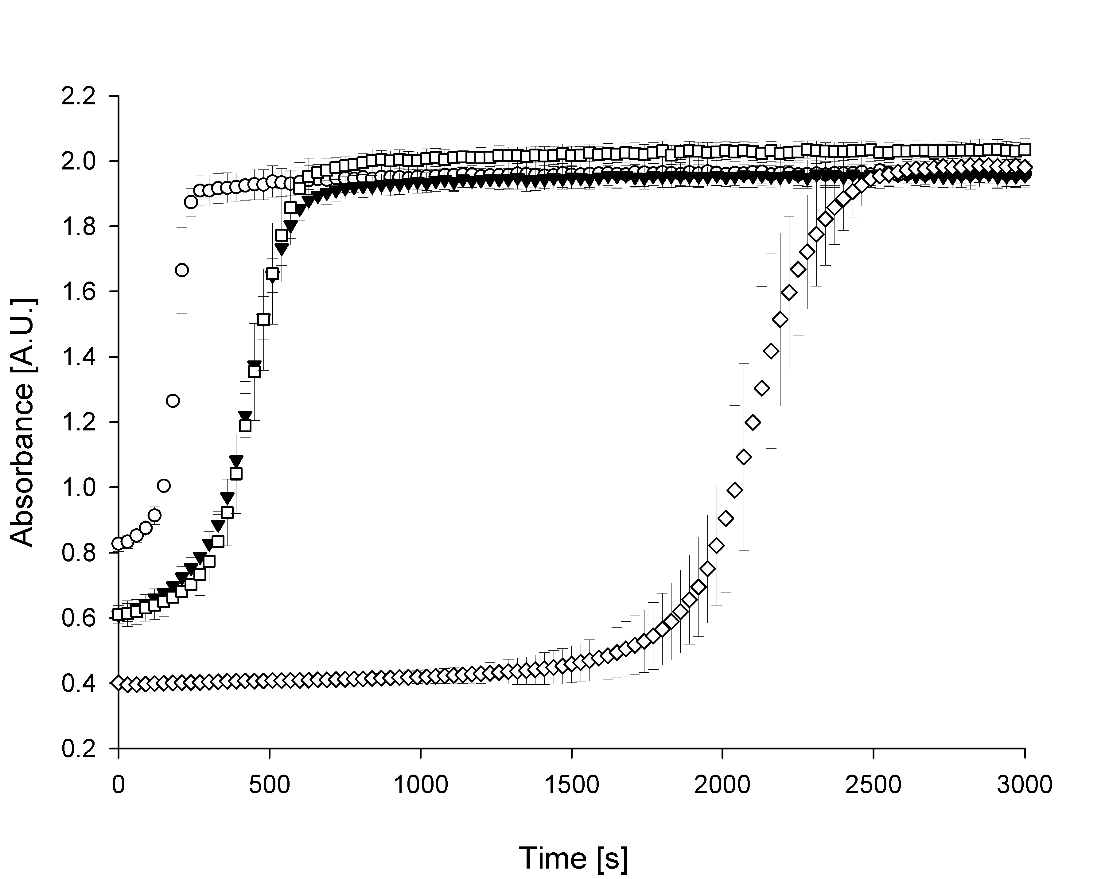
Fig. 2

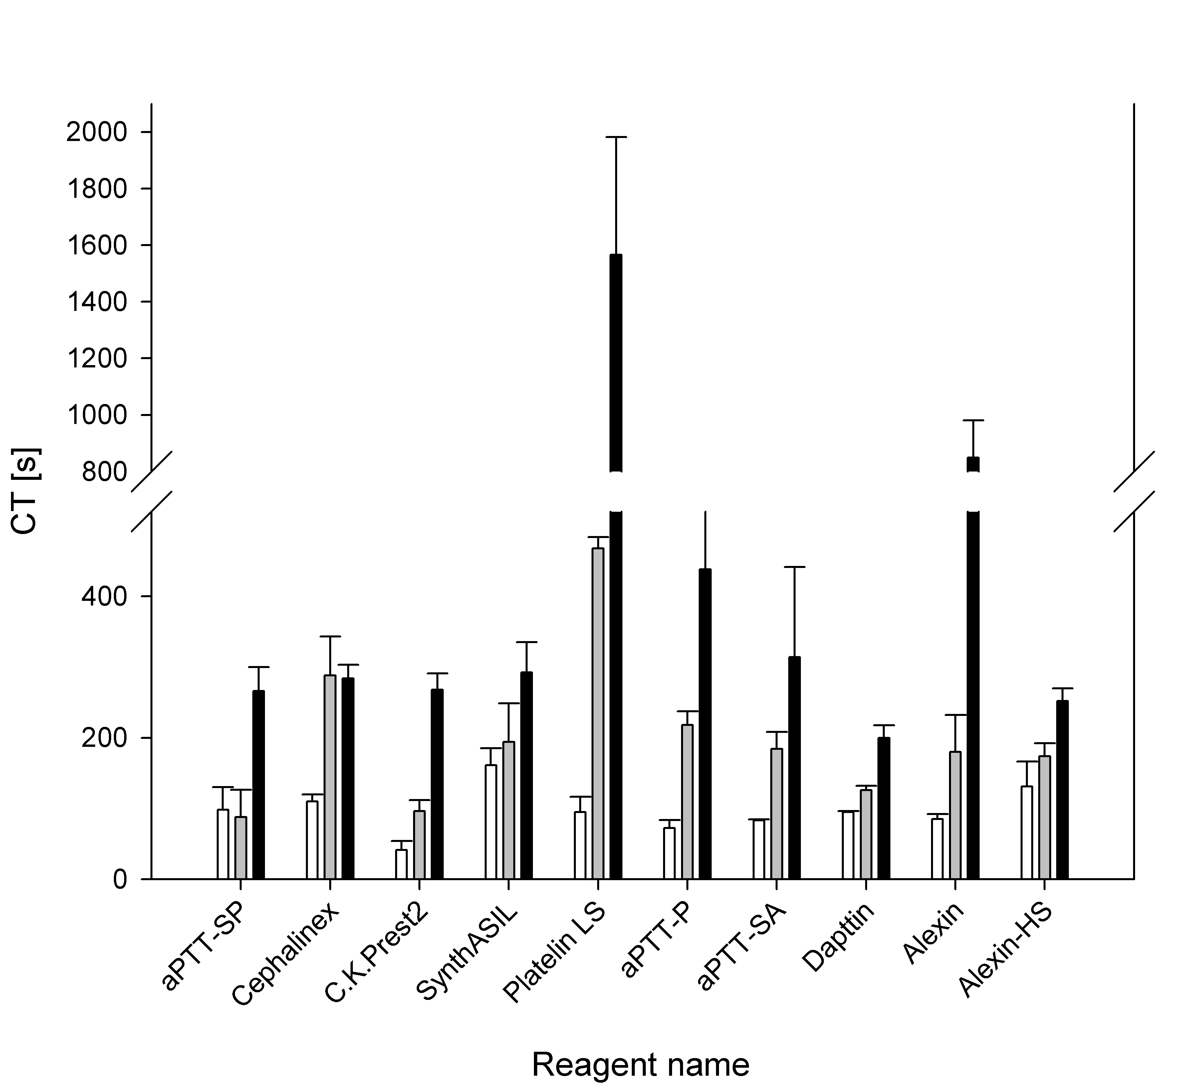
Fig. 3.

