Rewarding rush-hour avoidance: A study of commuters’ travel behavior

Eran Ben-Elia*,
Centre for Transport and Society
Dept. of Planning & Architecture
Faculty of Environment and Technology
University of the West of England
Frenchay Campus, Bristol, BS16 1QY, United Kingdom
eran.ben-elia@uwe.ac.uk

Dick Ettema
Urban and Regional Research Centre Utrecht
Dept. of Human Geography and Planning
Faculty of Geosciences
Utrecht University
P.O. Box 80115
3508 TC, Utrecht, The Netherlands
d.ettema@geo.uu.nl

*corresponding author

Submitted for peer-review to journal "Transportation Research A" 2nd Dec. 2009

In revised form 13th March 2011.

1. Introduction
Congestion on urban roads throughout the European Union is increasing and is expected to worsen as the demand for travel increases and supply of road infrastructure remains limited (European Commission, 2006a, 2006b). Loading of excess demand on the Transportation System has considerable external costs such as pollution, noise and road user safety (Mayeres et al., 1996), as well as, increasing frequency of incidents, interrupted vehicle flow and uncertain travel times (Lomax & Schrank, 2003).
Transportation economists have been arguing for implementation of road pricing as a first-best solution to efficiently alleviate congestion externalities. A toll which reflects the true marginal cost of travel is implemented on the congested facility, resulting in a reduction in the number of travelers at peak periods and improving traffic flows (Nijkamp & Shefer, 1998; Rouwendal & Verhoef, 2006). The bottleneck model (Vickrey, 1969) and its modern variants (Arnott et al., 1990, 1993) extend the Pigouvian model by showing how a queue is formed from the departure time decisions of individual travelers and how a time-dependent toll could in theory dissolve it efficiently.
In practice, imposing road pricing is controversial and insight is lacking in key domains which could lead to different outcomes than those predicted by economic theory. First, as suggested initially by Vickrey, optimal pricing requires that tolls are designed to be variable making it quite complex for drivers comprehension (Bonsall et al., 2007; Verhoef, 2008). Second, it raises questions regarding social equity (Giuliano, 1994) and public acceptability in addition to economic efficiency (Banister, 1994; Viegas, 2001). Furthermore, perceptions of fairness seem to play a key role in public acceptability of pricing schemes (Eriksson et al., 2006). Third, situational constraints such as household obligations (e.g. childcare), work organization and availability of information may also affect individuals’ responses to pricing schemes (Garling & Fujii, 2006) and limit their effectiveness.
Second-best schemes have been suggested to circumvent the difficulties in implementing first-best solutions (Small & Verhoef, 2007). In this context, it has been suggested that an incentive for avoiding peak-hour travel can achieve a similar behavioral response to that of pricing (Ettema et al., 2010). By rewarding those commuters who are willing to shift their commuting times or switch to alternative travel modes, overall penalization of drivers through tolling is avoided and overall welfare could well be improved by reducing peak demand.
People respond more favorably and are more motivated when rewarded rather than punished (Kahneman & Tversky, 1984; Geller, 1989). A considerable volume of empirical psychological evidence (e.g: Kreps, 1997; Berridge, 2001) supports the effectiveness of rewards to reinforce desirable behavior. However, in the context of travel behavior which has been to the most part analyzed using microeconomic theories (McFadden, 2007), it is not surprising that the behavioral rationale of many demand based strategies to manage traffic congestion is based on negative incentives that associate driving with punishments such as fines, tolls or increased parking costs (Rothengatter, 1992; Schuitema, 2003).
When rewards are applied in a travel context this is mostly in short term studies involving the use of a temporary incentive to reduce car driving either by providing free public transport (Fujii et al., 2001; Fujii & Kitamura, 2003; Bamberg et al., 2002; Bamberg et al., 2003; Currie, 2010), or toll (i.e. road pricing) discounts (Senbil & Kitamura, 2008; Chang-Hee & Bassok, 2008). In most cases commuter behavior returns to previous levels of peak travel once the incentive is ceased. Hence it still remains questionable if rewards can sustain behavior changes in the long run. These studies reveal that commuters’ habitual behavior of rush-hour driving and constraints related to household and work schedules are important factors which limit the positive impact of rewarding on car travel.
Moreover, following Prospect Theory (Kahneman & Tversky, 1979), perceptions of loss aversion suggest an asymmetry in the valuation of the reward as a prospective gain and the losses incurred by the time disruptions in changing one’s habitual schedule. Jou et al., (2008) and Senbil & Kitamura (2004) show through time use surveys the occurrence of loss aversion in prospective schedules around both the earliest and latest acceptable arrival time, whereby commuters are more sensitive to being late to work compared to arriving early. Hjorth & Fosgerau (2008), demonstrate in an experiment that when comparing travel prospects composed of time and costs, loss aversion is evident in both. However, the loss aversion in the time dimension is more acute, resulting in asymmetrical values of time which are higher when perceiving travel time losses. Thus, if a reward is to change commuter behavior, the time losses should be perceived as relatively small e.g. for commuters with more flexible work schedules.
In The Netherlands the notion of using rewards to change commuters’ behavior has been recently implemented in the context of the Spitsmijden program. Meaning peak avoidance in Dutch it is thus far the largest systematic investigation to assess the potential of rewards as an effective policy tool for congestion management. As such it is quite different than previous endeavors for evaluating the effect of rewards in both the scale and methods used. It commenced with a pilot study organized in the second half of 2006 by a public-private partnership consisting of three universities, private firms and public institutions (including the Dutch Ministry of Transport) and with an initial budget of over 1 million Euros. The pilot study centered on the vicinity of The Hague in the west of The Netherlands (see Figure 1), involving 340 participants and lasting over 13 weeks. The goal was to find, in an empirical field setting, what are the potential impacts of rewards on commuters’ travel behavior during the morning rush-hour. Participants could earn a reward (money or credits to keep a Smartphone handset which also provided real-time traffic information), by driving to work earlier or later, by switching to another travel mode or by teleworking.

*** Figure 1 – about here ***

Initial results provided evidence of substantial behavior changes in response to the rewards, with commuters shifting to earlier and later off-peak times and more use of public transport as well as working from home (Ettema et al., 2010). However, as noted, household and work constraints, flexible work arrangements and support measures such as travel information could well influence the response. For example, in a study of willingness to participate amongst local residents who were not participating in the program, Ben-Elia & Ettema, (2009) demonstrate that although the reward is the main motivation in potentially choosing to participate in a reward-based scheme, lack of flexibility in daily schedules was the main reason to reject it.
To date there is still a lack of understanding and knowledge as to what are the principle factors that could influence travelers’ behavior in response to the reward stimuli. Hence the main objective of this paper is to identify mediating factors and possible moderators (i.e. interactions). These are especially relevant if rewards are to be implemented as a policy tool for congestion management on a larger scale and for assessing their potential impacts on the transportation system’s performance. The rest of the paper is organized in the following way: Section 2 describes the pilot study’s design and data collection procedure. Section 3 details the data analysis methods and modeling of commuters’ choice behavior. Section 4 presents the analyses results. Section 5 presents a discussion and Section 6 concludes with suggested policy implications and further research directions.

2. Design & data collection

2.1 Participants
Following prior license plate observations, several hundred frequent morning rush-hour car commuters (with three trips per week or more) travelling on the busy A12 motorway stretch, were approached by mail. They were invited to participate in a program where they could receive daily rewards, either of money (between 3-7 Euros) or of credits to earn a 'Yeti' Smartphone (its market value was around € 500 at the time), if they avoided driving to work during the morning rush-hour (defined between 7:30-9:30 AM). 232 participants selected to receive a monetary reward (‘Money’) and 109 the Yeti reward. All the participants were inhabitants of the town of Zoetermeer and the vast majority was working at the time in The Hague or its vicinities. They are characterized by relatively high percentage of higher education, moderate to high incomes and mostly families with children. Table 1 presents a description of the participants by reward group.

*** Table 1 – about here ***

2.2 Design
Participants were instructed that they could avoid the peak-hour (defined between 7:30-9:30 AM) either by driving to work earlier or later, or by choosing other modes of travel (cycling, carpool, public transport), or by working from home (teleworking). A quasi-experiment (see Shadish et. al, 2002 for exact definition) ran for a period of 13 weeks. The first two weeks were unrewarded (pre-test). The data collected during the pre-test was used to determine participants’ reference travel behavior and subsequent assignment to reward classes. Weeks 3-12 were rewarded and the final week (post-test) was also not rewarded.
Participants selecting ‘Money’ were subjected to three consecutive reward treatments lasting 10 weeks in total: a reward of 3€ (lasting three weeks), a reward of 7€ (lasting four weeks) and a mixed reward (lasting three weeks) of up to 7€ - of which 3€ for avoiding the high peak (8:00-9:00) and an additional 4€ for avoiding also the lower peak shoulders (7:30-8:00, 9:00-9:30). A counterbalanced design was used to allocate participants randomly to 6 (that is 3! blocks) possible treatment orders. Participants selecting Yeti could acquire credit during a period of five consecutive weeks. If they earned enough credit relative to a known threshold they could keep the Smartphone. This threshold was determined by their reward class (see below). The other five weeks were without credits but participants could still have access to travel information. Participants were randomly divided between two treatment orders in relation to which of the first or second set of 5 weeks the credits could be awarded. Participants selecting Yeti also had 24 hour access to travel information via the handset for 10 weeks during the credit treatment, the no-credit treatment as well as the post-test. This information consisted of real-time travel times on the A12 motorway on the Zoetermeer – The Hague corridor and an online map showing congestion levels on other roads in the area. Information availability was not dependent on the reward itself. In contrast, participants in the money group had access to travel information available to all other drivers: pre-trip through internet and media and en-route from variable message signs along the motorway.
In addition to the treatments, each participant was also assigned to a reward class which determined his/her maximum eligible reward. A participant could only earn the reward relative to their frequency of driving in the morning rush-hour during the pre-test. That is, a participant who drove in the rush-hour during the pre-test three times per week, could only receive a reward for the third, fourth and fifth day in a week he/she avoided the rush-hour, whereas one who drove five times per week was eligible for any working day he/she avoided the rush-hour. This reward could be either the daily monetary reward or the threshold number of credits needed to keep the Yeti (see Table 2). The motivation was to avoid increasing off-peak travel which was not offset by at least a similar decrease in rush-hour travel. Accordingly, each participant was allocated into one of four possible reward classes. The majority of participants belonged to classes A and B and the minority to classes C and D. . Further details can be found in the report (in English) of Knockaert et al., (2007) also available from the authors by request.
*** Table 2 – about here ***

2.3 Data collection
Data was collected during the study in several stages. In the first stage, after registering (April-August, 2006), participants completed a web-based pre-test survey. This survey gathered data regarding home to work daily travel routines, individual and household characteristics (gender, age, education level, income, family composition); work schedules (i.e. flexibility in departure from home and in starting work early/late, or ability to telework), family obligations (e.g. childcare or child chauffeuring duties), availability and use of alternative means of transport, attitudes towards alternative travel modes and regular use of travel information. The survey results are reported in Section 4.
The second stage consisted of tracking participants’ observed behavior, and lasted 13 weeks (September-December, 2006) of which in weeks 3-12 rewards were eligible. Detection equipment using in-vehicle installed transponders and electronic vehicle identification (EVI) as well as backup road-side cameras was installed at the exits from Zoetermeer to the A12 motorway and on other routes leaving the city. This equipment allowed detecting each and every participant’s car passage during the course of the day, minimizing the ability of participants to cheat by trying to access alternative routes. Participants were also instructed to fill in a daily web-based logbook that recorded whether or not they had commuted to work (and if not, why not), which means of transport they used and at what time slot they made their trip. This information was used to gain insight into situations in which the participant’s car was not detected by the EVI.
The third stage of the study was a post-test survey conducted several weeks after the termination of the experiment. In this survey questions were asked about the participant’s subjective experience during the course of the experiment. This dealt with their retrospective assessment of behavior adjustment (was it easy / difficult to adjust travel behavior and how much effort was involved in changing one's behavior). Other questions focused on support measures such as discussions with the employer, colleagues and household members about flexible working times and household routines, practicing with rush-hour avoidance during the pre-test phase and purchasing of certain items. Questions were also asked regarding the use of travel information enabling a pre/post-test comparison that indicated a significant increase in usage of both traffic and public transport information. Retrospective motivations to participate in the program were also inquired. One fact to be noted is that during the experiment disruptions occurred with the regional rail service and bus service replacements were not always adequately provided. In retrospect this was mentioned as causing participants some difficulty for using the public transport.

3. Modeling and analysis method

3.1 Approach

The observed data consisted of 13 weeks equal to 22,165 observation-days. As the focus of the research is on commuter behavior, only working days (including working from home) were taken in account, leaving 16,725 observations for complementary analysis. Two data sources were available for observed behavior: detection data of participants’ car passages on one hand, and the daily logbook filled in online by the participants. In this paper we decided to focus on the logbook. The main reasons were the completeness of the data which included not only car travel but also non-car travel. In addition, the logs provide a unique description of each days travel choice whereas detections could appear several times a day. Furthermore, the logbooks and detections were checked by the project’s back-office for consistency. We leave the detection data for future work (and see Conclusions). The logbook contained several entries: first, normal entries on working days about the choice of departure time by car (in 30 minutes intervals), choice of another mode or working from home; second, abnormal entries included situations like use of another car, non working day (holiday/ illness), problems with the equipment etc. Only normal entries relating to working days were included in the analysis.
Commuters’ responses in the logbook were differentiated to a closed choice set of four discrete alternatives: rush-hour driving (RHD), driving earlier (DE) or later (DL) than the rush-hour and not-driving (ND). Since each participant provides up to 65 consecutive daily responses, the data is constructed as a panel. Although each participant's responses are independent of the other participants, within each participant's responses, observations are dependent and hence correlated. Thus, the classic assumption of identically independent distributed (i.i.d) error terms is violated. Specifying panel effects can accommodate for this deficiency. In the context of discrete choice this can be accomplished using a mixed discrete choice model such as the Mixed Logit model. Mixed Logit (MXL and also referred to as Logit Kernel) is an advanced and highly flexible discrete choice model. MXL accommodates random taste variation, substitution patterns, and correlation in unobserved factors unrestricted over time (McFadden & Train, 2000) and can be derived under a variety of different specifications (Ben Akiva & Bolduc, 1996; Bhat, 1998). It is also easily generalized to allow for repeated choices i.e. panel data (Revelt & Train 1998; Bhat, 1999; Train, 1999).
The discrete choice model uses an attractiveness measure (called utility) for each specified response category (called alternative). The greater the utility of an alternative is, the higher is the probability of a participant choosing it. The model uses the independent variables to explain this probability. Formally, the utility (U) of person n of alternative i in response t and the probability (P) of person n choosing alternative i in response t are (eq. 1, 2):

(1)

(2)

Here, P is the conditional probability that person n chooses alternative i out of a set of J alternatives, Y, is an indicator that i is chosen at response t, X is a vector of explanatory fixed factors, β is a vector of fixed coefficients and ε is a vector of independently, identically distributed (iid) extreme-value type 1 error terms (or white noise). α is a vector of random coefficients distributed with α₀ mean and a covariance matrix Σ_{α} varying between participants but remaining constant within the observation panel set of each participant i.e. capture the panel effects. Often, a normal distribution is assumed for α  i.e. (in this case the term ‘random effects’ is often used). Correlation between the random coefficients can also be specified and different combinations of error components (i.e. similar coefficients are attributed to different alternatives) creating specific correlation (i.e. pseudo nested) patterns.
The model is estimated by maximizing the log-likelihood (LL) function of the unconditional probability (eq. 3).
$LL=$ (3)
However, as the unconditional probability is obtained by integration over the random coefficients and this integrand has no closed form, simulated log likelihood (SLL) is applied using random draws (Train, 2000; Train, 2002; Bhat, 2003) (eq. 4):
$SLL=$ (4)
where, R is the number of draws (r).

3.2 Procedure and modeling specification
The data analysis process included two stages. In the first stage initial choice modeling using mixed logit specifications was conducted with aggregate data. Instead of daily discrete choices we computed average treatment-level proportions. Thus, each participant provided 4 or 5 grouped observations (depending on the group Money or Yeti), instead of 65 discrete observations (1532 observations in total). This method allowed a considerable amount of savings on estimation time (hours compared to days) and the ability to test different specifications rapidly. The analysis from this stage is reported in a separate paper (Ben-Elia & Ettema, in review).
In the second stage, which is reported here, we used the best specifications obtained from the aggregate model and applied them to the daily (disaggregate) data. Due to missing values in the data, this included in the final results 14,750 observation for a panel of 335 participants (6 were excluded listwise). This approach also allowed to test daily varying factors which could not be included in the aggregate model like weather variables. Furthermore, the aggregate model is very conservative in a sense that only averaged effects can be identified. Richer descriptions can be tested with the disaggregated daily data.
We used BIOGEME version 1.8 (Bierlaire, 2003; Bierlaire, 2009) for model estimation. We compared the goodness of fit of each model both to simpler models - one that contained only panel effects (i.e. a random coefficients' model) and one with only the reward treatment effects (a restricted model) but without other mediating factors. We tested different specifications for the random effects including independent alternative specific coefficients (ASC's), correlated ASC's and error components. Error components which mimic a nested structure were specified for a "drive" – "not drive" structure or a "rush-hour" vs. "change" (i.e. early, late or not drive) structure. However, in terms of goodness of fit we found that correlated ASC's provided better results. Simulated log likelihoods of all models were estimated with 1,000 Halton draws (Halton, 1960) which significantly reduce the number of draws required compared to pseudo-random draws (Train, 2000; Bhat, 2003). The models were estimated using 100, 500 draws and 1,000 draws. The differences between the last two sets were negligible. The results presented here are for the set of 1,000 draws. We also applied appropriate guidelines to assure proper identification (Walker et al., 2004). Consequently, for the Not-Driving alternative, α₀ND =0 and σ_{α}^{ND} =1.

4. Results

The results are presented in the following order: First (section 4.1) we report the main findings from the stated behavior obtained from the two surveys. Next (section 4.2), the analysis of observed behavior using the discrete choice model are presented.

4.1. Stated behavior from surveys
Participants filled in two surveys: before the pre-test and several weeks after the post-test. Table 3 presents the surveys’ results for selective factors. For lack of space we do not provide all the tables of frequencies these can be obtained from the authors by request.
*** Table 3 – about here ***

Pre-test survey
The survey focused on the usual (travel) behavior of the participants. The socio-demographic factors, also seen in Table 1, reveal a relatively homogenous population with high education levels (56%), moderate to high incomes and mostly families (81%). The majority of participants are men and the gender between-group difference is significant.. The common used transport mode of travel is the car (80%). Alternative modes are used by only 20%. However, the average frequency of using non-auto modes is usually less than twice per week. Public transport (mainly train) is considered as a realistic alternative to driving for about a third of the sample. The main stated reason why public transport is not used regularly is the travel time. Cycling is less acceptable, mainly due to distance. Departure time and preferred start of work time (proxy for preferred arrival time) show that the most common time for commuting is the morning rush-hour. Usual start of work time is almost identical to the preferred one.
Participants were also asked regarding to their ability to hold flexible schedules. Almost half of the participants can depart earlier from home (on average 26 minutes). More than half can depart later from home (on average about 30 minutes). Around 60% of the participants can start to work late at least 3 days per week reporting a possible delay of 70 minutes on average. A quarter of the participants reported they can telework around 0.5 days per week. About 46% of participants can leave work earlier if they begin to work earlier; 40% can finish working later if they begin later; 27% reported they have fully flexible working hours. The differences between groups appear to be quite small. Regarding home related constraints on early departure, 30% of the participants reported they have childcare duties and 20% reported children chauffeuring duties as not enabling them to depart earlier from home. On the latter the between-group difference is significant.

Post-test survey
The survey focused on evaluating the participant’s experiences, difficulties incurred and identifying support measures which assisted in changing of behavior.
As part of inquiring about their experiences, participants ranked the perceived effort involved in their avoidance behavior. Less than 10% reported a very high effort in changing their behavior and only about a third reported some effort involved. Around 32% raised the issue of problems with the running of the regional rail service (Randstad Rail). No significant between-group differences were identified. Relatively few complained about lack of alternative modes, or weather. Social support was stated by all participants as facilitating behavior change. This included mainly arrangements with the employer (40%), and with family members (30%). The former has a significant between-group difference. Practicing behavior adjustment in the pre-test phase (30%) was also mentioned. This factor reflects on the level of exploration of certain participants.
The retrospective motivations to participate in the program were also inquired. The main reason to participate was to get the reward (42% for money, 30% for Yeti). In the Yeti group, however, gaining experience with the Yeti and with traffic information also seemed important in addition to the reward itself (20%). ‘Social’ contributions such as solving or gaining knowledge about congestion were also indicated by both groups (34%). This result is in line with other studies that discussed road pricing acceptability, as well as the non-participant’s survey which indicated similar results (Ben-Elia & Ettema, 2009).
Posterior satisfaction from the experiment was on average positive. About half of the participants reported that they changed their driving times and would continue to do so in the future; 15% reported they changed to public transport (mostly to regional rail) and found it attractive; only about 14% reported they returned to their previous behavior once the experiment was terminated About 60% of the participants stated they consider the reward a good idea to encourage behavior change. In general, 88% of participants stated they would choose to participate again if given the opportunity. No significant differences between groups were found in this respect.

Change in travel information use
In comparison to the pre-test survey, the post-test survey shows an increase in the frequency of accessing travel information – both traffic information and public transport information. The mean weekly frequency of consulting pre-trip traffic information (for work trips only) for the Yeti group, increased from 1.8 to 3.7 times per week (t=-4.39, p<.001). For the money group there was no significant change (t=1.63, p>.1). The mean weekly frequency of consulting pre-trip public transport information increased significantly for both the money group (t=-2.48, p<.05) and Yeti group (t=-3.63, p<.001).

4.2. Model estimation
The results of the estimation are shown in Table 4. Figure 2 also presents an illustration of the response for each of the four chosen alternatives. For visualization purposes we present weekly average rates. All the utilities are linear. The definitions of each variable are also indicated in the table. The standard deviations and the covariance estimates of the random coefficients are also indicated..
*** Figure 2 – about here ***

*** Table 4 – about here ***
The goodness of fit of the final model was compared to two simplified models: The first with random constants only, the second with treatments (reward types and levels) but no other behavioral factor. The constants model with random coefficients has a log likelihood of -12,992.35. A log likelihood ratio test shows the final model has a better goodness of fit compared to the constants only model (χ² = 2143, df=26, p<.001). The rewards-only model had a log likelihood of -12,209.32 and the log likelihood ratio test is significant (χ² = 577.5, df=20, p<.001). Therefore, in both cases the final model is better than more restricted specifications. This also indicates that the reward is not the only significant factor explaining commuter’s travel behavior. The random coefficients’ means α^{RHD} and α^{DE} are significant, whereas α^{DL} is not significantly different than zero. All the standard deviations of the random effects (σ_{αi}) are significant (p<0.001) and the covariance’s of the random effects are also significant and negative as expected (p<0.001).
The rewards were entered into the utility of the RHD alternative as dummy variables representing the different treatment levels. Although it was possible to use the monetary values we were more interested in testing the difference in the effects of the three different levels. The table shows that all reward treatments are significant (p<.001) and the sign of the coefficient is negative as expected. This can also be seen in the reduction in RHD shares between weeks 3-12 (Figure 2A). The effects of the 7€ level (R3) and the mixed reward (R4) are the strongest albeit quite similar. The effect of the Yeti credit (R6) is similar to that of the 3€ level (R2). Surprisingly, the effect of Yeti without credit (R5) is also significant.
Regarding the other three alternatives Figures 2B through 2D show the rewards increase the weekly shares of driving earlier and later as well as of ‘not driving’ compared to both pre and post test levels. The main noticeable differences are the relatively higher shares of DE and lower shares of DL for the money group compared to the Yeti group (Figure 2B, 2C).
Mediating factors included the design related factors (reward class and treatment order), and factors relating to the participants’ stated behavior derived from the two surveys. First, as neither the treatment order nor any of its interactions were significant we can conclude that the order of treatments had no effect on behavior (the order effect is discarded from the final model and not seen in Table 4). Second, among socio-demographic characteristics gender has a significant effect on RHD (p<0.05) suggesting men tend to change behavior more often than women.
In the case of money, higher education has a significant and negative effect on driving later (p<0.001). A possible explanation is that education as a proxy for income could well be masking an income effect However, specifying an interaction between higher education and higher incomes (3,000 € or more) did not show any significant effect. The large number of refusals to report income is probably to blame for the lack of significance.
Third, we find that factors relating to usual or habitual behavior have significant results. The reward class, which relates to pre-test levels of driving to work during the rush-hour, has a significant and positive association with RHD for both groups (p<0.001)., In both groups, participants associated with classes A, B (2.5 - 5 rush-hour trips at pre-test) were more likely to continue driving during the rush-hour compared to classes C and D (0-2.5 trips). In addition, the class coefficient for money is slightly larger than that of Yeti. The usual departure time has a negative association with DE: i.e. the earlier is the usual departure time - the more probable is a change of behavior by driving earlier. The preferred start of work time, a likely proxy for the preferred arrival time, has a similar negative effect on DE. Finally, the use of other modes for commuting has a positive effect on not driving. This shows that positive experience with travel by other modes also may encourage their use to gain a reward.
Fourth, scheduling constraints on early departure such as child chauffeuring or childcare were not found significant. However, an interaction between child chauffeuring and the 7€ reward is significant (p<0.001). It indicates that even with the highest level of reward – this constraint is still effective in discouraging a change of behavior. A possible interaction by gender was tested but found to be not significant. In contrast to constraints, support measures have a positive effect on behavior change. Participants who stated they discussed flexible working times with their employers were less likely to drive during the rush-hour (p<0.05). It is noted that on this measure Yeti users reported in the post-test survey higher shares compared to the money group (see Table 3) which might have allowed them greater flexibility in their behavior during the pre-test as well as the rest of the experiment. However, a test of moderating this effect by group did not result in any significant interaction. The number of days (per week) that starting work late is possible has a positive effect on DL (p<0.001). This suggests that participants with ability to start working later are more likely also to drive later. Ability to telework was not found to have a significant effect. It seems that many participants that stated ability to telework also tended to start work later, which may explain lack of significance.
Fifth, several stated experiences during the course of the experiment were found significant. In the case of money, the parameter for ‘practicing with behavior change’ is almost significant (p<0.1); this suggests, participants in the money group who reported practicing with avoidance behavior during the pre-test were more likely to avoid the rush-hour. It is also noted that this effect may have resulted in a lower RHD share in the pre-test observations compared to the stated usual behavior. Participants in the money group, who reported in retrospect a greater difficulty (in terms of effort) in changing behavior, were also less likely to avoid the rush-hour (p<0.1). These results indicate that positive or negative perceptions regarding experiences can have an influence on the likelihood to change behavior.
Sixth, beliefs or attitudes in relation to public transport and cycling as realistic alternatives to driving are also important. Participants with a positive attitude towards public transport were less likely to change behavior by driving at other times (the parameters for both DE and DL are negative, p<0.001). In contrast, participants with a positive attitude to cycling were more likely to change behavior by not driving (the coefficient for ND is positive, p<0.001). This result indicates the significance of the attitudes towards driving alternatives in influencing change of behavior.
Seventh, we found several significant effects for information usage. Participants with frequenter use of traffic information were more likely to drive later (the coefficient for DL is positive, p<0.001). Since most of the change in use of traffic information is related to Yeti users, this effect might also indicate the greater propensity of these participants to depart later for other reasons. Participants with frequenter use of public transport information (p<0.05) and/or stating they had searched for public transport alternatives to support their behavior change (p<0.001, were more likely to change behavior by not driving (the coefficients for both these factors are positive). In addition, an interaction effect between the Yeti without credits and use of public transport information is significant (p<0.001). This indicates that even without an extrinsic reward, the Yeti has instrumental value by allowing easier access to travel information which in turn encourages also the use of non-driving alternatives to commute.
Finally regarding influence of the weather, the only significant factor found was wind speed which is associated negatively with not-driving (most likely to cycling inconvenience). Conversely, neither temperature (mean or max) nor precipitation had any significant effect.

5. Discussion
In terms of the factors influencing commuter travel behavior, the results indicate that the reward is the primary factor affecting their choices and the likely trigger that motivates commuters to consider changing their behavior. However, it is also clear that this effect is mediated by other factors which include socio-demographic characteristics, situational factors (home and work related), habitual behavior and experience, attitudes, travel information and even weather. We discuss their implications and relate to the relevant references in the literature below.

5.1 The rewards
The results assert that both the monetary reward and the Smartphone reward are effective in reducing rush-hour car commutes, at least in the short run. According to the choice model, this is the most prominent factor that influences behavior. The 3€ level already has the largest influence on behavior change while the 7€ level and the mixed level having relatively only a marginal effect. Thus in terms of cost-effectiveness it seems that most of the benefits from a change in commuters’ behavior can be accomplished with this level or similar. The Yeti credits seem to be equally effective to the 3€ level. A possible explanation for this is that the Smartphone handset (as an in-kind reward) may be regarded as an uncertain endowment. A valued endowment is not easily given up (Kahneman et al., 1991). The endowment effect may well motivate to change behavior just in order to avoid the loss (i.e. the negative affect) associated with the possibility to give up a valued object. However, for practical reasons, there may be difficulty in implementing an in-kind reward over a long period of time. Surprisingly, the effect of Yeti without credits is also significant.. Although it is has the weakest effect amongst the treatment levels, the results suggest that possession of the Yeti even without credits contributes to a moderate decrease in RHD. This treatment had no apparent reward but travel information was still accessible to Yeti users.
Furthermore, it is evident that Yeti users were more likely to choose to drive later compared to participants in the money group. Two possible explanations are possible for this different behavior. On one hand, the percentage of Yeti users stating they had support from employers with more flexible working times was significantly higher than the participants in the money group. Thus, it is possible that these pre-adjustments were influencing the choice to depart later (especially during the pre-test). On the other hand, the main advantage Yeti users had over the other group was 24 hour access to travel information. This leads us to suggest that the change of behavior is also influenced by travel information availability (discussed later on).
Despite the effectiveness of the rewards, it is difficult to conclude from a relatively short longitudinal study about the impacts of rewards in the long run. Motivation theories suggest that if intrinsic motivation kicks in, the change of behavior is more likely to be sustained (Deci & Ryan, 1985; Cameron et al., 2001). We observed in the post-test, once rewards ceased that avoidance shares dropped and that participants had returned more or less to their pre-test level of RHD. In this respect the results are similar to other studies involving temporary measures as mentioned in the Introduction. Therefore at first glance it seems the change was not sustained for most of the participants. Notwithstanding, in the post-test survey less than 15% of participants stated they had returned to their previous behavior. Unfortunately, we do not have field observations to corroborate this subjective evaluation.

5.2 Socio demographics
Among the socio demographic variables, gender and higher education, were found to have significant effects on commuters’ behavior. The connection between socio-economic characteristics and travel choices is well documented Harris & Tanner, 1974. It is apparent that men are more likely to avoid the rush-hour compared to women. Women’s lower motivation to avoid the rush-hour, despite the possibility of gaining a reward, can be associated with many issues. One idea that suggested in social mobility studies (Palma et al., 2009) is that women have more time constraints compared to men for various reasons, mainly household tasks and child raising obligations. Dutch women quite often leave work early in the afternoon to pick up children from nurseries (Schwanen, 2007). This limits their ability to change their schedule - e.g. to start work later even when extrinsically motivated by a reward. However, a larger sample is needed to verify causation between gender and time-use behavior. Participants (in the money group) with higher education were also less likely to drive later. Education is a known proxy for latent income effects. Income is regarded as a key issue determining willingness to pay for travel purposes as well as the value of travel time savings (Ben-Akiva & Lerman, 1985; Axhausen & Gärling, 1992). In the context of the money group, participants with higher real income are likely to be less sensitive to a marginal monetary gain compared to participants with lower incomes. As a result motivation to avoid the rush-hour would be likely negatively associated with real income. Education did not appear to be a relevant factor on the behavior of Yeti users, possibly because it its value is appreciated instrumentally and affectively, rather than in monetary (how much it’s worth) terms.

5.3 Situational factors
Scheduling constraints such as household obligations (e.g. child care, children chauffeuring) and work organization have been found by others to influence individuals’ responses to pricing schemes and limit their perceived effectiveness (Gärling & Fujii, 2006). Contrary to our expectation childcare or child chauffeuring duties do not seem to have a significant impact on commuters’ response to the rewards. The latter was found to have a positive significant interaction with the 7€ reward indicating that this constraint even with an attractive reward inhibits a change of behavior. We investigated if gender could have an interaction effect here but again no significant results were found. Conversely, factors related to flexible working times appear to be important in encouraging behavior change. Participants that could start working later were more likely to drive later. Participants reporting to have received support from their employer with arranging flexible working times were also less likely to drive in the rush-hour. These results assert that flexibility, especially at the work place, is a key issue in promoting changes in travel behavior. Home-related support measures such as household arrangements did not have any significant effect on behavior-change. These findings also concur with Hjorth & Fosgerau (2008) findings regarding loss aversion in travel time – i.e. participants who perceived the time disruption losses as minor (because of flexible schedules) compared to the gained reward were more likely to change their behavior in response to the reward.

5.4 Habitual behavior and experience
As asserted by Gärling et al. (2001) and Gärling & Axhausen (2003), in the long run habitual travel behavior, is quite relevant for promoting or discouraging a behavior change different from one’s usual travel behavior. Habitual behavior is less intentional more automated and script based (Triandis, 1977; 1980; Ronis et al., 1989; Gärling & Garvill, 1993). Travel decisions (e.g. the drive to work) are an example of habitual behavior as repeated decisions which loose intention and become gradually routinized (Verplanken et al., 1997; Gärling et al., 1998). The effect of habitual behavior is evident in the significance of the reward class, usual departure time, the preferred start of work time (in the case of shifting driving times) as well as the use of other modes for commuting purposes (in the case of switching mode).
Specifically, participants with higher rush-hour commute frequencies during the pre-test (reward class A, B) were relatively less likely to avoid the rush-hour compared to participants with lower rush-hour frequencies (class C, D). Two potential explanations are put forward. First, in terms of effort, a similar relative response demands more rush-hour avoidances from frequent rush-hour drivers than from less frequent ones. Hence, the effort involved is higher for high frequency drivers. This is in line with Gärling et al., (2004) and Cao and Mokhtarian (2005), who found that travelers prefer low effort responses over high effort responses. A second explanation is that the added value of additional rewards depends on the amount already gained, in the sense that the marginal utility of reward decreases. Thus, the extra rewards gained by high frequency drivers will have a lower impact on behavior. This is in line with the idea of ‘satisficing’ behavior described by Simon (1987). In the case of Yeti users, the effect of reward class is weaker. This might be related to the affective qualities of the Smartphone (i.e. avoiding the displeasure of having to give it back) encouraging avoidance. In addition, real-time travel information may have been useful in reducing perceived effort and promoting self confidence in the ability to manage with rush-hour avoidance. The usual departure time was a decisive factor affecting the choice to depart earlier as well as the preferred start of work time, a likely proxy for the preferred arrival time. Furthermore, previous experience using other transport modes contributed to the choice not to drive. These results suggest that a type of inertia has an important effect on the change of commuters’ behavior. Psychological literature asserts the importance of the status quo as point of reference and the bias it creates in the evaluation of alternatives (Kahneman et al., 1991). That is, behavior-change is likely linked to the perceived bias between the usual behavior and the required change – the smaller it is the more likely is that the change will be adopted.
Contrary to the usual behavior, a change of behavior involves exploration and learning based on practicing and reinforcement. Reinforcement theories, such as the fundamental law of effect (Thorndike, 1898), state that behavior will be sustained if a positive outcome is experienced (Dayan & Balleine, 2002). Several studies in route-choice behavior (Avineri & Prashker, 2003, 2006; Ben-Elia et al., 2008; 2010) have identified the significance of experience and learning in a travel decision context. Practicing avoidance behavior during the pre-test was reported by almost a third of the participants (in both groups) and, in the case of money found to decrease the likelihood of rush-hour driving. It is highly likely that the two weeks of pre-test were devoted by some participants for gaining experience with avoiding the rush-hour. This effect was not found to be significant for participants with the Yeti.

5.5 Beliefs, attitudes and perceptions.
Several studies (e.g. Gärling et al., 1998; Gärling et al., 2001; Gärling & Axhausen, 2003) suggest attitudes towards travel alternatives, affect the choice of travel modes and these have also been the focus of attempts to improve choice modeling (Walker, 2001; Cherchi, 2009). The Theory of Planned Behavior (Fishbein & Ajzen, 1975; Ajzen, 1991) suggests that positive beliefs regarding a behavior change leads to a positive attitude towards a certain behavior that will influence a person’s intention to consciously engage in it. Our results support this assertion in that participants’ beliefs regarding alternative modes influence the choice of avoidance behavior. If these are positive (defined as regarding a travel public transport and or cycling as a realistic alternative), driving is discouraged (including at off-peak periods) and mode switch away from the car is encouraged. Another issue is that of personal norms - self expectations or specific actions in specific situations (Schwartz, 1977 - referring to feelings of moral obligations to behave in a certain way (e.g. environmental friendly behavior). In the post-test survey we found that pro-social reasons regarding solving and gaining knowledge over congestion were also indicated, in addition to the reward, as a motivation to participate in the program. This indicates that norms also play some part in the change of behavior. However this requires further in-depth investigation. Perceptions regarding the difficulty in change of behavior were found, in the money group, to be negatively associated with rush-hour avoidance. This effect was found to be not significant for the Yeti group. It can be argued that possession of the Yeti and the accessibility to travel information may well have reduced the perceived effort. This also is in line with the results regarding the influence of the usual behavior and those of flexible scheduling.

5.6 Travel information
The influence of information on travelers’ choices is well documented (e.g. Polydoropoulou & Ben-Akiva, 1994). Recent studies in the lab point out to the availability of travel time information having significant effects on behavior and risk attitudes (Srinivasan, & Mahamassani, 2003; Avineri & Prashker, 2006; Ben-Elia et al., 2008). For example in the case of route-choice, Ben-Elia & Shiftan, (2010) found real-time travel information expedites learning in unfamiliar environments and reduces initial exploration compared to lack of such information. Our results point also to the behavioral effects of information in a real-life situation. First, there are significant between-group differences - Yeti users having relatively higher shares of driving later compared to higher shares of driving earlier in the money group. Yeti users’ main advantage was their easier access to travel information whereas the participants in the money group had to (actively) search for the same information i.e. it involved more effort. However, as noted this result could also be confounded by the difference in prior arrangements with employers over flexible working times which were more dominant with the Yeti group. Second, access of travel information, mainly traffic but also public transport information, intensified during the course of the experiment (pre/post-test comparison). Thus, decision-making in a changed environment apparently increased the need for information about the outcomes of alternatives. Again this change is most noticeable for Yeti users. Third, information availability is positively associated with not driving or driving later. Participants who frequently accessed traffic information were more likely to drive later. Participants who frequently accessed public transport information and who were actively perusing information over public transport connections were more likely to avoid driving altogether (as noted also in the positive interaction of not driving with the ‘without credit’ treatment). It seems therefore that active information acquisition and choice of avoidance behavior are related. However causality here is more difficult to determine as participants could also increase information acquisition for the alternative they liked better.

5.7 Weather
Windy conditions that are prevalent in the study area close to the North Sea show that ‘not driving’ is less likely with increasing wind speed. This probably relates to the use of the cycling/walking as a popular mode of access or egress when the main travel mode is public transport (train) and can make it uncomfortable and even unsafe to cycle when traversing open spaces. It is apparent that weather conditions should be more carefully considered in situations where a demand management scheme is trying to encourage more use of non-motorized modes and active travel.

6. Conclusions
Congestion levels on major roads in the Netherlands are rising while alternative policies like road pricing are difficult to implement, in the short run, mainly due to lack of public support. Consequently, rewards have been suggested as a second-best strategy for managing congestion. The 'Spitsmijden' program was designed to empirically investigate the impacts of rewards on travel behavior concerning commuting decisions.
The main conclusion regarding the use of rewards in changing commuters’ behavior is that in the short run it seems to work. Nonetheless, it is still an open question whether the change can be sustained in the long run and without rewards. We do not have enough post-test observations to provide an answer apart from subjective assessments by the participants. A second conclusion that can be drawn from this research is that although the reward influence the magnitude of change – an increase or decrease in rush-hour avoidance, choosing how to avoid the rush-hour – driving at other times, switching to another mode of transport or working from home, is not determined by the reward, but rather by different factors relating to the participants and their particular situations.
Two main drawbacks to the study to be noted are the self selection to reward types which makes it more difficult in a quasi-experimental design to validate some of the outcomes (e.g. did information contribute to driving later or were Yeti users more prone to drive later due to pre-arrangements). However given that there were not many a-priory differences between the groups and that some moderating effects are identifiable this issue seems less cardinal. A second issue is the lack of a control group of participants. Comparison with traffic states during the experiment show that there were no significant changes in behavior of other drivers. Therefore it is likely that a control group would have showed its behavior had not changed either.
Several further research directions can be indicated. First, the research so far has focused on the log-book data and aggregate response categories. However, vehicle detection data provides a unique opportunity to estimate departure time choice models from real data. We are working on such model based on concepts of a latent preferred arrival time (see Ben-Elia et al., 2010a for initial findings). Second, due to the success of the current study, a further investigation is being carried out (since 2009) on the basis of the monetary reward (Spitsmijden 2A/2D), involving a larger group of participants (close to 4,000), in a larger catchment area, over a much longer period of time (one year or more). For practical reasons and based on the current results that a modest monetary reward can motivate a cost-effective behavior-change, the Dutch Ministry of Transport has decided to peruse long-run surveillance of avoidance behavior using a single monetary treatment (€ 4). One important conclusion of the current study is that we lack an in-depth understanding of how the process of behavior-change occurs and participant motivations in the long run. For this purpose we recently conducted a small scale qualitative research (using semi-structured interviews) with a small number of participants (see Ben-Elia et al., 2011 for the main findings).
As a closing remark, following the success of the current study, application of reward-based schemes is now taking place across The Netherlands. Some concern has been expressed, mainly based on estimates of traffic simulation models, that too many people might start changing their schedules to gain a reward (Bliemer & van Amelsfort, 2008). However, the evidence in the field does not support this claim. Reward effectiveness in mitigating congestion, especially in situations involving temporary road and bridge maintenance or lane closures has been recently verified (Bliemer et al., 2009). A recent survey of firms also has shown positive attitude amongst employers towards the reward scheme (Vonk-Noordegraaf & Annema, 2009). The majority of the Dutch public and the (previous) government are quite content with the new policy. There has even been a suggestion to implement a similar scheme onboard the railways on lines where peak demand is excessive. Notwithstanding, the government also wants to advance a policy of a universal kilometer road charging by 2018 – beginning with Trucks in 2012.

Acknowledgements
This study was undertaken as part of the Spitsmijden project, which was funded by Transumo, the Ministry of Transport in the Netherlands, Bereik, RDW, NS, Rabobank, ARS T&TT, OC Mobility Coaching, Vrije Universiteit Amsterdam, TU Delft, Universiteit Utrecht. The modeling framework was discussed in the 5th Discrete Choice Modeling Workshop organized at EPFL (Lausanne, Swizterland) in August, 2009.

References
Ajzen, I. (1991), "The theory of planned behavior." Organizational Behavior and Human Decision Processes, 50, 179-211.
Arnott, R., de Palma, A., Lindsey, R. (1990), "Economics of a bottleneck." Journal of Urban Economics, 27, 111-130.
Arnott, R., de Palma, A., Lindsey, R. (1993), "A structural model of peak-period congestion: a traffic bottleneck with elastic demand." American Economic Review, 83, 161-179.
Avineri, E., Prashker, J., N. (2003), "Sensitivity to uncertainty: the need for a paradigm shift." Transp. Res. Rec, 1854, 90-98.
Avineri, E., Prashker, J., N. (2006), "The impact of travel time information on travelers’ learning under uncertainty." Transportation, 33 (4), 393-408.
Axhausen K & Gärling (1992) Activity-based approaches to travel analysis: conceptual frameworks, models and research problems. Transport Reviews 12: 324–341.
Bamberg, S., Ajzen, I., Schmidt, P. (2002), "Choice of travel mode in the Theory of Planned Behavior: The Roles of past behavior, habit, and reasoned action." Basic and Applied Social Psychology, 25, 175 - 187.
Bamberg, S., Rolle, D., Weber, C. (2003), "Does habitual car use not lead to more resistance to change of travel mode." Transportation, 30, 97-108.
Banister, D. (1994), Equity and Acceptability Questions in Internalising the Social Costs of Transport, Internalising the Social Costs of Transport, OECD, Paris.
Ben-Akiva, M. Lerman, S. R (1985), Discrete Choice Analysis: Theory and Application to Travel Demand, Cambridge, MA: MIT Press.
Ben-Elia, E., Shiftan, Y. (2010), "Which road do I take? A learning based model of route-choice and real-time information." Transportation Research A (44), 249-264.
Ben Akiva, M., Bolduc, D. (1996), Multinomial probit with a Logit kernel and a general parametric specification of the covariance structure, working paper, Massachusetts Institute of Technology.
Ben-Elia, E., Erev, I., Shiftan, Y. (2008), "The combined effect of information and experience on drivers’ route-choice behavior." Transportation, 35 (2), 165-177.
Ben-Elia, E., Ettema, D. (2009), "Carrots versus sticks: Rewarding commuters for avoiding the rush-hour - a study of willingness to participate." Transport Policy, 16, 68-76.
Ben-Elia E., Ettema D (in review). Changing commuters’ behavior using rewards: A study of rush-hour avoidance, submitted for peer-review in Transportation Research F.
Ben-Elia E, Bierlaire M., .Ettema D. (2010a), A model of departure time choice with latent classes and peak-hour avoidance rewarding, 12th World Conference on Transportation Research, Lisbon.
Ben-Elia E., Ettema D., Boeije H., (2011), Behaviour change dynamics in response to rewards for rush-hour avoidance: A qualitative research approach, Paper presented at 90th Annual meeting of the Transportation Research Board, Washington D.C.
Berridge, K. C. (2001), "Rewarding learning: reinforcement, incentives and expectations." The Psychology of Learning and Motivation, D. L. Medin, ed., Academic Press.
Bhat, C. (1998), "Accommodating variations in responsiveness to level-of-service variables in travel mode choice models." Transportation Research A, 32, 455–507.
Bhat, C. (1999), "An analysis of evening commute stop-making behavior using repeated choice observation from a multi-day survey." Transportation Research B., 33, 495–510.
Bhat, C. (2003), "Simulation estimation of mixed discrete choice models using randomized and scrambled Halton sequences." Transportation Research B, 37, 837-855.
Bierlaire, M. "BIOGEME: a free package for the estimation of discrete choice models." proceedings of the 3rd Swiss Transportation Research Conference, Ascona, Switzerland.
Bierlaire, M. (2009), "Estimation of discrete choice models with BIOGEME 1.8." Transport and Mobility Laboratory, EPFL, Lausanne, Switzerland.
Bliemer, M. C. J., van Amelsfort, D. H. (2008) "Rewarding instead of charging road users: a model case study investigating effects on traffic conditions." paper presented at 3rd Kuhmo-Nectar Summer School and Conference, Amsterdam, The Netherlands.
Bliemer, M., Dicke-Ogenia, M., Ettema, D.(2009) "Rewarding for avoiding the peak period: A synthesis of four studies in The Netherlands." paper presented at 12th International Conference on Travel Behaviour Research Jaipur.
Bonsall, P., Shires, J., Maule, J., Matthews, B., Beale, J. (2007), "Responses to complex pricing signals: Theory, evidence and implications for road pricing." Transportation Research A, 41 (7), 672-683.
Chang-Hee, C. B., Bassok, A. (2008), "The Pudget Sound (Seattle) congestion pricing pilot experiment." Road congestion pricing in Europe: Implications for the United States, H. W. Richardson and C. B. Chang-Hee, eds., Edward Elgar, Cheltenham.
Cameron, J., Banko, K. M., Pierce, W. D. (2001), "Pervasive negative effects of rewards on intrinsic motivation: Te myth continues." The Behavior Analyst, 24, 1-44.
Cao, X., Mokhtarian, P.L. (2005), How do individuals adapt their personal travel? Objective and subjective influences on the consideration of travel-related strategies for San Francisco Bay Area commuters, Transport Policy, 12 (4), 291-302.
Cherchi, E. "Modelling individual preferences: State of the art, recent advances and future directions." paper presented at 12th International Conference on Travel Behaviour and Research, Jaipur.
Currie G. (2010), A Quick Cost-Effective Solution to Rail Overcrowding – the 3 Melbourne Free „Early Bird‟ Ticket Experience, Paper presented at the 89th annual meeting of the Transportation Research Board, Washington D.C.
Dayan, P., Balleine, B. W. (2002), "Reward, motivation and reinforcement learning." Neuron, 36, 285-298.
Deci, E. L., Ryan, R. (1985), Intrinsic motivation and self determination in human behavior, Plenum Press, New York.
Eriksson, L., Garvill, J., Nordlund, A. M. (2006), "Acceptability of travel demand management measures: The importance of problem awareness, personal norm, freedom, and fairness." Journal of Environmental Psychology, 26, 15-26.
Ettema, D., Knockaert, J., Verhoef, E. "Using Incentives as Traffic Management Tool: Empirical Results of the “Peak Avoidance” Experiment.", Transportation Letters, 2, 39-51.
European Commission. (2006a), Keep Europe moving – Sustainable mobility for our continent. (Mid-term review of the European Commission’s 2001 Transport White Paper), Communication from the Commission, European Commission, COM(2006)314.
European Commission. (2006b), Raising Awareness of ICT for Smarter, Safer and Cleaner Vehicles, Communication from the Commission, European Commission, COM(2006)59.
Fishbein, M., Ajzen, I. (1975), Belief, Attitude, Intention and Behaviour: An Introduction to Theory and Research, Addison-Wesley, Reading, MA.
Fujii, S., Gärling, T., Kitamura, R. (2001), "Changes in drivers' perceptions and use of public transport during a freeway closure: Effects of temporary structural change on cooperation in a real-life social dilemma." Environment and Behaviour, 33, 796-808.
Fujii, S., Kitamura, R. (2003), "What does a one-month free bus ticket do to habitual? An experimental analysis of habit and attitude change ", Transportation, 30, 81-95.
Gärling, T., Garvill, J. (1993), "Psychological explanations of participants in everyday activities." Behaviour and Environment: Psychological and Geographical Approaches, T. Gärling and R. G. Golledge, eds., Elsevier, Amsterdam.
Gärling , T., Gillholm, R., Gärling , A. (1998), "Reintroducing attitude theory in travel behaviour research: The validity of an interactive interview procedure to predict car use." Transportation, 25, 147-167.
Gärling, T., Axhausen, K. W. (2003), "Introduction: Habitual travel choice." Transportation, 30, 1-11.
Gärling , T., Fujii, S., Boe, O. (2001), "Empirical tests of a model of determinants of script-based driving choices." Tranportation Research F, 4, 89-102.
Gärling, T., Jakobsson, C., Loukopoulos, P., Fujii, S. (2004), Adaptation of Private Car Use in Response to Travel Demand Management Measures: Potential Roles of Intelligent Transportation Systems, Journal of Intelligent Transportation Systems Technology, Planning, and Operations, 8 (4), 189-194.
Garling, T., Fujii, S. (2006) "Travel behavior modification: Theories, methods and programs." paper presented at 11th IATBR conference, Kyoto, Japan.
Geller, E. (1989), "Applied behavior analysis and social marketing: An integration for environmental preservation." Journal of Social Issues, 45, 17-36.
Giuliano, G. (1994), Equity and fairness considerations of congestion pricing, in Special Report 242: Curbing gridlock: Peak-period fees to relieve traffic congestion. vol 2., Transportation Research Board, Washington DC.
Halton, J. (1960), " On the efficiency of evaluating certain quasi-random sequences of points in evaluating multi-dimensional integrals." Numerische Mathematik, 2, 84-90.
Harris, A. J., Tanner, J. C. (1974). Transport demand models based on personal characteristics, in D. J. Buckley (ed.), Transportation and Traffic Theory, Elsevier, Amsterdam.
Hjorth K., Fosgerau M. (2008), ”Determinants of the degree of loss aversion”, proceedings of the European Transport Conference, Noordwijkerhout.
Jou, R.-C., Kitamura, R., Weng, M.-C., Chen, C.-C. (2008), "Dynamic commuter departure time choice under uncertainty." Transportation Research A, 42, 774-783.
Kahneman, D., Tversky, A. (1984), "Choices values and frames." American Psychologist, 39 (4), 341-350.
D. Kahneman, J. Knetsch and R. H. Thaler (1991), The Endowment Effect, Loss Aversion, and Status Quo Bias: Anomalies, Journal of Economic Perspectives, 5, 193-206.
Knockaert, J., Bliemer, M., Ettema, D., Joksimovic, D., Mulder, A., Rouwendal, J., van Amelsfort, D. (2007), Experimental design and modelling Spitsmijden, Bureau Spitsmijden, The Hague.
Kreps, D. (1997), "Intrinsic motivation and extrinsic incentives." American Economic Review Papers and Proceedings, 87, 359-364.
Lomax, T., Schrank, D. (2003), 2002 Urban Mobility Study, Texas Transportation Institute.
Mayeres, I., Ochelen, S., Proost, S. (1996), "Marginal and external costs of urban transport." Transportation Research D, 1 (2), 111-130.
McFadden, D., Train, K. (2000), "Mixed MNL models of discrete response." Journal of Applied Econometrics, 15, 447-470.
McFadden, D. (2007), "The behavioral science of transportation ", Transport Policy, 14, 269-274.
Nijkamp, P., Shefer, D. (1998), Urban Transport Externalities and Pigouvian Taxes: A Network Approach, Edward Elgar Publishing, Cheltenham.
Palma, P. A., González , C. D., Carrasco, S. L. "Gender differences in time use and mobility: Time poverty and dual consumption." paper presented at Time Use Observatory, Santiago, Chile.
Polydoropoulou, A., Ben-Akiva M. (1994), Influence of traffic information on drivers’ route-choice behavior, Transportation Research Record, 1453, 56-65.
Revelt, D., Train , K. (1998), "Mixed MNL models for discrete response." Review of Economics and Statstics, 80, 647-657.
Ronis, D. L., Yates, J. F., Kirscht, J. P. (1989), "Attitudes, decisions and habits as determinants of repeated behaviour." Attitude Structure and Function, A. R. Pratkanis, S. J. Breckler, and A. G. Greenwald, eds., Erlbaum, Hillsdale, NJ.
Rothengatter, T. (1992), "The effects of police surveillance and law enforcement on driver behaviour ", Current Psychological Reviews, 2, 349-358.
Rouwendal, J., Verhoef, E. T. (2006), "Basic economic principles of road pricing: From theory to applications." Transport Policy, 13 (2), 106-114.
Schuitema, G. (2003), "Pricing policies in transport." Human decision making and environmental perception: Understanding and assisting human decision making in real-life settings L. Hendrickx, W. Jager, and L. Steg, eds., University of Groningen, Groningen.
Schwanen, T. (2007), "Gender Differences in Chauffeuring Children among Dual-Earner Families." The Professional Geographer, 59, 447-462.
Schwartz S. (1977), Normative influences on altruism, in : Berkowitz L. (ed.), Advances in Experimental Social Psychology, vol. 10, Academic Press, London.
Senbil M., Kitamura R.,(2004) Reference points in commuter departure time choice: A prospect theoretic test of alternative decision frames, Journal of Intelligent Transportation Systems: Technology, Planning, and Operations, 8, 19-31
Senbil M., Kitamura R. (2008) Policy Effects on Decisions Under Uncertain Conditions Simulation with Mixed Logit Models of Toll Expressway Use. Transportation Research Record, 2076, pp. 1-9
Shadish, W. R., Cook, T. D., Campbell D.T., (2002), Experimental and Quasi-Experimental Designs for Generalized Causal Inference, Wadsworth, Belmont.
Simon, H. A. (1982), Models of Bounded Rationality, MIT Press, Cambridge MA.
Small, K. A., Verhoef, E. T. (2007), The Economics of Urban Transportation, Routledge, London.
Thorndike, E. L. (1898), "Animal intelligence: an experimental study of the associative processes in animals. ." Psychological Monographs, 2 (4).
Srinivasan, K. K., Mahamassani, H. S. (2003), "Analyzing heterogeneity and unobserved structural effects in route-switching behavior under ATIS: a dynamic kernel logit formulation." Transportation Research B., 37, 793-814.
Train, K. (1999), "Mixed logit models for recreation demand." Valuing Recreation and the Environment, J. Herriges and C. Kling, eds., Edward Elgar, Northampton, MA.
Train, K. (2000), Halton sequences for mixed logit, working paper, Department of Economics, University of California, Berkeley.
Train, K. (2002), Discrete Choice Methods with Simulation, Cambridge University Press, Cambridge, MA.
Triandis, H. C. (1977). Interpersonal behavior. Monterey, CA: Brooks/Cole.
Triandis, H. C. (1980). Values, attitudes, and interpersonal behavior. In H. E. Howe & M. M. Page (Eds.), Nebraska Symposium on Motivation 1979 (pp. 195-259). Lincoln: University of Nebraska Press.
Verhoef, E. (2008), "Road Transport Pricing: Motivation, Objectives and Design from an Economic Perspective." Pricing In Road Transport: A Multi-Disciplinary Perspective, E. Verhoef, M. Bliemer, L. Steg, and B. van Wee, eds., Edward Elgar Publishing, London.
Verplanken, B., Aarts, H., van Knippenberg, A. (1997), "Attitude versus general habit: Antecedents of travel mode choice." Journal of Applied Social Psychology, 24, 285-300.
Vickrey, W. S. (1969), "Congestion theory and transport investment." American Economic Review, 59 (251-261).
Viegas, J. M. (2001), "Making urban road pricing acceptable and effective: searching for quality and equity in urban mobility." Transport Policy, 8 (4), 289-294.
Vonk Noordegraaf, D. M., Annema, J. A (2009) "Employer attitude to rush-hour avoidance." proceedings of the European Transport Conference, Noordwijkerhout.
Walker, J. L. (2001), "Extended Discrete Choice Models: Integrated Framework, Flexible Error Structures, and Latent Variables," Ph. Dthesis, Massachusetts Institute of Technology.
Walker, J. L., Ben Akiva, M., Bolduc, D. (2004), Identification of the Logit Kernel (or Mixed Logit) Model, working paper, Massachusetts Institute of Technology.

Figure 1: Study area and main trajectory

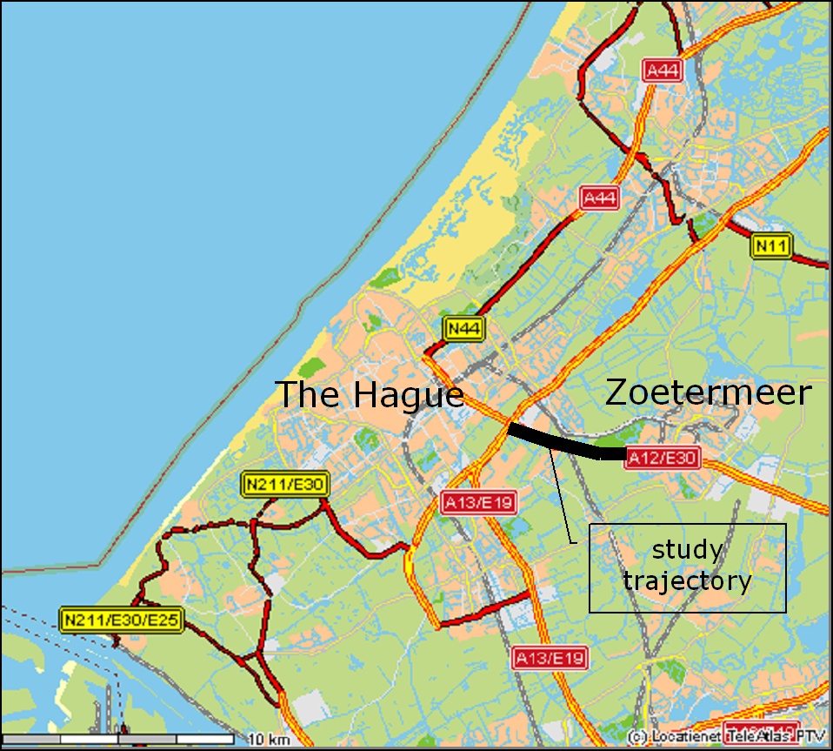

Figure 2: Average response shares by group by week
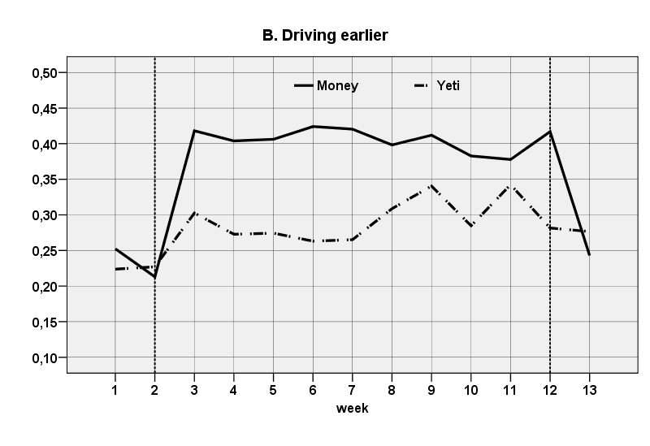
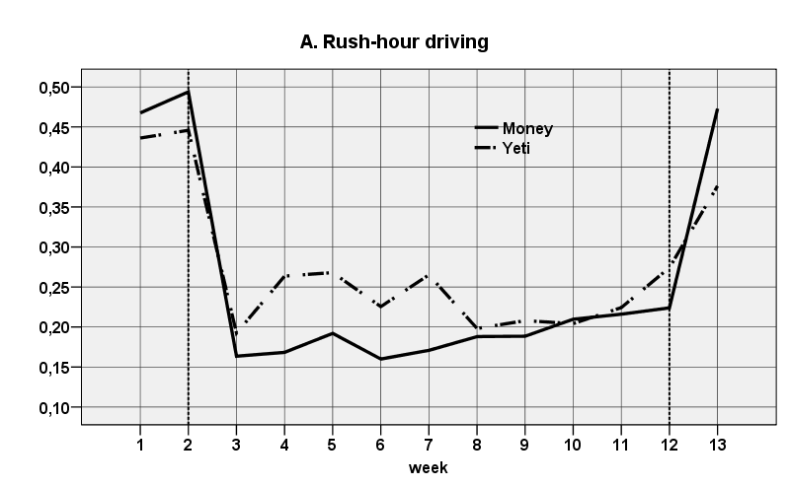

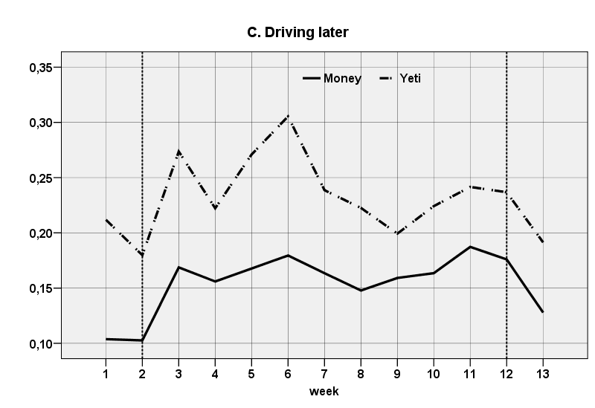
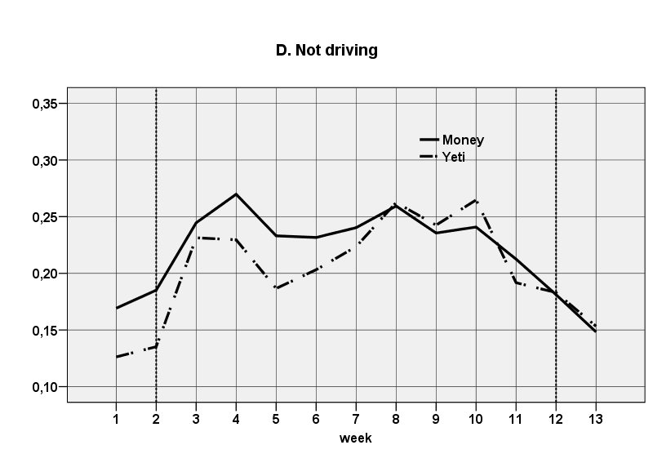

Table 1: Participants’ characteristics
 |  | Money |  | Yeti
 |  | N | % | N | %
Gender | man | 140 | 60.3 | 81 | 74.3
 | woman | 92 | 39.7 | 28 | 25.7
Education level | Secondary | 24 | 10.4 | 9 | 8.3
 | Low vocational | 9 | 3.9 | 5 | 4.6
 | Middle vocational | 64 | 27.7 | 36 | 33.3
 | Higher education | 134 | 58.0 | 58 | 53.7
Income €  (net person/month) | <1500 | 12 | 5.2 | 6 | 5.6
 | 1500-3000 | 98 | 42.4 | 38 | 35.2
 | 3000-4500 | 57 | 24.7 | 40 | 37.0
 | >4500 | 11 | 4.8 | 3 | 2.8
 | didn't answer | 53 | 22.9 | 21 | 19.4
Household  composition | single | 35 | 15.2 | 10 | 9.3
 | partner no kids | 61 | 26.4 | 20 | 18.5
 | partner + kids | 118 | 51.1 | 73 | 67.6
 | single parent | 13 | 5.6 | 3 | 2.8
 | other | 4 | 1.7 | 2 | 1.9
Cars / Household | 1 | 120 | 51.9 | 45 | 41.7
 | 2 | 103 | 44.6 | 59 | 54.6
 | 3+ | 8 | 3.5 | 4 | 3.7
Age (years) | Mean | 41.3 |  | 44.8
 | Median | 42.5 |  | 45
 | Per.25 | 34 |  | 37
 | Per.75 | 49 |  | 51

Table 2: Reward classes* by gender and reward type (group)
 |  | Money |  |  |  | Yeti
 |  | A | B | C | D | A | B | C | D
Thresholds** |  | 5 | 4 | 2 | 1 | 15 | 20 | 23 | 25
 | Men (N) | 83 | 33 | 13 | 11 | 34 | 27 | 13 | 7 | 221
 | % | 62% | 54% | 57% | 79% | 72% | 87% | 59% | 78% | 65%
 | Women (N) | 51 | 28 | 10 | 3 | 13 | 4 | 9 | 2 | 120
 | % | 38% | 46% | 44% | 21% | 28% | 13% | 41% | 22% | 35%
 | Total | 134 | 61 | 23 | 14 | 47 | 31 | 22 | 9 | 341
* A: 3.5-5, B:2.5-3.5, C: 1-2.5, D: 0-1 trips/week.
** Money: maximum number of eligible rewards per week; Yeti: number of credits at the end of 5 weeks required to keep the phone.

Table 3: Survey results (% of participants who answered affirmatively and selective means) by group*
 | Factor | Money (N=231) | Yeti (N=108)
Socio-demographics | Gender (women) % *** | 40% | 26%
 | High education % | 58% | 53%
Alternative modes | Other modes used for commuting % | 21% | 19%
 | Public transport is realistic alternative % | 35% | 32%
 | Cycling is realistic alternative % | 20% | 14%
Schedules | Usual departure time (hour:min) | 7:52 | 7:57
 | Preferred start of work time (hour:min) | 8:24 | 8:35
 | Can start work later (days/week) | 3.5 | 3.6
 | Can telework % (days/week) | 25% (0.5) | 31% (0.6)
 | Can Start work later % (minutes mean) | 56% (70) | 67% (76)
 | Can depart home earlier % (minutes mean) | 47% (26) | 45% (26)
 | Can depart home later % (minutes mean) | 61% (29) | 50% (36)
 | If I start earlier I can leave earlier % | 48% | 41%
 | if I start later I can finish later % | 39% | 42%
 | Fully flexible working hours % | 26% | 31%
Difficulties | Have chauffeuring children duties %*** | 16% | 27%
 | Have child care duties % | 30% | 29%
 | Very high effort perceived with changing behaviour % | 6% | 9%
 | Some effort perceived with changing behaviour % | 29% | 39%
 | Problems with regional rail % | 33% | 29%
Support measures | Arrangements with employer %*** | 34% | 55%
 | Discussion with family members % | 30% | 27%
 | Practice during pre-test % | 30% | 25%
 | Searched for public transport connections % | 13% | 13%
travel information | Use of traffic info (days/week) pre-test ** | 1.3 | 1.8
 | Use of traffic info (days/week) post-test *** | 1.1 | 3.7
 | Use of public transport info (days/week) pre-test | 0.1 | 0.01
 | Use of public transport info (days/week) post-test | 0.3 | 0.5
* chi-square test for nominal factors, t-test for interval factors; ** p < 0.1, *** p < 0.05

Table 4: Results of model estimation
Alt. | Name | Description | Value | S.E* | t-test | p-value
RHD | α_{RHD} | Const. rush-hour driving (Mean) | 1.32 | 0.311 | 4.25 | <0.001
 | σ_{RHD} | Const .rush-hour driving (S.D) | 1.66 | 0.090 | 18.44 | <0.001
 | β_{RH}Cm | Class A+B for money | 1.65 | 0.226 | 7.28 | <0.001
 | β_{RH}Cy | Class A+B for Yeti | 1.22 | 0.222 | 5.50 | <0.001
 | β_{RH}Gr | Gender (woman) | 0.45 | 0.167 | 2.69 | 0.01
 | β_{RH}R3V32C | Child chauffeuring constraint (for 7 € ) | 0.92 | 0.242 | 3.80 | <0.001
 | β_{RH}R2 | 3 € Reward | -1.80 | 0.147 | -12.19 | <0.001
 | β_{RH}R3 | 7 € Reward | -2.50 | 0.166 | -15.08 | <0.001
 | β_{RH}R4 | Mixed Reward | -2.34 | 0.160 | -14.64 | <0.001
 | β_{RH}R5 | Yeti no credit | -0.60 | 0.145 | -4.10 | <0.001
 | β_{RH}R6 | Yeti with credit | -1.97 | 0.208 | -9.48 | <0.001
 | β_{RH}v2Hm | I found it very difficult to change my behaviour (for money) | 0.97 | 0.518 | 1.87 | 0.06
 | β_{RH}v6A | I discussed flexible hours with my employer | -0.36 | 0.156 | -2.30 | 0.02
 | β_{RH}v6Km | I practiced with avoidance during the pre-test (for money) | -0.41 | 0.219 | -1.88 | 0.06
DE | α_{DE} | Const. Drive early (Mean) | 26.80 | 1.470 | 18.28 | <0.001
 | σ_{DE} | Const. Drive early (S.D) | 2.96 | 0.225 | 13.16 | <0.001
 | β_{DE}DP | Usual departure time (min. past midnight) | -0.04 | 0.002 | -16.10 | <0.001
 | β_{DE}V16 | Public Transport is realistic | -1.07 | 0.248 | -4.34 | <0.001
 | β_{DE}v27A | preferred start work time (min. past midnight) | -0.02 | 0.001 | -11.45 | <0.001
DL | α_{DL} | Const. Drive late (Mean) | -0.11 | 0.329 | -0.34 | 0.73
 | σ_{DL} | Const. Drive late (S.D) | 2.09 | 0.096 | 21.79 | <0.001
 | β_{DL}EdHm | High education for money | -0.61 | 0.163 | -3.70 | <0.001
 | β_{DL}Fil | Frequency of traffic info use (days/week) | 0.14 | 0.011 | 12.91 | <0.001
 | β_{DL}V16 | Public Transport is realistic | -0.93 | 0.252 | -3.70 | <0.001
 | β_{DL}v281 | Days/week starting late possible | 0.30 | 0.056 | 5.39 | <0.001
 | α_{ND} | Const. Not driving (Mean) | 0
 | σ_{ND} | Const. Drive early (S.D) | 1
ND | β_{ND}OV | Frequency of public transport info use | 0.25 | 0.095 | 2.67 | 0.01
 | β_{ND}R5OV | Frequency of public transport info use (Yeti no credit) | 0.18 | 0.052 | 3.45 | <0.001
 | β_{ND}fg | Average wind speed (m/sec) | -0.01 | 0.002 | -2.93 | <0.001
 | β_{ND}v23 | Cycling is realistic | 1.08 | 0.193 | 5.59 | <0.001
 | β_{ND}v6i | I searched for public-transport information as a supporting measure | 1.38 | 0.297 | 4.64 | <0.001
 | β_{ND}v9 | Used other modes to commute | 1.04 | 0.166 | 6.27 | <0.001
 |  | COV. (α_{DE},α_{DL}) | -1.33 | 0.190 | -6.97 | <0.001
 |  | COV. (α_{RH},α_{DE}) | -1.55 | 0.122 | -12.70 | <0.001
 |  | COV. (α_{RH},α_{DL}) | -0.73 | 0.072 | -10.21 | <0.001
 | LL₀ | Null log-likelihood | -20,447.84
 | LL const. | Constants (random) only log-likelihood | -12,992.35
 | LL Reward | Reward only log-likelihood | -12,209.32
 | LL_{β} | Final log-likelihood | -11,920.56
 | ρ² | pseudo R² | 0.417
 | ρ_{A}² | pseudo Adjusted R² | 0.415
* Robust standard error

