Enhanced electrochemical reduction of hydrogen peroxide on silver paste electrodes modified with surfactant and salt

Laura Gonzalez-Macia¹, Malcolm R. Smyth¹, Aoife Morrin¹ and Anthony J. Killard^{2*}

¹School of Chemical Sciences and National Centre for Sensor Research, Dublin City University, Dublin 9, Ireland.
²Department of Applied Sciences, University of the West of England, Coldharbour Lane, Bristol BS16 1QY, UK.

ABSTRACT

The modification of silver paste electrodes with a combination of dodecyl benzenesulphonic acid and KCl has been shown to lead to significant enhancements of the electrochemical reduction of hydrogen peroxide. The catalytic enhancement was shown to be dependent on the concentration of the surfactant/salt solution, which resulted in increases of some 80-fold in amperometric response to hydrogen peroxide at – 0.1 V vs. Ag/AgCl, pH 6.8 over unmodified silver paste. Physical analysis showed modifications to both the surface morphology and chemical composition of the silver paste electrode surface. However, BET analysis revealed no significant change in surface area. It is suggested that the enhanced catalysis may result from the formation of stabilised surfactant/salt structures at the metal electrode surface. The electrode was also shown to be suitable for the amperometric detection of hydrogen peroxide with a limit of detection of 1.1∙10⁻⁶ M (S/N=3).

Keywords
Silver; Hydrogen peroxide; catalysis; reduction; Screen-printed electrode; Dodecylbenzene sulphonic acid

* Corresponding author. Tel.: + 353 17007871; Fax: + 353 17007873
E-mail address: tony.killard@uwe.ac.uk
*ISE member.

- INTRODUCTION

For many years, hydrogen peroxide has been shown to be a very important material as an intermediate in many industrial processes as well as in many biological systems. This has made it highly relevant in the food, environmental, clinical and pharmaceutical industries and related areas of research [1, 2]. The importance of hydrogen peroxide is related to its unique oxidising properties. Hydroxyl radicals formed during the decomposition of hydrogen peroxide are used as oxidising agents in the degradation of organic pollutants in water such as the azo dye compounds used in the textile industry which are toxic to aquatic life and carcinogenic to humans [1, 3]. Moreover, the decomposition of hydrogen peroxide plays a very important role in the manufacture of industrial water electrolysers, secondary metal-air batteries and fuel cells [4-6]. In the latter example, oxygen is predominantly reduced through a two-electron reduction process, to form hydrogen peroxide. In order to decrease the polarization created in the cathode, to improve the electrode life and to reach high operation potentials, hydrogen peroxide concentration should be reduced [4, 7]. The use of a catalyst enhances the elimination of hydrogen peroxide. Due to these many and varied applications, its determination represents an important analytical issue. Traditionally, hydrogen peroxide has been detected using several analytical techniques, such as titrimetry [8], spectrophotometry [9] and chemiluminescence [10, 11]. However, these techniques have proved to be time-consuming, difficult for automated detection and highly prone to interferences [12]. Recently, electrochemical methods have become the techniques of choice due to their low cost and high sensitivity, resulting in an effective way to examine the reactions of many substances [2, 13-16]. In attempting to mimic biological systems, hydrogen peroxide has been determined by electrodes modified with redox proteins and enzymes such as haemoglobin, soybean peroxidase, myoglobin [12, 17, 18] and horseradish peroxidase (HRP) [12, 19, 20]. The latter has been the most commonly used enzyme for construction of H₂O₂ biosensors due to its widespread commercial availability at high purity and low cost. Many methods and materials including adsorption, cross-linking, self-assembly, gel or polymer entrapment have been studied to improve HRP immobilization and transduction in the manufacture of H₂O₂ biosensors, which in turn result in high enzyme activity and sensitive electron transduction [21]. However, the special requirements of temperature, concentration and pH to maintain enzyme stability and the difficulties in finding an appropriate method of immobilization of the enzyme on a solid surface as well as the saturation with the substrate, which affects linear calibration range, have led the industry to search for alternative non-enzymatic process to hydrogen peroxide determination [15, 22]. Many metals such as Pt [23, 24], Ag [25], Fe, Zn, Cu [26] and Pd [27] and metal alloys such as Pd/Au [28], Pd/Ir, and Au/Pt [13] have been employed as catalysts for hydrogen peroxide reactions. Recently, interest has been shown in using nanoparticles (especially nanoparticles of noble metals such as gold)[29-31] for the electro-analytical detection of hydrogen peroxide [2, 13, 32, 33]. The microelectrode arrays created by the deposition of metallic nanoparticles on electrodes have been shown to significantly improve the sensitivity of electro-analytical sensing methods due to their large specific surface areas, excellent conductivities and biocompatibilities.
Surfactants aggregates have shown to play a very important role in a wide range of industrial applications such as detergency, lubrication, medicinal chemistry, and cosmetology.[34, 35] Recently, the combination of surfactant aggregates and metal ions to create metallomicelles has been widely exploited because it allowed the construction of highly specified catalyst and sensing systems [34, 36, 37]. However, most of these macromolecular structures are formed in solution and no information on surface catalysis has been reported to date.
As mentioned earlier, silver as an electrode material or as nanoparticles deposited onto different electrodes is an excellent material for the direct electro-analytical detection of hydrogen peroxide [13, 15]. In the present work, silver paste electrodes were evaluated as a platform for hydrogen peroxide determination. These were modified with a dodecylbenzenesulfonic acid (DBSA)/potassium chloride (KCl) solution which led to the significant enhancement in the reduction of hydrogen peroxide. The effect of the surface modification on the hydrogen peroxide reduction was assessed by cyclic voltammetry and amperometry. Scanning Electron Microscopy (SEM), Energy Dispersive X-Ray (EDX) Analysis and X-Ray Photoelectron Spectroscopy (XPS) measurements were also performed to characterize the electrode surfaces before and after the surfactant-based modification.

- EXPERIMENTAL

  - Materials

Dodecylbenzenesulfonic acid (DBSA-D0989) was purchased from TCI Europe. Sodium and potassium chloride (NaCl, KCl), potassium dihydrogen phosphate (KH₂PO₄) and p-benzoquinone (BQ) were purchased from Sigma-Aldrich. Di-sodium hydrogen phosphate (Na₂HPO₄) was purchased from Riedel-de Haen. 30% (v/v) hydrogen peroxide solution was purchased from Merck. Silver conductive ink (Electrodag® PF-410) was purchased from Henkel (Scheemda, The Netherlands). Poly(ethylene) terephthalate substrates were Melinex® (pre-shrunk) films obtained from HiFi Industrial Film Ltd. (Dublin, Ireland). All the solutions were prepared using 18 MΩ Milli-Q water.

  - Buffers and solutions

Unless otherwise stated, all electrochemical measurements were carried out in phosphate buffered saline solution (PBS). The buffer solution was 10⁻¹ M phosphate, 1.37∙10⁻¹ M NaCl and 2.7∙10⁻³ M KCl. This was prepared by mixing solution 1 (10⁻¹ M Na₂HPO₄, 1.37∙10⁻¹ M NaCl and 2.7∙10⁻³ M KCl) and solution 2 (10⁻¹ M KH₂PO₄, 1.37∙10⁻¹ M NaCl and 2.7∙10⁻³ M KCl) to a pH of 6.8.

2.3. Instrumentation

Silver paste electrodes were fabricated using an automated DEK 248 machine (Weymouth, UK). Briefly, a layer of silver paste was deposited onto PET substrate and cured in a convection oven at 120ºC for 5 minutes. Then, an isolating tape layer was deposited to define the working electrode area (1.26∙10⁻¹ cm²).
All electrochemical measurements were performed in a three-electrode electrochemical batch cell, using a Ag/AgCl/NaCl (saturated) electrode and a platinum mesh electrode as reference and auxiliary electrodes, respectively. Cyclic voltammetry and time-based amperometric measurements were carried out with a CHI601C electrochemical analyzer with CHI601C software (IJ Cambria Scientific Ltd., UK). Measurements were performed at room temperature, 18 ± 2 ◦C. Unless otherwise stated, all potential values are referenced to the Ag/AgCl/NaCl (saturated) electrode.
Scanning Electron Microscopy (SEM) using Secondary Electron (SE) and Energy Dispersive X-ray (EDX) detection was carried out with a Hitachi S-3400N. An acceleration voltage of 20 kV was used to obtain the surface images. XPS was performed using a Kratos AXIS 165 Spectrometer.
BET nitrogen adsorption analysis was performed using a Gemini VI Surface Area Analyzer (Micromeritics) with 40 modified and 40 unmodified electrodes.

2.4. Electrode modification with surfactant-based solutions

Silver screen-printed electrodes were dipped into a freshly-prepared solution of surfactant (DBSA) and salt (KCl) at a range of concentrations (modification solution) for 3 hours. The electrodes were thoroughly rinsed with water to remove the excess of modification solution and measured directly.

2.5. Electrochemical characterisation

All the electrochemical measurements were carried out in a stirred batch system with a three-electrode configuration. Unless otherwise stated, the electrodes were measured in 10 ml PBS pH 6.8. Cyclic voltammograms were obtained in the potential range from -0.200 to 0.025 V (vs Ag/AgCl) at a scan rate of 0.1 V/s. Amperometry was performed at -0.1 V (vs Ag/AgCl). 1 M stock solution of hydrogen peroxide was prepared daily and then aliquots from this solution were added to the working cell during both cyclic voltammetric and amperometric measurements in order to characterize the sensor parameters.
Electrochemical impedance spectroscopy was perfomed in 5∙10⁻³ M potassium hexacyanoferrate in 0.1 M KF with approximate series resistance for both modified and unmodified electrode systems of 100 Ω.

- RESULTS AND DISCUSSION

3.1. Optimisation and electrochemical characterisation

Cyclic voltammetry and time-based amperometry were carried out in order to assess the catalytic effect observed when silver paste electrodes were modified with surfactant-based solutions. Fig. 1 shows the cyclic voltammograms for unmodified silver paste electrodes and following modification in 3.3∙10⁻² M DBSA/0.1 M KCl in the presence and absence of 5∙10⁻³ M H₂O₂. Here, a narrow potential window was chosen for the voltammetric measurements (– 0.2 to + 0.025 V vs. Ag/AgCl), as a wider potential range would lead to the oxidation of Ag (at more positive potentials) or O₂ interferences (at more negative potentials), distorting H₂O₂ responses. As can be seen, the non-faradaic or charging current from the cyclic voltammograms in the absence of H₂O₂ was found to be ten times higher for the modified electrodes than that for the unmodified ones. This indicated that the silver electrode surface had undergone a modification after being dipped into the surfactant-based solution. Moreover, the cathodic current in the presence of 5∙10⁻³ M H₂O₂ was more than 100 times higher for electrodes after modification compared with unmodified electrodes. Thus, the cathodic current at – 0.1 V in the presence of 5∙10⁻³ M H₂O₂ was approx. 4.4∙10⁻⁵ A for the modified electrode, after subtracting the background current, whereas the unmodified electrode exhibited only 3.8∙10⁻⁷ A at the same potential. Although a catalytic effect was seen on the modified electrodes from + 0.025 V, the current increased quite linearly within the cathodic potential window with a discernible peak between – 0.1 and – 0.15 V. Electrochemical impedance spectroscopy revealed that there was no significant difference in the charge transfer resistance between the modified and unmodified electrodes, being 1.2 x 10⁴ Ω and 8.0 x 10⁴ Ω, respectively.
Typical applied potentials used for the amperometric determination of H₂O₂ reduction in the literature range from – 0.7 V (GC/PABS-modified electrodes) [13, 14], – 0.5 V (Ag nanoparticles in a polyvinyl alcohol film on a Pt electrode) [2], – 0.1 V commonly applied in enzymatic biosensors (such as a HRP-modified electrodes) [20, 38] and up to 0 V with Prussian Blue [39]. The combination of the sensitive direct detection of H₂O₂ at low applied potentials without the need for organic catalysts is a distinct advantage in many potential applications. Given the significant current increases at these potentials, the narrow potential window of the silver paste electrodes and the desire to avoid interferences at higher potentials, – 0.1 V seemed to be a suitable potential to study the catalytic effect of the surfactant-based modification on silver paste electrodes towards H₂O₂ reduction.
(Figure 1)
(Figure 2)
Amperometric measurements were performed at – 0.1 V on silver paste electrodes modified with DBSA or KCl alone (Fig. 2). As can be seen, there was no notable enhancement in the cathodic current corresponding to the DBSA modified electrode. The unmodified electrode gave a cathodic current of 4.2∙10⁻⁷ A in the presence of 5∙10⁻³ M H₂O₂, compared to 2.4∙10⁻⁶ A at the DBSA modified electrode. Enhanced responses were obtained when the silver paste electrode was exposed to KCl, yielding a cathodic current of 9.4∙10⁻⁶ A. However, the highest cathodic current was obtained when the silver electrode was modified with a mixture of both DBSA and KCl which yielded a cathodic response of 3.6∙10⁻⁵ A, representing a more than 80-fold increase over the unmodified electrode. The modified electrodes also had greater steady state background currents (approx. 1.6∙10⁻⁶ A) compared to unmodified electrodes (approx. 9.0∙10⁻⁸ A).
The effects of the concentrations of both DBSA and KCl in the modification solution were optimised and characterised using amperometry. Fig. 3 shows the response of silver paste electrodes to 5∙10⁻³ M H₂O₂ at -0.1 V after dip coating for 3 h in modification solutions across a range of DBSA concentrations, with and without 0.1 M KCl. Electrodes modified with the DBSA solution alone showed little change in cathodic current compared to unmodified electrodes, with a slight increase at 10⁻² M DBSA. In the presence of 0.1 M KCl at low DBSA concentrations, there was a six-fold increase in cathodic current compared to an electrode modified without KCl. However, from 10⁻⁴ M DBSA and above, the difference between the reduction currents obtained from the electrodes with and without KCl increased to more than 20-fold. Of note were the response maxima of both electrode modifications at 10⁻² M DBSA which suggested an important link between surfactant concentration and catalytic effect. These observations suggested that the combination of both DBSA and KCl in the modification solution was essential for the full catalytic reduction effect of H₂O₂ observed on the silver electrodes.
(Figure 3)
The electrode modification underwent further optimisation with regard to the effect of KCl concentration and the more precise optimisation of the DBSA concentration. DBSA concentrations of 1∙10⁻¹, 3.3∙10⁻² and 10⁻² M were studied in KCl concentrations from 1 to 10⁻⁹ M (Fig. 4). The catalytic effect on H₂O₂ reduction was again observed for those electrodes modified with both DBSA and KCl, whereas those electrodes modified with KCl alone displayed background levels of reduction until the concentration reached 10⁻¹ M. Significant enhancement in H₂O₂ reduction was shown to occur at KCl concentrations greater than 10⁻⁴ M. The optimum concentration of KCl in the modification solution was found to be approx. 0.1 M. Further increases in KCl concentration in the modification solutions led to decreases in the reduction current. The onset of the enhanced catalysis was also dependent on DBSA concentration, as is illustrated by the cathodic currents at 10⁻⁴ M KCl. At this value, the catalytic ratio shown by the modified electrodes went according to the following relative order: unmodified < 10⁻² M DBSA/KCl < 3.3∙10⁻² M DBSA/KCl < 10⁻¹ M DBSA/KCl. Electrodes exhibited enhanced catalysis at lower KCl concentrations when DBSA concentrations were increased. Electrodes modified with 10⁻¹ M DBSA/KCl solutions showed catalytic activity at KCl concentrations of approx. 10⁻⁴ M, whereas the onset of the catalysis occurred from 10⁻³ M KCl for the electrodes modified with 3.3∙10⁻² M DBSA/KCl or 10⁻² M DBSA/KCl solutions.
It is well established that surfactants form organized structures in solution [40, 41]. At low concentrations above the critical micelle concentration (CMC), typical surfactant aggregations are in the form of spherical micelles. As the concentration of surfactant in solution increases, greater aggregations such as hexagonal or lamellar structures are observed. The addition of a salt or co-surfactant to the solution allows the formation of these high-aggregation structures at lower surfactant concentrations. This has been observed by Sein et al. [42] with sodium dodecylbenzenesulfonate (NaDoBS) in the presence of several chloride salts. The CMC for DBSA is approx. 1.6-2∙10⁻³ M [42, 43], which suggests that the DBSA in the modification solutions should be in a micellar, lamellar or some other ordered configuration at concentrations which result in the formation of a surface with enhanced reduction of H₂O₂. The fact that greater catalytic responses are obtained when optimal concentrations of both the surfactant and salt are present in the modification solution might be related to the formation of hexagonal or lamellar structures in the solution, which may bring about modification of the silver paste electrode surface. Hence, a solution of 3.3∙10⁻² M DBSA and 10⁻¹ M KCl was established as the modification solution which provided the highest electrocatalysis of H₂O₂ reduction on silver paste electrodes and this was used in all subsequent experiments.
(Figure 4)
The effect of the time required for electrode modification was investigated using the optimised DBSA/KCl solution (Fig. 5). What was particularly significant was that the catalytic effect was observed following very brief exposure of the electrodes to the modification solution (2-10 s) and which suggested that whatever process was taking place between the electrodes and the DBSA/KCl solution was extremely rapid. The catalytic reduction current increased with modification time but quickly reached a plateau. The highest cathodic current was obtained with electrodes following modification for 2 hours. Further exposure times such as 1 day or 1 week did not improved the response; on the contrary, the catalytic current started to decrease. To ensure that the highest catalytic currents were obtained, 3 hours was chosen as the optimum modification time for the experiments and this was used for all subsequent experiments.
(Figure 5)
The influence of the pH of the bulk electrolyte solution was investigated for both unmodified and modified electrodes during the reduction of 5∙10⁻³ M H₂O₂ at – 0.1 V (Fig. 6). The unmodified electrode again showed minimal catalytic response. However, there was a small increase in reduction current as the pH increased from pH 2 to pH 10 but with a peak at pH 6.8. The DBSA/KCl modified electrode showed no reduction at very acidic pH, whereas the cathodic current increased steadily with increasing pH up to approx. 50-fold at pH 10. This suggested that the catalytic mechanism of H₂O₂ reduction is significantly enhanced by the presence of hydroxide ions or suppressed in the presence of H⁺. This pH-dependence of H₂O₂ reduction has been observed previously [6] and has been explained by the effect of the pH on the reduction potential. At high concentrations of H⁺ in solution, H₂O₂ reduction occurs at more negative potentials than when the concentration is lower. This behaviour is typical of a reaction mechanism in which H⁺ appears as a product or OH⁻ as a reactant. Therefore, at – 0.1 V the rate of H₂O₂ reduction was higher when the reaction took place in more basic solution rather than in more acidic ones [44]. Although maximum responses were achieved at pH 10, pH 6.8 was selected for the electrolyte measurement solutions in further work as it exhibited more than 30-fold enhancement in catalytic currents while also being suitable for the study of biological systems, such as enzyme-based biosensors.
(Figure 6)

3.2 Physical characterisation

Scanning electron micrographs and EDX spectra of silver paste electrodes before and after DBSA/KCl modification and following electrocatalytic reduction of H₂O₂ are shown in Fig. 7. KCl-modified electrodes and AgCl-modified electrodes are also shown as controls. The unmodified electrode (Fig. 7a) shows the typical morphology of a metallic silver paste. It is known that such pastes contain metallic silver particles, an organic binder (in this case, acrylic-based binders) and solvent [45]. Thus, the SEM shows the amorphous metallic silver particles suspended in the organic binder, which is not visible to SEM. Following exposure to the DBSA/KCl solution, nodular structures became visible on the DBSA/KCl modified electrodes (Fig. 7b). These structures were not present on the KCl-modified control surface (Fig. 7e), although these electrodes did show some alteration in surface morphology. The nodular structures varied in size with typical diameters of approx. 1 μm. The morphology of these structures appeared to change following reduction of H₂O₂ (Fig. 7c), after which a further morphological alteration and surface patterning of the nodular structures appears to have taken place. BET nitrogen adsorption analysis performed on the modified and unmodified electrodes showed that the surface areas were 0.65 and 0.78 m²/g, respectively, demonstrating no significant, or even a small decrease in microscopic surface area, and suggesting that surface area enhancement was not the source of the enhanced catalysis. However, the BET surface area can be different from the electroactive area. To assess a possible increase of the electroactive surface area, cyclic voltammetry of the unmodified and modified electrodes in the presence of a reversible redox probe was performed. No electrocatalysis was expected to affect a process already reversible, but only changes of electroactive area would play a role. The electrodes were measured in 1∙10⁻³ M BQ/ 0.5 M KCl in the potential range from – 0.4 to 0.05 V (vs. Ag/AgCl) (data not shown). No remarkable changes in the calculated surface areas were observed, indicating that there was no increase in the electroactive surface area, but a real electrocatalytic effect of Ag SPEs after DBSA/KCl modification
EDX confirmed that Ag was shown to be the major component in the unmodified electrodes, where C was also detected, as one might expect due to the metallic/organic composition of the paste. When DBSA/KCl modified electrodes were analysed, Cl was detected as well as Ag, which was more pronounced in areas with greater numbers of nodular structures. This EDX spectra was similar to that obtained for the electrochemically deposited AgCl control (Fig. 7d). However, no Cl was detected in the spectra of the DBSA/KCl modified electrodes following reduction of H₂O₂. Therefore, the nodular structures formed after DBSA/KCl modification appear to result from, or result in an increase in surface Cl levels, which may also be involved in the catalytic process of H₂O₂ reduction.
(Figure 7)
X-Ray Photoelectron Spectroscopy (XPS) measurements of unmodified and DBSA/KCl modified silver paste electrodes are presented in Table 1. As might be expected, the electrode surface showed the significant presence of Cl, K and S after the modification with DBSA/KCl. This indicates that the surface may have become modified in some way by a combination of the surfactant and the salt. This observation is in agreement with the earlier electrochemical characterisation. However, a higher proportion of Cl (4.3 %) over K (0.6%) was detected on the electrode surface, which was approx. 7.5-fold greater than would be expected on a stoichiometric basis. This fact could be explained by the formation of significant amounts of AgCl on the electrode during the modification process. However, amperometric measurements of the reduction of H₂O₂ at AgCl modified silver paste electrodes failed to result in the significant increases in reduction current observed by the DBSA/KCl modified electrodes (data not shown). XPS also showed that the amount of silver increased by only 2% following surface modification, and so the phenomenon cannot be explained by enhanced exposure of silver
(Table 1)
DBSA/KCl modified silver paste electrodes were also shown to be more hydrophilic compared to the unmodified electrodes, as demonstrated qualitatively by contact angle measurements (data not shown). This increase in hydrophilicity and surface energy would be consistent with modification with an amphiphile in a predominantly “head-up” orientation and/or the presence of increased numbers of ionic species [46].
Lian et al. [15] recently reported the increasing roughness of silver electrodes by electrochemical oxidation-reduction cycles (ORC) in a KCl solution and their application to the quantitative determination of H₂O₂. The process began with the stripping of Ag to form Ag-Cl complex and the subsequent cathodic electrodeposition of Ag⁺ to form Ag nanoparticles on the Ag substrate. The Ag-Cl complex decreased the diffusion rate of Ag⁺ and made the reduction of Ag⁺ more difficult, which was helpful in the formation of small Ag nanoparticles. The activity of the roughened electrodes towards H₂O₂ reduction was assessed as a function of the number of cycles, KCl concentration and scan rate during the cyclic voltammetry. The catalytic current due to H₂O₂ reduction increased with cycle number and, therefore, Ag surface area of the electrodes [13, 47].
To explain the data and the phenomena observed on the DBSA/KCl modified silver paste electrodes, a possible explanation could be that micellar, or more likely, hexagonal or lamellar structures formed by the surfactant/salt modification solution become deposited onto, or modify the silver paste electrode in some way, creating an enhanced surface for the catalytic process. These structures or processes appear to create the appropriate environment for the enhanced formation of AgCl due to the presence of Cl⁻ in the modification solution and would explain the presence of a higher concentration of AgCl on the electrode surface following DBSA/KCl modification. Additionally, deposition of the DBSA/KCl and/or the formation of AgCl may also result in morphological changes to the silver electrode, creating a micro- and/or nano-structured surface, vastly increasing the surface area for H₂O₂ reduction. Although the precise nature of this novel process requires further investigation, it results in an appropriate environment to perform the significantly enhanced reduction of H₂O₂.

3.3 Analytical characterisation

The application of the modified silver paste electrodes for the direct detection of H₂O₂ was assessed. Amperometric responses to additions of 2∙10⁻⁵ M H₂O₂ are shown in Fig. 8, where response times of 10-15 s are observed. The response across the measured range (2∙10⁻⁵ M to 1.6 10⁻⁴ M) was non-linear. The upward curvature observed here is different from the downward curvature typically observed for substrate limitation at enzyme electrodes and might be explained by an autocatalytic process during the H₂O₂ reduction. The autocatalytic reduction of H₂O₂ on silver electrodes has been previously reported by Flatgen et al. [25] They observed two mechanisms of H₂O₂ reduction operating at different overvoltages. At potentials more negative than – 0.45 V (vs Ag/AgCl) the “normal” reduction takes place whereas a second mechanism was operative at E > – 0.35 V. They proposed that the rate of H₂O₂ reduction in this second case was increased by the presence of the adsorbate (OH)_{ad} formed during the reduction process on the silver surface, leading to an autocatalytic reaction on the electrode. This would be in agreement with the observation of the increase in catalysis at high pH observed here. Moreover, the catalytic activity of the modified silver paste electrodes seemed to improve with the number of repeat measurements at concentrations of H₂O₂ below 10⁻³ M and decreased after repeated exposure to H₂O₂ above this concentration and may relate to a saturation or irreversible effect at high substrate concentrations.
Other recent studies have demonstrated the direct detection of H₂O₂ using silver nanoparticles (AgNPs) on glassy carbon (GC) electrodes at – 0.7 V vs Ag/AgCl with a limit of detection in phosphate buffer pH 7.4 of 2.0∙10⁻⁶ M [13]. Ag NPs were also used to determine H₂O₂ at – 0.55 V vs Ag/AgCl by immobilization in a polyvinyl alcohol (PVA) film on a platinum electrode, showing a limit of detection of 1.0∙10⁻⁶ M [2]. Safavi et al.[48] reported the excellent electrocatalytic activity towards H₂O₂ reduction of Ag NPs electrodeposited on carbon ionic liquid electrode (CILE). The sensor exhibited a detection limit of 7∙10⁻⁷ M at an applied potential of – 0.35 V vs Ag/AgCl). Another widely used material in H₂O₂ detection is ferric hexacyanoferrate or Prussian Blue [22, 39, 49]. It has showed a limit of detection of 1.0∙10⁻⁸ M and a linear calibration range for H₂O₂ concentrations from 1.0∙10⁻⁸ to 1.0∙10⁻² M when nanostructured by electrochemical deposition through lyotropic liquid crystal templates [22]. Recently, a detection limit of 1∙10⁻¹¹ M was achieved by using a glassy carbon electrode modified with NAD⁺ and single walled carbon nanotubes at – 0.25 V vs Ag/AgCl. Such a low detection limit was reached at pH 7 by amperometry [16]. It should be noted that the values determined in the present study represent practical detection limits using moderate conditions of pH (6.8), on disposable screen printed electrodes and at low applied potentials (– 0.1 V) to avoid electrochemical interferences. Due to the fact that measurements were performed on mass producible screen printed electrodes and not on idealised rotating disk electrodes, these represent real and practical electrode materials for sensor fabrication and other applications. In saying this, the lowest measured concentration was 2∙10⁻⁵ M, and the theoretical limit of detection was found to be 1.1∙10⁻⁶ M, (S/N=3) [50] and the response sensitivity was 5.5∙10⁻² A M⁻¹ cm⁻². Reproducibility was within 10% in the range of 1 to 5∙10⁻³ M H₂O₂ (n=10). Signal to background levels increased from 12:1 to 22:1 following modification at 5∙10⁻³ M.
(Figure 8)

4. CONCLUSIONS

Hydrogen peroxide reduction has been shown to be enhanced on silver paste electrodes following their modification with DBSA/KCl. Catalytic responses of some 80-fold greater than equivalent unmodified electrodes was observed at neutral pH. Catalysis was also shown to be pH-dependent and dependent on surfactant and salt concentration. Physical characterisation of the electrode surface showed morphological changes to the electrode and elevated Cl levels. The resulting catalytic effect may be explained by the modification of the silver electrode surface with the DBSA/KCl solution which may enhance the concentration of AgCl at the electrode. This combination of processes appears to significantly enhance the electrochemical reduction of hydrogen peroxide.

Acknowledgements
The authors would like to acknowledge the financial assistance of Enterprise Ireland under Grant number TD/07/111.

5. REFERENCES

.

Captions

Table 1. XPS data for unmodified and DBSA/KCl modified silver paste electrodes.

Figure 1. Cyclic voltammograms of silver paste electrodes before and after modification with DBSA/KCl solution (vs. Ag/AgCl). (a) Unmodified, in the absence of H₂O₂; (b) unmodified in 5∙10⁻³ M H₂O₂; (c) modified in 3.3∙10⁻² M DBSA/ 0.1 M KCl modified, in the absence of H₂O₂ and (d) modified in 5∙10⁻³ M H₂O₂. Inset: magnified diagram of voltammograms (a) and (b).

Figure 2. Amperometric responses of silver paste electrodes measured at – 0.1 V (vs Ag/AgCl) in PBS pH 6.8: (a) unmodified; (b) 3.3∙10⁻² M DBSA (c) 0.1 M KCl and (d) 3.3∙10⁻² M DBSA/ 0.1 M KCl modified electrodes, with sequential additions of 1 10⁻³ M H₂O₂.

Figure 3. Current vs log [DBSA] obtained during amperometric measurements of Ag electrodes at – 0.1 V (vs Ag/AgCl) in 5∙10⁻³ M H₂O₂. The electrodes were modified with DBSA alone (a) or with the addition of 0.1 M KCl (b).

Figure 4. Current vs log [KCl] obtained during amperometric measurements of silver electrodes at – 0.1 V (vs Ag/AgCl) in 5∙10⁻³ M H₂O₂. The electrodes were modified with KCl alone (a), 10⁻² M DBSA and KCl (b), 3.3∙10⁻² M DBSA and KCl (c) and 10⁻¹ M DBSA and KCl (d). Value at log [salt] = – 10 corresponds to unmodified silver electrodes.

Figure 5. Current vs. modification time obtained during amperometric measurements of silver paste electrodes at – 0.1 V (vs Ag/AgCl) in 5∙10⁻³ M H₂O₂. Electrodes were modified in 3.3∙10⁻² M DBSA/10⁻¹ M KCl. Data at 0 s corresponds to the unmodified electrode.

Figure 6. Amperometric current at – 0.1 V vs Ag/AgCl in 5∙10⁻³ M H₂O₂ (i) vs. electrolyte pH for silver paste electrodes (a) with and (b) without DBSA/KCl modification.

Figure 7. SEM images using secondary electron (SE) detection of silver paste electrodes (a) unmodified; (b) DBSA/KCl-modified; (c) DBSA/KCl-modified after electrochemical reduction of 5∙10⁻³ M H₂O₂; (d) AgCl electrochemically deposited; (e) KCl modified. Accelerating voltage of 20 kV. (5.0k x magnification). Below, the respective EDX spectrum for each sample. Binding energies in keV.

Figure 8. Amperometric responses of the DBSA/KCl modified electrodes in 2∙10⁻⁵ M aliquots of H₂O₂ (2 - 16 ∙10⁻⁵ M) at – 0.1 V (vs Ag/AgCl) in PBS pH 6.8. Inset: Plot of cathodic current vs H₂O₂ concentration at – 0.1 V (vs Ag/AgCl) in PBS pH 6.8.

Tables

Table 1

Unmodified |  |  | DBSA/KCl modified
Name | Position (eV) | % Conc. | Name | Position (eV) | % Conc.
O 1s | 533.3 | 12.9 | O 1s | 531.4 | 11.7
Ag 3d | 368.2 | 24.5 | Ag 3d | 367.7 | 26.1
C 1s | 284.5 | 62.5 | C 1s | 284.6 | 55.8
-- | -- | -- | K 2p | 291.8 | 0.6
-- | -- | -- | Cl 2p | 197.5 | 4.3
-- | -- | -- | S 2p | 167.5 | 1.6

Figures

Figure 1

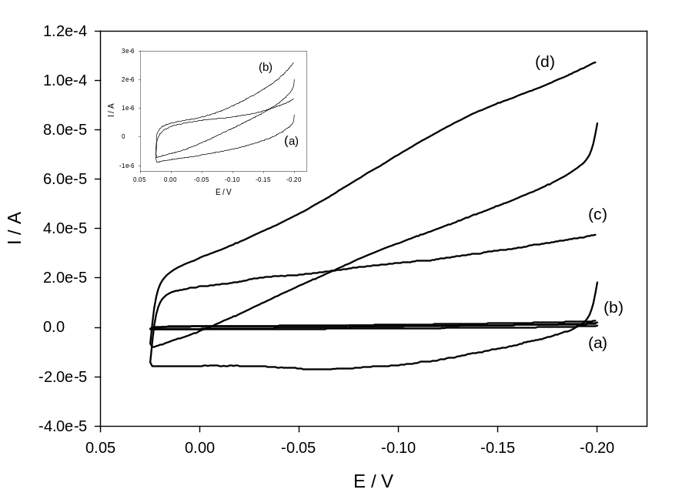

Figure 2

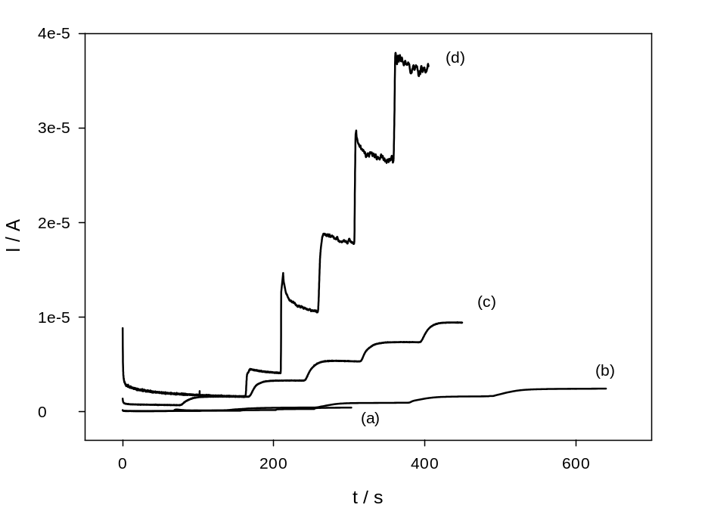

Figure 3

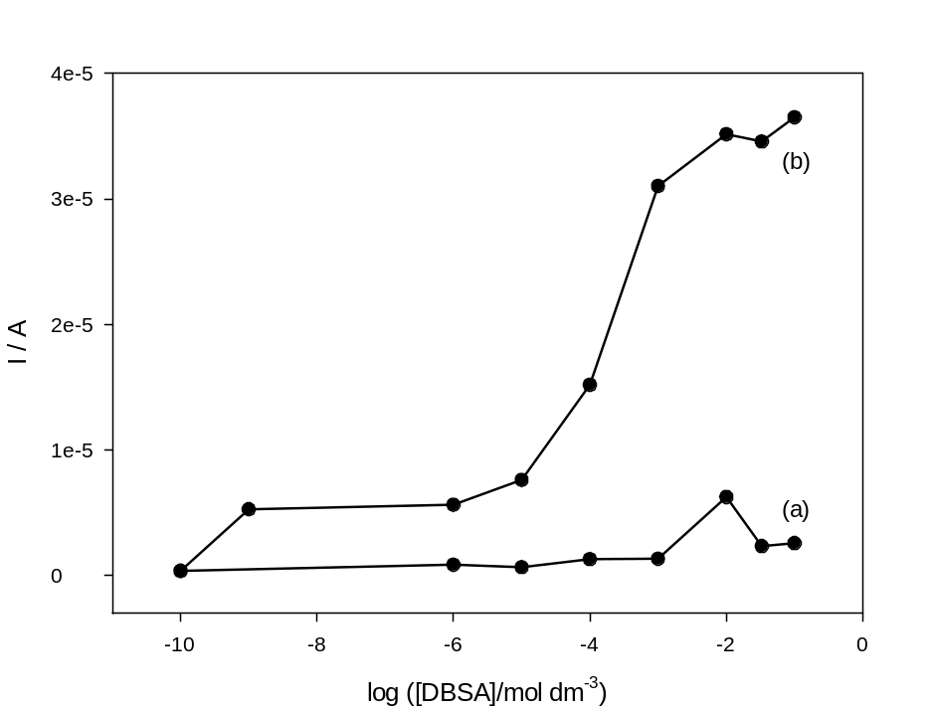

Figure 4

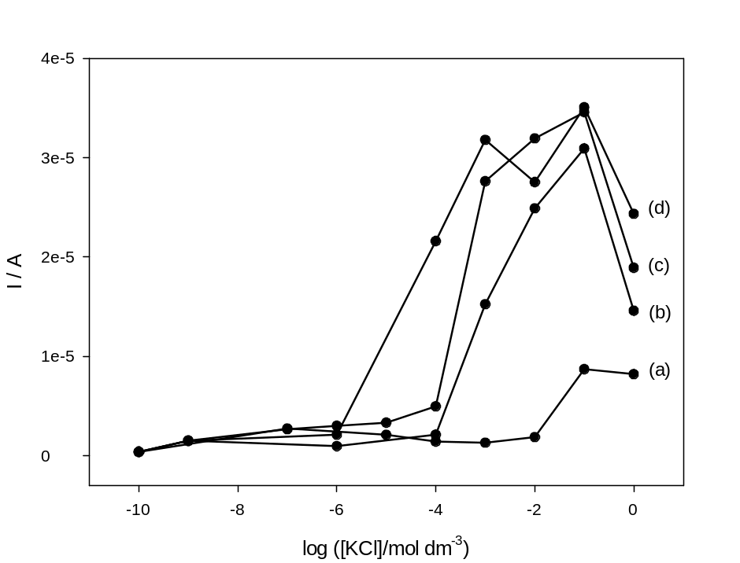

Figure 5

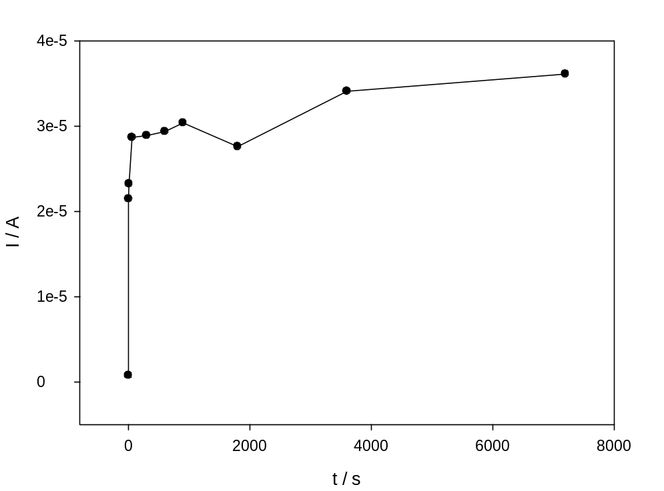

Figure 6

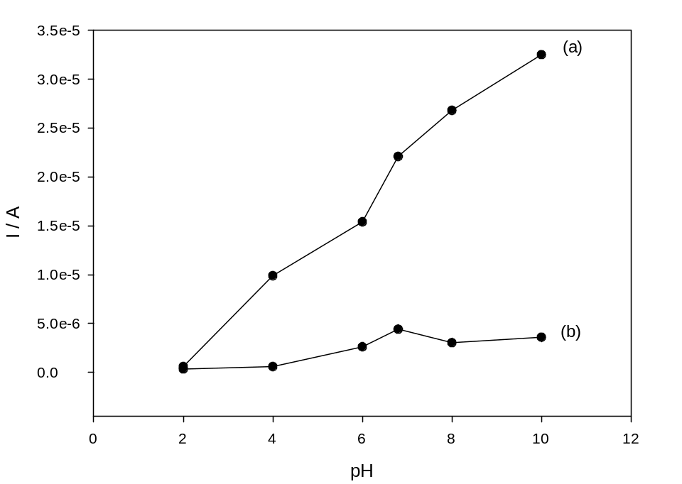

Figure 7

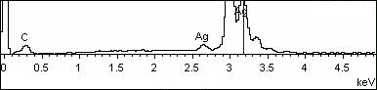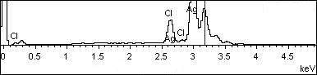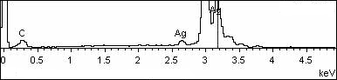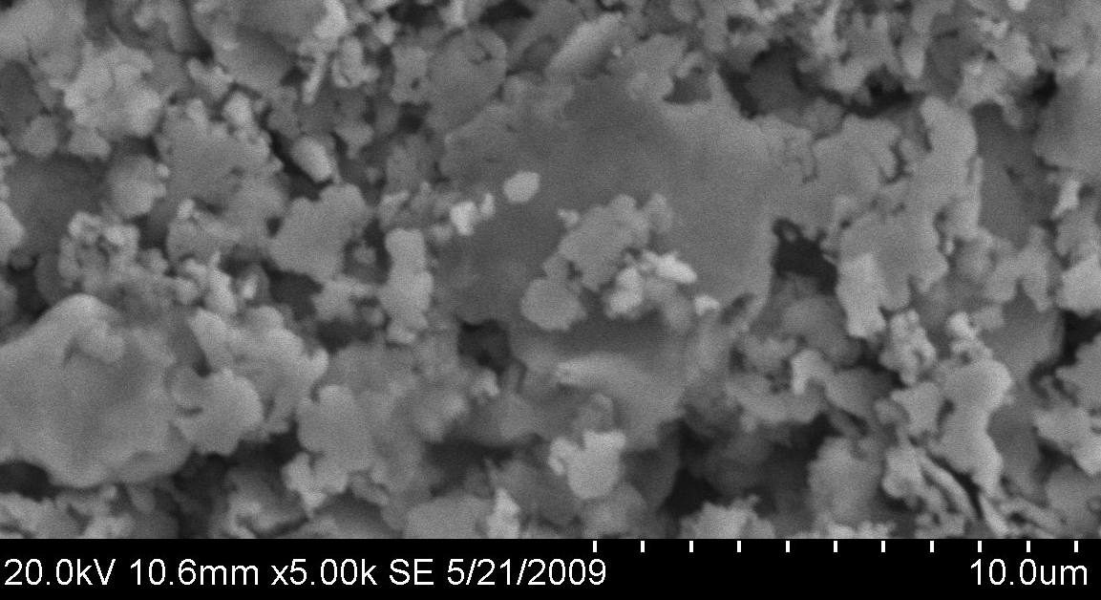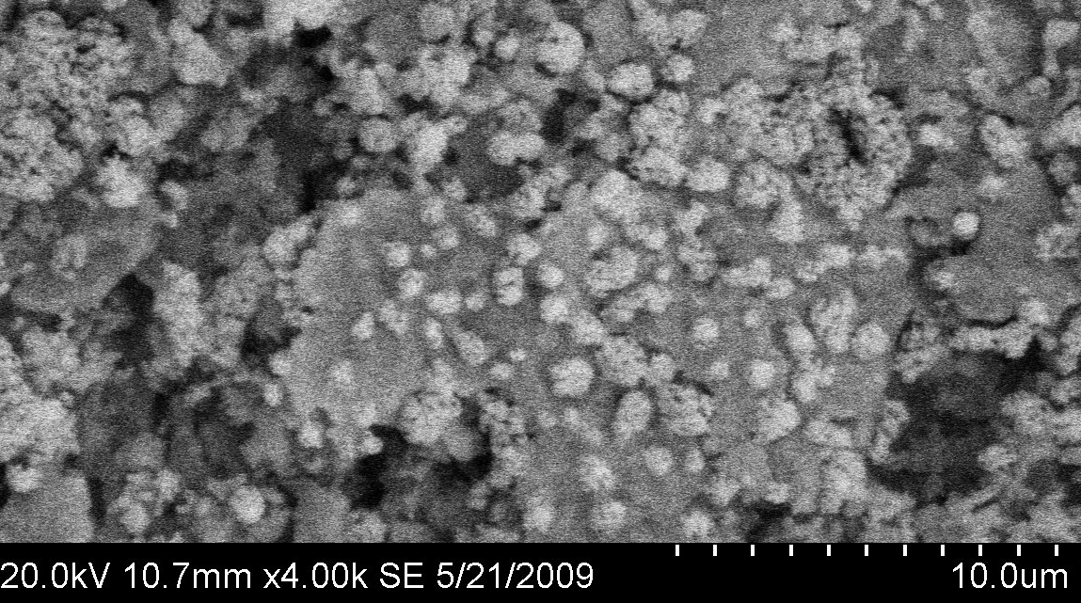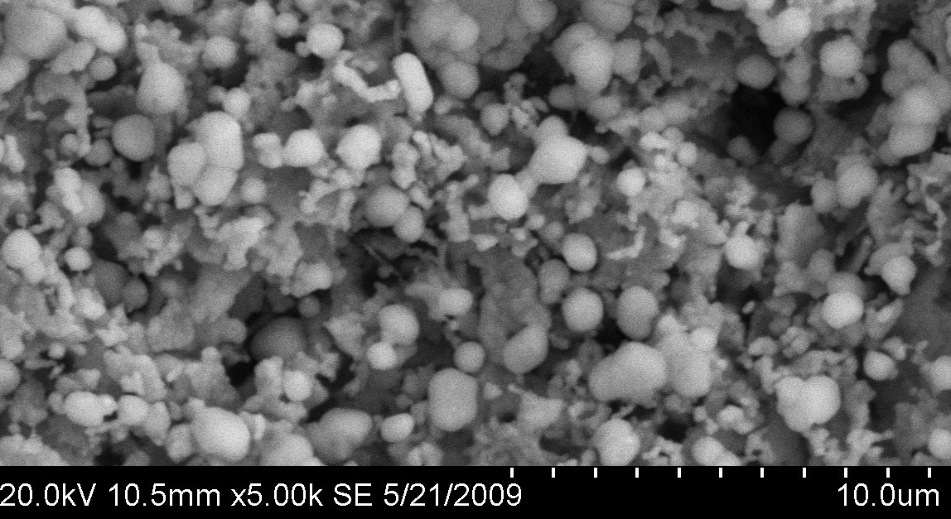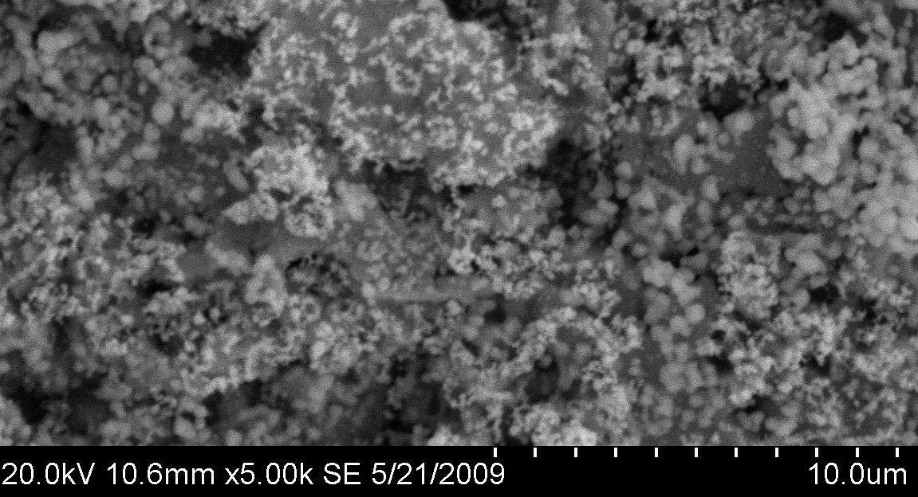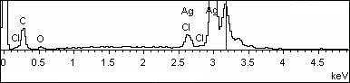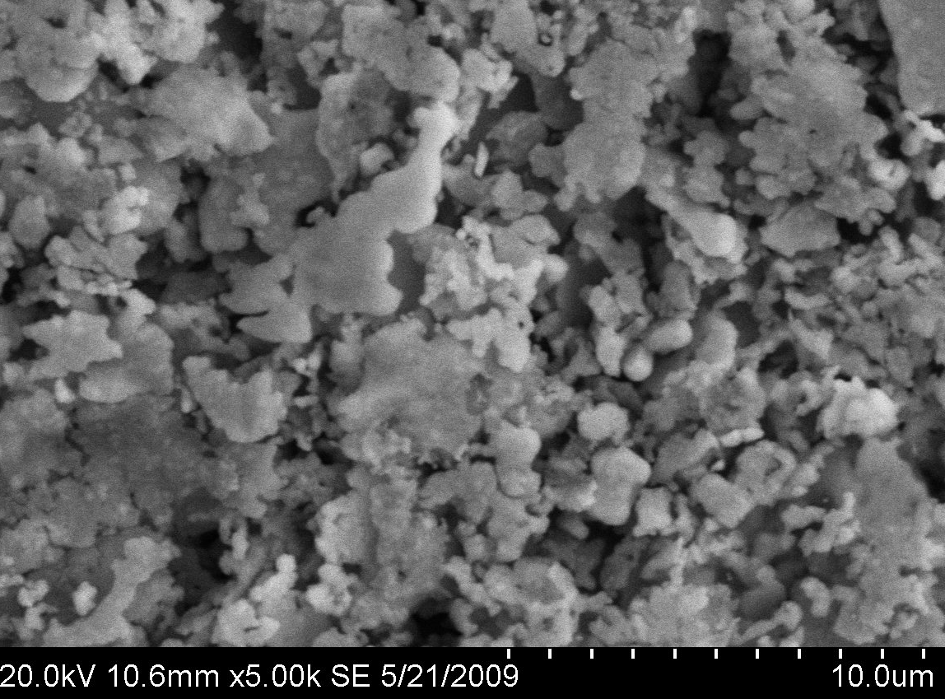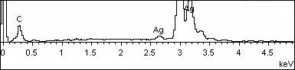
(a)
(c)
(b)
(d)
(e)

Figure 8



