Gharial (Gavialis gangeticus) populations and human influences on habitat on the River Chambal, India

Suyash Katdare (Tiger Watch, suyashk18@gmail.com, Ranthambhore Road, Sawai Madhopur, Rajasthan, India 322001)
Arjun Srivathsa (Tiger Watch, www.tigerwatch.net)
Apoorva Joshi (Tiger Watch)
Pritish Panke (Tiger Watch)
Ruchik Pande (Tiger Watch)
Dharmendra Khandal (Tiger Watch, E: dharmkhandal@gmail.com)
Mark Everard (Visiting Research Fellow, Faculty of Applied Sciences, University of the West of England, Coldharbour Lane, Frenchay Campus, Bristol BS16 1QY, UK, T: +44-(0)-7768-278429; F: no fax; E: mark@pundamilia.co.uk).

Abstract
- The gharial, Gavialis gangeticus (Gmelin 1789), a piscivorous reptile of Asian river systems, is increasingly threatened by diverse human pressures.
- Three survey expeditions were launched to monitor gharial populations, notable wildlife and the activities and attitudes of local people in a 110 kilometre stretch of the Chambal River in the National Chambal Reserve (NCS), India.
- Only 15% of gharial observed in December 2009 were in the upstream 54% of the surveyed river length. This coincides with the highest density of disturbance including water pumps, fishermen, and the highest growth in fishing activity since December 2008.
- Although fishing is recognised as a significant threat to gharial, no strong relationship was found between numbers of gharial and fishermen. However, numbers of water pumps, indicative of the intensity of agricultural activity, had a negative relationship with gharial numbers. This relationship was strengthened by omitting the upstream (Pali to Rameshwaram) survey reach, the tourist area of the NCS which is also potentially affected by upstream reaches.
- The downstream 46% of surveyed river length in December 2009 supported 85% of gharial (consistent with trends in other surveys), including 91.6% of males and 81.8% of juveniles. This reach is classified as a High Population Recorded Area of high potential conservation importance, also containing better habitat quality and lower human disturbance.
- A positive relationship was found between gharial numbers and sand habitat features. However, the Davar to Ghoonsai survey reach had low gharial numbers despite abundant sand features, perhaps due to a substantial length of the Ghoonsai sand bank having been converted or agriculture. This may have significant implications for gharial conservation.

Key Words: Chambal River, gharial, mugger, survey, threats, fishing, agriculture, habitat loss
Gharial (Gavialis gangeticus) populations and human influences on habitat on the River Chambal, India

Suyash Katdare, Arjun Srivathsa, Apoorva Joshi, Pritish Panke, Ruchik Pande, Dharmendra Khandal and Mark Everard

Introduction
The gharial, Gavialis gangeticus (Gmelin 1789), also known as the fish-eating crocodile, gavial, Indian gavial, Indian gharial or long-nosed crocodile, is a large piscivorous reptile endemic to the Indian subcontinent naturally occurring in approximately 20,000 km² of riverine habitat in the Indus, Ganges, Mahanadi, Brahmaputra and Irrawaddy river systems (Smith, 1939; Singh, 1978; Whitaker et al., 1974; Groombridge, 1987; Whitaker, 1987; Hussain, 1991, 1999, 2009). Gharial prefer calm and quiet areas of fast-flowing rivers. They are a long-lived crocodilian species with a generation length (the age at which 50% of total reproductive output is achieved) of 20 years (Rao et al., 1995). Reaching a length of up to 6 metres, gharial are also the second-longest crocodilians after the saltwater or estuarine crocodile (Crocodylus porosus) of Australasia.
The common name ‘gharial’ derives from the Hindi word ‘ghara’ meaning pot or vessel, recognising the resemblance to an inverted pot of the large protuberance at the tip of the snouts of adult male gharial; gharial are the only crocodiles that show sexual dimorphism. They are also accorded much importance in Indian mythology, including their depiction as the holy 'vehicle' of the goddess Ganga. Gharial have slender snouts armed with numerous sharp teeth that intersect to trap fish, which are the primary constituent of their diets. Their mating season is during the months of November, December and January. Sand banks, sand bars and sand islands play a significant role in the ecology of gharials as they are used preferentially as basking and nesting sites (Gharial Multi-Task Force, 2006). Throughout the summer months of March, April and May, female gharial clamber onto sand banks and islands exposed by receding river levels to nest communally, a large number of females using the same sand bank to lay their eggs in the sand (Rao and Singh, 1993). Parental care by the female has been observed for the first few days after birth.
Whilst a steady recovery from a widespread prior decline in gharial populations was reported up to 1997 (Sharma, 1999), there was a subsequent 58% decline from 436 adult gharials to 182 in 2006 (Whitaker, 2007). It is believed that the gharial is now extinct in its former habitats in Myanmar and Bhutan, with a small but unknown number remaining in Pakistan as well as remnant populations in Nepal and the upper Brahmaputra in Bangladesh (Bustard, 1980; Groombridge, 1987; Ross, 1998). A crisis situation was declared by the Indian government in January 2008 after a mass death of around 111 gharial in the National Chambal Sanctuary (the NCS, a wildlife sanctuary near Etawah in Uttar Pradesh, India) in 2007, the cause of which remains a matter of speculation but which is generally attributed to biomagnification of heavy metals and other toxins in fish in the Yamuna River (reviewed by Gharial Conservation Alliance, 2008).
The IUCN Red List (http://www.iucnredlist.org/apps/redlist/details/8966/0, accessed 27th February 2011) classifies gharial as Critically Endangered on the basis of long-term decline and the more recent, very rapid decline as well as low remnant wild global populations of less than 250 individuals. The causes of this decline include historic over-hunting for skins, trophies, eggs and indigenous medicine, and more recently the construction of dams, barrages, irrigation canals, siltation, changes in river courses, artificial embankments, sand-mining, riparian agriculture, domestic and feral livestock, pollution and fishing, which remains a major threat as gill nets continue to rapidly kill gharial of all sizes even in protected areas (Hussain, 1999, 2009).
Between 1975 and 1982, India established sixteen rehabilitation centres for the captive breeding and release of gharial, and also five gharial sanctuaries. The gharial population today is largely limited to these five refuges: the National Chambal Sanctuary (NCS); Katerniaghat Sanctuary; Chitawan National Park; the Son River Sanctuary; and the Satkosia Gorge Sanctuary. The NCS is the largest, founded in 1979 and covering 425 km². It takes in approximately 400 km of the Chambal River. The NCS is co-administered jointly by the states of Uttar Pradesh, Madhya Pradesh and Rajasthan (Whitaker, 2007). The Chambal River is the last stronghold for gharial, supporting 68% of the world’s wild population.
This paper reports on a series of three surveys of gharial and related biota and river uses and features along the Chambal River within the NCS.

Study Area
The Chambal River is perennial, rising in the Vindhya Range near the Mhow district of Madhya Pradesh. It flows in a predominantly easterly direction, forming the boundary of the states of Madhya Pradesh, Rajasthan and Uttar Pradesh along its course. Three major tributaries join the Chambal: the Parbati, Kali Sindh and Banas Rivers. A series of multipurpose dams (the Gandhi Sagar in Madhya Pradesh, and the Rana Pratap Sagar and Jawahar Sagar in Rajasthan) and a barrage (at Kota, Rajasthan) have been constructed in the upper reaches of the river (see Figure 1).
The Chambal is reported to be one of the cleanest rivers in India, at least upstream of its confluence with the Yamuna which carries substantial pollution from the greater Delhi area. Lined on either side by undulating ravines, the banks of the Chambal River are diverse in habitat. Banks of sand, pebbles, boulders, bedrock and deep ravines occur on both banks along the entire stretch of the river, frequently interspersed today by large areas of agricultural land. The most common agricultural crops in the sample area are Brassica juncea (mustard), Triticum vulgare (wheat), Cajunus cajan (yellow lentils), Pisum sativum (green peas) and Vigna radiata (green gram).

The riverine ecosystem of the Chambal River supports a great diversity of species of plants and animals, including for example invertebrates such as various species of water skaters and diving beetles, seven species of turtle and a wide variety of fish species. The local names of some fish found in the river, with probable taxonomic status determined from www.fishbase.org (accessed 27th February 2011), are ‘Rohu’ (Labeo rohita), Bawas (Gibelion catla), Baam (Mastacembelus armatus), Dhegra (species uncertain), Shingada (Hemiarius sona) and Mahseer (Tor species). Two species of crocodile are present: the gharial and the mugger (the freshwater ‘marsh crocodile’, Crocodylus palustris). Some of the most endangered species in the world, including the Gangetic river dolphin (Platanista gangetica gangetica), smooth-coated otter (Lutrogale perspicillata) and the Indian skimmer (Rhynchops albicollis), are also found here. The ravines dominating much of both banks of the tightly meandering river, interspersed with loose soil, rocky areas and thorny vegetation, serve to channel monsoon floodwater away from villages nestled on higher ground. They are thereby beneficial to village inhabitants as well as providing diverse habitat for wildlife. A variety of canids occur in these ravines, including the Indian wolf (Canis indicus), jackal (Canis aureus), Indian fox (Vulpes bengalensis), desert fox (Vulpes vulpes pusilla) and striped hyena (Hyaena hyaena). The sloth bear (Melursus ursinus) is also known to occupy this diverse ecosystem along with a range of other mammalian carnivores.

Objectives of the gharial survey
Following the mass death of gharial in 2007 in the Chambal River, three survey expeditions were launched to monitor gharial populations in a 110 kilometre stretch of the Chambal River between the villages of Pali and Khirkan (both on the Rajasthan bank). Other notable wildlife and the activities and attitudes of local people were also recorded. All surveys took place in the dry season when water levels had receded and much of the river was visible.
The three surveys took place in January 2008, December 2008 and December 2009. The first survey was a pilot, with the second and third surveys intended to quantify threats and determine High Population Recorded Areas (HPRAs) for gharial within the overall river reach. The third survey expedition (December 2009) built on the methods and results of its predecessors, yielding the majority of the quantitative information reviewed in this study. However, information from the third survey was compared with information gathered in prior surveys enabling comparative accounts to be drawn from three years of collected data, supporting other conclusions in this study. The objectives of the series of surveys were to:
- Survey a contiguous stretch of approximately 110 kms along the Chambal River, downstream from Pali village to Khirkan village over 11 days, dividing the entire sample area into 10 segments based on the adjacent villages on the Rajasthan bank of the river;
- Record the number of gharial and mugger in each segment, and to draw comparisons with data from prior expeditions. This enabled monitoring of increases, decreases and shifts in gharial numbers relative to previously-recorded High Population Recorded Areas (HPRAs) which were defined as reaches of river supporting the strongest gharial populations;
- Quantify relationships with direct threats such as fishing and sand/stone mining, and also indirect threats such as agriculture and the flattening of ravines to create agricultural land;
- Assess the habitat and land use patterns along the banks of the river to estimate the extent of natural habitat destruction;
- Document aspects related to the socio-economic status of the people around villages adjacent to the river, and examine the attitude of villagers towards gharial along the Rajasthan bank of the river;
- Study floral diversity; and
- Record sightings and locations of other threatened fauna found along the river.

Methods
Each selected segment was surveyed over a one-day period, the entire survey stretch taking over 11 days to complete. The timing of sampling was during good daylight between 10:00hrs and 17:00hrs. The first segment of the stretch from Pali to Rameshwaram (approximately 20 km lying within the tourism zone of the sanctuary) was surveyed by motorboat due to bank-side sampling difficulties. The remaining ten segments from Rameshwaram to Khirkan were surveyed on foot with the survey team walking along the river bank. Walking surveys were supported by porters, a cook and camel cart enabling the survey team to camp and obtain meals on the river bank.
Data captured included observed gharial and mugger numbers, quantification of threats, assessment of land use patterns along the banks, and records of flora and other threatened fauna in the area. Visual observations of gharial, muggers, other fauna and human activities in the river or on the banks were aided by Olympus 10x50 Field Binoculars. Two Garmin eTrex GPS units were used to record the co-ordinates of the spot perpendicular to gharial and mugger locations at every sighting. The specific location of gharial and muggers was noted, classifying them by position including ‘in water’, ‘on sand bank/bar/island’, ‘on rocks’ or ‘on mud banks’. The sex of observed gharial was also recorded in the December 2009 survey, classifying them as ‘males’ based on a clear protuberance at the tip of the snout, sub-adults/females for large individuals lacking such a protuberance, and juveniles for smaller specimens.
It is accepted that there are more accurate methods for quantifying the number of mature gharial, including for example the recommendation by Hussain (1999) to use gharial nest counts as they are easily visible and can be counted at well-known locations many of which have been monitored for decades. However, part of the purpose of this survey was to determine the impacts of disturbance, much of which appear to have occurred on these historic breeding habitats. Other data capture methods contributing to uncertainties include variations in survey stretch lengths and also the use of the motorboat between Pali and Rameshwaram. Gharial may also tend to hide where disturbance is more frequent, potentially impacting on their fitness. However, our selected methods were largely enforced by limitations of access and the survey budget, and serve to provide an indication of principal trends and associations.
GPS co-ordinates were also taken at every significant change in habitat or land use along the bank. In all, some 99 points such points were identified along surveyed stretch of river, marked with GPS coordinates, assessed for habitat and land use, and scored for the presence/absence of human disturbance. A location was considered ‘disturbed’ when one or more of the following was observed: human activity, cattle activity, fishing activity, water pumps, sand/stone mining, flattened ravines, and agriculture. Fishing, the presence of water pumps and sand/stone mining were recorded and quantified as direct threats. All the data collected were entered on pre-prepared data sheets in the field.

Results
Data gathered from survey reaches is summarised in Figure 2 and Table 1. A total of 122 gharial were counted in the 110km stretch between Pali and Khirkan in the third (December 2009) survey, comprising 11 males, 22 juveniles and 89 sub-adults/females. The stretch between Kemkutch and Khirkan was exclusive to the 2009 survey, lacking comparative data from previous surveys.
Relatively low populations of gharial were documented in the December 2009 survey between the villages of Pali and Gohta (the five upstream survey reaches), collectively comprising 15% of the total observed gharial population over 54% of the total river length surveyed. This length of river coincides with the highest density of water pumps, the most observed fishermen and the highest growth in numbers of fishermen between December 2008 and 2009.
Fishing presents a direct threat to the survival of gharial (Hussain, 1999). However, no strong relationship was observed between numbers of gharial and fishermen (R² = 0.017 on Figure 3) in December 2009. Furthermore, a regression of changes in observed gharial numbers and numbers of fishermen across the Pali to Kemkutch sites between December 2008 and 2009 surveys reveals no association (R² = 2E-06).
The number of water pumps within each survey segment was taken to indicate the intensity of agricultural activity. 128 water pumps were counted from both banks across the whole 110 km reach in December 2009, and a negative relationship was found between the numbers of water pumps and gharial (R² = 0.086 on Figure 3). Data for the upstream (Pali to Rameshwaram) site has a significant effect on the relationship of water pumps to gharial numbers in Figure 3 as, when it is removed from the regression, the R² value for this negative relationship rises from 0.086 to 0.1728 suggesting that other factors may be influencing the density of observed gharial. This may include, for example, the Pali to Rameshwaram survey stretch being the longest (21.5km compared to a mean of 9.8km for the remaining survey stretches downstream to Khirkan), it being the location of the tourist area, and also potential impacts from the upstream unsurveyed reaches of the Chambal River and a tributary. It is also notable that the highest incidence of water pumps in the December 2008 and December 2009 surveys did not coincide with the highest density of fishermen, and that there was also a significant growth in fishing activity (totals of 47 and 86) and a slight increase in water pumps (a total of 121 rising to 128) between the December 2008 and December 2009 surveys, emphasising the diversity and growth of pressures throughout the NCS.
The High Population Recorded Areas (HPRAs) in 2009 were identified between the villages of Gohta and Khirkan, supporting 85% of the total recorded number of gharial. This trend was consistent with data from January 2008 and December 2008 (though these surveys did not take in the downstream Kemkutch to Khirkan reach). These HPRAs are of high importance since they are likely to signify better habitat quality and lower disturbance (particularly lower numbers of recorded water pumps and fishermen although fishing activity was generally increasing between December 2008 and December 2009). They may therefore be priorities for long-term protection.
These contiguous HPRAs supported 91.6% of the total male population in the sample area in December 2009, suggesting strong viability for substantial long-term breeding within the gharial population. The same stretch also constituted 81.8% of the total juvenile population, indicating suitable growing conditions and better habitat suitability.
Analysis of the points marked with GPS and assessed for the presence/absence of human disturbance, habitat and land use in the December 2009 survey revealed that 79.8% of river length was subject to anthropogenic disturbance (human activity, cattle activity, fishing activity, water pumps, sand/stone mining, flattened ravines and/or agriculture). Sand banks/bars/islands, important for gharial nesting and basking, were found to be present in 32.3% of total river length. Gharial numbers were positively related to the percentage of these features observed within survey stretches (R2 = 0.013). However, the Davar to Ghoonsai survey reach was perceived as of specific significance as gharial numbers were low despite abundant sand features (3 and 31% respectively), whilst the downstream Ghoonsai to Kased reach had relatively high gharial numbers despite lacking sand features (17 and 0% respectively). Removing the Davar to Ghoonsai reach from the regression strengthens the positive correlation of gharial numbers to percentage of sand features (R2 = 0.1676) whilst removing the Ghoonsai to Kased reach as well strengthens it further (R2 = 0.2389). This is believed to be due to a substantial length of the Ghoonsai sand bank now having been converted into agricultural land (i.e. subject to substantial disturbance); we can perhaps anticipate a subsequent decline in numbers of the long-lived gharial in response to this important breeding habitat.
Figure 3 also plots a regression between numbers or observed gharial and mugger at the survey sites in December 2009. No strong relationship was observed (R² = 0.0034). However, removal of the Pali to Rameshwaram survey stretch from this regression identifies a weakly positive relationship (R² = 0.0692) suggesting differences in response to habitat and disturbance, including potential influences from the unsurveyed upstream reached of the Chambal River and its tributary.

Discussion
Although a substantial breeding population remains within the limits of the NCS, uncontrolled anthropogenic pressures continue to pose a threat to the survival of its gharial population. 79.8% of the total sampled river length faced disturbance due to direct or indirect human activity. With increasing fishing activity in the river channel and agricultural activities along its banks, the last stronghold of the gharial remains perilous. We review the implications of various of these pressures on gharial populations.

Fishing
Illegal fishing in the sanctuary has been identified as the most significant and direct threat to the gharial, with cast nets widespread across the river width responsible for entangling and drowning gharial, particularly juveniles (Sharma and Basu, 2004). This has significant impacts on both the breeding population and recruitment, and thus the viability of the entire gharial population. Increased fishing activity also affects the main diet of the gharial, as fish constitute a predominant portion in their diet. Fish are also consumed by other fauna inhabiting the river, including for example smooth-coated otter, Gangetic river dolphin, storks, pelicans and cormorants. Thus, excessive fishing can potentially disrupt the food chain and the entire ecology of the river.
Fishing activity was observed being carried out individually by fishermen. Typically, these lone fishermen use inflated inner tubes from tractor tyres as boats, propelled by two wooden paddles. From these, they set drift nets, most commonly made of nylon. The nets are generally cast into the water, sometimes 3-4 at a time early in the morning, and collected back with the catch at dusk. Rare cases of fishing using fixed fishing lines were recorded near Gohta village.
The total number of fishermen recorded throughout the whole survey reach in 2009 was 97, of which 86 were observed in the Pali-Kemkutch segment. 82 were observed fishing from the Madhya Pradesh bank and 15 from the Rajasthan bank. All the fishermen from the Rajasthan side came from Godikutch village. (Villagers on the Rajasthan side are traditionally vegetarian, and it was observed that only the Kahar community on the Rajasthan side consume fish.) Discussion with local people revealed that the fishing equipment is mostly purchased from Sheopur and Sabalgarh in Madhya Pradesh State. Fishermen interviewed during the 2009 survey reported that they catch between 10-20kg of fish per day and sell the catch for Rs.100-200 per kilogram. There was one case, however, where a person claimed that sometimes the total daily catch of fish is 2 quintals (200kg).
Notwithstanding the above arguments, analysis of survey data do not reveal a strong negative relationship between observed numbers of gharial and fishermen. This is possibly due to long-term impacts of fishing activities affecting gharial populations throughout the NCS and particularly as mortality of juveniles is proportionately higher affecting overall recruitment.

Agriculture
Riparian agriculture is a major threat to habitat essential to gharial. Agriculture was found to be extensive along both banks of the whole section of river, recorded in nearly one-third of the sampled length on the Rajasthan bank. The fertility of river banks and exposed river mud in proximity to villages encourages widespread encroachment onto riparian and exposed channel habitat, albeit that this is theoretically prohibited.
Various other activities associated with agriculture also perturb the river ecosystem and its suitability to support gharial, particularly water abstraction including the noise created by motorised pumps, constant human disturbance from pump operation and risks of water pollution from diesel spillages and leaks. The flattening of ravines on the river’s banks to promote this form of encroachment agriculture, making space for fields, was observed to be taking place along the river at an increasing rate. While ravines constituted 18% of the sampled area, 22% of these ravines were at least partially flattened for agricultural purposes. As mentioned previously, these ravines are important not merely for a rich variety of wildlife but also in terms of their role in safeguarding the wider habitat of the river and protecting adjacent villages from flooding. During floods, the water level rises 10-15m and often spreads up to 500m from either bank (Hussain, 2009); the ravines act as barriers to the floodwaters. The ravines also prevent wild animals in the river from drifting inland for a long distance with the floodwater. In the absence of the ravines, these animals instead risk becoming stranded in the soft clayey sand of the ravines, preventing their return to the river. Observation of ravines during the three surveys found that they also form important corridors between protected areas, for example between Keladevi Wildlife Sanctuary (in Karauli District of Rajasthan) and the National Chambal Sanctuary. The flattening of ravines not only alters the morphology of the river, but also further isolates the habitat for keystone species such as the tiger (Panthera tigris).
There is an increasing regional demand for fresh water, particularly from rivers, and many water pumps have been installed along the banks of the Chambal River primarily for abstraction of water for irrigation. This water is supplied to the agricultural fields on the banks as well as the fields near the villages, sometimes, using pipes as long as 1.2 km. Although small-scale pumping may have little individual impact, large numbers of pumps can cumulatively change river discharge which can affect river morphology. These frequent water pumps therefore represent a constant and cumulative threat to the river ecosystem. A total of 130 water pumps were recorded from both the banks of the survey reach in December 2009. Only 23% of these were recorded in HPRAs for gharial, representing 46% of the total surveyed river length in December 2009.
Excessive fertiliser use can also create problems. Urea is the most commonly-used fertiliser for agriculture in this part of India. This can result in long-term effects on the river ecosystem. As the urea slowly seeps into the river, eutrophication may promote excessive growth of floating vegetation in the river which can choke and alter the pace and potentially the oxygen content of the river. This might eventually affect the whole river ecosystem.
The destruction of sand banks is also a direct and problematic consequence of riparian agricultural intensification. The need for increasing amounts of cultivable lands has now driven the villagers from locations close to the banks to exploit large stretches of sand banks further into the river channel during low flows. Sand banks are of very high significance in gharial ecology as basking and nesting sites. Sand banks/bars/islands occupy 32.3% of the total sampled area in 2009, and spot samples revealed that nearly 10% of these banks had been converted into agricultural lands.
The negative relationship between numbers of gharial and water pumps, taken to indicate the intensity of agricultural activity, indicates the adverse outcomes of these cumulative agricultural impacts, and particularly when data for the upstream (Pali to Rameshwaram) reach was set aside. The slight rise in numbers of observed water pumps between the December 2008 and December 2009 surveys also suggests that this pressure may be growing throughout the NCS.

Mining
Mining of sand, stone and other aggregates from the Chambal River is another factor contributing to the destruction of gharial habitat. It alters natural habitat, and in particular has a direct negative influence on important nesting sites. Sand mining also has consequences of gharial outside of the nesting season. Gharial are known to prefer sand banks to rocks or clay banks. Another advantage of basking on sandy surfaces is that they contains more moisture than other surfaces and hence they provide a warm and moist environment, reducing the chance of desiccation while basking in the sun (Hussain, 2009). Extraction of sand from islands and the few remaining sand banks, meeting the growing local demand for sand for construction, is constantly increasing. Small-scale mining of sand was observed on the banks of Ghoonsai, where sand was being collected in small bags and loaded onto a mule as it is across much of India. This small-scale practice may be inherently sustainable; however, large-scale habitat removal by tractors and other powered machinery certainly is not.
Stone mining was also commonly observed throughout the 2009 survey reach of the Chambal River. The breaking of stone layers takes place either manually or by using dynamite. The sound of dynamite blasting can be heard for considerable distances from the stone mining site, as can sound and vibrations from crushing implements and tractors used to collect the extracted stone. This not only causes considerable disturbance to animals, but also eliminates important habitat for species such as the smooth-coated otter which use rocks and stones for nesting. In other rivers across India, the ready availability of dynamite leads to its use as a destructive means of fishing which has serious adverse impacts for the whole river ecosystem (Everard and Kataria, 2010).

Other significant findings from the three surveys
A dead gharial found entangled in a fishing net was reported by the expedition team in December 2008 in the (upstream) tourist area between Pali and Rameshwaram. The post-mortem report (unpublished) on this dead gharial revealed that the animal had multiple fractures in its lower mandible, indicating that the death could possibly be because of struggle and subsequent drowning.
During the summer of 2009, the Tiger Watch survey team conducted an additional rapid survey from a boat in the tourist area (Pali to Rameshwaram). The team recorded one dead gharial and one dead mugger, both also entangled in fishing nets. These deaths were reported to the relevant authorities.
During the 2009 survey, one dead mugger was recorded in the gharial HPRA (between the villages of Gohta and Khirkan). Although significant fishing activity was observed around the dead mugger, the cause of death was unknown.

Further implications for gharial
The survey reach of the Chambal River covered nearly a quarter of river length within the NCS. Extrapolating from the results of these three surveys, the NCS appears to continue to drift towards fragmentation and isolation. With human settlements expanding along the banks, its continuity with neighbouring protected areas is being broken. Increasing anthropogenic pressures through fishing, agriculture, mining and livestock interference continue to adversely affect the habitat, diet, recruitment and ecology of the gharial. The negative implications of human activities have also significantly degraded the ravines along the river bank and the wildlife that they support.
A fragile population of gharial continues to thrive in an even more fragile and progressively deteriorating ecosystem. The Chambal River is the last stronghold for the threatened gharial, but even after repeated incidents of gharial and mugger deaths due to unnatural causes were reported to the Forest Department there was no evidence of measures being undertaken to tackle the situation. The sanctuary, being divided under the jurisdictions of three different states, also suffers from ‘blame games’ to justify these failures in protection. The sanctuary also continues to suffer from lack of monitoring to keep a check on illegal fishing and mining activities and the encroachment of agriculture.
Failure to plan for long-term conservation initiatives can be seen in the Forest Department of Rajasthan, including enforced relocation of villages along the river bank. Negative attitudes created amongst these villagers and the wider community is likely to manifest in opposition to future conservation plans. Involvement of local communities in the conservation of gharial populations, as indeed for any effective conservation initiative, is of high and rising importance; all people need a voice and involvement in such schemes as well as to gain in some way from species and habitat protection.
Disturbance is also known to result in gharial hiding from human activities and observers, which may in turn reduce basking time. This has significant potential implications for physiological efficiency, reproductive success and possibly survival in the long term. It is possible that hiding gharial may be under-recorded in heavily-disturbed survey stretches, potentially leading to an underestimate of the impacts of this pressure.
A more extensive study is required, taking in the entire stretch of the Chambal River within the NCS to determine the total gharial population and the pressures upon it. It is likely that more HPRAs may occur in segments of the river that have not yet been surveyed. Along with regular monitoring, these high population areas need to be identified and given strict protection in order to establish a stable breeding population for gharials in the wild, in the hope that effective conservation in currently degraded or degrading areas will allow their recolonisation.

Acknowledgements
We thank the rest of the team members of the expedition (Digvijay Sabne, Sanket Deshpande, Neeraj Gade, Sohini Vanjari, Anupriya Karippadath, Raghav Agarwal, Mittal Gala, Sujay Kotian, Alok Chorghe, Vishal Rasal and Soujanya Srivastava) for their hard work and contribution towards the expedition.
We also thank Mr Fateh Singh Rathore (Vice-Chairman, Tiger Watch) and Mr Gaurav Kataria (Wildlife Travels, New Delhi) for their support.

References
Bustard HR. 1980. Maternal care in the gharial, Gavialis gangeticus (Gmelin). British Journal of Herpetology 6 : 63-64
Everard M, Kataria G. 2010. Recreational angling markets to advance the conservation of a reach of the Western Ramganga River. Aquatic Conservation. DOI: 10.1002/aqc.1159
Gharial Conservation Alliance. 2008. Mass Gharial Deaths in Chambal. (http://www.gharialconservation.org/mass-gharial-deaths-in-chambal/, accessed 21st September 2010.)
Gharial Multi-Task Force. 2006. Gharial Recovery Action Plan. Gharial Conservation Alliance. (http://www.gharialconservation.org/PDF/GRAP.pdf, accessed 21st September 2010.)
Groombridge B. 1987. The distribution and status of world crocodilians. In Wildlife Management: Crocodiles and Alligators, Webb GJW, Manolis SC, Whitehead PJ (eds). Surrey Beatty and Sons: Sydney; 9-21
Hussain SA. 1991. Ecology of gharial (Gavialis gangeticus) in National Chambal Sanctuary, India. M.Phil. Dissertation, Centre for Wildlife and Ornithology, Aligarh Muslim University, Aligarh
Hussain SA. 1999. Reproductive success, hatchling survival and rate of increase of gharial Gavialis gangeticus in National Chambal Sanctuary, India. Biological Conservation 87 : 261- 268
Hussain SA. 2009. Basking site and water depth selection by gharial Gavialis gangeticus Gmelin 1789 (Crocodylia, Reptilia) in National Chambal Sanctuary, India and its implication for river conservation. Aquatic Conservation: Marine and Freshwater Ecosystems 19 : 127–133
Rao RJ, Basu D, Hasan SM, Sharma BB, Molur S, Walker S. (eds.). 1995. Population and habitat viability assessment (P.H.V.A.) workshop for Gharial. P.H.V.A. Workshop, 16–18 January 1995. Zoo Outreach Organization/CBSG, Coimbatore, India.
Rao RJ, Singh LAK. 1993. Communal nesting by gharial Gavialis gangeticus (Gmelin) (Reptilia: Crocodilia) in National Chambal Sanctuary. Journal of the Bombay Natural History Society 90 : 17-22
Ross JP. 1998. Crocodile status, survey and conservation action plan. Second edition. IUCN/SSC Gland, Switzerland and Cambridge
Sharma RK. 1999. Survey of gharial in National Chambal Sanctuary – 1993-97. ENVIS (Wildlife and Protected Areas). Wildlife Institute of India. Dehradun. 2 : 81-86
Sharma RK, Basu D. 2004. Recent Reversals in the Population Trends in the Population of Gharial in the National Chambal Sanctuary in North India; implications and a suggested strategy for the conservation of one of the world's most endangered crocodilians. In: Crocodiles. Proceedings of the 17th Working Meeting of the Crocodile Specialist Group. IUCN – The World Conservation Union: Gland, Switzerland. 180-186
Singh LAK. 1978. Ecological studies on the Indian Gharial (Gavialis gangeticus Gmelin, Reptilia, Crocodylia). Unpublished PhD thesis, Utkal University, Bhubaneshwar, India.
Smith MA. 1939. The Fauna of British India Including Ceylon and Burma, Reptilia and Amphibia. Vol.I Loricata, Testudines. Indian Reprints. Vol. Edition 1974. Today’s and Tomorrow's Printers and Publisher, New Delhi.
Srivathsa, A. and Katdare, S. (2010). The gharial expedition December 2009: a survey of gharial populations in one segment of the National Chambal Sanctuary, Rajasthan. Tiger Watch, Rhanthambhore. (http://www.tigerwatch.net/docs/the_gharial_expedition_dec2009_report.pdf, accessed 22nd February 2011)
Whitaker, R., Rajamani, V., Basu, D. and Balakrishnan, V. (1974). Preliminary survey of the Gharial, Gavialis gangeticus. Unpublished Madras Snake Park Trust Report, 16 pp.
Whitaker R. 1987. The management of crocodilians in India. In Wildlife Management: Crocodiles and Alligators, Webb GJW, Manolis SC, Whitehead PJ (eds). Surrey Beatty and Sons: Sydney, 63-72
Whitaker R. 2007. Gharial going extinct again. Iguana 14(1) : 24-33
Tables

Table 1. Gharial numbers recorded in survey segments during December 2009, broken down into males, sub-adults/females and juveniles as well and their use of habitat

Village stretch | Males | Sub-adults/ Females | Juv. | No. in water | No. on Sand bank/bar/island | No. on rocks | No. on mud banks | Total
Pali-Rameshwaram | - | 2 | - | - | - | - | 2 | 2
Rameshwaram-Shankarpura | - | - | - | - | - | - | - | -
Shankarpura-Baghoda | - | - | - | - | - | - | - | -
Baghoda-Bilvasa | 1 | 6 | 2 | 6 | - | 3 | - | 9
Bilvasa-Gohta | - | 5 | 2 | 2 | - | 5 | - | 7
Gohta-Davar | 3 | 50 | - | 42 | 7 | - | 4 | 53
Davar- Ghoonsai | - | 3 | - | 2 | 1 | - | - | 3
Ghoonsai-Kased | 2 | 10 | 5 | 15 | 2 | - | - | 17
Kased-Kemkutch | 5 | 9 | 7 | 9 | 12 | - | - | 21
Kemkutch-Khirkan | 1 | 3 | 6 | 3 | 7 | - | - | 10

Figure 1: Map of the National Chambal Sanctuary (NCS)

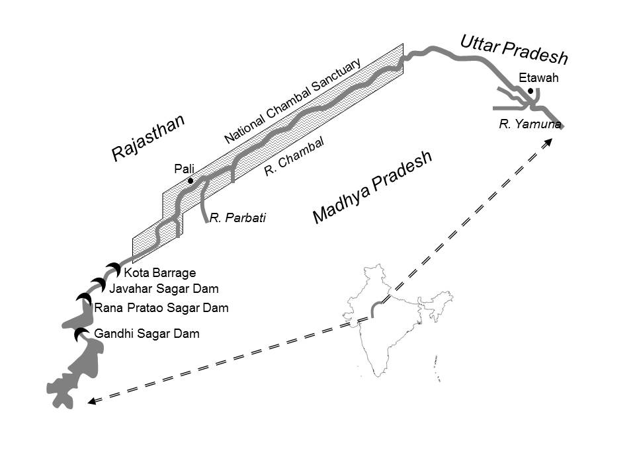

Figure 2: Length, disturbance, mugger and gharial numbers recorded in survey stretches

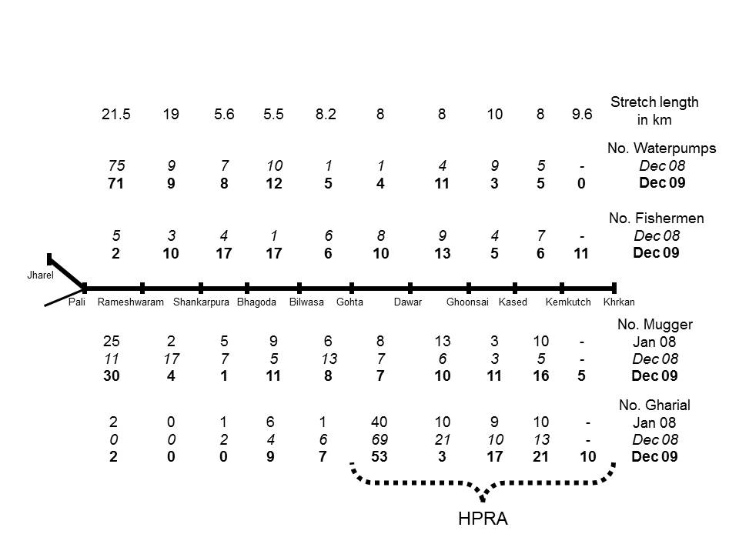

Figure 3: Relationships of number of muggers, fishermen and water pumps to numbers of gharial by survey stretch in the December 2009 survey

Corresponding author - current address: 2 Hollow Street, Great Somerford, Wiltshire SN15 5JD, UK.

