Report on the UWE Research Repository Survey, June 2011
1.0 Background
The UWE Research Repository was officially launched in March 2010, and has been running for a year and a half. In June 2011 the UWE Research Repository team organised a survey on the views of academic staff and researchers to open access publishing and the repository. The survey was organised in collaboration with the RSP and other UK university repositories, and 107 responses were received in total. The Repositories Support Project (RSP) is a UK-based initiative that aims to build repository capacity, knowledge and skills with UK HEIs.
The Repository currently contains over 13,000 bibliographic records. Over 1,600 of these (approximately 12 percent) have some form of full text attached. The repository is central to the University's preparations for the upcoming Research Excellence Framework (REF), ensuring that the university holds a central, standardised record of all research output relevant for this purpose. However, the repository is also ideally placed to make the full range of the university’s research more visible, by making it accessible to the wider research community and the general public.
As an open access repository, the UWE Research Repository can benefit both the university and wider society. Open Access publishing allows online access to journal articles, and other scholarly publications, via the Internet free for all to read. Where permission is given to do so, it also enables use or reuse to various extents. By ensuring that the outputs of publicly funded research are available to all, the university can improve its chances in the competition for government research funding. It also enables industry and third sector partners to discover the university’s research more easily (JISC 2011).
May 2011 saw a record number of unique visitors to the UWE Research Repository – a total of 9,081. Visitors have been rising steadily since the repository was launched from approximately 1,000 per week in January 2010 to over 2,000 per week in May 2011. This has resulted in a total of 50, 639 downloads to date; rising from 1,000 downloads in October 2010 to 7,500 in May 2011.

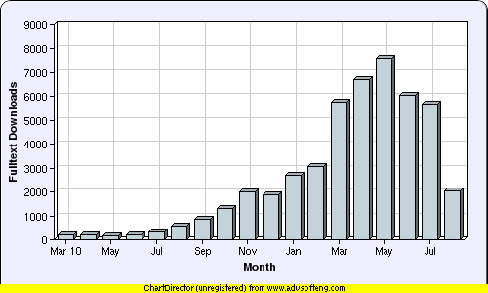
There is still work to do, however. To date only half (6 percent) of full text items are available on open access, often due to publisher’s copyright policies. This figure rises to 16 per cent of content published since 2008.

2.0 General information
Questions 1-3 asked for some general information about the background of those answering the survey.
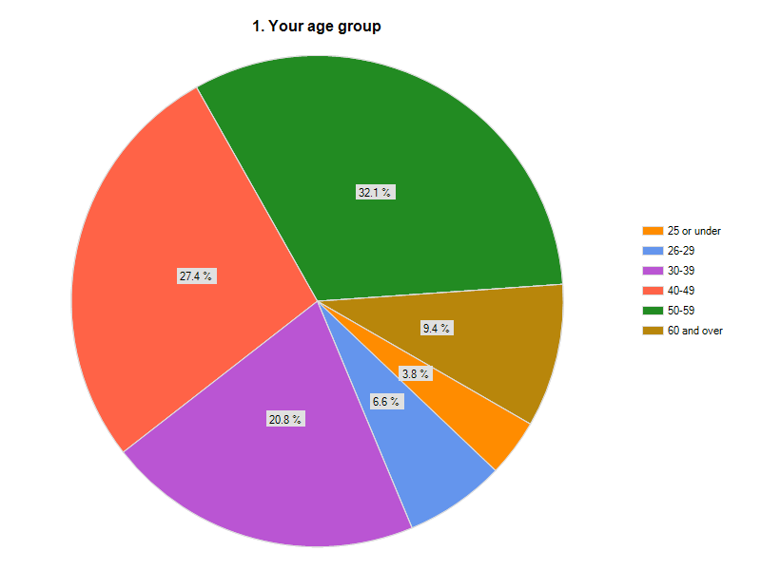
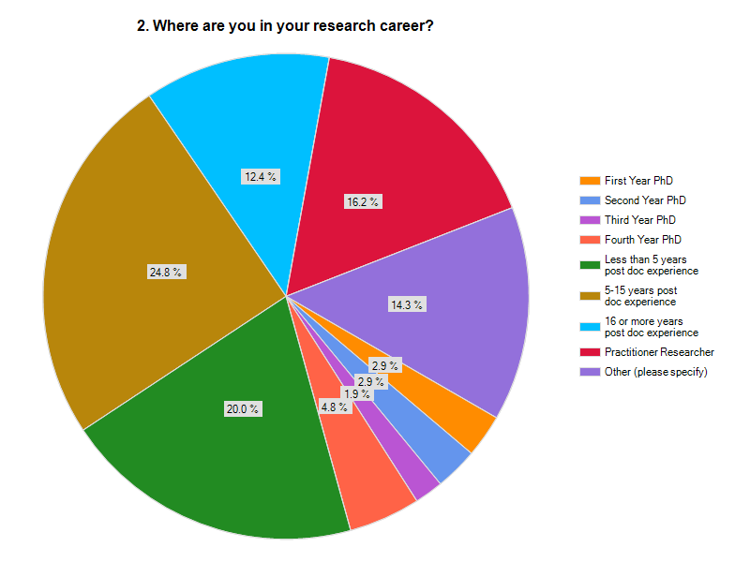
12.5 per cent of responses came from PhD students, while the majority of responses (44.8 per cent) can from staff with 1-15 years post doctoral experience.
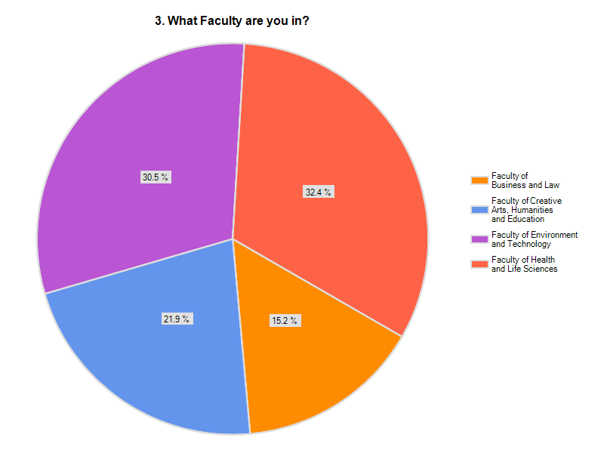

The survey was publicised by Faculty Research Officers and Subject Librarians in all Faculties over a period of four weeks. This resulted in a fairly even split of responses between the four Faculties, although the Faculty of Environment and Technology and the Faculty of Health and Life Sciences response rates were slightly higher. Table 1 shows the approximate percentages of items in the Repository added by members of each Faculty. Although there appears to be little correlation between the Faculties with the largest number of items in the Repository and those that returned the questionnaire, it is a positive outcome that all Faculties contributed significantly to both.

Table 1: Percentage share of Repository items by Faculty
Faculty | Percentage of items in the Repository
Faculty of Business and Law | 20%
Faculty of Creative Arts, Humanities and Education | 25%
Faculty of Environment and Technology | 37%
Faculty of Health and Life Sciences | 17%
Other (library, cross-faculty Research Institutes etc.) | 1%

3.0 Views on the Open Access movement
The second section of the questionnaire asked a number of general questions regarding the Open Access movement in order to gauge the attitude of staff and researchers at UWE.
82 per cent of those who responded were in favour of the principles of Open Access and 78 per cent were in favour of adding their research to an Open Access Repository. This compares to only 12 per cent of content which is available in full text in the UWE Research Repository.
Three replies stated that they were strongly against using Open Access Repositories, one from the Faculty of Business and Law and two from the Faculty of Health and Life Sciences.
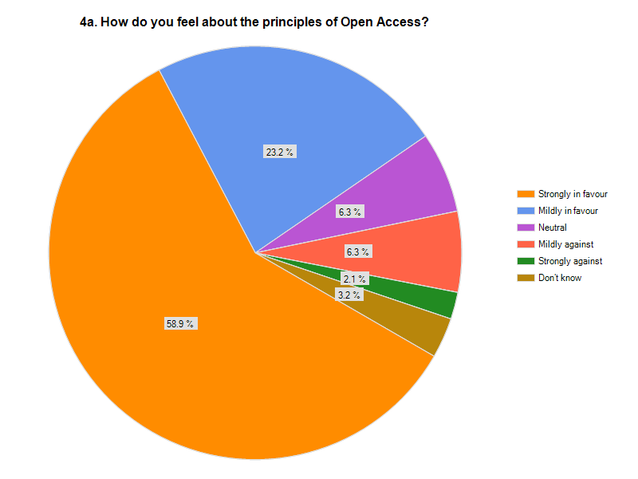

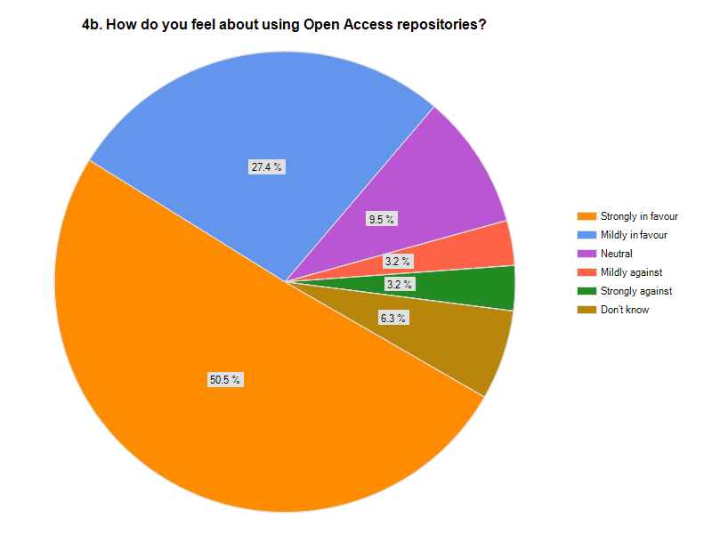
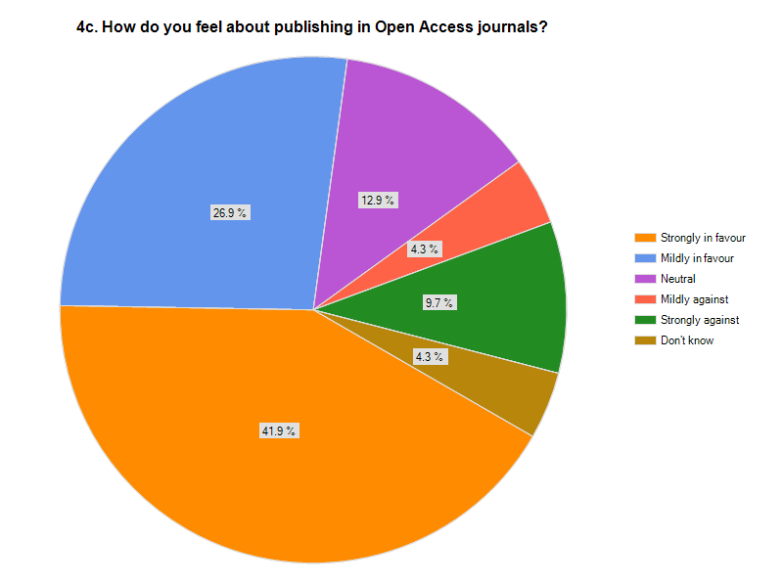
A further 69 per cent were in favour of publishing in open access journals. However, there were some comments regarding concerns over peer review and the impact factor of open access journals.
Recommendations
- In general, advocacy needs to concentrate on how to make research outputs available on open access rather than the arguments for or against
- Work needs to be done on publicising peer reviewed high impact open access journals such as those published by Biomed Central

4.0 Research Funding
This section asked that if researchers were applying for a grant from a funding body (e.g. EPSRC/ NERC/ Wellcome Trust) could they make provision for publication charges within the funding. Only 60 per cent answered the question regarding research funding, of these 63 per cent answered no. Some comments show that there is a lack of awareness about what funders require and how to go about budgeting for Open Access publishing in the bid writing process. For example: “I don’t know, as I have never applied personally for funding”; “depends mostly on whether I had thought to include it (and it had been approved) in the original grant application” and “that would depend entirely on the budget and views of funder”.
Recommendation
- Advocacy and information is needed on funder requirements on open access, including advice on how to submit proposals for publishing research on open access at the bidding stage.
5.0 UWE Research Repository
81 per cent of respondents had heard of the University Repository. Although this is quite reassuring, we need to ensure that the remaining 19 per cent become aware of the repository. Of those respondents that are not aware of the repository, 58 per cent are based in the Faculty of Health and Life Sciences.
71 per cent of respondents are currently making the metadata of their research available in the repository as a minimum (29 per cent did not reply to this question). Items being made available are:
Table 2: Item types being made available in the UWE Research Repository
Item Type | No. of replies*
Journal articles | 51
Book chapters | 22
Books | 10
Working papers, reports etc. | 13
Conference papers | 22
Shows/ exhibitions | 2
Performances | 0
Art work | 1
Sound/ video recordings | 0
Data sets | 0
Other | 4
*multiple types could be selected for this question
It is notable that very few researchers are adding non text-based material, such as performances and sound and video recordings, to the repository. Only 3 per cent of items in the repository are currently listed as this type of material, whilst less than 1 per cent of items have some form of audio visual full text material attached. Although 25 per cent of the material in the repository is added by the Faculty of Arts, Creative Industries and Education, the majority of this (78 per cent) is still text-based. Informal conversations with researchers in this faculty suggest there are two main reasons for this - researchers feel they will lose the rights to their work, and they are worried about the quality of the reproduction on the repository.
Those that were not making their research available cited the following as reasons why:
- Copyright restrictions 5
- Not yet published 5
- Time 4
- Not aware of the repository 3
- System is too complicated 3
- Don’t agree with it 2
- On other websites 1
- “Unsuitable” material 1
It is clear that there is still some misunderstanding about the copyright implications of adding research to the repository. All items can be added to the repository as metadata and a large number can be added in full text on open access. It is useful to know that those who have not yet published are at least aware that their work can be added to the repository.
A number of respondents also stated that they had not added their work because they were not aware of the repository, or because they found the system complicated and difficult to understand.
However, 60 per cent of replies stated that they self deposited items into the UWE Research Repository, suggesting that for many the system is not too complicated to use. 40 per cent did not self deposit, sending their items either directly to the Repository Team or to a Faculty Research Administrator. Anecdotal evidence suggests that additional training may help here, as previous attendees have claimed that attending a training session made the self-deposit process much clearer.
When asked if alternative repositories were used, 60 per cent of respondents did not use an alternative and of those that did, 76 per cent also deposited in the UWE Research Repository.
Recommendations
- Determine the reasons for non text-based work not being added to the repository, and seek to address this
- Further advocacy work is required regarding copyright restrictions and the UWE Research Repository
- Provide a range of additional, highly visible promotion on the UWE Research Repository. Ensure that staff within the Faculty of Health and Life Sciences are heavily targeted
- Provide, and evaluate, training on the UWE Research Repository to give people an opportunity to use the system
- Work with the Library IT team to ensure the UWE Research Repository is as intuitive to use as possible
6.0 Copyright
The section on copyright gave some interesting results. 74 per cent of those who responded thought that copyright should stay with the author, employer or funding council. Of those who said ‘other’, the majority thought that copyright should be shared. However, 25 per cent did not read the copyright transfer agreement which usually transfers all copyright to the publisher. Of the 75 per cent who did read the copyright transfer agreements, the results from question 12 imply that they did not necessarily agree with what they were signing.
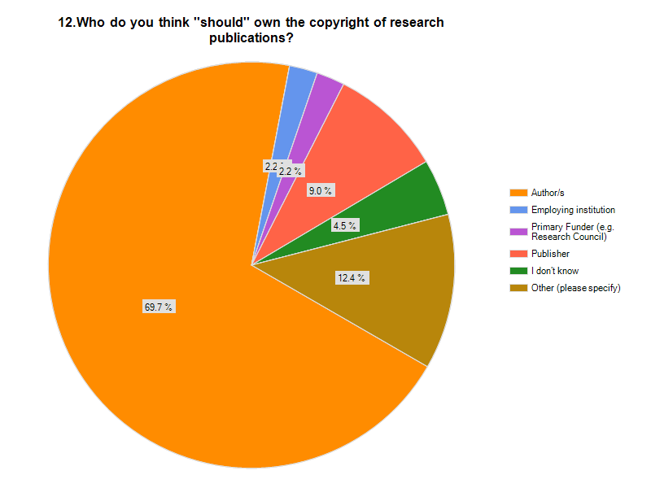

Many authors seem unaware that they are transferring their rights. There are alternatives to the copyright transfer agreement and many publishers will accept a ‘licence to publish’ or Creative Commons licence, which allow the author to retain rights. Creative Commons licenses allow you to express whether or not you are willing to let people copy, distribute, edit, remix or build upon your work. There are more details at http://creativecommons.org/.
Recommendation
- Further advocacy required on author’s rights and alternative copyright agreements
7.0 Publishing your research
Publisher’s copyright conditions often allow repositories to make the final draft post-refereeing, or the ‘author final version’ of research available. The ‘author final version’ is the author-created version that incorporates referee comments and is the accepted version for publication, but does not contain any publisher formatting. 88 per cent of those surveyed replied that they kept this version of their research. Of those that claimed they did not keep this version, some comments suggest the question was misunderstood and this may not necessarily be the case. For example, “the content is likely to be the same but not all the formatting/ typesetting”. Others were concerned about minor differences between this version and the published version: “I don’t bother with last minute minor changes made by the journal itself” and “sometimes late changes are made by the journal at copy-editing stage”.
77 per cent stated that they would be prepared to deposit the author version in the UWE Research Repository. It is hoped that the positive response to this final question will help to increase the amount of open access research available in the UWE Research Repository and thereby show the impact of the university’s research.
Recommendation
- Advocacy to further embed the depositing of ‘author final versions’ into the UWE Research Repository as part of the research process

8.0 Recommendations
- In general, advocacy needs to concentrate on how to make research outputs available on open access rather than the arguments for or against
- Work needs to be done on publicising peer reviewed high impact open access journals such as those published by Biomed Central
- Advocacy and information is needed on funder requirements on open access, including advice on how to submit proposals for publishing research on open access at the bidding stage.
- Determine the reasons for non text-based work not being added to the repository, and seek to address this
- Further advocacy work is required regarding copyright restrictions and the UWE Research Repository
- Provide a range of additional, highly visible promotion on the UWE Research Repository. Ensure that staff within the Faculty of Health and Life Sciences are heavily targeted
- Provide, and evaluate, training on the UWE Research Repository to give people an opportunity to use the system
- Work with the Library IT team to ensure the UWE Research Repository is as intuitive to use as possible
- Further advocacy required on author’s rights and alternative copyright agreements
- Advocacy to further embed the depositing of ‘author final versions’ into the UWE Research Repository as part of the research process
9.0 Conclusion
These recommendations will be used to form a comprehensive advocacy plan with the aim of further embedding the UWE Research Repository within the research community at UWE.
This survey was carried out in collaboration with the Repositories Support Project (RSP), a UK-based initiative that aims to build repository capacity, knowledge and skills with UK HEIs. The results from the UWE survey have been sent to the RSP, who will collate them, along with other institutions surveys, and feedback a comprehensive national picture for institutional use and comparison and national support and policy development.
The survey was based on a survey carried out at Huddersfield University (Stone 2010), which is available under a Creative Commons Attribution Non- Commercial Share Alike licence. A number of the findings were very similar, and as a result this report shares a number of commonalities with Huddersfield University’s report. Many of the recommendations are proposed in both reports.
10.0 References
Creative Commons (no date) Creative Commons. Available from: http://creativecommons.org/ [Accessed 30 September 2011]
JISC. (2011) Increasing the impact and visibility of your research [online]. Available from: http://www.jisc.ac.uk/supportingyourinstitution/researchexcellence/researchvisibility.aspx. [Accessed 15 August 2011]
Stone, G. (2010) Report on the University Repository Survey, October-November 2010 [online]. Huddersfield: University of Huddersfield. (Unpublished). Available from: http://eprints.hud.ac.uk/9257/ [Accessed 16 August 2011]

11.0 Appendix
Table 2: Percentage share of Repository items by Faculty, including items added as part of a faculty publication database upload
Faculty | Percentage of items in the Repository
Faculty of Business and Law | 11%
Faculty of Creative Arts, Humanities and Education | 13%
Faculty of Environment and Technology | 31%
Faculty of Health and Life Sciences | 44%
Other (library, cross-faculty Research Institutes etc.) | 1%

Anna Lawson
Repository Manager

August 2011

Items added to the repository as part of a faculty publication database upload have been excluded for the purposes of this report, as they were not added by an individual from a specific faculty. If included, the percentages change significantly – see Appendix 1: Table 3, which shows percentages with these items included.
At the time of this survey (June 2011), this Faculty was known as the Faculty of Creative Arts, Humanities and Education. It has since changed its name to the Faculty of Arts, Creative Industries and Education.
At the time of this survey (June 2011), this Faculty was known as the Faculty of Creative Arts, Humanities and Education. It has since changed its name to the Faculty of Arts, Creative Industries and Education.

