Fungal electronics
Andrew Adamatzky^{1,∗}, Phil Ayres², Alexander E. Beasley³, Alessandro Chiolerio^{1,4}, Mohammad M. Dehshibi⁵, Antoni Gandia⁶, Elena Albergati^{7,8}, Richard Mayne¹, Anna Nikolaidou¹, Nic Roberts¹, Martin Tegelaar⁹, Michail-Antisthenis Tsompanas¹, Neil Phillips¹, Han A. B. Wo¨sten⁹
¹ Unconventional Computing Laboratory, UWE, Bristol, UK;
² The Centre for Information Technology and Architecture, Royal Danish Academy, Copenhagen, Denmark;
³ Centre for Engineering Research, University of Hertfordshire, UK;
⁴ Center for Bioinspired Soft Robotics, Istituto Italiano di Tecnologia, Via Morego 30, 10163 Genova, Italy;
⁵ Department of Computer Science, Multimedia and Telecommunications, Universitat Oberta de Catalunya, Barcelona, Spain;
⁶ Institute for Plant Molecular and Cell Biology, CSIC-UPV, Valencia, Spain;
⁷ Department of Design, Politecnico di Milano, Milan, Italy;
⁸ MOGU S.r.l., Inarzo, Italy;
⁹ Microbiology, Department of Biology, University of Utrecht, Utrecht, The Netherlands;

Abstract
Fungal electronics is a family of living electronic devices made of mycelium bound composites or pure mycelium. Fungal electronic devices are capable of changing their impedance and generating spikes of electrical potential in response to external control parameters. Fungal electronics can be embed- ded into fungal materials and wearables or used as stand alone sensing and computing devices.
Keywords: fungi; electronics; sensing; computing

Introduction: Why fungal electronics?
Flexible electronics, especially electronic skins and e-textiles [59, 43, 74, 60], are amongst the most rapidly growing and promising fields of novel and emergent hardware. Flexible electronic devices are made of flexible materi- als where electronics capable of tactile sensing [26, 71, 65, 50] are embedded. Flexible electronic materials are capable of low level perception [25, 49] and

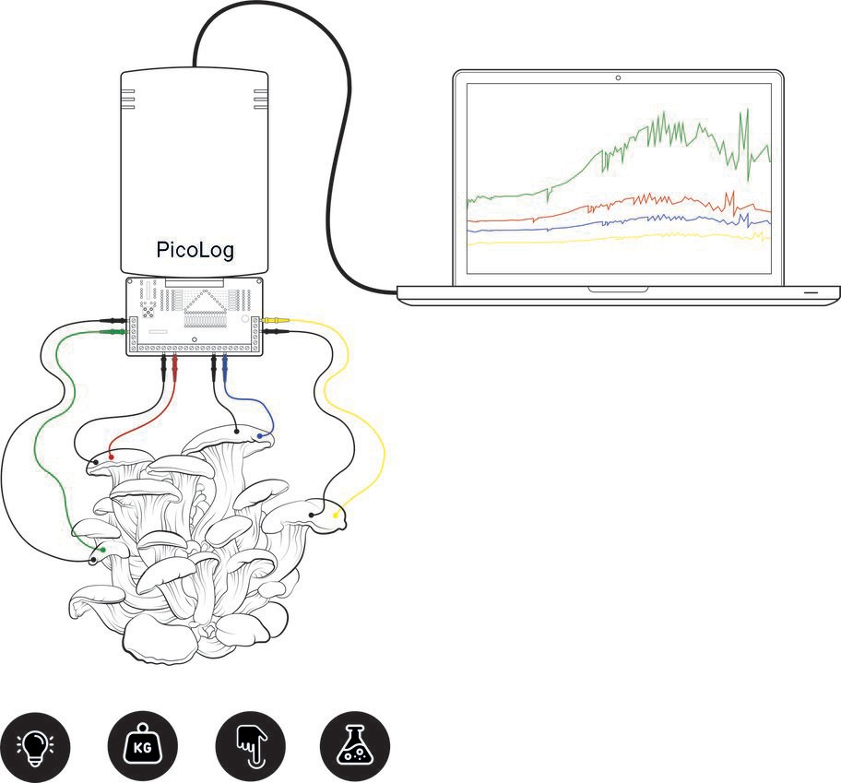

Figure 1: Caption

could be developed as autonomous adaptive devices [48]. Typical designs of flexible electronic devices include thin-film transistors and pressure sensors integrated in a plastic substrate [64], micro-patterned polydimethylsiloxane with carbon nanotube ultra-thin films [66, 57], a large-area film synthesised by sulfurisation of a tungsten film [38], multilayered graphene [51], platinum ribbons [74], polyethylene terephthalate based silver electrodes [75], digitally printed hybrid electrodes for electromyographic recording [55] or for piezore- sistive pressure sensing [1], or channels filled with intrinsically conductive polymers [22].
Whilst existing designs and implementations are highly impactful, the prototypes of flexible electronics lack a capacity to self-repair and grow. Such properties are useful, and could be necessary for organic electronics used in applications such as unconventional living architecture [6], soft and self-growing robots [33, 54, 52, 37] and development of intelligent materials
from fungi [45, 39, 41, 69] and bacteria [23]. Based on our previous ex- perience with designing tactile, colour sensors from slime mould Physarum polycephalum [3, 2, 67] and our recent results on fungal electrical activ-

ity [5, 19, 17], as well as following previously demonstrated thigmotropic [14] and phototropic response [28] in higher fungi, we overview our recent exper- imental results on electronic properties of mycelium bound composites.
In this article we report that fungi exhibit properties of memristors (re- sistors with memory), electronic oscillators, pressure, optical and chemical sensors, and electrical analog computers.

Fungal memristors
A memristor, also known as Resistive Switching Device (RSD), is a two or three-terminal device whose resistance depends on one or more internal state variables of the device [7]. A memristor is defined by a state-dependent Ohm’s law. Its resistance depends on the entire past signal waveform of the applied voltage, or current, across the memristor. Using memristors, one can achieve circuit functionalities that it is not possible to establish with resis- tors, capacitors and inductors, therefore the memristor is of great pragmatic usefulness. Potential unique applications of memristors have been enabled by their physical implementation and are expected to occur in spintronic de- vices, ultra-dense information storage, neuromorphic circuits, human brain interfaces and programmable electronics [27, 24].
In experimental laboratory studies (see the setup in Figs. 2(a) and 2(b)), we demonstrated that P. ostreatus fruit bodies exhibit memristive proper- ties when subject to a voltage sweep [17]. The ideal memristor model has a crossing point at 0V, where theoretically no current flows. Figures 2(c) and 2(d) show the results of cyclic voltammetry of grey oyster mushrooms with electrodes positioned in the caps and/or stems. When 0 V is applied by the source meter, a reading of a nominally small voltage and current is performed. The living membrane is capable of generating potential across the electrodes, and hence a small current is observed. To conclude, living fungi can be used as memristors (resistors with memory) in biocomputing circuits.

Fungal oscillators
An electronic oscillator is a device which converts direct current to an alternating current signal. A fungal oscillator is based on endogenous oscil- lations of an electrical resistance of mycelium bound composites. A nearly homogeneous sheet of mycelium of P. ostreatus, grown on the surface of a

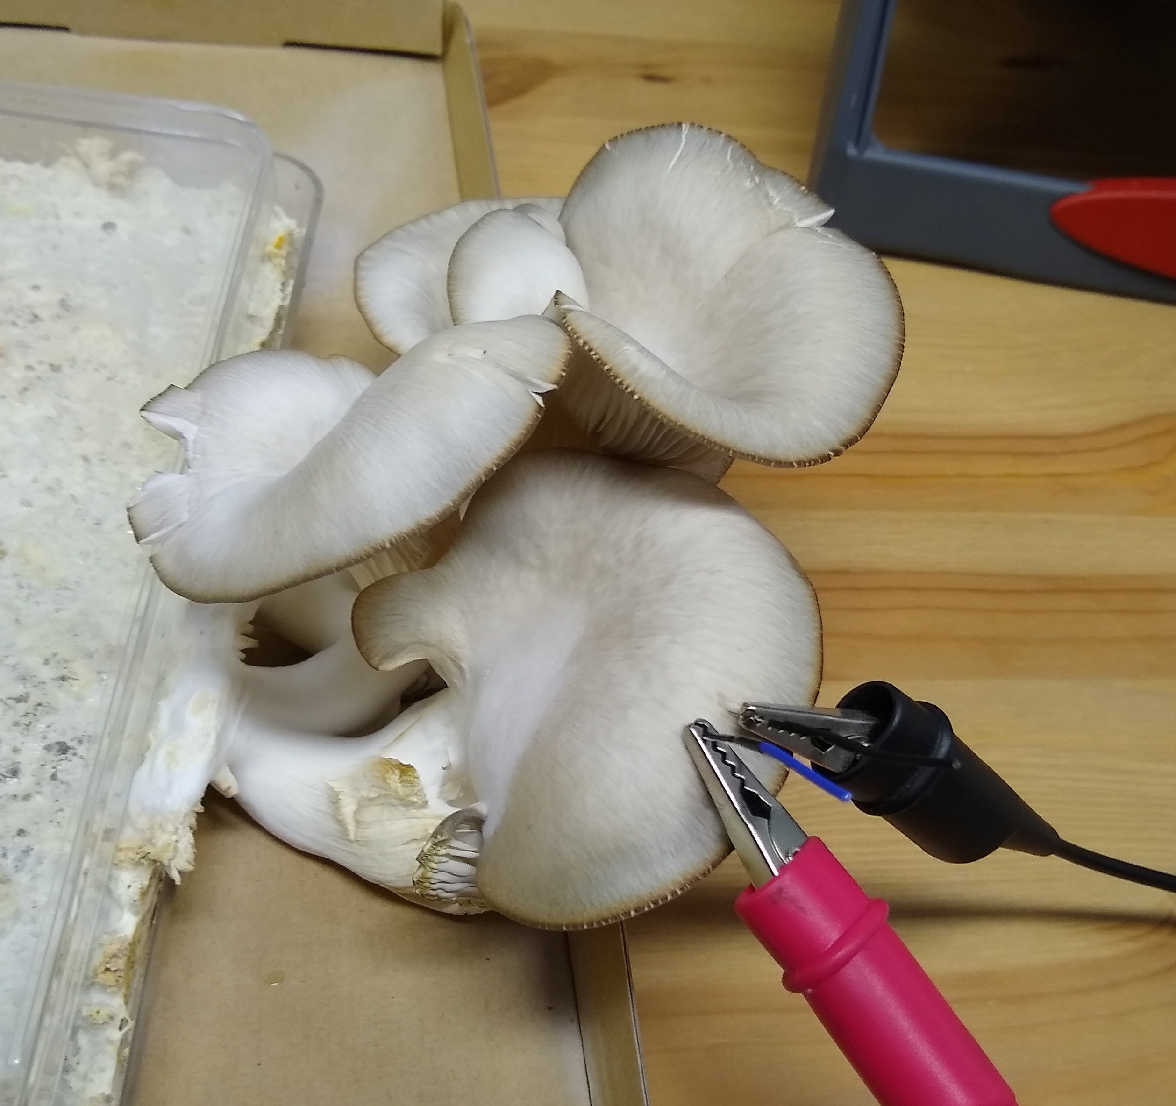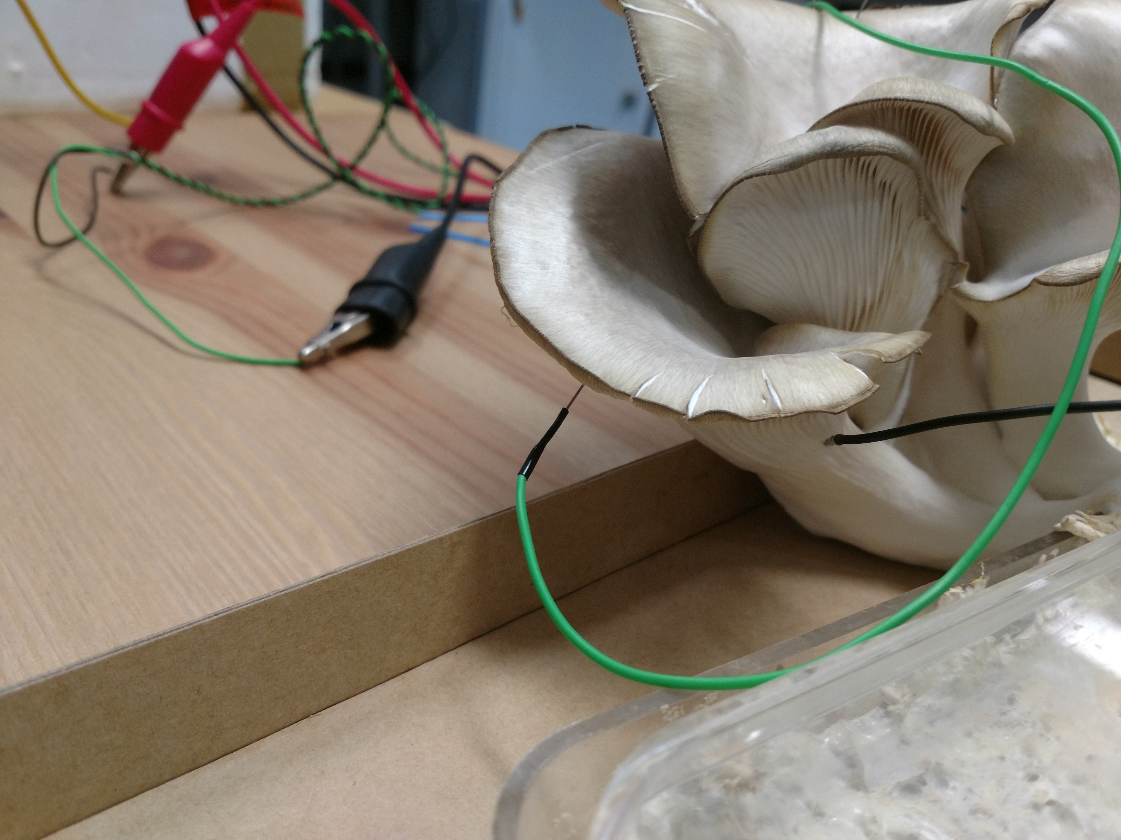
  - (b)

1
10-7 Oyster mushroom fruit bodies with cap to cap electrodes

0.5

0
Current [A]

-0.5

-1
-0.5 -0.4 -0.3 -0.2 -0.1 0 0.1 0.2 0.3 0.4 0.5
Voltage [V]

(c)

1
10-7 Oyster mushroom fruit bodies with stem to cap electrodes

0.5

0
Current [A]

-0.5

-1
-0.5 -0.4 -0.3 -0.2 -0.1 0 0.1 0.2 0.3 0.4 0.5
Voltage [V]

(d)

Figure 2: Fungal memristors. (ab) Positions of electrodes in fruit bodies. (a) Electrodes inserted 10 mm apart in the fruit body cap. (b) One electrode is inserted in the cap with the other in the stem. (cd) Raw data from cyclic voltammetry performed over -
0.5 V to 0.5 V. (c) Cap-to-cap electrode placement. (d) Stem-to-cap electrode placement. From [17].

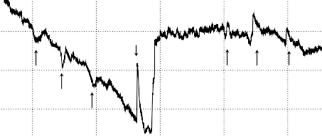
2.0×10⁵
s
*
*
*
*
*
*

1.9×10⁵

7.890

1.8×10⁵
Resistance, Ohm

7.885
Potential, V

1.7×10⁵

1.6×10⁵

7.880

8400 8450 8500 8550 8600 8650 8700
Time, ×10 sec

(a)

2000 2500 3000 3500 4000
Time, ×10 sec

Figure 3: (a) Examples of high amplitude and high frequency spikes. (b) Oscillation of electrical potential under 10 V DC applied, where spikes analysed are marked by ‘*’. From [10].

growth substrate, exhibits trains of resistance spikes (Fig. 3(a)) [10]. The average width of spikes is c. 23 min and the average amplitude is c. 1 kΩ. The distance between neighbouring spikes in a train of spikes is c. 30 min. Typically there are 4-6 spikes in a train of spikes. Two types of electrical resistance spikes trains are found in fruit bodies: low frequency and high amplitude (28 min spike width, 1.6 kΩ amplitude, 57 min distance between spikes) and high frequency and low amplitude (10 min width, 0.6 kΩ am- plitude, 44 min distance between spikes). To assess feasibility of the living fungal oscillator, we conducted a series of scoping experiments by applying direct voltage to the fungal substrate and measuring output voltage. An ex- ample of the electrical potential of a substrate colonised by fungi under 10 V applied is shown in Fig. 3(b). Voltage spikes are clearly observed. Spikes with amplitude above 1 mV, marked by ‘*’, except the spike marked by ‘s’ have been analysed. We can see two trains of three spikes each. Average width of the spikes is 10³ sec, average amplitude 2.5 mV, while average dis- tance between spikes is c. 2 10³K sec. To conclude, fungi can be used as a very low frequency electronic oscillators in designs of biological circuits.
·

Fungal pressure sensor
We stimulated blocks of G. resinaceum mycelium colonised substrate by placing a 16 kg cast iron weight on their top face (Fig. 4(a)). Electrical activity of the fungal composite block was recorded using 8 pairs of differ- ential electrodes, as specified in Fig. 4(a). An example of electrical activity recorded on 8 channels, during the stimulation with 16 kg weight, is shown in Fig. 4(b) [8]. In response to application of 16 kg weight the fungal blocks

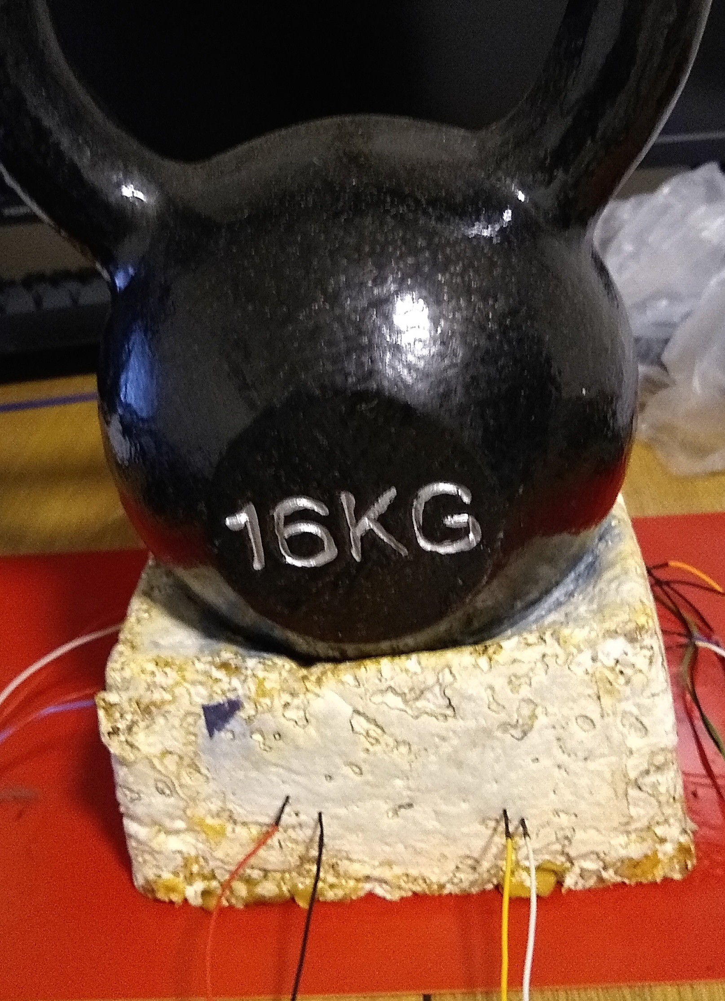

(a)

16
2.4×10⁵
2.6×10⁵
2.8×10⁵
3.0×10⁵
3.2×10⁵
1

0
ON
OFF
−1
OFF
ON
ON OFF
ON
OFF ON OFF ON
OFF
ON
OFF

14

12

10

8
Potential, mV

6

4

2

0

−2

−4

0 1×10⁵ 2×10⁵ 3×10⁵ 4×10⁵ 5×10⁵
Time, sec

(b)

Figure 4: (a) Experimental setup. Pairs of differential electrodes inserted in a fungal block and 16 kg kettle bell placed on top of the fungal block. Channels are from the top right clockwise (1-2), (3-5), . . . , (15-16). (b) The activity of the block stimulated with 16 kg load. Moments of the loads applications are labelled by ‘ON’ and lifting the loads by ‘OFF’. Channels are colour coded as (1-2) – black, (3-4) – red, (5-6) – blue, (7-8) –
green, (9-10) – magenta, (11-12)– orange, (13-14) – yellow. From [8].

produced spikes with median amplitude 1.4 mV and median duration 456 sec; average amplitude of ON spikes was 2.9 mV and average duration 880 sec. OFF spikes were characterised by median amplitude 1 mV and median du- ration 216 sec; average amplitude 2.1 mV and average duration 453 sec. ON spikes are 1.4 higher than and twice as longer as OFF spikes. Based on this comparison of the response spikes we can claim that fungal blocks recog- nise when a weight was applied or removed [8]. The results complement our studies on tactile stimulation of fungal skin (mycelium sheet with no sub- strate) [9]: the fungal skin responds to application and removal of pressure with spikes of electrical potential. The fungal blocks can discern whether a weight was applied or removed because the blocks react to the application of weights with higher amplitude and longer duration spikes than the spikes re- sponding to the removal of the weights. The fungal responses to stimulation show habituation. This is in accordance with previous studies on stimula- tion of plants, fungi, bacteria, and protists [15, 34, 36, 21, 72]. To conclude, mycelium bound composites are capable of detecting pressure, therefore fun- gal pressure sensors can be incorporated into living loci of fungal building materials.

Fungal photosensor
Fungal response to illumination was analysed using a fungal skin — a 1.5 mm thick sheet of pure mycelium of G. resinaceum fungi (Fig. 5(a)) [9]. The response of the fungal skin to illumination is manifested in the raising of the baseline potential, as illustrated in the exemplar recordings in Fig. 5(b). The response-to-illumination spike does not subside but the electrical potential stays raised until illumination is switched off. An average amplitude of the response is 0.6 mV. The rise in potential starts immediately after the illu- mination is switched on. The potential saturation time is c. 3 10³ sec on average; the potential relaxation time is c. 3 10³ sec. Typically, we did not observe any spike trains after the illumination was switched off, however, in a couple of trials we witnessed spike trains on top of the raised potential, as shown in Fig. 5(c). To conclude, living fungal materials respond to illumi- nation by changing their electrical activity, therefore fungal materials can be incorporated in logical circuits and actuators with optical inputs.
·
·

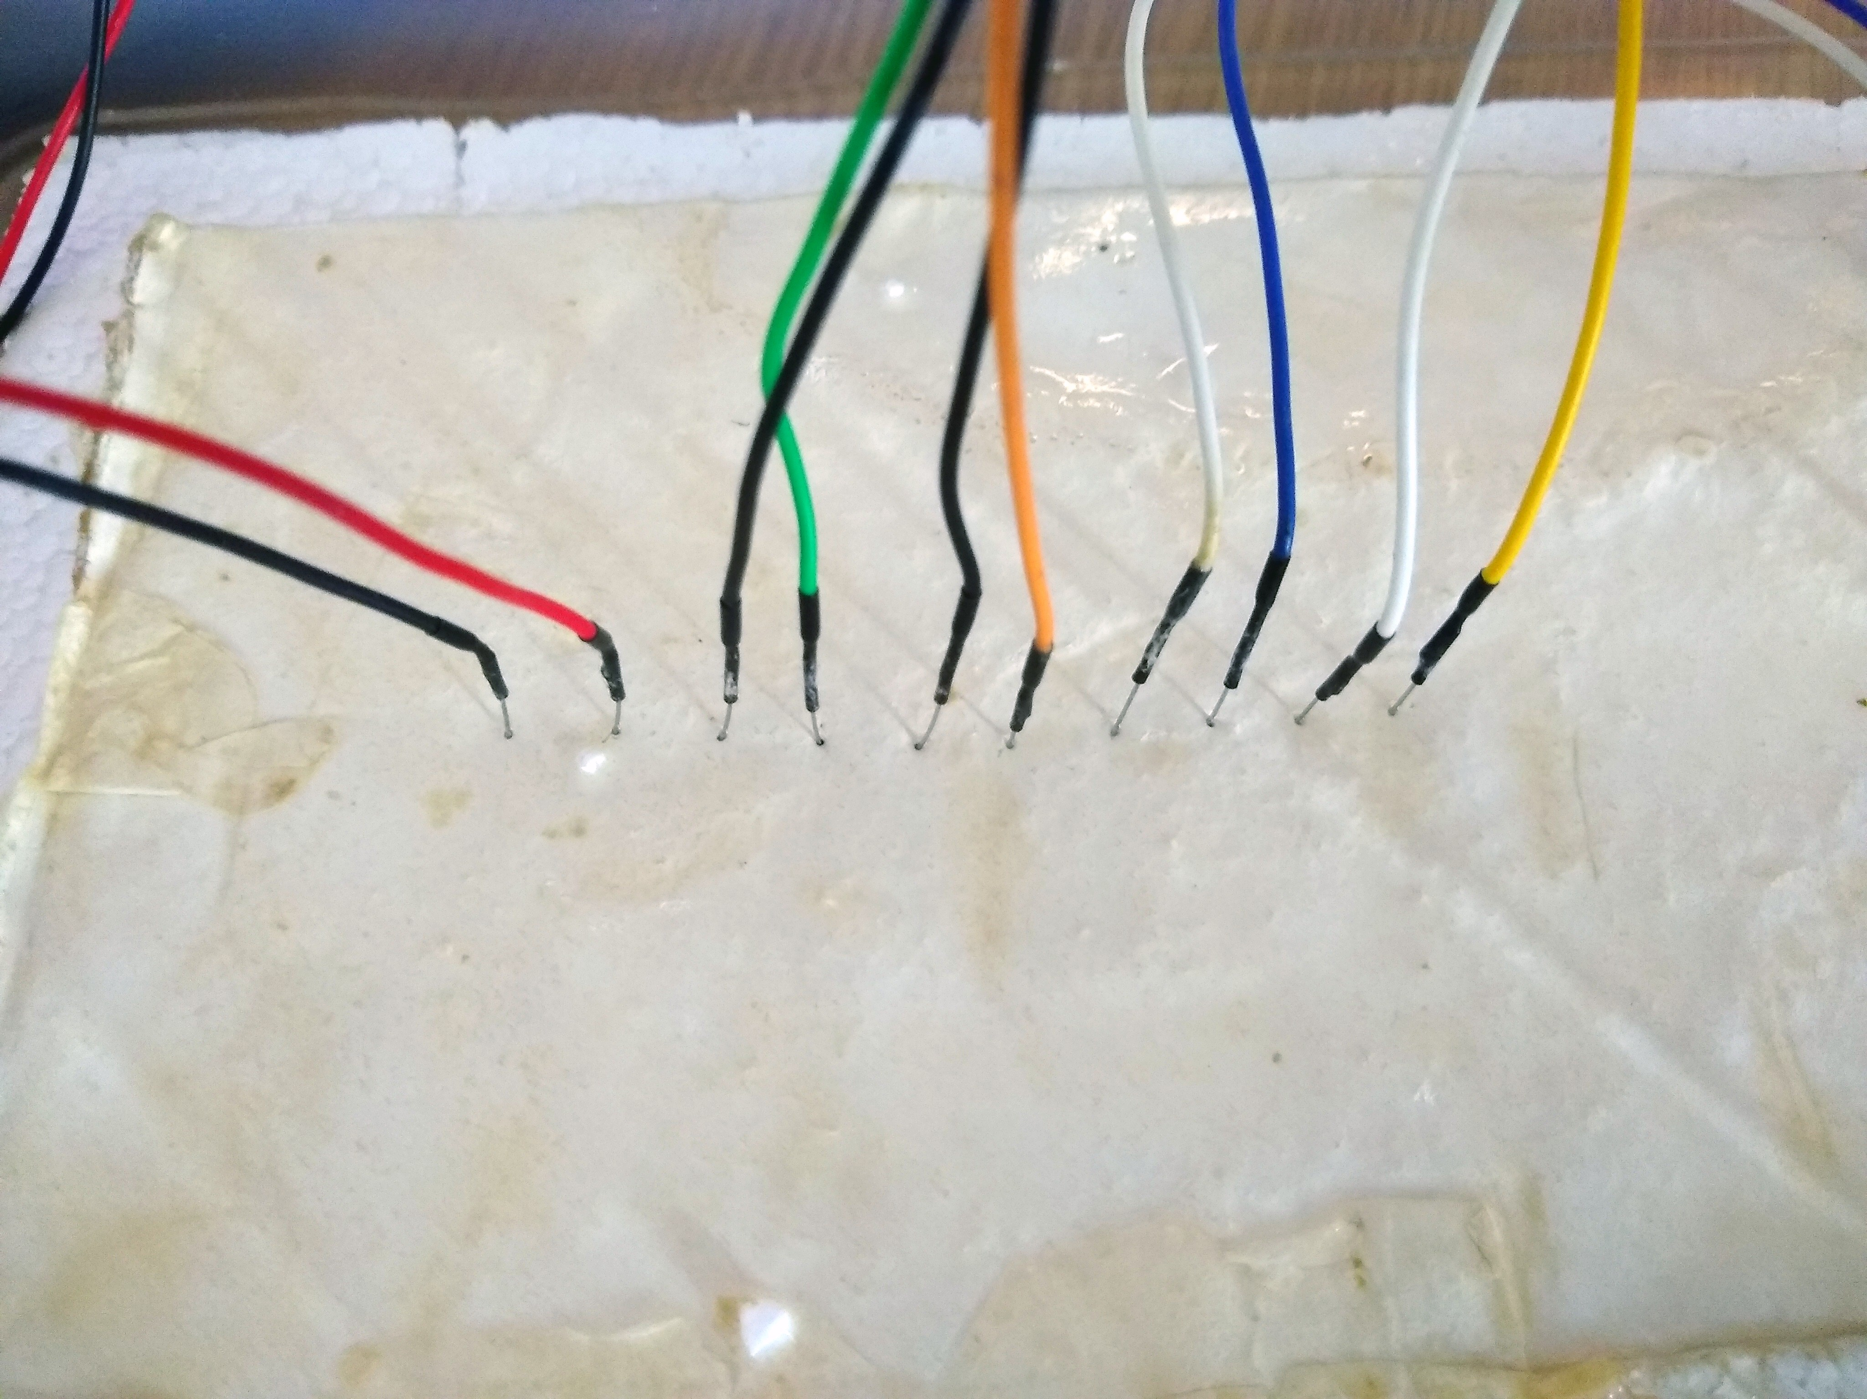
2
L*
Lo

1
Potential, mV

0

−1

20,000 25,000 30,000
Time, sec
  - (b)

2.2
Lo
L*

2.0

1.8
Potential, mV

1.6

1.4

1.2
35,000 40,000
Time, sec
(c)

Figure 5: Fungal response to optical stimulation. (a) A photograph of electrodes inserted into the fungal skin. (b) Exemplar response of fungal skin to illumination, recorded on three pairs of differential electrodes. ‘L*’ indicates illumination is applied, ‘Lo’ illumination is switched off. () A train of spikes on the raised potential as a response to illumination. From [9].

6
*

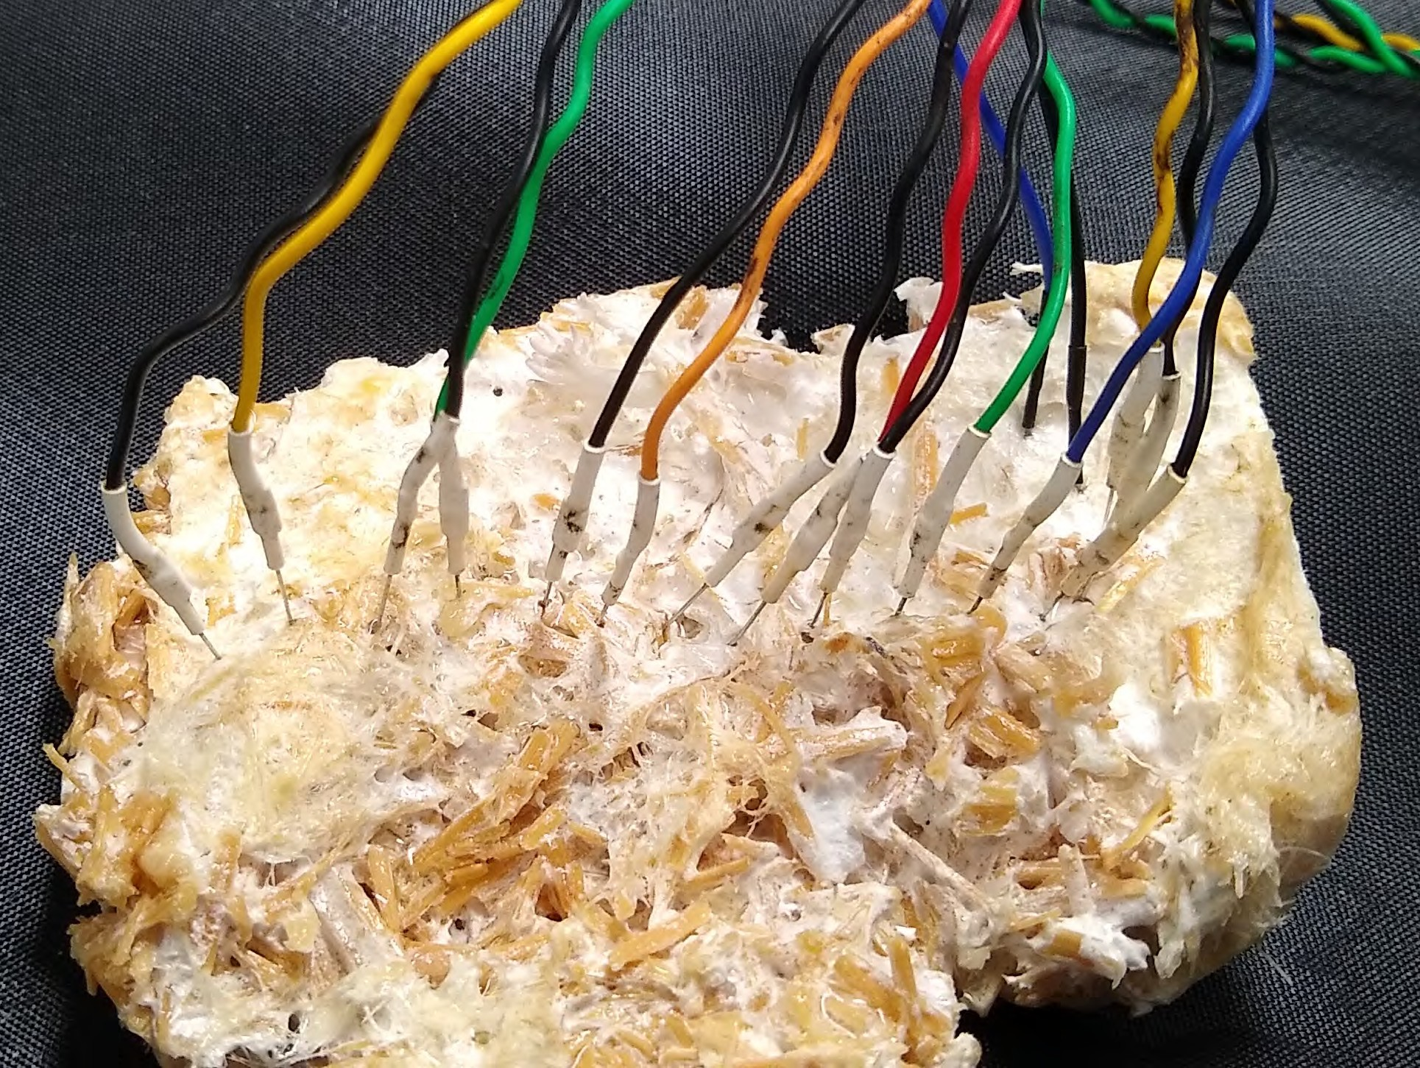
5

4
Potential, mV

3

2

1

0

0 2×104 4×104 6×104 8×104 10×104 12×104 14×104
Time, sec

(a) (b)

Figure 6: (a) Experimental setup. Exemplar locations of electrodes. (b) Response to application of dextrose. The moment of application is shown by asterisk.

Fungal chemical sensor
We demonstrated that hemp pads colonised by the fungus P. ostreatus (Fig. 6(a)) show distinctive sets of responses to chemical stimulation [11, 32]. We stimulated colonised hemp pads with 96% ethanol, malt extract powder (Sigma Aldrich, UK) dissolved in distilled water, dextrose (Ritchie Prod- ucts Ltd, UK) and hydrocortisone (Solu-Cortef trademark, 4 mL Act-O-Vial, Pfizer, Athens, Greece). An example of the response to chemical stimulation is shown in Fig. 6(b). A response to stimulation with ethanol is characterised by a drop of electrical potential, up to 8 mV, followed by repolarisation phase, lasting for up to 15 sec. Fungi respond to the application of nutrients by increasing the frequency of electrical potential spiking [11]. Exposure to hydrocortisone leads to a series of electrical disturbance events propagating along the mycelium networks with further indications of suppressed electrical activity [32]. Fungal chemical sensors show a great potential for future appli- cations, however substantial research should be invested in their calibration.

Fungal analog computing
In numerical modelling and experimental laboratory setup we exploited principles of electrical analog computing [18, 53]. True and False values are represented by above threshold and below threshold voltages. Due to the non-linearity of the conductive substrate along electrical current pathways between input and output electrodes, the input voltages are transformed and thus logical mappings are implemented. Detailed descriptions of these techniques can be found in [12, 18, 53].

Figure 7: Perspective views of the 3D Graph. Each frame shows the graph after a 36◦ rotation around the z-axis with origin located approximately in the centre of the colony, on the x-y plane indicated with registration marks.

15×104

25×10⁶

20×10⁶
0
0.002
0.004
0.006
0.008
0 0.001
3000
55,000

50,000
2000
45,000
AND
1000
SELECT
0
AND-NOT
SELECT
OR
AND

10×104 15×106
Number of gates
Number of gates

5×104

10×10⁶

5×10⁶

0
0 0.01 0.02 0.03 0.04 0.05
θ

(a)

0
0 0.01 0.02 0.03 0.04 0.05
θ

(b)

Figure 8: Occurrences of the gates from the groups and, black, or, green, and-not, red, and select, blue, for θ [0.0001, 0.05], with θ increment 0.0001, in (a) fungal colony modelled with serial RC networks, (b) fungal colony modelled with parallel RC networks.
∈

The z-stacks of a single colony of Aspergillus niger fungus strain AR9#2 [62] were converted to a 3D graph (Fig. 7). The 3D graph was converted to a resistive and capacitive (RC) network, whose magnitudes are a function of the length of the connections. Resistances were in the order of kOhms and capacitance in the order of pF. The positive voltage and ground nodes were randomly assigned from the sample and 1000 networks were created in each arrangement for analysis. SPICE analysis consisted of transient analysis us- ing a two voltage pulses of 60 mV on the randomly assigned positive nodes. We modelled the fungal colony in serial RC networks and parallel RC net- works. The output voltages were binarised with the threshold θ: V > θ symbolises logical True otherwise False.
There are 16 possible logical gates realisable for two inputs and one out-
put. The gates implying input 0 and evoking a response 1, i.e. f (0, 0) = 1, are not realisable because the simulated fungal circuit is passive. The re- maining 8 gates are and, or, and-not (x and not y and not x and y), select (select x and select y) and xor. In the model of serial RC networks, we found gates and, select and and-not; no or gates have been found. The number n of the gates discovered decreases by a power law with increase of θ. The frequency of and gates oscillates, as shown in the zoom insert in Fig. 8a, most likely due to its insignificant presence in the samples. The oscillations reach near zero base when θ exceeds 0.001. In the model of parallel RC networks we only found the gates and, select and or. The number of or gates decreases quadratically and becomes nil when θ > 0.03. The number of and gates increases near linearly with increase of θ. The number of select gates reaches its maximum at θ = 0.023, and

then starts to decreases with the further increase of θ.To conclude, mycelium bound composites can act as computing media and implement a wide range of Boolean circuits, thus opening a new perspective in biological analog and hybrid computing.

Applications of fungal electronics
We believe a potential practical implementation of the electronic prop- erties of fungi would be in sensorial and computing circuits embedded into mycelium bound composites. For example, an approach of exploiting reser- voir computing for sensing [16], where the information about the environment is encoded in the state of the reservoir memristive computing medium, can be employed to prototype sensing-memritive devices from living fungi. A very low frequency of fungal electronic oscillators does not preclude us from considering inclusion of the oscillators in fully living or hybrid analog cir- cuits embedded into fungal architectures [6] and future specialised circuits and processors made from living fungi functionalised with nanoparticles, as have been illustrated in prototypes of hybrid electronic devices with slime mould [68, 63, 47, 4, 20]. Electrical resistance of living substrates is used
to identify their morphological and physiological state [29, 56, 44, 40, 31]. Examples include determination of states of organs [35], detection of decay- ing wood in living trees [58, 13], estimation of root vigour [61], the study of freeze-thaw injuries of plants [73], as well as classification of breast tissue [30].

Discussion
The sensing fungal composites described here, exhibit a range of ad- vantages compared to other living sensing materials, e.g. slime mould sen- sors [3, 2, 67] electronic sensors with living cell components [42], chemical sensors using living taste, olfactory, and neural cells and tissues [70] and tac- tile sensor from living cell culture [46]. The advantages are low production costs, simple maintenance and durability. A further important advantage is scalability: a living fungal material patch can be as small as few millimeters or it can be grown to several metres in size.

Acknowledgements
This research has received funding from the European Union’s Horizon 2020 research and innovation programme FET OPEN “Challenging current

thinking” under grant agreement No 858132 / project Fungal Architectures,
www.fungar.eu.

References
- Chiolerio A., Rivolo P., Porro S., Stassi S., Ricciardi S., Mandracci P., Canavese G., Bejtka K., and C.F. Pirri. Inkjet-printed pedot:pss elec- trodes on plasma modified pdms nanocomposites: quantifying plasma treatment hardness. RSC Advances, 4:51477, 2014.
- Andrew Adamatzky. Slime mould tactile sensor. Sensors and actuators B: chemical, 188:38–44, 2013.
- Andrew Adamatzky. Towards slime mould colour sensor: Recognition of colours by Physarum polycephalum. Organic electronics, 14(12):3355– 3361, 2013.
- Andrew Adamatzky. Twenty five uses of slime mould in electronics and computing: Survey. International Journal of Unconventional Comput- ing, 11, 2015.
- Andrew Adamatzky. On spiking behaviour of oyster fungi pleurotus djamor. Scientific reports, 8(1):1–7, 2018.
- Andrew Adamatzky, Phil Ayres, Gianluca Belotti, and Han W¨osten. Fungal architecture position paper. International Journal of Unconven- tional Computing, 14, 2019.
- Andrew Adamatzky and Leon Chua, editors. Memristor networks. Springer Science & Business Media, 2013.
- Andrew Adamatzky and Antoni Gandia. Living mycelium composites discern weights. arXiv preprint arXiv:2106.00063, 2021.
- Andrew Adamatzky, Antoni Gandia, and Alessandro Chiolerio. Fungal sensing skin. Fungal biology and biotechnology, 8(1):1–6, 2021.
- Andrew Adamatzky and Jeff Jones. On electrical correlates of physarum polycephalum spatial activity: Can we see physarum machine in the dark? Biophysical Reviews and Letters, 6(01n02):29–57, 2011.

- Andrew Adamatzky, Anna Nikolaidou, Antoni Gandia, Alessandro Chi- olerio, and Mohammad Mahdi Dehshibi. Reactive fungal wearable. Biosystems, 199:104304, 2021.
- Andrew Adamatzky, Martin Tegelaar, Han AB Wosten, Anna L Powell, Alexander E Beasley, and Richard Mayne. On boolean gates in fungal colony. Biosystems, page 104138, 2020.
- SA Al Hagrey. Electrical resistivity imaging of tree trunks. Near Surface Geophysics, 4(3):179–187, 2006.
- Mariana Cruz Almeida and Alexandra C Brand. Thigmo responses: the fungal sense of touch. Microbiology spectrum, 5(2):5–2, 2017.
- Philip B Applewhite. Learning in bacteria, fungi, and plants. Inverte- brate learning, 3:179–186, 1975.
- Vasileios Athanasiou and Zoran Konkoli. On using reservoir comput- ing for sensing applications: exploring environment-sensitive memristor networks. International Journal of Parallel, Emergent and Distributed Systems, 33(4):367–386, 2018.
- Alexander Beasley, Mohammed-Salah Abdelouahab, Ren´e Lozi, Anna Powell, and Andrew Adamatzky. Mem-fractive properties of mush- rooms. arXiv preprint arXiv:2002.06413v2, 2020.
- Alexander E Beasley, Phil Ayres, Martin Tegelaar, Michail-Antisthenis Tsompanas, and Andrew Adamatzky. On electrical gates on fungal colony. Biosystems, page 104507, 2021.
- Alexander E Beasley, Anna L Powell, and Andrew Adamatzky. Capac- itive storage in mycelium substrate. arXiv preprint arXiv:2003.07816, 2020.
- Tatiana Berzina, Alice Dimonte, Angelica Cifarelli, and Victor Erokhin. Hybrid slime mould-based system for unconventional computing. Inter- national Journal of General Systems, 44(3):341–353, 2015.
- Aur`ele Boussard, Julie Delescluse, Alfonso P´erez-Escudero, and Audrey Dussutour. Memory inception and preservation in slime moulds: the quest for a common mechanism. Philosophical Transactions of the Royal Society B, 374(1774):20180368, 2019.

- Alessandro Chiolerio and Andrew Adamatzky. Tactile sensing and com- puting on a random network of conducting fluid channels. Flexible and Printed Electronics, 2020.
- Alessandro Chiolerio and Andrew Adamatzky. Acetobacter biofilm: Electronic characterization and reactive transduction of pressure. ACS Biomaterials Science & Engineering, 7:1651–1662, 2021.
- Alessandro Chiolerio, Michela Chiappalone, Paolo Ariano, and Sergio Bocchini. Coupling resistive switching devices with neurons: State of the art and perspectives. Frontiers in Neuroscience, 11:70, 2017.
- Alex Chortos, Jia Liu, and Zhenan Bao. Pursuing prosthetic electronic skin. Nature materials, 15(9):937–950, 2016.
- Ho-Hsiu Chou, Amanda Nguyen, Alex Chortos, John WF To, Chien Lu, Jianguo Mei, Tadanori Kurosawa, Won-Gyu Bae, Jeffrey B-H Tok, and Zhenan Bao. A chameleon-inspired stretchable electronic skin with interactive colour changing controlled by tactile sensing. Nature com- munications, 6(1):1–10, 2015.
- Leon Chua, Georgios Ch Sirakoulis, and Andrew Adamatzky. Handbook of Memristor Networks. Springer Nature, 2019.
- Luis M Corrochano. Light in the fungal world: From photoreception to gene transcription and beyond. Annual review of genetics, 53:149–170, 2019.
- George W Crile, Helen R Hosmer, and Amy F Rowland. The electrical conductivity of animal tissues under normal and pathological conditions. American Journal of Physiology-Legacy Content, 60(1):59–106, 1922.
- J Estrela Da Silva, JP Marques De S´a, and J Jossinet. Classification of breast tissue by electrical impedance spectroscopy. Medical and Biolog- ical Engineering and Computing, 38(1):26–30, 2000.
- DA Dean, T Ramanathan, D Machado, and R Sundararajan. Electrical impedance spectroscopy study of biological tissues. Journal of electro- statics, 66(3-4):165–177, 2008.

- Mohammad Mahdi Dehshibi, Alessandro Chiolerio, Anna Nikolaidou, Richard Mayne, Antoni Gandia, Mona Ashtari-Majlan, and Andrew Adamatzky. Stimulating fungi pleurotus ostreatus with hydrocortisone. ACS Biomaterials Science & Engineering, 7(8):3718–3726, 2021.
- Haitham El-Hussieny, Usman Mehmood, Zain Mehdi, Sang-Goo Jeong, Muhammad Usman, Elliot W Hawkes, Allison M Okarnura, and Jee- Hwan Ryu. Development and evaluation of an intuitive flexible interface for teleoperating soft growing robots. In 2018 IEEE/RSJ International Conference on Intelligent Robots and Systems (IROS), pages 4995–5002. IEEE, 2018.
- Yu Fukasawa, Melanie Savoury, and Lynne Boddy. Ecological memory and relocation decisions in fungal mycelial networks: responses to quan- tity and location of new resources. The ISME journal, 14(2):380–388, 2020.
- Eberhard Gersing. Impedance spectroscopy on living tissue for deter- mination of the state of organs. Bioelectrochemistry and bioenergetics, 45(2):145–149, 1998.
- Simona Ginsburg and Eva Jablonka. Evolutionary transitions in learn- ing and cognition. Philosophical Transactions of the Royal Society B, 376(1821):20190766, 2021.
- Joseph D Greer, Tania K Morimoto, Allison M Okamura, and Elliot W Hawkes. A soft, steerable continuum robot that grows via tip extension. Soft robotics, 6(1):95–108, 2019.
- Huayang Guo, Changyong Lan, Zhifei Zhou, Peihua Sun, Dapeng Wei, and Chun Li. Transparent, flexible, and stretchable ws 2 based humidity sensors for electronic skin. Nanoscale, 9(19):6246–6253, 2017.
- Muhammad Haneef, Luca Ceseracciu, Claudio Canale, Ilker S Bayer, Jose A Heredia-Guerrero, and Athanassia Athanassiou. Advanced ma- terials from fungal mycelium: fabrication and tuning of physical prop- erties. Scientific reports, 7(1):1–11, 2017.
- Paul H´eroux and Michel Bourdages. Monitoring living tissues by electrical impedance spectroscopy. Annals of biomedical engineering, 22(3):328–337, 1994.

- Mitchell Jones, Andreas Mautner, Stefano Luenco, Alexander Bismarck, and Sabu John. Engineered mycelium composite construction materials from fungal biorefineries: A critical review, feb 2020.
- Gregory TA Kovacs. Electronic sensors with living cellular components.
Proceedings of the IEEE, 91(6):915–929, 2003.
- Mingyuan Ma, Zheng Zhang, Qingliang Liao, Fang Yi, Linhong Han, Guangjie Zhang, Shuo Liu, Xinqin Liao, and Yue Zhang. Self-powered artificial electronic skin for high-resolution pressure sensing. Nano En- ergy, 32:389–396, 2017.
- ET McAdams and J Jossinet. Tissue impedance: a historical overview.
Physiological measurement, 16(3A):A1, 1995.
- Vera Meyer, Evelina Y. Basenko, J. Philipp Benz, Gerhard H. Braus, Mark X. Caddick, Michael Csukai, Ronald P. de Vries, Drew Endy, Jens C. Frisvad, Nina Gunde-Cimerman, Thomas Haarmann, Yitzhak Hadar, Kim Hansen, Robert I. Johnson, Nancy P. Keller, Nada Kraˇsevec, Uffe H. Mortensen, Rolando Perez, Arthur F. J. Ram, Eric Record, Phil Ross, Volha Shapaval, Charlotte Steiniger, Hans van den Brink, Jolanda van Munster, Oded Yarden, and Han A. B. Wo¨sten. Growing a circular economy with fungal biotechnology: a white paper. Fungal Biology and Biotechnology, 7(1):5, dec 2020.
- Kosuke Minzan, Masahiro Shimizu, Kota Miyasaka, Toshihiko Ogura, Junichi Nakai, Masamichi Ohkura, and Koh Hosoda. Toward living tactile sensors. In Conference on Biomimetic and Biohybrid Systems, pages 409–411. Springer, 2013.
- Vasileios Ntinas, Ioannis Vourkas, Georgios Ch Sirakoulis, and Andrew I Adamatzky. Oscillation-based slime mould electronic circuit model for maze-solving computations. IEEE Transactions on Circuits and Systems I: Regular Papers, 64(6):1552–1563, 2017.
- Carlos Garc´ıa Nu´n˜ez, Libu Manjakkal, and Ravinder Dahiya. Energy autonomous electronic skin. npj Flexible Electronics, 3(1):1–24, 2019.
- Steve Park, Hyunjin Kim, Michael Vosgueritchian, Sangmo Cheon, Hyeok Kim, Ja Hoon Koo, Taeho Roy Kim, Sanghyo Lee, Gregory

Schwartz, Hyuk Chang, et al. Stretchable energy-harvesting tactile elec- tronic skin capable of differentiating multiple mechanical stimuli modes. Advanced Materials, 26(43):7324–7332, 2014.
- Xiong Pu, Mengmeng Liu, Xiangyu Chen, Jiangman Sun, Chunhua Du, Yang Zhang, Junyi Zhai, Weiguo Hu, and Zhong Lin Wang. Ultra- stretchable, transparent triboelectric nanogenerator as electronic skin for biomechanical energy harvesting and tactile sensing. Science ad- vances, 3(5):e1700015, 2017.
- Yancong Qiao, Yunfan Wang, He Tian, Mingrui Li, Jinming Jian, Yuhong Wei, Ye Tian, Dan-Yang Wang, Yu Pang, Xiangshun Geng, et al. Multilayer graphene epidermal electronic skin. ACS nano, 12(9):8839–8846, 2018.
- John Rieffel, Davis Knox, Schuyler Smith, and Barry Trimmer. Growing and evolving soft robots. Artificial life, 20(1):143–162, 2014.
- Nic Roberts and Andrew Adamatzky. Mining logical circuits in fungi.
arXiv preprint arXiv:2108.05336, 2021.
- Ali Sadeghi, Alessio Mondini, and Barbara Mazzolai. Toward self- growing soft robots inspired by plant roots and based on additive man- ufacturing technologies. Soft robotics, 4(3):211–223, 2017.
- R.G. Scalisi, M. Paleari, A. Favetto, M. Stoppa, P. Ariano, P. Pan- dolfi, and A. Chiolerio. Inkjet printed flexible electrodes for surface electromyography. Organic Electronics, 18:89–94, 2015.
- Herman P Schwan and Calvin F Kay. Specific resistance of body tissues.
Circulation Research, 4(6):664–670, 1956.
- Tsuyoshi Sekitani and Takao Someya. Stretchable organic integrated circuits for large-area electronic skin surfaces. Mrs Bulletin, 37(3):236– 245, 2012.
- H Richard Skutt, Alex L Shigo, and Ronald A Lessard. Detection of dis- colored and decayed wood in living trees using a pulsed electric current. Canadian Journal of Forest Research, 2(1):54–56, 1972.

- Mahesh Soni and Ravinder Dahiya. Soft eskin: distributed touch sensing with harmonized energy and computing. Philosophical Transactions of the Royal Society A, 378(2164):20190156, 2020.
- Matteo Stoppa and Alessandro Chiolerio. Wearable electronics and smart textiles: A critical review. Sensors, 14:11957–11992, 2014.
- CD Taper and RS Ling. Estimation of apple rootstock vigor by the electrical resistance of living shoots. Canadian Journal of Botany, 39(7):1585–1589, 1961.
- Arman Vinck, Charissa de Bekker, Adam Ossin, Robin A Ohm, Ronald P de Vries, and Han AB W¨osten. Heterogenic expression of genes encoding secreted proteins at the periphery of Aspergillus niger colonies. Environmental microbiology, 13(1):216–225, 2011.
- Xavier Alexis Walter, Ian Horsfield, Richard Mayne, Ioannis A Ieropou- los, and Andrew Adamatzky. On hybrid circuits exploiting thermistive properties of slime mould. Scientific reports, 6:23924, 2016.
- Chuan Wang, David Hwang, Zhibin Yu, Kuniharu Takei, Junwoo Park, Teresa Chen, Biwu Ma, and Ali Javey. User-interactive electronic skin for instantaneous pressure visualization. Nature materials, 12(10):899– 904, 2013.
- Xiandi Wang, Lin Dong, Hanlu Zhang, Ruomeng Yu, Caofeng Pan, and Zhong Lin Wang. Recent progress in electronic skin. Advanced Science, 2(10):1500169, 2015.
- Xuewen Wang, Yang Gu, Zuoping Xiong, Zheng Cui, and Ting Zhang. Silk-molded flexible, ultrasensitive, and highly stable electronic skin for monitoring human physiological signals. Advanced materials, 26(9):1336–1342, 2014.
- James GH Whiting, Ben PJ de Lacy Costello, and Andrew Adamatzky. Towards slime mould chemical sensor: Mapping chemical inputs onto electrical potential dynamics of Physarum Polycephalum. Sensors and Actuators B: Chemical, 191:844–853, 2014.

- James GH Whiting, Richard Mayne, Nadine Moody, Ben de Lacy Costello, and Andrew Adamatzky. Practical circuits with physarum wires. Biomedical Engineering Letters, 6(2):57–65, 2016.
- Han A B Wo¨sten. Filamentous fungi for the production of enzymes, chemicals and materials. Current Opinion in Biotechnology, 59:65–70, oct 2019.
- Chunsheng Wu, Peter B Lillehoj, and Ping Wang. Bioanalytical and chemical sensors using living taste, olfactory, and neural cells and tissues: A short review. Analyst, 140(21):7048–7061, 2015.
- Tingting Yang, Wen Wang, Hongze Zhang, Xinming Li, Jidong Shi, Yi- jia He, Quan-shui Zheng, Zhihong Li, and Hongwei Zhu. Tactile sensing system based on arrays of graphene woven microfabrics: electromechan- ical behavior and electronic skin application. ACS nano, 9(11):10867– 10875, 2015.
- Kiichi Yokochi et al. An investigation on the habituation of amoeba.
Aichi Igakkwai Zasshi= Jl. Aichi Med. Soc., 33(3), 1926.
- MIN Zhang and JHM Willison. Electrical impedance analysis in plant tissues: the effect of freeze-thaw injury on the electrical properties of potato tuber and carrot root tissues. Canadian Journal of Plant Science, 72(2):545–553, 1992.
- Shuai Zhao and Rong Zhu. Electronic skin with multifunction sensors based on thermosensation. Advanced Materials, 29(15):1606151, 2017.
- Xiaoli Zhao, Qilin Hua, Ruomeng Yu, Yan Zhang, and Caofeng Pan. Flexible, stretchable and wearable multifunctional sensor array as arti- ficial electronic skin for static and dynamic strain mapping. Advanced Electronic Materials, 1(7):1500142, 2015.

