John Paley – Thinking Phenomenology

A two day workshop to develop thinking on and about phenomenology will take place on 26th and 27th March 2012.
John Paley (Stirling University), one of the UK’s best known theorists with an interest in nursing will run these workshops.

Workshop itinerary

Day One | 10.00 | Husserl’s philosophical phenomenology
26th March | 11.00 | Tea/coffee
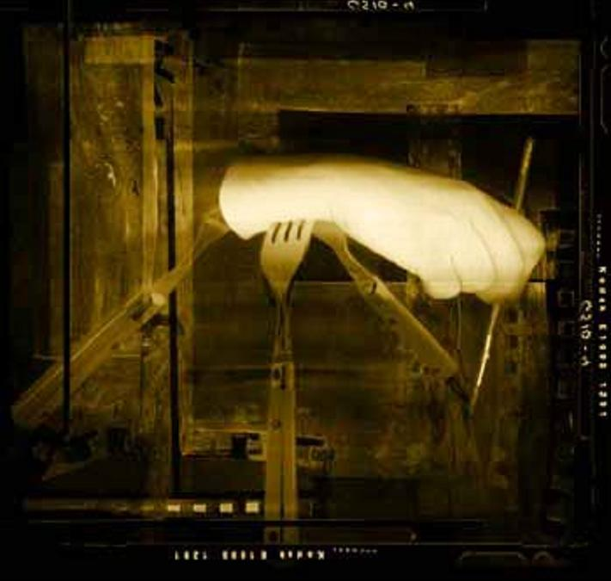 | 11.30 | Giorgi and scientific phenomenology
 | 1:00 | Lunch
 | 2:15 | Giorgi’s analysis of jealousy
 | 3.15 | Tea/coffee
 | 3.30 | Meaning transformation
 | 4.30 | Close
Day Two | 9.30 | Heidegger and method
27th March | 10.30 | Tea/coffee
 | 11.00 | Van Manen’s phenomenology
 | 12.30 | Lunch
 | 1:45 | Phenomenology and linguistics
 | 2:45 | Tea/coffee
 | 3:00 | Research on meaning
 | 4.30 | Close

To attend you will need to book a place and, to book a place, please email Martin.Lipscomb@uwe.ac.uk – this is expected to be a popular event. You are therefore advised to book early.

