DIFFERENT BEHAVIOUR SEEN IN FLEXIBLE TITANIUM DIOXIDE SOL-GEL MEMRISTORS DEPENDENT ON THE CHOICE OF ELECTRODE MATERIAL

Ella Gale¹, David Pearson², Stephen Kitson², Andrew Adamatzky¹ and Ben de Lacy Costello¹

¹Unconventional Computing Group, University of the West of England, Bristol, Avon, UK; ²Hewlett-Packard UK, Bristol, Avon, UK

The archetypal memristor was made via atomic deposition of TiO₂ between platinum electrodes [1]. The announcement of flexible solution-processed titanium dioxide memristor was greeted with much excitement as it made it easier to fabricate working memristors [2]. This device consisted of a spun-on sol-gel layer between two aluminium electrodes. Despite several examples in the ReRAM literature of aluminium oxide playing an essential role in resistance switching [3], even when it was just via aluminium electrodes [4,5,6,7], the sol-gel TiO₂ memristor paper did not report a detailed test comparing aluminium electrodes to noble metal electrodes and instead simply stated that the switching was not attributable to the aluminium electrodes as the memristors still switched with noble metal (Au, Pt) contacts.

We have undertaken a study of the effect of changing the electrode metal on TiO₂ sol-gel memristors prepared as in [2] to elucidate possible methods for control of device characteristics. We found that Au-TiO₂-Au memristors did still switch, but in a fundamentally different way. These devices switched in a fuse-like manner, but did not switch back the way that Al-TiO₂-Al devices did (as reported in both [2] and below). The low resistance state, LRS, and first high resistance state, HRS, currents were separated by 5 orders of magnitude and were ohmic, making these devices useful for Write-Once Read Many (times), WORM, memory. There was also a second low resistance separated by an order of magnitude. As all resistance states in these devices were ohmic, thus these devices are best described as resistance switching memory rather than memristors.

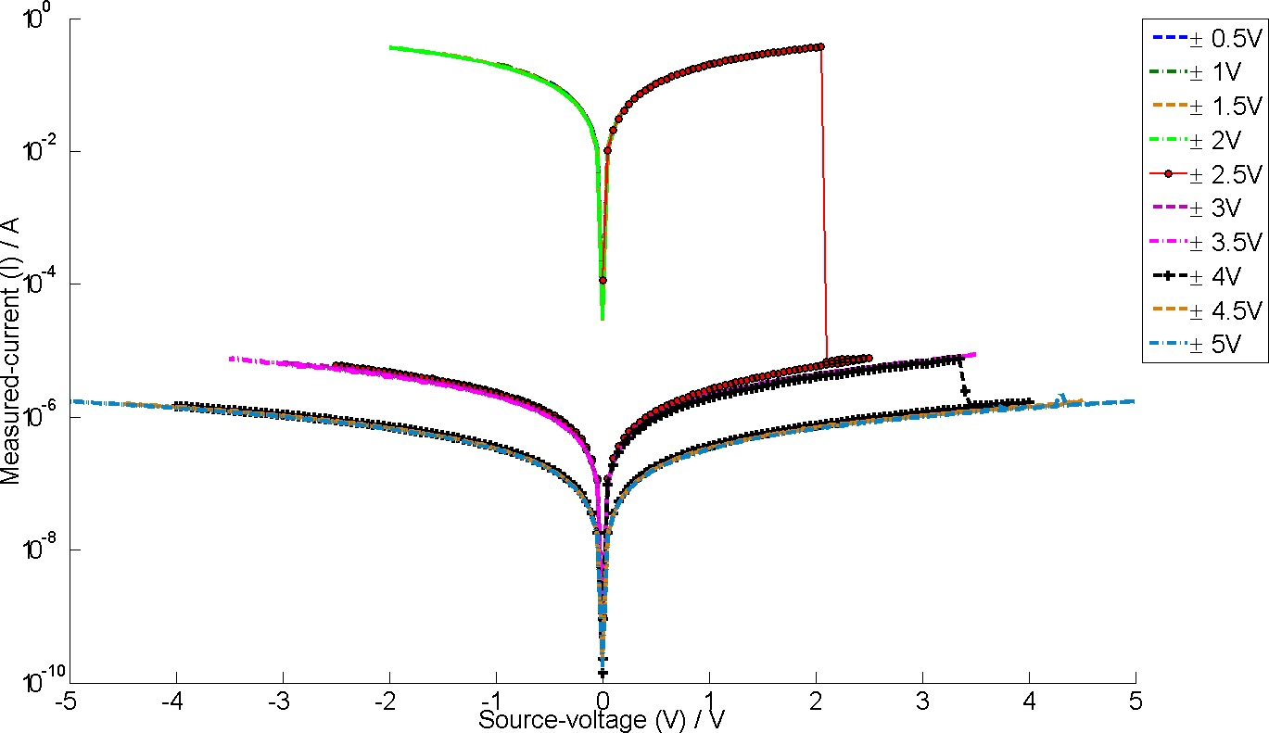 | Figure 1: Repeated I-V curves done over an increasing voltage range. Au-TiO2-Au sol-gel resistance switching memory acts like a fuse and could be useful for WORM memory.

We also investigated Al-TiO₂-Al memristors. We found high current triangular memristor profiles that resembled those reported in [2]. The LRS was ohmic and in the mA range and never reached the 10⁻²A range which the LRS of the Au-TiO₂-Au memristor did (in a comparison of virgin runs of the device between ±3V). These devices had non-linear HRS in the same range as the curved bipolar switching below.

We also found non-linear memristor I-V curves in these devices which resembled both Chua’s memristor theory[8] and also ReRAM bipolar resistance switching (they look like a centrosymmetric version of figure 2.). Devices with this mode of operation were higher resistance, (most in the 10⁻⁶ to 10⁻⁴A range over the voltage range tested) and very reproducible. Those with triangular memristor profiles were less reproducible, they had the same behaviour, but the switching voltage was not constant.

Mixed electrode devices, Al-TiO₂-Au, (gold as the top electrode) were also fabricated. These showed unidirectional memristance curves, ie. memristor behaviour was only seen when the aluminium electrode was negative with respect to the gold electrode. When the gold electrode was negative the hysteresis was at least 3 orders of magnitude smaller and there was significant deformation of the gold electrode caused by oxygen evolution from the TiO₂ gel layer. These devices lacked reproducibility.

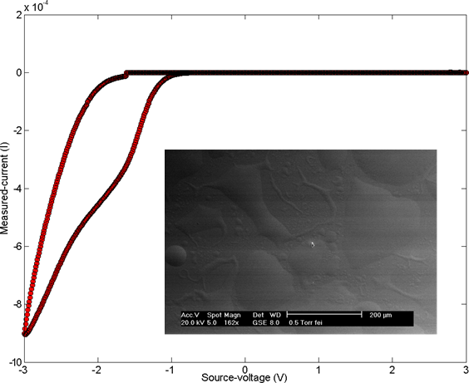 | Figure 2: Unidirectional memristance seen in an Al-TiO₂-Au sol-gel ‘half-memristor’. We see memristance on the negative side of the curve as the aluminium electrode was the source. Hysteresis on the right hand side of the curve has been suppressed. The current scale is in 10⁻⁴ A, which is towards the top end for the bipolar switching-like memristance seen in these devices. Gold bubbling of the top electrode happened at +1.5V. Insert shows disruption of the gold top electrode via oxygen gas evolution.
Therefore, whilst the spun-coated [2] and HP memristor [1] are both based on TiO₂ the mode of operation is subtly different and we have shown the electrode material plays a significant role in the case of sol-gel devices. We expect this work to enable greater control of device characteristics.

[1] D. B. Strukov et al, Nature, 453, 80-83 (2008).
[2] N. Gergel-Hackett et al, IEEE Electron Device Lett., 30, 706-708 (2009).
[3] S. Kim et al, Appl. Phys. Lett., 92, 223508 (2008).
[4] B. J. Choi et al, J. Appl. Phys., 98, 033715, (2005).
[5] H. Y. Jeong et al, Appl. Phys. Lett., 95, 162108 (2009).
[6] T. Kever et al, Appl. Phys. Lett., 92, 083506 (2007).
[7] M. Colle et al, Organic Elec., 7, 305-312 (2006).
[8] L. O. Chua, IEEE Trans. Circuit Theory, 18, 507-519, (1971).

