Automotive Enterprise Transformation: Build to Order as a sustainable and innovative strategy for the automotive industry?

Abstract
Lean has benefited the automotive industry, but the original vision of building cars at the rate and variety demanded by the customer has yet to be achieved. Innovations in new product development and collaborative supply can facilitate the production and delivery of a vehicle within days of order. Through addressing wastes such as overproduction, unnecessary transportation and inventory, the Build to Order approach outlined may allow automotive firms to be fully sustainable, achieving the triple bottom line of economic, environmental and societal prosperity. Research shows that enterprise transformation needs to be realized to successfully implement a sustainable future build to order strategy in the automotive industry.

Key Words
Enterprise Transformation, Innovation, New Product Development, Build to Order, Lean, Automotive Industry

Introduction
A Build to Order (BTO) strategy offers automotive manufacturers the opportunity to develop a sustainable future, requiring innovation and collaboration throughout the automotive enterprise and facilitating rapid and more cost effective new product development. In order to realize a BTO strategy, enterprise transformation is pivotal to drive change and strategic objectives. Transformation calls for radical changes to organizational relationships across key stakeholders, new value propositions for product and service delivery and re-organization of the enterprise, (Nightingale, 2009; Purchase et al., 2011).
Implementation of such a strategy will challenge convention and disrupt established practice, but the financial crisis of 2008 revealed the weakness of the industry. Such financial stress may facilitate the adoption of a BTO strategy. Financial crises have precedence as a driver for change in the automotive industry. The Toyota Production System was created through necessity following the Second World War when Japanese companies could not raise the capital necessary to build automobiles using the mass production processes developed in the US (Ohno, 1988). Lean was a result of necessary innovation in vehicle production, minimising waste and hence cost. Contrasting the approach of mass production developed by Henry Ford and providing a challenge to manufacturing convention, central to Ohno’s vision was the building of vehicles at the rate and variety demanded by the customer – building to customer order – such that each vehicle was paid for before it was built (Monden, 1983). Ianni (2011) outlines the steps needed to successfully realise lean as an enterprise transformation example in an automotive company. In addition, Roth (2011) outlines some key factors, namely attending to positive persona and interpersonal outcomes and balancing productivity gains with business growth – to realise lean transformation. While some evidence of enterprise transformation can be found in extant literature (e.g. Ianni, 2011; Rouse, 2011), Rifkin (2011) point out that we need to learn more about enterprise transformation by adopting a systematic approach. To fill this gap in the literature, this paper provides a systematic review of enterprise transformation by investigating not solely individual examples, but providing a deep investigation of the possible future state of the automotive industry.
This paper provides a view of how the original Lean vision of building cars at the rate of customer demand may be realised through innovations in product and process. The paper will proceed through the following parts: (i) Lean and Build to Order; (ii) What is Build to Order?; (iii) The intelligent logistics for innovative product technologies (ILIPT) project; (iv) Modular product development, configuration and flexibility; (v) Supply chain innovation; and (iv) Validation and implementation of a Build to Order strategy.

Lean and Build to Order
The automotive industry has a history of recovery from crisis through adoption of leading innovative practice in product design and manufacture (Holweg, 2008). ‘Lean production’ was documented and the auto industry in the West set out to employ Japanese best practice and close the productivity gap (Womack et al., 1990). Lean efforts have delivered improvements in manufacturing efficiency, but they have been largely ineffective in increasing profitability due to a myopic focus on factory processes. Through rigorous application of lean thinking Western automotive companies have now significantly reduced the productivity gap identified by Womack et al. (Merlis et al., 2001), but have not as yet delivered on its heralded promise of zero inventory or just-in-time approach to customer orders (Stone et al., 2006). Many car companies are losing money. The mass-production business model of the automotive industry is flawed and perhaps becoming dysfunctional. The industry suffers from global overcapacity and rising stock levels and exhibits inherently low profitability. The decoupling point, where build-to-stock becomes build-to order, is frequently absent at the vehicle purchasing interface where both customer and financial drivers show it is desirable. Whilst lean has enabled the automotive industry to optimise systems for mass production with minimal waste, it has not tackled the problems of capacity and demand. We find ourselves in a position where, following leading practice, a car can be built from flat steel within 11 hours, but a customer ordering a car in a dealership has to wait around 40 days to purchase their desired vehicle, or buy one from stock (3DayCar, 1999-2001; Holweg and Miemczyk, 2002 & 2003; Miemczyk and Holweg, 2004; Parry and Graves, 2008). Globally, manufacturers have yet to create an enterprise that is responsive enough to rapidly meet customer demand without reliance on large stocks.
Competitive advantage is afforded companies who can provide a product at the right price and quality to the customer within the shortest lead time (Bower and Hout, 1988; Stalk, 1988). To mask the delay within their supply chain and provide the customer with a vehicle more quickly, automotive suppliers hold tens of billions of dollars worth of stock in finished goods. Reported US stock figures ranged from an average of 25 days for BMW, 85 days for GM and 35 days for Toyota between 2006/7 (Automotive News,2006/7). This enabled them to find a ‘best match’ from across their stock to meet the purchaser’s requirement. However, customers frequently do not receive what they really want when incentivised by manufacturer discounts they purchase a vehicle that is a compromise, whilst manufacturers erode their own profits (Holweg and Pil, 2001). The model for the industry is self defeating and the automotive industry creating grounds for their own failure through their vehicle product model cycle, as illustrated in Exhibit 1.

< PLEASE INSERT ‘Figure 1. Automotive product cycle’ ABOUT HERE >

The automotive product cycle goes through the following stages (Holweg and Pil, 2001):
- Develop new vehicle; lower target costs set by OEM. Achieving target costs demands increased sales volumes. Optimistic forecasting of future sales facilitates vehicle development path to production.
- Launch new vehicle; temporary profit? However, forecast volumes set above demand to justify cost of investment.
- Vehicle in market; factory capacity demands that high production volumes are maintained even though sales are not meeting volume targets. OEM introduces pressure and incentives to increase sales, achieved through discounting, fleet sales, and pre-registration of vehicles to place them directly into 2nd hand market.
- Price environment worsens; all competitors are ‘in the same boat’. The approach has been to increase the specification of vehicles in each market segment, but the segment price is driven down - permanently
The financial crisis of 2008 crippled sales and a lack of availability of capital stilted cash flows, causing automotive stocks to increase rapidly at a time when it was least affordable. Reported US stock figures for December 2008 showed significant stock increases with an average of 44 days for BMW, 139 days for GM and 90 days for Toyota (Automotive News, 2008). Companies saw an almost doubling of stock level during the worst of the downturn, and there is a suggestion that there is an under reporting of figures by the industry (Webster, 2006). Comparative reported sales for February 2008 and 2009 showed a fall of 41.3% for major US manufacturers, leading analysts to declare an automotive recession (Thompson, 2009). This caused great damage to the automotive companies as it highlighted their inefficiencies. The reaction of the vehicle OEMs was to halt production, with Honda shutting its UK base for four months (BBC, 2009) and Toyota halting Japanese production for 2 months (Ryall, 2009). Government backed packages such as the ‘cash for clunkers’ or ‘scrappage schemes’ seen in Europe and the US has helped the industry turn some of its capital tied up in stock back into cash and perhaps saved the industry in the short term. German sales were reported to have risen 40% as a result of the scheme, but shares in automotive OEMs fell as investors were unconvinced that the governments rescue measures created sustainable change and forecast a further slump in 2010 (Reuters, 2009). Direct funding has also been called upon or offered by governments in an attempt to place the industry upon a more sustainable footing. These activities could simply restart what we perceive to be a failing business model.
The automotive industry clockspeed (Fine, 1999) does not match the expectation its marketing departments has created. Clockspeed may be seen as a measure of the rate of business evolution, or how quickly a company can convert investment in innovation into cash through mastery of their product, process and supply chain. The nature of product and lifecycle are determinants of a successful supplier strategy (Fisker, 1997). Within the electronics sector, companies such as Dell hold stocks of final components and configure them to form products giving them rapid responsiveness. The variety of components and final products extant in automotive OEMs make such a ‘late configuration’ strategy infeasible for the automotive industry (Holweg, 2005; Scavarda et al., 2009;).
A built to order future that extends through the automotive enterprise, integrating suppliers and providing a much stronger model upon which car companies could rebuild sustainable businesses (Holweg and Pil, 2004). This will lead to greater dependency between certain organizations within multi-organization enterprises, thus leading to complexity which needs to be managed to achieve innovation and efficient outcomes (Henshaw et al., 2011). Innovation in product and supply chain structure lies at the heart of the Build to Order vision. Through careful design and extensive utilisation of modularity it is possible to provide a high number of product variants to the market, configure the final product much later in the process, whilst limiting the number of different component parts required. Achieving this requires supply chain innovation and integration which builds upon previous lean implementations, facilitating the smooth flows of data that control the build activity. This paper will give details of some of the solutions developed for a Build to Order strategy delivering cars to customers within 5 days.

What is Build to Order?
Build to Order refers to a demand driven production approach where a product is scheduled and built in response to a confirmed order received for it from a final customer (Parry and Graves, 2008). The final customer is a known individual purchaser. Our definition excludes all orders by national sales companies (NSC), car dealers, fleet orders or other supply chain intermediaries. We also exclude the order amendment function, whereby vehicles in production are amended to customer requirements, as this is another level of sophistication for a build to stock (BTS) system.
Build to Stock is the dominant approach used across the automotive supply chain and refers to products that are built before a final purchaser has been identified, with production volume driven by forecasts. High stock levels, endemic across the auto industry, allow some dealers to find an exact or very close match to the customer’s desired vehicle within the dealer networks and supplier parks. This rapid customer gratification has been used to justify stock levels, but the approach is expensive, mainly in terms of stock, but also transportation as finished goods are rarely where they are required.
A BTO system does not mean that all suppliers in the supply chain should be producing only when a customer order has been confirmed. Clearly, it would not make economic sense for a manufacturer of windscreen wiper blades to employ BTO. These components should be built to a supplier order, effectively BTS. However, a large expensive item, such as an engine, could and possibly should be BTO. Part of the challenge in a BTO supplier network is in the identification of which suppliers should be BTO and which BTS. The point in the supply chain when this change occurs is called the ‘decoupling point’. Currently, the majority of automotive supply chains lack a decoupling point and the dominant BTS approach has resulted in capital being tied up in stock in the supply chain and billions worth of finished automobiles.
Development of innovative Build to Order products and processes requires a significant investment in research and broad access to expert resources. The European Commission recognised the sustainability of the BTO model and the importance of the automotive sector within Europe. The prohibitively high risk and cost associated with developing such an innovative approach to manufacture was too great for a single company to bear, so the EU Commission, in partnership with industry, provided $23 million to fund this research.

The ILIPT Project
The European Commission, through its four year ‘Intelligent Logistics for Innovative Product Technologies’ (ILIPT) programme, proposed a pan-European research project to study the applicability of Build to Order across the European automotive sector. It was agreed to set a challenging target of 5 days from order to delivery for the European context, following the completion of a UK only automotive project (3DayCar, 1999-2001). To meet this new ‘5 Day Car’ target the necessary improvement in productivity would require a radical restructuring across a broad spectrum of activities, as well as a possible revolutionary change with regard to its technological capacity. A stockless vehicle supply system to deliver a customer ordered vehicle in 5 days would represent a considerable breakthrough leading to the renewal of the entire automotive industry. The ILIPT project aimed to help support and facilitate the delivery of this approach through a set of innovations.
- Management of Product Configuration for Flexibility: addressing the need for a global product with local configurations in systems and modules for cars to 2015 leading to novel approaches to customisation of cars and their subsystems
- Innovative Production, Supply and Logistics Networks: groundbreaking informational and material flow processes, and software prototypes for designing and evaluating production networks that model new approaches to customisation, fulfilment and logistics.
- Management of Information Flow: defines the critical path for information flows during build-to-order through sophisticated electronic applications to facilitate a seamless knowledge and information flow
- Management of Material Flow: radical change in the management of supplies, inventories and the picking, transportation and monitoring of parts, modules and cars towards a customer specific treatment and optimisation.
- Extended Automotive Enterprise: where the whole supply chain operates on consumer demand, in real-time, with no stocks through collaborative planning and execution models providing pre-normative measures for the future requirements on inter-enterprise integration standardisation.
To achieve this vision a significant consortium of leading automotive experts was convened from across industry and academia. Project participants were drawn from all over Europe – Ireland, France, Spain, the Czech Republic and even Russia. From the automotive industry, Original Equipment Manufacturers (OEMs) and Tier One suppliers as diverse as Daimler, BMW, Lear Automotive, Dana Corporation, ThyssenKrupp Steel, Siemens VDO, Saint Gobain Sekurit and CLEPA (the European Association of Automotive Suppliers) representing the complete supply chain.
The ILIPT project represents a vast European effort to develop new concepts. This paper provides a brief overview of some of the research completed which illustrates how the BTO vision may be achieved, with focus upon the innovative elements that will deliver a globally leading automotive industry. Much greater detail may be found within the book produced by the project participant (Parry and Graves, 2008)

ModCar - Product Configuration for Flexibility
Automotive OEMs seek to provide products that address the needs of as many customers as possible, thus providing market coverage. The visual, external differences between vehicles play a significant part of defining their market segment. Internal differences, such as fuel injectors or windscreen wiper motors, are less significant and common parts and modules may be shared across vehicles in many segments. Automotive manufacturers seek to minimise their product part variance, which would drive up cost, and maximise part commonality whilst maintaining an individual product integrity and segment differentiation within the market (Gneiting and Sommer-Dittrich, 2008). Modular architectures would appear to provide a solution to this challenge. A product is divided into partial systems or modules which ideally connect through common standard interfaces. Each module consists of a number of sub modules, creating a hierarchy. Product variants can be created by changing different modules, and this set of interchangeable modules creates the product family.
This approach has already been employed extensively in automotive product design, where greatest focus has been placed upon common platform strategies (Untiedt, 2008). Here many common parts, including much of the main chassis, are reused over different vehicle variants. This allows higher volumes to be produced and, in theory deliver lower costs, though high volume processes require higher capital investment in tooling. However, the current body architectures are monocoque based, with styling surfaces forming part of the load baring structures. To produce variation in the appearance of the body, different panels are used across common platforms which can frequently only be assigned to one product variant, increasing variant number and cost. Despite the efforts of the lean theorists (e.g. Womack and Jones, 1995) in practice most manufacturers’ body panel metal presses still take a long time to change dies for different variants, leading OEMs to favour manufacturing large batches. When common body parts are used, colour remains a major variant which adds to the complexity, and hence cost, as parts must be correctly sequenced to arrive on the final assembly line (Schaffer and Heinrich, 2008). Paint shops are unreliable and challenged with colour matching across different base materials e.g. plastic, alloys, steel grades and galvanised coatings, using different paint types of the ‘same’ colour (Untiedt, 2008).
Within the ILIPT project leading practice was identified from within the automotive industry to develop a flexible product strategy for efficient Build to Order based on maximising the application of modularity. As multiple OEMs were involved in the project a virtual car, named ModCar, was designed and prototyped for production, drawing upon real industry vehicle production data and manufacturing knowledge. The ModCar had to conform to industry requirements relating to vehicle structure, including stiffness and crash protection. All features and variants had to meet packaging requirements to ensure all equipment could fit within the body structures. The vehicle also had to meet the market requirements for variants. There were three core aims behind the decisions made for the body design: a reduction in production time; a simplification of the order and delivery network facilitating logistics; and a reduction in the required fixed capital within the whole process.
Building on research done by Daimler AG (Truckenbrodt, 2001; Elbl-Weiser, 2003) it was decided to develop a virtual vehicle which had separated body structure from styling surfaces. The concept offers an alternative solution for the inexpensive development and production on vehicles, based on a modular structure with decentralised modular production – effectively allowing smaller localised production without the need for heavy investment in build facilities usually associated with car manufacture. The separation of body and styling surface has previously been used for a low volume commercially available vehicle, the BMW Z1. The Z1 was built between March 1989 and June 1991, which through modularity and focus on commonality also shared many of its parts with the BMW E30. It removes the paint line from the main vehicle production process which saves time and cost. Separate clip on styling surfaces are attached to the body to complete the car.
Focussing upon the body frame, the structure of the ModCar body is built from parts that were simple in shape and easy to manufacture. Parts were used in as many different body modules as possible. Materials were chosen to best suit the performance requirements of that body part, with relation to weight, crash worthiness, load routing and stiffness. The body structure followed the approach developed by Daimler AG known as “quartering the car”. The vehicle comprised a set of four modules: front module; engine module; greenhouse front; greenhouse rear. By following this approach eight different modules could be combined to produce four different variants of final vehicle: a five-door, three-door, estate/wagon, and convertible, as shown in Exhibit 2. The front end and engine module are common to all body variants. The greenhouse front for the five-door and wagon is common to both. The only difference for the three-door variant is the positioning of the B-pillar on the module, allowing greater commonality of sub-components. The convertible front greenhouse has more differences due to the requirements for overall vehicle stiffness and strength of the A-pillar for roll over protection. For the greenhouse rear all parts below the spring/suspension mounts are common to all, with additional reinforcements for the convertible. The rear consists of three modules: a module that is used for both the three-door and five-door variant; a module for the wagon; and a module for the convertible. Both front and rear modules are fitted with crash boxes to limit damage and repair cost in the event of low speed crash. To further achieve the aims of the approach, the modules are split into sub-components to achieve high packing density for transportation. The combination of modules is shown in Exhibit 2, which includes the percentage commonality achieved for each variant.

< PLEASE INSERT ‘Figure 2. Illustration of commonality between variants ‘ABOUT HERE >

As it can been seen from Exhibit 2, it is possible to have extensive commonality between the variants, with the convertible, at 30%, having the greatest number of unique parts. The implied cost reduction in areas such as complexity, handling, and storage is significant (Schaffer and Heinrich, 2008). As part of the approach to design for BTO, facilitating late determination of product variant within the supply chain, it is proposed that the modules are only joined together after they are equipped with components and interior materials. This limits the joining techniques available to bond the modules together to cold-joining technologies. Common interfaces were required; all oriented longitudinally to the vehicle direction of travel to ensure a feasible joining process that will also support the performance requirements such as crash worthiness and stiffness. Cold joining techniques that were identified as suitable and methods were an adhesive injection and mechanical screw bond. This technique of combining mechanical and chemical bonding has already found use in commercial vehicles for the chassis of the Lotus Elise, which has been in production since 1996, and in a more developed form in the Lotus modular chassis platform used for the Evora, which began production in 2008.
The outer styling surfaces for the ModCar would also follow the proposed ethos of modularity, low complexity and commonality. The commercial viability of the ModCar meant that, as well as being technically viable, it must also have attractive styling that would appeal to the European market. The modular body shell proposed consists of different outer panels and structures which, whilst not designed to bear the substantial mechanical loads of monocoque chassis, still had to perform in use meeting legislative requirements for crash and impact protection, as well as lighter wind loads and general misuse encountered in regular driving (Gude and Hufenback, 2008).
The commonality of the body frame meant that significant commonality was carried over into the styling surfaces. Careful design was required to ensure that the changes in the modules across the variants did not look awkward or impact upon the flow or aesthetic appeal of the vehicle. The front module was kept the same in all derivatives. The difference between the three and five door variants is the position of the B-pillar, leading to a longer front door in the 3 door variant. The five door and wagon variants only differ with regards to the design of the rear panels, with the side panels being common. The resultant designs are shown in Exhibit 3.

< PLEASE INSERT ‘Figure 3. Styling variants of the ModCar‘ ABOUT HERE >

In addition to the commonality, the design of the body panels allows for high packing density when in storage, further reducing cost and meeting the lean ideology. To eliminate the need for a paint shop at the point of production for complexity, cost, and environmental reasons it is proposed that the panels are manufactured from pre-coloured panels. Thermo formed and injection moulded plastics are suitable materials to fulfil this role.
To join the outer panels to the body frame multi-functional connector elements were developed. These are bridging structures that are snapped or screwed onto the body frame and then connect to the styling surfaces using adhesive bonding, which provides high variation tolerance at the join. Connecting methods for body frame and shell could have been integrated into the body frame and styling surfaces directly, such as mounting pins or holes, but this would add complexity and hence cost of the two. Complexities would include localised increases in material thickness to provide strength, compensation for thermal expansion, accurate mating of parts across variants and so forth.
The modular product innovations described all support the concepts of Build to Order, but require a collaborative and integrated supply chain so that they can be brought together as demanded.

Supply chain innovation
Key to delivering the 5-day car is the improvement of the flexibility and integration of the supply chain across physical, information, data, planning, and control processes. Modularisation requires extensive collaboration within the automotive enterprise so that modules may be co-developed between parties to reduce interface constraints, information shared and deliveries made on time. Such an approach introduces dependencies between firms which research suggests will facilitate greater collaboration (Howard and Squire, 2007).
To achieve a 5-day car a shared vision has to be maintained across the automotive enterprise: stocks must be avoided, order to delivery times reduced, queries answered rapidly and planning order data shared rapidly. These elements strongly reflect the lean principles (Womack and Jones, 1996; Henderson and Larco, 2000; Liker, 2004). Central to achieving this goal is the introduction of collaboration in the planning process. Within collaborative planning, production volumes are distributed across different final assembly plants according to their available capacity and proximity to the final customer. The OEMs need to constantly be aware of their suppliers’ available and utilised production capacity and dynamically assign customer orders to them, with detail of specification, delivery time and location such that they supply the correct plants in sequence with the production process. Local planning is undertaken by each plant to optimise the productivity of their internal processes. Collaborative planning is undertaken more broadly as allocation of demand for vehicle manufacture is optimised for the production capacity of the networked enterprise, which includes suppliers and OEMs.
Whilst planning autonomy ultimately remains with production partners, virtual order banks and autonomous agent negotiation facilitates the rapid assignments of orders to suppliers. Pre-negotiation of a supplier’s production capacity maximum and minimum levels, or ‘bandwidth’, along with conditions for temporarily extending or reducing capacity [cost, times etc], is central to the automated collaborative process. Any violations of capacity limits imply that the collaborative plan breaches the agreed capacity limits set within the supplier network. The automated process seeks to redress the capacity violation. The virtual order bank identifies plants that contribute to the violation and analyses the situation within the context of the violation. Excess capacity may be re-directed to a plant with spare capacity or a ‘capacity agreement add on’ initiated, where additional capacity may be added [or lowered] within a pre-agreed restricted scope and timescale. This process ensures collaborators within the networked enterprise remain viable and negates contractual arguments over time, order levels and cost, usual when ‘rush jobs’ are encountered. This process operates autonomously and hence more quickly than is currently possible, as the current approach would require individuals at OEMs contacting many suppliers and negotiating separate contract amendments. This process integration has been shown to be achievable using current IT systems, linked through innovative supporting systems (Fischer et al., 2008).

Validation and implementation
The dynamic Build to Order process described utilises a large number of different possible supply chains, forming a value creation network (Parolini, 1999). The design of value creation networks considers: logistics strategy, supplier selection, relationships and location. Supply chain design as an independent task determines suitable conditions for planning and execution and ensures that chosen pathways are economically efficient and viable in terms of the goal set, in this case the order, production and delivery of a bespoke vehicle to the customer within five days (Person and Olhager, 2002; Chopra and Meindl, 2009). Static comparative analysis and dynamic simulation are used extensively by automotive supply chain analysts. While the former is a rather simple analysis, the latter provides much greater granularity of data and the dynamic data-flow through simulation models is particularly useful in identifying constraints or bottlenecks within processes. A combination of both techniques, using static modelling to identify potentially valid processes and dynamic modelling to simulate and identify optimal solutions, provides a feasible approach to analysing large numbers of supply scenarios.
Through the simulation and modelling of the network it was possible, using actual demand data for a commercially available vehicle in production with the same variants as the ModCar but set in the year 2015 (Ost and Mandel, 2008), to test the validity of the whole Build to Order paradigm. The validation model required a set of assumptions, based on actual conditions within the European automotive industry, which included: 15 OEM plants established in Europe to build the vehicles; Build to Order and build to stock suppliers within the locations could deliver the product varieties; a virtual order bank and information transparency had been implemented successfully across the enterprise (Toth et al., 2008).

< PLEASE INSERT ‘Figure 4. Analysis of Build to Order methodology’ ABOUT HERE >

The analysis, Exhibit 4, showed that, following the Build to Order strategy outline delivery of 50% of vehicles can be achieved within the five day target time. 97% could be achieved within six days and 100% within eight days. This falls short of the target for all Build to Order vehicles to be delivered within five days, but exceeds the current industry capability of 40 days (3DayCar, 1999-2001; Parry and Graves, 2008b). The validation shows that a Build to Order strategy is feasible, but it is a challenging proposition that contrasts convention and implementation is therefore not straightforward.
Similar to the lean approach, the implementation of Build to Order is expected to have a slow start but rapidly gain momentum as investors realise the potential of the strategy. Through addressing three of the seven wastes within automotive production identified by Taiichi Ohno, namely overproduction, unnecessary transportation and inventory (Ohno, 1988), the Build to Order approach outlined allows automotive firms to be fully sustainable, achieving the triple bottom line of economic, environmental and societal prosperity (Elkington, 1994; Stone and Brauer, 2008). This is achieved and further enhanced by the holistic approach to product development which focuses on production, logistics as well as performance in use.
The potential economic impact of Build to Order is the removal of stocks [inventory] throughout supply chain, freeing billions of dollars of cash flow which may be reinvested in product development. Further, innovative product developments captured during the ILIPT project may reduce logistics costs by 45% (Seidel and Huth, 2008). These savings improve the return on capital employed by automotive businesses, a significant financial ratio used by city analysts to assess the capability of a firm in generating profits, and hence a driver of whether they will invest in new product development for the firm to continue. Automotive firms must compete for capital investment to develop new products and not just with other automotive firms. Investment banks are key suppliers to the automotive industry, but the current industry’s relatively slow clockspeed in comparison to telecommunications and consumer electronics producers leads to uncertainties in future returns (Parry and Graves, 2008c).
The environmental impact comes from the removal of waste through both unnecessary transport and in the production of unwanted vehicles (Ohno, 1988). Within this strategy, vehicles are assembled locally and major modules and components only made to confirmed order BTO by suppliers near finally assembly plants. This leads to shorter transportation distances of goods and removes overproduction, ultimately lowering the CO₂ emissions of the enterprise.
The societal impact is more difficult to assess as there is little quantitative data available. The automotive industry is an integral part of the European economy. It is estimated that the industry provides more than 12 million skilled jobs and generates $548 billion in tax revenues across Europe (ACEA, 2009). The Build to Order approach requires that the vehicles are manufactured close to the customer, which would mean that this approach would maintain production and assembly within the major markets, protecting employment and tax revenues and hence bringing benefit to society.
However, adopting new practices is highly complex and likely to be confronted with a variety of obstructions. Much of the complexity and indeed obfuscation is linked to the interactions of institutional push and need pull mechanisms. From 3Day car research we have seen the widespread adoption of lean production has encouraged entire industries (e.g. automotive, aerospace, construction, health) to transition towards new models. Promising practices are frequently presented as being part of a universal panacea and there is much evidence to suggest that there is no such thing as a single 'one size fits all' best practice (Leseure et al., 2004). Nevertheless, the case for adoption of a Build to Order strategy is strong and following on from this work implementation has already begun within parts of the European industry. Early adoption is challenging, but the longer term benefits of a transition to the new paradigm bring the potential for longer term sustainable competitive advantage.

Conclusion
This paper presents a strategy for a potentially more sustainable future for automotive production through Build to Order transformation. The original lean vision of building vehicles at the rate and variety demanded by the customer has not yet been achieved. Lean has improved productivity, but not yet achieved a full BTO enterprise. Similar to the lean approach, the implementation of BTO is expected to have a slow start but rapidly gain momentum as investors realise the potential of the strategy. Through addressing three of the seven wastes within automotive production identified by Taiichi Ohno, namely overproduction, unnecessary transportation and inventory (Ohno, 1988), the BTO transformation outlined allows automotive firms to be fully sustainable, achieving the triple bottom line of economic, environmental and societal prosperity (Elkington, 1994; Stone and Brauer, 2008). This is further enhanced by the holistic approach to product development which focuses on production, logistics as well as performance in use. Ohno noted, “an idea does not always evolve in the direction hoped for by its creator” (Ohno, 1988, p.100). The approach requires innovation within product development, with new products utilising extensive modularity to reduce costs whilst increasing potential variety. Enterprise collaboration will deliver product to customers within a timescale acceptable to the market. This will be achieved through innovative logistics and intelligent integration of suppliers. Build to Order offers the automotive industry an opportunity to eliminate overcapacity and realise the true potential of lean production. Implementation of the concepts will uncover new learning and, as with lean, will be a long and emergent process. In addition, Build to Order may provide a solution to delivering customer value through the provision of socially responsible mobility for the 22nd century.

Acknowledgement
We would like to acknowledge the support of the European Commission and ILIPT industry partners who funded the research. In particular we could also like to thank Andreas Untiedt, automotive body expert at ThyssenKrupp AG, for his the time and contributions he made towards the writing of this paper. Finally, we would like to acknowledge the support of Springer publications, in particular Claire Protherough and Anthony Doyle for their continued support.

References
3DayCar, (1999-2001). Available online: http://www.3daycar.com/
ACEA, European Automobile Manufacturers Association. Available online: http://www.acea.be/index.php/collection/statistics.
Automotive News, (2006-8). Available online: http://www.autonews.com/
BBC News, Honda's four-month break begins, (1st February 2009). Available online: http://news.bbc.co.uk/1/hi/business/7859863.stm.
Bower, J. L. and Hout, T. M. (1988) Fast-cycle capability for competitive power. Harvard Business Review, 66(6), 110-118.
Chopra, S. and Meindl, P. (2009) Supply Chain Management – Strategy, Planning and Operation 2nd Edition, Pearson Education.
Elbl-Weiser, K. (2003) Automobile coatings of the future - New solutions for modular automobile designs, BASF Coatings AG.
Elkington, J. (1994) Towards the sustainable corporation: Win-win-win business strategies for sustainable development. California Management Review, 36(2), 90-100.
Fischer, J.-G., Witthaut, M. and Berger, M. (2008) Functionalities of supporting IT systems: current situation, future requirements and innovative approaches. In Parry, G. and Graves, A. Eds Build to Order: The Road to the 5-day Car, Springer Chapter 13, pp 223-237.
Fine, C. (1999). Clockspeed: Winning Industry Control in the Age of Temporary Advantage, Perseus.
Gneiting, P. and Sommer-Dittrich, T. (2008) An overview of modular car architecture: the OEMs perspective on why and how. In Glenn C. Parry and Andrew P. Graves, ed’s Build to Order: The Road to the 5-day Car, Springer Chapter 6, pp 13-34.
Gude, M. and Hufenback, W. (2008) Modular Concepts and the design of the ModCar body shall. In Glenn C. Parry and Andrew P. Graves, ed’s Build to Order: The Road to the 5-day Car, Springer Chapter7, pp 133-153.
Henderson, B. A. and Larco, J.L. (2000) Lean Transformation: How to change your business into a lean enterprise. Oaklea Press.
Henshaw, M. J. C., Morcos, M. S., Siemieniuch, C. & Sinclair, M. A. (2011) Identification of Induced Complexity in Product Service System Enterprises. Journal of Enterprise Transformation, 1(4), 269-289.
Holweg, M. (2008) The Evolution of Competition in the Automotive Industry. In Glenn C. Parry and Andrew P. Graves, ed’s Build to Order: The Road to the 5-day Car, Springer Chapter 2, pp 13-34.
Holweg, M. and Miemczyk, J. (2002) Logistics in the 'three-day car' age. Assessing the responsiveness of vehicle distribution logistics in the UK. International Journal of Physical Distribution & Logistics Management, 32(10), 829–850.
Holweg, M. and Miemczyk, J. (2003) Delivering the '3-day car'- the strategic implications for automotive logistics operations. Journal of Purchasing and Supply Management, 9(2), 63–71.
Holweg, M. and Pil, F. K. (2001) Successful Build-to-Order Strategies Start with the Customer. MIT Sloan Management Review, 43(1), 74-83.
Holweg, M. and Pil, F. K. (2004) The second century: Reconnecting customer and value chain through build-to-order ; moving beyond mass and lean production in the auto industry, MIT Press.
Howard, M. and Squire, B. (2007) Modularization and the impact on supply relationships. International Journal of Operations and Production Management, 27(11), 1192-1212.
Ianni, P. (2011) Notes From The Field: Transforming Europe's Second Largest
Car Manufacturer: PSA Peugeot Citroën. Journal of Enterprise Transformation, 1(4), 263-268.
ILIPT, 2004-2009, Available: http://www.ilipt.org/
Leseure, M., Birdi, K., Bauer, J., Denyer, D. and Neely, A. (2004) Adoption of promising practice: a systematic review of the evidence, report for AIM [Advanced Institute of Management], (February 2004). Available online: http://www.aimresearch.org.
Liker, J. K. (2004) The Toyota Way: 14 Management Principles from the world’s greatest manufacturer, McGraw-Hill.
Merlis, S., Sylvester, M. and Newton, A. (2001) Lean manufacturing: the way to a better business model, Dresdner Kleinwort Wasserstein Research: Industry Report, Automotive/Auto Parts: Dresdner Kleinwort Wasserstein.
Miemczyk, J. and Holweg, M. (2004) Building cars to customer order-what does it mean for inbound logistics operations. Journal of Business Logistics, 25(2), 171–197.
Monden, Y. (1983) Toyota production system – practical approach to production management, Industrial Engineering and Management Press.
Nightingale D. (2009). Principles of Enterprise Systems. Second International Symposium on Engineering Systems. MIT, Cambridge, Massachusetts.
Ohno, T. (1988) Toyota Production System, Productivity Press.
Ost, S.and Mandel, J. (2008) Modelled Scenario examples for planning and execution processes. In Glenn C. Parry and Andrew P. Graves, ed’s Build to Order: The Road to the 5-day Car, Springer Chapter 14, 239-254.
Parry, G. C. and Graves, A. P. (2008) Build to Order: The Road to the 5-day Car. Springer.
Parry, G. C. and Roehrich, J. K. (2012) An engineering systems approach to strategic change: the case of the European automotive industry. Strategic Change, forthcoming.
Parolini, C. (1999) The Value Net: A Tool for Competitive Strategy. John Wiley & Sons.
Persson, F. and Olhager, J. (2002) Performance simulation of supply chain designs. International Journal of Production Economics, 77(33), 231-245.
Purchase, V., Parry G., Valerdi R., Nightingale D. and Mills J. (2011) Enterprise Transformation: why are we interested in it and what are the challenges?, Journal of Enterprise Transformation, 1(1),14–33.
Reuters (2009) UPDATE 2-German May car sales up 40 pct on tax ‘steroids, Reuters, (Wednesday Jun 3rd 2009). Available online: http://www.reuters.com/article/idUSL347499620090603
Rifkin, S. (2011) Raising Questions: How Long Does It Take, How Much
Does It Cost, and What Will We Have When We Are Done? What We Do Not Know About Enterprise
Transformation. Journal of Enterprise Transformation, 1(1), 34-47.
Roth, G. (2011) Sustaining Lean Transformation Through Growth and Positive
Organizational Change. Journal of Enterprise Transformation, 1(2), 119-146.
Rouse, W. B. (2011) Necessary Competencies for Transforming an Enterprise.
Journal of Enterprise Transformation, 1(1), 71-92.
Ryall, J. (2009) Toyota to halt Japanese production in February and March”, Telegraph.co.uk, (Tuesday January 6th 2009). Available online: http://www.telegraph.co.uk/finance/newsbysector/transport/4139865/Toyota-to-halt-Japanese-production-in-February-and-March.html
Scavarda, L.F., Schaffer, J., Scavarda, A.J., Reis, A.dC. Heinrich, S., (2009) Product variety: an auto industry analysis and a benchmarking study. Benchmarking: An International Journal, 16(3), 387-400
Schaffer, J., Heinrich, S. (2008) Complexity Cost Management. In: Glenn C. Parry and Andrew P. Graves, ed’s Build to Order: The Road to the 5-day Car, Springer Chapter 9, 155-174.
Seidel, T. and Huth, T. (2008) How the electro-mechanical valve train accelerates logistics and reduces costs. In Glenn C. Parry and Andrew P. Graves, ed’s Build to Order: The Road to the 5-day Car, Springer Chapter 18, pp 311-322.
Stalk, G. Jr., (1988) Time – the next source of competitive advantage. Harvard Business Review, 66(4), 41-51.
Stone, G. and Brauer, K. (2008) D7.7.2/D8.7.2 – Assessment of the Socio–economic & environmental impact potential of a European implementation of the 5DayCar, ILIPT report D7.7.2/D8.7.2 for the EU Commission, (April 24th 2008).
Stone, G., Parry, G. C. and Graves, A. P. (2006) Transformation of the European automotive industry, the future of lean. International Journal of Financial Transformation, 18, 10-15.
Thompson, C. (2009) GM, Ford plunge as U.S. sales drop 41.3%. Automotive News Europe, (March 3rd 2009). Available online: http:// www.autonews.com/article/20090303/ANA05/903039928/1078/COPY01
Toth, M., Mandel, J., Ost, S. and Dürr, P. (2008) D 8.6.2: Validated Digital Evaluation Platform, ILIPT report D8.6.2 for the EU Commission (April 30th 2008).
Truckenbrodt, A. (2001) Modularized Cars – die Quadratur des Autos. Verkehrswissenschaftliche Tage, Dresden.
Untiedt, A. (2009) Modular Vehicle Design and New Materials for Future Demands”, Environment, Safety and Mobility for 2020: The ILLIPT Project, Autoworld, Brussels (February 2008). Available online: http://www.clepa.eu/index.php?id=techday2009.
Webster, S. A. (2006) Top dealer says there are more unsold cars than reported”, Detroit Free Press (Online), (2006) 26th October.
Womack, J. P., Jones, D. R. and Roos, D. (1990) The Machine That Changed the World, Rawson Associates.
Womack, J. P. and Jones, D. T. (1996) Lean Thinking: Banish Waste and Create Wealth for Your
Corporation, Simon & Schuster.

Figures

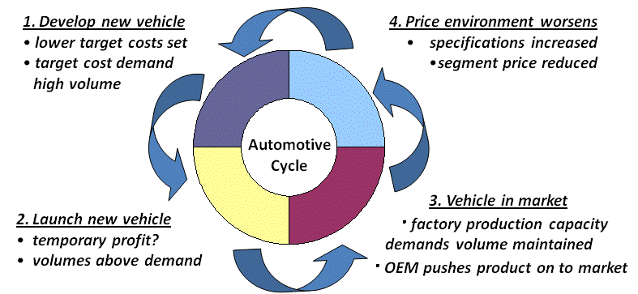
Figure 1. Automotive product cycle (Adapted from Holweg and Pil, 2001)

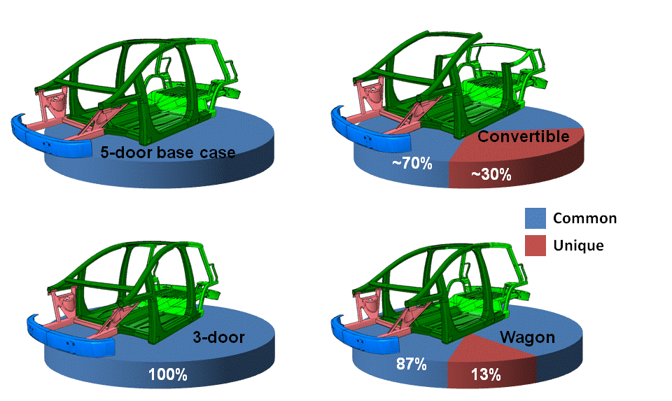
Figure 2. Illustration of commonality between variants (Untiedt, 2009)

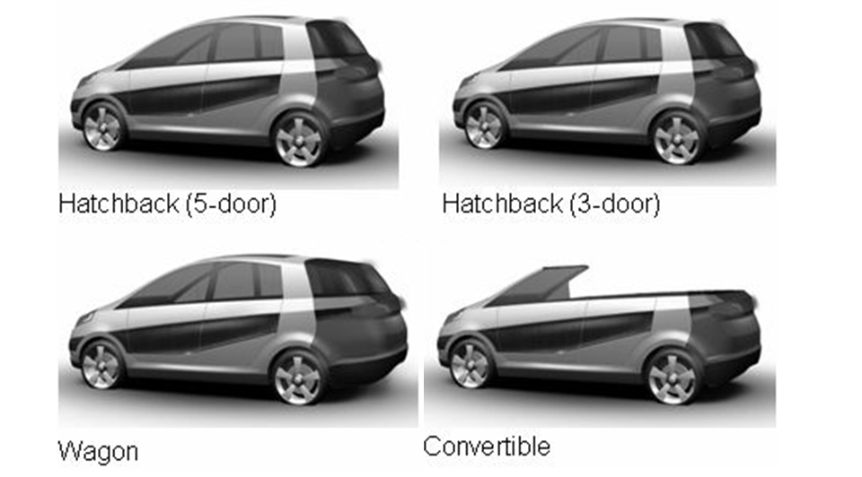
Figure 3. Styling variants of the ModCar (Adapted from Gude and Hufenback, 2008).

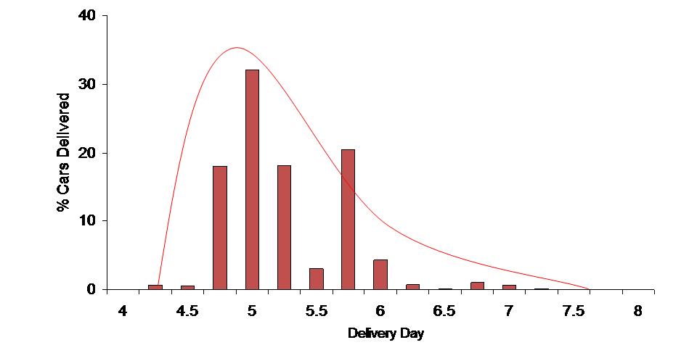
Figure 4. Analysis of Build to Order methodology (Toth et al., 2008)

