PROPOSAL : THE GARDENS OF ST GEORGE

The Asylum Seeker’s Allotment Project takes up the space of four allotments and is enclosed by hedgerows in the St George area of Bristol. The allotment is used by political asylum seekers from all around the world, as a space where they can come together to learn horticultural skills and where they can enjoy a communal and peaceful space to offer some respite from their social alienation. The project is run by Tim Lawrence and Daahir Mohammed, who was recently given to leave to stay in this country after having himself spent several years as an asylum seeker.

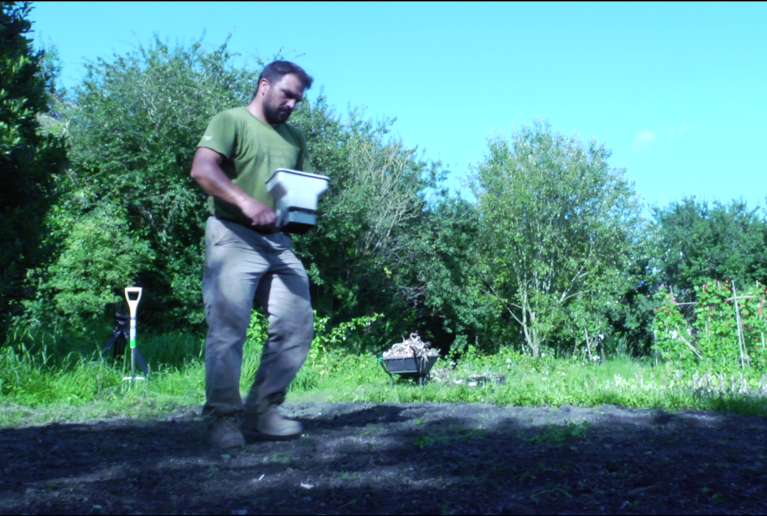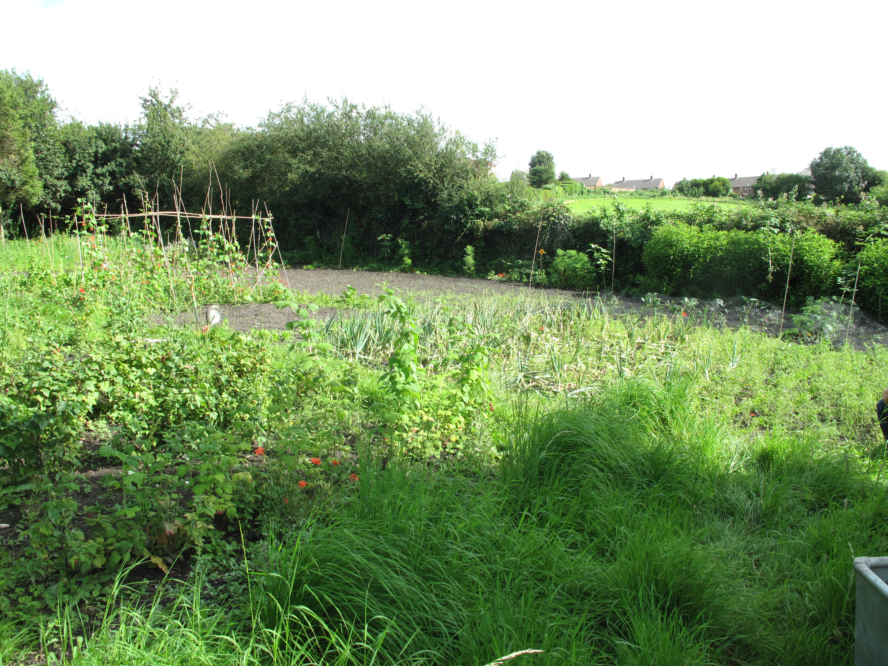

This short twenty minute film will document activity over an extended period of time to create an allegorical impression of the garden and its activity.
The film will not attempt to follow any one overarching storyline or narrative but will instead be an impressionistic montage created from different periods of time throughout the year. In resisting this sense of a dramatized reality, the film will hopefully be an evocative recreation of a space whose very essence is its timelessness. A distinct feature of the garden is its feeling of a peaceful connection with nature and the film will aim to recreate this immersive sensation with the audience.

One of the main functions of the allotment is to grow food, which the gardeners can take away with them to eat. But they have also made a raised clay and earth fireplace and a seating area, where meals are made in the late afternoon after working on the allotment. These meals will often reflect the multicultural heritage of the gardeners, for example making Somali or Iranian style recipes, which are then eaten collectively in the open air.

The food that is grown on the allotment is of an outstanding quality, which you would be hard pushed to find in any supermarket. The organic fruit and vegetables that are grown include broad beans, runner beans, squash, onions, tomatoes, carrots, chard, spinach, garlic, vines, raspberries, strawberries, red currants, gooseberries, apples, plums and so on. There are also established beehives which produce beautiful honeycomb.

Although it is not envisaged that the film will have any sense of a dramatized story, there are clearly opportunities to build material around a loose narrative arc of arrival at the allotment on bicycles, working collectively to grow food and then harvesting the food to create a meal, which eaten communally. Most of this will be impressionistic and observational, recording the activity of the garden, such as hoeing, pruning, raking, weeding, gathering, clearing and so on.

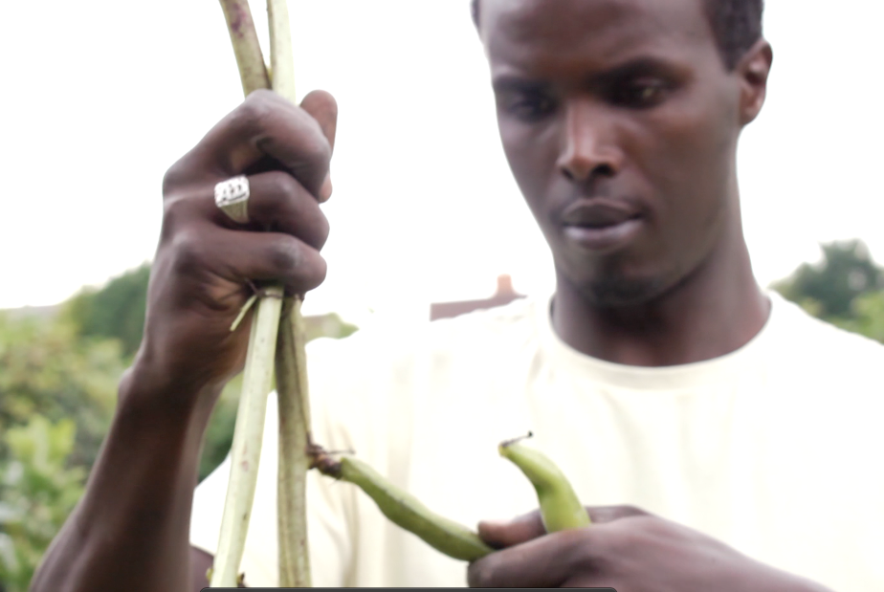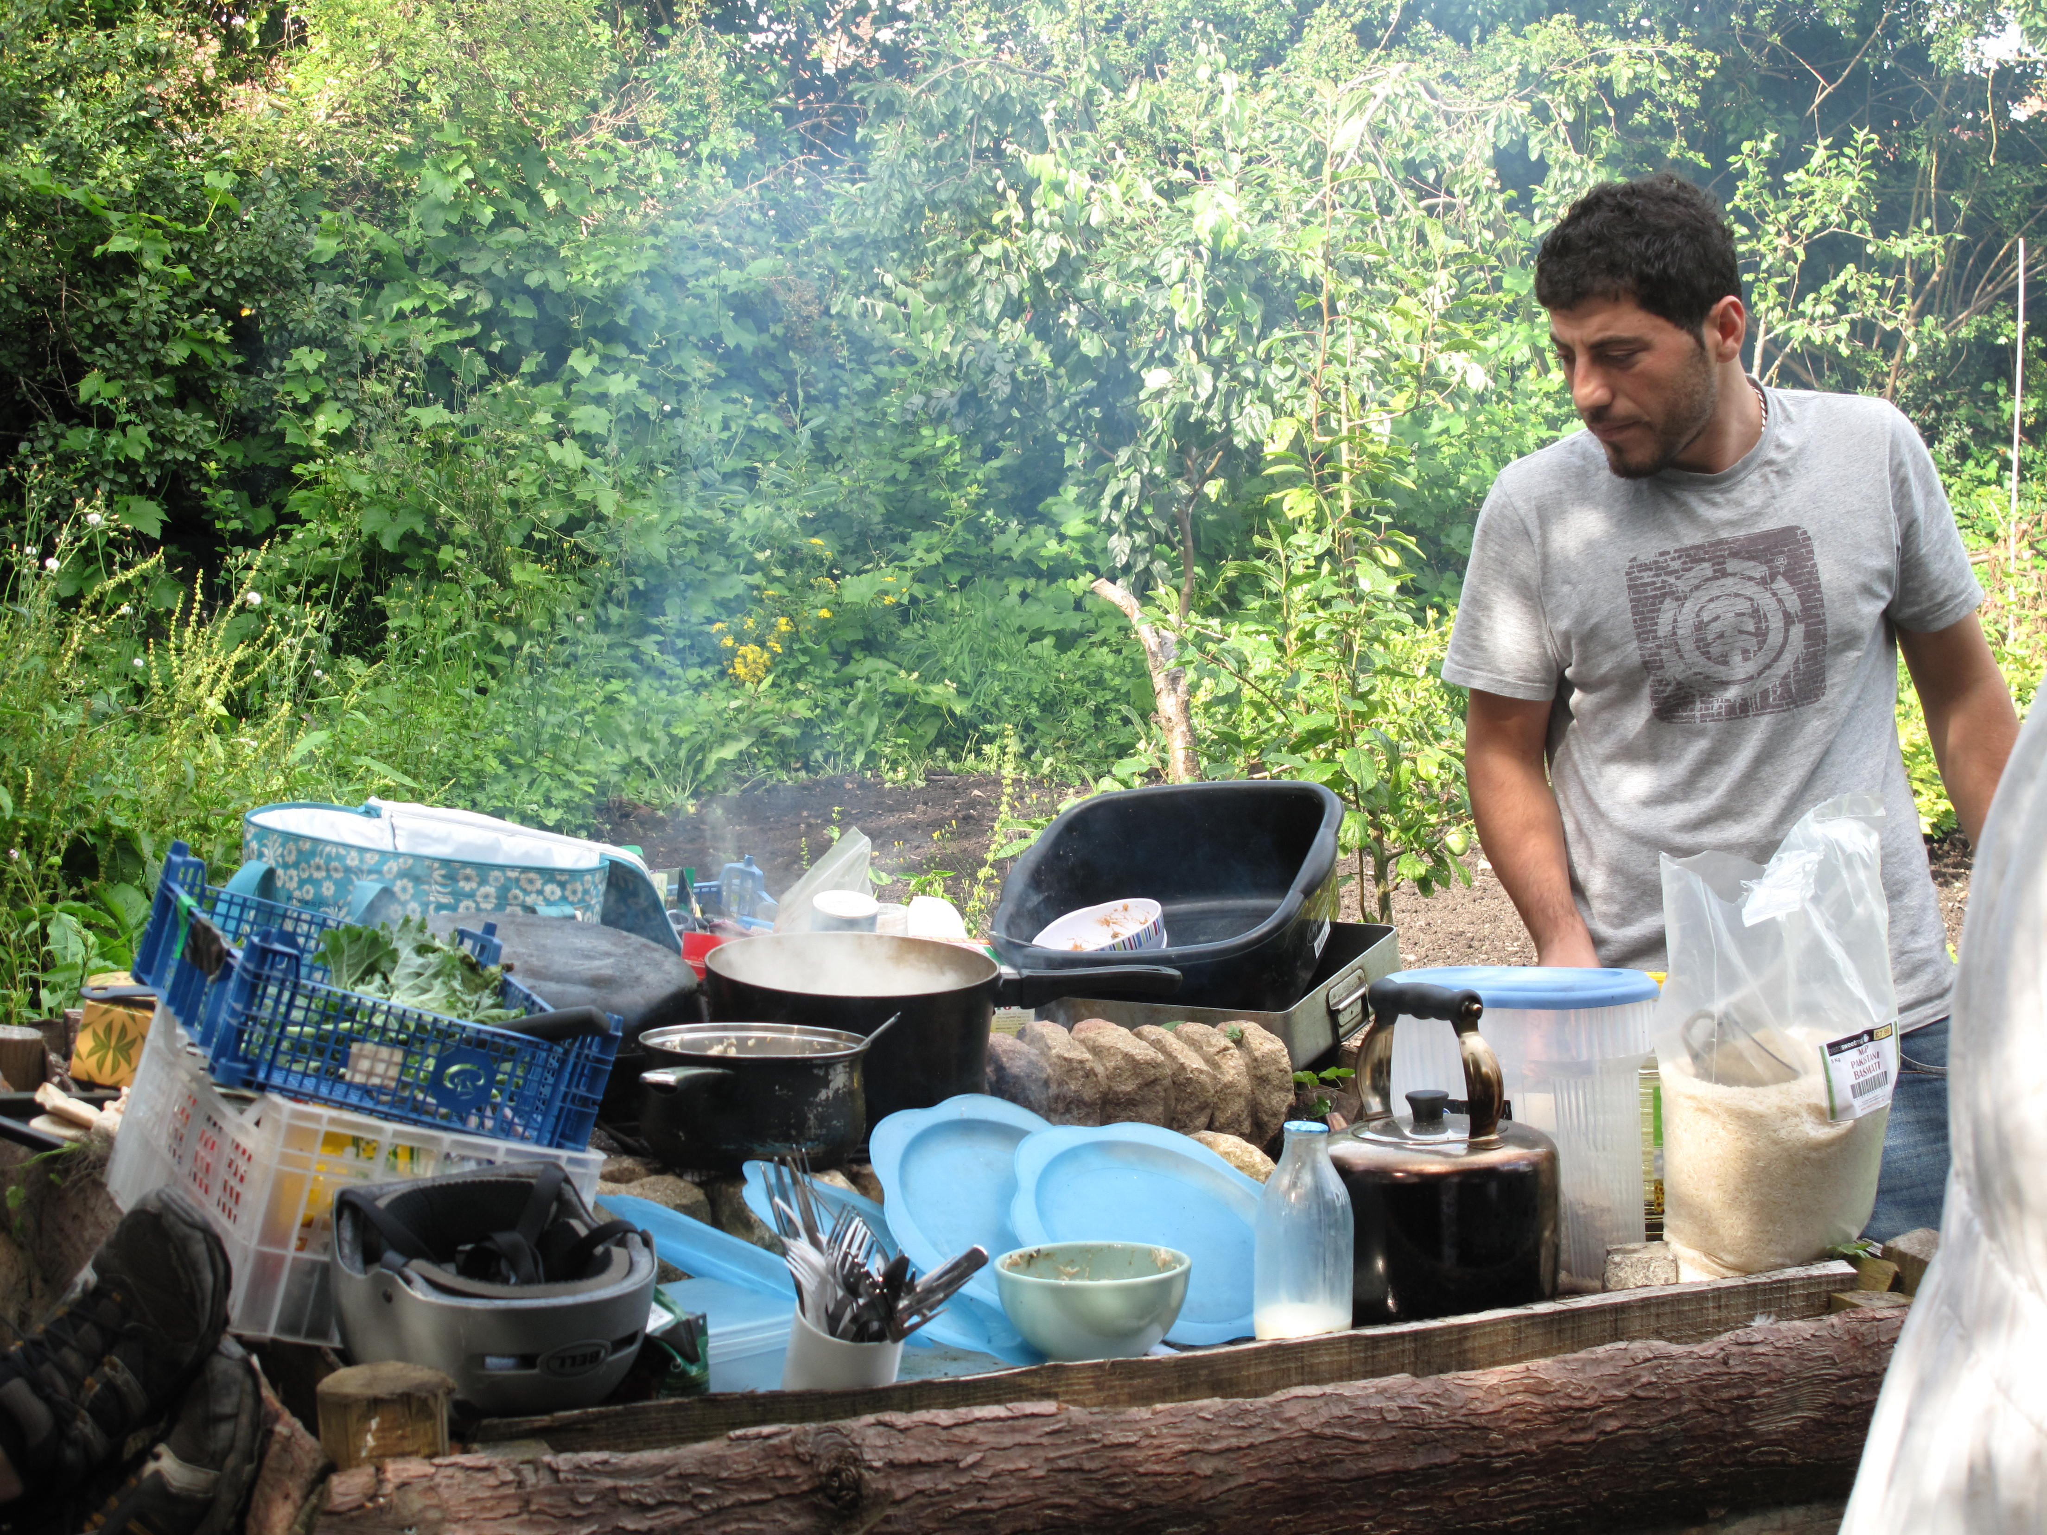

There won’t be any staged interviews, but we will hear the occasional internalised voice of different participants, reflecting on their feelings as they work in the allotment space. In general the sound track will aim to enhance an overall feeling of magical realism, by recording the diagetic sound of the natural environment and allowing it to be accentuated against the images on screen. In this respect the intended film has probably got more in common with an Eastern and Central European style of filmmaking, such as The Charcoal Burners and the films of Jan Sjvankmaejer, and the recently released Beasts of the Southern Wild, than it has with the British factual tradition.

Filming will take place over an extended period between the summer of July 2012 and Spring 2013, using a Panasonic 101 with interchangeable lenses, to create a cinematic effect that can enable the viewer to become really immersed in the allegorical space of this very special natural environment.

