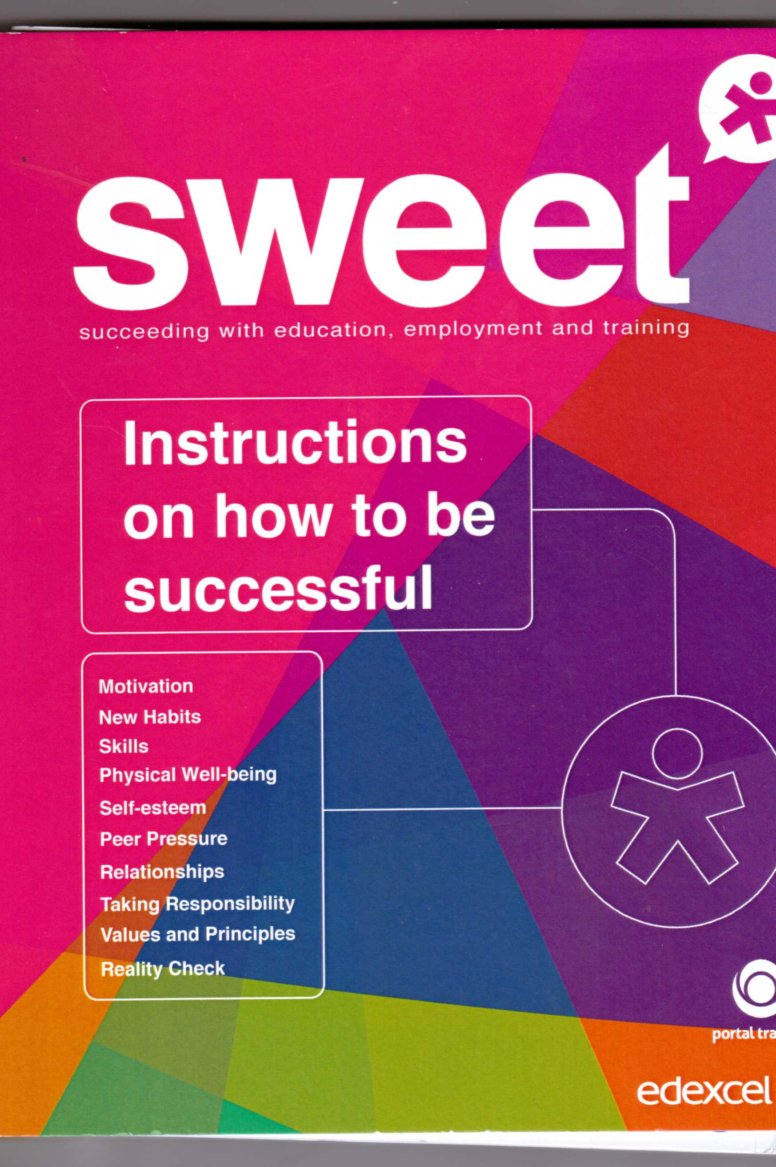

**Two Phased Independent Evaluation of the SWEET Pilot**

**Undertaken by Professor John Dwyfor Davies and Dr John Ryan**

**on behalf of *Portal Learning* - September2013**