Responsible management education using a study-trip:
pedagogy of risk and ethics
Svetlana Cicmil, Benoit Dutilleul, Derek Braddon and Fabian Frenzel
Case Story from the Faculty of Business and Law, University of the West of England, Bristol, UK

Introduction
The case story addresses a combination of Impact categories, primarily P3, P5 and P6 which are intrinsically inseparable by nature. It illustrates pedagogic, ethical and developmental aspects of introducing an annual study trip within the Faculty’s MBA programme curriculum by reflecting on the experience of the students and staff during 2009-2012.

The MBA field trip
The annual MBA study-trip was introduced in 2009 to address, in a responsible way, to a multi-national multi-disciplinary class, the pertinent topics of sustainability, risk, crises, complexity and security in a global context. It has aspired to provide a value-adding learning experience which combines traditional lectures and seminars with visits to specific locations and participation in consultancy projects for local partners (e.g. national parks and river protection; mining, tourism and eco-tourism; small professional firms/consultancies). Disciplinary diversity of the academic team involved in the teaching of the module and organising the field trip provides a unique added value as it covers the fields of economics, politics, philosophy, law, management, sociology, and engineering. The trips were made possible through a partnership with the team managing the EU supported project ‘Cross-European Danube Parks Protection Network’ (ref. PRME bi-annual report, 2012).
The 2009-2012 series of trips provided the students with an opportunity to engage with local organisations and academic institutions and gain ‘hands-on’ experience of privatisation, globalisation, economic transition, political life and public policies in the region. It also facilitates first-hand appreciation of nature’s intrinsic value and shared vulnerability by being-in-nature; as well as exposure, reflection and a healthy respect toward socio-cultural and ecological diversity and healthy relationships with others. The knowledge and hospitality of our hosts at each of the sites ensured an outstanding educational experience with the focus principally on global risk and sustainability issues. (PRME Principle 3).
By focusing from the very start on the values, the vulnerabilities, and the ideological struggle behind the sustainability crises and the proposed global and local solutions, it was our intention to create a rhetorical space for an emotional transitioning, a cognitive liberation and a collective negotiation of shared reality among the students – one that disallows the traditional ontological separation between economic and ecological spheres. Key challenges we faced were a combination of:
- ‘Sustainability’ and ‘management’ as non-homogenous subjects
- Micro-diversity in the class
- Vested / powerful interests, tradition and expectations of what a ‘responsible’ MBA education might be
- Learning process laden with resistance and anxiety
A variety of pedagogic methods and tools were employed to allow for a much needed space for collective and individual exposure to the ideas, and for reflection on real issues in the concrete local situations of the lived experience. The combination of specialist lectures and highly relevant visits, set against the background of a unique local culture, art and history, make the educational experience especially effective and also highly enjoyable.
The trip has been seen as an immensely valuable experience for all, summed up by one of the students as:
“A combination of amazing people, interesting lectures, flexible planning, intellectual input and open-mindedness that made this trip one that will never be forgotten.”
As part of a larger pedagogic project, a post-experience survey and individual interviews with participating students were conducted after each trip. All the quotes come from the resulting database. The illustrations and discussion below provide a fruitful foundation for addressing what in our view are the key questions
Key discussion points
How do we reorient the focus from sustainability to the complex moral problem of ‘un-sustainability’ (the sustainability crisis) which inevitably invokes considerations of risk and ethics beyond and above the economic and scientific ones?
How can we encourage pedagogy informed by moral philosophy to broaden the scope of the subject matter to embrace concerns of values, vulnerabilities, ideological struggle and (in)equality in context?
How do we ensure that business education in this area encourages ethical addressing of both the causes and solutions to the crisis without falling into a trap of dominant economic-technological drivers?
Illustrations:
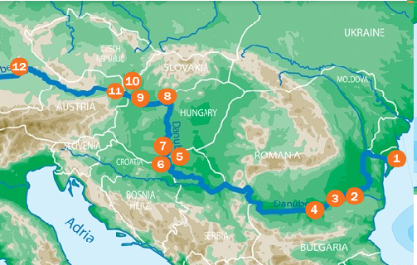
Visits to National Park Donau-Auen (Hainburg), an IUCN protected ecological sanctuary on the river Danube along the eastern borders of Austria (http://www.donauauen.at/?area=nationalpark) in 2009 and 2010 and to the National Park Djerdap on the River Danube on the Serbian border with Romania in 2011, provided a unique learning environment. Eight collaborative consultancy projects, led by the students, were successfully completed as a result of our collaboration with the management teams of the National Parks, of the Cross-European Danube Parks Protection Network and local communities and universities as per PRME Principles 5 and 6. The collaborative consultancy projects were about:
- An analysis of internal and external communications within the EU-funded, complex collaborative DANUBEPARKS project.
- Sustainability and eco-tourism in parks along the river Danube – some guidelines for National ParksDonau-Auen and Djerdap.
- Some recommendations for sustainable transport solutions in the context of National Park Donau- Auen.
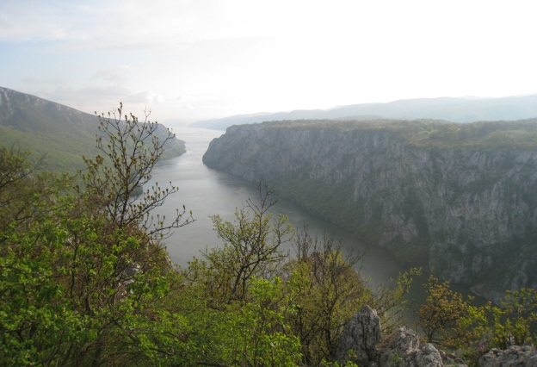
- Renewable energy, hydropower, ecology and risks – a comparative study of global practices/ feasibility study of the impact of opening a phosphate mine on environment and communities: risk, costs and benefits, for Victoria Group, Serbia.
– Sustainable business and knowledge economy for Yu-Build Consultancy, Belgrade, Serbia.
- Collaboration challenges between Djerdap National Park and the Danube Parks Protection Network for the management of Danube Parks.

The MBA students’ comments on their experience show the impact of our pedagogic aim on their development towards building a shared understanding in a global context, focusing on values, humanity and moral responsibility and considering alternatives in an informed manner.
‘‘This was different, it was not just another module about global business, it was about the people who do the business globally and the problems and opportunities that they may face during their journey of working globally, and the success and failures of their decisions and its impact not only on the global economy but also on the global environment.”
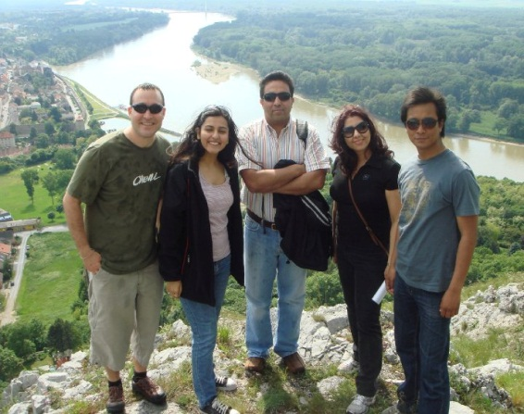
“The lectures and class discussions have opened up my awareness of decisions that I make both at work and at home and the impact of that decision. I feel that I have developed greater moral responsibility for the planet. I found myself getting very angry about global situations when writing my assignment.”
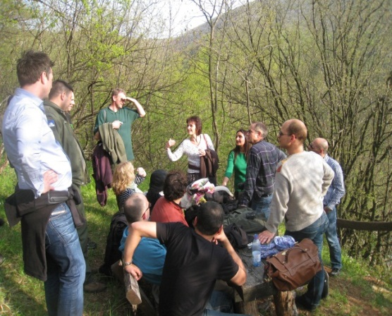
“I have been interested in why, as a nation and even globally, we haven’t woken up to the problems that are being talked about and are emerging as the years go by: being resourceful with waste; taking responsibility, being transparent about risks, thinking creatively about natural beauty, protection of the environment and business success away from pollutants and disregard. This trip broadened my awareness of these issues.”

