**Electronic Supplementary Material**

**Social Behaviour and Collective Motion in Plant-Animal Worms.**

Nigel R. Franks et al. corresponding author email: [nigel.franks@bristol.ac.uk](mailto:nigel.franks@bristol.ac.uk)

**Additional information about the statistical analysis**

FIGURE8 300 dots per inch.tif**Figure 1.** (*c*) Initially we fitted a linear regression model with an intercept which showed a significant relationship between number of interactions per frame in the experimental videos and the null model simulations for the same values of worm density (slope = 1.206, t9 = 9.79, p < 0.001, R2 = 91.4%) and fitted the data well (the residuals were compatible with a Normal distribution, Anderson-Darling test: AD = 0.334, n = 11, p = 0.440). However, the intercept was not significantly different from zero (intercept = -0.018, t9 = -0.01, p = 0.992). Given this and the absence of interaction at 0 density, we fitted a new linear regression model through the origin.

**Figure 1.** (*d*) “Worm density” is calculated as L2 n (n-1) where L is the mean length of the worms and n is the number of worms in the arena. Hence, this measures the total length of worms in a sample and yet accounts for individual worms not crossing themselves. Initially we fitted a General Linear Model (GLM) to the mean duration of polarization interactions with predictors treatment (experimental videos or null model simulations) as a fixed factor and worm density as a covariate. There was a significant relationship between mean interaction duration (s) and worm density (F1,18 = 8.70, p = 0.009) but treatment (F1,18 = 0.04, p = 0.845) and the interaction between treatment and worm density (F1,18 = 2.34, p = 0.144) did not have significant effects. The model did not fit the data well (R2(adj) = 30.69%) and the residuals were not compatible with a Normal distribution (Anderson-Darling test: AD = 1.228, n = 22, p < 0.005). A log10 transformation of the response variable gave the same qualitative results but this time R2(adj) = 32.54% and the residuals were compatible with a Normal distribution (Anderson-Darling test: AD = 0.548, n = 22, p < 0.140). We can conclude that a reduced model with worm density as the only predictor is the best model and hence there is no evidence to suggest that either the intercepts or slopes for this relationship are different between the experimental videos and the null model simulations. However, while the gradient of the relationship between log10 mean interaction duration (s) and worm density is significantly different from 0 for the videos, this is not the case for the null model simulations (figure 1*d*). This means that the relationship between interaction duration and density is entirely attributable to the videos. Note that the log10-transformation in figure 1*d* excludes the videos point with mean interaction duration of 0s at 0 worm density, which, if included, as in the plot above, has a lot of leverage, even though the results remain qualitative the same.

**Figure 1.** (*e*) The residuals were nearly-normal (Anderson-Darling test: AD = 0.958, n = 14, p = 0.011). The slope of 0.85779 had a s.e. = 0.02215. The critical t-value at d.f. = 12 and alpha = 0.05 (two-tailed) is 2.179. Therefore, the 95% CI for the gradient is (0.80953, 0.90605).The critical t-value at d.f. = 12 and alpha = 0.001 (two-tailed) is 3.055. Therefore, the 99% CI for the gradient is (0.79012, 0.92546).

**Figure 2.** (*b*) The model fits the data well (Hosmer-Lemeshow goodness-of-fit test: χ2= 14.83, n = 8, p = 0.062) and has good predictive power (concordance = 95.5%; Somers’ D = 0.91). It was fitted after the removal of four outliers (1 for milling and 3 for no milling; n = 81, 27 milling and 54 no milling) identified from the delta beta, delta deviance and delta chi-square residual plots. The predicted probabilities for these points did not fit the observed outcome well. However, the model fitted to all the 85 data points gave the same qualitative results, namely that with every additional worm per ml the probability of milling increases on average by 2% (95% CI: 1 – 3%).

**Figure 3.** (*c*) The initial binary logistic regression model had proportion milling as the response variable and density, bias (rad) and the interaction between the two as the predictors but bias (chi-sq = 2.335, d.f. = 4, p = 0.674) and the interaction (chi-sq = 1.646, d.f. = 4, p = 0.801) did not have a significant effect. The model was refitted without the interaction. Now both density (coefficient = 0.0710, p < 0.001) and bias (chi-sq = 58.413, d.f. = 4, p < 0.001) had significant effects. This model had a good fit (all goodness-of-fit tests had a p-value > 0.05, except Brown’s tests for an alternative link function with 0.01 < p-value < 0.05) and excellent predictive power (Somers' D = 0.96). For differences between inflection points for different levels of bias, please see table S1.

**Supplementary tables and figures**

**Table S1.** Differences between inflection points for different levels of bias (rad) in the movement of individual worms in the simulation of interacting worms (figure 3*c*).

|  |  |  |  |  |  |
| --- | --- | --- | --- | --- | --- |
| **Bias (rad)** | **-0.13** | **-0.06** | **0.00** | **0.06** | **0.13** |
| **-0.13** | 180 | Z = -4.98  p < 0.001 | Z = -7.05  p < 0.001 | Z = -4.81  p < 0.001 | Z = -0.94  p = 0.345 |
| **-0.06** |  | 228 | Z = -3.86  p < 0.001 | Z = 0.26  p = 0.798 | Z = 4.34  p < 0.001 |
| **0.00** |  |  | 256 | Z = 4.06  p < 0.001 | Z = 6.69  p < 0.001 |
| **0.06** |  |  |  | 226 | Z = 4.15  p < 0.001 |
| **0.13** |  |  |  |  | 189 |

0.00 rad represents no bias; both -0.06 and 0.06 rad, and -0.13 and 0.13 rad represent equal levels of bias clockwise and anticlockwise, respectively; numbers along the diagonal represent inflection point densities (i.e. the number of worms per simulation arena); z-values and p-values represent differences between the inflection points as measured by differences between the constants in the binary logistic equation for different levels of bias (since the inflection point is equal to the constant divided by the coefficient for density, which is the same for all levels of bias)

FIGURE6 300 dots per inch.tif

**Figure S1.** The relationship between mean speed and body length is best described by the line: worm speed (mm.s-1) = 1.53 + 0.178 worm length (mm). (F1,38 = 6.13, p= 0.018, R2 = 0.139). The average mean speed of these 40 worms was 1.78 mm.s-1. One worm, which was much smaller than the rest (just over 0.5 mm long) was removed from this analysis. With this individual, the mean speed was 1.76 mm.s-1.

FIGURE4 300 dots per inch.tif

**Figure S2.** Turn direction for 41 worms as summarised by a handedness variable h = (C-A)/(C+A+S) where C, A and S are the numbers of clockwise, anticlockwise and straight-on manoeuvres respectively. The worms are predominantly right biased – making clockwise movements; blue: right-biased or clockwise movement, red: left-biased or anticlockwise movement.

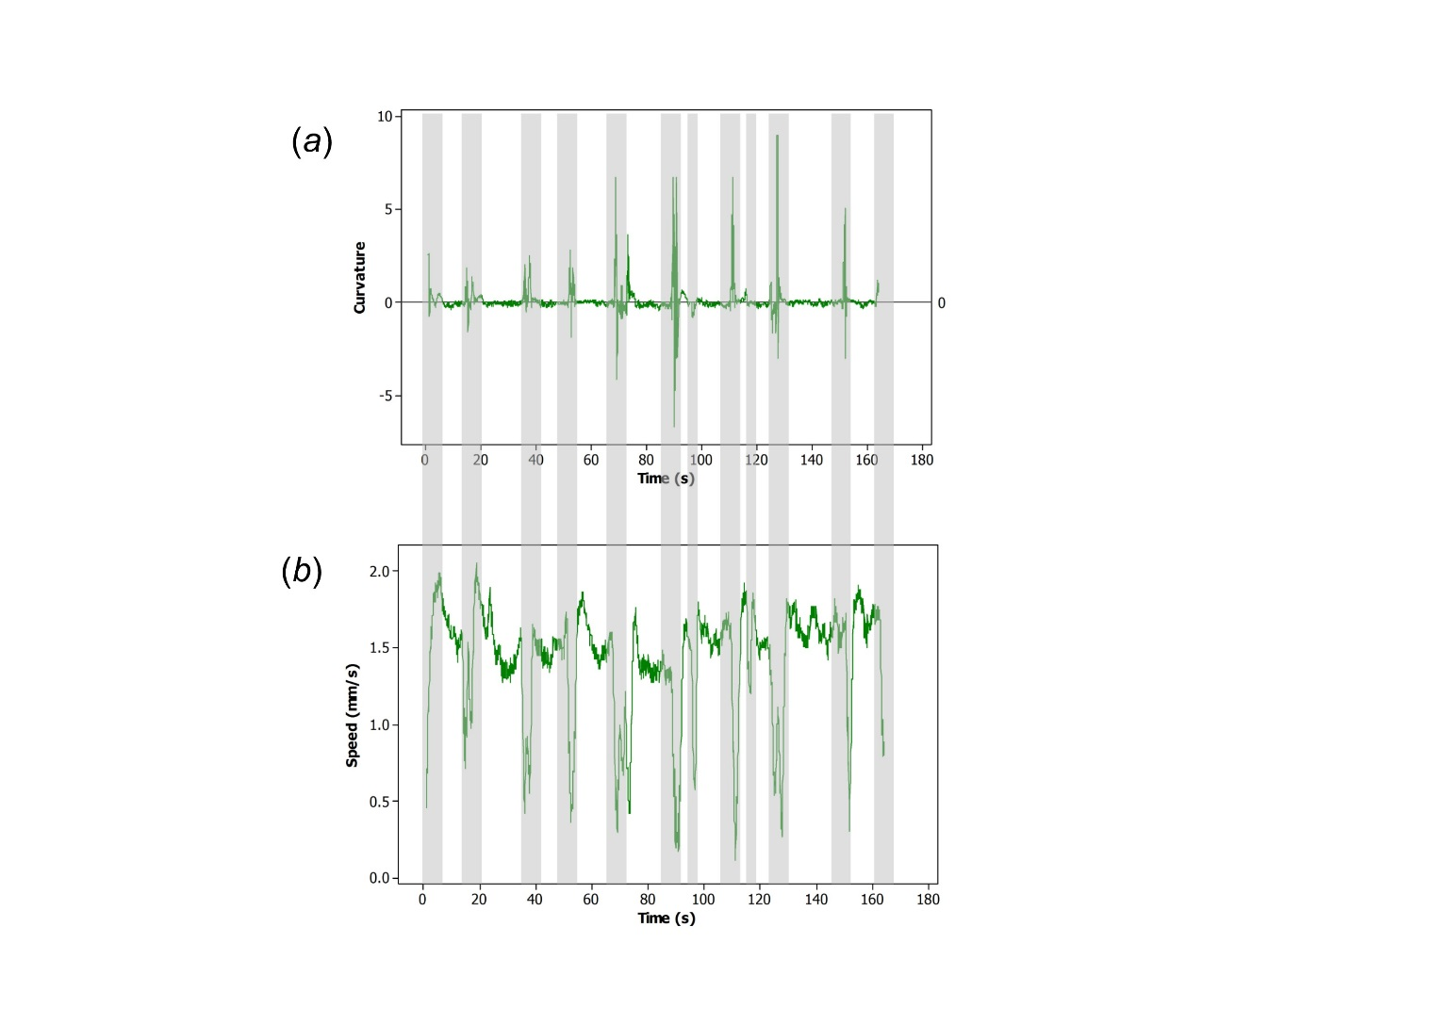

**Figure S3.** Worms executing curved trajectories are slower. (a) A worm’s body curvature over time and (b) the speed of the same worm over the same 165s. Comparison of (a) and (b) shows that when the worm curves its body its speed dips as indicated by the grey bars. The even spacing of the grey bars suggests some rhythmicity to the changes in body curvature and speed (see also figure 1*a*). The curvature *c* is the reciprocal of the radius of curvature multiplied by +/-1 depending upon whether the turning direction is clockwise or anticlockwise.

Place N worms at random in the arena - each worm consists of two rigid rods of equal length L units with a random angle in the range +/-0.05 radian between them.

For as many iterations as required, each representing dt seconds of real time

begin

Scramble the order of the worms

For each worm in turn

begin

Determine the centre of the circumcircle defined by the head, centre and tail positions

Determine the curvature of this circle = 1.0/radius of curvature

Calculate the worm speed = nominal speed*(1.0 - g*curvature)

Calculate dθ = speed*curvature*dt = the angle that the worm advances inside its

circumcircle

Calculate the new x,y coordinates of the worm tail, centre and head

For four alternative head positions

begin

Calculate alternative head positions with angles within +/-0.15 radian of the initial

one

end

For the total of five head positions

begin

Set the potential energy to zero

For all other worms within the distance rmax

begin

Calculate the distance between the chosen head position and the tail of its

neighbour

Add the energy as determined from the potential energy curve (figure 3a)

Calculate the distance between the chosen head position and the head of its

neighbour

Calculate the potential energy using figure 3*a*

If the tails of the two worms are separated by >2L, set λ=0.5, else λ=2.0

Add the energy multiplied by the weighting factor λ

end (loop over worm's near neighbours)

end (loop over possible head positions)

Adopt the head position with the lowest total energy

If the head is outside the arena, re-orient wholly within the boundary and facing inwards

end (loop over the N worms)

end (iteration loop)

L = 5 units (length of each of the two rods making up a worm)

V = 11.07 s-1 (nominal speed in units.s-1 – real worms move their own length in ~1s)

dt = 0.7s (elapsed time per iteration)

g = 2.98 (speed reduction coefficient)

r – range of interaction

rmax = 25 units (the maximum range of any interaction – see figure 3*a*)

rmin = 5 units (the range at which attraction is at is maximum – see figure 3*a*)

**Figure S4.** Pseudocode for the simulation with interacting worms.

1. Are circular mills more likely to form near the arena walls?

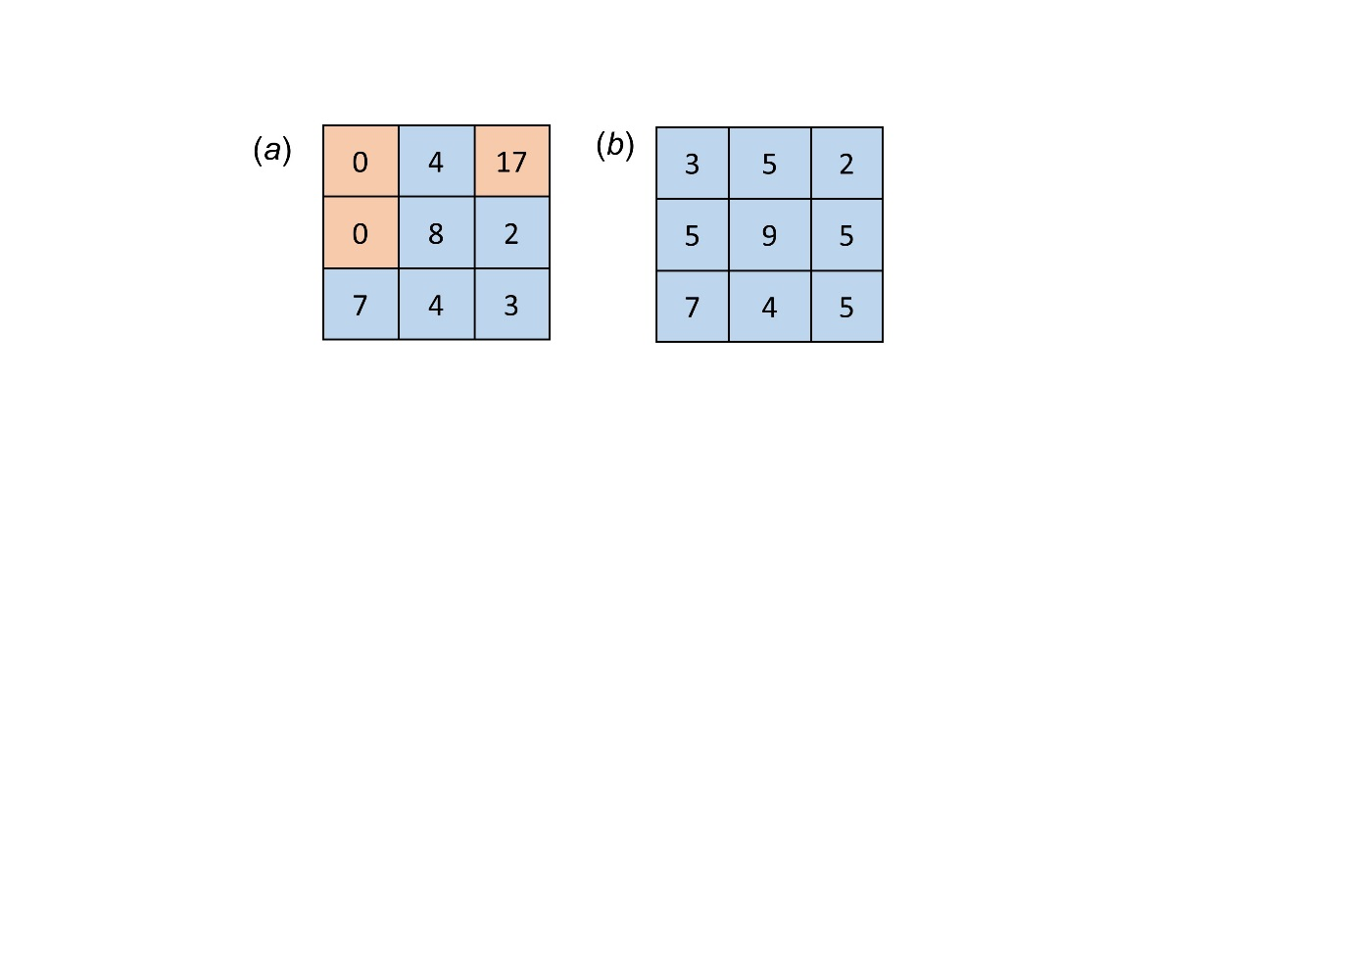

1. For the data collected in 2015, the positions of a total of 45 occurrences of circular mills were recorded on a 3x3 grid in 30 arenas of different shapes and sizes.
2. For the simulation of interacting worms, the formation positions of circular mills were recorded on a 3x3 grid for a total of 45 runs.

We compared a null model based on the assumption that a circular mill is equally likely to occur in any of the 9 cells of the 3x3 grid with (a) data on real worms and (b) data from the simulation of interacting worms. On the basis of the null model and the 45 circular mills observed altogether in the data for real worms, the probability of a cell containing no more than 1 circular mill is less than 5% and the probability of a cell containing no less than 10 circular mills is less than 5%. Therefore, for the data, the 17 circular mills observed in the top right cell are significantly more than expected by chance and the zero circular mills observed in the top and middle left cells are significantly fewer than expected by chance. The former could be explained by the orientation of the top right cell towards the sun. For the simulation with interacting worms, the number of circular mills in each of the 9 cells was compatible with random expectation. We conclude, that circular mills are not more likely to form near the arena walls.

1. Does the shape of the arena (perimeter-to-area ratio) influence the formation of circular mills?

We tested this in the simulation with interacting worms by comparing the formation of circular mills in two arenas with the same areas but with different shapes: one was circular (radius = 400 units), the other was square (with a side of 2*354.49 units). Therefore, although the two arenas had the same area, the perimeter of the square was 1.1284 times greater. Each arena had the same number of worms (n = 1016) and hence the same density. Hence, any difference between the formation of circular mills in the two arenas could be attributed to the difference in their shapes. We let the program run, repeatedly, for a fixed amount of (worm) time and at the end checked whether there was a mill or not. Every run that produced a mill at the end was counted as a success. No credit was given for a mill that formed before the end and then dispersed, nor for pairs of mills that merged. And if there were two at the end, it simply counted as a success. The initial worm time was 4min 30s. It was chosen on the basis of an approximately 50% success rate and was also long enough to allow any worm to cross either arena about three times. (The arenas were both ~800 units across and the worms 10 units long. Real worms cover their own length in ~1s so our simulated worms needed about 80s to cross the arena, so 4m 30s is ~3 crossings). The results from 1500 runs on each arena were: 839 successes for the circle and 577 successes for the square. We extended the time for each run to 10min to test whether this would narrow the difference in the success rate between the two arena shapes. If the production of mills in 100% of the runs is a matter of waiting long enough, that would suggest that the longer perimeter only delays the formation of circular mills. Indeed, the results from 500 runs of 10min duration on each arena resulted in 461 successes in the circle and 449 success in the square. We conclude that a longer perimeter of the arena delays the formation of circular mills.

Overall, our results suggest that, if anything, circular mills are more likely to form near the centre.

**Figure S5.** Analysis of the role of the arena walls in the formation of circular mills