**Progress with integration of ecosystem services in sustainable drainage systems**

**Dr Mark Everard**, University of the West of England, Frenchay Campus, Coldharbour Lane, Bristol BS16 1QY[1].

**Robert J McInnes**, RM Wetlands and Environment Ltd, 6 Ladman Villas, Littleworth, Oxfordshire SN7 8EQ.

**Hazem Gouda**, University of the West of England, Frenchay Campus, Coldharbour Lane, Bristol BS16 1QY.

**Abstract**

Society is moving from management addressing single or few outcomes towards recognition that all interventions have systemic impacts. Water management in urban environments presents particular challenges related to growing populations in finite land areas. Several sustainable drainage system (SuDS) techniques, from drainage-specific approaches to solutions potentially addressing multiple benefits, were considered in terms of ramifications for ecosystem service outcomes, represented using a ‘traffic lights’ coding. Narrowly-framed drainage solutions, often necessary in dense developments, omit or have negative implications for ecosystem services. Conversely, detention basins and constructed wetlands potentially offer broader ecosystem service outcomes. All ecosystem services have to be considered in design on a context-specific basis to optimize benefits and avoid negative outcomes. Modification of decision-support models to consider ecosystem services promotes optimization of net societal benefits, also providing confidence for developers and regulators.

**Keywords**

Sustainable drainage systems (SuDS), constructed wetlands, ecosystem services, urban water management

**Introduction**

Society is slowly transitioning from environmental management and resource use addressing single or few outcomes, towards recognition that all interventions have systemic impact (de Groot *et al*., 2010; Norgaard, 2010). Ecosystem services comprise the interconnected human benefits provided by the natural world, spanning interlinked value systems and societal needs (Millennium Ecosystem Assessment, 2005). International commitments encouraging governments to undertake an Ecosystem Approach include the Convention on Biological Diversity (2000, 2010), the EU Biodiversity 2020 strategy (European Union, 2011) and the Ramsar Convention (Resolution IX.1, 2005). Many countries have transposed these obligations into national-level strategy, for example the UK’s Natural Environment White Paper (HM Government, 2011). However, societal transition to systemic decision-making remains challenging (Armitage *et al*., 2008) due to knowledge gaps, narrow legacy assumptions, legislation, regulatory implementation, technical solutions, vested interests and decision-support models founded on reductive paradigms (Everard *et al*., 2014). Tools to expose the wider ramifications of policies, designs and actions, also highlighting the benefits and opportunities of systemic practice, are needed to promote systemic, sustainable practice (Smith *et al*., 2007). Failure to achieve this transition perpetuates risks from economic, social and environmental externalities (Robinson *et al*., 2012).

Water management in urban environments presents particular challenges related to growing populations accommodated by finite land area, with trends suggesting increasingly dense urbanisation (United Nations, 2011). Drivers include adequate water supply sourced from substantially beyond the urban catchment area (Fitzhugh and Richter, 2004), management of flood risk (surface water and groundwater) compounded by climatic instability (Scholz, 2006) and processing and treating wastewater and water-vectored pollutants (Figure 1) (Niemczynowicz, 1999).

These principal challenges operate within a wider operational landscape of urban land use planning and decision-making (Figure 1). Disconnected, single-solution outcomes still predominate (Everard, 2014) despite the need for the built environment to be planned to operate synergistically with functioning ecosystems (UN Habitat, 2012) accommodating water-mediated ecosystem services including maintenance of equable microclimate, food production and amenity (Bolund and Hunhammer, 1999) and reduced carbon and ecological footprints (Secretariat of the Convention on Biological Diversity, 2012).

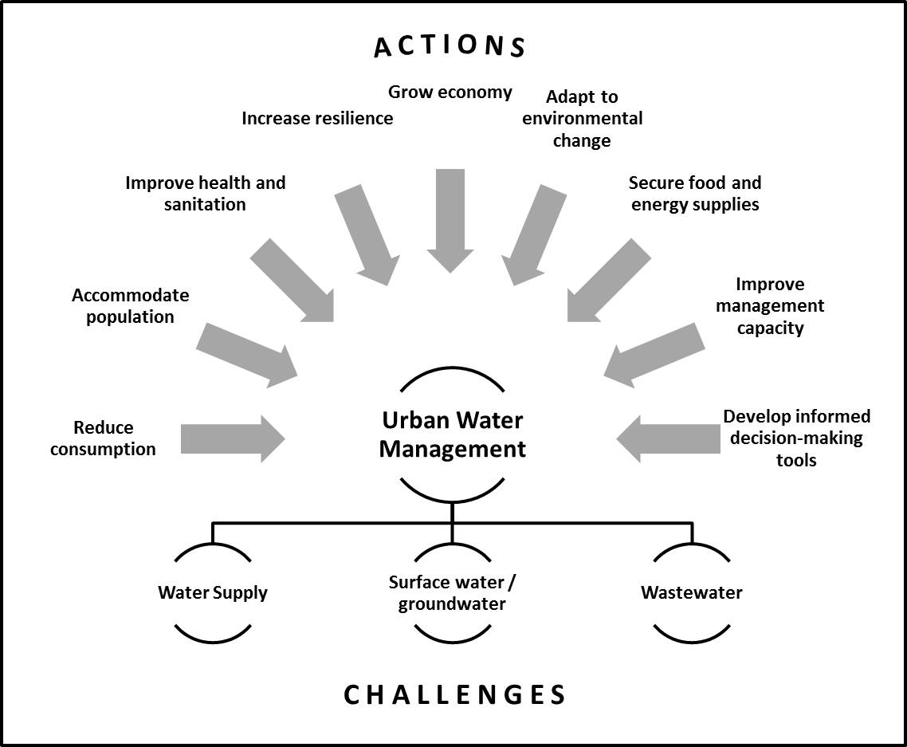

*Figure 1 Challenges of urban water management.*

Flood management policy and practice has morphed from localised ‘defence’ of assets towards an ecosystems-based, adaptive approach working with natural processes (Colls *et al*., 2009) partly responding to severe flooding, for instance in the UK where established flood management norms were insufficient (Defra, 2005), but also resulting from longer-term recognition of the importance of working with natural processes rather than reliance on increased ‘hard engineering’ defences (Palmer *et al*., 2009). Stepwise progress towards natural floodwater retention and dissipation mark an ongoing transition across the developed world at catchment scale and within urban environments (Wong, 2006; Everard *et al*., 2009).

The evolving philosophy of SuDS (sustainable drainage systems) and similar approaches such as WSUD (water sensitive urban design) underpin a significant transition in urban flood risk management (Wong, 2006). Published guidance (Woods-Ballard *et al*., 2007) highlights intent “…*to manage the environmental risks resulting from urban runoff and to contribute wherever possible to environmental enhancement*”, working ‘upstream’ in the drainage chain and progressively taking account of wider outcomes for water quantity, water quality, amenity and biodiversity. ‘Water regulation’ (scale and timing of flows) is also an ecosystem service, interconnected with a broader spectrum of potential societal benefits from management interventions.

Studies contrasting life cycle assessment (LCA) outcomes between conventional and sustainable approach to urban drainage highlight the transition to consideration of whole life cycle cost and performance, dependence on detailed scheme design, but particularly the importance of systematic assessment addressing frequently neglected dimensions of sustainability essential for meeting the challenges of growing urban populations and changing climate (Ellis et al., 2003; Zhou, 2014). SuDS principles thereby contribute to sustainable development by averting unintended negative impacts, particularly life cycle material inputs, environmental emissions and energy use, also potentially optimising outcomes across ecosystem services (Everard and Street, 2001; Natural England, 2009; McInnes, 2013; Everard and McInnes, 2013).

Even in more ecologically aware cities, urban environmental management systems often overlook many ecosystem benefits (McInnes, 2013). Implicit in SuDS design is protection and improvement of the environment (Woods-Ballard *et al*., 2007) and implementation of green infrastructure can also promote human health and deliver multiple benefits (Tzoulas *et al*., 2007). This chapter analyses the potential contribution of selected urban drainage solutions to delivery of ecosystem services.

**Potential contribution of SuDS types to ecosystem services**

The SuDS Manual (Woods-Ballard *et al*., 2007) specifies a range of techniques ranging from simply increasing floodwater storage capacity in dense, constrained urban settings (for example underground gabions beneath hard infrastructure) through to incorporating multiple ecosystem service outcomes additional to drainage. Filter drains and pervious pipes, pervious surfaces, infiltration basins, and constructed wetlands were selected as representative techniques. The following descriptions derive largely from Woods-Ballard *et al*. (2007):

* *Filter drains and pervious pipes* comprise trenches filled with permeable material receiving water falling on paved areas, filtering and conveying it elsewhere on site. This slows and provides some physical filtration of stormwater, though without significant chemical purification or habitat for amenity and biodiversity.
* *Pervious surfaces* allow water to infiltrate an underlying storage layer, detaining it before infiltration to the ground, reuse or release to surface waters. These systems offer no habitat for wildlife or amenity (beyond the paved surface which is built infrastructure rather than ecosystem service).
* *Infiltration basins* comprise depressions in landscapes constructed to store runoff during intense precipitation, enabling it to infiltrate progressively into the ground. Infiltration basins may be landscaped, providing aesthetic and amenity value but, due to necessary regular maintenance, only simple low-sward habitat tends to form.
* *Constructed wetlands* are diverse, typically comprising ponds with shallow, vegetated areas which improve pollutant removal and provides wildlife habitat. They may accumulate organic matter, recycle nutrients and become attractive features in urban developments. Constructed wetlands range from simple stilling ponds and reed-filled hollows through to extensive semi-natural systems. Potential outcomes from ‘best practice’ constructed wetlands designed to achieve multifunctional benefits are used as reference points from Australia (Wong and Brown, 2009) and Ireland (Doody *et al*., 2009).

All SuDS techniques vary in specific detail and potential service production depending on locational constraints and design, but each potentially achieves multiple ecosystem service outcomes. Assessment of modelled outcomes from traditional piped drainage solutions, featuring in the case study in Gouda *et al*. (unpublished data), are included as a comparative baseline. The potential contribution of SuDS types to each ecosystem service is scored using a ‘traffic lights’ approach (Table 1):

* Green: has the potential to make a contribution to the service, with foresighted planning and implementation;
* Amber: has a limited potential to contribute to the service; and
* Red: does not contribute to the service, or may undermine it.

Two broad areas of subjectivity are acknowledged in the assessments. Firstly, no SuDS method is uniform, varying in detail and outcome with location and design. Secondly, assessment of potential contribution to ecosystem service outcomes is challenging due substantially to a paucity of indicators and data (Burkhard *et al*., 2012). Burkhard *et al*. (2009) and Busch *et al*. (2012) propose using expert evaluations to garner an overview and identify trends, an approach successfully applied elsewhere where assessments have been based on intensive literature searches, stakeholder interviews, and partially on expert estimates (Vihervaara *et al*., 2010). Whilst detailed, quantitative analysis of SuDS schemes would add rigour, each case study represents a ‘snap shot’ of the potential of each approach. Therefore, whilst acknowledging some subjectivity, we suggest that the lack of detailed scheme-level appraisal under each SuDS option does not undermine the inherently systemic nature of the comparative analysis. Indeed, the key challenge being addressed in this analysis is to represent a systemic perspective of the contributions of drainage techniques, not a detailed reductive analysis of each service outcome.

This simplification of assessment via three ‘traffic lights’, building from a simpler pass/fail scoring system of other water management techniques (Everard, 2014), presents likely outcomes in illustrative yet intuitive terms that may be useful in guiding non-technical development proponents towards more sustainable methods. This articulation, therefore, usefully represents potential outcomes for design options in decision-support models. The ‘traffic lights’ approach has proved useful previously to represent the potential contribution of water management strategies to the twelve principles of the Ecosystem Approach without implying a greater degree of certainty than analyses can support, serving the important purpose of illustrating systemic coverage (Everard *et al*., 2014).

**Analysis of ecosystem service outcomes from SuDS schemes**

Potential ecosystem service contributions of traditional piped drainage and the four selected SuDS design approaches is presented in Table1. The simplified ‘traffic lights’ colour-coding reveals a spectrum from a low range of services for piped drainage to potentially far broader service contributions from constructed wetlands. Traditional piped solutions perform some services well (local removal of storm water including pollutant loads), but few other services are addressed though some potential co-benefits arise (fire regulation by avoidance of combustible materials and an educational resource) together with several negative externalities (displacement of storm water and contaminant concentration). Conversely, constructed wetlands potentially produce multiple co-benefits, albeit with some risks from inappropriate context-specific design and/or management.

*Table 1: ‘Traffic lights’ signalling outcomes for ecosystem services from drainage options*

[FULL TEXT NOTE: Table 1 is split into sections in the following pages to aid readability.

Regrettably, the publisher decided to publish the chapter in black and white, knowing full well that traffic lights are in colour.

So this Full Text version is far more useful than the ‘official version.

This is just one of the reasons I have told the publisher I will not work with them again.]

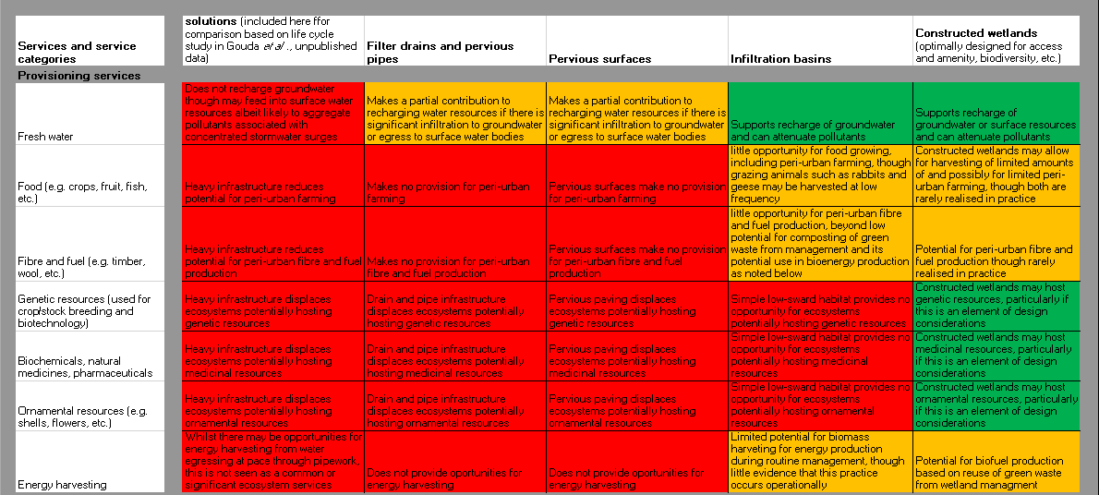

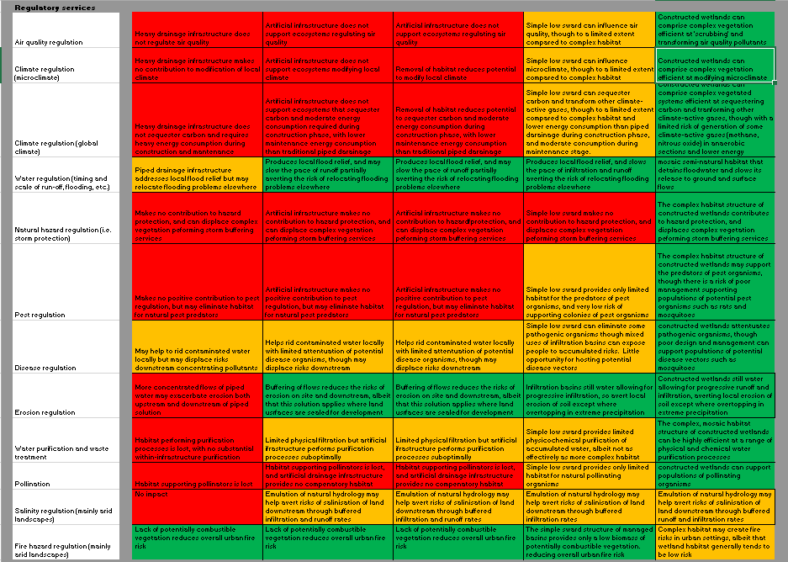

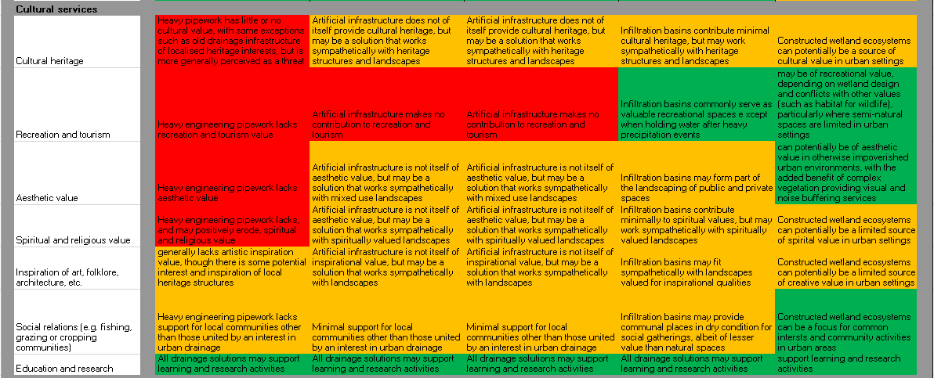

Identical narrow outcomes were identified for filter drains and pervious pipes and for pervious surfaces, reflecting their essentially volumetric role, albeit with some physical filtration. The low managed grass sward of infiltration basins performs some additional ecological and physicochemical functions and fit into multifunctional landscapes of wider value.

Certain ecosystem services (including provision of genetic, biochemical or ornamental resources) only potentially arise from constructed wetlands. Conversely, a high level of regulation of water and erosion control was provided by all approaches except traditional piped drainage. Education and research benefits extended across all approaches. Different approaches lend themselves to different ranges of ecosystem services, though net benefits to society (breadth of ecosystem services) increases with performance or emulation of natural processes. Each solution has its place in a mix of approaches in urban environments, yet also has a different ‘footprint’ of environmental impact and net provision of value to society within and beyond the discipline of urban drainage.

**Recognising the multifunctional opportunities of SuDS**

Notwithstanding the ethical, environmental and net societal value implications of considering multiple service outcomes in decision-making, consistent with international and national requirements to take an Ecosystem Approach, significant challenges remain in ‘mainstreaming’ ecosystem services into planning, policy and implementation (Apitz *et al*., 2006), with significant impediments to sustainable water management persisting particularly in urban contexts (Farrelly and Brown, 2011). Philosophical and practical progress, supported by a growing body of case studies (for example as reviewed by Grant, 2012), is promoting incremental integration of SuDS and related techniques into urban drainage policy and practice. This can contribute to wider uptake of ecosystem service considerations in urban design and management (Grant, 2012) helping overcome ignorance surrounding the potential values of urban biodiversity (Rodriguez *et al*., 2006).

Recognising multiple service outcomes differentiates the net consequences of ‘hard engineering’ (traditional piped drainage) versus ecosystem-based approaches to urban drainage. Individual scheme design has to be fit for purpose, though the definition of ‘purpose’ remains open to debate. Drainage design will be steered in a particular direction if the purpose is framed solely as dealing with flood events, assumed to become increasingly episodic due to climatic instability, and to deliver within specific urban context and policy requirements. ‘Hard engineering’ approaches focused narrowly on drainage may be locally appropriate in dense built infrastructure, with constrained opportunities for multi-benefit solutions, though unintended consequences have to be addressed and mitigated wherever possible. However, in ‘green field’ development, or where other design considerations permit, the benefits of a multi-benefit approach are compelling for delivering water management and wider societal benefits (Steiner, 2014). Nevertheless, narrow or otherwise ill-informed economic or perceived technical constraints still frequently shape decision-making (Barbosa *et al*., 2012). Yet more sustainable approaches to drainage are increasingly required by planning policies, whether because developers or planners see direct benefits from taking a more sustainable approach or because development proponents recognise wider benefits. Converting these aspirations into practical implementation requires clear communication of the advantages of taking a multi-benefit approach, requiring illustrative communications tools to engage diverse stakeholders influencing scheme design, operation and regulation.

Systemic intent, seeking optimal public value across services, can promote a multi-benefit vision. The systemic approach supersedes narrower paradigms that may generate unintended externalities, which nonetheless represent real costs and lost opportunities for multiple constituencies. Where a vision of multiple ecosystem service outcomes is successfully shared amongst stakeholders this may promote collaborative funding from multiple sources which, though formerly managed independently (for example estates management, public health, flood management, air quality and public amenity provision), may cost-effectively optimise societal benefits.

A shift to more sustainable practice will be driven not merely conceptually but by more integrated regulatory requirements, practical methods assuring developers and regulators that techniques are robust, broader economic considerations, and also pragmatic decision-support tools. This situation was highlighted in Australia, where historical entrenchment, sectorial barriers, perceived risks and lack of experimentation in policy decisions present perceived barriers to implementing sustainable urban water management (Farrelly and Brown, 2011).

As most design and regulatory decisions are based on modelled outcomes, drainage models need to incorporate potential public benefits and externalities across ecosystem services to promote cross-sector and multi-disciplinary working (Ward *et al*., 2012). Evolution of practical design guidance and evaluation models has an important role in accelerating transition to sustainable approaches to drainage.

As SuDS design progresses to encompass diverse ecosystem services, distinctions between SuDS and other urban water and environmental management solutions (green infrastructure, urban forests, urban river restoration, etc.) blur as narrow disciplinary interests coalesce into net contribution to sustainable urban design (Everard and Moggridge, 2012). Everard and McInnes (2013) identify a ‘systemic solutions’ approach, defined as “…*low-input technologies using natural processes to optimise benefits across the spectrum of ecosystem services and their beneficiaries*”, that can contribute to sustainable development by recognising and averting unintended negative impacts and through optimisation of outcomes, increasing net economic value.

The principle of fitness for purpose of drainage scheme design expands beyond ensuring sufficient drainage capacity, to also accommodate implications for all ecosystem services. Failure of vision in design can constrain the value of ostensibly more sustainable approaches (McInnes, 2013). For example, constructed wetlands designed with steep sides substantially limits area available for establishment of functional habitats (such as for wildlife and regulation of air quality (Becerra Jurado *et al*., 2010)) also representing a potential hazard for people (a disbenefit rather than a service). Wetland design has also to balance outcomes across services (Harrington *et al*., 2011), for example optimising outcomes for climate change by promoting the sequestration of carbon whilst averting methane and nitrous oxide generation in extensive anaerobic areas (Mander *et al*., 2011).

Local setting has also to be considered to prevent unintended consequences outweighing potential benefits (Wong, 2006). For example, permanent open water in a tropical constructed wetland in an urban environment may provide efficient drainage and other services, but could present malarial risks and substantial water loss through evapotranspiration (Greenway *et al*., 2003; Knight *et al*., 2003), where SuDS techniques promoting groundwater recharge may deliver service value additional to drainage including water resource recharge, disease regulation and other cultural benefits (Yang *et al*., 2008).

**Conclusions and recommendations**

The diversity of potential outcomes for any sustainable drainage design set in its geographic, climatic and demographic context demands case-by-case consideration. However, every design presents an opportunity to optimise benefits rather than maximise single outcomes (Everard and McInnes, 2013) and to integrate across the multiple actions demonstrated in Figure 1. To make this workable, we recommend:

1. Decision-makers, planners and managers need to adopt systemic approaches to urban water management challenges. These should optimise societal value, including elimination of unintended disbenefits, across the full spectrum of ecosystem services.
2. Cross-disciplinary models that can optimise design, accounting for all ecosystem services and context-specific risk factors and interdependences, will be invaluable in navigating this complexity. Such models must provide options, warnings and guidance to help developers shape design, supporting optimal public value across ecosystem services.
3. The simplistic ‘traffic lights’ illustration of likely outcomes of drainage options used in this paper represents a useful and intuitive means for models to represent potential outcomes to non-specialist users and audiences.

**References**

Apitz, S.E., Elliott, M., Fountain, M. and Galloway, T.S. (2006). European environmental management: moving to an ecosystem approach. *Integrated environmental assessment and management*, *2*(1), 80-85.

Armitage, D.R., Plummer, R., Berkes, F., Arthur, R.I., Charles, A. T., Davidson-Hunt, I.J., Diduck, A.P., Doubleday, N.C., Johnson, D.S., Marschke, M., McConney, P., Pinkerton, E.W. and Wollenberg, E.K. (2008). Adaptive co-management for social-ecological complexity. *Frontiers in Ecology and the Environment*, *7*(2), 95-102.

Barbosa, A.E., Fernandes, J.N. and David, L.M. (2012). Key issues for sustainable urban stormwater management. *Water research*, *46*(20), 6787-6798.

Bolund, P. and Hunhammer, S. (1999). Ecosystem services in urban areas. *Ecological Economics, 29*, 293-301

Burkhard, B., Kroll, F., Müller, F. and Windhorst, W. (2009). Landscapes’ capacities to provide ecosystem services – a concept for land-cover based assessments. *Landscape Online*, 15, 1–22.

Burkhard, B., Kroll, F., Nedkov, S. and Müller, F. (2012). Mapping ecosystem service supply, demand and budgets. *Ecological Indicators*, *21*, 17-29.

Busch, M., La Notte, A., Laporte, V. and Erhard, M., (2012)_. Potentials of quantitative and qualitative approaches to assessing ecosystem services. *Ecological Indicators*, 21, 89–103.

Colls, A., Ash, N. and Ikkala, N. (2009). *Ecosystem-based Adaptation: a natural response to climate change*. Gland: IUCN.

Convention on Biological Diversity. (2000). *Ecosystem Approach*. UNEP/CBD COP5 Decision V/6 (<http://www.cbd.int/decision/cop/?id=7148>, accessed 30th December 2013)

Convention on Biological Diversity. (2010). *Operational guidance for application of the Ecosystem Approach*. (<http://www.cbd.int/ecosystem/operational.shtml>, accessed 30th December 2013)

Defra. (2005). *Making space for water: Taking forward a new Government strategy for flood and coastal erosion risk management in England. First Government response to the autumn 2004 ‘Making space for water’ consultation exercise, March 2005*. Department for Environment, Food and Rural Affairs, London.

De Groot, R. S., Alkemade, R., Braat, L., Hein, L. and Willemen, L. (2010). Challenges in integrating the concept of ecosystem services and values in landscape planning, management and decision making. *Ecological Complexity*, *7*(3), 260-272.

Doody, D., Harrington, R., Johnston, M., Hofman, O. and McEntee, D. (2009). Sewerage treatment in an integrated constructed wetland. *Municipal Engineer, 162*(4), 199-205.

Ellis, J.B., Shutes, R.B.E. and Revitt, M.D. (2014). *Constructed Wetlands and Links with Sustainable Drainage Systems*. Environment Agency R&D Technical Report P2-159/TR1. Environment Agency, Bristol.

European Union. (2011). *The EU Biodiversity Strategy to 2020*. European Union: Belgium. 28pp.

Everard, M. (2014). Integrating integrated water management. *Water Management* (DOI: <http://dx/doi.org/10.1680/wama.12.00125>).

Everard, M., Bramley, M., Tatem, K., Appleby, T. and Watts, W. (2009) Flood management: from defence to sustainability. *Environmental Liability*, 2, pp.35-49.

Everard, M., Dick, J., Kendall, H., Smith, R.I., Slee, W., Couldrick, L., Scott, M. and MacDonald, C. (2014). Improving coherence of ecosystem service provision between scales. *Ecosystem Services*. DOI: 10.1016/j.ecoser.2014.04.006.

Everard, M. and McInnes, R.J. (2013). Systemic solutions for multi-benefit water and environmental management. *The Science of the Total Environment*, 461(62), pp.170-179

Everard, M. and Moggridge, H.L. (2012). Rediscovering the value of urban rivers. *Urban Ecosystems*, 15(2), pp.293-314.

Everard, M. and Street, P. (2001). *Sustainable drainage systems (SuDS): An Evaluation Using The Natural Step Framework*. The Natural Step, Cheltenham.

Fitzhugh, T.W. and Richter, D.D. (2004). Quenching urban thirst: growing cities and their impacts on freshwater ecosystems. *BioScience, 54*, 741-754.

Grant, G. (2012). *Ecosystem Services Come to Town: Greening Cities by Working with Nature*. Wiley-Blackwell, Chichester, UK.

Greenway, M., Dale, P. and Chapman, H. (2003). An assessment of mosquito breeding and control in 4 surface flow wetlands in tropical-sub-tropical Australia. *Water Science ad Technology*, 48(5), pp.249-256.

Harrington, R., Carroll, P., Cook, S., Harrington, C., Scholz, M. and McInnes, R.J. (2011). Integrated constructed wetlands: water management as a land-use issue, implementing the 'Ecosystem Approach'. *Water Science and Technology*, *63*(12).

HM Government. (2011). *The Natural Choice: Securing the Value of Nature*. The Stationary Office, London.

Jurado, G. B., Callanan, M., Gioria, M., Baars, J. R., Harrington, R. and Kelly-Quinn, M. (2010). Comparison of macroinvertebrate community structure and driving environmental factors in natural and wastewater treatment ponds. In: *Pond Conservation in Europe* (eds. B. Oertli, R. Cereghino, A. Hull and R. Miracle), Springer Netherlands. pp.309-321.

Knight, R.L., Walton, W.E., O’Meara, G.F., Reisen, W.K. and Wass, R. (2003). Strategies for effective mosquito control in constructed treatment wetlands. *Ecological Engineering*, *21*(4), 211-232.

Mander, Ü., Maddison, M., Soosaar, K. and Karabelnik, K. (2011). The impact of pulsing hydrology and fluctuating water table on greenhouse gas emissions from constructed wetlands. *Wetlands*, *31*(6), 1023-1032.

McInnes, R.J. (2013) Recognising wetland ecosystem services within urban case studies. *Marine and Freshwater Research*, 64, pp.1-14.

Millennium Ecosystem Assessment. (2005). *Ecosystems and Human Well-being: General Synthesis*. Island Press, Washington DC

Natural England. (2009). *Green Infrastructure Guidance*. Natural England, Peterborough.

Niemczynowicz, J. (1999). Urban hydrology and water management - present and future challenges. *Urban Water, 1*(1), 1-14.

Norgaard, R. B. (2010). Ecosystem services: From eye-opening metaphor to complexity blinder. *Ecological Economics*, *69*(6), 1219-1227.

Palmer, M. A., Lettenmaier, D. P., Poff, N. L., Postel, S. L., Richter, B. and Warner, R. (2009). Climate change and river ecosystems: protection and adaptation options. *Environmental Management*, *44*(6), 1053-1068.

Resolution IX.1 (2005) Additional scientific and technical guidance for implementing the Ramsar wise use concept. Resolutions of the 9th meeting of Conference of the Contracting Parties. Kampala, Uganda, 8-15 November, 2005.

Robinson, D.A., Hockley, N., Dominati, E., Lebron, I., Scow, K.M., Reynolds, B., Emmett, B.A., Keith, A.M., de Jonge, L.W., Schjonning, P., Modrup, P., Jones, S.B. and Tuller, M. (2012). Natural capital, ecosystem services, and soil change: Why soil science must embrace an ecosystems approach. *Vadose Zone Journal*, *11*(1), 6, pp. 10.2136/vzj2011.0051.

Rodriguez, J.P., Beard, T.D., Bennet, E.M., Cumming, G.S., Cork, S.J., Agard,J., *et al*. (2006). Trade-offs across space, time and ecosystem services. *Ecology and Society*, 11(1), 28. (<http://wwwecologyand> society.org/vol11/art28).

Scholz, M. (2006). *Wetland Systems to Control Urban Runoff.* Amsterdam: Elsevier.

Secretariat of the Convention on Biological Diversity (2012) *Cities and Biodiversity Outlook—Executive Summary.* Montreal, 16pp.

Smith, A. D. M., Fulton, E. J., Hobday, A. J., Smith, D. C. and Shoulder, P. (2007). Scientific tools to support the practical implementation of ecosystem-based fisheries management. *ICES Journal of Marine Science: Journal du Conseil*, *64*(4), 633-639.

Steiner, F. (2014). Frontiers in urban ecological design and planning research. *Landscape and Urban Planning*, *125*, 304-311.

Tzoulas, K., Korpela, K., Venn, S., Yli-Pelkonen, V., Kaźmierczak, A., Niemela, J. and James, P. (2007). Promoting ecosystem and human health in urban areas using green infrastructure: a literature review. *Landscape and Urban Planning*, *81*(3), 167-178.

UN Habitat. (2012). *Urban Patterns for a Green Economy – Working With Nature*. UN Habitat, Kenya: UNON. 74pp.

United Nations. (2011). *World Population Prospects: The 2010 Revision, Highlights and Advance Tables.* Department of Economics and Social Affairs, Population Division. New York: United Nations.

Vihervaara, P., Kumpula, T., Tanskanen, A. and Burkhard, B. (2010). Ecosystem services – a tool for sustainable management of human-environment systems. Case study Finnish Forest Lapland. *Ecological Complexity*, 7(3), pp.410-420.

Ward, S., Lundy, L., Shaffer, P., Wong, T., Ashley, R., Arthur, S., Armitage, N. P., Walker, L. Brown, R., Deletic, A. and Butler, D. (2012). Water sensitive urban design in the city of the future. Proceedings of the 12 Porto Alegre, Brazil, 11-16 September 2011.79-86

Wong, T.H. (2006). Water sensitive urban design-the journey thus far. *Australian Journal of Water Resources*, 10(3), 213.

Wong, T.H.F. and Brown, R.R. (2009). The water sensitive city: principles for practice. *Water Science and Technology*, *60*(3).

Woods-Ballard, B., Kellagher, R., Martin, P., Jefferies, C., Bray, R and Shaffer, P. (2007). *The SUDS Manual, C697*. Construction Industry Research and Information Association, London. (<http://www.ciria.org/Resources/Free_publications/the_suds_manual.aspx>, accessed 16th May 2014.)

Yang, W., Chang, J., Xu, B., Peng, C. and Ge, Y. (2008). Ecosystem service value assessment for constructed wetlands: A case study in Hangzhou, China. *Ecological Economics*, *68*(1), 116-125.

Zhou, Q. (2014). A Review of Sustainable Urban Drainage Systems Considering the Climate Change and Urbanization Impacts. Water, 6, pp.976-992.

1. Corresponding author: [mark@pundamilia.co.uk](mailto:mark@pundamilia.co.uk), +44-(0)-7768-278429