**MICROALGAE AS SUBSTRATE IN LOW COST TERRACOTTA-BASED MICROBIAL FUEL CELLS: NOVEL APPLICATION OF THE CATHOLYTE PRODUCED**

M. J. Salar-García1, I. Gajda2, V. M. Ortiz-Martínez1, J. Greenman2, M. M. Hanczyc3, A.P. de los Ríos4, I. A. Ieropoulos2,*

1. Polytechnic University of Cartagena, Chemical and Environment Engineering Department, Campus Muralla del Mar, C/Doctor Fleming S/N, E-30202 Cartagena, Murcia.
2. Bristol BioEnergy Centre, Bristol Robotic Laboratory, Block T, UWE, Bristol, Coldharbour Lane, Bristol BS16 1QY, UK
3. University of Trento, Laboratory for Artificial Biology, Via Sommarive Nº9, E: 38123 Povo, Trento, Italy
4. University of Murcia, Chemical Engineering Department, Campus de Espinardo, E-30071 Murcia, Spain

Corresponding author: E-mail: [ioannis.ieropoulos@brl.ac.uk](mailto:ioannis.ieropoulos@brl.ac.uk)

**HIGHLIGHTS**

* Novel application of the catholyte produced in ceramic MFCs to lyse microalgae.
* Microalgae as a potential low cost co-substrate for MFCs.
* Light/dark cycle assisted microalgae digestion in the presence of catholyte.

**ABSTRACT**

In this work, the by-product generated during the operation of cylindrical MFCs, made out of terracotta, is investigated as a feasible means of degrading live microalgae for the first time. In addition to the low cost materials of this design, the reuse of the solution produced in the cathode renders the technology truly green and capable of generating bioenergy. In this study, the effect of a light/dark cycle or dark conditions only on the digestion of live microalgae with the catholyte is investigated. The results show that a combination of light/dark improves the degradation of algae and allows them to be used as substrate in the anode. The addition of 12.5 mL of a 1:1 mix of catholyte and microalgae (pre-digested over 5 days under light/dark) to the anode, increases the power generation from 7 µW to 44 µW once all the organic matter in the anode have been depleted.

**GRAPHICAL ABSTRACT**

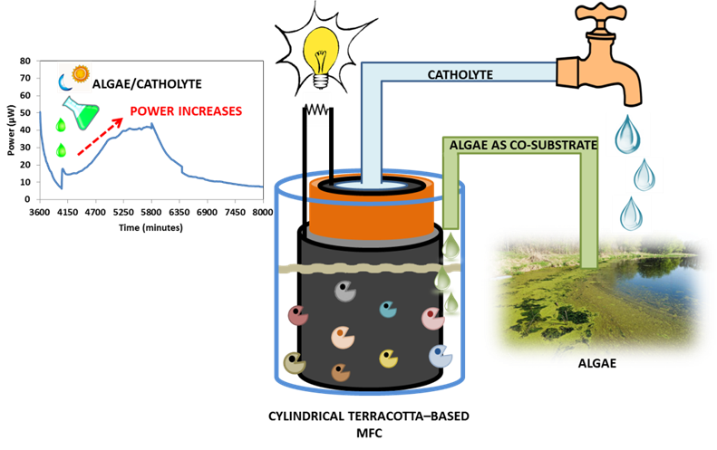

***Keywords: Microbial fuel cells; ceramic membrane; catholyte; microalgae; bioenergy.***

1. **INTRODUCTION**

The ongoing energy crisis and global warming have challenged the scientific community to develop alternative sources of energy [Creutzig *et al*., 2015; Guo *et al.,* 2015; Heinimö & Junginger 2009; Mao *et al.,* 2015]. A wide range of materials has been investigated to produce bioenergy such as industrial or crop waste [Deublein & Steinhauser, 2008; Ho *et al.,* 2014]. However, algae have received increased attention in recent years as an alternative option to conventional materials. The use of algae presents many advantages due to their high growth rates in relatively confined spaces, compared to other terrestrial plants. Algae can be grouped into two large categories: microalgae and macroalgae. The main characteristic of microalgae is that they are unicellular green plants that contain proteins, lipids and carbohydrates in different proportions, depending on the strain but not cellulose or lignin. Moreover, they are rich in chlorophyll and can be used for feeding aquatic organisms [Schenk *et al.,* 2008; Velasquez-Orta *et al.,* 2009]. On the other hand, macroalgae do not contain lignin but have low values of cellulose, which makes them more resistant to some predators. They mainly consist of polysaccharides and unsaturated fatty acids [Velasquez-Orta *et al.,* 2009; Vergara-Fernández *et al.,* 2008]. Microalgae and macroalgae can be cultivated in different aqueous environments such as rivers, seas or wastewater, and both types have been studied for the production of energy, via different pathways: macroalgae have been used in the production of methane and microalgae are more suitable for producing a wide range of energy products, such as bio-oil, methane, methanol, hydrogen or even electricity. The main drawback is the need for a resource-intensive infrastructure to support the transformation of microalgal biomass into electricity (storage, transport and processing) [Bahadar & Khan 2013; Velasquez-Orta *et al*., 2009]. In this regard, microbial fuel cells (MFCs) have played a key role in recent years as a technology that can directly produce electricity from different sources of organic waste, and perhaps algae. MFCs use microorganisms to degrade organic matter contained in different types of waste, producing electrons and protons. The electrons go through an external circuit to the cathode while protons go through a separator, usually a proton exchange membrane, to reach the cathode. In the cathode, incoming electrons and protons react with oxygen to produce water [Hernández-Fernández *et al*., 2015; Oliveira *et al*., 2013; Potter 1911].

Many advances have been achieved in terms of new materials and designs in the field of MFCs to improve their performance and reduce the cost [Hernández-Fernández *et al.,* 2015]. The use of ceramic materials as a separator is amongst the most important since commercial membranes like Nafion® are expensive [Ghadge & Ghangrekar 2015; Winfield *et al.,* 2013]. Ceramics have been previously reported as membrane/electrode combinations (Park & Zeikus, 2003) and as separators (Behera *et al*., 2010), and more recently, Gajda *et al*. (2015) reported a low-cost ceramic cylinder as the membrane and chassis of MFCs [Gajda *et al.,* 2015]. In this latter work, carbon veil was used as the anode electrode, wrapped around the outside of the cylinder, and the same carbon veil, covered with activated carbon was used as the cathode, on the inside of the cylinder. The group reported a maximum power of 2.86 mW.m-2, enough energy to power a LED over 7 days, with a concomitant 92% reduction in chemical oxygen demand (COD). In addition to the low cost and high power output of this assembly, the production of an alkaline solution inside the terracotta cylinder (cathode) was also reported as a function of the electrical performance. The catholyte was colourless and odourless containing carbonate and bicarbonate salts, and high levels of pH and conductivity. All of these chemical properties of the catholyte suggest opportunities for exploitation in a range of future applications [Gajda *et al.,* 2015].

This current work investigates for the first time the application of the alkaline catholyte solution, produced in the aforementioned cylindrical terracotta MFCs, to lyse live microalgae and then feed the lysed cells as substrate, in the anode for the microbes. This takes advantage of the chemical potential produced by the MFC by using the alkaline catholyte as an external digester to provide organics to the anode microbes that would be difficult or impossible for them to break down directly. The performance of these MFCs is then compared with that from MFCs using live non-lysed microalgae. This study shows a novel and promising application of the by-product generated during the operation of ceramic MFCs, which opens up further avenues for exploration and exploitation.

**2. MATERIALS AND METHODS**

***Microbial fuel cell configuration***

The microbial fuel cells used consist of a 10 cm tall terracotta cylinder sealed at the bottom with an internal and external diameter of 3.5 cm and 4 cm, respectively (Weston Mill Pottery, Nottinghamshire, UK). This structure acts as separator between the anodic and cathodic chamber. The anode is made out of carbon veil (20 g.m-2) folded and wrapped around the outside surface of the terracotta cylinder. A nickel-chromiun wire is used to hold this electrode in place and also serves as the current collector and connection point. The cathode is formed by the same carbon veil (90 cm2, substratum/diffusion layer) coated with a mixture of (conductive layer) activated carbon and polytetrafluoroethylene (PTFE 30%V/V). It is placed inside the terracotta cylinder with the conductive layer facing the separator. The cathode electrode is held against the inner wall of the cylindrical ceramic body, using a plastic ring and the cathode compartment is open to the air, in order to allow the oxygen reduction reaction to take place. Finally, an external resistance of 100 Ω is used to load the circuit and two stainless steel crocodile clips connect both electrodes to the data logger. Figure 1 describes the main components of the MFCs studied.

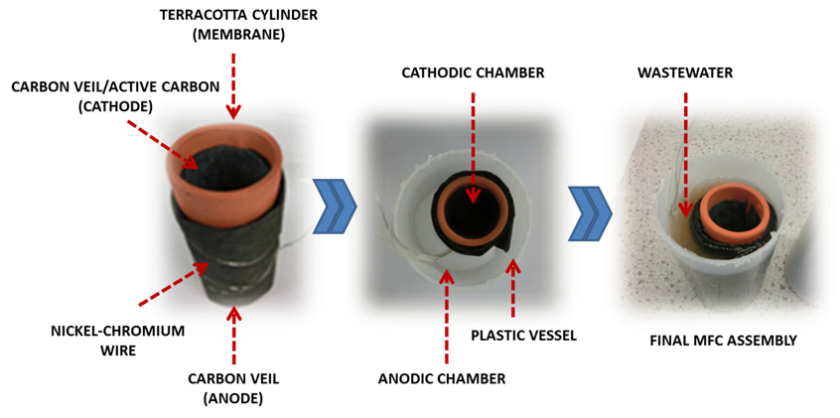

Figure 1. Main components of the MFCs studied.

***Analytical Method***

A 16-channel ADC-24 Picolog recorder data logger (Pico Technology Ltd, Cambridgeshire, UK) was used to monitor the voltage *vs.* time. The polarisation and power curves were measured by changing the external resistive loads, from 999999 to 0 Ω (including open circuit voltage), for 3 minute intervals for each load, using an automatic resistorstat tool [Degrenne *et al.,* 2012]. Data sampling (i.e. recording capacity) during the polarisation run was 30 second intervals.

The catholyte and anolyte solutions were characterised by measuring pH and conductivity during the experiment with a handheld pH meter (Hanna 8424, Hanna Instrument, UK) and 470 Jenway conductivity meter (Camlab, UK), respectively.

***Operation Mode***

The terracotta cylinders were placed inside a plastic container, which serves as the anode chamber, and filled with 170 mL of substrate. The fuel is a solution consisting of 10%V/V of sludge provided by Wessex Water Scientific Laboratory (Cam Valley, Saltford, UK), 90%V/V of deionised water and supplemented with sodium acetate anhydrous (Fisher Chemical, Loughborough, UK) with a final concentration of 20 mM. Prior to starting the experiments, the MFCs were matured during 14 days using a solution composed of sludge supplemented with 100 mM acetate as the substrate. At this starting point, the cathode chamber was completely empty and dry, in order for catholyte to be actively produced, as a direct result of the MFC operation. During this process, MFCs generated sufficient amount of catholyte to be subsequently used for microalgal lysis. MFCs were studied in batch mode under the 4 different conditions detailed below. Each one was carried out in triplicate and they were applied sequentially in the same reactors in the following order:

* **Condition A:** Following the maturing of the MFCs, the anodes were filled with 170 mL of substrate (20 mM of acetate and 10%V/V of sludge). The power increased initially due to the bacterial metabolism, then stabilised and finally started to decrease due to the depletion of the organic matter. When the power is below 10 µW, 12.5 mL of substrate (10% of the volume at that moment) is removed and replaced by 12.5 mL of a 1:1 mix consisting of microalgae and deionised water, to maintain the liquid volume of the reactor. The microalgae culture was collected from a pond at Frenchay Campus (University of the West of England, Bristol, UK) and grown in the laboratory in the cathodic chamber of a separate MFC. It is a wild mixed algal culture with an optical density of 1.77 (4.8 g.L-1), which was measured using a Jenway 6300 spectrophotometer (Wolflabs, UK) at a wavelength of 678 nm. The effect of adding the catholyte/deionised water solution in the systems was evaluated in terms of power generation.
* **Condition B:** Following the completion of Condition A, the MFCs were rinsed and carefully cleaned with deionised water. Then, they were filled with 170 mL of the same substrate as described for Condition A, but with the 12.5 mL added, consisting of catholyte and deionised water (1:1) as a control, to investigate the effect on power production. The catholyte is an alkaline solution that mainly contains carbonate and bicarbonate, and traces of chloride, phosphate and sulphate (data not shown).
* **Condition C:** Following the completion of Condition B, and before feeding, the MFCs were cleaned with deionised water again. When the power reached a value below 10 µW, 12.5 mL of a solution made from microalgae and catholyte (1:1) digested over a period of 5 days under natural cycles of day and night, were added to the anode.
* **Condition D:** In this case, the procedure followed is the same as for the previous conditions, but the 12.5 mL of mix added consisted of microalgae and catholyte (1:1) but the micro-algal digestion occurred over 5 days in total darkness.

1. **RESULTS AND DISCUSSION**

This work shows a novel application of the catholyte generated in ceramic tubular MFCs. This catholyte is a colourless and odourless liquid with high values of pH and conductivity. The amount of catholyte produced is a function of power performance for this type of MFCs; in other words, the higher the performance of the microbial fuel cells, the higher the production of catholyte and the higher the pH and conductivity levels [Gajda *et al.,* 2015]. The catholyte used in this study had a pH of 12.5 and a conductivity of 24.5 mS.cm-1. As mentioned above, the main purpose of this work is to reuse the catholyte produced to lyse algae in such a way that the mixture can be used as low cost substrate for anodic microorganisms.

Figure 2 shows the power and polarisation curves from each group of three MFC replicates, once they become stable and before applying the Conditions described above. A maximum power of 230 µW was recorded by the four groups of MFCs. Then, the four types of assay were carried out under Conditions A-D.

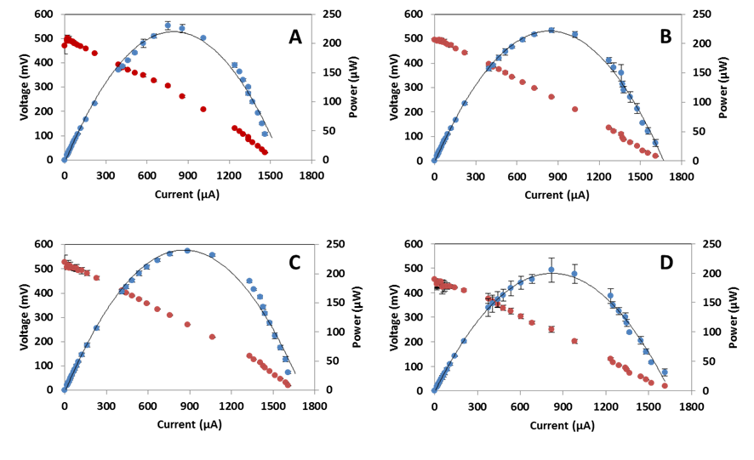 Figure 2. Power and polarisation curves of the three MFC replicates of each condition before adding the co-substrate mix.

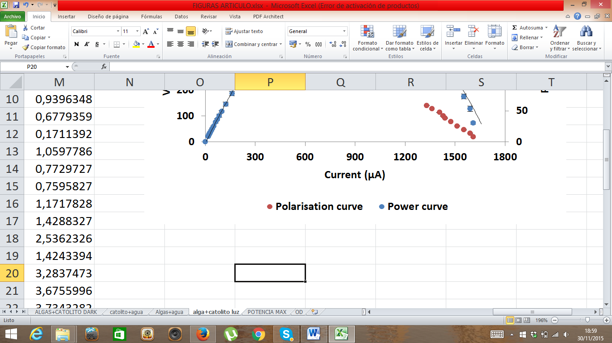

Figure 3 shows the evolution of the average power produced by each group of microbial fuel cell triplicate *vs.* time. The decay in the power curves indicates the precise time point at which the solution investigated as a substrate is added to the anodic chamber, indicated by the red arrows in the figure. As can be seen in Figure 3A, when the solution of algae/deionised water was added, the power of the MFCs continued decreasing. This suggests that the microorganisms are not able to directly utilise this type of algal mixture.

In Figure 3B, a peak of approximately 50 µW was recorded, when 12.5 mL of catholyte/deionised water (1:1) were added in the anode solution. However, this was a short spike, since power decreased within 3 hours. The power increase is due to the high conductivity of the catholyte although this effect disappears very quickly when the charges are balanced between the cathode and the anode. This would imply that the mixture added, does not contain bio-available compounds for the microorganisms to utilise.

Figure 3C shows a higher increase, after adding the solution containing algae/catholyte digested over 5 days under a light/dark cycle (natural diurnal). In contrast with the previous cases, the power continued increasing for 33 hours until a maximum of 44 µW was reached. This result suggests that perhaps the bacteria in the anode chamber could degrade better the substrate. This would mean that a natural cycle of light/dark (16:8 hours) may be necessary to lyse algae in the presence of the synthesised catholyte. Previous research shows that microalgae need light and darkness for growth, since they use the light for photochemical reactions (generating adenosine triphosphate (ATP), coenzymes, nicotinamide adenine dinucleotide phosphateoxidase (NADPH)) and the darkness for synthesising essential molecules by biochemical reactions (Calvin Cycle) [Al-Qasmi *et al.,* 2012]. This cycle is used by the photosynthetic cells to transform the inorganic carbon into organic carbon using the energy stored in the molecules synthesized during the light cycle, such as ATP. Some of the photosynthesised organic compounds are excreted into the media as dissolved organic carbon (DOC) that anodic microorganisms could degrade and use as carbon-energy source. The rate of decomposition depends on the identity of the microbial species present in the community, their affinity to the dissolved carbon source and their growth kinetics [Kouzuma & Watanabe 2015]. In this case, the mix of algae/catholyte was digested under a light/dark cycle, which allows microalgae to carry out the photochemical and biochemical reactions, and excrete a wider range of organic compounds into the media. On the other hand, during the growth process, algae will neutralise the alkaline pH of the catholyte. In order to buffer the external pH, microalgae also release acidic extracellular metabolites. These metabolites along with DOC enrich the media. It is therefore assumed that a combination of these factors renders the added mixture a better carbon-energy source that could be more readily degradable by the anodic microorganisms, thereby improving the performance of the MFCs.

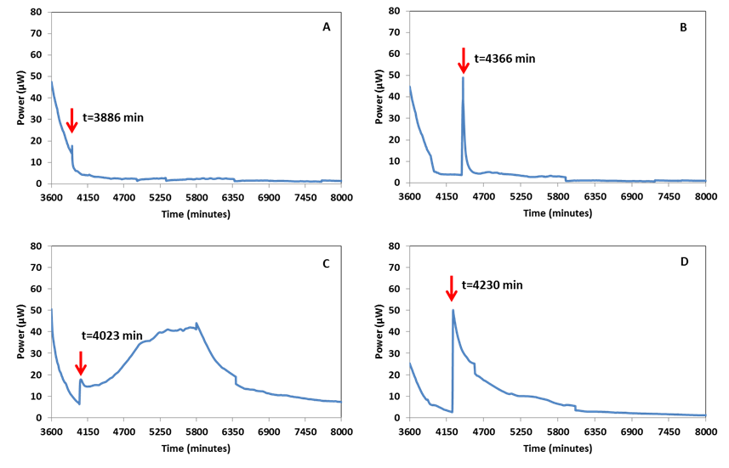

Figure 3. Power output of each MFC under the conditions studied. A) Condition A: Algae+Deionised water; B) Condition B: Catholyte+Deionised water; C) Condition C: Algae digested with catholyte under a cycle of light/darkness; D) Condition D: Algae digested with catholyte under darkness.

Finally, Figure 3D shows an immediate increase in power, when the mix of algae/catholyte digested under darkness was added. The magnitude of this peak is similar to that recorded in Figure 3B, when catholyte/deionised water was added. This implies that the increase in the power generated is caused by the high conductivity of the catholyte but perhaps not by the algal degradation itself. In this case, the mix was kept under dark conditions, so that algae could neither carry out their normal cycle of photochemical/biochemical reactions, nor adapt to the new conditions of the media (pH>12). This implies that they would not produce ATP or NADPH, which are required in the Calvin cycle to synthesise organic compounds necessary for their growth, such as sugars or starch. Hence, all the available biochemical material would be consumed for their survival. When this liquid mix is added into the MFC anode, it appears that there is not sufficient carbon-energy for the anodic microorganisms to consume [Kouzuma & Watanabe 2015], apart perhaps from any lysed algae, which is results in the relatively longer duration, of increased power, compared to Fig. 3B.

Figure 4 shows the area under curve of the power output (AUC) representation caused by the addition of the substrates analysed. The energy produced by the addition of the solution investigated was also determined and found to be: 0.003, 0.152, 5.162 and 1.688 Joules for Conditions A, B, C and D, respectively. As can be observed, the use of algae digested with catholyte under light/darkness shows the highest effect on power output, both in terms of magnitude and length (see Figure 4C). It is three times higher than the effect caused when the digestion is performed under dark (Fig. 4D). 34 times higher than the result after feeding with catholyte and deionised water (Fig. 4B) and 1.8 times higher than the power generated when the MFCs were fed with microalgae and de-ionised water (Fig. 4A).

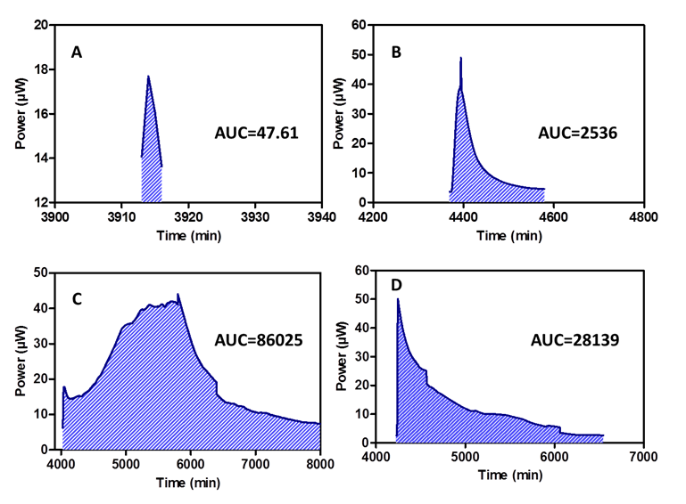

Figure 4. Area under curve representation of the effect of the conditions investigated on the MFCs power output. A) Condition A: Algae+Deionised water; B) Condition B: Catholyte+Deionised water; C) Condition C: Algae digested with catholyte under a cycle of light/darkness; D) Condition D: Algae digested with catholyte under darkness.

Power output was related to the conductivity, pH and volume of the catholyte produced in each MFC. All the results were compared with two types of MFCs, i.e. the controls, which (i) contained sludge and acetate in the proportion described above and were externally loaded with 100 Ω, and (ii) the open circuit voltage MFCs, which also contained sludge and acetate at the same concentrations, but were not externally loaded (no electrons transfer).

As can be seen in Figure 5, the better the MFCs perform, the higher the values of these parameters for the catholyte. Figures 5A and 5B show the conductivity and pH differences between the anolyte and catholyte for each set of conditions investigated. These results reveal that the conductivity and the pH of the catholyte increased with higher MFC performance, while decreasing in the anolyte. Moreover, the catholyte/anolyte ratio is higher for the MFCs that worked better (MFCs loaded and MFCs with algae and catholyte digested under a light/darkness cycle). In terms of volume of catholyte produced, the trend is the same (see Figure 5C). As previously mentioned, the volume of the catholyte is directly proportional to the level of MFC performance, since it is the result of oxygen reduction reaction, electro-osmotic drag and passive osmosis. In this regard, the MFCs with algae and catholyte digested under a cycle of light/darkness, resulted in the highest values of conductivity, pH and volume of catholyte, followed by the MFCs with algae and catholyte digested in dark conditions, which was followed by the MFCs with catholyte and deionised water, the MFCs with algae and deionised water and finally by the MFCs under open circuit conditions. These results are in line with those obtained by Gajda *et al.* 2015, who related high MFC performance to high values of pH and conductivity of the catholyte and high volumes of catholyte produced in terracotta-based MFCs.

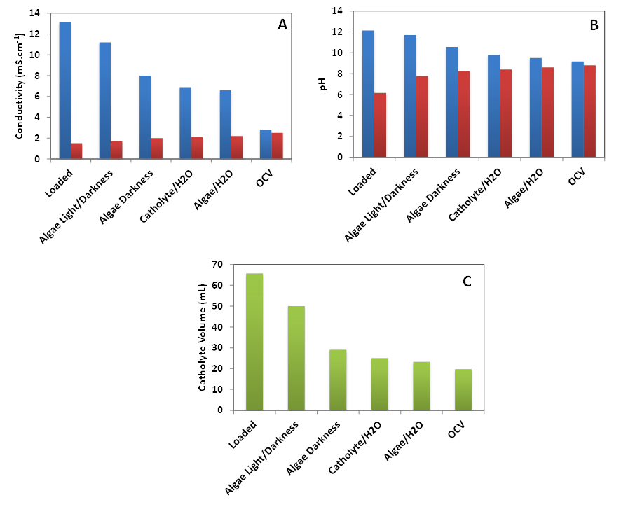 Figure 5. Physico-chemical parameters for the conditions investigated: A) conductivity levels in the catholyte and anolyte; B) pH levels in the catholyte and anolyte; C) volume of catholyte produced.

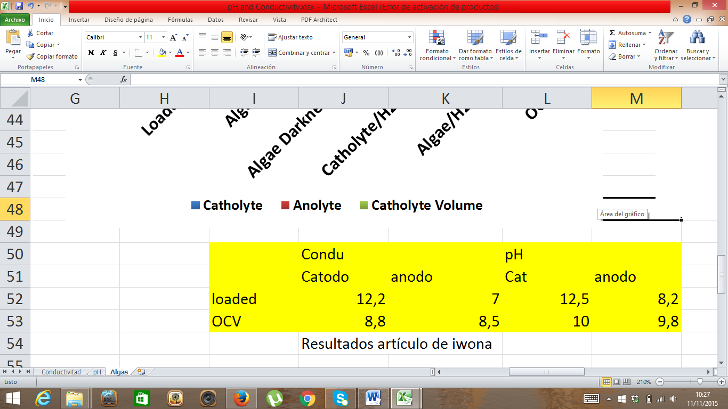

The results show that the unique properties of the MFC-generated catholyte such as the high values of pH and conductivity allow for a wild culture of microalgae to be lysed in five days under a natural cycle of light/dark in a kind of self-produced external digester. A mix of 12.5 mL (1:1) of catholyte/microalgae resulted in a 6-fold power increase – from 7 µW to 44 µW. These values could be explained by the light/dark conditions (i.e. natural rhythm of algae) and the specific properties of the catholyte, acting as an algal lyser. Moreover, higher power output led to higher values of pH, conductivity and volume of the catholyte generated, and in this context the MFCs using algae digested with catholyte under a cycle of light/darkness outperformed the rest of the test conditions. Higher power output was also quantified as area under curve, which revealed a significant improvement from feeding the MFCs with the catholyte/microalgae mixture.

The main advantages of the process described above are the low cost of the materials and the reuse of the by-product generated. Unlike previous work, the assembly studied uses a terracotta cylinder as exchange membrane instead of a commercial membrane, activated carbon as conductive layer in the cathode instead of platinum and live algae from a natural habitat, in a way alluding to algal bloom reduction [Rashid *et al.,* 2013; Velasquez-Orta *et al.,* 2009]. All of these materials reduce the cost of the MFC mitigating the main drawback for the scaling up process of these systems.

1. **CONCLUSIONS**

This work reveals a novel application of the catholyte produced during the operation of a terracotta tubular MFC. These results show great promise since they demonstrate that algae can be used as natural carbon source in terracotta-based MFCs when treated with the catholyte that has been synthesised *in-situ*. Further work is required to better understand the lysing mechanisms as well as the process of nutrient extraction optimise the catholyte and algal biomass ratio and improve the operating conditions from batch to continuous flow.

**ACKNOWLEDGEMENTS**

This work was funded by the Ministry of Science and Innovation of Spain (MICINN), ref. CICYT ENE2011-25188, and the Séneca Foundation Ref. 18975/JLI/13. M.J. Salar-García and V.M. Ortiz-Martínez thank the Ministry of Economy and Competitiveness and the Ministry of Education for supporting their doctoral theses (Ref: BES-2012-055350 and FPU12/05444, respectively) and the mobility grants received (Ref. EEBB-I-15-10446 and PMPDI-UPCT-2015, respectively) which made possible the collaboration between Polytechnic University of Cartagena and University of the West of England. Ioannis Ieropoulos is supported by an EPSRC New Directions award, grant no. EP/L002132/1.

**REFERENCES**

[1] Al-Qasmi M,Member Nr, IAENG, Talebi S, Al-Rajhi S, Al-Barwani T., 2012. A review of effect of light on microalgae growth. Proceeding of the world congress on engineering 1, 4-6.

[2] Bahadar A and Khan MB., 2013Progress in energy from microalgae: A review. Renew Sust Energ Rev. 27, 128-148.

[3] Behera M, Jana P.S, More T.T., Ghangrekar M.M. Rice mill wastewater treatment in microbial fuel cells fabricated using proton exchange membrane and earthen pot at different pH, Bioelectrochemistry 79, 2010, 228–233.

[4] Creutzig F, Ravindranath NH, Berndes G, Bolwig S *et al*., 2015. Bioenergy and climate change mitigation: an assessment. Glob Change Biol Bioenergy. 7(5), 916-944.

[5] Degrenne N, Buret F, Allard B, Bevilacqua P., 2012. Electrical energy generation from a large number of microbial fuel cells operating at maximum power point electrical load. J Power Sources 205, 188-193.

[6] Deublein D and Steinhauser A., 2008. Biogas from waste and renewable resources. Wiley-VCH, Weinheim, 57–79.

[7] Gajda I, Greenman J, Melhuish C, Ieropoulos I., 2015. Simultaneous electricity generation and microbially-assisted electrosynthesis in ceramic MFCs. Bioelectrochemistry 104, 58-64.

[8] Ghadge AN and Ghangrekar MM., 2015. Development of low cost ceramic separator using mineral cation exchanger to enhance performance of microbial fuel cells. Electrochim Acta 166, 320-328.

[9] [Guo M](https://apps.webofknowledge.com/OneClickSearch.do?product=UA&search_mode=OneClickSearch&SID=S1AUkmTuAF6zUyChUb5&field=AU&value=Guo,%20MX&ut=5280939&pos=%7B2%7D&excludeEventConfig=ExcludeIfFromFullRecPage), [Song W](https://apps.webofknowledge.com/OneClickSearch.do?product=UA&search_mode=OneClickSearch&excludeEventConfig=ExcludeIfFromFullRecPage&SID=S1AUkmTuAF6zUyChUb5&field=AU&value=Song,%20WP) and Buhain J., 2015. Bioenergy and biofuels: History, status, and perspective. Renew Sust Energ Rev 42, 712-725.

[10] Heinimö J and Junginger M., 2009. Production and trading of biomass for energy – An overview of the global status. Biomass Bioenerg 33(9), 1310–1320.

[11] Ho DP, Ngo HH and Guo W., 2014. A mini review on renewable sources for biofuel. Bioresource Technol 169, 742–749.

[12] Hernández-Fernández FJ, de los Ríos AP, Salar-García MJ, Ortiz-Marínez VM, Lozano-Blanco LJ, Godínez C, Tomás-Alonso F, Quesada-Medina J., 2015. Recent progress and perspectives in microbial fuel cells for bioenergy generation and wastewater treatment. Fuel Processing Technol 138, 284–297.

[13] Kouzuma A and Watanabe K., 2015. Exploring the potential of algae/bacteria interactions. Curr Opin Biotech 33, 125-129.

[14] [Mao GZ](https://apps.webofknowledge.com/OneClickSearch.do?product=UA&search_mode=OneClickSearch&excludeEventConfig=ExcludeIfFromFullRecPage&SID=S1AUkmTuAF6zUyChUb5&field=AU&value=Mao,%20GZ), [Liu X](https://apps.webofknowledge.com/OneClickSearch.do?product=UA&search_mode=OneClickSearch&excludeEventConfig=ExcludeIfFromFullRecPage&SID=S1AUkmTuAF6zUyChUb5&field=AU&value=Liu,%20X), [Du HB](https://apps.webofknowledge.com/OneClickSearch.do?product=UA&search_mode=OneClickSearch&excludeEventConfig=ExcludeIfFromFullRecPage&SID=S1AUkmTuAF6zUyChUb5&field=AU&value=Du,%20HB), [Zuo J](https://apps.webofknowledge.com/OneClickSearch.do?product=UA&search_mode=OneClickSearch&excludeEventConfig=ExcludeIfFromFullRecPage&SID=S1AUkmTuAF6zUyChUb5&field=AU&value=Zuo,%20J), [Wang LY](https://apps.webofknowledge.com/OneClickSearch.do?product=UA&search_mode=OneClickSearch&excludeEventConfig=ExcludeIfFromFullRecPage&SID=S1AUkmTuAF6zUyChUb5&field=AU&value=Wang,%20LY)., 2015. Way forward for alternative energy research: A bibliometric analysis during 1994-2013. Renew Sust Energ Rev 48, 276-286.

[15] Oliveira VB, Simões M, Melo LF, Pinto AMFR., 2013. Overview on the developments of microbial fuel cells. Biochem Eng J 73, 53–64.

[16] Park D.H. and Zeikus J.G. Improved fuel cell and electrode designs for producing electricity from microbial degradation, Biotechnol. Bioeng. 81, 2003, 348–355.

[17] Potter MC., 1911. Electrical effects accompanying the decomposition of organic compounds. Proc. R. Soc B, 84, 260–276.

[18] Rashid N, Cui YF, Saif Ur Rehman M, Han JI., 2013. Enhanced electricity generation by using algae biomass and activated sludge in microbial fuel cell. Sci Total Environ, 456-457, 91-94.

[19] Schenk P, Thomas-Hall S, Stephens E, Marx U, Mussgnug J, Posten C, Kruse O, Hankamer B., 2008. Second generation biofuels: High efficiency microalgae for biodiesel production. Bioenergy Res, 1(1), 20–43.

[20] Velasquez-Orta SB, Curtis TP and Logan BE., 2009. Energy from algae using microbial fuel cells. Biotechnol Bioeng, 103(6), 1068-1076.

[21] Vergara-Fernández A, Vargas G, Alarcón N, Velasco A., 2008. Evaluation of marine algae as a source of biogas in a two-stage anaerobic reactor system. Biomass Bioenerg, 32(4), 338–344.

[22] Winfield J, Chambers LD, Rossiter J, Ieropoulos I., 2013. Comparing the short and long term stability of biodegradable, ceramic and cation exchange membranes in microbial fuel cells. Bioresource Technol, 148, 480-486.