EBENEZER GATE POCKET PARK

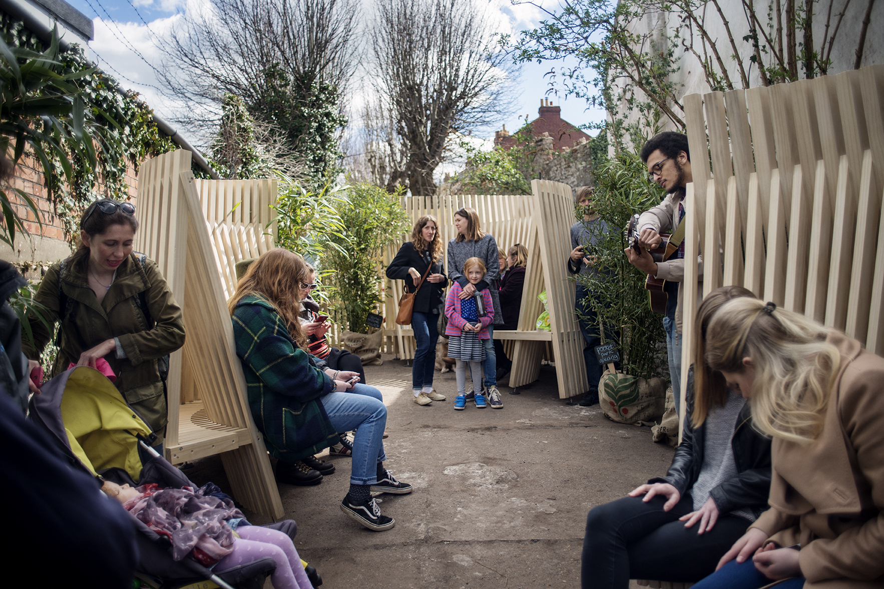
Image credit: Marcus Way Photography

Full project title: Ebenezer Gate Community Garden: Pocket Park
Duration: October 2015 – October 2016
Funded by: Department for Communities and Local Government
Project lead: Associate Professor Rachel Sara
Project team: Matthew Jones; Louis Rice; Sally Daniels; Ann de Graft-Johnson; Eve Zetlina; Constance Gregory; Anna Blamire-Brown.
Project Partners: George Lovesmith (architect); OOMA design; George Grace (TownCentred); Bedminster Town Team
Project summary
The Hands-on-Bristol collective worked with local residents, community groups artists, architects and makers to co-create a community run pocket park.

Aim
To use action-based design-research processes to explore how collaborative processes can positively empower communities in place-making.

This aim was broken down into the following sub-aims:
To explore how can abandoned pockets of urban space be reclaimed for community use through participatory design processes
To develop techniques which empower communities in place-making

Objectives
- To develop methods of engagement that facilitate working closely with a wide section of the community in collaboration with students and professionals
- To generate initial ideas for sustainable community place-making through organizing creative consultation and co-design events
- To identify abandoned pockets of urban space and stimulate debate around what should happen to them.
- To work with local stakeholders to negotiate the opening up of a disused pocket of land for community use
- To use co-design principles to design and build a community space
- To empower the community to take ownership of a community managed space.

Impact
Competitions:
2017 SEED Awards, Live projects network honorable mention Available from: https://designcorps.org/seed-awards-about/

AD Editorial Team (2016), 'The Best Student Design-Build Projects Worldwide 2016'. Available from: http://www.archdaily.com/794566/the-best-student-design-build-projects-worldwide-2016

Articles:

Jeffries, D., (2015), 'Can “co-creation” help cities find a new way to solve their problems?', City Metric, 02.12.15. Available from: http://www.citymetric.com/horizons/can-co-creation-help-cities-find-new-way-solve-their-problems-1624

New Start (2016) ‘Live’ architecture helps residents reclaim streets in Bristol’, New Start, 17.10.16. Available from: https://newstartmag.co.uk/articles/live-architecture-helps-residents-reclaim-streets-in-bristol/

Academic papers:
Sara, R (2016) ‘Live community architecture — a transformative feminist practice?
a critical exploration of the experiences of students involved in live community-based architecture projects’ Architecture and Feminisms; 13th international AHRA conference, KTH (Royal Institute of Technology) Stockholm, Sweden. November 17–19, 2016. Available: http://architecturefeminisms.org/abstracts/

Burch, J, Daniels, S, Marco, E, Sara, R, (2014) ‘A Taxonomy of Live Projects and the Ethical Implications of the University as Creative Host to Architectural Agency’, AAE conference, Sheffield University, 3rd – 5th September, 2014

Lectures:
Sara, R. Daniels, S. and Jones, M (2016) HANDS-ON-BUILDING: INVOLVING COMMUNITIES THROUGH LIVE BUILD PROJECTS – Public lecture: Architecture Centre: Wednesday 20 January 2016, 18:00 http://www.architecturecentre.co.uk/hands-on-building

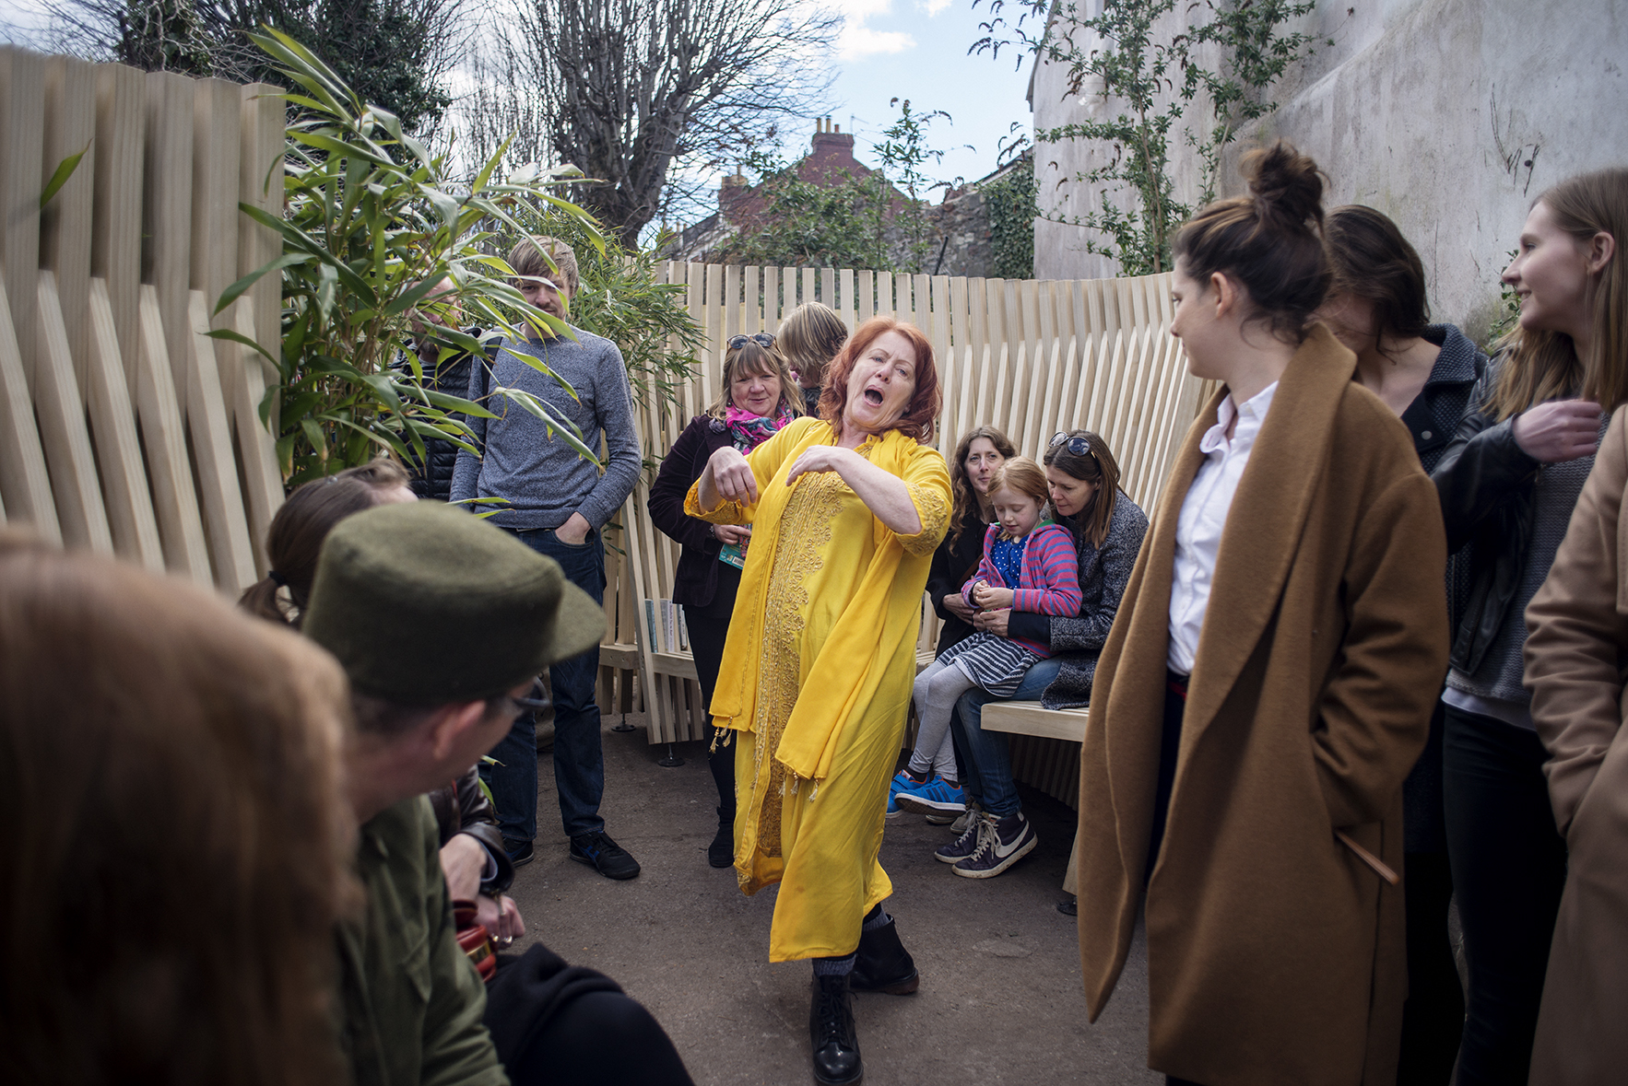
Image credit: Marcus Way Photography

