An Analysis of Managerial Factors Affecting the Implementation and Use of Overall Equipment Effectiveness

1st Author
Mrs. Nur Ainunnazli Binti Aminuddin
Warwick Manufacturing Group, The University of Warwick
International Manufacturing Centre, University of Warwick
Coventry, UK, CV4 7AL
E-mail: N.A.Binti-Aminuddin@warwick.ac.uk

2nd Author and Corresponding
Dr. Jose Arturo Garza-Reyes*
Centre for Supply Chain Improvement
The University of Derby
Kedleston Road Campus, Derby, UK, DE22 1GB
E-mail: J.Reyes@derby.ac.uk
Tel. +44(0)1332593281

3rd Author
Dr. Vikas Kumar
Bristol Business School
University of the West of England
Coldharbour Ln, Bristol, UK, BS16 1QY
E-mail: Vikas.Kumar@uwe.ac.uk
Tel. +44(0)1173283466

4th Author
Prof. Jiju Antony
School of Management and Languages
Heriot-Watt University
Edinburgh, Scotland, UK
E-mail: j.antony@hw.ac.uk
Tel. +44(0)1314518266

5th Author
Dr. Luis Rocha-Lona
Business School
National Polytechnic Institute of Mexico
Mexico City, Mexico
E-mail: lrocha@ipn.mx
Tel. Tel. +525553116328

* Corresponding Author

An Analysis of Managerial Factors Affecting the Implementation and Use of Overall Equipment Effectiveness

To ensure manufacturing organisations remain competitive, most of them are turning to Total Productive Maintenance (TPM) and lean manufacturing to ensure seamless operations. Overall Equipment Effectiveness (OEE) is the foundation of these two business improvement strategies as it tackles the underlying losses that impede equipment efficiency. This paper presents the prevalence of managerial issues related to the implementation and use of OEE in the manufacturing industry. To do this, five hypotheses and four research questions were formulated and tested using a combination of descriptive statistics and Cross Tabulation, Chi-Square, ANOVA, Tukey Pairwise Comparison, Z-test and Correlation tests. Data was collected through a survey questionnaire responded by 139 manufacturing organisations worldwide. The results establish, among other “soft” aspects, the linkage of the OEE implementation with that of TPM and lean manufacturing, and the drivers, most critical factors, barriers and the role of management in its implementation. The paper also identifies how manufacturing organisations employ the information provided by OEE and how the data for its computation is collected. This paper supports the very limited empirical research on the implementation and use of OEE. Thus, this research provides organisations, and their managers, with a better understanding of different factors that affect the successful deployment and management of this highly used measure in industry.

Keywords: Lean Manufacturing, Overall Equipment Effectiveness, Total Productive Maintenance

1. Introduction

To take better decisions to effectively and efficiently manage production systems, it is necessary for managers to establish appropriate metrics for measurement purposes (Nachiappan and Anantharam, 2006). Two of the most important and used metrics of performance in manufacturing operations are productivity and quality (Garza-Reyes et al., 2010). Overall equipment effectiveness (OEE) is a quantitative metric that endeavours to identify indirect and “hidden” productivity and quality costs, in the form of production losses.
These losses are formulated as a function of the mutually exclusive factors availability (A), performance (P) and quality (Q) (Huang et al., 2003). OEE is essentially the result achieved by multiplying these three components together as shown by equation (1):

OEE = A x P x Q (1)

The availability component measures the total time that a system is not operating because of set-ups, breakdowns, adjustments, and other stoppages (Jonsson and Lesshammar, 1999). In the case of the performance factor, it grades the ratio of the actual operating speed of a system (e.g. the ideal speed minus speed losses, minor stoppages and idling) to its ideal speed (Jonsson and Lesshammar, 1999). Finally, the quality factor expresses the proportion of defective production to the total production volume.
OEE is nowadays considered as one of the most important performance metrics being used by manufacturing organisations not only for monitoring the productivity and quality of production performance but also as an indicator and driver of performance improvements (Garza-Reyes et al., 2010; Andersson and Bellgran, 2011; ). This has prompted a wide stream of scholar research by the academic community. Table 1 summarises and categorises into four areas some of the academic research that has been conducted on OEE over the last two decades.

Insert Table 1 in here

Although Table 1 indicates that there is a considerable body of literature dedicated to review the OEE measure as well as to investigate its application, improvement, and relationship with other measures of performance and approaches; very limited empirical research has been conducted to understand the managerial implications regarding the implementation and use of OEE. In this sense, Sohal et al. (2010) carried out a study to identify the issues and challenges that organisations face during the deployment and use of OEE. In general, the study provides some light into the drivers/motives, critical success factors and barriers faced when implementing OEE as well as, once implemented, the critical success factors for its sustainment, the benefits obtained from, and challenges of using OEE. However, the study was limited to the collection of empirical data from six organisations only. As a consequence, although the results and conclusions drawn from such study may provide some insight into the managerial implications regarding the implementation and use of OEE, the validity can be considered limited and thus no generalisations can be drawn. To complement this study and support the very narrow empirical body of knowledge on the “soft” aspect of OEE, this paper explores different managerial conditions related to the implementation and use of OEE.
2. Literature review – formulation of hypotheses and research questions

2.1 Correlation of OEE implementation with TPM and lean manufacturing

Total Productive Maintenance (TPM) is considered to provide a foundation for the lean manufacturing’s (LM) philosophy through the reduction of equipment breakdowns and production defects (Nakajima, 1988; Chan et al., 2005; Ljungberg, 1998). The objective of deploying a TPM initiative is to acquire an overall improved productivity and quality through the effective use of production equipment. Thus, OEE was derived as a performance measure to determine the rate of effectiveness of equipment (Chan et al., 2005). Evidence suggests that there is an explicit linkage between OEE with TPM, lean and continuous improvement as it serves as one of the mechanisms to enable the effective application of TPM, and as a consequence the creation of a lean and continuous improvement culture (Belekoukias et al., 2014; Pakdil and Leonard, 2014). For example, Ahuja and Khamba (2008) suggest that OEE is a measure that supports the strategic outcome of a TPM implementation through the various metrics of manufacturing to reduce waste, which is also the main objective of LM. This suggests that there is a positive correlation between the implementation of OEE with that of TPM or lean initiatives, which may indicate that companies that have implemented these two improvement approaches are also more likely to have implemented OEE as a methodology to measure the performance of their production equipment. However, there is no empirical evidence to corroborate or refute this assumption. This led to the formulation of the following hypothesis:

H1: Organisations that have implemented both lean manufacturing and TPM are more likely to use OEE as a means of measuring its production performance than organisations that have not adapted both lean manufacturing and TPM.

2.2 Role of management, operator’s attitude and awareness training in the successful implementation of OEE
Garza-Reyes et al. (2010) and Bamber et al. (2003) comment that management support and the formation of small groups are key elements for the successful execution of OEE improvements. Similarly, Dal et al. (2000) study highlights the need for management support to ensure that the same level of enthusiasm is kept during the conduction of OEE improvement activities and that it is cascaded down to operational level, as their study indicated that it was only prevalent when the training on Kaizen activities and TPM workshops were in place. Besides understanding the role of OEE and its benefit to the organisation, training to operators in anticipating new roles is also highlighted as being important in the creation of autonomous workgroups (Bamber et al., 2003; Dal et al., 2000). Cross-functional teams are important in effectively addressing equipment losses as they contain a balanced mix of skills and knowledge of a production system to pinpoint activities that could be improved (Bamber et al., 2003). Sharma et al. (2006) concluded that a well-conceived plan with the aid of Autonomous Maintenance (AM) and Focus Improvement (FI) teams can also help to improve OEE and provide effective equipment maintenance. With the involvement of different teams in continuous improvement activities, it will then be required a team manager with strong leadership skills in order to facilitate the team in working together towards improvement initiatives.
McKone et al. (1999) also state the need to change the traditional employees’ mentality when implementing autonomous maintenance since there is a need for operators to take on maintenance roles. The need to take on new roles might result in employees’ resistance, which refers back to the ability of top management and the need for an effective implementation plan in terms of getting employees “buy-in” and a smooth transition to new OEE roles. Thus, the role of management, operator’s attitude and awareness training in the successful implementation of OEE is investigated through the following hypothesis.

H2: Management support, operators’ attitude and awareness training are equally important to ensure the successful implementation of OEE for an organisation.

To complement this investigation and H2, the following research questions were posed.

RQ1: What are the most common roles management teams are expected to be involved in and during the implementation phase of OEE?

RQ2: What should be considered as part of training to prepare operators prior to the implementation of OEE?

RQ3: What are the main challenges that organisations face during the implementation of OEE?

2.3 Identification of improvements and understanding of OEE

Besides being used as a performance measure at operational level, OEE is also used as an indicator for process improvement activities as it provides an insight into manufacturing issues such as excessive breakdowns, lack of preventive actions and an effective corrective maintenance approach, among others (Dal et al., 2000). Similarly, Garza-Reyes et al. (2010) comment that although OEE was originally designed to monitor and control performance, it has also been used to identify process improvement opportunities and as an approach to measure and achieve them. For example, Dal et al. (2000) used it to measure the improvement of a process within a manufacturing environment while Sohal et al. (2010) suggest that it can be used to analyse production data and identify potential areas for improvement and waste elimination. In this scenario, Sohal et al. (2010) highlight that teams can refer to OEE data in order to establish improvement programmes linked to TPM and lean. In the same way, Bamber et al. (2003) remark that by concentrating on quality, productivity, and machine utilisation issues, OEE is often used not only to identify areas for improvement but also to drive the improvement initiatives of a business.
However, in order for organisation to effectively identify improvement opportunities it is necessary for them to have a clear understanding of the OEE concept and its comprising elements (i.e. Availability, Performance and Quality) as well as a consistent definition of them. For instance, Baluch (2013) suggests that after years of use and misuse and given the lack of agreement between OEE experts, the acceptance of a single OEE definition within a business and industry is unlikely. For this reason, Baluch (2013) and Eldridge et al. (2005) comment that, in industry and the literature, it is possible to find inconsistencies in different aspects of OEE that include its interpretation, calculation, definition of losses and ideal cycle time, treatment of planned downtime and minor stoppages as well as the definition of an optimum overall value. This can prompt misunderstandings on the application of OEE, which may consequently result in incorrect application of the measure. For instance, the study conducted by Da Costa and de Lima (2002) on a Brazilian carmaker revealed several misunderstandings on OEE, mainly related to the calculation of cycle time as well as OEE misuses by using it as means to discuss capacity and identifying bottleneck machines. De Ron and Rooda (2005) had also made several observations concerning the application of OEE, mainly regarding the understanding of the considered time period and application of rate efficiency. This suggests the importance of having a clear understanding of the OEE concept and its elements prior to implementing the measure plant-wide.
Although it is clear, as indicated in by the previous discussion, that one of the roles of OEE has been to highlight areas for improvement, it is less clear as to whether manufacturers that have deployed OEE refer to it, compared to other operational measures, to identify improvement opportunities. Huang et al. (2003) suggest that this may be the case in the semi-conduct industry as they highlight that the traditional metrics of measuring throughput and machine utilisation are not sufficient to identify problematic areas that require improvement. Nevertheless, this is still unclear in other industries. In addition, the discussion above reveals the importance of having an understanding of OEE in order for it to be meaningful and subsequently provide a platform for identifying improvement opportunities. Hence, the following hypotheses were formulated:

H3: Understanding of the elements in OEE is vital to ease the selection of areas for improvement.

H4: Manufacturing organisations tend to identify improvement opportunities by referring to OEE compared to other performance measures.

The following research question was derived to further investigate the uses of OEE by organisations that have implemented it.

RQ4: How do organisations use the information gathered from OEE?

2.4 OEE data collection

In terms of data collection for OEE calculations, organisations should tread with caution when using it as accuracy is important in determining the effectiveness of the improvement activities. The need for measurement accuracy in determining OEE values has been emphasised by Wang and Pan (2011), Muchiri and Pintelon (2008), Eldridge et al. (2005) and Jeong and Phillips (2001). Sohal et al. (2010) found that a resistive culture could also lead to data inaccuracies and consequently demotivate employees, which may threaten the implementation of OEE. This also implies that although management has a key role in the implementation and simplification of operator roles such as that of data collection, automation needs to be in place to ensure an effective and timely computation of OEE in the organisation (Wang and Pan, 2011). An automated data collection was given a positive outlook to ensure appreciation towards the OEE values for performance improvements; therefore, the following hypothesis was derived:

H5: Organisations tend to use an automated data collection system in order to obtain accurate data compared to other methods of data collection.

3. Research methodology

3.1 Survey questionnaire

To support any research, and thus to produce reliable evidence, Houser (2008) suggests that the selection of an appropriate and effective data collection method is vital. In this case, since the subject focus was to investigate different managerial aspects of OEE, by testing the five hypotheses and four research questions formulated, in manufacturing organisations dispersed around the world, a survey questionnaire was selected as the most appropriate primary source of data. The questionnaire was developed using a well-known freeware via Google Forms, which respondents could easily access via web browser or mobile phones and from where results were directly tabulated into an Excel spreadsheet for an easy analysis. The questions were designed to provide nominal data which could be analysed descriptively as well as ordinal data that revealed a relationship between variables which were then analysed using inferential statistics. Twenty fixed-alternative questions were developed based on the hypotheses and research questions generated through the literature review. In cases where the questions offered choices for the respondents to select, these were formulated by combining the industrial and research experience of the authors with evidence from critical success factors and cases study regarding the implementation of approaches such as LM and TPM. Table 2 presents an overview of the questionnaire, including its sections, questions and relationship with the hypotheses and research questions that were investigated.

Insert Table 2 in here

3.2 Questionnaire validity and reliability

Reliability and validity are important in research as there is a need to ensure that the data collected, examined and analysed is consistent and accurate in order to obtain credible findings (Saunders et al., 2009). Robson (2011) suggests a method for validation by utilising a small group of individuals as a pilot study prior to the distribution of the questionnaires to participants. This method was adopted by the authors. In this case, a target of 6 subjects was used for the pilot study in accordance with recommendations from Robson (2011), hence the questionnaire was sent out to 6 manufacturing professional industrialists.
Robson (2011) asserts four threats to reliability; subject or participant error, subject or participant bias, observer error and observer bias. The objective of this pilot study was to ensure that the first two threats were overcome through the elimination of irrelevant questions and ambiguities when understanding and answering the questions. There was also opportunity given to provide feedback on whether any additional questions were needed to address the issue as well as to provide feedback on the linguistic and presentation aspects of the questionnaire. The last two threats were not relevant as the questionnaire used fixed-alternative questions that did not require interpretation. As a result from the feedback of the pilot study, some questions were rectified to ensure that respondents had the same interpretation of the questions.

3.3 Questionnaire distribution

A total of 880 questionnaires were sent via electronic mail to identified respondents, consisting of managers and engineers involved in manufacturing operations, as it is a quicker form of distribution for a large number of intended participants at low cost (Kaplowitz et al., 2004). As this was an exploratory research, the questionnaires were distributed to respondents worldwide. The participant organisations were randomly identified and selected from data bases and directories such as Amadeus, LinkedIn, IQS Directory and Global Sources while some others were personal contacts of the authors. The organisations that participated in this study were not necessarily involved with the use of OEE since the research also attempted to investigate why these organisations were not using it.
Out of the 880 questionnaires sent, a final total of 139 responses were obtained, making the response rate figure of 15.8%. Based on comparative studies in similar fields (i.e. Kirkham et al., 2014; Kumar et al. 2014; Mitra and Datta, 2014), the sample size of 139 responses used for the analysis was considered acceptable.

4. Survey questionnaire results

4.1 Organisations profile

Table 3 presents the profile of the respondent organisations in terms of their size, geographic location and industrial sector.

Insert Table 3 in here

4.2 OEE implementation

From the 139 respondents, 75.5% (105 organisations) had implemented OEE while 24.5% (34 organisations) had not. Since it could be safely assumed that organisations which had not implemented OEE would not have sufficient knowledge on it to provide reliable answers to test the formulated hypotheses and answer the research questions posed, only the answers of the 105 organisations that had implemented OEE were considered for the analyses presented in the following section.
Organisations that had implemented OEE were also asked whether they had deployed any other business improvement initiative. The top five business improvement initiatives that were implemented in organisations that were using OEE were lean manufacturing (LM) with 84.8%, followed by TPM with 81%, Total Quality Management (TQM) with 66.7%, Six Sigma with 46.7% and lean Six Sigma with 28.6%.
Organisations that had not implemented OEE were requested to rate the potential barriers to stop them from doing so. The barriers were ranked using a Likert scale. Figure 1 shows the distribution of opinions for each of the possible barriers. The 5-point Likert scale was grouped into three categories (Agree, Neutral and Disagree) to show significance in the result as most respondents tend to avoid extreme scales (Hair et al., 2006). It highlights that many respondents (62%) expressed disagreement that lack of finances is one of the barriers to implement OEE, whereas 76% agreed that the reason that organisation did not choose to implement OEE is because of the lack of awareness on how OEE can contribute to the improvement of the organisation’s operations.

Insert Figure 1 in here

4.3 Hypotheses and research questions - results

H1: Organisations that have implemented both lean manufacturing and TPM are more likely to use OEE as a means of measuring its production performance than organisations that have not adapted both lean manufacturing and TPM.

Results from respondents that had implemented LM and TPM and that had, or had not, implemented OEE to measure production performance were categorised into groups, see Table 4.

Insert Table 4 in here

In order to test H1, null (H0) and alternative hypotheses (H1) regarding the statistical association between implementing LM and TPM with the implementation of OEE were formulated. As these were categorical data, a Cross Tabulation and Chi-Square tests were performed on Minitab with an α-level of 0.05 for the Chi-Square test, see Figure 2(a). The result of the Chi-Square revealed a P-value of less than 0.05 (P = 0.008), which resulted in the rejection of H0 (Brook, 2010) and an indication of the association between the implementation of LM and TPM with the implementation of OEE. The acceptance of H1 thus suggests that organisations that have implemented LM and TPM approaches are more likely to use OEE as a means of measuring their production performance.

Insert Figure 2 in here

H2: Management support, operators’ attitude and awareness training are equally important to ensure the successful implementation of OEE for an organisation.

Several factors were found to be important in ensuring a successful OEE implementation. Respondents were asked to rate the importance of three factors; management support, operator attitude and awareness training. The results of the survey revealed that the majority of respondents agree that although strong management support and positive operator attitude is required to ensure an OEE’s implementation success, awareness trainings is more important.
To test H2, with an assumption that the results were normally distributed and have equal variances, an Analysis of Variance (ANOVA) was performed to compare the means from the survey results of all three factors. Prior to that, null (H0) and alternative (H1) hypotheses related to the no difference (H0) and difference (H1) between the importance levels for the factors that affect OEE implementation success (Management support, operator attitude and training) were formulated. The result of the ANOVA, see Figure 2(b), revealed a P-value of less than 0.05 which, indicates an acceptance of the alternative hypothesis H1 (Brook, 2010). This clearly shows that there is a significant difference between the three factors and that one of the criteria is more important than the others. As the result of the ANOVA rejected the null hypothesis, there was substantial evidence that a difference in the mean (level of importance) for each factor existed. A Tukey Pairwise Comparison was then applied to investigate the reason behind the significance of the test result. The result, see Figure 2(c), revealed that both awareness training and operators’ role are significant in ensuring the successful implementation of OEE. A correlation analysis was also performed to investigate the relationship between the role of management support, operators’ attitude and awareness training. The outcome of the correlation analysis shows that awareness training and operators’ role are significantly correlated (.390) at p<0.01 level. In addition, management support and operators’ attitude was also found be positively correlated (.289) and significant at p<0.01 level. These relationships were further explored with the following research questions.

RQ1: What are the most common roles management teams are expected to be involved in and during the implementation phase of OEE?

For this research question, respondents were requested to rate the relevance of the roles that management teams need to be involved with for the successful implementation of OEE. Out of the five roles (see Table 2) that were presented to the respondents, the majority, 99% and 98% respectively, agreed that management teams need to be strongly involved in activities such as the communication and engagement with shop-floor employees during the implementation of OEE as well as and in the removal of barriers during such deployment, for example, by providing shop-floor employees with a platform for voicing out grievances and suggestions for improvement. Other important roles, according to the respondents, included the simplification of data collection, development of a training plan and conveyance of training. To further investigate the importance of the most common roles management teams are expected to be involved in during the implementation phase of OEE, a correlation analysis was conducted. Among the various roles, the outcome showed that a correlation was evidenced between development of training plan and conveyance of training (.668, p<0.01). Data collection simplification was found to be correlated with development of training plan (.300, p<0.01) and conveyance of training (.428, p<0.01) as well as with communication and engagement with shop-floor employees (.238, p<0.05). Removal of implementation barriers was found to be correlated with development of training plan (.193, p<.05) and communication and engagement with shop-floor employees (.280, p<.01). These findings supported the assertions made earlier.

RQ2: What should be considered as part of training to prepare operators prior to the implementation of OEE?

Respondents were requested to rate the level of importance for each training needs, see Table 2, which will aid operators in preparing for the OEE implementation. In this scenario, 96.2% of the respondents agreed that operators need to be equipped with sound knowledge of equipment losses while 94.3% of the respondents suggested that they must possess knowledge on basic equipment handling. This was followed by understanding of the required roles operators need to perform (91.4%) in order to support OEE as well as to understand the importance of data collection in ensuring a meaningful OEE measure (85.7%). Other trainings related to understand the role of management, how OEE supports a business and how it is calculated were considered less important with 79%, 54.3% and 36.2% of the respondents respectively agreeing with this.

RQ3: What are the main challenges that organisations face during the implementation of OEE?

Figure 3 illustrates the main challenges that the respondent organisation faced during the deployment of OEE. These results corroborate the findings of H2, which highlighted the importance of operator training over management support and operator attitude in order to achieve successful OEE implementation, with 20.6%, of the respondents claiming it as the main challenge.

Insert Figure 3 in here

H3: Understanding of the elements in OEE is vital to ease the selection of areas for improvement.

Jeong and Philips (2001) stated that understanding stoppages or loss categories increases the probabilities of discovering and eradicating the causes of equipment losses. Understanding how OEE is calculated and the importance of data accuracy were also found to be the basic foundation of OEE. Hence, H3 aimed at exploring this through the understanding of these three elements (i.e. understanding stoppages or loss categories, understanding OEE calculation and data accuracy), which facilitate the identification of improvement opportunities (Jeong and Philips, 2001; Nakajima, 1988). The results indicate that 97.1% of the respondents considered the understanding of stoppages or loss categories and data accuracy as vital to effectively identify improvement opportunities when using OEE while 73.1% believed that this was also the case for understanding how OEE is calculated. To test H3, null and alternative hypotheses regarding a difference (H1), or no difference (H0), between the levels of understanding among the three elements of OEE to ease the selection of areas of improvement were formulated. An ANOVA was then performed to determine whether there were statistically significant differences among the three identified elements in the selection of areas for improvement. The results, see Figure 2(d), showed a P-value of less than 0.05 (P-value < 0.001), which suggested the rejection of H0 (Brook, 2010). This demonstrates that there is a significant difference between the levels of understanding required for the three elements. A further investigation was performed through a Tukey Pairwise Comparison to determine which factor contributed the most to the significance of the test. The results, see Figure 2(e), showed that understanding stoppages and loss category as well as the importance of data accuracy were the most significant to help management teams select areas for improvement. This was further verified by the correlation analysis, which showed that elements of OEE are correlated. Understanding of stoppages or losses categories and understanding of OEE calculation were positively correlated (.195) and significant at 0.05 level. The understanding of OEE calculation and understanding the method of collecting data were also found to be significantly correlated (.437, p< 0.01).

H4: Manufacturing organisations tend to identify improvement opportunities by referring to OEE compared to other performance measures.

Based on the survey responses, a one sample Z-test was performed in order to test H4, see Figure 2(f) for results. The P-value for the test revealed a value of less than 0.05, which indicated that based on a 95% confidence interval; there was failure to accept H0 (i.e. Manufacturing organisations refer to OEE 100% of the time to identify improvement activities) (Brook, 2010). This shows that manufacturing organisations do not only refer to OEE as a means to identify improvement activities. However, the test also revealed that there is a 95% confidence that OEE is referred between 59.4% and 66.5% of the time.

The survey results showed that organisations do in fact refer to other measures to identify improvement opportunities and that most of them refer to more than one measure, these are shown in Figure 4.

Insert Figure 4 in here

RQ4: How do organisations use the information gathered from OEE?

The survey results revealed that 71.9% of the respondents use the information gathered from OEE as a means to identify improvement activities whereas 62.6% stated that they use it to benchmark the performance of their productions lines and equipment. Other uses of such information include: to know the equipment’s status (i.e. performance) (61.9%), track the results of improvement activities (58.3%), for management to give timely and appropriate feedback on equipment improvement (30.9%), for loss analysis (29.5%), for annual target setting (25.2%) and for financial budgeting setting (17.3%).

H5: Organisations tend to use an automated data collection system in order to obtain accurate data compared to other methods of data collection.

Of the 105 respondents that use OEE to measure performance, 54 (56.3%) had adopted a mixed data collection method which combines both automated and manual data collection, 42 (43.8%) implemented an automated system, whereas only 9 (9.4%) use a pure manual data collection system. To test H5, Cross-tabulation and Chi-Square tests were performed. The results, see Figure 5, show that the P-value from the Chi-Square test was below 0.05, which indicated the failure to accept the H0 (i.e. there is no significant association between data collection method and data accuracy), hence, it can be concluded that there is, in fact, an association between data collection method with data accuracy. In addition, a further investigation was conducted to understand the reasons behind the selected data collection system. Based on the 54 organisation that chose the mixed method, 64.8% made this decision in order to get better data accuracy. Out of the 52 organisations that opted for an automated system, the majority decided to use this method to have real-time reporting and to let operators focus more on equipment improvement. As for the 9 organisation that maintained a manual method, 44.4% decided that the method was better to ensure that all stoppages were being recorded.

Insert Figure 5 in here

5. Discussion of results

Hypothesis 1
The results of this study indicate, through H1, that organisations that implement both TPM and LM would also use OEE to measure operational performance. Sharma et al. (2006) suggest that OEE is an important measure within TPM as it indicates the performance through a holistic approach that considers the utilisation of equipment and resources of a manufacturing system. As TPM is considered a basic tool for organisations going through a lean transformation (Bicheno and Holweg, 2009), it is therefore not surprising that Sohal et al. (2010) commended the existence of a clear linkage between OEE with TPM and LM. Hence, it could be concluded that this study’s results support the literature whereby organisations that implement both LM and TPM will most likely use OEE to measure performance. Nevertheless, despite the acceptance of H1, there still exist organisations that use OEE without having both TPM and LM being implemented. As OEE is the basis of TPM and subsequently LM, this might be due to the organisations still being in the early stages of the implementation of TPM and LM. For organisations that have implemented both LM and TPM but do not employ OEE as a performance measure, it might be due to various reasons. For example, due to the loss of ownership by operations management teams as confusion might exist between OEE as being more about maintenance rather than production reliability as well as the failure to initiate an operator-involved maintenance or autonomous maintenance within the shop-floor team. However, the explanation for the abovementioned categories of organisations could be explored further to understand the scenarios faced by them.

Hypothesis 2
Although the literature indicates that management support is vital in the OEE implementation (Garza-Reyes et al., 2010), the results from the survey show that providing employees with ‘awareness training’ prior to the implementation of OEE is considered more important. This is true as the training will help organisations develop a sense of ownership in the measure within the management and shop-floor teams. Hansen (2002) suggests that a highly driven, well-trained and flexible workforce is vital in helping organisations succeed. He also mentions that active learning and training are all attributes to a well-trained workforce which will eventually contribute to a successful OEE implementation (Hansen, 2002). Although the research findings do support the literature, the focus has now turned to prioritising trainings made for employees in order to support and ensure a successful implementation rather than focusing on management support. Further research could be performed to investigate the association between the categories investigated in H2 towards a successful OEE implementation through a regression analysis.

Research Question 1
Even though H2 did not suggest the management support to be significant in a successful OEE implementation, it could not be denied that it still plays a major role, as also indicated in the study. The survey results suggest that the majority of the organisations agreed that management plays a role in communicating and engaging with shop-floor. This practice is not only confined to the implementation phase but also during day-to-day problem solving activities, where together with the shop-floor, action plans are derived and agreed upon. Another role that was found to be relevant to the management team is the removal of barriers to ensure a smooth OEE implementation. This is supported by the literature, where it is suggested that management is to provide shop-floor with the basics on how to measure OEE as data collection and accuracy have been proven to be among the main challenges for many organisations (Muchiri and Pintelon, 2008). This goes hand-in-hand with data collection simplification, where this too was agreed by organisations as relevant to the role that management teams should be involved with during the implementation of OEE. Moreover, Ljungberg (1998) highlighted the importance of working together with the shop-floor team to design data collection forms based on the operating nature of equipment.

Research Question 2
Rather than making operators aware about how OEE could help improve the organisation’s business as it is suggested by Nakajima (1988) for TPM implementation, most respondents agreed that operators should be first equipped with the knowledge of equipment losses and basic equipment handling. By starting off OEE efforts on equipment which suffers chronic loss, confidence for the team will build up and the programme’s effectiveness will be proven (Nakajima, 1988). By understanding the equipment losses, operators would eventually appreciate the importance of OEE for the organisation. It was also revealed by the survey that operators on the shop-floor should understand their role in OEE. This is true as the shop-floor teams are responsible to manage equipment breakdowns first-hand and ensuring the smooth running of the production lines. As mentioned by Nakajima (1988), providing training for operators would raise their skills level and reactions to anomalies would become reflexes when often utilised. It is through the improvement of skills in operators that the gaps in basic OEE knowledge such as basic equipment fixes and losses as well as accuracy in data collection would eventually reduce. In the end this would create an autonomous workforce that would focus on eradicating losses and subsequently ease OEE implementation and improve the OEE measure.

Research Question 3
Research conducted by Sohal et al. (2010) highlighted the importance of tackling employee resistance, which was also deemed as one of the challenges to the implementation of OEE. This could be overcome through consistent training and awareness for employees, which according to the survey it was considered the top challenge in the implementation of OEE. Ljungberg (1998) also mentions that conducting training is a necessary foundation for the overall implementation. Moreover, Dal et al. (2000) highlighted the importance of awareness training to help cascade down the level of enthusiasm down to the shop-floor in order to have effective improvements put in place. Therefore, if organisations are provided with sufficient training and awareness about the importance of OEE, it could lead to a resistance-free, well-supported implementation of the measure.

Hypothesis 3
H3 indicated that respondents do not consider that understanding the OEE calculation is as important as understanding equipment stoppages or loss categories and having accurate data. Many organisations use the basic Availability x Performance x Quality, as devised by Nakajima (1988), for the OEE calculation. However, without the understanding of stoppages and loss categories, error would be made in terms of the calculation. This will cause imminent failure in the implementation of OEE as the lack of this understanding will accelerate the deterioration of equipment and hinder the ability to maintain basic equipment and operating conditions. Chan et al. (2005) claimed that the misunderstanding of the OEE concept would create confusion. It is therefore important to understand the different types of losses and the reasons causing it as a basis for actions. On the other hand, Wang and Pan (2011) claim that without accurate data, it is impossible to obtain a meaningful OEE measure as it causes difficulty in identifying areas to improve. This will eventually lead to decreasing confidence in the measure (Wang and Pan, 2011). Nakajima (1988) also stated the importance of data accuracy in ensuring that the necessary management and control of breakdowns take place. The finding of this research corroborates this.

Hypothesis 4
Based on the results of this study, it could be concluded that OEE is not the only measure that organisations refer to when identifying improvement activities but that other measures are also utilised, see Figure 4. Jonsson and Lesshammar (1999) indicate the need to have several structured sets of measures and a balanced scorecard in order to cover all aspects of production management. This is important to link internal and external measures to gain an insight into the overall organisation’s performance. In terms of OEE, although it covers the six big losses, material losses such as overfilling and overweight are not considered as part of the quality function of OEE (Garza-Reyes, 2010; Garza-Reyes et al., 2008), which reveals a weakness in the measure and the need to refer to other measures. Additionally, OEE assumes that all losses are equally important and that any improvement in OEE will positively improve business performance, which generally may not be the case (Baluch, 2013). Baluch (2013) also suggests that OEE can appear improved by the purchase of redundant standby critical equipment. He comments that this is a common practice to hide production inefficiencies. Finally, OEE is only valid for benchmarking or comparing similar processes/equipment (Baluch, 2013) when their original constraints are not changed. Due to these apparent limitations, it could be concluded that it would not be effective to use OEE as the only measure to identify improvements. Therefore, to achieve an overall increased organisational performance, other measures need to be referred to (Jonsson and Lesshammar, 1999). Baluch (2013) suggests, for example, operating and maintenance costs, return on net assets, mean time between failure, mean time to repair, and utilisation.

Research Question 4
Organisation agreed that the main use of the information obtained from the OEE calculation was to identify improvement activities, followed by using it as a benchmark for other production lines as well as to know the equipment status. This corroborates what Dal et al. (2000) suggest regarding the fact that OEE can be used as a benchmark, especially to measure the initial performance of a newly setup plant or compare performances between several production lines. Nakajima (1988) mentions that OEE could also be used to monitor machine performance or equipment status to detect those with the worst performance in order to initiate improvements. According to Andersson and Bellgran (2011), OEE is traditionally used by organisations as an operational measure, however, it could also be used to track process improvement activities (Garza-Reyes et al., 2010), as 58.3% of the responses revealed. Based on the survey’s feedback, it could be stated that organisations are using the measure in line with what it is advised in the literature, although there are several other uses that include management to provide immediate feedback on equipment status as well as loss analysis and annual and budget settings.

Hypothesis 5
The survey results showed that most of the organisations had adopted a mixed data collection method for the computation of OEE, followed by automated and manual systems. The low response for manual data collection shows that the method is not widely practiced across the industries, despite Ljungberg (1998) suggesting that this method is detailed and easier to examine equipment failure. This is perhaps due to the method being time consuming. In this case, organisations should adapt a method that is not labour intensive in order to reduce operator resistance against data collection. An automated data collection method is a powerful tool to help improve equipment utilisation. This is supported by Andersson and Bellgran (2011), who claim that user-friendly templates supported by an automatic data collection system provide reliable performance data. Wang and Pan (2011) state the importance of improving data collection and recording methods in order to maintain the credibility of OEE as a performance measure. Therefore, based on these studies, it is expected that many organisations would adopt one of the two methods, i.e. automated or semi-automated, as revealed by this research, despite these methods being more expensive and complex than manual methods. It was also found that organisations that use an automated data collection system implemented it to let their shop-floor operators focus more on equipment improvement and for real-time reporting.

Non-OEE practitioners
Out of the 139 respondents of the survey, 34 organisations acknowledged that they did not use OEE to measure performance. Based on the results, the majority of the respondents in this category disagreed that lack of finances was a barrier to implementing OEE, but many expressed that it was due to the lack of awareness on how OEE could benefit the organisation. Dal et al. (2000) comment that OEE is viewed more as an operational measure that has no direct linkage to the overall business performance. This might be one of the reasons behind the lack of awareness about OEE. Besides that, many claimed that implementing OEE requires too much effort, which may be linked to lack of resources. However, Hansen (2002) indicated that a fundamental problem is the lack of teamwork between production and maintenance teams. Since only a small amount of organisations that did not implement OEE responded to this survey, further studies could be performed to gather more information and investigate the true reasons behind this decision.

6. Conclusions, limitations and future research

This paper presents the prevalence of managerial issues related to the implementation and use of OEE in the manufacturing industry. In particular, it reveals the linkage of OEE implementation with that of TPM and LM, drivers, most critical factors, barriers and the role of management in its implementation as well as how manufacturing organisations employ the information provided by OEE and how the data for its computation is collected. By investigating these managerial factors, this research is among the very few studies that have focused on the “soft” aspect of OEE, filling, in this way, a gap in the academic literature as previously highlighted in Section 1. This is considered the main theoretical contribution of this research.
The results signify the idyllic environment that best facilitates the implementation and utilisation of OEE to help practitioners and support the existing academic research on the subject. For organisations that will embark in the OEE implementation, this study highlights that awareness training, a clear operators’ role definition, knowledge of equipment losses and basic equipment handling are some of the factors that organisation will need to develop prior to the implementation of OEE. These factors, supported with a strong involvement of top management in the implementation of OEE and making the removal of barriers one of its top priorities, will play a major role in the successful deployment of this approach. Thus, organisations could refer to this study when planning for the OEE deployment in order to minimise complications that might arise from its implementation.
The research has proven that it is important that prior to a full OEE implementation, the management team needs to ensure an understanding of the stoppages and loss classifications as well as ensuring data accuracy so that the selection of improvement activities improve equipment efficiency. It has also been highlighted that management needs to constantly engage with the shop-floor and help remove implementation barriers faced by them. This will not only improve the relationship between management and shop-floor operators but also create a conducive working environment and a sense of responsibility towards the measure. Finally, in order to gain maximum productivity improvements, organisations should not solely rely on OEE but also need to refer to other operational measures to improve overall organisation’s performance.
In terms of the study limitations, various constraints were encountered, with complex confounding factors that are important to highlight in order for similar future studies to consider. The relatively limited amount of global and regional sampling (i.e. 139 responses) and the fact that the Likert-style rating scale for the survey limits the ability of respondents to express opinions other than the pre-set answers can be considered two of the major limitations of this study. The geographical dispersion of the survey incorporated many non-English speaking countries, which limited the response rate in such instances. To gain a deeper understanding of the OEE’s implementation and use, it would therefore be beneficial to conduct a larger scale study by translating the data collection instrument into a variety of languages as a strategy to increase the sampling size and response rate. This is part of the future research agenda derived from this research. To overcome the Liker scale limitation, coupling this research with a qualitative approach such as interviews on selected companies would gain a further insight into the issues that are being faced by organisations during implementation and use of OEE and strengthen the results further.
To further develop this area, research could be performed to help organisations plan implementation activities better through the generation of a statistical model and tested on organisations that wish to embark on a lean journey by first implementing OEE in their system, or for organisations that just want to use OEE as a measure to improve productivity. Moreover, with a larger sample size, a continuation to study the barriers for implementation by non-practitioners could also help guide the above recommendation. This research focused mainly on the management, operator and training aspects of OEE. Thus, there is also an opportunity to investigate, define and rank the enhancing managerial attributes which may contribute to the successful implementation of OEE. This can be done for specific industries and countries, and through the use of, for example, a combination of fuzzy logic and quality function deployment (QFD) as indicated by Theagarajan and Manohar (2015). Finally, since there might be various complications when multiple departments engage in a single activity, there is also an opportunity to explore how cross-functional teams work together when dealing with improvement activities as well as their effect on the implementation, management and sustainment of OEE. As a conclusion, while this study has provided some insight and highlights several practices in the course of OEE implementation, it has opened up new areas for research.

References
Ahire, C.P. and Relkar, A.S. (2012), “Correlating failure mode effect analysis (FMEA) & overall equipment effectiveness (OEE)”, Procedia Engineering, International Conference on Modelling Optimization and Computing, Vol. 38, pp. 3482-3486.
Ahuja, I.P.S. and Khamba, J.S. (2008), “An evaluation of TPM initiatives in Indian industry for enhanced manufacturing performance”, International Journal of Quality & Reliability Management, Vol. 25 No. 2, pp. 147‐172.
Andersson, C. and Bellgran, M. (2011), “Combining Overall Equipment Efficiency (OEE) and productivity measures as drivers for production improvements”, Proceedings of the 4th Swedish Production Symposium (SPS11), Lund, May 3-5.
Anvari, F., Edwards, R. and Starr, A. (2010), “Evaluation of overall equipment effectiveness based on market”, Journal of Quality in Maintenance Engineering, Vol. 16, No. 3, pp. 256 – 270.
Anvari, F. and Edwards, R. (2011), “Performance measurement based on a total quality approach”, International Journal of Productivity and Performance Management, Vol. 60, No. 5, pp. 512-528.

Badiger, A.S. and Gandinathan, R. (2008), “A proposal: evaluation of OEE and impact of six big losses on equipment earning capacity”, International Journal of Process Management and Benchmarking, Vol. 2, No. 3, pp. 234-248.
Baluch, N. (2013), Maintenance management performance of Malaysian palm oil mills, Lambert Academic Publishing, Saarbruëcken.
Bamber, C., Castka, P., Sharp, J. and Motara, Y. (2003), “Cross-functional team working for overall equipment effectiveness”, Journal of Quality in Maintenance Engineering, Vol. 9, No. 3, pp. 223-239.
Belekoukias, I., Garza-Reyes, J.A. and Kumar, V. (2014), “The impact of lean methods and tools on the operational performance of manufacturing organisations”, International Journal of Production Research, Vol. 52, No. 18, pp. 5346-5366.
Bicheno, J. and Holweg, M. (2009), The lean toolbox: the essential guide to lean transformation, PISCIE Books, Buckingham.
Braglia, M., Frosolini, M. and Zammori, F. (2009), “Overall equipment effectiveness of a manufacturing line (OEEML): an integrated approach to assess systems performance”, Journal of Manufacturing Technology Management, Vol. 20 No. 1, pp. 8-29.
Brook, Q. (2010), Lean Six Sigma and Minitab: the complete toolbox guide for all lean Six Sigma practitioners, 3rd Edition, Opex Resources Ltd, UK.
Chan, F.T.S., Law, H.C.W., Ip, R.W.L., Chan, H.K., Kong, S. (2005), “Implementation of Total Productive Maintenance: a case study”, International Journal of Production Economics, Vol. 95, pp. 71-94.
Chien, C.F., Chen, H.K., Wu, J.Z. and Hu, C.H. (2007), “Constructing the OGE for promoting tool group productivity in semiconductor manufacturing”, International Journal of Production Research, Vol. 45, No. 3, pp. 509-524.
Da Costa, S.E.G. and de Lima, E.P. (2002), “Uses and misuses of the ‘overall equipment effectivenss’ for production management”, IEEE International Engineering Management Conference (IEMC), Cambridge, UK, 18-20 August.
Dal, B., Tugwell, P. and Greatbanks, R. (2000), “Overall equipment effectiveness as a measure of operational improvement – a practical analysis”, International Journal of Operations & Production Management, Vol. 20 No. 12, pp. 1488-502.
De Ron, A.J. and Rooda, J.E. (2005), “Equipment effectiveness: OEE revisited”, IEEE Transactions on Semiconductor Manufacturing, Vol. 18, No. 1, pp. 190‐196.
De Ron, A.J. and Rooda, J.E. (2006), “OEE and equipment effectiveness: an evaluation”, International Journal of Production Research, Vol. 44, No. 23, pp. 4987-5003.
Eldridge, S., Garza-Reyes, J.A., Barber, K.D. (2005), “An analysis of OEE performance measurement for an automated manufacturing system”, Proceedings of the 15th International Conference on Flexible Automation and Intelligent Manufacturing (FAIM), Bilbao, Spain, July 18-20.
Garza-Reyes, J.A., Eldridge, S., Barber, K.D. (2006), “Using discrete-event simulation and Taguchi methods to analyse the Overall Equipment Effectiveness (OEE) of an automated bottling process”, Proceedings of the 16th International Conference on Flexible Automation and Intelligent Manufacturing (FAIM), Limerick, Republic of Ireland, June 26-28.

Garza-Reyes, J.A., Eldridge, S., Barber, K.D., Archer, E. and Peacock, T. (2008), “Overall resource effectiveness (ORE) – an improved approach for the measure of manufacturing effectiveness and support for decision-making”, Proceedings of the 18th International Conference on Flexible Automation and Intelligent Manufacturing (FAIM), Skövde, Sweden, 30 June-2 July.
Garza-Reyes, J.A., Eldridge, S., Barber, K.D. and Soriano-Meier, H. (2010), “Overall equipment effectiveness (OEE) and process capability (PC) measures – a relationship analysis”, International Journal of Quality & Reliability Management, Vol. 27, No. 1, pp. 48-62.
Garza-Reyes, J.A. (2010), An investigation into some measures of manufacturing performance - Overall Equipment Effectiveness (OEE), Process Capability (PC), OEE+ and ORE, LAP Lambert Academic Publishing, Germany.
Gibbons, P.M. and Burgess, S.C. (2010), “Introducing OEE as a measure of lean Six Sigma capability”, International Journal of Lean Six Sigma, Vol. 1, No. 2, pp. 134–156.
Hair, J.F., Black, W.C., Babin, B.J., Anderson, R.E., Tatham, R.L. (2006), Multivariate data analysis, 6th edition, Pearson Education Inc., Upper Saddle River, New Jersey.
Hansen, R.C. (2002), Overall equipment effectiveness: a powerful production/maintenance tool for increased profits, Industrial Press, New York.
Houser, J. (2008), Nursing research: reading, using, and creating evidence, Jones and Bartlett Publishers, Sudbury, MA.
Huang, S.H., Dismukes, J.P., Shi, J., Su, Q., Razzak, M.A., Bodhale, R. and Robinson, D.E. (2003), “Manufacturing productivity improvement using effectiveness metrics and simulation analysis”, International Journal of Production Research, Vol. 41, No. 3, pp. 513-527.
Ivancic, I. (1998), “Development of maintenance in modern production”, in Euromaintenance’98 Conference Proceedings, CRO.
Jeong, K. and Phillips, D. (2001), “Operational efficiency and effectiveness measurement”, International Journal of Operations & Production Management, Vol. 21, No. 11, pp. 1404-1416.
Jonsson, P. and Lesshammar, M. (1999), “Evaluation and improvement of manufacturing performance measurement systems – the role of OEE”, International Journal of Operations & Production Management, Vol. 19 No. 1, pp. 55-78.
Kaplowitz, M.D., Hadlock, T.D. and Levine, R. (2004), “A comparison of web and mail survey response rates”, Public Operations Quarterly, Vol. 68, No. 1, pp. 94-101.
Kirkham, L., Garza-Reyes, J.A., Kumar, V., Antony, J. (2014), “Prioritisation of operations improvement projects in the European manufacturing industry”, International Journal of Production Research, Vol. 52, No. 18, pp. 5323-5345.
Konopka, J. and Trybula, W. (1996), “Overall equipment effectiveness (OEE) and cost measurement”, Proceedings of IEEE/CPMT International Electronics Manufacturing Technology Symposium, pp. 137‐40.
Kumar, M., Khurshid, K.K. and Waddell, D. (2014), “Status of Quality Management practices in manufacturing SMEs: a comparative study between Australia and the UK”, International Journal of Production Research, DOI: 10.1080/00207543.2014.948574.
Ljungberg, O. (1998), “Measurement of overall equipment effectiveness as a basis for TPM activities”, International Journal of Operations & Production Management, Vol. 18, No. 5, pp. 495-507.
Mansour, H., Ahmad, M.M., Dhafr, N. and Ahmed, H. (2013), “Evaluation of operational performance of workover rigs activities in oilfields”, International Journal of Productivity and Performance Management, Vol. 62, No. 2, pp. 204 – 218.
McKone, K., Schroeder, R.G. and Cua, K.O. (1999), “Total productive maintenance; a contextual view”, Journal of Operations Management, Vol. 17, No. 2, pp. 123-144.
Mitra, S. and Datta, P.P. (2014), “Adoption of green supply chain management practices and their impact on performance: an exploratory study of Indian manufacturing firms”, International Journal of Production Research, Vol. 52, No. 7, pp. 2085-2107.
Muchiri, P. and Pintelon, L. (2008), “Performance measurement using overall equipment effectiveness (OEE): literature review and practical application discussion”, International Journal of Production Research, Vol. 46, No. 13, pp. 3517-3535.
Muthiah, K.M.N. and Huang, S.H. (2007), “Overall throughput effectiveness (OTE) metric for factory-level performance monitoring and bottleneck detection”, International Journal of Production Research, Vol. 45, No. 20, pp. 4753-4769.
Nachiappan, R.M. and Anantharam, N. (2006), “Evaluation of overall line effectiveness (OLE) in a continuous product line manufacturing system”, Journal of Manufacturing Technology Management, Vol. 17 No. 7, pp. 987-1008.
Nakajima, S. (1988), An introduction to TPM, Productivity Press, Portland, OR.
Oechsner, R., Pfeffer, M., Pfitzner, L., Binder, H., Müller, E. and Vonderstrass, T. (2003), “From overall equipment efficiency (OEE) to overall fab effectiveness (OFE)”, Material Science in Semiconductor Processing, Vol. 5, No. 4, pp. 333-339.
Pakdil, F. and Leonard, K.M. (2014), “Criteria for a lean organisation: development of a lean assessment tool”, International Journal of Production Research, Vol. 52, No. 15, pp. 4587-4607.
Raouf, A. (1994), “Improving capital productivity through maintenance”, International Journal of Operations & Production Management, Vol. 14, No. 7, pp. 44–52.
Robson, C. (2011), Real world research, 3rd edition, John Wiley & Sons Ltd, Chichester, UK.
Saunders, M., Thornhill, A. and Lewis, P. (2009), Research methods for business studies, 5th edition, Prentice-Hall, London.
Sharma, R.K., Kumar, D., and Kumar, P. (2006), “Manufacturing excellence through TPM implementation: a practical analysis”, Industrial Management & Data Systems, Vol. 106, No. 2, pp. 256-280.
Sherwin, D. (2000), “A review of overall models for maintenance management”, Journal of Quality in Maintenance Engineering, Vol. 6 No. 3, pp. 137-64.
Sohal, A., Olhager, J., O’Neill, P. and Prajogo, D. (2010), “Implementation of OEE issues and challenges”, Proceedings of the International Conference on Advances in Production Management Systems (APMS), Cemobbio, Como, Itlay, October 11-13.
Theagarajan, S.S. and Manohar, H.L. (2015), “Lean management practices to improve supply chain performance of leather footwear industry”, Proceedings of the 5th International Conference on Industrial Engineering and Operations Management (IEOM), Dubai, UAE, March 3-5.
Tsarouhas, P.H. (2013a), “Evaluation of overall equipment effectiveness in the beverage industry: a case study”, International Journal of Production Research, Vol. 51, No. 9, pp. 5897-5907.

Tsarouhas, P.H. (2013b), “Equipment performance evaluation in a production plant of traditional Italian cheese”, International Journal of Production Research, Vol. 51, No. 19, pp. 5897-5907.
Wang, T.Y., Pan, H.C. (2011), “Improving the OEE and UPH data quality by automated data collection for the semiconductor assembly industry”, Data Systems with Applications, Vol. 38, No. 5, pp. 5764-5773.
Wudhikarn, R. (2012), “Improving overall equipment cost loss adding cost of quality”, International Journal of Production Research, Vol. 50, No. 12, pp. 3434-3449.
Zammori, F., Braglia, M. and Frosolini, M. (2011), “Stochastic overall equipment effectiveness”, International Journal of Production Research, Vol. 49, No. 21, pp. 6469-6490.
Zuashkiani, A., Rahmandad, H. and Jardine, A.K.S. (2011), “Mapping the dynamics of overall equipment effectiveness to enhance asset management practices”, Journal of Quality in Maintenance Engineering, Vol. 17, No. 1, pp. 74 – 92.

Table 1. Summary and categorisation of OEE research
Area of Research | Author(s)
Studies that present the application of OEE through case studies | Ljungberg (1998); Jonsson and Lesshammar (1999); Dal et al. (2000); Bamber et al. (2003), Sohal et al. (2010); Tsarouhas (2013a); Tsarouhas (2013b); Mansour et al. (2013)
Studies that have tried to expand the application scope of OEE from individual equipment to either entire processes/factories or through the inclusion of more elements of performance than just availability, performance and quality | Sherwin (2000) – Overall process effectiveness; Nachiappan and Anantharam (2006) – Overall line effectiveness; Braglia et al. (2009) – Overall equipment effectiveness of a manufacturing line; Oechsner et al. (2003) – Overall fab effectiveness; Ivancic (1998) – Total equipment effectiveness performance; Raouf (1994) – Production equipment effectiveness; Muchiri and Pintelon (2008) – Overall asset effectiveness; Garza-Reyes (2010), Garza-Reyes et al. (2008) – Overall resource effectiveness; Anvari et al. (2010) – Overall equipment effectiveness market-based; Anvari et al. (2011) – Integrated equipment effectiveness; Muthiah and Huang (2007) – Overall throughput effectiveness; Chien et al. (2007) – Overall tool group efficiency
Studies conducted to understand the relationship between OEE with other performance measures or approaches such as ⁽¹⁾Process capability, ⁽²⁾Cost measurement, ⁽³⁾ Failure Mode & Effect Analysis, ⁽⁴⁾Productivity and ⁽⁵⁾lean Six Sigma | ⁽¹⁾Garza-Reyes et al. (2010); ⁽²⁾Konopka and Trybula (1996); ⁽³⁾Ahire and Relkar (2012); ⁽⁴⁾Andersson and Bellgran (2011); ⁽⁵⁾Gibbons and Burgess (2010)
Studies that ⁽¹⁾review OEE and ⁽²⁾explore the different approaches to loss classification and/or calculation in order to obtain a more meaningful OEE figure | ⁽¹⁾Zuashkiani et al. (2011); ⁽¹⁾Garza-Reyes et al. (2006); ⁽¹⁾Muchiri and Pintelon (2008); ⁽²⁾Badiger and Gandinathan (2008); ⁽²⁾Eldridge et al. (2005); ⁽²⁾Jeong and Phillips (2001); ⁽²⁾De Ron and Rooda (2006); ⁽²⁾De Ron and Rooda (2005); ⁽²⁾Wudhikarn (2012); ⁽²⁾Zammori et al. (2011); ⁽¹⁾ ⁽²⁾Huang et al. (2003)

Table 2. Questionnaire overview and structure
Part A
Question | Reason for Inclusion
Please specify the organisation's industry sector | These profile questions were asked to find out general information about the organisations that took part in the survey. They sought to understand whether the different sectors, sizes and regions had effect on the implementation and use of OEE
Please specify the size of the organisation
Please specify organisation's region
Part B
Is the organisation using Overall Equipment Effectiveness? | These questions were asked to test H1
Has the organisation implemented one of the following business improvement initiatives, if yes, please select from following:  Lean Manufacturing/Total Productive Maintenance/Six Sigma/JIT/Total Quality Management/Theory of Constraints/Lean Six Sigma/Agile Manufacturing/Quick Response Manufacturing/Business Process Re-engineering  Others (please specify) | These questions were asked to test H1
(Follow up from previous question) If no,  Has the organisation implemented both Lean manufacturing and TPM?  Please rate the potential reasons/barriers:  Lack of Finances/Lack of Resources/Too Much Effort Required/Feels that OEE does not portray actual effectiveness of equipment or production line/No perceived benefits/Lack of Knowledge/Lack of Awareness/Lack of Assistance for Implementation | These questions were asked to test H1
How strongly do you feel that top management plays an important role in ensuring a successful OEE implementation? | These questions were asked to address H2, RQ1, RQ2 and RQ3
How strongly do you feel that operator’s attitude plays a part in ensuring OEE success? | These questions were asked to address H2, RQ1, RQ2 and RQ3
How strongly do you feel that awareness trainings are important prior to implementation of OEE? | These questions were asked to address H2, RQ1, RQ2 and RQ3
Rate the importance on the types of preparations that operators need to know before implementing OEE  Role of Operators/Role of Management/What is OEE and how it supports the business/How to calculate OEE/Knowledge of Equipment Losses/Basic Equipment Handling/Importance of Data Collection | These questions were asked to address H2, RQ1, RQ2 and RQ3
Rate the relevance of the most common roles management teams are expected to  be involved with during the implementation phase of OEE  Development of training plan/Conveyance of training/Communication of Implementation/Team or shop-floor engagement/Data collection simplification/Removal of barriers to implementation | These questions were asked to address H2, RQ1, RQ2 and RQ3
What are the main barriers organisations face during the implementation of OEE?  Lack of resources/Lack of experienced personnel/Possible lack of focus on intended activities/Lack of employee buy-in/Lack of management support/Insufficient training and awareness/Lack of standard system for OEE calculation | These questions were asked to address H2, RQ1, RQ2 and RQ3
Understanding the elements of OEE is important to select areas of improvement. Rate the following in order of importance.  Understanding of stoppages or losses categories/Understanding of OEE calculation/Understanding the method of collecting data | These questions were asked to test H3
How much percentage is OEE used to identify improvement projects/activities | These questions were asked to address H4 and RQ4
What is the success rate of improvement activities that were initiated through OEE | These questions were asked to address H4 and RQ4
Does the organisation use any other source of measure to identify improvement opportunities, if yes, please select:  Cost/Dependability (e.g.: On Time Delivery)/Employee's Morale/Quality Incident/Flexibility (e.g.: range of products, machine change over time)/Others (please specify) | These questions were asked to address H4 and RQ4
How do organisations use the information gathered from OEE, select the following:  To identify improvement activities/For annual target setting/benchmark for other production lines/To know equipment status/To track improvement activities/For management team to give timely and appropriate feedback on equipment improvement/For financial budget setting/For loss analysis/Other (please specify) | These questions were asked to address H4 and RQ4
Please rank how important is accurate data for OEE calculation | These questions were asked to test H5
What kind of data collection system does the organisation utilise:  Manual/Automated/Mixed | These questions were asked to test H5
Please select the most appropriate reason why the organisation has chosen the data collection system:  To let operators focus on equipment improvement/To get better data accuracy/To ensure all stoppages are recorded/To let operators to understand the concept of OEE/For real-time reporting | These questions were asked to test H5

Table 3. Organisations profile
Organisations Size | Percentage
Large organisations (>250 employees) | 61.2%
Medium-size organisations (between 50 and 250 employees) | 35.9%
Small-size organisations (<50 employees) | 2.9%
Geographical Location | Response Rate
Asia | 42.4%
Europe | 31.7%
North America | 12.2%
Australia | 5.8%
South America | 5.8%
Africa | 2.1%
Manufacturing Industrial Sector | Response Rate
Miscellaneous manufacturing (e.g. Rubber and Plastic Product, Pharmaceutical and Medicine, Forging and Stamping, and Transportation Equipment) | 28.8%
Electronics or Electrical Products | 21.6%
Automotive | 18.7%
Fast Moving Customer Goods – Food and Beverages | 10.8%
Chemical | 7.6%
Fast Moving Consumer Goods - Others | 5.8%
Other manufacturing industries such as Primary Metals, Machinery, Computer Products, Apparel, Wood Products and Paper  Wood Products and Paper | 6.7%

Table 4. Cross-tabulation for the implementation of lean manufacturing and TPM against implementation of OEE

 |  | Implement Lean Manufacturing and TPM
 |  | No | Yes
Use OEE | No | 19 | 15
Use OEE | Yes | 32 | 73

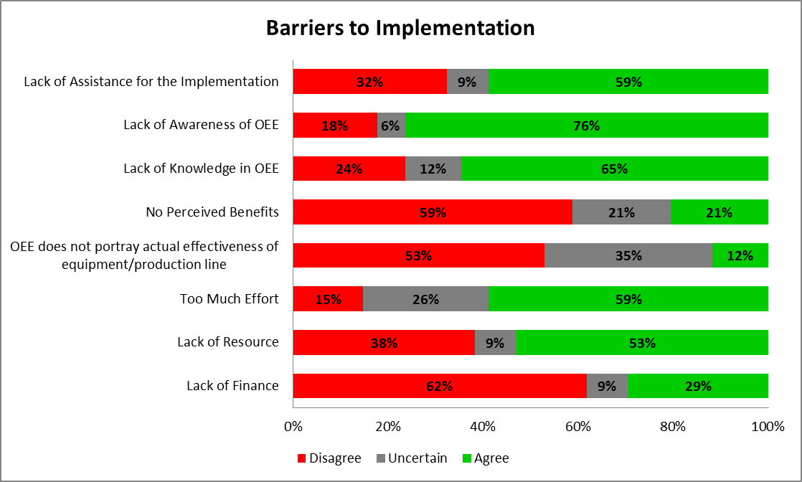

Figure 1. Barriers to the OEE implementation

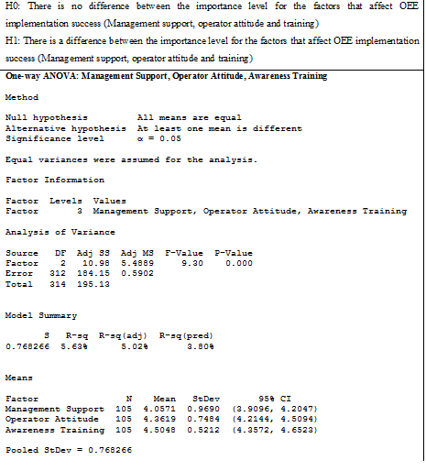
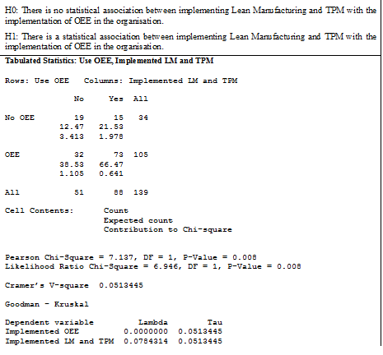
- (b)

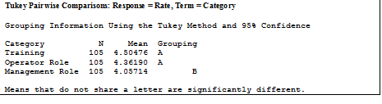
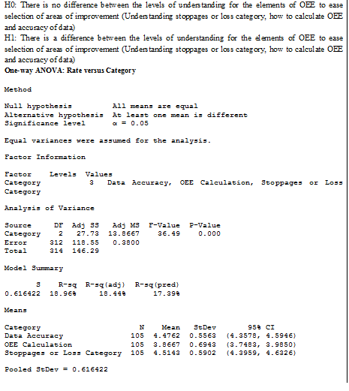
(c) (d)

(e)

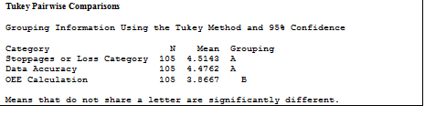

(f)

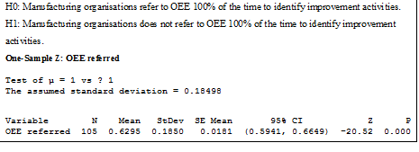

Figure 2. Results of cross-tabulation & chi-square, ANOVA, one sample z-test and Turkey pairwise comparison statistical tests

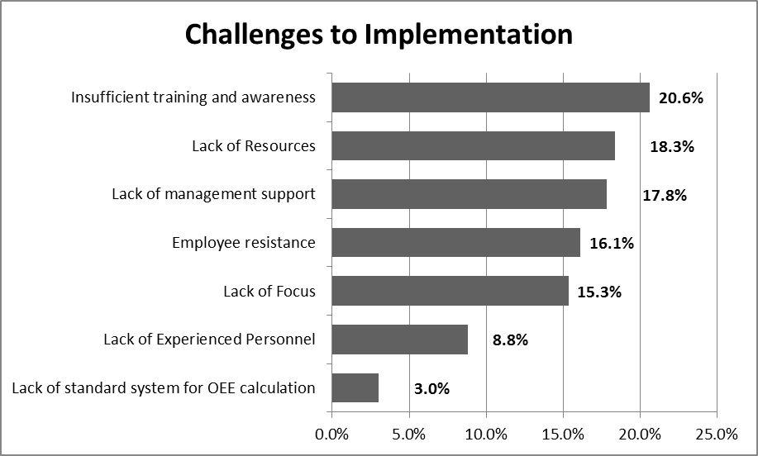

Figure 3. Challenges to the OEE implementation

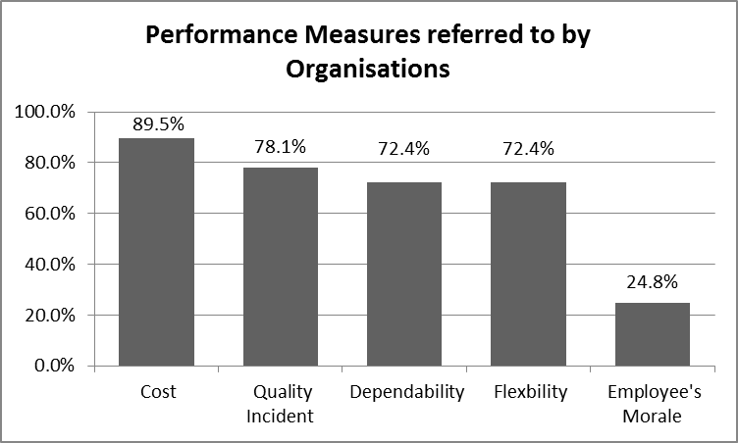

Figure 4. Other measures of performance organisations use as a reference

H0: There is no significant association between data collection method and data accuracy.
H1: There is a significant association between data collection method and data accuracy.
Tabulated Statistics: Data Collection Method, For Data Accuracy?

Rows: Data Collection Method Columns: For Data Accuracy?
No Yes All

Automated 39 3 42
25.38 16.63
7.316 11.166

Mixed 19 35 54
32.63 21.38
5.690 8.685

All 58 38 96

Cell Contents: Count
Expected count
Contribution to Chi-square

Pearson Chi-Square = 32.857, DF = 1, P-Value = 0.000
Likelihood Ratio Chi-Square = 37.225, DF = 1, P-Value = 0.000

Cramer’s V-square 0.342264
Figure 5. Results of Cross-Tabulation and Chi-Square for Hypothesis 5

