**Using the Participatory Patterns Design (PPD) Methodology to Co-Design Groupware: Confer a Tool for Workplace Informal Learning**

John Cook1, Yishay Mor 2, Patricia Santos1, Tamsin Treasure-Jones3, Raymond

Elferink4, Micky Kerr3,

1University of the West of England

{john2.cook, Patricia.Santosrodriguez}@uwe.ac.uk,

2Consultant, London, UK

yishaym@gmail.com

3University of Leeds, UK

{T.Treasure-Jones, M.P.Kerr} @leeds.ac.uk

4Raycom, Netherlands

raymond@raycom.com

**Abstract**: This paper proposes a methodology which attempts to address the barriers to the development of successful educational design research through a process which identifies gaps in current practices and devises innovations to target them. Educational design research assumes an ambitious position: a dual commitment to understand and contribute to both theory and practice. This task is confounded by the complexity of the domain and the inherent multi-stakeholder nature of most initiatives. Three barriers to success are identified: the shortage of mechanisms for cross-stakeholder dialogue, the failure to account for existing practices and contexts, and the rigid processes dictated by the dynamics of research projects. We report findings from an attempt to address these barriers. Confer is a Groupware tool that provides support to bridge face2face and online discussions by workgroups and has been co-designed with users by following the Participatory Patterns Design (PPD) methodology. The PPD provides a framework for engaging multidisciplinary communities in collaborative reflection on educational innovation in a given domain.

**Keywords:** Methodologies for System Design, Groupware Tools, Educational Design Research, Design-Based Research, Work-Based Learning, Informal Learning

# **Introduction**

Educational design research (EDR), or design-based research, emerged over a decade ago as an alternative paradigm for education science. Indeed design-based research has gained traction over the last 10 years appearing as a core topic in special issues of academic journals, in multiple book publications and in academic practice related to educational media environments (e.g. Kelly, Lesh, & Baek, 2008; Reeves & McKenney, 2012). EDR is a change oriented paradigm: its emphasis goes beyond understanding the world as it is, to ask “how do we make it better?” This entails a dual commitment to advance theory and practice simultaneously. It dictates a highly interventionist, inherently multi-disciplinary, iterative and situated methodology, which holds the promise of producing theory relevant to practice and practical innovations informed by theory. It is interventionist in the sense that researchers introduce innovations into the environment they study to observe their effects, iterative because these innovations evolve in tandem with their theoretical underpinnings, situated meaning that interventions are introduced into real-life settings, rather than laboratory conditions. The relation to theory is opportunistically eclectic: rather than maintaining a zealous allegiance to a monolithic theoretical tradition, researchers will draw on multiple sources as befits the challenges at hand. Research questions are unashamedly value-driven: when asking “how do we make the world better?” researchers are compelled to take a stance on what is “better”. This complexity introduces methodological and design challenges.

The Learning Layers Project (http://learning-layers.eu/), funded by the EU FP7 programme, is developing technologies to support informal learning in the workplace, specifically in the healthcare and construction sectors. A central construct in the projects conceptualisation of this domain is the idea of Hybrid Social Learning Networks (HSLN), which is a meta-design approach that sits on top of PPD. HSLN refers to situations where learners’ predominant mode of learning is social, where they rely on a network of activity systems to sustain their learning practices, and where this network is manifested in both physical and virtual connections. We extend the notions of ‘social learning’ and ‘networked learning’ with the concept of hybridity derived from the literature (Cook, 2015). First we have a hybrid combination of formal and informal social structures in terms of power and control in an activity system (Daniels, 2008). What are the rules? How do I play the game? Who are the players? What role can I adopt? Daniels draws on the work of Bernstein (1990) to extend normal approaches to CHAT (Cultural-Historical Activity Theory), which can often take a very cognitive orientation, to include the ‘social’ (see Cook, 2015, p. 11 for details). There is a second dimension to hybridity: hybrid in terms of how physical and digital cultural-historically developed tools mediate the individual’s and group’s relation to the world where the competence to handle such tools is acquired in social settings through guidance from other persons or guidance from digital tools in a “50-50 partnership” (Shadbolt, Smith, et al., 2013). Therefore, we must not view the HSLN narrowly as the socio-technical system that mediates learning but as the extended Zone of Possibility (ZoP) blending socio-technical systems and the actual practice. Such HSLNs need to be developed and orchestrated with the practices in the World using the HSLN meta-design approach, in order that the ZoP could address the relevant design patterns of HSLN. The project team identified EDR as an appropriate approach to actualise HSLN, given the commitment to advance both the professional practice in HSLN of healthcare practitioners (our domain of study, see *Learning scenarios* section below) and the theoretical understanding of emergent learning in such networks. Specifically, we identified the Participatory Pattern Workshop methodology (Mor et al., 2012) as appropriate to our work (see below). However, we found it necessary to extend and elaborate this methodology for two reasons. First, we noticed parallels and potential synergies with agile software development methodologies, and wanted to leverage these. Second, we observed a need for a closer account of the existing (pre-intervention) professional practices, which would allow our designs to blend into the current situation.

Below we argue that our EDR approach called Participatory Patterns Design (PPD) allows us to “systematically” seek out never-seen before possibilities to inform learning research in these messy, work place learning contexts that lend themselves to uncontrolled variability. This paper proposes a methodology which attempts to address the barriers to the development of successful EDR through a process which identifies gaps in current practices and devises innovations to target them. Confer is a tool for providing support to bridge face2face and online discussions by workgroups and has been designed by following the Participatory Patterns Design (PPD) methodology. The paper is structured as follows. The PPD is presented and Confer is then presented as a Groupware tool designed by following the PPD methodology.

**Participatory Patterns Design (PPD)**

The Participatory Pattern Workshop approach (Mor, Warburton, et al., 2012) is a framework for engaging multi-disciplinary communities in collaborative reflection on educational innovation in a given domain. This methodology leads participants through a process of articulating their experience in the form of design narratives, eliciting from those design patterns, and using these to generate testable future design conjectures, in the form of design scenarios. When considering the Participatory Pattern Workshop approach for the Layers project, we observed several limitations of the methodology:

1. Design patterns enable a trajectory from practice through theory back to practice. Patterns encode practitioner experiences in a form that can be calibrated with theory and then re-applied to new situations. Yet, they do not provide a pathway directly from theory into practice. A pattern always originates in experience. How do we rep-resent directives for design derived from theory?

2. In order to affect change in a socio-cultural situation, we need to first construct a detailed conceptualisation of the current state of affairs. Any innovation we introduce will need to blend in and then modulate existing practices. How do we describe these practices, and how do we bind them into the design cycle?

3. The Participatory Pattern Workshop approach has been shown to be effective in establishing cross-disciplinary design-level discourse. However, when developers proceed to translate the outcomes of such a discourse to a development plan, they need to represent them in a suitable language. We needed more specific boundary objects to bridge the research and reflection dynamics and the development processes.

Furthermore, three barriers to success were identified: the shortage of mechanisms for cross-stakeholder dialogue, the failure to account for existing practices and contexts, and the rigid processes dictated by the dynamics of research projects. We report below findings from an attempt to address these barriers. Specifically, we extended the Participatory Pattern Workshop approach by including design principles (see below) as boundary objects translating theory into practice, and agile user stories as boundary objects bridging the EDR language with that of software engineering. The resulting methodology (Figure 1), which we call Participatory Patterns Design (PPD) methodology, leads practitioners and researchers through design and development cycles in which they:

* Understand existing epistemic practices
* Identify gaps in those practices
* Consider relevant theories as well as existing / previous attempts to address these gaps
* Conceptualise a novel solution
* Define the evaluation protocols for this solution

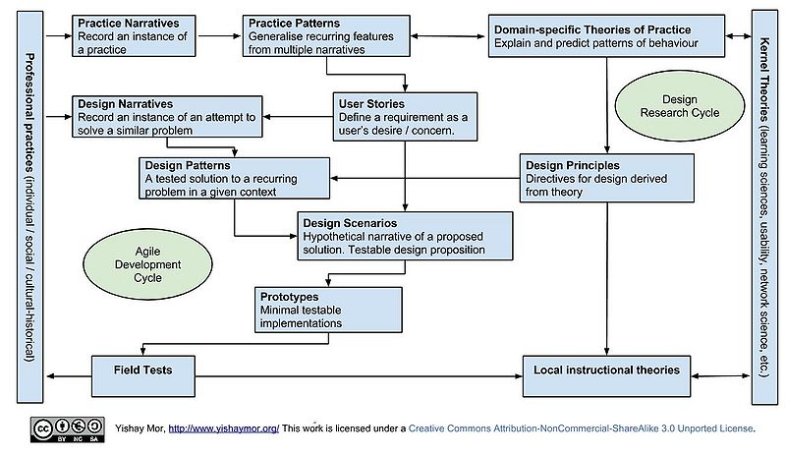

**Figure 1:** Schematic diagram of the Participatory Patterns Design (PPD) methodology (see <https://goo.gl/ZUMTVz> for glossary)

It has to be noted that the PPD methodology provides a systematic and targeted methodology and its development has built upon the experiences of empirical studies, co-design activities, and formative evaluation (e.g. see Cook and Santos, 2014). This methodology has been applied to the development of the Confer tool through a process of:

1. Reflecting on the data gathered from the empirical studies, co-design and stakeholder meetings in Y1 and Y2 of the Learning Layers project; and from this identifying Practice Narratives and Practice Patterns, which capture the relevant (problematic) experiences of healthcare professionals and their informal learning at work.
2. Articulating the healthcare experience (practice narratives) by applying our knowledge in the form of Design Narratives, eliciting from those Design Patterns.
3. Using these Design Patterns to generate testable future design conjectures in the form of Design Scenarios.
4. Pattern/narratives are based on a recurring pattern of behaviour manifesting certain intentions in a given context: in our case the healthcare domain. These practice/narrative perspectives (practice narratives and practice patterns) link to design principles, which provide a direct link to theory (see Figure 1).

Design principles are the projection of kernel theories into the problem domain (in our case above post-Vygotskian theory projected into the Confer tool). Our approach allows us to *synchronize with other streams of the project* (e.g. Social Semantic Server: the technological framework in the project providing tools and associated users with a growing set of services (e.g. recommenders) of different granularity that generate and utilize social and artifact network data needed in a HSLN). Below we propose various design principles and in Year 4 (2016) we will start the process of systematically connecting these to a network of other similar studies which are documented in a NSF funded Design Principles Database (see <http://tinyurl.com/yab6s2q>); if successful this would provide external validation of our conceptual approach. Design principles emanate from and connect to theories of learning and instruction, they can be at several levels of specificity and those presented below articulate the Hybrid Social Learning Network concept. The meta-design principles capture abstract theoretical ideas and project them into the problem domain. Each has meta-design principles follows this template: Description, Theoretical background, Tips (Challenges, Limitations, Tradeoffs, Pitfalls), and Links to other principles and patterns. The 3 meta-design principles with links to online public descriptions in ILDE[1] plus a brief overview how they link to theory are:

* **Respect Learners' Zone of Possibility**, <http://ilde.upf.edu/layers/v/brn>
  + Professionals engaged in social learning want to present themselves in the best possible professional light, i.e. people will position themselves in different ways depending what they deem as the best way from the perspective of their professional role in circumstances of a particular situation. They do not want to expose themselves professionally. Also, professionals are positioned by other actors in their activity systems by rating them and the resources they shared. Consequently, we are designing for a Zone of Possibility (ZoP). References: Daniels (2008); Vygotsky (1930/1978).
* **Support Knowledge Building Discourse**, <http://ilde.upf.edu/layers/v/btz>
  + Knowledge building is in essence a "coherent effort to initiate students into knowledge creating culture" (Scardamalia & Bereiter, 2006, p.98). This is closely linked to Progressive Inquiry theory (Muukkonen, Hakkarainen & Lakkala, 1999).
* **Aim for a "50-50 partnership",** <http://ilde.upf.edu/layers/v/brs>
  + Enable a “50-50 partnership”: a fruitful and deep collaboration between people and trusted software (machines) where we avoid being dominated by algorithms. Users and recommender systems work together to achieve a task or solve a problem and hence further professional learning. ‘50-50’ partnership is a metaphor of half machine, half human, whilst only hinting at a human-machine/cyborg-like partnership. Reference: Shadbolt, Smith, et al. (2013).

The meta-level (theory driven) design principles are linked to various design patterns (practice driven). Our approach therefore allows for meaningful connections between different theoretical viewpoints to emerge. Indeed, we plan to generalise our design principles and patterns to other areas and initiatives (outside healthcare). Furthermore, the learning support identified in our design patterns targets activities and does not prescribe processes, hence leaving room for appropriation.

All the design principles (and associated patterns) shown in this section can be accessed online at this address <https://goo.gl/jiwbgm>; this web page contains live links to online descriptions in ILDE (in some cases you may have to create a free account and log in). Note in the online diagram we do not show all possible links between design principles and design patterns in an attempt to reduce complexity of the diagram. The patterns that have particularly influenced the features of Confer tool are: Early easy engagement; Always have an easy way in; Tapas Tour; Cherry Pickin’; Dealing with Egos. Below you can see a summarized example of the design pattern ‘Dealing with Egos’ see Table 1.

In this way our approach has identified meaningful combinations of supported activities in that some design patterns indicate the specific features of Confer that a pattern has led to being implemented; furthermore there is also a link back to theory from the patterns (i.e. to the related meta-design principle(s)). Below we now illustrate how PPD methodology was used to co-design the Confer tool.

|  |
| --- |
| Context description: Online forums. In group of peers there is often an imbalance of power. Sometimes people with higher power/influence close of the discussion by posing an answer, discouraging others from making contributions. |
| Problem/challenge description: To rebalance and allow contribution from everyone, before conclusions are drawn. Support and egalitarian opportunity for discussion. |
| Solution (feature[s]): In the contextual discussion areas (Orange Step) in Confer we ask users to categorize their contributions, but we don’t include the option to provide a definitive ‘answer’ in the drop down menu to discourage closing down conversation and we do include a neutral ‘chat’ option to encourage ‘onboarding’. |

**Table 1.** Summary of the Dealing with Egos design pattern

**Confer**

Confer (see Figure 2) is a Groupware tool that has been designed by following the Participatory Patterns Design (PPD) methodology. As we describe above, the PPD is a framework for engaging multi-disciplinary communities in collaborative reflection on educational innovation in a given domain.

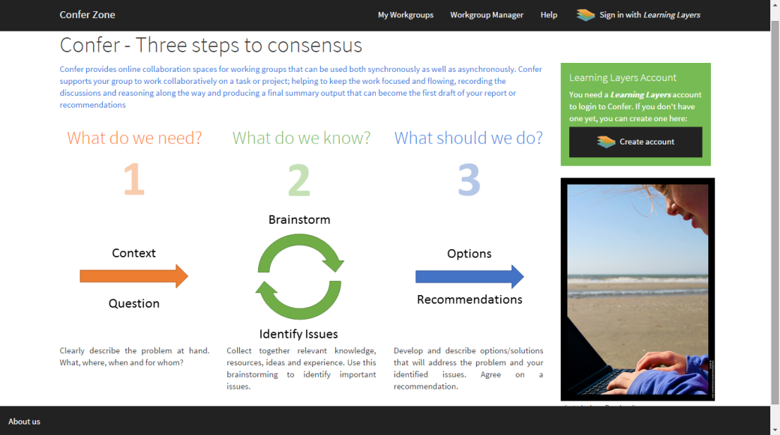

**Figure 2.** Confer Main Page – Three steps to consensus

*Learning scenario*

In the previous year’s work (e.g. Cook and Santos, 2015) we have already identified that the scenario of ‘Putting guidelines into practice’ was suitable as one exemplary scenario in healthcare domain (specifically the Primary Care domain of GP Practices). In this scenario, and many other similar scenarios in the healthcare domain, providing support to bridge between face2face and online discussions by workgroups is needed: national medical guidelines have to be understood, interpreted and implemented according to local needs; this is why it is common for workgroups to be set-up (either within a GP Practice or across GP Practices) to review new guidelines and come up with proposals for local implementation. This is just one example of the many work-based problems or projects that could prompt the setting up of a workgroup (commonly referred to as task and finish groups in Healthcare) and it is within these contexts that ‘informal learning’ takes place. Key issues identified were: to ensure that the exchange of knowledge is not lost, plus keeping the work focused and flowing. Confer provides an online collaboration spaces for working groups that can be used both synchronously as well as asynchronously. Confer supports work groups to collaborate on a task or project; helping groups to keep the work focused and flowing, recording the discussions and reasoning along the way and producing a final summary output that can become the first draft of your report or recommendations and therefore provides a way to export to other Learning Layers tools.

This collaborative process (Figure 2) is guided and supported by an adaptation of the Progressive Inquiry (PI) pedagogical model (Muukkonen, Hakkarainen, et al., 1999). The original 7 phases of the PI model are visualized as 3 consecutive steps: 1. What do we need? 2. What do we know? 3. What should we do? (See more theoretical details below.) The main aim of the tool is to scaffold and guide the process of collaborative discussion when professionals work in teams, whilst at the same time supporting and collecting the exchange of informal learning. A demonstration video of the Confer tool can be found in here (no sound just subtitles): <https://youtu.be/lSRpaUY6d-Q>

*Theory background*

The social aspect of learning for Confer is a key aspect, for this reason one of the main theories considered for its design has been the ‘Cultural Historical’ theory where social dimension is paramount in the formation of the mind (for a critical review of this and related theory see Cook, 2015: ‘Post-Vygostkian’ literature review). In particular, one of the main research questions to be explored with Confer was raised up by Daniels (2008): to what extent can cognition be considered situated in particular contexts and distributed across individuals acting in those settings? Therefore, through Confer we want to observe if the learning actions of individuals are influenced (or not) by the actions of the group, and by the particular context where the actions take place. Are these actions and meaning makings contained in activity systems that may overlap? Or are functional aspects of actions and understandings distributed over the work group?

Confer has been designed to support discussion and negotiations in professional workgroups when doing a task in a specific context. In particular, Confer is using an adaptation of the original Progressive Inquiry (PI) model proposed by Hakkarainen & Muukonen (1999). The successive elements of progressive inquiry (used to support work groups) is described in De Laat and Simons (2002). Originally, the PI model was proposed to describe process of discussion around a table. We follow the interpretation of the PI model proposed by De Laat and Simons (2002, p. 11) but adapting it to the needs of our end-users (professionals in the healthcare domain). The model is used to scaffold and guide the work group members during their collaboration. In each task (i.e. Creating the context; Setting up research questions…). Confer provides features to engage the process of discussion and the egalitarian collection of shared learning data. However, Confer also attempts addresses other theoretical concerns articulated as design principles: Respect Learners' Zone of Possibility and Aim for a "50-50 partnership"

By following the concept of the HSLN our longer-term plans in Y4 (2016) of the project are to integrate Confer with the Social Semantic Server. Potentially this combination will allow us: on the one hand to implement our idea of the ‘Zone of possibility’; by for instance using the information about users in Confer to recommend the formation of workgroups according to their skills, interest or experience. On the other hand, we will augment the hybridity between the guidance from other persons (work team members, Confer network) and the guidance from digital tools (through recommendation algorithms provided by the SSS such as for instance recommendations of similar questions and answers to those currently under consideration by a work-group) in a “50-50 partnership”. For instance, we could combine in the Confer Dropzone area items proposed by the workgroup members with learning resources recommended by the SSS.

In conclusion, Confer is based on multiple theories (post-Vygotskian notions of hybridity, progressive inquiry, knowledge building, the idea of “social machines”) which provide a fit to explain the phenomena we observed and thus enables us to construct an effective solution.

*Field testing and design process procedure & results*

In January and February 2015, the Confer team conducted two workshops (Bristol Participatory Patterns Design (PPD) workshops) to develop the conceptual basis of the Confer tool. The main objectives were:

* Establish a clear pathway between kernel theories/empirical evidence/experience and develop design patterns (Bristol January Meeting)
* Extract Agile User Stories and apply them to novel informal learning challenges represented as future oriented design scenarios (Bristol February Meeting).

Based on the design scenarios we developed a set of 3 storyboards, which we presented to representatives of the target Healthcare group, to obtain early feedback (March 2015). During this co-design session, our aim was to present and discuss the storyboards with healthcare staff in order to understand if the stories illustrate successfully (or not) their context, needs and potential solution. We had 4 healthcare representatives: a Practice Manager representing the Practice Managers' Network; a Data Quality Lead with links to the Practice Managers' Network; a Nurse who is the Lead of a Clinical Commissioning Group (CCG) Nurse Training Network and a GP representing a GPs Network. The participants discussed with two members of the Confer team the storyboards, and they selected 2 of the 3 storyboards as the most important ones to cover their needs. The 2 key storyboards are accessible from here:

* Storyboard Working Group Tools: working groups collaborate asynchronously online. <https://goo.gl/Xwu0lE>
* Storyboard Discussion Working Group: CoP - dealing with issues. Link: <https://goo.gl/BseZKB>

We also conducted a series of role-play walkthroughs to test early prototypes. Through this process, an initial version of the Confer tool was developed. The first prototype version of the Confer tool was used in a stakeholder engagement session in April 2015 (Figure 3).

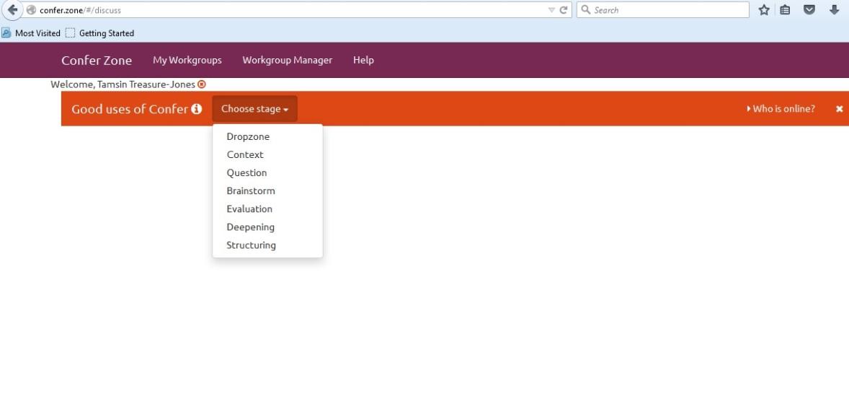

**Figure 3.** Confer 1st prototype – Phases Menu

In this session we worked with 3 of the representatives from the healthcare profession who had been involved in the March workshop: Practice Manager, the Data Quality Lead the GP. The main aim of this session was to check that the first prototype matched expectations and would fit into the working practice. As a summary, the main issues uncovered in this session, and to be fed in next iterations, were:

* Simplification. Whether all the 7 phases of the PI model are needed. Can steps be skipped or merged?
* Use. Which groups would benefit most from using the tool and for which tasks?
* Benefits. Early exposure to and collaboration on ideas (feeling of engagement) would mean that new proposals/processes developed using this tool are more likely to be adopted.
* Drawbacks. Some concern over the time needed to go through all the steps.

Following redesigns based on the above feedback, in July 2015 the Confer tool was also shown to a GP (with a role in GP training) and the Nurse (who had been involved in the earlier Confer Storyboard Workshop). The feedback obtained from this meeting confirmed the ‘Simplification’ and ‘Drawbacks’ issues (above). So the steps to go through the PI process needed to be adapted to our users’ needs. These co-design requirements were met as following. Figure 3 shows the first version of Confer where the PI phases were selected by using a menu in the main bar. In order to take into account the feedback from our healthcare participants, the visualization and the guidance through the PI phases was improved (the 3 steps shown in Figure 2). Figure 4 shows how the steps have been re-organized into 3 main interface sections. Each section guides the user through the specific actions to be done in order to complete the Progressive Inquiry process.

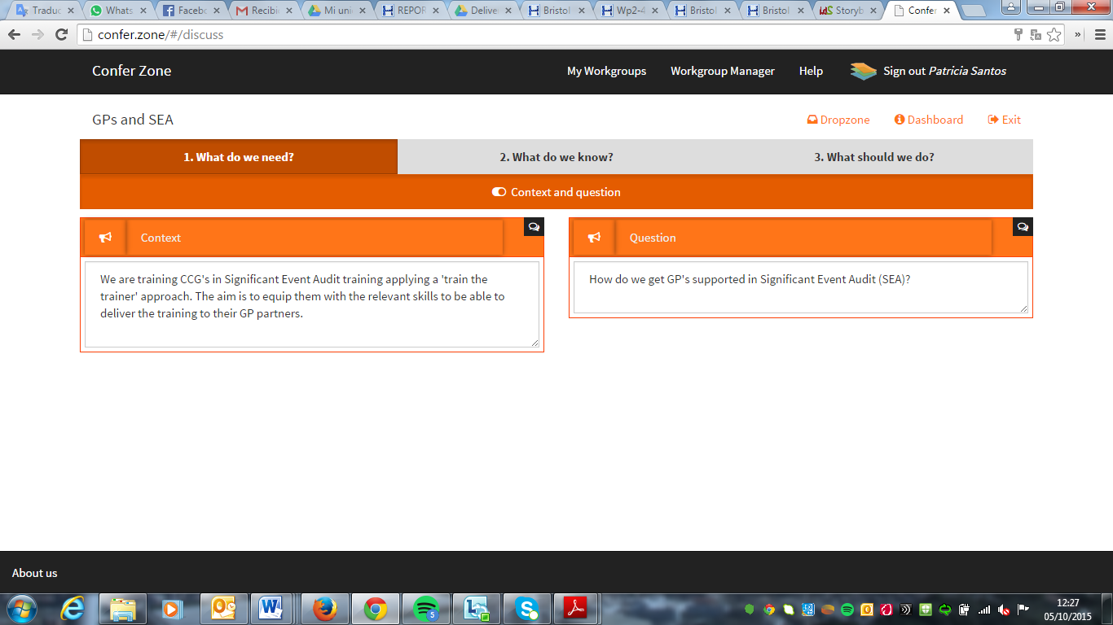

**Figure 4.** Confer 2nd prototype – Simplification of the PI model phases

Confer was next presented at the Learning Layers Mixing and Matching Meeting held in July 2015. This meeting brought together representatives from the 3 pilot GP Practices who have been working with Learning Layers, as well as representatives from several key healthcare networks with whom we hoped to work. One of the groups represented was an Academic Health Science Network (AHSN). Their representative was interested in Confer and this then led onto the invitation to present the tool to the wider AHSN group in August. In August 2015, the next version of Confer was shown to a group from the AHSN to discuss the possibility for them to be involved in field-tests. Participants (a total of 7) recognised the need for the tool (focus/flow maintained between meetings), could see uses for the tool and believed it would support their work. A new feature that was requested was a way to share a summary of the ongoing work with people outside the workgroup. This was deemed necessary so that someone, who was not part of the work group, could have an overview of the work before deciding to send in material to the Dropzone (our way of emailing in ideas to the work group) and therefore would feel like a contributor to the process. This idea was implemented as the current ‘Export’ feature.

It was agreed that we would return to run a short training session on Confer for those people who would take part in this field-testing. The training was set up in two sessions during September 2015. We have followed this up with a feedback/additional training session in October 2015 as new people wanted to take part. In sessions from November onwards participants will identify and put in practice ‘real world’ tasks/activities thus helping us to identify where Confer could provide the best support. For example, this may involve using the tool to discuss and decide upon the future of their Communities of Practice website/platform - e.g. addressing questions such as ‘should they continue to use the existing platform, adapt it or move to some-thing new?’

The data gathered from the Y2 studies also shows how Healthcare professionals have an interest in improving their networking practices particularly in sharing knowledge and opinion; however, this exchange of knowledge needs scaffolding support in order to improve the effectiveness of sharing practices. Taking this and co-design feedback into account, the following the main characteristics of Progressive Inquiry, the learning is contextualized, the approach also supports discussion and the process of learning is scaffolded by the three steps. This process has been adapted by simplifying the phases in 3 simple steps as follows.

*I. What do we need?*

A workgroup is set-up to work on a particular problem or project in step 1. Yet in the co-design sessions we had heard that often there is not enough explicit clarity and agreement on the problem that is being researched. Consequently, step 1 involves participants negotiating the definition of the question to be researched/answered and the context in which it occurs (see Figure 4).

*II. What do we know?*

Step 2 involves collecting and reviewing what is known about the problem being researched. Items can be sent by email to the Dropzone or created directly within the Brainstorm area. From the Dropzone, items can be transferred to the Brainstorming area, where they are discussed and the common issues identified (see Figure 5). This is a cyclic process, since in grouping items under common issues it may become clear that other items are missing or that further information is needed. Thus this step covers the Brainstorm, Evaluation and Deepening stages of the Progressive Inquiry model.

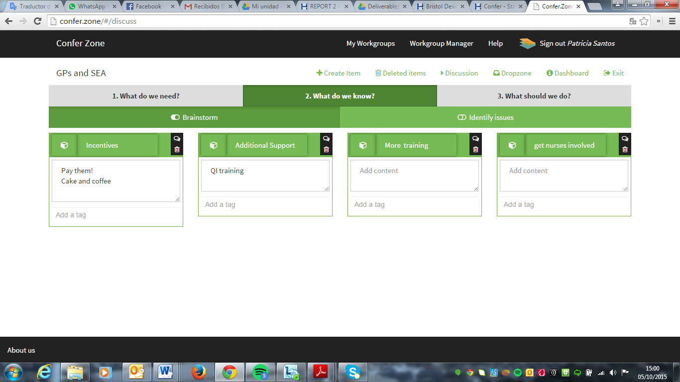

**Figure 5.** What do we know?

Tags and tagging were identified during Y2 as a useful feature with respect to help focus on relevancy. Users can add tags by clicking inside the tag area and start typing. Tags are used to organize areas with lots of items: i.e. Dropzone and Brainstorm features (not presented here due to space limitations). The used tags are shown as tabs/buttons in the top of the page and can be used to filter the displayed items.

*III. What we should do?*

In Step 3, the group begin to develop their options or solutions (their answers to the question that is being researched). For each option that is created the group are asked to explain how that option addresses each of the issues that they had identified in the previous stage (see Figure 6). Finally, before making a recommendation they are prompted to review the options they have created and consider under what conditions each option would be suitable thus in supporting the construction of this structured argument, this step fills the Structuring stage of the Progressive Inquiry model and is related to the ‘Dealing with egos’ design pattern.

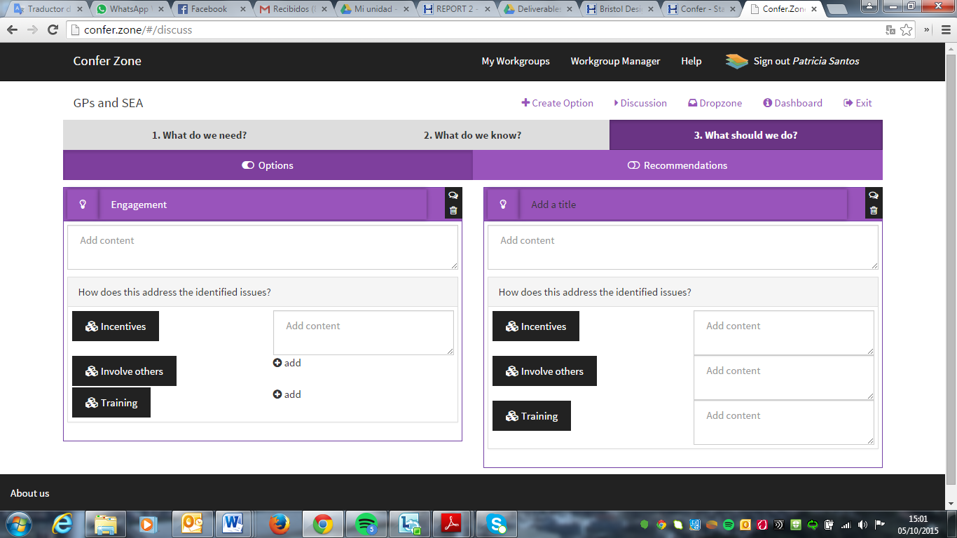

**Figure 6.** What we should do?

# **Conclusions and future work**

Using the Participatory Pattern Design (PPD) methodology, the co-design activities surrounding Confer has used design constructs from an early stage in the design cycle to mediate between theory and practice when designing tools for supporting the messy and under-explored area workplace informal learning. It was found that one of the strengths of such a design approach is that we do not commit to a single theoretical tradition. Rather, in true design science spirit, it draws on multiple theories articulated in the HSLN: in this particular case, post-Vygotskian concept of hybridity in professional learning networks (Daniels, 2008), knowledge building communities (Scardamalia & Bereiter, 1994) and the related concept of progressive inquiry (Muukkonen, Hakkarainen, et al., 1999), plus emerging concepts like social machines (Shadbolt, Smith et al., 2013). This does not come without a price and additional challenges as single-theory-systems (STSs) are “cleaner”, they are easier to explain and justify. Yet, the real world is a messy place, and STSs tend to shoe-horn thinking into nice boxes which cut out a lot of the essential complexity and messiness. Our approach provides a systematic and rigorous internal approach and potentially provides a way of warranting claims and a powerful explanatory and step-by-step guidance of the functioning and scope for learning in professional networks; it has also allowed for an in depth look at our research/ design question.

The overall plans for the 2016 evaluation activities of all of the Learning Layers tools have been formulated (from March to June 2016 an integrated evaluation will be carried out in the Healthcare domain, where Confer - integrated with other Layers tools - will be evaluated by using the resulted design patterns as the main key to explore our meta-design principles). We will be building on the interest and engagement we have already built up with several healthcare networks over the past 3 years, including the AHSN, Health Education England and the CCGs/Federations of GP Practices. For example, we expect the Academic Health Science Network (AHSN) to continue their use of Confer to explore relevant problems and issues, such as engaging GP practice clinical staff and how best to support their Communities of Practice (CoPs). Another evaluation context being explored is a group within Health Education England (HEE). Possibilities are also being explored with other networks (including CCGs and Federations of GP Practices) who are interested in piloting the Confer tool, and so we have back-up options available if any of these proposed evaluation scenarios fall through.

**Acknowledgments**

We acknowledge the input of users & James Griffin (UWE). Learning Layers is a 7th Framework Large-scale integrating project co-funded by the European Commission; Grant Agreement Number 318209.

**References**

Bernstein, B. (1990). *The Structuring of Pedagogic Discourse.* Vol 4, Class, Codes and Control, London: Routledge.

Cook, J. (2015). *Post-Vygotskian Perspectives on Learning and Research: A Critical Literature Review.* Learning Layers report from UWE Bristol, UK. Available: <https://goo.gl/vgaHmy>

Cook, J. and Santos, P. (2014). Social Network Innovation in the Internet’s Global Coffeehouses: Designing a Mobile Help Seeking Tool in Learning Layers. *Educational Media International,* 51(3). Link to paper: <http://tinyurl.com/oh6qzf7>

Daniels, H. (2008). *Vygotsky and Research.* Routledge, UK.

De Laat, M. F., and Simons, P. R. J. (2002). Collective learning: Theoretical perspectives and ways to support networked learning. *European Journal for Vocational Training,* 27(3), 13-24.

Kelly, A. E., Lesh, R., & Baek, J. (2008). *Handbook of design research methods in education: Innovation in science, technology, engineering, and mathematics learning and teaching.* New York: Routledge.

McKenney, S. and Reeves, T. (2012). *Conducting Educational Design Research.* London: Routledge.

Mor, Y., Warburton, S. & Winters, N. (2012). Participatory Pattern Workshops: A Methodology

for Open Learning Design Inquiry. *Research in Learning Technology,* 20.

Muukkonen, H., Hakkarainen, K. & Lakkala, M. (1999). Collaborative technology for facilitating progressive inquiry: future learning environment tools. In C. M. Hoadley & J. Roschelle (eds.), *CSCL* (pp. 51), *International Society of the Learning Sciences*.

Scardamalia, M., & Bereiter, C. (2006). Knowledge building: Theory, pedagogy, and technology. In K. Sawyer (Ed.), *Cambridge Handbook of the Learning Sciences* (pp. 97-118). New York: Cambridge University Press.

Shadbolt, N., Smith, D. A., Simperl, E., Van Kleek, M., Yang, & Y. Hall, H. (2013). *Towards a classification framework for social machines.* SOCM2013: Workshop on Theory and Practice of social machines, WWW2013, Brazil.

Vygotsky, L. S. (1930/1978). *Mind in society: The development of higher psychological processes.* In M. Cole, V. John-Steiner, S. Scribner, & E. Souberman (Eds.), Cambridge, MA: Harvard University Press. Originally published 1930.

1. ILDE is an Integrated Learning Design Environment used as an authoring tool and repository to collect our design principles and patterns. See: <http://ilde.upf.edu/about/>