Aural Spatial Mapping Tool: Constraining the Signal Sphere of Influence Validation (WIP)
Merate A. Barakat
Architectural Association School of Architecture
36 Bedford Square, London WC1B 3ES, United Kingdom
merate.barakat@aaschool.ac.uk

ABSTRACT
This paper is part of an on-going investigation with the primary objective of developing a computational modeling tool for urban design that generates qualitative aural spatial patterns. The architect is the target user of this computational tool. Given the character of this research, the model adopts a hierarchal Pattern-Oriented Modeling (POM) approach, namely Multi-Agent Based (MAB) systems, which is deterministic and allows preliminary validation of the basic logic. The concept of spheres of influence that are associated with agent systems is synthesized with the theoretical soundscape concept of acoustic arenas. This paper presents an exploratory experiment that tests the use of a number of frequency-dependent parameters to confine the sphere of influence of the system simulating urban sonic events. The aural mapping tool patterns are compared to the results of an auxiliary Object-Oriented Program (OOP) model that is based on the inverse-square law.

Author Keywords
Urban Design; Pattern-Oriented Modeling; Image Source Method; Morphology; Aural Architecture.

ACM Classification Keywords
J. Computer Applications; J.5 Arts and Humanities; Architecture.

INTRODUCTION
In acoustic simulation, there is a broad range of sophisticated tools that produce quantitative results that are graphical representations of numerical data. The representations are highly informative to acoustic engineers trained to analyze and make decisions based on quantitative numerical data. Unfortunately, there are constraints on assumptions, questions, methods and philosophy that limit the scope of these empirical results. Without extensive training in acoustics science, statistical mathematics, and perceptual psychology and physiology these limitations are difficult to evaluate [6]. An architects training does not include these domains. Small architectural practices cannot afford acoustic simulation engines or in-house expertise during the preliminary design phases. Therefore, the spatial designers are still left lacking semi-empirical and intuitive predictive decision-making tools.
This paper is part of a research [2, 3] that seeks to create a tool that integrates the theoretical spatial and soundscape design concepts, to aid spatial designers when considering sound as a design driver for urban design. The investigation explores the merging of spatial and acoustical computational approaches, through integrating the physical/mathematical representation of sound to the mapping of the spatial envelopes and phenomena of human aural responses. The fields of computation simulation, soundscape, and psychoacoustics inform the structure and the development of the tool. The spatiotemporal computational modeling technique Multi-Agent Based (MAB) systems is adopted to develop the aural mapping tool. The intended user is the spatial designer (architect, urban and event designer). Although the chosen acoustic indices and method are well-known within their associated fields of research, the assimilation of these concepts is distinctive, where this particular intersecting point of investigation is new to the architectural field. The resulting system does not strictly follow the conventional techniques used in soundscape sound pressure level (SPL) distribution models (e.g.; [13, 14, 16]). The models normally have a predetermined number of point sources and receivers to simulate SPL distribution in idealized spatial configurations. The tool aims to map the effect of multiple sound signals within a space. To that end, the majority of the selected acoustic indices are frequency dependent.
The sphere of influence concept associated with MAB systems is the point of investigation of this paper. When considering foreground sounds, if the energy detected is below the audible threshold and/or the general ambient SPL, the computation execution would be redundant. For that reason, the logic deviates from the norm and is designed to constrain the influence if the system simulating sound signals within a specific radius. The parameters that are used to define the influential domain of a sound signal are: Sound-to-Noise Ratio (SNR), attenuation, audible threshold, and acoustic impedance. This technique and the incorporation of these indices has not been previously addressed, and the validity of the technique requires investigation before testing its effect on the run-time. Therefore, a number of investigative validation processes are presented in this work-in-progress paper that aim to test the computational logic and the resulting patterns with the aggregation of these parameters. The resulting patterns are compared to the results of an auxiliary Object-Oriented Programming (OOP) model that is based on the inverse-square law.

Soundscape Pattern | SEMANTICS
The term soundscape has many loose interpretations, some of which provide insight into what tools may assist the study. This discourse necessitates explicitly stating which terms pertain to this research and the associated definitions. Given the spatial character of this research and the need for quantifiable spatial factors, this study is aligned with the definition provided by Genuit and Fiebig [9] that considers the spatial distribution of sounds. Genuit and Fiebig define soundscapes as domains that “consist of a number of spatially distributed sound sources, which give the soundscapes their distinctive features” [9, p. 953]. This concept allows the research to consider and map aural spatial patterns.
The spatial terms are assimilated from soundscape literature [20], including soundscape ecology [8] and aural architecture [6]. A receiver or sensor refers to a human listening/perceiving the sonic environment. The mapping tool designates agents to simulate human response, namely Sensor Agents. The considered foreground signals are denoted as sonic events, sound sources, and signals. These terms refer to the events emitting a signal that are located within the urban space. The simulation engine reduces the events to point sources, namely Sonic Event Agents. If the distance between a receiver and a sonic event allows the listener to detect and distinguish the signal, then an auditory channel forms. The level of information determines the strength of that channel. A receiver can be connected to multiple channels. An auditory channel can be disconnected for various reasons, including an increase in distance, other competing channels, the presence of a stronger channel connection, and the diversion of the listener’s attention. The simulation engine is only concerned with the strongest receiver-signal auditory channel.
Truax [20] presented the term acoustic space. Blesser and Salter [6] adapted the idiom for aural architecture as an acoustic arena. A similar concept is known in the field of soundscape ecology, known as a patch [8]. These three terms refer to the area of space where a sonic event can be cognitively de-codified, and it is centered on that event. An acoustic arena is delineated by the human response. In the presence of multiple adjacent sonic events, a number of auditory channels are connected to the receiver, and the associated acoustic arenas ‘overlap.’ In that intersecting domain two conditions may occur: 1) the strongest auditory channel severs the other weaker connections, or 2) all connections are of equal strength negating each other. In the former case, the receiver is considered in the arena associated with the strongest auditory channel and the emitting signal is considered dominant. In the latter case, the receiver is not connected to an auditory channel. The receiver may be counted in the edge domain. Edge is a term assimilated from the patch-edge epistemological concept [8].
As an extension of Genuit and Fiebig’s [9] definition of soundscape, soundscape patterns may be regarded as the spatial morphologies mediated by the acoustic arenas centered on the spatially distributed sound source, and the edges forming between them. Since the event spatial distribution distinguishes the features of the soundscape, each soundscape would have a characteristic morphological pattern.

PATTERN-ORIENTED MODELING (POM)
OOP is the common technique for developing soundscape models. However, the new soundscape research that considers urban sound as part of a meta-system of the ecological soundscape [11] indicates the benefit of using spatiotemporal modeling techniques such as Pattern-Oriented Modeling (POM) [10]. General principles underlying such systems often use a bottom-up simulation model, such as MAB systems. The production of spatiotemporal modeling techniques integrated into urban design and practice during the past decade [5], to study and explain the different internal organizational complexities of the emergence of urban patches at various scales [4, 22]. Only recently, have soundscape models employed hierarchical systems, and they are intended to predict the human response for psychoacoustic research, not spatial configurations.

Multi-Agent Based (MAB) Systems
Briefly, agents are autonomous self-governing systems that interact with the environment (local or remote) and its inhabitants [12]. The agent perceives the status of an environment using sensing protocols and makes a decision to perform an action based on the information gathered [19]. A multi-agent based (MAB) system is comprised of a number of agents interacting with one another, typically by exchanging information through a network infrastructure. Agents by nature are non-deterministic. If they are setup as Model-Based Reflex agents with a repertoire of reactional behaviors and inhabit a deterministic environment, the iterative results should be the same every time. The typical structure of an MAB system consists of a number of interacting agents designed to have control over some portion of the environment, referred to as spheres of influence. The agent produces some change in the environment affects agents that inhabit this influential domain. Adjacent agents also have influential spheres and compete to achieve their predetermined goals [23].
The aural mapping tool presented in this research is structured as a POM system that invokes behaviors associated with model-based reflex agents populating a deterministic MAB environment. The sphere of influence of the sonic event agent is the point of investigation of this paper. The methods for identifying the influential area calculates the maximum distance where the energy contribution is higher than the adjustment factors, namely the ambient level and audible threshold. The method checks the energy level at incrementally increasing distances, starting at the point source position. The maximum distance where the energy level is higher than the adjusting factors is considered the radius of the influence domain. This sphere of influence is similar to the concept of an acoustic arena and the sonic event can communicate with the systems within this domain.

VALIDATION | SPHERE OF INFLUENCE
It is worth noting that the current goal of this research is to create a tool that produces qualitative soundscape patterns for preliminary architectural design. Therefore, the aim of the experiment presented in this paper is to validate the base assumptions mediating the sensor agent energy calculations that constrain the associated influential domain. The indices examined here are those that are within the scope of this research: SNR, attenuation, audible threshold, and acoustic impedance. This section discusses a comparison with an auxiliary OOP model derived by the inverse-square law of a point source in a free field.
This experiment addresses two questions: How does the energy patterns resulting from the mapping tool compare to that resulting from the conventional inverse-square law? Further, is it valid to employ these parameters to mediate the initial sphere of influence of a sonic event agent?

Hypothesis
Since sound energy depreciates with distance according to the inverse-square law, except when considering the attenuation index, the resulting simulations should follow that rule. The acoustic impedance should not alter the energy depreciation profile and the resulting patterns, and the resulting configuration should be comparable.
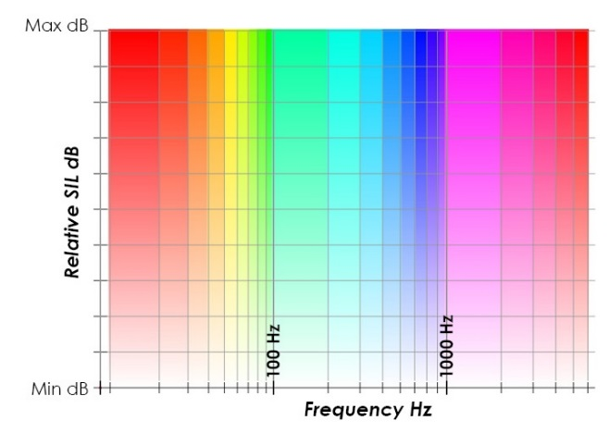
Figure 1. A hue and alpha mapping key of frequency and energy contribution, respectively.

As the maximum energy level is adjusted to the audible threshold and SNR indices, the curve should still follow the inverse-square law but at an offset value. In considering attenuation, the slope should deviate towards a linear form at large distances and high frequencies.

Procedure
An independent OOP maps the energy contribution for a point source in a free field according to conventional inverse-square equation. Each receiver calculates the energy contribution at the associated distance. The resulting pattern is tested for each parameter separately and compared with the inverse-square law pattern. The field dimensions are 2,000 x 2,000 meters. A point source is positioned at (x = 1,000, y = 1,000, z = 0) meters. Each receiver is a 200 x 200 meters square. The maximum SPL is 90 dB. The considered frequency is 1000 Hz. Attenuation for 20˚C, 50% relative humidity and sea level atmospheric pressure. Ambient SPL is considered at 40 dB (Figure 3) and 50 dB (Figure 7). Contours increment at 3dB. The reason the field dimension is set up at a large scale is to determine the extents of the energy patterns of a 90 dB signal, according to the inverse-square law.

Graphics Caveat
The tool graphics use hue and alpha values to represent frequency and energy contribution, respectively. The color key in Figure 1 shows the audible frequency range (20 Hz – 16 kHz) mapped logarithmically along the hue spectrum. Any parameter related to a signal is assigned a color corresponding to that frequency. Relative energies are mapped to the alpha channel. An entirely opaque color represents the maximum relative energy contribution. The transparency is an indication of a decrease in energy. Fully transparent regions represent the edge condition, where the energy values are below the auditory threshold and ambient levels. The energy distribution resulting from the inverse-square procedure is frequency independent and therefore represented on a gray-scale.

Analysis
This section analysis the radius change of contour encircling energy contribution equal or higher than 28 dB. In Figure 2, the radius denoted as x. The following subsections compare the resulting measurements these values.

Sound-To-Noise Ratio (SNR)
The signal-to-noise ratio (SNR) is “the ratio of the magnitude of the wanted signal to that of the unwanted noise, expressed as a simple arithmetic ratio in decibels” [20]. The SNR is both a soundscape and acoustic term that can be calculated by a formula that considers the amplitude of a signal to that of the ambience levels:
$$SNR= {\left(\frac{A_{foreground}}{A_{background}}\right)}^{2}$$
A ratio higher than 1:1 indicates signal dominance.
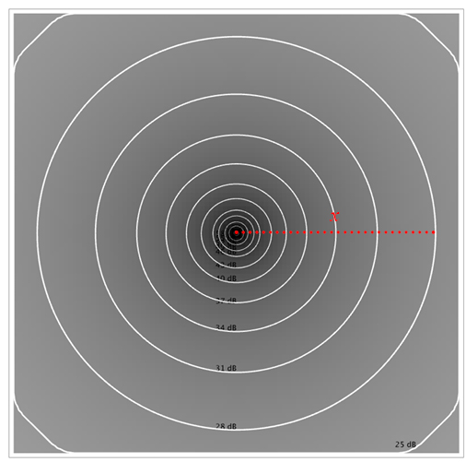
Figure 2.Visualization of energy distribution patterns in accordance to the inverse-square law.
It is not a frequency dependent parameter, but it has a strong relation to the perception of foreground events in the presence of background sounds in urban spaces. In considering the SNR factor, the initial maximum energy output of the point source is adjusted (Figure 3). The updated distribution indicates that the energy distribution still follows the inverse-square law with distance from the source, but at an offset value. As the background ambient SPL increases, the sphere of influence of the signal shrinks considerably.

Attenuation
Attenuation is a frequency and distance dependent index and is defined as “the reduction of the sound signal magnitude by separation of a sound source from a receptor, acoustical absorption, enclosure, active cancelation by electronic means, or a combination of these or other means” [7, p. 319]. The energy emitting from signals that have high frequencies attenuates with distance more than sources that have lower frequencies. This investigation considers the values presentd by Jian Kang [17, p. 14] that are typical attenuations per 100 meter caused by air temperature 20˚C and relative humidity of 50%. The distribution of the contours presented in Figure 4 tends to confirm that the simulation produces patterns following that premise. The energy attenuation diverges from the inverse-square law towards a more linear profile.

Loudness | Frequency Dependent Audible Threshold
The audible threshold is a perception index that is frequency dependent, due to the nonlinear cochlea mechanics [1]. This is evident in multiple psychoacoustic phenomena of as loudness [21], which is defined as “the attribute of auditory sensation in terms of which sounds can be ordered on a scale extending from quiet to loud” [8, p. 229]. Similar to the SNR experiment, in adjusting the sound level of the signal the energy reduction still follows the inverse-square law, at an offset value.
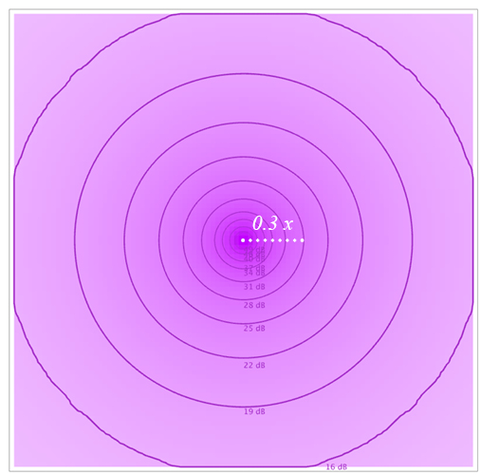
Figure 3. Ambient SPL is set at 40 dB and the maximum SPL is adjusted to the SNR.
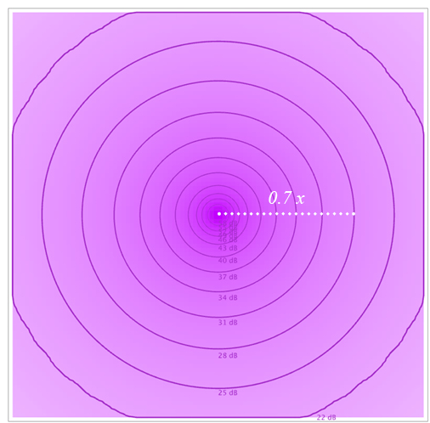
Figure 4. Energy reduction considers atmospheric attenuation at sea level, 20˚C and 50% relative humidity.
As oppose to attenuation, however, low frequencies have higher audible threshold values than higher frequencies. Loudness adjustment factors are incorporated into the tool by embedding a set of interpolated frequency audible weighting values (See table: [18, p. 147]). The pattern presented in Figure 5 do not show a large difference compared to the inverse-square condition. This is because low frequencies have higher audible threshold values than higher frequencies.

Acoustic Impendence
The acoustic impedance is defined as “the amount of driving pressure needed to set the medium particles into motion” [21, p. 14].
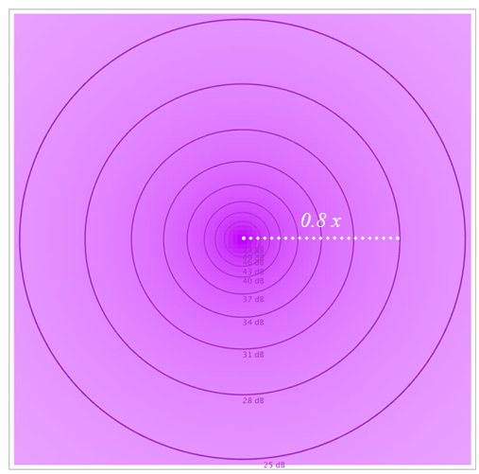
Figure 5. Energy distribution, where maximum SPL is adjusted to the audible threshold.
The tool calculates impedance as:
$$Z=\frac{ρckr\left(i+kr\right)}{\left(1+k^{2}r^{2}\right)}$$
Where: ρ the density of medium = 1.18 kg/m3; c is the speed of sound (meter per second); k is the acoustic number (radians per meter); r is the distance from source (meters); and I is the imaginary number expression.
Since the directionality of impedance is not considered the profile of energy decrease should not diverge from the inverse-square attenuation. Figure 6 tends to confirm this result, where the radii measured for both the inverse-square and impedance at different frequencies are comparable. It may be argued that this outcome shows that incorporating acoustic impedance for qualitative urban mapping may be redundant. However, it also may be argued that it has a relationship to other important frequency dependent acoustic properties. This allows further model development to consider additional indices at later stages such as particle velocity, displacement, reactive power, and acoustic efficiency that all depend on the frequency and have a relationship with acoustic impedance.

Limitations and Conclusion
When considering all the presented parameters (Figure 7) the results begin to show the delineation of the acoustic arena in the form of the sphere of influence. The 28dB contour radius is considerably smaller, and the outermost contour denotes the lowest energy contribution beyond which the signal is lower than the audible threshold and ambient level. The combination of these indices can produce a range of different outcomes (Figure 8). As the basis of the mapping tool, these measurements are an encouraging result.
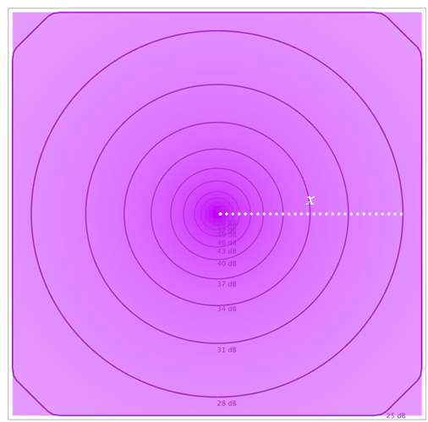
Figure 6. Energy distribution patterns considering acoustic impedance.
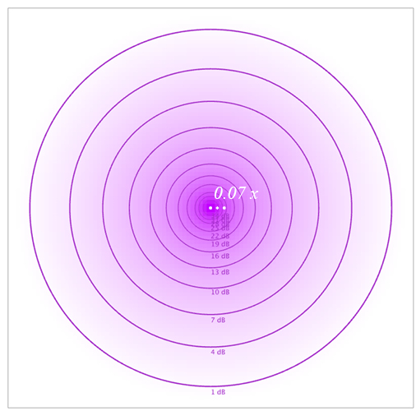
Figure 7. Energy distribution patterns considering all parameters.
The sonic event agent invokes a series functions that handle reflection against walls that inhabit the sphere of influence. In addition, the sensor agents use the same calculations and then proceed to weight the values according to a number of perceptual parameters, including A-weighting networks, spectral masking, attention and visual connection. The grid size and non-linear contouring seem to result in a potential distance discrepancy. The limitation of the non-linear interpolation of measured along with the grid resolution reduce the quantitative measurement accuracy. Therefore, it can be deduced that if the receiver grid resolution increases the fidelity would increase; however, that may result in a higher computation time. For qualitative results, it may be argued that the comparable patterns and appearance of area measurements convergence is encouraging. As the tool matures, a more linear interpolation between detected energy values, which would in turn compensate for any grid size variance.
The key design-based contribution is the development and calibration of a computational design and decision-aiding tool that can predict qualitative patterns of aural spatial perception, and translate them into spatial attributes within a modelled urban space. The merging of these concepts and processes are the knowledge-based contribution this research offers. Indeed, Kang recommends that some of the “challenges in the simulation of urban sound propagation [is] consider[ing] more sound sources. Much work has been done for traffic sources, but very limited work has been done for other sources, especially positive sources [and] more calculation indices are needed, in addition to simple SPL” [15, p. 2364].
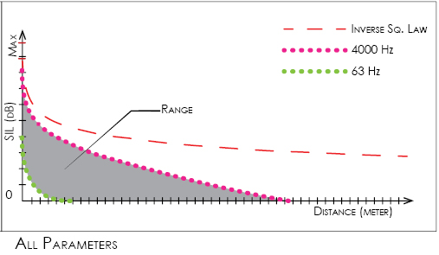
Figure 8. The range (grey shaded area) is between 63 Hz (green dotted) and 4000 Hz (pink dotted).

REFERENCES
- Ashmore, Jonathan F., and Fabio Mammano. 2001. "Can you still see the cochlea for the molecules?" Current opinion in neurobiology 11 (4): 449-454.
- Barakat, Merate A. 2015. "Towards Sonic Urban Morphologies: A Modeling Nexus (WIP)." SummerSim'15. 389-384.
- —. 2012. "Urban Acoustic Simulation: Analysis of Urban Public Spaces through Auditory senses." Proc. of the 30th eCAADe. 587-592.
- Batty, Michael. 2009. "Urban modeling." International Encyclopedia of Human Geography (Elsevier) 51-58.
- Besserud, Keith, and Mark Sarkisian. 2013. "Scales of Regional, Urban and Metabolic Building Systems Design at SOM." Architectural Design 83 (4): 86-93.
- Blesser, Barry, and Linda-Ruth Salter. 2007. Spaces Speak, Are You Listening? Experiencing Aural Architecture. Cambridge, Massachusetts: The MIT Press.
- Cavanaugh, William J, and Jospeh A Wilkes. 1999. Architectural Acoustics, Principles and Practices. New York: John Wiley & Sons, Inc.
- Farina, Almo. 2014. Soundscape Ecology: Principles, Patterns, Methods and Applications. New York, London: Springer Science+Business Media Dordrecht.
- Genuit, Klaus, and André Fiebig. 2006. "Psychoacoustics and its benefit for the soundscape approach." Acta Acustica united with Acustica 92: 952-958.
- Grimm, Volker, Eloy Revilla, Uta Berger, Florian Jeltsch, Wolf M. Mooij, Steven F. Railsback, Hans-Hermann Thulke, Jacob Weiner, Thorsten Wiegand, and Donald L. DeAngelis. 2005. "Pattern-oriented modeling of agent-based complex systems: lessons from ecology." science 310 (5750): 987-991.
- Holzherr, Florian. 2009-2012. James Turrell. Accessed 2014. http://www.boumbang.com/james-turrell/.
- Huhns, Michael N., and Munindar P. Singh. 1998. Readings in Agents . San Francisco: Morgan Kaufmann Publishers Inc.
- Kang, Jian. 2005. "Numerical modeling of the sound fields in urban squares." The Journal of the Acoustical Society of America 117 (6): 3695-3706.
- Kang, Jian. 2002. "Numerical Modelling of the Sound Fields in Urban Streets With Diffusely Reflecting Boundaries." Journal of Sound and Vibration 258 (5): 793-813.
- Kang, Jian. 2011. "Sound propagation at micro-scale in urban areas." The Journal of the Acoustical Society of America 129 (4): 2364-2364.
- Kang, Jian. 2001. "Sound propagation in interconnected urban streets: a parametric study." Environment and Planning B 28 (2): 281-294.
- —. 2007. Urban sound environment. 1st. Abingdon | New York: Taylor & Francis.
- Parmanen, Juhani. 2012. "Some Reasons to Revise the International Standard ISO 226:2003: Acoustics—Normal Equal-Loudness-Level Contours." Open Journal of Acoustics 2 (4): 143-149.
- Russomanno, David. 2002. "Introduction to AI Class." What is an Agent? Memphis: The University of Memphis, August 23.
- Truax, Barry. 1999. "Handbook For Acoustic Ecology, CD-ROM." Vers. Second Edition. Cambridge Street Publishing. Accessed February 12, 2015. http://www.sfu.ca/sonic-studio/handbook/.
- Vorländer, Michael. 2008. Auralization: fundamentals of acoustics, modelling, simulation, algorithms and acoustic virtual reality. Berlin: Springer-Verlag.
- Weinstock, Michael. 2011. "The Metabolism of the City - The Mathematics of Networks and Urban Surfaces." Architectural Design 81: 102-107.
- Wooldridge, Michael J. 2009. An Introduction to MultiAgent Systems. 2nd. New York, NY, USA: Wiley.

