A randomised controlled feasibility and proof-of-concept trial in delayed gastric emptying when metoclopramide fails: We should revisit nasointestinal feeding versus dual prokinetic treatment. Achieving goal nutrition in critical illness and delayed gastric emptying: Trial of nasointestinal feeding versus nasogastric feeding plus prokinetics

Stephen J. Taylor ^{a, *}, Kaylee Allan ª, Helen McWilliam ª, Alex Manara ^{b}, Jules Brown ^{b}, Rosemary Greenwood ^{c}, Deirdre Toher ^{d}
ª Department of Nutrition and Dietetics, Level 6, Gate 10, Brunel Building, Southmead Hospital, Bristol, BS105 NB, UK
^{b} Department of Anaesthetics, Level 3 Gate 38, Brunel Building, Southmead Hospital, Bristol, BS10 5NB, UK
^{c} Research Design ServiceeSouthWest, University Hospitals Bristol NHS FoundationTrust, Level 3 Education Centre, Upper Maudlin Street, Bristol, BS2 8AE, UK
^{d} Department of Engineering Design and Mathematics, University of the West of England, Frenchay Campus, Bristol, BS16 1QY, UK

* Corresponding author. Tel. +44 01174145428.
E-mail addresses: stephen.taylor@nbt.nhs.uk (S.J. Taylor), kaylee.allan@nbt.nhs.uk (K. Allan), Helen.McWilliam@nuth.nhs.uk (H. McWilliam), alex.manara@nbt.nhs.uk (A. Manara), jules.brown@nbt.nhs.uk (J. Brown), rosemary.greenwood@UHBristol.nhs.uk (R. Greenwood), Deirdre.toher@uwe.ac.uk (D. Toher).

Keywords: Delayed gastric emptying; nasogastric; nasoinestinal; prokinetic

Summary
Background & aims: Delayed gastric emptying (DGE) commonly limits the use of enteral nutrition (EN) and may increase ventilator-associated pneumonia. Nasointestinal feeding has not been tested against dual prokinetic treatment (Metoclopramide and Erythromycin) in DGE refractory to metoclopramide. This trial tests the feasibility of recruiting this ‘treatment-failed’ population and the proof of concept that nasointestinal (NI) feeding can increase the amount of feed tolerated (% goal) when compared to nasogastric (NG) feeding plus metoclopramide and erythromycin treatment.

Methods: Eligible patients were those who were mechanically ventilated and over 20 years old, with delayed gastric emptying (DGE), defined as a gastric residual volume ≥250 ml or vomiting, and who failed to respond to first-line prokinetic treatment of 3 doses of 10 mg IV metoclopramide over 24 h.
When assent was obtained, patients were randomised to receive immediate nasointestinal tube placement and feeding or nasogastric feeding plus metoclopramide and erythromycin (prokinetic) treatment.

Results: Of 208 patients with DGE, 77 were eligible, 2 refused assent, 25 had contraindications to intervention, almost exclusively prokinetic treatment, and it was feasible to recruit 50. Compared to patients receiving prokinetics (n=25) those randomised to nasointestinal feeding (n=25) tolerated more of their feed goal over 5days (87 – 95% vs 50 – 89%)and had a greater area under the curve (median[IQR] 432 [253 – 464]% vs 350 [213 – 381]%, p = 0.026) demonstrating proof of concept. However, nasointestinally fed patients also had a larger gastric loss (not feed) associated with the NI route but not with the fluid volume or energy delivered.

Conclusions: This is first study showing that in DGE refractory to metoclopramide NI feeding can increase the feed goal tolerated when compared to dual prokinetic treatment. Future studies should investigate the effect on clinical outcomes.

Glossary
CRRT continuous renal replacement therapy
DGE delayed gastric emptying
EN enteral nutrition
GRV gastric residual volumes
NG nasogastric
NI nasointestinal
PN parenteral nutrition
SAE serious adverse events
SAR serious adverse reactions
TPN total parenteral nutrition
VAP ventilator-associated pneumonia

Take home message
Under-nutrition in ICU is associated with poor outcome and commonly caused by delayed gastric emptying (DGE). In patients with DGE refractory to metoclopramide treatment, a higher percentage of goal nutrition is tolerated via intestinal feeding than gastric feeding plus dual metoclopramide and erythromycin treatment.

Tweet
Goal nutrition is better tolerated via intestinal feeding than with gastric feeding plus dual metoclopramide and erythromycin treatment

1. Introduction

Attempting to meet goal requirements using enteral nutrition (EN) may be associated with reductions in mortality, infection, hospital stay and nutritional deficit [1]. However, delayed gastric emptying (DGE) limits the use of EN and may be associated with increased risk of ventilator-associated pneumonia (VAP) [2]. NI feeding and total parenteral nutrition (TPN) can overcome DGE and may reduce VAP-risk but nasointestinal (NI) EN is cheaper and reduces infection risk [1] by maintaining gut immunocompetence [3].

Delayed gastric emptying (DGE) presents in 30.5% of ICU patients [4]. DGE is associated with increased mortality and time to discharge alive, lower energy and protein input and fewer ventilator-free days after adjustment for age, sex and APACHE score, particularly when it persists >1d or relapses [4]. Cumulative 24 h gastric residual volumes (GRVs) of even 150 mL are associated with objectively measured DGE [5]. However, while DGE is associated with increased retrograde intestinal peristalsis [6] prokinetic drugs such as metoclopramide and erythromycin improve gastric emptying and reduce intolerance due to large GRVs and vomiting [7]. And, the improved intestinal nutrient delivery following erythromycin increases glucose absorption [8] and is tolerated without ileus in most patients on full rate NI feeding [9].

Evidence on whether prokinetics or NI feeding are more effective in over-coming DGE is equivocal. When NI feeding is delayed, nasogastric (NG) feeding delivers more EN during erythromycin treatment [10] and achieved similar EN delivery and clinical outcomes during metoclopramide and erythromycin treatment [11]. Conversely, rapid NI tube placement was associated with greater tolerance (%goal), a smaller cumulative deficit and reduced prokinetic drug use and treatment cost [9].

Treatments are not risk-free. It has been recommended that gastric feeding is not interrupted when the GRV is less than 500 ml but that prokinetic drugs are initiated when GRVs are 200 – 500 ml [12]. However, prokinetic use is associated with early tachyphylaxis (metoclopramide: 2 – 3 days; metoclopramide + erythromycin: 6 days) [13] and side-effects (metoclopramide: neurological [14], erythromycin: cardiac and potential bacterial resistance). Conversely, additional ‘blind’ NI tube placement adds a 1.5% risk of misplacing the tube in the respiratory tract and 0.5% risk of pneumothorax or pneumonia [15].

This is the first trial to test the feasibility of recruiting patients with proven DGE where first-line prokinetic (metoclopramide) treatment has failed. We study the proof-of-concept of whether NI feeding immediately post-randomisation increases the feed goal (%) tolerated compared to NG feeding plus metoclopramide and erythromycin prokinetic treatment. Earlier studies recruited patients ‘at risk’ of DGE and only confirmed intestinal feeding 15 h after tube placement [11].

2. Methods

This was a randomised, feasibility and proof-of-concept study. Ethical (NRES Committee South Central – Southampton A, REC reference: 12/SC/0530) and Medicines and Healthcare products Regulatory Agency (MHRA) (18524/0221/001-0001) approval was obtained prior to commencement. Intervention blinding was not possible because the research team placed the enteral tubes whilst sham tubes are both discernible and an inherent complication risk.

The study was undertaken at Frenchay Hospital ICU admitting approximately 600 patients per year, 66% non-surgical, a mean APACHE II score of 16 ± 7.2 and overall predicted mortality of 33%. Mechanically ventilated adults receiving EN were eligible at any point post-ICU admission if they had DGE (vomiting or 1 GRV exceeded 250 mL) after first-line prokinetic treatment of three 10 mg doses of IV metoclopramide over 24 h [9]. Based on scintigraphy in critically patients, a GRV of 250 mL in 24 h approximates the lowest threshold at which only patients with DGE will be captured and therefore permits earlier treatment of DGE compared to higher thresholds [5]. Mechanical ventilation was defined as presence of an endotracheal tube or tracheostomy excluding those on CPAP alone or breathing spontaneously. Patients were excluded if prokinetics were contraindicated (erythromycin:
on macrolides, metoclopramide: <20y) [1], EN had become contraindicated because the GI tract was not accessible or functional including ileus, active GI bleeding, intestinal obstruction and potential GI ischaemia, EN was considered ineffective when moribund or anticipated EN requirement was for <48 h, if the EN goal was unattainable including those with severe malnutrition, short bowel syndrome, substrate intolerance, renal failure (serum creatinine >190uM) and not on continuous renal replacement therapy and hepatic encephalopathy necessitating protein restriction, or where an NI tube was contraindicated due to abnormal anatomy or surgery or was already in situ.

2.1. Recruitment and randomisation

Assent was obtained from relatives or a non-research ICU consultant for study admission until informed patient consent was possible. Researchers numbered each recruit then email requested allocation via an automated, concealed, random block, 1:1 ratio randomiser.

2.2. Feeding and gastrointestinal (GI) intolerance

All patients were increased from 40 mL feed/h or current rate to full rate whenever tolerated. Tolerance was defined GRVs <250 mL and no vomiting in the prokinetic group and where GRVs contained no macroscopic feed in the NI group. The first GRV ≥250 mL was discarded and EN was continued at the same rate but a second consecutive 4 hourly GRV ≥250 mL was discarded and the feed rate was reduced 50%. Ileus triggered cessation of EN and 4 hourly re-assessment for risk of bowel ischaemia [16].

2.3. Outcome, treatments and study size

Primary outcome was the percentage of feed goal tolerated (% goal). The research dietitian prescribed the ‘goal’ feed type and volume, based on individualised estimation of energy expenditure from validated ‘PSUm’ equations, less non-nutritional energy from IV glucose or the fat solvent in Propofol and ≥1.2 g protein/kg/ d [17].When substrate intolerance was a risk (BMI >30, diabetes) or present (serum glucose >10 mM), ‘goal’ was reduced from 100% to 75% of energy expenditure. The volume of feed tolerated was a pragmatic estimate: NI feed + (NG feed * (total NG fluid - discard)/total NG fluid). When NI feed was clinically visible in a GRV or vomit it was counted as NG feed.

When eligible patients failed to respond to 3 doses of metoclopramide over 24 h and assent was obtained, they were randomised either to receive 250 mg IV erythromycin qds in addition to metoclopramide [18] or NI feeding (Fig. 1). The NI tube guide-wire emits an electromagnetic signal, detected by a ‘receiver’ over the xiphisternum and projected as a computerised trace of the tube path to guide placement [14]. If NI placement failed, the patient received both prokinetic drugs but where it succeeded both drugs were stopped. All patients had an NG tube left in situ to check 4 hourly GRVs and NG feed ‘prokinetic’ patients or freely drain in ‘NI’ patients.

Historically, 21% of Frenchay ICU patients met our inclusion criteria, giving 129 potentially eligible patients per year; reduced by potential refusal (<20% [19]) and weekends and within grant constraints,
we aimed to recruit 50 patients per group. We tested the feasibility in recruiting DGE patients failing first-line prokinetic treatment and hope to prove the concept that immediate NI feeding would reduce the goal deficit over 5 days [9].

2.4. Clinical outcomes

As a foundation for studying the effect of treating DGE on VAP risk, we report clinical outcomes during the 5-day study period. Adverse events or reactions included: Diarrhoea (≥3 liquid stools per day), abdominal distension (clinically compared to baseline), vomit or regurgitation, minor nose-bleed, continuous renal replacement therapy (CRRT, in patients in stage 3 – 4 renal failure pre-randomisation) and hypernatraemia. Serious adverse events (SAEs) or reactions (SARs) included: Systemic infection (SIRS: Any two of temperature >38.3 or <36 °C, respiratory rate >20 min⁻¹ or PaCO2 <32 mmHg (4.3 kPa), heart rate >90 bpm, total white cell count <4 × 10⁹/L or >12 ×10⁹/L or sepsis: SIRS + presence of an infection) [20,21], ileus (identification of abdominal distention and lack of bowel movement, having excluded GI obstruction on clinical or radiological grounds), raised liver function tests (>3 × upper limit for bilirubin, alanine transaminase or alkaline phosphatase).

2.5. Statistical analysis

Statisticians performed ‘blind to intervention’, intention-to-treat analyses. Normality of continuous variables was determined by a Shapiro-Wilks test (p<0.05) and an independent samples Student's t test or Mann-Whitney test as appropriate. The 95% confidence intervals (95%CI) refer to the mean or median difference between treatment groups in the respective tests. Categorical data was analysed using Fisher's exact test. Results will be used to guide sample size for future full trial. Associations were tested using linear regression. Effect sizes ([mean of intervention e control]/ standard deviation) and bootstrapped 95%CI for medians were calculated and presented with the percentage difference between intervention and control. Analyses for continuous and categorical variables were done using Cohen's d and Cramer's V tests, respectively. A Mann-Whitney test was used to determine the difference of the area under the curves of feed goal (%), to provide an overall p-value over the 5 days of the intervention or up to the point of death.

3. Results

The study ran from22/2/13 to 12/5/14 including 5 days follow-up. Of 25 patients randomised to receive NI feeding, 92% had an NI tube placed on day 1, usually within 1 h of randomisation by the ICU dietitian (ST). Metoclopramide was continued in three ‘NI’ patients because the patient was in theatre or the tube failed to move out of the stomach or duodenum part-1. All three tubes were advanced into the intestine on day-2 and metoclopramide was stopped: 100% of tubes were intestinal, 92% in duodenum part-4 or beyond. Surviving NI patients inadvertently removed tubes in 8% by day-3 and 16% by days 4 – 5. Prokinetics were started within 3 h of randomisation in 24 of 25 patients randomised. However, patient 5 was re-classified ‘moribund’ before treatment on day-1, patient 32 failed to respond to prokinetic treatment and was successfully transferred to NI feeding from day 5 and patient 50 suffered a suspected serious adverse drug reaction to erythromycin and treatment was stopped on day 3. However, results were analysed on an intention-to-treat basis.

A quarter of ICU patients with DGE were refractory to metoclopramide and recruited (Fig. 1). In 27% DGE resolved with metoclopramide treatment whereas ~12% may have required treatment but were excluded because they were not mechanically ventilated. There was no apparent association between APACHE II score or age and failure to respond to metoclopramide. About 5% were excluded because of protocol deviation due to early treatment cessation of metoclopramide or initiation of erythromycin. Only 1% refused assent. Most of the remainder had absolute, if temporary, reasons for
not being treated. However, patients with DGE were twice as likely (11.3% vs 4.9%) to be excluded from prokinetic drug treatment (potential metoclopramide sensitivity or erythromycin drug interactions) as NI tube placement. Randomisation was restricted by weekends and leave of the single operator for NI placement. If operators provided full clinical cover, more patients suffering DGE are
eligible for NI feeding than dual metoclopramide and erythromycin treatment (99.5% vs 88.7%, p < 0.0001; Cramer's V = 0.25).

Age and APACHE II score were similar for ‘inclusions’ and ‘exclusions’ but exclusions had significantly more ICU and ventilator free days up to day 28 and a non-significant trend to increased mortality (Appendix A). Study groups were similar for all baseline measures (Table 1).

The NI intervention exceeded feed goal tolerance of prokinetics on 68 – 76% of patient days (Fig. 2). On days 4 and 5 the disparity is mainly because tolerance fell in the ‘prokinetic’ group. Days 1– 5, the area under the curve of feed goal (%) for the NI group was higher (median [IQR] 432 [253 – 464]% vs 350 [213 – 381]%, p = 0.026) demonstrating proof of concept and >80% was tolerated on 16 – 40% patient days more than the ‘prokinetic’ group. While the NI group received a higher enteral volume via EN and a trend to higher kcal delivered, 5 – 42% of NI patients had a higher gastric loss (not feed) than the NG group's median, particularly on days 1e3 (Appendix B). In a linear model, higher gastric loss was associated with the ‘NI’ intervention, but not EN volume or kcal delivered. Furthermore, regression analysis of age, APACHE II score, disease category, conscious state, airway, height, weight and study group, showed only NI feeding and ‘surgery’ diagnosis had significant independent associations with lower and higher cumulative deficits, respectively (Appendix C).

Groups were similar for minor and major complications and mortality (Table 2). Numbers were too small for analysis but the NI group had fewer infectious complications and days on PN but more cases of ileus diagnosed (Appendix D). Treatment groups had a similar number of minor complications associated with the intervention (NI feeding: 2 minor nose bleeds, Prokinetics: Erythromycin stopped because of ileus [n = 1] and skin rash [n = 1]). However, prokinetic drugs were stopped in two patients from that group: 1 because treatment failed to correct DGE by day 4 and 1 because of severe tachycardia, ectopics and loss of cardiac output suspected to be a serious adverse drug (erythromycin) reaction.

4. Discussion

4.1. Primary outcome

For the first time we demonstrate that 24% of patients with DGE fail first-line prokinetic treatment, can be recruited and prove the concept that NI feeding achieves higher goal (%) feed tolerance days 1e5 than dual prokinetic treatment (p = 0.026).Median tolerance was greater in NI than prokinetic patients on 68 – 76% patient days. There were minimal differences between groups at baseline or for clinical outcomes, though the study was not powered to determine the latter.

Relatively greater tolerance in the ‘NI’ group on day 1 may be due prokinetic effects being slower than instant intestinal access whereas on days 4e5 feed tolerance is maintained in the NI group but fell in the prokinetic group. Previous studies showed that the number of patients being successfully fed when receiving metoclopramide drops from 62% to 27% and 16% after 24 h, 3 and 7 days, respectively
[13]. Similarly, successful feeding on erythromycin treatment falls from 87% to 47% and 31% at 24 h, days 3 and 7, respectively. Combined treatment using both drugs was effective in 67% up to day 6.
We confirm that tolerance using combined metoclopramide-erythromycin treatment peaks at 88% on day 3 but falls to between 60 and 72% days 4 – 5. This suggests early tachyphylaxis, rather than our policy of stopping prokinetics after 48 h of improved tolerance, as prokinetic doses were not associated with tolerance. In contrast, NI group tolerance was 88% on day 1 and plateaued at 95%. Since 16% of NI tubes were lost to patient removal, use of nasal bridles might further improve success. Increasing the number of patients receiving >80% of goal nutrition by 7 – 18% was previously associated with shorter mean stay in hospital (25 vs 35 days) and a trend toward reduced mortality (27% vs 37%) [22]. Since our study increased the number of patients reaching this goal by 16 – 40% over days 1 – 5, the intervention may benefit clinical outcomes.

Our estimation of feed tolerance from NI feed þ (NG feed * (total NG fluid – loss)/total NG fluid) is an approximation because currently there are no accurate clinical methods for measuring gastric emptying. Because we classified ‘NI’ feed seen in a GRV as ‘NG’ on the assumption that either the tube or feed had regurgitated into the stomach, NI feeding may have been underestimated since only a proportion of intestinal feed is likely to have been regurgitated. Conversely, NG feed and fluid may be diluted by saliva and gastric juice, therefore feed loss in GRVs may be overestimated. Refractometry is an inexpensive measure of gastric emptying [23] but dilution leads to overestimation of gastric emptying and repeated sampling is difficult to apply in clinical settings. It is also possible that our definition of ‘tolerance’ does not equate to absorption and its possible benefit. Intestinal glucose absorption and glucose-transporters are reduced in critical illness [24]. Conversely, glucose absorption increases following erythromycin [8] and few patients suffer ileus during NI feeding [9]. It has not been determined whether or to what extent malabsorption or harm occur or are reversed by continuous intestinal nutrient delivery.

4.2. NI tube success

NI feeding previously failed to improve goal (%) tolerated [11,25]. Our study differed in having early and high NI tube placement success (1 h: 92%, 24 h: 100%) and feeding, equal to the best alternative techniques [26]. Tubes relying on peristalsis, have lower success rates (60e90%) and greater delays before placement confirmation (1.5 – 5 days) [11,27]. Fluoroscopy may achieve 96 – 100% success rates [28] but is rarely available at the bedside.

4.3. Gastric loss

Interestingly, while NI feeding by-passes DGE and reduces GRVs in some individuals, overall, we confirm that NI feeding is associated with higher gastric losses [9]. NI feeding may accentuate an underlying mechanism for DGE, the hypersensitive secretion of cholecystokinin (CCK) and peptide-YY (PYY) [29], in response to nutrient entering the small intestine, leading to reduced antral and fundal tone but increased pyloric tone [30]. Tending to confirm this, gastric loss was associated with site of delivery (NI intervention group) but not enteral volume or energy (kcal) delivered. If NI feeding alone increased DGE and aspiration risk relative to prokinetics, it helps explain failure to improve clinical outcomes [11]. However, while pepsin-positive tracheal secretions occur in 62% of NG-fed ventilated patients [31] our combination of NG drainage concurrent to NI feeding should additively reduce aspiration risk [2].

4.4. Safety and clinical outcomes

There were only 2 minor treatment-related complications in each group. However, prokinetics were stopped in two patients: one after a serious suspected erythromycin-related cardiac complication and one because there was no improvement in DGE by day 4. The small numbers preclude conclusions regarding the NI vs prokinetic difference in ileus (3 vs 2) and systemic infection (2 vs 5). Regarding ileus, mechanical ventilation in sedated patients with traumatic intracranial haemorrhage is not only associated with DGE but also prolonged small bowel and overall transit time [32]. Our results suggest that overcoming the DGE component facilitates adequate EN tolerance in the majority, while lower GI dysfunction may temporarily preclude this with ileus in ~12%; this needs to be confirmed in a larger study.

Limitations of this study include inability to perform ‘intervention blinding’ or quantify gastric emptying, introducing potential bias and reducing the efficacy in recruiting the target group, respectively. However, the concealed, mixed block randomisation method would reduce risk of allocation bias and the effect size for NI feeding improving EN tolerance, in patients with a wide range of primary conditions, was above a level that was previously shown to significantly improve clinical outcome [22].

4.5. Future

Meta-analysis indicates that compared to NG feeding, NI feeding reduces risk of pneumonia and VAP, even when limiting to studies using microbiological data, and increases nutrient intake [33– 35].
Other clinical outcomes were similar, possibly because of rapid response to antibiotics in early pneumonia. In addition, many studies failed to report success of NI tube placement or delays to feeding. These factors and inclusion of patients without proven DGE would limit any advantage from NI feeding. Indeed the largest multi-centre study recruited patients at risk of DGE within 72 h of ICU admission, when DGE may not have existed or was most likely to self-resolve and when factors other than DGE are likely to affect EN delivery, including their slower method of achieving and confirming NI tube placement. Lastly, patients intolerant to EN after 48 h of prokinetic treatment were allowed to crossover to NI feeding. Clinical outcomes could be different when restricting inclusion to patients with proven DGE and starting NI feeding within 1– 2 h of randomisation.

We propose that an adequately powered study is required to determine the efficacy of NG feeding plus prokinetics vs NI feeding in preventing VAP where eligibility is restricted to patients with DGE at highest risk of aspiration (GRVs of ≥250 mL or vomiting) [36] and poor outcomes (refractory to prokinetic treatment) [4]. Although complications were not increased by omitting GRV checks [37], this may not apply to high risk patients (surgical, shock) [38] or permit timely treatment to shorten intolerance [4]. In addition, in a larger, multicentre study, tolerance might be analysed using a repeated measures approach to determine an optimal time to stop an intervention. A precursor study would need to provide proof that new centres can be trained to achieve similar speed and success in placement of NI tubes.

While prokinetic treatment is initially effective in treating DGE, its effect declines after day 3 and safety issues precluded prokinetic use in more patients than NI feeding (11.3% vs 0.5%). However, compared to NG feeding, greatest risk reduction for aspiration and pneumonia is when NI feeding is deeper than duodenum part-3 [2]. Conversely, blind tube placement resulting in proximal duodenal feeding [39] and increased duodeno-gastric reflux [40] or increased VAP-risk from transporting a patient off ICU for fluoroscopic placement [41] are reasons for failure to improve outcome; bedside jejunal placement accompanied by gastric drainage appear preferable [2]. Lastly, bed-rest elevation must be controlled because aspiration risk falls by -3.8% per 10° [2].

Defining VAP diagnosis will be important. The clinical pulmonary infection score (CPIS) misclassifies about half of patients (sensitivity 50%, specificity 58%) but diagnostic accuracy is increased with addition of Gram staining (85% and 49%), blind protected sampling (78% and 56%) [42] or diagnosis from protected bronchial lavage.

5. Conclusion

Combined metoclopramide and erythromycin treatment during NG feeding or NI feeding are effective means of increasing goal (%) feed tolerance and widely applicable to patients suffering DGE. However, guided NI tube placement achieves high success rates and NI feeding more quickly and better maintains feed tolerance (% goal). Future studies should consider including only patients suffering DGE, use rapid bedside NI tube placement and simultaneous NG drainage.

Statement of authorship

ST, KA and HM contributed to every aspect of the study. AM and JB were involved in study design, steering group oversight, ethical and clinical issues and manuscript submission. RG advised on analysis and presentation of statistics and study write up. DT was involved in study and statistical design, blind randomisation and analysis and manuscript submission. All authors read and approved the final submitted paper.

Conflict of interest

ST has done consultancy, undertaken funded research and received lecture honoraria from Abbott, Corpak, Fresenius-Kabi and Nutricia. ST, KA and HM undertook a different study, funded by Corpak, through North Bristol NHS Trust. There were no other conflicts of interest and no company or other body played any part in the funding, planning, execution or submission of this study.

Funding

The research was funded and sponsored by North Bristol NHS Trust (NBT) Springboard Fund (No: 2787) and a small grant from the Anaesthetic Department allocated for Anaesthetic Registrar Research. Funders and sponsors did not influence the study design, collection, analysis or interpretation of data, the writing of the manuscript or the decision to submit the manuscript for publication.

Acknowledgements

Our thanks to Dr Abby Ford, Specialist Registrar in Anaesthesia NBT, for support during the study.

References
[1] McClave SA, Martindale RG, Rice TW, Heyland DK. Feeding the critically ill patient. Crit Care Med 2014;42:2600–10.
[2] Metheny NA, Stewart BJ, McClave SA. Relationship between feeding tube site and respiratory outcomes. J Parenter Enter Nutr 2011;35:346–55.
[3] Fukatsu K, Lundberg AH, Hanna MK, Wu Y, Wilcox HG, Granger DN, et al. Increased expression of intestinal P-selectin and pulmonary E-selectin during intravenous total parenteral nutrition. Arch Surg 2000;135:1177–82.
[4] Gungabissoon U, Hacquoil K, Bains C, Irizarry M, Dukes G, Williamson R, et al. Prevalence, risk factors, clinical consequences, and treatment of enteral feed intolerance during critical illness. J Parenter Enter Nutr 2014;39:441–8.
[5] Chapman MJ, Besanko LK, Burgstad CM, Fraser RJ, Bellon M, O'Connor S, et al. Gastric emptying of a liquid nutrient meal in the critically ill: relationship between scintigraphic and carbon breath test measurement. Gut 2011;60: 1336–43.
[6] Chapman MJ, Fraser RJ, Bryant LK, Vozzo R, Nguyen NQ, Tam W, et al. Gastric emptying and the organization of antro-duodenal pressures in the critically ill. Neurogastroenterol Motil 2008;20:27–35.
[7] Reignier J, Bensaid S, Perrin-Gachadoat D, Burdin M, Boiteau R, Tenaillon A. Erythromycin and early enteral nutrition in mechanically ventilated patients. Crit Care Med 2002;30:1237–41.
[8] Deane AM, Wong GL, Horowitz M, Zaknic AV, Summers MJ, Di Bartolomeo AE, et al. Randomized double-blind crossover study to determine the effects of erythromycin on small intestinal nutrient absorption and transit in the critically ill. Am J Clin Nutr 2012;95:1396–402.
[9] Taylor S, Manara A, Brown J. Treating delayed gastric emptying in critical illness: metoclopramide, erythromycin and bedside (cortrak) nasointestinal tube placement. J Parenter Enter Nutr 2010;34:289–94.
[10] Boivin M, Levy H, Hayes J. A multicenter, prospective study of the placement of transpyloric feeding tubes with assistance of a magnetic device. J Parenter Enter Nutr 2000;24:304–7.
[11] Davies AR, Morrison SS, Bailey MJ, Bellomo R, Cooper DJ, Doig GS, et al., Heyland DK for the ENTERIC Study Investigators and the ANZICS Clinical Trials Group. A multicenter, randomized controlled trial comparing early nasojejunal with nasogastric nutrition in critical illness. Crit Care Med 2012;40: 2342–8.
[12] McClave S, Martindale R, Vanek V, McCarthy M, Roberts P, Taylor B, et al., the A.S.P.E.N, Board of Directors and the American College of Critical Care Medicine. Guidelines for the Provision and assessment of nutrition support therapy in the adult critically ill patient: Society of Critical Care Medicine (SCCM) and American Society for Parenteral and Enteral Nutrition (A.S.P.E.N.). J Parenter
Enter Nutr 2009;33:277–317.
[13] Nguyen N, Chapman M, Fraser R, Bryant L, Holloway R. Erythromycin is more effective than metoclopramide in the treatment of feed intolerance in critical illness. Crit Care Med 2007;35:483e9.
[14] European Medicines Agency. European Medicines Agency recommends changes to the use of metoclopramide. EMA/443003/2013. 2013.
[15] Taylor SJ. In: Cortrak tube placement: a clinician's perspective on advanced training. Bristol, UK: Silhouette Publications; 2014. dusk@gotadsl.co.uk. ISBN: 978-0-9574558-3-2.
[16] McClave S, Chang W-K. Feeding the hypotensive patient: does enteral feeding precipitate or protect against ischemic bowel? Nutr Clin Pract 2003;18: 279–84.
[17] Taylor SJ. In: Nutrition support. 1st ed. UK, Bristol: Silhouette; 2012. ISBN: 978-0-9574558-0-1.
[18] Dickerson R, Mitchell J, Morgan L, Maish G, Croce M, Minard G, et al. Disparate response to metoclopramide therapy for gastric feeding intolerance in trauma patients with and without traumatic brain injury. J Parenter Enter Nutr 2009;33:646–55.
[19] Taylor SJ, Fettes SB, Jewkes C, Nelson RJ. Prospective randomised controlled trial to determine the effect of early enhanced enteral nutrition on clinical outcome in mechanically ventilated patients suffering head injury. Crit Care Med 1999;27:2525–31.
[20] Bone RC, Balk RA, Cerra FB, Dellinger RP, Fein AM, Knaus AM, et al. The American College of Chest Physicians/Society of Critical Care Medicine Consensus Conference Committee. Definitions for sepsis and organ failure and guidelines for the use of innovative therapies in sepsis. Chest 1992;101:
1644–55.
[21] Soong J, Soni N. Sepsis: recognition and treatment. Clin Med 2012;12:276–80.
[22] Martin CM, Doig GS, Heyland DK, Morrison T, Sibbald WJ. Multicentre, cluster-randomized
clinical trial of algorithms for critical-care enteral and parenteral therapy (ACCEPT). Can Med Assoc J 2004;170:197–204.
[23] Chang WK, McClave SA, Hsieh CB, Chao YC. Gastric residual volume (GRV) and gastric contents measurement by refractometry. J Parenter Enter Nutr 2007;31:63–8.
[24] Deane AM, Rayner CK, Keeshan A, Cvijanovic N, Marino Z, Nguyen NQ, et al. The effects of critical illness on intestinal glucose sensing, transporters, and absorption. Crit Care Med 2014;42:57–65.
[25] Neumann DA, DeLegge MH. Gastric versus small-bowel tube feeding in the intensive care unit: a prospective comparison of efficacy. Crit Care Med 2002;30:1436–8.
[26] Taylor SJ. Confirming nasogastric feeding tube position versus the need to feed. Int Crit Care Nurs 2013;29:59–69.
[27] Schroder S, van Hülst S, Raabe W, Bein B, Wolny A, von Spiegel T. Nasojejunal enteral feeding tubes in critically ill patients: successful placement without technical assistance. AAGBI 2007;56:1217–22.
[28] Hwang J-Y, Shin JH, Lee YJ, Kim K-R, Kim JH, Song H-Y, et al. Fluoroscopically guided nasojejunal enteral tube placement in infants and young children. AJR 2009;193:54–8.
[29] Chapman M, Fraser R, Vozzo R, Bryant L, Tam W, Nguyen N, et al. Antropyloro-duodenal motor responses to gastric and duodenal nutrient in critically ill patients. Gut 2005;54:1384–90.
[30] Nguyen NQ, Fraser RJ, Chapman MJ, Bryant LK, Holloway RH, Vozzo R, et al. Feed intolerance in critical illness is associated with increased basal and nutrient-stimulated plasma cholecystokinin concentrations. Crit Care Med 2007;35:82–8.
[31] Schallom M, Orr JA, Metheny N, Kirby J, Pierce J. Gastric reflux: association with aspiration and oral secretion pH as marker of reflux. A descriptive correlational study. Dimens Crit Care Nurs 2015;34:84–90.
[32] Rauch S, Krueger K, Turan A, You J, Roewer N, Sessler DI. Use of wireless motility capsule to determine gastric emptying and small intestinal transit times in critically ill trauma patients. J Crit Care 2012;27. 534. e7-12.
[33] Alhazzani W, Almasoud A, Jaeschke R, Lo BW, Sindi A, Altayyar S, et al. Small bowel feeding and risk of pneumonia in adult critically ill patients: a systematic review and meta-analysis of randomized trials. Crit Care 2013;17: R127. http://dx.doi.org/10.1186/cc12806.
[34] Alkhawaja S, Martin C, Butler RJ, Gwadry-Sridhar F. Post-pyloric versus gastric tube feeding for preventing pneumonia and improving nutritional outcomes in critically ill adults. Cochrane Database Syst Rev Aug 4, 2015;8: CD008875.
[35] Deane AM, Dhaliwal R, Day AG, Ridley EJ, Davies AR, Heyland DK. Comparisons between intragastric and small intestinal delivery of enteral nutrition in the critically ill: a systematic review and meta-analysis. Crit Care 2013;17:R125.
[36] Metheny N, Schallom L, Oliver D, Clouse R. Gastric residual volume and aspiration in critically ill patients receiving gastric feedings. Am J Crit Care 2008;17:512–9.
[37] Reignier J, Mercier E, Le Gouge A, Boulain T, Desachy A, Bellec F, et al., Lascarrou J-B for the Clinical Research in Intensive Care and Sepsis (CRICS) Group. Effect of not Monitoring residual gastric volume on risk of ventilator associated pneumonia in adults receiving mechanical ventilation and early
enteral feeding a randomized controlled trial. JAMA 2013;309:249–56.
[38] Elke G, Felbinger TW, Heyland DK. Gastric residual volume in critically ill patients: a dead marker or still alive? Nutr Clin Pract 2015;30:59–71.
[39] Silk DB. The evolving role of post-ligament of Trietz nasojejunal feeding in enteral nutrition and the need for improved feeding tube design and placement methods. J Parenter Enter Nutr 2011;35:303–7.
[40] Dive A, Michel I, Galanti L, Jamart J, Vander B, Installé E. Gastric acidity and duodenogastric reflux during nasojejunal tube feeding in mechanically ventilated patients. Intensive Care Med 1999;25:574–80.
[41] Kollef MH, Von Harz B, Prentice D, Shapiro SD, Silver P, St John R, et al. Patient transport from intensive care increases the risk of developing ventilator associated pneumonia. Chest 1997;112:765–73.
[42] Fartoukh M, Maitre B, Honore S, Cerf C, Zahar J-R, Brun-Buisson C. Diagnosing pneumonia during mechanical ventilation: the clinical pulmonary infection score revisited. Am J Respir Crit Care Med 2003;168:173–9.

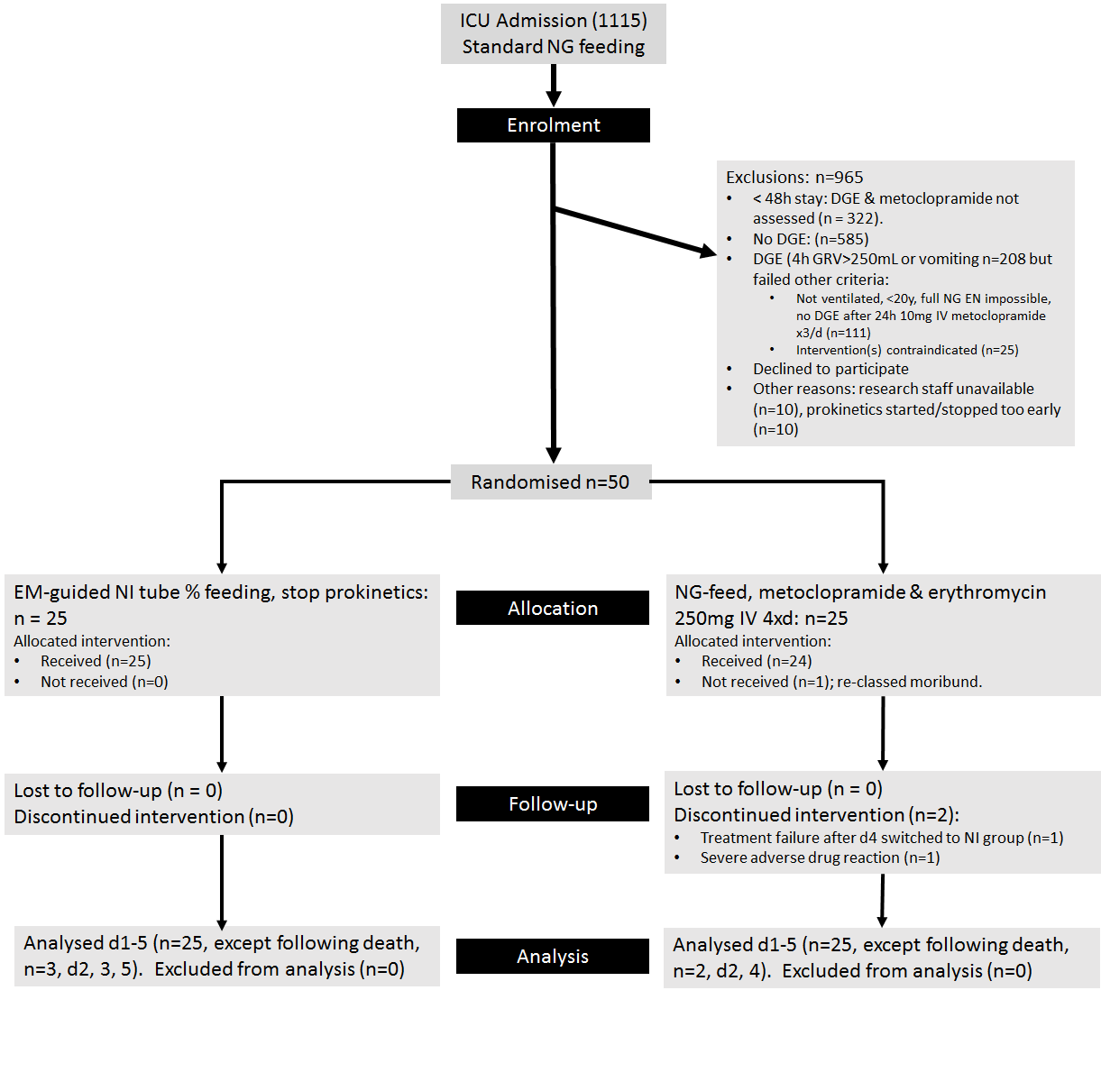
Fig. 1. Enrolment, allocation, follow-up and analysis
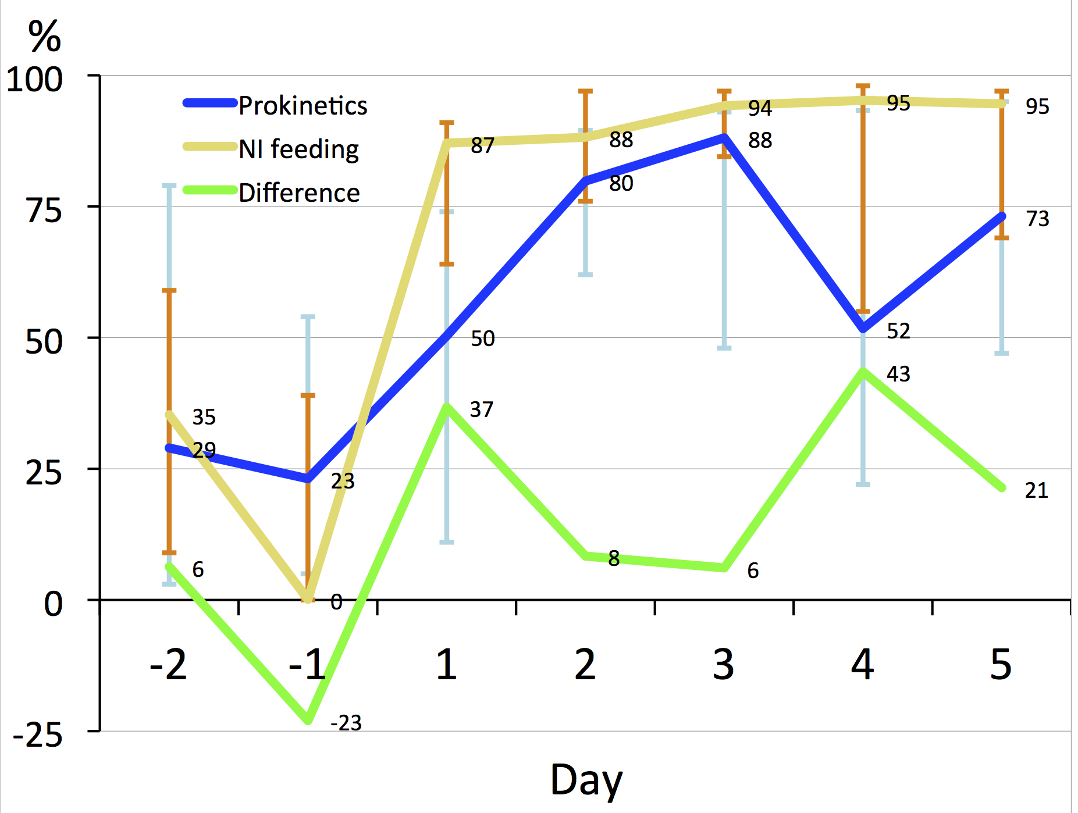
N | NG + prokinetics | 25 | 25 | 25 | 24 | 24 | 23 | 23
 | NI | 24 | 24 | 25 | 24 | 23 | 23 | 22
Effect Size |  | 0.02 | 0.21 | 0.4 | 0.19 | 0.19 | 0.18 | 0.17
 | 95% CI | -22, 23 | 0, 23 | -44, 4 | -19, 4 | -17, 4 | -47, 5 | -25, 4
% of NI > median NG |  | 60 | 40 | 76 | 68 | 72 | 72 | 76

Fig. 2. Median goal (%) tolerated

Table 1 Baseline characteristics of prokinetic vs NI groups.
Parameter |  | NG + prokinetics |  | NI |  | Effect:
 |  | Median | IQR | Median | IQR | Size | 95%CI | % of NI  > median NG
Age (y) |  | 51 | 36-59 | 53 | 42-61 | 0.09 | 0.21, 0.36 | 56%
APACHE II score |  | 20 | 13-19 | 18 | 12-24 | 0.03 | -0.24, 0.31 | 40%
Height_measured (cm) |  | 178 | 166-180 | 173 | 171-180 | 0.04 | -0.27, 0.33 | 40%
Weight_estimate (kg) |  | 80 | 73-110 | 75 | 70-85 | 0.15 | -0.13, 0.42 | 36%
Parameter |  | N | % | N | %
Sex (m) |  | 18 | 72% | 20 | 80% | 0.09 | 0, 0.36 | -
C  A  T  E  G  O  R  Y | - Medical | 7 | 28% | 9 | 36% | 0.14 | 0.08, 0.48 | -
 | - Neurosurgery (non-trauma) | 9 | 36% | 6 | 24%
 | - Surgery (abdominal)) | 3 | 12% | 4 | 16%
 | - Trauma | 6 | 24% | 6 | 24%

Table 2 Summary of complications.
Parameter | N (%) or median [IQR] |  |  | Effect:
 | NG + prokinetics | NI |  | Size | 95% CI | % of NI  > median NG
Complications:
Adverse event: occurrence | 9 |  | 9 [7*1+1*2] | 0.16 | 0, 0.38 | -
Adverse event: patients | 9 |  | 8 | 0.04 | 0, 0.32 | -
Serious adverse event: occurrence | 8 [6*1+1*2] |  | 6 | 0.14 | 0, 0.36 | -
Serious adverse event: patients | 7 |  | 6 | 0.05 | 0, 0.33 | -
Ventilation free days | 20 [13-25] |  | 21 [16-25] | 0.08 | -5, 3 | 56%
ICU free days | 11 [0-19] |  | 10 [0-16] | 0.02 | -4, 6 | 48%
Death | 4 (16%) |  | 4 (16%) | 0 | 0, 0.32 | -

Appendix A: Baseline characteristics of inclusions v exclusions.
Parameter | Inclusion |  | Exclusion |  | Effect size:
 | Median  or % | IQR | Median or % | IQR | Size | 95%CI | *% of NI  > median NG
Age (y) | 51.5 | [40-60.5] | 55 | [37-71.5] | 0.09 | -0.04, 0.22 | 46
APACHE II score | 18 | [12.3-24] | 16 | [11-23] | 0.06 | 0.07, 0.19 | 56
Outcomes:
- ICU free | 11 | [4-18.3] | 17 | [10-22.3] | 0.23 | 0.10, 0.36 | 32
- Ventilation free days | 16.5 | [10-20.8] | 21.5 | [15-24] | 0.27 | 0.14, 0.39 | 40
- Death | 16% | - | 28% | - | 0.10 | - | -
*For categorical variables the median is meaningless.

Appendix B Enteral volume and kcal delivered and gastric loss.
Parameter | Day | Inclusion |  | Exclusion |  | Effect:
 |  | Med. | IQR | Med. | IQR | Size | 95% CI | *% of NI > median NG
Gastric Loss  (mL) | -2 | 370 | 0-837 | 560 | 200-760 | 0.04 | 0.25, 0.31 | 60%
 | -1 | 850 | 350-1115 | 885 | 590-1090 | 0.07 | 0.21, 0.36 | 52%
 | 1 | 250 | 0-460 | 690 | 400-1055 | 0.43 | 0.15, 0.66 | 84%
 | 2 | 0 | 0-58 | 480 | 162-975 | 0.58 | 0.37, 0.76 | 92%
 | 3 | 0 | 0-0 | 455 | 246-898 | 0.71 | 0.51, 0.87 | 92%
 | 4 | 0 | 0-205 | 295 | 19-739 | 0.29 | 0.00, 0.55 | 76%
 | 5 | 0 | 0-181 | 69 | 0-482 | 0.27 | 0.04, 0.55 | 60%
EN delivered  (mL) | -2 | 1104 | 608-1476 | 1190 | 734-1618 | 0.10 | -495, 231 | 60%
 | -1 | 1117 | 619-1480 | 964 | 785-1494 | 0.04 | -335, 420 | 40%
 | 1 | 1124 | 744-1471 | 1497 | 1405-1593 | 0.37 | -673, -67 | 92%
 | 2 | 1650 | 1245-1944 | 1808 | 1384-1947 | 0.11 | -493, 179 | 64%
 | 3 | 1726 | 1108-1988 | 1880 | 1658-2172 | 0.23 | -691, 72 | 68%
 | 4 | 1492 | 893-2080 | 1945 | 1634-2382 | 0.37 | -1022, -112 | 92%
 | 5 | 1585 | 1261-1946 | 1917 | 1491-2392 | 0.31 | -921, -52 | 76%
Kcal  Delivered | -2 | 1300 | 685-1645 | 1184 | 758-1478 | 0.01 | -321, 377 | 56%
 | -1 | 1338 | 363-1680 | 1002 | 657-1237 | 0.23 | -69, 654 | 24%
 | 1 | 1249 | 783-1594 | 1510 | 1428-1611 | 0.18 | -565, -11 | 84%
 | 2 | 1718 | 1274-1842 | 1791 | 1396-2159 | 0.07 | -424, 89 | 56%
 | 3 | 1883 | 988-2206 | 1750 | 1523-2030 | 0.11 | -391, 374 | 44%
 | 4 | 1579 | 913-2224 | 1805 | 1589-2115 |  | -770, 310 | 76%
 | 5 | 1729 | 1354-2071 | 1684 | 1535-2128 |  | -602, 290 | 52%

Appendix C Associations with %goal tolerated.
 | Estimate | Std. Error | t value | Pr(>|t|)
Intercept | -165.422 | 282.002 | -0.587 | 0.561
Treatment group = NI | 145.863 | 47.176 | 3.092 | 0.004
Disease category = Neurosurgical (non-Trauma) | 95.033 | 61.408 | 1.548 | 0.130
Disease category = Surgery (general) | -187.790 | 71.155 | -2.639 | 0.012
Disease category = Trauma | -32.590 | 62.778 | -0.519 | 0.607
Age | -1.437 | 1.593 | -0.902 | 0.373
Apache II score | 4.359 | 3.858 | 1.130 | 0.266
Conscious state = sedated | -34.985 | 74.729 | -0.468 | 0.642
Conscious state = unconscious | -9.960 | 96.216 | -0.104 | 0.918
Airway = endotracheal tube | 159.070 | 178.253 | 0.892 | 0.378
Airway = tracheostomy | 4.732 | 58.305 | 0.081 | 0.936
Height (cm) | -0.907 | 1.273 | -0.712 | 0.481
Weight (kg) | 0.784 | 0.763 | 1.027 | 0.311

Reference categories: Disease category = Medical; Conscious state = awake; Airway = endotracheal tube.
Bold indicate significant independent associations with lower and higher cumulative deficits, respectively.

Appendix D Breakdown of adverse and serious adverse events and reactions and PN use.
Class | Complication | NG + prokinetic drugs | NI
GI | Diarrhoea | 2 | 0
 | Gastric distension | 0 | 1
 | Vomited | 5 | 3
Infection | Minor | 0 | 0
Metabolic | CRRT | 0 | 2
 | Hypernatraemia: Diuretic-induced | 0 | 1
 | Raised LFTs | 0 | 1
Mechanical | Minor nose bleed | 0 | 2
Drug | Ileus: Erythromycin stopped | 1 | 0
 | Skin rash: Erythromycin stopped | 1 | 0
GI | Ileus | 1 | 3
Infection | Systemic: Candidiasis | 1 | 0
 | Systemic: VAP | 4 | 2
Metabolic | All | 0 | 0
Mechanical | All | 0 | 0
Drug | Tachycardia, ectopics, loss of output: Erythromycin stopped | 1 | 0
PN | Patients | 2 | 2
 | Patient days | 9 | 5

