 | Abstract Form
Abstract Title:

Mathematical Modelling Analysis of Male Urine Flow Traces

Abstract Text:

Hypothesis / aims of study
Differentiating non-invasively detrusor underactivity (DU) from bladder outlet obstruction (BOO) in men remains a challenge. Invasive pressure flow studies (PFS) are still required despite many years of study. The shape of the urine free flow curve has been used as a qualitative indicator of diagnosis [1], but has not been quantitatively assessed. In this research, a noninvasive diagnostic method has been proposed to differentiate BOO from DU, using the shape of the urine flow curve [2].

Study design, materials and methods
Urine flow data of 24 adult male patients who had undergone PFS were analysed in this research using a linear discrete time dynamic model. The diagnostic group of each patient (BOO, DU and normal) was blinded during model development. Two models were assessed:
- Ratio of time constants for rise time to maximum flow (Qmax) and fall time from Qmax;
This indicator classifies the rising and falling shapes of the urine flow curve, while incorporating sensitivity to the timing of Qmax
The model uses the filtered flow rate curve separated into upward and downward part by dividing at the point of maximum flow. In order to obtain time constant values of each part, a number of existing approaches including least square algorithm and residue theorem are applied. Then the time constant value of upward part is compared with downward part in a simple ratio.

- Ratio of number of peaks in flow after two different filters;
This method is designed to differentiate between fluctuations in flow caused by the detrusor muscle and fluctuations caused by abdominal squeezing
In this model, in order to reduce the fluctuations induced by abdominal and bladder squeezing, a Butterworth filter with cut off frequency of 0.1Hz was applied. Counting of the number of peaks (flow maxima) is conducted on both the original and filtered curves, and the number of peaks per 100ml flow (to compensate for volume differences) was compared.

Results
24 patients were included: 2 normal (i.e. neither DU nor BOO), 7 DU and 15 BOO, in which 3 patients (1 for each group) were ineligible for the time constant analysis as negative values appear in the first part. The ratios of upward and downward time constant value in 7 out 7 non-BOO patients (1 normal and 6 DU) are greater than 1, meanwhile 11 out of 14 BOO patients have the time constant ratio less than 1.
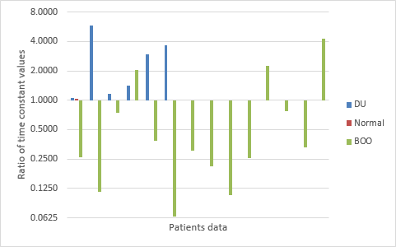
Fig 1. Ratio of time constants in 21 patients (rise constant/fall constant)

In the peak number counting comparison, 1 BOO patient was ineligible as the volume voided is much less than the usual volume range. In figure 2, it can be observed that all DU and normal points are located in the left bottom corner and 8 out of 9 located between the two diagonal lines (). 13 out of 14 BOO points are away from the two diagonal lines.

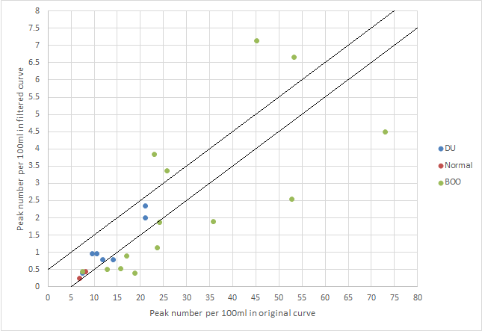
Fig. 2. Comparison of peak number per 100 ml in original curve and filtered curve

Interpretation of results
Sensitivity, specificity, positive and negative predictive value of differentiating DU from BOO using ratio of time constant were 100%, 79%, 67% and 100%. By using ratio of peak number counting, the sensitivity and specificity are 86% and 93%, the positive and negative predictive value are 86% and 93%.

Although the patient data analysed so far is small in scale, these new non-invasive methods appear to hold promise for differentiating BOO and DU in men. This new analytical method can be combined with existing noninvasive methods to enhance diagnostic power.

Further research will follow on more shape recognition methods including wavelet theory, Fourier analysis, time series analysis and empirical mode decomposition. It will also include prospective analysis of free flows prior to PFS diagnosis.

Concluding message
This study shows promising non-invasive methods to differentiate between BOO and DU in men, by comparing the time constant ratio of upward and downward parts of the flow curve, and by counting the number of peaks per 100ml voided in a filtered signal.

