A
B

Figure S1. PPHGI-1 is lost from Pseudomonas syringae pv. phaseolicola 1302A::NCR during passaging though bean. Pph 1302A::NCR was passaged six times (each passage 7 days) through resistant bean cv. TG. At each passage 200 colonies were tested on TG pods (A) and via antibiotic selection (B) for loss of PPHGI-1 and the percentage loss recorded. Means are of three replicates ±SEM.

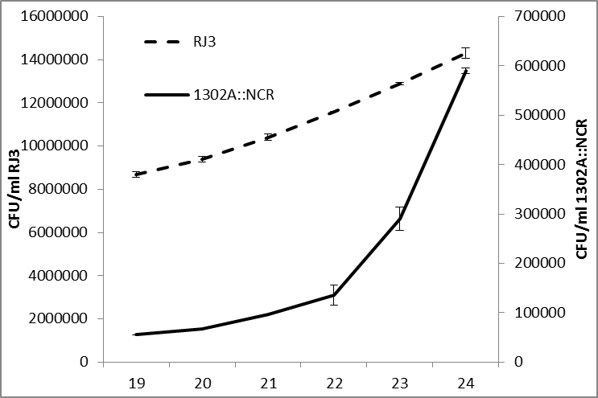

Figure S2. Pseudomonas syringae pv. phaseolicola 1302A has a faster growth rate than RJ3 when the starting cell proportions are unequal. The mixed bacterial population (99.5% RJ3 + 0.5% 1302A::NCR) harvested from the week 18 passage (Fig. 4) through Tendergreen leaves was inoculated into leaves of susceptible bean cultivar Canadian Wonder and passaged 6 times. 1302A::NCR displays an increased growth rate, its population increasing 6.5-fold compared to 1.6-fold for RJ3 between weeks 19-24. Means are of 3 replicates ±SEM.

Figure S3. Pseudomonas syringae pv. phaseolicola 1302A and RJ3 have similar growth rates in planta when the starting cell proportions are equal. Pph 1302A::NCR and RJ3 were diluted to OD₆₀₀ 0.1 and 250µl of each strain mixed and inoculated into susceptible bean cultivar Canadian Wonder leaves. Samples were taken every 2 h and total colony forming units (CFU) calculated. Data shown is log₁₀ CFU/ml and means are of 3 replicates ±SEM.

