**Blurb**

Miltos Hadjiosif and Meera Desai met while organising the first ever Community Psychology Festival and also spent some time together on the BPS Community Psychology Section Committee, becoming two of the main people behind the Festival's many iterations. They both feel very grateful for the wonderful people they have met through these activities. Miltos is a Senior Lecturer in Counselling Psychology at UWE Bristol, an institution that enables him to teach psychology from a critical, reflexive angle and support his students to think of psychology as holding potential for liberation at a personal and collective level. Meera is a clinical psychologist who has always been inspired by systemic, narrative and community approaches in her work with children, young people and families. Miltos’ main ambition in life is to have either PJ Harvey or Pearl Jam curate a Festival. Meera has no idea who either of these are, but judging by Miltos’ excellent taste in Avril Lavigne albums, she can only assume that said Festival would be pretty great.

**Abstract**

November 2014 saw the inaugural Community Psychology Festival. The British Psychological Society (BPS) Community Psychology Section Committee had a vision of an accessible, impactful and inclusive alternative to an academic conference, which materialised as a two-day event aiming to embody the values of community, social justice and stewardship. On the strength of positive feedback and invigorated by the level of enthusiasm for a follow up, the Community Psychology Festival was born as our annual flagship event. In this chapter, we suggest that a festival format can transform the experiencing and sharing of new critical and community psychologies. We discuss the organisational issues involved in putting on such an event and use the example of the Community Psychology Festival to illustrate how the content, venue, aesthetics, hierarchies, accessibility, and even catering, of such a gathering can shape the knowledges that it generates.  This context provides both permission and inspiration to psychologists interested in the inherent therapeutic value of social action to meet like-minded individuals, including many outside their discipline, forge links between their practices, and probe the boundaries of mainstream psychology as a collective. We conclude with brief reflections on how the Festival impacted us as individuals and practitioner psychologists.

**The Evolution of the Community Psychology Festival**

**Meera Desai & Miltos Hadjiosif**

Festivals have been a staple of human culture since antiquity. They usually take place within a pre-specified time period, during which various activities such as music, theatre, and food feasts occur to attract and unite people in celebration of a particular cause. Many festivals have spiritual or religious ties, while others have been born out of trade and commercial interests. In contemporary popular Western culture, the word ‘festival’ brings to mind annual commercial music events such as Glastonbury in the UK and Coachella in the US. At the same time, scientific disciplines increasingly seek to engage the public by using this appealing format. It was against this backdrop of definitions, and exciting possibilities, that the idea of launching our very own festival as an alternative to an academic conference came about.

The concept of a Community Psychology Festival grew out of a discussion between members of the BPS Community Psychology Section committee. We asked ourselves what was unique about community psychology, how to bring our passion for it into our everyday work contexts, and how to be more inclusive within and beyond the narrow confines of our discipline. Parallel discussions noted that it tended to be the same people speaking at and attending the conferences and events that the Section put on, and that speakers at these events were typically preaching to the converted. We felt that we needed to do something more aligned with the values of community psychology, something distinctive, to attract people to the field and demonstrate its potential to do psychology differently. One committee member made a throwaway comment about how we should put on a festival instead of a conference. Instead of laughing and moving on, another asked “Why not?!”, and thus the Community Psychology Festival was born. This brief exchange foreshadowed the start of an ethos of dreaming big, making connections during informal moments, and trusting the process even when the details are far from being worked out; an ethos that has woven its way through each Festival.

November 2014 saw the inaugural (or ‘first ever’, as we liked to call it) Community Psychology Festival in London. What began as a vision for an accessible, inclusive alternative to an academic event culminated in a two-day festival of presentations, performances, and participatory learning. Subsequent years saw a second Festival in Manchester, a third in Bristol, and a fourth in Hertford. At the time of writing, preparations were underway for the fifth Festival in Brighton. In this chapter, we outline how the flagship event of the Community Psychology Section took shape, share our learnings from organising three such Festivals, and offer some thoughts regarding the future of the Community Psychology Festival in the hope of inspiring alternative ways of sharing knowledge and practice.

***Combining values from critical community psychology and festival culture***

Each Festival has been unique to time, space, and local context. It is important to stress that there is no set formula to be followed for each iteration of the Festival, thus it takes a lot of work on behalf of the organising team to create an event that strives to educate as well as entertain. The planning stages of the first Festival saw us spend much time considering our hopes and ambitions, and laying down objectives that were aligned with Community Psychology. Much of our teleconference time was spent questioning taken-for-granted concepts, attempting to inspect each of our decisions with a critical eye, and challenging each other; it was perhaps our shared values that allowed us to do this relatively casually despite some of us having never met in person. We rallied around critical community psychology’s guiding principles of community, social justice, and stewardship (Kagan, Burton, Duckett, Lawthom, & Siddiquee, 2011) and were clear that the creativity afforded by a Festival format needed to be capitalised to serve these values rather than simply becoming a marketing gimmick. We were also keen to attract the attention of potential contributors who might be put off by traditional conferences in order to showcase work that sat on the fringes of mainstream psychology.

Many of us were inspired by Paulo Freire’s (1972) view of every ‘learner’ as an expert and educator with something to offer, and every ‘expert’ or ‘educator’ as having a lot to learn from those whom they purported to teach. Therefore, our aim was to create a learning community within the Festival, one in which the power dynamics that normally play out in academic events could be undermined. Our experiences suggested that these dynamics were often enacted between those who identified as psychologists and those who did not, between seasoned professionals and students, and between groups who held varying degrees of power in society, such as people of different genders, ethnic backgrounds, or abilities. For example, a common observation in mainstream conferences was that those who deliver talks and speak when delegates are invited to comment tend to be white, male, and with many decades of experience within a particular profession or discipline. This suggested that we had been losing out on some of the knowledge and experience held by those falling outside this privileged group. Another common critique of psychology is its historic exclusion of ‘experts by experience’ from the generation of knowledge, which is at odds with community psychology’s preference for co-production of both knowledge and human services (Mayer & McKenzie, 2017). We believed that it was important to reach out to people with lived experience of mental distress, social injustice and/or exclusion, as well as those in less professionalised roles who played a crucial part in helping people at a collective level, such as community organisers.

Although we acknowledged that we may not be able to wholly eradicate some of these power imbalances, we were determined to do our best, and learn from our mistakes for any future Festivals. By doing so, we hoped that we might be able to hear and learn from those who typically had less of a voice and whose wisdom was therefore obscured by more traditional knowledge sharing events. We were confident that this would enrich any discussion, learning, and action which took place during and beyond the Festival. This required a shaking up of the rituals and ‘taken-for-granteds’ of traditional conferences, to prevent us from slipping into the ways of being and relating associated with them. It also required some subversion of the traditional expert versus learner roles, in accordance with Freire’s idea of a ‘learner-educator’.

An example of one of the early challenges we encountered was around how to signal that the Festival not only welcomed, but vitally relied on attendance by non-psychologists. We considered the benefits and drawbacks of a tagline that was half-jokingly suggested for our promotional material: ‘*Psychologists welcome, non-psychologists more welcome*’. There was a tricky balance to strike as we wanted to attract people who did not necessarily have a psychology background without alienating psychology colleagues who could become potential allies in our attempts to infuse a social justice agenda into the discipline.

We were also attracted to aspects of festival culture which we felt complemented critical community psychology values. Victor Turner (1966) coined the term ‘communitas’ and developed the concept of ‘liminality’, two ideas central in comprehending the nuanced group processes that take place during festivals. Communitas refers to the feeling brought about by a collective experience that happens when people come together. It can be thought of as ‘inspired fellowship’, or a sense felt by a group of people when their life together takes on full meaning (Turner, 2012, p.1). Importantly, communitas occurs through the readiness of people to rid themselves of their concern for status and dependence on structure, and have an experience in each other’s presence (Turner, 2012). Liminality is a state of ‘in-betweenness’, such as when one identity has been shed before another has been adopted (Turner, 1966, p.94). It is a threshold often found in rituals, as well as natural daily phenomena when one state of being merges into another, for example the hour of twilight. Fuelled by our own experiences of significant learning often taking place both within a collective and on the edge of boundaries, we hoped to make space for communitas and liminality as part of the Festival experience.

***Themes, rock stars and community psychologists***

Music festivals tend to rely on headliners, which receive top billing above less known names. This trend can similarly be discerned in many contemporary conferences listing keynote speakers who can be thought of as the heavyweights of each discipline at any given time. We were very clear that we did not want to have keynotes for the Festival as this would dilute the communitas we were aiming for and introduce an untoward hierarchy of significance in contributions that we consider of equal value. However, as with every movement, community psychology has its ‘rock stars’ and we paid homage to one of them, the late David Smail (cf. Cosway et al., 2017) who had passed away shortly before the first Festival, by naming one of the stages after him.

Academic conferences tend to cohere around one or more themes to give some focus to the content and publicity of the event, and in this case, we felt that it may be a useful structure to lean on. The theme of the Festival typically depended on where the organising committee’s interests lay, as well as the socio-political zeitgeist of the time. The theme of the first Festival was *Children and Young People*. We did not exclude any submissions on the basis of their relevance to this theme, and ended up with some workshops and events which did not directly relate to it. However, holding children and young people in mind reminded us to foreground prevention and systems over intervention and individuals, and to give value to the resources of a group which holds much potential, but relatively little power in society (Burman, 2017). As part of this, we enjoyed talks, refreshments and break-time performances provided by young people representing London based social enterprises and community projects.

The second Festival had the theme of *Creativity, Collaboration and Community* and was promoted as an event open to anyone with an interest in social justice, wellbeing and community cohesion. Beyond local and national third sector organisations, we hosted participants and contributors from Spain, Greece, Italy, the Netherlands, and Israel. The spike in international interest presented us with the dilemma of how to maintain this appeal without contributing to an increase of the event’s carbon footprint and we trialled some remote contributions using video links as well as streaming the Festival online.

The theme of the third Festival was *Falling apart, pulling together: Collaboration in times of division.* This was a response to shifts in the contexts in which we were working, playing, learning and living (Karanikolos et al, 2013; Feigenbaum & Iqani, 2013; Hirsch, 2013), and a call-out to groups who might be able to teach us about finding hope and shared meaning within this. It is probably not a coincidence that the theme was selected in the aftermath of the polarisation shaking the UK in 2017, following a highly controversial referendum on leaving the European Union (colloquially referred to as ‘Brexit’) and leadership instability across the political spectrum (Mance, 2017). In the call for contributions we additionally included some more ‘concrete’ sub-themes, for example, *Housing and mental health*, in order to signify the types of contributions that we were interested in receiving. These also helped with publicity by letting people unfamiliar with community psychology know what to expect from an event of this type.

Perhaps the most consistent piece of constructive feedback we received following the first Festival is that people would have benefitted from an early session on what community psychology is. Responding to this was somewhat tricky as definitions of community psychology inevitably fall short of capturing the ethos that we believe makes one a community psychologist. In addition, community psychology is an umbrella term that attracts psychologists working in different areas of research, training and practice. As a result, we have refrained from including an orientation session in any of the Festivals and instead point those who want to find out more to resources such as the Section flier and a collection of online articles which *The Psychologist* magazine has put together and typically updates prior to each Festival[1].

***Contributions***

Inter-disciplinary collaboration is a vital aspect of community psychology (Maton, Perkins & Saergert, 2006). Although we would have loved to have more members of the public attend our Festivals, we recognised the limitations on our budget and the amount of time we could spend on promotion. Actively seeking contributions from other disciplines felt like a more realistic first step towards an outward facing Festival, and one which acknowledged the fact that psychologists certainly don’t have all the answers.

Let us give an example of the interdisciplinary work that the event tried to foster, from the third Festival in Bristol. An economics lecturer who teaches large numbers of undergraduate students at a redbrick university came to deliver a participatory workshop. The session had the explicit dual function of introducing the economics of the housing market to the audience whilst also gathering their ideas on how to enrich the lecturer’s material with insights that might sensitise her students to the effect of housing on mental health. A lively discussion followed, which illustrated the importance of allies, especially those from professions such as economics which risk being portrayed as villains in an all too simplistic manner.

The arts have been a strong thread running through the Festivals, and the reasons for our commitment to them were threefold. Firstly, we felt that the visual and performing arts have universal emancipatory and healing potential which is not amenable to conceptualisation within Western, euro-centric psychologies (Osei-Kofi, 2013; Rogers, 1993; Naidoo, 1996; Seedat & Suffla, 2017). Secondly, arts based workshops can offer a participatory element, which we thought was crucial to the success of our Festivals. Serving the values of community, social justice and stewardship often brings with it tensions and dilemmas; we believed that innovative solutions to some of these challenges would best be borne out of creative, participatory spaces, particularly those which encourage a sense of liminality. Thirdly, community psychology does not position itself as a science in which ‘benefit’ can be neatly measured; we wanted to resist austerity culture and its focus on an auditable surface by protecting and celebrating collectivist creative projects with real felt impact. Sessions ranged from arts based community action projects to an experiential Biodanza workshop, in which even the most cynical festival goers seemed to experience an embodied sense of community, connection and positive affect through music and movement (Bateman, 2008).

Contributors for all sessions were encouraged to prioritise ongoing audience participation over structured slide show presentations (‘participation over powerpoint’) followed by a ‘Q&A’. Continuous feedback was collected during the days of the Festival by encouraging festival goers to write on an ‘Ideas Wall’ and each day was structured so as to include sufficient time for connection whether during refreshment breaks or sessions which included higher levels of participation. However, every year feedback points to the fact that there is never enough time to do what mainstream conferences call ‘network’ and we prefer to think of as connecting with each other outside of sessions.

***Making it easier to attend: venues and access***

Each Festival aimed to organise itself in the heart of a local community, rather than take people out of the spaces in which they might typically live, work, play and gather. We also wanted to avoid unnecessarily intimidating or elitist venues, thus accessibility is a key criterion for any potential Festival venue. Mindful of cuts to community centre funding, this meant choosing community and/or arts based venues as far as possible within our budgetary and logistical constraints as a way of giving back to our host area.

We ended up with three very different venues across the first three Festivals. The first ever Festival took place in a spacious church in the heart of London. We were attracted to the venue due to its location, explicit commitment to accessibility, inclusivity (including an assertively inclusive stance on issues of gender identity and sexual orientation), political action and non-conformity. However, although we would not rule the possibility of having a future Festival in a building of worship, we did receive feedback that some festival goers were less comfortable in such a venue. The second Festival was held in a refurbished mill in Manchester, a venue which prioritised sustainability in its purchasing, building and catering practices, and provided low to no cost venue hire for community and activist groups. The third Festival was held in a publicly funded arts house on the Bristol harbourside which plays a central role in engaging under-represented communities with the arts.

We were aware that hosting a Festival which spanned one working day and one weekend day may prove to be a barrier to those with childcare responsibilities, so when we were asked whether children could be brought to the first Festival, we had an opportunity to put our organising principles to the test. Consciously putting aside our discomfort at breaking academic convention, and reminding ourselves that this was a festival and *not* a conference, we saw no reason to say no. Feedback following the Festival suggested that going back to our critical community psychology values in this instance had paid off:

*I just wanted to say a huge thank you for the wonderful festival (please pass on my thanks to the other organisers, as I don't have their e-mails). It was absolutely one of the best things I've been to in years. It totally embodied the spirit of community psychology. I loved the way everyone was included in such a natural way, including children. if only more spaces were like that, then the problem Sue Holland named of mothering and activism wouldn’t be so acute. Myself and my colleagues who took part absolutely loved it and I've been buzzing with the inspiration ever since.*

*Email following the first Festival (included with festival goer’s permission)*

Invigorated by this positive response, our dream for the third Festival was that our team of volunteers could use a spare room to create a family space with free childcare, however our energy and commitment to inclusion were no match for UK Health and Safety policies. We welcomed several infants and young people to the Festival nonetheless and they played a key part in a place-building intergenerational workshop that took over the entire Auditorium for half a day. Perhaps it was the ice-cream show, courtesy of a local enterprise, but we would like to believe that the radiant smiles on the youngsters’ faces indicated a growing interest in community engagement! We wanted festival attendees to mirror what an actual community might look like and saw it as a real strength that this crowd cut across generational, among many other, divides.

Venue permitting, the Festival uses independent, local caterers as far as possible. Sustainable produce, the reduction of waste, and the avoidance of plastics were other factors that were considered when planning the food and refreshments to sustain festival goers over the two days. For the first Festival, fruit and morning pastries were bought from an independent café, and a community based children’s charity agreed to bake cakes for us free of charge as part of one of their regular activities. We later decided to use some of our underspend to make a donation towards equipment as a thank you. We were delighted to contract Community Interest Company the Social Kitchen to provide lunch on both days as part of their *Mamas to Market* project, which supported a group of first-generation Vietnamese women towards running their own local market stall. Although it took some organising to transport hundreds of freshly cooked spring and summer rolls, aromatic stew and dumplings across London, we ended up with some of the best food participants had ever experienced at a festival (or conference!).

***Costs***

Funded by some generous grants from the BPS Research Board's Section Initiative Fund, the BPS North West Branch, and the BPS Division of Clinical Psychology’s Faculty for Children, Young People and their Families, we were able to keep registration fees relatively low for our first Festival. We were also able to offer a number of full bursaries, which meant that a large proportion of festival goers were from community organisations, activist networks and service user/survivor activist groups. With each successive Festival attracting more and more interest from within as well as beyond psychology, culminating in a sold-out third Festival, we also grew in confidence and felt increasingly able to use pricing models which allowed us to fund a significant number of bursary places ourselves.

Critical psychology helps us see that language constructs as well as conveys (Potter & Wetherell, 1987) and we wanted to use words that created an inclusive festival ethos (hence the ‘first ever’ instead of the ‘inaugural’ Community Psychology Festival). Clearly, an event like the Festival is allergic to the term ‘patient’ but we found that making bursaries available to ‘service users’ was also linguistically problematic as it obscures those who had experienced other sorts of marginalisation. As a result, our bursaries were available to ‘community members’ who could not afford the price of the ticket.

A large team of volunteers from local undergraduate psychology courses ensured the smooth running of the third Festival, and allowed some of the exuberance to be contained with an invaluable operation involving lists, rotas and timetables. This had the added benefit of allowing a group who might otherwise not have been able to afford the registration fees to immerse themselves in a branch of psychology which is largely absent from undergraduate curricula.

Keen to foster the sense of communitas which had developed over the two days at previous Festivals, and with the awareness that attendance fees were significantly lower than those of a typical academic conference, we also refrained from offering a single-day discount to registration fees for the third Festival in order to incentivise full participation over the two days. This had the unforeseen effect of helping to partially address the issue of there never being enough unstructured time for connection, as many festival goers spontaneously made use of the hours between the first and second days to continue their conversations. However, this pricing model is a point of debate amongst the organising team, as it effectively discourages people that can only attend one of the days from coming.

Having a university as an affiliate for the third Festival was advantageous for a number of reasons, including being able to use their press office and online payment facilities, as well as involving their talented students and staff in all aspects of organisation. The extent to which an academic institution with a more or less traditional psychology department will skew the Festival’s focus towards mental health oriented content is something we often debate. On the one hand, attaching the Festival to a university means that we get a chance to probe the boundaries of psychology right at the root of its dissemination, while on the other it signals a compromise that future Festivals will try to rectify. Nonetheless, we are keen for the Festival to remain an independent entity and it is important for any partner organisation to appreciate that it is not a profit-making venture. After all costs have been covered, any remaining profit goes into the planning of the next one, mainly in the form of bursaries to increase accessibility.

***The finishing touches***

We were aware that the formality and structures of academic conferences was a contributory factor to their inaccessibility by early career psychologists and members of the public. As many of our ‘day jobs’ were focused on the reduction of mental distress, we found the resultant exclusion of service user/survivor/lay groups particularly unhelpful. Therefore, we consciously attempted to foster a flexible, informal approach to hosting the Festival; one which acknowledged the necessity of play. During the first Festival, organisers identified themselves by wearing welly boots; we also referred to glitches as ‘Glastonbury rain’ and rooms as ‘stages’. By the time of the third Festival, we had given up any pretence of needing to be taken seriously, and went all out with our (optional) festival attire as organisers, including sequins, ‘festival hair’, and copious amounts of glitter. The feedback obtained would suggest that this stance was particularly well received and succeeded in its attempts to foster inclusivity. We experienced no negative effects of ‘being human’, or ‘being ourselves’ on our ability to tackle weighty topics or engage in academically rigorous debate, although we have yet to submit this to empirical testing. The signature object of the Community Psychology Festival is a wristband (see Fig. 1) which acts both as an easy way to identify festival goers and a keepsake to remind ourselves of the festival magic long after the final curtain call.



*Wristband from the 3rd Community Psychology Festival*

***Looking ahead***

In a study of Edinburgh’s Beltane Fire Festival, Matheson and Tinsley (2016) charted the festival’s evolution as it progressed from the initial stages of revival, through development and regulation, to maturation. The carnivalesque early days offered greater participation for all and a lack of division between performers and audience, which was an important element in its communitas. However, as audience sizes increased, the event became increasingly professionalised, leading to, for example, the exploration of different event funding models, the involvement of external stakeholders and the acquisition of charity status. Despite careful navigation, it was felt that the original communitas was eroded by these regulatory influences. As we look ahead, we are conscious to ensure that a similar fate does not befall the Community Psychology Festival. Everybody involved in the organisation of the Festival volunteers their time, enthusiasm, and skill-set as best they can, and it is this non-hierarchical ethos that will perhaps best protect the Festival from commercialisation. Our hope for the future is that community organisations will become more involved in each successive Festival, however hope is perhaps not enough to ensure that we don’t become complacent with the Festival’s success only within the networks that are familiar to us. We are currently wondering what a more concerted effort to attract and engage with the local communities might look like. The Section is exploring a more strategic plan for the future of the Festival, which could culminate in some pre-specified roles relating to community outreach being put in place.

Another challenge pertains to how we can meaningfully capture and articulate the ‘impact’ of the Festival. Feedback consistently indicates that what people value the most are the intangible qualities, liminal experiences, thought-provoking conversations, and moments of connection. At the same time, it strongly hints at frustrations regarding how to translate all this into action and bring about much desired changes in the contexts where people live and work. This should not be an unfamiliar tension to community psychologists, yet it is one that the Festival seems to bring into focus each year. Perhaps one way of thinking about the Festival’s role is as a physical forum where we can come together and ‘fail better’ (Prall, 2004) at bridging the proverbial ‘talk-walk’ divide. Figuring out how to sustain new collaborations and the following through of ideas is one area in which we have much further work to do.

We are aware of the dangers of being biased towards urban sites, particularly as the Festival was born right in the centre of London. Moving each Festival to another part of the country has brought its own challenges, as we have needed to balance responsivity to feedback from previous Festivals against responsivity to the needs of local communities. There have also been practical issues around needing to have at least a portion of each Festival’s organising committee based in the region, which has meant that the art and science of hosting a Festival has had to be re-learnt to some extent each year. This links to our hope of each Festival inspiring attendees and giving rise to a new team that picks up the mantle of putting on the next one, as indeed was the case for the organising team of the fourth Festival in Hertford.

***Personal reflections***

The rationale and theory behind the decisions we have taken when organising each Community Psychology Festival are important, as are the basic ‘nuts and bolts’ of how to run a Festival. However, it can be hard to convey in such concrete terms exactly how the Festival has managed to embody communitas and liminality, or the subtle ways in which it chips away at the barriers to community, social justice and stewardship. Therefore, we would like to conclude with some reflections on what the Festival represents for the two of us.

We met during the planning stages of the first Festival, at a time when we had not yet joined the Community Psychology Section committee. Our involvement with community psychology came at a particularly inspirational time, when many ideas were exchanged (some of them too wild to put to print) in the articulation of a shared vision of what this event might look like.

We were struck by the affinity we felt towards each other and the rest of the organising team with whom we held regular teleconferences. We knew each other’s voices before we saw each other’s faces, on the first day of the first ever Festival. It is no understatement that we were swept away by the enthusiasm and solidarity of the festival goers, and saw our anxieties about everything going according to plan give way to relief and a surrendering to the communitas of a psychology event that was truly different - people were standing shoulder to shoulder whether they were trainees, professors, activists or their children.

We witnessed genuine reflexivity, an openness to new ideas, those with traditionally more power stepping back to encourage those who might not normally be allowed to speak, camaraderie, an appetite to contest the status quo, and invitations to be challenged. Most probably as a result, we also benefitted from attendees from a wide variety of backgrounds confidently participating and feeling connected to each other and to the elements that attracted us to community psychology in the first place. We were always amazed at how quickly the festival spirit took over and the line between organisers and attendees became blurred; people were very keen to help with the running of the event in a way that suggested that for most people, it was an event that they co-created and took ownership of, rather than attending in the expectation that they would be catered for. While we are certain that there were times when our community psychology values were less embodied, and where we could have done better, what we saw provided a stark contrast, for four successive Festivals, to many mainstream psychology events that we had attended.

Returning to the Festival each time brings us the joy of reconnecting with familiar faces and forging new connections alike. We believe that one of the Festival’s most important functions is to energise those that attend it, and inspire those who follow it from afar, as it provides a galvanizing experience which can be crucial in sustaining community psychology work. As with many ‘continuing professional development’ events, it also provides a pause for us to reflect on the ways in which we have, and have not, brought community psychology values into our work, and re-energise ourselves to continue this cycle of action, reflection and dialogue over the coming months and years.

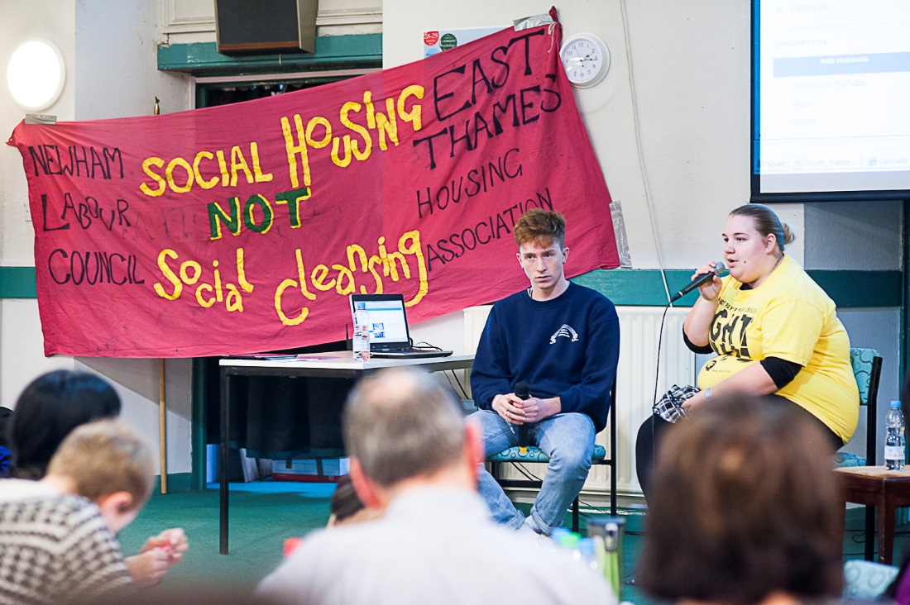

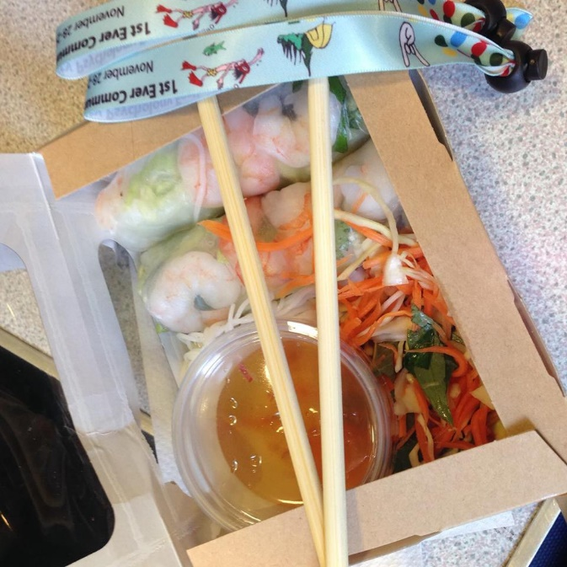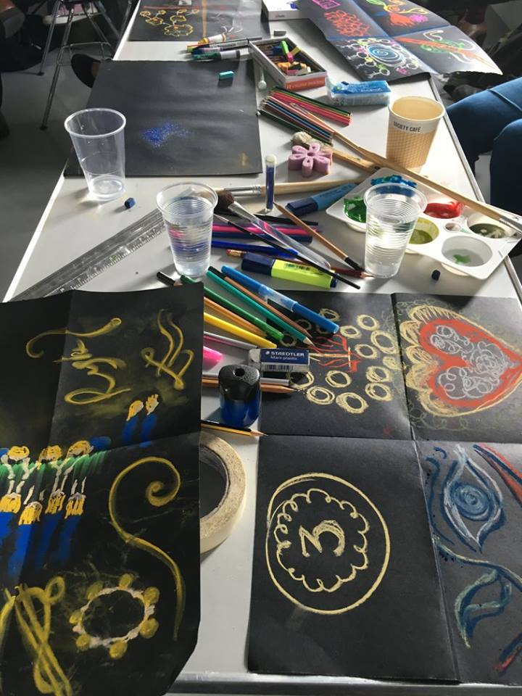

*A Selection of photographs from the first three festivals*

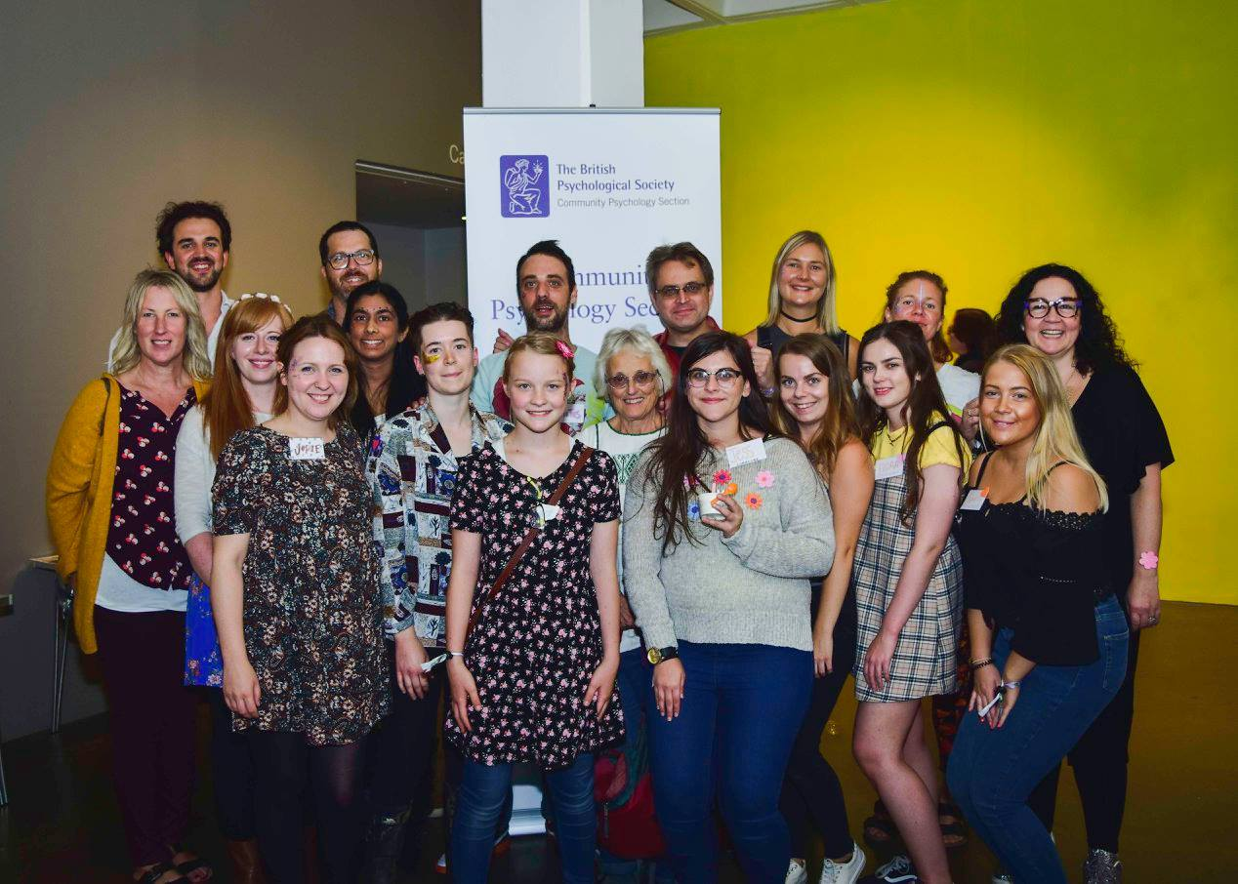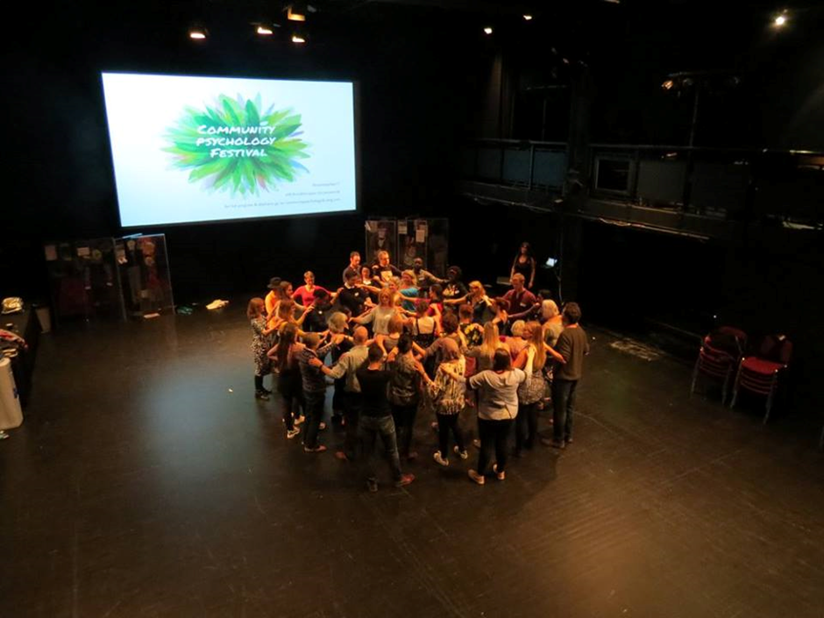

**References**

Bateman, C. (2008). Can we dance towards health? *South African Medical Journal*, *94*(2), 76.

Burman, E. (2017). *Deconstructing developmental psychology*. London: Routledge.

Cosway, R., Foley, J., Jones, J., Morgan, S., Priest, P., Richards, C., &Wainwright, T. (Eds.) (2017). Power, interest and psychology: Developing David Smail’s ideas [Special Issue]. *Clinical Psychology Forum*, *297*.

Feigenbaum, A., & Iqani, M. (2015). Quality after the cuts? Higher education practitioners’ accounts of systemic challenges to teaching quality in times of ‘austerity’. *Journal of Further and Higher Education, 39*(1), 46-66.

Freire, P. (1972). *Pedagogy of the oppressed*. London: Penguin books.

Hirsch, D. (2013). *A minimum income standard for the UK in 2013.* Retrieved from https://www.jrf.org.uk/sites/default/files/jrf/migrated/files/income-living-standards-full.pdf

Kagan C.M., Burton M., Duckett P.S., Lawthom R., Siddiquee A. (2011)*. Critical community psychology*. Oxford: Wiley-Blackwell.

Karanikolos, M., Mladovsky, P., Cylus, J., Thomson, S., Basu, S., Stuckler, D., ... & McKee, M. (2013). Financial crisis, austerity, and health in Europe. *The Lancet*, *381*(9874), 1323-1331.

Mance, H. (2017, December 30). British politics in 2017: Terror, tragedy, Theresa May and Brexit. The Financial Times. Retrieved from https://www.ft.com/content/861c1054-e57f-11e7-8b99-0191e45377ec

Matheson, C. M., & Tinsley, R. (2016). The carnivalesque and event evolution: A study of the Beltane Fire Festival. *Leisure Studies*, 35(1), 1-27. doi:10.1080/02614367.2014.962591

Maton, K. I., Perkins, D. D., & Saegert, S. (2006). Community psychology at the crossroads: Prospects for interdisciplinary research. *American journal of community psychology*, *38*(1-2), 35-49.

Mayer, C., & McKenzie, K. (2017). ‘…It shows that there’s no limits’: The psychological impact of co‐production for experts by experience working in youth mental health. *Health & Social Care in the Community*, *25*(3), 1181–1189.

Naidoo, A.V. (1996). Challenging the hegemony of Eurocentric psychology. *Journal of Community and Health Sciences, 2*(2), 9-16.

Osei-Kofi, N. (2013). The emancipatory potential of arts-based research for social justice. *Equity & Excellence in Education*, *46*(1), 135-149.

Potter, J., & Wetherell, M. (1987). *Discourse and social psychology: Beyond attitudes and behaviour*. London: Sage.

Prall, W. (2004). Failing better: Integrative theory as work in progress. *British Journal of Psychotherapy Integration*, 1(1), 24-32.

Rogers, N. (1993). *The Creative Connection Expressive Arts as Healing*. Palo Alto: Science & Behavior Books.

Seedat, M., & Suffla, S. (2017). Community psychology and its (dis) contents, archival legacies and decolonisation. *South African Journal of Psychology*, *47*(4), 421-431.

Turner, E. (2012). *Communitas: The Anthropology of Collective Joy*. New York: Palgrave Macmillan.

Turner, V. (1966). *The Ritual Process: Structure and Anti-Structure*. New York: Cornell University Press.

1. To see these please go to <https://thepsychologist.bps.org.uk/festival-community-psychology>