**Variability in Individual Assessment Behaviour and its Implications for Collective Decision-Making**

Thomas A. O’Shea-Wheller, Naoki Masuda, Ana B. Sendova-Franks and Nigel R. Franks

**Supplementary Material 1**

**A Computational Model Comparing Homogeneous and Heterogeneous Nest Acceptance Thresholds**

The experimental results from the accompanying paper (Figs. 2(a) and (b), S3), demonstrate wide heterogeneity in nest assessment durations among workers. There is good evidence to suggest that assessment duration is strongly linked to recruitment probability [1, 2]. Thus, we deemed it advantageous to assess how heterogeneity in recruitment would affect collective nest choices. Previous computational models of collective nest site selection employing heterogeneous acceptance thresholds for ants are mute about the benefit gained from being heterogeneous [3, 4]. Here we show, by computational modelling, that heterogeneously distributed acceptance thresholds can be advantageous. For example, when there is no new nest site of good quality available, but emigration is still necessary, colonies can emigrate to one of the new (mediocre) sites with heterogeneously distributed acceptance thresholds, much more rapidly than with homogeneous thresholds.

Our model is a variant of the two spatially non-explicit agent-based models investigated earlier [3, 4]. The present model is composed of *N*=100 ants and defined as having stochastic dynamics in continuous time. The structure of the model is shown in Fig. S1. We assume that ants are in either the current nest, new nest site A, or new nest site B. Ants in each new nest site are either assessors or recruiters.

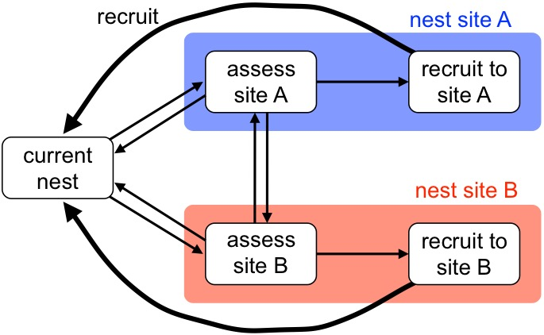

Figure S1: Schematic illustration of the computational model. The thick lines represent the effect of recruitment exerted upon ants in the current nest. The thin lines represent all other switching between nest sites.

At the beginning of a run of the simulation, each ant was assigned a personal acceptance threshold, which was drawn independently from a Gaussian distribution with mean 5 and standard deviation *σ* (= 0 or 1) [3]. We set the quality of sites A and B to *q*A and *q*B, respectively. An ant that visited a new nest site compared her personal threshold (with the addition of a Gaussian distributed observation error, with mean 0 and standard deviation 0.5) with the quality of the new nest site. If the quality of the new site was greater than the personal threshold plus the observation error, the ant then accepted the new site and turned into a recruiter. Otherwise, the ant eventually rejected the site and left it, switching to the other new nest site, or returning to the current nest. Because the observation error was drawn independently for different visit events, an ant that had rejected site A in her first visit could then possibly accept the same site during a later visit.

A fraction (0.3) of ants were assumed to be scouts, half initially going to site A and the other half to site B [4, 5]. Because we set *N*=100, for each simulation, site A was initially visited by 0.15*N*=15 ants, site B by 15 ants, and the remaining 70 ants started from the current nest. All ants, both scouts and non-scouts, switched among the three sites according to the behavioural rules described below, until either site A or site B became quorate. Such a quorum was reached when at least half of the ants in a colony visited any new nest site at the same time, either as assessors or recruiters. Once a quorum had been achieved, we terminated the simulation and recorded the time to quorum along with the colony’s decision (i.e., which new nest site had been selected). The ants underwent the following state transitions until a quorum was reached.

First, ants moved from the current nest to either of the two new nest sites. Ants in the current nest moved to site A either: (i) spontaneously at rate *α*curr→A(assess) (i.e., after a random time obeying an exponential distribution with mean 1/*α*curr→A(assess)), corresponding to independent discovery/revisit, or: (ii) by being recruited by a recruiter to site A at a rate of 1 per recruiter. Similarly, ants in the current nest moved to site B using either of these two methods, again at a rate of *α*curr→B(assess) and 1. We set the rate of recruitment to 1 without any loss of generality; as varying this rate would correspond to a change in the time scale of all simulation dynamics.

Second, ants assessing a new nest site (i.e., site A or B) were able to turn into recruiters, switch to the other new nest site, or go back to the current nest. As described previously, an ant entering site A either potentially accepted the site, or rejected it. If the ant accepted the site, that ant turned into a recruiter at rate *α*A(assess)→A(recruit). Furthermore, any ant assessing site A switched to becoming an assessor of site B at rate *α*A(assess)→B(assess). Any ant assessing site A went back to the current nest at rate *α*A(assess)→curr. Similarly, any assessor of site B was able to turn into a recruiter (if she had accepted the site), switched to site A, or went back to the current nest, at rates *α*B(assess)→B(recruit), *α*B(assess)→A(assess), and *α*B(assess)→curr, respectively.

Third, each recruiter recruited ants from the current nest at rate 1. Unlike the model in Ref. [1], recruiters were not then able to turn back into assessors, or return to the current nest.

When compared to the model in Ref. [3], the present model is simplified in that we have not explicitly modelled the travel time between nest sites. Instead, we have included a recruitment process, modelling tandem running, which the previous model [3] did not. When compared to the model in Ref. [4], the present model is simplified, in that we have assumed that recruiters do not stop recruiting at a certain rate, in order to keep the number of additional parameters to a minimum. This assumption is also present in the model described in Ref. [3].

We set *α*A(assess)→A(recruit) = *α*B(assess)→B(recruit) = 0.1 [4]. We also set *α*curr→A(assess) = *α*curr→B(assess) = *α*A(assess)→curr = *α*B(assess)→curr = *α*A(assess)→B(assess) = *α*B(assess)→A(assess) [3] and these common rate values to 0.05.

Colonies are expected to select a better new nest site with a higher probability, if the difference between the quality of the two new sites, *q*A and *q*B, is large. To examine this point, we ran the simulation 104 times with *q*B = 4, modelling a relatively mediocre quality site, in light of the mean acceptance threshold of ants (i.e., 5) [3], and different values of *q*A. The fraction of correct choices, defined as the number of times that a colony becomes quorate at the better quality new nest site, divided by 104, is shown in Fig. 2(e). The results are compared between the case in which all ants have the same threshold value; 5 (*σ* = 0, black line), and the case in which ants have heterogeneous thresholds, with a mean of 5 and standard deviation of one (*σ* = 1, blue line). As expected, the fraction of correct choices increased as the difference between *q*A and *q*B increased. In addition, across the whole range of *q*A, the fraction of correct choices was larger for the homogeneous than the heterogeneous case. Therefore, in terms of the accuracy of decision making, the present results suggest that heterogeneously distributed acceptance thresholds are detrimental rather than beneficial.

The mean time to quorum was then compared between the homogeneous and heterogeneous cases, in Fig. 2(d). A quorum was more rapidly reached in the heterogeneous case than the homogeneous case, particularly when both new nest sites were of mediocre quality (i.e., small *q*A, because we set *q*B = 4). Therefore, particularly when both new sites are mediocre, the present results suggest that heterogeneous acceptance thresholds make decisions faster, yet less accurate, realising the speed-accuracy trade-offs observed in previous studies [5, 6].

Such a result is relevant, as in nature, cases may occur where all possible nest sites are of mediocre quality, yet are still better than the current nest, which may be severely damaged, or even uninhabitable [3]. Indeed, this is likely to be common, as colonies often construct new walls within rock cavities after emigrating, suggesting that when chosen, certain nests are of mediocre quality at best [7, 8]. Furthermore, there is extensive empirical evidence that colonies housed within low-quality nests can accurately discriminate between new nest sites, even if all options are only slightly better than their present nest [9]. Thus, to explore this scenario, we carried out the following two sets of simulations.

First, we ran a simulation with *q*B = 3 and different values of *q*A. When *q*A ≤ 3 (= *q*B), both new nest sites are of mediocre quality at best. Under this condition, an ant with a mean acceptance threshold value of 5 would not accept either nest, so we might expect that a quorum in the homogeneous case would take an extremely long time to reach. Moreover, when *q*A ≤ 3, the fraction of correct choices was much greater in the heterogeneous case (blue line, Fig. 2(e)) than the homogeneous case (black line, Fig. 2(e)). Indeed, nest choices in the homogeneous case were close to random (i.e., the fraction of correct choices was only slightly above 0.5), suggesting that ants could not accurately compare the quality of the two sites because the quality of both was too low. By contrast, in the heterogeneous case, some ants had low thresholds, and thus could select the better new nest site even when both sites were of relatively low quality, leading to a higher probability of correct choices overall.

When *q*A was sufficiently larger than 3 (= *q*B), the homogeneous threshold colonies made correct choices with a higher probability than the heterogeneous threshold colonies. However, over the entire range of *q*A, the mean time to quorum was shorter in the heterogeneous than the homogeneous case (Fig. 2(f)). Specifically, when *q*A is sufficiently larger than 3, heterogeneity expedites emigrations at the expense of accuracy, as seen in the results for *q*B = 4 (Figs. 2(c) and (d)). Yet, when *q*A ≤ 3, heterogeneity improves both speed and accuracy (Figs. 2(e) and (f)).

Second, we set *q* ≡ *q*A = *q*B and varied *q*. Because the mean acceptance threshold for the ants was set to 5, if *q* was substantially smaller than 5, both new nest sites were again mediocre at best. However, because both new nest sites were of the same quality, colonies selected each site with equal probability. Therefore, we only measured the mean time to quorum, as shown in Fig. S2, this being the only relevant factor in such a scenario. The figure indicates that, when *q* is small, the mean time to quorum is much shorter when heterogeneous thresholds are used, than when homogeneous thresholds are used. This is because, in the homogeneous threshold case, no ant will accept either nest if *q* is small, making the time until quorum is reached extensive. However, given no other option, a rational behaviour under such a scenario is to emigrate to either mediocre nest site as soon as possible. Consequently, this objective is realised better by the use of heterogeneous, rather than homogeneous, acceptance thresholds.

social/thomas/equal-q-time.pdf

Figure S2: Mean time to quorum when the two new nest sites were of the same quality *q* (= *q*A = *q*B). The cases of homogeneous thresholds (σ = 0) and of heterogeneous thresholds (σ = 1) are compared.

**References**

[1] Planqué, R., Dornhaus, A., Franks, N.R., Kovacs, T., Marshall, J.A.R. 2006. Weighting waiting in collective decision-making. *Behav. Ecol. Sociobiol,* 61:347-356.

[2] Robinson, E.J.H., Feinerman, O., Franks, N.R. 2014. How collective comparisons emerge without individual comparisons of the options. *Proc. R. Soc. B,* 281:20140737.

[3] Robinson, E.J.H., Franks, N.R., Ellis, S., Okuda, S., Marshall, J.A.R. 2011. A simple threshold rule is sufficient to explain sophisticated collective decision-making. *PLOS ONE,* 6(5): e19981.

[4] Masuda, N., O’Shea-Wheller, T.A., Doran, C., Franks, N.R. 2015. Computational model of collective nest selection by ants with heterogeneous acceptance thresholds. *R. Soc. Open Sci.,* 2: 140533.

[5] Franks, N.R., Dechaume-Moncharmont, F-X., Hanmore, E., Reynolds, J.K. 2009. Speed versus accuracy in decision-making ants: expediting politics and policy implementation. *Phil. Trans. R. Soc. B,* 364:845–852.

[6] Franks, N.R., Dornhaus, A., Fitzsimmons, J.P., Stevens, M. 2003. Speed versus accuracy in collective decision making. *Proc. R. Soc. B,* 270:2457–2463.

[7] Aleksiev, A.S., Sendova-Franks, A.B., Franks, N.R. 2007. The selection of building material for wall construction by ants. *Anim. Behav,* 73:779-788.

[8] Aleksiev, A.S., Sendova-Franks, A.B., Franks, N.R. 2007. Nest ‘moulting’ in the ant *Temnothorax albipennis*. *Anim. Behav,* 74:567-575.

[9] Franks, N.R., Mallon, E.B., Bray, H.E., Hamilton, M.J., Mischler, T.C. 2003. Strategies for choosing between alternatives with different attributes: exemplified by house-hunting ants. *Anim. Behav,* 65:215-223.

**Graph of Visit Duration Relationships Not Included in the Main Text**

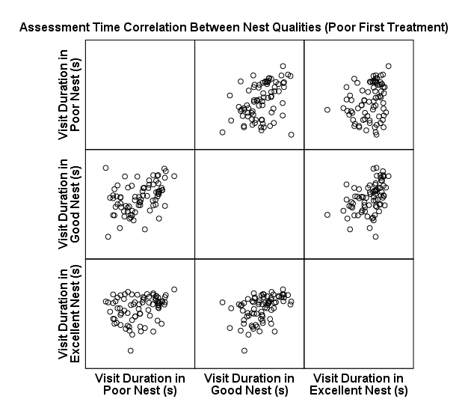 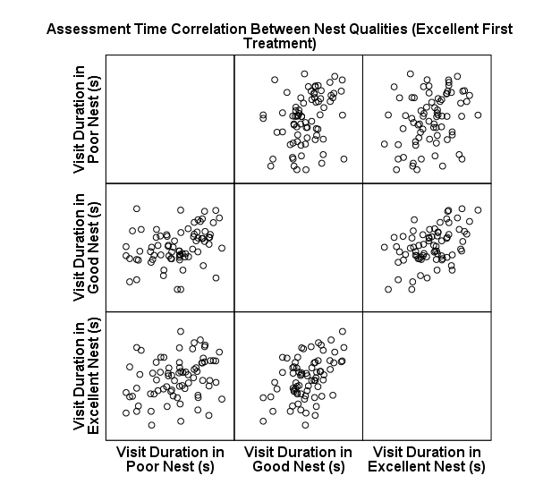

(*b*)

(*a*)

Figure S3: Experimental data showing the relationship between visit durations to different nests, for workers in the (c) ‘poor first’ and (d) ‘excellent first’ treatment orders. These data are from the experiments described in the accompanying paper.