**Improving Road Transport Operations through Lean Thinking: A Case Study**

*1st Author*

**Prof. Dr. Bernardo Villarreal**

Departamento de Ingeniería, Universidad de Monterrey, I. Morones Prieto 4500 Pte., San Pedro Garza Garcia, NL 66238, Mexico

E-mail: bernardo.villarreal@udem.edu

*2nd Author and Corresponding*

**Dr. Jose Arturo Garza-Reyes\***

Centre for Supply Chain Improvement

The University of Derby

Kedleston Road Campus, Derby, UK, DE22 1GB

E-mail: J.Reyes@derby.ac.uk

Tel. +44(0)1332593281

*3rd Author*

**Dr. Vikas Kumar**

Bristol Business School

University of the West of England

Coldharbour Ln, Bristol, UK, BS16 1QY

E-mail: Vikas.Kumar@uwe.ac.uk

Tel. +44(0)1173283466

*4th Author*

**Prof. Ming K. Lim**

Centre for Supply Chain Improvement

The University of Derby

Kedleston Road Campus, Derby, UK, DE22 1GB

E-mail: m.lim@derby.ac.uk

Tel. +44(0)1332591770

* Corresponding Author

Article word count: 9,585

**Improving Road Transport Operations through Lean Thinking: A Case Study**

***Abstract***

Traditionally, logistics and transportation problems have been addressed through mathematical modelling, operations research, and simulation methods. This paper documents a case study where the road transport operations of a leading Mexican brewery organisation have been improved through lean thinking and waste reduction. Two lean-based principles and tools were combined; the Seven Transportation Extended Wastes (STEWs) and Transportation Value Stream Mapping (TVSM), and three systematic steps were followed to facilitate the improvement project. Feasibility studies suggested that lean thinking is an effective alternative for the improvement of road transport operations. Logistics and transport managers can use this paper as a guide to improve the road transport operations of their organisations. This paper also contributes by expanding the limited evidence of the application of lean thinking in road transport logistics and highlighting the research areas where the application of lean has been concentrated in this sector.

**Keywords:** Lean, road transportation, transportation efficiency, value stream mapping, waste elimination.

**1. Introduction**

The improvement of transport operations has been traditionally approached with the use of mathematical modelling, operations research, and simulation methods (Sternberg *et al*., 2013). Under these, several classical transportation problems that include the vehicle scheduling problem (e.g. Zhang *et al.*, 2014; Eliiyi *et al.*, 2009), the delivery problem (e.g. Urban, 2006; Mitrovic-Minic *et al.*, 2004), the transportation problem (e.g. Yu *et al.*, 2015; Faulin, 2003; Zhang and Yun, 2009), the vehicle routing problem (e.g. Yu *et al.*, 2013; Lam and Mittenthal, 2013; Kumar *et al.* 2011; Mishra *et al.* 2011; Marinakis and Marinaki, 2008; Zhong *et al.*, 2007), among others, have been addressed. Using mathematical modelling, operations research, and simulation methods, the main approach used by researchers to improve transport operations has been primarily based on minimising cost, time or distance, and optimising resource utilisation, routes, and transportation/delivery schedules. Although, these methods and approaches have contributed to tackle the concern that industrialists and researchers have had for the improvement of transport operations since the mid-1990s (Dantzig and Ramser, 1959), criticism has emerged about their effectiveness to actually address real-life transportation problems (Berhan *et al.*, 2014). According to Ak and Erera (2007), one of the most compelling reasons for this is that the large majority of these approaches, and in particular vehicle routing models, are oversimplified by treating parameters such as demand, time, distance, and others, as deterministic, when in real life scenarios they are stochastic in nature. In addition, the improvement of actual road transport operations and activities to gain efficiency is rarely considered under the mathematical modelling, operations research, and simulation methods (Fugate *et al.*, 2009).

Since significant waste and unnecessary costs are normally present in most transportation networks (McKinnon *et al.*, 2003), the application of lean thinking, alongside its principles and tools, has emerged as an opportunity to complement the traditional mathematical modelling, operations research, and simulation methods. This may contribute in overcoming some of their limitations when addressing the improvement of road transportation. In line with the traditional lean’s philosophy of waste elimination, the focus of the so called “lean road transportation movement” lies on identifying and eliminating non-value adding activities, specifically relevant to transport operations, in order to improve the overall productivity and efficiency of a company’s logistics operations. Generally, the focus of research within the lean field has been on production activities related to quality improvement and the quest for increased efficiency. Although a research stream has also studied the application of lean thinking in supply chains (e.g. Mohammaddust *et al.*, 2015; Qrunfleh and Tarafdar, 2013; Liu *et al.*, 2013), specific research on the utilisation of lean in the road transportation sector is scarce and in early stages (Villarreal *et al.*, 2009). In this context, only a handful of articles have proposed methods or reported a case where transport operations have been improved through both the elimination of non-value added activities and the application of lean concepts and tools (e.g. Villarreal *et al.*, 2013; Villarreal, 2012; Villarreal *et al.*, 2012; Hines and Taylor, 2000). The relatively narrow research on lean road transportation is particularly evident when compared with the vast amount of research on lean’s application in other industries such as manufacturing (Taj, 2008), processes (Lyons *et al.*, 2013), and services (Sternberg *et al*., 2013).

To complement and support the limited body of knowledge on lean road transportation, this paper presents a case study where two lean-based principles and tools have been combined to improve the road transport operations of a leading Mexican brewing organisation. These lean-based principles and tools include the Seven Transportation Extended Wastes (STEWs) (Sternberg *et al*., 2013) and Transportation Value Stream Mapping (TVSM) (Villarreal, 2012). Besides providing a guiding reference for supply chain and logistics managers when undertaking similar improvement projects as well as expanding the rather limited body of knowledge on lean road transportation, this paper also intends to contribute by stimulating researchers to broaden the study of this under-researched area.

The rest of the paper is organised as follows: Section 2 provides a brief review of the primary research areas that have been derived from the application of lean thinking in road transportation; a description of some of the concepts and the methodology followed in this paper are outlined in Section 3; the case study application of lean thinking in road transport operations is undertaken in Section 4; and Section 5 presents the conclusions.

**2. Literature Review on Lean Road Transportation**

Within the limited research undertaken in the field of lean road transportation, three research areas (RAs) can be identified. Figure 1 illustrates the three main RAs identified in the academic literature in lean road transportation and the specific papers that correspond to every one of these RAs. These areas are discussed in the following sub-sections.

**Insert Figure 1 here**

***2.1 RA 1 - From production to transportation wastes***

The origins of lean can be traced back to the 1930s when Henry Ford revolutionised car manufacturing with the introduction of mass production techniques. However, the biggest contribution to the development of lean thinking principles and tools, over the last 50 years, has come from the Japanese automotive manufacturer ‘Toyota’. The central objective of the lean philosophy, as “preached” by Toyota, is the elimination of non-value added activities (Pettersen, 2009), which consequently contributes to the reduction of costs (e.g. Monden, 1998) and increased value for customers (e.g. Dennis, 2002; Bicheno, 2004). Toyota identified seven major types of non-value adding waste in production or business processes (Liker, 2004), namely: production of goods not yet ordered, waiting, rectification of mistakes, excess processing, excess movement, excess transport, and excess stock (Ohno, 1988). In this context, Sternberg *et al*. (2013), Sutherland and Bennett (2007), and Guan *et al*. (2003) realised the potential of studying the Toyota’s seven common forms of production and business waste within the context of road transport operations, and adapting them for their improvement. In this case, Sternberg *et al*. (2013) concluded that only five of the Toyota’s wastes applied to motor carrier operations excluding waste due to excess conveyance and excess inventory. Sternberg *et al*. (2013) included resource utilisation and uncovered assignments as part of the transportation wastes derived from Toyota’s original production and business wastes. They called them the “Seven Transportation Extended Wastes” (STEWs).

Similarly, Sutherland and Bennett (2007) defined overproduction, delay/wait, excess transport/conveyance, motion, inventory, space, and errors as the “Seven Deadly Wastes of Logistics”. According to Sutherland and Bennett (2007), these wastes keep the management of supply chains away from achieving their full business potential. Finally, Guan *et al*. (2003) identified five transport wastes, these being: driver breaks, excess load time, fill losses, speed losses, and quality delays. Sternberg’s *et al*. (2013) STEWs were developed and validated through multiple case studies and carrying out in-depth interviews with experts from carrier operations, the lean field, carrier technology providers and carrier service buyers. Hence, these wastes identified by Sternberg *et al*. (2013) were used as the basis to improve the road transport operations of the Mexican organisation studied. Figure 2 presents a description of the STEWs.

**Insert Figure 2 here**

***2.2 RA 2 - Lean performance measures for road transportation***

Measurement on a continuous basis is crucial to improve operations and supply chains (Dey and Cheffi, 2013; Cabral *et al.*, 2012). Thus, the application of lean practices in transportation needs to be supported by adequate metrics to measure the performance of lean systems as a basis for continuous improvement. In this line, Taylor and Martinchenko (2006) proposed four lean transportation laws (i.e. transportation waste, daily event management, transportation strategy, and transportation performance), which explain how and where transportation processes may be sub-optimal, and how the application of lean can positively impact these processes and overall organisational performance. Similarly, Mason *et al.* (2001) and Simons *et al.* (2004) adapted and extended the Overall Equipment Effectiveness (OEE) (Nakajima, 1988) metric, used by the lean’s Total Productive Maintenance (TPM) (Nakajima, 1988) approach to measure equipment effectiveness, and developed a new metric called Overall Vehicle Effectiveness (OVE). This metric was used by Simons *et al.* (2004) for measuring and improving the performance of truck transportations.

Later, to reflect the efficiency of a route, Guan *et al*. (2003) modified OVE by dividing the performance factor into two components: route and time efficiencies. Finally, Villarreal (2012) proposed a modified version of the OVE measure called Transportation Overall Vehicle Effectiveness (TOVE). Unlike OVE, TOVE considers total calendar time instead of loading time. This is due to the fact that waste identification and elimination is related to the transportation vehicles utilised to move products. Since vehicles represent a high investment, it is important to keep them in operation at all times. A comparative illustration of the structures of the OVE and TOVE measures is presented in Figure 3. In summary, although both measures broadly classify transportation wastes into three mutually exclusive elements (i.e. availability, performance and quality losses), TOVE adds the administrative availability element. Hence, it divides the availability component into administrative and operating availability. The concept of vehicle administrative availability is important as it has a significant impact on the overall vehicle utilisation and efficiency. It is mainly the result of administrative policies and strategies related to capacity or maintenance decisions. TOVE is obtained from the product of administrative availability, operating availability, performance and quality; whereas OVE is obtained by multiplying the availability, performance and quality components, see Figure 3.

**Insert Figure 3 here**

***2.3 RA 3 – Improvement of road transport operations***

It is well known that transportation is an activity classified by the lean movement as waste that should be, if possible, eliminated (Womack and Jones, 2003; Ohno, 1988). However, in the current globalised market, transportation is a necessary activity to deliver goods to customers. In fact, although transportation is also recognised as a tertiary economic activity (Chase and Apte, 2007), Villarreal *et al.* (2009) suggest that efficient transport operations can nowadays be considered a differentiating factor that adds service value to customers. Thus, when mapping a supply chain, unnecessary transportation becomes an important waste to identify, measure, and eliminate. According to Fugate *et al.* (2009) and McKinnon *et al.* (1999), unnecessary transportation problems and waste can be addressed by increasing the efficiency of transport operations. In this context, Hines and Taylor (2000) proposed a methodology, consisting of four stages, to increase efficiency and eliminate waste in transport operations. Villarreal *et al.* (2009) reported the application of this methodology in the logistics operations of a Mexican firm, leader in the production and distribution of frozen and refrigerated products. As a result, the organisation saved over half a million British pounds of capital investment and one million British pounds per year of operations cost by improving the capacity utilisation and availability of its distribution vehicles (Villarreal *et al.*, 2009).

Villarreal *et al.* (2012) also developed a methodology to reduce transport waste by integrating the Just-in-Time approach of milk runs with the traditional operations research approach of developing algorithms to optimise vehicle routing. Additionally, Villarreal (2012) adapted the lean’s Value Stream Mapping (VSM) (Rother and Shook, 2003) tool to support efficiency improvement programmes in transport operations. He called this adapted tool Transportation Value Stream Mapping (TVSM). Finally, Villarreal *et al.* (2013) developed a scheme for increasing transportation efficiency. The scheme was proposed around a modified version of the OEE index used in TPM. This index was adapted as the primary performance measure for transport operations and integrated with the VSM tool to identify and eliminate availability, performance and quality related transportation wastes.

***2.4 Other approaches for waste reduction and efficiency increase in road transport operations***

Lean relies on practices such as Just-in-Time (JIT), Total Quality Management (TQM), Total Productive Maintenance (TPM), pull, flow, and others, to reduce waste and increase efficiency (Yang *et al.*, 2011). Forrester *et al.* (2010) considers lean as the most influential new paradigm in manufacturing however, the reduction of waste and improvement of efficiency in the road transport sector has been addressed through different perspectives and using other approaches which are not necessarily based on lean practices or the use of lean tools. For example, Sanchez Rodrigues *et al.* (2014) suggest that avoiding extra travel in road freight operations is vital as these operations are characterised by low-profit margins. For this reason, they proposed a measure, called “Extra Distance”, which intends to reduce the additional operational costs associated with transport disruptions. Similarly, Sanchez Rodrigues *et al.* (2008) proposed a model to improve the efficiency of freight transport through a better management of supply chains’ uncertainty. Furthermore, Bottani *et al.* (2015) proposed an integrated approach to increase sustainability and efficiency of logistics activities. Similar additional works have been conducted, for example, by Cruijssen *et al*. (2010), McKinnon and Ge (2004), Abbas and Aly (2004) and Davies *et al*., (2007).

In general, other non-lean based approaches reported in the academic literature devised to reduce waste/cost and improve efficiency of road transport operations include the outsourcing of logistics operations (Atkas et al. 2011) and integration of supply, production and distribution/transport activities (Van der Vorst *et al.*, 2009; Mason and Lalwani, 2006). Other approaches, as previously discussed, have included the development of advanced tools or models based on mathematical modelling, operations research or simulation methods to improve efficiency through the optimisation of cost, time, distance, resource utilisation, routes, or transportation/delivery schedules. Examples of recent works in these areas include Yu *et al.* (2015), Zhang *et al.* (2014), Jemai *et al.* (2013), Eliiyi *et al.* (2009), among others.

We consider important to highlight the abovementioned studies and research streams, as future research may more closely look at the synergies of the approaches proposed in these studies and lean thinking. This may provide an opportunity to formulate more inclusive and enhanced methods and strategies for the improvement of road transport operations.

**3. Concepts and Methodology**

The improvement of the road transport operations of the Mexican organisation studied was addressed by following a sequential three stages approach that consisted of the following steps: (1) Analysing the value stream of the road transport operations, (2) Identifying the STEWs inherent in the road transport operations, and (3) Defining and implementing a strategy for the elimination of the STEWs.

To analyse the value stream of the road transport operations of the Mexican organisation studied, a TVSM (Villarreal, 2012) study was carried out. The use of VSM to document, visualise, quantify and comprehend the material and information flows of value streams in manufacturing operations (e.g. Singh and Sharma, 2009; Seth and Gupta, 2005), healthcare operations (e.g. Lumus *et al*., 2006; Teichgräber and de Bucourt, 2012), environmental-based operations (Kurdve *et al.*, 2011), and service operations (e.g. Barber and Tietje, 2008) has been widely documented in the academic literature. However, only a small number of researchers have considered the use of VSM to support the analysis and improvement of the value stream of logistics and transport operations (Villarreal *et al.*, 2013; Villarreal, 2012; Villarreal *et al*., 2012; Hines *et al.*, 1999; Jones *et al.*, 1997). For this reason, besides documenting the application of lean thinking in road transport operations to expand the limited body of knowledge in this area, this paper also contributes by presenting a further case study of the application of VSM in the road transport industry. In this case, the TVSM concentrated on uncovering waste related to transport efficiency (Villarreal *et al.*, 2012) through the entire distribution cycle, from loading product orders to the transportation vehicles to unloading product returns from the market and closing administratively the route or shipment.

The TVSM analysis consisted of two main facets; one that included activities pre and post transport and serving clients, known as “Not-In-Transit (NIT)” activities, and another that contemplated activities related to the actual physical distribution of the product, known as “In-Transit (IT)” activities. Villarreal (2012) suggests that vehicle drivers should focus on performing IT activities only, whereas the execution of NIT activities should be carried out by warehouse operators. This advice was taken into consideration when proposing the improvement initiatives, and after having analysed the value stream of the transport operations studied as well as identified and quantified the STEWs inherent in it. The data collected for NIT activities to conduct the TVSM study included some of the basic metrics of performance reflected in the traditional VSM as established by Rother and Shook (2003). These were: cycle time, value added time, uptime and setup time. Additionally, NIT activities were aligned to the takt time required to load customer orders to trucks and deliver them on time. On the other hand, data related to average time between clients, truck capacity utilisation level, average distance travelled per client, distance travelled in excess per route, and the percentage of waiting time in transit was collected for IT activities and the TVSM study. Finally, for serving clients; the average number of clients per route, cycle time, value added time, the percentage of product returns, and the percentage of clients not served was the key data gathered for the TVSM analysis.

The TVSM analysis contributed to the identification and quantification of the STEWs (Sternberg *et al*., 2013) inherited in the value stream of the transport operations studied. Once the STEWs were identified and quantified, improvement initiatives based on the semi-dynamic design of routes, automation of product loading and inspection, redesign of customer serving procedures, among others, were formulated and implemented(see Section 4), to reduce the STEWs and hence improve the road transport operations of the organisation studied.

**4. Case Study**

This section presents the case study documented in this paper to complement and support the limited body of knowledge on lean road transportation. Voss *et al.* (2002) emphasises the importance of conducting and publishing case study-based research as they suggest that it is particularly suitable for the testing and development of new theory, especially in the field of operations management (McCutcheon and Meredith, 1993). This is evident from the high volume of recent researches published in this field using a single case study research method approach (e.g. Bouzon, 2015; Bevilacqua *et al.*, 2015; Tuli and Shankar, 2015; Diehl and Spinler, 2013; Taylor, 2009; etc.). Serrano Lasa *et al.* (2008) therefore comments that many of the breakthrough concepts and theories in operations management, from manufacturing strategy to lean production, have been developed through field case research. Similarly, Zander *et al.* (2015), Cameron and Price (2009) and Eisenhardt (1989) consider a single detailed case study a valid research methodology to study and understand specific phenomenon within specific contexts, such as in this case the application of lean thinking in road transportation. In this study, and as suggested by Voss *et al.* (2002), the case study research approach proved to be a valuable source to document and report the experiences of the authors while conducting the improvement of road transport operations using lean thinking-based principles and tools. Thus, the case study was an ideal research strategy that contributed in enriching the limited body of knowledge on the application of lean thinking in the road transport industry.

The Mexican organisation used as the basis for this study processes and distributes bottled beverage. This organisation is a large and leading national company with major operations in the north of Mexico. This study focused on the distribution of products from regional distribution centres (RDCs) to retailing points that included convenience store chains, independent retailers, and supermarket chains. The company has a number of RDCs across Mexico, but considering the complexity and difficulties of conducting a large scale improvement initiative and the constraints in terms of budget, time, and personnel that organisations normally face when carrying out improvement projects (Marriot *et al*., 2013), this study focused only on the RDC located in the city of Monterrey, Mexico. Concentrating efforts in only one RDC helped, as suggested by Antony and Banuelas (2002) and Pyzdek (2003), in validating the application and results of lean thinking as an effective and suitable approach to drive the improvement of road transport operations, before proceeding into a future full scale deployment in the rest of the company’s RDCs.

In particular, the RDC studied counts with a fleet of about 90 distribution trucks (see Figure 4 for an illustration) to serve about 6,000 customers that include selling points (e.g. convenience stores) and consumption points such as pubs, restaurants, etc.

**Insert Figure 4 here**

Most selling points associated to established chains state morning time windows of three hours. However, some important chains were open 24/7. This offered the opportunity to supply them through evening and night shifts. The rest could be serviced any time of the day except from 2 to 4 P.M. Consumption points such as restaurants were supplied during the morning and pubs and entertaining businesses during late afternoon. The distribution of beverage was made daily through 76 fixed day routes. Labour cost per night or day shift was the same. However, night shifts presented contradictory situations; in one hand, driving conditions made night shifts more attractive due to significantly lower traffic congestion; but on the other hand, operating risk was higher due to the current climate of insecurity. It was common operational practice to have a two-person driving crew per route.

The foremost strategic concern of the company referred to cost reduction. In order to address this situation, the firm established a company-wide strategy for reducing cost. Since routing cost had become an important component of the total cost structure in recent years, it was necessary to consider it for improvement. Labour cost represented an important cost concept. The routing operations of interest presented a consistent level of overtime cost. Labour overtime was paid double for every hour after a day shift of eight hours until a maximum of nine hours per week per worker. Routing cost per hectolitre was about $86 Mexican pesos (i.e. about £3.40 British Pounds). This cost included labour (25%), truck maintenance (30%) and gas (45%).

***4.1 Analysis of the value stream***

As indicated previously, the first step in addressing the improvement of the road transport operations of the organisation studied consisted of analysing the value stream of such operations. This was done by developing the TVSM for the current routing operations as shown in Figure 5. The data used to construct the TVSM was collected from both company’s records and field data. For the first, data was gathered from an administrative database directly fed by the vehicle drivers’ handhelds and the truck’s GPS. For the second, a team of researchers collected detailed data by accompanying the truck driving crews. This was done by sampling 30% of the routes. The transport operations mapped consisted of the following activities:

* *Preparation of orders*. This was considered a NIT activity that was comprised of “sub” or “micro” activities such as inspecting the orders’ load, the truck, and reviewing the route;
* *Distribution of products* (i.e. transporting products, serving customers and collecting spoiled product). This was considered an IT activity;
* *Returning back to the RDC* was also considered as an IT activity;
* *Closing routes*. This NIT activity included “sub” or “micro” activities such as settling payments from customers with the cashiers and unloading/returning spoiled product and the truck.

In general terms, the TVSM study indicated that the overall average daily journey time for the distribution of goods from the Monterrey RDC to its corresponding retailing stores was 11.5 hrs, see Figure 5. Since an 8 hrs shift was the working standard for the studied organisation, the 3.5 hrs excess contributed to significantly increasing the operational cost, which was associated to overtime. All the activities included in the distribution operations, from preparing the routes, serving the stores until closing every route were executed as part of the journey. Internal NIT activities took 2.5 hrs on average (i.e. 22% of the journey’s time), whereas IT activities took an average of 9 hrs (i.e. 78% of the journey’s time), see Figure 5. The average number of stores served by a route was 15.

From Figure 5 it is clear that the TVSM shows the various important detail activities of the Monterrey RDC. According to Seth and Gupta (2005), a holistic visualisation of this type offers an actual trigger and a challenge for improvement. Therefore, the next steps in the improvement project consisted of identifying the STEWs (Section 4.2) and defining and implementing a strategy for their elimination (Section 4.3).

**Insert Figure 5 here**

***4.2 Identification of the STEWs inherent in the road transport operations***

The second step in the road transportation improvement project involved the identification of the relevant STEWs (Sternberg *et al*., 2013). Table 1 presents a summary of the most relevant STEWs identified through the TVSM, the operation activities where they were located, and their effect on the transport operation.

**Insert Table 1 here**

**Incorrect processing and resource utilisation**

As illustrated in Table 1 and by the Kaizen burst No. 1 in Figure 5, incorrect processing and resource utilisation wastes were found in the transportation of products to customers. These occurred because of inefficiencies in the design of routes (i.e. customer assignment to trucks and visit sequencing). Route design was a shared responsibility between the route dispatcher and the truck drivers. All the routes were defined with disregard of customer demand trends and behaviour. Company’s records showed that daily demand from Monday to Wednesday was lower than the level shown during the period from Thursday to Sunday. Additionally, routes were not designed according to daily demand and route sequences were determined by the driver every day. As a consequence, 35% of transport capacity was under-utilised and there was a 19% of distance per route travelled in excess.

**Unnecessary movements and waiting**

Unnecessary movements and waiting time were found in the IT operation activities of serving clients as well as the NIT activities of preparing and closing orders. This is shown in Table 1 and by the Kaizen burst No. 2 in Figure 5. These wastes occurred due to inefficient procedures that contained non-value added activities. According to Villarreal (2012), NIT activities must be carried out by warehousing operators and hence vehicle drivers should start working with the truck already loaded and properly inspected. However, in the organisation studied, this was not the case. The crew was required to be present to ensure that order product volume and mix was correct. In addition, there was an important proportion of waiting time because all the routes were inspected during the same period of time. The previous requirement originated that 70% of the total preparation activity was non-value added. In addition, closing routes included the activity of returning empty bottles. Since the majority of the trucks returned almost simultaneously, a high level of waiting time occurred. Therefore, it was found that 40% of the total time of closing routes was classified as waste due to it problem.

Waiting to serve customers was produced by restricted customer time windows that created an accumulation of suppliers arriving simultaneously to do so. Customer service time included the time taken to perform activities that did not add value or were not simplified, for example, inspecting products, verifying with the store leader whether the order was complete, and getting and loading empty bottle returns. The vehicle drivers devoted an important amount of time picking and classifying returned bottles on the street or the customer premises. Serving clients was an activity with 65% of its time categorised as waste. There was also the need to consider the time taken to obtain the payment of the order from the customer.

***4.3 Definition of a strategy for the elimination of the STEWs***

Different strategies have been proposed by, for example, Villarreal *et al.* (2009), La Londe and Masters (1994), Burns *et al.* (1985), Cooper (1983), among others, to improve transport operations. In this case, however, a group of experts that included the logistics managers of the organisation studied, a group of vehicle drivers, and a group of researchers gathered together to devise appropriate initiatives to reduce/eliminate the main wastes identified in the previous step. This approach to formulate improvement strategies encouraged the intuitive association within this group of experts to pick up one another’s ideas to firstly associate them, and then to develop the proposed initiatives shown in Table 2. In addition, since most successful improvement initiatives depend heavily on changing employees’ activities and attitudes (Karia and Asaari, 2006), involving the company’s employees (i.e. logistics managers and a group of vehicle drivers) was considered an strategy to facilitate the easy acceptance and implementation of the proposed initiatives.

**Insert Table 2 here**

Evidence suggests that in general, automation has positive effects on the productivity and ergonomics of logistics, warehousing and manufacturing operations (Echelmeyer *et al.*, 2008; Baker and Halim, 2007; Newman *et al.*, 2002). Based on this, the partial or full automation of repetitive operation activities such as loading and inspection was proposed by the team of experts as a possible solution to decrease waiting time, inspection, loading times in excess, and unnecessary movement. They also suggested that reassigning these operation activities to warehousing operators, alongside automation, would also contribute to improve these parameters. For the automation of the loading and inspection operation activities, the organisation considered, after consultation with automation engineers, the design and installation of arm robots that will pick product up according to customer orders from moving conveyors. The robots will be equipped with devices that will ensure that the correct quantity and product type is picked. The organisation is currently evaluating the realisation of this proposal as the capital investment required for its implementation is high. However, the feasibility study conducted by the automation engineers concluded that the inspection stages currently executed by the truck crew and warehousing personnel would be reduced by 70 minutes on average.

The initiatives of redesigning procedures with technology to serve customers and negotiating full time window flexibility have the objective of eliminating waiting time to serve and serve time in excess. This included the proposal and implementation of three initiatives. The first project considered the application of technology to receive and verify daily orders at the store, in particular, for those under franchise. The second initiative consisted of ensuring that customers returned bottles in their corresponding boxes. Finally, a team responsible for negotiating time windows considering night hours had approached store leaders. The feasibility studies conducted by the organisation to validate these proposed initiatives indicated that they had the potential of increasing the number of customers to be served per route, and decrease the number of routes required to satisfy all stores.

Finally, the project of implementing dynamic daily route design is planned to reduce fill loss and travelled distance in excess, by decreasing incorrect processing and therefore increasing truck capacity utilisation. The initial step in this improvement initiative proposed consisted of the implementation of specialised software programmes such as Roadnet Transportation Suite Routing and Scheduling Systems (UPS Logistics Group, 2004) and Map-Info (MapInfo Corporation, 2015). In particular, MapInfo software would help the organisation studied to perform a map and geocode analysis while Roadnet Transportation Suite would enable it to create optimised routes and load plans (Alagöz and Kocasoy, 2008). This is planned to reduce the number of daily routes according to the trend and behaviour of daily demand, assigning customers based on their location and demand. This will improve truck performance efficiency by increasing the utilisation of truck capacity and reducing travelled distance excess per route. The company’s management was also recommended to consider the utilisation of trucks for two daily routes, impacting favourably on the administrative availability efficiency. Finally, the company was also suggested to carry out a periodic update of routes to consider new store introduction. This initiative of route design is planned to significantly reduce resource utilisation and incorrect processing wastes. With these improvement initiatives, the organisation estimated that the average number of stores per route would increase from 15 to 25.

Overall, the organisation estimated that the outcome of this project would reduce the transportation cost of its operations by about 40%, once that all the improvement initiatives proposed are approved and implemented by the company. In addition, it is also estimated that there will be a significant decrease in truck investment requirements since it is considered that the average number of trucks necessary to satisfy daily demand will be reduced by also 40%.

***4.4 Implementation status of the strategy for the elimination of the STEWs***

Table 3 presents a summary of the initiatives suggested and their impact on the STEWs identified and important performance indicators. Given the recommendations provided, the management of the company decided to deploy an implementation plan consisting of three fronts.

The first two fronts were concentrated on decreasing excess customer serving time and improving warehousing activities. The first effort included the implementation of three initiatives. The first project considered the application of technology to receive and verify daily orders at the store. The second initiative consisted of ensuring that customers returned bottles in their corresponding beer cases. Finally, a team responsible for negotiating time windows considering night hours had approached store leaders. As of today, the first two initiatives have been implemented in the RDC located in the city of Monterrey, Mexico. The last initiative has been put on hold until a better assessment of the security level of the city is obtained. The direct impact observed by the company was a reduction on the average serving time from 40.6 mins to 18.7 minutes.

**Insert Table 3 here**

The second front considered a project to automate product loading and inspection before routing. After considering the capital investment required estimated in 100 thousand US dollars and the elimination required of 25 operators, the management decided to postpone its implementation. Instead, an alternative working scheme was implemented. This new scheme consisted of three changes; (1) loading the product was a responsibility of warehousing operators; (2) the utilisation of representatives of the drivers and warehouse operators that will check and certify that the product is loaded and inspected, are in accordance with customer orders and; (3) the re-assignment of the unloading activity to warehousing operators. This activity has already been simplified by having the right bottles in the right cases done by the customers. The company reported a significant reduction of the average route preparation time from 90 to 23 mins and of the average route closing time from 60 mins to 16 mins.

The last front was concerned with route design. The initial step in this front consisted of the implementation of the UPS Roadnet system. This will reduce the number of daily routes according to the behaviour of daily demand and assign customers based on their location and demand. This will greatly improve routing efficiency by increasing the utilisation of truck capacity and reducing excess distance travelled per route. The last step will also consider the utilisation of trucks for two routes per day. As of today, this initiative presents an important advancement in its implementation in the RDC located in the city of Monterrey, Mexico. Only the last step is still on hold until the security situation in city improves. The firm reports that the result of this application is important. Fill loss decreased by 71% from 54.9%, distance travelled in excess was eliminated and, the number of clients (given that serving time per customer was simultaneously reduced) served increased from 15 to 25.

The partially implemented strategy has already provided positive results. The average journey time per route has been reduced to about eight hours, practically eliminating the need for labour overtime. There is still the potential for utilising trucks twice per day and the investment of automating warehousing activity. The first initiative is on hold until a better social climate is present. The second initiative depends on two conditions; the availability of funds and more important; since the reduction of routes implied a relocation of operating personnel, management decided to wait for the layoff or relocation of more operating personnel.

**5. Conclusions**

Since the 1950s, mathematical modelling, operations research, and simulation methods have traditionally been the key techniques used by researchers to improve transport operations (Sternberg *et al*., 2013). With the support of these techniques, researchers have intended to address various logistics and transportation problems while minimising cost, time or distance, and optimising resource utilisation, routes, and transportation/delivery schedules. This paper documents a case study where a method to improvement based on lean thinking, specifically in the forms of concepts derived from the Toyota’s seven production and business wastes and tools such as VSM, has been applied to the road transport operations of a leading Mexican brewing organisation. The paper thus offers a valuable insight to logistics and transport organisations on how lean thinking can significantly improve their operations. Its empirical application, as presented in this paper, comprises some basic and generic steps and adapted concepts and tools that can be easily replicated to a good effect in other organisations and settings beyond the context of the case company. Thus, the paper presents important practical implications for logistics and transport managers as they can refer to this paper as a guide to improve the operations of their organisations. Organisations involved in the management and improvement of distribution and logistics operations will find this study particularly beneficial. This is considered the main practical contribution of this paper.

Besides reporting the application of lean thinking in the road transport industry, the paper also contributes to the lean and logistics literature by highlighting the main research areas where the application of lean has been concentrated in this sector. The limited research undertaken in this area as has been highlighted through this paper, is expected to stimulate scholars to further study the application of lean thinking in road transport operations and explore its compatibility with other traditional methods such as mathematical modelling, operations research, and simulation. Through this, a better understanding of this area will also be achieved, from which more effective strategies for the improvement of transport operations can be formulated. In this line, this paper has demonstrated, through the application of specialised software programmes (i.e. Roadnet Transportation Suite Routing and Scheduling Systems and Map-Info), that lean concepts and tools can complement, or be complemented, by other approaches and tools to improve road transportation. In this study, these software, which are equipped with inbuilt powerful and advanced operation research techniques, acted as a support mechanism to realise some of the improvement strategies devised for the reduction of waste identified through the TVSM study. Finally, the limited use of lean thinking to improve lean road transport operation suggests that there is no clear understanding on the benefits of lean, and how to use its principles and tools to improve this type of operations. This study has attempted to provide some evidence of the application of lean thinking to road transport operations, and can serve as a motivation to undertake further research in this area.

The partial application of the proposed scheme has already shown an important improvement of the routing operations of the Mexican company studied. The reduction of serving time per client and of the activities of preparing and closing routes, together with an increase in truck capacity utilisation and the reduction of distance in excess, increased the number of stops per route and eliminated the need for labour overtime. These results suggest lean thinking as an effective and suitable method to target the improvement of road transport operations. However, the use of a single case study research approach suggests that further research is required in different industrial settings and organisations to more widely test the effect of lean thinking in the transportation industry. Therefore, the collection of further evidence through a multiple case study approach is part of the future research agenda of the authors. In addition, to advance this area further, research is required to explore and understand the challenges and define the critical success factors (CSFs) for the deployment of lean thinking initiatives in the transport and logistics sector. Similarly, research is necessary to evaluate whether other lean principles and tools (e.g. OVE or TOVE), besides the ones employed in this paper, can contribute to enhance the positive improvements.

**References**

Abbas, K.A., & Aly, M.G.E.D. (2004), “Logistics chain analysis of a wheat-milling company: a basis for developing efficiency models for transport activities”, *International Journal of Logistics Research and Applications*, Vol. 7, No. 2, pp. 85-107.

Ak, A., & Erera, A.L. (2007), “A Paired-Vehicle Recursive Strategy for the Vehicle Routing Problem with Stochastic Demands”, *Transportation Science*, Vol. 41, No. 2, pp. 222–237.

Aktas, E., Agaran, B., & Ulengin, F. (2011), “The Use of Outsourcing Logistics Activities: The Case of Turkey”, *Transportation Research Part C: Emerging Technologies*, Vol. 19, No. 5, pp. 833–852.

Alagöz, A.Z., & Kocasoy, G. (2008), “Improvement and modification of the routing system for the health-care waste collection and transportation in Istanbul”, *Waste Management*, Vol. 28, pp. 1461–1471.

Antony, J., & Banuelas, R. (2002), “Key ingredients for the effective implementation of Six Sigma program”, *Measuring Business Excellence*, Vol. 6, No. 4, pp. 20-27.

Baker, P., & Halim, Z. (2007), “An exploration of warehouse automation implementations: cost, service and flexibility issues”, *Supply Chain Management: An International Journal*, Vol. 12, No. 2, pp. 129-138.

Barber, S., & Tietje, B.C. (2008), “A Research Agenda for Value Stream Mapping the Sales Process”, *Journal of Personal Selling & Sales Management*, Vol. 28, No. 2, pp. 155-165.

Berhan, E., Beshah, B., Kitaw, D. & Abraham, A. (2014), “Stochastic Vehicle Routing Problem: A Literature Survey”, *Journal of Information & Knowledge Management*, Vol. 13, No. 3.

Bevilacqua, M., Ciarapica, F. E., & Paciarotti, C. (2015), “Implementing lean information management: the case study of an automotive company”, *Production Planning & Control: The Management of Operations*, Vol. 26, No. 10, pp. 753-768.

Bicheno, J. (2004), *The New Lean Toolbox: Towards Fast, Flexible Flow*, 3rd ed., PICSIE Books, Buckingham.

Bottani, E., Rizzi, A., & Vignali, G. (2015), “Improving logistics efficiency of industrial districts: a framework and case study in the food sector”, *International Journal of Logistics Research and Applications*, Vol. 18, No. 5, pp. 402-423.

Bouzon, M., Spricigo, R., Rodriguez, C. M., de Queiroz, A. A., Cauchick & Miguel, P. A. (2015), “Reverse logistics drivers: empirical evidence from a case study in an emerging economy”, *Production Planning & Control*, DOI: <http://www.tandfonline.com/doi/full/10.1080/09537287.2015.1049239>, in press.

Burns, L.D., Hall, R.W., Blumenfeld, D.E., & Daganzo, C.F. (1985), “Distribution strategies that minimize transportation and inventory costs”, *Operations* *Research,* Vol. 33, No. 3, pp. 469- 490.

Cabral, I., Grilo, A., & Cruz-Machado, V. (2012), “A decision-making model for lean, agile, resilient and green supply chain management”, *International Journal of Production Research*, Vol. 50, No. 17, pp. 4830-4845.

Cameron, S., & Price, D. (2009), *Business Research Methods: A Practical Approach*, Chartered Institute of Personal and Development, London.

Chase, R.B., & Apte, U.M. (2007), “A history of research in service operations: What's the *big idea*?” *Journal of Operations Management*, Vol. 25, No. 2, pp. 375-386.

Cooper, C.M. (1983), “Freight consolidation and warehouse location strategies in physical distribution systems”, *Journal of Business Logistics,* Vol. 4, No. 2, pp. 53-74.

Cruijssen, F., Dullaert, W., & Joro, T. (2010), “Freight transportation efficiency through orizontal cooperation in Flanders”, *International Journal of Logistics Research and Applications*, Vol. 13, No. 3, pp. 161-178.

Dantzig, G.B., & Ramser, J.H. (1959), “The Truck Dispatching Problem”, *Management Science*, Vol. 6, No.1, pp. 80-91.

Davies, I., Mason, R., & Lalwani, C. (2007), “Assessing the impact of ICT on UK general haulage companies”, *International Journal of Production Economics*, Vol. 106, No. 1, pp. 12-27.

Dennis, P. (2002), *Lean Production Simplified: A Plain Language Guide to the World’s Most Powerful Production System*, Productivity Press, New York, NY.

Dey, P. K., & Cheffi, W. (2013), “Green supply chain performance measurement using the analytic hierarchy process: a comparative analysis of manufacturing organisations”, *Production Planning & Control: The Management of Operations*, Vol. 24, No. 8-9, pp. 702-720.

Diehl, D., & Spinler, S. (2013), “Defining a common ground for supply chain risk management – a case study in the fast-moving consumer goods industry”, *International Journal of Logistics Research and Applications*, Vol. 16, No. 4, pp. 311-327.

Echelmeyer, W., [Kirchheim, A.](http://ieeexplore.ieee.org/search/searchresult.jsp?searchWithin=%22Authors%22:.QT.Kirchheim,%20A..QT.&newsearch=true), & [Wellbrock, E.](http://ieeexplore.ieee.org/search/searchresult.jsp?searchWithin=%22Authors%22:.QT.Wellbrock,%20E..QT.&newsearch=true) (2008), “Robotics-logistics: Challenges for automation of logistic processes”, *Proceedings of the IEEE International Conference on Automation and Logistics (ICAL)*, Qingdao, 1-3 September.

Eisenhardt, K.M. (1989), “Building theories from case study research”, *Academy of Management Review*, Vol. 14, No. 4, pp. 532-550.

Eliiyi, D.T., Ornek, A., & Karakütük, S.S. (2009), “A vehicle scheduling problem with fixed trips and time limitations, *International Journal of Production Economics*, Vol. 117, No.1, pp. 150-161.

Faulin, J. (2003), “Combining Linear Programming and Heuristics to Solve a Transportation Problem for a Canning Company in Spain”, *International Journal of Logistics Research and Application*, Vol. 6, No. 1-2, pp. 17-27.

Forrester, P., Shimizu, U., Soriano-Meier, H., Garza-Reyes, J.A., & Basso, L. (2010), “Lean production, market share and value creation in the agricultural machinery sector in Brazil”, *Journal of Manufacturing Technology Management*, Vol. 21, No. 7, pp. 853-871.

Fugate, B.S., Davis-Sramek, B. & Goldsby, T.J. (2009), “Operational collaboration between shippers and carriers in the transportation industry”, *International Journal of Logistics Management*, Vol. 20 No. 3, pp. 425-47.

Guan, T.S., Mason, K., & Disney, S. (2003), “MOVE: Modified Overall Vehicle Effectiveness”, *8th International Symposium on Logistics*, Seville, Spain, July 2003.

Hines, P., Rich, N., & Esain, A., (1999), “Value stream mapping: A distribution industry application”, *Benchmarking: An International Journal*, Vol. 6, No. 1, pp.60 – 77.

Hines, P., & Taylor, D. (2000), *Going lean*, Lean Enterprise Research Centre, Cardiff Business School.

Jemai, Z., Rekik, Y., & Kalaï, R. (2013), “Inventory routing problems in a context of vendor-managed inventory system with consignment stock and transshipment”, *Production, Planning & Control*, Vol. 24, Nos. 8-9, pp. 671-683.

Jones, D.T., Hines, P., & Rich, N. (1997), “Lean logistics”, *International Journal of Physical Distribution & Logistics Management*, Vol. 27, No. 3/4, pp.153-173.

Karia, N., & Asaari, M.H.A.H. (2006), “The effects of total quality management practices on employees' work‐related attitudes”, *The TQM Magazine*, Vol. 18, No. 1, pp. 30-43.

Kurdve, M., Hanarp, P., Chen, X., Qiu, X., Yan, Z., John, S., & Jonas, L., 2011. Use of environmental value stream mapping and environmental loss analysis in lean manufacturing work at Volvo. *In: Proceedings of the 4th Swedish Production Symposium (SPS11)*, Lund, Sweden, May 3-5th.

Kumar, V., Mishra, N., Chan, F. T., & Verma, A. (2011), “Managing warehousing in an agile supply chain environment: an F-AIS algorithm based approach”, *International Journal of Production Research*, Vol. 49, No. 21, pp. 6407-6426.

Lam, M., & Mittenthal, J. (2013), “Capacitated hierarchical clustering heuristic for multi depot location-routing problems”, *International Journal of Logistics Research and Applications: A Leading Journal of Supply Chain Management*, Vol. 16, No. 5, pp. 433-444.

La Londe, B.J., & Masters, J.M. (1994), “Emerging logistics strategies: blueprints for the next century”, *International Journal of Physical Distribution & Logistics Management*, Vol. 24, No. 7, pp. 35-47.

Liker, J. (2004), *The Toyota Way: 14 Management Principles form the World's Greatest Manufacturer*, CWL Publishing Enterprises, New York, NY.

Liu, S., Leat, M., Moizer, J., Megicks, P., & Kasturiratne, D. (2013), “A decision-focused knowledge management framework to support collaborative decision making for lean supply chain management”, *International Journal of Production Research*, Vol. 51, No. 7, pp. 2123-2137.

Lummus, R.R., Vokurka, R.J., & Rodeghiero, B. (2006), “Improving Quality through Value Stream Mapping: A Case Study of a Physician's Clinic”, *Total Quality Management & Business Excellence*, Vol.17, No. 8, pp. 1063-1075.

Lyons, A.C., Vidamour, K., Jain, R., & Sutherland, M. (2013), “Developing an understanding of lean thinking in process industries”, *Production, Planning and Control: The Management of Operations*, Vol. 24, No.6, pp. 475-494.

MapInfo Corporation (2015), available at: <http://www.mapinfo.com> (accessed on 7 April 2015).

Marinakis, Y., & Marinaki, M. (2008), “A Bilevel Genetic Algorithm for a real life location routing”, *International Journal of Logistics Research and Applications*, Vol. 11, No. 1, pp. 49-65.

Marriott, B., Garza-Reyes, J.A., Soriano-Meier, H., & Antony, J. (2013), “An integrated methodology to prioritise improvement initiatives in low volume-high integrity product manufacturing organisations”, *Journal of Manufacturing Technology Management*, Vol. 24, No. 2 pp. 197-217.

Mason, R., Simons, D., & Gardner, B. (2001), “Translating the overall equipment effectiveness measure from the lean manufacturing paradigm to the road freight transport industry”, *Proceedings of the 6th Logistics Research Network Conference*, Edinburgh, September 13-14, pp. 362-367.

Mason, R., & Lalwani, C. (2006), “Transport integration tools for supply chain management”, *International Journal of Logistics Research and Applications*, Vol. 9, No. 1, pp. 57-74.

McCutcheon, D., & Meredith, J. (1993), “Conducting case study research in operations management”, *Journal of Operations Management*, Vol. 11 No. 3, pp. 239-56.

McKinnon, A., Campbell J., Leuchars, D. (1999), *Benchmarking vehicle utilisation and energy consumption measurement of key performance indicators*, Energy Consumption Guide 76 (DETR).

McKinnon, A.C., & Ge, Y., (2004), “Use of a synchronised vehicle audit to determine opportunities for improving transport efficiency in a supply chain”, *International Journal of Logistics Research and Applications*, Vol. 7, No. 3, pp. 219-238.

McKinnon, A.C., Ge, Y., & Leuchars, D. (2003), *Key performance indicators for the food supply chain*, *Transport Energy Benchmarking Guide 78*,Department for Transport, London.

Mishra, N., Kumar, V., Kumar, N., Kumar, M., & Tiwari, M. K. (2011), “Addressing lot sizing and warehousing scheduling problem in manufacturing environment”, *Expert Systems with Applications*, Vol. 38, No. 9, pp.11751-11762.

Mitrovic-Minic, S., Krishnamurti, R., & Laporte, G. (2004), “Double-horizon based heuristics for the dynamic pickup and delivery problem with time windows”, *Transportation Research Part B: Methodological*, Vol. 38, No. 8, pp. 669-685.

Mohammaddust, F., Rezapour, S., Farahani, R.Z., Mofidfar, M., & Hill, A. (2015), “Developing lean and responsive supply chains: A robust model for alternative risk mitigation strategies in supply chain designs”, International Journal of Production Economics, [doi:10.1016/j.ijpe.2015.09.012](http://dx.doi.org/10.1016/j.ijpe.2015.09.012), in press.

Monden, Y. (1998), *Toyota Production System: an integrated approach to just-in-time*, 2nd ed., Chapman & Hall, London.

Nakajima, S. (1988), *An introduction to TPM*, Productivity Press, Portland, OR.

Neumann, W.P., Kihlberg, S., Medbo, P., Mathiassen, S.E., & Winkel, S. (2002), “A case study evaluating the ergonomic and productivity impacts of partial automation strategies in the electronics industry”, *International Journal of Production Research*, Vol. 40, No. 6, pp. 4059-4075.

Ohno, T. (1988), *Toyota Production System: beyond large-scale production*, Productivity Press, Portland, OR.

Pettersen, J. (2009), “Defining lean production: some conceptual and practical issues”, *The TQM Journal*, Vol. 21, No. 2 pp. 127-142.

Pyzdek, T. 2003, *The Six Sigma handbook: A complete guide for Green Belts, Black Belts, and managers at all levels*, McGraw-Hill, New York, NY.

Qrunfleh, S., & Tarafdar, M. (2013), “Lean and agile supply chain strategies and supply chain responsiveness: the role of strategic supplier partnership and postponement”, *Supply Chain Management: An International Journal*, Vol. 18, No. 6, pp. 571 – 582.

Rother, M. & Shook, J. (2003), *Learning to see: value stream mapping to create value and eliminate muda*, Lean Enterprise Institute Inc., Cambridge, MA.

Sanchez Rodrigues, V., Stantchev, D., Potter, A., Naim, M., & Whiteing, A. (2008) “Establishing a transport operation focused uncertainty model for the supply chain”, *International Journal of Physical Distribution & Logistics Management*, Vol. 38, No. 5, pp. 388-411.

Sanchez Rodrigues, V., Cowburn, J., Potter, A., Naim, M., & Whiteing, A. (2014), “Developing “Extra Distance” as a measure for the evaluation of road freight transport performance”, *International Journal of Productivity and Performance Management*, Vol. 63, No. 7, pp. 822-840.

Seth, D., & Gupta, V. (2005), “Application of value stream mapping for lean operations and cycle time reduction: an Indian case study”, *Production Planning & Control: The Management of Operations*, Vol. 16, No. 1, pp. 44-59.

Serrano Lasa, I., Ochoa Laburu, C., & de Castro Vila, R. (2008), “An evaluation of the value stream mapping tool”, *Business Process Management Journal*, Vol. 14, No. 1, pp. 39 – 52.

Simons, D., Mason, R., & Gardner, B. (2004), “Overall vehicle effectiveness”, *International Journal of* *Logistics: Research and Applications*,Vol. 7, No. 2, pp. 119-34.

Singh, B., & Sharma, S.K. (2009), “Value stream mapping as a versatile tool for lean implementation: an Indian case study of a manufacturing firm”, *Measuring Business Excellence*, Vol. 13, No. 3, pp. 58 – 68.

Sternberg, H., Stefansson, G., Westernberg, E., Boije af Gennas, R., Allenstrom, E., & Nauska, M.L. (2013), “Applying a Lean Approach to Identify Waste in Motor Carrier Operations”, *International Journal of Productivity and Performance Management*, Vol. 62 No. 1, pp. 47-65.

Sutherland, J.L., & Bennett, B., (2007), “The seven deadly wastes of logistics: applying Toyota Production System principles to create logistics value”, *White Paper No. 701*, Center for Value Chain Research, Lehigh University, August.

Taj, S. (2008), “Lean manufacturing performance in China: assessment of 65 manufacturing plants”, *Journal of Manufacturing Technology Management*, Vol. 19, No. 2, pp. 217–234.

Tapping, D. & Dunn, A. (2006), *Lean Office Demystified – Using the Power of the Toyota Production System in Your Administrative Areas Chelsea*, MCS Media Inc, Chelsea, MI.

Taylor, L., & Martichenko, R. (2006), “Lean Transportation- Fact or Fiction?”, *Executive White Paper*, *www.fedex.com*, September.

Taylor, D.H. (2009), “An application of value stream management to the improvement of a global supply chain: a case study in the footwear industry”, *International Journal of Logistics Research and Applications: A Leading Journal of Supply Chain Management*, Vol. 12, No. 1, pp. 45-62.

Teichgräber, U.K., & de Bucourt, M. (2012), “Applying value stream mapping techniques to eliminate non-value-added waste for the procurement of endovascular stents”, *European Journal of Radiology*, Vol. 81, No. 1, pp. e47-e52.

Tuli, P., & Shankar, R. (2015), “Collaborative and lean new product development approach: a case study in the automotive product design”, *International Journal of Production Research*, Vol. 53, No. 8, pp. 2457-2471.

UPS Logistics Group (2004), *Transportation suite routing and scheduling systems*, In: UPS Logistics Systems Presentation, Amnon Rasner Engineering Logistic System Ltd.

Urban, K.P. (2006), “A guided simulated annealing search for solving the pick-up and delivery problem with time windows and capacity constraints”, *International Journal of Logistics Research and Applications*, Vol. 9, No. 4, pp. 369-381.

Van der Vorst, J.G.A.J., Tromp, S.O., & Van der Zee, D.J. (2009), “Simulation Modelling for Food Supply Chain Redesign; Integrated Decision Making on Product Quality, Sustainability and Logistics”, *International Journal of Production Research*, No. 47, No. 23, pp. 6611–6631.

Villarreal, B., Garcia, D., & Rosas, I. (2009), “Eliminating transportation waste in food distribution: a case study”, *Transportation Journal*, Vol. 48, No. 4, pp. 72-77.

Villarreal, B., Sañudo, M., Vega, A., Macias, S., & Garza, E. (2012), “A lean scheme for improving vehicle routing operations”, *Proceedings of the 2012 International Conference on Industrial and Operations Management*,Istanbul, Turkey, July 3–6.

Villarreal, B. (2012), “The Transportation Value Stream Map (TVSM)”, *European Journal of Industrial Engineering*, Vol. 6, No. 2, pp. 216-233.

Villarreal, B., Macias-Sauza, S., & Garza-Varela, E., (2013), “An efficiency improvement approach to reduce transportation cost: an application”, *Industrial and Systems Engineering Review*, Vol. 1, No. 2, pp. 153–161.

Voss, C., Tsikriktsis, N. & Frohlich, M. (2002), “Case research in operations management”, *International Journal of Operations and Production Management*, Vol. 22, No. 2, pp. 195-219.

Womack, J.P., & Jones, D.T. (2003), *Lean Thinking – Banish Waste and Create Wealth in Your Corporation*, Free Press, Simon Schuster Inc., New York, NY.

Yang, M.G., Hong, P., & Modi, S.B. (2011), “Impact of lean manufacturing and environmental management on business performance: An empirical study of manufacturing firms”, *International Journal of Production Economics*, Vol. 129, No. 2, pp. 251-261.

Yu, B., Ma, N., Cai, W., Li, T., & Yuan, X. (2013), “Improved ant colony optimisation for the dynamic multi-depot vehicle routing problem”, *International Journal of Logistics Research and Applications*, Vol. 16, No. 2, pp. 144-157.

Yu,V.F., Hu, K.J., & Chang, A.Y. (2015), “An interactive approach for the multi-objective transportation problem with interval parameters”, *International Journal of Production Research*, Vol. 53, No. 4, pp. 1051-1064.

Zander, S., Trang, S., & Kolbe, L.M., (2015), “Drivers of network governance: a multitheoretic perspective with insights from case studies in the German wood industry”, *Journal of Cleaner Production*, DOI:10.1016/j.jclepro.2015.03.010, in press.

Zhang, R., & Yun, W.Y. (2009), “A reactive tabu search algorithm for the multi-depot container truck transportation problem”, *Transportation Research Part E: Logistics and Transportation Review*, Vol. 45, No. 6, pp. 904-914.

Zhang, J., Li, W., & Qiu, F. (2014), “Optimizing single-depot vehicle scheduling problem: fixed-interval model and algorithm”, *Journal of Intelligent Transportation Systems: Technology, Planning, and Operations*, Vol. 19, No. 3, pp. 215-224.

Zhong, H., Hall, R.W., & Dessouky, M. (2007), “Territory planning and vehicle dispatching with driver learning”, *Transportation Science*, Vol. 41, No. 1, pp. 74-89.

Table 1. Summary of relevant STEWs

|  |  |  |  |
| --- | --- | --- | --- |
| **Wastes** | **Operation Activity** | **Description** | **Impact on** |
| Incorrect processing and resource utilisation | * Transporting product to customers | * Route sequencing defined by drivers. This resulted in sub-optimal sequencing of the customers visits * Routes not designed according to daily demand (i.e. it does not consider demand variability) | * Truck capacity under-utilisation of 35% * Distance in excess per route of 19% * Long journey time of 11.5 hrs |
| Unnecessary movements and waiting | * Preparing orders/routes * Serving clients * Returning empty bottles * Closing routes | * Procedures for serving customers, preparing and closing routes have non-value added activities | * Serving time in excess of 65% * Waiting time to close routes |

Table 2. Improvement strategies proposed to reduce STEWs

|  |  |  |
| --- | --- | --- |
| Wastes | Waste Description | Initiatives Considered |
| Incorrect processing and resource utilisation | * Route sequencing defined by drivers. This resulted in the sub-optimal sequencing of customers visits * Routes not designed according to daily demand (i.e. it does not consider demand variability) | * Semi-dynamic route design |
| Unnecessary movements and waiting | * Procedures for serving customers, preparing and closing routes have non-value activities. | * Automating product loading and inspection * Assigning inspection, loading and unloading product to warehousing operators * Redesigning procedures to serve customers with the use of technology * Negotiating full time window flexibility with store leaders |

Table 3. Summary of initiatives suggested and their impact on routing performance indicators

|  |  |  |  |
| --- | --- | --- | --- |
| **Waste Description** | | **Initiatives Considered** | **Impact on** |
| Incorrect processing and resource utilisation | * Route sequencing defined by drivers * Routes not designed according to daily demand | * Semi-dynamic route design | * Truck capacity under-utilisation of 35% * Distance in excess per route of 19% * Long journey time of 11.5 hrs |
| Unnecessary movements and waiting | * Procedures for serving customers, preparing and closing routes have non-value added activities | * Automating product loading and inspection * Assigning inspection, loading and unloading product to warehousing operators * Redesigning procedures to serve customers with the use of technology * Negotiating full time window flexibility with store leaders | * Serving time in excess of 65% * Waiting time to prepare and close routes |

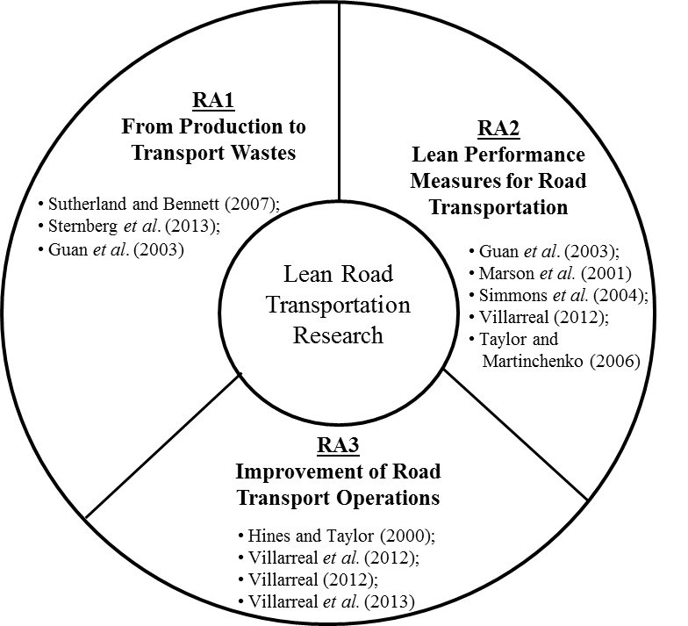

Figure 1. Areas where research on lean transportation has been conducted

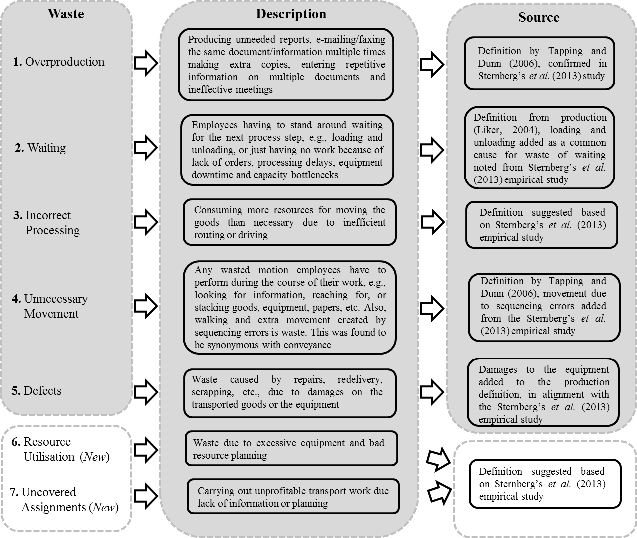

Figure 2. Description of the Toyota’s seven wastes adapted to transport operations (adapted from Sternberg *et al*., 2013)

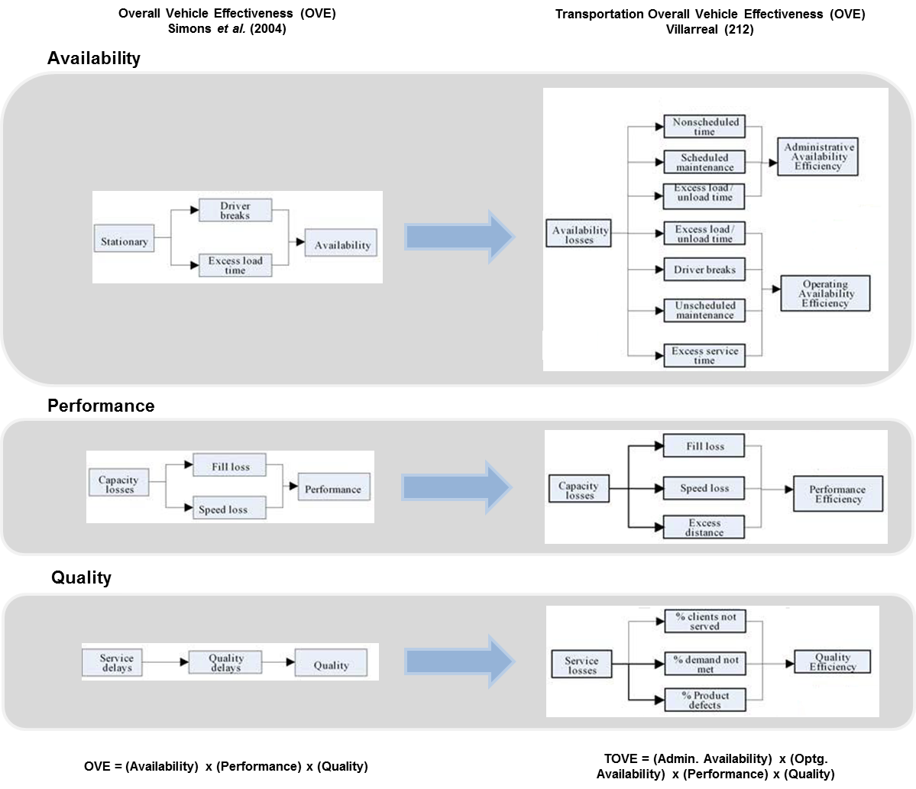

Figure 3. Comparison of the OVE and TOVE structures and components (Adapted from Simons *et al.*, 2004 and Villarreal, 2012)

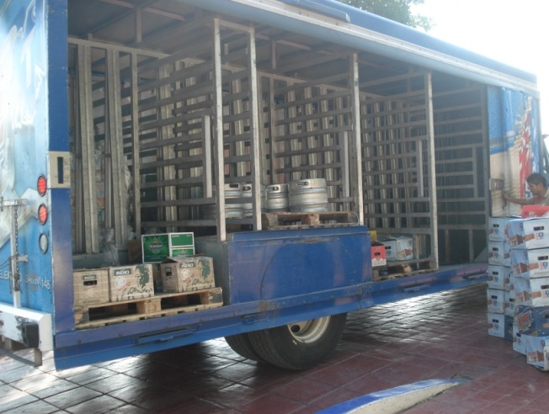

Figure 4. Illustration of truck utilised in routing operations

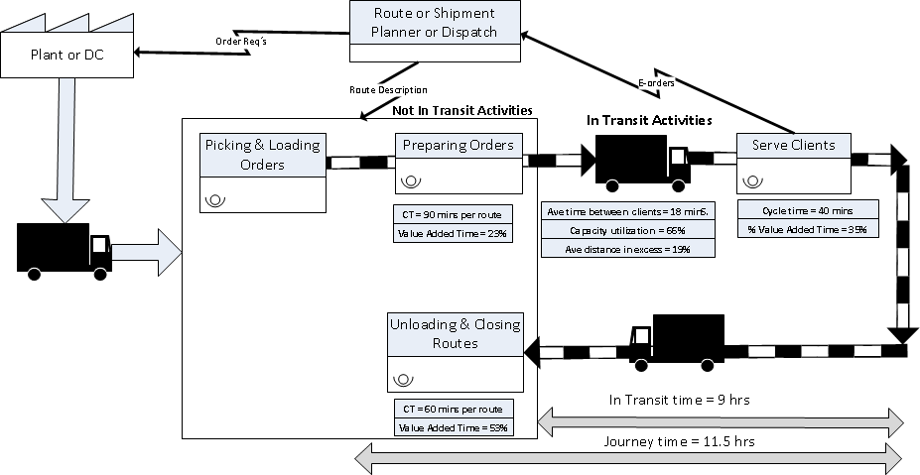

**Incorrect Processing**

**& Resource Utilization**

**Unnecessary Movements**

**& Waiting**

***Kaizen Burst 1***

***Kaizen Burst 2***

Figure 5. TVSM of the organisation studied