Spoken Rules: How children learn language is one of the oldest controversies in linguistics. But speaking may just be a matter of grasping the relationship between things
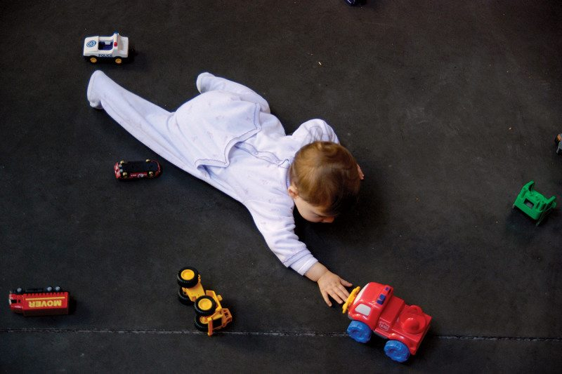
What’s the relationship between this truck and that truck?
Marie Genel/Picturetank
By Freddy Jackson Brown and Nic Hooper
SIXTY years ago, renowned Harvard psychologist B. F. Skinner published one of the most important books ever written about language. Verbal Behavior offered a comprehensive account of our unique capacity for symbolic communication, arguing forcefully over nearly 500 pages that it was learned rather than innate. The culmination of years of work, it was certainly influential – although not in the way Skinner anticipated. Rather than propelling his ideas into the limelight, it sparked a counter-revolution that catapulted a rival theory to worldwide acclaim.
Now, though, that rival theory is in decline and some of Skinner’s ideas are making an unexpected comeback. In recent years, psychologists have discovered that language really is learned, emerging from some general skills that are taught to children in the first few years of life. Surprisingly, these are not grand intellectual feats. Rather they can appear almost trivial – as simple as grasping the relationships between things, such as a large ball and a small one.

Happy talk: How your language shapes your brain and personality
The debate over the extent to which language is learned or innate is one of the most enduring in linguistics. Most children start to speak around age 2, and within a few short years are proficient, often prolific, users of language. Do they simply listen and learn, or are they born with some language facility that is filled in by the specifics of their native tongue? Learning is obviously involved – children pick up the language(s) they are brought up with. But can this alone account for the complexity and creativity of language?
That was the question Skinner set out to answer in the 1940s. As a behaviourist, he championed the idea that much of human behaviour, including language, could be explained by learning theory. He was especially interested in operant learning, which holds that our actions are shaped by their consequences. In a nutshell, behaviour is shaped by environmental feedback in the form of reinforcement or punishment.
As an approach to language, it was highly original. Linguists typically study form and structure – grammar, syntax and so on. But Skinner was interested in function: under what circumstances is language produced, and to what effect? He developed a system that grouped very different behaviours according to their function. For example, saying “hello” or “hi”, nodding, and writing the word “hello” can all have the same function, so they can be grouped into a single unit called an operant.
The parallel with evolution was clear. Skinner saw operant learning as the process by which organisms adapted to their environments within their lifetimes. In much the same way that natural selection can lead to biological complexity, selection of behaviour can shape increasingly novel and complex repertoires, including language. Successful behaviours are selected, the operant evolves, and this is the basis of linguistic complexity.
Verbal Behavior was conceptually bold, but was almost immediately on the back foot. In 1959, a young linguist called Noam Chomsky published a highly critical review that laid the foundations for an alternative explanation of language – possibly the most influential book review in the history of science.
Chomsky’s main critique was that Skinner hadn’t accounted for a feature of language called “generativity”. That is, our ability to produce and understand sentences we’ve never heard before. He pointed out that a lot of what we say has not been directly learned or prompted by our immediate environment. To use Chomsky’s own example, “colourless green ideas sleep furiously” is a grammatically correct but meaningless sentence that nobody had ever thought to utter before. If language was learned, how could he have come up with it? He explained away this “poverty of stimulus” by positing that humans are born with innate language skills called universal grammar.
Another classic example comes from an anecdote recounted by Skinner in Verbal Behavior. In 1934, as a young scholar, he attended a Harvard fellows’ dinner where he found himself sitting next to the philosopher Alfred North Whitehead. After a discussion about behaviourism, Whitehead issued Skinner with a challenge: “Your behaviourism works except with verbal behaviour. How can you explain my sitting here saying something like, ‘No black scorpion is falling on this table’?” His point was that he had never said it before and nothing in the room had prompted him. The challenge set Skinner on an intellectual journey that culminated with his book; in it he suggested that the black scorpion was a metaphor for behaviourism, thus accounting for Whitehead’s words within his framework.
“Do children just listen and learn, or are they born with an innate language ability?”
But Chomsky’s ideas proved the more persuasive and his star began to rise. Within a decade universal grammar was the dominant idea in linguistics. But some psychologists remained unconvinced. Although there were gaps in Skinner’s account, this did not mean that a functional analysis of language was not worth pursuing – indeed a small number of researchers continued this pursuit.
In the 1970s and 1980s, Murray Sidman at Northeastern University in Boston led a small research group aiming to understand how we learn to read. In various experiments they used a simple procedure called “matching to sample”, teaching young children to select one stimulus in the presence of another. For example, when presented with the letters “D-O-G”, they were taught to choose a picture of a dog. This is how most people learn the names of things and it is a core component of learning to read.
Sidman noticed something interesting: after learning one relationship, the children automatically understood others that they had not been taught. In one experiment he taught children aged 5 to 7 to match the names of Greek letters to their upper and lower case symbols. When they heard the word “gamma”, they learned to select the symbols Γ and γ. They also learned the words and symbols for xi (Ξ and ξ) and lambda (Λ and λ).

All Greek to me
During later tests, Sidman found that the children also knew relationships that they had not learned: when presented with γ they could select Γ and vice versa, even though they hadn’t explicitly been taught that relationship. They were also able to say the names of the Greek letters when presented with their symbols, again without any training. Sidman called this phenomenon “stimulus equivalence”.
These findings prompted a great deal of interest in behavioural science at the time because they could not be explained by the children’s learning history, further challenging Skinner’s original account. Perhaps more importantly they provided experimental demonstrations of people uttering things they had never said or heard before, opening up new ways to explore language generativity.
Over the past 30 years research led by Steven C. Hayes of the University of Nevada, Reno, and Dermot Barnes-Holmes at the University of Ghent in Belgium has shown Sidman’s equivalence to be just one type of stimulus relationship. There are lots of others, like opposition (up versus down) comparison (an elephant is bigger than a mouse) and hierarchy (cheese is a type of diary product). All can be learned and then generalised.
We now know that young children learn to link all sorts of different stimuli together using these relationships and then effortlessly generalise them to novel stimuli – a skill called generalised relational responding.
Having learned the relation “bigger”, for example, they find it easy to identify the larger object in other pairs, like two trees, two chairs, or indeed two unlike objects, such as a book and a chair, or a dog and a cat. Even though they might never have seen the stimuli before, they can generalise.
At first sight, this can appear almost trivial. How hard can it be to learn that one thing is bigger than another, then generalise that relationship? However, it turns out to be a uniquely human skill. While children can effortlessly do it from the age of 16 months, no other animal has shown a similar aptitude.
Many species can learn the basics. For instance, a pigeon can be taught to select the larger of two balls by presenting it with both and rewarding it when it pecks the right one. After a few successes it learns to peck the correct ball every time. But it cannot generalise this relationship to other objects that do not look similar to the ones it was trained with.
Our closest living relatives can’t do it either. In 2000, psychologists Neil Dugdale and Fergus Lowe of Bangor University, UK, published the results of their research with three chimpanzees, Sherman, Austin and Lana. They taught the chimps to respond to the letter Y by selecting the letter G and not R. Once they had learned this relation, the chimps were shown the letter G to see if they would reverse it and choose Y. They failed. This was despite having lived with the primatologist Susan Savage-Rumbaugh for years and receiving extensive language training – probably more than any other non-human animals in history.
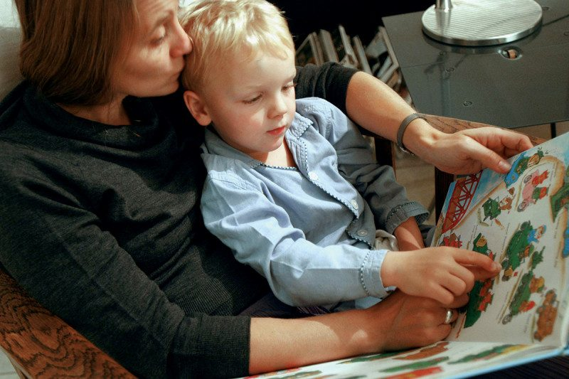
Learning to link words and pictures is a key part of language development
Peter Marlow/Magnum Photos
Another key feature of generalised relational responding is that it requires learning. Almost from birth, infants are given intensive training in the relationship between stimuli. Parents or caregivers might pick up a ball and say “ball” and then moments later say “ball” and point to a ball, or a picture of a ball. Over time the child will be exposed to many objects and words, in many different settings and with different people, but in each case the equivalence relationship remains constant. After sufficient training the child is able to abstract out the relation and use it with any stimuli in any situation. The same happens with other relationships such as bigger/smaller, higher/lower or same/opposite.
“Children can eventually ask abstract questions like ‘who has the bigger ego?’”
With time and practice the stimuli can become more abstract and context-independent, enabling children to compare arbitrary symbols and even concepts. Eventually, they can ask and answer questions such as: which country has the stronger economy? Who has the bigger ego? What is more important, time or money?
This turns out to have far-reaching implications. It explains, among other things, how we are able to link together arbitrary symbols such as written and spoken words – the essence of symbolic language. It also enables us to combine symbols in novel ways, to extend our language use beyond our direct learning histories. Sound familiar?
As experimental evidence accumulated, the researchers began to ask themselves the same question: is generalised relational responding the key to language?

In the frame
The research programme begun by Sidman has been synthesised into a comprehensive model of language called Relational Frame Theory (RFT), which is now vying to replace Chomsky’s increasingly unfashionable ideas as the dominant theory in linguistics.
A relational frame is a specific type of relational responding with three defining features – the ability to reverse and combine stimulus relations, and what is called the “transfer of stimulus function”. The “frame” refers to the nature of the relationship between two stimuli – sameness, for example, or opposition. Once two stimuli are framed together, their relationship can be reversed and/or combined, and the function of one stimulus is transferred to the other. In that way an arbitrary symbol like a written word can acquire a meaning.
As a very simple example, once the arbitrary sound “dog” has been linked to actual dogs in a “sameness” frame, they end up having the same function. A child with a fear of dogs will experience fear if told that there is a “dog” in the next room. The function of an arbitrary stimulus, “dog”, has been transformed to have the same meaning as an actual dog. This transfer can then continue onto other stimuli. For example, if the child learns that “chien” is the French word for “dog”, then they would have a similar fear response on hearing a “chien” is in the next room.
To date RFT has identified nine types of stimulus relation and how they are learned in early childhood (SEE “Same, different and the rest“). It also describes how they can be built into networks of relations. Each and any of these relations can connect stimuli together, allowing us to link anything to anything. In this way RFT describes how we are able to create a richly symbolic, dynamic network of relations between arbitrary stimuli – in other words, language.
Admittedly, it can sometimes be hard to see how a skill as apparently simple as relational framing can give rise to something as rich and complex as language. In this respect RFT has similarities with natural selection. The idea that life evolves as the environment selects variations from the gene pool is quite straightforward, but what makes the mind boggle is how it can account for the huge diversity of living things on our planet.
Nonetheless, RFT’s big claim is that our ability to reverse and combine relations and transfer stimulus functions answers the big question that motivated Skinner and Chomsky: what are the origins of language?
If RFT is correct, Skinner was right after all – sort of. Language is learned, although not quite as he originally conceived it. We don’t need innate abilities such as universal grammar to account for language generativity. Instead, it is the product of a learned, generalised – and uniquely human – ability to respond to simple relationships between stimuli. We take it for granted, but it is arguably what makes us human.

Same, different and the rest
Objects and events are related to each other in nine basic ways. According to an emerging theory of language called relational frame theory (see main text), networks of these relations are the building blocks of symbolic thought and language
1. COORDINATION dog is the same as hound
2. DISTINCTION a white dog is not the same as a brown dog
3. OPPOSITION a black dog versus a white cat
4. COMPARISON this dog is bigger than that dog
5. SPATIAL that dog is on the left, the other dog is on the right
6. DEICTIC (similar to spatial but in terms of the perspective of the speaker) I am in front of that dog but behind the other
7. TEMPORAL I fed the dog before I fed the cat
8. HIERARCHICAL a dog is a sort of mammal, which is a type of animal
9. CAUSAL if the dog bites me, I will punish it
This article appeared in print under the headline “Spoken rules”
Freddy Jackson Brown is a clinical psychologist and associate fellow at the University of Warwick, UK. Nic Hooper is a lecturer at University of the West of England in Bristol

