Evaluation of recombinant Factor C (rFC) assay for the detection of divergent LPS structural species and comparison with Limulus amebocyte lysate (LAL)-based assays and a human monocyte activity assay.

Wondwossen Abate1, Anas A Sattar1, Jian Liu2, Myra E Conway3 and Simon K Jackson1

1Centre for Biomedical Research, School of Biomedical & Healthcare Sciences, Peninsula Schools of Medicine and Dentistry, Plymouth University, Plymouth, UK;

2 Academic Unit of Ophthalmology, University of Bristol, Bristol, UK.,

3Centre for Research in Biosciences, Faculty of Health and Life Sciences, University of the West of England, Bristol, UK

Corresponding author:

Wondwossen Abate, Centre for Biomedical Research, School of Biomedical & Healthcare Sciences, Plymouth University Peninsula Schools of Medicine and Dentistry, Portland Square, Plymouth University, Plymouth, UK.

Email: [wondwossen.abatewoldie@plymouth.ac.uk](mailto:wondwossen.abatewoldie@plymouth.ac.uk). Tel: (+44) 01752584680

Running title: Detection of LPS structures by rFC- and LAL-based assays

**Abstract**

**Purpose:** The Limulus amebocyte lysate (LAL) assay is widely used for the screening of LPS in parenteral pharmaceuticals. However, correlation of LPS in Gram-negative bacterial infections by LAL assay has been problematic, partly due to the variable reactivity of different LPS structures. Recombinant Factor C (rFC) has allowed the development of a new simple, specific and sensitive LPS detection system (PyroGene®). In this work, the potential of the new assay in detecting various LPS structures has been investigated and compared with two LAL-based and a human monocyte activity assays.

**Methodology**: The activity of the various LPS structures has been investigated by Pyrogene® and two LAL-based and a human monocyte activity assays.

**Results:** The rFC assay detected most LPS structures in picogram quantities and the potency of *E. coli, B. cepacia*, *Salmonella* smooth, *Salmonella* R345 LPS were not different when measured with PyroGene® or LAL assays. However, the reactivities of *K. pneumoniae*, *S. marcescens, B. pertussis* and *P. aeruginosa* LPS differed significantly between these assays. Importantly, pairwise correlation analysis revealed that only the PyroGene assay produced a significant positive correlation with the release of IL-6 from a monocytic cell line.

**Conclusion**: We conclude that the rFC-based assay is a good replacement for conventional LAL assays and as it correlates significantly with IL-6 produced by a human monocyte cell line it could potentially be more useful to detect LPS in a clinical setting.

**Keywords: lipopolysaccharide, recombinant factor C, LAL, cytokine**

**Introduction**

Parenteral pharmaceutical products and medical devices such as pace makers, catheters and other invasive devices are required to be free from pyrogenic contamination [1] as potentially life-threatening septic shock could be elicited if pyrogens are administered inadvertently to the human body [2]. Bacterial endotoxin (lipopolysaccharide; LPS) is the pyrogen of main concern to the pharmaceutical industries as it is the most common contaminant and also due to its stability and high pyrogenicity [3-5].

Lipopolysaccharide (LPS), which is a complex glycolipid embedded within the outer membrane of Gram negative bacteria, is ubiquitous and has manifold biological activities [6] . It comprises a conserved acylated disaccharide, known as lipid A, which is attached to a core oligosaccharide moiety (Figure 1a). The core region is further extended by additional glycosylation to give the O-specific antigen [7]. The nature and the number of sugars as well as the number of repeat units within the O-polysaccharide region determine the serotype specificity of each bacterial strain within a species. The biologically active part of LPS, lipid A, also shows structural diversity due to the pattern of substitution of the two phosphate groups on lipid A, the type of fatty acids as well as the degree of acylation [7, 8].Lipid A from *E.coli* LPS typically has a hexa-acyl structure (similar to the one shown in Figure 1a), while LPS from different Gram-negative bacteria may have different numbers and arrangements of the acyl chains (Figure 1b) [9].

LPS is an important inflammatory molecule that has been shown to induce responses in many different cell types [8]. Humans are extremely sensitive to endotoxin and nanomolar quantities of LPS are sufficient to induce an acute fever response [10] and sepsis [11]. The extremely high potency of LPS in affecting biological systems along with its ubiquity and stability have required the development of a highly reliable, sensitive and quantitative test for the pharmaceutical and medical industries [12].

Currently the rabbit pyrogen test and the bacterial endotoxin test (BET), often referred to as the *Limulus* amebocyte lysate (LAL) test, are prescribed by health authorities and pharmacopoeias to test parenteral medicinal products. The adoption of the Russel and Burch 3R concept [13], which aims to refine, reduce and replace the use of animals in diagnostic and research testing, by the European Union in 1986 [14] led to a marked reduction of the rabbit pyrogen test in subsequent years and the adoption of the LAL test as an *in vitro* alternative pyrogen test for many parenteral products.

The principle of the LAL assay is based on the observation that endotoxin causes serine protease mediated extracellular coagulation of the haemolymph of the horseshoe crab [15]. The enzymatic components and the molecular events that are responsible for the clotting cascade of *Limulus polyphemus* and of other related species (namely *Tachypleus tridentatus* [16]and *Carcinoscorpius rotundicauda* [17] are well characterised (Figure 2). Factor C, the first component of the cascade, is a serine protease that is activated by endotoxin binding [16]. The cascade, initiated by LPS, culminates in the activation of the pro-clotting enzyme to its active form, the clotting enzyme, which in turn acts on coagulogen to convert it into the coaglulin clot (Figure 2) [16, 18, 19]. The kinetic chromogenic LAL assay uses a synthetic peptide-p-nitroanaline substrate that is cleaved by the clotting enzyme, resulting in a product that exhibits a yellow colour (Figure 2). The intensity of the yellow colour or the rate of colour formation correlates with the concentration of LPS in the assayed samples. The coagulation cascade of the LAL system can also be activated via activation of Factor G by fungal glucans [20] (Figure 2, upper right), though the activation of Factor C by LPS is many times more sensitive [21].

In addition, the LAL assay shows batch-to-batch fluctuations due to seasonal and geographical differences in the starting materials [12]. Furthermore, the dwindling horseshoe crab population, mainly due to extensive harvesting as a bait for commercial fishing [22], habitat loss and pollution, mandates the conservation of this organism as it has important roles in the ecology and marine life it resides in [2]. The commercial exploitation of the horseshoe crab for the LAL assay, therefore, adds to the threats to the horseshoe crab populations[2, 12]. To overcome all these issues, an alternative source of LAL assay was required.

This led to the production of the Factor C (FC) by recombinant DNA technology. Factor C (FC) has been cloned and expressed in *Escherichia coli* [23] yeast [23, 24] and mammalian cells [25] and recombinant FC (rFC) is capable of strongly binding LPS. The production of a rFC has enabled the development of a simple, specific and sensitive LPS detection assay that could potentially replace routine LAL based assays (Figure 2, upper left) particularly in cases where fungal contamination might be high.

Despite the applicability of the LAL assay for the detection of LPS from many bacterial sources, there has been no study to investigate the reactivity of rFC with different LPS structures. The range and sensitivity of rFC to different LPS structures will be important to determine before rFC-based assays become more widely adopted for different test samples. Moreover, the comparison of LPS detection capabilities between rFC and current LAL assays is also important to ascertain. We believe this is the first study to determine the reactivity of different LPS chemotypes with the PyroGene® (rFC) assay and then to compare the rFC-based assay with two other commercial kinetic chromogenic LAL-based assays in detecting LPS structures from various bacterial species. Furthermore, the inflammatory potential of selected LPS structural species was determined by the induction and release of IL-6 from a human monocytic cell line to allow comparison and assess the clinical relevance of rFC-based and LAL assays.

**Materials and Methods**

Lipopolysaccharides from *Salmonella* *minnesota* smooth strain, *Salmonella minnesota* rough strain (R345), *Escherichia coli* O111:B4, *Klebsiella pneumoniae*, *Pseudomonas aeruginonsa* serotype 10, were purchased from Sigma-Aldrich (Poole, UK). (‘Premium Grade’ (protein, nucleic acids <1%)). LPS from *E. coli* J5, *Salmonella* *minnesota* lipid A, *Salmonella* *minnesota* rough strain (R595), *Bordetella pertussis* and *Francisella tularensis* were from List Biologicals Laboratories, Inc. (Campbell, CA, USA) (‘Ultra Pure’ grade (protein, nucleic acids <1%)). LPS from *Burkhoderia cepacia* and *Serratia marcescens* was extracted from bacteria and treated with DNase and proteinase K as described previously by Bamford *et al* [26]. The Kinetic-QCL LAL assay kit, WinKQCL® V 3.0.1 software, pyrogene-free water, dilution tubes and pipette tips were purchased from Lonza (Verviers, Belgium). The PyroGene® recombinant Factor C endotoxin detection kit was kindly provided by Lonza (Verviers Belgium). Endosafe® Endochrome-K Kinetic LAL Assay Kit was purchased from Charles River (Charleston, SC, USA). The FLx800 TBIE fluorescence microplate reader and the ELx-808 IUBWI spectrophotometer were supplied by Bio-Tek Instruments (Bedfordshire, UK). The human monocytic cell line, Mono-Mac 6, (MM6) was obtained from the German Cell Collection (DSMZ, Braunschweig, Germany) and all tissue culture consumables were purchased from Lonza (Verviers, Belgium). A DuoSet Elisa Kit for IL-6 ELISA was obtained from R & D systems (Oxford, UK) and reverse transcription RT-PCR kits and primers were purchased from Invitrogen Ltd (Paisley, UK). iCycler Thermal cycler was supplied by Bio-Rad Laboratories (Hertfordshire, UK).

**Cell lines**

Mono-Mac 6, (MM6) cells were maintained in RPMI 1640 medium, supplemented with 200mM L-glutamine, 1% Penicillin/Streptomycin, 10% (v/v) foetal bovine serum, 1mM sodium pyruvate and 1% (v/v) non-essential amino acids. The cells were seeded at a density recommended by the supplierand grown at 37° C in humidified air and 5% CO2.

**Measurements of Cytokines at protein and mRNA level**

MM6 cells (5 x 105 for protein and 2.5 x 106 for the expression of mRNA) were incubated with various LPS structural species for 4 hours (RT-PCR) or 24 hours (ELISA). The released IL-6 in the cell culture supernatants following stimulation with various endotoxins was measured by ELISA using DuoSet ELISA kit whereas the level of mRNA expression was measured by RT-PCR using iCycler Thermal cycler (Bio-Rad, UK) according to the manufacturer’s instructions. The primers for IL-6 and the internal control GAPDH was designed using OligoPerfectTM online software (<http://tools.invitrogen.com>). The primer for IL-6 forward 5’-TAC CCC CAG GAG AAG ATT CC-3’, reverse 5’-TTT TCT GCC AGT GCC TCT TT-3’ and GAPDH forward 5’-ACA GTC AGC CGC ATC TTC TT-3’ and reverse 5’-GAC AAG CTT CCC GTT CTC AG-3’.

**Endotoxin detection assays**

The PyroGene® Recombinant Factor C Endotoxin Detection end-point assay was performed as described in the manufacturer’s instruction and analysed using WinKQCL® V 3.0.1 software. The sensitivity or the gating setting of FLx800 TBIE reader for individual kits was also determined as outlined by the supplier using WinKQCL® software. The assays were performed according to the manufacturer’s instructions using WinKQCL® V 3.0.1 software for both KQCL® and Endosafe Endochrome-K® assays.

The following US pharmacopoeia (USP) Reference Standard Endotoxin (RSE) (LPS from *E. coli* O55:B5) dilutions were made: 0.01, 0.1, 1 and 10EU/mL in each experiment as a standard for all the assays. Since different LPS structures did not have similar potency; i.e., endotoxin activity as measured by LAL or rFC-based assays, their activity in a LAL- or rFC-based assay is expressed using an endotoxin unit (EU). The EU is the activity of a specific endotoxin preparation defined as one fifth the amount of *E. coli* O55:B5 endotoxin required to bring about the threshold pyrogenic response when injected into man and rabbit on a per kilogram basis (1EU = 100pg of *E. coli* O55:B5 endotoxin) [27]. The amount of the various LPS structures and lipid A (from *Salmonella minnesota*) that were tested in the LPS detection assays varied from a picogram up to 50ng, however, for comparison the results were expressed as EU/ng of LPS for both rFC-based and LAL assays.

**Data Analysis**

Statistical comparisons among groups were determined by student t-test and one-way ANOVA or Pearson's correlation using GraphPad PRISM® software version 4.03 (GraphPad Software Inc).

**Results**

**Detection of various LPS structural species by rFC based assay**

In the present work, the reactivity of 11 different LPS structural species and a lipid A portion with rFC were analysed and results from the rFC-based assay was compared with two LAL-based assays. The rFC-based assay is designed to detect the LPS potency in the range of 0.01 to10 EU/mL and this assay was able to detect all the LPS structures in picogram quantities except for the lipid A and LPS from *F*. *tularensis* (Figure 3 A). However, there is a significant variation in the activity of the different LPS structures as measured by this assay (Figure 3A).The most rFC-reactive; i.e., potent, LPS structure detected was LPS from *K. pneumoniae* while the LPS from *F*. *tularensis* was the least reactive of all the structures investigated in the present work. Indeed, on an equal weight basis, LPS from the most active species (*K. pneumoniae*) was 35687 times more reactive than the least reactive LPS (*F*. *tularensis*). The assay was able to detect LPS from *F. tularensis* only when its concentration was greater or equal to 50ng/mL, considerably higher than the amounts detected for the other species.

To investigate the detection of the different chemotypes of LPS from the enteric bacteria, LPS from Salmonella smooth type, R345 (Rb2), R595 (Re) and lipid A from *Salmonella* (Figure 1a)*;* smooth-type *E. coli* O111:B4 and *E. coli* J5 were used (Figure 3A). Chemotypes containing the core saccharide region (*Salmonella* R345 and *E. coli* J5) showed no marked difference in rFC reactivity compared with the smooth strain chemotype. However, chemotypes with a truncated core region (R595) and lipid A showed significantly reduced potency. The mean reactivity of *Salmonella* smooth type LPS was 134 times more than the lipid A. This marked difference in rFC reactivity between smooth and rough strain LPS chemotypes is probably due to differences in solubility. It was previously suggested that the detergent additives of the PyroGene® assay buffer, zwittergent, makes lipid A more insoluble and un-reactive [28]. To aid the solubility of lipid A and improve its reactivity with rFC, lipid A was treated with triethylamine, which is a known LPS dispersion agent [29], and Triton X-100, which is also reported to increase the reactivity with Factor C [30]. The activation of rFC by lipid A was doubled when triethylamine at a concentration range of 0.01 to 0.2% was used (Figure 3B). The activity of the smooth LPS structures was also slightly increased with low levels of triethylamine but higher concentrations of triethylamine (>0.1%) reduced its activity. Likewise, when other LPS structures were treated with triethylamine at a concentration of 0.01%, it either slightly increased or had no effect on their activation of rFC but higher concentrations of triethylamine negatively affected their activity (Figure 3C). Treatment of samples which contained lipid A with low concentrations of Triton X-100 also enhanced the reactivity of lipid A spiked samples (results not shown).

**Comparison of rFC-based assay with LAL based assays**

The reactivity of the rFC-based assay with LPS was compared with two LAL-based assays provided by two different suppliers. The rFC-based assay showed greater sensitivity to a number of LPS from different organisms while it gave approximately equal sensitivity in the detection of LPS from others (Figure 4). The activity of LPS from *E. coli* O111:B4*, Burkholderia cepacia*, *Salmonella* smooth, *Salmonella* rough (R345) when analysed by rFC-based assay showed no significant difference compared with the LAL assays (Kinetic QCL® (KQCL®) and Endosafe Endochrome-K® assays) (p=0.1392). There was no marked variation between the rFC-based assay and KQCL® in the detection of LPS from *E.* *coli* J5 but the Endochrome-K® assay gave a significantly higher reading for this structure (p= 0.0016).

The potency of LPS from *Klebsiella pneumoniae* and *S*. *marcescens* when measured by rFC-based assay was significantly higher than KQCL® and Endochrome (p=0.0001). The potency of the LPS from *P. aeruginosa*, *B. pertusis* was significantly higher when assayed by rFC-based assay compared to KQCL® assay (p= 0.0159 and p=0.00001 respectively). However, the PyroGene® (rFC) assay was least sensitive to *Salmonella* R595 compared to the LAL assays. The rFC-based assay also showed least reactivity to lipid A p=0.0007 and LPS from *F*. *tularensis* compared to KQCL® assay (p=0.00001). The Endochrome-K® assay was the least sensitive of all the three assays in detecting lipid A; it only detected lipid A when the concentrations were > 10ng/mL. Furthermore, the effect of concentration gradient on these assays was also investigated by using the three strains of *E. coli* LPSs; namely O55:B5, O111:B4 and J5. A dilution ranging from 1000 to 1pg/ml was prepared and assayed. The results showed there is a classic linear relationship between the activity from the individual assays and the LPS concentrations in the concentration range that was tested (see supplementary data).

**Induction of IL-6 by various LPS structural species**

The various LPS structures used to study the reactivity of rFC were also investigated for their potential to induce IL-6 from a human monocyte cell line. The induction of IL-6 at the mRNA and protein levels were studied after the cells were stimulated with various LPS structures for 4 and 24 hours respectively. The various LPS structural species when added to the cells at equal concentrations induced a markedly different level of IL-6 (Figure 5). Previous studies have shown that production of IL-6 by MM6 cells in response to the LPS used is almost completely blocked by polymyxin B and that MM6 cells are almost uniquely sensitive to LPS at the concentrations used here, indicating that activation of the cell assay was due to LPS rather than other contaminants [31, 32]. A very high level of IL-6 was released from the cells when they were stimulated with LPS from *E. coli*, *K. pneumoniae*, *B. cepacia* and *Salmonella* (both the smooth and rough R345 chemotypes) and *S. marcescens* and there was no marked difference amongst these structures in the level of IL-6 induction. However, LPS from these bacteria induced significantly higher amounts of IL-6 compared with LPS from *B. pertussis, P. aeruginosa* and lipid A. The level of IL-6 mRNA induction following stimulation of the cells with selected LPS structures for 4 hours was also studied. The result obtained from RT-PCR was very similar to the ELISA result (data not shown). The rFC-based assay showed a significant positive correlation with the induction and release of IL-6 from the monocyte cell line (r2 =0.62, p=0.039) (Table 1). In contrast, the KQCL® and Endosafe® Endochrome assays showed positive correlation with IL-6 but the correlation was not significant as shown in Table 1.

**Discussion**

Because of its ubiquity and biological potency, lipopolysaccharide is the most important contaminant of pharmaceutical products [3, 4, 33]. Human beings are extremely sensitive to endotoxin and its effects range from fever to shock and death [2, 11, 34]. This necessitated the development of a highly reliable, sensitive quantitative test for pharmaceutical and medical industries to avert any potential risks [12]. The LAL-based assay has been used to detect endotoxin successfully from pharmaceuticals, parenteral fluids, medical devises, water and foods [12] and supplanted the time consuming and expensive rabbit pyrogen test [2]. However, several groups [1, 2, 20, 35, 36] have questioned the specificity and sensitivity of the LAL-based assay as the alternative pathway (Factor G) could react with fungal contaminants (β-D-glucan) [20] and also give a positive result. In addition, some LAL reactive materials that co-purify with clot proteins in the *Limulus* lysate may also give false positive or negative results in some batches of LAL [20, 35]. Moreover, the commercial procurements of the horseshoe crabs for LAL assays might exacerbate the ecological concern for horseshoe crab populations which are threatened with extinction [2, 12].

A simple and rapid fluorimetric assay for the detection of endotoxin based on rFC that overcome the shortcomings of LPS detection based on clot proteins derived from the haemolymph of horseshoe crabs has been recently introduced [12]. In the present work, the ability of the rFC assay to detect various LPS structural species and lipid A which vary in the length of their O-chain, core region, number and length of acyl chains and presence or absence of phosphate groups on their lipid A was evaluated. Although Factor C has been shown to be uniquely sensitive to LPS, in order to avoid any possible reactivity to potential contaminants, commercially highly-purified LPS was utilised and at the concentrations used (100ng/ml) there was minimal protein or nucleic acid. In addition, the rFC based method was compared with two other LAL-based assays in the detection of these different LPS structures.

The rFC-based endotoxin assay is able to detect all the LPS structures in picogram quantities with the exception of LPS from *F*. *tularensis* and lipid A from *Salmonella* *minnesota*. Within the LPS structures, there is a striking range of reactivity where the most reactive LPS (from *K. pneumonia*) is nearly 36000 times more reactive than the least reactive LPS (from *F*. *tularensis*). This difference could perhaps arise due to the structural characteristics of the lipid A moiety of *F*. *tularensis* [37-39]. Unlike the typical potent endotoxins which are equipped with two phosphate groups on the diglucosamine backbone, *F*. *tularensis* lipid A has none [39] or perhaps only one phosphate group [38]. Takada et al., [40] have shown using synthetic lipid A analogues (LA-14-PP), that dephosphorylation of both phosphate groups reduced the *Limulus* activity by approximately 32000-fold. This is almost the same degree of reduction in activity as noted in this study using the rFC-based assay. It is worth pointing out here that Factor C has also been reported to interact with acidic phospholipids such as phosphatidylglycerol and phosphatidylserine (but not with neutral phospholipids) in a manner comparable to synthetic lipid A analogues [19, 41, 42]. Therefore, it could be speculated that electrostatic interaction is very important for binding and activation of Factor C by LPS and the reduction of negative charge due to lack of the phosphate groups could potentially affect this interaction. The absence of phosphate groups on the lipid A of *F*. *tularensis* might also indirectly affect the interaction with Factor C due to poor solubility of the LPS species in the reagent mixture [40].

It has been demonstrated that the nature of the acyl groups linked to the diglucosamine backbone of lipid A plays a key role in the potency of lipopolysaccharide activation of Factor C [19, 40, 43]. The low reactivity of the LPS from *F*. *tularensis* could thus be further explained by its significant deviation in terms of number and chain length of the fatty acids on lipid A. *F*. *tularensis* lipid A is tetraacylated with three C-18 and a C-16 fatty acid [38, 39] resembling less potent lipid A structures from *Helicobacter pylori* and *Porphyromonas gingivalis* [44, 45] (as assessed by their potential in inducing pro-inflammatory cytokines from macrophages) while a typical biologically potent endotoxin has six C-12 to C-14 acyl chains. Therefore, we would expect the reactivity of the LPS of *Helicobacter pylori* and *Porphyromonas gingivalis* to be similar to that of *F*. *tularensis*. Kanegaski et al., [43] have also shown, using synthetic lipid A and its analogues, a significant reduction in Limulus activity when the number of fatty acids reduces from six to four.

The low reactivity of lipid A of *Salmonella minnesota* in all assays could be likely caused by its low solubility in aqueous medium. Furthermore, there is a report [28] which claims that lipid A is most likely made more insoluble and un-reactive in the presence of zwittergent, which is a detergent additive of the rFC PyroGene® Assay buffer. This detergent is added to assay buffer to disperse the LPS aggregate and make it more reactive to rFC. Since lipid A and lipid A-rich endotoxins are most likely to occur in naturally contaminated solutions, the chance of missing these when using buffer containing zwittergent as a detergent could, therefore, be high although the spike recovery with the O-antigen rich endotoxin results appear acceptable [21]. The solubility of lipid A was enhanced by using triethylamine, which is a known LPS dispersion agent [29],and Triton X-100, which is also reported to increase the activity of Factor C[19]. The reason why the Kinetic chromogenic LAL assay was more sensitive to *F*. *tularensis* and lipid A is not known but may be due to differences in the buffer contents which aid solubility of more hydrophobic LPS structures. This suggestion is supported by the results using less soluble LPS from *Salmonella* R595 which also gave a higher reactivity with KQCL® LAL assay than the PyroGene® rFC-based assay. However, the more soluble penta- and hexa-acylated LPS structures that were tested in this study were seen to be at least as potent if not more potent when assayed by rFC-based assay compared to the LAL-based tests.

Relevance of assays using non-human *in vitro* systems (i.e. rFC or LAL) to assess potential human health risks requires comparison with systems using human cells. Production of inflammatory cytokines, such as IL-6, form a human monocyte cell line, MonoMac 6 (MM6) has been shown to be a good model of inflammatory potential in humans [46-48]. This cell line expresses all the receptor components for LPS signalling and is phenotypically and functionally similar to human peripheral blood monocytes [32, 49]. Several investigators [46-48] have also tried to use this cell line as an *in vitro* test for pyrogens. Moesby et al., [50] made a comparative study of MM6 cells with isolated mononuclear cells and the LAL assay in their potential to detect pyrogens. IL-6 was the preferred readout in the present project since IL-6 is, in contrast to IL-1β or TNF-α, released entirely into the cell-conditioned medium allowing its complete estimation [1] and this cytokine has been shown to be released by low levels of LPS[47]. IL-6 is also the main endogenous pyrogen in humans and experimental animals thus it shows a better correlation with pyrogenic activity of LPS in the blood1 The various LPS structures used at the concentration of 100ng/mL in the present study induced a significant level of IL-6 from MM6 cells. Previous studies have shown that MM6 cells are very sensitive to LPS [31, 32] and that compared with LPS, putative pyrogens from gram-positive organisms were much less potent inducers of cytokines in the MM6 cells [46]. Moreover, in studies to identify microbial contaminants in biological products using MM6 cells and HEK293 cells transfected with different TLRs, only MM6 cells and HEK293 cells transfected with TLR4 responded to LPS [34]. Therefore, MM6 cells are useful models for assessing cell responses to LPS and our results with MM6 cells with LPS at the concentrations used in the current work is unlikely due to non-LPS contaminants. The same LPS structures also gave significant activity in the rFC-based assay and there was a significant positive correlation between rFC and the MM6 cell system (r2 =0.62, p=0.039). This suggests that rFC may react to lipid A/LPS structural variations in a similar manner to the MD-2–Toll-like receptor 4 receptor of the host immune system and theoretically, would be a useful assay for the assessment of LPS as a potential biomarker of Gram-negative bacterial infections and sepsis.

In conclusion, the rFC-based assay can be a viable alternative assay for the detection of endotoxin for pharmaceuticals, medical devices, water and foods and could replace LAL-based assays and preclude the need to harvest horseshoe crabs and contribute significantly to the conservation of horseshoe crabs which are considered as “living fossils”.

**Conflict of Interest Statement**: The Authors declare that there is no conflict of interest. This work received no specific grant from any funding agency.

**References**

1. Poole, S., et al., *A rapid 'one-plate' in vitro test for pyrogens.* Journal of Immunological Methods, 2003. **274**(1-2): p. 209-20.

2. Hoffmann, S., et al., *International validation of novel pyrogen tests based on human monocytoid cells.* Journal of Immunological Methods, 2005. **298**(1-2): p. 161-73.

3. Twohy, C.W., A.P. Duran, and T.E. Munson, *Endotoxin contamination of parenteral drugs and radiopharmaceuticals as determined by the limulus amebocyte lysate method.* J Parenter Sci Technol, 1984. **38**(5): p. 190-201.

4. Mascoli, C.C. and M.E. Weary, *Limulus amebocyte lysate (LAL) test for detecting pyrogens in parenteral injectable products and medical devices: advantages to manufacturers and regulatory officials.* J Parenter Drug Assoc, 1979. **33**(2): p. 81-95.

5. Mascoli, C.C., *Limulus amebocyte lysate (L.A.L.) test for detecting pyrogens in parenteral injectables and medical devices.* J Pharm Belg, 1979. **34**(3): p. 145-55.

6. Zhang, G.H., L. Baek, and C. Koch, *New microassay for quantitation of endotoxin using Limulus amebocyte lysate combined with enzyme-linked immunosorbent assay.* J Clin Microbiol, 1988. **26**(8): p. 1464-70.

7. Caroff, M., et al., *Structural characterization of the lipid A of Bordetella pertussis 1414 endotoxin.* J Bacteriol, 1994. **176**(16): p. 5156-9.

8. Bhor, V.M., et al., *Polymyxin B: an ode to an old antidote for endotoxic shock.* Mol Biosyst, 2005. **1**(3): p. 213-22.

9. Munford, R.S., *Sensing gram-negative bacterial lipopolysaccharides: a human disease determinant?* Infect Immun, 2008. **76**(2): p. 454-465.

10. Leive, L., *The barrier function of the gram-negative envelope.* Ann N Y Acad Sci, 1974. **235**(0): p. 109-29.

11. Schmid, B., et al., *Acylation of lysophosphatidylcholine plays a key role in the response of monocytes to lipopolysaccharide.* European Journal of Biochemistry, 2003. **270**(13): p. 2782-2788.

12. Ding, J.L. and B. Ho, *A new era in pyrogen testing.* Trends in Biotechnology, 2001. **19**(8): p. 277-+.

13. Russel, W.M.S. and R.L. Burch, *The principle of humane experimental techniques*. 1959, London: Methuren.

14. European Union, *EU-directive 86/609/EEC.* Official Journal of European Union, 1986: p. L358.

15. Levin, J. and F.B. Bang, *A Description of Cellular Coagulation in the Limulus.* Bull Johns Hopkins Hosp, 1964. **115**: p. 337-45.

16. Muta, T., et al., *Limulus Clotting Factor-C - Lipopolysaccharide-Sensitive Serine-Protease Zymogen.* Proteolytic Enzymes in Coagulation, Fibrinolysis, and Complement Activation, Part B, 1993. **223**: p. 336-345.

17. Ding, J.L., M.A. Navas, 3rd, and B. Ho, *Two forms of factor C from the amoebocytes of Carcinoscorpius rotundicauda: purification and characterisation.* Biochim Biophys Acta, 1993. **1202**(1): p. 149-56.

18. Muta, T., et al., *Limulus Factor-C - an Endotoxin-Sensitive Serine Protease Zymogen with a Mosaic Structure of Complement-Like, Epidermal Growth Factor-Like, and Lectin-Like Domains.* Journal of Biological Chemistry, 1991. **266**(10): p. 6554-6561.

19. Nakamura, T., et al., *Interaction between lipopolysaccharide and intracellular serine protease zymogen, factor C, from horseshoe crab (Tachypleus tridentatus) hemocytes.* J Biochem, 1988. **103**(2): p. 370-4.

20. Morita, T., et al., *A New (1-]3)-Beta-D-Glucan-Mediated Coagulation Pathway Found in Limulus Amebocytes.* FEBS Lett, 1981. **129**(2): p. 318-321.

21. Roslansky, P.F. and T.J. Novitsky, *Sensitivity of Limulus amebocyte lysate (LAL) to LAL-reactive glucans.* J Clin Microbiol, 1991. **29**(11): p. 2477-83.

22. Novitsky, T.J., *State of Horseshoe crab*. 2000. p. 1-5.

23. Roopashree, S.D., et al., *Expression of Carcinoscorpias-Rotundicauda Factor Cdna.* Biochem Mol Biol Int, 1995. **35**(4): p. 841-849.

24. Ding, J.L., et al., *Expression of full length and deletion homologues of Carcinoscorpius rotundicauda Factor C in Saccharomyces cerevisiae: Immunoreactivity and endotoxin binding.* Journal of Endotoxin Research, 1997. **4**(1): p. 33-43.

25. Roopashree, S.D., H. Bow, and J. L.D, *Recombinant COS-1 cells express Carcinoscorpius rotundicauda Factor C.* Biotechnology Letters, 1997. **19**(4): p. 357-362.

26. Bamford, S., H. Ryley, and S.K. Jackson, *Highly purified lipopolysaccharides from Burkholderia cepacia complex clinical isolates induce inflammatory cytokine responses via TLR4-mediated MAPK signalling pathways and activation of NFkappaB.* Cell Microbiol, 2007. **9**(2): p. 532-43.

27. Hirayama, C. and M. Sakata, *Chromatographic removal of endotoxin from protein solutions by polymer particles.* Journal of Chromatography B, 2002. **781**(1): p. 419-432.

28. Novitsky, T.J., *Selection of standards*. 1999. p. 1-5.

29. Hejna, J. and J.A. Cameron, *Effect on particle size of solubilization of wild-type and Re chemotype lipopolysaccharides solubilized with bovine serum albumin and triethylamine.* Infect Immun, 1978. **19**(1): p. 187-93.

30. Nakamura, T., et al., *Intracellular serine-protease zymogen, factor C, from horseshoe crab hemocytes. Its activation by synthetic lipid A analogues and acidic phospholipids.* Eur J Biochem, 1988. **176**(1): p. 89-94.

31. Huang, L.-Y., et al., *Use of toll-like receptor assays to detect and identify microbial contaminants in biological products.* Journal of clinical microbiology, 2009. **47**(11): p. 3427-3434.

32. Liu, J., et al., *Evaluation of inflammatory effects of airborne endotoxin emitted from composting sources.* Environmental Toxicology and Chemistry, 2011. **30**(3): p. 602-606.

33. Mascoli, C.C. and M.E. Weary, *Applications and advantages of the Limulus amebocyte lysate (LAL) pyrogen test for parenteral injectable products.* Prog Clin Biol Res, 1979. **29**: p. 387-402.

34. Jackson, S.K., et al., *Lysophospholipid metabolism facilitates Toll-like receptor 4 membrane translocation to regulate the inflammatory response.* J Leukoc Biol, 2008. **84**(1): p. 86-92.

35. Jorgense.Jh and R.F. Smith, *Preparation, Sensitivity, and Specificity of Limulus Lysate for Endotoxin Assay.* Applied Microbiology, 1973. **26**(1): p. 43-48.

36. Pearson, F.C., et al., *Detection of endotoxin in the plasma of patients with gram-negative bacterial sepsis by the Limulus amoebocyte lysate assay.* J Clin Microbiol, 1985. **21**(6): p. 865-8.

37. Barker, J.H., et al., *Basis for the failure of Francisella tularensis lipopolysaccharide to prime human polymorphonuclear leukocytes.* Infect Immun, 2006. **74**(6): p. 3277-84.

38. Phillips, N.J., et al., *Novel modification of lipid A of Francisella tularensis.* Infect Immun, 2004. **72**(9): p. 5340-8.

39. Vinogradov, E., M.B. Perry, and J.W. Conlan, *Structural analysis of Francisella tularensis lipopolysaccharide.* Eur J Biochem, 2002. **269**(24): p. 6112-8.

40. Takada, H., et al., *Structural Requirements of Lipid-a Species in Activation of Clotting Enzymes from the Horseshoe-Crab, and the Human-Complement Cascade.* European Journal of Biochemistry, 1988. **175**(3): p. 573-580.

41. Ariki, S., et al., *A serine protease zymogen functions as a pattern-recognition receptor for lipopolysaccharides.* Proc Natl Acad Sci U S A, 2004. **101**(4): p. 953-8.

42. Li, P., et al., *The specificity of Sushi peptides for endotoxin and anionic phospholipids: potential application of POPG as an adjuvant for anti-LPS strategies.* Biochem Soc Trans, 2006. **34**(Pt 2): p. 270-2.

43. Kanegasaki, S., et al., *Structure-activity relationship of lipid A: comparison of biological activities of natural and synthetic lipid A's with different fatty acid compositions.* J Biochem, 1986. **99**(4): p. 1203-10.

44. Darveau, R.P., et al., *Porphyromonas gingivalis lipopolysaccharide contains multiple lipid A species that functionally interact with both toll-like receptors 2 and 4.* Infect Immun, 2004. **72**(9): p. 5041-51.

45. Moran, A.P., B. Lindner, and E.J. Walsh, *Structural characterization of the lipid A component of Helicobacter pylori rough- and smooth-form lipopolysaccharides.* J Bacteriol, 1997. **179**(20): p. 6453-63.

46. Eperon, S., et al., *Human monocytoid cell lines as indicators of endotoxin: comparison with rabbit pyrogen and Limulus amoebocyte lysate assay.* Journal of Immunological Methods, 1997. **207**(2): p. 135-45.

47. Eperon, S. and T.W. Jungi, *The use of human monocytoid lines as indicators of endotoxin.* Journal of Immunological Methods, 1996. **194**(2): p. 121-129.

48. Nakagawa, Y., H. Maeda, and T. Murai, *Evaluation of the in vitro pyrogen test system based on proinflammatory cytokine release from human monocytes: comparison with a human whole blood culture test system and with the rabbit pyrogen test.* Clin Diagn Lab Immunol, 2002. **9**(3): p. 588-97.

49. Caroff, M., et al., *Structural and functional analyses of bacterial lipopolysaccharides.* Microbes Infect, 2002. **4**(9): p. 915-26.

50. Moesby, L., et al., *A comparative study of Mono Mac 6 cells, isolated mononuclear cells and Limulus amoebocyte lysate assay in pyrogen testing.* Int J Pharm, 1999. **191**(2): p. 141-9.

51. Qureshi, N., et al., *Monophosphoryl lipid A obtained from lipopolysaccharides of Salmonella minnesota R595. Purification of the dimethyl derivative by high performance liquid chromatography and complete structural determination.* J Biol Chem, 1985. **260**(9): p. 5271-8.

52. Sforza, S., et al., *Determination of fatty acid positions in native lipid A by positive and negative electrospray ionization mass spectrometry.* Journal of Mass Spectrometry, 2004. **39**(4): p. 378-383.

53. Makimura, Y., et al., *Chemical structure and immunobiological activity of lipid A from Serratia marcescens LPS.* J Med Microbiol, 2007. **56**(Pt 11): p. 1440-6.

54. Ernst, R.K., et al., *Pseudomonas aeruginosa lipid A diversity and its recognition by Toll-like receptor 4.* Journal of Endotoxin Research, 2003. **9**(6): p. 395-400.

55. Silipo, A., et al., *Complete structural characterization of the lipid A fraction of a clinical strain of B-cepacia genomovar I lipopolysaccharide.* Glycobiology, 2005. **15**(5): p. 561-570.

**Legends to Figures and Table(s)**

**Figure 1**. (**a)** Schematic diagram of lipopolysaccharide from *Salmonella* *minnesota* showing the main structural components. The regions with truncation of the core sugars in the rough mutants Rb2 (S. *minnesota* R345) and Re (*S.* *minnesota* R595) are shown. GlcN, glucosamine; Kdo, ‘2-keto-3-deoxyoctulosonic acid’ (3-deoxy-D-manno-octulosonic acid); Hep,D-glycero-D-manno-heptose. Adapted and modified from Alexander and Rietschel 50.

**(b)** lipid A structures of the LPS from different Gram negative bacteria used in this study. The table shows the number, length and type of acyl chains for each lipid A species.

**Figure 2**. Diagram of the LPS reactive coagulation cascade system in *Limulus* horseshoe crab that results in the formation of a coagulin gel. The coagulogen chromogenic substrate and chromogenic product used in the LAL assays [adapted from Muta *et al*., 1991(28)] are shown. The scheme also shows the activation of the LAL clotting system by Factor G through interaction with fungal 1, 3-β-D-glucan (top right). Activation of recombinant factor C (rFC) by LPS and subsequent reaction to form a fluorogenic product as used in the Pyrogene assay is shown at top left.

**Figure 3.** The reactivity of different LPS structures as determined with the rFC-based assay. (A) The activity of each LPS structure is expressed as endotoxin units (EU)/ ng of LPS (N=at least 3 independent experiments conducted in duplicate). * p<0.05; *** p<0.001 vs LPS from *E.coli* O111.B4. Effect of Triethylamine on the reactivity of Lipid A (B) and *E.coli* O111.B4 (C). for the *E.coli* O111.B4 the reactivity of LPs with Triethylamine is normalised against the LPS without the addition of Triethylamine * p<0.05; *** p<0.001 vs LPS from *E.coli* O111.B4.

**Figure 4**. Comparison of the reactivity of the different LPS structures in the LAL assays and rFC assay (N =at least 3 independent experiments conducted in duplicate). * p<0.05; ** p<0.01; *** p<.0001 rFC response vs LAL responses.

**Figure 5.** The release of IL-6 induced by LPS structures.MonoMac 6 cells (5 x 105 per well) were stimulated with the various LPS structural species at a concentration of 100ng/mL for 24 hours (N=at least 3 independent experiments conducted in duplicate). The released IL-6 in the cell culture supernatants was measured by ELISA using DuoSet ELISA kit following manufacturer’s instruction. * p<0.05 vs mean IL-6 production in LPS-stimulated cells.

**Table 1.** The Pearson’s correlation analysis matrix of the various LPS structural species and lipid A for induction of IL-6 and pyrogenicity as determined by PyroGene®,KQCL®  and Endosafe® Endochrome assays. (N= at least 3 independent experiments conducted in duplicates).

**Table 1**

|  |  |  |  |  |
| --- | --- | --- | --- | --- |
|  | PyroGene | KQCL® | Endosafe | IL-6 |
| KQCL | **0.34** | - | - | - |
| P value | 0.14 | - | - | - |
| Endosafe | **0.41** | **0.93** | - | - |
| P value | 0.09 | 0.00 | - | - |
| IL-6 | **0.62** | **0.24** | **0.28** | - |
| P value | 0.04 | 0.27 | 0.23 | - |

**Figure 1a.**

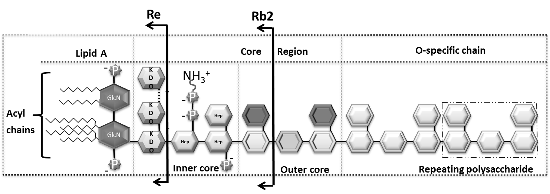

**Figure 1b.**

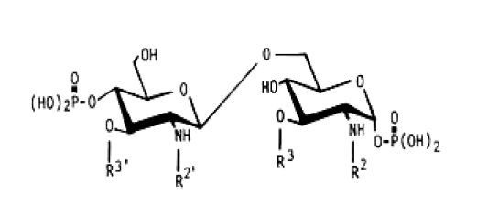

|  |  |  |  |  |  |
| --- | --- | --- | --- | --- | --- |
| Bacterial species | **R3’** | **R2’** | **R3** | **R2** | **References** |
| *Salmonella minnesota* | **C14-O-(C14)** | **C14-O-(C12)** | **C14-OH** | **C14-O-(C16)** | [51] |
| *E. coli* | **C14-O-(C14)** | **C14-O-(C12)** | **C14-OH** | **C14-OH** | [52] |
| *F. tuleransis* | **H (with one P group)** | **C18-O-(C16)** | **C18-OH** | **C18-OH** | [35] |
| *S. marcescens* | **C14-O-(C14)** | **C14-O-(C14)** | **H** | **C14-OH** | [53] |
| *B. pertussis* | **C14-OH** | **C14-O-(C14)** | **C10-OH** | **C14-OH** | [7] |
| *K. pneumoniae* | **C10-O-(C12)** | **C10-O-(C12)** | **C10-OH** | **C10-OH** | [52] |
| *P. aeroginosa* | **C10-OH** | **C12-O-(C12)** | **C10-OH** | **C12-OH** | [54] |
| *B. cepacia* | **C14-OH** | **C14-O-(C16)** | **C14-OH** | **C16-OH** | [55] |

**Figure 2.**

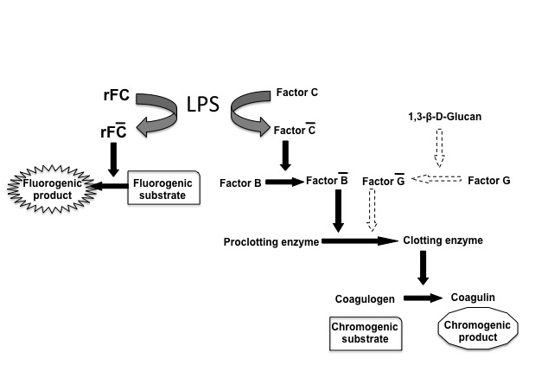

**Figure 3 (A).**

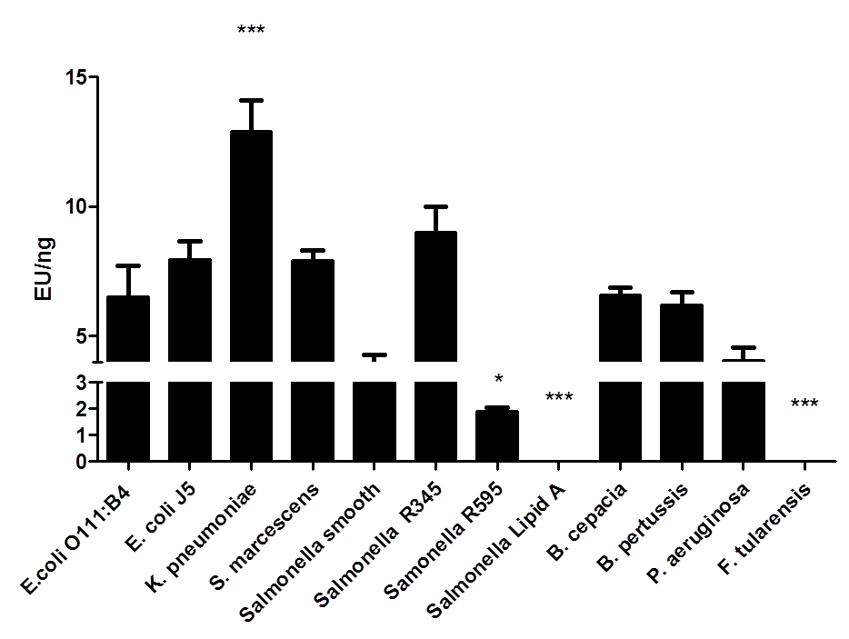

**LPS Source**

**Figure 3 (B).**



**Figure 3 (C).**



**Figure 4.**

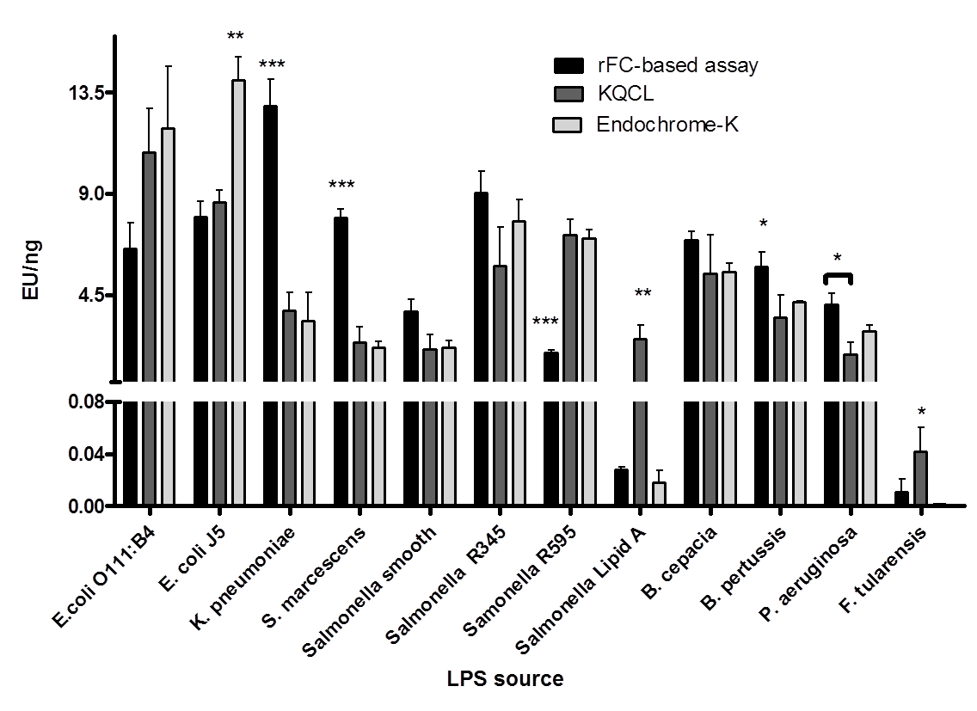

**Figure 5.**

