A Semantic Representation of the Knowledge Management Enablers Domain: The aKMEOnt Ontology
Mohammad Sabri, Mohammed Odeh, Mohammed Saad
The University of the West of England (UWE), Bristol, United Kingdom
Mohammad2.Sabri@live.uwe.ac.uk
Mohammed.Odeh@uwe.ac.uk
Mohammed.Saad@uwe.ac.uk

Abstract: Knowledge management is a significant driver for any enterprise development and evolution as it is engaged with planning, implementing, controlling, monitoring and improving enterprise’s processes and systems. However, organisations are still at a disadvantage when applying knowledge management in a real environment. A resourced-based view of knowledge management stimulates the consideration of knowledge management enablers (KMEs) as factors that should be employed during the development and implementation of knowledge management systems. Using organisations’ KMEs is critical for understanding how knowledge is created, shared, disseminated and upgraded in order to better respond to the dynamic environment. They are also essential to identify available assets and resources and clarify how an organisation’s capabilities are created and utilised. Sustaining these KMEs and applying them in systematic modes and business processes requires a generic overview of these KMEs and the relationship between them. The semantic representation of the KMEs domain can be an attractive approach to meet this demand. Using ontologies facilitates the semantic representation of the KMEs and provides a shared understanding of knowledge among individuals in the organisation. This paper proposes the employment of an abstract KMEs ontology (aKMEOnt) that formally defines an essential pillar of the knowledge management domain. Organisation structure, culture, information technology, leadership, knowledge context and business repository have been selected as representatives to define the KMEs domain. Each of the selected KMEs has a set of concepts that characterises its domain. The whole concept map of these KMEs has been developed to depict the concepts and their relationships in the KMEs domain. Based on the concept map of the KMEs, the aKMEOnt, including its classes and properties is implemented using the Protégé tool and Ontology Web Language-Description Logic (OWL-DL).The aKMEOnt is important to explicitly manage and control the flow of knowledge in the organisation, and, in addition, it can be integrated with potential semantic representation of other related disciplines.

Keywords: knowledge management, knowledge management enablers, resource-based view, ontologies.

Introduction
A resourced-based view suggests that organisations should focus on resources and capabilities as a stage in reaching their products and potential markets (Barney et al, 2011). It also motivates business processes to exploit intangible resources in order to sustain a competitive advantage (Ray et al, 2004). Knowledge, as the most significant strategic intangible resource, has an increasing role in business processes. However, many enterprises still find the topic of knowledge unclear to handle (Zack et al, 2009).
Knowledge of an enterprise cannot be understood apart from its capabilities and an understanding of the knowledge assets of an organisation; it should be seen as a set of capabilities that will improve its chances to grow and survive (Kogut and Zander, 1992). Nevertheless, knowledge lacks enablers that identify the existing and new capabilities and clarify how they are created and applied in practical settings (Senge, 2006). These knowledge management enablers (KMEs) encourage individuals to overcome barriers to develop and share their knowledge and experience (Ho, 2009). They also contribute to the initial planning and building of the essential infrastructure for the enterprise and reinforce the efficiency and flow of knowledge (Ho, 2009; Lee and Choi, 2003).
A semantic representation of the KMEs using ontologies supports capturing and exploiting knowledge. It shares a common understanding of the KMEs domain and specifies what is necessary at its abstract level (Antoniou et al, 2005). Moreover, it supports traceability, interoperability and integration between KMEs and other domains (Happel and Seedorf, 2006). Therefore, this paper aims to define the KMEs ontology that bridges the gap between knowledge management and other systems. It is also part of further research that seeks to develop an effective knowledge-based business process architecture (BPA) using the Riva method (Ould, 2005).
In this paper, we describe the development of the abstract KMEs ontology (aKMEOnt) which conceptualises the elements of the KMEs and the relationship between them. In addition to the introduction, the rest of this paper is structured around five sections. Section 2 identifies the used semantic KMEs. Section 3 briefly explains the methodology and design tool used to develop the aKMEOnt and section 4 explains the design specification of the aKMEOnt. Section 5 presents the development of aKMEOnt’s classes and properties and finally, section 6 concludes the paper.

Semantic knowledge management enablers
Knowledge management enablers are factors or incentives with exchange techniques that stimulate knowledge creation and dissemination in an organisation (Magnier-watanabe et al, 2011; Yeh et al, 2006). A generic overview that identifies KMEs with their reasonable connections can be accomplished through semantic representation using ontologies. Ontology is an “explicit specification of a shared conceptualisation” (Gruber, 1993, p.199) that facilitates formal use, portability and interoperability of knowledge (Breitman et al, 2003; Roussey et al, 2011).
A semantic representation of the KMEs using ontology supports an understanding of the KMEs domain and finding the relationships between its concepts. It also extracts useful approaches to link knowledge management with other disciplines such as the semantic Riva Business Process Architecture (srBPA) ontology (Yousef and Odeh, 2014).
The semantic approach does not only show the ontological representation of the shared concepts and relationships of the knowledge management domain, it also highlights the necessary pillars to build a knowledge management system design with minimum cost and effort. Moreover, it can provide an open infrastructure for the flow of knowledge in the enterprise (Knublauch, 2004).
Different KMEs were surveyed in relation to their significant contribution to knowledge management implementation (Theriou et al, 2011). Following a review of these organisational KMEs, five KMEs were selected as representatives of the KMEs domain, in addition to the knowledge context enabler which is derived from the environment, resources and managerial influences to distinguish the business situation (Pomerol and Brezillon, 2001; Holsapple and Joshi, 2004). This selection which mainly includes leadership, technology, structure and culture is based on the crucial need and common use of these KMEs in previous studies (Gold and Malhotra, 2001; Lee and Choi, 2003; Migdadi, 2009; Ho, 2009). Technology, structure and culture KMEs are also defined in the American Productivity and Quality Centre (APQC) knowledge management model (Andersen et al, 1996). Furthermore, leadership, organisation structure and information technology are addressed as pillars of knowledge management implementation (Bixler, 2002). These KMEs can be ontologised and interrelated to produce general conceptualisation of the KMEs domain.
The aKMEOnt suggests an essential pillar that defines the knowledge management domain; it also covers the main capabilities or resources for the organisation by identifying the aKMEOnt instances.

Methodology and design tool

A methodology for building the aKMEOnt
Building an ontology has no standardised methodologies (Uschold and Gruninger, 1996). However, it is an iterative process and relates to the phases of the requirements engineering design, development, integration, validation and feedback (Subhashini and Akilandeswari, 2011). These phases are identified in the knowledge-engineering methodology of Noy and McGuinness (2001) who consider iteration as a continuous activity through the ontology lifecycle. The knowledge-engineering method presents a simple approach with clear steps to follow while building a research ontology. This approach is important to determine the KMEs that are used in the research scope and it is found useful in providing incremental detection of the KMEs concepts and their relationships. In addition, the knowledge-engineering method does not ignore existing ontologies in the same domain and this supports research into new ontologies and minimises effort. Furthermore, it highlights the significant terms or concepts that the research needs to utilise in building the ontology. The adopted knowledge-engineering methodology has seven steps in order to develop an ontology. The aKMEOnt adopts these following steps:
- Determine the domain and scope: Each KME’s domain and scope is defined by answering the following questions (Noy and McGuinness, 2001): What is the domain that the ontology will cover? What is the ontology going to be used for? Each KME covers its area in business organisations such as organisation structure, technology and culture and it will be used to identify the resources and capabilities that are related to its domain.
- Consider reusing the existing ontology: Existing ontologies for each KME are considered if they are found in previous studies or else one of the KME’s definitions or classifications in its domain is used instead.
- Enumerate important terms: Based on KME’s existing ontologies or definitions, important terms/concepts are enumerated or extracted.
- Define the classes and class hierarchy: A top-down development of the classes/concepts and their hierarchy are established using the concept mapping tool (Cañas et al, 2004).
- Define the properties/slots of classes: Object properties and data types of the KMEs’ classes are created using the Protégé Tool.
- Define the facets (restrictions) of the slots: Slot’s cardinality, value-type, domain and range of each class are defined.
- Create instances: creating individual instances of the KMEs’ classes is accomplished with a case study which is out of the scope of this paper.

The aKMEOnt development language and tool
To build the aKMEOnt we use the Ontology Web Language-Description Logic (OWL-DL). It is part of the World Wide Web Consortium (W3C) recommendations for the semantic web (McGuinness and Harmelen, 2004). Protégé 3.4.1 environment is used to build the aKMEOnt classes and properties as well as edit and execute OWL axioms and Semantic Web Rule Language (SWRL) rules.

Design specification of the aKMEOnt

The information technology KME
The capabilities and tools of information technology play different roles in facilitating enterprise knowledge management processes (Alavi and Leidner, 2001). Through knowledge management applications, two types of information technologies can be distinguished; interactive and integrative applications (Hayes, 2011). Another categorisation has been proposed by Revilla et al (2009) for whom information technology consists of a combination of both the convergent and the divergent dimensions. Both the convergent and interactive classifications are related to the connection and communication between the members of the enterprise in order to facilitate knowledge transfer. Tools such as e-mails, blogs, discussion forums and video-conferencing are used in that dimension. On the other hand, integrative or divergent classification is related to the retrieval and accessibility of the stored explicit knowledge. Office applications, decision-support systems and the intranet are examples of tools which refer to the integrative dimension. According to the research categorisation suggested by Hayes (2011) and Revilla et al (2009), the technology KME will be deconstructed into three elements: tool, dimension (integrative/interactive), and user.

The leadership KME
Leadership was introduced as one of the pillars for successful knowledge management implementation (Bixler, 2002). It is a persistent factor which organisations adopt to facilitate the transfer of knowledge and encourage their members to collaborate (Theriou et al, 2011). Deconstructing the leadership KME for ontology use was already coined by Bennis and Biederman’s proposition (2009, p.350) who argued that “leadership is grounded in a relationship; in its simplest form, it is a tripod-a leader or leaders, followers, and the common goal they want to achieve”. Based on this proposition, the main components of the leadership KME include the leader, the follower and a goal.

The culture KME
An organisational culture that prepares suitable settings can have a motivating role in knowledge exchange and activities (Allameh et al, 2011). One of the essential definitions of culture which is useful to be deconstructed and ontologised is: “a pattern of shared basic assumptions that was learned by a group as it solved its problems of external adaptation and internal integration, that has worked well enough to be considered valid and, therefore, to be taught to new members as the correct way to perceive, think, and feel in relation to those problems” (Schein, 2006, p.17). According to this definition, the culture KME can be deconstructed into different components: assumption, external adaptation or internal integration problems and reference. The pattern of shared assumptions is the solution and the right approach to handle these problems. A basic assumption could be a behaviour, rule, norm or visible artefact. The reference is the source of that assumption.

The organisation structure KME
Choosing the right enterprise structure can be a significant aspect when applying knowledge management (Migdadi, 2009). It promotes social interaction and facilitates the flow of knowledge within the organisation (Rasula et al, 2012). Organisation structure implies “an enduring configuration of tasks and activities” (Skivington and Daft, 1991, p.46) and is usually classified into centralisation, formalisation and integration (Chen and Huang, 2007). Ontologies representing organisational structure already exist in previous research. Reynolds’ (2014) organisation structure ontology is recommended by the (W3C). The existing ontologies have common concepts such as roles, skills, positions, persons or agents, units and resources (Abramowicz et al, 2008; Reynolds, 2014). The organisation structure KME in this paper covers the main concepts with consideration of other KMEs in order to build a whole concept map of KMEs that represents the KMEs domain apart from further details in each KME area. The concept map of the organisation structure will assist in the integration with other KMEs and forms a cornerstone in building the aKMEOnt since it is the largest and more interactive. Moreover, it has a useful existing ontology that is endorsed by the (W3C) (Reynolds, 2014). The main concepts that are extracted from the existing organisational structure ontology are: unit, position, agent, resource, business function, role and skills.

The business repository KME
The business repository can be a subject or part of the integrative information technology KME if considered as a well-structured warehouse with efficient query techniques (Weske, 2010). However, it would be useful to separate it as a standalone KME in order to classify and facilitate seeking the documented explicit knowledge. In this paper, the business repository KME is defined as metadata schemas which semantically represent information about e-documents (Yang et al, 2004). Metadata will be limited to a few attributes which are considered sufficient to be integrated with other ontologies such as the srBPA ontology (Yousef and Odeh, 2014) and represent the necessary information about the document for the development of the aKMEOnt. These attributes are type, description, unit, creation date and creator. The instances or the individuals of the e-documents are considered as the titles or the names of the e-documents.

The knowledge context KME
Knowledge context is related to the surrounding factors and relevant conditions that create a unique business situation (Brézillon and Pomerol, 2001). To address the previous definition by using the ontology, a few elements are selected to represent the factors or conditions that form a business situation. These elements “intervening in a context come from the domain” (Brézillon et al, 1998, p.359) and are in relation to other KMEs. Units or divisions, business rules, restrictions, and customers are considered surrounding relevant conditions that are produced by the domain and form a business situation. These elements are used to build the knowledge context in the aKMEOnt.

KMEs concept map
After discussing the literature relating to each KME, all KMEs concepts are combined to extract the concept map of the KMEs (see Figure 1). This map facilitates understanding the KMEs domain and developing the aKMEOnt classes, subclasses and their relationships using the protégé tool. The combination of the KMEs’ elements results in the following changes while building the concept map:
- The information technology KME: The tool concept is classified into an integrative or interactive tool using properties. A property is an attribute that describes the values of the concept. The integration of the information technology KME with other KMEs will demonstrate that the user concept can be replaced with the agent concept in the leadership KME. Therefore, the user concept will be omitted and represented instead by the agent concept. The agent can be any individual that has a role in the enterprise (Reynolds, 2014). These agents are supposed to be the only users of the tools in the organisation. Connecting tool and agent concepts in the aKMEOnt is accomplished using relationship properties.
- The leadership KME: Following an overview of all the selected KMEs, every leader or follower is eventually an organisation’s member holding a role and wanting to achieve a goal. Therefore, all these members are merged into one concept while aligning all the KMEs. This concept is the agent who is originally presented in the organisational structure KME. The agent concept is implemented in the leadership KME as the aKMEOnt is developed. A goal is achieved by the agent. The leader or follower is presented by a property that classifies the agent. Other relationship properties are used to link the leadership KME with other KMEs.
- The culture KME: The external or internal description of the problem concept is presented as a property. The problem has a reference that teaches the assumptions. The assumptions solve these problems. A reference is the assumptions’ source that learns from an e-document or agent if the culture KME is mapped to other KMEs.
- The organisation structure KME: The concepts of the organisation structure KME are included in the concept map with modifications to the resource and agent concepts in order to integrate with other KMEs. The agent concept is implemented in the leadership KME. A resource could be an asset that supports business activities and processes. Regarding this research it is important to define particular resources which are aligned with other KMEs. Tools and e-documents which are defined in information technology and business repository KMEs respectively, are suitable alternatives to be classified as resources. These resources are accessed according to the positions in the organisation structure KME. Relationship properties are used to link between different inner and outer concepts of the organisation structure KME.
- The business repository KME: The type, description and creation date attributes are properties that describe the e-document. The creator is any organisation member; therefore, it is replaced with the agent who is implemented in the leadership KME. The unit is already defined in the organisation structure KME. Further relationship properties are presented in the concept map.
- The knowledge context KME: All business rules, restrictions and customers are related to a unit which is already defined in the organisation structure KME. Customers and restrictions can be classified as external or internal using properties. Relationship properties are used to link the knowledge context KME with other KMEs in the concept map.
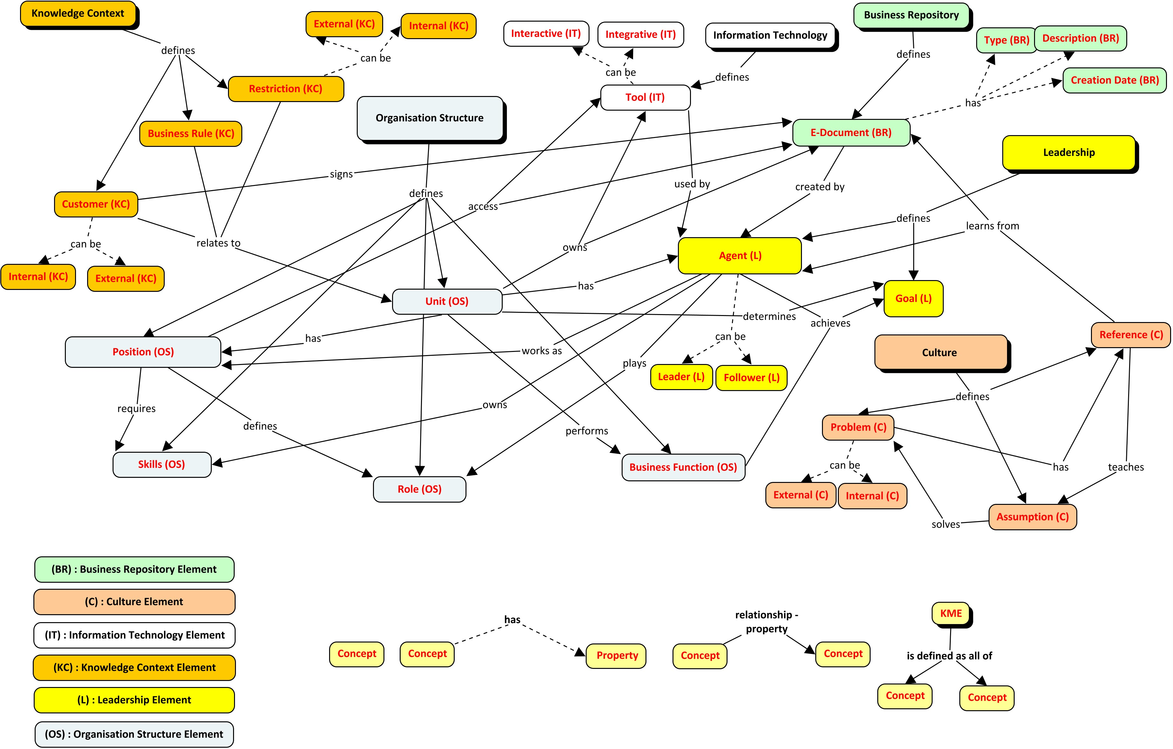

Figure 1: Concept map of the knowledge management enablers

Development of the aKMEOnt classes and properties
After building the concept map of the KMEs, the KMEs’ concepts and their relationships are mapped onto ontological elements and classes and their properties using the protégé tool (see Figure 2).

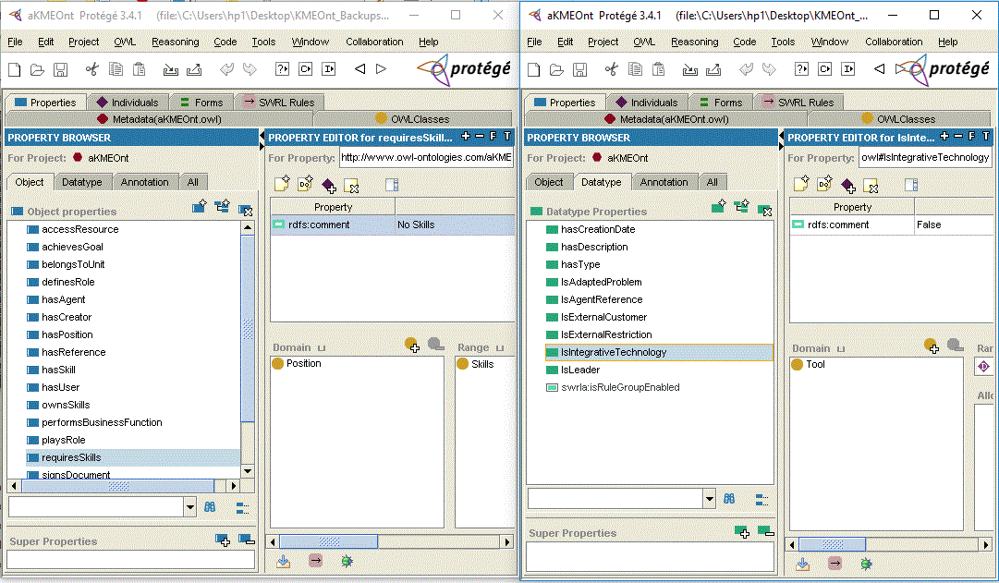

Figure 2: Object and data type properties of the aKMEOnt using protégé tool

Concepts are defined as classes in the aKMEOnt. A concept property in the concept map is a data type property in the ontology. A data type property is a description or categorisation of the concept/class individuals. It links individuals to data values. Relationship properties in the concept map are defined as object properties in the aKMEOnt. Object properties link instances of different classes. Protégé developed classes with their object and data type properties are summarised in Table 1.

Table 1: aKMEOnt main concept classes and properties

Concept/Class | Description | Object and data type properties
Business repository
E-Document | Main e-documents in the enterprise which can be work procedures, contracts and manuals. These documents have creators, creation dates, types and descriptions | - hasType of type: String  - createdBy of type Agent  - hasCreationDate of type dateTime  - hasDescription of type : String
Culture
Assumption | Solutions, processes or values for any internal or external problems | - solvesProblem of type problem (class of the domain range)
Problem | External problems that should be adapted or internal problems that appear during the integration | - IsExternal/InternalProblem of type: Boolean  - hasReference of type Reference
Reference | Documents or agents that act as a reference for the assumption or the solution | - teachesAssumption of type Assumption  - learnsFromAgent of type: Agent  - learnsFromDocument of type: E-Document
Concept/Class | Description | Object and data type properties
Knowledge context
Business Rule | General principles that should be applied during work | - relatesToUnit of type Unit
Customer | Clients from inside or outside the enterprise | - IsExternal/InternalCustomer of type: Boolean  - relatesToUnit of type Unit  - signsDocument of type E-Document
Restriction | Limitations imposed by internal or external stakeholders | - IsExternal/InternalRestriction of type: Boolean  - relatesToUnit of type Unit
Leadership
Goal | Objectives that are desired to be achieved by each leader and his followers
Agent | Any Individual or member of the organisation who holds managerial or non-managerial position. An agent can be a leader or follower. | - achievesGoal of type Goal  - playsRole of type Role  - ownsSkills of type Skills  - IsLeader/Follower of type : Boolean  - worksAs of type Position
Organisation structure
Business Function | The upper-level description of functions or work that an organisation performs such as Marketing, Sales, Research and Development. in order to achieve specific goals | - achievesGoal of type Goal
Unit | Divisions or departments of the organisational context that deal with common activities | - performsBusinessFunction of type Business_Function  - hasAgent of Type Agent  - hasPosition of type Position  - ownsResource of type Tool  - ownsResource of type E-Document  - determinesGoal of type Goal
Position | Organisation positions that define the roles and their potential resources | - definesRole of type Role  - requiresSkills of type Skills  - accessResource of type Tool  - accessResource of type E-Document
Role | Description of the roles that are related to a position in the organisation
Skills | Description of capabilities that are needed to meet job requirements
Information technology
Tool | Communication or storage tools to retrieve information (Interactive/Integrative) | - IsIntegrative/InteractiveTechnology : Boolean  - usedBy of type Agent

Conclusion
This paper has introduced the aKMEOnt as a general ontology of the KMEs domain. The aKMEOnt implements different KMEs semantically. Information technology, leadership, culture, organisation structure, knowledge context and business repository are the utilised KMEs in the aKMEOnt. Accordingly, they were analysed and deconstructed into derived concepts. The whole map of these KMEs concepts has been presented to illustrate and construct the aKMEOnt. The aKMEOnt enables a formal shared understanding of the KMEs domain which can be presentable and usable in the knowledge management area. It simplifies applying knowledge management in the enterprise and supports controlling its different processes. It also provides an abstract view of the KMEs domain for decision makers and facilitates describing the flow of knowledge in organisations. Furthermore, it contributes towards automating the alignment between knowledge management, business processes and computer-based systems.
The aKMEOnt will have a significant role in building a knowledge-based BPA throughout the semantic process of identifying the candidate essential business entities (CEBEs) for the Riva BPA method (Ould, 2005). This role can be addressed by providing the knowledge assets and capabilities using SWRL rules in order to initialise the srBPA ontology (Yousef and Odeh, 2014). The srBPA ontology has been used in different frameworks and demonstrated at King Hussein Cancer Centre (KHCC) in Jordan (Ahmad and Odeh, 2013). The aKMEOnt will be integrated with the srBPA ontology to instantiate the BPA for the Islamic International Arab Bank (IIAB) in Jordan. Developing and demonstrating the aKMEOnt is recommended in different case studies or contexts to seek a consistent semantic representation of the KMEs domain.

References
Ahmad, M. and Odeh, M. (2013) “A New Approach to Semantically Derive Enterprise Information Architecture from Business Process Architecture”, Proceedings of 15th International Conference on Enterprise Information Systems (ICEIS 2013), Angers, France, July, pp 274 - 280.

Abramowicz, W., Filipowska, A., Kaczmarek, M., Pedrinaci, C., Starzecka, M., and Walczak, A. (2008) “Organization Structure Description for the Needs of Semantic Business Process Management”, 3rd International Workshop on Semantic Business Process Management Collocated with 5th European Semantic Web Conference, January.

Alavi, M., and Leidner, D. E. (2001) “Review: Knowledge Management and Knowledge Management Systems: Conceptual Foundations and Research Issues”, MIS quarterly, pp 107-136.

Allameh, M., Zare, M., and Davoodi, M. (2011) “Examining the Impact of KM Enablers on Knowledge Management Processes”, Procedia Computer Science, Vol 3, pp 1211-1223.

Andersen, A., Productivity, T. and Center, Q. (1996) "The Knowledge Management Assessment Tool: External Benchmarking Version", [online], Chicago, IL,
http://docs.lib.purdue.edu/cgi/viewcontent.cgi?article=1425&context=iatul

Antoniou, G., Franconi, E. & Van Harmelen, F. (2005) "Introduction to Semantic Web Ontology Languages", In Reasoning Web, Springer, pp. 1-21.

Barney, J.B., Ketchen Jr, D.J. and Wright, M. (2011) “The Future of Resource-based Theory: Revitalization or Decline?”, Journal of Management, Vol 37, No. 5, pp 1299-1315.

Bennis, W. G., and Biederman, P. W. (2009) The Essential Bennis, John Wiley and Sons.

Bixler, C. H. (2002) “Applying the Four Pillars of Knowledge Management”, KM World, Vol 11, No. 1, pp 10-20.

Breitman, K.K. and do Prado Leite, J.C.S. (2003) “Ontology as a Requirements Engineering Product”, In Requirements Engineering Conference, 2003. Proceedings. 11th IEEE International, September, pp 309-319. IEEE.

Brézillon, P., and Pomerol, J. C. (2001) “Some Comments about Knowledge and Context”, Research Raport, Vol 22.

Brézillon, P., Pomerol, J. C., and Saker, I. (1998) “Contextual and Contextualized Knowledge: An Application in Subway Control”, International Journal of Human-Computer Studies, Vol 48, No. 3, pp 357-373.

Cañas, A. J., Hill, G., Carff, R., Suri, N., Lott, J., Eskridge, T., and Carvajal, R. (2004) “CmapTools: A Knowledge Modelling and Sharing Environment”, In Concept Maps: Theory, Methodology, Technology. Proceedings of the First International Conference on Concept Mapping, Vol. 1, pp 125-133.

Chen, C. J., and Huang, J. W. (2007) “How Organizational Climate and Structure Affect Knowledge Management—The Social Interaction Perspective”, International Journal of Information Management, Vol 27, No. 2, pp 104-118.

Happel, H. J., and Seedorf, S. (2006) “Applications of Ontologies in Software Engineering”, In International Workshop on Semantic Web Enabled Software Engineering (SWESE’06), pp 1-14.

Hayes, N. (2011) “Information Technology and the Possibilities for Knowledge Sharing”, Handbook of Organizational Learning and Knowledge Management, pp 83-104.

Gold, A. H., and Arvind Malhotra, A. H. S. (2001) “Knowledge Management: An Organizational Capabilities Perspective”, Journal of Management Information Systems, Vol 18, No. 1, pp 185-214.

Gruber, T. R. (1993) “A Translation Approach to Portable Ontology Specifications”, Knowledge Acquisition, Vol 5, No. 2, pp 199-220.

Ho, C. T. (2009) “The Relationship between Knowledge Management Enablers and Performance”, Industrial Management and Data Systems, Vol 109, No. 1, pp 98-117.

Holsapple, C. W., and Joshi, K. D. (2004) “A Formal Knowledge Management Ontology: Conduct, Activities, Resources, and Influences”, Journal of the American Society for Information Science and Technology, Vol 55, No. 7, pp 593-612.

Knublauch, H. (2004) “Ontology-driven Software Development in the Context of the Semantic Web: An Example Scenario with Protege/OWL”, In 1st International Workshop on the Model-Driven Semantic Web (MDSW2004), Monterey, California, USA, September, pp 381-401.

Kogut, B. and Zander, U. (1992) “Knowledge of the Firm, Combinative Capabilities, and the Replication of Technology”, Organization Science, Vol 3, No. 3, pp 383-397.

Lee, H., and Choi, B. (2003) “Knowledge Management Enablers, Processes, and Organizational Performance: An Integrative View and Empirical Examination”, Journal of management information systems, Vol 20, No. 1, pp 179-228.

Magnier-watanabe, R., Benton, C. and Senoo, D. (2011) “A Study of Knowledge Management Enablers across Countries”, Knowledge Management Research and Practice, Vol 9, No. 1, pp 17-28.

Migdadi, M. (2009) “Knowledge Management Enablers and Outcomes in the Small-and-medium Sized Enterprises”, Industrial Management and Data Systems, Vol 109, No. 6, pp 840-858.

McGuinness, D. L., and Van Harmelen, F. (2004) “OWL Web Ontology Language Overview”, W3C Recommendation, Vol 10, No. 10.

Noy, N. and McGuinness, D. L. (2001) “Ontology Development 101: A Guide to Creating your First Ontology”, [online], Stanford University
http://protege.stanford.edu/publications/ontology_development/ontology101.pdf

Ould, M.A. and British Computer Society (2005) Business Process Management: A Rigorous Approach, Swindon, British Computer Society.

Theriou, N., Maditinos, D., and Theriou, G. (2011) “Knowledge Management Enabler Factors and Firm Performance: An Empirical Research of the Greek Medium and Large Firms”, European Research Studies, Vol 14, No. 2, pp 97.

Rasula, J., Vuksic, V. B., and Stemberger, M. I. (2012) “The Impact of Knowledge Management on Organisational Performance”, Economic and Business Review for Central and South-Eastern Europe, Vol 14, No. 2, pp 147.

Ray, G., Barney, J. B., & Muhanna, W. A. (2004) “Capabilities, Business processes, and Competitive Advantage: Choosing the Dependent Variable in Empirical Tests of the Resource‐based View”, Strategic management journal, Vol 25, No. 1, pp 23-37.

Reynolds, D. (2014) “The Organization Ontology”, [online], W3C, https://www.w3.org/TR/vocab-org/.

Revilla, E., Rodríguez-Prado, B. and Prieto, I. (2009) “Information Technology as Knowledge Management Enabler in Product Development”, European Journal of Innovation Managemen, Vol 12, No. 3, pp 346-363.

Roussey, C., Pinet, F., Kang, M. A., and Corcho, O. (2011) “An Introduction to Ontologies and Ontology Engineering”, In Ontologies in Urban Development Projects, Springer, London, pp 9-38.

Schein, E. H. (2006) Organizational Culture and Leadership, John Wiley and Sons.

Senge, P.M. (2006) The Fifth Discipline: The Art and Practice of the Learning Organization, London: Random House.

Skivington, J. E., and Daft, R. L. (1991) “A Study of Organisational Framework and Process Modalities for the Implementation of Business-level Strategic Decisions”, Journal of Management Studies, Vol 28, No. 1, pp 45-68.

Subhashini, R., and Akilandeswari, J. (2011) “A Survey on Ontology Construction Methodologies”, International Journal of Enterprise Computing and Business Systems, Vol 1, No. 1, pp 60-72.

Uschold, M., and Gruninger, M. (1996) “Ontologies: Principles, Methods and Applications”, The Knowledge Engineering Review, Vol 11, No. 2, pp 93-136.

Weske, M. (2010) Business Process Management: Concepts, Languages, Architectures. Springer Publishing Company, Incorporated.

Yang, S.J., Chen, I.Y. and Shao, N.W. (2004) “Ontology Enabled Annotation and Knowledge Management for Collaborative Learning in Virtual Learning Community”, Journal of Educational Technology and Society, Vol 7, No. 4, pp 70-81.

Yeh, Y., Lai, S. and Ho, C. (2006) “Knowledge Management Enablers: a Case Study”, Industrial Management and Data Systems, Vol 106, No. 6, pp 793-810.

Yousef, R. and Odeh, M. (2014) “The srBPA Ontology: Semantic Representation of the Riva Business Process Architecture”, International Journal of Computer Science Issues (IJCSI), Vol 11, No. 2, pp 84.

Zack, M., McKeen, J. and Singh, S. (2009) “Knowledge Management and Organizational Performance: An Exploratory Analysis”, Journal of Knowledge Management, Vol 13, No. 6, pp 392-409.

