Service Innovation and Performance in Mexican Service SMEs

Gonzalo Maldonado-Guzman¹, Jose Arturo Garza-Reyes², Luis Rocha-Lona³, and Vikas Kumar⁴

¹Centro de Ciencias Económicas y Administrativas, Universidad Autónoma de Aguascalientes, Aguascalientes, México
gmaldona@correo.uaa.com
²Derby Business School, The University of Derby, Derby, UK
J.Reyes@derby.ac.uk
³Instituto Politécnico Nacional, ESCA Santo Tomás, México City, México
lrocha@ipn.mx
⁴Bristol Business School, University of the West of England, Bristol, UK
vikas.kumar@uwe.ac.uk

Abstract. This empirical research investigates the influence of service innovation on the performance of service SMEs, especially within the context of a country with an emerging economy as it is the case of Mexico. Data were collected through a survey instrument designed and distributed among service SMEs in the Aguascalientes state of Mexico to test a hypothesis formulated from the literature review conducted. The instrument was validated using Confirmatory Factor Analysis, Cronbach’s alpha test and the Composite Reliability Index to ensure its reliability. The hypothesis was tested using structural equation modelling (SEM) using an as input 308 valid responses obtained from the survey. In general, the results obtained show that service innovation has a positive and significant effect on the performance of service SMEs. Specific research related to service innovation in service SMEs is limited. This paper therefore fills this research gap by expanding the limited body of knowledge in this field.

Keywords: Innovation, Mexico, service industries, service innovation, SMEs.

1 Introduction

The concept of innovation has been recognized for decades in the literature of business and management sciences as one of the essential resources to achieve higher competitive advantages, not only in manufacturing enterprises but also in service companies [1]. Therefore, innovation in service enterprises has had an important growth and dynamism in the scholarly literature since the end of the previous and the beginning of this century. However, it is important to highlight that a high percentage of the empirical and theoretical research which has been published in the scholarly literature has been mostly focused on transnational and large enterprises; with only a limited number of investigations focusing on small and medium-sized service enterprises (SMSEs) [2].
Consequently, innovation in service enterprises has become, in the current literature, as one of the most relevant topics to improve in order to achieve a high level of business growth since innovation in services has focused on the creation of more and better competitive advantages [3]. Innovation in services has also been analyzed from a perspective of a predecessor of internal and external business innovation and the existing relation with firm performance that enterprises have achieved [2]. For that reason, de Brentani [4] concluded that companies that carry out modifications or improvements in their services generally have more benefits as well as higher performance which allow them to increase their innovation activities.
In this regard, innovation in processes is considered in the analysis and discussion of services innovation not only as an essential element that shows a strong organizational structure but also as a sequential process [4,5] or a circular unstructured process in order to obtain a higher level of services innovation [6]. This sequential process can produce better results as well as a significant increase in the performance of service enterprises [7].
Similarly, it is possible to observe the development and implementation of processes innovation of new services in the literature, where the details are generally specified as well as the interactive activities, the negotiation and decision making which are present not only in the services innovation but also in firm performance [8]. Thus, there is theoretical and empirical evidence in the literature of business and management sciences that innovation in service enterprises is much more dynamic and has evolved at a faster pace that innovation in manufacturing enterprises [9].
However, relatively few publications have analyzed service innovation in SMEs, so it is necessary to increase the theoretical and empirical evidence of innovation activities within the context of service SMEs [10]. According to von Koskull and Strandvik [7], it is necessary to analyze and discuss what is really happening in service innovation and processes innovation in service SMEs. Therefore, the main contribution of this research is the analysis and discussion of the existing relation between services innovation and performance of service SMEs in a country with an emerging economy as it is the case of Mexico, and as it suggested by Perks et al. [10] and Tuominen and Toivonen [11].

2 Literature Review

There is a variety of definitions regarding the concept of services, but if the reader considers the definition coined by Sampson and Froehle [12] then it is possible to establish that services can be defined as a clear combination of co-produced resources and processed based on the provision of personal services. Similarly, this definition of services is based on the same processes that require the services which define accurately the importance of final clients and consumers in the processes of services creation [12].
Similarly, the services sector is usually one of the biggest economic sectors in both developed and developing countries. That is why service innovation is one of the essential elements that allow a higher level of growth and firm performance [13]. Moreover, in the literature it is possible to observe an important increase in theoretical and empirical investigations regarding services innovation in the last decade, which indicates that several research papers from the area of innovation are focusing more in the services rather than in the manufacturing sector [14,15,16]. This shows the importance that services innovation has in the current literature.
In this regard, the context of the concept of services is changing with the creation of the concept of new services or services innovation. These usually refer to the creation of completely different services that entirely satisfy the needs of the clients segments that have a lot of interest in getting intensive services in new knowledge [17]. As a result, service innovation researches are usually associated to the creation of new knowledge into enterprises and with the increase of competition of companies [18], as well as the growth of the development of new products [19] and the ability to innovate in the service enterprises [20].
The existing relationship between services innovation and firm performance has been analyzed and discussed marginally in the literature of innovation when compared to the innovation of manufactured products. This is because services do not have a physical component, it is complicated that consumers obtain immediate benefits after their purchase and it is difficult that they distinguish the components of services innovation [2]. Therefore, Voss et al. [21] established that service innovation probably takes more time to create positive effects in performance of the services sector when compared to the innovation of manufactured products in enterprises from the manufacturing industry.
Consequently, services are frequently perceived as basic by clients and consumers but the improvement, change or innovation in services is not as tangible as the innovation of manufactured products [2], even when innovation is usually much easier to implement in the services sector than in manufacturing enterprises, but at the same time it is also easier to be copied by the main competitors in service enterprises [21]. This situation can be the main reason as to why service enterprises have a lower number of innovation projects, especially regarding radical innovation, than manufacturing enterprises. As a result, it will be necessary to emphasize more services innovation as it also produces different economic and financial benefits, just like their counterpart from the manufacturing sector [21].
Thus, it is not surprising that in the literature of business and management sciences it is suggested that innovation in manufacturing SMEs produces similar benefits to the ones of service SMEs, except for the amount of innovations introduced to the market [22]. Therefore, the literature considers innovation as one of the business strategies that allow the significant increase of a number of competitive advantages as well as the level of performance in service SMEs [2]. As a result, both researchers and scholars have an area of opportunity to carry out empirical and theoretical investigations that focus on services innovation and the effects on firm performance, and in this way take advantage of the modifications and opportunities provided by this important sector [15].
Similarly, forthcoming theoretical and empirical investigations about services innovation will have to consider the difference between the diverse types or categories of services, the analyses made and their effects on the performance or organization [15,23]. Upon this idea, Menor et al. [15] concluded that there is a gap in the literature about understanding the operationalization of the background of service innovation and its effects on firm performance. Moreover, it is not only necessary to differentiate the types of services in the literature but also consider the existing effects of the relationship between service innovation and the level of performance that enterprises have in the services sector [2].
Within this perspective, the categorization of services usually reflects the effects that discontinuous (radical) innovation and continuous (incremental) innovation have on service innovation [4], since the radical services innovation is completely different from the incremental services innovation [2]. Thus, Oke [24] considered that most enterprises of the service sector focus more on incremental innovation, which is commonly associated to firm performance. Similarly, Lubatkin et al. [25] discussed that services innovation is more incremental in SMEs since this provides them with a higher level of firm performance. Accordingly, Oke et al. [26] also considered that service innovation is mostly incremental because it produces a higher level of firm performance. Therefore, at this point it is possible to establish the following research hypothesis:

H1: The higher the level of service innovation, the higher level of firm performance

3 Methodology

The business directory of the ‘Sistema de Información Empresarial Mexicano’ 2016 (Mexican Business Information System) for the Aguascalientes State was used to determine the size of the service enterprises that were considered for this empirical research. This directory had a register of 1,334 service enterprises between 5 and 250 employees by January 2016. Therefore, the sample contained 308 enterprises with a reliability level of 95% and a maximum level of error of ±5%. A questionnaire was designed, validated and distributed to the 308 selected enterprises by means of a simple random sampling method from January to April, 2016. The questionnaire collected data regarding the characteristics of service enterprises, the innovation activities in the previous two years as well as the firms’ performance.
In order to measure service innovation, managers were asked to indicate if the enterprise had carried out innovation activities in the previous two years. In order to measure the importance of innovations, managers were asked to evaluate the innovation in services, processes and management systems with seven items by means of a five-point Likert scale (from 1 = Not Important to 5 = Very Important as their limits). The scale was adapted from those developed by Frishammar and Hörte [27] and Madrid-Guijarro et al. [28]. Regarding the measurement of firm performance, it was measured with eight traditional indicators constructed from the perception of the managers of service SMEs about their competitive position regarding market share, profitability and productivity [29]. These eight questions were also measured by means of a five-point Likert scale (from 1 = Not Important to 5 = Very Important) as their limits.
Similarly, in order to evaluate the reliability and validity of the two scales of this empirical investigation, a Factorial Confirmatory Analysis (FCA) of second order was carried out by using the method of maximum likelihood with the software EQS 6.2. Moreover, the reliability was evaluated by means of Cronbach’s alpha and the Composite Reliability Index (CRI) proposed by Bagozzi and Yi [30]. The results obtained are presented in Table 1 and they indicate that the model had a good adjustment of data (S-BX² = 205.576; df = 80; p = 0.000; NFI = 0.924; NNFI = 0.941; CFI = 0.953; y RMSEA = 0.061). The values of Cronbach’s alpha and the CRI were higher than 0.7, which provided evidence of reliability and it justified the internal reliability of the scales of the theoretical model [31].
Additionally, the suggestions made by Chou et al. [32] were observed for the corrections of statistics when it is assumed that the normalcy of the scales is present. Robust statistics were used in order to provide better evidence of the statistical adjustments of the scales [31]. As evidence of convergent validity, the FCA results of second order indicated that all the items of the related factors were significant (p < 0.01). The size of all the standardized factorial loads were above 0.60 [30] and the Extracted Variance Index (EVI) of each pair of constructs from the theoretical model had a value above 0.5 as suggested by Fornell and Larcker [33]. This indicated that the theoretical model had a good adjustment of data.

Table 1. Internal consistency and convergent validity of the theoretical model
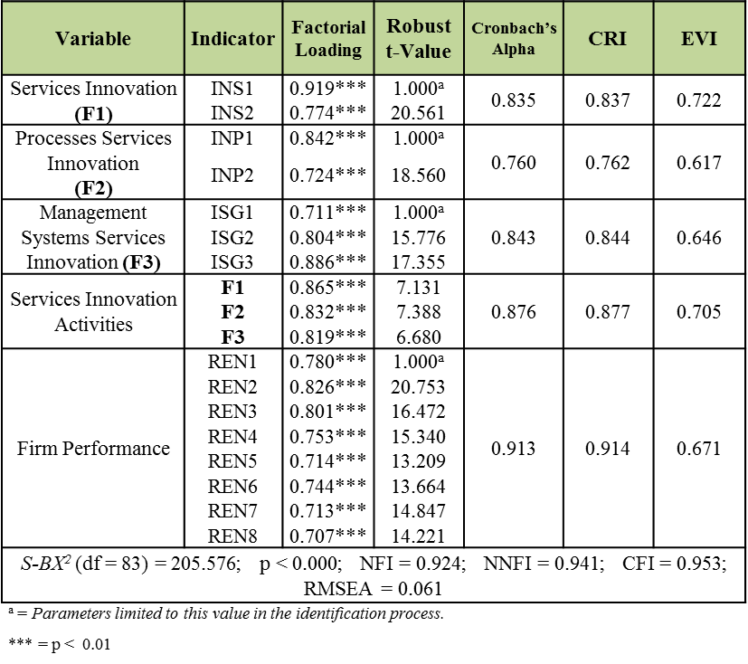

Regarding evidence of the discriminant validity, the measurement was provided by two tests that can be seen in Table 2. Firstly, with an interval of 95% of reliability, none of the individual latent elements of the matrix of correlation had a value of 1.0 [34]. Secondly, the EVI between each pair of constructs was higher than their corresponding variance [33]. Based on these criteria, it was concluded that the different measurements used in this research provided enough evidence of reliability and discriminant validity.

Table 2. Discriminant validity of the measurement of the theoretical model
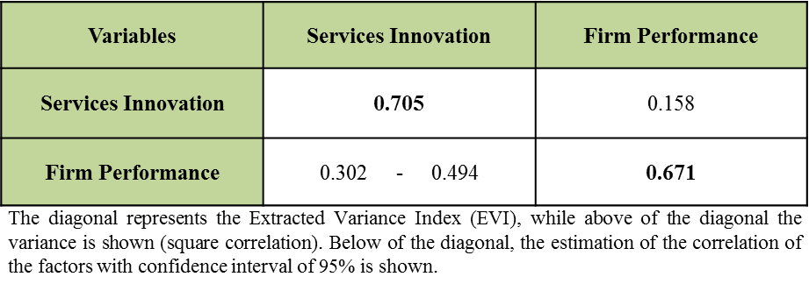

4 Results

A structural equation model (SEM) of second order was used in order to answer the hypothesis stated in this research by using the software EQS 6.2 [35]. Similarly, the nomological validity of the theoretical model was analyzed through the Chi-square test. It was mostly based on the comparison of the results obtained from the theoretical model and the measurement model whose results were statistically not significant between the Chi-square of both models. This provided an explanation of the relationships observed between the constructs of the latent variables of the two models [34]. The results obtained by using the SEM of second order are presented in Table 3.

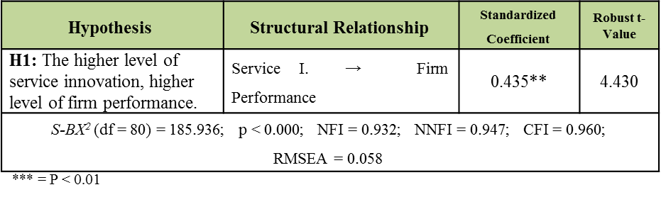
Table 3. SEM results of the theoretical model

Regarding the research hypothesis stated in this investigation H₁, shown in Table 3, it can be seen that the results obtained (β = 0.435 p < 0.01) indicated service innovation has significant positive results on the performance of service SMEs. In other words, service innovation activities (innovation in services, processes and management systems of services sector) that are adopted and implemented in service SMEs are good indicators to achieve a better level of firm performance. This would support service SMEs in achieving the necessary economic and financial resources to keep on with innovation activities.

5 Discussion and Conclusions

Considering the results obtained in this empirical research, it is possible to conclude on two main aspects. Firstly, it is possible to measure services innovation activities through three activities: services innovation, processes of services innovation and management systems of services innovation. Therefore, it is important to consider that if executives of service SMEs want to adopt and implement innovation as a business strategy, and as part of their everyday activities, then they will have to develop activities related not only to service innovation but they will also have to pay special attention to innovation in processes that are needed for the production of services, as well as to implement systems that improve their management.
Secondly, since service innovation is regarded as a strategy that creates several benefits for enterprises, especially SMEs, then it is possible to conclude that enterprises that adopt and implement innovation activities as part of their routine will have more possibilities of significantly improving their level of firm performance. This will provide them with the basic economic and financial resources needed to keep on developing service innovation, and even SMEs will have the necessary conditions to implement radical innovation in their services by creating new services that do not currently exist in the market. Thus, they will be able to dethrone their main competitors as well as to significantly increase their firm performance.
Similarly, these results have several implications for both managers and service enterprises themselves. One of these implications is that, in general, the innovation activities carried out by service SMEs, not only in Mexico but in other countries, are focused only on the modifications or improvements of existing services in the organization (incremental innovation); that is why it is not possible to establish that service SMEs are innovative. Conversely, it cannot be said that service SMEs that develop new services (radical innovation) are the only innovative enterprises. Innovation does not refer exclusively to create services but also to change or improve the existing ones. Therefore, any SME that produces a modification, an improvement or creates a new service can be considered as an innovative enterprise.
Likewise, it is also possible to state that, considering the results obtained in this research, service SMEs that make modifications or improvements to their services, processes and management services, have higher possibilities of adopting and implementing the necessary activities to achieve a higher level of innovation and, consequently, significantly increase their level of firm performance. However, it is important to consider that in Mexico, just like other countries in Latin America, around 70% of service SMEs have an organizational structure based on their families, they include their own members in executive positions and they are managed by the families. As a result, decisions taken are controlled by the family that owns the enterprise and workers and employees are considered as part of the family.
In this regard, managers of service SMEs have to change the organizational culture of their companies in order to adapt it to the innovation activities as it is necessary for their employees and workers to suggest solution alternatives, not only to address the main problems faced by the organization but also to improve services. Therefore, the organization needs to create an environment that promotes team working, the participation of all employees in the design of innovation activities, and the freedom to express their ideas to produce changes or improvements in the creation of services, processes and management services. As a result, enterprises will be in a better position to increase incremental service innovation and the level of the firm’s performance without further complications.
Additionally, managers of service SMEs will need to find a way to increase the innovation activities of their enterprises because this will determine their success. In a similar trend, managers will also have to find methods to have a better control on innovation activities. This will need the use of different training programs to improve innovation activities from government offices, business boards and associations. This will determine the level of a firm’s performance as well as its growth, development and survival.
Finally, the results of this investigation provide enough theoretical and empirical evidence that proves that service innovation, processes and management services have different benefits for enterprises of the services sector. Therefore, managers will have to create in the organizations an environment with a positive and pro-positive attitude in the innovation of services and avoid as much as possible a “resistance to change” attitude from workers and employees and provide the necessary modifications demanded by the market, clients and final consumers. This will align the organizational culture of innovation with the general strategies of service SMEs.
By contrast, this empirical research has several limitations that are important to consider. The first one is related to the sample as the enterprises that were selected had between 5 and 250 workers. Further investigations will need to take into account enterprises with less than five workers as they represent more than half of SMEs in Mexico. A second limitation is that the questionnaire was distributed, exclusively, to service SMEs from the Aguascalientes State region, but a high concentration of this type of enterprises in located in the country’s capital city. Further investigations can replicate this research in other states, or even countries, to expand and compare the results obtained from this study.
A third limitation is linked to the scales used for the measurement of service innovation and firm performance. In this case, only seven items were used to measure the information of services and eight items to measure firm performance. Future investigations can develop and use other scales to verify the results obtained. A fourth limitation is that only qualitative variables were considered for the measurement of barriers for innovation and innovation itself. Further researches will need to consider the use of quantitative variables such as investment in research & development in order to verify if there are significant differences in the results obtained.
Finally, a fifth limitation is that the questionnaire was distributed only to managers of service SMEs. This created the assumption that they had a lot of knowledge about innovation activities and firm performance, so further investigations will need to apply the same questionnaire to employees, clients and suppliers of enterprises to verify the results obtained.

References

- Löfsten, H.: Product innovation processes and the trade-off between product innovation performance and business performance. European Journal of Innovation Management. 17, 1, 61-84 (2014).
- McDermott, C.M., Prajogo, D.I.: Service innovation and performance in SMEs. International Journal of Operations & Production Management. 32, 2, 216-237 (2012).
- den Hertog, P., van der Aa, W., de Jong, M.W.: Capabilities for managing service innovation: towards a conceptual framework, Journal of Service Management. 21, 4, 490-514 (2010).
- de Brentani, U.: Innovative versus incremental new business services: Different keys for achieving success. Journal of Product Innovation Management. 18, 3, 169-187 (2001).
- Song, L.Z., Song, M., Di Benedetto, C.A.: A staged service innovation model. Decision Science. 40, 3, 571-599 (2009).
- Stevens, E., Dimitriadis, S.: Managing the new service development process: Towards a systematic model. European Journal of Marketing. 39, 1/2, 175-198 (2005).
- von Koskull, C., Strandvik, T.: Discovering the unfolding of service innovations. Journal of Business & Industrial Marketing. 29, 2, 143-150 (2014).
- Woodside, A.G.: Bridging the chasm between survey and case study research: Research methods for achieving generalization, accuracy, and complexity. Industrial Marketing Management, 39, 1, 64-75 (2010).
- Lyons, R.K., Chatman, J.A., Joyce, C.K.: Innovation in services: Corporate culture and investment banking. California Management Review. 50, 1, 174-191 (2007).
- Perks, H., Gruber, T., Edvardsson, B.: Co-creation in radical service innovation: A systematic analysis of microlevel processes. Journal of Product Innovation Management, 29, 6, 935-951 (2012).
- Tuominen, T., Toivonen, M.: Studying innovation and change activities in KIBS through the lens of innovative behavior. International Journal of Innovation Management. 15, 2, 393-422 (2011).
- Sampson, S.E., Froehle, C.M.: Foundations and implications of a proposed unified service theory. Production & Operation Management Journal. 15, 2, 329-343 (2006).
- Agarwal, R., Selen, W.: Multi-dimensional nature of service innovation: Operationalization of the elevated service offerings construct in collaborative service organizations. International Journal of Operations & Production Management. 31, 11, 1164-1192.
- Goldstein, S.M., Johnston, R., Duffy, J., Rao, J.: The service concept: The missing link in service design research. Journal of Operations Management. 20, 2, 121-134 (2002).
- Menor, L.J., Tatikonda, M.V., Sampson, S.E. New service development: Areas for exploitation and exploration. Journal of Operations Management. 20, 2, 135-157 (2002).
- Jaw, C., Lo, J., Lin, Y. The determinants of new service development: Service characteristics, market orientation, and actualizing innovation effort. Technovation, 30, 4, 265-277 (2010).
- Leiponen, A. Organization of knowledge and innovation: The case of Finnish business services. Industry and Innovation. 12, 2, 185-203 (2005).
- Gupta, A.K., Govindarajan, V. Knowledge flows within multinational corporations. Strategic Management Journal. 21, 4, 473-496 (2000).
- Goes, J.B., Park, S.H. Interorganizational links and innovation: The case of hospital services. Academy of Management Journal. 40, 3, 673-696 (1997).
- Lee, R.P., Ginn, G.O., Naylor, G. The impact of network and environmental factors on service innovativeness. Journal of Service Marketing. 23, 6, 397-406 (2009).
- Voss, C., Johnston, R., Silvestro, R., Fitzgerald, L., Brignall, T. Measurement of innovation and design performance in services. Design Management Journal. 3, 1, 40-46 (1992).
- Prajogo, D.I. The relationship between innovation and business performance – a comparative study between manufacturing and service firms in Australia. Knowledge and Process Management Journal. 13, 3, 218-225 (2006).
- Johnson, S.P., Menor, L.J., Roth, A.V., Chase, R.B.: A critical evaluation of the new service development process: Integrating service innovation and service design. In Fitzsimmons, J.A. and Fitzsimmons, M.J. (Eds.), New service Development-creating Memorable Experience. Thousand Oaks, CA: Sage (2000).
- Oke, A.: Innovation types and innovation management practices in service companies. International Journal of Operation & Production Management. 27, 6, 564-587 (2007).
- Lubatkin, M.H., Simsek, Z., Yan, L., & Veiga, J.F.: Role of top management team behavioral integration ambidexterity and performance in small-to medium-sized firms: The pivotal. Journal of Management. 32, 5, 646-672 (2006).
- Oke, A., Burke, G., Myers, A.: Innovation types and performance in growing UK SMEs. International Journal of Operations & Production Management. 27, 7, 735-753 (2007).
- Frishammar, J., Hörte, S.: Managing external information in manufacturing firms: The impact of innovation performance. Journal of Product Innovation Management. 22, 3, 251-266 (2005).
- Madrid-Guijarro, A., Garcia, D., Van Auken, H.: Barriers to innovation among Spanish manufacturing SMEs. Journal of Small Business Management. 47, 4, 465-488 (2009).
- AECA: Estrategia e Innovación de la Pyme Industrial en España. Madrid: Asociación Española de Contabilidad y Administración de Empresas (2005).
- Bagozzi, R., & Yi, Y.: On the evaluation of structural equation models. Journal of the Academy of Marketing Science. 16, 1, 74-94 (1988).
- Hair, J.F., Anderson, R.E., Tatham, R.L., & Black, W.C.: Multivariate Data Analysis with Readings. New York, NY: Prentice-Hall (1995).
- Chou, C.P., Bentler, P.M., Satorra, A.: Scaled test statistics and robust standard errors for non-normal data in covariance structure analysis. British Journal of Mathematical and Statistical Psychology, 44, 347-357 (1991).
- Fornell, C., Larcker, D. (1981). Evaluating structural equation models with unobservable variables and measurement error. Journal of Marketing Research. 18, 39-50 (1981).
- Anderson, J., Gerbing, D.: Structural equation modeling in practice: a review and recommended two-step approach. Psychological Bulletin, 13, 411-423 (1988).
- Byrne, B.: Structural Equation Modeling with EQS, Basic Concepts, Applications, and Programming. 2th Edition. London; LEA Publishers (2006).

