Institution: | University of the West of England, UWE Bristol
Department: | Department of Engineering Design and Mathematics
Name: | Karen Henderson, Alison Hooper, Tilly Line, Wendy Fowles-Sweet
Title / Scheme: | Employability sessions for Mathematics students
Skills Addressed: | Graduate development, careers support.

Context: We present details of the graduate development and careers support sessions provided for students on our Mathematics based programmes. The schedule described below was introduced four years ago and was set up in order to better prepare our students for placement opportunities as well as for future careers. Prior to the scheme, feedback from potential employers indicated that our students lacked confidence and were not selling themselves. In particular, students needed coaching on how to get a job and to prove to potential employers that they had the skills to get a job. The introduction of the careers team-led sessions coincided with a new careers service being offered at UWE Bristol. UWE Bristol's Careers and Enterprise Team won the prestigious National Undergraduate Employability Award 2014 for Best University Careers/Employability Service.
Implementation (including barriers and enablers): The programme has been evolving over several years and is presented to all students in the Department of Engineering Design and Mathematics. It comprises a mixture of whole group sessions, delivered across the department, together with cohort sessions, for just our own mathematics students. The programme is introduced to students in induction week and reinforced by Academic Personal Tutors. The first formal sessions currently take place half-way through the second semester of Level 1 held a week apart and comprise two extra-curricular time-tabled cohort sessions run by the careers team. Details of the content are shown below.
Year 1
Session 1: Know Yourself - What do you want to do? Exploring the world of professional work;
Session 2: Action Planning.
It is important to raise awareness of, and for students to realise the importance of graduate development early in their studies. These sessions used to be held in Level 2 but, after consultation with student representatives, we recognised the benefit of holding them in Level 1. In particular, students were able to use the summer to prepare; they could improve their CV, look for and achieve short internships to gain early work experience and start the second year with a better understanding of the merits of applying for year-long placements.
The Level 2 sessions start as soon as students return to University with a departmental Introduction to Professional Development followed by mathematics cohort sessions as shown below.
Year 2
Session 1: Know Yourself - Establishing your ‘professional’ starting point;
Session 2: Know Your Options - What is your current professional profile?
These sessions are followed by four whole group weekly Employer Talks sessions. Each week three employers are invited to lead a panel discussion on a particular subject followed by a Question and Answer session. Employers who are of interest to students across the department are selected, that is to appeal to Engineering and Mathematics based students. For example in one week employers from Babcock, The Office for National Statistics and Hydrock were represented. The employers are invited to bring along a placement student and any available live placement opportunities. Further whole group sessions explore academic postgraduate opportunities and professional recognition.
In Level 3 we run a cohort session on “Getting Ready for Graduation” and further sessions are planned which will be especially useful for students who have not previously engaged with the Graduate Development programme as they realise that they need to think about getting a job/other roles.
One of the main challenges is to get students to engage with this extra-curricular Graduate Development programme. Despite this, there is raised awareness of the careers service evidenced by the high take up across the department of careers drop-in sessions by our students. In one of our core second year modules, prospective employers demonstrate within some class-time what they do in a typical working day. Invited employers have recruited from our graduates before and are often UWE alumni. This enables students to find out from past UWE Bristol graduates about opportunities. Class time is also offered to current placement students - this connection works very well in engaging students by removing perceived barriers.
Across the department 20 - 25% of students go out on placement annually. We aim to increase this as opportunities are there, and because of the fact that students who go on placement tend to perform very well. For those that do not go on placement, there are many other employability activities in which they can participate to help them improve their graduate profile such as volunteering opportunities and being a student ambassador. Employers value this and students can evidence their engagement through their HEAR report and the UWE Futures Award.
Evidence and recommendations: Student feedback following each teaching session/employer panel indicates that there is an increase in knowledge and confidence across the attendees – with regard to factors such as ‘the concept of professional development’, ‘how to plan and manage professional development’, ‘how to evidence professional skills’, ‘how to research work opportunities’, and ‘how to write an effective action plan’. Destination of Leavers in Higher Education (DLHE) data for our Mathematics graduates, shown below, points to evidence that our practice is working, with improvements over the last four years.
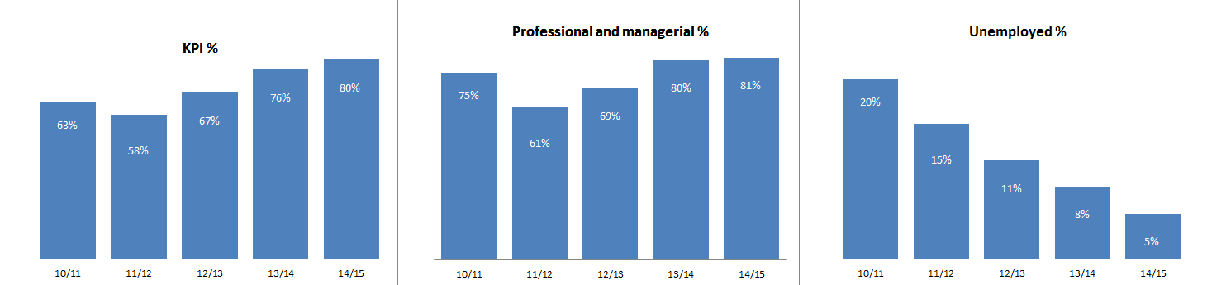
We recognise that students mature at different times, so regular exposure to information about careers is vital from level 1 onwards. Also, we have a very diverse student intake, with varying levels of social mobility and capital – these also impact on engagement and their choice of timing to engage. Students may freely access the careers services throughout their time at UWE Bristol and for three years after graduation.
References / more information:
UWE Bristol Careers and Employability: http://www.uwe.ac.uk/careers

