**Capel Soar-y-mynydd,**

**Ceredigion**

**Richard Coates**

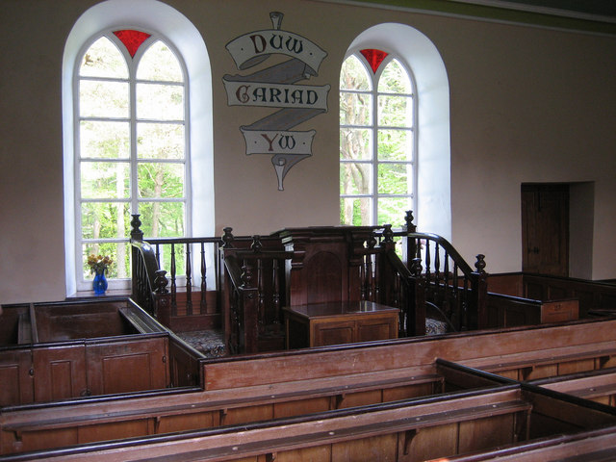

**2017**

**Capel Soar-y-mynydd, Ceredigion**

The chapel known as Soar-y-mynydd or Soar y Mynydd lies near the eastern extremity of the large parish of Llanddewi Brefi, in the valley of the river Camddwr deep in the “Green Desert of Wales”, the Cambrian Mountains of Ceredigion (National Grid Reference SN 7847 5328). It is some eight miles south-east of Tregaron, or more by road. Its often-repeated claim to fame is that it is the remotest chapel in all Wales (“capel mwyaf pellennig/anghysbell Cymru gyfan”). Exactly how that is measured I am not sure, but it is certainly remote by anyone in Britain’s standards. It is approached on rough and narrow roads from the directions of Tregaron, Llanwrtyd Wells, and Llandovery. It is just east of the now vanished squatter settlement *(tŷ unnos)* called Brithdir (whose site is still named on the Ordnance Survey 6" map in 1980-1), and it has become progressively more remote as the local sheep-farms have been abandoned, most of them as a result of the bad winter of 1946-7.

Its name means ‘Zoar of the mountain’ or ‘of the upland moor’. *Zoar* or its Welsh equivalent *Soar* is a not uncommon chapel name in Wales. It derives from the mention in Genesis 19:20-30 of a place with this name which served as a temporary sanctuary for Lot and his daughters and which was spared by God when Sodom and Gomorrah were destroyed. (“Behold now, this city is near to flee unto, and it is a little one: Oh, let me escape thither, (is it not a little one?) and my soul shall live. / And he said unto him, See, I have accepted thee concerning this thing also, that I will not overthrow this city, for the which thou hast spoken. / Haste thee, escape thither; for I cannot do anything till thou be come thither. Therefore the name of the city was called Zoar.” [King James Version, Genesis 19:20-22]; “And Lot went up out of Zoar, and dwelt in the mountain, and his two daughters with him; for he feared to dwell in Zoar: and he dwelt in a cave, he and his two daughters.” [KJV, Genesis 19:30].) The name is supposed to be from *tsaʕar*, Hebrew for ‘little’, but its significance for this chapel must be the sparing of the city from general destruction, a metaphor for the promise of the preservation of the Elect by Divine Grace (Irresistible Grace), the key doctrine of the Calvinistic Methodists.

***The Calvinistic Methodists***

Soar-y-mynydd is a Calvinistic Methodist chapel originating within Llanddewi Brefi parish. The Calvinistic Methodists are a Welsh Protestant revivalist movement forming the Presbyterian Church of Wales. They trace their origins back to the evangelism and preaching of George Whitefield and especially Howell Harris in the late 1730s and 40s. As with many such movements, the history of their doctrine and organization is complicated, but they in effect formed a separate body from the Church of England and from other Methodists after 1821, when their Rules of Discipline were finalized and published, followed in 1823 by their Confession of Faith based on the predestinationist Five Points of Calvinism. The Rules and Confession were published in Welsh, and the language of the Calvinistic Methodists’ services and organization has generally been Welsh wherever required. This is symbolized by the inscription at Soar-y-mynydd referred to below and seen in the photo on the cover, and services at Soar have always been in Welsh. The Calvinistic Methodists were the numerically dominant Dissenting movement in nineteenth-century Cardiganshire, and they had five chapels in Llanddewi Brefi alone, according to Gareth Hicks’s database of chapels on the Genuki web-site ([www.genuki.org.uk/big/wal/CGN/CGNchapels.html](http://www.genuki.org.uk/big/wal/CGN/CGNchapels.html)).

The Five Points of Calvinism can be expressed as follows:

* *Total depravity*: The doctrine of total depravity asserts that because of the Fall of Adam and Eve, every human being is a slave to sin. They are therefore not naturally inclined to love God completely and unconditionally, but prone to serve their own interests and to reject God’s law. It follows that all humans are by nature morally unable to *choose* to follow God and be saved, so some other process leading to salvation is necessary.
* *Unconditional election*: The doctrine of unconditional (“predestined”) election asserts that God has chosen from eternity those whom He will save (the Elect), for unknowable reasons: not because of any virtue, merit or faith which those people might have or acquire, but unconditionally on the basis of His mercy alone.
* *Limited atonement*: The doctrine of limited atonement asserts that Jesus’s death atoned only for the sins of the Elect, so this atonement is “limited” in that it is designed only for some. Calvinists therefore hold that Jesus’s atonement is *sufficient* for all and *efficient* for the Elect (i.e. it *must* work for them).
* *Irresistible grace*: The doctrine of irresistible grace asserts that God’s saving grace applies to those, and only those, whom He has determined to save, and that this grace brings them to a saving faith whether they accept or resist its call. This means that when God chooses to save a person, they will indeed be saved, but that individuals in their earthly lifetime can do no more than *hope* to have been saved.
* *Perseverance of the saints*: The doctrine of perseverance or preservation of the saints asserts that because the Divine Will cannot be thwarted, God’s Elect (the Saints) necessarily continue in faith for all eternity. Those who seem to fall by the wayside either never really had Sainthood in the first place or must, and therefore will, return to the fold.

The Calvinistic Methodists’ 1823 Confession of Faith can be studied in English at [www.creeds.net/reformed/cmwales/main.htm](http://www.creeds.net/reformed/cmwales/main.htm). Their periodical *Y Drysorfa* (‘The Treasury’, first published regularly in 1831, folded 1968) can be studied at the National Library of Wales in Aberystwyth.

***Origin of the congregation and building***

The congregation or “cause” of Soar-y-mynydd is said to have originated in 1747 (see Text 1), early in the time of the preaching careers of George Whitefield and Howell Harris. Some records of its baptisms are preserved in The National Archives at Kew (ref.: GB/NNAF/C49002; former ISAAR ref.: GB/NNAF/O58710); they run from 1811-35, so some of them date from before the construction of the present building. The chapel was built in 1822, immediately following the independence of the Calvinistic Methodists. (Some sources say 1828, including Cadw (record no. 18943), but the 175th anniversary was locally celebrated in 1997-8.) The prime mover was Rev. Ebenezer Richards of Tregaron and his trustees, and the land was provided by John Jones, the then farmer at Nant-llwyd lower down the valley of the river Camddwr. The scattered congregation arrived for the ten o’clock Sunday service on horseback. Before the chapel was built, services took place at local farms on either side of the Cardiganshire-Brecknockshire boundary, including Nant-llwyd, Dolgoch (now a youth hostel), the now abandoned or ruined Bronhelem/Fronhelem (Bron-yr-Helm), Nantneuadd, Nantstalwyn, Nant-yr-hwch and Tywi (Towy) Fechan, and lastly Y Fanog (Fannog) which was drowned in the waters of the Llyn Brianne reservoir a little to the south-east in about 1970. The name of Rhos-Bettws (‘Chapel Moor’) in the records of Bronhelem must refer to Soar, since there was no other chapel within many miles. Both before and after Soar was built, hospitality was offered to the allocated itinerant preacher in turn at various of these farms. Sheep-farming was finally broken by the catastrophic winter of 1946-7, and local farmers sold out to the Forestry Commission, putting the little congregation at extreme risk.

***Architecture***

The description below incorporates a small amount of unaltered wording quoted from: RCAHMW (2007; NPRN 7229), sources: Cadw listed buildings database (1997); T. J. Hughes, *Wales’s best one hundred churches* (2006). The full listed building text is © Crown Copyright.

The Cadw grade II*-listed building is made of local rubble stone collected from riverbeds and ruined farmsteads in the area. It is whitewashed on the outside. On the gable of the rendered exterior north wall is a painted sign reading “Capel Soar y Mynydd”. Earlier photos show that this wall was slate-hung. House martins nested under the eaves in recent years.

It consists of a rectangular side-wall façade chapel (as Anthony Jones has called them) at the northern end, attached to a two-storey house with two chimney-stacks on the ridge, under a single slate roof. The chapel is entered on the longer east side through two pairs of double two-panel doors, embracing the pulpit. It has no gallery. As in all early Welsh chapels, the pulpit is placed centrally on the long wall, between two windows, and the four blocks of raked pews are also along the longer axis. The extremities of these rows are angled slightly inwards to face the pulpit. There are two smaller blocks between the entrances and the pulpit. Above the pulpit, and between the two windows, is a painted scroll with the text “Duw cariad yw”, ‘God is love’ (First Epistle of John 4:8 and 4:16), first done in 1911. The pulpit is fronted by a plainish cupboard, and the *sêt fawr* for the diaconate is the first of the pews facing it. Apart from the inscription, the chapel’s interior is plain except for a painted coved cornice and plaster rose on the ceiling. The walls are colourwashed in a neutral “stone” effect; the ceiling itself is pale turquoise. A black and white photograph taken by Geoff Charles in 1955 (page 18) reveals that the east wall was once more highly decorated, with a frieze of stylized foliage at the bottom.

The pulpit (east) wall of the chapel has two tall semicircular-headed windows, splayed on the interior, with stone sills and with wooden frames topped by simple Y-tracery with red glass between the arms of the Y. The rear (west) wall has two tall windows, also splayed on the interior, with cambered heads and coloured glass in a few small panes.

The pulpit probably dates from the late nineteenth century. It has two short flights of steps with turned balusters, newels with finials, an arched panel to the pulpit front and consoles under the book-rest. The present pulpit seat, with “SOAR” carved into it and bearing a brass plaque to the memory of Secretary John Hughes Williams of Bryn-ambor, is modern.

The southern end of the building contains the now derelict chapel-house or minister’s dwelling, part of which served as the local schoolroom until the 1940s, and which was used for services in winter because it had fireplaces. On its east wall are two doors, the more southerly one for a stable, store or similar, and a sash window on the ground floor and two sash windows on the first. On the west there is one sash window on the ground floor and two on the first, and one stairwell window. The writer has not viewed this part of the building internally. It is locked and derelict and contains a collapsed staircase visible through the east window. The south end wall has one window on each floor, said to have been boarded up in 1996, and the north end is a party wall with the chapel.

The chapel and house have never had mains electricity, and services on dark evenings were held as required at local farms instead [Text 3]. The chapel is unheated.

There is a rubble stone outbuilding comprising two interior sections: a former stable, with a single roof slated on the north pitch and with corrugated material on the south. It is open on the south, and on the north has four brick cambered-headed openings: two doorways and two windows. This building is Cadw grade II-listed, for its group value, along with the enclosure wall. There is also a free-standing toilet building to the south of the chapel.

On the north and west sides (the chapel end), the enclosure is walled in stone with a metal gate, and is accessed across a stream, Nant y Brithdir, using a wooden footbridge. Earlier views of uncertain date show a stone pound between the chapel and this wall. The gate has a footstone with the name *SOAR* picked out in small stones bedded in mortar within it. On the east and south sides (the graveyard end), the enclosure is skirted by mature trees, mainly beeches and conifers.

On the east side of the building is a graveyard with an unknown number of burials, the oldest apparent one being from 1856. There are few complete and erect stones. The most conspicuous is the most recent (2001), that of Professor John Griffiths [obituary Text 5], a prominent London cancer surgeon of Welsh origin, whose inscription is, like that of others still legible, in Welsh (“Er cof annwyl am …”, ‘In loving memory of …’).

***Timeline of the congregation of Soar-y-mynydd***

↓ 1740 Howell Harris preaches at Rhiwhalog, close by to the south-east

↓ 1747 Congregation (“cause”) of Soar founded

↓ 1779 Revival precipitated by the preaching of Jack Edward Watkin (Text 1)

↓ 1811 Earliest preserved baptismal records

↓ 1822 Building of present chapel and house by Rev. Ebenezer Richards of Tregaron and his trustees

↓ 1858 “Confrontation with God” of Dafydd Morgan, revivalist preacher (Text 2)

↓ late 19th century alterations (including provision of pulpit, and the present windows?)

↓ till 1940 in use also as a day-school

↓ 1947 Some local sheep-farmers sell out to Forestry Commission after a severe winter: Bronhelem is farmed till 1956

↓ 1956 Winter closure of chapel some time in or before 1956

↓ 1957 Summer re-opening reported in the press *(Cambrian News)*

↓ early 1970s Decision by Presbyterian Committee of South Cardiganshire to dissolve Soar-y-mynydd as a place of worship; resisted by local ministers; chapel remains open

↓ 1973 Official re-opening

↓ 1983 Murder of John Hughes Williams of Bryn-ambor, some five miles south-west of Soar, secretary of the chapel

↓ 1986 Dedication of chair to memory of Mr Williams

↓ 1994 W. J. Gruffydd ‘Elerydd’ (died 2011) publishes first edition of *Tua Soar*

↓ 1998 Celebration of 175 years of the chapel building

↓ 2001 Burial of the surgeon Prof. John D. Griffiths (Text 5)

2007 Hugh Jones publishes *Bugail olaf y cwm*

***Size of the congregation***

This amounted to 40 in 1819; about 100 in the 1880s; 58 in 1902; 44 in 1944; 10 in the 1960s (the size fell after local farmland was sold off to the Forestry Commission in 1947 and traditional farming was abandoned); 2 in 1968 and 1970; 9 in 1971; and 18 in 2003. Since the chapel nearly suffered closure in the 1950s and around 1970, publicity leading to the modest present celebrity of Soar-y-mynydd has meant that some well-attended summer services with visiting preachers are now held, on the last Sunday in August. The chapel also now attracts a fair amount of artistic and media attention, as the reading-list on page 8 shows.

[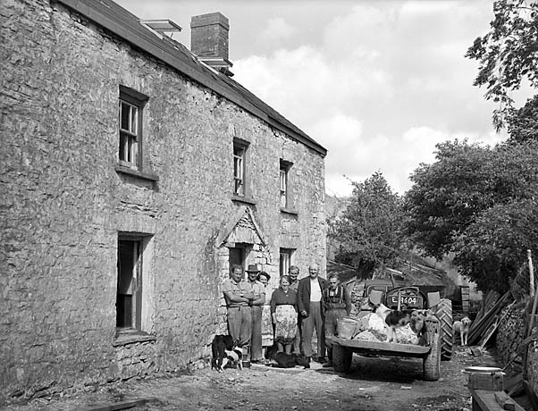](http://www.gtj.org.uk/cy/small/item/17655/)

**Three farms, three states**

⇐ Nant-llwyd, 1955 (Geoff Charles Collection, ©, used by courtesy of the National Library of Wales)

Nant-neuadd (Ceredigion County Council library, accession no. 782, date and copyright status unknown) ⇒

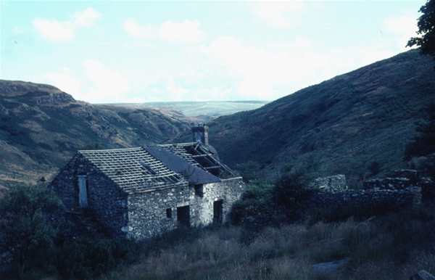

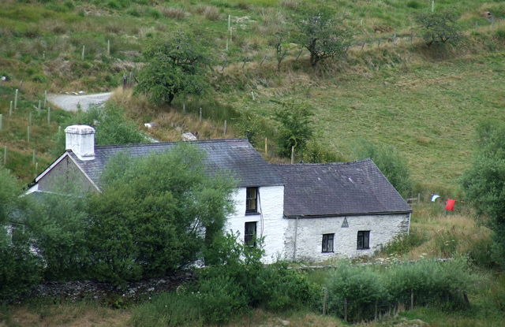

⇐ Dolgoch, abandoned 1947, former youth hostel, now run as a bunkhouse (basic backpackers’ hostel) by the Elenydd Wilderness Trust (© Roger Kidd, licensed for reuse under Creative Commons Licence Attribution-ShareAlike 2.0 Generic (CC BY-SA 2.0))

**Reading more about Soar-y-mynydd**

**and its surrounding area**

*A number of details above have been taken from the works mentioned here.*

*anonymous (1983-4) Extensive reporting of murder of local man John Hughes Williams of Bryn-ambor by Anthony Gambrell, in January 1983. *Western Mail* and other local newspapers. See also [www.ceredigion.gov.uk/index.cfm?articleid=9901](http://www.ceredigion.gov.uk/index.cfm?articleid=9901) (scroll through).

*anonymous (1998) *Gwasanaeth dathlu 175 mlynedd yng Nghapel Soar y Mynydd: Dydd Sul 28ain Mehefin 1998, am 2 o’r gloch.* Capel Soar y Mynydd.

*anonymous (2007) Pererindod Gofalaeth Hafren. Tachwedd 2007. Aelodau a ffrindiau Capel Bethel Y Drenewydd ar bererindod i gapel Soar y Mynydd. *Seren Hafren*, at BBC Lleol, Canolbarth, Papurau Bro. Online at [www.bbc.co.uk/cymru/canolbarth/papurau_bro/seren_hafren/newyddion/tachwedd07.shtml](http://www.bbc.co.uk/cymru/canolbarth/papurau_bro/seren_hafren/newyddion/tachwedd07.shtml), accessed 18 June 2012.

*anonymous (2010) Capel Soar y Mynydd. *Welsh Country*, formerly online at [www.welshcountry.co.uk/in-your-area/960-ceredigion/5803-soar-y-mynydd](http://www.welshcountry.co.uk/in-your-area/960-ceredigion/5803-soar-y-mynydd), accessed October 2010.

*Cadw (1997) Listed buildings detail report, records 18943 (building) and 18950 (outbuilding and wall).

*Davies, Beryl (1997) “Soar y Mynydd.” [Poem in English.] *Cardiganshire Family History Society Journal* 4.2, 37-38.

*Davies, Beryl (2010) *Emynau’r mynydd, a dylanwad bore oes.* Tregaron: privately published. [Poem about chapel on p. 52, English version (as above) p. 53. There is much else connected with Soar-y-mynydd in the book.]

*Davies, D. (1912) Soar y Mynydd, Cymru 42, pp. 253-256. Ceredigion County Library shelfmark P39(2).

*Ebenezer, Lyn (2006) Lle i enaid gael llonydd. *Cambrian News*, 14 September 2006, p. 30.

*Ebenezer, Lyn (2007) Last shepherd of the valley [about Hugh Jones]. Online at [www.bbc.co.uk/wales/mid/sites/tregaron/pages/hughjones.shtml](http://www.bbc.co.uk/wales/mid/sites/tregaron/pages/hughjones.shtml), accessed 8 July 2014.]

*Edwardus (1860) Soar Ceredigion (adfywiad crefyddol). Y Drysorfa, pp. 131-132.

*Ellis, Thomas Iorwerth (1953, second edition 1977) *Crwydro Ceredigion.* Llandebie [= Llandybïe]: Llyfrau’r Dryw. [Travel essays.]

*Evans, Dyfed (1955) Soar y Mynydd. *Y Cymro*, 8 September 1955. Ceredigion County Library shelfmark P39(2).

*Evans, John (1904) *Hanes Methodistiaeth rhan ddeheuol Sir Aberteifi, 1735-1900.* Dolgellau: E. W. Evans.

*Evans, Joseph (1907) *Biographical dictionary of ministers and preachers of the Welsh Calvinistic Methodist body, or Presbyterians of Wales. From the start of the denomination to the close of the year 1830.* Carnarvon: D. O’Brien Owen, C. M. Book Agency. [Includes biographies of Howell Harris, Ebenezer Richard, Daniel Rowland and John (Jack) Edward Watkin.]

*Faichney, Keith (2010) “The Welsh Desert”. *Cambria Magazine* 11.5 (Spring), 20-22. Formerly online at [www.cambriamagazine.com/index.php/Cambria-Spring-2010.html](http://www.cambriamagazine.com/index.php/Cambria-Spring-2010.html), accessed 2011.

*[Griffiths, John D., subject] anon. (2001) Obituary of John D. Griffiths. *Daily Telegraph*, 18 May 2001. Online at [www.telegraph.co.uk/news/obituaries/1330621/John-Griffiths.html](http://www.telegraph.co.uk/news/obituaries/1330621/John-Griffiths.html), accessed October 2010. Also one by Sian Griffiths. *British Medical Journal* 322, 16 June 2001. Online at [www.bmj.com/cgi/reprint/322/7300/1493.pdf](http://www.bmj.com/cgi/reprint/322/7300/1493.pdf), accessed October 2010.

*Gruffydd, William John, pseud. ‘Elerydd’ (1986) *Meddylu: atgofion archdderwydd.* Llandysul: Gomer.

*Gruffydd, William John, pseud. ‘Elerydd’, ed. (1994) *Tua Soar.* Capel Soar y Mynydd. [3rd edition (or printing) 1997.]

*Hicks, Gareth (2003). See W. J. Lewis (1970).

*Hicks, Gareth (2007) Ceredigion chapels database: Llanddewi Brefi. Online at [www.genuki.org.uk/big/wal/CGN/Llanddewibrefi/Chapels.html](http://www.genuki.org.uk/big/wal/CGN/Llanddewibrefi/Chapels.html).

# *Hughes, John (1854) *Methodistiaeth Cymru: sef hanes blaenorol a gwedd bresenol y Methodistiaid Calfinaidd yn Nghymru, o ddechread y cyfundeb hyd y flwyddyn 1850*, vol. 2*.* Wrexham: R. Hughes, esp. vol. 2, p. 43.

*Hughes, T. J. (2006) *Wales’s best one hundred churches.* Bridgend: Seren. [Mention of Soar-y-mynydd pp. 193-194, image p. 142.]

*Jones, Anthony (1996) *Welsh chapels*, expanded edition. Stroud: Sutton. [Mention of Soar-y-mynydd pp. 38-39, image p. 40.]

*Jones, Evan (1979) *Cymdogaeth Soar-y-mynydd*. Swansea/Abertawe: Christopher Davies (Cyfres cynefin).

*Jones, Huw, ed. Lyn Ebenezer (2007) *Bugail olaf y Cwm.* Llanrwst: Gwasg Carreg Gwalch. [By a shepherd of Dolgoch in the Tywi valley. See also Lyn Ebenezer (2007).

*Jones, J. Melville (1954) Rhamant Soar y Mynydd. *Blodau’r Ffair*, 4. Ceredigion County Library shelfmark P39(2).

*Jones, Mary (1942) Tro i Soar y Mynydd. Cymru’r Plant, pp. 161-162.

*Lewis, W. J. (1970) *Hanes darluniadol o Geredigion/An illustrated history of Cardiganshire.* Aberystwyth: Cymdeithas Lyfrau Ceredigion. [Mentions some of the *tai unnos* (squatter smallholdings) in the Camddwr valley, map on p. 68: Ffrwd-ar-gamddwr, Rhyd-y-meirch, Nant y gronw, Brithdir Bach, Brithdir, Rhydtalog. Excerpted by *Gareth Hicks, [www.genuki.org.uk/big/wal/CGN/IllustratedCardiganshire.html](http://www.genuki.org.uk/big/wal/CGN/IllustratedCardiganshire.html) (2003)]

# *Llwyd, Iwan (1983) “Soar y Mynydd.” [Poem.] In *Sonedau bore Sadwrn*. Tal-y-bont, Aberystwyth: Y Lolfa.

*Owen, D. Huw (1998) Diolch a chofio [Horeb, Y Gors (New Cross) a Soar-y-Mynydd]. *Capel* *(The Chapels Heritage Society Newsletter)* 32 (Autumn), 7-10. [Includes brief report of the chapel’s 175th anniversary celebrations. Online at [www.capeli.org.uk/uploads/newsletter_32.pdf](http://www.capeli.org.uk/uploads/newsletter_32.pdf), accessed 2010, 2011. Illustrations on p. 10.]

# *Perrin, Jim (2008) Country diary: Soar y Mynydd. *The Guardian*, 26 July 2008, main section, 36. Online at [www.guardian.co.uk/environment/2008/jul/26/ruralaffairs](http://www.guardian.co.uk/environment/2008/jul/26/ruralaffairs), accessed 2011, 2012.

### *Pike, David E. (2011) Soar-y-Mynydd: revival at the remotest chapel in Wales. Online at [daibach-welldigger.blogspot.co.uk/2011/07/soar-y-mynydd-revival-at-remotest.html](http://daibach-welldigger.blogspot.co.uk/2011/07/soar-y-mynydd-revival-at-remotest.html), accessed 29 May 2012.

# *Price, Kay Lorraine (2005) More connections with Soar-y-Mynydd. [Features the lives of Margaret Jones and Beryl Davies.] *Cardiganshire Family History Society Journal* 4.2 (June), 36-38.

# *RCAHMW. See Royal Commission on Ancient and Historic Monuments in Wales.

*Rees, Ben (2010) Soar-y-Mynydd. Cymanfa’r Sul 2010. Web-page ofCymdeithas Dydd yr Arglwydd yng Nghymru. Online at [www.lordsdayinwales.co.uk/cymanfarsul.htm](http://www.lordsdayinwales.co.uk/cymanfarsul.htm), accessed 2011, 2012.

*Richards, E. E. (Lynne) (2004) Soar y Mynydd. *Cardiganshire Family History Society Journal* 3.9 (October), 202-205.

*Royal Commission on Ancient and Historic Monuments in Wales (RCAHMW) (2007) Soar-y-Mynydd Calvinistic Methodist Chapel, Llanddewi Brefi (NPRN 7229). [Text derives from Cadw (1997) and Hughes (2006), but differs from both, e.g. about date of foundation. This mentions a handwritten account of the chapel catalogued as C401041; not seen.]

*Thomas, R. S. (1948) “Dau gapel.” *Y Fflam: cylchgrawn Cymraeg* 5, 7-10. Translated as “Two chapels”, by Catherine Thomas, in Sandra Anstey, ed. (1983) *R. S. Thomas: selected prose*. Bridgend: Poetry Wales Press, 41-48. [One of the two chapels is Soar-y-mynydd.]

*Williams, D. Emrys, compiler (1961) Deeds and documents relating mainly to property of the families of Herbert and Hughes of Hendrefelen, parish of Ysbyty Ystwyth, co. Card. [Cardiganshire], 1546-1885. Acquisition announced in *Annual Report of the National Library of Wales 1948-49,* 26. The National Library of Wales reference can be found at [isys.llgc.org.uk/isysquery/irl712/4/doc](http://isys.llgc.org.uk/isysquery/irl712/4/doc), and Emrys Williams’ typescript list of deeds can be found at [tinyurl.com/kghxjqg](http://tinyurl.com/kghxjqg) [bibliographical dates as stated there], accessed 22 July 2010, 9 July 2014. [First item on Williams’ list mentions a quitclaim of …. part of the land of *brithdir y gilydd* at *camddwr*, 1 July 1546 (in Latin).]

*Williams, Terence, pseud. ‘Gwefan’ (date uncertain) Rhys Williams (1849-1930): the life story of an old Elenydd shepherd. Also *[Llofruddiaeth Wmffre Jenkins](http://www.hanesybont.co.uk/wmffrejenkins/wmffrejenkins.htm) [(Nantstalen 1699)](http://www.hanesybont.co.uk/wmffrejenkins/wmffrejenkins.htm). Both on the web-site “Pontrhydfendigaid: The Bridge of the Blessed Ford”, online respectively at [www.hanesybont.co.uk/rw/rhyswilliams1.htm](http://www.hanesybont.co.uk/rw/rhyswilliams1.htm), [www.hanesybont.co.uk/wmffrejenkins/wmffrejenkins.htm](http://www.hanesybont.co.uk/wmffrejenkins/wmffrejenkins.htm), accessed 27 October 2010.

*Williams, William, ed. Gwyn Davies (1998) *Welsh Calvinistic Methodism: a historical sketch of the Presbyterian Church in Wales*, 3rd edn. Bridgend: Bryntirion Press, esp. p. 178.

***Small, mainly anonymous, items from the online Ceredigion county bibliography (useful start-page*** [www.ceredigion.gov.uk/index.cfm?articleid=4001](http://www.ceredigion.gov.uk/index.cfm?articleid=4001)***) which are not included above. [The county library’s shelfmark is given where reported in the catalogue. Many of the items can now be viewed online.]***

***Soar-y-mynydd***

**1957**\*Re-opening of Soar y Mynydd. *Cambrian News*, 26 April 1957. P39(2)

**1987**

Cymdogaeth Soar y Mynydd. *Llais Aeron* 105 (Tachwedd), 9.  
**1989**\*Yr alwad i Soar. *Golwg*, 19 October 1989. P39(2)   
**1998**\*Gwasanaeth dathlu yn Soar y Mynydd. *Cambrian News*, 2 July 1998. P39(2)

**2004**

Llythyr am Gapel Soar y Mynydd yn y 60au a’r 1970au. *Barcud* 289 (Tachwedd), 3.

***John Hughes Williams, secretary of chapel***

**1986**

*Cadair i goffau John Williams. *Cambrian News*, 6 June 1986. P39(2)

*Cadair i gofio gwr addfwyn y bryniau. *Y Cymro*, 11 June 1986. P39(2)  
  
***Y Fanog***

**1984**(Llythyr gan David Jones). *Barcud* 87 (Rhagfyr), 15.

***Nant Llwyd***

**1969**Men is a desert of ruined farms. *Western Mail*, 19 July 1969. RC630.92

**2012**

*Diwedydd y mynydd a’r mawndir. *Cambrian News*, 15 March 2012. PDF accessible.

**Texts relating to Soar-y-mynydd**

***Text 1: Before the building: Jack Edward Watkin and Daniel Rowland***

1779-83 Soar-y-Mynydd, Cardiganshire. ‘The first visitation here, by way of a powerful revival, was in the year 1779. The church had been formed for 32 years, but the church at the time was only small in number, although a fair number used to listen. The revival began in the month of April, 1779. A man by the name of Jack Edward Watkin, of Llanddewibrefi, was preaching there one Sabbath afternoon. The preacher was thought to be a good man, but of middling gifts. The church was already as one that had begun to bestir himself a little from his sleep; but on the Sabbath referred to, the congregation broke out crying and shouting in an uncommon way, religious and irreligious together, and among them two of the sons of the house, and they continued crying out and praising until daybreak on Monday. Daniel Rowland heard about the stir, and was truly glad of it, and announced that he would quickly go there, and it was more wonderful there that Sabbath than the previous one. “It is a heath fire,” said Mr. Rowlands, because it had started on the mountain, “and will also spread abroad,” he said, and it did spread. The revival that started like this in those mountains reached many parts of North and South Wales before the end of three years, and it continued in the place where it started, without completely dying out, for four years. Many came to the church in this revival, some who have been very useful men throughout their life.’

[John Hughes, *Methodistiaeth Cymru*, vol. 2, p. 43; cf. William Williams, *Welsh Calvinistic Methodism*, 3rd edition, p. 178; quoted online at [ukwells.org/locations/displaylocations/494](http://ukwells.org/locations/displaylocations/494)]

***Text 2: Dafydd Morgan*, On the Mountain**

On the last day of 1858, Dafydd Morgan, a Welsh Calvinistic Methodist minister, was travelling home over Llanerchpentir Hill. He had been preaching at the remote chapel of Soar-y-mynydd in the hills above Tregaron in mid Wales, UK.

Glorious Experience.  It seems that he was on the mountain for hours, and he experienced something so glorious that he was not sure whether he was in the body or out of it. He felt such mysterious forces lifting him from the earth that he had to cling to the gorse bushes.

Confrontation.  Undoubtedly it was some kind of confrontation with God. Arriving home so much later than expected, with a strange expression and with his clothes very dishevelled, he was hardly recognisable. Asked for an explanation, he said, “I have been wrestling for a blessing, and I have received it.”

Preaching at Devil’s Bridge the next day, someone present said that his words “were so like fire as to create terrible convictions. It was a fearful place…”

Great Things.  After that meeting, Dafydd Morgan said, “The Lord would give us great things if he could trust us not to be thieves; if he could trust us not to steal the glory for ourselves.”

[Formerly online at [www.cryaloud.org.uk/revivalarchive.htm](http://www.cryaloud.org.uk/revivalarchive.htm), now at [www.tellout.org.uk/revival.htm](http://www.tellout.org.uk/revival.htm) (scroll down)]

***Text 3: Rev. David Idris Owen* (born 1913, Old Colwyn), memories of Soar-y-Mynydd sent to *Gathering the Jewels***

“When I was a Theological student at Aberystwyth (1935-7) one of our regular weekend duties was to conduct services at places of worship in Wales. On three occasions I was selected to visit the remote chapel of Soar-y-Mynydd in the beautiful Cambrian Mountains. In those days the Great Western railway (formerly the Manchester and Milford) ran south from Aberystwyth via Strata Florida and Tregaron to Pencader. I would set off on a Saturday afternoon and disembark at a small halt called Pont Llanio about a mile or so from Llanddewibrefi. There I would be met by a member of the congregation (usually one of the Edwards brothers who owned two sheep farms) and two horses and we would then travel on horseback the seven or eight miles up steep paths, fording streams, to his farm. Hospitality was warm and generous. Meals were a major feature with large slices of ham (carved from shanks suspended by hooks from the kitchen rafters), home-grown vegetables and potatoes, farm butter and freshly baked bread. A rare treat for a poor student! On the Sunday morning I would conduct the service in Soar chapel. There was neither electricity nor any other source of power for lighting so services could only take place in daylight hours. In the afternoon I would conduct a second service in the kitchen of the farm. It was a very cosy affair before a large, open, semicircular peat fire which, as the heat built up, caused the congregation to retreat. The next morning the horseback journey to the railway would be repeated.

On my final visit (in early March) we set out for Soar in good weather but as we entered my hosts’ farm gate the first flakes of snow began to fall. Overnight it snowed heavily and by Sunday morning the snow was lying several feet deep. All thoughts of conducting services were abandoned and I spent a very pleasant day with the farmer and his family. The next morning I was advised that it would be impossible for me to travel on horseback but that it might be possible to travel on foot. I set off at about 11 a.m. to walk the ten miles back to the railway, wearing a heavy coat and shod in light shoes and galoshes. As I descended over the brow of the first hill I discovered that the snow, which was initially several feet deep, had settled into high drifts. I struggled on, staggering and falling. In places the cold, wet snow was up to my chest. I began to fear that I would never survive and tears of despair welled- up. Eventually after many hours and near to total exhaustion I reached the welcome sight of Llanddewibrefi. I called in at the local Co-operative Store, where I knew the manager Eben Ebeneezer (the brother of a fellow student) and was able to bathe my tired, cold feet in hot water and given a change of hose and a very welcome meal. I still had at least a mile to walk to the railway and this last stretch was excruciating. The train departed at 7 p.m. and I arrived back in Aberystwyth an hour later. My colleagues were amazed to see me. ‘Soar is back!’ they shouted. This was poignant because many of the other student preachers did not return for several days!!”

[Online at <http://education.gtj.org.uk/en/item10/30127>]

***Text 4: Annual meeting of the The Fellowship of the Lord’s Day in Wales, 16 June 2002, at Soar-y-mynydd***

Un weddi sydd gennyf gobeithio y bydd y tywydd yn ffafriol ar Sul, 16 Mehefin pan y cawn gyfle i ddod i Gymanfa’r Sul yn Soar-y-Mynydd. Deil y capel tua 120 ‒ ond gobeithiaf y daw llawer mwy na hynny i ddathlu ystyr y Sul yn hanes y Ffydd. Fel y dywed y Prifardd Einion Evans: “Molwn Sant, malwn y Sul”.

Dewi Sant yw Nawddsant y Cymru ac ym mhlwyf Llanddewi Brefi y saif Soar-y-Mynydd. Ond ni allwn mynd iddo drwy Llanddewi, y ddwy ffordd orau ydyw trwy sgwâr Tregaron heibio cofgolofn Henry Richard neu trwy Llanymddyfri, Rhandirmwyn a chael golwg ar y Brianne. Bydd croeso mawr yn ein disgwyl yn Soar-y-Mynydd, capel mwyaf pellennig Cymru gyfan. Da y dywedodd Alwyn Thomas am Soar-y-Mynydd:

*Daw’r nef i’r capel twt*

*Drwy ymbil gweddi daer,*

*A hwyl a mawl fydd traethu sôn*

*Am wyrthiau Mab y Saer.*

Byddwch yn rhan o wyrth Mab y Saer y Sul hwnnw o Ogledd a De, Dwyrain a Gorllewin a dewch.

***Gweddi***

Dduw y cariad nad yw’n oeri, Tad y gras nad yw’n lleihau, bydd gyda ni heddiw wrth i ni ystyried cariad a myfyrio ar ddyfnderoedd yr hyn wnest ti drosom oherwydd dy gariad anhraethol dy hun tuag at y ddynoliaeth. Rydyn ni’n byw mewn cyfnod pan fo geiriau yn colli eu gwerth yn aml. Rydyn ni’n dweud bod pwdin yn fendigedig ac yn ystyried y gair cariad fel rhywbeth pinc neu goch , ar ffurf calon, sy’n ymrithio’n ysbeidiol i’n bywydau ar siâp modrwy neu siocled neu X ar waelod cerdyn. Ond mae dy gariad di yn golygu llawer mwy na’n syniadau bach daearol ni. Gad i ni ystyried yn ddwys felly yr hyn mae’r gair yn ei wir olygu, a boed i ryw adlewyrchiad gwan o’r cariad roddaist ti ar Galfaria ymddangos yn ein bywydau, yn ein henwadau ac yn ein heglwysi llegach. Yn enw’r un a’n carodd ac a roes ei fywyd drosom, Iesu Grist yr anwylyd. Amen.

(“One prayer I have, hoping that the weather will be favourable on Sunday 16th June when we have the opportunity to come to Sunday Service at Soar-y-Mynydd. The chapel holds around 120 – but I hope that many more than that will come to celebrate the meaning of Sunday in the history of the Faith. As the Prifardd (Chief Bard) Einion Evans said: “Praise the Saint, heed the Sunday”.

(“Saint David is the patron saint of Wales and Soar-y-Mynydd sits in the parish of Llanddewi Brefi [David’s Church]. But it’s not possible to go there through Llanddewi; the two best ways are through Tregaron Square, past the memorial to Henry Richard, or through Llandovery [and] Rhandirmwyn and get a sight of the Brianne. We can expect a big welcome at Soar-y-Mynydd, the most remote chapel in the whole of Wales. Alwyn Thomas said well about Soar-y-Mynydd:

*Heaven will come to the small chapel*

*Through imploring importunate prayer*

*And fervour and praise will make mention*

*Of the miracles of the Son of the Carpenter.*

(“You will be part of the miracle of the Son of the Carpenter on that Sunday, coming from North and South, East and West.

***Prayer***

(“God the love that does not grow cold, Father of grace that does not diminish, be with us today as we consider the love and reflect on the profundity of what you did for us because of your incalculable love towards humanity. We live in a period where words often lose their meaning. We say that pudding is ‘blessed’ and we consider the word love as something pink or red, in the form of a heart, that appears in our lives intermittently in the shape of a ring or chocolate or an X at the bottom of a card. But your love means a lot more than our small earthly ideas. Let us therefore consider deeply the word in its true meaning, and let some weak reflection of the love you gave on Calvary appear in our lives, in our denominations, and in our feeble churches. In the name of the one that loved and gave his life for us, the beloved Jesus Christ. Amen.)

[Online at [www.lordsdayinwales.co.uk/cymanfarsul.htm](http://www.lordsdayinwales.co.uk/cymanfarsul.htm), Ben Rees, “Sul hudolus Soar y Mynydd”. Translation by Betsan Ellis-Williams]

***Text 5: John Daniel Griffiths, buried at Soar-y-mynydd***

*Daily Telegraph* obituary, published 18 May 2001. Displayed at Soar-y-mynydd.

JOHN GRIFFITHS, who has died aged 75, was one of the leading cancer surgeons of his day, achieving the rare distinction of being the senior consultant surgeon both at Barts and the Royal Marsden hospitals.

John Daniel Griffiths was born of Welsh farming stock at Llanelli on March 31 1926. He was educated at Llanelli Grammar School, where he was a fine rugby player. In 1945 he followed his older brother to Barts Medical School, at that time relocated to Cambridge during the war years. After qualifying as a surgeon, Griffiths was awarded a Rockefeller scholarship to Chicago, where he completed his Master’s degree on the blood supply to the colon.

Griffiths was an influential teacher for generations of students, to whom he taught not only the requisite surgical skills, but also the importance of seeing patients as individuals, and he retained many friendships with former students around the world.

In his position as an expert in colorectal surgery, Griffiths travelled widely. His skills were called upon when surgical problems arose for Sir Anthony Eden, who suffered from a liver infection, and he was a trusted medical adviser to a number of influential figures.

When he retired from Barts in 1991, he had completed 45 years at London’s oldest and most famous teaching hospital. He also had a distinguished research career, which included more than 40 published papers, and was appointed Hunterian Professor, Gresham Professor of Physic at Gresham College, London, and ‒ a rare recognition ‒ one of Barts’ few Honorary Surgeons.

At the time of his death, Griffiths was preparing the first draft of a book on the relationship of illness to significant events in history, such as Napoleon’s discomfort from haemorrhoids on the morning of Waterloo, and Eden’s misjudgements over Suez while suffering the illness that eventually led to his retirement from politics.

Throughout his life, Griffiths had a passion for politics. The Labour Party and the Liberal Party, of which he was a life-long member, recognised the value of a Welsh-speaking radical thinker, and both courted him as a parliamentary candidate.

Although he retired from surgical practice in 1995 and was no longer able to indulge his love of hunting, he channelled his considerable energies into successfully opposing the plans for the closure of Barts Hospital.

Griffiths was equally respected as a Christian thinker, an occasional preacher both in English and Welsh, and a regular contributor to debates at Cumberland Lodge about the place of Christianity in modern life. A new-found love of painting led him to revive the Barbican Art Society and he went on to be a formidable chairman of the Barbican Residents’ Association.

He is survived by his wife, Rosemary, four sons and a daughter.

***Text 6: Soar today***

“Un o agweddau rhyfeddaf y sefyllfa grefyddol yng Nghymru heddiw yw’r modd y denir niferoedd helaeth i’r capel hwn a saif tua deng milltir o Dregaron, yn un o ardaloedd mwyaf anghysbell Cymru, ac ardal sydd wedi dioddef yn enbyd o effeithiau diboblogi.” D. Huw Owen (2003).

(“One of the strangest aspects of the religious situation in Wales today is how large numbers are drawn to this chapel, about ten miles from Tregaron, in one of the remotest areas of Wales and an area that has suffered badly from the effects of depopulation”.)

[Quoted online at [www.bbc.co.uk/cymru/adloniant/llyfrau/adolygiadau/550-capeli.shtml](http://www.bbc.co.uk/cymru/adloniant/llyfrau/adolygiadau/550-capeli.shtml). Translation by Richard Coates]

**Gallery**

*[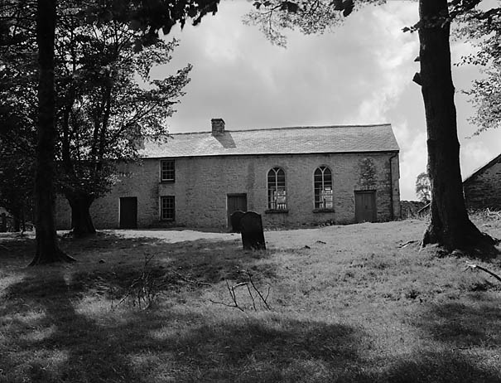](http://www.gtj.org.uk/en/small/item/GTJ12140/)*

The chapel in 1955, exterior and interior, appearing in *Y Cymro*, 8 September 1955, (Geoff Charles Collection, ©, used by courtesy of the National Library of Wales)

[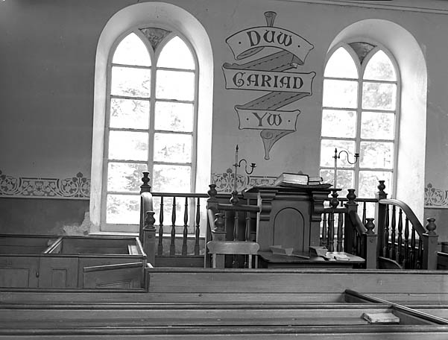](http://www.gtj.org.uk/en/small/item/GTJ12142/)

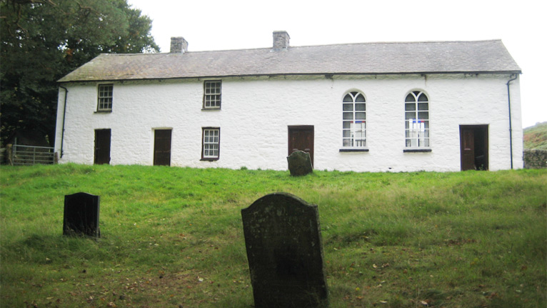

Chapel exterior and graveyard (© BBC, date unknown, believed to have been placed in the public domain)

Chapel exterior (© Richard Coates, 2014)

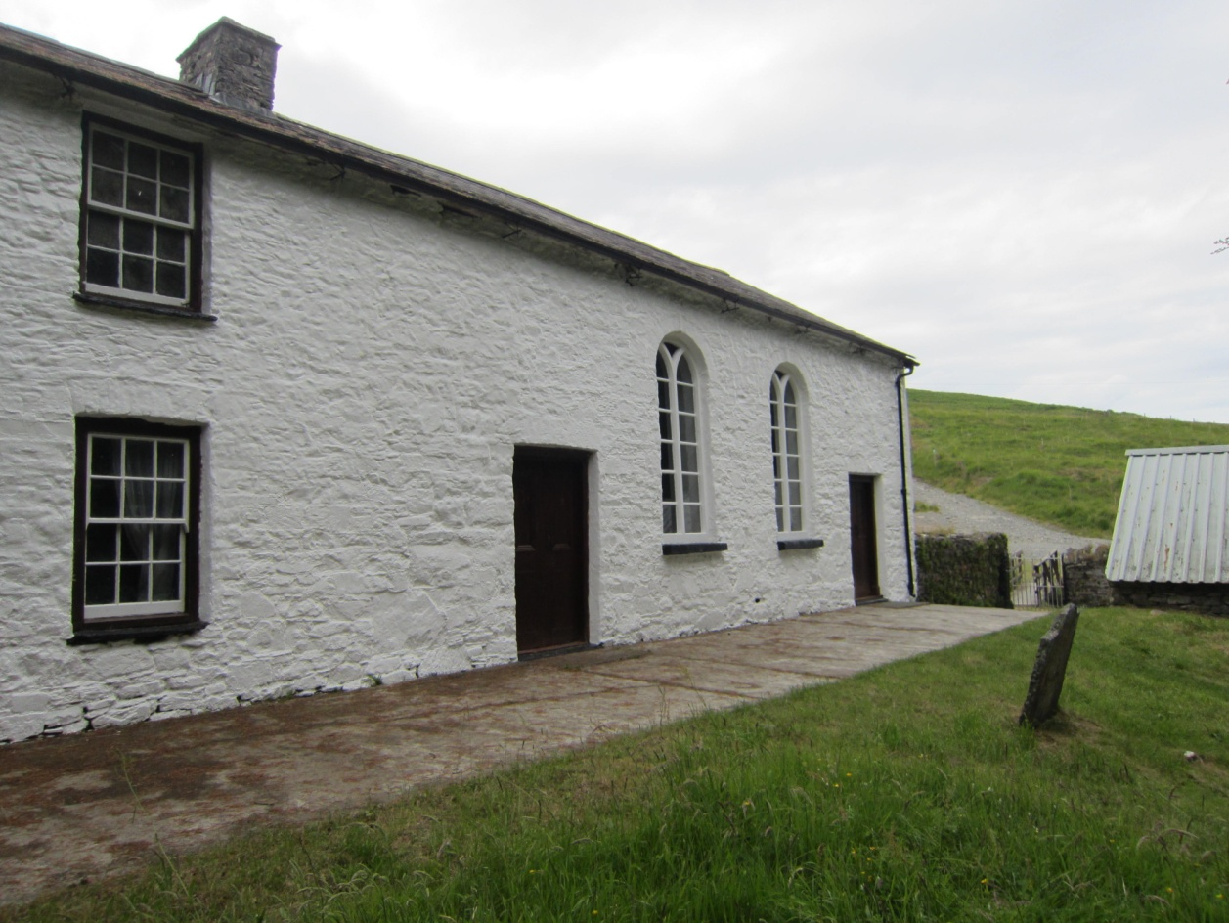

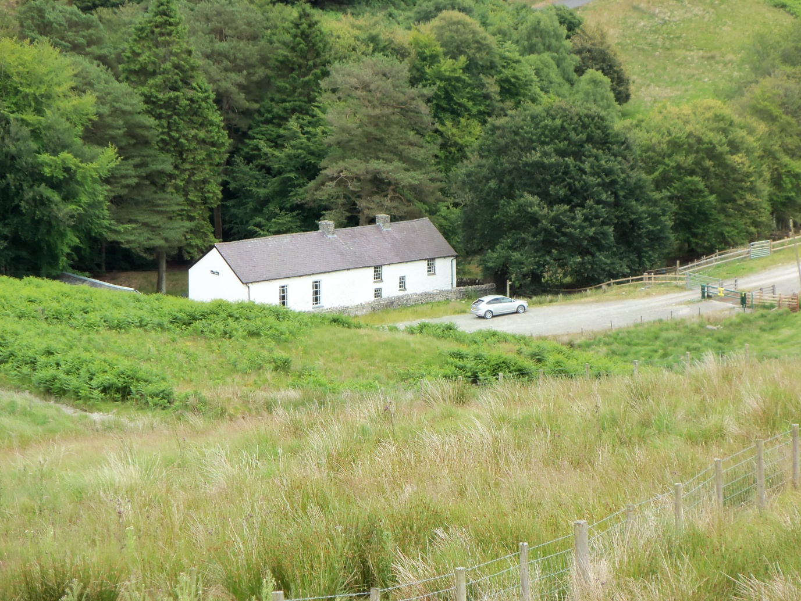

Chapel exterior (both © Richard Coates, 2010)

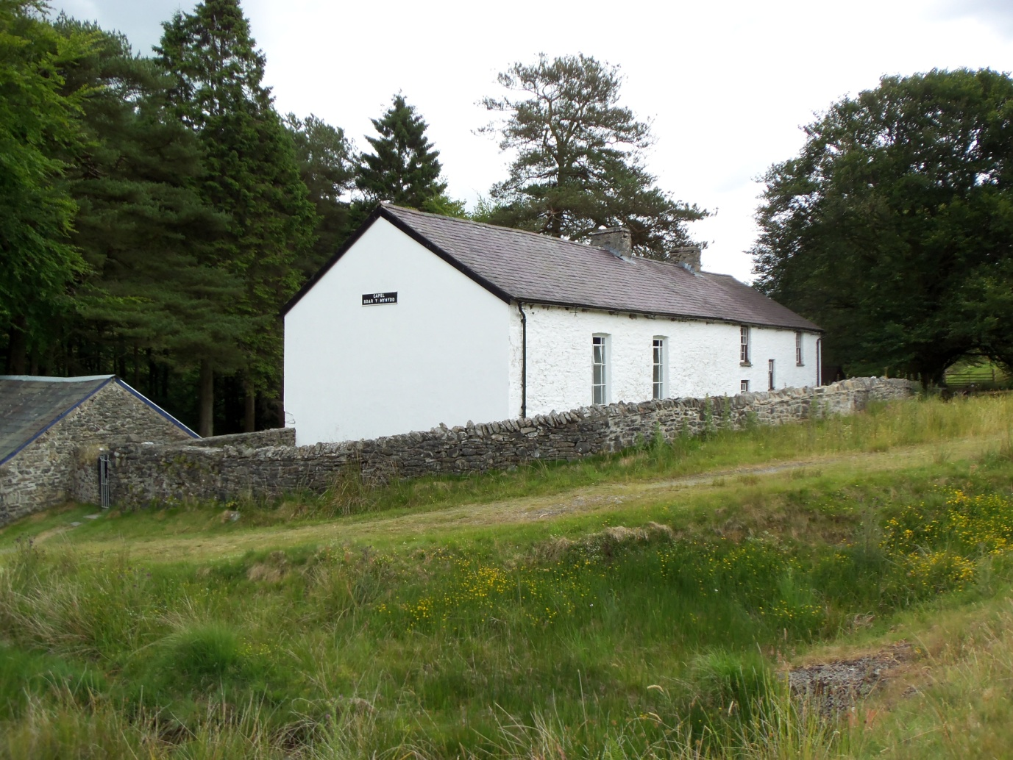

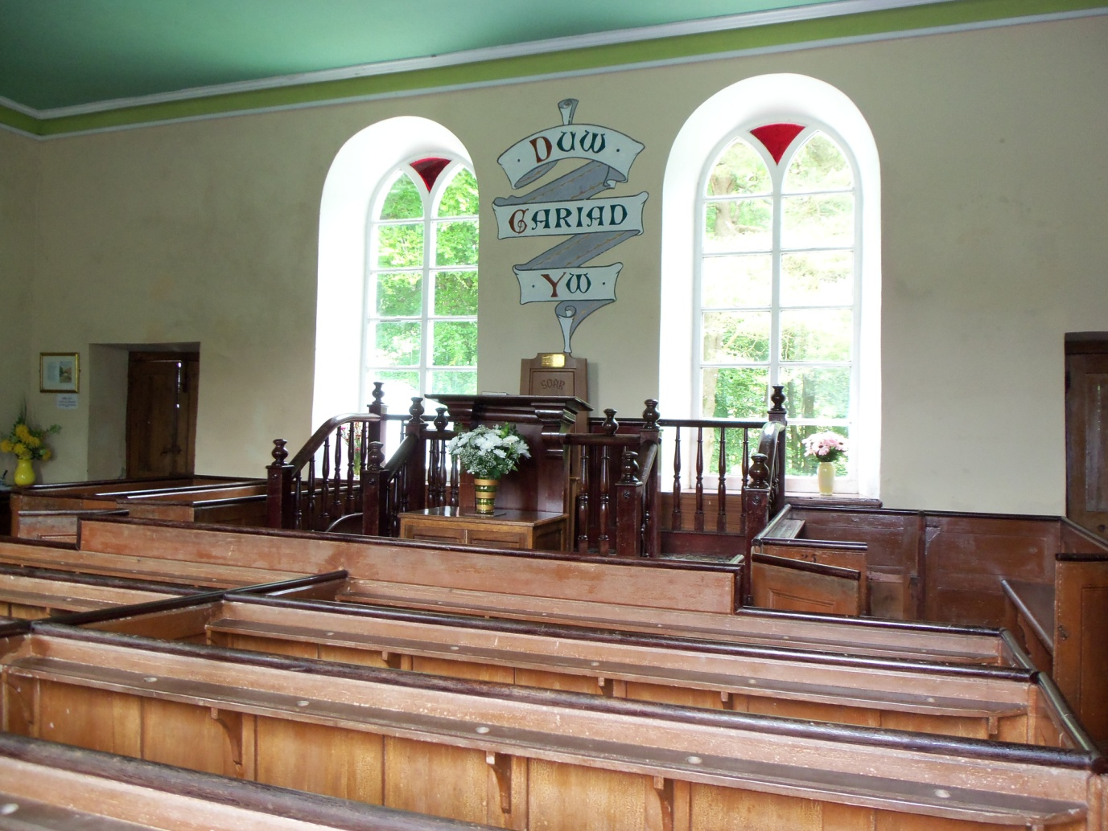

Chapel interior (both © Richard Coates, 2010)

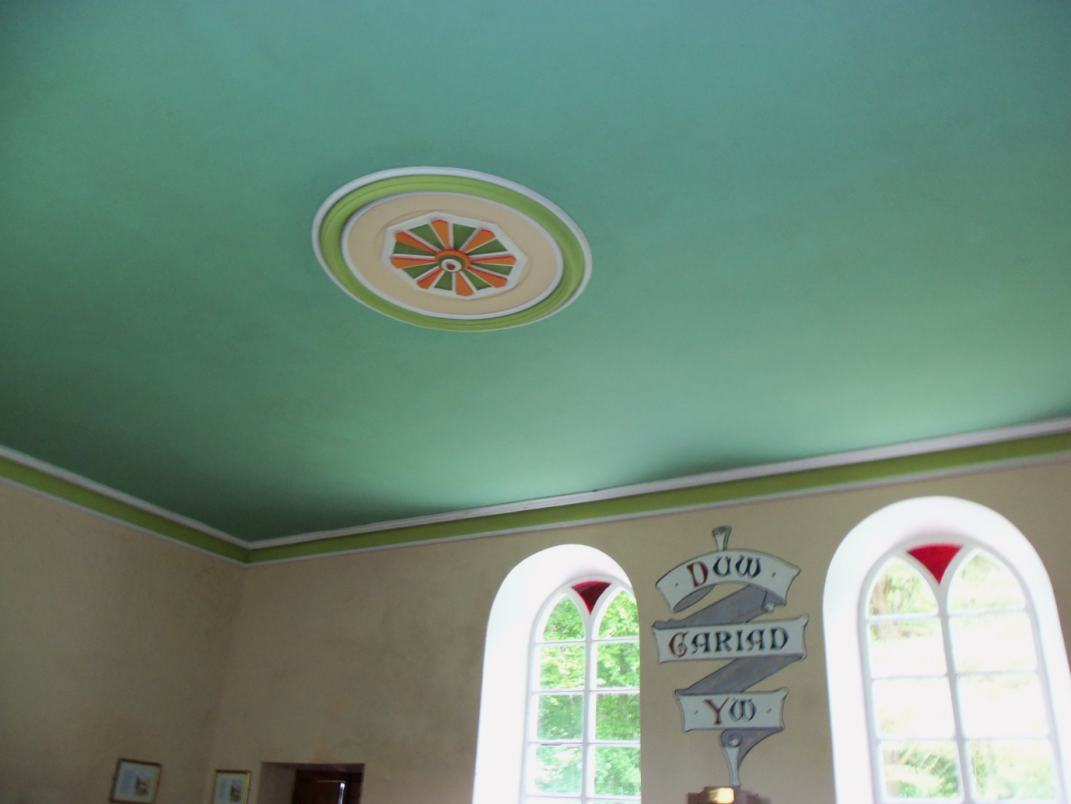

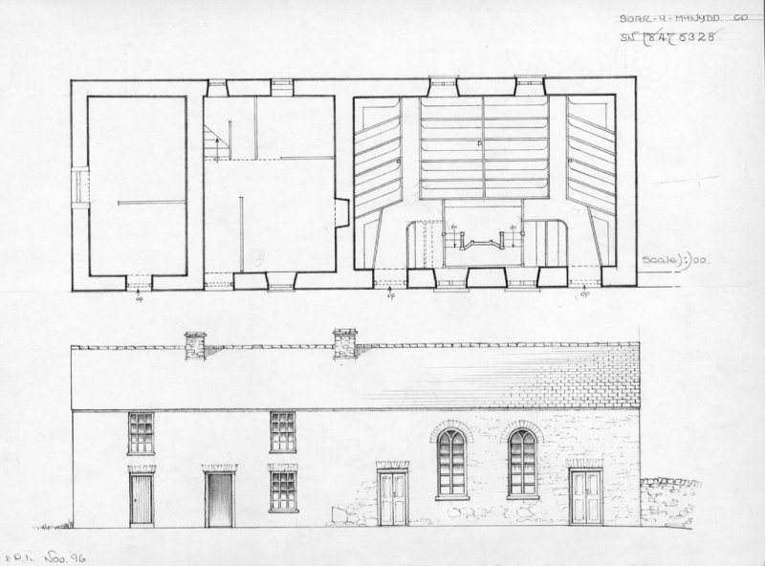

Pencil elevation drawing and plan of Soar-y-mynydd by Dylan Roberts, Olwen Jenkins and Penny Icke (1996), used by courtesy of RCAHMW

|  |  |
| --- | --- |
| RCAHMW file number DI2011_0598, catalogue number | C6692 |

© Crown copyright: Royal Commission on the Ancient and Historical Monuments of Wales

© Hawlfraint y Goron: Comisiwn Brenhinol Henebion Cymru

From Tregaron From Abergwesyn and Rhandirmwyn

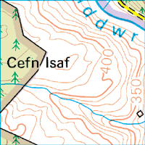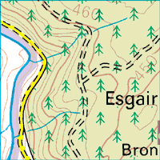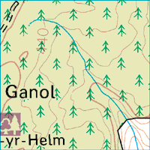

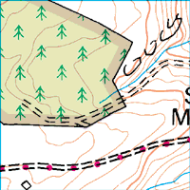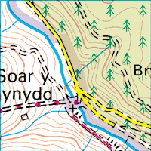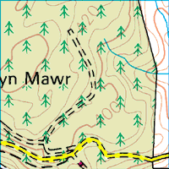

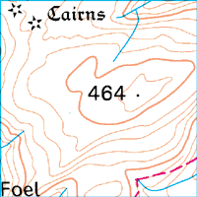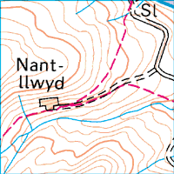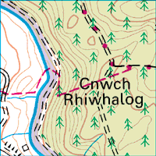

Ordnance Survey 1: 50 000 map (2006 revision, © Crown Copyright)

*Acknowledgements*

The image on page 1 is © Gerald Davison and licensed for reuse under Creative Commons Licence Attribution-ShareAlike 2.0 Generic (CC BY-SA 2.0).

Thanks to the National Library of Wales for permission to use photos from the Geoff Charles Collection, and to RCAHMW for the use of the elevation drawing. Other permissions are noted in the text.

The creator of this document, Richard Coates, can be contacted at the University of the West of England, Bristol, email [richard.coates@uwe.ac.uk](mailto:richard.coates@uwe.ac.uk). All cited links were active and safe in 2017.

THE END