Passive Feeding in Paper-Based Microbial Fuel Cells

J. Winfieldª, P. Milani^{b}, J. Greenmanª and I. Ieropoulosª

ª Bristol BioEnergy Centre, Bristol Robotics Laboratory, University of the West of England, Bristol, UK
^{b} University of Milano, CIMAINA and Department of Physics, Milano, Italy

Microbial fuel cells (MFCs) are often constructed using materials such as plastic that can be hazardous to the environment. Building MFCs from paper is a sustainable option, making the fuel cells lightweight and easy to carry. Transported in the bottom of luggage until needed they could be used as backup power supplies in remote locations. Ideally, they would extract nutrients from the environment without extensive input from the operator, particularly if the user was injured. The current study looked at different paper MFC designs to observe whether they could produce useful power after simply being dropped onto liquid puddles containing organic matter. The results showed that both flat and 3D MFCs could generate current when dropped onto liquid without any need for physical feeding. The 3D tetrahedron MFCs generated power for over 2 weeks with the output sufficient for useful applications such as broadcasting via a transceiver.

Introduction

The global population faces a number of environmental challenges if it wants to ensure the planet is suitable for future generations. Identifying and applying alternative and sustainable sources of energy is one area that needs addressing as is the accumulation of human produced waste such as wastewater and plastics. Microbial fuel cell (MFC) is a technology that can transform the organic matter in wastewater into electricity. This process generates power and treats the waste liquids concomitantly.
The versatility of MFCs has meant that the technology can now branch towards a growing variety of applications (1). One of the big challenges however, has not been the microbial community but the identification of materials that allow the organisms to thrive and ultimately produce power. In addition, it is perhaps a paradox that MFCs should be made of plastics particularly in the current climate when growing evidence is showing that plastics are causing untold damage to the environment. This is epitomised by recent reports that plastic bags have reached depths of 36,000 feet below the ocean in the Mariana trench (2).
Paper is biodegradable and inexpensive and reports have demonstrated it to be a viable material functioning both structurally and as the medium for proton exchange in MFCs (3). The cellulosic fibrous structure allows liquid to wick up the material and the protons to naturally conduct towards the cathode from the anode whilst also acting as sufficient separation between the air-breathing cathode and anaerobic anode (4). To date; the most reported use for paper-based MFCs has been as a diagnostics tool (5), however it is highly desirable to develop paper MFCs as lightweight, portable power supplies. In a diagnostic role, the paper MFCs reported have been low-power and short-lived (lasting just minutes) which is not suitable if the role were as power supply (6).
There have been reports of longer-term electrical outputs using paper-based MFCs (with air-cathodes) such as origami stacks (3) and 3D-tetrahedron MFCs (4). However, in both cases the method for feeding was via careful liquid injection. This is all very well in a lab-based environment but in a real-world scenario MFCs might need activating quickly and without delicate feeding requirements. Here it would be advantageous to simply distribute onto pools of liquid (puddles) and have them passively intake the fuel. The goal of the current study therefore was to look at paper-based MFCs and investigate whether they might be able to passively intake nutrients from the surrounding environment. The perceived scenario is one where the paper MFCs can be carried safely and easily in luggage and then be quickly activated if needed simply by throwing on to a puddle containing organic matter. Rather than the operator having to carry out any awkward feeding, the fuel cells would naturally intake the nutrients from the environment. To do this two strategies were investigated; firstly flat MFCs with an anode on the underside and cathode on the upper side of the paper, and secondly 3D structures where the base of the paper MFCs was able to draw in the anolyte through capillary action while keeping the anode safe and enclosed in an internal chamber.

Experimental

Two MFC designs were looked at; the first being flat 2D-MFCs with the anode on the underside of the paper, directly in contact with the liquid and the cathode on top, open to air. The second design was 3D-tetrahedron MFCs constructed from standard copier paper but with an absorbent cellulose material incorporated into the base. For all MFCs, air-cathodes were used without platinum or ferricyanide.

Flat style MFCs

For the flat style MFCs, 2 methods were tested, the first employed supersonic cluster beam deposition (SCBD-MFCs) and the second was hand crafted by simply adhering and painting on the electrodes (HC-MFCs).

SCBD MFCs - The MFCs were fabricated by coating an electrode onto either side of filter paper. The electrodes were applied using supersonic cluster beam deposition where gold and carbon nanoparticles were deposited (7). The electrodes were positioned in the centre of the paper with legs fashioned to allow the MFC to stand (Fig. 1a). Copper tape and wire were affixed to provide a connection for the crocodile clips to attach.
Three methods of feeding were tested with the SCBD-MFCs; (i) The first was to assess whether the paper legs of the MFC could wick up the anolyte towards the electrodes (Fig.1a), and what the response might be, (ii) for the second a strip of absorbent cellulosic material was adhered to the anode and dipped directly into a reservoir of anolyte (Fig. 1b). To test the response, water was periodically dripped onto the cathode, (iii) the third involved a piece of absorbent material adhered to the anode and anolyte was syringed onto the material (Fig. 1c).

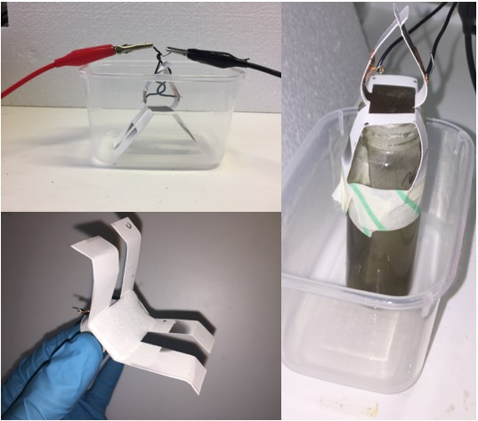
(c)
(b)
(a)
Figure 1. The various configurations of the SCBD MFCs, (a) standing in container waiting for liquid to be added, (b) an absorbent piece of cellulose attached to anode and dipped in jar of anolyte, (c) an absorbent piece of cellulose adhered to anode and awaiting injection of anolyte.

HC MFCs - For the 2D-flat MFCs, three types of paper were looked at; greaseproof, copier and brown paper. These were three-layered structures with conductive latex cathodes painted on one side and a sheet of carbon fibre adhered to the other side. Stainless steel wire was used to enable crocodile clip attachment and a piece was adhered to each side with wire glue prior to coating/fixing the electrodes. The conductive latex cathodes were prepared as previously reported (8). Each MFC was approximately 2cm x 4cm. In all experiments, there was no inoculation prior to the MFC being placed on puddles of enriched wastewater.

3D style MFCs

To look at the capability of MFCs with 3D structure and internal anode chambers, tetrahedron MFCs were prepared. These were fabricated as previously described (4) however instead of a standard paper base, an absorbent cellulose material was incorporated into the design. The anodes were constructed from carbon veil folded down into a triangular prism (Fig 2a) with a projected surface area of 14cm² and the cathode was painted on the three upper surfaces of the tetrahedron but not the base. Stainless steel wire was used as the current collector for crocodile clip attachment. Negative control MFCs were prepared using a synthetic latex (Plasti-dip, Petersfield, UK) that was painted onto the bottom thus waterproofing the base. The MFCs were not inoculated prior to being dropped onto the puddle. Puddles in all experiments consisted of activated sludge (Wessex Water, Saltford) with 1% tryptone and 0.5% yeast extract.
(c)
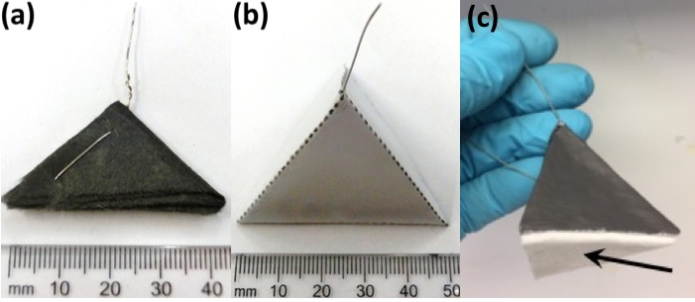
(b)
(a)

Figure 2. Preparing the tetrahedron paper MFC; (a) carbon veil anode, (b) paper tetrahedron with anode inside awaiting cathode application, (c) after cathode application, arrow indicates the absorbent cellulose base.

Results and discussion

For a paper MFC to be used in a remote location perhaps as the back up power supply they would need to be able to tap into the local nutrients with minimal effort from the operator. Ideally they should also be easily fabricated using state of the art techniques that optimize electrode performance. Supersonic cluster beam deposition (SCBD) is a technique that is being developed particularly for the manufacture of biomaterials (7) with a focus on the industrial process. The technique enables the application of conductive materials at the small scale, which should theoretically benefit MFCs (9). To the authors knowledge this is the first attempt at developing paper SCBD MFCs.
The first set of experiments looked at the SCBD-MFCs in a shallow puddle and whether they would come alive once the anolyte had wicked up the paper legs and reached the section of paper between the electrodes. Fig. 3a shows the liquid wicking up the leg as indicated by the arrow. When the anolyte reached the electrodes the first response was for the open circuit voltage to drop to negative values before gradually rising (Fig. 3b arrow A). On three occasions the anolyte was topped up so that it reached the anode (arrows B) but a useful OCV was never maintained. A 5kohm load was applied after the period shown in Fig. 3b but the voltage peaked at 4mV which clearly is not a usable output (data not shown). The resistivity of the the anode electrodes drastically increased during operation from approximately 220Ω to approx. 20MΩ and so it is envisaged that the liquid diluted the electrodes. The cathode dropped as well but not to the same extent as the anode because it was the anode that was in direct contact with the liquid.

(b)
(a)
Figure 3. SCBD MFCs in puddle, (a) arrow shows anolyte wicking up MFC leg, (b) the open circuit voltage over time of MFC in puddle, arrow A shows point when anolyte reached electrodes and arrow B shows the times that anolyte was topped up so that it came into contact with the anode electrode

In order to try and negate damaging the anode electrode two other attempts were made using an absorbent cellulosic material. Firstly, MFCs were strapped to small tube containing anolyte with an absorbent piece of cellulose adhered to the section of paper surrounding the anode and dipped into the liquid (Fig. 1b). Figure 4a shows that again the initial response was a negative OCV which eventually rose to approximately 20mV. When water was dripped onto the cathode there was a slight spike but the OCV was never enough to be considered useful (Fig. 4b). Another test involved adhering a small piece of absorbent material to the anode (Fig. 1c) and syringing anolyte into the material, in this scenario the open circuit voltage peaked at almost 350mV before a decline. This is more in line with other paper MFC studies where an initial spike is observed quickly followed by a decline (3). This might be sufficient for single use diagnostic but not for the purpose of prolonged power generation. Although the SCBD MFCs were not successful in the current study they certainly can play a role in future studies either by incorporating a material to prevent the electrodes from dissolving or by using alternative support materials (10).

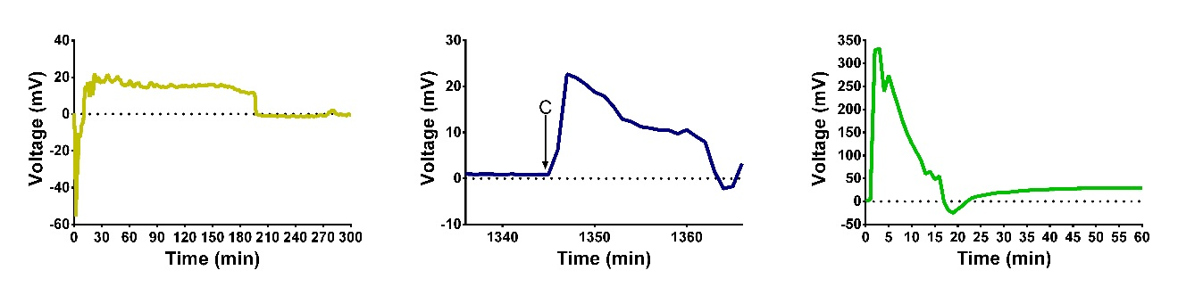
(c)
(b)
(a)

Figure 4. The open circuit voltage of SCBD MFCs; (a) Fed by absorbent material dipped in sludge, and (b) when tap water dripped onto cathode as indicated by C arrow, (c) MFC when anolyte dripped onto absorbent material attached to anode

In summary, the MFCs with SCBD deposited electrodes reached peak OCV of 350mV which quickly dropped. In closed circuit the current peaked at 2.4 µA before rapidly declining which is clearly unsuitable for real-world use. The reason for the poor performance was the dissolution of the electrode as the liquid displaced the conductive elements as verified by the significant increase in resistance after use. Further work with printed MFCs will investigate incorporating a stabilising material to prevent the electrodes dissolving.

Flat HC-MFCs

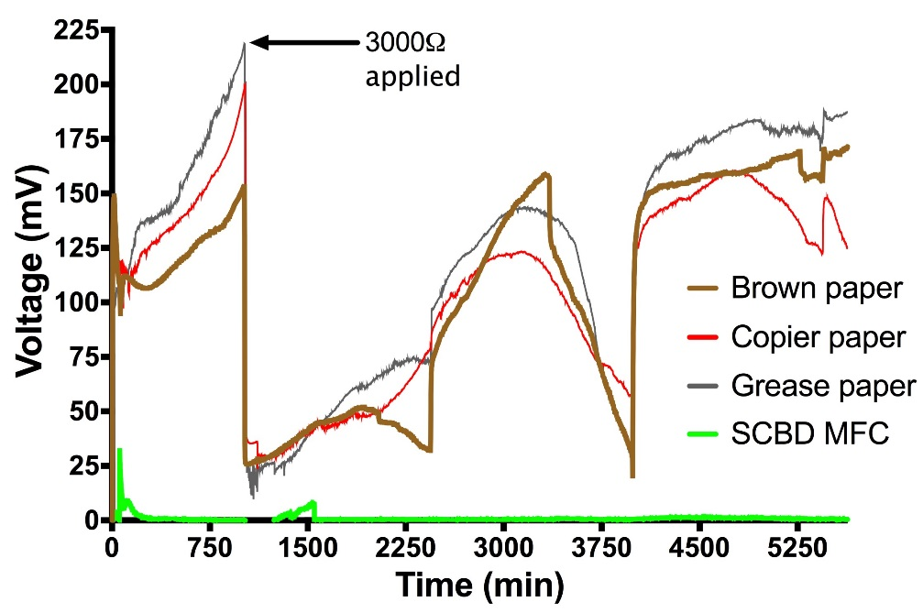
Figure 5. Comparison of flat MFCs made from different types of paper

The flat hand-made MFCs (HC-MFCs) fared much better. Interestingly the conductive-latex cathodes were more resistive than the printed ones yet the MFCs were superior and more stable over time. After being dropped onto a pool of organic liquid, the OCV gradually rose before a 3kohm load was applied. Then, rather than a spike and decline the working voltage climbed and stabilised for 4 days at 11 µW (185mV) as shown in Fig. 5. The SCBD prepared MFCs were also tested alongside the HC-MFCs and as previously discussed did not produced viable output. Different types of paper were trialled including brown, greaseproof and copier and all performed comparably. Further work will investigate stacking multiple flat-MFCs on single sheets of paper.

3D paper MFCs

The simple flat-MFCs are promising but for MFCs operating outside and tapping into nutrients in puddles they should ideally have enclosed chambers housing the anode. To trial this, 3D-tetrahedron MFCs with 15mL volume were set up to sit on pools of liquid with the only method of feeding via capillary motion of the absorbent base.
Copier paper was used as the main structural material and has a fibrous structure (Fig. 6a) that enables capillary movement but is also suitable for sufficiently isolating the anode and cathode electrodes. The absorbent material is also fibrous but it has a more tangled, spongy and less uniform structure (Fig. 6b) enabling better absorbency of liquids.
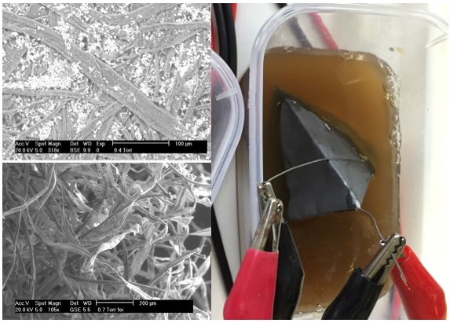
(c)
(b)
(a)

Figure 6. Absorbent paper tetrahedron MFCs; (a) SEM image showing the surface of copier paper, (b) SEM image showing the surface of the absorbent cellulose material, (c) MFC sitting in puddle

(b)
(a)

Figure 7. The output of tetrahedron paper MFCs (3D-MFCs); (a) the power compared to MFCs with plastic waterproof bases and (b) the voltage improvement when additional nutrient was added to puddle. Data presented as mean and range (n = 3)

The 3D-MFCs with absorbent bases were compared to MFCs with a waterproof coating over their base. Those with the absorbent bottoms started slowly after being placed in the puddle. But gradually over time the power increased and continued to improve over a 16 day period (Fig. 7a) peaking and stabilising at 40µW (2.7 W/m³). The MFCs with plastic coated bases showed no working voltage throughout the period. In addition, when fresh nutrient was added to the reservoir (not directly to the MFCs), they responded almost immediately as indicated by the arrows in Fig. 7b, a factor that could be advantageous if the role were biosensor. The output generated by the MFCs relying on a passive feeding mechanism is comparable to that produced by the same MFCs with sealed bases from a previous study where injection feeding took place (4). This output is sufficient to cold start a power management system and broadcast radio signals.

Conclusion

MFCs with electrodes fabricated using the supersonic cluster beam deposition method produced a maximum OCV of 350mV but only managed a low current (2.4uA). This is because the method of feeding damaged the electrodes. Further work will look at alternative feeding mechanisms and materials. Paper MFCs with conductive latex cathodes and carbon veil anodes generated useful outputs after being placed onto organic liquid puddles. In particular the 3D tetrahedron MFCs with absorbent bases were able to passively wick up liquid and generate a stable output for over 2 weeks. The power density peaked at almost 3 W/m³ compared to the plastic based MFCs that generated zero power. Based on this output and on previous studies, just two MFCs are needed to energize a power management system and transceiver.
These findings are an exciting development because when there is a need for small amounts of power in a remote location, lightweight paper-MFCs can be dropped onto puddles of organic liquid. Then through passively sucking up nutrients from the surrounding area, sufficient power can be generated to enable the broadcasting of radio signals. Should a suitable puddle not be immediately available the user could quickly and easily fabricate their own by digging a hole and filling it with water (or urine), then adding components from the surrounding area to enrich the mixture such as foliage, animal excreta or fruit.

References

- I. Ieropoulos, J. Winfield et al., Microbial Electrochemical and Fuel Cells: Fundamentals and Applications, ch.12, Ed Woodhead Publishing, Elsevier Ltd
- National Geographic website (accessed 25th May 2018); https://news.nationalgeographic.com/2018/05/plastic-bag-mariana-trench-pollution-science-spd/?beta=true
- Fraiwan et al., Biosens Bioelectron., 49, (2013)
- J. Winfield, L. Chambers, J. Rossiter, J. Greenman and I. Ieropoulos, J. Mat. Chem, 152, (2005)
- S. Mahadeva, K. Walrus, B. Stoeber, ACS App. Mat. Int., 7, (2015)
- H. Lee, S. Choi, Nano Energ. 15, (2015)
- L. Bettini, A. Bellaciccia, P. Piseri, P. Milani, Flex. Print. Electron. 2, (2017)
- J. Winfield, L. Chambers, A. Stinchcombe, J. Rossiter, I. Ieropoulos, J Power Sources, 249, (2014)
- F. Soavi, L. Bettini, P. Piseri, P. Milani, C. Santoro, P. Atanassov, C. Arbizzani, J Power Sources, 326, (2016)
- A. Bellaciccia, P. Milani, arXiv:1706.08586, (2017)

.

