Chapter 1

Phenomenology in Virtual Worlds: an example from archaeology

Liz Falconer, PhD; Curie Scott
Centre for Excellence in Learning, Bournemouth University, U.K.

Abstract

This chapter discusses a project to construct a simulation of Avebury Henge, a Late Neolithic/Early Bronze Age monument in the SW of the U.K., in a 3D, virtual world environment, and to use phenomenological and phenomenographic methods for its evaluation. We explore notions of place and digital being in virtual worlds, and the potential of these methods in understanding virtual worlds and their applicability to evaluations of virtual archaeology. The phenomenological approach to archaeology tends to stress the importance of the archaeologists’ senses, working through their physical presence in a landscape to enable an appreciation of the materiality, or physicality, of an environment. In this study, phenomenology was applied to the experience of a virtual environment where sight and hearing senses are restricted, and the senses of smell and touch are deprived altogether. So, the immersion of all the body’s senses in a landscape, to the exclusion of all other experiences, cannot be achieved. We argue that the phenomenological narrative describing one author’s experiences in Virtual Avebury (VA) has demonstrated that experiencing a landscape from an archaeological point of view can be achieved in a virtual environment, but that the nature of the experience is different to that in the physical world. The ability to experiment with designing landscapes, to change environmental aspects in simulations of places that could not otherwise be experienced, and to meet with others in those places to discuss, explore and experience them together, has the potential to offer a new practice of phenomenology in archaeology, and in virtual worlds research. The phenomenographic method used to explore the range of experiences of members of a small evaluation group found that six categories of experience emerged. These were sense of place in VA, recall of VA at Avebury, sense of place in Avebury, effects of sounds and soundscapes and a sense of Avebury’s original purpose. Based upon these findings, we make recommendations for wider research in phenomenological methods of enquiry in virtual worlds.

Keywords: archaeology, virtual worlds, phenomenology, phenomenography, co-presence

Introduction
Virtual worlds are environments that enable us to create spaces that are drawn from the physical world, or purely from our imagination, or from a mixture of the two. We can lose ourselves in the visual beauty of a virtual space, explore unknown areas in a space otherwise familiar to us, imagine ourselves in a different age and imagine different ways in which a location may have developed over time. But what do virtual spaces mean to us? How do we experience them? What changes a virtual space into a virtual place? And how might virtual places affect our archaeological understanding of ancient sites? This chapter explores these questions through constructing and experiencing a virtual world simulation of the Avebury Henge and Stone Circle Complex, a Neolithic stone circle and associated ritual landscape in the South West of the U.K., circa 2,200 BCE. The main aim of the study was to explore how creating and experiencing a virtual simulation of an imagined past might affect understanding and interpretation of the monument and its surrounding landscape in the present day. This aim was achieved by constructing a simulation of Avebury in a virtual world and evaluating the experiences of the constructor using a phenomenological approach, and a small group of visitors by utilising a phenomenographic technique.
The chapter begins with a discussion of the rationale for the study, followed by a literature review which develops this argument further. The methods used to construct the simulation, and to explore the experiences of users there, are then detailed and explained, followed by a discourse on the findings and consideration of future work that might explore the issues raised further. However, before discussing the project, it would be helpful for the reader to be introduced to Avebury as the location for the project.
Avebury is situated in Wiltshire in the South West of the U.K. at 51º25’ N, 1º51’ W. Located in a rich prehistoric landscape, it is the largest known Neolithic stone circle in Europe and one of the largest ditch and bank monuments in the U.K. The henge and its surrounding landscape is the northernmost part of the Stonehenge, Avebury and Associated Sites World Heritage Site and is protected as a Scheduled Ancient Monument under the Ancient Monuments and Archaeological Areas Act 1979. Most of the original stones are missing and the ditches are now significantly shallower than originally constructed, partly due to natural infilling and slippage of the banks, whose top edges have also eroded. The roughly circular earthwork is a henge construction, i.e. a ditch on the inside of the circle and a bank on the outside. It measures more than a kilometre in circumference and is divided into four arcs by breaks in the ditch and bank system that have been interpreted as entrances and/or exits. The henge contains the remains of three stone circles; one large outer circle that lined the inside of the ditch, and two smaller inner circles that surrounded arrangements of large and small stones. The aerial photograph at Figure 1 was taken from outside the NE quadrant of the henge and shows the ditch and bank system, remains of the stone circles and the modern village of Avebury today.
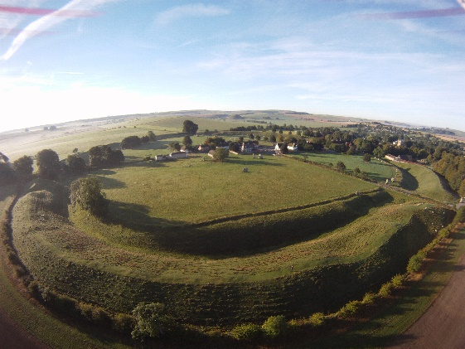
Figure 1. Aerial view of Avebury today
The schematic at Figure 2 indicates how the original arrangement of stones is currently understood; it is important to note that this diagram is not drawn to scale and does not represent all the stones, but shows the general layout and orientation of the henge to enable the reader to understand the Avebury context.
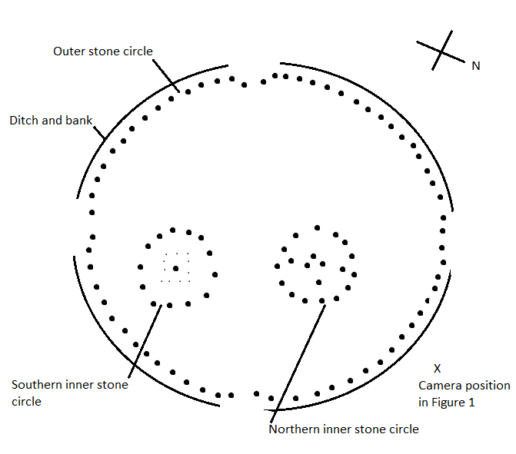
Figure 2. Schematic of stone circles at Avebury

Although specific dating of its construction is not clear, the henge and the stone circles it contains are estimated to have been built between 2,800 – 2,000 BCE, the construction having been carried out in phases that included digging the ditches and banks and locating, transporting and erecting the stones (Pollard and Reynolds, 2002: 81). From a ground perspective it is difficult to appreciate how the henge and avenues would have related to the wider landscape when they were first constructed, due to modern roads, farming, fencing and building. The view across the henge is obstructed by houses and other buildings that line High Street, which bisects the henge from west to east. Figure 3 illustrates this, showing how part of the north bank is just visible above the cars in the distant car park. So it can be argued that Avebury today is rather incongruous and diffcult to appreciate as an entire Neolithic monument. This makes it an interesting location for investigating how experiencing a virtual interpretation of an ancient monument in the past, free of present-day context, might affect our understanding and interpretation of it today.

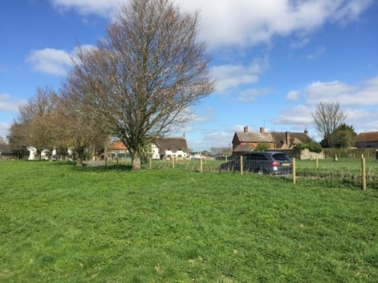
Figure 3. The view across the henge today

Virtual places in archaeology

Virtual archaeology
This study is in the field of virtual archaeology, a term first coined by Reilly (1990) and originally referring to the promise of information technologies in creating 3D computer models of buildings and artefacts. The notion of ‘cyber-archaeology’ was subsequently discussed by Jones (1997) as a way to encourage a wider use of technology to facilitate interaction through the formation of virtual communities and virtual settlements, and thereby to enhance our understanding of the social aspects of archaeological sites and landscapes. Available technologies and their use in virtual and cyber archaeology have developed considerably in the past 20 years to include the use of virtual reality techniques (e.g. Gillings, 2005; Knabb et al., 2014), 3D virtual world environments (e.g. Morgan, 2009) and augmented reality (e.g. Pierdicca et al., 2015). Over the same period a small but increasing number of virtual simulations of Neolithic sites in Europe have been created, such as Stonehenge (Exon et al., 2000; Welham et al., 2015) and Skara Brae (Watterson, 2015) in the U.K., and Çatalhöyük in Turkey (Forte, 2014). These detailed and evocative constructions demonstrate ways in which computer technologies can enhance our understanding of how ancient sites might have been constructed, and how they might have been used at various points in their history. But, many of these digital constructions lack both the ability to enable personal presence of the user in the virtual landscape itself, and the ability for users to interact with others and the virtual environment around them in real time. Even in those simulations that have utilised virtual world platforms with sophisticated collaborative functions, such as Morgan’s (2009) simulation of Çatalhöyük in the virtual world Second Life® (SL), the emphasis in reports has largely remained upon the visual authenticity of the virtual model, rather than what can be learned from the interactive experiences of the creators and users of the simulations. We would argue that this is a missed opportunity to broaden our understanding of how virtual technologies might be effective tools in experimental and interpretive archaeology, and in heritage management as a means of interpretation and orientation for visitors.
Virtual worlds have recently begun to create interest as technologies that might provide opportunities to develop interpretations of archaeological sites that explore their physical, conceptual and social aspects. Sequeira and Morgado (2013) identify four different approaches to virtual archaeology and virtual heritage that utilise virtual world platforms; these include virtual world cyber archaeology, reconstructive virtual archaeology, virtual museums and interactive virtual archaeology, the latter being characterised as an archaeological “…laboratory, where hypotheses can be put to the test and visually confirmed by having avatars interacting with the reconstructed space.” This chapter discusses how the project synthesised the second approach of reconstructive virtual archaeology, i.e. the creation of a simulation of the henge at Avebury, and the fourth approach of interactive virtual archaeology, by involving participants in interactions with the virtual Avebury environment, and with each other in that environment. Our particular focus is on the way in which our understanding of the virtual space called Virtual Avebury developed into a sense of place, The distinction between space and place is a fundamental aspect of our study and is discussed in detail next.

Space and place
In their creation of a virtual Stonehenge, Exon et al (2000) discuss how the concepts of actual and imagined spaces are central to the development of virtual simulations of ancient places. They cite the work of Edward Soja (1996) who argued that ideas about space have tended to concentrate upon a binary opposition of what he termed ‘first space’ and ‘second space’. First space is understood to mean space as a material environment, i.e. the space we experience physically in the present. Second space refers to the feelings that humans experience during their interaction with first space and also how we conceptualise and conceive space psychologically, including how we might imagine landscapes that existed in the past. Soja argued that this binary opposition was overly reductionist and in response he created the notion of ‘third space’, where aspects of the real and the imagined are combined to create a richer understanding of the meaning ascribed to spaces and landscapes. So, although Soja’s work was primarily focussed on the study of postmodern urban landscapes, there is a strong resonance between the third space notion of combining actual and imagined aspects of space with virtually constructed spaces.
There has been a long discussion in the literature into the distinction between space and place from a range of subject perspectives, including phenomenology, psychology and sociology (see, for example, Relph, 1976; Turner and Turner, 2006). From an archaeological point of view, Crane (2016) discusses how the development of the British landscape after the last Ice Age demonstrates that humans have a tendency to imbue locations with emotional meaning, evidenced by leaving marks in the landscape from hardly-discernible Mesolithic post holes, to large and complex Neolithic structures like Avebury. Harrison and Dournish (1996: 67) offer a definition of place as consisting of a combination of space and meaning, and Gustafson (2001: 7-8) further identified three main themes in the meanings that are associated with places, which are self, including a person’s emotions and self-identity, environment, including the physical features of the place and events that are experienced there, and others, referring to the behaviours and characteristics of other people who share the place.
Echoing Gustafson’s recognition of the importance of others, Ingold (2009) argues that we do not live our lives in places, but that we move to, from, around and through them, disagreeing with Tilley (1994) that humans are bound to particular places. Ingold instead sees us as place-binding; we move along paths that encounter places and people, becoming wayfarers who leave trails that intertwine with the trails of others. Ingold sees places as being delineated and defined by human movement, whereas Malpas (1999) stresses the importance of recognising the two-way nature of human relationships with places; we influence places and places influence us. Malpas also argues that the past cannot be grasped independently of a sense of place; that ‘…only within the compass of place can there be the spatio-temporal ordering of things on which grasp of the past depends’. This argument could be extended to imply that virtual renditions of physical places are at risk of being dissociative if an attempt is made to extract the ‘essence’ of a place, distil it, construct it on a digital platform and then expect visitors to experience the same sense of place virtually as they would in the physical location. But such an argument would misunderstand the nature of spaces in virtual worlds and the vital role of shared experiences in establishing a sense of place in those spaces. Turner and Turner (2006), Goel et al (2011) and Falconer (2013) provide evidence from studies that show virtual spaces are not only constructed space; they are also capable of becoming places in their own right, recognised and understood as such by people who interact with those places, and with others in them. A virtual space is not simply a surrogate for a physical space. Virtual space can become virtual place.
The advent of computer games and virtual worlds has broadened the concept of what is meant by space and place, our relationships with them and with others whose trails intertwine with ours. In his seminal ethnographic study on communities and social interaction in virtual worlds, Boellstorff (2008: 5) discusses the importance of recognising what it means to be “virtually human”, i.e. experiencing human activities in virtual environments and with people who represent themselves as avatars. He argues that virtual world cultures are profoundly human and that, ‘…. since it is human ‘nature’ to experience life through the prism of culture, human being has always been virtual being. Culture is our ‘killer app’: we are virtually human.’.
The terms ‘virtual’ and ‘real’ are frequently used in studies such as this, and need to be clarified before the discussion progresses. The antithesis of virtual is often expressed as real, but we argue that this is neither a suitable nor correct distinction. Experiences that are shared in virtual environments are real; they are shared by people in the same way as they are shared in physical environments. Whilst it is true that the nature of virtual environments can be very different to those we can experience physically, the error that arises from using real as the antithesis of virtual is that virtual is then inferred to mean unreal, a term that does not represent the experiences and knowledge that result from interactions in virtual simulations. Physical is therefore used in this chapter as the antithesis of virtual, a distinction which relates to the nature of the environments rather than presupposing the reality or otherwise of experiences in them.
The above discussion raises questions regarding how experiencing virtual places affects our experiences in analogous physical places, as we can now move around and interact with environments and other travellers in both kinds of place. Literature on the relationship between physical and virtual places is increasingly recognising the fluidity and permeability of those interfaces (Bower et al., 2017). For example, Savin-Baden and Falconer (2016) apply the philosophical concepts of metaxis (a term first used by Plato to describe the condition of in-betweenness) and liminality to considerations of the interstices between the virtual and the physical, arguing that there is no hard boundary between them. Interactions in virtual places have physical components such as human users and hardware, and our memories and experiences in virtual spaces can bring the virtual into the physical. In this way, we can see ourselves inhabiting both places simultaneously and to varying degrees (Linds, 2006). This perspective is in stark contrast to Earl and Wheatley’s (2002: 8) statement in relation to their virtual rendition of Avebury, that ‘…with a virtual past the context within which any experience is generated is totally devoid physically from the present upon which the archaeologist bases his or her experience…’. This study challenges Earl and Wheatley’s view by exploring how experiences in a virtual simulation of Late Neolithic Avebury might affect our experiences in, and understanding of, Avebury today. So, we need to begin by exploring how experiences can be understood.

Researching experience: Phenomenology and phenomenography
There are 2 perspectives that researchers can take to exploring participant experiences; emic, where the perspective is that of a participating subject, and etic, where the perspective is that of an external observer. As we were concerned with understanding a range of experiences from the subject’s point of view, our methodological approach focussed upon the emic perspectives of virtual and physical Avebury; firstly, a phenomenological account from Liz’s perspective (author 1) as the builder of the simulation, and secondly, a phenomenographical account of participants’ experiences. The use of phenomenography is not as well-known as phenomenology in either virtual worlds or archaeology, so its value to both disciplines is posited here.
Both phenomenology and phenomenography garner experiences of a phenomenon. The Oxford English Dictionary defines a phenomenon as a fact or situation that is observed to exist or happen, especially one whose cause or explanation is in question. It also has the meaning of something that is remarkable and, in philosophical terms, something that is the object of a person’s perception. Phenomena could be concepts such as fear, wonder or curiosity; constructs such as risk, scientific theories or areas of study such as history; or more complex experiences such as a period in hospital or a visit to an ancient monument. This section introduces phenomenology and phenomenography as research approaches and considers them within the context of virtual worlds and archaeology. It then moves on to how both approaches were utilised to research experiences of virtual and physical Avebury.

An introduction to phenomenology and phenomenography
Phenomenology is a branch of philosophy that studies human experience and consciousness. It was initially founded as a philosophical movement by Edmund Husserl in the early part of the 20th century and further developed by philosophers such as Heidegger and Merleau-Ponty (2012). Fundamentally, it is a worldview in subjective juxtaposition to the post-Enlightenment, subject/object dualist approach to understanding the world. From a theoretical point of view, Cibangu and Hepworth (2016) describe phenomenology as a descriptive rather than explanatory or deductive process, which aims to reveal experience as it is, not to frame hypotheses or speculate beyond its bounds. Phenomenologists therefore recognise the essentially subjective nature of human experience and apply descriptive methods to attempts to understand those experiences. There is a complex literature on the nature of phenomenology that demonstrates how its ideas have been developed in, and applied to, a wide range of contexts. This has led to the view that phenomenology does not have a single definition; it is ‘... not a doctrine, nor a philosophical school, but rather a style of thought, a method, an open and ever-renewed experience…’ (Farina 2014: 52). So, phenomenology is a way of thinking about our lived experience of the world which seeks to describe what Owen (1994) refers to as the very nature or essence of a phenomenon. Phenomenological research seeks not only to uncover what individuals experience, but how they experience the phenomenon in question (Savin-Baden and Major, 2013).
Phenomenography also gathers an emic perspective but unlike phenomenology, it is empirically rather than philosophically grounded (Marton, 1981; Marton and Booth, 1997; Svensson, 1997; Entwistle, 1999). The approach is less well-known than phenomenology, possibly due to being relatively new at 45 years old. It arose within the field of education to challenge the dominant positivist and quantitative research traditions within the field (Svensson, 1997). The majority of phenomenographic studies reside in education (such as Harris, 2011; Paakkari et al., 2011; Tigchelaar et al., 2012) and health studies (such as Munck et al, 2012; Berg et al., 2013; Weimand et al., 2013).
In phenomenography, the ontological claim is of a non-dualist ontology implying that the subject and object are inseparable:
‘From a non-dualistic ontological perspective there are not two worlds: a real, objective world, on the one hand, and a subjective world of representations on the other. There is only one world, a really-existing world, which is experienced and understood in different ways by human beings. It is simultaneously objective and subjective. An experience is a relationship between object and subject, encompassing both. The experience is as much an aspect of the object as it is of the subject’. (Marton, 2000:105)
Phenomenography subscribes to being non-dualist, centring on participants’ views to create a second order perspective. The basic unit of phenomenography is how people ‘…experience or conceptualise any aspect of the world around them’ (Marton, 1981:188). In phenomenography, there is an assumption that there is a limited number of qualitatively different ways something is experienced (Säljö, 1997). A collective rather than individualised account is developed during analysis, which requires a sample broad enough to generate a variation in experience (Marton, 1981; Booth, 1997; Entwistle, 1997; Hasselgren and Beach, 1997; Säljö, 1997; Svensson, 1997; Barnard et al., 1999; Richardson, 1999; Ashworth and Lucas, 2000). The focus on variation differentiates phenomenography from other qualitative approaches as the prominence is given to variation or differences of experience rather than commonalities. Therefore, though experiences are central to both phenomenography and phenomenology, different things are emphasised (Marton 1981; Hasselgren and Beach, 1997; Marton, and Booth, 1997; Entwistle 1999; Barnard et al. 1999; Giorgi, 1999). These are summarised in Table 1. Firstly, phenomenology is philosophically based whereas phenomenography is empirically based. In phenomenology, a singular essence is sought based on an individual’s first order perspective, whereas a second order perspective about how people experience and conceptualise something is gleaned in phenomenography (Marton, 1981). Instead of being dealt with on an individual basis, a collective meaning is generated across all the participants and therefore a broad sample where variation is likely is necessary. From a complete data set, experiences that emerge inductively from the data are developed into categorises of description which are finally logically ordered into an outcome space model to demonstrate the variations of meaning (Trigwell, 2000).
This chapter reports on initial themes that arose from the first phase of participants in this study, with a relatively small sample size. Over time, we intend to supplement and extended this sample size to enable a broader base to develop.

 | Phenomenology | Phenomenography
Underpinning rationale | Philosophically-based | Empirically-based
The aim | To clarify experiential foundations in the form of a singular essence. | To describe variation in understanding from a perspective that views ways of experiencing phenomena as closed but not finite.
The emphasis | On individual experience. | On collective meaning
The perspective | First-order perspective that engages in the psychological reduction of experience. | Second-order perspective: experience is descriptive and presented in a distinctive, empirical manner
Analysis | Leads to the identification of meaning units. | Leads to the identification of categories of description and an eventual outcome space.
Table 1. The Relationship between Phenomenography and Phenomenology (further developed from Barnard, et al., 1999:214)

Phenomenology and Phenomenography in Virtual Worlds
Considering experiences in virtual worlds from a phenomenological perspective has been an area of interest for researchers and practitioners for more than 20 years. Although Houliez and Gamble (2013) argue that, from a strictly philosophical position, research into virtual world experiences has not followed a phenomenological paradigm, much of that research has in fact striven to consider first person experience from a ‘being-in-the-world’ perspective. For example, Zahorik and Pavel (1998) argue that notions of presence and the sense of being ‘in’ a virtual environment have been central to virtual reality since its inception. Heeter (1992) identified 3 aspects of feeling a sense of presence in a virtual world, viz, personal presence, social presence and environmental presence. Kim (2001) has extended these notions towards a phenomenology of ‘digital-being’, arguing that a digital being is not exactly a thing in the sense of a corporal human body, but that it defies normal spatiotemporal constraints as it can exist in two locations at once, i.e. the physical and the virtual. Kim suggests that a digital being might be seen as a third entity, as res digitalis, located somewhere between the corporal home for our consciousness (res cognita), and the extended world of the pure imagination (res extensa). In this chapter, we argue that it is as res digitalis that we encounter experiences in virtual worlds.
Phenomenographical accounts of the experiences in virtual worlds is less commonplace. Jelfs and Whitelock (2000) studied what features were necessary in a virtual environment for users to experience presence. They highlighted six metrics that facilitated presence, viz., audio changes, level of interactivity, feedback, ease of navigation and persistence with program, correlations between previous experience and presence. In a separate study, they identified that for some aspects, such as handling rock samples, the sense of touch of the physical world was of greater benefit than the senses possible in the virtual world (Whitelock and Jelfs, 2005). Presence or sense of place may also be contingent on familiarity with a virtual environment interface. For example, occasional users in virtual environments enjoyed the virtual experience but were disorientated, having difficulties moving in a virtual space with bodily reactions such as nausea and dizziness which they either managed to adapt to or not (Tainen et al, 2006).

Phenomenology and Phenomenography in Archaeology
In many disciplines, phenomenological research methods are used to understand and explain present-day phenomena, concentrating upon describing experience as it is. A distinguishing feature of a phenomenological approach to archaeology has been the attempt to project those experiences and their meanings into the past to understand the experiences of people who lived then. Tilley (2005) describes the phenomenological approach to archaeology as a way of understanding the past that does not rely solely upon uncovering, measuring and documenting objects, structures and landscapes, but upon their materiality. He later argues that to more fully understand an ancient landscape, archaeologists need to engage with its qualitative aspects by investigating how social and cultural meaning might become associated with the place, documenting their own physical engagement and using their bodies and senses as research instruments as they move around and through the landscape (Tilley, 2016). Thomas (1993) also argues that the post-Enlightenment view of the distinction between subject and object fails to recognise the embedded nature of human experience. Tilley (2005) contends that the archaeological literature generally has much less to say about the sensory qualities of places than their physical qualities, and yet we understand a place through our senses, e.g. how it actually feels to be at Avebury. The circumference of Avebury Henge is approximately 1 km, but we do not experience that knowledge; we experience how long it takes us to walk around it, what we hear at different points on our walk and how the landscape changes as we move, experiences that Tilley (2005: 205) describes as ‘...the manifold sensory qualities of things (that) have effects on persons’. Johnson (2010) comments that archaeological phenomenology has been particularly applied to the study of landscapes and monuments, and indeed Avebury has been the subject of such approaches (Watson, 2001).
Whilst phenomenology may enable a more human understanding of archaeological sites, the approach also has drawbacks and limitations as an archaeological method and has resulted in significant debate in the literature. For example, Bruck (2005: 59) describes phenomenology in archaeology as one of the most provocative developments in the discipline in recent years. She discusses the problems associated with drawing conclusions about the past from experiences today, arguing that phenomenological archaeology has continued to ‘... project modern Western concepts of the person into the past’. Barrett and Ilhong (2009) also critique Tilley’s approach to phenomenology as an archaeological method. They do not argue for the abandonment of phenomenology in archaeology, but rather that the transcendental approach adopted by Tilley, i.e. that human consciousness can be separated from context, leads to the problems of projection into the past highlighted by Bruck. Barrett and Ilhong prefer the approach to phenomenology that takes account of changes in historical context and does not strive to identify a pure form of human experience that transcends either history or context. Landscapes and monuments continually change, and in any case the material properties of landscapes are not objective phenomena; they are construed through culture and meaning which also changes over time. If meaning is culturally constructed, we are unlikely to be able to experience things as they were experienced in the past. Even the notion that the human body has materiality (Thomas, 2002) can be problematic, as we do not know how the landscape was experienced physically. Take, for example, the Basilica of Our Lady of Guadalupe in Mexico City today. If someone were to walk the road in front of the Basilica in the distant future they might draw conclusions about past experiences of the walk, not knowing that many walked this last part on their knees, a form of movement that greatly reduced the distance that could be travelled and lowered the visual perspective of the experience.
We would argue that phenomenological approaches need to be used thoughtfully in archaeology, to take advantage of the insights the method can provide, but at the same time being careful to recognise the pitfalls of projecting present day contexts into the past. And, in any case, whose past do we mean? If, as we’ve discussed, places are personally constructed through meaning, then how could we capture the meaning of a place as a single entity? Also, in the case of a site such as Avebury that spanned the Late Neolithic and Early Bronze Ages, it is likely that the on-going nature of constructions over 1,000 years or more were bound up with many changes in meaning; trying to answer the simple question “what did Avebury mean?” is therefore likely to be at least complex, if not ultimately pointless.
Unlike phenomenological approaches within archaeology, phenomenography is not established within the discipline. Phenomenography emphasises the variation of human experiences of a phenomenon and is therefore well-suited to explore experiences of archaeology. However, to date no literature linking phenomenography and archaeology has been located. As a newer research approach, the potential of phenomenography in archaeology remains unknown and we argue its value in this chapter.

Methods
The multidisciplinary nature of this project made the mixed methods approach, described by Creswell and Clark (2011: 4) as ‘…multiple ways of seeing…’, an appropriate method for the study. One of the most frequently used design approaches within mixed methods is convergent parallel design, described by Morse (2003) as obtaining different but complementary data on the same topic. Creswell and Clark (2011: 77) comment that this approach is particularly relevant when the researcher is interested in ‘…synthesising complementary quantitative and qualitative results to develop a more complete understanding of a phenomenon…’. As this project focused upon discovering what might emerge from the phenomena of constructing and experiencing a virtual simulation of Avebury, complementary data was drawn from archaeological research methods for the planning and design of the simulation, technological methods for its construction and phenomenological/phenomenographic research techniques for the evaluation elements of the study. These three approaches are discussed and justified below.

Archaeological and technological methods for planning and constructing VA
A broad range of literature and data sources were consulted to inform the design and construction of the simulation. For practical purposes, a core set of sources were then selected to create the main parts of the simulation. With regard to literature, sources were chosen because they best represent some of the currently accepted interpretations of Avebury’s development, based upon archaeological evidence. Other data demonstrate quantifiable evidence of how Avebury appears today, e.g. the number and condition of extant stones. Therefore, the core sources were:
Pollard and Reynolds’ (2002) interpretation of Avebury circa 2,500 - 2,000 BCE
Personal communications with Dr. Josh Pollard (University of Southampton) and Dr. Mark Gillings (University of Leicester)
Data on Avebury based upon the survey of A.C.Smith in 1881, the work of Alexander Keiller (Smith, 1965) and the 2003 geophysical survey carried out by the National Trust (2003),
William Stukeley’s (1743) drawings of Avebury, and
Data sets of photographs Liz took of Avebury between April 2016 and January 2017.

Terraforming
Avebury Henge is estimated to have been constructed between 3,000-2,200 BCE (Pollard and Reynolds 2002 p.81). Whittle (1993) describes the evidence for sequence at Avebury as complicated and uncertain, and Barrett (1994) comments that, in any case, it is probably most appropriate to think of Avebury Henge and the surrounding monuments developing organically as the result of periodic construction and re-working activities, rather than a long-term construction activity with a planned outcome. The nature of the henge at any particular time is currently unknown, so Liz chose to make the whole henge look similar in terms of ditch depth, bank height, grass coverage and areas where chalk showed through, as taking any particular view of variations in the henge circa 2,200 BCE would be impossible to verify.
Liz created Virtual Avebury (VA) in the virtual world platform OpenSim, hosted by Kitely.com, using the Phoenix Firestorm viewer. A grey-scale plan of the ditch and bank system was created and used to sink a shallow depression and raise a low bank to give the outline of the henge. The final henge and bank system was created by terraforming by hand to the original dimensions suggested by Pollard and Reynolds (2002) viz., the ditch approximately 10 metres deep, increasing to approximately 14 metres by the entrances, and the banks approximately 6 metres high, rising to 8m and widening by the entrances. Terraforming by hand in a virtual world is a relatively slow process, as the land is gradually formed by sinking, raising, smoothing and flattening to achieve the desired eventual terrain (see Figure 4).
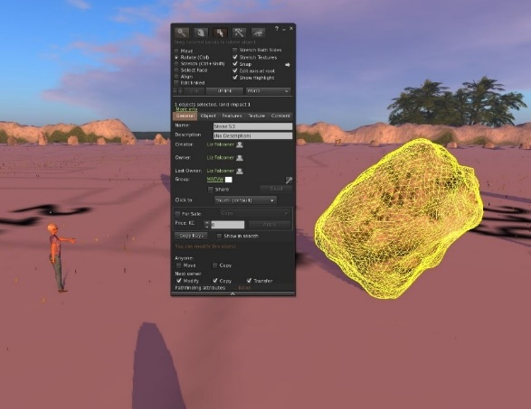
Figure 4. Terraforming Virtual Avebury

The stones
Small pyramid-shaped prims were placed as moveable markers in VA at each of the locations where a stone is currrently understood to have been set at Avebury. Liz then created each of the stones individually as mesh objects in Blender, a 3D modelling programme, and then imported the finished stones to the simulation and placed them according to the positions of the markers. Figure 5 shows how an object created in this manner is a mesh of interconnecting nodes, to which a texture is attached by wrapping to the contours of the mesh. The interface for sizing, orientating and moving the stones in Firestorm is also shown.
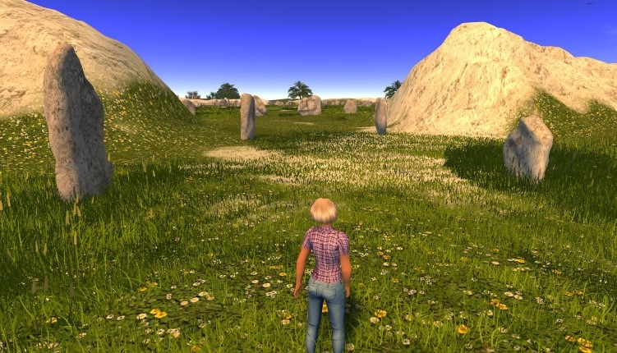
Figure 5. Placing a mesh stone in Virtual Avebury
Regarding the archaeological plausibility of the simulated stones, each simulation of a stone that is still currently standing at Avebury was based upon the shape and texture of the stone in the present day, incorporating any major differences from descriptions by Keiller (Smith, 1965) and Stukeley (1743). Those stones which no longer exist at Avebury, but for which there are dimensions and descriptions by Stukeley, were made according to those descriptions. An example of this is The Obelisk, which used to stand at the centre of the southern inner circle. The remaining stones in the outer and inner circles were consistent with Pollard and Reynolds’ (2002:86) suggestions of the differing characteristics of stones in different areas of the henge. The stones of the West Kennett avenue section were based upon those still standing at Avebury today, and those of the Beckhampton avenue section were replicas of West Kennett Avenue as there is little historical or archaeological evidence of the appearance of the stones along Beckhampton Avenue.

Technical specification for solar settings in Firestorm
Avebury does not have stone arrangements that demonstrate an obvious solar alignment, unike Stonehenge. However, some writers do note the midsummer sunrise orientation of the stones at the centre of the northern inner circle, now known as The Cove (e.g. Pollard and Reynolds, 2002). The Phoenix Firestorm viewer has the facility to change the position of sunrise and sunset from its default of rising dead east and setting dead west. To calculate the settings needed to simulate sunrise at midsummer, Liz used the time of sunrise on 21st June 2016, which was 03:43 GMT. As midsummer and midwinter sunrises and sunsets still produce specific effects at Neolithic sites such as Stonehenge and Newgrange, basing the sun settings in VA upon present day azimuth settings would be reliable, and also have the added benefit of being empirical values rather than projections into the past. Using the online NOAA Solar Position Calculator, the date was entered as 21st June, and the latitude and longitude for Avebury (51.4295N, 1.8530W) and the time of 03:43 GMT were also added. The sun position calculator returned a solar azimuth as 49.29, i.e. the sun’s position on the horizon measured in degrees clockwise from north at that time, location and date. However, the elevation above the horizon at that time was -0.06, so whilst that may technically be sunrise, it would not be visible as rising above the horizon at Avebury due to the hills of the Marlborough Downs in the east. The elevation was therefore adjusted to +1, which made little difference to the time (03:55) and the azimuth setting (51.33). The Firestorm environment pre-set editor enables eastings to be set as sunrise positions, so Liz translated the azimuth setting to an easting percentage (0.895) and saved this as an environmental pre-set. The same method was used to create further pre-sets, including midwinter sunrise and sunset.

The environment and seasons
The environment external to the henge attempted to evoke the Avebury landscape by including hills, valleys, running water and vegetation. The topographical features incorporated were Waden Hill, Silbury Hill, Windmill Hill and the Marlborough Downs, although their scale was not strictly accurate. The Winterbourne stream was also included, but due to restrictions on sim size, it was significantly closer to the henge in virtual Avebury than it is in physical Avebury. Oak, ash and willow trees were placed outside the henge to provide a sense of the mixed woodland that appears to have been present in the late 3rd millennium BCE, with a mosaic of bare chalk, grass, scrub plants and chalkland wild flowers constituting the ground surfaces inside and outside the henge (Whittle, 1997).

Sounds and soundscapes
Sounds in virtual environments can be ambient, or they can come from other participants or particular objects. These could be participant voices or the sound of water trickling down a stream, for example. The sound architecture in VA included both types; the ambient sound formed the foundation for the overall soundscape and was audible from anywhere in the simulation, whereas located sounds and the voices of participants faded or were reinforced depending upon the distance from the source. Sounds and soundscapes in VA were diegetic, i.e. they were contextualized within the virtual space. Therefore, the ambient sounds of VA created an imagined soundscape whose constituent parts would have been audible around 2,200 BCE, comprising roe deer, wolf, buzzard and skylark calls (Serjeantson, 2011) and wind gusts. These sounds were taken from purchased pre-recordings, mixed and formed into a looped recording which was streamed into VA. The flowing water sound for the stream was recorded by Liz and attached as sound files (.wav) to the animated prims that created the effect of flowing water.

Phenomenological method for evaluating virtual Avebury
Phenomenological research is fundamentally descriptive (van Manen 2014), attempting to capture the complexity and ambiguity of life experiences. In this project, we have taken a hermeneutic approach, recognising that archaeology is an area of studies in the humanities. Van Manen (2014: 25) advocates the use of an artistic depth to writing hermeneutic phenomenology narratives, and comments that such a narrative is most effective if readers feels that it is directly addressing them by ‘… stirring our pedagogical, psychological or professional sensibilities’. Todres (2007: 19) advocates approaching phenomenological research as an embodied experience that ‘… evokes lived experience in a lively, engaged way’. The phenomenological section of this chapter is therefore written in the first person present tense, and is a personal narrative of Liz’s experiences on a day in VA.

Phenomenographic method for evaluating virtual Avebury
The emphasis on the researcher’s personal experience in phenomenology made it an appropriate research method for investigating personal, individual experience of VA. However, each member of the group of participants had their own, individual experiences of how both VA and Avebury appeared to them, and this study sought to understand that range of different perspectives. Therefore, phenomenology was not an appropriate method for the participant element of the study and the related methodological approach of phenomenography was used.
A group of 4 students studying the BA(Hons) History with Heritage at a university in SW England were invited to take part in the study. The group experienced 6 hours of exploratory activities in VA in classes on 15th and 22nd February 2017, further activities in their own time and a physical site field trip to Avebury on 1st March 2017. The field trip included the use of mobile devices to bring VA into Avebury, recognising that these are ubiquitous devices and visitors to heritage sites are already being encouraged to use them for guides and interpretive activities. Liz took 3D pictures in Avebury from 12 vantage points and made these available for download to the group. During the field trip, participants had the opportunity to use these pictures on their phones, with Google Cardboard 3D viewers, if they so wished.
Data was gathered from:
observing group interaction during the students’ use of VA over the 2-week period,
a discussion group at the end of the period,
observations during a visit to Avebury in the following week, and
a discussion group at the end of the visit.
Notes and photographs were taken during the VA sessions, the discussion group and the visit to Avebury. A semi-structured, guided approach was used to facilitate the discussions in the groups, emphasising the research questions that related to visual and soundscape experiences, and the sense of place in both VA and Avebury. However, the group facilitator role was as a guide only, as their experiences would be best captured by what emerged from an open discussion, rather than trying to gain specific answers to particular questions. The discussion groups were recorded and Liz transcribed the main points. As this study was an exploration of experiences, an empirical approach was taken to the analysis, as recommended by Miles and Huberman (1994:127), using a conceptually clustered matrix method, i.e., sources of data were initially examined to identify general trends that related to the research objectives, as opposed to the conceptual method where the analyst has some a priori ideas about themes which may emerge. As the focus group was small, a single participant-by-objective matrix was created, which constituted the 4 participants on one axis and the research questions on the other. Data was entered in each of the cells of the matrix in the form of short summary phrases and ratings relating to each participant.. This was an iterative process to assemble initial categories which are adjusted through the analytical process (Entwistle, 1997, Akerlind, 2005). This analysis resulted in the categories of experience discussed in the findings section below.
In terms of the sampling strategy for choosing the phenomenography group, this was essentially opportunity sampling. This method is defined as inviting people from a target population available at the time and willing to take part (Savin-Baden and Major 2013). It is based upon convenience, and has the benefit of being quick and simple. However, the disadvantage is that the sample is unlikely to be representative of a population as a whole. However, this study is a first phase of a larger study planned for the future, and was undertaken as an initial exploration of the categories of experience that might emerge. Although the use of focus groups is uncommon in phenomenography, Glendor and Goransson (2013), Hedman et al (2013) and Weimand et al (2013) demonstrate that this approach can be applicable.

Reliability and validity
Reliability in research usually refers to repeatability of findings, assessing if the instrument being used for the research is likely to give the same results each time it is used. In phenomenological research methods, there is no pre-defined, objective scale that is separate from the researcher’s experience, or from the individual experiences of a group in phenomenographic research. Seamon (2000) argues that the phenomenological researcher’s findings are therefore interpretations rather than repeatable findings, and that reliability is best seen as inter-subjective corroboration, looking to see if other people have experienced similar phenomena in similar ways. Equally, categories of description in phenomenography are also accepted as subjective interpretations which are adjusted through the analytical process (Entwistle, 1997, Ashwin, 2015). Kelly (2002) disputes the application of realist positions of validity to qualitative summaries produced in phenomenography. These issues have been taken account of in this study by specifically incorporating both phenomenological and phenomenographic approaches to avoid the study being only about Liz’s own experience.
Both content and construct validity have been considered during the design and execution of this study. The topics of archaeological interpretation of Avebury, technological issues in the construction of virtual simulations and the appropriate use of phenomenology and phenomenography have provided adequate coverage of the phenomena under study, and the methods chosen are appropriate for measuring what the study set out to measure, as discussed above.

Limitations
The complexity of creating a simulation of a site like Avebury has been discussed above, but the specific limitations of this project fell into 2 categories. Firstly, the technical limitations of the OpenSim platform and Firestorm viewer meant that the size of the sim was restricted to be just large enough to contain the Avebury henge and a narrow strip of land outside it. As a result, the scale of the surrounding hills was not strictly correct. Also, the nearby Winterbourne stream was more than 250 metres too close to the henge in VA for the same reasons of sim space restriction.
The second limitation relates to the size of the focus group that experienced VA. Four people is a small group and is in no way representative of the wide range of people who might experience such a simulation when open for public use. However, phenomenographic methods are concerned with discovering the variety in experience rather than looking for consensus, and so there was no attempt to generalise to theory from this group’s experiences, nor categorise the range of experiences possible in such a simulation. Also, Nielsen and Landauer (1993) developed a mathematical model to establish the cost/benefit ratio for optimum numbers of test users in research into individual experiences of IT systems, and found that the optimum number was between 4 and 5, which adds validity to the sample size used in this study.

Phenomenological findings
This narrative follows van Manen’s recommendation for a first-person dialogue that is aimed directly at the reader. Tilley (2016) states that embodiment is central to landscape phenomenology; that the experience of landscape takes place through the medium of the ‘…sensing and sensed carnal body’. But, as we’ve discussed, in the case of virtual phenomenology the nature of that embodiment is characterised by Kim (2001) as res digitalis, i.e. located somewhere between the physical body and the extended cognition of the imagination. It is with this sense of embodiment that Liz set out to experience VA one day.

Liz’s phenomenological narrative
People and place
It’s a clear, sunny morning, with a blue sky and scudding white clouds. Birds fly overhead; I hear the plaintive call of a buzzard circling above me, and the burbling song of larks as they ascend from the surrounding grasslands. The wind is gusty, carrying the calls of distant roe deer and wolves from the rolling Marlborough Downs to my right. I can see the outside of an enormous banked earthwork in front of me, and tantalising views of stones that appear to lead to an inner area. I set out across the grass and wild flowers, following a path that seems to be used often, judging from the short, trampled grass under my feet. The path takes me by a stream; I hear it babbling gently to my right as I follow it to an avenue of stones, leading to an entrance between two of the banks (Figure 6). I walk through the entrance onto a causeway, and see two dizzyingly deep ditches on either side, which momentarily take my breath away. It’s odd; I know this place well, I made it, but the depth of the ditches always provokes a response of surprise when I walk through the entrances. I keep walking, passing between two stones that tower over my head, and into a wide-open expanse of grassland, enclosed by white-topped banks that recede into the distance. The land slopes up gently, towards two collections of stones in the interior of the circle. But, from this distance, I can’t see any pattern or form in their arrangement. As I turn to my right I see the large sarsen stones that have been placed on the inside perimeter of the ditch, forming an arc that leads to another entrance.
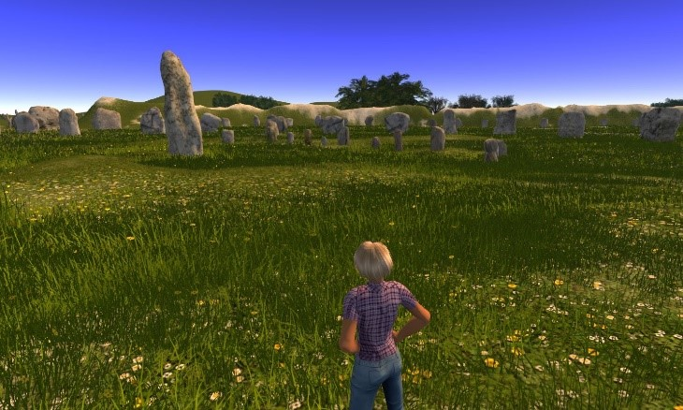
Figure 6. Entering the henge
But this is a strange place. The sun is shining, but I can’t feel its warmth. The wind is blowing but my hair doesn’t move. I can’t smell the grass or flowers. Walking up the slope doesn’t make my knees hurt. And yet I am here. And so are others. I can see them in the distance, two people walking along the path between the collections of stones near the centre. I set off to greet them, walking along the well-trodden trail that leads to the centre of the henge. As I get closer to the central stones I can begin to see more clearly how they form two inner circles surrounding stone settings in the centre of each, and I meet the two visitors who have stopped on the path to look at these circles. We say hello through text chat, and they introduce themselves as historians living in the USA who are taking part in History Month, visiting a range of historical simulations on the Kitely platform. We all have voice capability, so we set up our microphones and chat in person as we walk, enjoying each other’s company and exploring the large stones in the northern inner circle that make up The Cove. They have lots of questions about what Avebury was for, who built it and how it might have been used. I say I don’t know, and that this simulation is an exploration of those questions rather than an attempt to answer them. They seem satisfied, and after swapping contact details and promising to meet again, we part, each of us continuing with our own route around the henge.

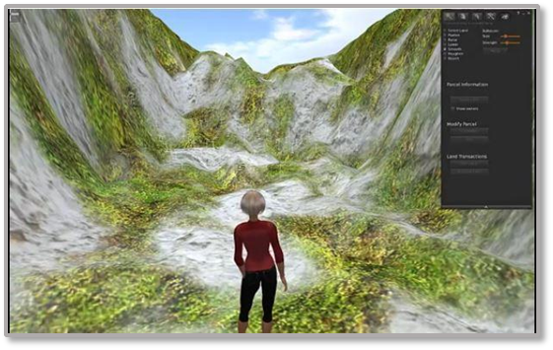
Figure 7. Looking across to The Obelisk
I leave the path and head towards the tall stone in the centre of the southern inner circle, known as The Obelisk (Figure 7). Its presence dominates this part of the henge, and its size is particularly emphasised by its proximity to an arc of the smallest stones in the monument. It reminds me of a sundial; I have no way of knowing if that was its original purpose, but I find the idea thought-provoking. I also recall reading about the apparent alignment of the back stone of The Cove with the midsummer sunrise, which I find a tantalising idea. As the arc of small stones, known as the z-stones, are on the west side of The Obelisk, I wonder what the arrangement would look like at sunrises through the year. This thought leads me to recall a visit to Avebury, and noticing that trees and buildings mask the area to the east of The Obelisk. A practical experiment with a surrogate of equivalent height to the original Obelisk would be unlikely to work at Avebury these days as sunrise would be obscured, particularly during summer months. But I am here in VA, and can control where and when the sun rises, and so decide to carry out some experiments. I begin to feel better about not being able to feel the wind on my face, if I can exchange that experience for the power to control the sun.
Sun and shadow
Standing by the northern stones of the southern circle, I make the change from a bright sunny midday to sunrise at the midsummer solstice. The effect is immediate; the landscape is bathed in a gentle, rosy light, and the stones cast long shadows across the henge. The sun is rising over the bank to my left, and as I scan the top of the banks from east to west, I just catch a glimpse of the top of Silbury Hill, illuminated over the SW bank of the henge. As I walk towards the centre of the southern circle, my shadow moves across the z stones and it’s then that I notice the shadow of The Obelisk (Figure 8).
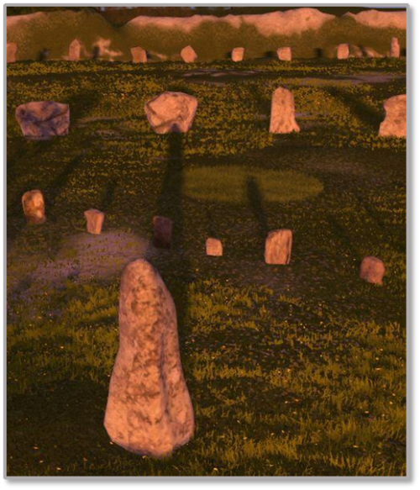
Figure 8. The Obelisk shadow
It obscures the eighth z stone completely, and hits one of the stones in the southern circle, the tip of the shadow forming a point against the flat surface of the stone. I’m transfixed for a while. The shadow fascinates me, so I walk along its length to get a closer view of how it strikes the stone. I turn to face The Obelisk with the stone at my back and move the camera around to see how this looks (Figure 9). I’m transfixed again. I’m aware of some of the pagan and New Age beliefs about Avebury being a site for goddess worship and fertility rites, but this has not been in my mind at all. At least not until now. The symbolism of where the shadow falls is hard to ignore, and while I adhere to Heidegger’s view of contextual meaning, rather than Husserl’s transcendental approach, there is something fundamentally human about the symbolism of fertility and reproduction.
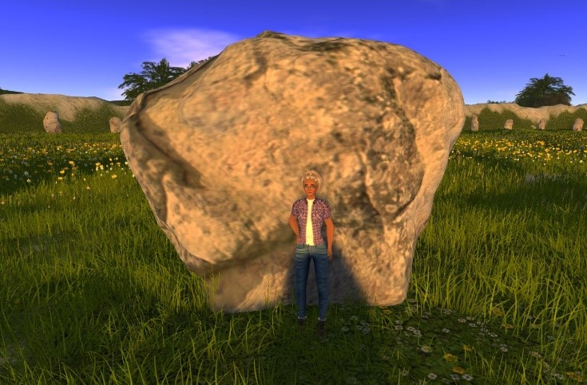
Figure 9. Being hit by the shadow
I start to feel uncomfortable; not because of any prudish dislike of fertility symbolism, but because it doesn’t feel ‘scientific’. And, of course, I may have got the measurements of The Obelisk wrong, which would make a significant difference to the length of the shadow. Maybe it is just coincidence, so I decide to move to the northern circle to see how the sunrise looks there.
As I walk from the southern circle towards The Cove, I’m struck with how evocative and beautiful the henge looks. And this worries me. Have I fallen into the trap of making it too pretty? Is it too complete? How would it feel if it were muddy and messy and partially complete? Is the weather too good? I promise myself to remove some of the wild flowers and change the weather to low cloud and rain on my next visit.

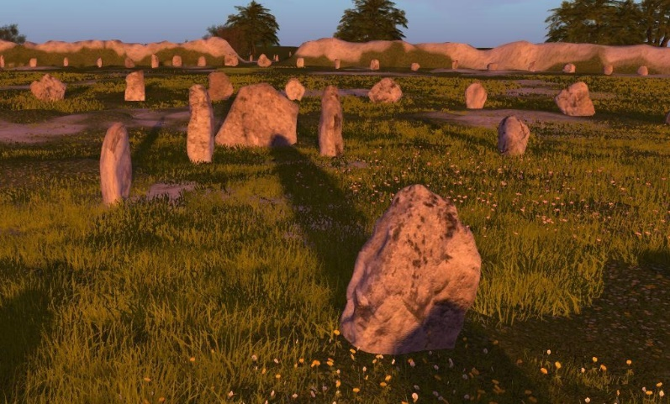
Figure 10. Shadow strike at The Cove
I reach The Cove, and initially I’m struck by the way the sunlight fills it, almost as if the stones are reaching out to capture the light. But then my vague sense of disquiet returns. The shadow of the stone at the mouth of The Cove, now missing at Avebury, enters the Cove and strikes the back stone (Figure 10). It is so reminiscent of The Obelisk shadow striking the stone in the southern inner circle that I begin to feel both excited and distrusting of my own construction. I must have got this wrong. But it isn’t just the position of the shadow strikes; the shapes of the two shadow-struck stones seem to echo each other (Figures 11 and 12). Even whilst making the stones, I hadn’t recognised the similarity. The stones at Avebury show no sign of deliberate working, although some appear to have been used as stone sharpening surfaces before their erection at Avebury, so they were likely to have been chosen for their shape. It strikes me that the effect of the shadows hitting these stones would not only occur on the longest day, but would have persisted for several days around the solstice due to the width of the stones, increasing the chance of a clear morning to experience the sunrise.

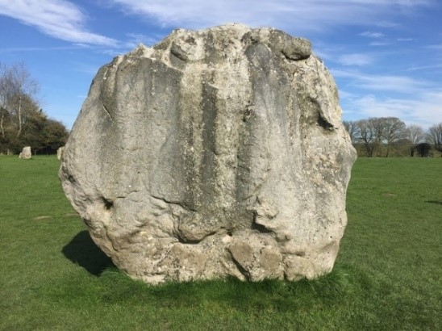
Figure 11. The stone struck by The Obelisk shadow
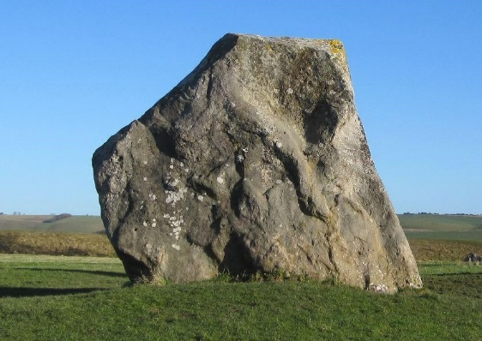
Figure 12. The back stone of The Cove
My time here is drawing to a close. I have things I must do in the other world, but I’m already thinking of the experiments I’d like to do on my next visit. What does the midwinter sunrise look like? And what about the sunsets? Any other dates that might be significant, like the equinoxes or May Day?
I could just close the viewer and leave right now, but I want to walk out of the henge like I walked in. As I stroll back to the path in the middle of the henge, I wonder why I am following paths! It just feels right, in the end. And then I begin to wonder how VA might feel to other visitors…

Phenomenography findings
The phenomenographic analysis centred on the observation, discussion group and focus group data from the four participants. Five different categories of experience that specifically related to the relationship between VA and Avebury emerged from this analysis, viz.
- sense of place in VA
- recall of VA at Avebury
- sense of place in Avebury
- effects of sounds and soundscapes
- sense of Avebury’s original purpose
In this section, each of the five categories are described and discussed in the order shown above, but it is important to stress that this order neither implies nor suggests any structure related to importance or relevance of those experiences. Rather, it echoes the chronological order in which participants experienced VA and Avebury, and how issues emerged during those experiences. Whilst the meaning of each category ‘…resides in the essence of the comments from which the category has been constituted…’ (Entwistle, 1997: 132) it is also synthesised through reference to the observations described in the Methods section above. Each category is described and discussed through a narrative that is supported by a table of the main elements that emerged in that category, and consideration of the similarity of experiences expressed as the range of co-incidence of those experiences, i.e. the difference between the greatest agreement and the least agreement in the category; the highest and lowest n numbers in Tables 2-6.

Category : sense of place in VA
It was noticeable during the observation of classroom sessions (see Figures 13 and 14) that participants had varying experiences of being present at VA and that these experiences developed at different rates. This became more perceptible during the second week of interaction as they began to explore the environment and discuss it as if it were a place. Experimenting with the personalised collaboration facilities in the Firestorm viewer, such as changing time of day, weather conditions and ambient light, led to 3 of the group making comments like ‘…it’s raining here…’ and ‘…the place feels different when it’s sunny…’, demonstrating how VA was beginning to be referred to as a place. One participant did not feel this way, though. He described how he found it hard to feel immersed in VA to any extent and described this as being due to sensory deprivation, specifically not being able to smell or touch anything in a virtual environment.

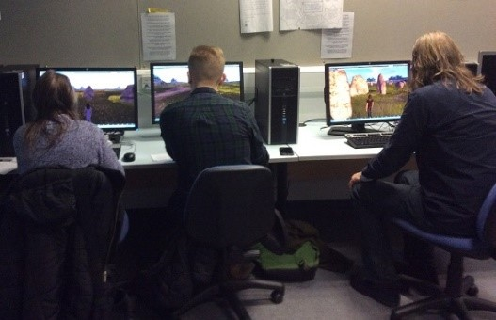
Figure 13. VA in the classroom

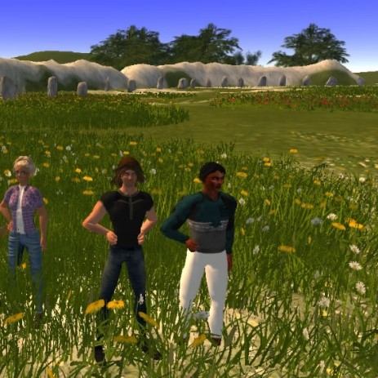
Figure 14. Some of the group in VA
The opportunity for exploration in VA was commented upon by all the participants. Their comparisons between VA and Avebury strengthened the sense that they considered VA as a place in its own right, although the strength of that feeling still varied significantly in individuals. A sense of VA having more meaning as a place in the Neolithic than Avebury was felt by three of the participants. One of the most interesting factors of this sense of place was that it seems to have been a specifically historical sense in comparison to Avebury today. Whilst Avebury felt more real to all of the group, VA felt more archaeologically faithful, although one participant remained less sure about experiencing this sense of history, feeling that the lack of a full sensory experience prevented him having a strong experience.
Table 2 demonstrates that the range of co-incidence of the experiences in this category was 1, i.e. moderately narrow.
Elements | n
Freer to explore in VA | 4
VA concentrates on vision and hearing so less immersive than Avebury | 4
Shifted perspective in VA (camera behind head) detracts from 1st person feeling | 4
Overall, VA has more meaning as a place in the Neolithic than Avebury | 3
Table 2. Elements of ‘sense of place in VA’ category

Category : Recall of VA at Avebury
All 4 members of the group commented that they could recall VA in Avebury at the beginning of the field trip visit, but this effect was significantly heightened when 3D photographs of VA were viewed through mobile phone (cell phone) viewers at equivalent vantage points at Avebury (see Fig 15). This method of mixing the virtual and physical experiences as a method of orientation in Avebury was commented upon by three participants, particularly as a means of overcoming the sightline restrictions at Avebury today.

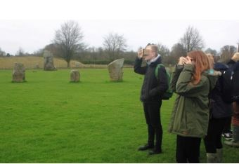
Figure 15. Viewing VA at Avebury
The differential sense of scale in VA compared to Avebury was commented upon by all the group, and there seemed to be much co-incidence in their experiences of this. The stones in Avebury felt larger than in VA, the henge in VA felt larger than in Avebury and the avenues felt about the same in both places. The lack of sensory perception in a virtual world viewed on a screen was felt to be a major drawback in experiencing a sense of place, particularly on visiting the physical environment upon which the simulation is based and feeling the comparison between the two. Although some parts of Avebury felt more immersive than VA, three members of the group said they felt restricted in Avebury. Part of this feeling appeared to be due to restricted sightlines and physical barriers in Avebury henge, along with the current restrictions on accessing parts of the ditches and banks due to erosion prevention. In contrast, the view across VA henge is unrestricted and participants have access to all parts of the VA simulation. As well as the visual aspects, activities that the group had shared in Avebury evoked memories of VA, such as walking together from the henge along part of the West Kennett Avenue and climbing the banks to gain a better view of the henge as a whole.
Table 3 demonstrates that the range of co-incidence of the experiences in this category was 1, i.e. fairly narrow.
Elements | n
VA henge feels bigger than Avebury henge | 4
VA avenues feel same size as Avebury avenues | 4
Google cardboard a useful orientation device in Avebury | 4
Recall of VA led to a sense of relative restriction in Avebury | 3
Some parts of Avebury more immersive than VA | 3
Memories of walking in VA avenues resurfaced when walking in Avebury avenues | 3
Table 3. Elements of ‘recall of VA at Avebury’

Category : Sense of place in Avebury
A conspicuous phenomenon during the visit to Avebury was how individuals seemed familiar with the site. This observation was born out by the discussion in the focus group, where all members commented that they experienced a sense of familiarity. Two of the members of the group had last visited Avebury several years ago, and two had never visited the monument or the surrounding landscape. All four commented upon experiencing a sense of orientation that was greater than they would have felt from studying a map prior to the visit. They also commented that they felt a greater sense of presence in Avebury than they felt in VA, but the strength of that sense varied in individuals. The sense of size and mass of the large stones at Avebury, such as those at the southern entrance, appeared to be one of the phenomena that didn’t transfer well into the virtual environment.
Three of the group commented that they did not experience a strong sense of Avebury as an ancient place because of the houses and roads, and 1 of the 3 felt that the houses detracted from the ability to really get any sense of how ancient the Avebury monument is. This participant described the houses as grand and overpowering, and also made the comment that Avebury village is itself a tourist destination, with attractions such as The Manor and parish church confusing the historical context for visitors. These experiences appeared to result from experiencing VA without modern-day constructions.
Table 4 demonstrates that the range of co-incidence of the experiences in this category was 3, i.e. moderately broad.
Elements | n
Familiarity with Avebury even though haven't been there | 4
Stronger sense of 'being' in Avebury due to using all human senses | 4
Greater sense of scale in Avebury - don't get sense of largeness of stones in VA | 4
Overall Avebury has more sensory immersive quality then VA | 4
Low sense of historical immersion in parts of Avebury due to houses, roads etc | 3
Avebury buildings detract from the sense of the Neolithic | 3
Avebury village is place to visit in its own right | 3
Avebury buildings seem 'out of place' | 2
Avebury buildings 'grand' and 'overpowering' | 1
Presence of houses etc took away from feeling of the stones | 1
Table 4. Elements of ‘sense of place in Avebury’

Category : Sounds and soundscapes
The sounds of modern-day life dominate Avebury; the roads are busy and the village is a year-round visitor destination. During the summer months, light aircraft fly from a local airfield and flocks of sheep frequently graze the henge. With the possible exception of some sheep, none of these sounds would have been likely constituents of a Late Neolithic soundscape; despite this, one of the group commented that when looking through the Google cardboard viewer at a 3D picture of VA, he became more aware of the kinds of sounds he remembered from the VA soundscape such as gusting wind and buzzard calls. Interestingly, this extended to sounds that did not feature in the VA soundscape such as general birdsong, the effect appearing to be a heightening of sensitivity to the soundscape in general rather than recalling particular sounds. This is notable as, during observations of the groups’ activities in VA, the soundscape did not seem to feature as a point of discussion and superficially appeared to have little effect on their experiences. This suggests that virtual world soundscapes may operate on a subtler level than visual stimuli, and this is an interesting area for future research.
Another member of the group commented that she noticed the way voices changed when people were standing inside the Cove stones; how the sound appeared to reverberate and be directed out from the stones into the northern circle. This led the group to discuss how sound and soundscapes in virtual environments add an important dimension to an otherwise predominantly visual experience. Three members of the group commented that they would like to have more depth of sound in VA, including subtler directional and reverberation effects, which would begin to overcome the ‘sensory deprivation’ experiences commented upon by some of the group.
Table 5 demonstrates that the range of co-incidence of the experiences in this category was 2, i.e. moderate.
Elements | n
Noticed sound in Avebury and would be good to have more sound depth in VA | 3
Became more aware of Avebury soundscape when looking through Google Cardboard | 1
Table 5. Elements of ‘sounds and soundscapes’

Category : Sense of Avebury’s purpose
All the group agreed that they felt that ‘…something had happened…’ at Avebury in the Late Neolithic period. They did not feel that Avebury was a defensive structure. Although they knew the ditch would normally be on the outside of the bank in a defensive structure, unlike at Avebury, they also felt that it wasn’t a place of defence. One member of the group did ask if there had ever been water in the ditch, as the notion of a defensive moat had crossed his mind because of the depth and steep-sidedness of the ditches in VA. Three of the group commented that the Avenues in VA gave them a strong sense of being guided to the henge rather than away from it, and this sense persisted in Avebury. However, no member of the group had any particular view as to whether what happened there might be viewed as positive or negative. Two participants did comment that they felt it was a place for spectators and the banks were for viewing, as both in VA and Avebury the best views of the henge as a whole were to be had from the tops of the banks. One member of the group said that the banks in both VA and Avebury reminded him of a Roman amphitheatre, although he did not feel that the same kinds of activities would necessarily have taken place there.
Table 6 demonstrates that the range of co-incidence of the experiences in this category was 3, i.e. moderately broad.
Elements | n
Avebury Doesn't feel defensive as a structure | 4
Felt like some imporant event happened at Avebury | 3
Avenues make you feel guided in both Avebury and VA | 3
Felt like banks were for viewing | 2
Asked if ditch was filled with water e.g. moat | 1
Banks in VA and Avebury reminded of Roman amphitheatre | 1
Table 6. Elements of ‘sense of Avebury’s purpose’

Discussion and thoughts on further research
The process of planning VA gave Liz pause to consider the type of planning that may have taken place for various phases of the Avebury monument. Barret (1994) argues that Avebury developed in stages over a period of 1,000 years or so, and therefore there was probably no long term overall plan. As a result of this study, we would argue that, whilst Avebury may well have evolved over time, building a virtual simulation of a site might change our view of the type of planning necessary for the phases of such a structure. Constructing a roughly circular ditch and bank system requires forward thinking and resource planning in a virtual environment and in the physical world. The restrictions on movement and equipment in a virtual world require more planning in the form of trial and error than would normally be carried out in a modern construction project. An example of the synergy between constructing a virtual simulation and building such a structure in the physical world was demonstrated to Liz when she read about a ditch and bank system discovered at Avebury (Pitts and Whittle, 1992) that is underneath the main henge, and may have been a test ditch before building the final one; Liz read about this finding after she had terraformed the ditches and banks at VA, and was struck by how similar it was to the process of sinking a shallow ditch and bank in the virtual world from a greyscale map, before terraforming the final ditches and banks. Further research might explore the affordances of virtual environments to provide test-bed environments for different approaches to planning and constructing simulations of ancient sites.
The phenomenological approach to archaeology tends to stress the importance of the archaeologists’ senses, working through their physical presence in a landscape to enable an appreciation of the materiality, or physicality, of an environment (Tilley, 2016). In this study, phenomenology was applied to the experience of a virtual environment where sight and hearing senses are restricted, and some such as smell and touch are deprived altogether. As Kim (2001) points out, this sensory deprivation is further compounded by the person being in two places at once; the physical world and the virtual world. So, the immersion of all the body’s senses in a landscape, to the exclusion of all other experiences, cannot be achieved. However, we would argue that the phenomenological narrative describing Liz’s experiences has demonstrated that experiencing a landscape from an archaeological point of view can be achieved in a virtual environment, but that the nature of the experience is different to that in the physical world. The ability to experiment with designing landscapes, to change environmental aspects in simulations of places that could not otherwise be experienced, and to meet with others in those places to discuss, explore and experience them together, has the potential to offer a new practice of phenomenology in archaeology, and in virtual worlds research. Future research might extend these ideas to virtual simulations of a range of landscapes and undertake comparative studies of phenomenological approaches to understanding them.
A phenomenographic method was used to explore the range of experiences of members of the small evaluation group. Phenomenography does not appear to be used in archaeology at present, where the major focus appears to be on individual, personal experiences of landscapes rather than looking to widen the experience base by appreciating the range of experiences that people can have in the same landscape. One of the major criticisms of the use of phenomenology in archaeology has been the attempt to project personal experience back in time to understand how people who lived then might have experienced the landscape. Phenomenography is a method that takes account of differences in experience, moving the emphasis from one person to understanding ranges of experience, and exploration of its applicability to archaeology research would be a beneficial area for further research. The technique is little-recognised in virtual world research too, and we would argue that the same considerations of how users of virtual worlds have a range of experiences, rather than researchers trying to locate a consensus of opinion, would result in an even richer research base than exists at present.

Acknowledgements
We would like to thank Aaron Griffiths for his enthusiastic help and support in the technical aspects of the construction of virtual Avebury, and Dr Corinne Roughley, Dr Josh Pollard and Dr Mark Gillings for their advice and guidance on the archaeological aspects of the simulation.
This chapter is partly drawn from a dissertation written by Liz Falconer in part fulfilment of the requirements of the Advanced Diploma in Archaeology at Cambridge University, U.K.

References

Akerlind, G. (2005) Ways of Experiencing Being a University Researcher. In: Bowden, J.A. and Green, P. (Eds) Doing Developmental Phenomenography. Melbourne: RMIT
Ashworth, P. and Lucas, U. (2000) ‘Achieving Empathy and Engagement: A practical approach to the design, conduct and reporting of phenomenographic research’, Studies in Higher Education, 25(3), pp. 295–308.
Barnard, A., McCosker, H. and Gerber, R., (1999) ‘Phenomenography: A Qualitative Research Approach for Exploring Understanding in Health Care’, Qualitative Health Research, 9(2), pp.212–226.
Barrett, J. C., (1994). Fragments from Antiquity: An Archaeology of Social Life in Britain 2900-1200 BCE. Oxford: Blackwells.
Barrett, J. C. and Ilhong K., (2009). A phenomenology of landscape A crisis in British landscape archaeology? Journal of social archaeology, 9 (3), 275.
Berg, K., Arestedt, K. and Kjellgren, K. (2013) ‘Postoperative recovery from the perspective of day surgery patients: A phenomenographic study’, International Journal of Nursing Studies, 50(12), pp.1630–8.
Biörn Hasselgren, B. and Beach, D. (1997) Phenomenography — a “good‐for‐nothing brother” of phenomenology? Outline of an analysis, Higher Education Research and Development, 16 (2), pp 191-202
Boellstorff, T., (2008). Coming of Age in Second Life: an anthropologist explores the virtually human. 1 edition. Woodstock, Oxfordshire: Princeton University Press.
Bower, M., Lee, M. J. and Dalgarno, B., (2017). Collaborative learning across physical and virtual worlds: Factors supporting and constraining learners in a blended reality environment. British Journal of Educational Technology, 48 (2), 407-430.
Brück, J., (2005). Experiencing the past? The development of a phenomenological archaeology in British prehistory. Archaeological dialogues, 12 (01), 45.
Cibangu, S. K. and Hepworth, M., (2016). The uses of phenomenology and phenomenography: A critical review. Library & Information Science Research, 38 (2), 148-160.
Crane, N., (2016). The Making of the British Landscape: From the Ice Age to the present. London: Weidenfeld & Nicholson.
Creswell, J. W. and Clark, V. L. P., (2011). Designing and Conducting Mixed Methods Research. Thousand Oaks, California: Sage.
Earl, G. and Wheatley, D., (2002). Virtual reconstruction and the interpretative process: a case study from Avebury. In: Wheatley, D., Earl, G. and Poppy, S., eds. Contemporary Themes in Archaeological Computing. Oxford: Oxbow Books, 5-15.
Entwistle, N., (1997) ‘Introduction: Phenomenography in Higher Education’ Higher Education Research and Development, 16(2), pp. 127–134.
Exon, S., Gaffney, V., Woodward, A. and Yorston, R., (2000). Stonehenge Landscapes:journeys through real and imagined worlds. Oxford: Archaeopress.
Falconer, L., (2013). Situated learning in virtual simulations: Researching the authentic dimension in virtual worlds. Journal of Interactive Learning Research, 24 (3), 285-300.
Farina, G., (2014). Some Reflections on the Phenomenological Method. Dialogues in Philosophy, Mental and Neuro Sciences, 7 (2), 50-62.
Forte, M., (2014). 3D Archaeology: New Perspectives and Challenges—The Example of Çatalhöyük. Journal of Eastern Mediterranean Archaeology and Heritage Studies, 2 (1), 1.
Gillings, M., (2005). The real, the virtually real and the hyperreal; the role of virtual reality in archaeology. In: Smiles, S. and Moser, S., eds. Envisioning the past: archaeology and the image. London: Wiley-Blackwell, 223.
Giorgi, A. (1999) ‘A phenomenological perspective on some phenomenographic results on learning’, Journal of Phenomenological Psychology, 30 (2), pp. 68-88.
Goel, L., Johnson, N. A., Junglas, I. and Ives, B., (2011). From space to place: Predicting users' intentions to return to virtual worlds. MIS quarterly, 35 (3), 749.
Gustafson, P., (2001). Meanings of place: Everyday experience and theoretical conceptualizations. Journal of environmental psychology, 21 (1), 5-16.
Harris, L. (2011) ‘Secondary teachers’ conceptions of student engagement: Engagement in learning or in schooling?’ Teaching and Teacher Education, 27(2), pp.376–386.
Harrison, S. and Dournish, P., (1996). Re-place-ing space: the roles of place and space in collaborative systems. , pp67–76, ACM conference on Computer supported cooperative work (pp. 67-76).
Heeter, C., (1992). Being There: the subjective experience of presence. PRESENCE: Teleoperators and Virtual Environments, 1 (2), 262.
Houliez, C. and Gamble, E., (2013). Dwelling in Second Life? A phenomenological evaluation of online virtual worlds. Virtual Reality, 17 (4), 263.
Ingold, T., (2009). Against Space: Place, Movement, Knowledge. In: Kirby, P. W., ed. Boundless Worlds: an anthropological approach to movement. 1 edition. New York: Berghahn Books, 29.
Jelfs, A. and Whitelock, D (2000) The notion of presence in virtual learning environments: what makes the environment “real” British Journal of Educational Technology, 31 (2) pp. 145–152
Johnson, M., (2010). Archaeological Theory: an introduction. 2nd edition. Chichester: Wiley-Blackwell.
Jones, Q., (1997). Virtual‐Communities, Virtual Settlements & Cyber‐Archaeology: A Theoretical Outline. Journal of Computer‐Mediated Communication, 3 (3), 0.
Kim, J., 2001. Phenomenology of Digital-Being. Human Studies, 24, (1-2), pp. 87-111.
Knabb, K. A., Schulze, J. P., Kuester, F., DeFanti, T. A. and Levy, T. E., 2014. Scientific Visualization, 3D Immersive Virtual Reality Environments, and Archaeology in Jordan and the Near East. Near Eastern Archaeology (NEA), 77 (3), 228.
Linds, W., (2006). Metaxis: dancing in the in-between. In: Cohen-Cruz, J. and Shutzman, M., eds. A Boal Companion: dialogues in theatre and cultural politics. New York: Routledge, 114-124.
Malpas, J. E., (1999). Place and Experience: a philosophical topography. Cambridge: Cambridge University Press.
Marton, F. (1981). Phenomenography ‐ describing conceptions of the world around us. Instructional Science, 10: 177–200
Marton, F., (1994). Phenomenography. In: Husen, T. and Postlethwaite, T. N., eds. The International Encyclopedia of Education. Oxford: Pergamon.
Marton, F. and Booth, S. (1997) Learning and Awareness. New York: Routledge
Merleau-Ponty, M., (2012). Phenomenology of Perception. London: Routledge.
Miles, M. B. and Huberman, A. M., (1994). Qualitative Data Analysis. 2nd edition. Thousand Oaks, California: Sage.
Morgan, C., (2009). (Re)building Catalhoyuk: changing virtual reality into archaeology. Archaeologies - Journal of the World Archaeological Congress, 5 (3), 468.
Morse, J. M., 2003. Principles of mixed methods and multi-method research design. In: Tashakkori, A. and Teddlie, C., eds. Handbook of Mixed Methods in Social and Behavioural reseach. Thousand Oaks, California: Sage, 189-208.
Munck, B., Sandgren, A., Fridlund, B., and Mårtensson, J. (2012) ‘Next-of-kin’s conceptions of medical technology in palliative homecare’, Journal of Clinical Nursing, 21 (13-14), pp.1868–77.
National Trust, (2003). 2003 Geophysical Survey [online]. Swindon: National Trust. Available from: https://archaeologynationaltrustsw.files.wordpress.com/2013/03/avebury-geophysical-survey1.pdf [Accessed 22nd April 2017].
Paakkari, L., Tynjälä, P. and Kannas, L. (2011) Critical aspects of student teachers’ conceptions of learning, Learning and Instruction, 21, pp.705–714.
Pierdicca, R., Frontoni, E., Zingaretti, P., Malinverni, E. S., Colosi, F. and Orazi, R., (2015). Making Visible the Invisible. Augmented Reality Visualization for 3D Reconstructions of Archaeological Sites. Augmented and Virtual Reality. Springer, 25.
Pitts, M. and Whittle, A., (1992). The development and date of Avebury, Proceedings of the prehistoric Society (Vol. 58, pp. 203-212): Cambridge Univ Press.
Pollard, J. and Reynolds, A., (2002). Avebury: the biography of a landscape. Stroud: The History Press.
Reilly, P., 1990. Towards a Virtual Archaeology. In: Lockyear, K. and Rahtz, S., eds. Computer Applications in Archaeology. Oxford: British Archaeological Reports, 133.
Relph, E., (2008). Place and Placelessness. 1 edition. London: Sage.
Richardson, J.T.E., (1999) ‘The Concepts and Methods of Phenomenographic Research’, Review of Educational Research, 69(1), pp.53–82.
Säljö, R., (1997) 'Talk as Data and Practice — a critical look at phenomenographic inquiry and the appeal to experience', Higher Education Research and Development, 16(2), pp. 173–190.
Savin-Baden, M. and Falconer, L., (2016). Learning at the interstices; locating practical philosophies for understanding physical/virtual inter-spaces. Interactive Learning Environments, 24 (5), 991-1003.
Savin-Baden, M. and Major, C. H., (2013). Qualitative Research: the essential guide to theory and practice. Abingdon: Routledge.
Seamon, D., (2000). A Way of Seeing People and Place: phenomenology in environment-beaviour research. In: Wapner, S., Demick, J., Yamamoto, T. and Minami, H., eds. Theoretical Perspective in Environment Behaviour Research. New York: Plenum.
Sequeira, L. M. and Morgado, L. C., (2013). Virtual archaeology in second life and opensimulator. Journal For Virtual Worlds Research, 6 (1).
Serjeantson, D., 2011. Review of Animal Remains from the Neolithic and Early Bronze Age of Southern Britain (4000-1500 BC). Portsmouth.
Smith, I. F., (1965). Windmill Hill and Avebury: excavations by Alexander Keiller 1925-1939. Oxford: Clarendon Press.
Stukeley, W., (1743). Abury, a temple of the British druids, with some others described...Volume the second. 1 edition. London: Gale ECCO Print Editions.
Svensson, L. (1997) 'Theoretical Foundations of Phenomenography', Higher Education Research and Development, 16(2), pp. 159–171.
Tiainen, T., Ellman, A., Katajamäki, T., Kaapu, T. (2006) Occasional Users’ Experience on Visiting in a virtual environment. In: Proceedings of Tenth IEEE/ACM DS-RT, pp.63-69.
Tigchelaar, A., Vermunt, J.D. and Brouwer, N. (2012) ‘Patterns of development in second-career teachers’ conceptions of learning and teaching’, Teaching and Teacher Education, 28(8), pp.1163–1174
Tilley, C. Y., (1994). A Phenomenology of Landscape: places, paths and monuments. Oxford: Berg 3PL.
Tilley, C., (2005). Phenomoenological Archaeology. In: Renfrew, C. and Bahn, P., eds. Archaeology: The key concepts. London: Routledge, 201.
Tilley, C., (2016). Interpreting Landscapes: Geologies, topographies, identities. London: Routledge.
Todres, L., (2007). Embodied enquiry: phenomenological touchstones for research, psychology and spirituality. AIAA.
Trigwell, K. (2000). Phenomenography: Variation and Discernment. In C. Rust (Ed.), Improving student learning. Proceedings of the 1999 7th International Symposium (pp. 75-85). Oxford, UK: Oxford Centre for Staff and Learning Development
Turner, P. and Turner, S., (2006). Place, sense of place, and presence. Presence: Teleoperators and Virtual Environments, 15 (2), 204.
van Manen, M., (2014). Phenomenology of Practice: meaning-giving methods in phenomenological research and writing. Abingdon: Routledge.
Watson, A., (2001). Composing Avebury. World Archaeology, 33 (2), 296.
Watterson, A., (2015). Beyond digital dwelling: Re-thinking interpretive visualisation in archaeology. Open Archaeology, 1 (1), 119.
Weimand, B.M, Hall-Lord, M.L. Sällström, C. and Hedelin, B. (2013) ‘Life-sharing experiences of relatives of persons with severe mental illness - a phenomenographic study’, Scandinavian journal of caring sciences, 27(1), pp.99–107.
Welham, K., Shaw, L., Dover, M., Manley, H., Parker Pearson, M., Pollard, J., Richards, C., Thomas, J. and Tilley, C., (2015). Google Under-the-Earth: Seeing Beneath Stonehenge using Google Earth-a Tool for Public Engagement and the Dissemination of Archaeological Data. Internet Archaeology, 40.
Whitelock, D., and Jelfs, A. (2005) 'Would you rather collect data in the rain or attend a virtual field trip? Findings from a series of virtual science field studies', International Journal Of Continuing Engineering Education and Lifelong Learning, 15, 1/2, p. 1, Supplemental Index

Corresponding Author email address: efalconer@bournemouth.ac.uk

