*Table 1. Price setting institutions in Burkina Faso, Mozambique and Tanzania*

|  |  |  |  |
| --- | --- | --- | --- |
|  | **Burkina Faso** | **Mozambique** | **Tanzania** |
| Administered price | yes (fixed price) | yes (minimum price) | yes (indicative price) |
| Panterritorial & panseasonal price | yes | yes | yes |
| Linked to world price | yes | yes | yes |
| Announced prior to planting | yes | yes (since 2007) | no |
| Announced/Adjusted prior to harvesting | no | yes, but no downward revision yet | yes, but subject to changes |
| Secondary payment after marketing | yes | no | no |
| Stabilisation fund | yes | no | no |
| How is price set? | Negotiated within  interprofessional  committee (government, cotton companies and farmers) | Negotiated  between  government, cotton companies and farmers | Negotiated between government, cotton companies and farmers |

Source: Adapted from Tschirley et al. 2009.

*Figure 1. Open positions (left axes) and share of financial investors (right axes) in ICE cotton futures and options*

Source: CFTC.

Note: Until 2006 data on commercial and non-commercial traders was reported with the large share of index investors/swap dealers being part of the commercial trader category. Hence, the share of non-commercials under represents the share of financial investors. From 2006 onwards, swap dealers and money managers have been reported separately which are jointly shown in the financial investor category.

*Figure 2. ICE futures prices, export prices and producer prices (cotton lint price, US$/tonne)*

Source: ICE; Export prices from UN Comtrade; Producer prices from MAFAP, FAO (compared with national sources - UNPCB in Burkina Faso, TCB in Tanzania and IAM in Mozambique); Exchange rate from WDI.

Note: The export price value for 2003 is unrealistically low for Mozambique – hence, we excluded it from the analysis; A conversion factor from seed cotton to cotton lint of 0.42 was assumed for all countries; Marketing year based on season in Burkina Faso.

*Figure 3. Timing of producer price setting in Burkina Faso, Mozambique and Tanzania*

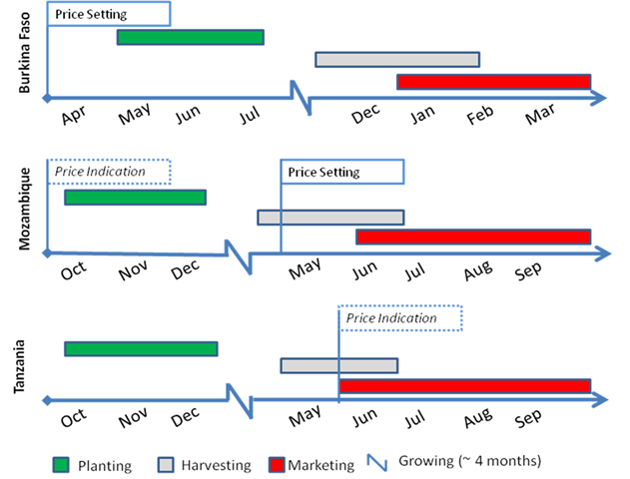

Source: Own elaboration based on Mwinuka/Maro (2012) for Tanzania, ITFC-IDB (2014) for Burkina Faso, and Textile-in-depth (2009) for Mozambique; and World Cotton Calendar (ICAC 2015b).

Note: In Tanzania cotton is produced in Western and Eastern zones with the former accounting for up to 99% of production. Dates are therefore only shown for the Western zones.

*Figure 4. Intra-seasonal price risk and PRM ability for farmers and cotton companies*

**Ability to mitigate price risk**

**Exposure to price risk**

high

high

low

low

Trader-owned ginners MOZ

Local ginners MOZ

Producers TAN

Producers MOZ

Producers BF

Trader-owned ginners TAN

Local ginners BF

Local ginners TAN

Trader-owned ginners BF

Source: Own elaboration.