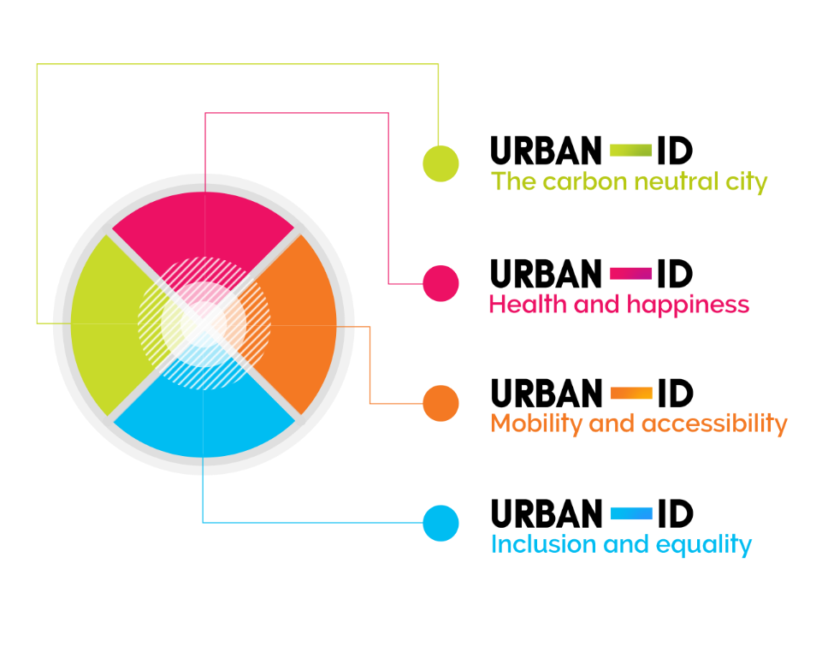

Bristol Urban Integrated Diagnostics Project Case Study Report.

**The role of neighbourhood in the health and happiness of older people**

**Report Authors**

Dr Tom Calvert. Centre for Sustainable Planning and Environments, Centre for Transport and Society, University of the West of England. Email: thomas2.calvert@uwe.ac.uk

Dr Michael Buser. Centre for Sustainable Planning and Environments, University of the West of England. Email: michael.buser@uwe.ac.uk

Professor Katie Williams, Centre for Sustainable Planning and Environments, University of the West of England. Email: Katie4.Williams@uwe.ac.uk

**Acknowledgement**

This report comprises a case study for a programme of research entitled the Bristol Urban Integrated Diagnostics Pilot Project.

The authors would like to acknowledge the support of South Gloucestershire Council (including Page Park walks team) and Bristol Health Partners.

**Disclaimer**

The views and recommendations expressed in this report are solely those of the authors, and do not necessarily represent those of the project team as a whole, or the project funders.

Contents

Executive Summary 6

1 Introduction 8

1.1 Health and Happiness 10

2 Research Methodology 11

2.1 Overview 11

2.2 Case study 11

2.3 Review of Quantitative data analysis and policy 11

2.3.1 Limitations of extant data on Staple hill 11

2.3.2 Older people 12

2.3.3 Quality of life in Staple Hill, including for its older residents 13

2.4 Site visits 14

2.5 Workshop 14

2.6 The neighbourhood context understood from workshop 18

2.6.1 Definitions of happiness gained from workshop 18

2.6.2 Neighbourhood context understood from workshop 18

2.7 Walking Interviews 21

2.8 Dissemination within the community 23

2.9 Conceptual model 23

2.10 Summary 24

3 Research Analysis & Findings 25

3.1 Mobility 25

3.2 Nature 28

3.3 Social capital and community 29

3.4 Sustainable Staple Hill 32

3.5 The neighbourhood as a resource for health and happiness 33

3.6 Next Steps 34

4 Evaluation of Integrated Diagnostics Framework 35

4.1 Evaluation of Co-production 35

4.1.1 Co-production with project partners 35

4.1.2 Co-production with the Staple Hill residents 35

4.2 Evaluation of Systems Thinking 36

4.3 Evaluation of the Challenge Theme Framework 36

5 Conclusion & Recommendations 37

5.1 Conclusions & recommendations relating to case study learning 37

5.2 Conclusions around challenge themes and the Integrated Diagnostics framework. 38

6 References 39

Annex A Challenge Theme Definitions (draft) 42

Annex B List of annotations added to workshop maps 44

Annex C Walking interviews questions/ prompts 48

# Executive Summary

This case study examined factors affecting the health and happiness of older residents in Staple Hill. It also yielded insight into the other challenge themes. The research, which was qualitative in nature, was primarily achieved through a workshop, and 13 walking interviews, with older residents in the ward. Other stages of the research included examination of extant quantitative data, site visits and dissemination of findings within the community. Staple Hill was chosen as: containing varying deprivation levels, representing a type of neighbourhood that has been under-researched, and including a recently regenerated Park. Older residents were chosen as a focus of the case study as census data showed a higher than average percentage of older residents in the ward. Examination of existing quantitative data on the ward suggested that there was a gap in information regarding the psychological well-being of Staple Hill’s older residents. This is in a context of South Gloucestershire Council noting predicted increases in percentages of older residents and thus wishing to understand and address the independence, health, social isolation and general needs of these citizens.

Findings centre on five themes including mobility, relations with nature, social capital, sustainable neighbourhood design and the role of the neighbourhood as a resources for health and happiness. These are briefly introduced below.

Our examination coheres to other research on the importance of **mobility** and suggests it is very influential for the happiness of older residents. Factors affecting mobility can include environmental factors such as poor paving and bad lighting, but also include wider psychosocial factors such as positive attitudes, and the presence of encouraging, motivating friends.

The local park is a key destination for older residents in the neighbourhood. This demonstrates the importance of **nature** for older residents. The park provides multi-faceted interest for residents. However, the high quality of green infrastructure inside the park is not mirrored elsewhere in the neighbourhood, suggesting an incomplete and inequitable provision of this important aspect of urban life.

An examination of **social capital and community** suggested that the plethora of social opportunity in Staple Hill, including informal and unorganised encounters and meeting places, should particularly be protected where possible, especially in the context of real or perceived changes happening in the neighbourhood. More organised events for older residents are often under-attended, and whilst reasons for this remain a mystery some explanations are explored, including a decreasing sense of community-mindedness.

Staple Hill was found to be an exemplar, for some older residents, in providing walkable accessibility to a wide range of services and destinations. This accessibility has concomitant benefits for environment, personal health but also happiness, leading to a **sustainable Staple Hill**. Wide concepts of accessibility are relevant in the area because places where people socialise spread beyond organised social events, to include shops, bus shelters and the streets generally.

The above findings would lead to a summarising conclusion that neighbourhoods form an influential and complex **resource for the health and happiness** of older residents.

The case study shows very clearly important links between the four challenge themes, with mobility and accessibility being particularly vital to the other three. Two additional themes that the study suggests are important would be nature, and the psycho-social life of individuals.

The case study benefitted from co-produced aspects, particularly with project partners (Bristol Health Partners, South Gloucestershire Council) and participants who helped shape and direct the walking interviews, and who in the workshop grounded the researchers’ understandings of the geographical neighbourhood and relevant meanings of happiness. The nature of the research allowed substantial good will to develop between participants and researchers, increasing potential for further research in the future.

The findings suggest that in the neighbourhood a range of intermediary individuals serve to link older residents with the local authorities. These individuals range from confident, vocal older residents and members of local trade organisations, to the (very locally engaged) local councillors. The study suggests that in neighbourhoods like Staple Hill, such intermediaries should be valued as key assets in effective co-production between resident and authority.

The idea of systems working together, to create a system of systems greater than its parts was understood qualitatively in the study. For example, it was seen that environmental factors enabling mobility for older people need to be coupled with positive motivation issuing from the individual or motivating friends. As another example, some participants relied on a combination of means of transport that enabled them good access to their neighbourhood and Bristol more generally.

The concept of resilience was important in the data, particularly in the context of real or perceived neighbourhood change (types of shops changing, gentrification etc.) The concept of agency was also important, with a particular emphasis on interdependence and the important role, again, that intermediary individuals within the neighbourhood play in forming communication channels with the authorities active in the area.

Different actors within the research process encountered different learning experiences during its course. The researchers transitioned from having an external, quantitative understanding of the neighbourhood, to becoming more grounded in the experience of some of those who live within it. Participants themselves learnt or relearnt some of the meaning the neighbourhood has for them, through the process of their walking interviews. The study also revealed that generally, in the neighbourhood, much learning of local information occurs through word of mouth, via informal social networks (although these networks are not always effective, as shown by the lack of awareness many participants had of the neighbourhoods Air Quality Management Area.)

The case study reveals the important ways in which neighbourhood and individual interact, influencing the individuals’ happiness. Specific recommendations for policy makers are derived. The study also highlights the important links between Urban ID’s four project themes, in the case of older residents.

# Introduction

Staple Hill was chosen as the location for a case study as it represented a type of suburban neighbourhood that is less researched than others such as city centres or inner cities. The ward was also chosen as analysis of national deprivation data (South Gloucestershire Council, 2015a) suggested great variety in the levels of deprivation between the ward’s four Lower super output areas. In 2013 Staple Hill was considered a ‘priority neighbourhood’ with challenges in health, crime, employment and education. In addition to varying deprivation, the neighbourhood includes one of Bristol’s air quality management areas (AQMA) (an area that has been prioritised as having poor air quality). Another feature of the area, considered of potential interest was Page Park, a greenspace that had recently been awarded £2.1M of lottery and other funds for regeneration aimed at increasing community use. Staple Hill sits entirely within the area of Bristol that is the remit of South Gloucestershire Council, and thus offered the opportunity to work closely with these partners. It is located in the far North East of Bristol. As shown in figure 1.

Figure 1: Staple Hill’s geographical location (shown in red)



The case study was informed by the project’s regular management meetings where a range of team members from across the project could comment on the direction and shaping of the research.

The main non-academic partners involved in the shaping of the case study were Bristol Health Partners and South Gloucestershire Council. Bristol Health Partners attended project management and case study meetings, and supported the direction for the case study that the case study research team proposed. South Gloucestershire Council’s priority for the case study was that it should be of practical value to the authority.

The case study was conducted in two phases. A workshop was conducted on 12th June 2017. This workshop informed a subsequent series of 13 individual walking interviews (the majority of these being with older Staple Hill residents.) These were conducted between the 3rd and 29th July 2017, and formed the main body of data collection.

Due to the importance to the case study of the neighbourhood’s characteristics, a focus on the neighbourhood, external to residents’ homes was decided upon. This focus would also be particularly well explored by the walking interviews.

Health and happiness was the primary project theme addressed by the case study. Older people were identified, through extant quantitative data and site visits as a key subgroup to focus on. Focusing on this cohort leant itself to examining questions pertaining to the other challenge themes: around Inclusion and Equality, and also Mobility and Accessibility (Carbon Neutrality was less obviously linked to the case study, although older people and car dependency could be one link for future examination).

Interdependency is an interest of the overall Urban ID project. The concept of interdependency, was applied qualitatively in the research design: The Staple Hill neighbourhood would be explored as a system of different interacting factors that would come together to influence the happiness of older residents. This concept would prevent the analysis from simplistic assumptions of one isolated cause in the environment leading to happiness or unhappiness.

Agency and resilience are also foci in the overall project. Agency has been defined as factors, including psychosocial elements, which enable people to respond to (often adverse) change (Brown and Westaway, 2011). One definition of resilience is that it is formed by, at the level of community or individual, a recognition of available strengths and the employment of agency, organisation, and a wide range of psychological, social and practical tools. This recognition and activation can then address and withstand challenges and changes (Berkes & Ross, 2012).

For the case study then, agency and resilience could be examined in a number of ways: The first is how much ownership older residents feel they have over their neighbourhood, and how much power they feel they have to bring about positive change in it. Resilience could be examined in terms of coping with change. One source of change that would be commonly experienced by older Staple Hill residents would be the changes the individuals experience as they grow older. Another source of change in the area is the changing demographic profile, as the area is becoming gentrified, with house prices rising sharply in some areas.

Another overarching concern of the Urban ID project is co-production. Co-production seeks to empower individuals besides researchers, including those being ‘researched’, to engage with and help form the research process. This means that the experiential knowledge of people, other than the researchers, can be drawn upon in the design and implementation of the research (Beebeejaun et al., 2011). As will be discussed in the methods section, the Staple Hill case study included elements of co-productive process. These included workshop attendees creating their own understanding of what constituted and defined ‘happiness’ and ‘older person’, and also the participants leading the walking interviews that constituted the main data collection.

## Health and Happiness

The case study sought primarily to address the Health and Happiness theme. (The case study team also led this theme). The main focus of the research was placed on happiness rather than physical health. This reflects a gap in extant knowledge about framing older people’s condition in terms of ‘happiness’ although substantial work around older people’s well-being exists. The focus on happiness was also chosen due in part to Happy City’s, (an organisation seeking to measure happiness as an indicator of cities’ success,) finding that although Bristol scored very well for happiness levels, in comparison to eight other core cities in England, it came only fifth for equality of happiness across the city (Happy City Index, 2016). Specific drivers that Bristol scored poorly on were ‘quality of work’ ‘mental health’ ‘safety’ and ‘housing’ and ‘interpersonal relations’. The qualitative, open ended nature of the research design would be likely to raise issues of physical health in conjunction with happiness.

# Research Methodology

## Overview

The process by which this study arrived at its focus progressed by a number of steps. Having decided on case studies as the means of addressing the Urban ID’s project aims, the wider project team chose Staple Hill as one such case study. Once chosen the neighbourhood was initially examined in light of relevant extant quantitative data. Following a review of this data, the researchers used site visits to observe, and gain impressions of, the neighbourhood. A workshop with older residents, and people associated with this group, furthered a grounding within the neighbourhood for the researchers. The workshop also helped to explore key concepts for the study. Following this, walking interviews formed the main method for data collection. After data collection and analysis, some dissemination of findings back into the community took place. The following section explains these steps in more detail.

## Case study

A case study approach was chosen for the wider Urban ID project as a way of providing reasonable scope for examining elements within Bristol’s sustainability. The case study approach would also allow for combinations and interactions of challenge themes to be examined in the chosen studies. Staple Hill was useful as it lay in the remit of South Gloucestershire Council, and represented a less commonly researched type of neighbourhood.

## Quantitative data analysis and policy

During the early stages of the case study, a number of relevant datasets were examined in relation to the health and happiness of Staple Hill residents. These included national level investigations of happiness (Happy City Index, 2015, 2016,) mapping tools of 2011 Census and other data (South Gloucestershire Council, 2017a, 2017b,) council documents that touched on well-being issues (South Gloucestershire Council, 2014, 2016a, 2016b, 2016c), information relating to deprivation (Department for Communities and Local Government, 2015, South Gloucestershire Council, 2015a) information relating to the Air Quality Management Area (Department for Environment Food & Rural Affairs, 2016) and one source that was a profile of Staple Hill as a ‘priority ward’ in need of improvements (South Gloucestershire Council, 2013).

### Limitations of extant data on Staple hill

Although there were a number of existing datasets that touched upon the well-being of Staple Hill residents, these were limited in a number of ways: The evidence available was often quantitative and survey-based in nature, there were no detailed data on the psychological well-being of Staple Hill residents, although the ward did feature in quality of life surveys conducted by South Gloucestershire Council (2016a). The extant datasets were also limited by the fact that they were created at a Council level. This means that Staple Hill was often compared to other South Gloucestershire wards, many of which are rural, rather than perhaps more illuminating comparison to all wards in the Bristol urban area.

Another limitation of extant datasets were they told different stories according to the scale at which the data was analysed. For example, the ward as a whole is considered to have significant deprivation issues. However, at the lower super output area (LSOA) level, analysis of national deprivation (South Gloucestershire Council, 2015a) suggested great variety in the levels of deprivation between the four LSOAs that comprise Staple Hill, with one LSOA not suffering from significant deprivation, one suffering a middling level, one being quite deprived and the fourth being in the worst national quintile for Index of Multiple Deprivation (IMD), income deprivation, employment deprivation, education, skills and training and living environment deprivation. Living environment deprivation was formed of measures of indoor conditions (central heating, housing condition, meeting Decent Homes standard etc.) and outdoor conditions (air quality, road traffic incidents injuring cyclists or pedestrians,) (South Gloucestershire Council, 2015a). Thus quantitative data gave different pictures according to scale of analysis.

### Older people

Demographic data suggested older people might be a key group to study in the area. 2011 Census data indicated that Staple Hill had a higher than average proportion of residents who were older than 65. In the ward, 9.2% of residents were ages 65-74, compared to 8.7 nationally. There were an even higher percentage of ‘older old’ in the ward, a percentage of 10.2% compared to 7.8% nationally. This data indicates that in recent decades Staple Hill has had a substantial group of older residents. An online Interactive health map, which maps determinates of health, suggests that in Staple Hill 38% of those over 65, lived alone, the highest proportion of any ward in the South Gloucestershire area (South Gloucester Council, 2017a). Mid-year estimates by the Office of National Statistics suggest that there has been a small 1% drop in the number of Staple Hill residents who are 60+, from 2011 to 2016. (Taken from unpublished South Gloucestershire Council source that was based on Office for National Statistics data (Office for National Statistics, 2017) (It should be noted that the data this is based on is estimated, and does not have the accuracy of Census data.)

These high levels of older people sit within a context where in South Gloucestershire as a whole, the percentage of people over 75 years old is predicted to increase by 47% by 2030. The percentage of people over 85 is predicted to increase by 153% by 2030 (South Gloucestershire Council, 2016b). South Gloucestershire Council (2016b) also suggested that whilst the number of residential care home beds available to older people in the council area totalled around 1500, by 2030 around 2400 such beds would be needed (South Gloucestershire Council, 2016b). Thus, in response to their study South Gloucestershire Council (2016b p.552) made the following recommendations:

* ‘Commission public health programmes that increase the number of older people who can lead independent, healthy and active lives and include evidence based approaches to prevent frailty.’
* ‘Provide information and advice about services to older people to facilitate and promote independent living and reduce social isolation.’

The Council concluded: ‘It would be useful to better understand the needs of older people in South Gloucestershire and share this understanding across all agencies commissioning and delivering services for these groups’ (South Gloucestershire Council, 2016b).

### Quality of life in Staple Hill, including for its older residents

South Gloucestershire Council (2014, 2016a, 2016b, 2016c) periodically conduct ‘Viewpoint’ surveys that touch on quality of life issues in the area. These reports do not contain sufficient numbers of respondents from Staple Hill, as an individual ward, to be statistically reliable. For this reason, the reports group together the six ‘priority’ (priority for action) wards in South Gloucestershire and compare them to the non-priority wards. Some of the reports’ findings also disaggregate findings by working age against non-working age. These two disaggregations of data are both relevant to the group of older residents living in Staple Hill. However, the data should be viewed with the qualification that the survey panel is advertised as an ‘opportunity to become involved in, and influence, the decisions the council and its partners make.’ (South Gloucestershire Council, 2017c). Thus, the survey may be self-selecting to a degree, by attracting people who would be interested in feeding into council decisions, and thus not perfectly representative.

The surveys indicated some issues and challenges for the happiness of those in Staple Hill. Respondents in the six priority wards in South Gloucestershire including Staple Hill were significantly less likely to feel they have as much social contact as desired with liked people, than those in the other South Gloucestershire wards reported (75% compared to 85%) [South Gloucestershire Council, 2016a]. There were gender differences in South Gloucestershire as a whole, with females more likely to have as much social contact as desired.

Respondents in the priority wards, including Staple Hill were significantly more likely to disagree with ‘feeling optimistic about their future’ compared to the non-priority wards. (In priority wards 14% disagreed, compared to non-priority wards 8%) (South Gloucestershire Council 2016c).

Residents in the priority wards, including Staple Hill, were more likely to never have used the internet (41% compared to 25% in the non-priority wards). Residents of non-working age in South Gloucestershire generally (including those above 65) were also more likely to have never used the internet (43% compared to 6% of those of working age) (South Gloucestershire Council, 2016c). Thus, both in terms of being older people and in terms of living in the ward, the case study target group would be less likely to use the internet.

However, extant data suggests there are also some happiness benefits of being an older person, A South Gloucestershire Council (2014) survey indicated that a higher percentage (51%) of respondents aged 65+, said they spend their time doing things they value or enjoy, compared to respondents aged 25-34 (23%). The same survey indicated that those of non-working age, including the retired were more likely to offer help or support to their neighbours, either daily or weekly than those of working age (44% compared to 26%). Those of non-working age were also more likely to report having received help from others, either daily or weekly (38% compared to 21%).

The data sources explored above suggested high proportions of older people living in Staple Hill, in a context where large increases in older people are predicted for South Gloucestershire in general in coming decades. They also suggested that the happiness of people in older people in Staple Hill was under researched. The Viewpoint surveys indicated some challenges for happiness for older people in Staple Hill, but also some advantages for this age group.

The quantitative data suggested varying levels of deprivation within the ward. The data available painted different pictures according to the scale at which it was aggregated, and also usually compared Staple Hill to other South Gloucestershire wards, many of which are rural, rather than the rest of the Bristol Urban area.

## Site visits

Having decided, amongst the wider project team, on Staple Hill as a case study, the case study team made four site visits to the neighbourhood. These included trips to explore Staple Hill on foot, to make observations, and to become acquainted with the atmosphere and ambience of the neighbourhood. It was noted on one site visit that, during the daytime, there were large numbers of older people walking, often accompanied by a younger person, in the the high street and adjacent area. One site visit was a guided walk led by Merlin Housing Society, a home provider active in the area.

Having surveyed what extant data was available, as summarised, and having made site visits to the area, a workshop was devised to ground the researchers in a preliminary understanding of ‘happiness’ and ‘older people, in the context of Staple Hill.

## Workshop

The workshop’s aims were to:

* gain insight into the lives of older people in Staple Hill with respect to Health and Happiness
* identify key resources for older people in Staple Hill
* identify deficiencies or challenges associated with both physical and social elements of the area.
* build connections with older people in the area for ensuing in-depth research.
* refine what we meant by ‘happiness’ and ‘older people’ in our research.

The workshop was conducted in Staple Hill library, a location easily accessible to many in the ward. It was attended by older residents of Staple Hill, people who work with or who are associated with this group, and two local councillors. In total 18 people attended. Attendees sat grouped around tables. The workshop had a format in which overall discussion with everyone present was interspersed with exercises and discussions undertaken by smaller groups around tables. The workshop contained two activities, in addition to informal chats. The first of these was a happiness affinity mapping exercise. Attendees individually took a few minutes to write words on post-it-notes that represented ‘happiness’, and then ‘older person’ to them. Having completed this they placed the post-it-notes on large sheets and grouped them by themes and categories. Each table of attendees then examined one sheet of post-it-notes and developed, from the sheet, a definition of ‘happiness’ and/or ‘older person’. These definitions were then fed back into a discussion with the workshop as a whole. Thus a co-productive element of this workshop lay in the creation of definitions of these concepts by residents themselves.

The second exercise was a mapping exercise using large maps of Staple Hill. As shown in figure 2. Using these maps, table groups identified places in Staple Hill that contributed positively to their happiness. These sites were identified using sticky coloured dots and annotations on post-it-notes. Attendees also identified places that limited or hindered their happiness and well-being. After this exercise, members of the group summarised the overall themes developing on the maps to the workshop as a whole. Thus, a preliminary understanding of issues and locations important to older Staple Hill residents was defined by the residents.

The mapping exercise contained an implicit element of systems thinking, as it invited participants, in a minimally guided manner, to consider the wide range of features in Staple Hill and how these interacted with their happiness.

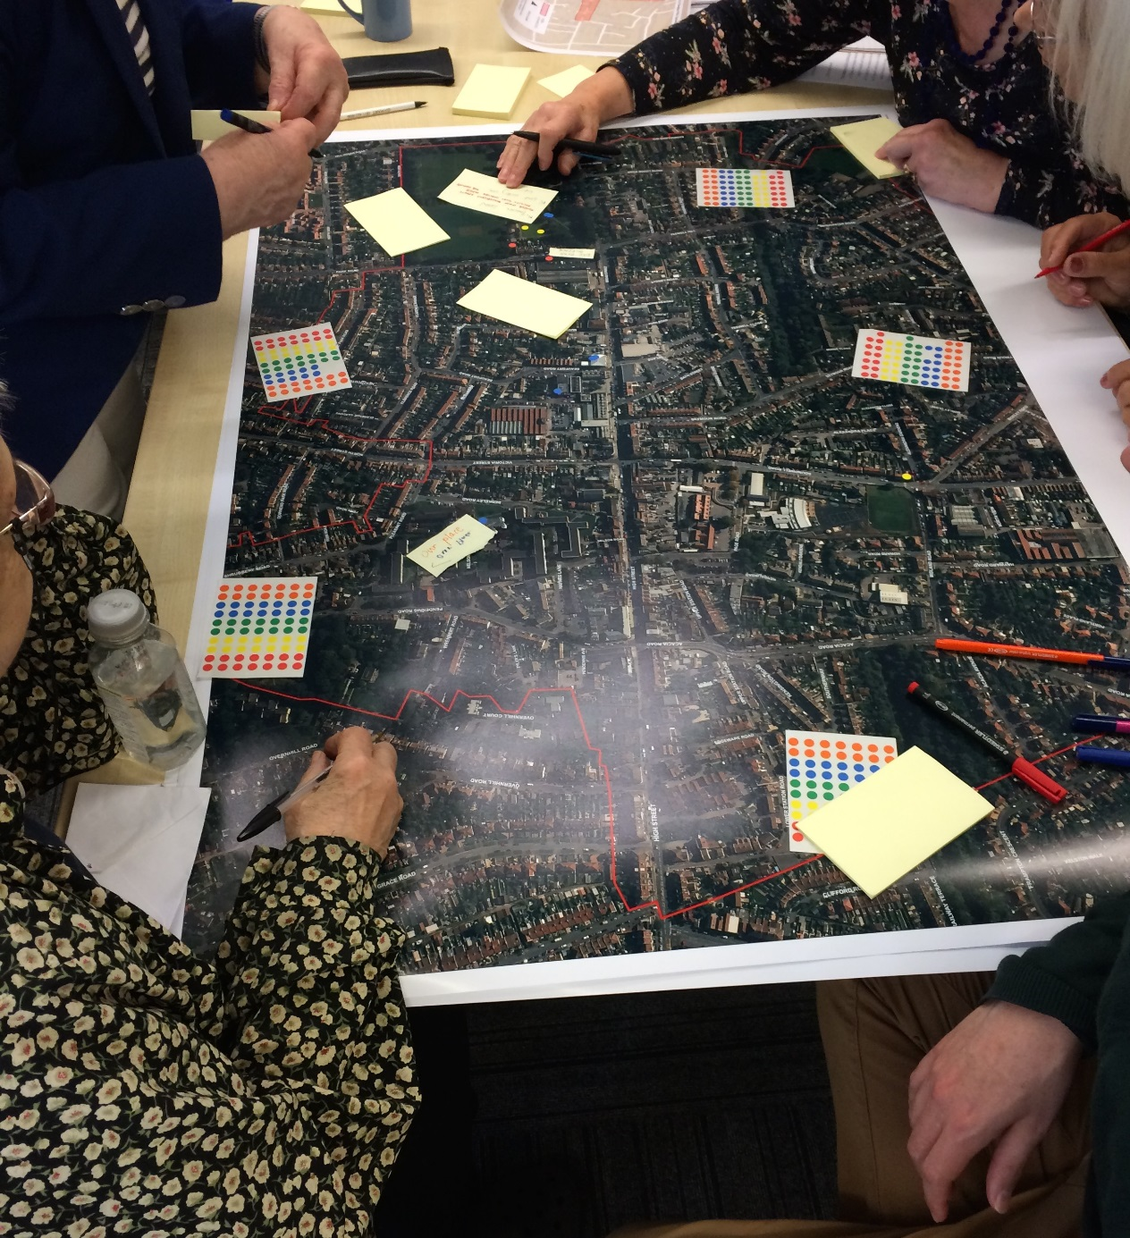Figure 2: Workshop attendees annotating a map

A source of verification of the data would be the comparison of what information was presented at the workshop, with the information gained from the subsequent walking interview phase of data collection.

The workshop involved input from project partners: the group facilitating the event, both in terms of practical arrangements and on-the-day facilitation of discussions included Oliver Watson from Bristol Health Partners, and Alice Jennings from South Gloucestershire Council.

**Figure 3: Annotated map**

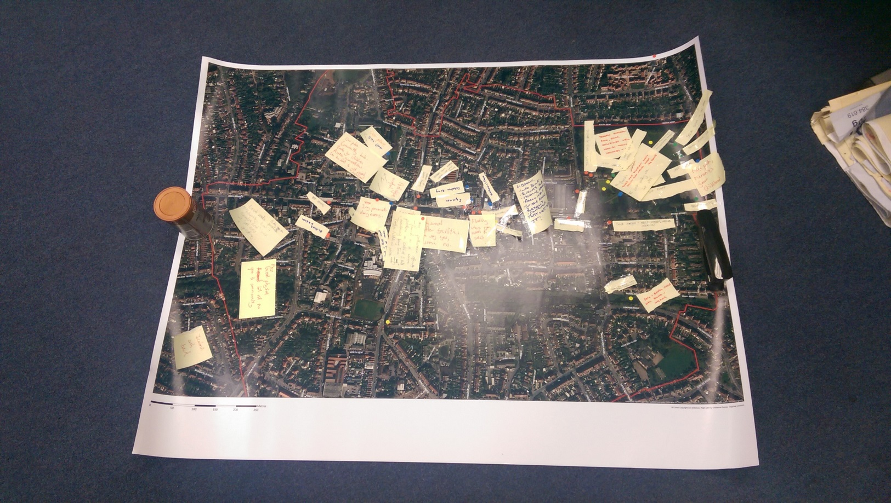

The workshop was not audio recorded, in order to keep an informal feel to the event. Thus data issuing from the workshop were mainly contained in the physical sheets of paper and maps and research team notes. Two important outcomes of the event were contacts with older local residents and various professionals relating to this group, and also a degree of mental ‘grounding’ in the Staple Hill area for the researchers. Data were analysed using thematic analysis (Braun and Clark, 2006) by the case study team.

Attendees of the workshop seemed to generally enjoy the event. The maps and mapping exercise particularly aroused enthusiasm, with the majority of participants becoming engaged in this task. There were some instances of dissatisfaction expressed with the workshop. Two attendees were overheard expressing the opinion that the workshop had been misrepresented to them. However, these attendees did become more enthusiastic when working on the maps. Another attendee expressed concern in the overall discussion at the end of the gathering that the research might be another occasion that would explore issues of local concern without leading to practical action and benefit. In general the researchers had to be clear, both at this workshop and at the subsequent walking interviews that we could not promise practical action following the findings we gained.

## The neighbourhood context understood from workshop

### Definitions of happiness gained from workshop

The workshop gave the researchers an awareness of Staple Hill and its older residents on which the narratives of the walking interviews would develop. Workshop attendee definitions of happiness primarily stressed the importance of knowing, and communicating with, other people. Friendship and friendship groups, a sense of belonging, having good neighbours (both long-time local people and newcomers could be valued), lunch clubs, and community events were all cited as important to happiness. Some groups, such as community groups, can act as family. Actual family, and having them nearby, was also often considered important, although sometimes family are working and are only available at weekends.

Neighbourhood communication, being able to find out what was going on locally, by word of mouth or leaflet drops, was considered important. The personal communication brought about by modern technology was viewed with ambivalence. Attendees were not clear whether social media helps or hinders real communication. It was felt sometimes to be an obsession that hinders face to face communication. Technological communication can be inclusive, but only for those people who have it. Again then there was an emphasis on face to face contact.

Health was also commonly considered vital for happiness. Good health can enable mobility and the ability to engage with activities. Whilst the emphasis from the workshop mainly seemed to be on interdependence with other people, remaining active and independent was also valued. Feeling useful, wanted and needed could be important to happiness. Getting outside for shopping and other outings was considered beneficial, with some suggesting that features of their neighbourhood were important to their happiness.

### Neighbourhood context understood from workshop

The three maps from the three workshop tables showed different distributions of dots/annotations (indicating significant neighbourhood features) on the maps. This may be due to group dynamics on the tables and the different foci for the task that developed on each table. Map 1 showed most dots on Page Park and along the High street. Virtually all the dots on Map 2 were along, or near to, the High street. Dots on Map 3 were much more diffuse, spread throughout the neighbourhood area shown in the map and with less emphasis on the High Street and Page Park.

In total there were 98 dots or annotations added to maps in the mapping exercise, of which just over a third were negative in nature and two thirds either positive or neutral descriptions. Figure 4 shows a rough distribution of these comments in four different aspects of the neighbourhood. The research was not intended to gain quantitative data and should not be taken as such. The figure does however give rough indication of the focus of interest of participants in the mapping exercise. It can be seen in the figure that there were 19 dots or comments placed on Page Park and these were mainly positive or neutral. The largest number of dots and comments centred on the High Street, a larger proportion of these were negative, than for the park. A large number of comments also related to elsewhere in the neighbourhood (neither park nor High Street), with roughly half (the largest proportion) of these being negative in nature. This might hint (but not substantially prove) that Page Park and High Street are commonly thought of as important parts of the neighbourhood and that the Park is generally held in positive esteem, with the High Street and the rest of the neighbourhood being less esteemed.

Figure 4: showing distribution of dots and annotations throughout neighbourhood

*Many of the positive or neutral comments gave no indication of positivity or negativity but were simple labels such as ‘Library’ or ‘Shared use path’.

Annex B gives a list of the short annotations that participants added to the maps, using post-it notes. Comments on Page Park included a number of lists of the sports facilities there. Not all of these would be used by older people and this suggests participants’ concern in the neighbourhood went beyond the interests of their own generation. Some comments summarised memories associated with the park, including ‘Memories from childhood’ and ‘Met husband.’

**Figure 5: Page Park**

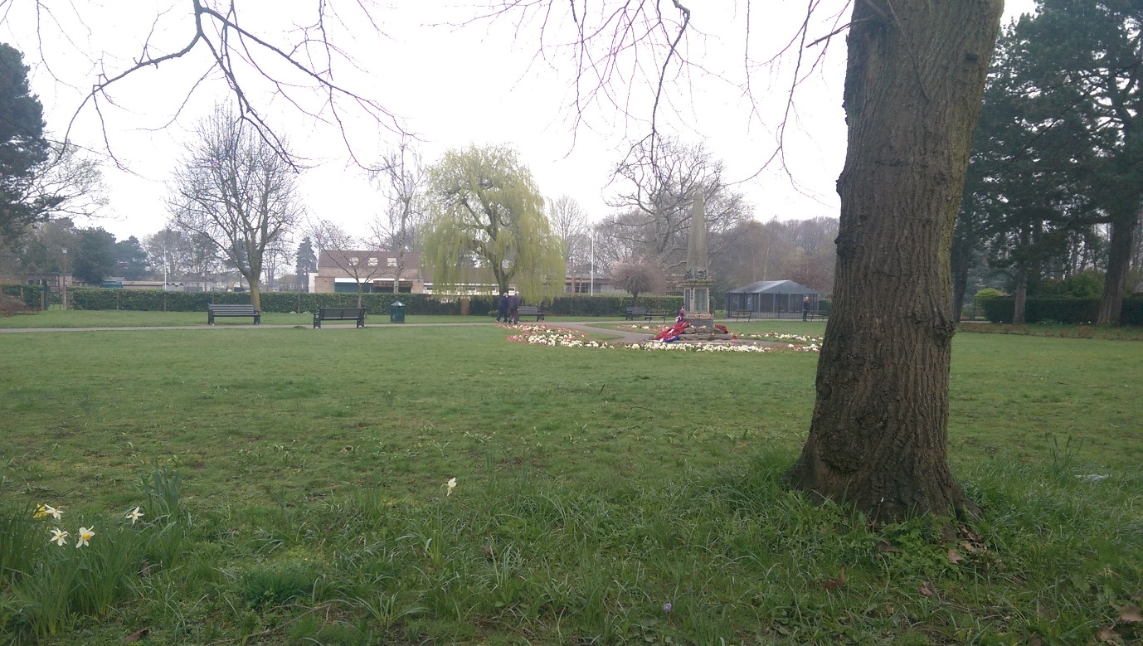

Comments on the neighbourhood High Street were mixed. A number of practical problems for walking were highlighted, including bad paving, icy pavements, dangerous cyclists, difficulty crossing, lack of toilets and insufficient lighting. Opinions on the High Street shops differed. Some liked the independent shops, one felt the street provided for most needs, and was friendly and busy. Others suggested the shopping streets had lost their ‘local’ feeling, and that shopping options needed to improve.

There were a range of annotations to the remainder of the neighbourhood. The shared use Bristol to Bath path attracted mixed views. There were also a cluster of comments around the Pendennis estate, the most deprived area of Staple hill. These included negative comments about insufficient police presence, poor parking, rats, changing demographics in the flats that had previously been only for older people, and potholes. Comments also highlighted a community flat facility in the Pendennis estate, which hosts events and groups.

**Figure 6: Pendennis Estate**

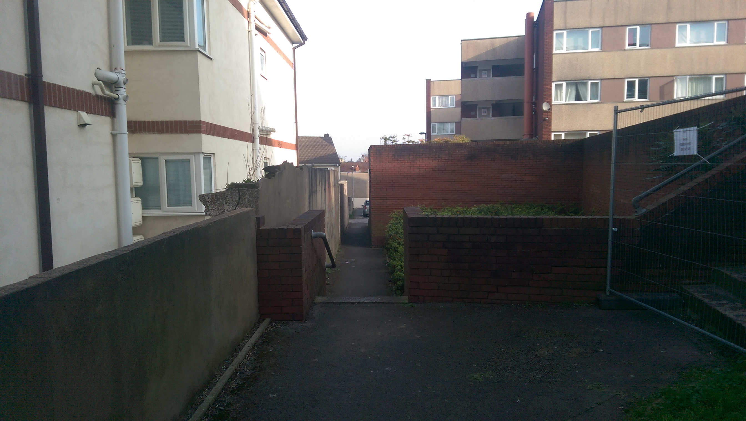

Across the neighbourhood there were references to crime and police presence, the latter sometimes being considered insufficient. Changing demographics and increasing house prices in Staple Hill in general were also noted. There were concerns about changing demographics in Staple Hill due to gentrification. Some felt increasing house prices might change both the feel of the area and community cohesion. There were related worries about costs of rent rising.

The workshop provided then a basic layout of concerns in the area, and a context for understanding older residents’ happiness. A key understanding gained from the mapping exercise was that Page Park and the High Street were key places of interest for participants. Another understanding gained was that there were both negative and positive associations with Staple Hill, and that some specific sites were viewed positively by some residents but negatively by others.

## Walking Interviews

Following the workshop the case study team decided walking interviews would form the main body of data collection for the study. This method would enable older participants to physically lead the researchers in quotidian routes that they took in the neighbourhood. A strength of walking interviews is that they provide more sensory prompts to thought and conversation than a room interview might. It has been remarked that the method is in effect a three way conversation, between the interviewer, the interviewee and their surroundings, surroundings that can contribute their own input, sometimes interrupting or provoking discussion (Moles, 2008). Walking interviews have additionally been found to provide rhythmic movement that can aid reminiscing and can inspire conversations (Anderson, 2004). The method can produce a ‘more collaborative’ and less ‘interrogative’ interview encounter (Anderson, 2004, p.260). The walking interviews might also provide interesting details in highlighting any practical problems the participants had with walking outdoors in the ward.

A co-productive element of the walking interviews was the leading role that the participant took, in determining the route of the walk, and also, to some degree, the topics of conversation.

Thirteen walking interviews were conducted with older residents. Two of these were with local councillors who have extensive contact with older residents in the area. The majority of walking interviews lasted from between 45 and 75 minutes. One interview was changed, on the day of the interview, to an indoor interview, as the participant expressed discomfort with walking, some others encompassed periods sitting down outside, for the comfort of the participants. An ad hoc arrangement made in some of the interviews was that the interviewer and participant would join an organised group of older people who regularly walk around Page Park, and then stop for a cup of tea. This represented a regular quotidian walking experience for some participants.

Recruitment of participants was achieved through the connections the case study team had made in the area, through the workshop and other contacts. Snowball sampling was effective with participants, particularly on the Page Park walks or who lived in sheltered accommodation adjoining the park, introducing the researchers to other potential participants, sometimes during an interview. An unfortunate result of this is that more participants were recruited from the more affluent Page Park area of Staple Hill, than from the more deprived Pendennis Road area. An advantage of the Snowball sampling was that the researchers, introduced by participants to their friends, became trusted and well-known amongst the older people surrounding Page Park. This held importance for gaining frank and open interviews.

A rough schedule of questions was prepared for the walking interviews (see Annex C). (However, the researchers gave themselves, and the participants, significant leeway in which to explore the topic of happiness in Staple Hill). This schedule was informed by the workshop, which had suggested topics that could be explored in the interviews.

The interviews were audio recorded by lapel mics, feeding into digital Dictaphones. Some participants expressed some mild unease at the idea of being recorded, but all were willing.

In general, the attitudes of participants towards the walking interviews were very positive. All of the participants were forthcoming with ideas and comments on their neighbourhood. The majority of participants found plenty to talk about in relation to Staple Hill and their happiness.

The data were analysed using Thematic Analysis (Braun and Clark, 2006). There were both inductive and deductive elements in the analysis (Braun and Clark, 2006): In some senses the analysis was open ended, searching for unexpected findings in the data. However, at the same time the analysis incorporated the wider project interests. These were thought about, in relation to the data, during a workshop attended by partners from across the wider project.

## Dissemination within the community

Primary dissemination of the report and findings occurred through involvement in South Gloucestershire’s Staple Hill Quality of Life project. The research team has contributed via attendance at meetings, review of draft materials and discussion of Urban ID findings as related to South Gloucestershire’s objectives. On 21st of September 2017, the research team presented preliminary findings to the Health and Wellbeing sub-group. Feedback from the group was helpful in producing the final draft of this report.

## Conceptual model

A key component in the researchers’ approach to data collection was that of neighbourhood affordances. Clark and Uzzell (2002) summarize Gibson’s (1979) theory that individuals assess their surrounding environment in terms of what opportunities (positive or negative) it may hold for them. These opportunities or affordances may come from an inanimate element, such as a bench, that can be used to sit on or to help tie a shoe, but can also include other people that are found in the environment. Thus the case study approach would be to look at the positive and negative affordances offered by Staple Hill and its occupants, from the perspective of older residents.

Based on initial findings from the workshop, the research team developed the conceptual model for understanding older peoples’ health and happiness shown in Figure 7. Social structures were proposed as important, due to the preponderance of references to human contact and relationships in the workshop definitions of happiness. The natural environment would also seem key due to the positive associations with Page Park, in the mapping exercise. Built form can be important in itself but can also be integral to access to nature and social structures. Similarly, movement and mobility would be necessary to accessing the other factors in the model.

Figure 7: Conceptual model proposing some of the elements important to health and happiness.

Health and Happiness

Built Form

Social Structures

Natural Environment

Movement and Mobility

Both the concepts shown in the model, and the concept of affordances, would be implicit in the researchers’ approach to the ensuing walking interviews.

## Summary

Prior to conducting the walking interviews, a successful grounding in Staple Hill had been achieved. The review of extant quantitative data had given an overview of the area. However this data left gaps and contained inherent problems, providing different pictures when examined at different scales for example. The workshop had provided a basic understanding of what might be important to the happiness of older residents of Staple Hill. In addition the mapping exercise had begun to provide an understanding of the geographical layout of the neighbourhood and of the affect that certain sites within it held for residents. A conceptual model had been posited, suggesting key aspects of the neighbourhood that might be important to explore with respect to health and happiness.

# Research Analysis & Findings

The walking interviews built upon workshop findings by suggesting that social contact and green space were key to the way in which Staple Hill succeeds and fails in support older residents’ happiness. Factors influencing mobility and accessibility were very important as they could facilitate or impede access to social contact and greenspace. The interviews suggested that wide understandings of both mobility and accessibility, (understandings including psychosocial factors and the numerous informal neighbourhood locations for social contact), are relevant when considering older residents’ happiness.

**Mobility** was a key element facilitator or barrier to the participant’s happiness. Interviews suggested that an older individual’s mobility is influenced by psycho-social factors and not only the built quality of a neighbourhood.

The workshop had highlighted positive affect towards Page Park amongst attendees. This was amplified in the walking interviews. The park became a major focus of discussion in many of the interviews. These discussions would indicate that **nature** can be important to older urban dwellers’ happiness. Green space can stimulate not only aesthetically, but also through human contact, memory, physical exercise and intellectual stimulation. However, natural features outside of the Park were considered dilapidated. In a context where older people may only be able to walk certain distances, this may mean that there are inequalities in the access older people have to the benefits of high quality green infrastructure.

**Social capital and community** also stood out as important in the interviews. Interviews highlighted the importance of protecting the informal structures supporting social capital in Staple Hill, particularly in the context of real or perceived neighbourhood changes, and also the importance of facilitating attendance at social events amongst older people who wish to attend.

The interviews also highlighted the importance of accessibility for older residents. In general many participants were able to walk to a wide range of services in the neighbourhood that were favourably close to them. This advantageous land use in Staple Hill has concomitant benefits for environmental and health (through encouraging walking rather than car use) but also happiness for the older residents. Thus Staple Hill can be seen as **Sustainable** in some respects. The interviews also suggested that wide concepts of social accessibility are relevant in the area: Participants did not only travel to organised lunches and clubs to meet with people, but also met people in bus shelters, local shops, and on the streets generally.

The above findings would lead to a summarising conclusion that neighbourhoods form an influential and complex **resource for the health and happiness** of older residents.

## Mobility

Mobility and Accessibility, particularly via walking, are key mediators between Staple Hill and the health and happiness of its older residents. The interviews suggested the importance of wide understandings of mobility, particularly including the older resident’s motivational and relational circumstances, and the effect these have on mobility.

Some participants’ mobility was unavoidably limited by physical impediment. One participant for instance had medical issues with her foot, which hampered her walking, another was restricted by arthritis, whilst another had a wife with limited mobility.

Participants also highlighted a few central environmental barriers to mobility. Most notable here were issues associated with pavements (either in need of repair or used inappropriately) and crossings. Participants highlighted some specific locations as being particularly challenging, for example poor paving in Page Park. This finding supports evidence from Sugiyama and Thompson (2008) that good quality paths were associated with older people’s levels of walking for transport. The present study found older people’s walking can also be hampered by other mode users. For example, Sandra’s walking was impeded by inappropriately parked cars. For Sandra, these led to negative affect as well as physical difficulty.

The limited number of public toilets was also noted as an environmental barrier to use of the high street. This shortfall can prohibit some older people from accessing the far end of the High Street on foot. This means that some from the Western end of the neighbourhood, cannot practically access the attractive Page Park at the Eastern end. Local awareness of this problem led to shop owners being asked if they would open their toilets to older residents, but this scheme has been unsuccessful as traders were unhappy with their toilets being used so often.

Despite these neighbourhood issues, Staple Hill was more often talked about as walkable and accessible – with ample opportunities for mobility. Previous studies have found associations between well maintained neighbourhoods and a greater longevity of independence in older people (Wentzel et al. 20010). Built environments that are supportive have also been found to be associated with levels of walking amongst older people (Sugiyama and Thompson, 2007).

The interviews suggested that there were wider factors influencing levels of mobility, beyond factors such as pavements. In particular psycho-social factors were often alluded to. These included fear and lack of motivation. Fear of going outdoors has previously been found to be a predictor of reduced walking mobility in older people. Rantakokko et al. (2009, p.634) found that participants who feared going outside had a quadrupled chance of ‘developing difficulties in walking 05.km’. Some participants in our study expressed personal safety fears around walking outside at night. These sometimes prevented attendance at meetings and other events. Not all participants, however, were inhibited from walking at night.

Walking in Staple Hill was associated with fear of cyclists on pavements. Some felt the council were not doing enough about this issue. The obvious fear was of collision, but it was suggested older people might also fear criminal acts by cyclists, including handbag theft. John suggested complaints to cyclists on pavements could also result in verbal abuse and physical attack.

A resilient attitude to mobility can be challenged by fears but also by a more general loss of confidence. John (a shop owner) reported that difficulties with everyday actions can result in loss of confidence for an older resident. John reported a closed shop door can be an obstacle for some:

*‘We like to keep our doors open (text omitted) cos that encourages people to come in. They feel that they don’t want to go inside. Older people are like that. You wouldn’t think anything of it you’d just push the door open and go in but of course you’ve got confidence. They lose their confidence and they get a lot of lack of respect whereas they were used to respect with age you automatically got respect. You don’t get that anymore they just push you out the way and that can concern some older people.’*

John mentions both a loss of inner confidence in older residents and an external lack of respect from younger people, suggesting the latter can increase negative affect for the older resident. It can be seen then that an older resident’s walking mobility can depend not only on material features of the environment, but also on their resilience to changes in their capacities, and also on the patterns of behaviour that the wider public have towards them.

Personal motivation appeared as an important factor influencing mobility levels in the interviews. This was often achieved through the support and encouragement of friends and family. Having a friend, family member or known other, with whom to attend events in the neighbourhood can provide good motivation. Sandra considered that her attendance at a number of events and meetings could be firmly traced to her friend:

*SANDRA: Yes, no regrets at all. And as I say, I’ve made a couple of friends in here, and that’s it. Betty upstairs she’s made me go to different things! It was her that made me go to this.*

*INTERVIEWER: Yes, she talked you into it!*

*SANDRA: She talked me into it, keep her company to go up, otherwise I don’t think I would bother.*

Similarly, other participants enjoyed trips out with local friends and also with their families. The motivating influence of friends to encourage older people getting outside may be a pathway by which social relationships impact on health, as found by House et al. (1988). Conversely, sometimes the end of a relationship, through bereavement, can lead to some activities being curtailed. Linda, for example, commented that she had attended the British Legion community centre but when her husband passed away she lost interest. This suggests that some of the mobility an older resident experiences may be influenced by the flux of close relationships.

There were differences in attitudes towards getting out and above, even between individuals living in similar circumstances. This indicates the importance of personal mindset for older residents’ mobility patterns. Some of these mindsets were very positive. Linda, who walks frequently, for example, seemed motivated by an appreciative interest in the neighbourhood, frequently referring to things we passed as ‘lovely’, ‘interesting’ or ‘brilliant’.

The motivation to ‘keep moving’ and ‘active’ seemed a particularly strong inspiration to getting outside. Its importance was expressed by four participants. There was a notion expressed that if activity and adventurousness was not maintained, a more sedate or housebound mentality might develop. This was a common contrast drawn in the interviews. Judith, for example contrasted the option of getting out in all weathers, with ‘sitting in the chair and all that’.

Judith and other participants had resilient, positive and adventurous attitudes to getting outside, in different weathers, in order to keep themselves active, and on the move. Susan for example displayed a robust attitude to getting out in the rain, suggesting that she and her peers are ‘quite a hardy bunch aren’t we?’ Resilient attitudes were also displayed in relation to physical impediments. Carol, for example, had an optimistic attitude towards a physical problem with her foot, predicting its temporary nature. Similarly Judith, predicted a recovery from illness.

As indicated above, there were a range of attitudes towards walking in Staple Hill at night. This fact indicates the importance of personal attitude. Susan for example was unperturbed by walking in darkness or by youths in the park, and gave an example of remaining phlegmatic in the face of verbal opposition from young people:

*SUSAN: Just – some people would feel threatened on a night. I don’t personally cause I walk around here on an evening but the – the kids seem to congregate there, you know and I did tell one off about kicking a football into the flower bed the other day and I got a mouthful but it doesn’t really bother me but you know, some would feel threatened.*

*INTERVIEWER: Yeah, yeah so you’re not really intimidated by them or anything?*

*SUSAN: Not really, no.*

*INTERVIEWER: That’s good.*

*SUSAN: When you’ve brought up two boys you [Laughs].*

Participants talked about a range of positive social and psychological factors, then, which helped them to maximise their walking mobility. These included, having someone to go with, the motivation to stay active and avoid a sedentary lifestyle, adventurousness, robust attitudes to weather, courage, and optimism in relation to physical ailments and impediments. Thus the personal mobility a neighbourhood affords will depend not only on its built fabric and the physical health of individuals but also their motivational and relational resources.

## Nature

Page Park was discussed at length by many participants and most participants brought us through the area during their walk. It is clearly a source of pride and enjoyment. The space provides opportunities for social interaction, connections to nature and various forms of passive and active recreation. The importance of walkable green space has been highlighted by Takano et al. (2002) who found that living near such space can increase older people’s prospect of surviving five years.

Interviews suggested the multifaceted benefits of urban green space. The park was often enjoyed in conjunction with other elements of life, such as family, social opportunities, bandstand events or people watching. An obvious facet of the Park, highlighted by participants, is its aesthetic appeal. Participants noted bird song contributing to a sense of peace, and commented on the beauty of the trees and flowers.

However, the park played other roles in the lives of participants. Carol felt the trees represented healthier air, significant for her due to respiratory problems. She was also interested in the conkers produced in the park, which she had given to her grandchildren. Another interest expressed by participants was in the bat walks conducted in the park in which bats were observed and heard, through technology. This indicates nature can stimulate the intellectual interest of urban residents. The park is also perceived by some as a good setting for walking, as exercise. The park and the events held in it can also constitute the setting for an adventure, such as a solo trip outdoors. For participants like Linda, these aspects of the park combine in ways that make the park a very satisfying feature of the neighbourhood.

Another important facet of the park is as an experience shared with other people, and sometimes memories of these experiences. Previous evidence suggests that places supporting the combination of social interaction and enjoyment of nature can support older people’s health (Sugiyama and Thompson, 2007). As we sat in the park Carol remembered often enjoyed the park in conjunction with her grandchildren:

*‘Moved me to a flat. I used to bring the grandchildren up, used to get the conkers from the trees up here we did. Play football or something over there. Me grandson, I’ve come up to cheer him up now and again. Not so much now, they’re all grown up now.’*

This supports evidence from Sugiyama and Thompson (2008) that suitable places for children to play may encourage active lifestyles amongst older people who may accompany the children.

However, interviews suggested a focusing of resource on the quality of green space within the park, and the relative neglect of what green infrastructure lies beyond its boundaries, may lead to a form of inequality for some residents. Sandra for example, whilst living in Staple Hill was unable to reach the park, other than very rarely, due to arthritis. A sense of a boundary distinguishing Page Park from the rest of Staple Hill is amplified by a lack of high quality green infrastructure beyond its perimeter. Stephanie for example criticised Staple Hill High Street for lacking flowers and thus not enabling the same civic pride or giving the ‘same vibes’ as nearby neighbourhood shopping streets that are more flowery. Stephanie also criticised the poor upkeep of Staple Hill’s greenery outside of Page Park. For instance, she complained of trees not being weeded, hedge cuttings not being cleared away and grass not being cut. For these reasons Stephanie would not feel comfortable sitting in the public spaces in Staple Hill, apart from Page Park. Whilst some experienced difficulty reaching the park then, others felt uncomfortable in going out into Staple Hill, beyond the boundary of the Park and its adjacent roads. It can be posited then that a barrier of privilege surrounds Page Park reflecting a difference in levels of care and resource between what is inside its perimeter and what is outside.

## Social capital and community

There is clearly a desirable wealth of social support for older residents of Staple Hill. This is beneficial as social isolation is a key issue relating to older people and has been found to be associated with mortality in older people (Pantell et al., 2013). As discussed in section two, workshop attendees had indicated the importance of human contact to their happiness.

Walking interviews highlighted positive feelings of agency in relation to the authorities in the area. The perception of being able to interact with these authorities often depended on informal ‘middle men’. Participants talked about the role of friends, local councillors, and house managers who serve as conduits between themselves and authorities. These middle men were in some cases valued by participants who were less motivated or confident to voice views or complaints themselves. Judith for example relies on Helen, also an older person, to voice views on issues like implementation of 20mph limits. Judith perceives Helen to know the local area better than herself, to be attending relevant meetings, and to be the ‘type’ to communicate with authorities. Thus Judith seems content for Helen to be her voice to the authorities:

*JUDITH: So if someone’s done it, she’s done it for us all really isn’t it. As I said she knows a lot more, she’s lived here for years and she knows all the places and everybody and she goes to where they’re building all that, you know the cafe and all that, she goes to all the meetings and everything. So I think she’s done it for years, like been involved in the park.*

*INTERVIEWER: So it is possible to be quite engaged in the area and have a say in it if you want to.*

*JUDITH: Yes and she’s the type that would do that. ‘Cause some people can do all that can’t they.*

Staple Hill’s chamber of trade, an organisation for local shop owners, is another example of a middle man between local people and the authorities. John, a participant who had been involved with the chamber recounted how he had collected issues that local residents had, (such as street lighting, paving etc.) and had presented them at council, police and other local meetings. However John felt this organisation had become less influential now. This saddened him as he feels some older residents may not want to go directly to an authority.

The two South Gloucestershire Councillors serving Staple Hill, were viewed by most participants as effective, involved and accessible points of contact with the council. Both Councillors participated in walking interviews, and a feature of these walks was the number of residents who stopped them in the street to greet them. Generally then the walking participants expressed satisfactory levels of agency in relation to relevant authorities in the area.

As well as wide understandings of mobility, the interviews inform wide understandings of social accessibility. Formal organised lunches and clubs are not the only destinations at which older people can find human contact. Instead the neighbourhood fabric that supports social interaction includes many informal meeting places. These include local shops, bus shelters, buses, the Weatherspoon’s pub and the streets generally, including the park. As a simple example, one participant talked about the staff in the local Tesco’s knowing her name and greeting her, which she appreciated. Other participants talked about meeting and chatting with new or known people, whilst waiting in Staple Hill bus stops or on buses. A number of participants reported that they would often get chatting when walking in the neighbourhood and this was evidenced when they stopped to greet known and unknown people during our interviews. Weekly walks for older people around Page Park, culminating with a cup of tea in the park’s club house, also provide social connection. Thus, the neighbourhood contains a rich variety of places for meeting people that are far more extensive than the officially visible friendship clubs or older people lunches. These informal places form loci in which social relationships can be developed. The interviews suggest they are an important source of human connection for older residents.

Participants suggested that there were also plenty of more organised weekly events available for older residents to attend. These include clubs, church lunches and other events, sports and exercise clubs, Women’s legion, Slimming world and events in a community flat. However, take-up of the social events available in Staple Hill is not universal. Participants expressed the view that some participants access many events while others don’t access any. The challenge seems to be finding ways of engaging those who are less motivated, physically impaired, and/or suffering from isolation. James thought people living on their own, may get particularly isolated.

A common comment amongst participants was that many Staple Hill events are under-attended. James for example commented on parties for older people not attracting older people.

*‘There’s plenty of opportunities to do what they – this is what gets frustrating, when you perhaps have a cheese n’ wine party, or something like that, hardly anybody comes to it.’*

Similarly, Sandra talked about lack of engagement with events by residents in general, including older residents:

*SANDRA: Well the people around here, they just don’t bother. You can have fun days, you can do all sorts of things, and they just don’t bother. We’ve had Easter eggs being hid, and we’ve had to ask people that’s coming up the paths that are going up the road.*

*INTERVIEWER: To take part.*

*SANDRA: To take part because nobody else down here takes it.*

Sandra’s view was that money might be a disincentive for people to engage, although James reported even free events being under attended. John and Susan commented that it was particularly difficult to get older residents to engage in Staple Hill in a voluntary capacity.

Although there are many different events available for older residents in Staple Hill, and also the informal structures facilitating community, as outlined above, some feel that Staple Hill is losing a sense of community and community-mindedness. Sandra commented that some loss of community mindedness may be due in part to changes within the neighbourhood, such as demographics shifting towards younger people. She commented unhappily, that flats in the Pendennis Estate had originally been provided for older people only but that younger people had moved into her block, whilst older people had moved away or died. However, although a number of participants suggested that Staple Hill has a younger demographic then it used to, as stated in section 2.1, estimates suggest the percentage of residents in the ward who are over 60 has only fallen by 1% between 2011 and 2016. Other participants also commented on changes. Several participants commented that Staple Hill had ‘come upmarket’ and is being gentrified. John, considered there had been a deterioration in the social fabric of Staple Hill:

*INTERVIEWER: Do you feel like Staple Hill would be a happy place for older people to live relative to other places or not or…?*

*JOHN: Yes. Yeah. I think it’s okay if we can hang onto it properly. It’s becoming not a happy place that’s the problem and it’s happening so rapidly.*

*Other participants remained unsure whether the sense of a decline in community was the view of a few individuals or was actually happening.*

In conclusion, three main challenges in relation to social fabric in Staple Hill are identified. The first is to maintain the informal social structures that are present in the neighbourhood, including informal social structures, ad hoc social meeting places and friendships. The second challenge is to increase the ability for anyone who wants to attend social events to have the physical means and motivational ability to do so. The third is to maintain a sense of resilience for older residents in the face of real or perceived changes in the neighbourhood.

It is important, however, not to reach a paternalistic view that older people must be involved in social activity. Susan and Linda both commented that older people should be able to decide whether or not to socialise. For Linda, one of the advantages of supported living accommodation is that it gives people this choice.

## Sustainable Staple Hill

Staple Hill features land use and layout that is conducive to an environmentally sustainable community. These have concomitant benefits for the satisfaction and happiness of its older residents. The majority of participants expressed a thorough satisfaction and positivity in relation to their circumstance of living in Staple Hill. Their positive situation can be understood as a combination of factors working positively together, a system of systems that for some individuals is working very well.

A feature of the land use in Staple Hill that was remarked upon by participants is the accessibility to a wide range of services that is available by foot. Various participants noted the nearness of their GP, the park, a wide range of shops, bus stops to the centre, an optician, a post office, a hairdresser, a library etc. Thus Staple Hill can be seen as having an exemplary layout for older residents, in terms of mixed uses and variety of services. Linda for example commented:

*‘You’ve got your variety of shops. You’ve got your bank, your Post Office, dentist, opticians. What more do you want? I think it’s a really, really good place. Bus service, you can get into Bristol, Emerson Green, Yate.’*

There was some concern expressed about the shops in Staple Hill, and particularly the variety between these shops, deteriorating. John suggested this was due to an increasing proliferation of charity shops and take-away restaurants.

A number of participants commented that because of the mix of services and shops available in Staple Hill, there was little need to travel to the city centre. When participants did travel to the centre, this was often by bus. Participants generally reported the buses giving them easy access to other parts of the city. However, some commented that buses tend to follow a radial pattern, mainly providing access to the centre of the city, which can be ineffective for reaching some destinations. Some of the participant’s travel is supplemented by transport services for which a small annual fee is paid, and which utilise volunteer drivers. These services provide both short trips, to shops for example, but also longer sight-seeing trip to other parts of the country.

In general then participants were able to use means and patterns of travel that were both relatively sustainable environmentally and also resulted in personal satisfaction with the neighbourhood. Some though did use cars for some purposes and there were a spectrum of car use patterns amongst the participants, ranging from not driving, to driving regularly. Car use did serve positive purpose for some participants, such as transporting an injured spouse, or providing a sense of personal independence. In the case of car use area then benefits to environment and benefits to personal well-being may be in opposition.

Despite the generally sustainable nature of travel for older Staple Hill residents, the neighbourhood suffers from poor air quality (something that appeared to be little known by participants) due to its location on a busy transport corridor to Bristol centre. However, that existence of an air quality management area crossing the high street, was not known about by the majority of walking interview participants (although some workshop participants were aware of it).

In general Staple Hill can be considered an exemplar of land-use and neighbourhood layout that supports the happiness of older people. The themes discussed thus far suggest that Staple Hill, as a neighbourhood, has important, and complex interactions with the health and happiness of its older residents.

## The neighbourhood as a resource for health and happiness

We know that quality places support healthy and happy people. As discussed above, in many ways Staple Hill provides for a good quality of life for older people. There are groups, activities and environmental features that are particular to Staple Hill that may make it more likely to support this. However, to what extent could these features of wellbeing be further supported and enriched?

How might the neighbourhood be ‘re-imagined’ as a health and happiness resource? If older people get so much enjoyment and support from their local area, and it makes such an impact on their quality of life, perhaps we should think of investments in libraries, parks, social gatherings and quality pavements as preventive healthcare. In this way, caring for the places we love, we also care for loved ones.

The previous sections have highlighted that in many cases, in order for good health and wellbeing, there needs to be alignment between conducive physical properties of a neighbourhood, which Staple Hill has, in many respects, and a positive psychological state of the older individual. These twin elements of the physical/technical aspects of a place, alongside the agency and connection of its residents are crucial for considering how neighbourhoods can support health and happiness.

The themes and data above can be drawn upon in order to argue that neighbourhoods like Staple Hill, both in terms of their physical and social fabric contain specific elements that may be important to health and happiness of older people. These elements might ideally be factored in to public health decisions around health resource allocations:

The theme of mobility has suggested that walkable conditions, including toilets, and cyclist free pavements are important for older people’s health and happiness. Quantitative studies have suggested that providing environments that are conducive to outdoor activity are a valid way to safeguard health in older people (Sugiyama and Thompson, 2007). Factors motivating and inspiring the confidence in older people to get outside are also important. These include positive personal mindsets, and social networks and friends.

The discussion of nature has suggested that a park can provide multifaceted reasons for an older person to go outdoors, and can itself be a conducive location for taking exercise. A park has potential to improve well-being through aesthetics, a sense of adventure, social contact, events and people watching. The discussion has also noted however, that in Staple Hill green space outside the park is not well-maintained, and thus may have limited benefit for residents.

The discussion of social capital has suggested that informal social structures, and informal meeting places, in a neighbourhood such as Staple Hill, can be very important for well-being, and can provide a sense of agency in communicating with authorities. Such structures can also be conduits for conveying suggestions for more ‘older people friendly’ conditions, to the authorities. There is a danger that because these social structures and meeting places are informal, they can fall into neglect, or disappear. As is the case with mobility, providing external conditions for social interaction, such as organised lunches or other events, may not be sufficient. It is also necessary that the individual feel sufficiently motivated and confident to attend.

The section on ‘sustainable Staple Hill’ has highlighted the importance of land use and urban design for neighbourhoods being satisfying and accessible for older individuals.

The study then has highlighted a number of pathways through which neighbourhood fabric, social fabric and the individual may interact to support health and well-being in older residents. It has also highlighted that in some respects, although not all, health and happiness benefits can be concomitant with environmental sustainability.

## Next Steps

Some participants at the case study workshop expressed a view that the research might not result in real change. It is thus important to highlight important ongoing actions based on the case study findings. One of these will be to continue dissemination of findings and also our research involvement in the Staple Hill area, particularly with its older residents. This research could maintain the good personal links between participants, stakeholders and research team, and could move towards more practically orientated developments. Bristol Heath Partners remain keen to support future research efforts and dissemination.

# Evaluation of Integrated Diagnostics Framework

## Evaluation of Co-production

### Co-production with project partners

Bristol Health Partners (BHP) attended regular management meetings, feeding into this process. The BHP representatives, David and Olly, also attended case study meetings and fed into the research design process. As mentioned Oliver Watson was part of the team that facilitated the workshop.

South Gloucestershire Council, mainly in the person of Alice Jennings, played a role in facilitating the practicalities of the research, including a venue for the workshop, and incentives for participants etc. Alice was keen that the research should be of use to the authority, and these concerns were accommodated in the research design. Alice’s attendance at case study meetings and the workshop were important in keeping the Council in communication with the project.

Further collaboration with the council occurred through involvement in the Staple Hill Quality of Life project. These activities overlapped with the Urban ID work and provided a clear venue for discussion and dissemination.

### Co-production with the Staple Hill residents

A feature of Staple Hill, is that there is significant amount of shared local knowledge. One researcher was told a number of times that in Staple Hill, this knowledge often travels by word of mouth. Thus, the researchers were alerted to a number of community and social groups active in the area. This went some way to shaping the direction of the research. Thus one element of co-production with the community lay in residents connecting the researchers to individuals and organisations working actively with older people in Staple Hill.

The workshop included co-production elements in terms of the older residents creating definitions of the concepts of ‘happiness’ and ‘older person’, which fed into the conceptual approach of the walking interviews. The workshop’s mapping exercise also meant that older residents fed into the researcher’s awareness of the area, prior to the walking interviews. Specifically the mapping exercise indicated where places of interest in the neighbourhood were, *in the minds of residents*. Thus the researchers’ initial grounding in the case study was not only achieved through data collected by authorities, but also through ‘ground up’ narratives and insights of residents themselves.

In general the leading role that participants took in the walking interviews was productive, enabling them to talk about what they considered important to their happiness in the area. Some of the participants were more comfortable talking about general practical problems in the area than more personal experiences, and one of the researchers, Tom, on reflection felt he could have pushed more firmly to capture the latter. This maybe was a case where concern for coproduction should have been matched with a firmer pursuit of the research aims. One by-product of the co-production approach of the case study is that participants seemed to enjoy the research process, enabling goodwill that may facilitate useful future research in the neighbourhood.

### Implications for co-production between residents and council authorities

The findings have highlighted persons who act as informal intermediaries between older residents and authorities, including local trade organisations or more vocal friends of residents. These individuals may represent a valuable resource in effective cooperation between and co-production between residents and councils for example. A range of such individuals were highlighted in the study ranging from the most informal, who were simply confident and vocal older residents, to the most formal, who were the local councillors. Although the latter have a formal position within the local council, they were also clearly regarded as part of the community who had a strong understanding, from door to door visits etc., of the community and its issues. The findings suggest that intermediaries, across the formal-informal range, should be encouraged, and can be beneficial, in co-productive roles.

## Evaluation of Systems Thinking

The case study did not employ data collection methods that were explicitly modelled on systems thinking. However, a holistic approach to the Staple Hill environment and its provision for older residents was taken. In this approach the combination of different systems and the effect of these combinations for older people, were taken into account. The two councillors interviewed in particular had a comprehensive overview of Staple Hill as a system of systems which they outlined in their walking interviews.

A number of the findings indicate the importance of a systems outlook. For example Page Park was found to have a number of interlocking aspects and benefits. The Park is a place where nature, people, exercise, intellectual stimuli, sensory interest and memories can all interact and enhance each other, together creating a significant attraction for older residents. Conversely, barriers such as insufficient toilets, poor pavements or benches can provide barriers to full use of the park.

This report has found that Staple Hill enables the lives of some of its older residents to be sustainable in terms of environment, health (at least in terms of walking) and happiness. This was found to result from factors such as mixed-land use, accessible bus stops and motivating friends working in harmony.

The case study particularly highlighted the importance of the built environment being complemented by psycho-social factors in order to encourage walked mobility. Older residents may not make the most of conducive built environment features without the existence of positive attitudes or motivating friends and family etc. Thus the built infrastructure and social fabric of a neighbourhood can have an interwoven influence on the mobility of its residents.

A more negative example from the findings also shows the importance of a systems outlook. Findings showed that the ward examined has a plethora of social activities for older people, including lunch clubs, church events, fitness clubs etc. but that many such events are under attended. Several participants alluded to this phenomenon as being a mystery. It is very possible that there are elements within Staple Hill as a ward, or its older residents as individuals, that are impeding the attendance of some. Further research investigating holistically the way in which the systems existing in Staple Hill interact negatively, or fail to operate together positively, might be able to identify such barriers.

Findings have led to an overall conclusion that a neighbourhood can form an influential and complex resource for the health and happiness of its older residents. Clearly an important factor in understanding the complexity of this resource, is in understanding how individual elements in the neighbourhood work together, and provide, or against each other, and impede, a health resource for its inhabitants. For example, poor paving may impede access to a fitness club difficult for an older resident.

## Reflections on Learning Journeys

Different actors within the research embarked on different learning journeys during the course of the case study. One of the main changes in insight of the researchers was a transition from ‘understanding’ Staple Hill from the outside by means of quantitative indicators, to exploring it on the ground by engaging residents as guides. This process enriched an understanding of the ward in a number of ways. For instance it highlighted that quantitative indicators do not register the substantial differences that can exist between individuals, even living on the same street, and their different experiences of a shared neighbourhood.

The walking interview method could be considered a form of learning for the participants. Through taking time to reflect on their neighbourhood, and their happiness, they had opportunity, through talking about their circumstances, to understand their neighbourhood in new ways. A number of the participants commented they were happy to have had a chance to talk about their lives in this way.

Several participants alluded to Staple Hill as a neighbourhood where people acquire a lot of the information they need through word of mouth. The residents interviewed did not report gaining a lot of information through the internet. Rather, local information is spread through informal networks and social interactions. This came through strongly in the walking interviews where participants would often refer to things that their friends had told them. This suggests that, like mobility, information gathering in Staple Hill is woven together with social relationships. One instance of the information system failing in the ward however was that the majority of participants did not know of Staple Hill’s AQMA.

## Evaluation of the Challenge Theme Framework

Three of the themes: health and happiness, inclusion and equality, and mobility and accessibility were found to be firmly linked in the lives of many of those interviewed. This supports the relevance of the challenge themes, both within themselves, and also in combination with each other.

Mobility and accessibility were found to be key mediators between Staple Hill and the health and happiness of its older residents. The walking interview method obviously highlighted walking mobility, and this was found to link with happiness in terms of maintaining an active lifestyle, engaging with organised social walks, enabling access to Page Park and reaching the numerous social destinations in the ward.

In relation to inclusion and equality, there was an obvious dichotomy between levels of deprivation between the east and west ends of Staple Hill. However, the participant interviews suggested that a simple diagnoses that those in the more deprived west end suffered from exclusion and inequality may be misleading. A diverse picture of the deprived Pendennis Estate was gained, with some pointing to the inhibiting effect of youths outside in the area etc. but others highlighting organised social opportunities within the estate. In addition those in Pendennis have access to many of the same services on the high street as those from more affluent LSOAs.

Greenspace however was a specific feature type in which there is a failure of inclusion and equality for older residents in Staple Hill. This is because a lack of toilets mean that reaching Page Park is not possible for some. The only green infrastructure these participants have access to then is outside of the main park, and this is often of lesser quality and is poorly kept.

An overall conclusion from the findings, is that older residents can face more exclusion in terms of inhibited mobility than is necessary. Factors such as cyclists on pavements, people parking on pavements, and poor paving are potentially addressable but at present inhibit the older resident.

The carbon neutrality theme was also linked with health and happiness via Staple Hill as an accessible, walkable neighbourhood. However, carbon neutrality did not arise as spontaneously in the interviews as the other themes, and was not as explicitly linked to them in the minds of the participants. It should be noted that for the cohort studied, the home environment might be a prime area of carbon emissions, through heating the home. However, as outlined in the introduction, the neighbourhood, external to residents’ own homes was decided upon as the focus of the study, due to the interesting features, such as Page Park and the areas differing in deprivation, in the neighbourhood’s urban form.

# Conclusion & Recommendations

## Conclusions & recommendations relating to case study learning

The case study’s prime conclusion is that the neighbourhood is an important resource for the health and happiness of older people. This resource partly depends on interactions between the opportunities the neighbourhood affords and the psycho-social resources the individual can draw upon.

Returning to the conceptual model outlined in Section 2.9, we found all four factors posited as important to health and happiness of older people, were in fact important to those interviewed.

**Mobility and movement** were key facilitators of contact with people and with nature. Such mobility depends on environmental factors such as pavements, but also psycho-social resources.

* It is recommended that older people’s psycho-social resources be supported in neighbourhood in whatever ways are possible. There are already at present, fitness coaches active in the area, who also provide motivational encouragement. The organised Page Park walks have multiple benefits and thus should be protected.
* It is recommended that environmental impediments, such as poor paving are addressed. However, clearly local authorities’ resources for this activity are limited. Interventions to encourage responsible road use by cyclists and motorists i.e. for cyclists not to ride on pavements, and for motorists not to park on pavements, would be beneficial.

The **Built form** of Staple Hill is key in affording happiness for its older residents. Specifically it enables walked accessibility to many key services (G.P., library, organised lunches etc.) In addition to these destinations a plethora of informal destinations where human contact can be experienced are accessible to many older residents, including shops, bus shelters etc. Thus when considering social accessibility for older people it is important to understand whether these more informal social meeting places are accessible or not.

* It is recommended that local authorities should make efforts to understand, through talking to older residents which places within a neighbourhood are important for their social contact. These may be unexpected and informal locations.

**Social structures** supporting older people were found to be plentiful and important to the residents interviewed. Findings show that many of the community resources (people, networks, physical spaces etc.) that older people actually value, can be informal and arise from within the community, rather than formal activities offered by the council and other authorities.

* It is recommended that informal social structures be understood, maintained and protected where possible.
* It is however, important to avoid a paternalistic attitude that all older people ‘should’ get out and socialise, participants stressed the importance of older people having a choice in this regard.
* In addition the mystery of why some organised events for older people are so under-attended could be further researched. Perhaps a small scale, short household questionnaire could look for reasons why older people don’t attend these events. Two areas for consideration are supporting the physical means and motivational ability to attend.

The **Natural environment** particularly Page Park was found to be attractive for older people in terms of aesthetics but also stimulated relationships, memory, intellect interest, and physical exercise. However, Staple Hill could be criticised for neglecting the green infrastructure beyond the boundaries of the Park, which is too distant to be reached by some older residents of the ward.

* Any intervention that could maximise the multifaceted benefits that older residents can enjoy in Page Park would be beneficial.
* It is recommended that the Green Infrastructure in Staple Hill, beyond the boundaries of Page Park, be improved. Findings suggest that widespread good quality Green infrastructure can send out powerful messages within a neighbourhood.

## Conclusions around challenge themes and the Integrated Diagnostics framework.

The case study highlights that for older residents there are strong and close links between all four Urban ID challenge themes. Specifically, mobility and accessibility are absolutely vital in achieving both health and happiness, but also inclusion and equality. The findings have also highlighted links with carbon neutrality: Neighbourhoods that are walkable for older residents both facilitate potential health and happiness but also reduced car use, with positive implications for carbon emissions.

The case study highlights two areas or themes that could be beneficially added to the four that Urban ID has explored. The first is that of ‘Nature’, as Page Park proved central to many of the positives found in Staple Hill as a neighbourhood. The second is the importance of ‘Psychological and social resources’, as these can be key to enabling those such as older residents in making the most of a city’s services, opportunity and built fabric.

In the context of objective, and perceived, changes happening in the neighbourhood it is important that individually, and collectively, resilience is encouraged in the older residents. Specifically a sense of community mindedness should be preserved if possible. Workshop and walking interview findings suggest that channels for human contact, interdependence and communication are vital for such resilience.

The case study indicated that agency for older people often depends on high levels of communication and interdependency.

The study highlighted interdependencies of systems within the neighbourhood. Specifically, it showed that neighbourhood characteristics, such as good quality pavements and lighting, need to be combined with psycho-social factors, such as positive motivation and supportive friends if individuals are to be as mobile in the neighbourhood as possible. More generally it is the successful interaction of elements and systems that allows for the claim that the neighbourhood can be an important health resource.

The co-produced element of the research can be most clearly contrasted with the pre-existing quantitative data on the area. Our research contrasts with the quantitative methods in that residents themselves helped to direct the conversation to topics and locations that they felt were of interest within the area. By doing this the participants were able to shape the data we analysed, and highlight features within the area, such as informal ‘middle men’ for example, that more directive methods, on the part of the researchers, might have missed.

# References

1. Anderson, J., 2004. Talking whilst walking: a geographical archaeology of knowledge. Area, 36(3), pp.254-261.
2. Beebeejaun, Y., Durose, C., Rees, J., Richardson, J. and Richardson, L., 2011. Towards coproduction in research with communities.
3. Berkes, F. and Ross, H., 2013. Community resilience: toward an integrated approach. Society & Natural Resources, 26(1), pp.5-20.
4. Braun, V. and Clarke, V., 2006. Using thematic analysis in psychology. Qualitative research in psychology, 3(2), pp.77-101.
5. Brown, K. and Westaway, E., 2011. Agency, capacity, and resilience to environmental change: lessons from human development, well-being, and disasters. Annual review of environment and resources, 36.
6. Clark, C. and Uzzell, D.L., 2002. The affordances of the home, neighbourhood, school and town centre for adolescents. Journal of environmental psychology, 22(1-2), pp.95-108.
7. Department for Communities and Local Government 2015. Domains of deprivation. Online. Available at https://www.gov.uk/government/statistics/english-indices-of-deprivation-2015. Accessed 15/02/2017.
8. Department for Environment Food & Rural Affairs., 2016. AQMAs interactive map. Online. Available at https://uk-air.defra.gov.uk/aqma/maps, accessed 15/02/2017.
9. Happy City Index 2015. Policy report. Available online at: <http://www.happycity.org.uk/wp-content/uploads/2016/12/HC-Index-policy-report-2015.pdf> Accessed 23/08/2017.
10. Happy City Index., 2016. Happy City Index 2016 Report. Available online at: [http://www.happycity.org.uk/wp-content/uploads/2016/10/Happy-City-Index-2016-Report-FINAL.pdf Accessed 23/08/2017](http://www.happycity.org.uk/wp-content/uploads/2016/10/Happy-City-Index-2016-Report-FINAL.pdf%20Accessed%2023/08/2017).
11. House, J., Landis, K., and Umberson, D., 1988. Social Relationships and Health. Science. Vol. 241,(4865) pp.540-45.
12. Moles, K., 2008. A walk in thirdspace: Place, methods and walking. Sociological Research Online, 13(4), p.2.
13. Office for National Statistics., 2017. Ward Level Mid-Year Population Estimates (Experimental Statistics). Avaliable online at: <https://www.ons.gov.uk/peoplepopulationandcommunity/populationandmigration/populationestimates/datasets/wardlevelmidyearpopulationestimatesexperimental> Accessed 01/12/2017.
14. Pantell, M., Rehkopf, D., Jutte, D., Syme, S. L., Balmes, J., & Adler, N., 2013. Social Isolation: A Predictor of Mortality Comparable to Traditional Clinical Risk Factors. American Journal of Public Health, 103(11), 2056–2062. <http://doi.org/10.2105/AJPH.2013.301261>
15. Rantakokko, M., Mänty, M., Iwarsson, S., Törmäkangas, T., Leinonen, R., Heikkinen, E. and Rantanen, T., 2009. Fear of moving outdoors and development of outdoor walking difficulty in older people. Journal of the American Geriatrics Society, 57(4), pp.634-640.
16. South Gloucestershire Council., 2013. Staple Hill Priority Neighbourhood Proxy Indicator Profile. December, 2013. Online Available at: <https://www.southglos.gov.uk/documents/research/Staple%20Hill%20priority%20neighbourhood%20profile%20December%202013.pdf> Accessed 23/08/2017.
17. South Gloucestershire Council., 2014. Viewpoint. Research report May 2014.
18. South Gloucestershire Council., 2015a. An analysis of the English indices of Deprivation 2015 for South Gloucestershire. Online. Available at http://www.southglos.gov.uk/council-and-democracy/census/english-indices-deprivation-analysis/ Accessed 15/02/2017.
19. South Gloucestershire Council., 2016a. Viewpoint. Research report August 2016.
20. South Gloucestershire Council., 2016b. Joint Strategic Needs Assessment. Online. Available at http://www.southglos.gov.uk/community-and-living/stronger-communities/community-strategy/joint-strategic-needs-assessment-jsna/ Accessed 15/02/2017.
21. South Gloucestershire Council., 2016c. Viewpoint. Research report March 2016.
22. South Gloucestershire Council., 2016d. Quality of life. Better or worse? Reports published annually (<http://www.southglos.gov.uk/community-and-living/stronger-communities/community-strategy/quality-of-life/>)
23. South Gloucester Council., 2017a. (data may be older) Interactive health map. Online. Available at <https://dashboards.instantatlas.com/viewer/report?iaoUserId=b7c9701f-73a8-45be-bb99-26ceba463153-public&atlasId=39f96c08-7f55-1d18-6921-764e567488c0> Accessed 15/02/2017.
24. South Gloucestershire Council., 2017b. South Gloucestershire: 2011 Census Interactive profile. Online. Available at: [http://atlas.southglos.gov.uk/html9_allgeogs/atlas.html Accessed 23/08/2017](http://atlas.southglos.gov.uk/html9_allgeogs/atlas.html%20Accessed%2023/08/2017).
25. South Glucestershire Council., 2017c. Viewpoint. Citizen’s Panel. Online. Available at: <http://www.southglos.gov.uk/council-and-democracy/customer-services/viewpoint-citizens-panel/> Accessed 24/08/2017.
26. Sugiyama, T. and Thompson, C.W., 2007. Older people's health, outdoor activity and supportiveness of neighbourhood environments. Landscape and Urban Planning, 83(2), pp.168-175.
27. Sugiyama, T. and Thompson, C.W., 2008. Associations between characteristics of neighbourhood open space and older people's walking. Urban forestry & urban greening, 7(1), pp.41-51.
28. Takano, T., Nakamura, K. and Watanabe, M., 2002. Urban residential environments and senior citizens’ longevity in megacity areas: the importance of walkable green spaces. Journal of Epidemiology & Community Health, 56(12), pp.913-918.
29. Wentzel, C., Rose, H., Rockwood, H., 2001. Measurement of the influence of the physical environment on adverse health outcomes: technical report from the Canadian study of health and aging. Int. Psychogeriatrica 13 (S1), 215–221.

# Annex A Challenge Theme Definitions (draft)

**Carbon Neutrality**

The carbon neutrality theme looks at how the Bristol urban area might become ‘carbon neutral’, that is producing zero greenhouse gas (CO2) emissions, and what the barriers to this change might be. Transformation to a zero carbon city-region can provide many benefits locally and improve people’s lives. Bristol City Council and South Gloucestershire Council have ambitious aims committing them to reduce emissions. Action locally will also make an essential contribution to the UK’s climate change targets.

Key concerns:

* Decarbonisation across three scopes of carbon emission (energy use; energy supply; consumption of goods and services)
* To identify what ‘carbon neutrality’ means for the Bristol Urban Area (and what the Bristol urban area is) and over what timescale such a vision should be achieved.
* To develop a vision of how the area’s energy demand can be met by the area’s energy production
* To consider a more radical approach where carbon neutrality includes ‘all embodied carbon’ as well as emissions from energy use and supply.

**Health and Happiness**

Bristol is already considered to be a happy place. Recently, the Happy City Index (happycity.org.uk) found Bristol to be the happiest of nine core cities in England. This index takes into account a range of factors including work, health, education, place and community. However, evidence suggests that happiness is not evenly distributed across Bristol. The health and happiness challenge theme explores what is stopping Bristol from bridging the gap between the city’s present reality and the desire, of policy makers, other stakeholders and communities, to see a healthy, happy population. It seeks to address potential reductions in health and happiness inequalities.

Key concerns:

* Significant difference in life expectancy between adjacent wards (e.g. Henleaze and Southmead are separated by only a few streets, and yet there is a difference in the life expectancy in the two areas of around 9.5 years)
* Challenging the mental model that sees the city as serving the economy, rather than as a city that is served by its economy.
* Explore how happiness, not economic productivity, is the best indicator of a society’s provision for wellbeing and quality of life.

**Mobility and Accessibility**

The mobility and accessibility challenge theme focuses on the effectiveness (in sustainable mobility terms) of the movement of people and goods and the ability of people to reach different services. Measures to improve mobility and accessibility in urban areas may include sustainable mobility polices (such as walking and cycling, high-efficiency motorized modes and also avoiding the need to travel). The theme links to the other themes in a number of ways, through enhancing public health through active mobility (cycling and walking), enabling social inclusion, and minimising greenhouse gas emissions.

Key concerns:

* Environmental and economic costs: congestion with consequences for travel time cost, air pollution and noise pollution have become serious issues in the last few decades.
* High car use in Bristol due to purpose-designed road network and the wider car dependence of society
* Need to enhance the accessibility of the transport system by ensuring people have the skills (cycling, driving) and information (online, signage in the streets) and the economic means (fare levels) to use it
* People who walk and cycle can feel unsafe sharing space with other vehicles and the threat of collisions creates a perception of danger when travelling on foot or by bike.

**Inclusion and Equality**

The inclusion and equality theme focuses on fostering greater social cohesion within and between community networks. This involves developing citizens’ sense of belonging; enhancing inclusiveness to the city (including its organisations and services); and ensuring an equal representation of citizens in private and public decision-making.

Key concerns:

* High levels of ethnic and social segregation in Bristol.
* Differentials in health outcomes (difference of 10 years of life expectancy between the best and worst wards in the city), crime prevention and the quality of the local environment.
* Disparities in attainment within the education system.
* Uneven engagement with and provision of Bristol’s goods and services.

# Annex B List of annotations added to workshop maps

* **Comments on Page park**
* ‘Page park’
* ‘Lovely to visit’
* ‘Antisocial behaviour’
* ‘Young people in park – bombfire by bandstand’
* ‘Met husband’
* ‘Toilets could be better’
* ‘Terrific Victorian park, being refurbished, well used for many activities and sport’
* ‘Group meet at green’
* ‘Cricket pitch’
* ‘Bowling club - single most significant sports facility that involves older age group.’
* ‘Great walking area – safe’
* ‘Bird Aviary’
* ‘Sensory park’
* ‘Very good facilities for childrens park’
* ‘Special events in the park’
* ‘Young people use for football’
* ‘Café opening’
* ‘Page park, memories from childhood’
* ‘Tennis courts.’
* ‘Beautiful open space. Big lunch event. Running club, markers for distance. Recent regeneration (in the process of) Lots of benches’
* **Comments on High Street**
* ‘Poppins’ (café)
* ‘Main road problems’
* ‘Shops range & independent’
* ‘Shops not empty for long’
* ‘Blue sky café’
* ‘Salvation army’
* ‘Air quality’
* ‘Traffic on main roads, sharp turn, large vehicles.’
* ‘Noise, and incidents not reported’
* ‘Oasis’ (café) ‘good – friendly meeting food.’
* ‘Oasis’
* ‘Bad paving’
* ‘Library’
* ‘Bad pavements’
* ‘Good shopping – local Tesco’
* ‘Flooding where you want to cross’
* ‘Square’
* ‘Air pollution – found as a severe problem in central Staple Hill –monitoring long term.’
* ‘Crossroads, cyclists dangerous.’
* ‘Icy pavements dangerous.’
* ‘Post office useful.’
* ‘Shopping needs to improve.’
* ‘Bad paving’
* ‘Methodist church.’
* ‘Traders from different areas, lost ‘local’ feeling.’
* ‘Iceland. Cash back.’
* ‘Christmas on the hill parade/event.’
* ‘Not enough crossings across the high street.’
* ‘Centre for enjoying reading – lots of groups (childrens’ craft) band practice.
* ‘Benches on high street’
* ‘Salvation army lunch club, club for older people on Thursdays – meet and greet’
* ‘Fountain square – could be more attractive with flowers’
* ‘Unreliable buses - have to wait a long time – one hour for bus to Southmead hospital’
* ‘Lack of toilets’
* ‘High street you can get anything. Shops busy/well used/friendly’
* ‘Cafes lots of cafes and pubs’
* ‘Sculpture’
* ‘Church’
* ‘Cake’
* ‘Always dark not well lit’
* ‘Methodist church. Coffee on Saturday morning. Taze service, meditative’
* **Elsewhere in neighbourhood**
* ‘Gypsies’
* ‘Railway path – mixed blessing’
* ‘Merlin housing association – will be good – at moment building site’
* ‘Private land, no one takes responsibility’
* ‘Potholes’
* ‘Sharp turn – large vehicles’
* ‘Rogue landlord’
* ‘Mulberry gardens’
* ‘Robbery’
* ‘Youth club and legion ladies’
* ‘Youth club’
* ‘Road bridge has been widened’
* ‘Local roads –parking on pavements. E.g. Hermitage road and Beaufort road used as rat runs and speeding’
* ‘Police station – held smaller officer check in’
* ‘Police station – you know they are there’
* ‘Community centre. Seems to have a closed membership’
* **Pendennis estate**
* ‘Berkeley house – lack of police, parking bad, rats’
* ‘Lack of police visibility’
* ‘People moving into flats – not suitable for area which was previously older people/community’
* ‘Change in designated housing, used to be fore older people only’
* ‘Potholes’
* ‘Our place community hub, events for children, across generations, can be hard to get people involved’
* ‘Home’
* ‘Community flat- events and groups’
* **Shared use path**
* ‘Walking the dog – son’
* ‘Some poor surfacing’
* ‘Vandalism etc. cycle path’
* ‘Not safe enough for children unaccompanied’
* ‘Bath and Bristol cycle way. Biking and walking’
* ‘Well used at weekends’
* ‘Is now light’
* **Neighbourhood wide comments.**
* ‘Changing demographics – what will it mean?’
* ‘Increasing house prices might change feel of the community cohesion’
* ‘Houses: gentrification – divisive’
* ‘Cost of rent rising – people in army can’t afford’
* ‘Kingswood has better facilities? – some say yes, some no’

# Annex C Walking interviews questions/ prompts

**Demographic questions**

Age, type of residence, gender, how much they get out/walk, how long lived in Staple Hill, walking aids?

**Other aspects of specific places – focus on this** (For the following include questions about time of day and weather)

How do you ‘feel’ about this street/place.

Please point out anything in our surroundings that makes you happy/unhappy/ or neither (that you find boring).

What could be added/taken away that might make you happier?

Do you feel you have the power to change this place? How in control do you feel of environment?

Who do you think is responsible for this feature/thing that makes you happy/unhappy?

How do you use the place – in normal way or unusual way.

Would you tend to spend time in this place, or just walk through it? Why?

Would you normally be on your own in this place, or with others?

Feel free to tell any stories you have about the places we pass through

Do you have any memories relating to this place?

What do you think about the ways streets are laid out in Staple hill?

What do you think about the way services – shops, leisure, health care etc. are laid out in Staple Hill?

**Main questions/instructions**

Tell me something about what makes you happy in life generally?

Is being happy an important aim in your life?

Do you think living in Staple Hill helps or hinders your happiness?

How long have you lived in this area?

Do you think there is a community spirit in Staple Hill? Does this make you happy/unhappy/neither?

Do you know many people in Staple Hill?

Do you tend to meet people you know when you are walking?

Please point out any places where you often meet people.

Do you feel you have your own space in Staple Hill? Does this make you happy/unhappy/neither?

**Emerging questions**

Is it the practicalities of the surroundings that are more important than aesthetic/social aspects?

Do you trade of the benefits of reaching a destination with the difficulty of getting there?

What are the pathways between impractical walking conditions and safety issues, and unhappiness? i.e. Fear?

Do you use technology to communicate? Pros and cons

Do you think new technology like mobile phones and social media affects the way you are connected to local people and the people in your life?

What improvements to Staple Hill would you prioritise?

Changes in area, gentrification etc.

How does age change the way the person experiences S. Hill.

Are there any aspects of Staple hill that make getting out and about difficult?