Smart Contracts in Construction: Views and Perceptions of Stakeholders.

Jim Mason United Kingdom & Hollie Escott United Kingdom

Keywords: smart contracts; construction contracts, procurement, contract administration.

Summary

Smart contracts and blockchain technology are at the forefront of technological advancement in the financial services industry. The basic premise involves the creation of an automated contract capable of satisfying common conditions and reducing the need for intermediaries in the process. The blockchain is a means by which the transactions can be recorded on a distributed ledger.
The enquiry carried out in this paper discusses whether these technologies are capable of being transposed into the United Kingdom’s (UK) construction industry and whether this is a desirable outcome. Technological progression is much slower in construction than in other industries as evidenced by the slow take up of UK government-backed initiatives such as the introduction of Building Information Modelling (BIM) and collaborative working agendas.
A survey questionnaire was designed and distributed to investigate attitudes towards technology and collaborative working. A variety of professions across various organisations including clients, main contractors, consultants and law firms returned 117 responses mainly from senior management or commercial staff. There were divisions between participants believing technology and innovation are important, exciting and the future and those who believe automation is an impossible task in such a complex industry as construction.
Key findings reveal a fear of the unknown and the overwhelming doubt from participants that full automation is possible. There was an acknowledgement that the technology could benefit simple supply-type contracts and that it would be beneficial to reduce the amount of paperwork involved in contract administration. There is a view throughout the industry that disputes cannot be solved with a computer. Opinions were further split along the lines of whether human interaction and relationships are key and technology would detract from or enhance the position.

Key Words: smart contracts, blockchain, construction contracts, technology

Introduction

The term “smart” is in wide popular usage at present and the construction industry is no exception. It seems that every conference and article uses the term in some way, shape or form as we approach the end of the second decade of the 21st century.
What is actually meant by the term is open to conjecture. A consensus would appear to be that the term denotes some sort of artificial intelligence ultimately replacing human endeavour or making tasks easier to complete. Our attitudes towards these innovations reflects our standing point on matters technological. This was summed up by Douglas Adams:
“I've come up with a set of rules that describe our reactions to technologies:
- Anything that is in the world when you’re born is normal and ordinary and is just a natural part of the way the world works.
- Anything that's invented between when you’re fifteen and thirty-five is new and exciting and revolutionary and you can probably get a career in it.
- Anything invented after you're thirty-five is against the natural order of things.”(Adams, 2002)
One of the consolations of being in the third bracket is the ability to take a longer view on the prospects of recently heralded initiatives to embed themselves successfully and to objectively view the obstacles in their path. One such long term view is provided in the “hype cycle” which divides technological advances into those enjoying a technology trigger through to a peak of inflated expectations followed by a trough of disillusionment (Gartner, 2016). Happily, these setbacks are then followed by a slope of enlightenment and a plateau or productivity. Smart contracts are represented as being in the first bracket where academic enquiry is loudest and only conference organisers are in a position to actually make any money.
This paper presents findings and discussions based on 117 respondents to a questionnaire testing the hypothesis that full automation in construction will never be possible. This survey represents the largest piece of work completed to date on attitudes to smart contracts and provides important insight into a fast moving topic.

Literature

The term “smart contract” (sometimes termed an Intelligent Contract) was coined in 1994 by Nick Szabo, a cryptographer, who defined it as ‘A computerised transaction protocol that executes the terms of a contract. The general objectives of Smart Contract design are to satisfy common contractual conditions (such as payments terms), minimise expectations and minimise the need for trusted intermediaries (Szabo, 1994).
Other definitions have sought to extend the notion that only certain contractual conditions are automatable. Taken to its natural conclusion a smart contract can be defined as ‘Contracts that are fully executable without human intervention’ (Morgan, 2014), or ‘Self-enforcing, monitoring external inputs from trusted sources in order to settle according to the contracts stipulations’ (Peters & Panayi, 2015). The application of smart contracts in the banking and investment sectors appears easier to establish given the relative straight forward nature of the instruments involved. The general rule is that the longer the contract, the less straightforward its automation (Norton, Rose & Fullbright, 2016). An attempt to predict how the concept might apply to construction was made in the first author’s original paper on this topic (Mason, 2017). The conclusion identified that the semiautomated position was the likely outcome in the short and medium term.
The other ever-present debate in the modern construction industry, besides technology and how to use it, has been the influence of the collaborative agenda. The construction industry suffers from a poor reputation as being slow to change, adversarial, untrusting and unfair to subcontractors (Lynch, 2012).
Collaboration was to have been the key to reform. Numerous reports dating back to post Second World War times (Simon, 1944; Emmerson, 1962; Latham, 1994) and many research papers that review these (Langford & Murray, 2003, Emmitt & Gorse 2003) have studied, argued and deliberated the topic. By 2005 various industry groups and bodies had come together to create Constructing Excellence, an organisation working across the industry to drive change (Constructing Excellence, 2016). Common themes run through the papers including early contractor involvement and the need to communicate effectively. The term “collaboration” became the short hand for these themes. The key to successful collaboration is said to be trust (Bouchlaghem, (2012). The most valuable aspect of the collaboration agenda is claimed to be the ethos of mutual trust and understanding enshrined in the NEC contracts (Waterhouse, 2015).
Another commonality has been in the lack of meaningful success for the virtues extolled in the reports. ‘All this talk (80 years of it) about collaboration, co-operation, partnering, and working together, is all baloney. Latham, Simon, Emerson, and Egan are and were, not talking reality. Building is a business where disputes are so very ordinary”’ (Bingham, 2014).
The new departure explored in this paper is the introduction of technologies to support collaboration. The merging of the two themes of technology and collaboration is writ large in meet the Government’s ‘Digital Built Britain’ which seeks to create a mature digital economy for the built environment, delivering high performing assets and exceptional client value (Digital Built Britain, 2016). Smart, automated contracts can be seen as the logical fulfilment of this desire to go digital.
Smart contracts are therefore currently on the way to the peak of their inflated expectations buoyed by claims as to the benefits. The autonomy of the smart contract removes reliance on lawyers or other intermediaries also resulting in savings in transaction fees and time taken for manual tasks. The record of all transactions on a shared ledger improves trust through transparency and accuracy.
The system is constantly backed up and rendered secure by its distributed nature (Blockgeek.com, 2017).
The case for what smart contracts could achieve in the construction context has been expressed in terms of the automation of contract formation through to execution, updating or works programmes and the payment/certification role (Fox, 2016). The ability to secure payments and protect parties from insolvencies and late payments is one of the main attractions (Caderia, 2015). The reduction in the incidence of disputes is also a major part of the business case for adoption.
‘Intelligent and Smart Contracts will radically reduce the scope, type and size of contract dispute. (Fox, 2016).
The inevitable trough of disillusionment in relation to smart contracts will centre around concerns about the length of time this will take to achieve and the complexities involved. According to many, every construction project is different, with a specific design and scope of works, this type of contract drafting is complex, and trying to account for all contingencies is not possible (Gronbaek, 2016)
The smart contract process probably relies on BIM uptake as the platform for the data it needs. BIM has been the most prominent advancement in the sector in recent years. A recent review of BIM (Mosey et al, 2016) concludes that more integration and collaboration among project members is required and there are concerns over liability, the legalities of BIM and reliability of the software. Levels 2-6 take-up would appear necessary before wholescale contract automation stands a chance. BIM has been identified as the means to deliver the Government’s Construction Strategy targets of lower costs, faster delivery, lower emissions and improvement in exports be achieved (NBS National BIM Report, 2016). The pathways of BIM and smart contracts are not inextricably linked. It is conceivable that smart contracts can remain at a simpler, purely transactional level (Mason, 2017).
The increased rate of technology is undeniable. The number of sensors in devices is set to pass 25 billion by 2020 (Gartner, 2013). It appears perfectly logical that the sensors then report back to the BIM model, allowing planned completion to be over-written with actual performance and for the smart contract vision to be realised. The position reached through the literature is that technology can facilitate collaboration and represents the best chance for reversing the cycle of government initiative failing to instigate real change.

Methodology

The methodology for this study lies in the socio-legal tradition. “The socio-legal discipline describes the point where the epistemological nature of research changes from that of an internal enquiry into the meaning of the law to that of external enquiry into the law as a social entity” (Chynoweth, 2008). In this tradition, it is only through investigating stakeholder perceptions into any phenomena that the truth is observable. The value in observing these views is all the more heightened when the subject matter is the fast paced and polarising topic of technology.
The views and perceptions of stakeholders therefore forms the backbone of this study. The discussion section takes the time to record the sentiments and views expressed in the respondents’ own words. De Bouton was promoting the approach of the 15th century French philosopher De Montaigne when he summed up the value of quoting others “they express our very own thoughts but with a clarity and psychological accuracy we cannot match…what is shy and confused in us is succinctly and elegantly phrased in them.” (De Botton, 2001)
It has been the author’s experience that the insightfulness and wisdom contained in the quotes set out in the discussion section certainly help to validate personal thoughts on the phenomena being examined. The achievement of a consensus on these points helps to normalise the debate and provide a datum point for further studies in this topic.
A hypothesis approach is used in the paper following Socratic logic that a correct statement is one incapable of being rationally contradicted (De Botton, 2001). The mere fact that a majority view is that full automation is not possible in the construction contract is not of determinative importance. The nuances and exceptions described by the respondents provide the context for the debate to become more focused.

Research Methods

The questions contained in the on-line survey circulated were a mixture of closed questions to gather data for analysis and open questions to gain qualitative data to measure opinion. The second author’s workplace is a leading utility provider in the south west of the United Kingdom and their approved list of framework Contractors and Consultants was used due to the ease of accessibility.
This selection was complimented by approaching authors discovered during the literature review. This was deemed necessary given the newness of the topic. Finally, Social media (via LinkedIn) was used to target specific groups of people, such as the RICS Quantity Surveyors Group, and groups for discussion specifically on Blockchain technology.
The questionnaire was designed using a mixture of positive and negative statements so as to unearth a greater understanding on respondents’ views towards collaboration and technology.
The data gathered was analysed using sunburst charts to demonstrate findings as a percentage of all respondents. Bar charts were also used to show the responses of the Likert scale statements. The next section analyses the quantitative data which has the benefit of setting the context for the discussion section which follows it.

Findings

The findings section sets out graphical representations of the quantitative data.
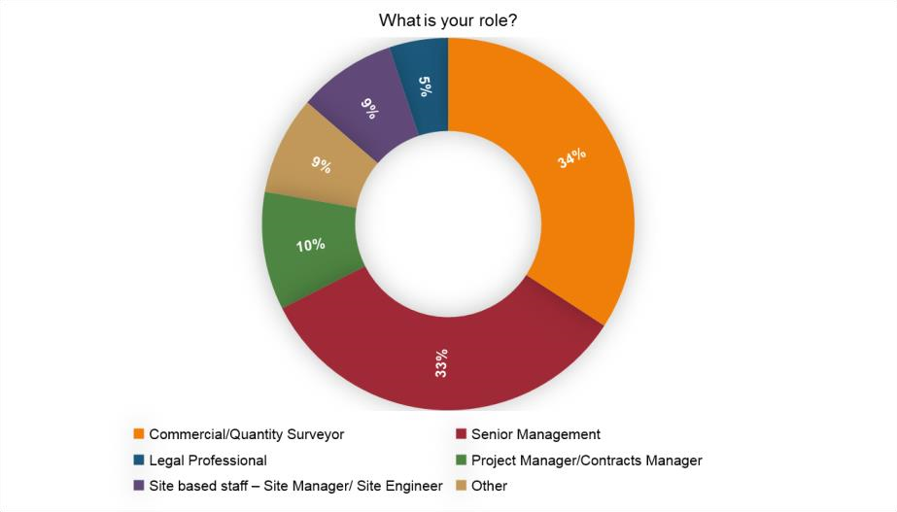
Figure 1 – Respondents by Profession

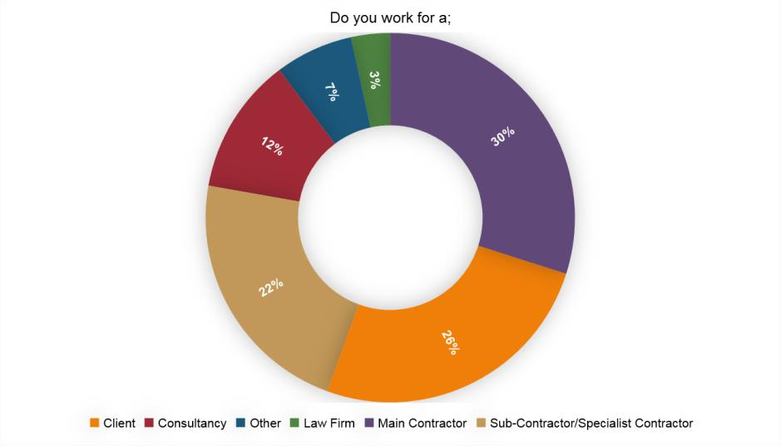
Figure 2 –Respondents by Supply Chain Position
The first substantive question addressed the respondent’s perception of their businesses attitude to technological change.

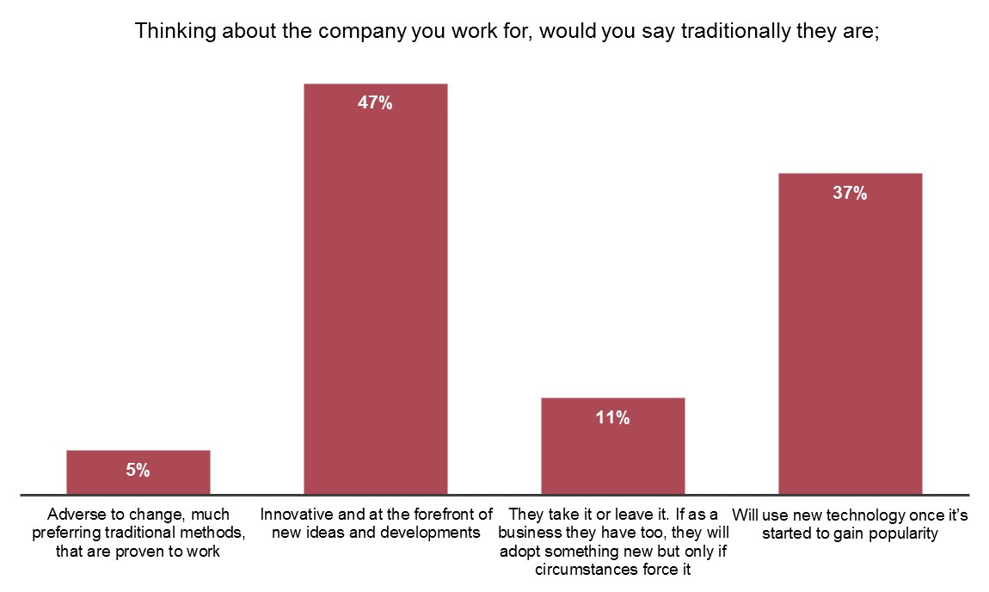
Figure 3 – Attitudes to technological change
Almost half consider their company to be innovative and at the forefront of new ideas, a striking statistic considering the industry has a reputation for being slow to change and behind innovation (Lynch 2012). The next question asked about knowledge of smart contracts.
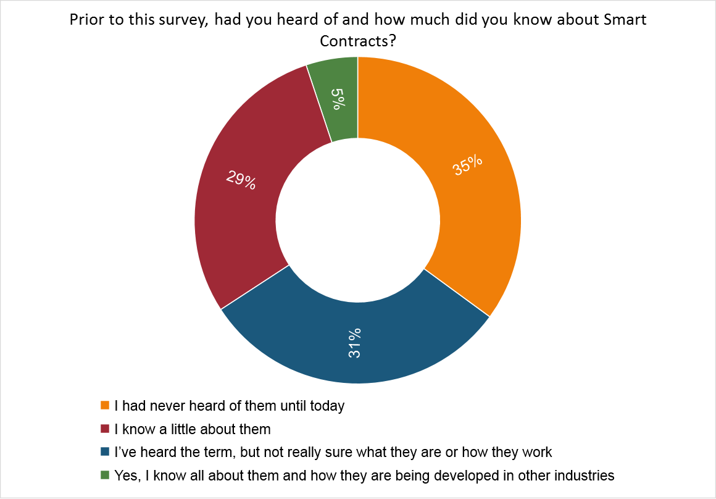
Figure 4 – Knowledge of Smart Contracts
The knowledge gap identified will necessitate a lengthy and costly education to ensure people fully understand the technology and its potential before considering adoption.
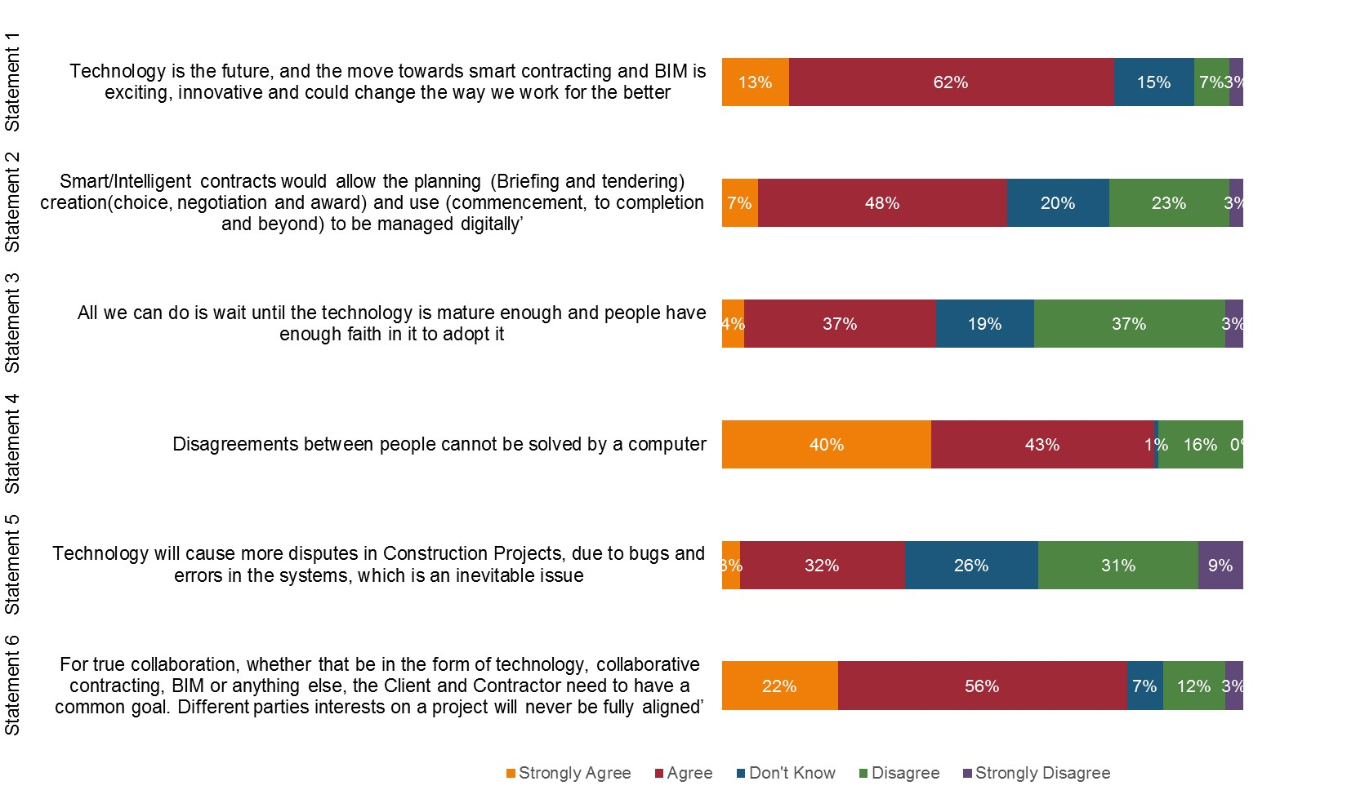

Figure
5

–

Perceptions on Technology

Figure 5 demonstrates that r
espondents
overwhelmingly

accept

that technology is the future.
However, o
nly 50% agree
s
mart
c
ontracts will i
mprove contractual processes. No consensus
emerges as th
e

statement
about passively waiting for developments to happen with
a relatively
The statements attracting the largest degree of consensus addressed the question of whether a computer could resolve disputes - 80% thought not. A similar percentage also expressed the view that self-interest destroys trust and collaboration.
The quantitative findings of the study revel therefore that the construction industry is not confident that a fully automated system will work, and are not trusting and collaborative enough to enable it to be used.
The next section examines the respondents’ comments which accompanied their selections on the questionnaire. This is accompanied by the author’s commentary based on the literature reviewed.

Discussion

In all, the respondents made 300 comments to accompany their multiple choice selections shown in Figure 5. This discussion features a selection of these insights which have been grouped together in thematic analysis. The purpose of setting out the quotes is to allow the reader to select and reflect on those sentiments which resonate with and potentially challenge their own stance on technology.

1 Definitions

The importance of definitions in legal scholarship and contract writing is of paramount importance. This discussion is no exception. The respondents apply succinct and largely accurate responses to the question as to what they understand a smart contract entails. One could surmise that, given the richness of the definitions and the paucity of knowledge claimed, the respondents turned to technology (internet searching) to augment their own definitions.

“A contract performed by technological means. Once initiated, a smart contract is typically irrevocable and automatic. It can either be a coded contract or compromise a written contract which has automated functionality – such as payment- in smart contract alongside a more traditional written contract.”
“I understand the concept of instantaneous payment and a “brick by brick” idea of plotting progress. Also

the idea that the middle men are removed from the process such as banks.”

“The general premise is that they are pre-programmed and have the ability to self-execute.”

“They are aimed to facilitate and project manage a given contract on behalf of the user with his or her minimal input and supervision.”
“They are computer programs that take the place of traditional contracts for simple contractual arrangements primarily used for digital transactions.”

The remarkable point is how accurate and seemingly well-informed the respondents are on a subject about which the majority profess not to know anything. The ease with which the subject can be grasped therefore, sometimes by deduction alone based on its logical premise, bodes well for long term adoption.

2 Obstacles to Adoption

The comments start with a recognition that it is incumbent on the client side to make the investments of time, money and energy into innovation.

“Smart contracts will only truly succeed when people and organisations change their procurement

mind-sets and strategies and invest more in inovation.”

“As a client organisation we should lead the industry into the digital age and insist these items are taken up now, even if just in small ways.”

The comments selected move on to point out the shortcomings of the status quo in terms of contract drafting.
“Contract drafting remains very clunky and expensive and clients dislike it, and yet they derive comfort from the to and fro of negotiation.”

“There is still far too little standardisation with contracts in some industries. In my industry I have not received any contracts based on standard forms in the last two years.”

“Where standard forms are used they are often modified to the point where they are no longer standard leading to potential for ambiguity and disputes. If smart contracts is used correctly it can only be beneficial for the construction and manufacturing industries.”
These comments sum up the shortcomings of the current legal arrangements whereby a great deal of resource is used in the negotiation of contracts and seemingly self-defeating nature of amendments. Any steps towards automation of the process would reduce this expenditure.

3 The Potential for Positive Impact

There are 81 recorded comments in this section featuring repeated themes and some similarities in approach and expression. Not all of the comments are set out in this discussion. The author has
sought to capture the essence of the insights shared by the respondents. Nine themes have been used for the purposes of analysis, they are:

3.1 The Requirement for Knowledge

The key sentiment being expressed in this theme is that it is not necessary to know how the smart contract works in order to use it and trust it.

“A car can be driven with great skill without knowing how the engine works.”

“Everyday users of smart contracts will not be exposed to the coding structure and algorithms needed for it to work.”
“If proven to work, the code is likely to be less of an issue.”

An observation here is that the time has now passed when a construction professional needed to know the intricacies of the process and their involvement with it. This loss of specialist knowledge is, on the one hand, regrettable for those of us brought up on the discipline-based approach. On the other hand, younger generations would see this as entirely normal (Adams, 2001).

3.2 What to do about the Bugs

The respondents’ experiences around information technology and its reliability are addressed in this section. The prevailing view is that bugs can be worked around and should not prevent progress per se.

“All bugs are manageable through the transition phase.”

“Anticipating bugs is a very backwards opinion and could be said of any technological advances we’ve made.” “As technology resilience gets better there will be less bugs/issues. Bugs will not necessarily cause disputes.”

The last point is particularly reassuring for those seeking to promote smart contracts. BIM has its detractors, based on its complexity and the need for clients to be clear on what they want (Mason,
2017B). Reliability has not been one of its problems though which is testament to the investments

made by the technology providers. This investment is rewarded through the licence fees charged.

3.3. The Relationship between smart contracts and trust

The respondents were questioned on whether trust and collaboration were “baked in” to the smart contract process. This section analyses those responses appreciating that a transparent and granular process can actually add trust.

“The building of trust and collaboration is a key benefit. This is good for building more long-term strategic alliances with your suppliers – more cost efficient savings to be made.”

“If the technology really works and people give it a chance then faith and trust can be built. “

“If things were more automated and out in the open and clear for everyone to see then maybe the trust between the parties would improve.”

These comments appreciate the point that the transparency of the procedure would result in the trust required and the benefits presented by a long-term strategic alliance. The last comment is insightful in demonstrating that the trust is already in place well before the smart contract is required to manage the transactions.

3.4 The Benefits of Standardisation

These comments recognise the benefits of standardisation in terms of ensuring minimum quality standards and the potential to reduce disputes. The removal of subjective wording is also seen as being beneficial in this section:

“The potential to remove errors in drafting contracts and avoid individuals interpreting contract clauses

differently due to the way they are written could be a major advantage of smart contracts.”

“The technology can help resolve disputes on timings and what has been agreed, issued, paid etc.”

The difficulty is that the replacement of subjective wording, although desirable, with computer code is a massive ask in terms of being able to cover the variables encountered on a building project. The point is made that the reason for having a written contract in the first place is to deal with the uncertainty arising from the project (see discussion section 5.2). This limitation on what is achievable then come more sharply into focus in terms of the application being to pre-fabricated or factor type installations on individual or linked elements.

3.5 The Business Case

The notion of smart contracts requires the business case to be made out. The respondents in this section were quick to recognise the positive impact this technology could have.

“As a subcontractor we can spend a lot of time chasing payments so a system to reduce this work load would be of benefit to us.”
“As with innovations like BIM the company are happy to invest in order to be market leaders in new technology.”

“Cost savings on administration may be moved over to IT support to solve a unique bug to a specific contract or a system bug that assists all of the companies.”

“Due to the streamline nature of the process and service it would mean less time spent on paperwork and more time spent where more beneficial.”
“Getting payments from the construction industry can be notoriously tricky, so the idea of automated payment upon completion is certainly attractive.”
“I believe the technology and cost of upskilling would only be minor inconveniences at the start.”

“If the Managing Director of a company believes in the idea then a top/down attitude will spread across the business and give a new idea a very good chance of succeeding.”
“Less paperwork and more automation will eventually reduce writing, negotiating, operation and admin costs.” “This simplifies the process of stage payments and administration of this process from a contractor’s point
of view.”

“Subcontractor payments are one of the industry’s biggest problems anything to improve payments has to

be a good thing.”

A recurring theme here is the potential for redeployment of people and resource to other tasks. The huge amount of time and effort spent in chasing payments appear as a frustration to the respondents. The references to “cutting out middle men” is of interest. Most seem not to appreciate that the middle man being cut out in this instance is likely to be the respondents themselves.

The last comment identifies one of the major benefits of the smart contract initiative. The poor treatment of subcontracts and the weekly cost of this in terms of insolvencies is a stain on the image of the construction industry. The alleviation of this through a transparent and repeatable payment process is to be welcomed.

3.6. The Relationship with BIM

The literature reviewed established that smart contracts probably need to reside alongside BIM as this is where the information will be harvested in terms of the specifications and standards to be achieved and verified before payment. The equivocal nature of this statement is based upon the observation that “anything goes” in relation to predicting smart contract development and what it will and will not be tethered to both now and in the future.

If BIM is the pathway chosen then there are encouraging signs as remarked upon above that the experiences are positive.

“BIM is also growing and an exciting way to standardise construction data.”

“Improvements in technology including BIM will deal with issues before they arrive on site saving cost and time.”

The observation here is that in a survey of 117 results, only three commented on the BIM position which speaks volumes on the relatively small numbers with BIM experience.

3.7 The Process of Automation

Automation can be distinguished from standardisation as the latter is one of the benefits from the former. The process of automation itself was addressed in a positive manner by the following respondents:

“Clearly emotional issues cannot be resolved but the objective decision as to the right process after an event can be solved by a computer.”

“Disputes that are likely to occur will still centre around risk or scope and there are likely to always be work arounds that can be deployed to make the process work.”
“Technology brings greater accuracy from survey devices to drawings and cross checks/approvals.”

The last reference to the application to manufacturing processes echoes the constraint about the vast scope of variables that would be experienced on a wider construction project.

3.8 Other Positive Comments

This section identifies some of the other positive comments made before the discussion turns away to look at some of the more intractable issues. The comments underline the “buzz” around the subject which supports its position on the “Hype Cycle” (Garnett, 2016).

“This is exciting as it brings new talent and ideas, innovative as it changes age-old practices better because it

could simplify contracting build trust and reduce disputes. What’s not to like?”

“Never underestimate the ability for people to adapt their methods of working and communicating

(social media did not exist 20 years ago).”

“These are exciting and innovative and could change the way we work for the better.”

“There are many improvements that can be effected in the construction industry by technology to give managers more time to deal with “real” issues that need thinking time to resolve.”
“Wait and see could lead us to stagnate whilst waiting for things to improve. We can’t be afraid of trying

and failing and trying again.”

There are a good deal of positive statements here and therefore plenty of support for the process. Presumably, those advocating the redeployment of the labour away from the tasks that would become automated are mainly at a managerial level where their own role is not so compromised. The insight demonstrated in the last two comments underlines the potential to revert to existing methods in the event of issues arising.

The position reached with the sum total of the comments examined so far is the highpoint of the cycle. The business case, potential and technological readiness have all been made out together with a good dose of respondent enthusiasm for the process. These positives should be borne in mind for what they represent - a compelling case for smart contract adoption. The next section of comments examine the limitations present on the technology which has the effect of dampening these expectations.

4 Limitations on Applicability

This next section explores the theme of limitations on the applicability of smart contracts. The examination focuses on the anticipated constraints preventing a general adoption of the technology which has already been identified as being beneficial in the first section.

4.1 Control

These initial comments in this section reveal the perception that the control and opportunistic behaviour in the construction industry will remain of pivotal importance despite the advent of automation.

“I don’t believe it will ever be fully automated managers will always like to keep control of payments and not rely on the payments being automatic.”
“A contractor will always want to maximise profits and therefore seek CEs.”

“In larger value disputes one of other party will want to take things as far as they possibly can and are unlikely to accept a computer’s verdict if they are the party found against.”

The last two comments are similar and have the ring of truth about it in terms of parties wishing to have the

Control to escalate a dispute which can occur sometimes regardless of the merits or advice received.

A lack of control or a surrender to an automated third party is identified as a limitation here in

terms of the ability to act commercially. Expecting institutions to act against their vested interest is fanciful. The business case must therefore be made out to demonstrate a new way for those interests to be protected.

4.2 Lack of a complete solution

The potential is recognised for improvement here but not to the extent envisaged in section 3. Here the
smart contract initiative is effectively damned with faint praise about its limited potential impact.

“A reduction in paper is always welcome but the reality is that storage of a document would still be required and need to be retrievable.”
“In a busy office would you revert to the “old” systems – new technology will only be used if easy and user

friendly.”

“Ultimately due to the fact that this will not eliminate human requirements in the process the most beneficial aspects would be reduction in errors and speed.”
“You will still need a QS to do a role, it’s just QS could add more value now, as opposed to paper pushing.”

The process, when viewed collectively through these comments, still appears to be extremely worthwhile even if these limitations are accurate.

4.3 Too many variables/complications

The main drawback of the process is featured here in the limitation section and returned to in the next section where the sentiment is expressed not only as a limitation but as an insurmountable obstacle.

“All the little bits of variation from the millions of random events have to go somewhere like scope or budget. You can automate these events, but only if they are repeatable; these characteristics of logic and maths leave little space for smart contracts.”
“Breaking down the components of construction cost (Resources employed) and the item/element of work to

its lowest common denominator will be challenging. There will inevitably mean higher risk built in and consequently a higher charge to the client.”
“In my opinion full automation would be relatively simple to achieve, however I have concerns over how you would automate dispute resolution and issues that arise once work has started on site.”

The next limitation is linked to these observations which examines the inability to scale up the process from simple manufactured based tasks.

4.4 Simple tasks only

“Full smart contracts would suit factory type production or linear projects or those with precise and clear activities.”
“The only plausible use in the construction industry would be for supply contracts not replacing NEC JCT FIDIC.”

The last comment holds out some hope for the process in terms of rather than seeing it as being only suitable for simple projects the solution could lie in viewing the whole as a sum of its parts. The individual process can therefore be broken down into its constituent processes.

4.5 Human contact required

Again, these concerns are expressed all the louder in the next section. A semi-automated process is being anticipated in this latest limitation.

“A lot of works in the construction industry is undertaken on trust and collaboration break the trust and the project becomes a contractual mess. Would a computer system have trust?”

The last view raises the point that the role of the human is to enthuse. There may well be something in this point although reducing the human to a “cheer leading” role is to become marginalised in importance.

4.6 Lack of a driving force

This final limitation identifies the requirement for intervention in an industry well known for its resistance to change. The parallels are there to be seen with BIM and its limited take-up in the private sector despite it having been mandated in the public sector. This section has analysed the responses concerned about the limitations of smart contracts. The main ones address the complexity and requirement for human intervention in the process. The clamour of the naysayers builds to a crescendo in the next section where the scepticism around the claims of smart contracts is addressed.

5 Scepticisms around smart contracts

The old saying about it is easier to tear down than to build up should preface these remarks.

5.1 Claims on costs unfounded

The first challenge to the smart contract project is that the cost savings case is not made out.

“I’m not sure there would be cost savings on a typical contract as the backlog of unresolved issues would lead to more cost to resolve.”
“The amount of cost savings I think will be unjustified, as system install and upskilling will null that out.”

In the main, these comments are not denying that cost savings are possible, merely that the case has not yet been made out sufficiently well. This is something that can be addressed either academically or commercially.

5.2 Contractual purpose

These scepticisms centre around the unique ability of written contracts to be able to cope with uncertainty generated on construction projects and to be a frame of reference for their resolution.

“Construction contracts cannot be 100% prescriptive the uniqueness of the construction delivery cannot

be “beyond all reasonable doubt”.

“If the problem is complex enough to require a contract, it’s too complicated to predict the outcome.”

The point being missed here is that the nature and content of a contract will be vastly different in the envisaged project. The contract will be prescriptive and exhaustive in its handling of the variable scenarios to which it will apply. This will either be achieved at the component or trade skill level. This leads into the next criticism which is whether that level of detail is ever going to be achievable.

5.3 Too complex/unique

This section revisits the complexity issue already identified as a limitation. Here the limitation becomes a major obstacle.

“Construction is a very complex business where there are many risks and changed circumstances which need to be well managed to compute with a variable option for each event encountered based on yes or no answer I cannot see happening.”
“It is very difficult to produce an automated response no matter how cleverly coded to cope with all anomalies that might/can occur.”
“Too many “what ifs” for coding to ever reach a point of agreement. Computers now far more capable

but the concept is still flawed because of the immense variable inputs – let alone the output expectations.”
“Even with the immense progress that has been and will be made in technology the complexities

are not to be underestimated and human attitude is what is holding things back more than anything.”

A recurring theme in the above comments is that construction projects are unique. Clearly, the size and complexity of projects vary but the degree to which they are truly unique is open to challenge. A more open debate on the topic can be achieved by approaching from a different angle –all construction projects involve elements of repeatable and severable processes that can be automated. There are a glimmer of hope in the last comment which identifies it is human attitude about what computers can do which is the obstacle.

5.4 Cloud Cuckoo Land

This section is reserved for the out and out doubters. The points raised are nonetheless revealing and contain valuable insights. The accusation of doublespeak can, in part, be upheld. A contract cannot be smart in the sense of real intelligence. The misnomer seems to haves stuck, however, in the way that BIM does not really cover the process it has become. The remarks about deteriorating relations between main and subcontractors are also noteworthy against a background of Brexit nervousness in the economy. Further, the accusation of being too far removed from site level provides a caution against being divorced from the realities of the construction site.

5.5 IT fatigue

This section examines the comments based on people’s ennui and mistrust of computers usually

borne out of their own bad experiences.

“Anything that is IT developed is prone to hacking and similar system errors.”
“Technology is fallible as are humans. Technology which is poorly applied may well cause more initial disputes but because it is linear disputes should be resolved very quickly if they have arisen due to technological errors, bugs etc.”
“The risk of coding incorrectly is a big risk throughout the process from implementing to completion. This would inevitably lead to change.”

Some of the comments made above are phrased as questions which, once answered satisfactorily, would address the concern. The back-up of the system would be a reliability issue addressed in the development stages of the technology. The “rubbish in, rubbish out” phenomenon has not tainted people’s experience of BIM and those standards would also be achievable on this platform. The comment about being able to unpick linear disputes arising from computer error is actually a positive. This challenges the received wisdom that “to err is human, to really mess up requires a computer.” Quite the opposite would appear to be the case.

The final comment is reflective of one criticism levelled at IT suppliers – namely the need to constantly upgrade the systems and pay additional premiums. Smart contracts would not appear to be in a position to reverse this trend.

5.6 Risk of Replacing Humans

This scepticism follows on from the points made about the complexity of the process. The perception is that humans can deal with the complexity and prioritise what is important (Mason,
2017B). One of the most important things is held out as trust and collaboration which cannot, so the thought goes, be replaced by computers.

“How can code replace human judgment interpretation and variable management techniques?” “Removing the human element will reduce trust and collaboration.”

“You need interaction for trust and collaboration and this does take some of that out of the process.”

The last comment acknowledges the sea-change necessitated by the smart contract project. The construction industry has endured twenty years of the promotion of collaboration and relationships. Any replacement of this sentiment with a more mechanistic approach is bound to cause upheavals.

5.7 The Training Requirement

The contemplation of implementing any change affecting the construction industry concludes in whole or in part with the requirement for training. The subsequent failure of the training programme to materialise usually causes consternation. The case for the training is made out in the following comments:

“I use software and data often – software is only useful when the quality of data is high and therefore the humans inputting the data are trained properly.”

The requirement for training and malleable staff interested in the developments are certainly constraints. The investment required would follow from the business case being properly made out and the market leaders setting the pace in this field.

6 Computers and Trust

The respondents were specifically asked about how they saw the relationship between computers and trust. The notion being tested is that collaboration is part and parcel of the automated process and that, far from being a casualty, is part of the DNA of smart contracts.

6.1 Contrary to the direction of travel

The first comments discussed seem to resist the move towards automation on the grounds that this is not where the industry has been headed.

“A computer cannot decide this and will only use the facts which in a time of mutual trust and cooperation

isn’t the way forwards.”

“Taking the human element out of the contract will not lead to collaboration as the contract will be administered as a binary yes/no process with no option for discussion.”
The alternative view is that the process requires the trust and collaboration at the outset before the construction actually commences. Viewing the relationships holistically in this manner appears to alleviate these concerns.

6.2 Computers cannot negotiate or conduct interpersonal relationships

These comments are an extension of the observation that computers can never replicate the face- to-face nature required in a business setting.

“Getting round the table is a key part of collaboration. Can computers argue a point?”
“Standard construction contracts are “prescriptive” to a point, interpretation and good management makes up a large part of the success of a contract which cannot be written into code.”

The alternative view is to bear in mind that computers are a tool and can perform a good deal of the repeatable aspects of construction whilst allowing for human input on the more intractable problems. This is the semi-automated position advocated as likely to be the work around in the short to medium term.

6.3 Humans are required for dispute resolution

Nowhere is the case made out more forcefully in the comments than for human intervention than in the dispute resolution procedure. Whether or not this ought to be singled out for special mention is debatable.

“Dispute resolution and human intervention seem interlocked to me – how are unforeseen circumstances to be handled?”
“I believe some straight forward issues can be solved by computers by more complex disagreements with an unclear conclusion will always require human intervention.”
“If there are any unknown or unquantifiable risk events then a traditional “manual” control that engages all parties to the contract are preferable and advisable.”

“Taking the human element out of construction is likely to result in a more adversarial approach.”

“The reduction in risk is always welcome but there is a need for the human brain to be applied to the words.”

You can use technology to highlight any problems due to incorrect data, late works etc. This would need face- to- face collaboration to resolve. Can this be done computer to computer?

The last point is again framed as a question to which the answer could conceivably be “yes.” The vast majority of the respondents are self-confessed as not being particularly familiar with the intricacies of the subject and presumably are open to the possibility of their being the technologically enhanced answer they question.

6.4 Trust as a by-product

A few of the respondents made the connection between trust and smart contracts as being capable of residing in the same place.

“Trust and collaboration will be automatic if [smart contract] is delivered.”
“Trust can always be worked upon when something has proven to work well.”

“Trust will only be gained if the contract is seen as fair and reasonable in the first place.”

These insights establish some of the new connections made in the final section of insights.

7 The Long Run

This section of comments looks at the phenomenon where respondents decide that the advances being described lie far off in the future.

7.1 Testing

It appears to be generally accepted across the respondents that a period of testing and trial and error would be involved before implementation.

“As with the change from previous forms of contract to more collaborative workings, any changes, particularly when decisions are taken away from people, systems and processes will need to be tested and bedded in before gaining confidence and trust.”
“Computers are too glitch and error prone (due to poor information input by human element) computer systems are not reliable enough yet.”
“There will be many failures before we recognise success.”

These points appear incontestable and would in any event be part of the process of introduction.

7.2 BIM first

The link between BIM and smart contracts has been discussed as being the probable route to implementation. If this is correct then citing comparisons with the BIM journey are valid.

“BIM is still in early days. Long way to go before full automation.”

“Many of the projects I work on are not fully BIM enabled and I don’t think this is unusual. Therefore I think we are a long way off smart contracts.”
“Much like BIM it is a good idea that will be useful but will take time to integrate into the industry.” “Projects will become fully BIM enabled eventually.”

The general acceptance of where things are going means that the debate centres on the time it will take and the benefits/impacts. BIM appears to be making progress but not, if these respondents are to be believed, at the stellar rates claimed in the NBS Surveys (NBS, 2015).

7.3 Long play/new generation

The issue examined here is how respondents judge the passage of time required for something to become established. Erring on the side of a long lead in appears as the default position.

“Always with new technology a critical mass is needed.”

“I am currently unsure about the future of smart contracting and BIM. I think ultimately it will be positive but it will be many years until it is fully embraced.”
“It may take a generation to change this as younger staff would embrace this technology easier.”

“Yes technology is the future for all industries, but smart contracting I don’t believe is remotely achievable on complex construction projects any time soon. “

“The NEC took 20 years to become the contract of choice and that only due to government intervention so collaboration does not come naturally to the industry."
“It will take some time to understand where contractors are able to gain an edge.”

This last point can be addressed once the business case is made out. The encouragement appears to be that, as with the NEC experience, real change can eventually be effected.

8 New approaches and connections

This final section of the discussion considers some of the comments making connections beyond the more obvious points considered so far.

8.1 Priorities to Address

These perceptive comments appear to establish that: trust needs to come before the business case, the element based approach is the correct one and that a semi-automated process could be developed using existing contractual procedures.

“Although costs savings are important, I think that smart contracts would need to overcome the trust and collaboration issues first before money were an issue.”
“Procurement teams rarely understand what it is they are procuring in enough detail and do not

want to engage with people to really find the best service or product at a fair price. They just want to set things up through e platform and score against stuff they can understand/measure like whether you have ISO standard. These tell you very little other than
some paper work has been filled out correctly. Smart contracts seem like an extension of something that is already not working well.”

The last point again resonates with a shortcoming of current procurement procedures. The fallacy that procurers want to know the complete picture before awarding a contract is touched upon here. The de-skilling of the process can be observed as starting much earlier than the construction side of operations. Ensuring the proper application of high level skill at the key points in the process is as vital as it ever was.

2 Flipped Thinking

The last selection of comments have been chosen for their illumination of counter-intuitive thinking and are analysed independently.The prediction of more disputes is of interest here. This might be along the lines of clash detection in BIM where thousands of clashes are highlighter, only to be resolvable at the move of a
mouse click on the design programmes.

The issue of whether 8 out of 10 is good enough is flagged up here. Presumably the remaining two incidences would require human intervention.
“It is the very complexity that means that automation is essential and not a hindrance.” “Why should a person matter? The facts should.”

These two observations have a common genus which is that computers can manage complexity.

The real issue is whether this can be translated into a simple decision on how to the issues to prioritise and arrive at a decision.

“If a smart contract is used as intended then trust and collaboration should be of no real concern as each parties roles and responsibilities would be clearly defined.”

This comment reveals the point that trust and collaboration were never the end in themselves but a mean to that end which can also be achieved and complimentary to, the smart contract approach.

In this comment, the dispassionate nature of the decision making process is seen as a positive. This contradicts the requirement for the “human touch” espoused earlier. The automation of the judicial process was discussed as a possibility.3

“Newer QSs are much more “technology native” and do understand the processes which

underpin this technology.”

This comment supports the Adams approach quoted earlier (Adams, 2001). Newer Quantity Surveyors do not concern themselves about the developments in the same way as the older Quantity Surveyors and are consequently less threatened by them.This sentiment centres on the intangible and flighty nature of trust. Ultimately it is not a reliable or bankable commodity on which an industry can be built. Ultimately, the same limitation on trust applies to the human involvement more widely. This comment encapsulates the potential benefits for smart contracts to ultimately save us from ourselves.

9 Conclusions and Recommendations

The priorities for smart contracts and their likely impact in the foreseeable future are summarised below.
In order to overcome problems in the short term it would be useful to:
- settle upon a definition suitable for the construction industry and its inter-relation with other technologies
- form a clearer picture of what it is the industry is currently dissatisfied with
- establish which benefits are realisable and by what means
- draw the parameters of what is achievable by reference to the limitations which currently curtail performance and how these may fall away in the future
- Dispel those cynical opinions and fallacies which do not reflect the true picture whilst acknowledging those which are real and present roadblocks
- Form a strategy for implementation and training, possibly learning from the BIM experience
- Draw a line under the computers and trust debate by recognising that the two are not mutually exclusive
- Draw up a realistic timetable and monitoring platform to accompany developments
- Take the debate in new directions and recognise the huge potential for positive impact on a dispute ridden industry.

References

Adams, D. (2002) The Salmon of Doubt, Heinemann Limited
Bingham, T. (2014) The JCT Povey Lecture [online]. Available from:
https://blackboard.uwe.ac.uk/bbcswebdav/pid-5360055-dt-content-rid-
10756775_2/courses/UBLMVS-30-3_16sep_1/JCT-Povey-Lecture-2014-for-publication.pdf [Accessed 29 March 2017].
Blockgeek. (2017) Smart Contracts: The Blockchain Technology That Will Replace Lawyers. [online].
Available from: https://blockgeeks.com/guides/smart-contracts/ [Accessed 07 February 2017].
Bouchlaghem, D. et al. (2012) Collaborative Working in Construction. 1st ed. New York: SPON Press.
Cardeira, H. (2015) Smart Contracts and their applications in the construction industry [online].
Available from: http://heldercardeira.com/H%20Cardeira%202015%20-
%20Smart%20contracts%20and%20possible%20applications%20to%20the%20construction%20indu stry.pdf [Accessed 24 September 2016].
Chynoweth, P. (2008) ‘Legal Research’ in Knight, A. and Ruddock, L., Advanced Research Methods in the Built Environment, Blackwells
Constructing Excellence. (2016) Constructing Excellence. [online]. Available from: http://constructingexcellence.org.uk/ [Accessed Thursday 4th February 2017].
De Botton, A. (2001) The Consolations of Philosophy, Vintage Books
Digital Built Britain. (2015) Digital Built Britain [online]. Available from: http://digital-builtbritain.com/ [Accessed 19 March 2017].
Emerson, S, H. (1962) A survey of problems before the construction industry, Unknown: Unknown.
Emmitt, S., and Gorse, C A. (2003) Construction communication. Oxford: Wiley- Blackwell.
Fox, S. (2016) Why construction needs smart contracts [online] Available from:
https://www.thenbs.com/knowledge/why-construction-needs-smart-contracts [Accessed 23
January 2017]
Gartner. (2013) Gartner Identifies the Top 10 Strategic Technology Trends for 2014 [online]. Available from: https://www.gartner.com/newsroom/id/2211115 [Accessed 26 January 2017].
Gartner (2016) Hype Cycle for Emerging Technologies available at: www.gartner.com/newsroom/id/3412017 [Accessed 3rd July 2017]
Gronbaek, MvH. (2016) Blockchain 2.0, smart contracts and challenges [online]. Available from: https://www.twobirds.com/en/news/articles/2016/uk/blockchain-2-0--smart-contracts-andchallenges [Accessed 12 January 2017].
Langford, D.A. and Murray, M. (2003) Construction reports 1944-98. Oxford: Blackwell Science.
Latham, S. M. (1994) Constructing Excellence, Constructing the Team. [online].
Available from: http://constructingexcellence.org.uk/wp-content/uploads/2014/10/Constructingthe-team-The-Latham-Report.pdf [Accessed 4th March 2016].
Lynch, P.R. (2012) HGCRA: Re-Addressing the Balance of Power Between Main Contractors and Subcontractors. [online]. Available from:
http://www.nadr.co.uk/articles/published/construction/TheBalanceOfPowerBetweenContractors.pd f [Accessed 13 March 2017].
Mason, J. (2017A) Intelligent contracts and the construction industry. Journal of Legal Affairs and Dispute Resolution in Engineering and Construction. 9(3) Available from: http://ascelibrary.org/journal/jladah [Accessed 01 February 2017].
Mason, J. (2017B) Intelligent contracts: Get Smart Building Magazine 7 July Available from: http://www.building.co.uk/professional/legal/intelligent-contracts-get-smart/5088630.article
Morgan, P. (2014) Bitcoin South: Innovating Legal Systems through Blockchain Technology [online]. Available from: http://bravenewcoin.com/news/pamela-morgan-at-bitcoin-south-innovating-legalsystems-through-blockchain-technology/ [Accessed 01 June 2016].
Mosey, D. Howard, C & Bahram, D. (2016) Enabling Building Information Modelling through
Procurement and Contracts [online]. Available from: www.scl.org.uk [Accessed 01 January 2017].
NBS. (2016) National BIM Report 2016 [online]. Unknown: RIBA Enterprises Ltd. [Accessed 05 January 2017]
Norton, Rose Fullbright (2016) Smart Contracts: Coding the Fine Print, Available at:
http://www.nortonrosefulbright.com/knowledge/publications/137955/smart-contracts-coding-thefine-print [Accessed 12 July 2017]
Norton Rose Fulbright. (2016) Can smart contracts be legally binding contracts? [online]. Available from: http://www.nortonrosefulbright.com/files/norton-rose-fulbright--r3-smart-contracts-whitepaper-key-findings-nov-2016-144554.pdf [Accessed 20 March 2017].
Peters, G. W, Panayi, E. (2015) Understanding Modern Banking Ledgers through Blockchain Technologies: Future of Transaction Processing and Smart Contracts on the Internet of Money [online]. Available from: https://arxiv.org/abs/1511.05740 [Accessed 01 June 2016].
Simon, S. E. (1944) The Placing and Management of Contracts. Unknown: HMSO.
Szabo, N. (1994) Smart Contracts [online]. Available from: http://szabo.best.vwh.net/smart.contracts.html [Accessed 26 September 2016].
Waterhouse, R. (2015) National Construction Contracts and Law Survey, RIBA Enterprises Ltd.
Biographical Notes

My work at Bristol has included authoring major textbooks in construction law and law for the built environment, as well as numerous publications on aspects of construction law. One of the textbooks has become the set book on degree courses at many universities in the UK. My research interests include the doctrinal and socio-legal aspects of construction law and the relationship between construction industry stakeholders and the law/policy makers. The focus of my work is on why some laws work whilst others falter. I have developed and tested a hypothesis based on the notion that directive laws work better than coercive or voluntary laws. The results are described in my thesis submitted in partial fulfilment of my Doctorate of Philosophy by Publication completed in 2012.
Dr Jim Mason, University of the West of England. Jim.mason@uwe.ac.uk 01173283096

Department of Architecture and Built Environment, University of the West of England, Bristol BS161QY
Wessex Water Services Limited, Wessex Water, Claverton Down, Bath BA2 7WW

