THIS IS THE PRE_PRINT VERSION OF THIS PAPER – PLEASE SEE PUBLISHER WEBSITE FOR PUBLISHED VERSION IN WATER PRACTICE & TECHNOLOGY (<https://doi.org/10.2166/wpt.2018.043>):

https://iwaponline.com/wpt/article-abstract/13/2/321/38712/Inter-organisational-resilience-for-flood-focussed?redirectedFrom=fulltext

Inter-organisational resilience for flood focussed emergency planning: Examining multi-agency connectedness through Twitter

Sarah Bunney*, Sarah Ward and David Butler

Centre for Water Systems, College of Engineering, Mathematics and Physical Sciences, University of Exeter, North Park Road, Exeter, Devon, EX4 4QF, United Kingdom

* Corresponding author’s e-mail: **sb734@exeter.ac.uk**

**Summary**

The use of Twitter as a platform to share and exchange information between emergency responders, water service providers and the public during an emergency situation is becoming more evident. The sharing of real-time information is invaluable for situational awareness and effective emergency response. To explore this integrated approach, twitter profiles for Local Resilience Forums and Water Service Providers were analysed to demonstrate their connectedness. It was discovered that the connectivity between the Local Resilience Forums and the Water Service Providers was limited and further research is being conducted to establish why these connections do not exist.

**Keywords**

Emergency planning, inter-organisational. multi-agency, resilience, Twitter

**Introduction**

The sharing and exchange of real-time information is invaluable for situational awareness and effective emergency response (Bharosa *et al*, 2010; Vieweg *et al,* 2010). It is important for the public to be provided with accurate and consistent information during an emergency situation so they know how to respond and what actions they may need to take as the emergency situation progresses (Panagiotopoulos *et al,* 2016). The emergence and popularity of social media platforms such as Twitter and Facebook has enhanced the provision of real-time information and is increasingly being used by emergency responders both to disseminate vital information to the public as an emergency evolves, but also to receive information from affected areas (Simon *et al,* 2014; Annikeva *et al,* 2015). During the severe flood event in Queensland, Australia 2010-2011, Twitter and Facebook were used as a platform by Queensland Police to provide essential information to local community groups that were unable to access any other form of media due to power failures (Anikeeva *et al,* 2015). Twitter was also used to share information between the public and the emergency responders during the terrorist attack on Westgate Mall in Kenya during 2013, allowing vital information to be shared ensuring public safety throughout the event (Simon *et al,* 2014).

This is in contrast to the severe flooding of Mythe Water Treatment works in Gloucestershire, UK, in 2007 when over 350,000 people were left without a centralised water supply for up to 17 days (Pitt, 2008). Both the Water Service Provider and the emergency responders were criticised for not providing members of the affected community with adequate information regarding the provision of water supplies or when the water supply would be reconnected (Pitt, 2008; CC Water, 2007; BBC Radio Gloucestershire Website, 2007).

The local BBC Radio Station webpage was actively used by the public throughout the event to request and share information however, emergency responders and the water service provider were not active on the radio station webpage to answer any of the questions (BBC Radio Gloucestershire Website, 2007). This resulted in the general public acting as the primary source of information potentially allowing misinformation and confusion to persist unchecked. With Twitter only just becoming active, it was not considered as a possible method for the dissemination of emergency information. Had such a mechanism existed, accurate and consistent information could have been provided more effectively to those that were affected.

More recently, in the UK, Twitter was used as a live stream for affected communities to access and share information during the 2015/16 flood event in Cumbria, UK, (Twitter feed, #Cumbriafloods). An independent Twitter account was established at the start of the floods to collate information and advice provided by the emergency responders and the use of the hashtag ‘#Cumbriafloods’ allowed people to be connected to a live stream of information as the situation progressed (Twitter feed, Cumbria Floods). Emergency responders and the utility companies provided real-time updates and information regarding the provision of essential services on their individual twitter accounts. This allowed organisations to share and exchange information with those affected by the severe flood. It also allowed the control of misinformation, particularly for the water service provider when false rumours started circulating regarding potential water loss and contamination (Twitter feed, United Utilities).

The ability to disseminate information in real time, relatively quickly to a large population has increased the strength of twitter as an effective tool for emergencies. This was recognised by Twitter and led to the development of Twitter Alerts in 2013 (Twitter Alerts, 2017). This is an extension of the normal service provided by Twitter and allows the public to sign up to receive a Twitter Alert during an emergency from one or more of the participating organisations. However, the ability to control misinformation is becoming increasingly difficult, particularly if responder organisations are not connected on Twitter and have no knowledge of what is being posted by the other operating organisations. A collaborative, multi-agency approach in the dissemination of accurate information in real time to the public will help control the spread of misinformation. Twitter provides a useful tool, which if used effectively could assist in this process.

Within the framework of the UK Civil Contingencies Act, 2004, a multi-agency approach is adopted for effective emergency management at the local-level. This is through the development of Local Resilience Forums (Cabinet Office, 2012). These are composed of Category 1 and Category 2 responders. Category 1 responders comprise the Emergency Services, The Environment Agency and the Health Trusts and they have statutory duties under the provision of the Civil Contingencies Act. Category 2 responders comprise the Utility and Transport Companies and whilst they do not have any statutory duties within the framework of the Civil Contingencies Act, they are expected to provide a supportive role to Category 1 responders. The category 1 responders in the Local Resilience Forums have a mandatory requirement to communicate information and advice to members of the public (Cabinet Office, 2013).

There is an increasing use of social media as a method to share and exchange information to affected communities during an emergency situation. Should the Local Resilience Forum Managers and the Category 2 responders, such as the Water Service Providers seek to be more connected on Twitter? This would ensure an accurate and consistent stream of information for the public to access. This study examines the connection between these UK organisations through the use of Twitter data and discusses the use of Twitter in a multi-agency response to provide accurate, consistent information in real-time to communities affected by the failure of an essential service.

**Methods**

Twitter is one source of data that can be analysed regarding multi-agency communication. Other communication and situational awareness tools, such as Resilience Direct, are used by multiple agencies and is being examined in parallel research. Twitter represents an online platform and offline methods of communication have not been considered in the research presented here.

Analysis was conducted to identify all of the Local Resilience Forums and Water Service Providers that are active on Twitter. Confusion over identifying and distinguishing between Local Resilience Forums and Local Authority Emergency Planning Departments was observed, due to naming conventions used on Twitter.Only the 10 largest Water and Sewerage providers were included in the analysis (i.e. water only service providers were omitted) to enable preliminary analysis to inform future direction. Each individual profile was accessed to establish the existence of a connection (Following or Follower) with a Local Resilience Forum, a Water Service Provider or both.

A comparative analysis was conducted to establish the connections between the emergency responders and Water Service Providers during the Cumbria Flood event to understand if these organisations are more connected outside of the Local Resilience Forum. This is because Cumbria Local Resilience Forum does not have an active twitter account.

All the information was collated and imported within R Studio for analysis using the social network analysis package, igraph. An adjacency matrix of undirected and directed relationships was developed to understand how connected these organisations are on Twitter. Further analysis was conducted on the directed relationships to establish the central organisations within the network and the influence they may have on the network.

**Results and Discussion**

Local Resilience Forum and Water Service Provider Connectivity

Of the 38 Local Resilience Forums in England, only 15 have a recognisable active twitter account and use this method to communicate information and connect to emergency responders, utility companies, government departments and the public. .

There is a high level of connectivity between the Local Resilience Forums and a high level of connectivity between the Water Service Providers on Twitter. However, connectivity between the Local Resilience Forums and the Water Service Providers is limited (Fig.1). Only two connections exist between Anglian Water and Norfolk Local Resilience Forum and Yorkshire Water and West Yorkshire Resilience Forum. These are the respective local water companies and resilience forums for these local areas. Direct connections between individual Local Resilience Forums and their respective Water Service Providers is very limited. For instance a connection does not exist between Severn Trent and the Gloucestershire Resilience Forum even considering the consequences of the 2007 flood event. Many of the Water Service Providers operated over a wide geographical area where they may be in contact with more than one Local Resilience Forum. For instance Merseyside, Cheshire and Greater Manchester Local Resilience Forums would be connected to United Utilities. However, this connection does not exist on Twitter.

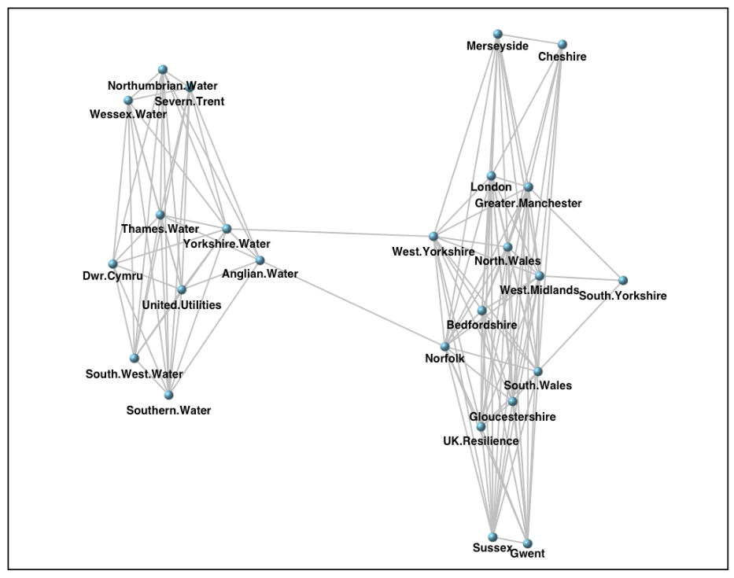

**Fig.1.** *R Plot of the connectivity between Local Resilience Forums and Water Service Providers*

Outside of the Twitter environment, Local Resilience Forums are particularly active in England, establishing and maintaining an effective multi-agency approach to emergency response. It could be argued that these organisations do not need to be connected on Twitter because they are sharing information throughout an emergency situation through other platforms such as Resilience Direct or through their attendance at an incident command centre. However, it is important for those in the affected areas to be provided with a consistent stream of accurate information so they understand how to respond as the situation evolves. A high level of connectivity between Local Resilience Forums and Water Service Providers would ensure consistent and accurate information is disseminated to the public during an emergency.

Analysis of the Cumbrian Flood Event

Many of the Local Resilience Forums are not active on Twitter. For instance, Cumbria Local Resilience Forum does not have an active twitter account. Further analysis was conducted to establish the connectivity between the responder organisations and the utility companies including the water service provider during the Cumbrian Flood event (Fig 2). There is a high level of connectivity between the responder organisations and the utility companies despite Cumbria Local Resilience Forum not having an active Twitter account. In particular the water service provider, United Utilities is connected to a large number of organisations involved in emergency response.

Lessons learned from the flooding of Mythe Water Treatment Works during the severe flood of 2007 demonstrate the public require accurate and consistent information throughout an emergency so they know how to respond and what actions they may take as the emergency situation evolves (CC Water, 2007). A lack of information can lead to panic, confusion and the dissemination of misinformation (CC Water, 2007; Annikeva *et al,* 2015). Following the 2007 flood event, Water Service Providers have developed a very strong presence on Twitter, collectively sending over 291,000 tweets and followers in excess of 182,000 (Twitter feed, Water Service Providers). In particular during the Cumbrian Flood Event, there was a two way flow of information sharing between the Water Service Provider, United Utilities and members of the public (Twitter feed, United Utilities). This allowed the Water Service Provider to control and prevent the dissemination of false rumours regarding water contamination and potential water loss. It also allowed them to maintain contact with people within the affected communities.

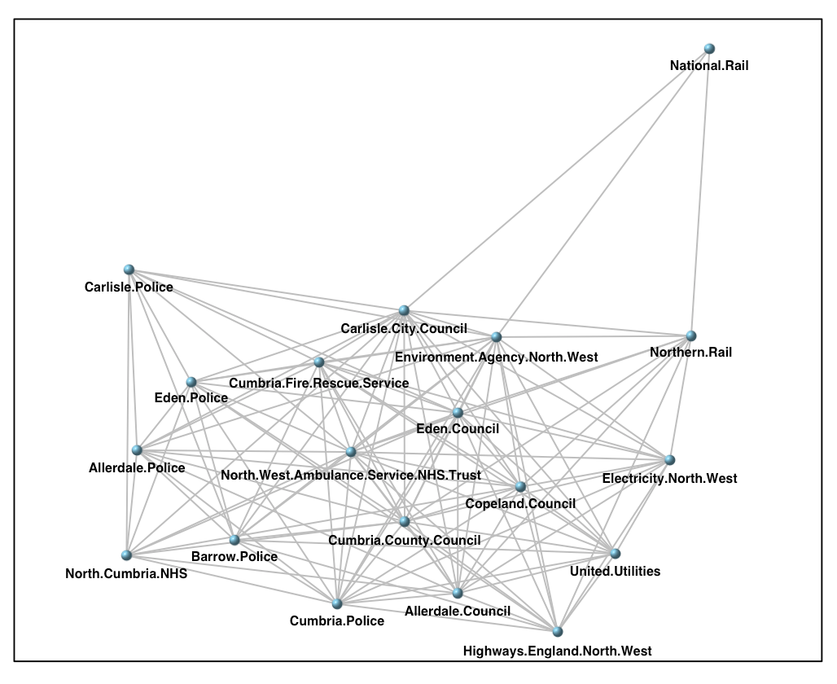

**Fig. 2**. *R Plot of the connectivity between Emergency Responder organisations and Water Service Providers during the Cumbria Flood event 2015.*

Use of Twitter by Responder Organisations

The Police and County Council also used Twitter during this period for the dissemination of information and advice to the public regarding road closures, bridge closures and essential safety information (Twitter feed, #Cumbriafloods). Providing the public with real-time information from a reliable source also helps to limit the quantity of emergency calls to the Police, allowing them to concentrate on more urgent matters. Each organisation used Twitter in a slightly different manner with the Water Service Providers opening up a two way flow of information sharing and the Police and the Councils using Twitter as more of an alert system (Twitter feed, #Cumbriafloods).

The establishment of a Twitter account to collate information provided by the emergency responders provided a useful tool for people within the affected communities to access. However, this method depends on the ability of the account holder to recognise and re-tweet relevant information posted on Twitter and the responder organisations actively using Twitter. It also depends on members of the public in the affected areas recognising Twitter as a source of emergency information and the use of a common hashtag. If unregulated, numerous accounts could be opened following future events and lead to confusion. Throughout the Cumbria flood event over 59 different hashtags were used by the responder organisations (Twitter Feed, Cumbria Flood Update). Even though #Cumbriafloods was the most common, there remains the possibility that information might be missed if the public relies solely on this hashtag for information.

Twitter for the Communication of Emergency Information

To ensure the public have access to an accurate and consistent stream of information during an emergency situation would require a formal structure regarding how Twitter is used by multiple agency responder organisations during an event. The establishment of a multi-agency Twitter account and the identification of a common hashtag, utilised as soon as an incident occurs would ensure the public have access to information from a reliable source during an emergency. This would assist in the prevention of misinformation.

If there are strong connections with local communities it also has the potential to improve situational awareness through a two-way flow of information. This was evident during the Queensland Flood where Twitter provided a valuable mechanism for allowing Queensland Police to maintain contact with affected communities when all other communication failed due to a loss of power.

**Conclusion**

Twitter is increasingly being used as a platform for emergency responders, water service providers and the public to access during an emergency situation. The sharing and exchange of real-time information is invaluable for situational awareness and effective emergency response. Twitter profiles for Local Resilience Forums and Water Service Providers were analysed to demonstrate their connectedness. While there is a high level of connectivity between the Local Resilience Forums and a high level of connectivity between the Water Service Providers, there are limited connections between individual Local Resilience Forums and their respective Water Service Provider. However, in the absence of a Local Resilience Forum, a water service provider demonstrated a high level of connectivity on Twitter with responder organisations during an emergency situation.

Although it is understood that other communication and situational awareness tools exist, research is being conducted to examine why these connections do not exist within Twitter. Further research is also being conducted to understand effective mechanisms of communicating emergency information to communities during an emergency.

**Acknowledgements**

This research was funded by the UK Engineering and Physical Sciences Research Council (EPSRC) project Safe & SuRe (EP/K006924/1).

**References**

Anikeeva, O., Steenkamp, M. and Arbon, P. 2015 The future of social media use during emergencies in Australia: Insights from the 2014 Australian and New Zealand Disaster and Emergency Management conference social media workshop. *Australian Journal of Emergency Management, The*, *30*(1), p.22.

BBC Radio Gloucestershire. 2007

<http://www.bbc.co.uk/gloucestershire/content/articles/2007/07/23/flood_news_latest_feature.shtml> (Accessed archived webpage February 2017)

Cabinet Office. 2013 The role of Local Resilience Forums: A reference document. *Cabinet Office,* London

Cabinet Office. 2012 Chapter 4, Local Responder Risk Assessment Duty. Revision to Emergency Preparedness. *Cabinet Office,* London.

CC Water. 2007 Response to loss of water supply. *Accent,* London.

Environment Agency. 2010 The Costs of the Summer Floods in England. *Environment Agency,* Bristol.

Ofwat. 2010 Water today, water tomorrow. Resilient Supplies: How do we ensure secure water and sewerage services? *Ofwat.* Birmingham.

Panagiotopoulos, P., Barnett, J., Bigdeli, A.Z. and Sams, S. 2016 Social media in emergency management: Twitter as a tool for communicating risks to the public. *Technological Forecasting and Social Change,* ***111,*** *pp. 86-96.*

Pitt, M. 2008 Learning Lessons from the 2007 Floods. *Cabinet Office,* London.

Simon, T., Goldberg, A., Aharonson-Daniel, L., Leykin, D. and Adini, B. 2014 Twitter in the cross fire—the use of social media in the Westgate Mall terror attack in Kenya. *PloS one*, ***9***(8), p.e104136.

Twitter Alerts. 2017 [https://support.twitter.com/articles/20170444#](https://support.twitter.com/articles/20170444) (Accessed February 2017)

Twitter Feed, #CumbriaFloods <https://twitter.com/search?q=%23cumbriafloods&src=typd>

(Accessed February 2017)

Vieweg, S., Hughes, A.L., Starbird, K. and Palen, L. 2010 Microblogging during two natural hazards events: what twitter may contribute to situational awareness. In *Proceedings of the SIGCHI conference on human factors in computing systems*, pp. 1079-1088. ACM.