Urine flow rate shape template and intermittent flow in males

Hypothesis / aims of study
Uroflowmetry serves as a preliminary urodynamic test for physicians to indicate the possible cause of lower urinary tract symptoms. Alongside the most researched parameter maximum flow rate (Q_{max}), the shape of urine flow rate curve is also reported to associate with one or more voiding abnormalities [1]. Therefore, this novel study aims at by mathematically generating free-flow shape template in specified diagnostic groups, bladder outlet obstruction (BOO) and detrusor underactivity (DU), to assess its possibility for non-invasive diagnostic use.

Study design, materials and methods
Free-flow data of 273 adult male patients who had also undergone PFS were analysed in this research. Based on their PFS record, these patients are divided into three groups: 104 BOO, 93 DU, and 76 normal (DU and BOO disease free) for reference. For each flow data, the starting and ending point has been selected by the threshold value of 0.5ml/s, then 2 seconds averaging window filter has been applied as suggested by ICS good urodynamic practice [2].
For the accuracy of the shape template, the intermittent flow data is not considered in template generating. ICS defines intermittent flow shape as flow stopping and starting during a single void [3]. However, an early or end dribble is normally included in the flow curve, as it is a part of voiding, the shape could therefore be classified as intermittent even the rest of flow is bell-shaped. We therefore detect intermittent flow on criteria of flow rate<0.5ml/s in the 0.5% to 98% volume void part, and generate flow shape template on non-intermittency data in the same area following the steps listed below:
- Normalise flow curve into amplitude of 1 and samples of 1000, by dividing whole flow curve by Q_{max} and resampling of 1000 samples.
- Calculate the mean values on each sample point in normalised flow curves in both diagnostic groups
- Divide the whole generated data sequence by the maximum value in both diagnostic groups
Then the calculated data sequences are the shape template for BOO and DU. To assess the diagnostic usage of the template, all BOO and DU non-intermittent flow data in 0.5%-98% volume voided area are normalised and calculated the ratio of sum square errors (Res) on each re-sample point comparing with BOO template and comparing with DU template.
Intermittency detection and template generation were calculated in Matlab 2017a. Statistical analysis was performed in SPSS version 24, Mann-Whitney U test and T-student test were performed as appropriate. A statistically significant difference was considered as P value<0.05.

Results
In total of 197 DU and BOO data, 75 data has been detected as intermittent, the rest 71 BOO and 51 DU non-intermittent data are employed for the template generating. The templates for each diagnostic group are presented as in figure 1.
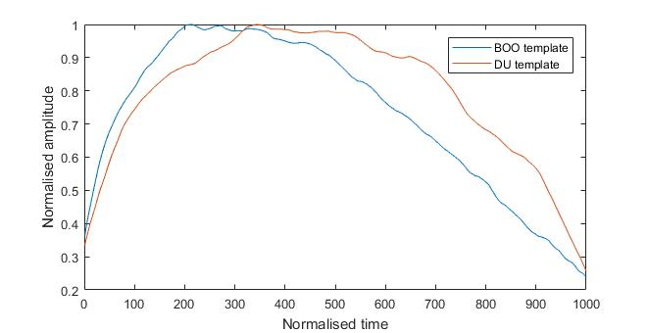
Figure 1 BOO and DU flow shape template
The Res value is found having significant statistical difference between DU and BOO groups, with P=0.005. In receiver operating characteristic (ROC) analysis, area under curve (AUC) is 0.676 with 71% sensitivity and 63% specificity.

Interpretation of results
In this study, we found the flow shape template, generated by normalised flow curves, has a shape difference between two diagnostic groups. As presented in figure 1, the BOO template shows an asymmetric shape with maximum amplitude value appears in the first half and prolonged falling slope, while the DU template is almost a bell shape with maximum amplitude value located nearly at centre. The main differences between two templates are the maximum value location and the descending speed in falling slope.
The ICS definition on intermittency did not specify the starting and ending point to count stopping flow, and this could result in categorising flow curve with very small volume of starting or ending dibbles as an intermittent curve. In our study, we found it would be more accurate to only count in 0.5% to 98% volume voided area for intermittency detection.
The parameter Res generated in our study could serve as an additional non-invasive indicator for differentiating non-intermittency DU and BOO flow in male. Although the diagnosing power could not be compared with simple Q_{max}<10ml/s for selecting male with BOO, the diagnosing accuracy for this new proposed parameter could be enhanced with other non-invasive indicators. It also shows the promise to explore the shape difference in other symptomatic groups, and its further application on diagnostic usage.

Concluding message
This study finds the shape difference between DU and BOO in males and proposes a novel non-invasive indicator for differentiating DU from BOO if the flow is non-intermittent. Further research will analyse the shape template difference in other diagnostic groups, and explore the possibility of non-invasively diagnosing DU by combining other non-invasive parameters.

