Multivariate analysis of variance for maximising the diagnosing accuracy in differentiating DU from BOO in males

Hypothesis / aims of study
Detrusor underactivity (DU) and bladder outlet obstruction (BOO) bother almost half of elder men. Although the treatment is different for these two lower urinary tract symptoms, invasive pressure flow studies remains the only gold standard for diagnosing both. To non-invasively differentiate DU from BOO, a few studies have mathematically analysed urine flow rate curve and proposed promising parameters [1,2], but each proposed parameter is not strong enough for diagnostic usage. Therefore, in this study we aim to use multivariate analysis of variance on parameters derived from free flow data to assess the possibility of non-invasive differentiating DU from BOO in males.

Study design, materials and methods
Free-flow data of 273 adult male patients who had also undergone PFS were analysed in this research. Based on their PFS record, these patients are divided into three groups: 104 BOO, 93 DU, and 76 normal (DU and BOO disease free) for reference. All free flow data has pre-processed by threshold value of 0.5ml/s for the start and end micturition point [3].
The multivariate analysis is performed by bundling multiple dependent variables into a weighted linear combination variable to achieve the best statistically significant between two groups. The following non-invasive variables which have significant statistical difference between two groups, are employed for multivariate analysis:
- Parameters obtained from 2 seconds averaging window filtered urine flow rate data, including Q_{max} (P<0.0001), Q_{ave} by voiding time (P<0.01), Q_{ave} by flow time (P<0.0001) and ratio of Q_{max} time to voiding time (P=0.05).
- Parameters mathematically derived from 2 seconds averaging window filtered urine flow rate data, including mean flow rate in rising part and falling part (P<0.01 and P=0.01 respectively), and ratio of flow time to voiding time.
- Parameters required complex mathematically calculation of raw flow data, including median frequency values in different bandpass filtered curve (statistical difference varies from P=0.0001 to P<0.05), ratio values of peak numbers in different lowpass filtered curve (P<0.0001), time constant value in falling part of 2 seconds averaging window filtered curve (P=0.01), and sum of amplitude changes in rising slope in 0.1Hz to 1Hz filtered flow curve (P<0.001).
Then the inputted parameters are assigned with coefficients each and summed to create a variable which has the best diagnosing accuracy on differentiating DU with BOO.
Non-invasive parameters were derived in Matlab 2017a. All statistical analysis was performed in SPSS version 24, Mann-Whitney U test and T-student test were performed as appropriate. A statistically significant difference was considered as P value<0.05.

Results
The variable calculated in multivariate analysis has significantly statistical difference between DU with BOO groups, with P value less than 10⁻²². The area under the curve in receiver operation characteristic analysis is 0.872, which is presented as in figure 1, the most balanced sensitivity and specificity for the new variable are 73.1% and 84.6% respectively on differentiating DU from BOO.
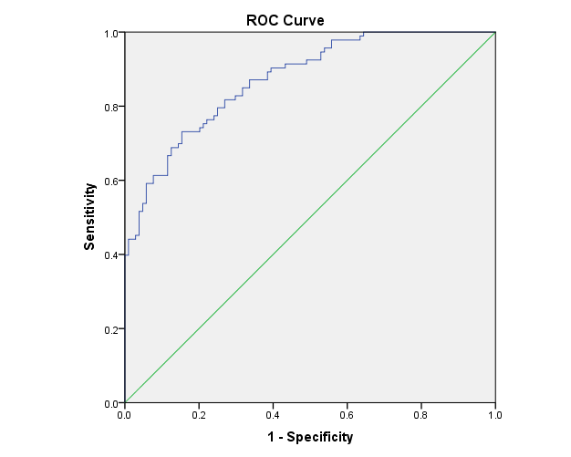
Figure 1 Area under curve for new variable on differentiating DU with BOO

Interpretation of results
The result shows that multivariate analysis could improve the diagnosing accuracy, by mathematical linear combining the inputted parameters. While the single variable could have limited diagnosing power, such as Q_{max} with P<0.0001 only having area under curve value of 0.634, the combination of these non-invasive parameters shows promise on differentiating DU from BOO. Moreover, the diagnosing accuracy could possibly be further improved if any other non-invasive parameter is employed. However, it should be noted that the current result is only valid in training procedure, and a larger data number is needed for validation before diagnostic use.

Concluding message
In this study, we found the multivariate analysis could improve the diagnosing accuracy by combining parameters which have statistical difference between DU and BOO groups, and presented the possibility to non-invasively differentiate DU with BOO only by analysing the flow rate data alone. Further research will focus on explore other parameters which could serve as additional indicators for differentiating two symptoms, and other classification methods such as neural network and classification/regression tree analysis.

