Median frequency and sum of amplitude changes in rising slope: two potential non-invasive indicators for differentiating DU from BOO in males

Hypothesis / aims of study
It remains a challenge to non-invasively differentiate detrusor underactivity (DU) from bladder outlet obstruction (BOO) in males, and the gold standard is pressure flow studies, which is invasive, relatively expensive and may cause bleeding and infection. This novel study aims to non-invasively differentiate DU from BOO in males by analysing urine flow rate curves in the frequency domain. The hypothesis is that underactive patients may perform more abdominal straining than obstructed patients during micturition due to their underactive detrusor. Thus, it is possible to analyse the urine flow rate in frequency domain and derive non-invasive parameters for differentiating these two groups, as abdominal muscle strains in a different frequency range comparing with detrusor contraction [1].

Study design, materials and methods
Free-flow data of 273 adult male patients who had also undergone PFS were analysed in this research. Based on their PFS record, these patients are divided into three groups: 104 BOO, 93 DU, and 76 normal (DU and BOO disease free) for reference. All free flow data has pre-processed by threshold value of 0.5ml/s for the start and end micturition point [2].
To leave only the fluctuations in the flow curve for analysis in frequency domain, a bandpass Kaiser window filter has been designed and applied on the pre-processed flow data. The selection criteria and specifications for the filter are listed as below:
- The passband of filter should be flat and ideally without ripples, for the accuracy frequency analysis result.
- The roll-off should be sharp, for a better filter performance.
- The group delay response should be a constant value, for shifting back filtered curve with same data sequence length as raw curve.
- The bandpass range is set to 0.1-1Hz, for maximise reducing fluctuation by detrusor contraction with frequency under 0.1Hz and artefact noise such as coughing.
- The attenuation is set to -40dB, for reducing artefact fluctuations up to 50ml/s to 0.5ml/s.
Then the sum of amplitude changes is calculated in the filtered flow curve, which is presented as in figure 1. Meanwhile, the frequency spectra of filtered flow curves are generated by fast Fourier transform, and median frequency values are calculated as the frequency value dividing power spectrum into two regions with equal amplitude, which are as presented in figure 2. The filtered flow curve is also divided into two parts by maximum flow rate (Q_{max}), half of voiding time (Tv), and the location where half of volume is voided, to calculate median frequency in each part.
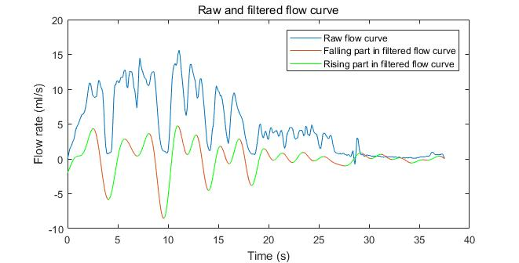
Figure 1 Raw and filtered curve for sum of amplitude changes in rising slope
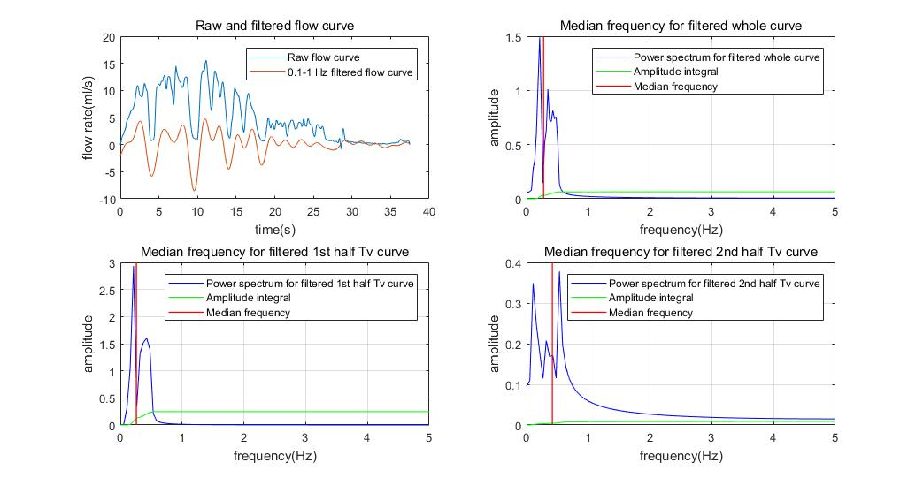
Figure 2 Median frequency in whole, 1st and 2nd half Tv filtered curve
All statistical analysis was performed in SPSS version 24, Mann-Whitney U test and T-student test were performed as appropriate. A statistically significant difference was considered as P value<0.05.

Results
We found the significantly statistical difference in sum of amplitude changes in rising slope with P value<0.001, between DU group (mean±SD, 27.4±20.2) and BOO group (mean±SD, 18.3±14.2). Area under the curve (AUC) value is 0.651 in receiver operating characteristic (ROC) analysis, with 63.4% sensitivity and 65.4% specificity. However, no statistical difference is found for differentiating DU from BOO when this parameter takes a ratio to Q_{max} or volume voided.
In median frequency analysis, the significantly statistical difference for differentiating DU with BOO appear in the filtered whole flow curve (DU vs BOO=0.42±0.10 vs 0.48±0.10) with P value of 0.0001, followed by in the first half volume voided part (P<0.001), ratio of median frequency in 1st to 2nd half part divided by Q_{max}, (P=0.002), ratio of median frequency in whole filtered curve to 2nd half part divided by Q_{max} (P=0.003) and median frequency in 1st half part divided by Tv (P=0.004). The AUC value is 0.665 for median frequency in filtered whole flow curve, with 43% sensitivity and 86.5% specificity.

Interpretation of results
In this study, we found the flow rate curve fluctuations during micturition in DU patients group have higher amplitude changes than BOO group, and the frequency difference in the whole filtered flow curve. Currently the sensitivity and specificity of these two indicators could not yet exceed those of the simple Q_{max} cut-off of 10ml/s to select symptomatic men with a high likelihood of BOO, but it still shows promise that these may serve as additional indicator for preliminary screening of DU before invasive pressure flow studies. Furthermore, these indicators could be combined with other non-invasive parameters to enhance current diagnosing accuracy.

Concluding message
This study shows promising non-invasive indicators for diagnosing DU in men by analysing urine flow curves in the frequency domain. Further research will explore other possible non-invasive parameters, and mathematically combined with existing indicators for achieving more promising diagnostic accuracy of DU in male.

