‘Wrecked on the Intertidal Zone’ : documenting an investigative arts project on the environmental destruction of the Thames Estuary.

Alistair Oldham
University of West of England, Department of Film & Journalism, UK

Abstract

“Wrecked on the Intertidal Zone” is a gallery of fifteen short films that document a multi-layered investigative arts project exploring the changing ecology, society and industry of the Thames Estuary. As this subject matter presented a significant challenge for a conventional narrative documentary, new ways had to be discovered to represent it, including breaking up the recorded material into a
non- linear, interactive form. This paper follows the process of the project from inception to postproduction and dissemination, reflecting on its methodologies from the perspective of the producer/director.

Keywords

Documentary, Interactive, Environment, Anthropocene, Estuary

Introduction

This is a practice based research paper that reflects upon the production of an interactive documentary project called “Wrecked on the Intertidal Zone.” The author of the paper, Alistair Oldham, was the producer-director of the documentary project, which can be viewed at the following link :

www.wreckedontheintertidalzone.co.uk

As can be seen from the opening ‘Introduction’ film, the project sets out to explore the changing ecology, society and industry of the Thames Estuary. The project was led by local artists YoHa and Arts Catalyst (the London based Centre for Arts, Science & Technology) with multiple partners including the Arts Council, the Wellcome Trust and American collaborators the Critical Art Ensemble.

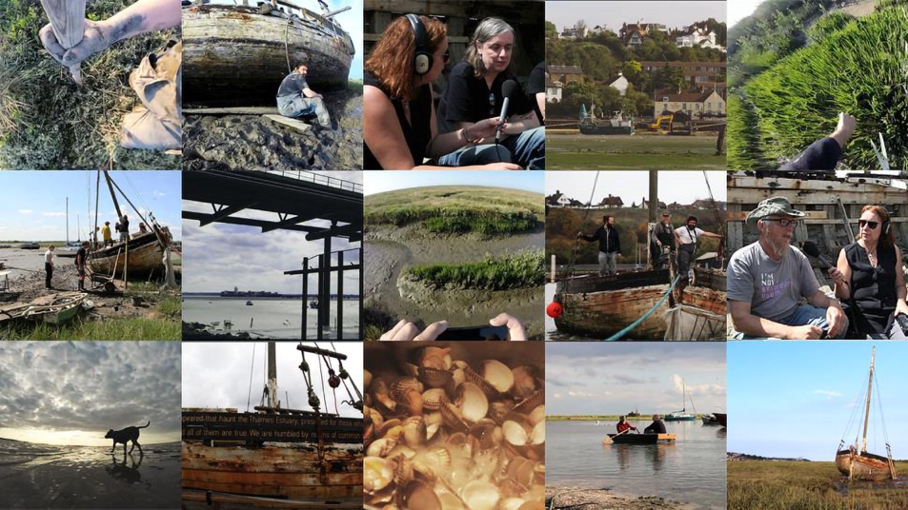

Image 1- Wrecked on the Intertidal Zone interface

The arts project has multiple layers, but its centerpiece is “The Graveyard for Lost Species”, which involved digging a forty foot, twelve ton cockle fishing boat out of the deep Essex mud, towing it to shore, and then turning it into an anti-monument by writing an “Epitaph of the Common Mud” to all the lost species and vanishing ways of life in the local area of the Thames Estuary, and then routering the words of the epitaph into the boat’s hull, before dragging it out back to the marshes and leaving it there to decompose in posterity.

Other elements of the project include a series of citizen science workshops, foraging for wild food, creating a meal at a local Arts Centre made exclusively from local products (including grey mullet sashimi with soya sauce made from human hair), going on brown shrimp fishing expeditions, exploring local geographic features such as Canvey Island and the Hadley Ray, and conducting interviews with local author and historian Rachel Lichtenstien and American project collaborators the Critical Art Ensemble.

In terms of viewing and dissemination, the work has been designed as an online video gallery of fifteen short films (that can be viewed on a computer, mobile phone or tablet ), but elements of the work have also been viewed as a gallery installation, as a presentation to a live audience and individual films have been shown at film festivals and conferences. The gallery’s organisation is built around the central project ‘The Graveyard of Lost Species’, and this forms the narrative spine of the material, which can be followed through the films ‘Refloating the Souvenir’, ‘Final Mud Day’, ‘Epitaphs of the Common Mud’, ’Anti-Monument’ and ‘Final Resting Place’. But the project’s broader themes are also picked up and expanded on in the Introduction window, and in the edited interview sequences with local author Rachel Lichtenstein, whose book ‘Estuary’ features two chapters on ‘Wrecked on the Intertidal Zone’, and who comes to act as a very useful mediator of some of the more complex ideas in the project overall.

The following sections of this paper will aim to document the process of the project, from conception to production, postproduction and dissemination, asking what can be learned or deduced from this process, particularly in its stated aim of attempting to find the best documentary form by which to represent a multilayered investigative arts project.

Starting Points : Research and Preproduction

My starting point for the project was being invited by the artists YOHA and arts organisation Arts Catalyst to document their proposed arts project project, “Wrecked on the Intertidal Zone”, which sought to investigate the environmental destruction of the Thames Estuary through a range of field based activities and workshops. I should say from the outset that this documentation was not funded as part of any doctoral or university funded research programme, and the films were produced solely with a £2000 grant from London based Arts Catalyst, who formed part of the wider funding network of the overriding arts project.

My research process began by travelling to Leigh-on-Sea in Essex to meet the various collaborators, particularly Graham Harwood and Matsuko Yokoshimi of the arts group YOHA, and Claudia Lastra from Arts Catalyst. As they described the project, I admit I struggled to understand all of its multiple layers and the complexity of what they were trying to achieve. I have worked with YOHA before, particularly making a short documentary film for their project ‘Invisible Airs’, another investigative based arts project, which sought to explore the relationship between open data and local government expenditure. So I knew that the artists’ approach was partly defined by an unfolding of process, revealing new insights as the project progressed and developed. I also knew that making a conventional narrative documentary film was not necessarily going to be the best way of documenting this often quite disparate and slightly unpredictable process. And maybe I also wanted to challenge myself as a filmmaker to try something different, and to not just fall back on the familiar narrative arc and three act structure of the conventional narrative documentary.

As I listened to the artists discussing the complexity of the Thames Estuary, the traditions and ways of life of the communities that lived there, and how they had found an old cockle fishing boat that they wanted to haul out of the deep mud of the marsh, and turn into some kind of anti-monument to the lost ways of life and species extinction, I simultaneously realized that I was going to have to think of new and different approaches to production, in order to find a form and a process that would adequately represent the complexity of this ambitious arts project and the landscape in which it was embedded. As far as my own practice was situated in a higher education framework, the research question that I used to define this approach, became ‘how to best use the documentary form to represent a multilayered investigative arts project’.

In terms of its broader subject area, the arts project is also a kind of commentary on the Anthropocene, particularly in the central piece “Graveyard of Lost Species”, (see ‘Refloating the Souvenir’, ‘Epitaphs of the Common Mud’, ‘Anti-Monument’ and ‘Final Resting Place’). Other aspects of the project document the environmental impact of the Anthropocene on the Estuary, through the effects of industrialisation on the environment and the communities that it has traditionally supported, for example through rising water temperature, deep water dredging, food scarcity, species extinction and loss of livelihood.

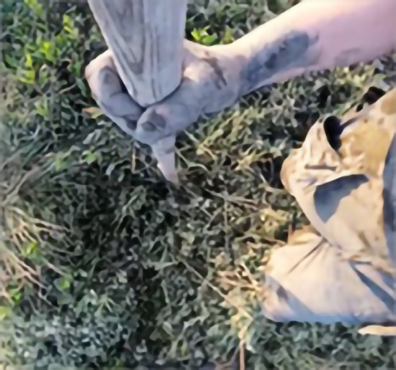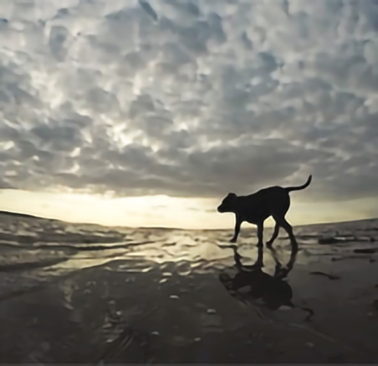

Image 2- Refloating the Souvenir. Image 3 - Hadleigh Ray

These interests and concerns also align with my own previous filmmaking practice in terms of exploring the relationship of environmental sustainability and creative process, adding to an ongoing body of short documentary films that deal with these areas : the films The Bristol Bike Project (2011), Bonnington Square (2012) and The Gardens of St George (2014) all deal with environmental sustainability, and Invisible Airs (2013) and Drawing on Topolski (2015) both document the work of artists’ creative process. “Wrecked on the Intertidal Zone” adds to that body of work by combining those themes, while simultaneously moving toward a more interactive platform.

Production processes and methodologies

My own process of investigation at these early stages of the project was to discover an appropriate method of documentation and to design a screen format by which to most effectively represent it. An open ended methodology was important, to accommodate the complexity of the arts project itself, which involved multiple layers of exploration into local community, landscape, boats, tides, marshes, species extinction, land contamination, tactical media, citizen science and anti-monuments, which would not all together fit tidily into a conventional linear narrative. The emerging form of the gallery also seemed to be the best way to represent the amorphous nature of the Thames Estuary itself, with its concurrent themes of flows, currents and ideas that seep across the boundaries of the different films. A lot of this process of production was fairly organic, in that we knew broadly what were trying to achieve, but we weren’t quite sure how we were going to get there.

This evolving process of research and editorial design, was also partly based on the back of watching students engage with Klynt software in the level two undergraduate multiplatform documentary module at UWE Bristol, where they had to produce work in either sound and video, or interactive media and video, presenting the whole documentary package in a Klynt webpage housing to be delivered online. So I knew that it was at least possible to produce disparate video elements that could be presented together in an integrated platform for one online screen delivery.

In terms of producing and directing, it was a case of identifying what stories need to be told, what ideas needed to be communicated, and of identifying a shooting schedule that was feasible in terms of travelling across the country from Bristol to Essex. To this end I decided to work with two former UWE Filmmaking graduates, Jim Smith and Zander Mavor, who I employed as a lightweight camera and sound recording crew to accompany me on two separate trips to Essex. A large part of my task as director, was to identify which parts of the project needed to be recorded, and to sketch out a rough plan or template of what this gallery of films might become, and what different storylines might need to be identified and developed within the overall project.

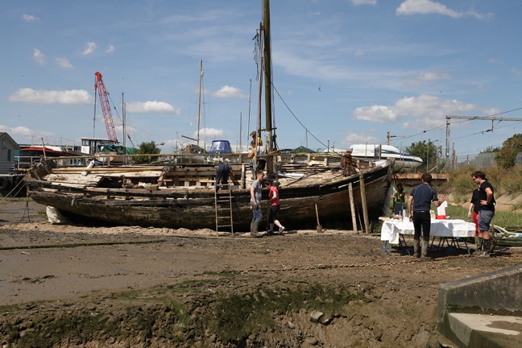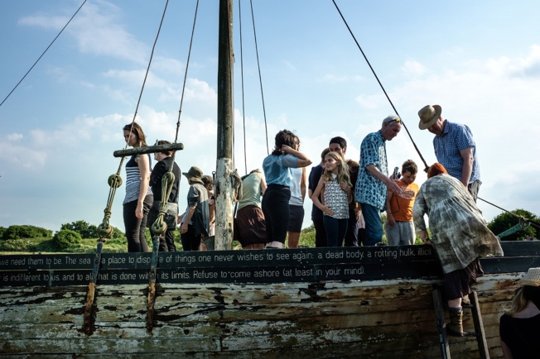

Image 4- Final Mud Day Image 5 – Final Resting Place

The production process also adopted some of the participatory methods of interactive documentary, in its collaboration with other artists and filmmakers, with footage coming from a range of different filmed sources. As well as the footage gathered by myself Jim and Zander, other material had already been recorded by Graham Harwood and Fran Gallardo (a Phd student from Queen Mary’s College), using GoPro cameras. And more footage was shot and edited by local filmmaker and Royal College of Art postgraduate student, James Ravinet,(who shot “Epitaphs of the Common Mud” and the sequence of ‘Conversation” films with local historian and author Rachel Lichtenstein) and also by local sound artist, Stuart Bowditch.

I personally took on the role of overall producer and director, designing the gallery interface and arranging the editorial content across the fifteen different films, including directing individual sequences and conducting interviews. Some footage was shot entirely on GoPro cameras by people who would not describe themselves as filmmakers. Some of the most interesting sequences were shot in this way, with cameras mounted on paddles, on the bow of a boat, and on top of someone’s head, in situations where it wasn’t even envisaged to end up being in a film (eg the films “Refloating the Souvenir”, “Foraging” and “Hadley Ray”).’ In this way the project was very much about involving local people in the production process, who are themselves embedded in their landscape and community. Some of the most striking sequences in the films were recorded in this way, where the wide angle fish-eye lens of the GoPro camera captures perspectives and viewpoints that feel almost non-human in their recording of a strikingly posthuman landscape.

Editorial design and postproduction

A lot of the method of the project was collating and gathering footage together in this way from disparate sources, and then adding to it and shaping it together into individual films with a coherent and overarching editorial strategy, that together represented the broader concerns of the project. This selection and arrangement of the material, deciding what stories to follow and then deciding how to best organise them in relation to each other, was a core element of the project’s design. I was more like a director, producer and content designer, working with a collaborative and participatory documentary collective, which seemed like an interesting and significant disruption of the hierarchy of a traditional film crew.

As a director I also concentrated on gathering interview material from Graham Harwood, capturing on camera some of the conversations that we had during the research process, where I was trying to define and give shape to Graham’s thinking, which would then form some of the key voiceover material to provide the narrative spine of many of the individual films. And then as we went along, I roughly sketched out where this interview material would sit, what titles the individual films might be given, and what conceptual areas their content might address. Instead of writing a conventional documentary treatment, which is maybe the closest one gets to scripting in documentary, it was more
like scripting a documentary mosaic, writing and editing across fifteen films simultaneously, to try and tease out the best arrangement of the material. So we tried to create stories from the various bits of footage that we were given, and make those stories complement each other in terms of their meaning, shaping material through interview and through a process of paper editing, and then applying that process to each individual film and then also across the gallery as a whole.

The final part of the production process was to assemble all of the material into the Klynt software, making final decisions on film titles, and designing an interface in Photoshop with interactive buttons to enable each film to play. I’d like to think that the finished gallery of thumbnails captures something of the pastoral of the landscape, but beyond that, decisions had to be made about what was the best editorial arrangement of the films, so that they were not just placed at random, but instead offered a viewer at least some assistance in navigating their way around the material.

Some broader context

As previously stated, this project was not funded as research and it was not part of any doctoral or post doctoral activity, so I had no particular obligation to present a literature review before embarking on production. However, in the course of my own production research I did revisit some interactive documentaries such as Out my Window (Cizek,2016), Bear 71( Allison,2012) and Journey to the End of Coal (Bollendorff & Segretin, 2008), as well as referring to the theoretical positioning of interactive documentary from the i-Docs conference, held at the Watershed, Bristol and the recent edited collection “i-Docs : the Evolving Practices of Documentary”. Another source of inspiration has been the film and installation work of John Akomfrah, particularly for the qualities of creative montage that his work displays, deploying fragmented imagery across multiple screens to create different possible readings and interpretations. Also, since the project's completion, a reviewer has directed me to the short film ‘Ain’t Got No Fear’ (Karikis,2016), which is an interesting reference in terms of adopting a participatory and performed response to a similarly post industrial estuary landscape around Sheerness in Kent.

These various influences led me to consider strategies of how to best represent meaning that emerges from a distinct geographical space, how to editorially map across different subjects and themes, how to engage different collaborative voices within the production of one documentary project, and how to address considerations of audience that depart from conventional linear story telling. I also researched previous examples of work from both YOHA and the Critical Art Ensemble, to understand some of the principles of tactical media, the notion of the technical object, and of the idea of the anti-monument as a means of cultural resistance.

Outcomes, dissemination and impact

Since completion the work has been shown in different contexts, particularly in galleries, conferences and festivals, as well as online, where it can be viewed on smartphones and tablets, as well as on a computer. To some extent the work has still not been concluded and in particular I would like to be able to measure audience data in terms of visits to the website, including by what device the work is viewed on. To be honest, I don’t think anyone is likely to sit there and watch all of the films, they might watch one or two, or they might just dip in and try different elements of the overall project, but in a way that feels okay and is quite reflective of broader contemporary audience behaviour.

Individual films have screened at the Crossroads of Art & Science conference (Hermitage, St Petersburg), the Voices from the Waters Film Festival (Bangalore, India), the Ostrava Environmental Film Festival in the Czech Republic, at the large outdoor screen of the Focal gallery (University of Essex, Southend), and at the Museum of Applied Arts and Sciences in Sydney, Australia. The work has also been shown as a gallery installation at the launch of Arts Catalyst’s Centre for Art, Science & Technology (Kings Cross,London) in an exhibition called ‘Notes from the Field : Commoning Practices in Art and Science’ , as a conference presentation at the annual NAHEMI Talking Shop conference at the London College of Communication, and more recently at the i-Docs conference at the Watershed, Bristol (March 2018), at a Screenworks symposium at the Cube cinema in Bristol (June 2018) and also at the Avanca Film Conference in Portugal (July 2018).

These varied forms of dissemination have enabled the work to be tested out and received in different ways, for example by a more autonomous audience led navigation in an installation or gallery setting, compared to being guided through the material in a conference setting, or the more traditional narrative form of conventional film festival screenings. The Arts Catalyst installation, and the Hermitage and the Sydney Museum of Applied Arts and Sciences screenings have both enabled the work to be experienced in the specific context of the convergent fields of Arts and Science. These differing contexts of distribution have been an unexpected outcome of the project’s design and I would like to explore further how and where audiences might experience the work. As previously mentioned in the Outcomes section, the dissemination of the project into various settings, is enabling me to gain more insight into my own practice, particularly as a traditional filmmaker trying out different ways of working within the documentary idiom.

Conclusions and reflecting on practice

I think the gallery approach works well for this subject matter, but of course it might be appropriated in all sorts of ways and across different genres. Practitioners in other research disciplines might gain inspiration from the possibility of breaking a subject down into multiple strands in terms of its filmic representation, rather than being tied to a more conventional linear narrative . This online gallery based approach has been designed to represent an investigative arts project, but the same model could be applied to similar explorations that deal with historic or geographic representation, where the act of documentation can offer added value beyond the simple recording of process. In this respect, the medium of film and then also of interactive documentary can enable a much more expansive investigation of a project’s principal themes, in this case locating the investigative arts project very much into the environment from which it has evolved. Film can take you out into the field in a way that other mediums might struggle to do. And the format of the interactive gallery can then expand that field of vision even further, allowing a variety of viewpoints and perspectives much in the same way as you might experience being in the actual landscape itself.

The gallery format has also enabled a different means of representing the sense of place of the Thames Estuary, not just in the very specific location photography of ‘Hadley Ray’ and ‘Canvey Island’, but also in the way in which a deeper mapping of landscape emerges across the different spaces of the films, for example through the walking sequences of ‘Foraging’,’Hadley Ray’ and ‘Citizen Science’, and in the edited visual sequences of the interview sections and ‘Thames Estuary’. Some of these sequences have an almost performative feel, where individuals are seen walking through the landscape, while hearing their thoughts and reflection through voiceover. The gallery platform has enabled a deeper texture of geographic space to emerge through the films, where stories and ideas can seep across the different elements of the gallery space.

I like the fact that the material has been derived from different sources, as I think the Klynt gallery platform can accommodate different filmmaking styles and voices, and actually it is totally in keeping with the collaborative nature of the project overall, breaking down some of the production hierarchy of traditional filmmaking . And those different stylistic approaches become integrated through the editorial arrangement of the final gallery and also through the distribution and employment of sound design across the various strands. Similarly, there are some shots that are repeated, or pop up again, in different spaces across the different films, and I like to think the whole piece has a kind of layered, painterly effect in terms of both the interface design, but also in the evocation of the sense of place, particularly in the exploration of the ‘intertidal zone’, the liminal space between the tides, of mud and marsh, that is neither land nor sea.

Hopefully, the project also demonstrates that the documentation of an arts project like this can do much more than just record its process, and can add discursive value and reflection in its own right to the project’s original activity. So although themes that relate to the Anthropocene such as the impact of industrialisation, environmental damage to the Thames Estuary and species extinction are all central to the arts project itself, their expansion through interview, voiceover and filmed montage and juxtaposition is given added value through the documentary. This has given the artists space to speak about a range of more detailed issues related to the Anthropocene (for example, the shipping industry, necro-capitalism, and the post industrial landscape) that would otherwise remain unrecorded in the arts project by itself. Some of the films, such as ‘Hadley Ray’, ‘Canvey Island’ and ‘Thames Estuary’ are not even part of the original arts project, but have been included in the documentary to substantiate and expand on it, and in this way the documentary project can be argued to have added additional layers of meaning to the arts project itself, so that the documentary and the arts project start to feed off each other, rather than one being simply the record of the other.

Finally, since completing the project,various conferences, presentations and papers, such as this one, have encouraged me to reflect on my own practice, which has been a positive and revealing process for me as a documentary film maker and teacher.

Bibliography

Aston.J, Gaudenzi.S, Rose.M (2017) : i-Docs, The Evolving Practices of Interactive Documentary. Wallflower Press.

Critical Art Ensemble (2001) : Digital Resistance, Explorations in Tactical Media. New York, Autonomedia.

Lichtenstein.R (2016) Estuary : Out From London to the Sea. Hamish Hamilton.

Filmography / Installations and Interactive Documentaries

Vertigo Sea (2016) dir. John Akomfrah. Smoking Dog Films.

Purple (2017) dir. John Akomfrah. Smoking Dog Films.

Out My Window (2010) dir. Katerina Cizek. National Film Board of Canada.

Bear 71 (2012) dir. Leanne Allison. National Film Board of Canada.

Journey to the End of Coal (2008) dir. Samuel Bollendorff & Abel Segretin. Honkytonk Films.

Evil Media Distribution Centre (2013) dir. Graham Harwood & Matsuko Yokokoji.

Ain’t Got No Fear (2016) dir. Mikhail Karikis

