Fabrication of miniaturised screen-printed glucose biosensors, using a water-based ink, and the evaluation of their electrochemical behaviour
G. Hughes¹, R.M. Pemberton¹, P. Nicholas², J.P. Hart¹*
1. Centre for Research in Biosciences, Faculty of Health and Applied Sciences, University of the West of England, Bristol, Coldharbour Lane, Bristol, BS16 1QY
2. The Gwent Group, Gwent Electronic Materials, Gwent Group Ltd., Monmouth House, Mamhilad Park, Pontypool, NP4 OHZ, UK
* Corresponding Author: john.hart@uwe.ac.uk Tel: 0117 328 2469

Abstract
This paper describes a simple, convenient approach to the fabrication of microband electrodes and microband biosensors based on screen printing technology. These devices were printed in a three-electrode configuration on one strip; a silver/silver chloride electrode and carbon counter electrode served as reference and counter electrodes respectively. The working electrodes were fabricated by screen-printing a water-based carbon ink containing cobalt phthalocyanine for hydrogen peroxide detection. These were converted into a glucose microband biosensor by the addition of glucose oxidase into the carbon ink. In this paper, we discuss the fabrication and application of glucose microband electrodes for the determination of glucose in cell media. The dimensions (100 – 400 microns) of the microband electrodes result in radial diffusion, which results in steady state responses in the absence of stirring. The microband biosensors were investigated in cell media containing different concentrations of glucose using chronoamperometry. The device shows linearity for glucose determination in the range 0.5 mM to 2.5 mM in cell media. The screen-printed microband biosensor design holds promise as a generic platform for future applications in cell toxicity studies.
Keywords: Water-based ink, glucose oxidase, microband biosensor, cyclic voltammetry, chronoamperometry, hydrogen peroxide.

There is a growing demand for biosensors to monitor changes in metabolite levels of viable cells, particularly for applications such as drug toxicity testing [1,2]. The electrochemical devices must be small enough that they do not perturb the normal metabolic processes occurring within the cell; to achieve this, microband biosensors can be used [3]. Microband biosensors are fabricated by screen-printing a carbon ink containing the enzyme glucose oxidase (GOX) and the mediator cobalt phthalocyanine (CoPC) onto a plastic PVC substrate. CoPC is commonly utilised as an electrocatalyst for the oxidation of H₂O₂ [4], as it decreases the potential required to electroxidise this species [5] and increases the sensitivity of the device [6]. During the operation of the biosensor, GOX enzymatically converts glucose to gluconolactone and simultaneously generates H₂O₂. This latter species then undergoes electrocatalytic oxidation involving the following reactions:
H₂O₂ + 2Co²⁺ → 2Co⁺ + 2H⁺ + O₂ (1)
Co⁺ → Co²⁺ + e⁻ (2)
It should be noted that the Co²⁺ and Co+ species are co-ordinated to the phthalocyanine moiety within the CoPC molecule. Equation (1) shows the chemical reduction of Co ²⁺ by H₂O₂, to form Co+, which is followed by the electrochemical oxidation of Co⁺ back to Co²⁺; this latter reaction constitutes the analytical response of the glucose biosensor.
Screen-printing is now recognised as a rather convenient approach to the mass production of biosensors. The method consists of transferring ink through a mesh which is manufactured to the desired shape and size of the electrodes required. Enzyme-containing inks are then typically dried at room temperature. This technique allows for the rapid and low-cost production of electrodes. Due to their small sizes, microband biosensors do not consume a significant concentration of the target biomarkers (for example; glucose and lactate) present in the cell culture medium. Another advantage of microband biosensors is that they exhibit steady-state behaviour in the absence of stirring. Consequently, changes in the concentration of the target biomarker, which occur during cytotoxic challenge to the cells, can be readily measured [7–9].
The aim of the present investigation is to explore the possibility of fabricating microband sensors and biosensors using a cost-effective, rapid and robust screen printing procedure. To date, micro biosensor and microband biosensor devices have been manufactured using several approaches and electrode materials. Previously reported devices have utilized expensive materials such as gold [10] and diamond [11] which do not lend themselves to mass production. A far more cost effective alternative to fabricate such devices is the manipulation of conventional sized screen-printed carbon electrodes by transverse cutting [12,13], as well as drilling through the working area [14]. Although these approaches have successfully resulted in microband behaviour, which could be applied to toxicity testing, the manufacturing process is not considered suitable for mass production purposes due to the requirement of additional modification steps in order to produce the final device. Such additional steps may be cost-prohibitive as they would require the sophisticated and accurate cutting machines to reproduce the electrodes on a large scale, despite the low-cost of printing the electrodes. Our fabrication method addresses this issue by producing microband sensors and microband biosensors using a convenient, direct screen-printing procedure whereby the reference and counter electrodes are printed alongside the working sensors / biosensors. This would be of interest to both the sensor manufacturing industry and the pharmaceutical industry for the high-throughput toxicity testing of prospective drugs.
Initial cyclic voltammetric studies were performed to characterise the electrochemical behaviour of the cobalt phthalocyanine screen printed carbon electrodes (CoPC-SPCEs) for the measurement of hydrogen peroxide. This particular electrocatalyst has been found to be effective for the electroxidation of hydrogen peroxide and has been used by our group and others in numerous studies [15]. It was important to understand the electrochemical behaviour of hydrogen peroxide with this new electrode configuration, as it is the product of the reaction of numerous oxidase enzymes with their appropriate substrates. For example, in the present paper we have studied a microband biosensor containing glucose oxidase, for the measurement of glucose [3].
In this paper, we have examined four different microband working electrode widths using cyclic voltammetry. Figure 1 shows the resulting cyclic voltammograms obtained with the presence and absence of 8 mM hydrogen peroxide, 5mV/s, pH 7.4. In order to clearly demonstrate the electrocatalytic behaviour of the microband electrode in response to hydrogen peroxide, a relatively high concentration of 8mM was chosen. This concentration also allowed us to compare our results to those reported in a previously published paper, involving the fabrication of microband sensors using a water based ink, but with a different geometry [12]. Fig.1. shows that, in the absence of the electron mediator, no catalytic response to hydrogen peroxide was observed. This is in agreement with the findings reported in our previous paper [12]. In all five cases, the cyclic voltammograms do not exhibit the typical peak shape response for a species undergoing planar diffusion, but are indicative of a species undergoing mainly radial diffusion to the electrode surface. It should be mentioned that the presence of pure radial diffusion would be expected to result in voltammograms showing an extended plateau region; however, one electrode dimension (length) is of a conventional size, therefore it might be expected that some contribution from planar diffusion occurs. This combined diffusional behaviour appears to result in a pseudo-sigmoidal voltammetric response. The voltammetric, behaviour involving the redox couple Co⁺/Co²⁺ [16], exhibits typical characteristics expected for microelectrodes: low capacitance [17] and a high signal-to-noise ratio [18,19]. A scan rate study, whereby different scan rates (5, 10, 25 and 50mV/s) at a fixed concentration of hydrogen peroxide was carried out (not shown). It was determined that the current is independent of scan rate up to 50mVs, whereby the current increases. This suggests that radial diffusion is dominant and is indicative of microband behaviour, rather than being controlled by the rate of the reaction of hydrogen peroxide with cobalt phthalocyanine, or the electron transfer reaction from cobalt phthalocyanine to the carbon electrode. Furthermore, it should be mentioned that, in previous work [24], voltammetric peaks have been observed with hydrogen peroxide, using electrodes comprised of the water based inks containing cobalt phthalocyanine. This behaviour was observed when either a conventional sized electrode (3 mm x 3mm) was employed, or where diffusion layers overlapped with microelectrode arrays. Consequently, we can conclude that, in the present study, the current produced during the electrocatalytic oxidation of hydrogen peroxide, is not kinetically controlled, but is controlled by radial diffusion.

This behaviour demonstrated the possibility that our new microband sensor design could form the basis of a microband biosensor for the measurement of glucose. For subsequent studies, we selected the 400-micron width electrodes, as these were far more robust than the narrower width microband electrodes with respect to the determination of hydrogen peroxide due to the larger surface area and subsequent greater current response. Additionally, we determined that despite the larger dimensions, the 400 micron electrodes produced a quasi-microelectrode response.
In order to determine the reproducibility of these devices, repeat cyclic voltammograms were recorded with buffer containing 8 mM H₂O₂; currents were measured at a potential of +450mV and the coefficient of variation was calculated to be 3.04% based ( n = 3).
In the next part of the study we investigated the new design comprising of a working electrode containing the enzyme glucose oxidase. Chronoamperometric calibration studies were carried out at an applied potential of +450mV (versus Ag/AgCl); this value was deduced from the CV responses (Figure 1) and agrees well with our previous studies using a CoPC-SPCE [15]. In our previous research, we have found that the first part of our voltammetric response was due to the re-oxidation of Co⁺ to Co²⁺, which occurred at around +450 mV. We avoided higher potentials as this could result in the oxidation of Co²⁺ to Co³⁺, which is not an efficient electrocatalyst for H₂O_{2,} and can result in a loss in the analytical response. The performance of the microband biosensor was investigated with increasing concentrations of glucose. Figure 2 illustrates typical chronoamperometric responses for concentrations in the range 0.5 to 2.5mM. It should be noted that homogenisation takes approximately 60 seconds from the initial addition of glucose into an unstirred 10mL volume of cell media which contains the previously submerged sensor. A steady state response is then established as a result of radial diffusion at the microband biosensor surface. The steady state response also indicates that the CoPC and GOX enzyme are not leaching out into free solution. The absence of leaching when using CoPC inks has previously been reported in amperometric [20] and flow-injection systems [21,22].
A linear response to glucose was observed over a range of 0.5 – 2.5 mM (Figure 2) with a sensitivity of 8.69 nA/mM, and a current density of 4.35 nA/mM/mm². This improves upon the sensitivity achieved by the transverse cutting of a conventional sized electrode (0.936 nA mM⁻¹ mm⁻²) [13].
In summary we have described the successful fabrication of micron dimension microband glucose biosensors based on direct screen-printing of a water based carbon ink onto a PVC substrate. This is the first report of a microband biosensor working electrode fabricated in a single step without further modification. We believe our device is the first glucose microband biosensor to be fabricated entirely by screen-printing, without cutting the working electrode [3] or utilising laser ablation [23,24] in a complex multi-stage process. The use of carbon screen-printed electrodes also significantly reduces the cost of the device in comparison to previously reported micro-biosensor devices which utilise platinum [25,26], platinum/iridium [27] and carbon fibre/ruthenium as the material for the microelectrodes [28]. Our method lends itself to mass-production of microelectrodes, without requiring use of MEMS technology. We believe this method holds promise as a generic platform for future microband devices for the investigation of cell metabolites. The sensitivity/current density of our device with respect to glucose in cell culture media compares favourably to previously reported current densities [8,13,29] (1.4 nA mM⁻¹ mm⁻², 0.936 nA mM⁻¹ mm⁻², 4.7 nA mM⁻¹ mm⁻² respectively).
Experimental
Foetal bovine serum (FBS), hepatocyte medium (Modified L-15), Dulbecco's Modified Eagle's Medium (DMEM) and all other chemicals were of analytical reagent grade, purchased from Sigma–Aldrich. 0.05 M phosphate buffer was prepared from 0.5 M stock solutions of sodium dihydrogen orthophosphate and disodium hydrogen orthophosphate, mixed to obtain the desired pH, then diluted with deionised water (dH₂O; Purite R200 system, Purite Ltd., Oxon, UK). For all electrochemical measurements, buffer solutions were fortified with 50 mM NaCl. A 500 mM stock solution of β-d-glucose was prepared with distilled water, allowed to mutarotate at room temperature overnight, and then used to prepare standard solutions.
The cell culture medium used for our studies was DMEM containing 10% FBS, 1% non-essential amino acids, 200 nM l-glutamine. This culture medium has frequently been used to support growth of hepatocytes and we have also employed this medium in our previous studies [8].
All electrochemical measurements were carried out using a screen-printed three-electrode design (Figure 3). The working electrodes were fabricated either with a carbon ink containing cobalt phthalocyanine (ink code C207070501R2) without glucose oxidase (microband sensors), or with an ink incorporating glucose oxidase (ink code C2041124D3) (glucose microband biosensors). These inks were obtained from Gwent Electronic Materials Ltd. (GEM), (Crouch et al., 2005b). The carbon based counter electrodes were also screen-printed. The 100 – 400 microns × 0.5 cm working electrodes, Ag/AgCl reference (ink code C2130809D5) and carbon counter electrodes (ink code C2030519P4) were screen-printed using a DEK248 printer with a 156 threads/in polyester screen. This yielded 8 electrodes, 2 of each dimension, printed directly onto PVC. The carbon counter and Ag/AgCl reference were cured in a fan box oven @ 60°C for 30 minutes. In order to avoid denaturing the glucose oxidase, the water based working electrode was printed last and cured at room temperature.
The screen-printed microband sensors and microband biosensors were fabricated with the following dimensions: 100, 200, 300, & 400 microns’ width by 0.5 cm length. The Ag/AgCl reference and carbon counter electrodes were also fabricated from inks obtained from GEM Ltd, (code: C61003P7, C2030519P4, respectively) and deposited as 2-mm wide strips. All electrodes were printed onto 0.5-mm thick heat-shrunk PVC, supplied by Cadillac Plastics, Swindon, UK. A schematic of the electrodes in Figure 3A and a photo displaying the 400-micron electrode is shown in Figure 3B. The yellow tape indicates the insulating tape used to define the electrode area.
All electrochemical experiments were conducted with the three-electrode design (Figure 3A) mentioned above. The electrodes were connected to a µAutolab II electrochemical analyser and interrogated using cyclic voltammetry and chronoampeormetry with general purpose electrochemical software GPES 4.9 (Metrohm, Netherlands).
The measurement and monitoring of the pH was conducted with a Fisherbrand Hydrus 400 pH meter (Orion Research Inc., USA). Sonications were performed with a Devon FS100 sonicator (Ultrasonics, Hove, Sussex, UK).
References
[1] J. Hansen, P. Bross, A Cellular Viability Assay to Monitor Drug Toxicity, in: Protein Misfolding Cell. Stress Dis. Aging Concepts Protoc. Methods Mol. Biol., 2010: pp. 303–311.
[2] K.L. Audus, R.L. Bartel, I.J. Hidalgo, R.T. Borchardt, Pharm. Res. (1990) 7 435–451.
[3] R.M. Pemberton, F.J. Rawson, J. Xu, R. Pittson, G.A. Drago, J. Griffiths, S.K. Jackson, J.P. Hart, Microchim. Acta. (2010) 170 321–330.
[4] J.H. Zagal, Coord. Chem. Rev. (1992) 119 89–136.
[5] J. Wang, T. Golden, R. Li, Anal. Chem. (1988) 60 1642–1645.
[6] N.A. Pchelintsev, P.A. Millner, Anal. Chim. Acta. (2008) 612 190–197.
[7] R.M. Pemberton, T. Cox, R. Tuffin, I. Sage, G.A. Drago, N. Biddle, J. Griffiths, R. Pittson, G. Johnson, J. Xu, S.K. Jackson, G. Kenna, R.W. Luxton, J.P. Hart, Biosens. Bioelectron. (2013) 42 668–77.
[8] R.M. Pemberton, J. Xu, R. Pittson, N. Biddle, G.A. Drago, S.K. Jackson, J.P. Hart, Anal. Biochem. (2009) 385 334–41.
[9] G. Hughes, R.M. Pemberton, P.R. Fielden, J.P. Hart, Anal. Chim. Acta. (2016) 933 82–88.
[10] H. Ju, D. Zhou, Y. Xiao, H. Chen, Electroanalysis. (1998) 10 541–545.
[11] P.U. Prayikaputri, J. Gunlazuardi, T.A. Ivandini, IOP Conf. Ser. Mater. Sci. Eng. (2017) 188 12035.
[12] F.J. Rawson, W.M. Purcell, J. Xu, R.M. Pemberton, P.R. Fielden, N. Biddle, J.P. Hart, Talanta. (2009) 77 1149–54.
[13] R.M. Pemberton, J. Xu, R. Pittson, G.A. Drago, J. Griffiths, S.K. Jackson, J.P. Hart, Biosens. Bioelectron. (2011) 26 2448–53.
[14] F.J. Rawson, W.M. Purcell, J. Xu, D.C. Cowell, P.R. Fielden, N. Biddle, J.P. Hart, Electrochim. Acta. (2007) 52 7248–7253.
[15] G. Hughes, K. Westmacott, K.C. Honeychurch, A. Crew, R.M. Pemberton, J.P. Hart, Biosensors. (2016) 6 50–89.
[16] K. Wang, J.-J. Xu, H.-Y. Chen, Biosens. Bioelectron. (2005) 20 1388–1396.
[17] R.J. Forster, (n.d.).
[18] R.M. Pemberton, R. Pittson, N. Biddle, J.P. Hart, Biosens. Bioelectron. (2009) 24 1246–52.
[19] M.I. Montenegro, M.A. Queirós, J.L. Daschbach, Microelectrodes: Theory and Applications, Springer Netherlands, 1991.
[20] E. Crouch, D.C. Cowell, S. Hoskins, R.W. Pittson, J.P. Hart, Anal. Biochem. (2005) 347 17–23.
[21] J.J. Rippeth, T.D. Gibson, J.P. Hart, I.C. Hartley, G. Nelson, Analyst. (1997) 122 1425–1430.
[22] C.D. Kuhnline, M.G. Gangel, M.K. Hulvey, R.S. Martin, K.M. Walsh, R.S. Keynton, R.P. Baldwin, J.P. Ferrance, S.H. Feldman, P.M. Norris, J.P. Landers, Analyst. (2006) 131 202–207.
[23] M. Aller Pellitero, M. Kitsara, F. Eibensteiner, F.J. del Campo, Analyst. (2016) 141 2515–2522.
[24] S. Liébana, L.J. Jones, G.A. Drago, R.W. Pittson, D. Liu, W. Perrie, J.P. Hart, Sensors Actuators B Chem. (2016) 231 384–392.
[25] *,† Gerhard Jobst, † Isabella Moser, † Mehdi Varahram, † Peter Svasek, † Elmar Aschauer, ‡ Zlatko Trajanoski, ‡ Paul Wach, § Peter Kotanko, § and Falko Skrabal, G. Urban†, (1996).
[26] I. Karube, K. Yokoyama, E. Tamiya, Biosens. Bioelectron. (1993) 8 219–228.
[27] E.S. McLamore, J. Shi, D. Jaroch, J.C. Claussen, A. Uchida, Y. Jiang, W. Zhang, S.S. Donkin, M.K. Banks, K.K. Buhman, D. Teegarden, J.L. Rickus, D.M. Porterfield, Biosens. Bioelectron. (2011) 26 2237–2245.
[28] O.M. Schuvailo, O.O. Soldatkin, A. Lefebvre, R. Cespuglio, A.P. Soldatkin, Anal. Chim. Acta. (2006) 573–574 110–116.
[29] C. Boero, M.A. Casulli, J. Olivo, L. Foglia, E. Orso, M. Mazza, S. Carrara, G. De Micheli, Biosens. Bioelectron. (2014) 61 251–259.

Figure 1 – Cyclic voltammetric behaviour in response to 8mM H₂O₂, PBS pH 7.4, with respect to increasing surface area, 5mV/s scan rate for each electrode, including the electrode without CoPC. The blank response was acquired with a 0.02cm² (400 micron width) microelectrode in PBS only.

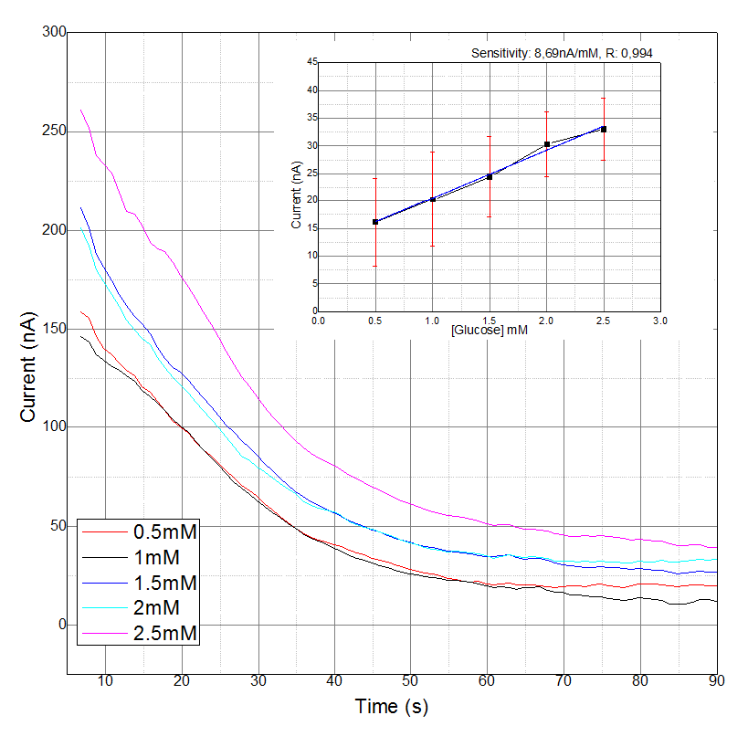
Figure 2 – A) A typical chronoamperometric response illustrating increasing concentrations of glucose in cell media, following a 5 second wait time, 450mV vs. Ag/AgCl. B) Resulting calibration plot taken from the average of currents produced at 90s from three 400 micron electrodes, standard deviations represent n = 3.

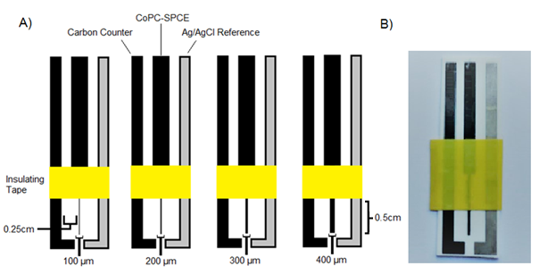
Figure 3. A) Figure illustrating the screen-printed electrode configuration. The distance between the counter-working and working-reference was 0.25cm. The electrodes were printed onto PVC, which is designated by the white background. The yellow bar indicates the insulating tape used to define the electrode area. B) Photographic image of the final 400-micron screen printed electrode.

