USE OF TECHNOLOGY ENHANCED TEACHING ROOMS TO SUPPORT FLIPPED TEACHING

K.L. Henderson*, C.A. Hobbs, and D.Rh. Gwynllyw

Department of Engineering Design and Mathematics
University of the West of England, Bristol, UK

* Karen.Henderson@uwe.ac.uk

Abstract

In this paper we report on our experiences of flipping the classroom for three modules delivered to first and second year Mathematics students at the University of the West of England, Bristol. In particular we focus on how using collaborative teaching rooms have supported the flipped classroom. All of the modules described are now delivered in a Technology-Enhanced Active Learning (TEAL) space as opposed to a typical flat teaching room, as was the case previously. This space contains collaborative working pods comprising a plectrum-shaped table and a single large-screen integrated PC. Each pod can seat up to six students. The display on these PCs is flexible; options include reproducing the main podium display, displaying a different pod’s output or each pod having their own individual display. Flipped-style teaching or the flipped classroom has seen a surge in interest recently. This style of teaching is a change to the traditional lecture model used in universities for hundreds of years. In the traditional model the lecturer is in charge of the class and largely dictates the material and pace at which this is delivered. Typically students are then required to work through more challenging material on their own before attending tutorials/problem classes for support. The idea behind the flipped classroom is that students’ initial exposure to material takes place in their own time, so students work through material independently at their own pace before the formal class. Class time may then be used for active learning, where students are able to deepen their understanding of the material, through for example problem-solving, peer instruction and discussion. Enabling students to work with each other is an effective methodology, encouraging students to be active learners by talking through concepts in their own words to each other. We have found that using a TEAL space encourages better small group discussion and peer instruction in class.

Keywords: Flipped-style teaching, active learning, TEAL classroom, collaborative teaching room

Introduction
We report on our experiences of flipping the classroom for three modules, namely a compulsory first year Calculus and Numerical Methods module (CNM), a compulsory second year Algebra, Combinatorics and Graphs module (ACG) and an optional second year Coding Theory and its Applications module (CTA). All these modules are taken by Mathematics students at the University of the West of England (UWE Bristol). Flipped-style teaching or the flipped classroom has seen a surge in interest recently (Brame, 2013; Maciejewski, 2015). This style of teaching, pioneered by Mazur (1997), is a change to the traditional lecture model used in universities for hundreds of years. In the traditional model the lecturer is in charge of the class and largely dictates the material and pace at which this is delivered. Typically students are then required to work through more challenging material on their own before attending tutorials/problem classes for support. The idea behind the flipped classroom is that students’ initial exposure to material takes place in their own time, so students work through material independently at their own pace before the formal class. Class time may then be used for active learning, where students are able to deepen their understanding of the material, through for example problem-solving, peer instruction and discussion.
In this paper we focus on how using collaborative teaching rooms have supported the flipped classroom. All of the modules described above are now being delivered in a Technology-Enhanced Active Learning (TEAL) space (MIT iCampus, 2016) as opposed to a typical flat teaching room, as was the case previously. This space contains collaborative working pods which each seat up to six students and includes a PC. Students within each pod can work independently on their PC and the lecturer can choose to project the pod’s or the podium’s screen to the whole class if desired. A typical TEAL room used at UWE Bristol is shown in Figure 1 with a close up of one of the collaborative working pods shown in Figure 2. CNM and CTA used TEAL rooms for the first time in 2016/17. ACG was been flipped for the first time in the 2017/18 academic year.
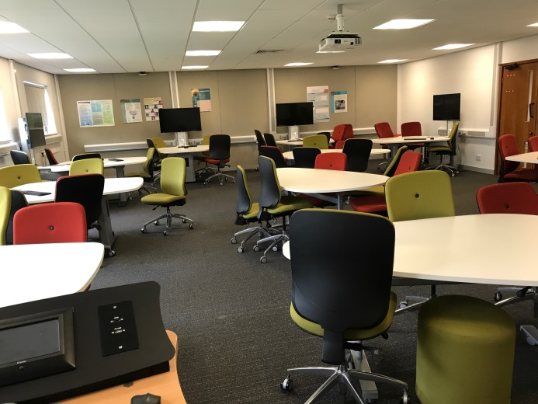
Figure 1: A typical TEAL room at UWE Bristol.

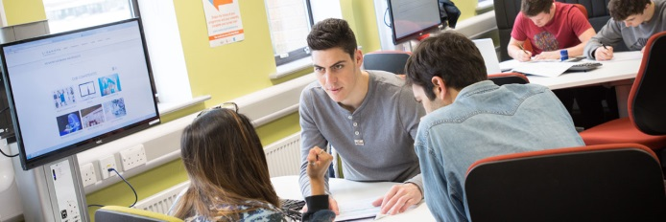
Figure 2: Close up of a collaborative pod in a TEAL room.

The flipped approach has been used very successfully for the CTA and CNM modules for several years, measured in terms of student engagement, attainment and satisfaction (Henderson, 2017; Henderson, Hobbs & Last, 2017). However, we found that running the classes in a traditional flat teaching room was not conducive to group working. Enabling students to work with each other is an effective methodology, encouraging students to be active learners by talking through concepts in their own words to each other. Research has found that students who work in groups perform better academically, particularly in regard to reasoning and critical thinking skills (Lord, 2001). We have found that using a TEAL space encourages better small group discussion and peer instruction in class. In addition, the technology built into each pod facilitates students to use relevant software (e.g. Maple) during class.

Methodology

Calculus and Numerical Methods (CNM) is a 30 credit compulsory first year module taken by all mathematics students at UWE Bristol. It runs year-long and the second semester has been taught using a flipped approach since the 2014/15 academic year. For this module, a highly scaffolded approach was employed using technology to create pre-class materials (Hooper, Henderson and Gwynllyw, 2014). A workbook containing gapped lecture notes was created as well as a handbook containing exercise sheets and extra reading material. Typically there were four screencasts to watch each week lasting on average 10 minutes each. A total of 35 screencasts were produced using Camtasia Studio software on a tablet PC. These were made available through SCORM packages on the University’s Virtual Learning Environment (VLE). Each week, prior to attending the class, students were expected to independently do the following:
- watch screencasts and fill in the relevant gaps in their workbooks;
- take a formative e-Assessment;
- try some basic questions from the exercise sheet;
- optionally do some extra reading and/or work through a Maple file.
The formative e-Assessments were run using Dewis (2012) and further details of how e-Assessment was used to support the delivery of this module can be found in Henderson (2017). During the two hour class, TurningPoint (TP) audience response questions and group activities were used to encourage active learning. Worked solutions as well as the filled in workbook were made available via the module’s VLE after the class.
Algebra, Combinatorics and Graphs (ACG) is a 30 credit compulsory second year module taken by all mathematics students at UWE Bristol. It runs year-long and the second semester has been taught using a flipped approach for the first time in the 2017/18 academic year. Prior to the start of the module students have been supplied with a booklet containing a complete set of lecture notes together with approximately three questions per weekly topic. In all a total of 60 screencasts were produced using Camtasia Studio software on a tablet PC. These included several which recapped some of the key topics covered in the pre-requisite first year module. Each week students were emailed an announcement from the University’s VLE giving details of what topics were to be covered that week. Students were directed to read the relevant section of the lecture notes, watch particular screencasts (typically lasting a total of 1 hour, 15 minutes) and to try three pre-class questions which were designed to check surface learning of the material. Solutions to these questions were made available shortly before the start of the three hour class. Following a brief overview, students work through a set of more challenging in-class questions in groups and these are designed to encourage debate amongst the students and to develop deeper understanding of the topic. In addition some very challenging questions were made available but it was made clear by the lecturer that these went beyond what was required to satisfy the learning outcomes of the module. Full solutions to all of the in-class questions were made available after the class.
Coding Theory and its Applications (CTA) is a 15 credit optional module run in the first semester of students’ second year of the Mathematics award at UWE. It has been taught using the flipped approach very successfully since the 2013/14 academic year. For the last three academic years, students coming into the second year have had experience of the flipped approach through taking the CNM module in their first year. The CTA module is based on a set textbook (Biggs, 2008) and students are informed in advance of signing up for this module that they need access to it. The style of the sessions each week varies, but the main philosophy is that mathematics is best learnt through doing rather than watching others. Students are expected to undertake directed reading each week in advance of the class; this is typically a chapter of Biggs (2008), and to attempt particular exercises from this book. Some videos, recorded via a data visualiser, covering particular algorithms/problems are available. During classes, which are scheduled for 3 hours, students work together on problems designed to check their understanding of the material. This takes the form of TP questions, further exercises from Biggs (2008) as well as supplementary problems. The style of the module is active rather than passive learning. Students are informed that it is expected that they will contribute to sessions, possibly by reporting on a particular topic they have researched, or by presenting their solutions to problems to the rest of the class. After each class, the TP questions (with solutions) as well as worked solutions to exercises are posted on the module’s VLE.

Results

Student feedback has been very positive to the flipped-style approach on all three modules. Students recognise that carrying out the pre-class work means that they get more out of the classes. We have found that module performance is strongly correlated to engagement and attendance (Henderson, 2017; Henderson, Hobbs & Last, 2017). In the first year of flipping CTA, feedback from the few students who failed to engage and did poorly in module indicated that they were unhappy about the lack of lectures and the requirement to engage during sessions. It is unlikely that we are able to please everyone all the time, but our goal is to change the culture so that our students recognise the benefits and move away from just being passive learners. We now emphasise the benefits of the flipped approach very clearly and set expectations at the start of each module and have received fewer comments along these lines as a result.
At the point of writing, two of the modules (CNM and CTA) have been fully delivered using the TEAL classroom for two years. ACG was flipped for the first time in 2017/18 and a TEAL room was used. Feedback from students on this aspect has been sought via the end of module evaluation (all modules) and via mid-term in-class questionnaires (CNM and ACG) as well as other aspects of the flipped-style approach. Feedback on the TEAL rooms has been positive with students remarking on how it facilities the interaction with other students.
For CNM the same mid-term in-class questionnaire has been used on three separate cohorts (2015, 2017, 2018) and the results over these three years to some of the questions are displayed in Figures 3-5. Note that the 2015 classes were in a flat teaching room whilst 2017 and 2018 were in a TEAL room. It can be seen that responses have been quite consistent across the three year groups and that working in the TEAL room has not had a significant impact on student responses. However it is clear that the majority like the flipped-style delivery, would like to experience it in their second year modules and are happy with the amount of time available to go through the example sheet questions in class. As a result of earlier student feedback on CNM an additional weekly one hour extra support session was timetabled for students to utilise if they felt that they needed more help with a particular topic. This was not heavily used but was appreciated by the students that attended.

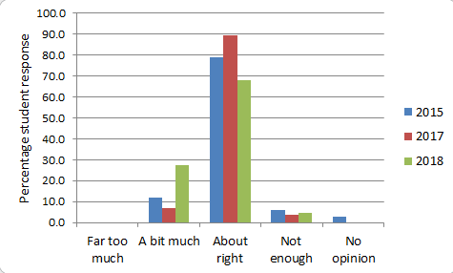
Figure 3: CNM Student responses to the question: The time we had to go through the example sheet questions in class was.

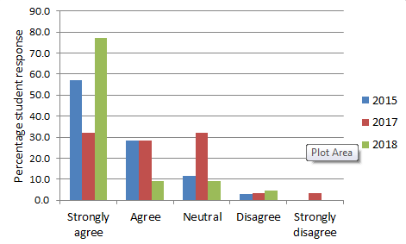

Figure 4: CNM Student responses to the question: I liked the new style of teaching.

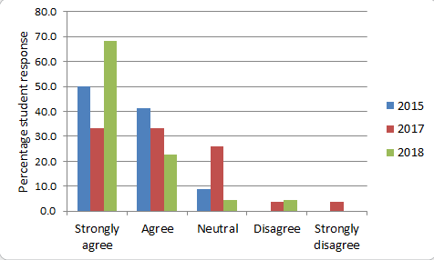

Figure 5: CNM Student responses to the question: I would like to experience this style of teaching for my level 2 modules.

ACG used a similar questionnaire and the results to some of the questions are displayed in Table 1. Again it can be seen that the majority of students found that doing the pre-class students helped them understand the topic, that the in-class questions gave them a deeper understanding of the subject, that they benefitted from working as part of a group and that they preferred this style of teaching. Typically mathematics students dislike working in groups so it was very encouraging to see students working together to solve problems and recognising the benefits of doing so. The TEAL room certainly facilitated this approach. In flipping ACG for the first time, the lecturer found a noticeable increase in the quality and depth of the questions asked to them in class.

Table 1: ACG Student responses to some of the questions used in an in-class questionnaire (April 2018).

Qn 1: I found doing the pre-class questions helped me understand the topic
Strongly agree | Agree | Neutral | Disagree | Strongly disagree
5 | 6 | 5 | 1 | 0
Qn 2: The in-class questions gave me a deeper understanding of the subject
Strongly agree | Agree | Neutral | Disagree | Strongly disagree
9 | 7 | 1 | 0 | 0
Qn 3: I have benefitted from working on questions as part of a group
Strongly agree | Agree | Neutral | Disagree | Strongly disagree
10 | 4 | 1 | 1 | 0
Qn 4: For this topic, I prefer this style of teaching
Strongly agree | Agree | Neutral | Disagree | Strongly disagree
7 | 9 | 0 | 0 | 1

For all three modules we observed that students tended to sit at the same pod each week, so although group working was happening, it tended to be within the same students each week. All classes were held in a TEAL room which has a capacity of 56. This has worked better for the compulsory modules (ACG & CNM), which have higher student numbers than for CTA which is optional. For example, in the 2017/18 academic year only 20 students enrolled on this module resulting in students being quite dispersed in the room and just five of the possible eight pods were used. One way of resolving this issue would be to have a greater range of sizes of TEAL rooms available to use, which should be the case next year.
Students in CNM and ACG were specifically asked for their feedback (via the in-class questionnaire) on how they found the TEAL rooms. They unanimously preferred the TEAL room to a traditional flat teaching space. They liked working in small groups even though some did not like the flipped approach. The following is a selection of student feedback which typifies their comments:

- These rooms are so much better, more interactive, so I stay focussed for longer and can discuss with people better..
- The room we used was very useful as could work in groups using the computers for Maple.
- The room was good and it helps a lot for working in groups. It was good working with other people on questions.
- TEAL room was great – comfortable, good layout. Liked the idea of working in groups.
- Liked the group table, can discuss and share answers/methods more effectively. Less chance of getting lost/left behind.
- Room was great, however sometimes had issues with screen to computer and other way round. Otherwise really like it!

Conclusions

We have found that students recognise the benefits of being taught in TEAL rooms using a flipped approach. However TEAL rooms are also being used for classes for modules which are delivered in a more traditional way. Students have remarked that they like the layout, which also facilitates the lecturer moving around the room enabling them to more easily interact with students and view their written work. From a lecturer’s perspective, the TEAL rooms are proving to be very flexible teaching spaces. Two TEAL rooms, with capacity of 24 and 48, have been incorporated into the design for the new Mathematics and Statistics space that is planned to open at UWE Bristol in September 2018 (Henderson, 2018).
Although the collaborative rooms have software installed, enabling sharing of individual PC screens to the podium/other pods, facilities do not currently exist for students to be able to easily upload hand-written workings onto their pod PC. This is something that we aim to address in the future through the use of webcams and electronic writing pads which will enable the lecturer to easily share students hand-written work between pods.

References

Biggs, N.L. (2008). Codes: An Introduction to Information Communication and Cryptography. Springer-Verlag London.
Brame, C., (2013). Flipping the classroom. Vanderbilt University Center for Teaching. Retrieved from: http://cft.vanderbilt.edu/guides-sub-pages/flipping-the-classroom/
Dewis Development Team (2012). Dewis welcome page. Retrieved from: http://dewis.uwe.ac.uk
Henderson, K (2017). Using e-Assessment to support flipped–style teaching. MSOR Connections, 15 (2). pp. 34-41.
Henderson, K (2018). Designing a new space for mathematics and statistics at the University of the West of England. Presented at the sigma workshop on Designing Effective Learning Spaces for Mathematics and Statistics Support. Retrieved from: https://maths.shu.ac.uk/sigma/learning_spaces_workshop/
Henderson, K., Hobbs, C. and Last, K. (2017) Evaluation of flipped teaching. In: Mathematics Education beyond 16: Pathways and Transitions, Birmingham, England, 10-12 July 2017.
Hooper, A., Henderson, K. and Gwynllyw, R. (2014) Using technology in the module delivery of mathematics. Presented at the CETL-MSOR Conference, Cardiff. Retrieved from: http://www.sigma-network.ac.uk/wp-content/uploads/2014/09/K_Henderson_A_Hooper_R_Gwynllyw_-session5.pdf
Lord, T. (2001). 101 reasons for using cooperative learning in biology teaching. The American Biology Teacher 63(1),30-38.
Maciejewski, W. (2015). Flipping the Calculus Classroom: an Evaluative Study. Teaching Mathematics and its Applications. Retrieved from: http://teamat.oxfordjournals.org/content/early/2015/12/28/teamat.hrv019
Mazur. E. (1997) Peer Instruction: A user’s manual. Series in Educational Innovation. Prentice Hall.
MIT iCampus (2016) TEAL – Technology Enabled Active Learning. Retrieved from: https://icampus.mit.edu/projects/teal/

