Comparison of Prediction Tools to Determine their Reliability on Calculating Operational Heating Consumption by Monitoring No-Fines Concrete Dwellings
Francisco Sierraa,∗, Lamine Mahdjoubia, Bill Gethinga, Ammar Alzaatreha, Richard Fittonb, Alex Marshallb
a University of the West of England, Faculty of Environment and Technology, BS16 1QY, Bristol, UK.
b University of Salford, School of the Built Environment, Salford, M54 WT, UK.

Abstract

Nowadays most retrofit decisions are based on reducing CO₂ / heating consumption. The aim of this study was to determine the reliability of three tools (RdSAP, SAP and IES) often used to predict these reductions. Three no-fines concrete (NFC) dwellings (C1, C2, and C3) with similar floor area and construction but different occupants were monitored. Key information about the thermal performance of the fabric; the behaviour of the occupants and the energy consumption was collected before and after 110mm of external wall insulation (EWI) was added. The target was a 30% reduction on energy consumption due to the EWI. However, only C3 decreased it by 30% as expected, C2 only by 14% due to a subtle rebound effect and C1 actually increased consumption by 75%, due to rebound effect.

Steady state tools (RdSAP and SAP) were found to be inaccurate in predicting the operational energy consumption of dwellings, only dynamic performance analysis software (IES) was suitable to carry out this type of prediction accurately. However, this type of software requires highly accurate and detailed information regarding: the baseline performance of the fabric, external weather conditions and, most importantly, accurate pre- and post- heating operational habits of the occupants. Few retrofitting projects have the resources and time to gather this information. Unless those are available, the retrofit decisions should be based in a different criteria, rather than using inaccurate SAP or RdSAP energy consumption predictions.

The coefficient of heat loss of the fabric of a dwelling is independent of the occupants. SAP was found quick to calculate reasonable predictions of the coefficient, by using accurate fabric data, and to show the impact of different factors on the heat loss of the fabric. Therefore, it could be claimed that the coefficient of heat loss of the fabric is a suitable alternative criteria to make pre-retrofit decisions.

Keywords:
Standard Assessment Procedure (SAP); Reduced Data SAP (RdSAP); Integrated Environmental Solutions (IES); Building Performance Evaluation; Operational Energy Consumption; No-fines concrete; Social housing; Energy loss; Fuel poverty; Heating energy consumption; Retrofitting; External wall insulation;

1. Introduction

In the last decade, research and policy have moved towards reducing CO₂ emissions and improving the building stock to reduce its impact on climate change. Uninsulated solid walls, like those made from NFC, contribute a large proportion of domestic CO₂ emissions due to their poor thermal performance. No-fines concrete (NFC) was a construction method for mass-production of low-rise dwellings at a low cost. Around 300,000 NFC houses were built in the UK between 1940s and 1980s (Ross, 2002). Although this research is based in the UK, NFC was extensively used for housing in South Africa (Bekker, C. 1998), the Middle East, West Africa and countries like Venezuela or Hungary (Moss, 1979). Therefore, some of the findings will also have a global impact.

The thermal transmittance of NFC walls is far from the backstop of 0.30 W/m²K required by current Part L1 for England (DCLG, 2013), making these dwellings expensive to run (Williams and Ward, 1991). In addition, more than 45% of all fuel-poor households live in solid wall properties, most of them uninsulated (Platt and Rosenow, 2014). Therefore, the report by the Centre for Sustainable Energy (2005) argues that in the current context NFC is not thermally efficient anymore, recommending the thermal upgrading of this type of external wall. For this type of cases, Decent Homes Standard for public housing of the United Kingdom was introduced to demand the provision of a reasonable degree of thermal comfort in social houses (BRE, 2008). Therefore, insulating the solid no-fines walls housing stock potentially offers a significant reduction on demand for energy supply, associated carbon emissions and fuel poverty, plus an improvement of the level of comfort for the occupants.

When retrofitting pre-existing residential buildings, it is necessary to effectively evaluate them in order to have enough information to make informed decisions towards reducing CO₂ emissions (King, 2010). However, there is a lack of information on materials and thermal behaviour of the fabric of existing buildings (Milsom, 2014). This is especially limited in the case of NFC dwellings. In addition, few studies address the impact of applying external insulation to solid walls and the impact of this improvement is usually diluted in a mix of other retrofit measures. The aim of this study was to quantify the actual impact of adding EWI, on the operational heating consumption, of a set of NFC dwellings and compare it with the values predicted by three different tools to determine the level of reliability of these tools making predictions. Two steady state tools commonly used for this purpose (RdSAP and SAP) and a more sophisticated dynamic simulation software (IES-VE), described in more detail in section 2.1.2. For this purpose, firstly it would be necessary to determine the baseline thermal performance of the fabric of NFC buildings and then to gather detailed information about the operational heating behaviour of the occupants.

The findings are expected to be of benefit to several stakeholders, especially homeowners, designers, consultants, councils, and in general, any stakeholder involved in implementing thermal improvements to NFC dwellings. This research makes accurate information available about the importance of using the right tool and criteria to make informed decisions in any EWI retrofit project and about the pre- and post-retrofitting thermal performance of NFC fabrics. This paper commences by reviewing literature to discuss the assumptions used by the three energy prediction tools studied, and available information about the thermal performance of this type of building. This is followed by the research methodology, findings, discussion and conclusions drawn from the research.

2. Heating savings predicted by tools vs actual savings when adding EWI

The aim of the literature review was to identify and describe relevant research conducted over the last few decades on assumptions and accurate prediction of heating energy consumption. This review gathers data and key lessons learned from previous research studies on measurement and modelling methodologies, and current accepted practices to predict accurate energy savings. In this way, it would be possible to identify possible changing points for the industry to better predict energy savings and build on this to make more informed decisions.

Literature searches have been carried out in following databases for the period 1965-2017: Elsevier Science Direct, Research Gate; Construction Information Service; Iconda; Emerald; DOAJ, SpringerLink, JSTOR.

The research available consistently shows that the predicted savings of adding insulation to solid walls are typically, significantly greater than the actual savings achieved (Miles-Shenton et al., 2011; Stafford et al., 2012, Platt and Rosenow, 2014; Milsom, 2014). Models can never fully take account of all factors that affect energy use. Therefore, there will always be some divergence. According to Milsom (2014), there are three primary reasons for the difference between the predicted and actual savings including:

- Inaccurate assumptions regarding the baseline performance of the building envelope and most importantly of the solid wall.
- Calculation methodologies and tools to predict the savings, which could simplify the model assuming inaccurate: building fabrics, pre and post-insulation heating behaviour, or climatic conditions.
- Human/occupancy related factors.

This research will focus in these three main reasons. However, the review and literature in general also highlighted that non-ideal design and poor workmanship during the retrofit process can significantly undermine the expected energy savings of the dwelling (Reeves, 2009). These latter issues are outside the scope of this paper.

2.1 Accurately determine the baseline performance of a wall

Prior to the application of the external insulation, thermal performance measurement is critical to accurate prediction of energy savings. However, most of the research found in the literature covers solid brick walls, and there is little reliable information available on the thermal performance of NFC walls measured in-situ.

In terms of fabric, the accurate prediction of the heating demand of a dwelling relies on a good estimate of several key elements such as the area and linear thermal transmittance of the fabric, the air-tightness and the heating system of the building (Milsom, 2014). Baseline performance based on standard values may differ to the baseline performance of the actual building under study, especially when default U-values are used (Stone et al., 2014). They are a significant source of uncertainty (Li et al., 2014). In situ measurements of the U-values and air permeability close this existing “performance gap” between measured and modelled data (Marshall et al., 2017), a well-studied issue within the British construction industry.

2.1.1 Thermal performance of no-fines concrete solid walls

NFC is a mix of clean aggregate and Portland cement (1:8-10) with no fine aggregates (sand or gravel) added and placed without mechanical compaction (Williams and Ward, 1991). The result is an open textured cellular concrete with a higher porosity than conventional concrete (Moss, 1979). This higher porosity makes the strength properties lower than normal weight concrete, but sufficient for structural use on low-rise dwellings. This open texture results in a lower thermal conductivity than conventional concrete (Wieloch,1966; Neville, 1981; Abadjieva and Sephiri, 2000) which typically has a conductivity of around 2W/mK (Sommerville et al., 2011).

NFC walls are usually finished externally with a layer of 15mm cement-sand pebbledash and a variety of interior finishes. The most common are dry-lining plasterboard, wet plaster and “Paramount” panels, which consist of two sheets of plasterboard separated by a cellular cardboard core (Williams and Ward, 1991).

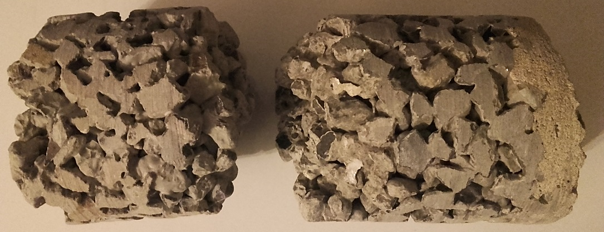
Fig 1. Sample of one of the NFC walls under study composed by 280mm NFC and 15mm thick external render

The "Reduced Data Standard Assessment Procedure" (RdSAP) is the tool used in the UK to evaluate the energy performance of existing homes and to predict the energy savings of certain building improvement measures. In most cases, the thermal properties and thickness of the layers of existing walls are unknown. Because of this, RdSAP allocates generic U-values measured under controlled laboratory conditions (Milsom, 2014). They represent a safe estimate which complies with the Building Regulations in force on the date they were built. RdSAP includes NFC within the “System Build Type” group, and it gives the same estimated U-value for any pre-cast concrete panel, steel framed, or poured concrete wall. Then, a band of age is selected, which for this research is 1967-1975. Finally, for this age band and construction type, RdSAP assumes that the wall has a thickness of 250mm and a U_{NFC} = 1.7 W/m²K (BRE, 2013). But the assumptions not always match the case under study. For instance, the walls used for this research have a thickness of 350mm.

Table 1 shows the different values found in the literature for the thermal transmittance of the NFC walls and the thermal conductivity of the specific NFC layer. Unless specified, every U-value includes an external finishing of 15mm cement-sand pebbledash (λ=1.0 W/mK) which is indicated as “R”, while the internal finishing varies. The U-values of NFC walls found in the literature are in most cases based on analytical calculations, taking into consideration the thickness and an average conductivity of the materials that form each layer. The table also includes a list of thermal conductivities of NFC measured empirically in-situ and in laboratory tests. The range of variation found for the U_{NFC} was from 0.94 W/m²K (Craig et al., 2013) to 1.71 W/m²K (Williams & Ward, 1991) and for the conductivity of the NFC layer alone from 1.33 W/mK to 0.22 W/mK.

Table 1 Thermal conductivity of NFC walls and thermal transmittances of NFC in the literature.

Calculated U-values according to BS EN ISO 6946 and BS EN ISO 13370.
(*) The thermal conductivity of the NFC (λ) was obtained by reverse engineering the given U-value using FSAP STROMA2012
Author | Specification | Wall U-value (W/m²K) | NFC λ (W/mK)
BRE (2013) - RdSAP | 250mm “System Build Type” | 1.70 | 0.85
Williams & Ward (1991) | R+254mm NFC + 15mm Plaster | 1.71 | 0.65
EST (2005) | R+250mm NFC (dense aggregate) + Plaster | 1.70 | 0.65
BRE (1996) | R+250mm NFC + Plaster | 1.70 | 0.65
CIBSE (2016) | 19mm R + 220mm NFC (2000 kg/m³) + 50mm airspace/timber battens + 12.5mm Plasterboard | 1.64 | 1.33
EST (2005) | R+250mm NFC (lightweight aggregate) + Plaster | 1.30 | 0.45
Williams & Ward (1991) | R+254mm NFC + Plasterboard | 1.23 | 0.65
BRE (1996) | R+250mm NFC + Plasterboard | 1.23 | 0.65
BRE (1996) | R+200mm NFC + 38mm Paramount | 1.10 | 0.65
Williams & Ward (1991) | R+203mm NFC + 38mm Paramount | 1.10 | 0.65
Williams & Ward (1991) | R+254mm NFC + 38mm Paramount | 1.03 | 0.65
EST (2005) | R+250mm NFC (dense aggregate) + Paramount | 1.00 | 0.65
Moss (1979) | R+250mm NFC + Plasterboard | 1.13 | 0.45

U-values measured in-situ
(*) The thermal conductivity of the NFC (λ) was obtained by reverse engineering the given U-value using FSAP STROMA2012
Craig et al. (2013) | West facing wall2 (R+250mm NFC+Plasterboard) | 1.21 | 0.50
Craig et al. (2013) | West facing wall1 (R+250mm NFC+Plasterboard) | 1.19 | 0.49
Craig et al. (2013) | North facing wall (R+250mm NFC+Plasterboard) | 0.94 | 0.32

NFC thermal conductivity data (New cores Lab test)
Author | Description | Density (kg/m³) | NFC λ (W/mK)
CIBSE (2016) | NFC Heat Capacity 1000 J/kg·K | 2,000 | 1.33
Wieloch (1966) | Bank run gravel | 1,810 | 0.99
Neville (1981) | Normal weight aggregate |  | 0.94-0.69
ESP-r (1989) | NFC Heat Capacity 840 J/kg·K | 1,800 | 0.96
Wieloch (1966) | Crushed calcareous stone | 1,620 | 0.87
Abadjieva&Sephiri (2000) | No-fines concrete | 1,600 | 0.70
Wieloch (1966) | Granulated blast furnace slag | 1,470 | 0.52
Sommerville et al. (2011) | Laboratory panels with 25% voids. |  | 0.43
Wieloch (1966) | Crashed brick | 1,220 | 0.40
Wieloch (1966) | Agglomerated carbonaceous shale | 1,030 | 0.40
Sommerville et al. (2011) | Laboratory panels with 37% voids. |  | 0.35
Neville (1981) | Lightweight aggregate. |  | 0.22

Table 1 highlights that the density and subsequently the conductivity of the NFC can vary significantly. Laboratory tests carried out by Wieloch (1966) determine a linear relationship between the weight of the concrete and its thermal conductivity. While traditional concrete has a density of around 2,400 kg/m3, different authors have determined lower densities for the NFC of between 2,000 to 1,030 kg/m3 (Wieloch, 1966; CIBSE, 2016).Therefore, there is also a large range of thermal conductivities from 1.33 W/mK to 0.22 W/mK. This variation can be attributed to differences in the density of the concrete (Wieloch, 1966; EST, 2005), which is related to the level of compaction of the concrete or amount of air gaps (Sommerville et al., 2011). The data included in Table 1 indicate that the density of the NFC is the main factor to determine the thermal conductivity of the material.

Compaction of the NFC is provided by gravity alone (Williams and Ward, 1991) and variations in site practice leads to different levels of compaction (Craig et al., 2013). Laboratory work by Sommerville et al. (2011) demonstrates the relationship between the percentage of voids within the concrete and the conductivity of NFC, finding a reduction from 0.43 W/mK to 0.35 W/mK when the percentage is increased from 25% to 37%. Additionally, in-situ cores studied by Williams and Ward (1991) gave up to 66% of voids, a higher percentage when compared to the 37% of voids for laboratory samples (Sommerville et al., 2011). This fact highlights that lab tests do not reproduce the characteristics of an actual wall (Craig et al., 2013; CIBSE, 2016 and Loucari et al., 2016). However, most of the data available for NFC is based on extrapolations from laboratory test data using well-prepared samples and steady-state conditions (Sommerville et al., 2011).

Finally, the thermal transmittance of a NFC wall not only depends on its conductivity but also depends on the thickness of its layers and its interior finishes. The previous facts highlight the difficulty in determining the actual thermal transmittance of a NFC wall with a simple visual survey, without knowing the level of compaction / density of the aggregate of the NFC layer, the thickness of each layer and the internal finishing of the NFC wall. Therefore, before insulating a wall, it is paramount to accurately determine its baseline U-value to be able to predict the benefits of doing so accurately.

However, there is solid evidence in the literature that current assumptions underestimate the thermal performance of solid walls. Studies have shown that the standard U-values ​​for solid walls used by RdSAP are greater than the U-values ​​obtained in-situ (Milsom, 2014) and over the mean of the analytically calculated U-values ​​produced after visual observation of the actual walls (Boss, 2014). The use of unrealistic thermal conductivities for the materials that make up the wall generates unrealistic U-values and subsequently inaccurate predictions of the heating energy consumption (Loucari et al., 2016). This review reveals that for NFC walls there is a level of uncertainty of the 45% between the safe guess used by RdSAP (U_{NFC} = 1.71 W/m²K) and the value obtained by an in-situ measurement (U_{NFC} = 0.94 W/m²K) (Craig et al., 2013).
Based on these findings, there is a need for accurate in-situ measurements of the heat loss of NFC walls to determine their baseline performance and subsequently improve future energy saving prediction (Milsom, 2014; Boss, 2014; Gorse el al., 2016; Loucari et al., 2016).

2.1.2 Calculation method and tools to predict savings

The energy consumption of a building is easily measured, but understanding why consumption differs from what is expected requires a detailed building performance analysis (Gorse el al. 2016). For this purpose, certain software is used. However, the tools used to predict the heating energy consumption of NFC dwellings represent another source of possible uncertainty. The process of transferring a real building to a computer model introduces uncertainties due to the simplifications made (Demanuele, 2010). In addition, each modelling/simulation tool produces different predictions due to different algorithms, assumptions embedded in the tool used, and degree of detail for key elements, even when using similar input parameters (Agami 2006; Maile et al., 2007; Heath et al., 2010; Abdullah and Cross, 2014; Loucari et al., 2016). This research will determine and compare the percent error of three popular software tools, when predicting the expected heating savings when adding EWI to NFC walls. Two steady state tools, RdSAP and SAP, and the more advanced dynamic performance analysis software, IES-VE.

RdSAP is the building performance evaluation and certification tool used in the UK for estimating the building performance of existing dwellings and recommending improvements to lowering overall emissions. RdSAP is a simplification of the ‘Standard Assessment Procedure’ (SAP) used to assess the energy performance of new dwellings (Elmhurst energy, 2017). Both are regulatory tools, RdSAP and SAP were developed to assess the energy use and CO₂ emissions of dwellings to comply with energy efficiency policies in the UK. They are steady-state tools designed to assess the building performance using the same standard occupancy, heating habits and weather location to enable fair comparisons between energy ratings of properties throughout the UK (Stroma, 2015). Therefore, they were not created to predict the operational energy of the buildings, although they are often used for this purpose. Kelly et al. (2012) studied the capability of both tools to calculate the energy consumption of a building and concluded that both are “grossly inaccurate“ for this type of prediction. The reason given is the great simplification of the model, which subsequently also makes it unreliable to make sensible recommendations for improvements. The Centre for Sustainable Energy (2013) also found inherent limitations on RdSAP and SAP for accurately “assessing the energy savings associated with energy efficiency improvements in any given property". This research centre claim that the tools are only able to produce ‘rough estimates’. On the other hand, IES-VE IES Virtual Environment (VE) is an advance dynamic energy analysis and performance modelling software that offers the possibility to include the actual occupancy, ventilation, heating patterns and weather data.

This chapter critically analyses a series of assumptions for key issues to assess the energy performance of a building depending on the software used, which can increase or reduce the level of uncertainty of the predictions:

1) Weather data: RdSAP and SAP use standard weather data based on weather in the East Pennines region which is taken to be ‘UK average’ weather for any dwelling. On the other hand, IES uses a local weather file taking into account the impact of the local microclimate (Hughes et al., 2016) to predict the heating demand more accurately.

2) Window area. RdSAP estimates this area based on the floor area and age of the property, while SAP and IES require the actual area to be measured and input.

3) U-value. Ideally, the U-values should be measured in-situ (Hughes et al., 2016). However, RdSAP offers generic values depending on the age and type of construction of the wall and the requirements of the Building Regulations in force at this time (Milsom, 2014). If insulation is added, it only allows for thickness multiples of 50mm and assumes thermal conductivities for the insulation of ~0.032 W/mK (Elmhurst energy, 2016). SAP and IES require calculation of the U-value of each construction element in accordance with BS EN ISO 6946 (BSI, 2007a) and, if insulation is added it allows inputting the actual thickness and thermal conductivity of the new layer. However, for existing dwellings there is a lack of information about the materials forming the wall and their thermal properties. Therefore, in most cases default values are used.

4) Thermal bridging. RdSAP adds a y-factor = 0.15 (W/m²K) by default to account for the heat loss associated with thermal bridges, while SAP and IES allow inputting the actual calculated Ψ-values, or use all detailing based on standard calculated values of Accredited Construction Details (ACD). However, ACDs were not available prior to 2007 and the calculation of each thermal bridge is rarely considered for existing buildings due to the lack of information on the construction details and the complexity of the calculation (Sierra, 2017). Therefore, the default y-factor = 0.15 (W/m²K) is commonly applied for energy saving predictions.

5) Thermal mass parameter (TMP). RdSAP assumes a medium TMP (250 kJ/m²K), while SAP and IES allows inputting the actual TMP for walls, floors and roofs. Concrete is considered as a material with high thermal mass. However, Williams and Ward (1991) argue that NFC walls perform more like a lightweight framed construction due to their lower density than conventional concrete, especially in cases with dry lining (BSI, 2007b).

6) Sheltered walls. RdSAP assumes that the entire external area of the walls is unsheltered, while SAP and IES allow to treat the wall area sheltered by unheated internal spaces, such as the integral garage and the rear porch in this case study, as a semi-exposed wall in a lower heat-loss regime.

7) Infiltration. RdSAP estimates a value according to the area of the wall, treated by default as masonry, while SAP and IES allows the input of the result of a pressure test.

8) Occupants and occupancy pattern. RdSAP and SAP use a standard occupancy pattern based on the size of the dwelling, which determines the number of occupants. Kelly, et al. (2012) question the ability of both tools to predict energy demand, because it is very sensitive to the behaviour of the occupants. IES allows the input of specific occupancy rates and patterns.

9) Space heating. RdSAP and SAP calculate the energy required to heat the building month by month, from October to May (taken as a standard heating season). The calculation is based on steady state heat loss and using a Mean Internal Temperature (MIT) of 21ºC for the living room (Zone1) and 18ºC for the rest of the dwelling (Zone2), following the standard heating pattern shown in Table 2.

Table 2. RdSAP and SAP standard heating pattern

TIME | ZONE - MIT | From-to | HOURS
Weekdays | for Zone 1 (21ºC) | 07:00–09:00 & 16:00–23:00 | 9h
 | for Zone 2 (18ºC) | 07:00–09:00 & 18:00–23:00 | 7h
Weekends | for Zone 1 (21ºC) | 07:00–23:00 | 16h
 | for Zone 2 (18ºC) | 07:00–09:00 & 14:00–23:00 | 11h

The energy required for heating is then calculated based on the mean external temperature, the heat loss of the fabric, solar gains, the efficiency of heating systems, and fuel sources (Bennett al., 2016). However, in practice the heating demand does not follow a constant pattern, and under-heating periods may occur due to external seasonal variations, and un-occupied periods (Hughes et al., 2016). Furthermore, occupants of poorly insulated dwellings tend to under-heat their homes due to frugality or fuel poverty (Deurinck et al. 2011b; Aspen et al., 2012; Banks and White, 2012). This is not taken into account by RdSAP and SAP which assume the same heating standard temperatures, regardless of external weather, occupancy or income (Sorrell, 2007; Milsom, 2014). In contrast, IES allows setting up of bespoke heating patterns and heating temperature baselines.

In addition, SAP and RdSAP assume that when heating is turned off, there is a linear response to return to the background temperature. This method is accurate enough for days with long heating periods, but during short heating periods substantially reduce its accuracy (Hughes et al., 2016). IES takes a dynamic approach using logarithmic responses to vary MIT, which takes better account of the time taken to heat the dwelling and to cool it.

10) Window operation. RdSAP assumes natural ventilation with no extract fans for the age band of the dwellings monitored in this research. SAP can take account of existing extract fans. In addition, RdSAP and SAP do not take into account the operation of windows/vents to provide fresh air during the heating season, while IES allows inputting any type of natural ventilation (windows, vents) opening sizes and ventilation patterns to provide fresh air.

11) Water heating. RdSAP and SAP calculate the water heating and cooking energy use based on a standard number of occupants, while IES allows inputting specific water-use patterns.

12) Internal gains due to appliances, cooking and occupants. RdSAP and SAP apply estimated internal gains depending on the floor area, while IES allows inputting detailed equipment and daily profiles of occupancy, cooking and equipment use to get more accurate internal gains.

The list above highlights the limitations of using assessment tools for building regulation compliance with standard assumptions for the fabric, weather, occupancy, and energy use to predict the operational heating demand of existing dwellings. SAP and RdSAP were not created for this purpose. Those models are a substantial simplification of reality (Hughes et al., 2016), because they are designed to enable fair comparisons between energy ratings of properties throughout the UK (Stroma, 2015). Research on this topic concluded that tools such as SAP and RdSAP could not accurately calculate the operational energy use of dwellings due to “inaccurate assumptions about occupation and heating patterns and standardised scenarios of comfort practices” (Miles-Shenton et al., 2011; Stafford et al., 2012; Wingfield et al., 2011). On the other hand, dynamic simulation modelling tools like IES can accept specific occupancy behaviour and weather data and subsequently they are more likely to accurately estimate the energy savings (Milsom, 2014), but they require more extensive data, more time and expertise to input it and much greater computational effort (Hughes et al., 2016).

2.1.3 Human factor

In theory, if the U-value of NFC walls is reduced, by adding external insulation, a significant decrease in space heating demand should occur. However, occupant space-heating operation has a large impact on the energy consumption of a dwelling (Wei et al., 2014). Several studies have demonstrated that the energy use in similar dwellings can vary significantly depending only on occupant behaviour (English Heritage, 2014). Wei et al. (2014) found 27 factors that may motivate changes in occupant behaviour over heating use. This reflects the complexity of human factors that can increase the level of uncertainty of energy-saving prediction.

The most cited reason for the uncertainty of the models is the “rebound effect”. Hong (2010) found that a significant number of homes actually used more fuel following energy efficiency improvements than before. Poorly insulated properties tend to be under-heated prior to retrofitting, especially if occupants have low incomes, and energy efficiency improvements cannot save energy that was not being consumed in the first place (Sunikka-Blank and Galvin, 2012). Also, once the thermal efficiency of the walls is improved, occupants might choose to heat their homes for longer periods of time and to higher temperatures as they can finally achieve the desired thermal comfort level (Milsom, 2014). Sorrell (2007) estimated a rebound effect for space heating up to 30% due to a rise on the temperatures of the living area of between 1.14°C to 1.6 C before and after upgrading. Other authors such as Gavankar and Geyer (2010) suggest percentages up to 60%. For this reason, Greening et al. (2000) advice that actual measurements of pre-retrofit energy should be taken.

Assumptions related to human behaviour should ideally be based on actual data. Occupants are responsible for the mean internal temperature, hours of heating and length of the heating season (Demanuele, 2010). Variations of any of these three factors can greatly affect the final heating energy consumption. Only by monitoring the dwellings and carrying out interviews is possible to get accurate occupancy patterns in terms of energy use.

2.2. Concluding remarks

This review demonstrated that accurate prediction of heating energy consumption when adding insulation to NFC walls is not an easy task because of the number of factors adding uncertainty.

It is also clear that more research is needed to make prediction tools and their limitations well understood, especially in relation to assumptions about human behaviour and baseline performance of the fabric to ultimately minimise the degree of uncertainty of the predictions.

Finally, it was found that is common practice to carry out calculations based on standard “average” assumptions and using relatively simplistic tools such as RdSAP and SAP. The reason behind this practice is the lack of information on materials and thermal behaviour of the fabric of existing buildings, which is even more limited in the case of NFC dwellings. This review revealed that the use of assumptions regarding U_{NFC} could imply an uncertainty of up to 58%. Therefore, a further investigation into this type of wall and building will provide paramount background information for future retrofit projects to make informed decisions.

3. Methodology

This research is reliant on a combination of quantitative and qualitative data collection techniques for in-depth exploration from multiple perspectives, given the complexity of this particular topic. Diagram 1 will help the reader navigate the methodology of the paper.

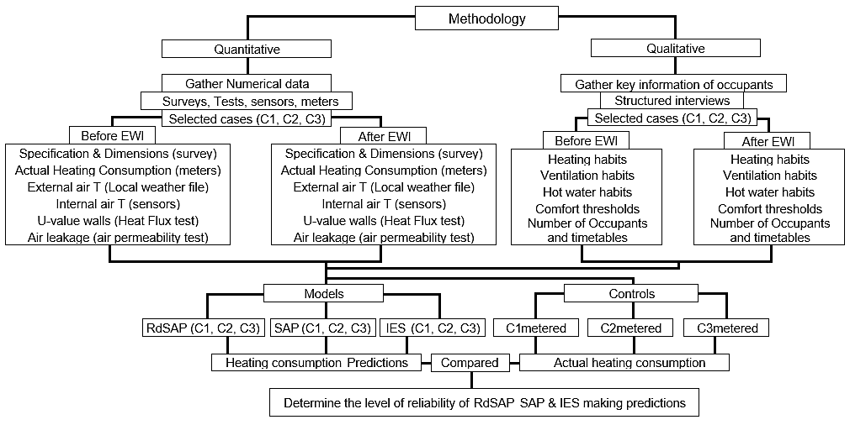
Diagram 1. Methodology

The quantitative research methods collect numerical data to predict and explain the phenomena studied. In this way, this research has monitored three NFC dwellings to gather key information on thermal performance of the fabric, and the energy consumption before and after EWI was added. This data was used to create models, using RdSAP, SAP and IES, to predict the impact of EWI on the heating consumption of NFC dwellings. Then, these heating consumption predictions were compared with the actual energy consumption to determine the degree of accuracy of each tool. In addition, qualitative research rooted in interviews of individuals was undertaken to collect information about the heating patterns of the occupants to help creating the models and understanding the energy consumption of each house due to human behaviour.

3.1 Parameters measured and instrumentation

Three NFC dwellings were selected in Bristol and their energy consumption and thermal characteristics were monitored in their natural settings (Denzin and Lincoln, 1994). The sampling strategy was devised reflecting the criteria outlined by Miles and Huberman (1994) such as the relevance of the sample to the research question and conceptual framework, the ability to generate rich information, enhance the generalizability and reliability of findings as well as resources available, practical feasibility and ethical issues. The three buildings were built in 1971 and have the same floor area and internal layout and construction. For confidentiality, each dwelling has been identified as CASE1, CASE2 and CASE3 as seen in Figure 2. Elevations and floorplans are shown in Figure 3 and 4. There are two main differences between case studies, the type of dwelling and the type of occupant. The first allows comparison of the energy demand between mid-terrace dwellings (CASE 1 and 2) and end-terrace with an extra external wall (CASE 3). The second allows comparison of the energy consumption depending on the behaviour of the occupants to increase the depth of the analysis and the amount of cases covered. The dwellings are built with solid NFC walls finished with Paramount plasterboard, solid concrete slab ground floors and pitched trussed rafter roofs insulated at ceiling level. They also present unheated internal garages, loft and back porch, which were not included in the air permeability test or any energy analysis. The only thermal improvements of the original building were the installation of double-glazed windows, a more efficient boiler and 100mm insulation added to the loft. In the first 6 weeks of 2017, 110mm EPS insulation boards were attached to the external walls. The characteristics of the NFC under study are as follow:

Table 3. List of material of the studied buildings and properties:

Materials | Thickness (mm) | Conductivity (W/m·K) | Density (kg/m³) | Water vapour resistance (μ)
Render (cement based & silicon based colour top coat) (BBA, 2016) | 15 | 1.00 | 1,800 | 10 - 6
Graphite EPS Insulation (BBA, 2016) | 110 | 0.032 | 16.5 | 20 - 40
Adhesive (BBA, 2016) | 10 | 0.43 | - | -
Pebbledash Render (BSI, 2010) | 15 | 1.00 | 2,000 | 15 - 35
No-fines Concrete | 280 | - | 1,542 | -
Air layer | 15 | R = 0.18 m²K/W | 1.2 | -
Paramount Panel (Placo, 2008) | 40 | 0.21 | 450 | 10

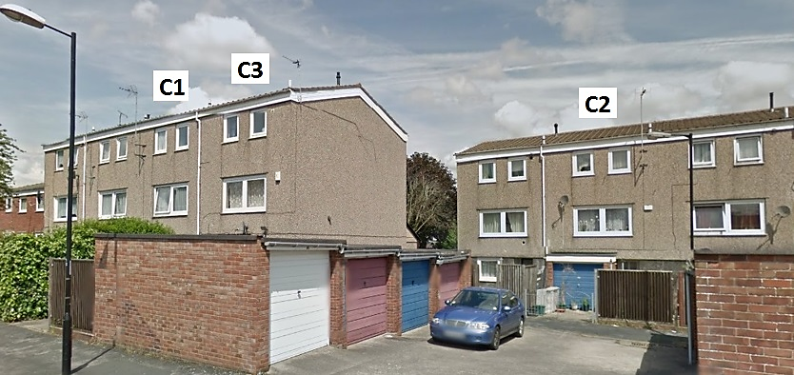

Fig 2. Three No-fines concrete dwellings. C1 (mid-terrace), C3 (end-terrace), and C2 (mid-terrace) case studies.

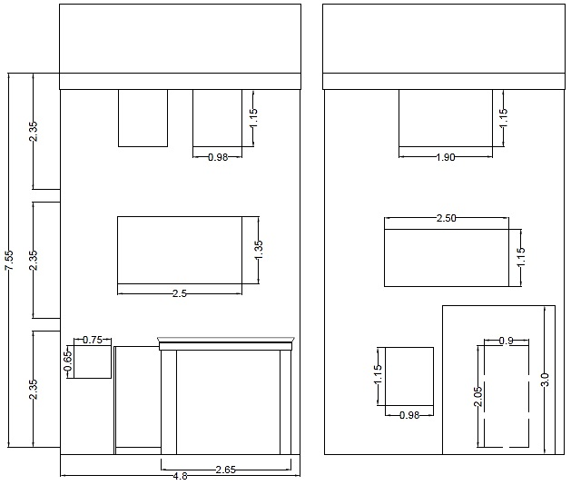
Fig 3. Elevation of C1, C2 and C3.
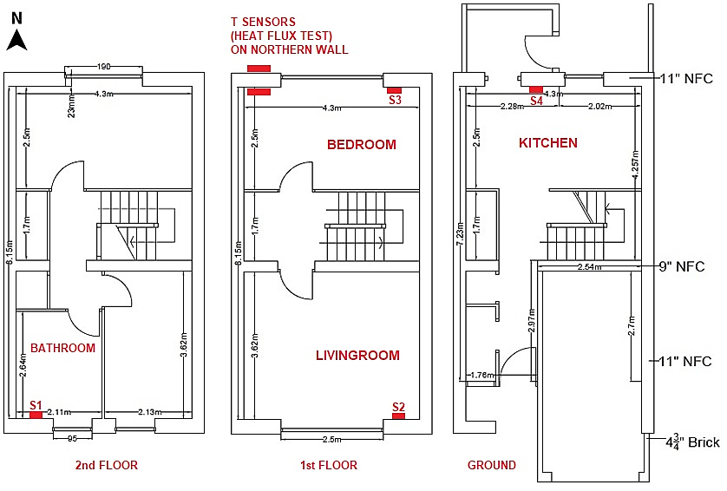

Fig 4. Floor plans of C1, C2, C3 and location of the four T sensors (S1, S2, S3, S4).

Based on the findings of the literature review, and in order to achieve the aim of this project, it was necessary to carry out several procedures adhering to corresponding standards and good practices. The following information was gathered for each case study before and after the insulation was installed to create models that are as close to reality as possible:

- Dimensions, heating, hot water, lighting and ventilation systems and controls, by carrying out a visual survey.
- Actual heating energy consumption by installing readers in the meters to collect the natural gas consumption.
- Internal air temperature (T_{i}), by installing sensors in the living room, main bedroom, kitchen and bathroom.
- Thermal transmittance of the NFC walls by carrying out an in-situ heat-flux test in one of the properties.
- Air leakage by carrying out an air permeability test in each property.
- Number of tenants, heating and ventilation habits by carrying out structured interviews to the occupants in order to understand the energy use of each case study.

The visual survey allowed to produce dimensioned floorplans and the specification of the services and fabric. Temperature sensors were installed to collect the internal air temperature of Living room, Bedrooms, Kitchen and Bathroom and recording gas consumption, before and after the EWI was installed. The sensors were placed about 1.5m above floor level and out of direct sunlight and out of any immediate influence of heat emitters as seen in Fig. 4. The temperature monitoring system, was made up of a central monitoring hub and of four temperature wireless connected sensors per case study. These sensors are used to capture information relating to temperature, which communicate wirelessly with the monitoring hub, were is stored, using a technology known as “Zigbee”.

An in-situ heat flux measurement was carried out to determine the amount of heat loss through a north-facing NFC wall of one of the case studies. The test was conducted over a two-week period before (November 2016) and after (March 2017) the insulation was added. This period is considered long enough to take into account the thermal inertia of the NFC wall and temperature stability on heat flux, allowing the result to converge (Boss, 2014; BSI, 2014). In order to determine the thermal transmittance air to air (U-value), the average method was followed according to ISO 9869-1 (BSI, 2014). Infrared thermography was also used to survey the wall internally. In this way, it was ensured that the general uniformity of the surface temperature to locate the heat flux micro-sensors (HFM), avoiding thermal bridges. A logger simultaneously acquired the mean heat flow of the three HFM attached to the internal face of the wall and the mean “environmental temperature difference” gathered by the external and internal air temperature calibrated thermocouples. The parameters measured and instruments used to measure the in-situ U_{NFC} wall are listed in Table 4.

Table 4. List of parameters measured and instruments used

Parameter/Datalogger | Instrument | Range | Accuracy
Inside wall surface temperature | 3 Thermocouple T-75 | -75 to +250°C | ±0.1 °C
Inside air temperature | 1 Thermistor 108, Campbell Scientific Inc. | -5–95 °C | ±0.5 °C
Outside air temperature | 1 Thermistor 108, Campbell Scientific Inc | -5–95 °C | ±0.5 °C
Heat flux sensor | 3 Thermopile Hukseflux HFP01 | ±2000W/m² | ± 5%
Thermal image Camera | FLIR ThermaCam P25 IR Thermal Imaging | -15 +50 °C | ± 2°C
Datalogger | CR1000 Campbell Scientific Inc., USA | Input ±5000mW | ±0.06% of reading

In addition, two air permeability tests were carried out, before and after the insulation was installed. The tests were conducted in accordance with BS EN 13829 (BSI, 2001) following the procedures set out in the Air Tightness Testing and Measurement Association (ATTMA, 2015) for testing buildings for air leakage to determine the leakage rate per square metre of building envelope at a test pressure of 50 Pascals. The test was also beneficial to quantify the reduction of infiltration due to EWI and its proportion in the heating demand.

In addition, structured interviews were conducted with the occupants before and after the insulation was added. This type of interview encourages two-way communication, providing not just answers, but also the reasons for the answers. The answers helped to understand the energy consumption of each house due to human behaviour. The data was contrasted with the outputs of the sensors and interpreted by comparison with previous theories, using the literature review.

The review revealed that actual building performance often deviates significantly from predictions. Therefore, the data gathered following the previously outlined methodology was used to create models using RdSAP, SAP and IES to predict the impact of EWI on the heating demand of the NFC case studies. The same data was used for each tool to allow comparison of the outputs, within the capabilities that each tool has to host certain data. In this way, the RdSAP model was completed with the assumptions that the manual advises to use for assessing the energy performance of existing dwellings, since it does not allow to include in-situ data for most of the factors. SAP let include some in-situ data of the fabric in the model. Finally, IES is the only tool that allows calibration of the model using operational data. Calibrated operational models can support decision-making in a better way (Coakley et al., 2016). Therefore, the IES models were calibrated through a two-tier process. The first tier defined the fabric of the building in detail to set up an accurate baseline (tested U-value of the walls, infiltration, dimensions, sheltered walls etc.). The second tier defined how the building is used by filling open-form profiles with actual data for occupancy, equipment, ventilation, and heating usage.

Finally, for validation purposes, the heating consumption predicted by each of these three tools was compared with the actual energy consumption, to determine the degree of accuracy of each tool. The actual energy consumption values were collected using meters in the dwellings under study. The reasons behind discrepancies and lessons learned about the impact of EWI on heating demand were drawn out, using the literature review outputs and the analysis of the results.

4. Results

The initial part of this section presents the data collected from the in-situ heat-flux test, airtightness test, sensors, meter readers, building surveys, and structured interviews, to determine the thermal performance baseline of the fabric of the NFC dwellings and its performance after adding EWI. The second presents the results of the SAP/RdSAP/IES models and compares them with the actual energy consumption to determine their degree of accuracy. The final part quantifies the impact of the EWI on the heat loss coefficient of the fabric of the NFC case studies.

4.1 Thermal performance of the NFC fabric. Data used to create the models.

The accurate prediction of the heating consumption of a dwelling relies on a good estimate of the baseline of the thermal performance of the NFC fabric and most importantly of the U-value of the external walls to be insulated. The necessary data was obtained following the methodology outlined in section 3, and the results were listed below.

A core sample of the NFC wall was obtained, featuring 15mm Pebbledash cement-sand render, 280mm No-fines concrete, 15mm air gap and a 40mm paramount cellular-cored panel (λ = 0.21 W/mK, Placo, 2008)). In January 110mm EPS insulation boards (λ = 0.032 W/mK) were attached to the external walls and later on covered with 15mm of render.

The output of the in-situ heat-flux test of this wall was a U_{NFC} = 0.85 (±0.052) W/m²K, before, and 0.22 (±0.013) W/m²K after the insulation was installed. The thermal conductivity of the NFC (λ = 0.50 W/mK) was obtained by reverse engineering the measured U-value using FSAP STROMA2012 (STROMA, 2017).
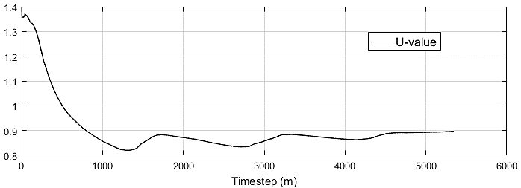
Figure 5.1. Cumulative U-values for C2 measured during November 2016 (pre-EWI)

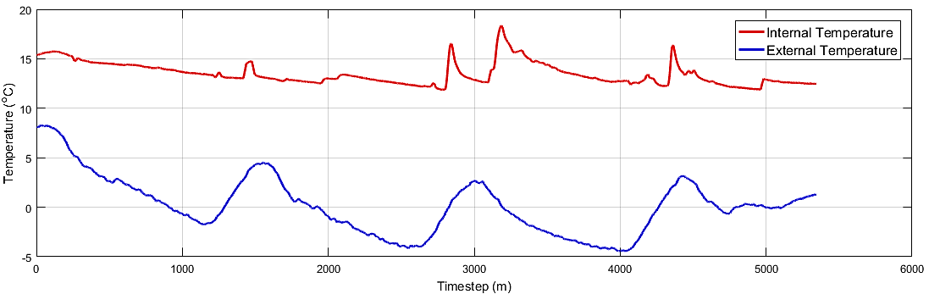
Figure 5.2. ΔT for C2 measured during November 2016 (pre-EWI)

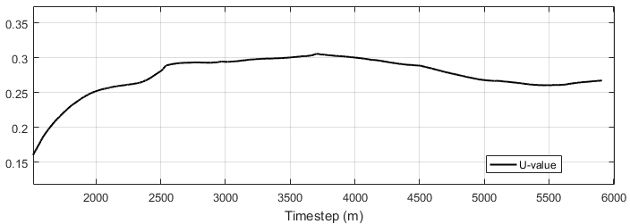
Figure 5.3. Cumulative U-values for C2 measured during April 2017 (post-EWI)

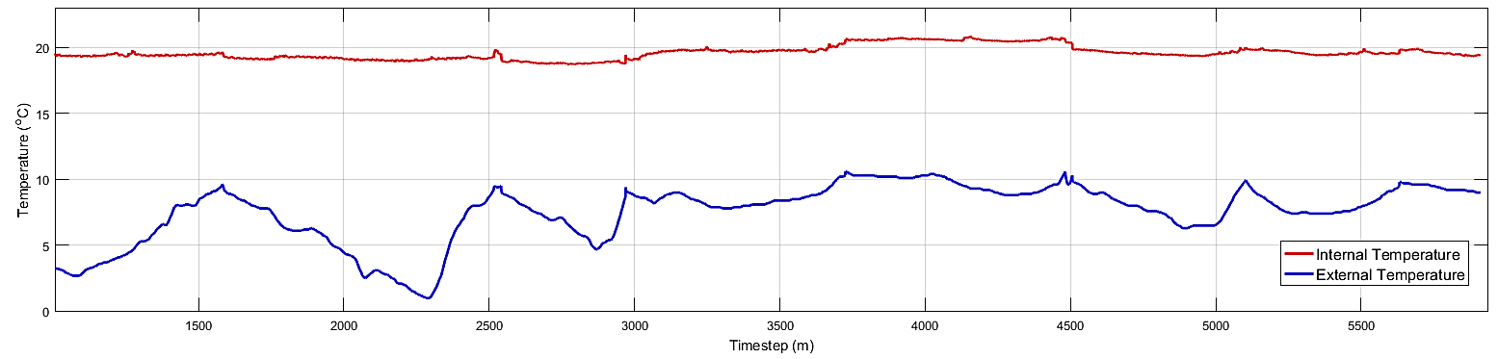
Figure 5.4. ΔT for C2 measured during April 2017 (post-EWI)

In addition, the NFC specimen taken from the same wall was tested to determine a density of 1.542kg/m³. Wieloch (1966) obtained, for specimens of similar density (1470 kg/m³), a λ = 0.52 W/mK validating the results of this in-situ test. The measured values were thus found to be 50% lower than of those used in RdSAP (1.70 W/m²K).

Higher starting U-values result in predicting unrealistic higher savings. A calculation using SAP reveals that if the same 110mm (λ = 0.032 W/mK) of EWI are added to a wall of U = 1.70 W/m²K (U_{insulated} = 0.245 W/m²K), this produces a reduction of the heating from 111.55 to 81.43 kWh/m²yr, a 27% reduction. If the same insulation is added to the actual wall of U_{NFC} = 0.85 (±0.052) W/m²K (U_{insulated} = 0.22 (±0.013) W/m²K), the heating drop is smaller, from 95.2 to 80.1 kWh/m²yr, only a 15.5%. An inaccurate reduction of 27% of the heating consumption in comparison to a 15.5% reduction if the actual baseline is used.

The air permeability test carried out in accordance with BS EN 13829: 2001 following the procedures set out in the ATTMA - TSL1 testing buildings for air leakage (2011), revealed, using a smoke pencil, that much of the leakage in these three properties was due to penetrations originally associated to services and now redundant, around the tilt and turn opening windows and through the 40mm air gap between the paramount panel and the NFC. Table 5 shows the measured air permeability of each building envelope at a test pressure of 50 Pascals.

Table 5. Permeability measured before (November) and after (March-April) EWI installation.
Property | Air Permeability m³/(h·m²)@50Pa
 | Before insulating | After insulating
Case 1 | 15.29 | 13.92
Case 2 | 18.33 | 17.56
Case 3 | 14.36 | 14.23

Sensors located in the living room, kitchen, bathroom and main bedroom of the three case studies collected data on internal air temperature of these rooms. Table 6 compares the measured monthly mean indoor temperatures of those spaces with the external monthly average air temperature over the entire monitoring period. The data revealed differences between the standard heating pattern used by RdSAP and SAP (living room 21 ºC and other rooms 18 ºC) and the actual internal air temperatures.

Case 1 appears underheated as compared with this standard: before the insulation was installed, the average temperatures were ~16 ºC in the living room and 15 ºC in other rooms. However, after insulation, temperatures were closer to the standard, with each room approaching 21 ºC, indicating a greater use of the heating.

Case 2 appears overheated before insulation: ~26 ºC in the living room, 25 ºC in the bedroom, 23 ºC in the bathroom and 21 ºC in the kitchen. Once retrofitted, the occupants maintain the high temperatures of the living room, and increase the temperature of the remaining rooms until they are even.

Case 3 appears close to the standard heating profile before insulation: 21.5 ºC in the living room and 19-20 ºC in other rooms). Once retrofitted, the occupants generally maintain pre-retrofit temperatures, with a slight increase in temperatures in some rooms.

It is worth noting that, in all three case studies, the difference between living room temperatures and the rest of the rooms is reduced post insulation. The insulation appears to result in the air temperature of the homes as a whole, being more even.

Table 6. Internal and external monthly average air temperatures variations over the entire monitoring period.

Internal and external average air temperature
 | Living room(S) |  |  | Kitchen (S) |  |  | Bathroom (N) |  |  | Bedroom (N) |  |  | External | Insulation
Month | C1 | C2 | C3 | C1 | C2 | C3 | C1 | C2 | C3 | C1 | C2 | C3 | C1,C2,C3 | C1,C2,C3
Sep16 | 21.3 | 21.9 | 23.0 | 20.9 | 20.8 | 22.2 | 19.5 | 21.5 | 21.8 | 19.8 | 21.5 | 21.3 | 15.3 | NO
Oct16 | 17.7 | 23.3 | 22.4 | 17.2 | 21.3 | 20.5 | 16.4 | 21.7 | 21.4 | 16.0 | 22.1 | 19.3 | 11.3 | NO
Nov16 | 16.1 | 25.6 | 21.6 | 15.7 | 20.6 | 19.4 | 14.9 | 21.6 | 20.9 | 14.6 | 23.1 | 18.8 | 7.0 | NO
Dec16 | 15.5 | 25.5 | 21.6 | 15.7 | 20.9 | 17.0 | 14.5 | 23.1 | 20.6 | 14.6 | 23.9 | 19.5 | 7.0 | NO
Jan17 | 15.4 | 27.3 | 21.5 | 14.8 | 20.6 | 16.1 | 14.0 | 23.5 | 20.3 | 14.1 | 25.3 | 19.4 | 5.3 | INSTALLING
1-14F | 15.3 | 26.3 | 21.5 | 14.8 | 20.8 | 15.8 | 14.6 | 23.6 | 20.3 | 15.1 | 24.2 | 19.8 | 5.5 | INSTALLING
14-28F | 16.1 | 27.3 | 21.6 | 15.8 | 22.5 | 18.0 | 15.6 | 24.2 | 20.3 | 16.3 | 25.9 | 20.6 | 8.7 | YES
Mar17 | 17.7 | 24.8 | 21.4 | 17.5 | 22.7 | 18.6 | 16.9 | 25.3 | 21.5 | 17.5 | 25.1 | 20.7 | 9.5 | YES
Apr17 | 21.5 | 24.9 | 21.8 | 22.9 | 22.1 | 18.9 | 21.4 | 25.5 | 21.7 | 20.7 | 24.5 | 20.7 | 10.6 | YES
May17 | 21.1 | 25.0 | 22.0 | 21.1 | 22.9 | 20.6 | 20.5 | 25.4 | 21.7 | 20.3 | 24.6 | 21.6 | 14.5 | YES
Jun17 | 22.2 | 23.6 | 22.4 | 22.7 | 23.2 | 21.2 | 21.5 | 24.2 | 21.8 | 21.2 | 23.9 | 23.0 | 17.4 | YES

The information gathered in the building surveys, tests, by the sensors and structured interviews is shown in Table 7. At the same time, this table gathers and compares the data that will be used to model CASE2 in RdSAP, SAP and IES to predict the heating energy consumption. Table 7 serves as an example of the type of information included in the C1, C2, and C3 models.

Table 7. Data used to model C2 in RdSAP, SAP and IES, before and after EWI was installed.

Factors | RdSAP | SAP | IES
Weather data | East Pennines weather file | East Pennines weather file | Bristol weather centre ASHRAE weather file
Total floor area (m²) | 94.3m² | 94.3m² | 94.3m²
Window areas (m²) | 19 m² estimated by age and floor area | 12.65 m² actual window area | 12.65 m² actual window area & location on each wall
350mm External walls:  15mm Render + 280mm NFC + 40” Paramount Plasterboard. | U_{NFC} = 1.7 W/m²K Estimated based on age. | U_{NFC} = 0.85 W/m²K measured in-situ.  U_{Sheltered} = 0.58 W/m²K | U_{NFC} = 0.85 W/m²K  measured in-situ.  U_{Sheltered} = 0.58 W/m²K
490mm External insulated walls:  350mm NFCwall + 110mm EPS insulation (λ = 0.032 W/mK) | U_{NFCwall} = 0.35 W/m²K when adding 100mm of insulation (λ = 0.032 W/mK) | U_{NFCwall} = 0.22 W/m²K in-situ when adding 110mm of insulation λ = 0.032 W/mK U_{Sheltered} = 0.58 W/m²K | U_{NFCwall} = 0.22 W/m²K in-situ when adding 110mm of insulation λ = 0.032 W/mK  U_{Sheltered} = 0.58 W/m²K
135mm Side Sheltered integral garage wall: 15mm plaster + 120mm Brick. | Party wall U_{Brick} = 0.0 W/m²K | U_{Brick} = 2.54 W/m²K  U_{Sheltered} = 0.93 W/m²K | U_{Brick} = 2.54 W/m²K  U_{Sheltered} = 0.93 W/m²K
260mm Back Sheltered integral garage wall: 15mm Render + 230mm NFC + 15mm Plaster | Load bearing internal wall  U_{NFC} = 0.0 W/m²K | U_{NFC} = 1.51 W/m²K  U_{Sheltered} = 0.75 W/m²K | U_{NFC} = 1.51 W/m²K  U_{Sheltered} = 0.75 W/m²K
120mm Cellular plasterboard panels (Front ground floor) | U_{Cellular} = 1.7 W/m²K | U_{Cellular} = 2.22 W/m²K  U_{Sheltered} = 0.99 W/m²K | U_{Cellular} = 2.22 W/m²K  U_{Sheltered} = 0.99 W/m²K
310mm Party wall: 15mm Render + 280mm NFC + 15mm Plaster | Party wall U_{NFC} = 0.0 W/m²K | U_{NFC} = 0.0 W/m²K | U_{NFC} = 1.32 W/m²K
Roof: 100mm insulation at joists | U_{roof} = 0.40 W/m²K Estimated based on age | U_{roof} = 0.40 W/m²K Estimated based on age | U_{roof} = 0.40 W/m²K  Estimated based on age
Solid ground floor slab: 9mm screed + 100mm concrete slab | U_{floor} = 0.51 W/m²K Estimated based on age | U_{floor} = 0.51 W/m²K  Estimated based on age | U_{floor} = 0.51 W/m²K  Estimated based on age
Double glazed windows | U = 2.60 W/m²K & g = 0.76  Estimated based on age | U = 2.0 W/m²K & g = 0.6  Actual window | U = 2.0 W/m²K & g = 0.6  Actual window
Front solid wood door and back sheltered PVC door. | 2 doors | Front U_{Solid wood} = 3 W/m²K  Back sheltered U_{PVC} = 1 | Front U_{Solid wood} = 3 W/m²K  Back sheltered U_{PVC} = 1
Thermal bridging (W/m²K) | y = 0.15 W/m²K | y = 0.15 W/m²K | +10% of each U-value
Thermal mass (kJ/m²K) | Medium (250 kJ/m²K) | Medium (250 kJ/m²K) | Individual input
Infiltration | Estimated based on age | Pressure test 15.29 m³/hm² | Pressure test 15.29 m³/hm²
Infiltration (insulated) | Estimated based on age | Pressure test 13.92 m³/hm² | Pressure test 13.92 m³/hm²
Ventilation patterns | Natural ventilation with standard patterns. 0 extract fans for this age band | Natural ventilation with standard patterns. 2 extract fans for this age | Actual Natural ventilation + 2 extractors (kitchen, bathroom) installed with the insulation, the second disconnected because of the noise.
Occupancy | 2.68 occupants based on the size of the dwelling | 2.68 occupants based on the size of the dwelling | 3 occupants with actual occupancy profiles
Heating pattern | Standard heating pattern | Standard heating pattern | User patterns (interviews)
Heating pattern (insulated) | Standard heating pattern | Standard heating pattern | User patterns (interviews)
Thermostat | Zone1(21ºC)+Zone2(18ºC) | Zone1(21ºC)+Zone2(18ºC) | Living, Bed (26ºC)  Other rooms (23ºC)
Thermostat (insulated) | Zone1(21ºC)+Zone2(18ºC) | Zone1(21ºC)+Zone2(18ºC) | Living, Bath, Bed, Kit (25ºC)
Heating controls | CBE (Programmer, room thermostat and TRVs) | CBE (Programmer, room thermostat and TRVs) | CBE (Programmer, room thermostat and TRVs)
Heating systems | PCDF: Vaillant, ecoTEC pro 246/3-3 R1 89.10% | PCDF: Vaillant, ecoTEC pro 246/3-3 R1 89.10% | PCDF: Vaillant, ecoTEC pro 246/3-3 R1 89.10%
Heating season | 8 months | 8 months | From October to 15th May
Hot water usage | Standard based on TFA | Standard based on TFA | Actual pattern
Lighting | 12 light fittings L.E.L | 12 light fittings L.E.L | 12 light fittings L.E.L
Internal gains | Standard based on TFA | Standard based on TFA | Actual internal gains included
Solar gains | Based on generic weather | Based on generic weather | Based on local weather

In addition, Table 8 compares the data used to model the three case studies to facilitate the future analysis, showing the main differences that could have an impact on the energy consumption of each case. This includes occupancy, hot water, infiltration, ventilation and heating patterns, thermostats, systems and appliances.

Table 8. Occupational patterns and building specification of each case study.

Parameter | CASE Study 1 | CASE Study 2 | CASE Study 3
External wall area without openings | 55.56 m² | 55.56 m² | 114.82 m²
Infiltration uninsulated | 15.29 m³/hm² | 18.33 m³/hm² | 14.36 m³/hm²
Infiltration insulated | 13.92 m³/hm² (-1.37) | 17.56 m³/hm² (-0.77) | 14.23 m³/hm² (-0.13)
Occupants | 1 occupant (retired) | 3 occupants (working) | 3 occupants (working)
Occupants’ pattern | ~22h inside the house weekday & weekend. Bed (21-8); Living (9-10 & 3-9); kitchen (8-9 & 2-3) | 3 occupants. Bed1 (22-08 & 19-24). Living (17-19). Bed2 playroom (18-22 & 10-22 weekends). Bed3 (22-08 & 22-10 weekends) | 3 occupants. Bed1 & Bed2 (22-08 & 19-24). Living (17-19). Kitchen (13-14). Bed3 (24-13)
Gas Combi Boiler | Vaillant, ecoTEC pro 246/3-3 R1 (89.10%) | Vaillant, ecoTEC pro 246/3-3 R1 (89.10%) | Worcester Greenstar 25si (89.8% efficiency)
Heating season | From October to April | From October to May | From October to May
Thermostat | (21°C) | Before and after (25°C) | Before and after (22°C)
Mean Internal T of main rooms (°C) | Before: Liv & Kit (16); Bath & Bed (15); Bed (15).  After: Liv; Kit; Bath & Bed (17 in progression to 21). | Before: Liv (26), Bed (24), Bath (23), Kit (21).  After: Liv, Bed, Bath (25); Kit (23). | Before/After: Living(21.5); Kit(18); Bath(21); Bed(20)
Gas consumption | More gas consumption | Less gas consumption | Less gas consumption
Heating usage | Switching boiler on and off if required. Evenings (1h) & some mornings (1h) | Boiler always on | Switching boiler on and off. Mornings (7-14:00) and evening (19-02)
Ventilation in winter | Vents always opened. North facing windows of 1st 2nd floor opened for 20 min (morning & evening) and Bathroom when bathing | Vents always closed.  Windows only opened when having a shower (every day) or cooking (rarely). | Vents always closed.  Windows only opened when having a shower (every day) and ~13:00 for cooking.
Ventilation in summer | Trickle vents always opened. North facing windows of the first and second floor 24hours partially-opened. | Trickle vents always closed. Windows only opened when having a shower (every day) or cooking (rarely). | Trickle vents always closed. Windows only opened when having a shower (every day) and ~13:00 for cooking.
Windows in summer open at | 19°C | 26°C | 26°C
Ventilation patterns after insulating | Same. Extractors installed to Bathroom and Kitchen. | Same. Extractors installed to Kitchen & Bath. (2nd disconnected due to noise) | Same. Extractors installed to Bathroom and Kitchen.
Hot water | 1 bath every 2 days | 2 Showers a day | 3 Showers a day
Lighting | 12 light fittings L.E.L | 12 light fittings L.E.L | 12 light fittings L.E.L
Cooking | Minimum | Minimum | Daily ~ 13:00.
Appliances | Kitchen (Electric cook, microwave, oven); Living room (TV); | Kitchen (Electric cook, microwave, oven); Living room (TV); Bedroom2 Playing room (Xbox, TV & laptop); Bedroom1 (laptop) | Kitchen (Cook, microwave, oven, TV); Living (TV & Sound); Bed1 (laptop); Bed3 (Laptop & sound). Porch: Fridge and washing machine/dryer.

4.2 Predictions of operational heating consumption based on RdSAP, SAP and IES models.
Models were created in RdSAP, SAP and IES to predict the heating consumption for each case study before and after the insulation was installed. The outputs of the two steady state tools (RdSAP and SAP) and the more advanced dynamic performance analysis software (IES-VE) are shown in Table 9 and compared with the actual heating consumption data gathered in-situ to determine the validity of the models. Whenever a prediction is made, a percent error calculation gives the magnitude of the inaccuracy of the calculation. Table 9 shows the percent of error of each tool and reveals that the selected tool has an impact on the accuracy of the prediction of the heating energy consumption of a building, probably due to the quality of the data included in each of them. Figure 6 represents these values visually. The percent error by tool and case study is as follow:

Table 9. Measured heating consumption over the monitoring period (Sep 2016-17), predicting tools and percent error

Property | Tool | Heating (kWh/m²yr)  Sept16 to Sept17 | Percent error  (%)
C1 | RdSAP | 72.17 | 183%
 | SAP | 88.2 | 246%
 | IES | 24.8 | -2.70%
 | Measured | 25.5 | 0%
C2 | RdSAP | 72.17 | 49%
 | SAP | 94.6 | 34%
 | IES | 139.8 | -0.15%
 | Measured | 140.0 | 0%
C3 | RdSAP | 72.07 | -27.50%
 | SAP | 107.8 | 8.30%
 | IES | 98.2 | -1.30%
 | Measured | 99.5 | 0%

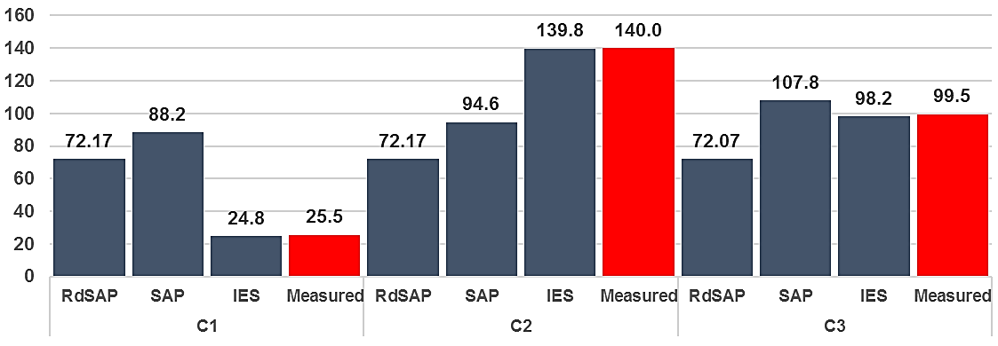

Fig 6. Annual space heating (kWh/m²yr) predictions from September 2016 to September 2017 and actual measurement for C1, C2 and C3.

The steady state tools, RdSAP and SAP present a large range of percent error. For RdSAP varies from 183% to 27.5%, while for SAP the range is from 246% to 8.3% when trying to predict the annual heating consumption. On the other hand, the dynamic performance analysis software IES is more accurate and presents a lower range of variation between 2.7% and 0.15%.

Table 10 expands the results of Table 9 and includes the local Heating Degree Days HDD, using 15.5ºC as base for the UK and the local maximum and minimum outside air temperatures. The HDD are included to be able to compare heating energy consumption taking into account the difference in weather conditions. In this way, it can be calculated how much heating consumption would be expected to be used to achieve the same internal air temperature for similar external conditions. Therefore, in Table 10 in the right side and within the TOTAL space heating consumption column after adding the insulation, close to the figure of the actual consumption appears in brackets ()* the expected total consumption that would have happened if the occupants had continued their heating habits. This figure in brackets is based on the HDD of the insulated period (green).

In addition, IES (1) shows the prediction of energy consumption if the occupants of the house do not change their habits after the insulation is added, while IES (2) takes into consideration the change in habits based on the internal air temperatures collected by the sensors and the interviews. The comparison between the (1) and (2) will allow to determine the impact of the change of habits on the percent error of the IES predictions.

Table 10. Comparison between predicted and measured monthly heating consumption before and after adding insulation.

Space heating monthly (kWh/m²) 2016-17 |  |  |  |  |  |  |  |  |  |  |  | Annual  (kWh/m²)
Month |  | Oc16 | Nv16 | Dc16 | Jn17 | 1-14F | 14-28F | Mr17 | Ap17 | My17
External T | TOTAL | 11.3C | 7C | 7C | 5.3C | 5.5C | 8.7C | 9.5C | 10.6C | 14.5C | TOTAL
HDD | 643 | 132 | 249 | 262 | 311 | 134 | 99 | 185 | 150 | 67 | 501
HDD | NO INSULATION |  |  |  | INSTALLING |  | EWI INSTALLED
C1 RdSAP |  | 87.70kWh/m² |  |  | - |  | 61.82kWh/m² |  |  |  |  | 72.17
C1 SAP |  | 7.9 | 12.3 | 16.7 | 16.8 | 5.9 | 5.9 | 10.9 | 7.4 | 4.5 |  | 88.23
C1 IES (1) |  | 0.57 | 2.1 | 3.2 | 5.0 | 1.9 | 1.7 | 2.7 | 1.1 | 0.3 |  | 18.4
C1 IES (2) |  | 0.57 | 2.1 | 3.2 | 5.0 | 1.9 | 2.8 | 4.9 | 2.9 | 1.5 |  | 24.8
C1 Measured | 5.8 | 0.5 | 2.2 | 3.1 | 4.4 | 1.6 | 2.3 | 3.1 | 4.4 | 3.9 | 13.7(5)* | 25.46
C2 RdSAP |  | 87.70kWh/m² |  |  | - |  | 61.82kWh/m² |  |  |  |  | 72.17
C2 SAP |  | 8.3 | 12.9 | 17.6 | 17.8 | 6.5 | 6.5 | 11.9 | 8.0 | 5.0 |  | 94.56
C2 IES (1) |  | 8.9 | 19.0 | 23.0 | 28.4 | 12.6 | 9.0 | 18.2 | 13.0 | 5.7 |  | 137.8
C2 IES (2) |  | 8.9 | 19.0 | 23.0 | 28.4 | 12.6 | 9.9 | 18.2 | 13.1 | 5.8 |  | 139.8
C2 Measured | 59.6 | 16.6 | 20.6 | 22.4 | 26.2 | 8.4 | 9.6 | 17.4 | 13.0 | 5.8 | 45.8(46.4)* | 140.0
C3 RdSAP |  | 87.64kWh/m² |  |  | - |  | 61.70kWh/m² |  |  |  |  | 72.07
C3 SAP |  | 10.3 | 15.6 | 20.9 | 21.0 | 6.7 | 6.7 | 12.5 | 8.6 | 5.5 |  | 107.8
C3 IES (1,2) |  | 8.3 | 13.3 | 17.2 | 22.5 | 9.6 | 6.0 | 11.1 | 6.9 | 3.3 |  | 98.2
C3 Measured | 40.8 | 7.4 | 14.7 | 18.7 | 21.9 | 8.9 | 6.2 | 10.9 | 5.7 | 5.1 | 28(32)* | 99.5

Table 10 shows that 40.8 kWh/m² were consumed during the non-insulated period (643HDD) for C3. Therefore, (32)* kWh/m² were expected to be required to achieve the same internal air temperature for similar external conditions for the insulated period (501HDD). However, the presence of insulation allowed retention of the same internal comfort consuming 28 kWh/m², 4 kWh/m² less heating than would have been consumed if the EWI would have not been installed. Therefore, C3 has a decline in consumption. Conversely, C1 increases on the heating energy consumption and the expected (5)* kWh/ m² were exceeded by 8.7 kWh/m² even after having added insulation. Table 6 reveals that this increase contributes to raise the prior retrofitting low internal temperatures to comfortable standards. Finally, C2 slightly decreases the prediction based on HDD by 0.6 kWh/m². The extra heating in rooms like kitchen, bathroom and bedroom, which are reflected in Table 6 on a raise in their internal temperatures, makes the impact of the EWI in terms of heating consumption lower than expected. Therefore, the impact of installing EWI has a dissimilar effect on the heating consumption for each case study, the possible reasons will be outlined in the analysis section.

In addition, if IES (1) and (2) are compared, the post-insulation change of heating habits involves a 35% increase of the predicted consumption for C1, 1.5% for C2 and 0% for C3, since C3 maintains the same habits. This reveals the importance of monitoring and carrying out pre- but also post-retrofitting interviews to be able to consider the adaptation of the occupants to their new thermal environment, otherwise the percent error of the IES predictions will rise.

Figure 7 compares the actual heating consumption baseline (pre-EWI) for C1, C2 and C3 and the predictions of the three tools. This baseline will be used to determine the benefit of adding EWI. C1 and C2 are exactly the same NFC dwelling, however the baseline consumption is 17.7 kWh/m²yr for C1 versus 151.7 kWh/m²yr for C2, which reveals a large difference of 134 kWh/m²yr, not because of the building itself, but by how the building is used by its occupants. This highlights how the occupants can become highly significant to the annual heating consumption.

For the C1 RdSAP predicts that the dwelling would consume 70 kWh/m²yr more than it actually consumes, SAP 77.5 kWh/m²yr and IES 1.5 kWh/m²yr. The prediction of RdSAP and SAP is based on a default heating consumption, which in this case is greater than the actual consumption. Energy efficiency improvements cannot save energy that was not being consumed. For C2 RdSAP predicts that the dwelling is consuming 64 kWh/m²yr less than actually consumes, SAP 50.7 kWh/m²yr and IES 4.8 kWh/m²yr. Finally, the occupants in C3 seem to be closer to the standards used in RdSAP and SAP, but still RdSAP underestimate on 25.5 kWh/m²yr, SAP exceed on 8.5 kWh/m²yr and IES underestimates on 1.5 kWh/m²yr the heating consumption of this dwelling.

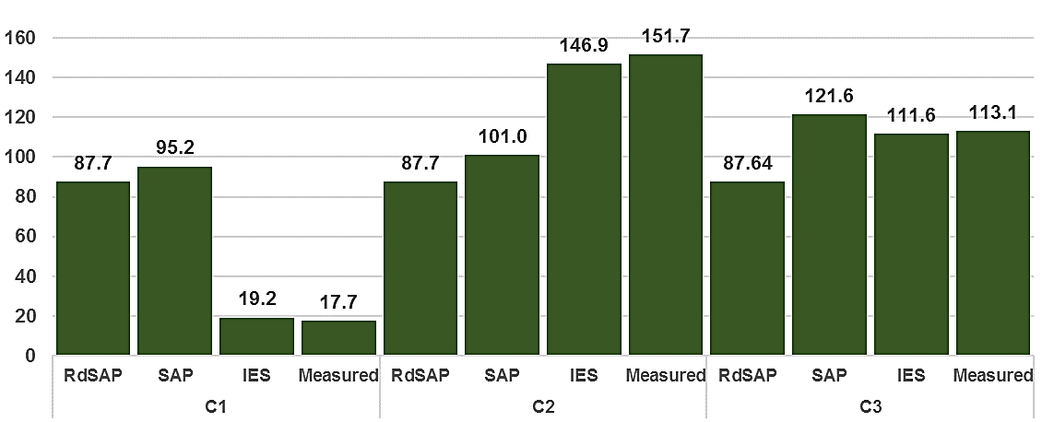

Fig 7. Annual space heating (kWh/m²yr) predictions and actual measurement for C1, C2 and C3 without insulation (September 2015 to September 2016)

On the next Figure (8) the first three columns of each case study compare the pre- (dark colour) and post-insulation (light colour) annual energy consumption prediction depending on the tool used. For C1 RdSAP predicts a reduction of 25.88 kWh/m²yr, SAP predicts 15.1 kWh/m²yr and IES predicts an increase of 14.4 kWh/m²yr. For C2 RdSAP predicts a reduction of 25.88 kWh/m²yr, SAP 13.8 kWh/m²yr and IES 20.9 kWh/m²yr and finally for C3 RdSAP predicts a reduction of 25.94 kWh/m²yr, SAP 29.73 kWh/m²yr and IES 33.7 kWh/m²yr.

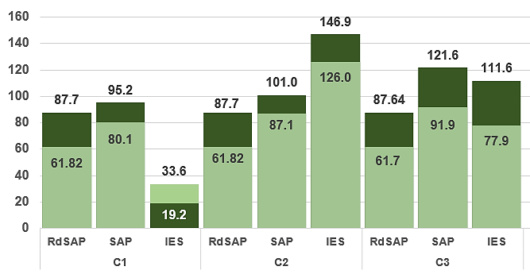
Fig 8. Annual reduction on space heating (kWh/m²yr) predictions if EWI is added (light colour) vs dwellings without EWI (dark colour).

The results of Table 9 demonstrated that the IES predictions were reliable, since the models were calibrated and were taking into account the pre- and post-occupants behaviour. Therefore, it is already possible to quantify the actual impact of the EWI on the heating consumption. The IES predictions of Figure 8 reveal that, for a complete year, the installation of EWI will reduce the heating consumption of C2 by ~ 21 kWh/m²yr (14%) and by ~ 34kWh/m²yr (30%) for C3. However, it will increase it for C1 by ~ 14.5 kWh/m²yr (75%). Figure 8 shows how a reduction of 30% of the heating consumption was expected thanks to the EWI for this project based on RdSAP calculations. However, only the Case 3 has a similar reduction, since the occupants and their habits are similar to the British standard habits used by SAP and RdSAP, and because they did not change their habits after the insulation was installed.

Based on this data and the data shown in Table 6 it is possible to link variations in internal air temperature to variations of the recorded/predicted energy use and to find an explanation due to a change in physical aspects of the house (EWI) or change in occupants’ behaviour. For example, C1 was under-heated before the insulation was installed; the extra heating after insulation has enabled raising the level of comfort in the house to UK norms. C2 maintains the high internal temperatures; expanding the parts of the house heated to this level to include new rooms, like the kitchen, that were previously underused. Finally, C3 keeps the same habits before and after the insulation was installed, resulting in a reduction in heating energy that can be directly attributable to the EWI. This reduction is also larger in comparison with C1 and C2, because C3 has an extra external wall. In addition, EWI reduces the differences between room temperatures, increasing the general levels of comfort throughout C1, C2, and C3.

Finally, Figure 8 compares the pre- and post-insulation external wall heat loss (W/k) as a proportion of the total heat loss of the fabric (heat transfer coefficient). IES does not generate a "heat loss coefficient" of the fabric, or a list of the various elements that define the thermal performance of the fabric and their respective heat losses. The heat transfer coefficient is a key figure for predicting the amount of heating demand to achieve comfort within a dwelling. It includes the heat loss through the external walls and other elements such as ground floor, roof windows etc., the heat loss due to thermal bridges and infiltration. The heat loss through external walls represents a 25% of the total heat loss of the fabric for terraced dwellings (C1, C2) and a 40% for end-terrace ones (C3), which have an extra external wall. Figure 9 shows how the EWI has a greater impact for an end-terrace in comparison with the mid-terrace dwellings. In this way, C3 reduces 60 W/K the heat loss through external walls, while C1 and C2 only reduces by 24 W/K. Therefore, the impact of EWI in the total heat loss of the fabric of these NFC dwellings is 25% for C3 and 15% for C1 and C2.

Figure 9 also shows that the portion of heat loss due to infiltration is bigger than the one due to external walls for the mid-terrace houses and the other way around for end-terrace houses, and that the installation of EWI has a minimum impact on the infiltration rates.

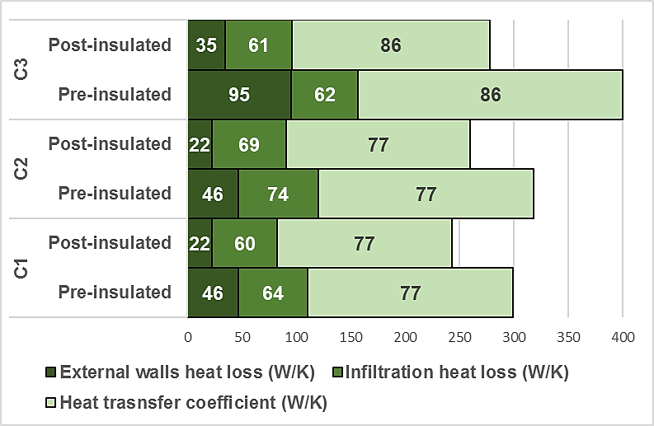

Fig 9. Comparison of the pre and post-insulation overall Heat transfer coefficient (W/k), with the individual colour shades showing the proportions due to: External wall heat loss (W/k); “other” fabric heat loss (windows, ground, thermal bridging etc..) and Infiltration heat loss (W/k) of the NFC dwellings studied. SAP calculations (STROMA, 2017).

5. Analysis

The thermal performance baseline of the fabric of the NFC dwellings was determined, featuring a pre U_{NFC} = 0.85 (±0.052) W/m²K, some 50% better than the standard value for NFC used in RdSAP (1.70 W/m²K) and post U_{NFC} = 0.22 (±0.013) W/m²K. The use of a standard 1.70 W/m²K would create false expectations of reducing the heating demand for C1 and C2 by 27% after insulating, if compared to the prediction of a reduction of 15.5% based on data measured in situ.

The in-situ measurement also determined that the fabric of these NFC dwellings had a high level of permeability, between 14.36 and 18.33 m³/hm², which was minimally reduced when the outer insulation was applied (13.92 to 17.56 m³/hm²).

The percent of error of RdSAP, SAP and IES to predict the heating consumption was determined by comparison with the actual heating consumption of the case study measured by meters in-situ. The results show that the steady state tools, RdSAP and SAP present a large range of percent error. The reasons for using RdSAP is that provides a quick and affordable prediction, based just on the dimensions and age of a building, which is convenient due to the limited quantity and quality of information available about existing buildings in general and NFC in particular. Following the instructions of a simple manual, RdSAP can generate a prediction of the thermal behaviour and energy consumption of the building studied in less than an hour. Because of this, it is commonly used for energy prediction savings for existing buildings. However, the level of simplification and uncertainty of the models produced by RdSAP are high. Consequently, the percent of error of RdSAP for this study varies from 183% to 27.5%. SAP has some similar limitations, but allows inputting of more detailed data of the thermal performance of the fabric, but requires slightly more time and expertise. However, its predictions do not take into account the local weather, and especially the habits of the occupants of the house, which is why its error range is also high from 246% to 8.3%. These outputs highlight the inaccuracy of using standard occupant-behaviour assumptions embedded in tools to attempt to predict the consumption of existing dwellings. These figures confirm that in general these tools are not accurate for predicting the operational energy consumption of a house, since they were not created for this purpose. More sophisticated tools such as IES can predict operational heating consumptions accurately. Provided the models are calibrated and the input data is accurate, as is the case here, the range of percent error variation was between 2.7% and 0.15%. However, significant expertise and time are required to use the software and to collect the data by carrying out airtightness and in-situ U-value tests, interviews and locating sensors within the dwelling to determine heating patterns.

The aim of this study was to quantify the level of reliability of three tools commonly used to make energy saving predictions when retrofitting existing houses. These results demonstrate that the tool selected has an impact on the accuracy of the prediction of the operational heating consumption of a building, due to the following three factors:

1) The accuracy of the baseline performance of the fabric included in the tool. SAP and IES can include a more accurate fabric information if available, while RdSAP generates a more simplified relying on embedded estimates depending on the age of the building that tend to reflect “worst case” scenarios.

2) The external weather conditions included in the model, which can be local for IES, whereas the same East Pennines conditions is used for any model using RdSAP and SAP.

3) The occupant characteristics and behaviour. In theory, if the U-value of the NFC walls is reduced, a decrease in heating consumption should be expected, assuming the same behaviour before and after an intervention. This was the reason of adding EWI. Figure 6 shows how C1 and C2, being effectively identical dwellings, present a large difference of 134 kWh/m²yr between their baseline consumptions, not because of the building itself, but because the buildings are used differently by their occupants. This highlights how the occupants can be the most significant factor affecting the annual operational heating consumption. This factor depends on the comfort threshold of the occupants, their economic status, cultural background, age, gender etc. This factor can never be properly accounted by SAP or RdSAP, since they use average data to enable fair comparisons between energy ratings of properties throughout the UK.

This study finds that the same factor is responsible for the dissimilar effects on post-operational heating consumption following the installation of EWI. Figure 8 shows how C1 is affected by the "rebound effect”, a well-explained phenomenon that explains why homes use more fuel following energy efficiency improvements than before. C1 was under-heated prior to retrofitting with temperatures in the living room between 14 to 16 ºC and 15 ºC for the other rooms. Once the thermal performance of the walls was improved, the occupant decided to heat the dwelling for longer periods of time and higher temperatures, as it was finally possible to achieve improved thermal comfort level. As a result, there was an increase in heating by 80%. RdSAP and SAP use a fixed model of Zone1 (21ºC) for the living room and Zone2 (18ºC) for the rest of the rooms. Therefore, they are not designed to accurately predict the operational heating consumption for this type of occupant, nor the savings due to EWI. Energy efficiency improvements cannot save energy that was not being consumed, since the actual temperatures were between 14 to 16 ºC. The same applies for occupants who prefer higher than normal temperatures before the insulation was installed, such as C2 (Living ~26 ºC, Bedroom 25 ºC, Bathroom 23 ºC, Kitchen 21 ºC). C3 was heated to a standard that was more similar to the British norm before and after the insulation was installed (Living 21.5 ºC and other rooms 19-20 ºC). Under these circumstances, the SAP prediction for C3 is quite close to the actual consumptions. Finally, IES is the only tool here studied which includes the actual heating pattern of the occupants before and after EWI was installed. Human behaviour is responsible for the mean internal temperature, hours of heating, length of the heating season, amount of ventilation, lighting and hot water. IES can include all of these variables in the model, but to get to know them, the building needs to be monitored and interviews need to be carried out at an extra cost to time and money. Unfortunately, detailed post intervention monitoring would only be carried out in practice for research purposes or to explain unexpected energy consumption.

In conclusion, this research has demonstrated that in order to be able to perform accurate predictions it is necessary to use tools such as IES, an advanced dynamic performance analysis software that can accept detailed inputs and can model complex interactions, but, then only if the model is properly calibrated, something that is rarely done in practice for reasons of time and cost. Of course, if there is no detailed information about the building to be retrofitted and inaccurate default values are used, even IES will return corresponding inaccurate results. For this purpose, expertise and time are required to use the software and to collect precise data. The resources and the time used in this research to gather the detailed information about the NFC fabric and the habits of the occupants to determine the impact of installing EWI in the operational heating consumption are not always available. Most projects lack detailed information, and this is why steady state tools are usually employed to predict the reduction of consumption and make decisions.

The second aim of this study was to quantify the actual impact on the operational heating consumption of a set of NFC dwellings when installing EWI. The main reason for adding the insulation was to reduce CO₂ emissions and heating bills. However, this research found mixed results. The results shown in Figure 8 based on calibrated IES models predict that EWI will make C1 increase consumption by 75%, decrease C2 by 14% and C3 by 30%. The RdSAP calculations predicted 30% reduction for all of them, unfortunately different from the actual values achieved. Quite often the decision to choose certain retrofitting measures are based on the cost-effective recommendations that a RdSAP analysis provides for the studied dwelling. However, if heating energy consumption goes up as a result of the retrofitting measure, as it was the case for C1, there will be an economic loss. If the retrofitting measure of adding EWI would had been chosen based on its cost-effectiveness, the results of this study demonstrate that although in theory it is, the behaviour of the occupants can make it not cost-effective.

The improvement of social houses adding EWI, although it considers the cost-effectiveness of the measure, it does not look for an economic benefit, in fact the city council will not recover the money from the intervention. Decent Homes Standard for public housing of the United Kingdom aims to enhance the quality of life of the occupants and Table 6 demonstrates that EWI brings a reasonable degree of thermal comfort for NFC dwellings. Additionally, the U-value of the walls now comply with the requirements of current Building Regulations, which expects the heat loss through the walls to be below 0.25 kW/m².

In this research the heating consumption has varied due to controlled changes in the fabric of the dwelling (EWI), but also due to changes in the heating habits. The results have demonstrated that the second factor is difficult to control and predict. The coefficient of heat loss of the fabric of the dwelling is independent of its occupants. It is a measure of the thermal quality of the fabric, which accounts the amount of heat loss through the external plane elements (U-values), the thermal bridges, plus losses due to infiltration. The heat transfer coefficient is a key figure for predicting the amount of heating demand to achieve comfort within a dwelling. Therefore, it could be claimed that unless the resources and information are available to carry out the kind of full analysis described above, it would make more sense to use the reduction of the heat loss coefficient as a basis on which to make decisions, when retrofitting a dwelling, rather than the reduction of operational heating consumption, which is commonly used but is very difficult to predict accurately.

In addition, factors such as the U-values and air permeability are relatively easy to quantify in terms of importance within this coefficient. If the proportion of heat that is lost through the roof or wall or through infiltration is known, is possible to compare them and decide which will be more effective to reduce, using a simple SAP calculation. In this way, Figure 9 determined that by installing EWI in the NFC terraced dwellings (C1 and C2) the heat loss coefficient of the fabric was reduced by 15% and by 25% for the end-terrace C3. The reason for this difference is that the heat loss through external walls represents a 25% of the total heat loss of the fabric for detached dwellings and a 40% for end-terrace ones, due to its extra external wall. It was also found that heat loss due to infiltration is quite high, and in the case of the terrace houses higher than the heat loss through walls. The retrofitting project under study only installed external insulation, and did not consider draught proofing the dwellings. Therefore, the infiltration rates were barely reduced. Based on these figures and given that the occupants are going to be inconvenienced by the installation of EWI, and contractors and the logistics are already in place, it makes sense to make the most of the “trigger point” created, for a deeper retrofit (Maby and Owen, 2015). Therefore, and in parallel to adding insulation to the walls, where possible, it would be worth considering measures to reduce infiltration to levels similar to those suggested under building regulations, taking care to consider ventilation issues so as to avoid the creation of condensation problems. The reduction of infiltration will not only bring energy-savings but also an improvement of the level of comfort.

In this sense, as long as the information of the thermal envelope baseline is correct, SAP can quick and easily predict the reduction of heat losses through the fabric. In addition, SAP clearly displays the coefficient to show the impact of the different factors on the heat loss of the fabric. Therefore, the heat loss coefficient could be used to make quick comparisons between factors within this coefficient using SAP. If the operational heating consumption is difficult to predict, due to being strongly linked to the behaviour of the occupants, it could be claimed that the coefficient of heat loss of the fabric is the most suitable alternative criteria to make pre-retrofit decisions, and to avoid unrealistic expectations.

6. Conclusions

The aim of this study was to determine the level of reliability of three tools (RdSAP, SAP and IES) often used to predict heating savings when adding EWI. Even though RdSAP and SAP are simply regulatory tools with known limitations, they are commonly used de-facto to benchmark the impact of thermal upgrades. On the other hand, IES is a more sophisticated dynamic simulation software, capable of inputting actual data for most of the factors linked to heating consumption. The comparison between predictions and actual values demonstrated that steady state tools (RdSAP and SAP) are not able to predict the operational energy consumption of a house accurately. The data they use to make predictions is often inaccurate. They use default standard values for the information not available and fixed models for the heating and occupant behaviour. Therefore, it was concluded that it is essential to choose a tool that is capable of correctly predicting the heating consumption, which is strongly linked to the heating habits of the occupants of the house. Subsequently, only those tools capable of taking into account the occupants behaviour can be trusted.

The human factor can be the most significant factor when trying to predict the annual operational heating consumption. In this study, two identical dwellings presented a large difference of 134 kWh/m²yr between their baseline consumptions exclusively due to the habits of the occupants. The uncertainty that occupants add to the operational heating consumption makes it hard to get accurate predictions. Only the dynamic performance analysis software (IES) was suitable to carry out this type of prediction accurately, with a range of percent error variation between 2.7% and 0.15%, provided the models were calibrated and the input data was accurate. A safe IES prediction requires highly accurate and detailed information regarding pre and post fabric performance, external weather conditions and, most importantly, accurate pre- and post- heating operational habits of the occupants. However, few retrofitting projects have the resources and time to gather all this information. This is why highly simplified RdSAP models are commonly used to make heating consumption predictions.

Another significant factor for accurate predictions is the accuracy of the information of the fabric being retrofitted. One of the objectives of this paper was to cover the literature gap offering reliable information about the thermal performance baseline of the fabric of NFC dwellings. Pre-insulation U values were measured at U_{NFC} = 0.85 (±0.052) W/m²K for a 280mm NFC (λ = 0.52 W/mK) with a 40mm Paramount plasterboard internal finishing, and, post-insulation at U_{NFC} = 0.22 (±0.013) W/m²K, after adding 110mm of EWI (λ = 0.032 W/mK). In addition, the air permeability ranged between 14.36 and 18.33 m³/hm². Therefore, after being retrofitted, the dwellings comply with the requirements of current British Building Regulations for walls to keeping the heat loss through them below 0.25 kW/m², but not with the air permeability limit of 10 m³/hm².

It has been demonstrated, that the operational heating consumption is very difficult to predict accurately, due to being strongly linked to the behaviour of the occupants. Therefore, it could be claimed that retrofit decisions should be based on a different criteria. The coefficient of heat loss of the fabric of the dwelling is independent of the occupants. It could be claimed that the coefficient of heat loss of the fabric is the most suitable alternative criteria to make pre-retrofit decisions, and to avoid unrealistic expectations.

For this purpose, simple SAP calculations could be suitable if the input data of the fabric is accurate. In addition, by investigating the change of this coefficient it is possible to better understand the relative importance of the different sources of heat loss and explore other possible interventions in parallel to insulating the walls. In this way, it was found that the EWI reduced the heat loss coefficient of the fabric by 15% for the mid-terrace NFC dwellings and by 25% for the end-terrace one. It was also found that heat loss due to infiltration is quite high and in the case of the terrace houses bigger than the heat loss through walls. Therefore, for any NFC retrofit project, and in parallel to adding insulation to the walls, it would be advisable considering measures to reduce infiltration to levels similar to those suggested under building regulations.

Finally, and once the previous data was gathered and the correct tool determined, it was possible to quantify the actual impact of installing EWI on the operational heating consumption of the three NFC case studies. Although a reduction of 30% was expected, this research found that C1 actually increased its consumption by 75%, albeit from a very low level, due to rebound effect; C2 decreased its consumption only by 14% and C3 was the only one achieving the expected reduction of 30%. Although, the expectations in terms of heating savings were not achieved in all the cases, it was found that the installation of EWI brought a reasonable degree of thermal comfort to these NFC dwellings.

The lessons learned on this research can help stakeholders to choose the right tool and criteria when making decisions. It can also help homeowners, designers, consultants, councils, and in general, any stakeholder involved in implementing thermal improvements to NFC dwellings, in any country where this type of construction method was used, since they currently have limited access to accurate information and case studies.

Acknowledgements This work forms part of a project for which financial support was provided by the British Council-funded Institutional Links.

7. References

Abadjieva, T. and Sephiri, P. 2000. Investigations on Some Properties of No-Fines Concrete. Gaborone: University of Botswana.
Abdullah, A. and Cross, B. 2014. Whole Building Energy Analysis: A Comparative Study of Different Simulation Tools and Applications in Architectural Design. Proceedings of the 2014 ACEEE Summer Study on Energy Efficiency in Buildings.
Agami, R. 2006. Literature Review on Calibrati on of Building Energy Simulation Programs: Uses, Problems, Procedures, Uncertainties, and Tools. ASHRAE Transactions Vol. 112 (1) pp 226-240.
Anderson, B. 2006. Conventions for U-value calculations BR443. Watford: BRE.
Aspen, P. Ball, M. Roberts, M. and Whitley, T. 2012. A holistic evidence-based approach to retrofit in social housing. In Proceedings of Retrofit 2012 conference, University of Salford, Manchester.
ATTMA. 2015. ATTMA TSL1 - Air testing standard for residential. Amersham: ATTMA.
Baker, P. 2011. Historic Scotland technical paper 10: u-values and traditional buildings. Edinburg: Historic Scotland
Banks, N. and White, V. 2012. Evaluation of solid wall insulation in fuel poor households in the private sector. Final report to Eaga Charitable Trust.
British Board of Agrément. 2016. Agrément Certificate 16/5319. Product Sheet 1. Soltherm external wall insulation systems. [Online] Available at: http://www.bbacerts.co.uk/CertificateFiles/53/5319PS1i1.pdf [Accessed 10 April 2017].
Bekker, C. 1998. Building science N3: an outcomes-based course for technical students. Maskew Miller Longman. Johannesburg
Bennett, G. Elwell, C. Lowe, R and Oreszczyn, T. 2016. The Importance of Heating System Transient Response in Domestic Energy Labelling. Buildings 6 (3).
BRE. 1996. Good Practice Guide 183. Minimising Thermal Bridging while Upgrading Existing Housing: A Detailed Guide for Architects and Building Designers. Watford: BRE.
BRE. 2008. Energy analysis focus report – A study of hard to treat homes using the English house condition survey, Part 1: dwelling and household characteristics of hard to treat homes. Watford: BRE.
BRE. 2013. SAP 2012. The Government’s Standard Assessment Procedure for Energy Rating of Dwellings. Watford: BRE.
Boss, A. 2014. In-situ measurements of wall U-values in English housing. Watford: BRE.
BSI. 2001. ISO 13829:2001. Thermal performance of buildings. Determination of air permeability of buildings. Fan pressurization method. London: BSI.
BSI. 2007a. ISO 6946:2007. Building components and building elements. Thermal resistance and thermal transmittance. Calculation method. London: BSI.
BSI. 2007b. ISO 13786:2007. Thermal performance of building components -- Dynamic thermal characteristics -- Calculation methods. London: BSI.
BSI. 2010. ISO 10456:2007. Building materials and products - Hygrothermal properties - Tabulated design values and procedures for determining declared and design thermal values (incorporating corrigendum December 2009). London: BSI.
BSI 2014. ISO 9869-1:2014. Thermal insulation-building elements-in-situ measurement of thermal resistance and thermal transmittance. London: BSI.
Centre for Sustainable Energy (CSE). 2005. Fuel poverty and non-traditional construction: final report. Bristol: CSE
CSE. 2013. Centre for Sustainable Energy response to Ofgem. Energy Company Obligation (ECO): Consultation on how to account for the percentage of measure installed when calculating ECO scores. Bristol: CSE
CIBSE. 2016. CIBSE Guide A: Environmental Design 2016. CIBSE: London.
Coakley, D. Aird, G. Earle, S. Klebow, B. Conaghan, C. 2016. Development of Calibrated Operational Models of Existing Buildings for Real-Time Decision Support and Performance Optimisation. CIBSE Technical Symposium, Edinburgh, UK 1 4-1 5 April 2016.
Concrete Construction. 1961. No-fine concrete. Aberdeen: The Aberdeen Group.
Craig, N. Sommerville, J. Charles, A. 2013. No-fines concrete homes: a typical thermal performances. Structural Survey, 31(1), pp. 43-55
Demanuele, C. Tweddell, T. Davies, M. 2010. Bridging the gap between predicted and actual energy performance in schools. In World Renewable Energy Congress XI 25-30 September 2010, Abu Dhabi, UAE
Denzin, N. K., & Lincoln, Y. S. 2005. The SAGE handbook of qualitative research. Thousand Oaks: Sage Publications.
Deurinck, M., Saelens, D. and Roels, S. (2011b). The impact of physical rebound effects on the heat losses in a retrofitted dwelling. In Proceedings of 9th Nordic Symposium on Building Physics NSB.
Elmhurst energy. 2016. Technical bulletin. TB24 - All RdSAP Conventions v9.0. [Online] Available at: http://www.elmhurstenergy.co.uk/uploads/TB24_All_RdSAP_Conventions_Final_Aug_2016.pdf [Accessed 10 April 2017].
Energy Saving Trust. 2005. Energy Efficiency Best Practice in Housing. Northern Ireland: assessing U-values of existing housing. EST: London
Energy Simulation Research Unit (ESP-r). 1989. ESP-r Reference Manual. Glasgow: ESR University of Strathclyde.
English Heritage. 2011. Energy Efficiency and Historic Buildings. Application of Part L of the Building Regulations to historic and traditionally constructed buildings. London: English Heritage.
DCLG. 2013. Approved Document L1A: Conservation of Fuel and Power in New Dwellings. London: DCLG.
DCLG. 2015. Approved Document L1B: Conservation of Fuel and Power in New Dwellings. London: DCLG.
Gavankar, S. and Geyer, R. 2010. The rebound effect: state of the debate and implications for energy efficiency research. Bren School of Environmental Science and Management, Santa Barbara.
Gorse, C. Smith, M. Glew, D. Thomas, F. Shenton, D. M. Farmer, D. 2016. Building Sustainable Futures. Springer
Greening, L. Greene, L. and Difiglio, C. 2000. Energy efficiency and consumption, the rebound effect, a survey. Energy Policy, 28(6–7), 389-401.
Heath, N. Pearson, G. Barnham, B and Atkins, R. 2010. Technical Paper 8. Energy modelling of the Garden Bothy, Dumfries House. Prepared for Historic Scotland by Changeworks. Technical Report. Historic Scotland, Conservation Group.
Hong, S. 2011. Changes in space heating energy consumption following energy efficient refurbishment in low-income dwellings in England. PhD thesis. The Bartlett School of Graduate Studies, University College London.
Hughes, M. Pope, P. Palmer, J. Armitage, P. 2016. UK Housing Stock Models Using SAP: The Case for Heating Regime Change. Science Journal of Energy Engineering. Vol. 4, No. 2, 2016, pp. 12-22.
Kelly, S. Crawford-Brown, D. and Pollitt, M. G. 2012. Building performance evaluation and certification in the UK: Is SAP fit for purpose? Renewable and Sustainable Energy Reviews. Vol. 16 No. 9, pp. 6861–6878.
King, C. and Weeks, C. 2010. Sustainable refurbishment of non-traditional housing and pre-1920’s solid wall housing. BRE Information paper IP 3/10. Garston: BRE Press.
Li, F. Smith, A. Hamilton, I. Lowe, R. Mavrogianni, A. Oikonomou, E. Raslan, R. Stamp, S. Stone, A. Summerfield, A.J. Loucari, C. Taylor, J. Raslan, R. Oikonomou, E. Mavrogianni, A. 2016. Retrofit solutions for solid wall dwellings in England: The impact of uncertainty upon the energy performance gap. Building Services Engineering Research and Technology. 37, 5
Maby, C. and Owen, A. 2015. The key to unlocking low carbon retrofit in private housing. University of Leeds: The aims of the research were to produce evidence, and develop policy and intervention recommendations, to identify how building trade micro enterprises could help accelerate the low carbon retrofit of the UK's private housing stock.
Maile, T. Fischer, M. and Bazjanac, V. 2007. Building Energy Performance Simulation Tools. A Life-Cycle and Interoperable Perspective. Center for Integrated Facility Engineering Working Paper 107, Stanford University.
Marshall, A. Fitton, R. Swan, W. Farmer, D. Johnston, D. Benjaber, M. Ji, Y, 2017. Domestic building fabric performance: Closing the gap between the in situ measured and modelled performance. Energy and Buildings Vol 150, pp307-317.
Miles, M. B., & Huberman, A. M. 1994. Qualitative data analysis: An expanded sourcebook. Thousand Oaks: Sage Publications.
Miles-Shenton, D. Wingfield, J. Sutton, R. Bell, M. 2011. Final report to Joseph Rowntree Housing trust project title: temple avenue project part 2, Energy efficient renovation of an existing dwelling: evaluation of design & construction and measurement of fabric performance. Leeds
Milsom, E. 2014. Solid wall heat losses and the potential for energy savings. Watford: BRE.
Moss, J.K. 1979. No-fines building gives energy-conserving homes. International Construction. Sutton: Aberdeen Group
Neville, A.M., 1981. Properties of Concrete. Upper Saddle River: Prentice Hall.
Placo. 2008. Ouvrages Placopan. [Online] Available at: http://www.placo.fr [Accessed 10 April 2017].
Platt, R. and Rosenow, J. 2014. Up against the (solid) wall. What changes to the ECO mean for energy efficiency policy. London: IPPR.
Reeves, A. 2009. Achieving deep carbon emission reductions in existing social housing: the case of Peabody. PhD thesis. De Montfort University.
Ross, K. 2002. Non-Traditional Housing in the UK – A Brief Review. Watford: BRE.
Sierra, F. Gething, B. Bai, J. Maksoud, T. 2017. Impact of the position of the window in the reveal of a cavity wall on the heat loss and the internal surface temperature of the head of an opening with a steel lintel. Energy and Buildings, Vol142, pp 23-30.
Sommerville, J. Craig, L. Charles, A. 2011. No-fines concrete in the UK social housing stock: 50 years on. Structural Survey, 29 (4), pp. 294-302.
Sorrell, S. 2007. The rebound effect: an assessment of the evidence for economy-wide energy savings from improved energy efficiency. UK Energy Research Centre, London.
Stafford, A. Bell, M. Gorse, C. 2012. Building confidence: a working paper, report no 8. Energy Saving Trust & Low Carbon Futures.
Stone, A. Shipworth, D. Biddulph, P. & Oreszczyn, T. 2014. Key factors determining the energy rating of existing English houses. Building Research & Information, In Print, 1–14.
STROMA. 2015. RdSAP manual methodology. London: STROMA
STROMA. 2017. FSAP2012 1.0.4.6. London: STROMA
Sunikka-Blank, M. and Galvin, R. 2012. Introducing the prebound effect: the gap between performance and actual energy consumption. Building Research & Information, Vol 40(3), pp 260-273.
Ward, T. (1993). In situ measurement of the U-value of walls of several different constructions. BRE Note No. 66/93.
Wei, S., Jones, R., & de Wilde, P. 2014. Driving factors for occupant-controlled space heating in residential buildings. Energy and Buildings, 70, 36–44.
Wieloch, R. 1966. Tests on lightweight concretes and the design of buildings. Towards Industrialised Building. Proceedings of the third CIB Congress, pp 369-371
Williams, A.W. and Ward, G.C. 1991. The Renovation of No-Fines Housing: A Guide to the Performance and Rehabilitation of Load Bearing No-Fines Concrete Dwellings Built Using the Wimpey and Scottish Special Housing Association Systems. Watford: BRE.
Wingfield, J. Bell, M. Miles-Shenton, D. and Seavers, J. 2011. Elm Tree Mews Field Trial. Evaluation and Monitoring of Dwellings Performance. Leeds: Leeds Metropolitan University.

