White weddings and the reproduction of white femininity
Julia Carter, University of the West of England

When my colleague and I entered the wedding show venue in London we were immediately confronted by a salesperson asking if she could see our legs so that she could administer a hair removal treatment. This was somewhat off-putting and neither my colleague nor I took her up on her offer. It also, however, set the tone for the rest of our visit to this wedding show and to the subsequent shows we visited- our bodies were central to the experience of wedding shows and, by extension, weddings. This may seem like an obvious point but it nevertheless deserves stating: weddings in the UK, or rather, the particular brand of white weddings offered at national wedding shows, at least, require the bodies, emotions, thoughts and dreams of women. Not just any women either, for the special brand of femininity bartered at wedding shows is white, middle-class, young (or ageless) and heterosexual.

This type of femininity, which I shall call ‘white wedding femininity’ is characterised by hyper-sanitised pureness, represented by white and pale tones, slim and tall bodily features enveloped in long, full-length white dresses, and a gendered identity based on late-nineteenth/early twentieth invented notions of female passivity, flowery and fluffy accessories, white and pink colours. The repetition of the word ‘white’ here is not coincidental, for one of the functions of the white wedding is to provide security and safety for white people in a cushion of frivolity from the dark and unknown other; to create in-group status and reinforce notions of family, wealth, status and privilege. Take the royal wedding between Prince Harry and Meghan Markle as a recent example: while presented as a light distraction to the public who could engage in patriotic frivolity and revel in the ‘progressiveness’ of having a mixed-race royal, behind the scenes an ancient and declining family shore up their struggling reputation, welcome the wealth of a member of the nouveau riche, and engage in rituals designed to communicate both exceptional status and the highest privilege. Thus when referring to wedding femininity as ‘white’, I mean not that all brides are, or should be, white racialized. But rather that white weddings in the UK communicate messages about whiteness- messages that have connections with privilege, status, wealth, class and wedding femininity.

Let’s look at some examples from the photos I took at the three regional weddings shows I attended with my research colleague during the Spring of 2017. These wedding shows were open to a paying public and cost in the region of £15 to attend- a price which excludes the poorest but allows most earning couples to attend. At once providing a sense of exclusivity and affordability. In fact from our observations, the majority of attendees were women, and brides appeared to opt to bring mothers, sisters and female friends to the shows rather than male partners (some may of course have been female partners although the shows were almost exclusively heterosexual). This perhaps indicates the status of these events as offering a form of leisure activity, aimed primarily at women, who attend in groups or pairs, with friends and/or family. Wedding work is an extension of household and/or relationship labour and therefore falls traditionally under the purview of femininity and women. It is perhaps only when weddings become classified as ‘event planning’ and therefore seen as more serious or masculine work, that involvement in the wedding could encompass a form of masculinity.
Picture A
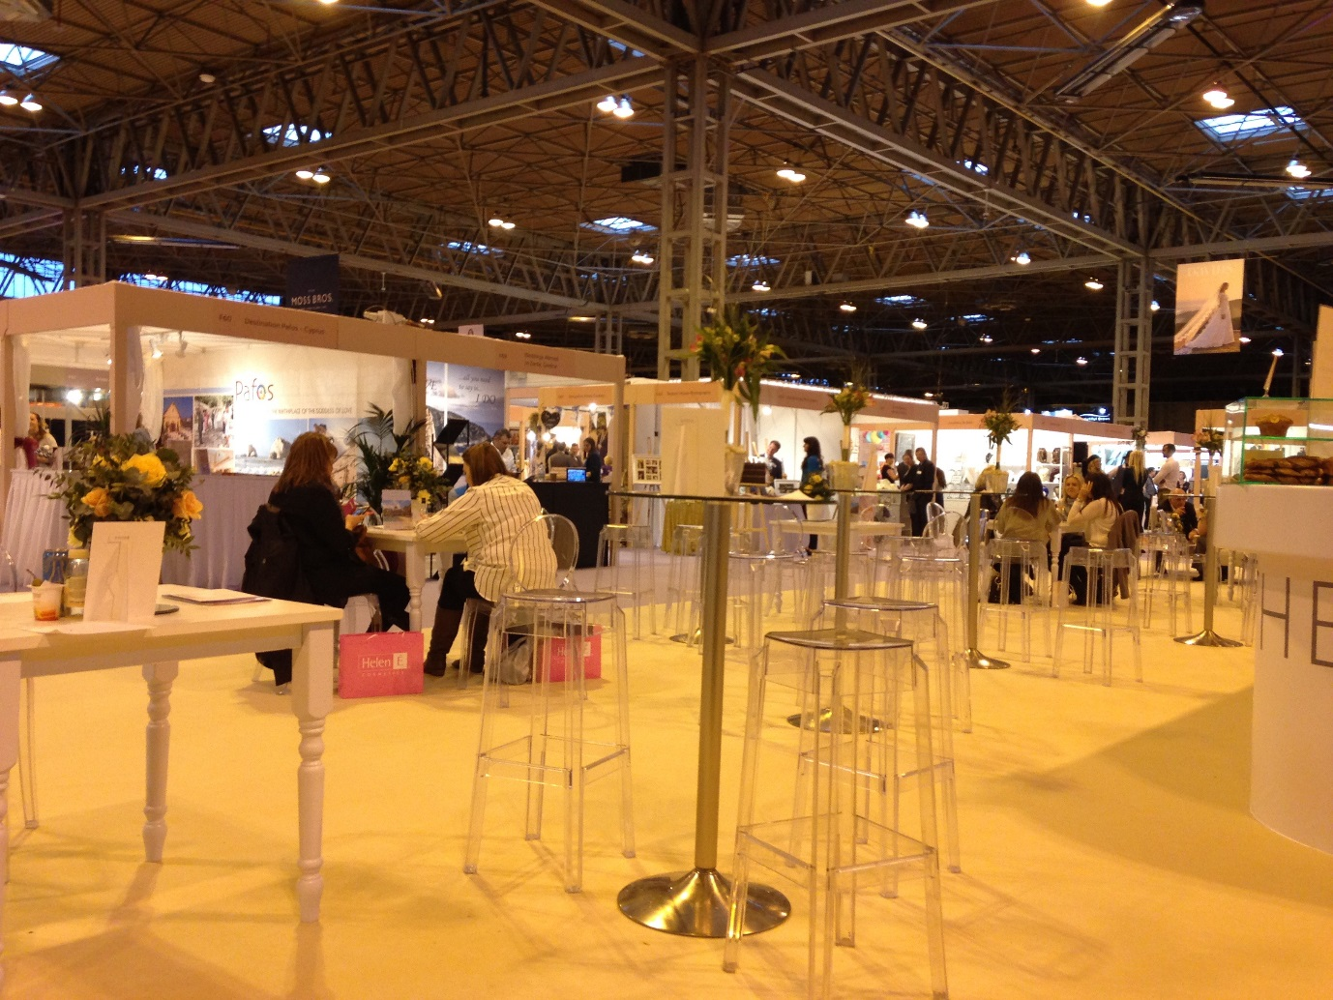

Picture A shows a typical view at one of these wedding shows. The setting is a large industrial warehouse which has been converted into a space designed to exude, encompass and encourage white wedding femininity. As you can see from the photograph, the venue uses low lighting rather than bright or spot lights, the overwhelming colours are white with highlights of pink, pastel purple and silver (or grey). Flowers are a constant presence at these shows and pictures of tall, slim white women in wedding dresses are ubiquitous. What is most revealing in this picture is the wonderful juxtaposition of wedding femininity against industrial functional space- the lower portion of the picture compared to the upper portion. Where one indicates soft, subtle lines, low lights, pastel colours, floral displays, the other imposes itself with functional no-nonsense practical straight lines and metallic efficiency. I like to think of this juxtaposition as a simile revealing the huge effort and work involved in wedding femininity to hide the practical and pragmatic processes involved in wedding work.

Work is not a word most commonly associated with weddings but planning a wedding takes a significant amount of work: time, resources and effort. My colleague and I both found attending these wedding shows exhausting, perhaps because we were involved in observations and research, but also because of the overwhelming scale and size of the events and venue (captured by Picture A) and the amount of walking, talking and negotiation required by attendees (sometimes in fending off vendors, sometimes talking to them, explaining requirements, negotiating terms and so on). Seating areas as seen in Picture A were available and required. The work attendant at these shows was, however, belied by the requirement for white wedding femininity.
Picture B
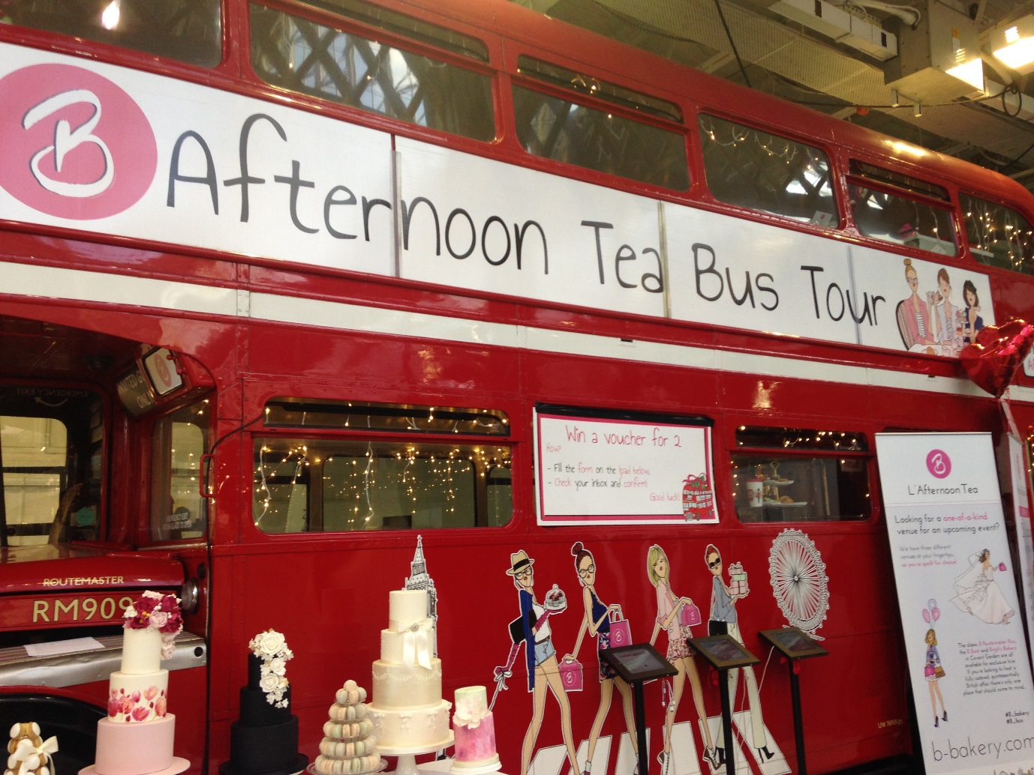

Picture B is a photo captured of a bus advertising ‘afternoon tea bus tours’ which could be incorporated into a wedding. The most obvious symbol in Picture B is the red ‘London’ bus: one of the most iconic images of British- or English- national identity. This is accompanied by a number of other images: first the women depicted having afternoon tea (top right), who appear to be white, slim and appropriately femininely dressed in pale and pastel colours. Second, the four tall, white, slim, young women depicted in high heeled shoes with pink shopping bags and other items of feminine consumption (cupcakes and presents). Finally, the wedding cakes presented in front of the bus: tall, tiered and elaborately decorated. Afternoon tea itself can be seen as a symbol of upper and middle class leisure in Britain, open to those who are not involved in usual hours of 9-5 work (or at the weekend) and therefore intricately linked with femininity and feminine leisure pursuits in a time before women entered the work force in greater numbers. While this may be an invented tradition, it certainly has roots in the practices of the upper classes in British society who partook in early afternoon refreshments.

This is congruous with the images of the women depicted on the bus who represent white privileged feminine leisure and wealth: women who have plenty of free time for shopping and afternoon tea and enough money to enjoy both activities freely. Although in no way necessarily reflective of the actual demographic attending the wedding shows, these images do reflect the ideal wedding femininity expected and circulated at the shows: wealthy and concerned with conspicuous consumption. Which is also where the cakes come in- while originating in a rural working class tradition of setting the newly wedded couple up with food to eat, the wedding cake is a marooned tradition now seemingly illustrating little more than the personal tastes, wealth and preferences of the wedding couple. Nevertheless, as this picture illustrates, they also align with a wedding femininity- pink, white, highly decorative, elaborate, and involving a simplicity which hides highly skilled cake making and decorating (also largely associated with femininity despite the most highly regarded pastry chefs often being men).

The wedding cake has become a part of the change in the meaning behind modern British weddings- where traditions have become increasingly self-reinforcing, tautological, and for their own sake. Thus the cake, the dress, the rings, for example, are traditions in their own right, with tradition used as both cause and outcome. Because of this marooning of tradition, they become adapted to suit the needs of the situation. At a time when gendered roles are being challenged in other parts of daily life, in wedding consumption they continue largely unchallenged. Therefore, marooned wedding traditions become co-opted by interested parties- wedding retailers- and adapted to serve in the interests of these parties. Thus the wedding cake becomes incorporated into an industry and adapted to reflect both a feminised and consumption oriented purpose. The latest market to enter the wedding cake field is cheese manufacturing and many cheese makers now offer an adapted version of the ‘traditional’ tired wedding cake, made up of different varieties of cheeses. This can, of course, then be offered up as the ‘cheese course’ at the end of the wedding breakfast meal. Due to expectations around particular wedding rituals, these ‘cheese cakes’ are often accompanied by additional wedding cakes (made from cake) so that the guests are able to recognise and appreciate both standard tradition and adapted tradition- a bricolage of old and new to allow for a form of individualised conformity.

Pictures C and D
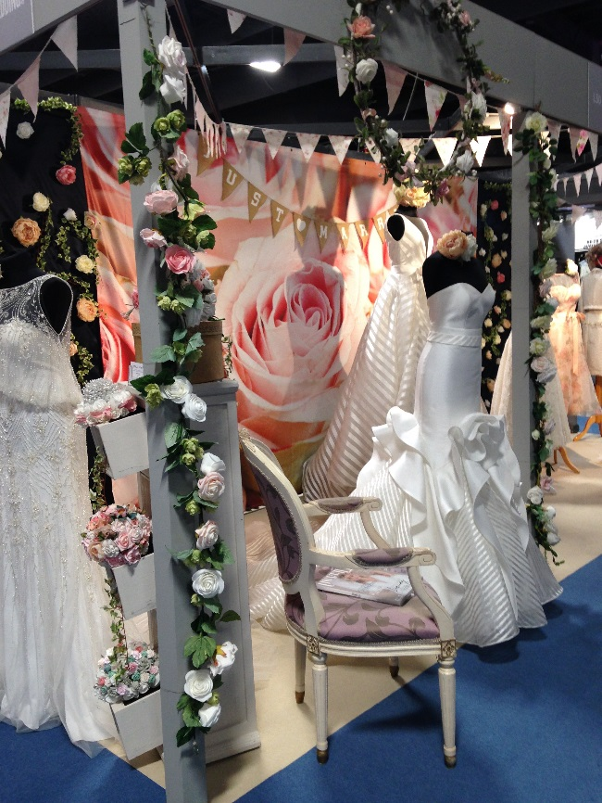

Finally let’s turn to Pictures C and D. Picture C epitomises the wedding shows: flowers, white wedding dresses, pinks, peaches, yellows. Ostensibly advertising a product but really selling an atmosphere, feelings, emotions, colours, femininity. The main image in the picture is that of a rose- an English rose perhaps- a symbol of virginal youth and beauty in historical England. The over-abundance of roses in this display is telling. It is a very traditional flower, dating back many centuries in English country gardens, associated with the ‘War of the Roses’ battle for power between the Houses of York and Lancaster, 12 red roses synonymous with St Valentine’s day and romance- the rose is the ideal flower to represent English female beauty and romance. But roses are also one of the more expensive flowers and can, therefore, denote luxury and wealth, especially when displayed in excess. Roses and rose petals can also be seen in Picture D alongside other indicators of luxury and wealth: a candelabra, silver service; and femininity: pink cherry blossom, decorative lighting, flowing pink chair covers. Both images are heavily invested in the colour white, representing purity, femininity, beauty. And both also contain vestiges of English heritage or tradition: roses, antique-looking furniture, an old-style gas-effect lamp post. This is how tradition is brought into contemporary wedding practices in a bricolage of old and new.

The images presented here contain symbols of Englishness- the red bus, roses, afternoon tea- symbols which already have meaning and associations in English culture and date from a time in the late nineteenth century when notions of national identity were becoming increasingly important. This may, in part, be due to the expansion of the British empire where colonising different cultures increased the importance of separating and protecting a sense of English culture to preserve both difference and a sense of superiority. Indeed, what is missing in these images of tea and cake, is an acknowledgement of the origins of these products- tea leaves and sugar- which were plundered or cultivated in the far reaches of empire. By incorporating the end product into a notion of English national identity, the origins and people from whom the products came can be ignored and written out of English history. At events such as these wedding shows, what these symbols of ‘Englishness’ therefore allow and enable is ethnic- and class- appropriate consumption, where consumers can forget who is the sugar at the bottom of their English cup of tea, as sociologist Stuart Hall might say. These wedding show spaces allow individuals to engage with (upper) middle-class whiteness and Englishness (and sometimes Britishness) in safe and appropriate ways, where often invented ‘English’ traditions are celebrated and the presence of the unknown other, crucial in the construction of the empire and these traditions, is absented.

Taken as a whole, these images provide a glimpse into the world of the wedding show. While in no way suggesting that these images are a pure reflection of actual weddings or wedding practices in the UK, what they do demonstrate are some of the ways in which meanings and messages about weddings and notions of white femininity, wealth and beauty are communicated at these events. Images are powerful and can contain many meanings, which may not be evident or obvious at first glance. While taking these pictures, I did not draw out the meanings I have written about here- it is only on closer inspection and with some reflection that these meanings can take shape and be articulated. Nevertheless, when immersed in the wedding world of bridal magazines, wedding shows and wedding media more generally, certain messages are hard to miss. What can be seen in each of the images presented here is an emphasis on an individualised notion of femininity- empowered enough to shop and consume in a post-feminist way- while still desiring a level of tradition that allows wedding work to be women’s work and requires women to maintain superhuman bodily perfection. Overwhelmingly the wedding shows demonstrate that in the wedding show arena at least, women are still expected to conform to an idealised vision of white feminine beauty standards and to produce a classically traditional wedding concomitant with standards of English or British whiteness, all while passing this off as a fun and easy feat of organisation: this is ‘white wedding femininity’.

